RAJAKISHORE CHANDRA ACADEMY OF TECHNOLOGY
(POLYTECHNIC)



LECTURE NOTES ON
ELECTRONICS MEASUREMENT &INSTRUMENTATION

DEPARTMENT OF ELECTRONICS & TELECOMMUNICATION
3rd SEMES
PREPARED BY
ER. NILADRI BIHARI NAYAK
LECTURER (ETC)

UNIT-1
Qualities of Measurement

Introduction:
The measurement of any quantity plays very important role not only in science but in all branches of engineering, medicine and in almost all the human day to day activities.
The technology of measurement is the base of advancement of science. The role of science and engineering is to discover the new phenomena, new relationships, the laws of nature and to apply these discoveries to human as well as other scientific needs. The science and engineering is also responsible for the design of new equipments. The operation, control and the maintenance of such equipments and the processes is also one of the important functions of the science and engineering branches. All these activities are based on the proper measurement and recording of physical, chemical, mechanical, optical and many other types of parameters.
The measurement of a given parameter or quantity is the act or result of a quantitative comparison between a predefined standard and an unknown quantity to be measured. The major problem with any measuring instrument is the error. Hence, it is necessary to select the appropriate measuring instrument and measurement procedure which minimizes the error. The measuring instrument should not affect the quantity to be measured.
An electronic instrument is the one which is based on electronic or electrical principles for its measurement function. The measurement of any electronic or electrical quantity or variable is termed as an electronic measurement.

Advantages of Electronic Measurement
The advantages of an electronic measurement are
- Most of the quantities can be converted by transducers into the electrical or electronic signals.
- An electrical or electronic signal can be amplified, filtered, multiplexed, sampled and measured.
- The measurement can easily be obtained in or converted into digital form for automatic analysis and recording.
- The measured signals can be transmitted over long distances with the help of cables or radio links, without any loss of information.
- Many measurements can be carried either simultaneously or in rapid succession.
- Electronic circuits can detect and amplify very weak signals and can measure the events of very short duration as well.
- Electronic measurement makes possible to build analog and digital signals. The digital signals are very much required in computers. The modern development in science and technology are totally based on computers.

Higher sensitivity, low power consumption and a higher degree of reliability are the important features of electronic instruments and measurements. But, for any measurement, a well defined set of standards and calibration units is essential. This chapter provides an introduction to different types of errors in measurement, the characteristics of an instrument and different calibration standards.
The necessary requirements for any measuring instrument are:
With the introduction of the instrument in the circuit, the circuit conditions should not be altered. Thus the quantity to be measured should not get affected due to the instrument used.
The power consumed by the instruments for their operation should be as small as possible.

Classification of Measuring Instruments:
- Indicating Instruments
- Recording Instruments
- Integrating Instruments
Indicating Instruments: These instruments make use of a dial and pointer for showing or indicating magnitude of unknown quantity .ex: Voltmeter
Recording Instruments: These instruments give a continuous record of the given electrical quantity which is being measured over specific period.
Integrating Instruments: These instruments measure the total quantity of electricity delivered over period of time.

Performance Characteristics:
The performance characteristics of an instrument of an instrument are mainly divided in two types. Static characteristics
Dynamic characteristics
Calibration: It is the process of making an adjustment or making a scale so that the readings of an instrument agree with the accepted and certified standard.

Static characteristics:
As mentioned earlier, the static characteristics are defined for the instruments which measure the quantities which do not vary with time. The various static characteristics are accuracy, precision, resolution, error, sensitivity, threshold, reproducibility, zero drift, stability and linearity.

Accuracy:
It is the degree of closeness with which the instrument reading approaches the true value of the quantity to be measured. It denotes the extent to which we approach the actual value of the quantity. It indicates the ability of instrument to indicate the true value of the quantity. The accuracy can be expressed in the following ways. Accuracy as 'Percentage of Full Scale Reading .

For example, the accuracy of an instrument having full scale reading of 50 units may be expressed as ± 0.1% of full scale reading. From this accuracy indication, practically accuracy is expressed in terms of limits of error. So for the accuracy limits specified above, there will be ± 0.05 units error in any measurement. So for a reading of 50 units, there will be error of ± 0.05 units i.e. ± 0.1 % while for a reading of 25 units, there will be error of ± 0.05 units in the reading i.e. ± 0.2%. Thus as reading decreases, error in measurement is ± 0.05 units but net percentage error is more. Hence, specification of accuracy in this manner is highly misleading.

Accuracy as 'Percentage of True Value' : This is the best method of specifying the accuracy. It is to be specified in terms of the true value of quantity being measured. For example, it can be specified as ± 0.1% of true value. This indicates that in such cases, as readings get smaller, error also gets reduced. Hence accuracy of the instrument is better than the instrument for which it is specified as percent of full scale reading.

Precision:
It is the measure of consistency or repeatability of measurements.
Let us see the basic difference between accuracy and precision. Consider an instrument on which, readings up to 1/1000th of unit can be measured. But the instrument has large zero adjustment error. Now every time reading is taken, it can be taken down upto '1000th of unit. So as the readings agree with each other, we say that the instrument is highly precise. But, though the readings are precise up to 10100th of unit, the readings are inaccurate due to large zero adjustment error. Every reading will be inaccurate, due to such error. Thus a precise instrument may not be accurate. Thus the precision means sharply or clearly defined and the readings agree among themselves. But there is no guarantee that readings are accurate. An instrument having zero error, if calibrated properly, can give accurate readings but in that case still, the readings can be obtained down upto 1/10th of unit only. Thus accuracy can be improved by calibration but not the precision of the instrument.
The precision is composed of two characteristics:
Conformity and
Number of significant figures. Conformity:
Consider a resistor having true value as 2385692.0Ω, which is being measured by an ohmmeter. Now, the meter is consistently measuring the true value of the resistor. But the reader, can read consistently, a value as 2.4 MΩ due to non availability of proper scale. The value 2.4 MΩ is estimated by the reader from the available scale. There are no deviations from the observed value. The error created due to the limitation of the scale reading is a precision error.
Significant Figures:
The precision of the measurement is obtained from the number of significant figures, in which the reading is expressed. The significant figures convey the actual information about the magnitude and the measurement precision of the quantity.

Resolution:
It is the smallest increment of quantity being measured which can be detected with certainty by an instrument.
So if a nonzero input quantity is slowly increased, output reading will not increase until some minimum change in the input takes place. This minimum change which causes the change in the output is called resolution. The resolution of an instrument is also referred to as discrimination of the instrument. The resolution can affect the accuracy of the measurement.

Static Error:
The difference between the true value, 𝐴𝑡 of the quantity that does not vary with respect to time and the indicated value of an instrument, 𝐴𝑖 is known as static error, 𝑒𝑠. Mathematically, it can be represented as:
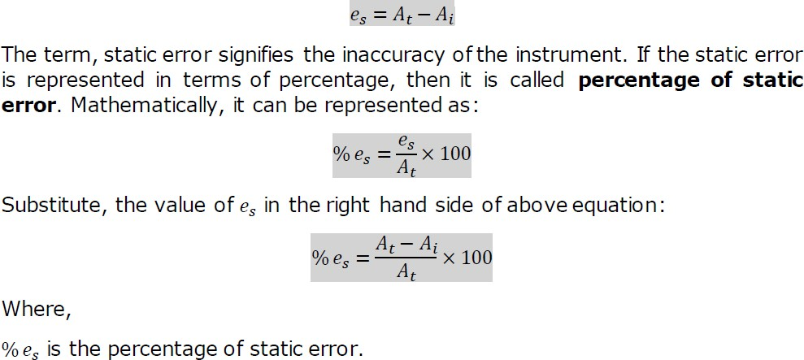

Sensitivity:
The sensitivity is always expressed by the manufacturers as the ratio of the magnitude of quantity being measured to the magnitude of the response. Actually, this definition is the reciprocal of the sensitivity is called inverse sensitivity or deflection factor. But manufacturers call this inverse sensitivity as sensitivity.
Inverse sensitivity = Deflection factor Deflection factor = 1/ sensitivity = 1/S
The units of the sensitivity are millimeter per micro-ampere, millimeter per ohm, counts per volt,
Drift : Gradual shift in the measured value ,over an extended period, when there is no change in input.
Threshold: The minimum value of input for which the device just starts to respond.
Range/Span: The minimum and maximum value of quantity so that the device is capable of measuring.

Repeatability: A measure of how well the output returns to a given value when the same precise input is applied several times. Or The ability of an instrument to reproduce a certain set of reading within a given accuracy.
Linearity: Input output relationship of a device must be linear.
But practical systems shows small deviations from the linear shape ( allowed within the specified limits)
Hysteresis: Input is increased from negative value, output increases as indicated by curve 1
- Then the input is steadily decreased , output does not follow the same path , but lag by a certain value as indicated by curve 2 •
The difference between the two curves is called Hysterisis.
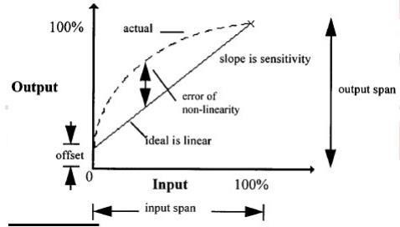

DYNAMIC CHARACTERISTICS:
The response of instruments or systems to dynamic I/P s are also functions of time. Instruments rarely respond instantaneously to changes in the measured variables.
Instead, they exhibit slowness or sluggishness due to such things as mass, thermal capacitance, fluid capacitance or electric capacitance.
- Speed of Response: It is the ability of a system to respond to sudden changes in the input signal/quantity
- Fidelity: It is the degree to which an instrument indicates the changes in the measured variable without dynamic error (Indication of how much faithfully system responds to the changes in input).
Lag: It is the retardation or delay in the response of an instrument to changes in the measured variable. Two types: Process lag(process) and Control lag (Instrument)
Dynamic error:It is the difference between the true value of the variable to be measured, changing with time and the value indicated by the measurement system, assuming zero static error. The Fig. 1.13 shows the dead time, i.e. time delay and the dynamic error.

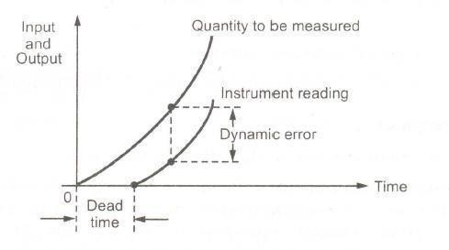
Types of errors:
The static error is defined earlier as the difference between the true value of the variable and the value indicated by the instrument. The static error may arise due to number of reasons. The static errors are classified as:
  - Gross errors
  - Systematic errors
  - Random errors

Gross errors:
The gross errors mainly occur due to carelessness or lack of experience of a human being. These cover human mistakes in readings, recordings and calculating results. These errors also occur due to incorrect adjustments of instruments. These errors cannot be treated mathematically. These errors are also called personal errors. Some gross errors are easily detected while others are very difficult to detect.
The complete elimination of gross errors is not possible, but one can minimize them. Some errors are easily detected while others may be elusive. One of the basic gross errors that occur frequently is the improper use of an instrument. The error can be minimized by taking proper care in reading and recording the measurement parameter.

Systematic errors:
The systematic errors are mainly resulting due to the shortcomings of the instrument and the characteristics of the material used in the instrument, such as defective or worn parts, ageing effects, environmental effects, etc.
A constant uniform deviation of the operation of an instrument is known as a systematic error. There are three types of systematic errors as
1) Instrumental errors 2) Environmental errors 3) Observational errors

Instrumental errors :
These errors are mainly due to following three reasons
- Short-comings of instrument

These are because of the mechanical structure of the instruments eg. Friction in the bearings of various moving parts, irregular spring tensions, hysteresis, gear backlash, variation in air gap etc.
Misuse of instrument A good instrument if used in abnormal way gives misleading results. Poor initial adjustments, Improper zero setting, Using leads of high resistance. Elimination: Use the instrument intelligently & Correctly
- Loading effects Loading effects due to Improper way of using the instrument

Elimination.
- Selecting proper instrument and the transducer for the measurement.
- Recognize the effect of such errors and apply the proper correction factors.
- Calibrate the instrument carefully against standard.
Environmental Errors (due to the External Conditions)
- The various factors : Temperature changes, Pressure, vibrations, Thermal emf., stray capacitance, cross capacitance, effect of External fields, Aging of equipments and Frequency sensitivity of an instrument.
Elimination • Using proper correction factors and using the instrument Catalogue • Using Temperature & Pressure control methods etc. • Reducing the effect of dust, humidity on the components in the instruments. • The effects of external fields can be minimized by using the magnetic or electrostatic shields of screens.

Observational Errors:
Observational errors are errors introduced by the observer. The most common error is the parallax error introduced in reading a meter scale, and the error of estimation when obtaining a reading from a meter scale. These errors are caused by the habits of individual observers. For example, an observer may always introduce an error by consistently holding his head too far to the left while reading a needle and scale reading.
In general, systematic errors can also be subdivided into static and dynamic errors. Static errors are caused by limitations of the measuring device or the physical laws governing its behavior. Dynamic errors are caused by the instrument not responding fast enough to follow the changes in a measured variable

Random errors:
Some errors still result, though the systematic and instrumental errors are reduced or at least accounted for. The causes of such errors are unknown and hence, the errors are called random errors. These errors cannot be determined in the ordinary process of taking the measurements.
These are errors that remain after gross and systematic errors have been substantially reduced or at least accounted for. Random errors are generally an accumulation of a large number of small effects and may be of real concern only in measurements requiring a high degree of accuracy. Such errors can be analyzed statistically.

These errors are due to unknown causes, not determinable in the ordinary process of making measurements. Such errors are normally small and follow the laws of probability. Random errors can thusbe treated mathematically.

Absolute and relative errors:
When the error is specified interms of an absolute quantity and not as a percentage, then it is called an absolute error.
Thus the voltage of 10 ± 0.5 V indicated ± 0.5 V as an absolute error. When the error is expressed as a percentage or as a fraction of the total quantity to be measured, then it is called relative error.

Limiting errors:
The manufacturers specify the accuracy of the instruments within a certain percentage of full scale reading. The components like the resistor, inductor, capacitor are guaranteed to be within a certain percentage of rated value. This percentage indicates the deviations from the nominal or specified value of the particular quantity. These deviations from the specified value are called Limiting Errors. These are also called Guarantee Errors.
Thus the actual value with the limiting error can be expressed mathematically as,Aa = As ± ΔA
Where Aa = Actual value
As= Specified or rated value ΔA= limiting error or tolerance
Relative limiting error:This is also called fractional error. It is the ratio of the error to the specifiedmagnitude of a quantity.

SOURCES OF ERROR
The sources of error, other than the inability of a piece of hardware to provide a true measurement, are asfollows:
- Insufficient knowledge of process parameters and design conditions
- Poor design
- Change in process parameters, irregularities, upsets, etc.
- Poor maintenance
- Errors caused by person operating the instrument or equipment 6. Certain design limitations

MEASURING INSTRUMENTS

Definition of instruments
An instrument is a device in which we can determine the magnitude or value of the quantity to be measured. The measuring quantity can be voltage, current, power and energy etc. Generally instruments are classified in to two categories.

Instrument

Absolute Instrument Secondary Instrument

Absolute instrument
An absolute instrument determines the magnitude of the quantity to be measured in terms of the instrument parameter. This instrument is really used, because each time the value of the measuring quantities varies. So we have to calculate the magnitude of the measuring quantity, analytically which is time consuming. These types of instruments are suitable for laboratory use. Example: Tangent galvanometer.

Secondary instrument
This instrument determines the value of the quantity to be measured directly. Generally these instruments are calibrated by comparing with another standard secondary instrument.
Examples of such instruments are voltmeter, ammeter and wattmeter etc. Practically secondary instruments are suitable for measurement.

Secondary instruments

Indicating instruments Recording Integrating Electromechanically
Indicating instruments

Indicating instrument
This instrument uses a dial and pointer to determine the value of measuring quantity. The pointer indication gives the magnitude of measuring quantity.

Recording instrument
This type of instruments records the magnitude of the quantity to be measured continuously over a specified period of time.

Integrating instrument
This type of instrument gives the total amount of the quantity to be measured over a specified period of time.

Electromechanical indicating instrument
For satisfactory operation electromechanical indicating instrument, three forces are necessary.
They are
- Deflecting force
- Controlling force
- Damping force

Deflecting force
When there is no input signal to the instrument, the pointer will be at its zero position. To deflect the pointer from its zero position, a force is necessary which is known as deflecting force. A system which produces the deflecting force is known as a deflecting system. Generally a deflecting system converts an electrical signal to a mechanical force.
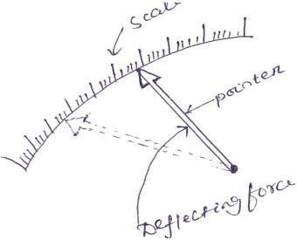

Fig. 1.1 Pointer scale

Magnitude effect
When a current passes through the coil (Fig.1.2), it produces a imaginary bar magnet. When a soft-iron piece is brought near this coil it is magnetized. Depending upon the current direction the poles are produced in such a way that there will be a force of attraction between the coil and the soft iron piece. This principle is used in moving iron attraction type instrument.
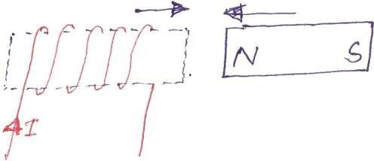
Fig. 1.2

If two soft iron pieces are place near a current carrying coil there will be a force of repulsion between the two soft iron pieces. This principle is utilized in the moving iron repulsion type instrument.

Force between a permanent magnet and a current carrying coil
When a current carrying coil is placed under the influence of magnetic field produced by a permanent magnet and a force is produced between them. This principle is utilized in the moving coil type instrument.
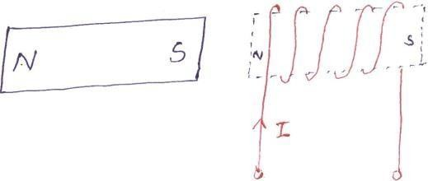
Fig. 1.3

Force between two current carrying coil
When two current carrying coils are placed closer to each other there will be a force of repulsion between them. If one coil is movable and other is fixed, the movable coil will move away from the fixed one. This principle is utilized in electrodynamometer type instrument.

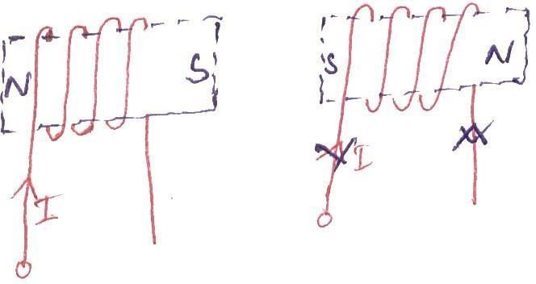
Fig. 1.4

Controlling force
To make the measurement indicated by the pointer definite (constant) a force is necessary which will be acting in the opposite direction to the deflecting force. This force is known as controlling force. A system which produces this force is known as a controlled system. When the external signal to be measured by the instrument is removed, the pointer should return back to the zero position. This is possibly due to the controlling force and the pointer will be indicating a steady value when the deflecting torque is equal to controlling torque.
Td = Tc (1.1)

Spring control
Two springs are attached on either end of spindle (Fig. 1.5).The spindle is placed in jewelled bearing, so that the frictional force between the pivot and spindle will be minimum. Two springs are provided in opposite direction to compensate the temperature error. The spring is made of phosphorous bronze.
When a current is supply, the pointer deflects due to rotation of the spindle. While spindle is rotate, the spring attached with the spindle will oppose the movements of the pointer. The torque produced by the spring is directly proportional to the pointer deflectionθ .
TC ∝ θ (1.2)

The deflecting torque produced T_{d} proportional to ‘I’. When TC = Td , the pointer will come to a steady position. Therefore
θ ∝ I (1.3)

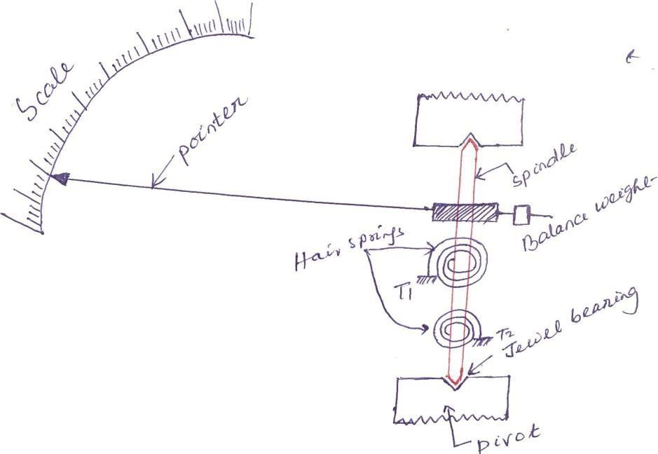

Fig. 1.5

Since, θ and I are directly proportional to the scale of such instrument which uses spring controlled is uniform.

Damping force
The deflection torque and controlling torque produced by systems are electro mechanical. Due to inertia produced by this system, the pointer oscillates about it final steady position before coming to rest. The time required to take the measurement is more. To damp out the oscillation is quickly, a damping force is necessary. This force is produced by different systems.
- Air friction damping
- Fluid friction damping
- Eddy current damping

Air friction damping
The piston is mechanically connected to a spindle through the connecting rod (Fig. 1.6). The pointer is fixed to the spindle moves over a calibrated dial. When the pointer oscillates in clockwise direction, the piston goes inside and the cylinder gets compressed. The air pushes the piston upwards and the pointer tends to move in anticlockwise direction.

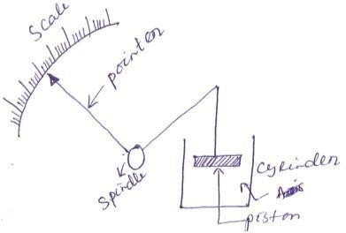

Fig. 1.6

If the pointer oscillates in anticlockwise direction the piston moves away and the pressure of the air inside cylinder gets reduced. The external pressure is more than that of the internal pressure. Therefore the piston moves down wards. The pointer tends to move in clock wise direction.

Eddy current damping
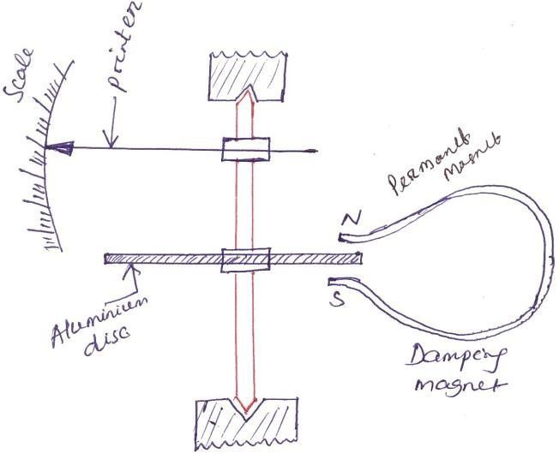
Fig. 1.6 Disc type

An aluminum circular disc is fixed to the spindle (Fig. 1.6). This disc is made to move in the magnetic field produced by a permanent magnet.

When the disc oscillates it cuts the magnetic flux produced by damping magnet. An emf is induced in the circular disc by faradays law. Eddy currents are established in the disc since it has several closed paths. By Lenz’s law, the current carrying disc produced a force in a direction opposite to oscillating force. The damping force can be varied by varying the projection of the magnet over the circular disc.
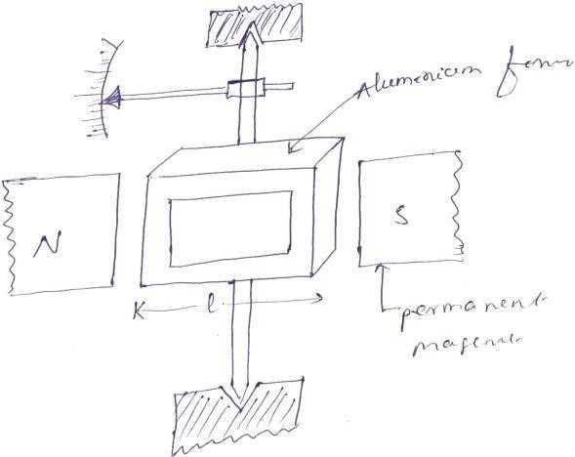
Fig. 1.6 Rectangular type

Permanent Magnet Moving Coil (PMMC) instrument
One of the most accurate type of instrument used for D.C. measurements is PMMC instrument. Construction: A permanent magnet is used in this type instrument. Aluminum former is provided in the cylindrical in between two poles of the permanent magnet (Fig. 1.7). Coils are wound on the aluminum former which is connected with the spindle. This spindle is supported with jeweled bearing. Two springs are attached on either end of the spindle. The terminals of the moving coils are connected to the spring. Therefore the current flows through spring 1, moving coil and spring 2.
Damping: Eddy current damping is used. This is produced by aluminum former. Control: Spring control is used.

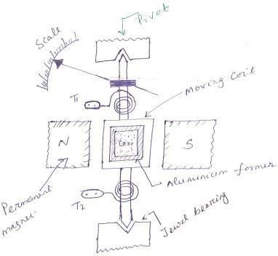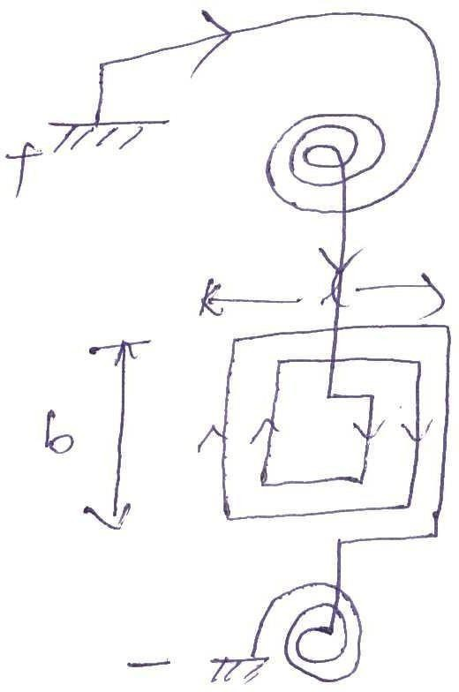
Fig. 1.7

Principle of operation
When D.C. supply is given to the moving coil, D.C. current flows through it. When the current carrying coil is kept in the magnetic field, it experiences a force. This force produces a torque and the former rotates. The pointer is attached with the spindle. When the former rotates, the pointer moves over the calibrated scale. When the polarity is reversed a torque is produced in the opposite direction. The mechanical stopper does not allow the deflection in the opposite direction. Therefore the polarity should be maintained with PMMC instrument.
If A.C. is supplied, a reversing torque is produced. This cannot produce a continuous deflection. Therefore this instrument cannot be used in A.C.

Torque developed by PMMC

Let Td =deflecting torque
TC = controlling torque
θ = angle of deflection K=spring constant b=width of the coil

l=height of the coil or length of coil N=No. of turns
I=current B=Flux density
A=area of the coil
The force produced in the coil is given by
F = BIL sin θ
When θ = 90°

(1.4)

For N turns, F = NBIL (1.5)
Torque produced Td = F× ⊥r distance (1.6)
Td = NBIL× b = BINA (1.7)

Td = BANI
Td ∝ I

Advantages
- Torque/weight is high
- Power consumption is less
- Scale is uniform
- Damping is very effective
- Since operating field is very strong, the effect of stray field is negligible
- Range of instrument can be extended

Disadvantages
- Use only for D.C.
- Cost is high
- Error is produced due to ageing effect of PMMC
- Friction and temperature error are present

Moving Iron (MI) instruments
One of the most accurate instrument used for both AC and DC measurement is moving iron instrument. There are two types of moving iron instrument.
  - Attraction type
  - Repulsion type

Attraction type M.I. instrument
Construction:The moving iron fixed to the spindle is kept near the hollow fixed coil (Fig. 1.10). The pointer and balance weight are attached to the spindle, which is supported with jeweled bearing. Here air friction damping is used.

Principle of operation
The current to be measured is passed through the fixed coil. As the current is flow through the fixed coil, a magnetic field is produced. By magnetic induction the moving iron gets magnetized. The north pole of moving coil is attracted by the south pole of fixed coil. Thus the deflecting force is produced due to force of attraction. Since the moving iron is attached with the spindle, the spindle rotates and the pointer moves over the calibrated scale. But the force of attraction depends on the current flowing through the coil.

Torque developed by M.I
Let ‘θ ’ be the deflection corresponding to a current of ‘i’ amp
Let the current increases by di, the corresponding deflection is ‘θ + dθ ’

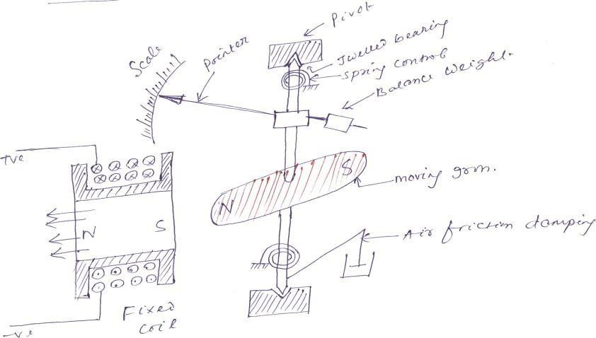

Fig. 1.10
There is change in inductance since the position of moving iron change w.r.t the fixed electromagnets.
Let the new inductance value be ‘L+dL’. The current change by ‘di’ is dt seconds. Let the emf induced in the coil be ‘e’ volt.
e = d (Li) = L di + i dL (1.22)
dt dt dt
Multiplying by ‘idt’ in equation (1.22)
e × idt = L di × idt + i dL × idt (1.23)
dt dt
e × idt = Lidi + i2dL (1.24)

Eq^{n} (1.24) gives the energy is used in to two forms. Part of energy is stored in the inductance. Remaining energy is converted in to mechanical energy which produces deflection.

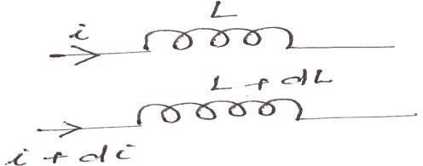
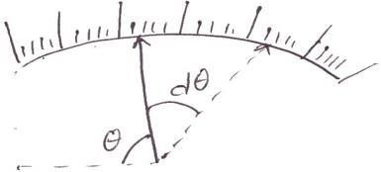
Fig. 1.11

Change in energy stored=Final energy-initial energy stored
= 1 (L + dL)(i + di)2 − 1 Li2

2 2
= 1 {(L + dL)(i2 + di2 + 2idi) − Li2} 2
= 1 {(L + dL)(i2 + 2idi) − Li2} 2
= 1 {Li2 + 2Lidi + i2dL + 2ididL − Li2} 2
= 1 {2Lidi + i2dL} 2
= Lidi + 1 i2dL

2
Mechanical work to move the pointer by dθ
= Td dθ
By law of conservation of energy,
Electrical energy supplied=Increase in stored energy+ mechanical work done.
Input energy= Energy stored + Mechanical energy
Lidi + i2dL = Lidi + 1 i2dL + Td dθ
2
1 i2dL = Td dθ
2

(1.25)

(1.26)

(1.27)

(1.28)

T = 1 i2 dL (1.29)
d 2 dθ

At steady state condition Td 1 i2 dL = Kθ
2 dθ
= TC

(1.30)

θ = 1 i2 dL (1.31)
2Kdθ
θ ∝ i² (1.32)
When the instruments measure AC, θ ∝ i²rms
Scale of the instrument is non uniform.

Advantages
- MI can be used in AC and DC
- It is cheap
- Supply is given to a fixed coil, not in moving coil.
- Simple construction
- Less friction error.

Disadvantages
- It suffers from eddy current and hysteresis error
- Scale is not uniform
- It consumed more power
- Calibration is different for AC and DC operation

Repulsion type moving iron instrument
Construction:The repulsion type instrument has a hollow fixed iron attached to it (Fig. 1.12). The moving iron is connected to the spindle. The pointer is also attached to the spindle in supported with jeweled bearing.
Principle of operation: When the current flows through the coil, a magnetic field is produced by it. So both fixed iron and moving iron are magnetized with the same polarity, since they are kept in the same magnetic field. Similar poles of fixed and moving iron get repelled. Thus the deflecting torque is produced due to magnetic repulsion. Since moving iron is attached to spindle, the spindle will move. So that pointer moves over the calibrated scale.
Damping: Air friction damping is used to reduce the oscillation. Control: Spring control is used.

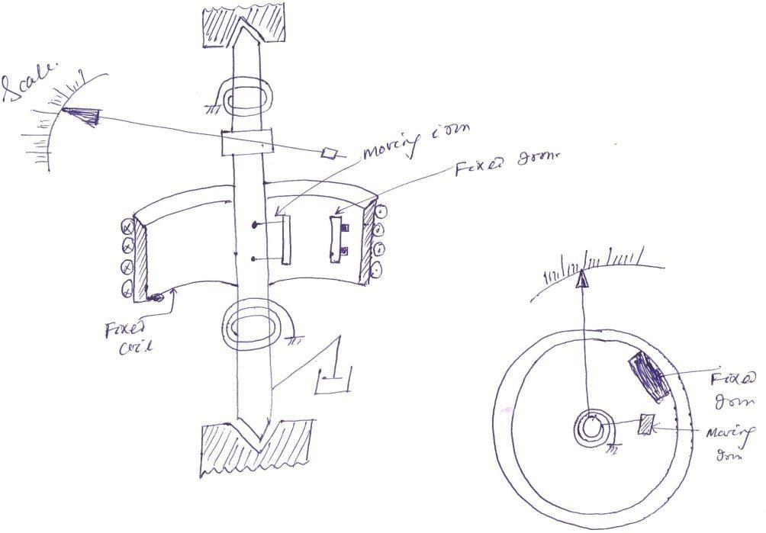

Errors in PMMC
- The permanent magnet produced error due to ageing effect. By heat treatment, this error can be eliminated.
- The spring produces error due to ageing effect. By heat treating the spring the error can be eliminated.
- When the temperature changes, the resistance of the coil vary and the spring also produces error in deflection. This error can be minimized by using a spring whose temperature co-efficient is very low.

Difference between attraction and repulsion type instrument
An attraction type instrument will usually have a lower inductance, compare to repulsion type instrument. But in other hand, repulsion type instruments are more suitable for economical production in manufacture and nearly uniform scale is more easily obtained. They are therefore much more common than attraction type.

Error in M.I instrument Temperature error
Due to temperature variation, the resistance of the coil varies. This affects the deflection of the
instrument. The coil should be made of manganin, so that the resistance is almost constant.

Hysteresis error
Due to hysteresis affect the reading of the instrument will not be correct. When the current is decreasing, the flux produced will not decrease suddenly. Due to this the meter reads a higher value of current. Similarly when the current increases the meter reads a lower value of current. This produces error in deflection. This error can be eliminated using small iron parts with narrow hysteresis loop so that the demagnetization takes place very quickly.

Eddy current error
The eddy currents induced in the moving iron affect the deflection. This error can be reduced by increasing the resistance of the iron.

Stray field error
Since the operating field is weak, the effect of stray field is more. Due to this, error is producedin deflection. This can be eliminated by shielding the parts of the instrument.

Basic principle of operation of DC Ammeter:
Current is the rate of flow of electric charge. If this electric charge flows only in one direction, then the resultant current is called Direct Current (DC). The instrument, which is used to measure the Direct Current called DC ammeter.
If we place a resistor in parallel with the Permanent Magnet Moving Coil (PMMC) galvanometer, then the entire combination acts as DC ammeter. The parallel resistance, which is used in DC ammeter is also called shunt resistance or simply, shunt. The value of this resistance should be considered small in order to measure the DC current of large value.
The circuit diagram of DC ammeter is shown in below figure.

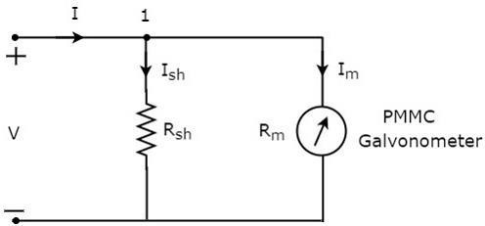
We have to place this DC ammeter in series with the branch of an electric circuit, where the DC current is to be measured.
the voltage across the elements, which are connected in parallel is same. So, the voltage across shunt resistor, 𝑅𝑠ℎ and the voltage across galvanometer resistance, 𝑅𝑚 is same, since those two elements are connected in parallel in above circuit.
Mathematically, it can be written as 𝐼𝑠ℎ𝑅𝑠ℎ=𝐼𝑚𝑅𝑚

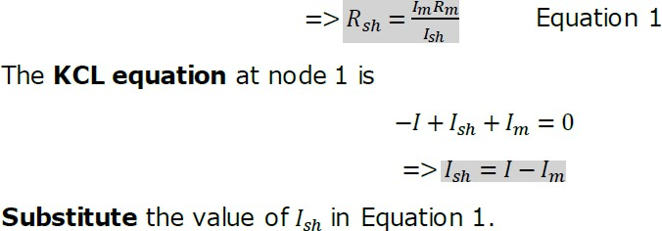

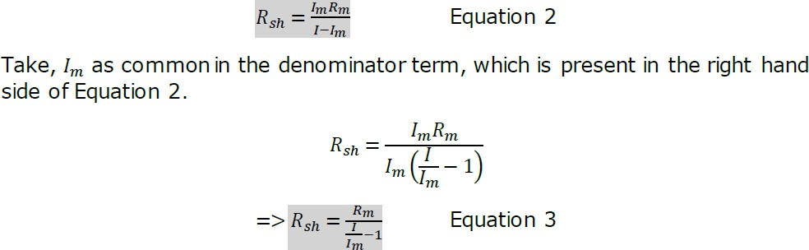

Where,
𝑅𝑠ℎ is the shunt resistance
𝑅𝑚 is the internal resistance of galvanometer
𝐼 is the total Direct Current that is to be measured
𝐼𝑚 is the full scale deflection current
The ratio of total Direct Current that is to be measured, I and the full scale deflection current of the galvanometer, 𝐼𝑚 is known as multiplying factor, m. Mathematically, it can be represented as
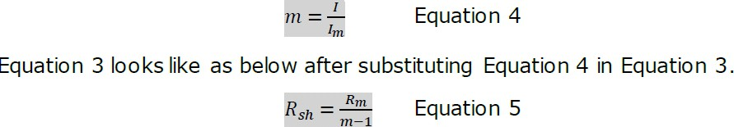
We can find the value of shunt resistance by using either Equation 2 or Equation 5 based on the available data.

Multi Range DC Ammeter:
In previous section, we discussed about DC ammeter which is obtained by placing a resistor in parallel with the PMMC galvanometer. This DC ammeter can be used to measure a particular range of Direct Currents.

If we want to use the DC ammeter for measuring the Direct Currents of multiple ranges, then we have to use multiple parallel resistors instead of single resistor and this entire combination of resistors is in parallel to the PMMC galvanometer. The circuit diagram of multi range DC ammeter is shown in below figure.
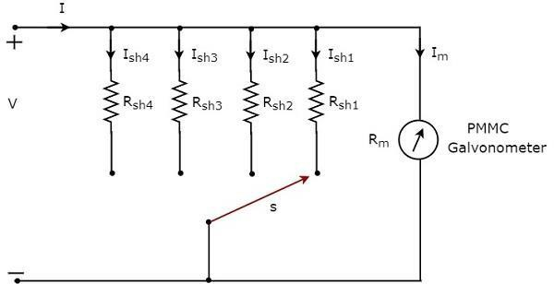
Place this multi range DC ammeter in series with the branch of an electric circuit, where the Direct Current of required range is to be measured. The desired range of currents is chosen by connecting the switch, s to the respective shunt resistor.
Let, 𝑚1, 𝑚2, 𝑚3 and 𝑚4 are the multiplying factors of DC ammeter when we consider the total Direct Currents to be measured as, 𝐼1, 𝐼2, 𝐼3 and 𝐼4 respectively. Following are the formulae corresponding to each multiplying factor.
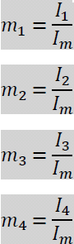
In above circuit, there are four shunt resistors, 𝑅𝑠ℎ1, 𝑅𝑠ℎ2, 𝑅𝑠ℎ3 and 𝑅𝑠ℎ4. Following are the formulae corresponding to these four resistors.

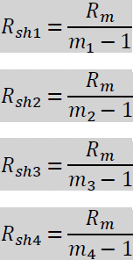
The above formulae will help us find the resistance values of each shunt resistor.

Basic principle of operation of AC Ammeter:
Current is the rate of flow of electric charge. If the direction of this electric charge changes regularly, then the resultant current is called Alternating Current (AC).
The instrument, which is used to measure the Alternating Current that flows through any branch of electric circuit is called AC ammeter.
Example: Thermocouple type AC ammeter
Now, let us discuss about Thermocouple type AC ammeter.

Thermocouple Type AC Ammeter:
If a Thermocouple is connected ahead of PMMC galvanometer, then that entire combination is called thermocouple type AC ammeter. The block diagram of thermocouple type AC ammeter is shown in below figure.
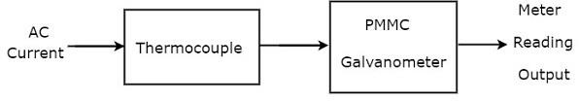
The above block diagram consists of mainly two blocks: a thermocouple, and a PMMC galvanometer. We will get the corresponding circuit diagram, just by replacing each block with the respective component(s) in above block diagram. So, the circuit diagram of thermocouple type AC ammeter will look like as shown in below figure.

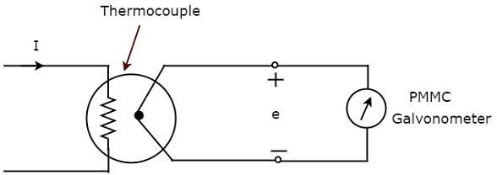

Thermocouple generates an EMF, e, whenever the Alternating Current, I flows through heater element. This EMF, e is directly proportional to the rms value of the current, I that is flowing through heater element. So, we have to calibrate the scale of PMMC instrument to read rms values of current.
So, with this chapter we have completed all basic measuring instruments such as DC voltmeters, AC voltmeters, DC ammeters and AC ammeters. In next chapter, let us discuss about the meters or measuring instruments, which measure resistance value

Basic principle of operation of DC Voltmeter:
DC voltmeter is a measuring instrument, which is used to measure the DC voltage across any two points of electric circuit. If we place a resistor in series with the Permanent Magnet Moving Coil (PMMC) galvanometer, then the entire combination together acts as DC voltmeter.
The series resistance, which is used in DC voltmeter is also called series multiplier resistance or simply, multiplier. It basically limits the amount of current that flows through galvanometer in order to prevent the meter current from exceeding the full scale deflection value. The circuit diagram of DC voltmeter is shown in below figure.
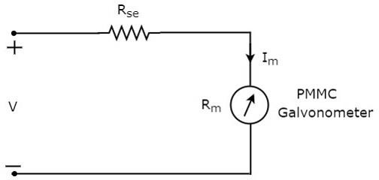

We have to place this DC voltmeter across the two points of an electric circuit, where the DC voltage is to be measured.
Apply KVL around the loop of above circuit.

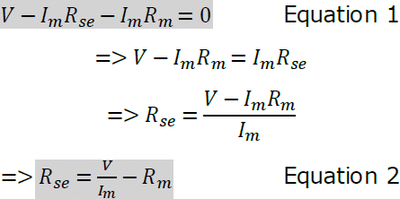
Where,
𝑅𝑠𝑒 is the series multiplier resistance
𝑉 is the full range DC voltage that is to be measured
𝐼𝑚 is the full scale deflection current
𝑅𝑚 is the internal resistance of galvanometer
The ratio of full range DC voltage that is to be measured, V and the DC voltage drop across the galvanometer, 𝑉𝑚 is known as multiplying factor, m.
Mathematically, it can be represented as
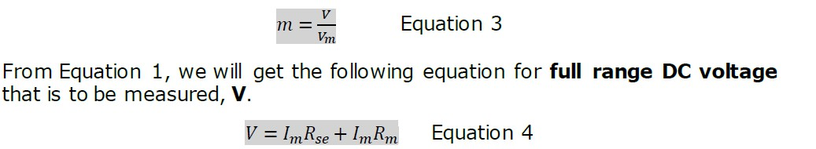
The DC voltage drop across the galvanometer, 𝑽𝒎 is the product of full scale deflection current, 𝐼𝑚 and internal resistance of galvanometer, 𝑅𝑚. Mathematically, it can be written as
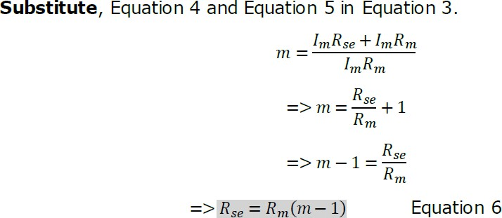
𝑉𝑚=𝐼𝑚𝑅𝑚 Equation 5

We can find the value of series multiplier resistance by using either Equation 2 or Equation 6 based on the available data.

Multi Range DC Voltmeter:
In previous section, we had discussed DC voltmeter, which is obtained by placing a multiplier resistor in series with the PMMC galvanometer. This DC voltmeter can be used to measure a particular range of DC voltages.

If we want to use the DC voltmeter for measuring the DC voltages of multiple ranges, then we have to use multiple parallel multiplier resistors instead of single multiplier resistor and this entire combination of resistors is in series with the PMMC galvanometer. The circuit diagram of multi range DC voltmeter is shown in below figure
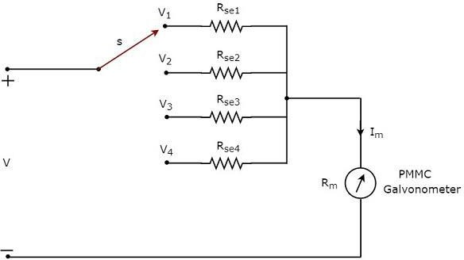
We have to place this multi range DC voltmeter across the two points of an electric circuit, where the DC voltage of required range is to be measured. We can choose the desired range of voltages by connecting the switch s to the respective multiplier resistor.
Let, 𝑚1, 𝑚2, 𝑚3 and 𝑚4 are the multiplying factors of DC voltmeter when we consider the full range DC voltages to be measured as, 𝑉1, 𝑉2, 𝑉3 and 𝑉4 respectively. Following are the formulae corresponding to each multiplying factor.
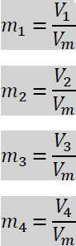
In above circuit, there are four series multiplier resistors, 𝑅𝑠𝑒1, 𝑅𝑠𝑒2, 𝑅𝑠𝑒3 and 𝑅𝑠𝑒4. Following are the formulae corresponding to these four resistors.

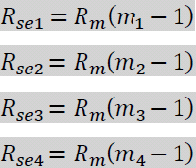
So, we can find the resistance values of each series multiplier resistor by using above formulae.

Basic principle of operation of AC Voltmeter :
The instrument, which is used to measure the AC voltage across any two points of electric circuit is called AC voltmeter. If the AC voltmeter consists of rectifier, then it is said to be rectifier based AC voltmeter. The DC voltmeter measures only DC voltages. If we want to use it for measuring AC voltages, then we have to follow these two steps.

- Step1: Convert the AC voltage signal into a DC voltage signal by using a rectifier.

Step2: Measure the DC or average value of the rectifier’s output signal.
We get Rectifier based AC voltmeter, just by including the rectifier circuit to the basic DC voltmeter. This chapter deals about rectifier based AC voltmeters.

Types of Rectifier based AC Voltmeters:
Following are the two types of rectifier based AC voltmeters.
  - AC voltmeter using Half Wave Rectifier
  - AC voltmeter using Full Wave Rectifier
Now, let us discuss about these two AC voltmeters one by one.

AC Voltmeter using Half Wave Rectifier:
If a Half wave rectifier is connected ahead of DC voltmeter, then that entire combination together is called AC voltmeter using Half wave rectifier. The block diagram of AC voltmeter using Half wave rectifier is shown in below figure.
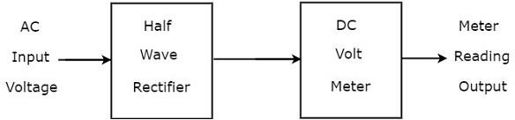

The above block diagram consists of two blocks: half wave rectifier and DC voltmeter. We will get the corresponding circuit diagram, just by replacing each block with the respective component(s) in above block diagram. So, the circuit diagram of AC voltmeter using Half wave rectifier will look like as shown in below figure.

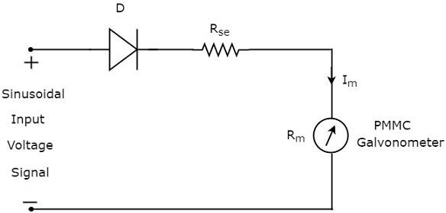
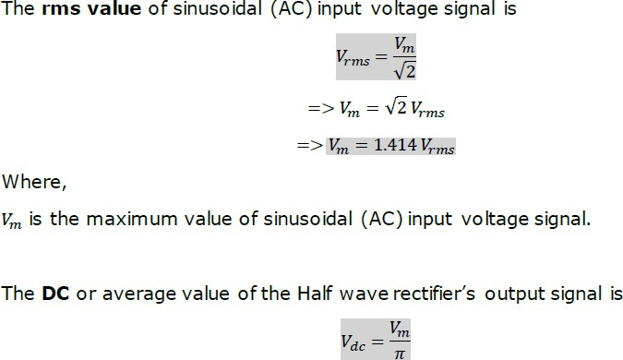
Substitute, the value of 𝑉𝑚 in above equation.
𝑉𝑑𝑐=1.414 𝑉𝑟𝑚𝑠/𝜋 𝑉𝑑𝑐=0.45 𝑉𝑟𝑚𝑠
Therefore, the AC voltmeter produces an output voltage, which is equal to 0.45 times the rms value of the sinusoidal (AC) input voltage signal.

AC Voltmeter using Full Wave Rectifier:
If a Full wave rectifier is connected ahead of DC voltmeter, then that entire combination together is called AC voltmeter using Full wave rectifier. The block diagram of AC voltmeter using Full wave rectifier is shown in below figure.

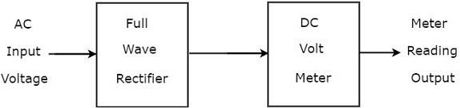

The above block diagram consists of two blocks: full wave rectifier and DC voltmeter. We will get the corresponding circuit diagram just by replacing each block with the respective component(s) in above block diagram.
So, the circuit diagram of AC voltmeter using Full wave rectifier will look like as shown in below figure.
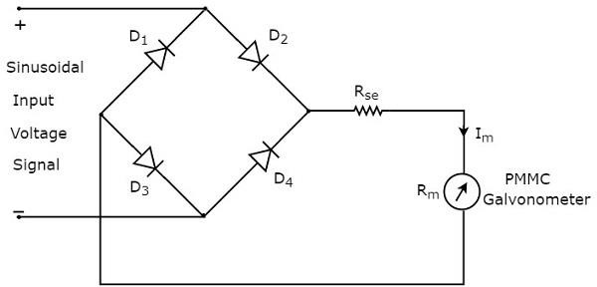
The rms value of sinusoidal (AC) input voltage signal is
𝑉𝑟𝑚𝑠=𝑉𝑚/√2
=>𝑉𝑚=√2 𝑉𝑟𝑚𝑠
=>𝑉𝑚=1.414 𝑉𝑟𝑚𝑠
Where,
𝑉𝑚 is the maximum value of sinusoidal (AC) input voltage signal.
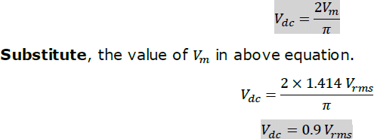
The DC or average value of the Full wave rectifier’s output signal is

Therefore, the AC voltmeter produces an output voltage, which is equal to 0.9 times the rms value of the sinusoidal (AC) input voltage signal.

Basic principle of Ohm Meter:
The instrument, which is used to measure the value of resistance between any two points in an electric circuit is called ohmmeter. It can also be used to find the value of an unknown resistor. The units of resistance are ohm and the measuring instrument is meter. So, the word “ohmmeter” is obtained by combining the words “ohm” and “meter”.

Types of Ohmmeters:
Following are the two types of ohmmeters.
- Series Ohmmeter
- Shunt Ohmmeter
Now, let us discuss about these two types of ohmmeters one by one.

Series Ohmmeter:
If the resistor’s value is unknown and has to be measured by placing it in series with the ohmmeter, then that ohmmeter is called series ohmmeter. The circuit diagram of series ohmmeter is shown in below figure.
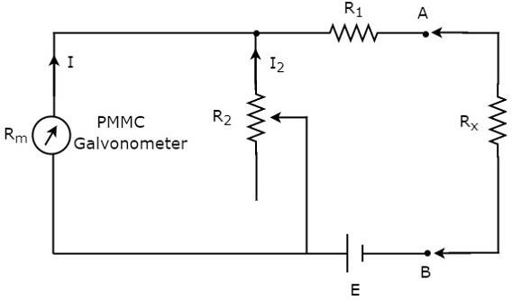
The part of the circuit, which is left side of the terminals A & B is series ohmmeter. So, we can measure the value of unknown resistance by placing it to the right side of terminals A & B. Now, let us discuss about the calibration scale of series ohmmeter.

- If 𝑅𝑥=0 𝛺, then the terminals A & B will be short circuited with each other. So, the meter current gets divided between the resistors, 𝑅1 and 𝑅2. Now, vary the value of resistor, 𝑅2 in such a way that the entire meter current flows through the resistor, 𝑅1 only. In this case, the meter shows full scale deflection current. Hence, this full scale deflection current of the meter can be represented as 𝟎 𝜴.

- If 𝑅𝑥=∞ 𝛺, then the terminals A & B will be open circuited with each other. So, no current flows through resistor, 𝑅1. In this case, the meter shows null deflection current. Hence, this null deflection of the meter can be represented as ∞ 𝜴.

- In this way, by considering different values of 𝑅𝑥, the meter shows different deflections. So, accordingly we can represent those deflections with the corresponding resistance value.
The series ohmmeter consists of a calibration scale. It has the indications of 0 𝛺 and ∞ 𝛺 at the end points
of right hand and left hand of the scale respectively. Series ohmmeter is useful for measuring high values of resistances.

Shunt Ohmmeter:
If the resistor’s value is unknown and to be measured by placing it in parallel (shunt) with the ohmmeter, then that ohmmeter is called shunt ohmmeter. The circuit diagram of shunt ohmmeter is shown in below figure.
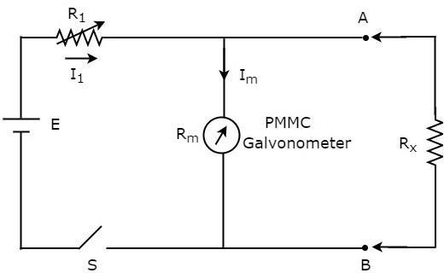
The part of the circuit, which is left side of the terminals A & B is shunt ohmmeter. So, we can measure the value of unknown resistance by placing it to the right side of terminals A & B.
Now, let us discuss about the calibration scale of shunt ohmmeter. Close the switch, S of above circuit while it is in use.

- If 𝑅𝑥=0 𝛺, then the terminals A & B will be short circuited with each other. Due to this, the entire current, 𝐼1 flows through the terminals A & B. In this case, no current flows through PMMC galvanometer. Hence, the null deflection of the PMMC galvanometer can be represented as 𝟎 𝜴.

- If 𝑅𝑥=∞ 𝛺, then the terminals A & B will be open circuited with each other. So, no current flows through the terminals A & B. In this case, the entire current, 𝐼1 flows through PMMC galvanometer. If required vary (adjust) the value of resistor, 𝑅1 until the PMMC galvanometer shows full scale deflection current. Hence, this full scale deflection current of the PMMC galvanometer can be represented as ∞ 𝜴.

- In this way, by considering different values of 𝑅𝑥, the meter shows different deflections. So, accordingly we can represent those deflections with the corresponding resistance values.
The shunt ohmmeter consists of a calibration scale. It has the indications of 0 𝛺 and
∞ 𝛺 at the end points of left hand and right hand of the scale respectively.
Shunt ohmmeter is useful for measuring low values of resistances. So, we can use either series ohmmeter or shunt ohmmeter based on the values of resistances that are to be measured i.e., high or low.

Basic principle of Analog Multimeter, its types & applications:
In previous chapters, we discussed about voltmeters, ammeters and ohmmeters. These measuring instruments are used to measure voltage, current and resistance respectively. That means, we have separate measuring instruments for measuring voltage, current and resistance.
Suppose, if a single measuring instrument can be used to measure the quantities such as voltage, current & resistance one at a time, then it is said to be multimeter. It has got the name multimeter, since it can measure multiple electrical quantities one at a time.

Measurements by using Multimeter:
Multimeter is an instrument used to measure DC & AC voltages, DC & AC currents and resistances of several ranges. It is also called Electronic Multimeter or Voltage Ohm Meter (VOM).

DC voltage Measurement:
The part of the circuit diagram of Multimeter, which can be used to measure DC voltage is shown in below figure.
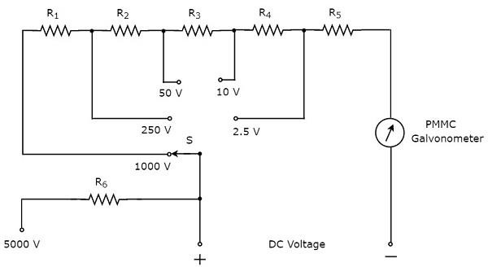
The above circuit looks like a multi range DC voltmeter. The combination of a resistor in series with PMMC galvanometer is a DC voltmeter. So, it can be used to measure DC voltages up to certain value. We can increase the range of DC voltages that can be measured with the same DC voltmeter by increasing the resistance value. the equivalent resistance value increases, when we connect the resistors are in series.
In above circuit, we can measure the DC voltages up to 2.5V by using the combination of resistor, 𝑅5 in series with PMMC galvanometer. By connecting a resistor, 𝑅4 in series with the previous circuit, we can measure the DC voltages up to 10V. In this way, we can increase the range of DC voltages, simply by connecting a resistor in series with the previous (earlier) circuit.
We can measure the DC voltage across any two points of an electric circuit, by connecting the switch, S to the desired voltage range.

DC Current Measurement:
The part of the circuit diagram of Multimeter, which can be used to measure DC current is shown in below figure.

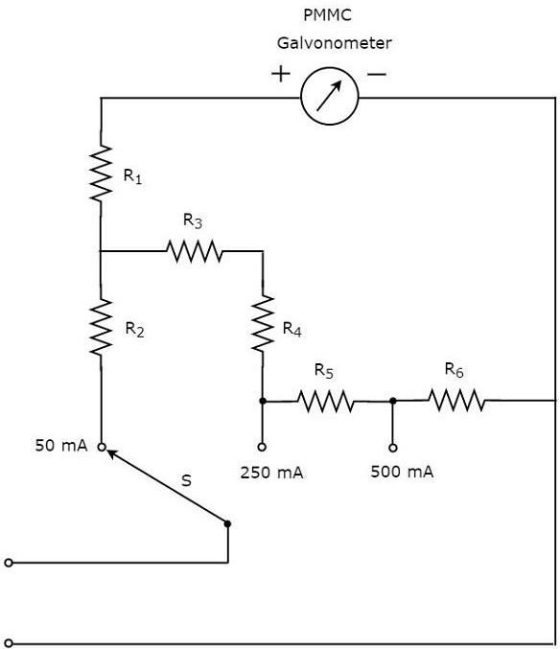

The above circuit looks like a multi range DC ammeter. the combination of a resistor in parallel with PMMC galvanometer is a DC ammeter. So, it can be used to measure DC currents up to certain value. We can get different ranges of DC currents measured with the same DC ammeter by placing the resistors in parallel with previous resistor. In above circuit, the resistor, 𝑅1 is connected in series with the PMMC galvanometer in order to prevent the meter gets damaged due to large current.
We can measure the DC current that is flowing through any two points of an electric circuit, by connecting the switch, S to the desired current range.

AC voltage Measurement:
The part of the circuit diagram of Multimeter, which can be used to measure AC voltage is shown in below figure.

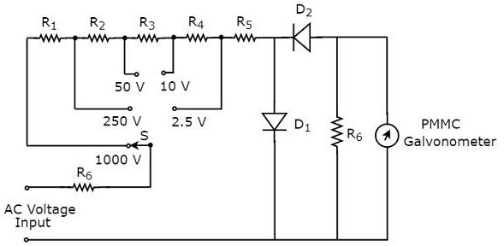

The above circuit looks like a multi range AC voltmeter. We know that, we will get AC voltmeter just by placing rectifier in series (cascade) with DC voltmeter. The above circuit was created just by placing the diodes combination and resistor, 𝑅6 in between resistor, 𝑅5 and PMMC galvanometer.
We can measure the AC voltage across any two points of an electric circuit, by connecting the switch, S to the desired voltage range.

Resistance Measurement:
The part of the circuit diagram of Multimeter, which can be used to measure resistance is shown in below figure.

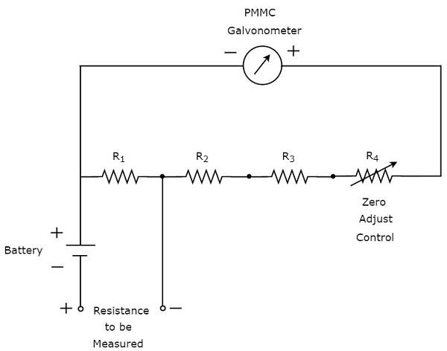
We have to do the following two tasks before taking any measurement

Short circuit the instrument

- Vary the zero adjust control until the meter shows full scale current. That means, meter indicates zero resistance value.
Now, the above circuit behaves as shunt ohmmeter and has the scale multiplication of 1, i.e. 100. We can also consider higher order powers of 10 as the scale multiplications for measuring high resistances.

