

LECTURE NOTES
ON
THERMAL ENGINEERING –II

Compiled By

ER. PABITRA PRASAD PANI

DEPARTMENT OF MECHANICAL ENGINEERING
4TH SEMESTER
RKCAT POLYTECHNIC,NILGIRI,BALASORE

THERMAL ENGINEERING-II
4TH SEMESTER – MECHANICAL ENGINEERING

CONTENT

Chapter  ID | Chapter Name | Page No
1 | Performance Of I.C Engine | 3-7
2 | Air Compressor | 8-15
3 | Properties Of Steam | 16-29
4 | Steam Generator | 30-38
5 | Steam Power Cycle | 39-44
6 | Heat Transfer | 45-52

PERFORMANCE OF I.C ENGINE

Indicated Power:
- It is defined as the rate of work done on the piston by the combustion of charge inside
the engine cylinder.
- It is determined from an indicated diagram obtained from the engine. It is also called
as gross power produced by the engine.
Mathematically: | Indicated power = indicated mean effective pressure × swept volume rate
 | I.P = Pm LAnk  60 | (in watt)
Where: | Pm = mean effective pressure | (in N/m²)
 | L = stroke length | (in m)
 | A = cross sectional area of the cylinder of bore diameter d =  π d 2  4 | (in m²)
n = number of working strokes per minute
= N (for 2 stroke engine)
= N/2 (for 4 stroke engine)
 | k = number of cylinders

Brake Power:
- It is the net power available at the engine shaft.
- It is measured by brake and dynamometer.
Mathematically: | Brake power = brake load (F) × velocity of brake drum ( 2π R N )  60
 | B.P = 2πRNF = 2πNT  60 60 | (in watt)
Where: | F = breaking force | (in N)
 | R = effective radius of brake drum = ½ (D + d) | (in m)
 | D = diameter of brake drum | (in m)
 | d = diameter of rope | (in m)
 | T = F.R = torque | (in N-m)
 | N = speed of the engine shaft in r.p.m | (in r.p.m)

Frictional Power:
- It is the net power available at the engine shaft. It is the part of indicated power which is used to overcome the frictional effects within the engine.
Mathematically: | Frictional Power (F.P) = I.P – B.P

Fuel Consumption:
- It is the mass flow rate of fuel consumed by the engine cylinder.
- It is calculated as the mass of fuel consumed per hour.
Mathematically: | mass flowrate of fuel (m˙ ) = Vf × ρ f × 3600  ^{f} Δt | (in kg/h)
Where: | Vf = volume of fuel used in time Δt | (in m³)
 | ρ f = density of fuel | (in kg/m³)
 | Δt = time taken | (in sec)

Specific Fuel Consumption:
- It is defined as the ratio of mass of fuel consumed per hour per unit power output.
- It can be calculated in terms of brake and indicated power.
- The ratio of mass of fuel consumed per hour per unit brake power produced is called as brake specific fuel consumption (B.s.f.c) and the ratio of mass of fuel consumed per hour per unit indicated power produced is called as indicated specific fuel
consumption (I.s.f.c).
Mathematically: | B.s. f .c = m˙ f  B.P | (in kg/kWh)
 | I.s. f .c = m˙ f  I.P | (in kg/kWh)

Air Fuel Ratio:
- It is the ratio between the mass of air and mass of the fuel supplied to the engine.
- It lies between 12-19 for petrol engine and 20-60 for diesel engine.
Mathematically: | A / F = m˙ a  m˙ f | (unit less)
Where: | m˙a = mass flow rate of air, m˙ f = mass flow rate of fuel

Air Consumption:
- It is the mass flow rate of air consumed by the engine cylinder.
- It is calculated as the mass of air consumed per hour.
Mathematically: | m˙ a = ρa ×V˙  a | (in kg/h)
Where: | m˙a = mass flow rate of air | (in kg/h)
 | ρ_{a} = density of air | (in kg/m³)
 | V˙ = volume flow rate of air = π × d ² × C × 2gh  a 4 0 d | (in m³/sec)
 | do = diameter of orifice | (in m)
 | Cd = coefficient of discharge | (unit less)
 | h = head of air | (in m)

Brake thermal efficiency:
- It is defined as the ratio of brake power to the heat supply rate.
Mathematically: | η = B.P  ^{bth} m˙ × C.V  f | measured in %
Where: | m˙ f = mass flow rate of fuel | (in kg/s)
 | C.V = calorific value of fuel | (in kJ/kg)

Indicated thermal efficiency:
- It is defined as the ratio of indicated power to the heat supply rate.
Mathematically: | η = I.P  ^{ith} m˙ × C.V  f | measured in %
Where: | m˙ f = mass flow rate of fuel | (in kg/s)
 | C.V = calorific value of fuel | (in kJ/kg)

Mechanical thermal efficiency:
- It is defined as the ratio of brake power to the indicated power.
Mathematically: | η = B.P = ηbth mechanical I.P η  ith | measured in %

Relative thermal efficiency:
- It is defined as the ratio of actual thermal efficiency to the air standard efficiency.
Mathematically: | η = Actualthermalefficiency  ^{relative} Air st andard efficiency | measured in %

Volumetric efficiency:
- It is defined as the ratio of mass of the actual charge flow into the cylinder to the mass
of charge corresponding to the swept volume.
Mathematically: | η | = actual mass flowrate of char ge density × swept volume per sec. | = | ρ | a | × | m˙ a  π ₂ | × | n  60 | measured in %
- It is also defined as the ratio of volume of the charge supplied into the cylinder measured at NTP to the swept volume of the cylinder.
Mathematically: | η | = Vactual V
Where: | Vactual = actual volume of charge flow into the cylinder |  |  |  |  |  |  |  |  | (in m³)
 | Vswept = swept volume |  |  |  |  |  |  |  |  | (in m³)

PROBLEM

Q.1) | A rope brake dynamometer was used to measure the brake power of a single cylinder, 4-stroke cycle petrol engine. It was found that the torque due to brake load was 175 N-m and the engine makes 500 rpm. Determine the brake power developed by the engine. (Ans: 9.16 kN)
Q.2) | A four cylinder, four stroke petrol engine develops indicated power of 14.7 kW at 1000 rpm. The mean effective pressure is 5.5 bar. Calculate the bore and stroke of the engine if the stroke is 1.5 times the bore. (Ans: 87.96 mm, 131.94 mm)
Q.3) | A four cylinder two stroke cycle petrol engine develops 30 kW at 2500 rpm. The mean effective pressure on each piston is 8 bar and mechanical efficiency is 80%. Calculate the diameter and stroke of each cylinder, if the stroke to bore ratio is 1.5. Also calculate the fuel consumption of the engine, if the brake thermal efficiency is 28 %. The calorific value of fuel is 43900 kJ/kg. (Ans: 62 mm, 93 mm, 8.78 kg/h, 0.293 kh/kWh)
Q.4) | The following results were obtained from a test on a single cylinder four stroke Diesel engine. Diameter of the cylinder is 30 cm, stroke of the piston is 45 cm, indicated mean effective pressure is 540 kPa and engine speed is 240 rpm. Calculate the indicated power of the engine. (Ans: 34.353 kW)
Q.5) | In a test of a single cylinder four stroke Diesel engine the following data were recorded.  Indicated mean effective pressure = 755 kPa, cylinder diameter = 10 cm, piston stroke = 15 cm, engine speed = 480 rpm, brake wheel diameter = 62.5 cm, net load on the brake wheel = 170 N.  Calculate: (1) indicated power, (2) brake power, (3) mechanical efficiency of the engine. (Ans: 3.557 kW, 2.67 kW, 75%)
Q.6) | The following results refer to a test on a petrol engine.  Indicated power = 30 kW, brake power = 26 kW, engine speed = 1000 rpm, Bsfc = 0.35 kg/kWh, CV of fuel = 43900 kJ/kg.  Calculate: (1) indicated thermal efficiency, (2) brake thermal efficiency,  (3) mechanical efficiency. (Ans: 27%, 23.4%, 86.7%)
Q.7) | The mechanical efficiency of a single cylinder, four stroke engine is 80%. The frictional power is estimated to be 26 kN. Calculate the indicated power and brake power developed by the engine. (Ans: 130 kN, 104 kN)
Q.8) | A diesel engine has a brake thermal efficiency of 30%. If the calorific value of the fuel is 42000 kJ/kg, calculate the brake specific fuel consumption.  (Ans: 0.287 kg/kWh)
Q.9) | A two stroke Diesel engine develops a brake power of 420 kN. The engine consumes 195 kg/h of fuel, air fuel ratio is 22:1 and calorific value of fuel is 42000 kJ/kg. If 76 kW of power is required to overcome the frictional losses, calculate (1)

mechanical efficiency, (2) air consumption and (3) brake thermal efficiency.
(Ans: 84.67%, 71.5%, 18.46%)
Q.10) | Calculate the brake mean effective pressure of a four cylinder four stroke Diesel engine having a 100 mm bore and 120 mm stroke which develops a power of 42 kW at 1200 rpm. (Ans: 1114.08 kPa, 11.14 bar)
Q.11) | A single cylinder four stroke diesel engine running at 1800 rpm has an 85 mm bore and a 110 mm stroke. It takes 0.56 kg of air per minute and develops a brake power of 6 kW, while the air fuel ratio is 20:1, calorific value of fuel is 42550 kJ/kg and density of air is 1.18 kg/m³. Calculate: (1) volumetric efficiency and (2) brake specific fuel consumption. (Ans: 84.5%, 0.28 kg/kWh)
Q.12) | Calculate the brake mean effective pressure of a four cylinder two stroke engine of 100 mm bore, 125 mm stroke when it develops a torque of 490 N-m.  (Ans: 784 kPa, 7.84 bar)
Q.13) | A single cylinder CI engine with a brake thermal efficiency of 30% uses diesel oil having calorific value 42000 kJ/kg. If its mechanical efficiency is 80%, calculate:  (1) Bsfc, (2) Isfc and (3) indicated thermal efficiency. (Ans: 0.286 kg/kWh, 0.229  kg/kWh, 37.5%)
Q.14) | The following data and results refer to a test on a single cylinder two stroke cycle engine.  Indicated mean effective pressure = 550 kPa, cylinder diameter = 21 cm, piston stroke = 28 cm, engine speed = 360 rpm, brake torque = 628 N-m, fuel consumption = 8.16 kg/h, CV of fuel = 42700 kJ/kg.  Calculate: (1) mechanical efficiency, (2) indicated thermal efficiency, (3) brake thermal efficiency and (4) bsfc in kg/kWh.  (Ans: 74%, 33%, 24.4%, 0.3446 kg/kWh)

REFERENCES

: Thermal engineering book (Mahesh.M Rathore)
  - : A text book of Thermal Engineering (R.S Khurmi & J K Gupta)
  - : https://youtu.be/2b0YaDrdO1I
  - : https://youtu.be/DjjbItLWNVQ
  - : https://youtu.be/rU5b3lqF3Cs

AIR COMPRESSOR

Air Compressor:
An air compressor draws atmospheric air into it and compresses it to high pressure. The high pressure compressed air is delivered to a storage tank for its uses.

Applications of Air Compressor:
Air compressor is used for:
    - Air refrigeration.
    - Starting of heavy duty diesel engines.
    - Scavanging and supercharging of I.C engine.
    - Operating air motors.
    - Carrying out processes in plants.
    - Blowing compressed air in blast furnace and cupola.
    - Operating pneumatic drill, hammer, screw drivers etc.
    - Operating pneumatic brakes
    - Operating gas turbine.
    - Operating automobile suspension system.

Classification of Air Compressor:
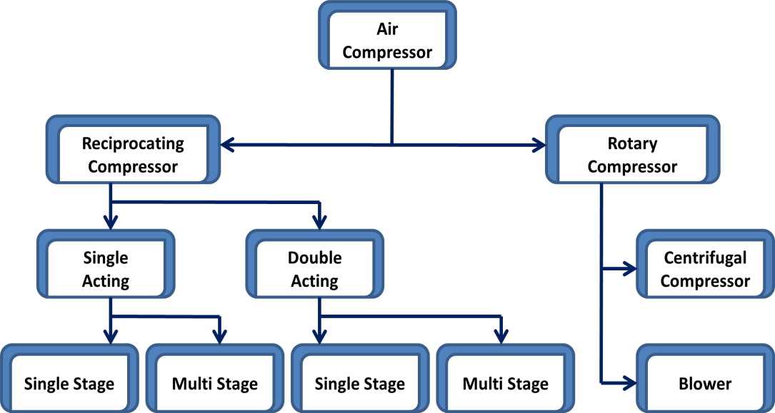

Important Terms:
    - Single stage and Multi stage Compressor: When compression of air is carried out in one cylinder, the compressor is called as Single stage compressor. When compression of air is carried out in more than one cylinder, the compressor is called as Multi stage compressor.

    - Single acting and Double acting Compressor: When suction, compression and delivery of compressed air is done on one side of the piston, the compressor is called as Single acting

compressor. When suction, compression and delivery of compressed air is done on both sides of the piston, the compressor is called as Double acting compressor.
    - Swept Volume or Compressor displacement volume: It is the volume through which the piston

moves in one stroke of the piston. It is given by: VS
π
= × D × L
2
4

    - Clearance Volume: It is the space left in the cylinder when the piston reaches its top dead centre. The ratio of clearance volume to swept volume is called as clearance ratio.
    - Bore and Stroke length: The cylinder internal diameter is called as bore and it is given by ‘D’. The distance by which the piston moves from one dead centre to another in a stroke is called as length of stroke or stroke and it is given by ‘L’.
    - Pressure ratio: It is the ratio of discharge pressure (P2) to the inlet pressure or suction pressure

(P1). It is given by
p
r = P2 P1

    - Free Air Delivered (FAD): It is the discharge volume of the compressor corresponding to conditions of temperature and pressure.
    - Piston Speed: It is the linear speed of the piston measured in m/min. Vspeed = 2LN

Working Principle of Single Stage Single Acting Reciprocating Air Compressor:
The major components of a reciprocating air compressor are cylinder, piston, crank, connecting rod, crank shaft, suction valve and delivery valve. It works on two strokes, i.e suction and compression stroke.
In a single stage and single acting air compressor compression of air is carried out in one cylinder and one side of piston only.
During downward motion of the piston, the pressure in the cylinder drops below the atmospheric pressure. So suction valve opens and air is sucked into the cylinder. At this time delivery valve remains closed. This is called as Suction stroke.
During upward motion of the piston, air is compressed inside the cylinder. The pressure and temperature of air increase. This pressure is more than the atmospheric pressure. So delivery valve opens and suction valve remains closed. The compressed air is discharged through the delivery pipe. This stroke is called as compression stroke.
At the end of compression some volume of air at high pressure remains in the space between the piston and cylinder called as clearance space. This air expands in the cylinder and creates suction.

Working of Single Stage Double Acting Reciprocating Air Compressor:
In a single stage and double acting air compressor suction and compression of air are carried out in both sides of piston. The compressor consists of two numbers of suction and delivery valves.
During downward motion of the piston, the pressure in the cylinder drops below the atmospheric pressure. So suction valve opens and air is sucked into the cylinder. At this time delivery valve remains closed. This is called as Suction stroke. During upward motion of the piston, air is compressed inside the cylinder. The pressure and temperature of air increase. This pressure is more

than the atmospheric pressure. So delivery valve opens and suction valve remains closed. The compressed air is discharged through the delivery pipe. This stroke is called as compression stroke.
When piston moves from one dead centre to other, suction is produce on one side of piston and compression is produce on other side. When piston moves in reversed direction, the suction and compression sides also reversed. Thus during for each stroke of piston, there is discharge of air.
Work done for Single Stage Single Acting Reciprocating Air Compressor: (neglecting clearance)
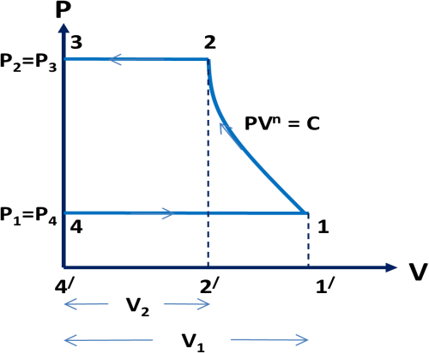
Let:

P1 = air pressure before compression P2 = air pressure after compression
T1 = air temperature before compression T2 = air temperature after compression V1 = volume of air before compression V2 = volume of air after compression
Consider the compression is polytropic and follows the law of PV^{n} = C

For Polytropic compression PV^{n} = C
Workdone = W = area 1-2-3-4-1 = (area 2-3-4/-2/-2) + (area 1-2-2/-1/-1) – (area 4-1-1/-4/-4)

W = PV
+ P2V2 − P1V1 − PV
= nP2V2 − P2V2 + P2V2 − P1V1 − nP1V1 + P1V1

2 2

= n (P V
n −1

− PV )
1 1

- (1.1)
n −1

n − 1 2 2 1 1

⎛ − 1 ⎞

n ⎛ P₂V₂ ⎞ n
⎜ P2
⎛ P2 ⎞ n ⎟

= n −1 × P1V1 ⎜ PV
−1⎟ = n −1 × P1V1 ⎜ P × ⎜ P ⎟
−1⎟

⎝ 1 1 ⎠
⎜ 1 ⎝ 2 ⎠ ⎟
⎝ ⎠

⎛
n ⎜⎛ P₂ ⎞
1− 1 ⎞
n ⎟

= n − 1 × P1V1 × ⎜⎜ P ⎟ −1⎟
⎜⎝ 2 ⎠ ⎟
⎝ ⎠
⎛ n−1 ⎞
n ⎜⎛ P₂ ⎞ n ⎟

= n − 1 × P1V1 × ⎜⎜ P ⎟ −1⎟
- (1.2)

⎜⎝ 2 ⎠ ⎟
⎝ ⎠
Equations 1.1 and 1.2 give the expression for work done for Polytropic compression.

For Adiabatic Compression
PV ^{γ} = C

Work done = W =
γ (P V − PV )

- (1.3)

γ −1 2 2 1 1

⎛ γ −1 ⎞
γ ⎜⎛ P₂ ⎞ γ ⎟

= γ −1 × P1V1 × ⎜⎜ P ⎟ −1⎟
- (1.4)

⎜⎝ 2 ⎠ ⎟
⎝ ⎠

For Isothermal Compression PV = C
Work done = W = area 1-2-3-4-1 = (area 2-3-4/-2/-2) + (area 1-2-2/-1/-1) – (area 4-1-1/-4/-4)
W = PV + PV + log V1 − PV
2 2 1 1 1 1
V
2

= PV × log V1 = PV × log P2

- (1.5)

1 1 1 1
V
P
2 1

Work done for Single Stage Single Acting Reciprocating Air Compressor: (with clearance)
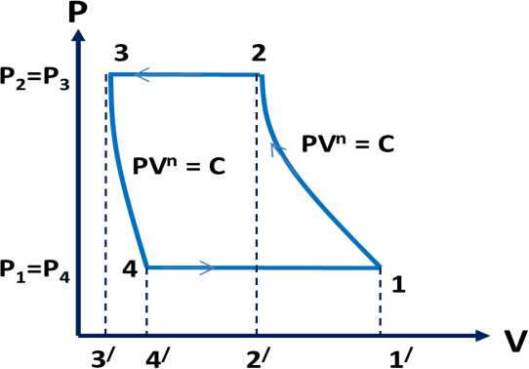
Let:
P1 = air pressure before compression P2 = air pressure after compression
T1 = air temperature before compression T2 = air temperature after compression V1 = volume of air before compression V2 = volume of air after compression
Consider the compression is polytropic and follows the law of PV^{n} = C

For Polytropic compression PV^{n} = C
Workdone = area 1-2-3-4-1 = (area 2-3-3/-2/-2) + (area 1-2-2/-1/-1) – (area 3-4-4/-3/-3) - (area 1-4-4/-1/-1)
W = P (V −V )+ P2V2 − P1V1 − P3V3 − P4V4 − P (V −V )


2 2 3
n −1
n −1
1 1 4

= PV − PV + P2V2 − P1V1 − P3V3 + P4V4 − PV + PV

² ² ³ ³ n −1 n −1 n −1 n −1 ¹ ¹ ¹ ⁴
= ⎛ P V + P2V2 ⎞ − ⎛ PV + P1V1 ⎞ − ⎛ P V + P3V3 ⎞ + ⎛ PV + P4V4 ⎞

⎜ 2 2
⎝
⎟
n −1 ⎠
⎜ 1 !
⎝
⎟
n −1⎠
⎜ 2 3
⎝
⎟
n −1⎠
⎜ 1 4
⎝
⎟
n −1 ⎠

= ⎛ P V + P2V2 ⎞ − ⎛ PV + P1V1 ⎞ − ⎛ P V + P2V3 ⎞ + ⎛ PV + P1V4 ⎞

⎜ 2 2
⎝
⎟
n −1 ⎠
⎜ 1 !
⎝
⎟
n −1⎠
⎜ 2 3
⎝
⎟
n −1 ⎠
⎜ 1 4
⎝
⎟
n −1⎠

= P V × n − PV × n − P V × n + PV × n

² ² n −1
¹ ¹ n −1
² ³ n −1
¹ ⁴ n −1

= n (P V − PV ) − n × P V + n × PV

n −1 ² ²
¹ ¹ n −1
2 3 n −1 1 4

n ⎛ P2V2 ⎞ n

= n −1 × P1V1 ⎜ PV
−1⎟ − (P2V3 − P1V4 )
n −1

⎝ 1 1 ⎠

n ⎛ P2V2 ⎞ n ⎛ P₂V₃ ⎞

= n −1 × P1V1 ⎜ PV
−1⎟ − n −1 × P1V4 ⎜ PV
−1⎟
- (i)

⎝ 1 1 ⎠ ⎝ 1 4 ⎠

For Polytropic process 1-2,
PV ^{n} = P V ^{n}

1 1 2 2

1
V2 ⎛ P1 ⎞ n
− 1
⎛ P2 ⎞ n

⇒ = ⎜ ⎟
V P
= ⎜ ⎟
P

1 ⎝ 2 ⎠ ⎝ 1 ⎠

For Polytropic process 1-2,
PV ^{n} = P V ^{n}

1 1 2 2

1
V3 ⎛ P4 ⎞ n
1
⎛ P1 ⎞ n
− 1
⎛ P2 ⎞ n

⇒ = ⎜ ⎟
V P
= ⎜ ⎟
P
= ⎜ ⎟
P

4 ⎝ 3 ⎠
⎝ 2 ⎠
⎝ 1 ⎠

Substituting the values of V2 and V3 in equation-(i)

V1 V4

⎡ − 1 ⎤

⎡ − 1 ⎤

n ⎢ P₂
⎛ P₂ ⎞ n ⎥ n
⎢ P2
⎛ P2 ⎞ n ⎥

W = n −1 × P1V1 ⎢ P
× ⎜ ⎟
P
−1⎥ − n −1 × P1V4 ⎢ P
× ⎜ ⎟
P
−1⎥

⎢⎣ 1
⎝ 1 ⎠ ⎥⎦
⎢⎣ 1
⎝ 1 ⎠ ⎥⎦

⎡ n−1 ⎤ ⎡ n−1 ⎤

n ⎢⎛ P₂ ⎞ n ⎥ n
⎢⎛ P2 ⎞ n ⎥

= n −1 × P1V1 ⎢⎜ P ⎟
⎥
−1⎥ − n −1 × P1V4 ⎢⎜ P ⎟
−1⎥

⎝ 1 ⎠
⎢
⎣
⎥⎦
⎡ n−1
⎝ 1 ⎠
⎣ ⎦
⎢
⎤

n ⎢⎛ P₂ ⎞ n ⎥
W = n −1 × (P1V1 − P1V4 )⎢⎜ P ⎟ −1⎥
⎝ 1 ⎠
⎢
⎥
⎣ ⎦
⎡ n−1 ⎤
n ⎢⎛ P₂ ⎞ n ⎥

W = n −1 × P1 (V1 − V4 )⎢⎜ P ⎟ −1⎥
- (ii)

⎝ 1 ⎠
⎢
⎥
⎣ ⎦
Where: V1-V4 = actual volume of air drawn in a cycle = V

As P1V = mRT1

⎡

n−1 ⎤

n ⎢⎛ P₂ ⎞ n ⎥

W = n −1 × mRT1 × ⎢⎜ P ⎟ −1⎥
- (iii)

Mean Effective Pressure (pm):
⎝ 1 ⎠
⎣ ⎦
⎢
⎥

It is given by:
p = Work output (Wnet )

Swept volume (Vs )
m

Volumetric Efficiency:
It is the ratio of actual volume of air sucked into the cylinder during a cycle to the swept volume.

Mathematically: η
= V1 − V4
= V1 − V4

volumetric
V1 −V3
V1 − VC

Where: V1-V4 = actual volume of air drawn in a cycle VC = V3 = clearance volume
Volumetric efficiency for Polytropic process:
For Polytropic process 3-4,

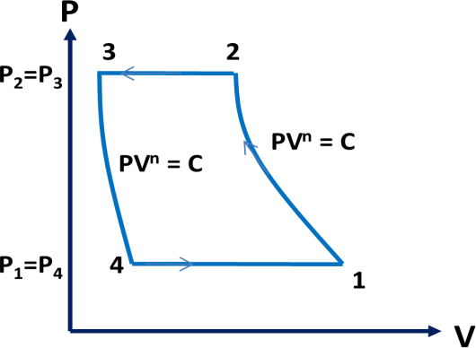
PV ^{n} = P V ^{n}
3 3 4 4
⇒ PV ^{n} = P V ^{n}
3 C 4 4
1 1
V4 ⎛ P3 ⎞ n ⎛ P2 ⎞ n

⇒ = ⎜ ⎟
V P
= ⎜ ⎟
P

C ⎝ 4 ⎠
⎝ 1 ⎠
1

⎛ P2 ⎞ n
⇒ V4 = VC × ⎜ P ⎟
⎝ 1 ⎠
Where: P1 = P4 = suction pressure, and P2 = P3 = discharge pressure

1
⎛ P2 ⎞ n
1
⎛ P2 ⎞ n

V1 − VC × ⎜ P ⎟ V1 − VC + VC − VC ×⎜ P ⎟

Volumetric Efficiency = η
= ⎝ 1 ⎠ = ⎝ 1 ⎠

V1 − VC V1 − VC
V

1
⎛ P2 ⎞ n
− VC ⎜ P ⎟ ⎛ ⎞ 1

= V1
VC + VC
− ⎝ 1 ⎠ = 1 + C − C⎜ P2 ⎟ n

V − V V − V V − V
⎜ P ⎟

1 C 1 C 1 C
⎝ 1 ⎠

Where: C = Clearance ratio
Free Air Delivery:

Pf Vf
= P1 (V1 − V4 ) = P2 (V2 − V3 )

Tf T1 T2

Where: P1 = intake pressure, T1 = intake temperature, P2 = discharge pressure, T2 = discharge temperature, V1 – V4 = intake actual volume, V2 – V3 = discharge volume
Brake power:
It is the power supplied to the compressor.

Indicated power:

It is the power required to do work upon air in the compressor.

I.P = W × N
60

Watt ; for single acting

I.P = W × 2N
60

Watt ; for double acting

It is also given by:
IP = Pm × L × A× N × k
60

Where: k = number suction per revolution of crank shaft
= 1 (for single acting)
= 2 (for double acting) N = revolution per minute

Mechanical Efficiency:

It is the ratio of Indicated power to the Brake power of a compressor. η

mechanical =

I.P

B.P

CLASS ROOM PROBLEMS

- A Single stage, Single- acting reciprocating air compressor receives air at 1.013 bar pressure, 27⁰c and delivers it at 9.5 bar. The compressor has a bore = 250mm, and stroke = 300mm and it runs at 200 rpm. The mass flow rate of air is 200kg/h. calculate the volumetric efficiency of compressor.
- A single-stage reciprocating air compressor air takes in 1.4 kg of air per minutes at 1 bar and 17⁰c and delivers it at 6 bars. Assuming compression process follows the law PV^{1.35}=Constant, Calculate indicated power input to a compressor.

- A single-acting single-cylinder reciprocating air compressor has cylinder diameter of 200mm and a stroke of 300mm. Air enters the cylinder at 1 bar; 27⁰C. It is then compressed poly tropically to 8 bar according to the law PV^{1.3}=Constant. If the speed of the compressor is 250rpm, Calculate the mass of air compressed per minute, and the power required in kW for driving the compressor.
- A single acting, single-cylinder reciprocating air compressor is compressing 20kg/min, of air from 110kPa, 30⁰C to 600kPa and delivers it to a receiver. Law of compression is PV^{1.25}=Constant. Mechanical efficiency is 80%. Find the power input to compressor.
- A single-cylinder, double-acting, reciprocating air compressor receives air at 1 bar, 17⁰C, compresses it to 6 bar according to the law PV^{1.25}=C. The cylinder diameter is 300mm. The average piston speed is 150m/min at 100 rpm. Calculate the power required in kW for driving the compressor.

REFERENCES

: Thermal engineering book (Mahesh.M Rathore)
  - : A text book of Thermal Engineering (R.S Khurmi & J K Gupta)
  - : https://youtu.be/_PYqHJY_QyU
  - : https://youtu.be/NakOoD-G0IY

: Thermodynamics book by B.S. UBHI

PROPERTIES OF STEAM
A substance that has a fixed chemical composition throughout is called pure substance. Water, helium carbon dioxide, nitrogen are examples.

It does not have to be a single chemical element just as long as it is homogeneous throughout, like air. A mixture of phases of two or more substance is can still a pure substance if it is homogeneous, like ice and water (solid and liquid) or water and steam (liquid and gas).

Vapor


Water (Pure substance)
Liquid

Vapor

Liquid

Phases of a Pure Substance
Air
(Not a pure substance because the composition of liquid air is different from the


There are three principle phases – solid, liquid and gas, but a substance can have several other phases within the principle phase. Examples include solid carbon (diamond and graphite) and iron (three solid phases). Nevertheless, thermodynamics deals with the primary phases only.
In general:
- Solids have strongest molecular bonds.
- Solids are closely packed three dimensional crystals.
- Their molecules do not move relative to each other
- Intermediate molecular bond strength
- Liquid molecular spacing is comparable to solids but their molecules can float about in groups.
- There is molecular order within the groups
- Weakest molecular bond strength.
- Molecules in the gas phases are far apart, they have no ordered structure
- The molecules move randomly and collide with each other.
- Their molecules are at higher energy levels, they must release large amounts of energy to condense or freeze.

Phase – Change Processes Of Pure Substances
At this point, it is important to consider the liquid to solid phase change process. Not so much solid to liquid because thermodynamics deals only with liquid to gases (or vice versa) to generate power.

Consider water at room temperature (20°C) and normal atmospheric pressure (1atm) in a piston-cylinder device. The water is in liquid phase, and it is called compressed liquid or sub cooled liquid (not about to vaporize).

Compressed liquid

)
Liquid

(Point 1)



If we add heat to water, its temperature will increase; let us say until 50°C. Due to the increase in temperature, the specific volume v will increase. As a consequence, the piston will move slightly upward therefore maintaining constant pressure (1atm).

Compressed liquid
Liquid

(Point-2)

Now, if we continue to add heat to the water, the temperature will increase further until 100°C. At this point, any additional addition of heat will vaporize some water. This specific point where water starts to vaporize is called saturated liquid.

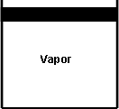


Saturated liquid
Liquid

(Point 3)
If we continue to add heat to water, more and more vapor will be created, while the temperature and the pressure remain constant (T = 100°C and P= 1 atm). The only property that changes is the specific volume. These conditions will remain the same until the last drop of liquid is vaporized. At this point, the entire cylinder is filled with vapor at 100°C. This state is called saturated vapor
The state between saturated liquid (only liquid) and saturated vapor (only vapor) where two phases exist is called saturated liquid-vapor mixture.
Vapor
Liquid


Saturated liquid-vapor mixture

(Point-4) (Point-5)

After the saturated vapor phase, any addition of heat will increase the temperature of the vapor, this state is called superheated vapor

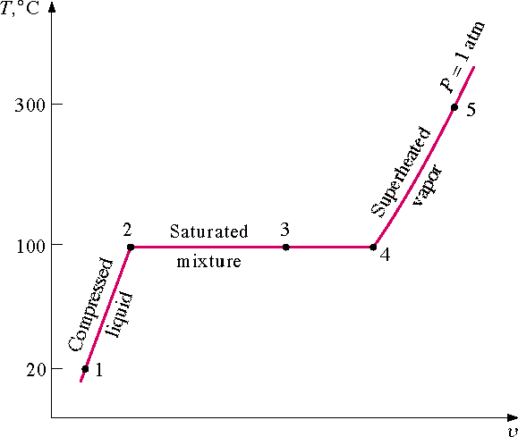

T-v diagram representing phase change for water at constant
pressure.

Saturation Temperature And Saturation Pressure

Recall that during a phase change, pressure and temperature are not independent intensive properties. As a consequence, the temperature at which water starts boiling depends on the pressure. In other words, water starts boiling at 100 ºC but only at 1 atm. At different pressures, water boils at different temperatures.

At a given pressure, the temperature at which a pure substance changes phase is called the saturation temperature (Tsat).

Likewise, at a given temperature, the pressure at which a pure substance changes phase is called the saturation pressure (Psat).

Property Diagrams for Phase Change Processes (T-V Diagram)
If we increase the pressure of water in the piston-cylinder device, the process from compressed liquid to superheated vapor will follow a path that looks like the process for P = 1 atm, the only difference is that the width of the mixture region will be shorter.

Then, at a certain pressure, the mixture region will be represented only by one point. This point is called the critical point. It is defined as the point at which the saturated liquid and saturated vapor states are identical.

At the critical point, the properties of a substance are called critical properties (critical temperature (Tcr), critical pressure (Pcr) and critical specific volume (vcr)).

Example

Water Pcr = 22.09 MPa
Tcr = 374.148°C = 647.298 K
vcr = 0.003155 m³/kg

Air Pcr = 3.77 MPa
Tcr = 132.5°C = 405.65 K
vcr = 0.0883 m³/kg

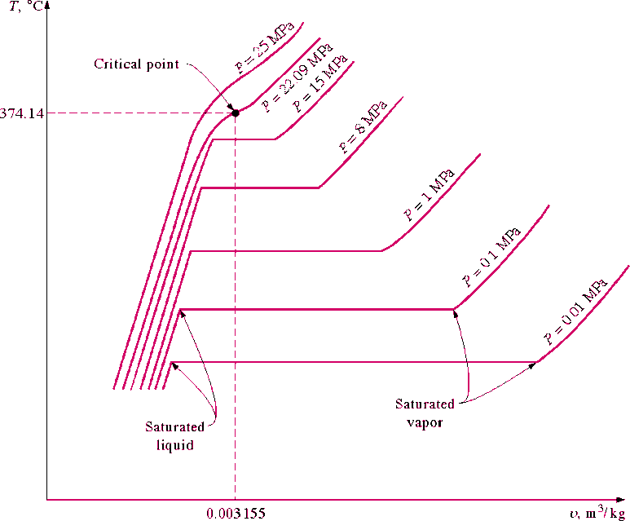

T-v diagram.

If we connect all the points representing saturated liquid we will obtain the saturated liquid line.

If we connect all the points representing saturated vapor we will obtain the saturated vapor line.

The intersection of the two lines is the critical point.

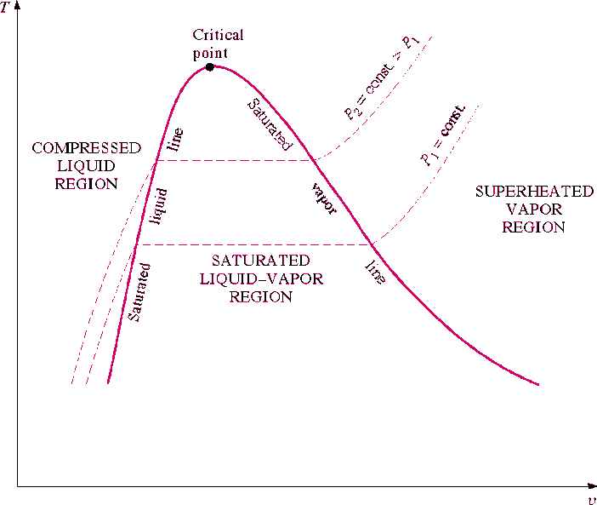

T-v diagram and saturation lines.

P-v Diagram
If we consider the pressure-cylinder device, but with some weights above the piston, if we remove the weights one by one to decrease the pressure, and we allow a heat transfer to obtain an isothermal process, we will obtain one of the curves of the P-v diagram.
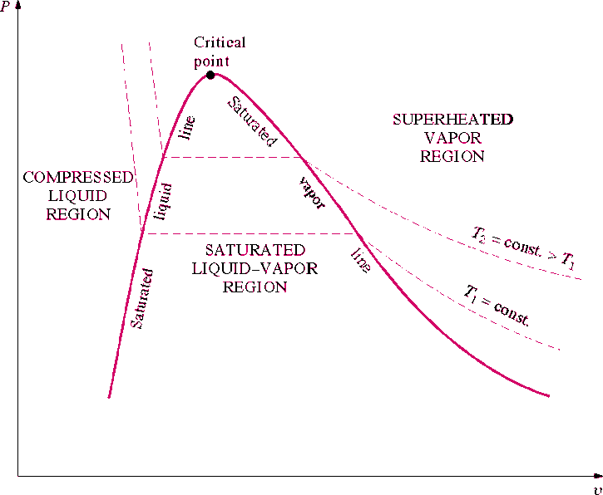

: P-v diagram.

The P-v diagram can be extended to include the solid phase, the solid- liquid and the solid-vapor saturation regions.

As some substances, as water, expand when they freeze, and the rest (the majority) contracts during freezing process, we have two configurations for the P-v diagram with solid phase.

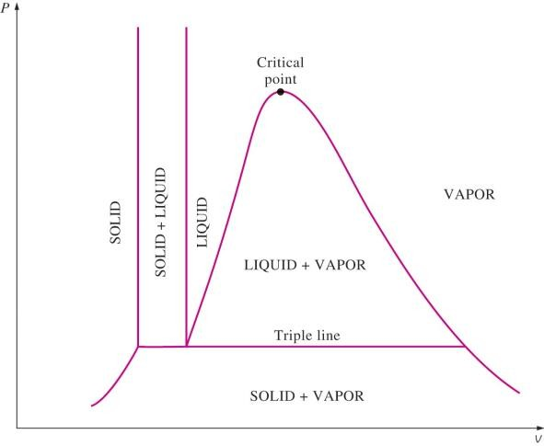
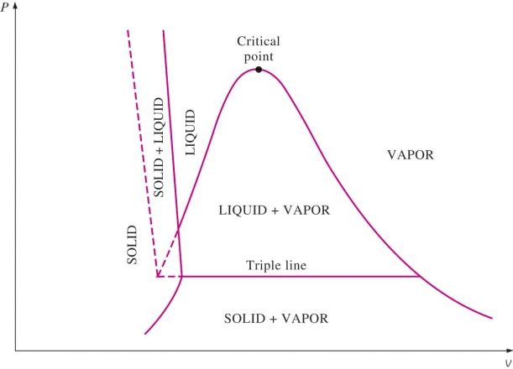

P-v diagram for a substance that contracts during freezing (left) and for a substance that expends during freezing (right).

Triple point
we have defined the equilibrium between two phases. However, under certain conditions, water can exist at the same time as ice (solid), liquid and vapor. These conditions define the so called triple point.

On a P-T diagram, these conditions are represented by a point. Example

Water T = 0.01°C = 273.16 K and P = 0.6113 kPa

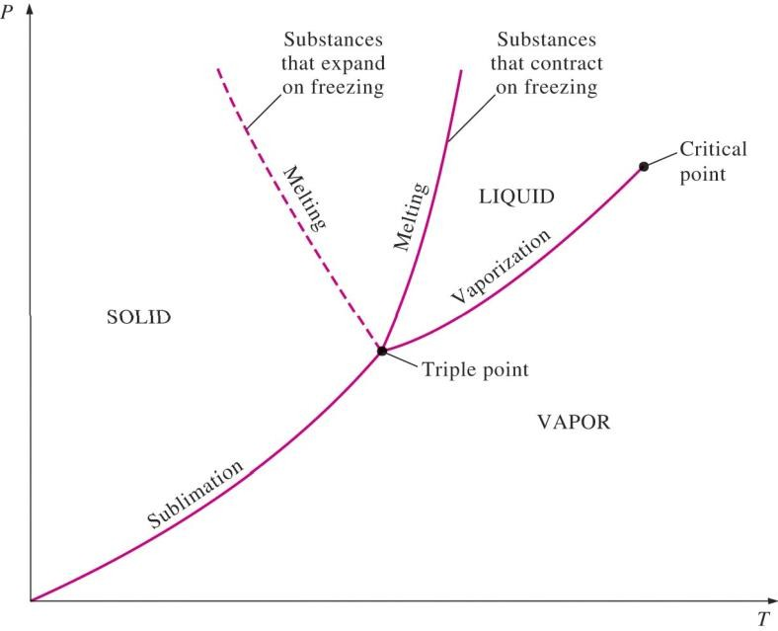

P-T diagram and the triple point.

The P-T diagram is often called the phase diagram since all three phases are separated by three lines.

P-T-V Diagram
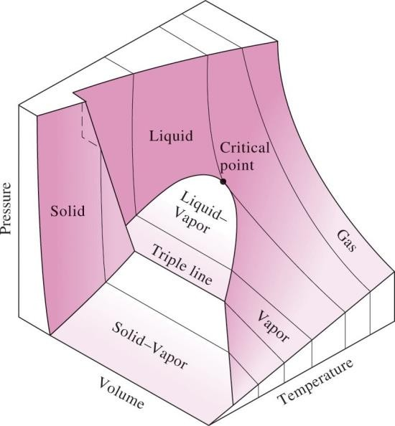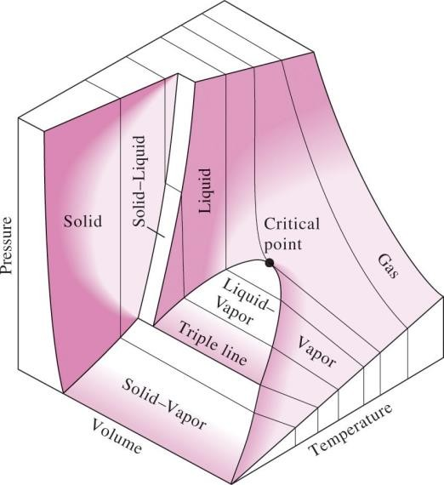
P-T-v diagram for a substance that contracts during freezing (left) and for a substance that expends during freezing (right).
Property Tables
In addition to the temperature, pressure, and specific volume data, tables contain data for the specific internal energy u, the specific enthalpy h, and the specific entropy s.

In thermodynamics analysis, we will encounter the combination of properties U + PV frequently. For simplicity this combination is defined as a new property called enthalpy.
H = U + PV(kJ)

The enthalpy per unit mass is

h = u + Pv (kJ/kg

Enthalpy Change during formation of Steam Enthalpy of steam
To find out the total heat content or enthalpy of any state of water/ steam we have to add all types of
heat added i.e., sensible and latent to convert the water to that state starting from some initial state or datum which is assumed as a zero enthalpy point or where the heat content is taken as zero. Generally in engineering calculations the datum is water at 0⁰C where it is considered as having zero heat content or zero enthalpy.

Specific enthalpy of un-saturated water (hw)
It is simply the amount of heat required to raise the temperature of one kg of water from 0 ℃ to its actual temperature which is below its saturation temperature. It can be calculated by multiplying actual temperature of unsaturated water with its specific heat which is considered equal to 4.187 kJ/ kg/ K. It is denoted as hw

Specific enthalpy of saturated water (hf)
It is the quantity of heat required to raise the temperature of one kg of water at 0⁰C to its boiling point or saturation temperature corresponding to the pressure applied. It is denoted as hf. It can be calculated by multiplying the specific heat of water to the total rise in temperature. The specific heat Cpw of water may be approximately taken as constant i.e., 4.187 kJ/kg K

Latent heat of steam (hfg)
Latent heat of steam at a particular pressure may be defined as the quantity of heat in kJ required to convert one kg of water at its boiling point (saturated water) into dry saturated steam at the same pressure. It is usually denoted by L or hfg. It decreases with increase in pressure or saturation temperature.

Wet and dry steam
Wet steam is that steam in which the whole of water has not vaporized but the un-vaporized water is present in the form of mist/fog suspended in completely vaporized water or steam. Due to this mist the wet steam is visible. However the dry steam i.e., in which the vaporization is complete is invisible or colorless. Any steam which is completely dry and present at saturation temperature is called dry saturated steam.

Dryness fraction
This term refers to quality of wet steam. It is defined as the ratio of the weight of dry steam actually presents to the weight of total wet steam which contains it. It is denoted by x.

Specific enthalpy of wet steam (hws)

It may be defined as the quantity of heat required to convert 1 kg of water at 0⁰C into wet steam of a given quality and at constant pressure. It may be denoted by hws. It is equal to the sum of specific enthalpy of saturated water and latent heat of dry fraction of steam. So

h_{ws} = h_{f} + x.

Specific enthalpy of dry saturated steam (hg)

It may be defined as the quantity of heat required to convert 1kg of water at 0⁰C into dry saturated steam at given constant pressure. It may be denoted by hg. It is equal to the sum of specific enthalpy of saturated water and latent heat corresponding to given saturation pressure and temperature. Thus

h_{g} = h_{f} + h_{fg}

Specific enthalpy of superheated steam (hsup)

It is defined as the quantity of heat required to convert 1kg of water at 0⁰C into the superheated steam at given temperature and pressure. It may be denoted as hsup and is equal to the sum of specific enthalpy of dry saturated steam and product of specific heat of superheated steam (Cs) to degree of superheat.

h_{sup} = h_{g} + C_{s} (t_{sup} –t_{s})

Specific Volume of Water/Steam

The volume of a unit mass of water/steam is known as its specific volume.

Specific volume of saturated water (vf)
It is defined as volume of 1kg of water at saturation temperature corresponding to the given pressure. It is denoted by vf. It can be calculated experimentally. It slightly increases with increase in saturation temperature and hence the pressure. The reciprocal of sp-volume is equal to density.

Specific volume of dry saturated steam (vg)

It is defined as volume of 1kg of dry saturated steam corresponding to the given pressure. It is denoted by vg and can be calculated experimentally. As dry saturated steam is a gas, its specific volume decreases with increase in pressure or the saturation temperature.

Specific volume of wet steam of quantity x

It is the volume of 1kg of wet steam and is denoted as

v_{ws}= x.v_{g}+ (1-x) v_{f}

Specific volume of Superheated Steam (vsup)

It is the volume of 1kg of superheated steam and can be determined by assuming that the steam behaves as a perfect gas i.e., obeys the gas laws. It is denoted by v_{sup}

Let P = pressure under which steam is superheated.
t_{sup} =temperature of superheated steam
v_{g} = Specific volume of dry saturated steam
t_{s} = saturation temperature at pressure P.

Change in specific entropy during evaporation, (sfg)
During evaporation heat added = h_{fg} = Latent heat of water

Temperature remains constant during evaporation and is equal to saturation Temperature Ts.

Specific entropy of dry saturated steam (sg)

It is the entropy of one kg of dry saturated steam and is given as the sum of entropy of 1kg of saturated water and entropy change during evaporation. It is denoted by s_{g}.
Thus sg = sf + sfg

Specific entropy of wet steam

Specific entropy of wet steam is equal to sum of specific entropy of saturated water and change in specific entropy during evaporation of dry fraction of steam. It is denoted by s_{ws}

s_{ws} = s_{f} + x.

Specific entropy of superheated steam (ssup)

It is the sum of specific entropy of dry saturated steam and entropy change during superheating from saturation temp Ts to superheated temp T_{sup}.

Total specific entropy of superheated steam
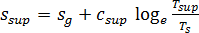

CLASS ROOM PROBLEMS

Q1. A vessel of volume 0.04 m3 contains a mixture of saturated water and steam at a temperature of 250°C. The mass of the liquid present is 9 kg. Find the pressure, mass, specific volume, enthalpy, entropy and internal energy.
Q2. A steam power plant uses steam at boiler pressure of 150 bar and temperature of 550°C with reheat at 40 bar and 550 °C at condenser pressure of 0.1 bar. Find the quality of steam at turbine exhaust, cycle efficiency and the steam rate.
Q3. Ten kg of water 45 °C is heated at a constant pressure of 10 bar until it becomes superheated vapour at 300°C. Find the change in volume, enthalpy, internal energy and entropy.
Q4. 4 Kg of 0.5 dry steam at 6.0 bar pressure is heated, so that it becomes

- 0.95 dry at 6.0 bar pressure or

- Dry & saturated at 6.0 bar or

- Superheated to 300ºC at 6.0 bar or

- Superheated to 250ºC at 8.0 bar

Using steam tables determine in each case the quantity of heat required to be supplied. Take Csup for superheated steam as 2.3 kJ/ kg K.

Q5. Calculate the entropy and volume of 4.73 kg of superheated steam at pressure 7.8 bar and temperature 240ºC. Take Cp for superheated steam = 2.32 kJ/kg. K.
  - Calculate the enthalpy of 1 kg of steam at a pressure of 8 bar and dryness fraction of 0.8. How much heat would be required to raise 2kg of steam from water at 20⁰ C.

  - Determine the quantity of heat required to produce 1 kg of steam at a pressure of 6 bar at a temperature of 25⁰C under the following condition.
    - When the steam is wet having a dryness fraction of 0.9

    - When the steam is dry saturated.

  - Steam at 18bar pressure and dryness fraction of 0.9 is heated at constant pressure until dry and saturated. Find the increase in volume, heat supplied and work done per kg of steam. If the volume is kept constant, find how much heat must be extracted to reduce the pressure up to 14 bar.
  - Steam enters an engine at a pressure of 12 bar with 67⁰C of superheat. It is exhausted at a pressure of 0.15 bar and 0.95 dry. Find the drop of enthalpy of the steam.
  - Steam engine obtains steam from a boiler at a pressure of 15 bar and 0.98 dry. It was observed that the steam loses 21kJ of heat per kg as it flows through the pipe line, pressure remaining constant. Calculate dryness fraction of steam, at the engine end of the pipeline.

REFERENCES

  - : Thermal engineering book (Mahesh.M Rathore)
  - : A text book of Thermal Engineering (R.S Khurmi & J K Gupta)
  - : Thermodynamics book by B.S. UBHI.
  - : https://youtu.be/O2FwEIKg3ts
  - : https://youtu.be/4-BI22Wx4Pc
  - : https://youtu.be/6WBhEvWHD_o

STEAM GENERATOR
Steam generator:
- A boiler is a steam generator which is used to convert steam from water by heating it.
- A steam generator or boiler, usually, a closed vessel made of steel. Its function is to transfer the heat produced by the combustion of fuel (solid, liquid or gas) to water, and ultimately to generate steam. The steam produced may be supplied:
  - To an external combustion engine, i.e. steam engines and turbines.
  - At low pressures for industrial process work in cotton mills, sugar factories, breweries etc.
  - For producing hot water.
Classification of steam boilers:

According to the contents in the tube
      - Fire tube or smoke tube boiler
      - Water tube boiler.

According to the position of the furnace
      - Internally fired boilers
      - Externally fired boilers

According to the axis of the shell
      - Vertical boilers
      - Horizontal boilers

According to the number of tubes
      - Single tube boilers
      - Multi tubular boilers

According to the method circulation of water and steam
      - Natural circulation boilers
      - Forced circulation boilers

According to the use
      - Stationary boilers
      - Mobile boilers

Fire tube boiler:
- Fire tube boilers are those in which flue gas flows inside the tubes and the water that is to be heated remains outside the tube.
- Examples of fire tube boilers are: Simple vertical boiler, Cochran boiler, Lancashire boiler, Cornish boiler.

Water tube boiler:
- Water tube boilers are those in which water flows inside the tube and flue gas remains outside the tube to heat the water.
- Examples of water tube boilers are: Babcock and Wilcox boiler, Stirling boiler, La- Mont boiler, Benson boiler.

COCHRAN BOILER:
Cochran boiler is a vertical multi-tubular fire tube boiler. It produces steam at low pressure from the heat exchange between water and flue gas. It has the Steam capacity up to 3500 kg/hr.

Construction of Cochran boiler:
It consists of a cylindrical shell with a dome shaped top where the space is provided for steam. The furnace is one piece construction and is seamless. Its crown has a hemispherical shape and thus provides maximum volume of space. It has the following parts and mountings.
- Boiler shell (cylindrical, top is dome shaped, hemispherical crown)
- Grate and furnace (Internally fired boiler)
- Combustion chamber and fire tubes
- Smoke box and chimney
- Mountings: water gauge, pressure gauge, fusible plug, feed check valve, steam stop valve, safety valve and blow off cock.

Working of Cochran boiler:
When the fuel burns inside the fire box/furnace flue gas produces and flows into the combustion chamber after striking through the fire brick linings. Then the flue gas passes through the fire tubes to exchange heat with water surrounding to them. Then the flue gas is collected in a smoke box and escape to the atmosphere through chimney. In this way the steam produces at the top of the boiler shell and collected.
Mountings: These are the fitting and devices which are necessary for the operation and safety of a boiler.
- Steam Stop Valve: It is use to regulate the flow of steam from the boiler to the
steam pipe.
- Safety Valve: It is use for releasing the excess steam when the pressure of steam inside the boiler exceeds the rated pressure. Types of safety valve are the following: · Dead weight safety valve, Lever safety valve, Spring loaded safety valve, Gravity safety valve
- Water Level Indicator: It is use to indicate the level of water in the boiler constantly.
- Pressure Gauge: It is use to measure the pressure exerted inside the vessel.
- Fusible Plug: It is use to protect the boiler against damage due to overheating for low water level.
- Feed Check Valve: It is use to control the supply the water to the boiler and to
prevent the escaping of water from the boiler when the pump is stopped.
- Blow Off Cock: It is use to discharge a portion of water when the boiler is
empty when necessary for cleaning, inspection, repair, mud, scale and sludge.

- Man Hole: It is used for inspection and maintenance purpose.
Accessories: These are auxiliary parts required for steam boilers for the proper operation and for the increase of their efficiency.
- Super heater: It is use to increase the temperature of steam above it saturation point.
- Economizer: It is a device in which the waste heat of flue gases is utilized for heating the feed water before supplying into the boiler.
- Air pre heater: It is use to increase the temperature of air before it enters the furnace.
- ESP: It is used to collect dust or harmful particle from flue gas before escape into the atmosphere.
- Boiler feed pump: It is used to deliver feed water to the boiler.\

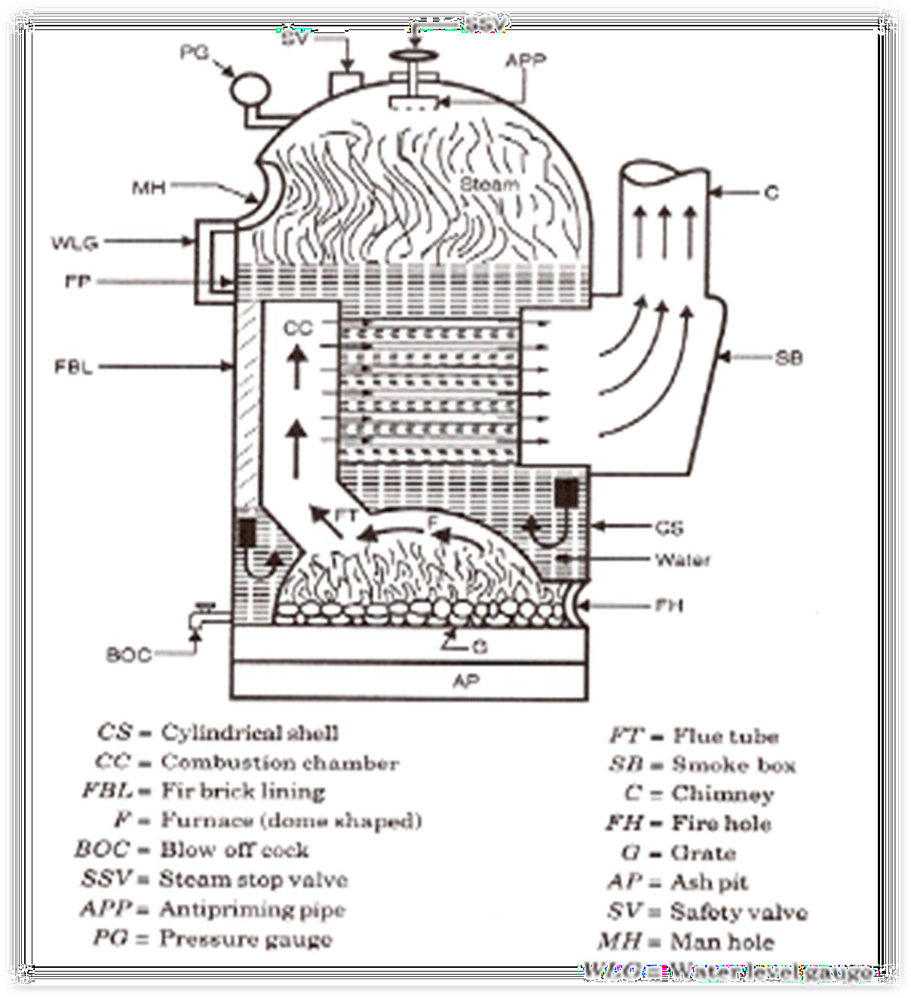

BABCOCK WILCOX BOILER:
It is a horizontal inclined tube, water tube boiler. In this boiler high pressure steam produces from the heat exchange between water and hot flue gas.

Construction:
It consists of a longitudinal drum connected to a series of front end and rear end header by short riser tubes. These headers are connected by a series ofinclined water tubes. The angle of inclination of the water tubes to the horizontal is about 15° or more. Mountings are mounted over the boiler shell for safe operation such as: steam stop valve, safety valve, water level indicator, pressure gauge, thermometer, fusible plug, feed check valve, blow- off cock, man hole etc.

Working:
Fuel is supplied to grate through fire door where it is burnt. The hot gases are forced to move upwards between the tubes by baffle plates provided. The water from the drum flows through the inclined tubes via down take header and goes back into the shell in the form of water and steam via uptake header. The steam gets collected in the steam space of the drum. The steam then enters through the anti-priming pipe and flows in the super heater tubes where it is further heated and is finally taken out through the main stop valve and supplied to the Steam turbine or Steam engine when needed.

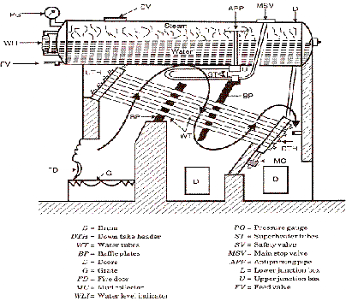

Lancashire Boiler

Lancashire boiler works on the principle of the heat exchanger. The heat is a transfer from exhaust gases to the water through convection. It is a natural circulation boiler that uses natural current to flow the water inside the boiler.

It is basically a shell and tube type heat exchanger in which the exhaust gases flow through the tubes and the water flows through the shell.

Parts of Lancashire Boiler

The following are the parts of Lancashire Boiler:

- Water level indicator
- Pressure gauge
- Safety valve
- Steam stop valve
- Feed check valve
- Blow off valve
- Manhole
- Fusible plug
- Grate
- Fire door
- Ash pit

Water Level Indicator

It indicates a level of water in the boiler. It is located in front of the boiler. There are two water level indicators are used in boilers.

Pressure Gauge

The pressure gauge is adapted to measure the pressure of the steam inside the boiler. It is fixed in front of the boiler.

Safety Valve

A safety valve is an important device in the boiler which ensures safety to a boiler from being damaged due to excessive steam pressure.

Steam Stop Valve

Its purpose is to prevent and allow the flow of steam from the boiler to the steam pipe.

Feed Check Valve

The function of a feed check valve is to control the flow of water from the feed pump to the boiler and to prevent the backflow of the water from the boiler to the pump.

Blow off valve

The function of a blow-off valve is to eliminate periodically the sediments deposited at the bottom of the boiler while the boiler is in operation.

Man Hole

It is a hole situated on the boiler so that a man can easily enter the boiler for the purpose of cleaning and repairing it.

Fusible Plug

The function of the fusible plug is to put off the fire in the furnace of the boiler when the water levels fall below the unsafe level.

Grate

The Grate is a floor that is used to burn coal.

Fire Door

It is used to burn the fuel inside or outside the boiler.

Ash Pit

The function of the ash pit is to collect fuel ash after burning the fuel.

Construction of Lancashire Boiler

This boiler is similar to a shell and tube-type heat exchanger. It consists of a large drum of diameter up to 4-6 meters and length up to 9-10 meters. This drum consists of two fire tubes of a diameter up to 40% of the diameter of the shell. The water drum is located over the bricks works.

Three spaces between the drum and the bricks, one is at the bottom and two are insides as shown in the figure. Flue gases pass through the fire tubes and side and bottom space.

The water level inside the drum is always above the side channels of the flue gases, so more heat is transferred to the water. The drum is filled with water and the upper half-space for steam. A furnace is placed at one end of fire tubes inside the boiler.

The low brick is situated at the grates (space where flue burns) which does not allow unburned flue and ash to flow in the fire tubes. The boiler also consists of other necessary mountings and accessories like economiser, superheater, safety valve, pressure gauge, water gauge, etc, to perform boiler.
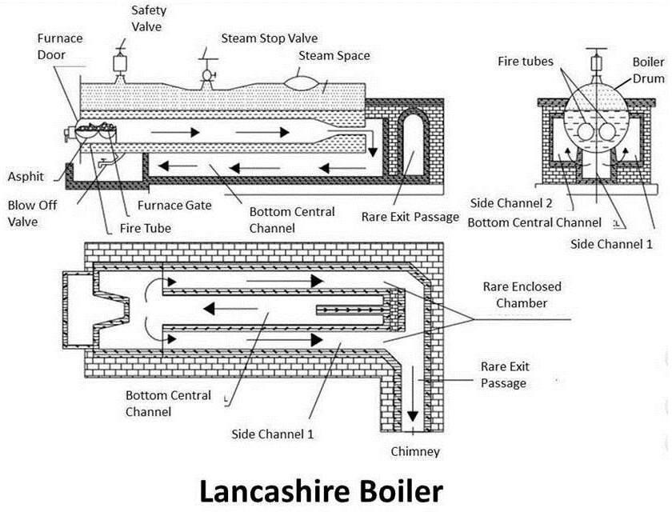

Working of Lancashire Boiler

Lancashire boiler is a shell and tube type, heat exchanger. The fuel is burned at the grate. The water is pumped into the shell through the economiser which increases the temperature of the water. Now the shell is filled with water. The fire tube is fully immersed in the water. The fuel is charged at the grate produces exhaust gases.

These flue gases first pass through the fire tubes from one end to another. These fire tubes transfer 80% to 90% of the heat to the water. The backward flue gases pass from the bottom passage where it transfers 8-10% heat to water.

The remaining flue gases pass from the side passage where it transfers 6-8% of the heat to the water. The brick is the lower conductor of heat, so works as a heat insulator. The steam produced in the drum shell is taken out from the upper side where it flows through the super heater if required. So the steam generated is taken out for process work.
THERMAL ENGINEERING-II 37 | P a g e A b h i j i t S a m a n t

Advantages of Lancashire Boiler

- Cleaning and inspection can be done easily.
- It is more reliable and can generate a large amount of steam.
- It required less maintenance.
- This boiler is a natural circulation boiler so lower electricity consumption than others

Disadvantages of Lancashire Boiler

- This boiler required more floor space.
- This boiler has a leakage problem.
- It requires more time to generate steam.
- It cannot generate high-pressure steam if required.

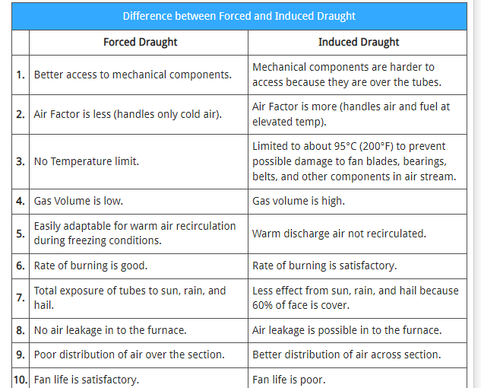
Forced draught and induced draught

Difference between Water tube and Fire tube boiler:

 | Water tube boiler |  | Fire tube boiler
1. | The water circulates inside the tubes which are surrounded by hot gases from the furnace. | 1. | The hot gases from the furnace the furnace pass through the tubes which are surrounded by water.
2. | The rate of generation of steam is high. | 2. | The rate of generation of steam is low.
3. | It generates steam at a higher pressure up to 165 bar. | 3. | It generates steam at up to 24.5 bar.
4. | For a given power, the floor area required for the generation is less. | 4. | For a given power, the floor area required for the generation is more.
5. | The operating cost is high. | 5. | The operating cost is less.
6. | The bursting chance is more. | 6. | The bursting chance is less.
7. | It is used for large power plants. | 7. | It is not suitable for large power plants.

REFERENCES

: Thermal engineering book (Mahesh.M Rathore)
  - : A text book of Thermal Engineering (R.S Khurmi & J K Gupta)
  - : https://youtu.be/gYyg8m9mntg
  - : https://youtu.be/e_OhHeF45JU

: Thermodynamics book by B.S. UBHI

VAPOUR POWER CYCLE
  - Draw the layout of steam power plant.
Ans)
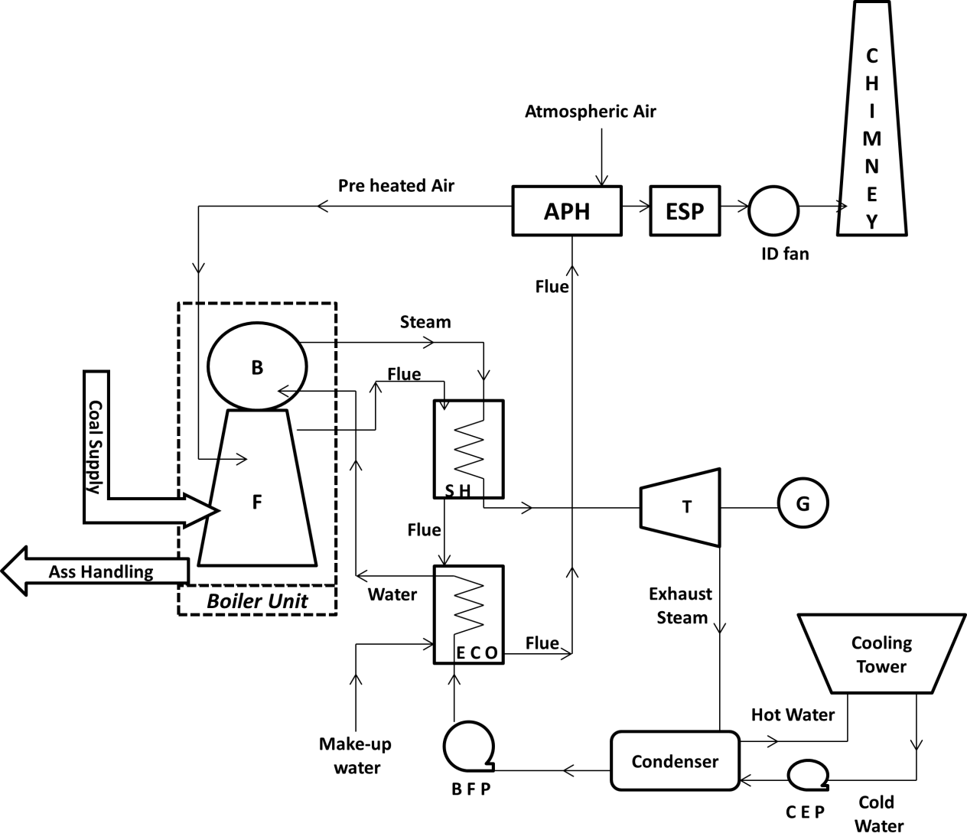

(Layout of steam power plant)

With neat sketch explain the working of Carnot Vapor cycle. Derive the expression for its efficiency. Draw the P-V and T-S diagram.
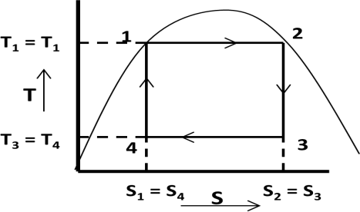
Ans) The P-V and T-S diagram for Carnot vapor cycle is shown below.
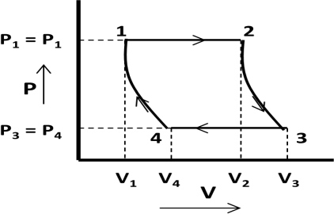

(P-V diagram) | (T-S diagram)
Carnot vapor cycle consists of the four processes as described below.

    - Isothermal expansion: In figure process 1-2 shows the isothermal expansion process. In this process water gets heated in the boiler at constant temperature (T1 = T2) and pressure (P1 = P2) and converted into steam. Entropy increases from s1 to s2 and dry steam is collected at state 2.
Heat absorbed by water (Q1-2) = T1 (s2-s1)
    - Reversible adiabatic expansion: In figure process 2-3 shows the reversible adiabatic expansion process. In this process steam expands inside the turbine at constant entropy
(s1 = s2) and produce shaft power. Steam becomes wet at state 3. Pressure and temperature get changed from state 2-3.
    - Isothermal compression: In figure process 3-4 shows the isothermal compression process. In this process steam gets condensed in the condenser at constant temperature (T3 = T4) and pressure (P3 = P4). Entropy decreases from s3 to s4 and wet steam is collected at state 3.
Heat rejected from steam (Q3-4) = T3 (s3-s4) = T3 (s2-s1)
    - Reversible adiabatic compression: In figure process 4-1 shows the reversible adiabatic compression process. In this process wet steam at state 4 gets compressed to state 1 at constant entropy (s4 = s1) in feed pump. Pressure and Temperature get changed from state 4-1.
Efficiency of Carnot Cycle:

Efficiency = η

carnot =
Workdone Heat Supplied
= Heat
su pplied − heat rejected Heat Supplied

= Q1−2 − Q3−4
= T1 (s2 − s1 ) − T3 (s2 − s1 ) = T1 − T3

= 1 − T3

Q1−2
T1 (s2 − s1 )
T1 T1

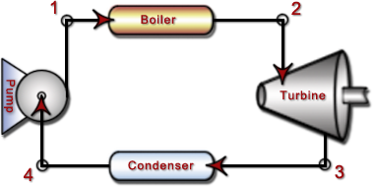
(Simple steam power plant working on Carnot cycle)

What are the limitations of Carnot vapor cycle?
Ans) The limitations of Carnot vapor cycle are
- It is difficult to compress a wet vapor isentropically to the saturated state (process 4-1).
- It is difficult to control the quality of the condensate coming out of the condenser.
- The efficiency of the Carnot cycle is greatly affected by the temperature T1.
- The cycle is still more difficult to operate in practice with superheated steam.

With neat sketch explain the working of Rankine cycle. Derive the expression for its efficiency. Draw the T-S diagram.
Ans) The T-S diagram for Rankine cycle is shown below.

THERMAL ENGINEERING-II 40 | P a g e

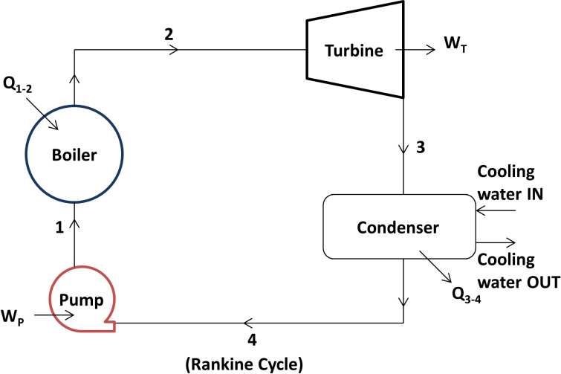
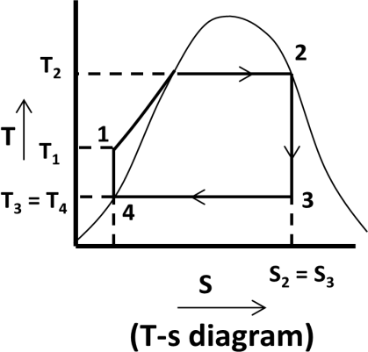
Rankine cycle consists of the four processes as described below.
    - Isothermal expansion: In figure process 1-2 shows the isothermal expansion process. In this process saturated water at state 1 is converted into dry saturated steam at state 2 in a steam boiler at constant pressure (P1 = P2). Water absorbs the latent heat of vaporization (hfg1 = hfg2) and converted into dry saturated steam.
Amount of heat absorbed in process 1-2 = hfg2 = h2 – hf 2 (for dry steam: h2 = hfg2+ hf 2)
    - Reversible adiabatic or Isentropic expansion process: In figure process 2-3 shows the reversible adiabatic or isentropic expansion process. In this process dry saturated steam at state 2 expands isentropically in turbine to state 3. Steam at state 3 is wet.
Work done in the process 2-3 = Turbine work = h2 – h3
    - Isothermal compression process: In figure process 3-4 shows the isothermal compression process. In this process exhaust steam of turbine is cooled by cold water in the condenser at constant pressure (P3 = P4) and constant temperature (T3 = T4). Steam releases latent heat of vaporization and converted into saturated water.
Amount of heat rejected in process 3-4 = hfg3 = h3 – hf 4
    - Reversible adiabatic or Isentropic process: In figure process 4-1 shows the reversible adiabatic or isentropic process. In this process saturated water is drawn by the pump and feed into the boiler.
Work done in this process 4-1 = Pump work = h1 – hf 4
Efficiency:

Efficiency =

Net Workdone = WT − WP
= (h2 − h3 ) − (h1 − hf 4 )

Heat Supplied
Q1−2
(h2 − hf 1 )

If pump work is neglected then WP = 0

With suitable T-s diagram explain about the various conditions of steam supplied into the turbine.
Ans) The T-S diagram for various end conditions of steam of Rankine cycle is shown below.

THERMAL ENGINEERING-II 41 | P a g e

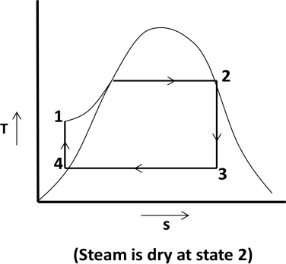
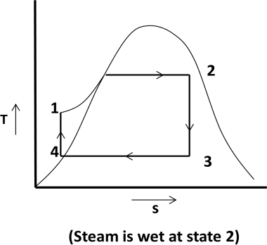
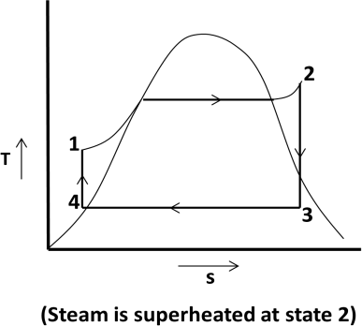

With P-V and T-s diagram explain modified Rankine cycle.
Ans) In case of reciprocating steam engine, when steam expands in the engine cylinder, it can’t expand to the state 3 at condenser pressure. Due to friction of moving parts expansion is carried out at high pressure.
The work obtained near the tail end of P-V diagram is very small. This work is not sufficient to overcome friction. So Rankine cycle is changed into modified Rankine cycle.
In modified Rankine cycle, the isentropic expansion is limited to point 3 by opening the exhaust port of steam engine. This steam is exhausted at constant volume. This causes sudden pressure drop from P3 to P5 at constant volume. The work done is shown by line 1-2-3-4-5-1 in the cycle.
The modified Rankine cycle is shown in P-v and T-s diagram.
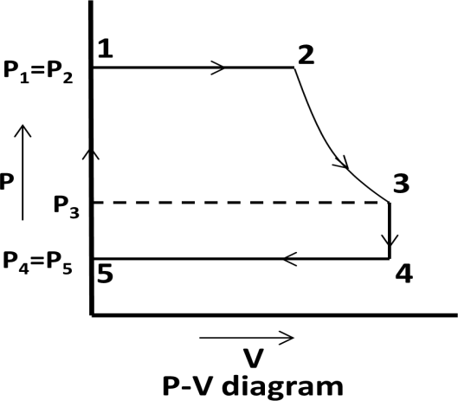
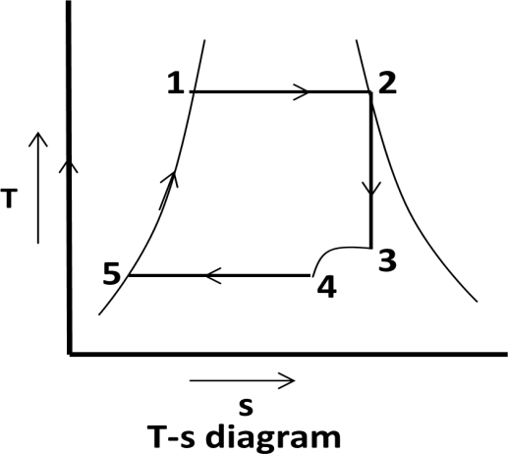

Define the terms efficiency ratio, work ratio and specific steam consumption.
Ans) Efficiency ratio: It is the ratio of thermal efficiency to rankine efficiency or actual cycle efficiency to ideal cycle efficiency.

Efficiency ratio =
Thermal efficiency Rankineefficiency

Thermal efficiency =
3600 × P

m (h2 − hf 3 )

Where P = power developed in kW and m = mass of steam supplied
Work ratio: It is the ratio of net work done to the turbine work.

THERMAL ENGINEERING-II 42 | P a g e

Work ratio =

Turbine work − Compressor work Turbine work

Specific steam consumption: It is defined as the mass of steam supplied to the turbine to develop unit power output. It is also known as steam rate or specific rate of flow of steam.

Specific steam consumption =
3600
h2 − h3

kg / kWh

CLASS ROOM PROBLEMS

  - A power plant is supplied with dry saturated steam at a pressure of 16 bar and exhaust at 0.2 bar. Using steam tables, find the efficiency of the Carnot cycle.
  - Determine the quantity of heat required to produce 1 kg of steam at a pressure of 6 bar at a temperature of 25⁰C, under the following conditions.
(i) when the steam is dry saturated (ii) when the steam is wet having a dryness fraction 0.9
(iii) when steam is superheated at a constant pressure at 2500C assuming the specific heat of steam is to be 2.3 kJ/kg K.
  - In a steam power cycle, the steam supply is at 15 bar and dry and saturated. The condenser pressure is 0.4 bar. Calculate the Carnot and Rankine efficiencies of the cycle. Neglect pump work.
  - A simple Rankine cycle works between pressures 28 bar and 0.06 bar, the initial condition of steam being dry saturated. Calculate the cycle efficiency, work ratio and specific steam consumption.
  - Dry and saturated steam at 15 bar is supplied to a steam turbine working in Rankine cycle. The exhaust takes place at 1 bar. Calculate (i) Rankine efficiency, (ii) steam consumption per kWh if the efficiency ratio is 0.65.
  - A turbine working on a Rankine cycle is supplied with dry saturated steam at 25 bar and exhaust takes place at 0.2 bar. For a steam flow rate of 10 kg/s, estimate – (i) quality of steam at the end of expansion, (ii) turbine shaft work, (iii) power required to drive the pump,
(iv) work ratio, (v) Rankine efficiency, (vi) heat flow in condenser.
  - In a Carnot cycle, heat is supplied at 350⁰C and is rejected at 25⁰C. The water as a working fluid evaporates from liquid at 350⁰C to steam at 350⁰C. If the entropy change for this process is 1.438 kJ/kgK determine the heat supplied, work done and heat rejected per cycle for 1 kg of water.

  - In a Rankine cycle the minimum pressure of steam supplied is 6 bar. The dryness fraction is
0.9. The exhaust pressure is 0.5 bar. Find the theoretical work done and Rankine efficiency.
  - A steam turbine receives steam at 15 bar and 350⁰ C and exhausts to the condenser at 0.6 bar. For the ideal Rankine cycle operating between these two limits, determine the (i) heat supplied,
(ii) heat rejected, (iii) net work done (iv)thermal efficiency.

  - Steam at 50 bar and 400⁰ C expands in a Rankine cycle to 0.5 bar. For a mass flow rate of 150 kg/s of steam determine (i) power developed, (ii) thermal efficiency, (iii)specific steam consumption.

REFERENCES

  - : Thermal engineering book (Mahesh.M Rathore)
  - : A text book of Thermal Engineering (R.S Khurmi & J K Gupta)
  - : Thermodynamics book by B.S. UBHI.
  - : https://youtu.be/O2FwEIKg3ts
  - : https://youtu.be/4-BI22Wx4Pc
  - : https://youtu.be/TE95-CCh5Ds

HEAT TRANSFER

What are the different modes of heat transfer?
Ans) Different modes of heat transfer are Conduction, Convection and Radiation.

Define Conduction, Convection and Radiation.
Ans) Conduction is the transfer of heat from one part of a substance to another part of the same substance, or from one substance to another when there is physical contact.
Convection is the transfer of heat within a fluid by mixing of one portion of the fluid with it.
Radiation is the transfer of heat through space or matter by means other than conduction or convection.

Explain about the modes of heat transfer.
Ans) Heat transfer takes place by the three modes: Such as – Conduction, Convection and Radiation.

Conduction:
    - Conduction is the transfer of heat from one part of a substance to another part of the same substance, or from one substance to another in physical contact with it.
    - In solids, the heat is conducted by the lattice vibration and by transport of free electrons.
    - In case of gases, the molecules are in a continuous random motion exchanging energy and momentum. When a molecule from the high temperature region collides with a molecule from the low temperature region, it loses energy by collisions.
    - In liquids, the mechanism of heat is nearer to that of gases. However, the molecules are more closely spaced and intermolecular forces come into play.

Convection:
    - Convection is the transfer of heat within a fluid by mixing of one portion of the fluid with another.
    - Convection is possible only in a fluid medium.
    - The heat flow depends on the properties of fluid and is independent of the properties of the material of the surface.

Radiation:
    - Radiation is the transfer of heat through space or matter by means other than conduction or convection.
    - All bodies radiate heat; so a transfer of heat by radiation occurs because hot body emits more heat than it receives and a cold body receives more heat than it emits.
  - What are the assumptions for Fourier’s law? Ans) The following are the assumptions of Fourier’s law.
    - Conduction of heat takes place under steady state conditions.
    - The heat flow is unidirectional.
    - The temperatures gradient is constant.
    - There is no internal heat generation.
    - The bounding surfaces are isothermal in character.
    - The material is homogeneous and isotropic

Explain the Fourier law of heat conduction.

Ans) Fourier’s law states that, “The rate of flow of heat through a simple homogeneous solid is directly proportional to the area of the section at right angles to the direction of heat flow, and to change of temperature with respect to the length of the path of the heat flow”.
Mathematically, it can be represented by the equation:- Q ∝ A. ^{𝒅𝒕}
𝒅𝒙
Where, Q = Heat flow through a body per time (in watt)
A = Surface area of heat flow (perpendicular to the direction of flow in m²) dt = Temperature difference of the faces of block (homogeneous solid) of
thickness dx through which heat flows in ℃ or K
dx = Thickness of body in the direction of flow in m.
Thus, Q = −𝑲. A. ^{𝒅𝒕}
𝒅𝒙
Where, k = Constant of proportionality and is known as thermal conductivity of the body.
The –ve sign of K is taken for decreasing temperature along with the direction of increasing

thickness or the direction of heat flow. The temperature gradient ^{𝒅𝒕}
𝒅𝒙
is always negative along

positive x-direction and therefore, the value as Q becomes + ve.

Define thermal conductivity and state its unit.
Ans) It is defined as the amount of energy conducted through a body of unit area, and unit thickness in unit time when the difference in temperature between the faces causing heat flow is unit temperature difference. Its unit is W/mK or W/m°C

Mathematically;
k = Q × dx

A dt
Where:Q = amount of heat transfer, A = surface area of heat flow, dx = thickness of body, dt = temperature difference between the faces

Explain the steady State heat conduction through flat walls.
Ans) Consider a plane wall of homogeneous material through which heat is flowing only in x-direction.
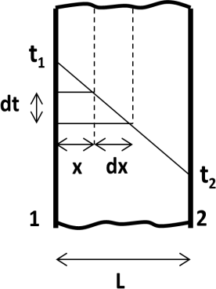
Let, L = Thickness of the plane wall,
A = Cross-sectional area of the wall,
k = Thermal conductivity of the wall material, and
t1, t2 = Temperatures maintained at the two faces 1 and 2 of the wall, respectively.
The general heat conduction equation in Cartesian coordinates is given by
d ²t + d ²t + d ²t + q = 1 × dt

dx ²
dy ²
dz ²
k α τ
dt =

d ²t

d ²t

For steady state condition τ 0 , for one dimensional flow
dy ²
=
dz ²
= 0 ,

for no internal heat generation
q = 0
k

d ²t =

Heat conduction equation can be modified as
dx ²
0 (1)

THERMAL ENGINEERING-II 46 | P a g e

Integrating the above relation twice we get: Where C1 and C2 are the constants

dt = C dx ¹

and t = C₁x + C

2 (2)

For boundary conditions: at x = 0; t = t1 at x = L; t = t2 Substituting these values in equation-1 we get: t1 = 0 + C2 and t2 = C1L + C2

⇒ C = t
and
C = t2 − t1

2 1 1 L
Substituting the values of C1 and C2 in equation-2 we get:
t = ⎛ t2 − t1 ⎞ x + t
⎜ ⎟ ₁
⎝ L ⎠
On differentiation of the above with respect to dx, we get:
dt = d ⎡⎛ t₂ − t₁ ⎞x + t ⎤ = t₂ − t₁
⎢⎜ ⎟ 1 ⎥
dx
dx ⎣⎝ L ⎠ ⎦ L
We know that; rate of heat transfer through plane wall is Q = −𝐾. A. ^{𝑑𝑡}
𝑑𝑥

Thus
Q = k A ⎛ t₁ − t₂ ⎞

⎜ ⎟
⎝ L ⎠

Explain the steady state heat conduction through hollow cylinder.
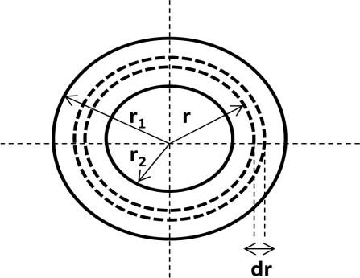
Ans) Consider a hollow cylinder made of material having constant thermal conductivity and insulated at both ends.
Let r1, r2 = Outer and inner radii respectively t1, t2 = Temperature of outer and inner
surfaces respectively
k = Constant thermal conductivity Consider an element at radius ‘r’ and thickness ‘dr’ for a length of the hollow cylinder through which heat is transmitted.
Let dt be the temperature drop over the element. Area through which heat is transmitted. A = 2π r. L

Q = −k. A. dt
dr
= −k.2π r. L. dt
dr
⇒ Q × dr = −k.2π . L..dt
r

Integrating both the sides within limits we get:
r1 dr t1 r1 dr t1

∫Q ×
r
r2
= ∫− k.2π .L.dt
t2
⇒ Q × ∫
r2
r
= −k.2π .L × ∫ dt
t2

r1 t1
2
⎛ r1 ⎞

⇒ Q(ln r)r = −k.2π.L × [t]t
⇒ Q × ln⎜ r ⎟ = −k.2π.L.(t1 − t2 ) = k.2π .L.(t2 − t1 )

2
⇒ Q = k.2π .L.(t2 − t1 )
⎛ r1 ⎞
⎝ 2 ⎠

ln ⎜ ⎟
r
⎝ 2 ⎠

Explain the steady state heat conduction through hollow cylinder.
Ans) Consider a hollow sphere made of material having constant thermal conductivity.

THERMAL ENGINEERING-II 47 | P a g e

Let r1, r2 = Outer and inner radii,
t1, t2 = Temperature of outer and inner surfaces
k = Constant thermal conductivity of the material Consider a small element of thickness dr at any radius r.
Area through which the heat is transmitted, A = 4 π r²

Q = −k. A. dt
dr
= −k.4π r ² . dt
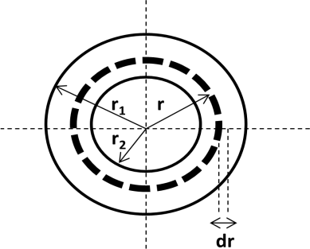
dr

⇒ Q× dr = −k.4π .dt
r 2
Integrating both the sides within limits we get:
r1 dr t1 r1 dr t1

⇒ ∫Q× 2
r
r2
= ∫ − k.4π .dt
t2
⇒ Q× ∫ 2
r2
r
= −k.4π × ∫ dt
t2

⎡ r −2+1
⎤ r1
[ ]t1
⎡ r ⁻¹ ⎤ r1
⎡1⎤ ^{r}1
[ ]t1

⇒ Q⎢− 2 + 1⎥
= −k.4π t
2
t
⇒ Q⎢ −1⎥
= − Q
⎣ r ⎦
= −k.4π t
2
t

⎣ ⎦ _{r} ⎣ ⎦ _{r} r2
2
2

⎛ 1 1 ⎞
⎢ ⎥
⎛ r2 − r1 ⎞
⎛ r1 − r2 ⎞

⇒ − Q⎜
r
− ⎟ = − Q⎜
r

r .r
⎟ = Q⎜
r .r
⎟ = −4kπ (t1 − t2 ) = 4kπ (t2 − t1 )

⎝ 1 2 ⎠ ⎝ 1 2 ⎠ ⎝ 1 2 ⎠
⇒ Q = 4π k.r1.r2 .(t2 − t1 )
(r1 − r2 )
  - The inner surface of a plane brick wall is at 60°C and the outer surface is at 35°C. Calculate the rate of heat transfer per m² of surface area of the wall, which is 220 mm thick. The thermal conductivity of the brick is 0.51 W/m°C.
Ans) Data Given:
Temperature at the inner surface (t1) = 60 ºC, temperature at the outer surface (t2) = 35 ºC thickness of wall (L) = 220 mm = 0.22 m, thermal conductivity of wall (k) = 0.51 W/m°C
Rate of heat transfer per m² of surface area (q) = Q = k ⎛ t1 − t2 ⎞
⎜ ⎟
A ⎝ L ⎠
= 0.51 ⎛ 60 − 35 ⎞ = 57.95 W / m²
⎜ 0.22 ⎟
⎝
⎠

Temperature difference on two sides of a wall measuring 5m × 4m is 25 ºC. If thermal conductivity of the material od the wall is 0.0004 kW/m ºC, determine thickness of the wall if the rate of heat flow is 5000 kJ/h.
Ans) Given Data:
Area (A) = 5×4 = 20 m² temperature difference (t1 - t2) = 25 ºC
thermal conductivity (k) = 0.0004 kW/ m ºC = 0.0004 × 3600 = 1.44 kJ/h per m ºC
Q = k A ⎛ t₁ − t₂ ⎞ ⇒ 5000 = 1.44 × 20 × 25 ⇒ L = 1.44 × 20 × 25 = 0.144 m

⎜ ⎟
⎝ L ⎠ L

5000

∴Thickness of the wall is 0.144 m.

Differentiate between the free and forced convection.
Ans) Free Convection Forced Convection

Free or Natural convection is the process | Forced convection is the process of heat
THERMAL ENGINEERING-II 48 | P a g e

of heat transfer which occurs due to movement of the fluid particles by density changes associated with temperature differential in a fluid | transfer in which the motion of the fluid generated by external sources like pump, fan, suction device etc.
When there is density difference among the heated and cooled layers of fluid, the fluid layers flow freely. | When the fluid is forced by means of external sources to flow in a device for heat transfer, it is said to be forced  convection.

Define convective heat transfer coefficient.
Ans) The coefficient of convective heat transfer may be defined as ‘‘the amount of heat transmitted for a unit temperature difference between the fluid and unit area of surface in unit time”.
Its unit is W/m² ºC.
(
)

Mathematically;
h = Q A t − t

Where: h = convective heat transfer coefficient, Q = rate of heat transfer, A = surface area, ts = surface temperature, tf = fluid temperature
s f

Define Stefan Boltzman law.
Ans) According to Stefan Boltzman’s law, the emissive power of a black body is directly
b

proportional to absolute temperature to the fourth power. i.e.
Where: Eb = total emissive power of a black body,
σ = Stefan Boltzmann constant = 5.67×10⁻⁸ W/m²K⁴
E = σAT ⁴

A = surface area of heat radiation T = absolute temperature

Explain the Max Planck’s theory of heat radiation.
Ans) According to Max Planck’s theory, monochromatic emissive power is defined as the energy emitted by the black surface in all directions at a given wavelength λ per unit wavelength interval around λ; that is, the rate of energy emission in the interval dλ is equal to (Eλ)b dλ.
2π c ²hλ⁻⁵
According to Planck’s law: (Eλ ) = ⎛ c h ⎞
⎜ eπ k T ⎟ −1
⎜ ⎟
⎝ ⎠
Where, (Eλ)b = Monochromatic (single wavelength) emissive power of a black body,
c = Velocity of light in vacuum = 3 × 108 m/s,
h = Planck’s constant = 6.625 × 10⁻³⁴ J-s, λ = Wavelength in μm,
k = Boltzmann constant = 1.3805 × 10^{–23} J/K
T = Absolute temperature in K
Hence the unit of (Eλ)b is W/m² in μm

Explain the concept of Black body heat radiation.
Ans) A black body is an object that absorbs all the radiant energy reaching its surface. A black body neither reflects nor transmits any part of the incident radiation but absorbs all of it. For a black body: absorptivity ( α ) =1, Reflectivity ( ρ ) = 0 and Transmittivity (τ ) = 0. It emits maximum
amount of thermal radiations at all wavelengths at any specified temperature. The radiation emitted

THERMAL ENGINEERING-II 49 | P a g e

by a black body is independent of direction. It absorbs all the incident radiation falling on it and does not transmit or reflect regardless of wavelength and direction.

State Kirchoff’s law of heat radiation.
Ans) The law states that at any temperature, the ratio of total emissive power (E) to the total absorptivity (α) is a constant for all substances, which are in thermal equilibrium with their environment.
Kirchhoff’s law also states that, the emissivity of a body is equal to its absorptivity when the body remains in thermal equilibrium with its surroundings.

Define total emissive power and emissivity.
Ans) Total emissive power (E): The emissive power is defined as the total amount of radiation emitted by a body per unit area and time. It is expressed in W/m².
According to Stefan Boltzmann’s law, the emissive power of a black body is directly
proportional to absolute temperature to the fourth power. i.e. E = σAT ⁴
b
Emissivity ( ε ): It is defined as the ability of the surface of a body to radiate heat. It is also defined as the ratio of the emissive power of a body to the emissive power of a black body of

equal temperature. i.e.
ε = E Eb

where: E = emissive power of a body, Eb = emissive power of a black body

Define total emissive power for a black body.
Ans) According to Stefan Boltzman’s law, the emissive power of a black body is directly
b

proportional to absolute temperature to the fourth power. i.e.
Where: Eb = total emissive power of a black body,
σ = Stefan Boltzmann constant = 5.67×10⁻⁸ W/m²K⁴
E = σAT ⁴

A = surface area of heat radiation T = absolute temperature

What is the value of emissivity for a black body, white body and grey body?
Ans) Emissivity for a black body is one, for a white body is zero and for a grey body lies between 0 and 1.

What do you mean by black body, white body and grey body?
Ans) Black body: A black body is one which neither reflects nor transmits any part of the incident radiation but absorbs all of it.
For a black body: absorptivity ( α ) =1, Reflectivity ( ρ ) = 0 and Transmittivity (τ ) = 0.
White body: If all the incident radiations falling on the body are reflected, it is called a ‘white body’.
For a white body: absorptivity ( α ) = 0, Reflectivity ( ρ ) = 1 and Transmittivity (τ ) = 0.
Grey body: If the radiative properties, α, ρ, τ of a body are assumed to be uniform over the entire wavelength spectrum, then such a body is called gray body.

Define absorptivity, reflectivity and transmittivity.
Ans) Absorptivity (α ): It is the ratio of amount of heat absorbed to total incident radiation. Reflectivity ( ρ ): It is the ratio of amount of heat reflected to total incident radiation. Transmittivity (τ ): It is the ratio of amount of heat transmitted to total incident radiation.

What is a heat exchanger? Classify it. What is its application?

Ans) A heat exchanger is the equipment which transfers the heat energy from a hot fluid to a cold fluid.
Classification: Heat exchangers are classified according to the following basis.
- On the basis of nature of heat exchange process
  - Direct contact heat exchangers
  - Indirect contact heat exchangers (Regenerators and Recuperators)
- On the basis of direction of fluid motion
  - Parallel flow heat exchangers
  - Counter flow heat exchangers
  - Crossed flow heat exchangers
- on the basis of design
  - Concentric tube type heat exchangers
  - Shell and tube type heat exchangers
- on the basis of physical state of fluid
  - Condensers
  - Evaporators
Application:
  - Intercoolers and Pre-heaters
  - Condenser and Boiler in steam power plant
  - Condenser and Evaporator in refrigeration unit
  - Oil coolers of heat engine
  - Automobile radiators
  - Air pre heater, economizer, superheater
  - Explain about the parallel flow, counter flow and cross flow heat exchangers. Ans) Parallel flow heat exchangers:
In these types of heat exchangers the hot and cold fluids both flow in a same direction.
Counter flow heat exchangers:
In these types of heat exchangers the hot and cold fluids flow in opposite directions.
Cross flow heat exchangers:
In these type of heat exchangers the hot and cold fluid flow cross wise.

REFERENCES

: Thermal engineering book (Mahesh.M Rathore)
  - : A text book of Thermal Engineering (R.S Khurmi & J K Gupta)
  - : https://youtu.be/2b0YaDrdO1I
  - : https://youtu.be/DjjbItLWNVQ
  - : https://youtu.be/rU5b3lqF3Cs

