

LECTURE NOTES
ON
THERMAL ENGINEERING –I

COMPILED BY

ER. GAGAN KUMAR SINGH

THERMAL ENGINEERING-I

3RD SEMESTER – MECHANICAL

CONTENT

Chapter  ID | Chapter Name | Page No
1 | Thermodynamic Concept and Terminology | 3-17
2 | Laws of thermodynamics | 18-26
3 | Properties and Process of perfect gases | 28-38
4 | Internal Combustion Engine | 39-43
5 | Gas Power Cycle | 44-51
6 | Fuels and Combustion | 52-54

THERMODYNAMIC CONCEPT AND TERMINOLOGY

Thermodynamics

Thermodynamics is defined as the branch of science which deals with concept of heat, work and their interconversion.

Origin

Thermodynamics is the result of man’s constant effort to convert heat into work. Developed in the nineteenth century due to joule, Clausius, Kelvin, and Carnot.
The name thermodynamics comes from the Greek words therme (heat) and dynamics (power) which is most descriptive of the early efforts to convert heat into power.
The term thermodynamics was first used in a publication by Lord Kelvin in 1849. The first textbook in thermodynamics was written in 1859 by William Rankine, a professor at the University of Glasgow.

What is Thermodynamics?

- Thermodynamics is a science dealing with energy and its transformation.
- It deals with equilibrium and feasibility of a process.
- Deals with relation between heat and work and the properties of a system. The principle of thermodynamics are summarized in four laws, they are
- Zeroth law of thermodynamics deals with thermal equilibrium and provides a means of measuring temperature.
- The first law of thermodynamics tells about the conservation of energy and introduces the concept of internal energy.
- The second law of thermodynamics shows the limit of converting internal energy into work and introduces the concept of entropy.
- The third law of thermodynamics provides a datum for the measurement of entropy.
The laws of thermodynamics cannot be directly proved. They were deduced from experimental results through logical reasoning. The validity of the laws of thermodynamics rests upon the fact that till date no experimental evidence is available to disprove them.

Application area of thermodynamics

All activities in nature involve some interaction between energy and matter; thus, it is hard to imagine an area that does not relate to thermodynamics in some manner.

Thermodynamics system System
It is defined as a definite quantity of matter or region in space considered for thermodynamic study. A system may be very simple like a gas contained in a cylinder or it may be complex like a thermal power plant. The choice of a system may differ from person performing the analysis.

Surrounding
The mass or region outside the system is called surrounding. A system can exchange energy in the form of work and heat with its surrounding.

Boundary
The real and imaginary surface that separates the system from its surrounding is called the boundary.

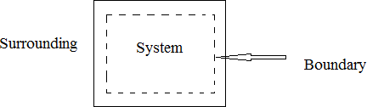

Closed System-

The closed system also known as Control Mass is one, in which the boundaries are closed so that no substance may enter or leave the system. In such a system, the mass of the substance within the system remain constant. A transfer of energy in the form of heat and work may take place at the boundaries and the volume of a closed system does not have to be fixed. Ex Sun

Open system-
The open system or a Control Volume is one where the boundaries are not closed so that both mass and energy can cross the boundary of an open system. It usually encloses a device that involves mass flow such as a compressor, turbine and nozzle.
Isolated System- It is the system, in which no mass and energy interaction takes place. Ex- universe, ice box, thermo flask.

Adiabatic System
A thermodynamic system in which mass can cross the boundary, but energy in the form of heat can’t cross the boundary is called as adiabatic system.
Ex throttle valves, water pumps, water turbines heat exchanger.

Homogeneous System
A thermodynamic system consists of single phase is called as homogeneous system.

Heterogeneous System
A thermodynamic system consists of two or more than two phases is called as heterogeneous system.

Macroscopic Approach-
In this approach a certain quantity or matter is considered without considering the events occurring at molecular level. In this approach simple mathematical formulae are required for analyzing the system. A few properties are needed to describe the system.

Microscopic Approach
In this approach a certain quantity of matter is considered with taking into account the events occurring at molecular level. In this approach advanced statistical and mathematical methods are used for analyzing the system. Large number of variables required to describe the system.

Concept of Continuum
It is the concept which explains about the continuity and homogeneity of matter in a thermodynamic system. In a continuous system the matter is present without any void in it, and it is homogeneous throughout the system. This concept is not applicable when the negligible number of molecules present in matter.

Thermodynamic Properties

The characteristic of a system is called as thermodynamic property. The properties like pressure, temperature, volume, enthalpy and entropy describes the state of thermodynamic system.
Types of properties

Intensive Properties-

The properties those are independent of the mass of a system are known as intensive properties such as temperature, pressure and density.

Extensive properties-

The properties whose value depend upon the mass of a system are called as extensive properties. Such as mass, volume and momentum.

State

A thermodynamic state is the condition of a system which is characterized by thermodynamic properties.
  - represents path where the state changes from 1 to 2

Path is the locus of series of states through which a thermodynamic process occurs.

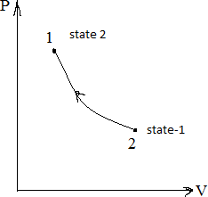

Processes

The transformation of thermodynamic system from one thermodynamic state to another is called a process.

Non Flow Process

A process undergone by a fluid in a closed system is referred as a non- flow process.

Flow Process

A process undergone by a fluid in an open system is referred as flow process.

Quasi-static Process

When a process proceeds in such a manner that the system remains almost infinitesimally close to equilibrium such a process is called a quasi-static Process.

Reversible Process

A reversible process is that, which can be take place between two states once and again act in reverse manner to reach the initial state of the system without changing the effect on the surrounding. It passes through a series of equilibrium states. Ex- frictionless relative motion, expansion and compression of spring.

Irreversible process

An irreversible process is that which can’t be reversed in the same path & also unidirectional. It passes through a series of non equilibrium states. Ex expansion, free expansion.

Adiabatic process

A process is called adiabatic process if there is no heat exchange between the system and surrounding. That is heat transfer (Q) = 0.

Isothermal Process

A Process is called isothermal process if there is no temperature change during the process. t= constant

Isobaric Process

A process is called isobaric process if there are no pressure changes during the process. P = constant

Isochoric process

A process is called process if there are no volume changes during the process. V = constant

Isentropic Process A process is called an isentropic process if there is no entropy changes during the process. i.e s = constant

Isenthalpic process

A process is called isenthalpic process if there is no enthalpy change during the process. i.e h= constant

Macroscopic Approach-

In this approach a certain quantity or matter is considered without considering the events occurring at molecular level. In this approach simple mathematical formulae are required for analyzing the system. A few properties are needed to describe the system.

Microscopic Approach

In this approach a certain quantity of matter is considered with taking into account the events occurring at molecular level. In this approach advanced statistical and mathematical methods are used for analyzing the system. Large number of variables required to describe the system.

Cycle

A cycle or cyclic process is that, in which the initial and final states of a system are identical. The cycle follows a series of process in such a way that the sequence of process begins and ends at same state.
    - represents a cycle.

Point Function

There are certain properties which depend on states but don’t depend on the these properties are called as point or state functions.
Ex Pressure, temperature, volume etc.

Path function

There are certain properties which depend upon the path between two ends state but don’t depend upon the state only. These properties are called as path function.

Thermodynamic equilibrium

Thermodynamics deals with equilibrium states. The word equilibrium implies a state of balance. That is in equilibrium state there is no unbalanced force present in a system, and the system experience no change.
There are different types of equilibrium

Thermal equilibrium

When a body is brought into contact with another body that is at a different temperature heat is transferred from a body at higher temperature to lower temperature until both bodies attain same temperature. At that point the heat transfer stops, and the two bodies are said to have reached thermal equilibrium. The equality of temperature is the only requirement for thermal equilibrium.

Mechanical equilibrium

A system is said to be in mechanical equilibrium in the absence of any unbalance force. The force is directly related to pressure. Thus if there is no pressure difference throughout the system then the system is said to be in mechanical equilibrium.

Chemical equilibrium

A system is said to be in chemical equilibrium if its chemical composition does not change with time, that is no chemical reaction occur within a system.

Phase equilibrium

If a system involves with two phases and the mass of each phase reaches an equilibrium phases and stays there it is said to be in phase equilibrium.
A system is not in thermodynamic equilibrium unless the condition of all the types of equilibrium is satisfied.

Pressure

It is defined as the normal force exerted by a fluid per unit area. We speak about pressure only when we deal with a gas or liquid. The counterpart of pressure in solids is normal stress.
Unit It has the unit of N/m² which is called a Pascal 1 Pa = 1N/m²

Three other pressure units commonly used in practice are bar, standard atmosphere and kilogram-force per square centimeter.
1 bar = 10⁵ Pa = 0.1MPa = 100kPa 1 atm= 101.325kPa, 1.01325bars 1kgf/cm² = 9.807 N/cm² = 9.807 * 10⁴ N/m² = 9.807 * 10⁴ Pa = 0.9807bar 1 torr = 1mm of hg column = 133.33 pa

Absolute Pressure

It is the actual pressure measured in a system.

Gauge Pressure It is the Positive pressure measured by the pressure gauge, when pressure is above 1 atmospheric pressure.
Vacuum Pressure It is the negative pressure measured by the pressure gauge when pressure is 1 atmospheric pressure.
Relation Pabs = Patm+ Pgauge Pabs = Patm - Vacuum

Conceptual Explanation of energy and its Sources

Definition of Energy - The capacity for doing work. It may exist in potential, kinetic, thermal, electrical, chemical, nuclear, or other various forms. There are, moreover, heat and work—i.e., energy in the process of transfer from one body to another. After it has been transferred, energy is always designated according to its nature.

Sources of Energy
Sources of energy can be classified into:

- Renewable Sources
- Non-renewable Sources
A renewable source is the natural resources that cause no impact to nature. Renewable sources of energy are available plentiful in nature and are sustainable. These resources of energy can be naturally replenished and are safe to the environment.
Examples of renewable sources of energy are: Solar energy, geothermal energy, wind energy, biomass, hydropower and tidal energy.
Non-renewable sources of energy cause impact to nature and are a limited supply source. Non- renewable sources can be extracted from the earth, and will run out as time passes.

Difference between Renewable and Non-renewable Sources of Energy

Renewable | Non-renewable
The resources that can be renewed or replaced are called renewable sources of energy. | The resources that cannot be renewed once they are consumed are called non-renewable sources of energy.
These resources do not cause any pollution to the environment. | These resources cause pollution to the environment.
Renewable resources are inexhaustible. | Non- Renewable resources are exhaustible.
Renewable resources are not affected by human activities. | Non- Renewable resources are affected by human activities.
Examples of Renewable resources- Air, water and solar energy | Examples of Renewable resources- Mineral, oil, and Coal

Natural Sources of Energy
The natural resources around us provide a variety of sources of energy around us. During the Stone Age, it was wood. During the Iron Age, we had coal. In the modern age, we have fossil fuels like petroleum and natural gas. So how do we choose sources of energy?
Good sources of energy should have the following qualities:

- Optimum heat production per unit of volume/mass used
- Easy to transport
- Least Polluting
- Economical
Earlier coal was used pretty much everywhere, from domestic used to steam engines all the way to Titanic. One problem that coal faced was transporting large amounts of coal needed all around the world. Hence, now the world over energy use is shifting towards either diesel or electricity. This example shows how petroleum is better against coal on all the above parameters.

Types of Natural Sources of Energy
There are two types of natural sources of energy classified by their popularity and use,

- Conventional Sources of Energy
- Non-Conventional Sources of Energy

Difference between Conventional and Non-Conventional Sources of Energy

Conventional | Non-conventional
The resources which have been in use for a long time. | The resources which are yet in the process of development over the past few years.
These resources are exhaustible. | These resources are inexhaustible.
These resources cause pollution as they emit smoke and ash. | These resources are usually pollution-free.
These resources are very expensive to be maintained, stored and transmitted. | These resources are less expensive due to local use and can easily be maintained.
Examples- coal, natural gas, petroleum, and water power. | Examples- solar, biomass, wind, biogas, and tidal, geothermal.

Definition of Work and heat

Work,- in physics, measure of energy transfer that occurs when an object is moved over a distance by an external force at least part of which is applied in the direction of the displacement.
Mathematically, the above statement is expressed as follows:
W = F. d

Unit of Work
The SI unit of work is the joule (J), which is defined as the work done by a force of 1 Newton in moving an object through a distance of 1 meter in the direction of the force.
Heat, energy is transferred from one body to another as the result of a difference in temperature. If two bodies at different temperatures are brought together, energy is transferred—i.e., heat flows—from the hotter body to the colder.

Unit of Heat

Units of Heat
Calorie | 1 cal | 4184 J
Joules | 1 J | 0.000239006 kcal / 0.000947817Btu
BTU | 1 Btu | 1055.06 J

 | Work (W) | Heat (Q)
Interaction | Mechanical | Thermal
Requires | Force and Displacement | Temperature difference
Process | Macroscopic pushes and pulls | Microscopic collisions
Positive value | W > 0 when a gas is compressed. Energy is transferred into system. | Q > 0 when the environment is at a higher temperature than the system. Energy is transferred into system.
Negative value | W < 0 when a gas expands. Energy is transferred out of system. | Q < 0 when the system is at a higher temperature than the environment. Energy is transferred out of system.
Equilibrium | A system is in mechanical equilibrium when there is no net force or torque on it. | A system is in thermal equilibrium when it is at the same temperature as the environment.

Work transfer and Displacement work (PdV) work
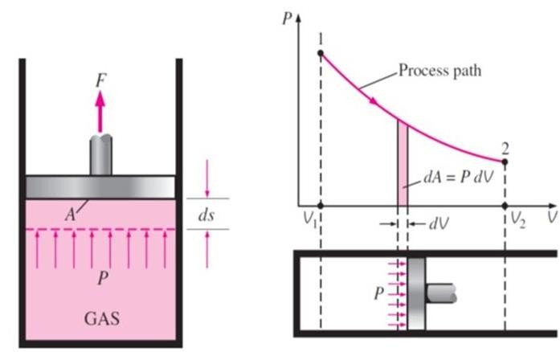
- Let us consider the following arrangement of cylinder and piston. Cylinder contained with gas and displayed here the two equilibrium state of the system by state 1 and state 2. At state 1, gas will be at high pressure and will have lower volume and state of the system is displayed here by the co-ordinate P1V1.
- Let piston moves to its final position which is displayed here as state 2. Gas will be at lower pressure and will have higher volume as compared to state 1. Condition of the system at state 2 is displayed here by the co-ordinate P2V2.

- Let us consider one intermediate point with pressure p and volume v during travelling of piston from state 1 to state 2. We must note it here that this intermediate point must also be equilibrium state as thermodynamic properties such as pressure p and volume v are only significant for equilibrium states.
- Let area of the piston is A and piston moves by infinitesimal distance ds due to the pressure force of the gas acting over the piston.

- What will be the pressure force acting over the piston? Pressure force exerted by gas over the piston will be calculated as F= P. A

- Let us concentrate the infinitesimal amount of work carried out by gas over the piston in order to move the piston by infinitesimal distance i.e. dl and it will be calculated as mentioned here

dW = F. dS = P. A.dS dW= P. (A.dS) = P.dV

- Because (A.dS) will the infinitesimal displacement volume i.e. dV

- So the Displacement work done in a closed system is W= P*dV.

CLASS ROOM PROBLEMS

      - The gauge pressure of steam in a steam generator is 2.0N/mm2 The atmospheric pressure as read by the barometer is 760mm of Hg. Find the absolute pressure in (a) N/mm2 (b) Kpa (c) Bar (d) N/m2
      - The condenser pressure as shown in the vacuum gauge is 720mm of Hg. If the atmospheric pressure is 760mm of Hg. Find the absolute pressure in the condenser in
        - mm of Hg (b) kN/m²
      - A steam generator has a gauge pressure of 100bar. The atmospheric pressure is 760mm of Hg. Find the absolute pressure of the steam in (a) Bar (b) N/m² (c) MPa (d) N/m².

REFERENCES

  - : Thermal engineering book (Mahesh.M Rathore)
  - : A text book of Thermal Engineering (R.S Khurmi & J K Gupta)
  - : Thermodynamics-I (Er. B.S. UBHI)
  - : https://youtu.be/iUEjQQtrT50
  - : https://youtu.be/v0IdjFPGcQI

LAWS OF THERMODYNAMICS

ZEROTH LAW OF THERMODYNAMICS

Zeroth law of thermodynamics tells us the concept of temperature. This law states that if two bodies are each in thermal equilibrium with a third one, then they are in thermal equilibrium with each other.

When a body ‘A’ is in thermal equilibrium with another body ‘b’, and also separately in thermal equilibrium with a body ‘C’, then body ‘B’ and ‘C’ will also be in thermal equilibrium with each other. This statement defines the Zeroth law of thermodynamics. The law is based on temperature measurement.


Zeroth Law of Thermodynamics

First Law of Thermodynamics
The first law of thermodynamics states that the quantity of the heat absorbed, when some amount of heat is given to a system that is capable of doing external work, is equal to the sum of the increase in internal energy of the system due to a rise in temperature and external work done during expansion.

The first law of thermodynamics is generally represented by the equation- U=Q-W
Where U=change in internal energy of the thermodynamic system Q=heat given to the system
W=work done on the system
Differential form of the first law of thermodynamics equation-
dU − dQ = dW

The first law of Thermodynamics is also called ‘Law of Conservation of Energy’. The law of conservation of energy states that “Energy can neither be destroyed nor be created; it can only be transferred from one form to another”

Significance of First Law of Thermodynamics
Significances that the first law of thermodynamics has are as follows-

- The relation between heat and work is established by the first law of thermodynamics.
- Both Work and Heat are equivalent to each other.
- The exact equivalent amount of energy of the surrounding will be lost or gained, if any system gains or losses energy.
- Applied heat is always equal to the sum of work done and change in internal energy.

Applications of First Law of Thermodynamics
- The first law of thermodynamics is commonly used in heat engines.

- Refrigerators are another example where the first law of thermodynamics is used.
- Sweating is a great example of the first law of thermodynamics since the heat of the body is transferred to sweat.
- When an ice cube is put in a drink, the ice cubes absorb the heat of the drink which makes it cool.

Limitations of First Law of Thermodynamics
    - The first law of thermodynamics does not state anything about the heat flow direction.

    - The process is not reversible.

STEADY FLOW ENERGY EQUATION
A flow is said to be steady flow if the properties like pressure, volume and temperature don’t vary with respect to time.
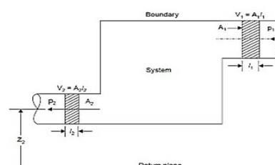
Such type of flow can be observed when a mass entering and leaving in a system is same.

Consider an open system in which the working fluid flow at a steady rate
      - The working substance enters the system at section 1-1 and leaves the system at section 2-2
      - Let M= mass flow rate of the working fluid in (kg/sec)
      - P1 and P2 are the absolute pressure of the working substance in (N/m²)
      - C1 and C2 are the velocity of the working substance (m/sec)
      - Z1 and Z2 are elevation above the datum line at entrance and exit respectively.
      - U1 and U2 are the internal energy of the working substance (J/kg)
      - Qcv – Amount of heat added to the system (J)
      - W- Work done by the system (J)
Energy in = 1 mc ² + mgz + u + Q

2 1 1 1 cv

Energy out= 1 mc ² + mgz + u + W

2 2 2 2 cv
W = −P1V1 +WCV + P2V2
Where
−P1V1 is the flow work done by the surrounding.
WCV - Work done by the control volume
P2V2 - flow work done by the system.
Since we know that energy is conserved, so inlet energy = outlet energy.
= 1 mc ² + mgz + u + Q = 1 mc ² + mgz + u + W

2 1 1 1

cv 2 2 2 2 cv

= 1 mc ² + mgz + u + Q = 1 mc ² + mgz + u − p v + W + p v

2 1 1 1
cv 2 2 2 2 1 1
cv 2 2

= u + p v + 1 mc ² + mgz + Q = u + p v + 1 mc ² + mgz +W

1 1 1 2 1 1 cv 2 2 2 2 2 2 cv

= H + 1 mc ² + mgz + Q = H + 1 mc ² + mgz + W

1 2 1 1 cv 2 2 2 2 cv
Dividing by m on both the sides

h + 1 c ² + gz
+ Qcv = h
+ 1 c ² + gz

+ Wcv

(a)

1 2 1 1 m 2 2 2 2 m

Steady flow energy equation for nozzle

Nozzle it is a device used to increase the velocity of fluid. According to SFEE

(COP)
R
= QL
Win

Win = QH − QL
(COP)R = Q − Q
QL
H L
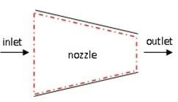

Here heat transfer Work done W=0
Qcv =0 (As perfectly insulated)

Potential energy Ep=0 (Z1=Z2=Z)
So the equation becomes

v 2 v 2
h1 + 1 = h2 + 2 (1) as V2>>V1
2 2
2
v
Then h1 = h2 + ²
2

2
v
So ² = h1 − h2
2
V2 =
2(h1 − h2 )

(1)

Second Law of Thermodynamics

Kelvin Planck Statement

It states that “It is impossible to construct a device which operates on a cycle and produces no other effect than the transfer of heat from a single body in order to produce work.” This means that it is impossible to construct an engine whose sole purpose is to convert the heat from a high-temperature source/reservoir into an equal amount of work.

Clausius Statement

It is impossible to design a device which works on a cycle and produce no other effect other than heat transfer from a cold body to a hot body.

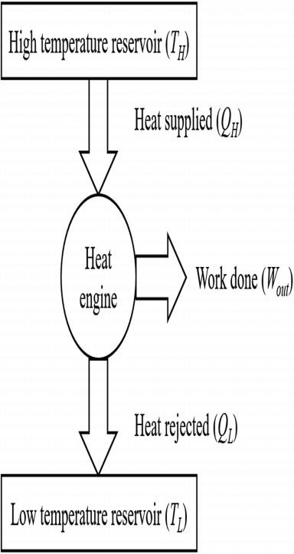
APPLICATION OF SECOND LAW OF THERMODYNAMICS

HEAT ENGINE

A heat engine is a device which operates on a cycle.
It receives heat energy from a high temperature reservoir convert some of heat energy into work and reject the remaining heat to a low temperature reservoir.
A steam power plant best fits into the definition of heat engine
It receives heat from the high temperature reservoir (Source) at TH
It converts part of heat supplied into useful work as Wnet
It rejects the remaining heat QL to a low temperature reservoir (sink) at TL The net work output of a heat engine
Wnet=Wout-Win or Wnet=QH-QL

Thermal Efficiency
It is defined as the ratio of desired output to the energy input Thermal efficiency (η_{th} ) = net work output/energy input
η = Wnet

th
Q

Or η
QH

= QH − QL

= 1 − QL (@)

th
Q
H H

HEAT PUMP
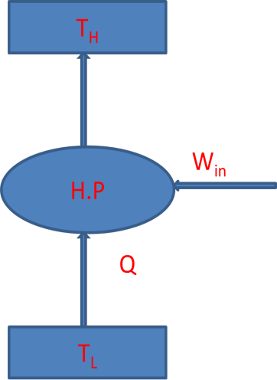
A heat pump is a device, operating in a cycle that maintains a space at a higher temperature than the surrounding.
The heat pump supply heat continuously to the controlled space and thus maintained at higher temperature than surrounding
The refrigerator and heat pump are operated on same thermodynamic cycle but they differ in their objective
The heat pump absorbs heat from low temperature surrounding and supplied it to a higher temperature space at the cost of work input to the compressor.
Let an amount of heat QL be absorbed from a low temperature region and Win be the work input. Then the heat supply QH to the room is the desired effect for a heat pump

The Co-efficient of performance of a heat pump is expressed as

(COP)HP = Heat Supplied
Work input

(COP)HP = QH
, Q = Q +W

(COP)
HP

Win

= QL + Win Win
R
H L in

(COP)
HP
= 1+ QL
Win
= 1+ (COP)
- (a)

REFRIGERATOR
A refrigerator is a device operating in a cycle that maintains a body at lower temperature than its surroundings
A refrigerator extract heat continuously from a controlled space thus it maintained at lower temperature than surroundings.
The most frequently refrigeration cycle is the vapor compression cycle. Co efficient of performance (cop)
The performance of a refrigerator is measured in term of co-efficient of performance. It is defined as the ratio of refrigerating effect to the energy input.
Consider an amount of heat QL is removed from refrigerated space at temperature TL . The work input is Win and heat rejected to consider is QH.

(COP)
R
=Refrigerating Effect Work input
= QL
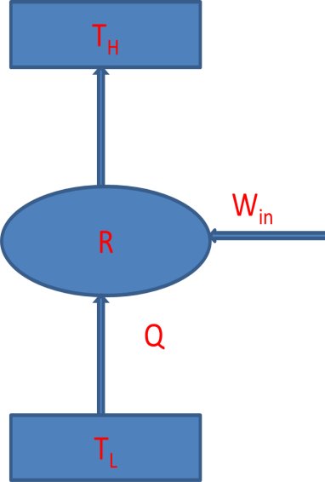
Win

Win = QH − QL

(COP)R = Q − Q (a)
QL
H L

CLASSROOM PROBLEMS

- A heat engine operates on a Carnot cycle between sources and sink temperatures of 3370C and 570C, respectively. If the heat engine receives 400KJ of heat from the source, find the efficiency, net work done and heat rejected to the sink.
- A cyclic heat engine operates between a source temperature of 8000C and a sink temperature of 300C. What is the least rate of heat rejection per KW net output of the engine?
- In a Steady-flow system, a substance flows at a rate of 5kg/s. It enters the system at a pressure of 6 bar, velocity 300m/s, internal energy 2000kj/kg and specific volume of 0.38m3/kg. It leaves the system at a pressure of 1.5bars, velocity 150m/s, internal energy 1600kj/kg and specific volume of1.26m3/kg,during its passage through the system, the substance losses80kj/kg of heat to the surroundings. Determine the power of the system, stating whether it is from or to the system. Neglect any changes in the potential energy.
- During an expansion of gas, it is observed that 10,000N.m of work is done on the piston and 7.0Kj of heat is absorbed. Calculate the work required to compress the gas to its initial condition if 2.0KJ of heat rejected to the surroundings.
- How much heat must be supplied to 1.5 kg of a gas to raise the temperature from 90⁰C to 225⁰C at constant pressure? Also find out the external work done during the supply of heat. Take Cp=10KJ/kg K, Cv=0.7128KJ/kgK.
- A closed vessel contains 2.0 kg of gas at 20⁰ C and 0.7 bar absolute pressure. Heat is supplied to the vessel till the gas acquires a pressure of 1.4 bar absolute. Find out
- Final temperature of gas
- Work done
- Heat added
- Change in internal energy.
- A gas occupies 0.35m3 at a pressure 0f 1 bar. Find out the work done on the gas if it is compressed isothermally to a pressure of 16bar.
- In a steady-flow apparatus 135kJ work is done by each kg of fluid. The specific volume of the fluid, Pressure and velocity at the inlet are 0.37m³/kg 600kpa and 16m/s, respectively. The discharge is at floor level. The discharge conditions are 0.62m³/kg, 100kpa and 270m/s. The total heat loss between inlet and outlet is 9kJ/kg of the fluid. In flowing apparatus, does the specific internal energy increase or decrease and by how much?

REFERENCES

  - : Thermal engineering book (Mahesh.M Rathore)
  - : A text book of Thermal Engineering (R.S Khurmi & J K Gupta)
  - : Thermodynamics-I (Er. B.S. UBHI)
  - : https://youtu.be/9aAZQ9-jcuY

PROPERTIES AND PROCESSES OF PERFECT GASES

LAWS OF PERFECT GASES

Boyle’s law –
It states that for a given mole of gas at a constant temperature pressure is inversely proportional to volume. Boyle’s law was put forward by the Anglo-Irish chemist Robert Boyle in the year 1662.
For a gas, the relationship between volume and pressure (at constant mass and temperature) can be expressed mathematically as follows.

P ∝ (1/V)
Where P is the pressure exerted by the gas and V is the volume occupied by it. This proportionality can be converted into an equation by adding a constant, k.

P = k*(1/V) ⇒ PV = k Charle’s law-
Charles law states that the volume of an ideal gas is directly proportional to the absolute temperature at constant pressure. The law also states that the Kelvin temperature and the volume will be in direct proportion when the pressure exerted on a sample of a dry gas is held constant.
Charles’ Law is expressed by the equation: VαT

Or
V1 = V2
T1 T2
Where,
V1 and V2 are the Initial Volumes and Final Volume respectively. T1 refers to the Initial Temperature and T2 refers to the Final Temperature. Both the temperatures are in the units of Kelvin.

Avogadro’s law
Avogadro’s law, also known as Avogadro’s principle or Avogadro’s hypothesis, is a gas law which states that the total number of atoms/molecules of a gas (i.e. the amount of gaseous substance) is directly proportional to the volume occupied by the gas at constant temperature and pressure.

At constant pressure and temperature, Avogadro’s law can be expressed via the following formula:
V ∝ n V/n = k
Where V is the volume of the gas, n denotes the amount of gaseous substance (often expressed in moles), and k is a constant. When the amount of gaseous substance is increased, the corresponding increase in the volume occupied by the gas can be calculated with the help of the following formula:
v1 = v2
n1 n2 = k, (as per Avogadro’s law).

Dalton’s law of partial pressure-
Dalton’s law of partial pressures is a gas law which states that the total pressure exerted by a mixture of gases is equal to the sum of the partial pressures exerted by each individual gas in the mixture.
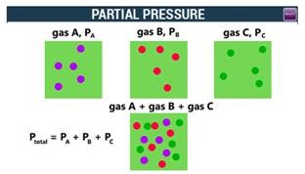

Dalton’s Law Formula
Dalton’s law of partial pressures can be mathematically expressed as follows:
n
Ptotal = ∑ pi (or) Ptotal = P1 + P2 + P3 + …. + Pn
i =1
Where,

- Ptotal is the total pressure exerted by the mixture of gases
- P1, P2,…, Pn are the partial pressures of the gases 1, 2,…, ‘n’ in the mixture of ‘n’ gases

Gay lussac’s law-
Gay-Lussac’s law is a gas law which states that the pressure exerted by a gas (of a given mass and kept at a constant volume) varies directly with the absolute temperature of the gas. In

other words, the pressure exerted by a gas is proportional to the temperature of the gas when the mass is fixed and the volume is constant.
This law was formulated by the French chemist Joseph Gay-Lussac in the year 1808. The mathematical expression of Gay-Lussac’s law can be written as follows:
P ∝ T
P = Cons tan t T
Where:
  - P is the pressure exerted by the gas.
  - T is the absolute temperature of the gas

Ideal gas equation
The Ideal gas law is the equation of state of a hypothetical ideal gas. It is a good approximation to the behaviour of many gases under many conditions, although it has several limitations. The ideal gas equation can be written as
PV = nRT

Where,

- P is the pressure of the ideal gas.
- V is the volume of the ideal gas.
- n is the amount of ideal gas measured in terms of moles.
- R is the universal gas constant.
- T is the temperature. According to the Ideal Gas equation-
The product of Pressure & Volume of a gas bears a constant relation with the product of Universal gas constant and the temperature.
i.e. PV = nRT

Universal Gas Constant (R)
When the molecular mass of any gas is multiplied by its specific gas constant (R), it is observed that the product R is always the same for all gases. This product is called universal gas constant and it is denoted as R.
Note: From the SI system the value of the universal gas constant is 8.314 kJ/mole.K

Derivation of the Ideal Gas Equation
Let us consider the pressure exerted by the gas to be ‘p,’ V= the volume of the gas be
T=Temperature
N = be the number of moles of gas

Universal gas constant – R
According to Boyle’s Law,
At constant n & T, the volume bears an inverse relation with the pressure exerted by a gas.

i.e.V ∝ 1
P

… (i)

According to Charles’ Law,

When p & n are constant, the volume of a gas bears a direct relation with the Temperature.
i.e. V ∝ T (ii)

According to Avogadro’s Law,

When p & T are constant, then the volume of a gas bears a direct relation with the number of moles of gas.
i.e. V ∝ n (iii)
Combining all the three equations, we have-
V ∝ nT
P
OR PV = nRT

Where R is the Universal gas constant, which has a value of 8.314 J/mol-K

Heat capacity –
As the body absorbs heat the temperature of the body rises, but when heat is withdrawn from the body it cools down, so the body heat decreases. The temperature of any body is the measure of its molecules’ kinetic energy. Heat capacity is the ratio of heat absorbed by a material to the temperature change. Therefore, the temperature change in a body is directly proportional to the heat transferred to the given body.

HEAT CAPACITY C, Cp, and Cv

Definition of molar heat capacity, C:
The total amount of energy in form of heat needed to increase the temperature of 1 mole of any substance by 1 unit is called molar heat capacity (C) of that substance.
It also depends greatly on the nature, size and composition of a substance in a system. q = n C ∆T
This Formula Represents:
- q is the heat supplied or needed to bring about a change in temperature (∆T) in 1 mole of any given substance
- n is the amount in moles

- The constant C is known as the molar heat capacity of the body of the given substance.

Specific heat at constant pressure ( CP )
The amount of heat energy released or absorbed by a unit mass of the substance with the change in temperature at a constant pressure. In another words, under a constant pressure it is the heat energy transfer between a system and its surrounding.

Specific heat at constant volume ( CV )
It is the amount of heat energy absorbed/released per unit mass of a substance where volume does not change. In other words, Cv is the heat energy transfer between a system and its surrounding without any change in the volume of that system.

Relationship Between Cp and Cv
According to the first law of thermodynamics:
ΔQ = ΔU + ΔW where, ΔQ is the amount of heat that is given to the system, ΔU is the change in internal energy
ΔW is the work done. We can write
ΔQ = ΔU + PΔV, as ΔW = PΔV
Since ΔQ = ncp ΔT and ΔU = ncv ΔT
Therefore ncp ΔT = ncv ΔT + PΔV (1) We know that PV = nRT
At T1 Kelvin: PV₁ = nRT₁ (a)
At T2 Kelvin: PV₂ = nRT₂ (b)
Subtracting (a) from (b):
PV₂ - PV₁ = nRT₂ - nRT₁ P (V₂ - V₁) = n R(T₂ - T₁)
Where V₂ - V₁ = ΔV and T₂ - T₁ = ΔT Therefore, PΔV = nRΔT
Putting the value of PΔV in equation (1)
ncp ΔT = ncv ΔT + nRΔT

ncp ΔT = nΔT (CV + R)
Cp = Cv + R
CP − Cv = R (A)

Non flow process:
It is the one in which there is no mass interaction across the system boundaries during the occurrence of process. Different type of non-flow process of perfect gas is given:
- Constant volume process
- Constant pressure process
- Isothermal process
- Adiabatic process
- Polytrophic process

Constant volume process (Isochoric Process)
A thermodynamic process taking place at constant volume is known as the isochoric process. It is also sometimes called as an isometric process or constant-volume process. The term isochoric has been derived from the Greek words “iso” meaning “constant” or “equal” and “choric” meaning “space” or “volume.
An isochoric process is one for which,
Vf = Vi (Δv = 0, dv = 0)
In such a process, the work done is zero (since dW = pdv = 0 when V = constant). Hence from the first law of thermodynamics
dQ = dU (isochoric process)
The total heat supplied or rejected is also equal to the increase or decrease in the internal energy of the system.

Constant Temperature process (Isothermal Process)
It is a thermodynamic process in which the temperature of the system remains constant. The transfer of heat into or out of the system happens so slowly that thermal equilibrium is maintained.
We know an isothermal process is the one in which the pressure and volume of the gas changes at constant temperature.
Hence ΔT = 0
The total work done by a gas in expanding from V1toV2
v2
W = ∫ Pdv
v1 (1)
By ideal gas law PV = RT

Therefore,
P = RT
V

Hence by substituting the value of P in equation -- (1)
v2 dv
W = RT ∫
v
v1
Since ‘R’ is universal gas constant and ‘T’ is also constant because it is isothermal process, we can simplify the equation as
v2 dv
W = RT ∫
v
v1

Since, 1dx = log x
∫
x e
the equation can be simplified further as,

W = RT [log

V ]V2
1
e V

W = RT [log V −log V ] Or W = 2.306RT log V2
e 2 e 1 10
V
1

Constant Pressure process (Isobaric Process)
An Isobaric process is a thermodynamic process taking place at constant pressure. The term isobaric has been derived from the Greek words “iso” and “baros” meaning equal pressure. As such, the constant pressure is obtained when the volume is expanded or contracted.
In an isobaric process, when the heat is transferred to the system some work is done. However, there is also a change in the internal energy of the system

Work done in Constant Pressure Process
An isobaric process is also called constant pressure process.

p f = pi (ΔP = 0 and dP = 0)

v f
The work done is found from the equation; W = ∫ PdV
vi

Since the pressure is constant in an isobaric process, the integral becomes

v f
W = ∫ PdV ,

vi
0

Pi (Vf −Vi ) = Pi ΔV


If the gas expands, Vf
Vi , so ΔV
and the work done by the gas is positive.

Adiabatic Process
An adiabatic process is defined as
The thermodynamic process in which there is no exchange of heat from the system to its surrounding neither during expansion nor during compression.

Reversible Adiabatic Process
Reversible adiabatic process is also called an Isentropic Process. It is an idealized thermodynamic process that is adiabatic and in which the work transfers of the system are frictionless; there is no transfer of heat or of matter and the process is reversible. Such an idealized process is useful in engineering as a model of and basis of comparison for real processes.

What is Adiabatic Expansion
Adiabatic expansion is defined as an ideal behaviour for a closed system, in which the pressure is constant and the temperature is decreasing.

What is Adiabatic Compression
Adiabatic compression of the air is defined as the compression in which no heat is added or subtracted from the air and the internal energy of the air is increased which is equal to the external work done on the air. The pressure of the air is more than the volume as the temperature increases during compression.

Derive an expression for work done in adiabatic expansion

In adiabatic process PV ^{γ} = K
So P = KV ^{−γ}
Work done W = ∫ Pdv
Or W = ∫ KV ^{−γ} dv

⎡V −γ +1 ⎤V2
Or ∫W = K × ⎢ 1− γ ⎥
⎣ ⎦_{V}
1

Or W = K × ⎡⎣V ^{−γ} ⁺¹ −V ^{−γ} ⁺¹ ⎤⎦
1− γ ² ¹

Or W = 1 × ⎡⎣KV ^{−γ} ⁺¹ − KV ^{−γ} ⁺¹ ⎤⎦
1− γ ² ¹

Or W = 1 × ⎡⎣PV ^{γ}V ^{−γ} ⁺¹ − PV ^{γ}V ^{−γ} ⁺¹ ⎤⎦ Or W = P2V2 − P1V1 (A)

1− γ
2 2 2 1 1 1
1− γ

Polytropic Process
A polytropic process is any thermodynamic process that can be expressed by the following equation:
PV ^{n} = Cons tan t

The polytropic process can describe gas expansion and compression which include heat transfer. The exponent n is known as the polytropic index and it may take on any value from 0 to ∞, depending on the particular process.
There are some special cases of n, which corresponds to particular processes:
- The case n = 0, p= constant, corresponds to an isobaric (constant-pressure) process.
- The case n= 1, pV=constant, corresponds to an isothermal (constant-temperature) process.
- The case n =, pV = constant, corresponds to an isentropic (constant-entropy) process.
- The case n ➝ ∞ corresponds to an isochoric (constant-volume) process.

Work done in polytropic process

In Polytropic process PV ^{n} = K

So P = KV ^{−n}
Work done W = ∫ Pdv
Or W = ∫ KV ^{−n}dv

⎡V −n+1 ⎤V2
∫
Or W = K × ⎢ 1− n ⎥
⎣ ⎦_{V}
1

Or W = K × ⎡⎣V ^{−n+1} −V ^{−n+1} ⎤⎦
1− n ² ¹
Or W = 1 × ⎡⎣KV ^{−n+1} − KV ^{−n+1} ⎤⎦
1− n ² ¹

Or W = 1 × ⎡⎣PV ^{n}V ^{−n+1} − PV ^{n}V ^{−n+1} ⎤⎦

1− n
2 2 2 1 1 1

Or W = P2V2 − P1V1 (A)
1− n

Free Expansion and Throttling Process Throttling Process
This is an expansion process at constant enthalpy. That it exists in refrigeration and air-
conditioning. The liquid throttles in the expansion valve. Further, process exists in the liquefaction of gases. Throttling is an irreversible process. No work is obtainable with decrease of pressure. Thus, it is not a useful process. This expansion is not possible in a turbine because of phase change in throttling.

Free Expansion Process
In free expansion process gas is allowed to expand in vacuum. This is happened quickly so there is no heat transferred and no work is done because the gas doesn’t displace anything. There is also no change in internal energy so temperature doesn’t change.

CLASSROOM PROBLEMS

- A 2.5 m³ of gas at 8 bar pressure expand at constant temperature to a volume of 10 m³. Find the final pressure of gas.
- The state of a quantity of gas enclosed in a gas engine cylinder, at the beginning of compression is, volume0.05m³, temperature 80⁰ C and pressure 0.98 bar. What will be the temperature after the volume is reduced to 0.014m³ and the pressure raised to 7.35 bar, at the compression.
- Find the volume occupied when a given quantity of gas exists at a temperature of 400⁰C, if the volume of this quantity of gas at 0⁰C is 0.57m³, the pressure being same at both temperature.

- How much heat must be supplied to 1.5 kg of a gas to raise the temperature from 90⁰C to 225⁰C at constant pressure? Find also the external work done during the supply of heat. The specific heat at constant pressure is 1.0Kj/kg k and at constant volume is 0.7128 Kj/kg k.
- A gas occupies a volume of 0.1m³ at a temperature of 20⁰C and a pressure of 1.5 ba. Find the final temperature of gas if it is compressed at a pressure of 7.5 bar and occupies a volume of 0.04m³.

- A closed vessel contains 2kg of carbon dioxide at a temperature of 20⁰C and pressure of 0.7 bar. Heat is supplied to the vessel till the gas acquires a pressure 0f 1.4 bar. Calculate
  - Final Temperature
  - Work done on or by the gas
  - Heat added
  - Change in internal energy.

REFERENCES

  - : Thermal engineering book (Mahesh.M Rathore)
  - : A text book of Thermal Engineering (R.S Khurmi & J K Gupta)
  - : Thermodynamics-I (Er. B.S. UBHI)

INTERNAL COMBUSTION ENGINE

Internal Combustion (I.C) engine:
    - When the combustion of fuel supplied to the engine takes place inside the engine cylinder, the engine is called as an internal combustion engine.
    - Examples – 2-stroke and 4-stroke petrol and diesel engines.

Terminology:
    - Bore: It is the diameter of the engine cylinder or piston.
    - Stroke: It is the distance moved by piston between two dead centres.
    - Swept volume: It is the maximum volume swept by the piston when it moves from one dead centre to another.
    - Compression ratio: It is the minimum volume between the cylinder head and top of the piston when the piston is at the top dead centre.
    - Air standard efficiency: It is ratio between work done and heat supplied for air standard cycle.

Main Components of I.C engine:
The main components of an I.C engine are cylinder, cylinder head, piston, piston rings, connecting rod, crank, crank shaft and flywheel.

Classification of I.C engine:
The classification of I.C engine is as follows:
    - According to number of strokes:
      - Four stroke engine
      - Two stroke engine
    - According to fuel used
      - Petrol engine
      - Diesel engine
      - Gas engine
    - According to method of ignition
      - Spark ignition engine
      - Compression ignition engine
    - According to cooling system
      - Air cooled engine
      - Water cooled engine
    - According to number of cylinder
- Single cylinder engine
- Multi cylinder engine
  - According to speed of engine
    - Low speed engine
    - Medium speed engine
    - High speed engine

Difference between Petrol engine and Diesel engine:
Petrol engine Diesel engine

1. | Air fuel mixture is drawn into the engine cylinder in suction stroke. | 1. | Only Air mixture is drawn into the engine cylinder in suction stroke.
2. | The carburetor is used to mix air and petrol in a proper ratio. | 2. | Fuel injector is used to inject fuel.
3. | Pressure at the end of compression is about 10 bar. | 3. | Pressure at the end of compression is about 35 bar.
4. | The air fuel mixture is ignited by using the spark plug. | 4. | Mixture is self ignited at high compression ratio.
5. | Combustion of fuel takes place at constant volume. | 5. | Combustion of fuel takes place at constant pressure.
6. | It has compression ratio approximately 6 to 10. | 6. | It has compression ratio approximately 15 to 25.
7. | It has easy starting. | 7. | Its starting is difficult.
8. | It is lighter and cheaper. | 8. | It is heavier and costlier.
9. | Its running cost is high. | 9. | Its running cost is low.
10. | Its maintenance cost is less. | 10. | Its maintenance cost is high.
11. | It has thermal efficiency up to 26%. | 11. | It has thermal efficiency up to 40%.
12. | It is used in light vehicles. | 12. | It is used in heavy vehicles.
Difference between 2-stroke and 4-stroke engine:
2-Stroke engine 4-Stroke engine

1. | Two stroke engines give one power stroke for each revolution of crank. | 1. | Four stroke engines give one power stroke for every two revolutions of crank.
2. | Power produced by this engine is almost double than four stroke cycle engine. | 2. | Power produced by this engine is almost half than two stroke cycle engine.
3. | To produce same power it requires less space. | 3. | To produce same power it requires more space.
4. | It has inlet, exhaust and transfer ports. | 4. | It has inlet and outlet valves.
5. | Its thermal efficiency is low. | 5. | Its thermal efficiency is high.

6. | It requires lighter fly wheels. | 6. | It requires larger flywheels.
7. | It is used in light vehicles. | 7. | It is used in light, medium and heavy vehicles.
8. | Its initial cost is less. | 8. | Its initial cost is high.

Indicated horse Power of I.C engine:
Indicated power is defined as the rate of work done on the piston by the combustion of charge inside the engine cylinder. Indicated power in terms of horse power is called as Indicated horse power.
Mathematically: I.P = Pm LAnk
60

Brake horse power of I.C engine:
It is the net power available at the engine shaft. Brake power in terms of horse power is called as Brake horse power.

Mathematically: B.P = 2πRNF
60
= 2πNT
60

Mechanical efficiency of I.C engine:
It is defined as the ratio of brake power to the indicated power or I.H.P to B.H.P.

Four stroke Cycle Petrol Engine:
It is also known as Otto cycle. It requires four strokes of the piston to complete one cycle of operation in the engine cylinder. The four stroke of a petrol engine sucking fuel air mixture (petrol and Air operation with proportionate quantity of air in the carburetor known as charge) are described below:

Suction or charging stroke
In this stroke, the inlet valve opens and charge is sucked into the Cylinder as the piston moves downward from top dead centre (T.D.C). It continues till the piston reaches Its bottom dead centre (B.D.C).

Compression stroke
In this stroke, both the inlet and exhaust valves are closed and charge is compressed as the piston moves upwards from B.D.C. to T.D.C. As a result of compression the pressure and temperature of the charge increases considerably (the actual values depend upon compression ratio). This completes one revolution of the crankshaft.

Expansion or working stroke
Shortly before the piston reaches T.D.C. (during compression stroke), the charge is ignited with the help of a spark plug. It suddenly increases the pressure temperature of the products of combustion but the volume, practically, remains constant. due to rise in pressure. The piston is pushed down with a great force. The hot burnt gases expand due high speed of the piston. During this expansion, some of the heat energy produced is transformed mechanical work. It may be noted that during this working stroke both valves are closed and piston moves from T.D.C. to B.D.C.

- Exhaust stroke
In this stroke, the exhaust valve is open as piston moves from B.D.C to T.D.C. This movement of the piston pushes out the products of combustion, from the engine cylinder and are exhausted through the exhaust valve into the atmosphere.
Now the cycle completes and the engine cylinder is ready to suck the charge again

Four stroke Cycle Diesel Engine

It is also known as compression ignition engine because the ignition takes place due to the compression produced in the engine cylinder at the end of compression stroke. The four strokes of a diesel engine sucking pure air are described below :

Suction or charging stroke
In this stroke, the inlet valve opens and pure air is sucked into the cylinder as the piston moves downwards from the top dead centre {TDC). It continues till the piston reaches its bottom dead centre {BDC).

Compression stroke
In this stroke, both the valves are closed and the air is compressed as the piston moves upwards from BDC to TDC. As a result of compression, pressure and temperature of the air increases considerably (the actual value depends upon the compression ratio). This completes one revolution of the crank shaft.

Expansion or working stroke
Shortly before the piston reaches the TDC (during the compression stroke), fuel oil is injected in the form of very fine spray into the engine cylinder, through the nozzle, known as fuel injection valve. At this moment, temperature of the compressed air sufficiently high to ignite the fuel. It suddenly increases the pressure and temperature of the producer of combustion. The fuel oil is continuously injected for a fraction of the revolution. The fuel oil assumed to be burnt at constant pressure. Due to increased pressure, the piston is pushed down with a great force. The hot burnt gases expand due to high speed of the piston. During this expansion, some of the heat energy is transformed into mechanical work

5. Exhaust stroke
In this stroke, the exhaust valve is open as the piston moves from BDC to TDC. This movement of the piston pushes out the products of combustion from the engine cylinder through the exhaust valve into the atmosphere. This completes the cycle and the engine cylinder ready to suck the fresh air again.

REFERENCES

  - : Thermal engineering book (Mahesh.M Rathore)
  - : A text book of Thermal Engineering (R.S Khurmi & J K Gupta)
  - : Thermodynamics-I (Er. B.S. UBHI)
  - : https://youtu.be/vIJ50aUiBgM
  - : https://youtu.be/fw8Jfoif1BM
  - : https://youtu.be/Pu7g3uIG6Zo
  - : https://youtu.be/OiX9oXvxZWs
  - : https://youtu.be/FEyXPIQvuyY

GAS POWER CYCLES

What is air standard cycle? Give some examples.
Ans) A thermodynamic cycle which works with working substance air is known as air standard cycle. Examples – Otto cycle, Diesel cycle, Dual cycle etc.

What do you mean by Internal combustion engine? Give some examples.
Ans) When the combustion of fuel supplied to the engine takes place inside the engine cylinder, the engine is called as an internal combustion engine.
Examples – 2-stroke and 4-stroke petrol and diesel engines.

Define the terms – (i) Bore, (ii) Stroke, (iii) Swept volume, (iv) Compression ratio,
(v) Mean effective pressure, (vi) Air standard efficiency, (vii) Relative efficiency. Ans) Bore: It is the diameter of the engine cylinder or piston
Stroke: It is the distance moved by piston between two dead centres.
Swept volume: It is the maximum volume swept by the piston when it moves from one dead centre to another.
Compression ratio: It is the minimum volume between the cylinder head and top of the piston when the piston is at the top dead centre.
Mean effective pressure: It is the maximum pressure acting on the piston during the working stroke. Mathematically it is the ratio between work done and swept volume.
Air standard efficiency: It is ratio between work done and heat supplied for air standard cycle.
Relative efficiency: It is the ratio between actual thermal efficiency and air standard efficiency.

What are the main components of an I.C engine.
Ans) The main components of an I.C engine are cylinder, cylinder head, piston, piston rings, connecting rod, crank, crank shaft and flywheel.

Explain the Otto cycle with its P-V and T-s diagram and determine the air standard efficiency of the cycle.
Ans) Otto cycle is an air standard cycle. It is used in S.I engines. Air fuel mixture is used as the working substance. It is also known as constant volume cycle. The P-V diagram of the cycle is shown in the following figure.
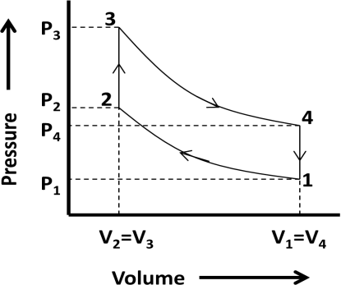
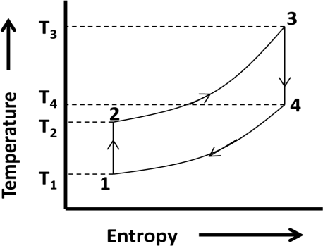
Otto cycle is consisting of four processes as described below.

T H E R M A L E N G I N E E R I N G - I P a g e | 44

Process 1-2: This process is a reversible adiabatic or isentropic compression process. In this process, the working substance is compressed in the engine cylinder when the piston moves from bottom dead centre to top dead centre. At constant entropy, pressure increases from P1 to P2, temperature increases from T1 to T2 and volume decreases from V1 to V2. There is no heat absorbed or rejected in this process.
Process 2-3: This process is a constant volume heating process. In this process, the working substance is heated in the engine cylinder when the piston reaches the top dead centre. At constant volume, pressure increases from P2 to P3, temperature increases from T2 to T3 and entropy increases from s2 to s3.
Heat absorbed by working substance = Q2−3 = mcv (T3 − T2 )
Process 3-4: This process is a reversible adiabatic or isentropic expansion process. In this process, the working substance expands in the engine cylinder after heating and piston moves from top dead centre to bottom dead centre. At constant entropy, pressure decreases from P3 to P4, temperature decreases from T3 to T4 and volume increases from V3 to V4. There is no heat absorbed or rejected in this process but mechanical work is obtained.
Process 4-1: This process is a constant volume cooling process. In this process, the burnt working substance is exhausted out from cylinder and fresh working substance enters. Piston moves from the top dead centre to bottom dead centre. At constant volume, pressure decreases from P4 to P1, temperature decreases from T4 to T1 and entropy decreases from s4 to s1.
Heat rejected by working substance = Q4−1 = mcv (T4 − T1 ) Air standard efficiency of Otto cycle:
Work done during the cycle = W = heat absorbed – heat rejected
= mcv (T3 − T2 )− mcv (T4 − T1 )
Heat absorbed by working substance = Q2−3 = mcv (T3 − T2 )
Air standard efficiency = η = Work done = mcv (T3 − T2 )− mcv (T4 − T1 )

Heat absorbed
= 1 − T4 − T1
T3 − T2

mcv (T3 − T2 )
…………………………………. (1)

We know that, compression or expansion ratio =
r = V1
V2
= V4 V3

T ⎛ V

⎞γ −1

⎛ 1 ⎞γ −1

For process 1-2,
1 = ⎜ 2 ⎟
= ⎜ ⎟

T2 ⎝ V1 ⎠
⎝ r ⎠

T ⎛ V

⎞γ −1

⎛ 1 ⎞γ −1

For process 3-4,
4 = ⎜ 3 ⎟
= ⎜ ⎟

From above, we get
T3 ⎝ V4 ⎠
T1 = T4 T2 T3
⎝ r ⎠
⇒ T = T1T3
T
4
2

Replacing the value of T4 in equation we get,

T H E R M A L E N G I N E E R I N G - I P a g e | 45

T1T3 − T

T1T3 − T1T2

T1 (T3 − T2 )

T − T T ¹ T T
Efficiency = η = 1 − ⁴ ¹ = 1 − ² = 1 − ² = 1 − ²

T3 − T2
T (T − T )
T3 − T2
T
T3 − T2
⎛ 1 ⎞γ −1
T3 − T2

= 1 − ¹ ( 3 2 ) = 1 − ¹ = 1 − ⎜ ⎟

T2 T3 − T2
T2 ⎝ r ⎠

…………………….. (2)
∴ Air standard efficiency for Otto cycle = η _{Otto} = 1 − (r )γ −1
1

Explain the Diesel cycle with its P-V and T-s diagram and determine the air standard efficiency of the cycle.
Ans) Diesel cycle is an air standard cycle. It is used in C.I engines. Air is used as the working substance. It is also known as constant pressure cycle. The P-V diagram of the cycle is shown in the following figure.
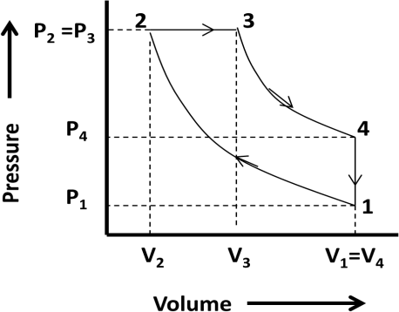
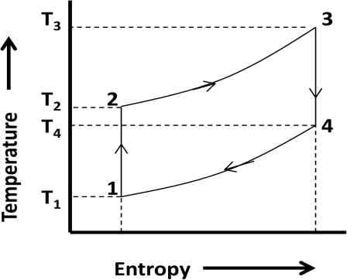
Diesel cycle is consisting of four processes as described below.
Process 1-2: This process is a reversible adiabatic or isentropic compression process. In this process, the working substance is compressed in the engine cylinder when the piston moves from bottom dead centre to top dead centre. At constant entropy, pressure increases from P1 to P2, temperature increases from T1 to T2 and volume decreases from V1 to V2. There is no heat absorbed or rejected in this process.
Process 2-3: This process is a constant pressure heating process. In this process, the working substance is heated in the engine cylinder when the piston reaches the top dead centre. At constant pressure, volume increases from V2 to V3, temperature increases from T2 to T3 and entropy increases from s2 to s3.
Heat absorbed by working substance = Q2−3 = mcp (T3 − T2 )
Process 3-4: This process is a reversible adiabatic or isentropic expansion process. In this process, the working substance expands in the engine cylinder after heating and piston moves from top dead centre to bottom dead centre. At constant entropy, pressure decreases from P3 to P4, temperature decreases from T3 to T4 and volume increases from V3 to V4. There is no heat absorbed or rejected in this process but mechanical work is obtained.
Process 4-1: This process is a constant volume cooling process. In this process, the burnt working substance is exhausted out from cylinder and fresh working substance enters. Piston moves from the top dead centre to bottom dead centre. At constant volume, pressure decreases from P4 to P1, temperature decreases from T4 to T1 and entropy decreases from s4 to s1.

T H E R M A L E N G I N E E R I N G - I P a g e | 46

Heat rejected by working substance = Q4−1 = mcv (T4 − T1 ) Air standard efficiency of Diesel cycle:

Work done during the cycle = W = heat absorbed – heat rejected = mcp (T3 − T2 ) − mcv (T4 − T1 )
Heat absorbed by working substance = Q2−3 = mcp (T3 − T2 )

Work done
mcp (T3 − T2 ) − mcv (T4 − T1 )

Air standard efficiency = η = =
Heat absorbed

mcp (T3 − T2 )

cv ⎛ T4 − T1 ⎞
1 ⎛ T4 − T1 ⎞
⎛ c_{p} ⎞

= 1−
c
⎜
T − T
⎟ = 1 − γ ⎜ T − T ⎟
………. (1)
⎜ = γ ⎟
c

p ⎝ 3 2 ⎠
⎝ 3 2 ⎠
⎝ v ⎠

We know that, compression ratio = r = V1
V2

cut-off ratio =
ρ = V3
V2

expansion ratio = r
= V4
= V1
= V1 × V2 = r

V3 V3
1
V2 V3 ρ

T ⎛ V

⎞γ −1

⎛ 1 ⎞γ −1

For process 1-2,
1 = ⎜ 2 ⎟
= ⎜ ⎟ ⇒ T = T r^{γ} ⁻¹
… (i)

T2 ⎝ V1 ⎠
⎝ r ⎠ 2 1

For process 2-3,
V2 = V3

⇒ T = T
× V3

= T ρ = T ρ r^{γ} ⁻¹
2
1

…….. (ii)

T2 T3

T ⎛ V

⎞γ −1
3

⎛ 1 ⎞γ −1

V2
2

⎛ ρ ⎞γ −1

For process 3-4,
4 = ⎜ 3 ⎟
= ⎜ ⎟
= ⎜ ⎟

T3 ⎝ V4 ⎠
⎝ r1 ⎠
⎝ r ⎠

⎛ ρ ⎞γ −1 ⎛ ρ ⎞γ −1

⇒ T = T ⎜ ⎟ = T ρ r ^{γ} ⁻¹⎜ ⎟ = T ρ ^{γ}
… (iii)

4 3 ⎝ r ⎠ 1 ⎝ r ⎠ 1
Replacing the value of T2, T3 and T4 in equation-1 we get,

1 ⎛ T
− T ⎞
1 ⎛ T ρ^{γ} − T ⎞
1 ⎛ ρ^{γ} −1 ⎞

Efficiency = η = 1 −
⎜ ⁴ ¹ ⎟ = 1−
⎜ ¹ ¹ ⎟ = 1 − ⎜ ⎟

γ ⎜ T − T ⎟
γ ⎜ T
ρ r^{γ} ⁻¹ − T
rγ −1 ⎟
γ ⎜ ρ rγ −1 − rγ −1 ⎟

⎝ 3 2 ⎠ ⎝ 1
1 ⎡ ρ^{γ} −1 ⎤
1 ⎠ ⎝ ⎠

= 1 − γ ⎢ r^{γ} ⁻¹ (ρ −1)⎥
⎣ ⎦
∴ Air standard efficiency for Diesel cycle = η
diesel
= 1 −
1 ⎡ ρ −1 ⎤
γ
r γ (ρ −1
γ −
1
⎢
⎣
)
⎥
⎦
…………….. (2)

Explain the Dual cycle with its P-V and T-s diagram.
Ans) Dual cycle is an air standard cycle which is a combination of Otto and Diesel cycle. The processes of this cycle are shown in the following P-V and T-s diagram.

T H E R M A L E N G I N E E R I N G - I P a g e | 47

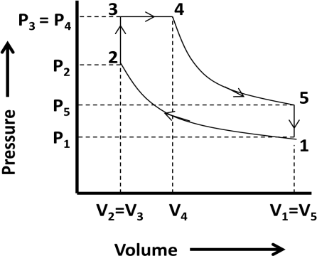
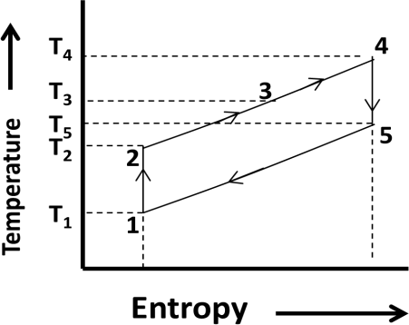
Dual cycle is consisting of five processes as described below.
Process 1-2: This process is a reversible adiabatic or isentropic compression process. In this process, the working substance is compressed in the engine cylinder when the piston moves from bottom dead centre to top dead centre. At constant entropy, pressure increases from P1 to P2, temperature increases from T1 to T2 and volume decreases from V1 to V2. There is no heat absorbed or rejected in this process.
Process 2-3: This process is a constant volume heating process. In this process, the working substance is heated in the engine cylinder when the piston reaches the top dead centre. At constant volume, pressure increases from P2 to P3, temperature increases from T2 to T3 and entropy increases from s2 to s3.
Heat absorbed by working substance = Q2−3 = mcv (T3 − T2 )
Process 3-4: This process is a constant pressure heating process. In this process, the working substance is heated in the engine cylinder when the piston moves down from the top dead centre. At constant pressure, volume increases from V2 to V3, temperature increases from T3 to T4 and entropy increases from s3 to s4.
Heat absorbed by working substance = Q3−4 = mcp (T4 − T3 )
Process 4-5: This process is a reversible adiabatic or isentropic expansion process. In this process, the working substance expands in the engine cylinder after heating and piston moves from top dead centre to bottom dead centre. At constant entropy, pressure decreases from P4 to P5, temperature decreases from T4 to T5 and volume increases from V4 to V5. There is no heat absorbed or rejected in this process but mechanical work is obtained.
Process 5-1: This process is a constant volume cooling process. In this process, the burnt working substance is exhausted out from cylinder and fresh working substance enters. Piston moves from the top dead centre to bottom dead centre. At constant volume, pressure decreases from P5 to P1, temperature decreases from T5 to T1 and entropy decreases from s5 to s1.
Heat rejected by working substance = Q5−1 = mcv (T5 − T1 )

Compare between the Otto, Diesel and Dual cycles
Ans) The comparison between the Otto, Diesel and Dual cycle can be studied from the following combined P-V and T-s diagram. Consider the equal compression ratio and heat input.

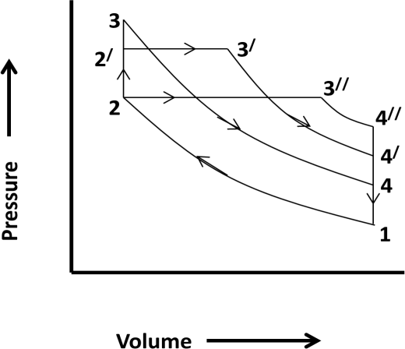
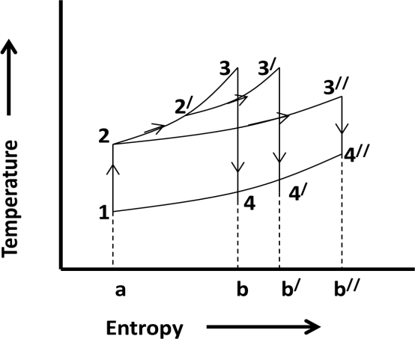
- In the above P-V and T-s diagram Otto cycle is represented by 1-2-3-4, Diesel cycle is represented by 1-2-3//-4// and Dual cycle is represented by 1-2-2/-3/-4/ respectively.
- All cycles are starting from point 1 at same pressure, temperature and volume.
- All cycles have same adiabatic or isentropic compression process 1-2.
- All cycles are differing with different heat supply conditions. But same amount of heat is supplied to each cycle
- The cycle which rejects least amount of heat is more efficient.
- In T-s diagram, the heat rejected by Otto cycle. Diesel cycle and dual cycle is given by the area a-1-4-b, a-1-4//-b// and a-1-4/-b/ respectively.
- As the area occupied by Otto cycle is least, it has maximum thermal efficiency.
- As the area occupied by diesel cycle is more, it has minimum thermal efficiency.
- It is concluded that, η Otto > η Diesel > η Dual
  - State the difference between the 2 stroke and 4 stroke engines.

Ans) 2-Stroke engine 4-Stroke engine

1. | Two stroke engines give one power  stroke for each revolution of crank. | 1. | Four stroke engines give one power stroke  for every two revolutions of crank.
2. | Power produced by this engine is  almost double than four stroke cycle engine. | 2. | Power produced by this engine is almost half than two stroke cycle engine.
3. | To produce same power it requires less space. | 3. | To produce same power it requires more space.
4. | It has inlet, exhaust and transfer ports. | 4. | It has inlet and outlet valves.
5. | Its thermal efficiency is low. | 5. | Its thermal efficiency is high.
6. | It requires lighter fly wheels. | 6. | It requires larger flywheels.
7. | It is used in light vehicles. | 7. | It is used in light, medium and heavy  vehicles.
8. | Its initial cost is less. | 8. | Its initial cost is high.

  - State the difference between the 2 stroke and 4 stroke engines.

Ans) Petrol engine Diesel engine

1. | Air fuel mixture is drawn into the  engine cylinder in suction stroke. | 1. | Only Air mixture is drawn into the engine  cylinder in suction stroke.
2. | The carburetor is used to mix air and petrol in a proper ratio. | 2. | Fuel injector is used to inject fuel.
3. | Pressure at the end of compression is about 10 bar. | 3. | Pressure at the end of compression is about 35 bar.

4. | The air fuel mixture is ignited by using  the spark plug. | 4. | Mixture is self ignited at high compression  ratio.
5. | Combustion of fuel takes place at constant volume. | 5. | Combustion of fuel takes place at constant pressure.
6. | It has compression ratio approximately 6 to 10. | 6. | It has compression ratio approximately 15 to 25.
7. | It has easy starting. | 7. | Its starting is difficult.
8. | It is lighter and cheaper. | 8. | It is heavier and costlier.
9. | Its running cost is high. | 9. | Its running cost is low.
10. | Its maintenance cost is less. | 10. | Its maintenance cost is high.
11. | It has thermal efficiency up to 26%. | 11. | It has thermal efficiency up to 40%.
12. | It is used in light vehicles. | 12. | It is used in heavy vehicles.

CLASS ROOM PROBLEMS
  - The efficiency of an Otto cycle is 60% and γ = 1.5. What is the compression ratio?

  - A certain quantity of air at a pressure of 1 bar and temperature of 70°C is compressed adiabatically until the pressure is 7 bar in Otto cycle engine. 465 kJ of heat per kg of air is now added at constant volume. Determine :
    - Compression ratio of the engine.
    - Temperature at the end of compression.
    - Temperature at the end of heat addition. Take for air cp = 1.0 kJ/kg K, cv = 0.706 kJ/kg K.
  - A diesel engine has a compression ratio of 15 and heat addition at constant pressure takes place at 6% of stroke. Find the air standard efficiency of the engine. Take γ for air as 1.4.
  - In an ideal Diesel engine the temperature at the beginning and end of compression are 57⁰ C and 603⁰ C respectively. The temperature at the beginning and end of expansion is 1950⁰ C and 870⁰ C respectively. Determine the ideal efficiency of the cycle γ = 1.4. If the compression ratio is 14 and the pressure at the beginning of the compression is 1 bar, calculate the maximum pressure in the cycle.

ASSIGNMENT PROBLEMS

  - In an Otto cycle the temperature at the beginning and end of the isentropic compression are 316 K and 596 K respectively. Determine the air standard efficiency and the compression ratio Take γ = 1.4.
Q.6) An engine working on the Otto cycle has a cylinder diameter of 150 mm and a stroke of
225 mm. The clearance volume is 1.25 × 10⁻³ m³. Find the air standard efficiency of this engine. Take γ = 1.4.
  - An engine of 250 mm bore and 375 mm stroke works on Otto cycle. The clearance volume is 0.00263 m³. The initial pressure and temperature are 1 bar and 50°C. If the maximum pressure is limited to 25 bar, find the air standard efficiency of the cycle. Assume the ideal conditions.
  - A certain quantity of air at a pressure of 1 bar and temperature 70⁰ C is compressed reversibly and adiabatically until the pressure is 7 bar in an Ottocycle engine.460 kJ of heat per kg of air is now added at constant volume. Determine: (i) compression ratio of the engine, (ii) temperature at the end of compression, (iii) temperature at the end of heat addition.
Take Cp = 1 kJ/kg K and Cv = 0.707 kJ/kg K.
  - The stroke and cylinder diameter of a compression ignition engine are 250 mm and 150 mm respectively. If the clearance volume is 0.0004 m3 and fuel injection takes place at constant pressure for 5 percent of the stroke determine the efficiency of the engine. Assume the engine working on the diesel cycle.
  - An ideal Diesel engine has a diameter 150 mm and stroke 200 mm. The clearance volume is 10 percent of the swept volume. Determine the compression ratio and the air standard efficiency of the engine if the cut-off takes place at 6 percent of the stroke.

REFERENCES

  - : Thermal engineering book (Mahesh.M Rathore)
  - : A text book of Thermal Engineering (R.S Khurmi & J K Gupta)
  - : Thermodynamics-I (Er. B.S. UBHI)

FUELS AND COMBUSTION

Define fuel and combustion.
Ans. Fuel is a substance which mainly consists of carbon and hydrogen (hydrocarbons). It burns inthe presence of oxygen to release large amount of heat.
Combustion is a chemical process in which a substance produces heat and light in the presenceof oxygen.

Classify the fuels.
Ans) Fuels occur in nature called primary fuels and those are prepared called secondary fuels.
Fuels are in solid, liquid or gaseous state. The detailed classification of fuels is given below.

Types of fuel | Natural (Primary) | Prepared (Secondary)
Solid | Wood, Coal | Coke, Charcoal
Liquid | Petroleum | Gasoline, Kerosene, Fuel oil, Alcohol, Benzol
Gaseous | Natural Gas | Petroleum gas, Producer gas, Coal gas, Coke-oven gas, Blast furnace gas, Sewer  gas

State the advantages of liquid and gaseous fuels.
Ans) Advantages of Liquid fuel Advantages of Gaseous fuel

- Require less space for storage.  - Higher calorific value.  - Easy control of consumption.  - Staff economy.  - Absence of danger from spontaneous combustion.  - Easy handling and transportation.  - Cleanliness.  - No ash problem.  - Non-deterioration of the oil in storage. | - Better control of combustion.  - Much less excess air is needed for complete combustion.  - Economy in fuel and more efficiency of furnace operation.  - Easy maintenance of oxidizing or reducing atmosphere.  - Cleanliness.  - No problem of storage if the supply is available from public supply line.  - The distribution of gaseous fuels even over a wide area is easy through the pipe lines.  - Gaseous fuels give economy of heat and

What do you mean by enthalpy of formation?
Ans) The enthalpy of formation (ΔHf) is the increase in enthalpy when a compound is formed from its constituent elements in their natural form and in a standard state. The standard state is 25°C,and 1 atm. Pressure.

What is calorific value or heating value of fuel?
Ans) The “calorific value or heating value” of the fuel is defined as, the energy liberated by the complete oxidation of a unit mass or volume of a fuel. It is expressed in kJ/kg for solid andliquid fuels and kJ/m³ for gases.

Define flash point and fire point of fuel.
Ans) Flash point is the minimum temperature at which the sufficient vapors of heated oil come outand catch fire when a flame comes with its contact, but the oil will not catch fire.
Fire point is the minimum temperature at which a fuel oil will continue to burn when lighted.

Explain about the desirable qualities of I.C engine fuels.
Ans) Desirable qualities of gasoline to be used in S.I engines are:
(i) Good volatility, (ii) anti-knock quality, (iii) less gum depositing property,
    - less sulphurcontent.
Desirable qualities of diesel to be used in C.I engines are:
(i) Low viscosity, (ii) good volatility, (iii) high flash point, (iv) high fire point,
    - less sulphurand other impurities content, (vi) anti knock quality.

Define Octane number and Cetane number.
Ans) Octane number is a measure of knocking of a liquid fuel used in Otto cycle engine.
Cetane number is a measure of knocking tendency of Diesel cycle engine.

REFERENCES

  - : Thermal engineering book (Mahesh.M Rathore)
  - : A text book of Thermal Engineering (R.S Khurmi & J K Gupta)
  - : Thermodynamics-I (Er. B.S. UBHI)

