

LECTURE NOTES

ON

STRENGTH OF MATERIAL

3rd Semester, Mechanical Engineering

PREPARED BY:

ER. SANJAY KUMAR BEHERA

DEPARTMENT OF MECHANICAL ENGINEERING

RKCAT POLYTECHNIC,NILGIRI,BALASORE

SIMPLE STRESS & STRAIN
Stress (σ) = ^{𝑅} = ^{𝑃}
𝐴 𝐴

STRENGTH OF MATERIAL:
It is the property of the material due to which the material can resist the external load acting upon it.

LOAD:
It is the external force which acts on a body, machine parts or structural members. It is denoted as P or W. Its SI unit is Newton (N).

Types of Load:
There are various types of load such as dead/steady load, variable load, suddenly applied or shock load, impact load. It may also be classified as tensile loads, compressive loads, shearing load, bending loads, torsional - loads.

STRESS:
It is the internal resistive force offered by the body against the deformation caused by external load acting upon it. It is denoted as σ or f.
If an external force P acts on a body, the body offers resistant force R per unit area of resisting section.
Mathematically, where, P = external load acting on the body = Resistive force (R)
- Stress is defined as the resistance offered by a body per unit area of resisting section, against the loads producing deformation.

STRAIN:
It is the measure of deformation of a body per its original dimension. It is denoted as „e or ϵ‟.
Mathematically, Strain (e) = ^{𝐷𝑒𝑓𝑜𝑟𝑚𝑎𝑡𝑖𝑜𝑛}
𝑂𝑟𝑖𝑔𝑖𝑛𝑎𝑙 𝑑𝑖𝑚𝑒𝑛𝑠𝑖𝑜𝑛 𝑜𝑓 𝑡𝑕𝑒 𝑏𝑜𝑑𝑦

TYPES OF STRESS:
There are two kinds of basic stresses which are
- Normal stresses – always act normal to the stressed surface (either tensile or compressive)
- Shearing stresses – always act parallel to the stressed surface

Tensile Stress:
It is the stress offered by the body against the increase in length caused by the tensile load acting on it. If a tensile load or pulling force (P) acts on the area of cross section (A) of the body, the tensile stress
may be written as - Tensile Stress (σ) = ^{𝑃}
𝐴

Compressive stress:
It is the stress offered by the body against the decrease in length caused by the compressive load acting on it. If a compressive load or pushing force (P) acts on the area of cross section(A) of a body,
then the compressive stress may be written as – Compressive Stress (σ) = ^{𝑃}
𝐴

Shear Stress:
It is the stress offered by the body against the two equal and opposite tangential force acting on its area of cross section which causes the sliding of one part of the body over the other. If the tangential
force P acts on a body to cause shear, then shear stress may be written as – Shear Stress (τ) = ^{𝑃}
𝐴

TYPES OF STRAIN:

Tensile strain:
It is the strain produced in the body when tensile stress induced in it due to the external tensile load. Mathematically, Tensile strain (e) = 𝑑𝑒𝑓𝑜𝑟𝑚𝑎𝑡𝑖𝑜𝑛 𝑜𝑓 𝑡𝑕𝑒 𝑏𝑜𝑑𝑦 𝑑𝑢𝑒 𝑡𝑜 𝑡𝑒𝑛𝑠𝑖𝑙𝑒 𝑙𝑜𝑎𝑑
𝑜𝑟𝑖𝑔𝑖𝑛𝑎𝑙 𝑑𝑖𝑚𝑒𝑛𝑠𝑖𝑜𝑛 𝑜𝑓 𝑡𝑕𝑒 𝑏𝑜𝑑𝑦

Compressive strain:
It is the strain produced in the body when compressive stress induces in it due to the external compressive load.
Mathematically, Compressive strain (e) = 𝑑𝑒𝑓𝑜𝑟𝑚𝑎𝑡𝑖𝑜𝑛 𝑜𝑓 𝑡𝑕𝑒 𝑏𝑜𝑑𝑦 𝑑𝑢𝑒 𝑡𝑜 𝑐𝑜𝑚𝑝𝑟𝑒𝑠𝑠𝑖𝑣𝑒 𝑙𝑜𝑎𝑑
𝑜𝑟𝑖𝑔𝑖𝑛𝑎𝑙 𝑑𝑖𝑚𝑒𝑛𝑠𝑖𝑜𝑛 𝑜𝑓 𝑡𝑕𝑒 𝑏𝑜𝑑𝑦

Shear Strain:
It is the strain produced in the body when shear stress induces in it due to the external tangential load.
It is the measure of angle through which the body is deformed by the applied force. Mathematically,
Shear strain (ø) = 𝑠𝑕𝑒𝑎𝑟 𝑑𝑒𝑓𝑜𝑟𝑚𝑎𝑡𝑖𝑜𝑛
𝑜𝑟𝑖𝑔𝑖𝑛𝑎𝑙 𝑑𝑖𝑚𝑒𝑛𝑠𝑖𝑜𝑛 𝑜𝑓 𝑡𝑕𝑒 𝑏𝑜𝑑𝑦

Volumetric strain:
It is the ratio of change in volume per original volume of the body.
Mathematically, Volumetric Strain (e_{v}) = ^{𝑐𝑕𝑎𝑛𝑔𝑒} ^{𝑖𝑛} ^{𝑣𝑜𝑙𝑢𝑚𝑒} ^{𝑜𝑓} ^{𝑡𝑕𝑒} ^{𝑏𝑜𝑑𝑦}
𝑜𝑟𝑖𝑔𝑖𝑛𝑎𝑙 𝑣𝑜𝑙𝑢𝑚𝑒 𝑜𝑓 𝑡𝑕𝑒 𝑏𝑜𝑑𝑦

HOOKE’S LAW:
It states that, “Within elastic limit, stress is directly proportional to strain”.

Mathematically, Stress α Strain

⇒ σ α e
⇒ σ = E e

(where E = Young‟s modulus)

YOUNG’S MODULUS OF ELASTICITY:
It is the ratio of tensile stress to tensile strain or compressive stress to compressive strain, within
elastic limit. It is denoted by E. Mathematically, ^{𝑛𝑜𝑟𝑚𝑎𝑙} ^{𝑠𝑡𝑟𝑒𝑠𝑠} =
𝜎
𝑒
= E
𝑛𝑜𝑟𝑚𝑎𝑙 𝑠𝑡𝑟𝑎𝑖𝑛

MODULUS OF RIGIDITY:
It is the ratio of shear stress to shear strain, within the elastic limit. It is denoted by C /G/ N.

Mathematically, ^{𝑠𝑕𝑒𝑎𝑟} ^{𝑠𝑡𝑟𝑒𝑠𝑠} =
𝜏
ø
= E
𝑠𝑕𝑒𝑎𝑟 𝑠𝑡𝑟𝑎𝑖𝑛

BULK MODULUS:
It is the ratio of normal stress to the volumetric strain, within elastic limit. It is denoted by K.

Mathematically, ^{𝑑𝑖𝑟𝑒𝑐𝑡} ^{𝑠𝑡𝑟𝑒𝑠𝑠} =
^{𝜎} = K
𝑒
𝑣𝑜𝑙𝑢𝑚𝑒𝑡𝑟𝑖𝑐 𝑠𝑡𝑟𝑎𝑖𝑛

LINEAR STRAIN:
It is the strain produced by tensile or compressive forces in longitudinal axis. If a rectangular bar under tension extends along its length, the linear strain or longitudinal strain may be given

mathematically, Linear strain = ^{𝐶𝑕𝑎𝑛𝑔𝑒} ^{𝑖𝑛} ^{𝑙𝑒𝑛𝑔𝑡} 𝑕
𝑂𝑟𝑖𝑔𝑖𝑛𝑎𝑙 𝑙𝑒𝑛𝑔𝑡 𝑕
= 𝛥𝑙
𝑙

LATERAL STRAIN:
It is the strain produced by the tensile or compressive force along the other two mutually perpendicular axes other than the longitudinal axis. It is the ratio of change in lateral dimension to the original lateral dimension of the body. It is also known as the transverse strain.
Mathematically, Lateral Strain = ^{𝐶𝑕𝑎𝑛𝑔𝑒} ^{𝑖𝑛} ^{𝑙𝑎𝑡𝑒𝑟𝑎𝑙} ^{𝑑𝑖𝑚𝑒𝑛𝑠𝑖𝑜𝑛}
𝑂𝑟𝑖𝑔𝑖𝑛𝑎𝑙 𝑙𝑎𝑡𝑒𝑟𝑎𝑙 𝑑𝑖𝑚𝑒𝑛𝑠𝑖𝑜𝑛

NOTES:
- If a cylindrical body of length l and diameter d is subjected to a tensile pull along its length, its length increases and its diameter decreases. This change in length per original length is known as linear strain and the change in diameter per original diameter is known as lateral strain.

- If a rectangular body of length l, breadth b and thickness t is subjected to a tensile pull along its length, its length increases and its lateral dimensions such as breadth and thickness decreases. This change in length per original length is known as linear strain and the change in breadth per original breadth or change in thickness per original thickness is known as lateral strain.

POISSON’S RATIO:
It is the ratio of lateral strain to the longitudinal strain. It is denoted by µ or ^{𝟏}
𝐦

NOTES:

Terms | Symbol | Formula | Units
Stress | σ or f | P  A | N/m² | N/mm² | N/cm²
Stress | σ or f | P  A | KN/m² | MN/m² | kgf/cm²
Strain | E | Δ𝑙  𝑙 | Unit less
Young‟s modulus | E | σ  e | Same as stress
Rigidity modulus | C / N / G | τ  ø | Same as stress
Bulk modulus | K | σ  dv/v | Same as stress
Poisson‟s ratio | µ or ¹  m | Lateral strain  Linear strain | Unit less
Change in length | 𝜟l or dl or δl | ^{P𝑙} or e × l  AE | mm , cm
Change in volume | 𝜟V | ^{Δ𝑙} (1 - ² )×V  𝑙 m | mm³, cm³

RELATION BETWEEN ELASTIC CONSTANTS:

Relation between Bulk modulus (K) and Young’s modulus (E):

Consider a cube subjected to direct tensile stresses along three mutually perpendicular directions shown in figure.

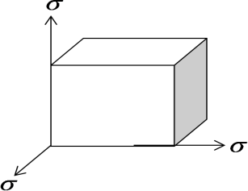
Consider the side AB deforms linearly and the other two perpendicular sides undergoes lateral deformations.
So the net tensile strain in any direction may be written as –

e = σ − ( 1 × σ ) − ( 1 × σ ) = σ (1 − 2 )
- (1)

E m E m E E m
Volume of the body (V) = l ³

Differentiating both sides with respect to l, we get

dV = 3l ²
dl
⇒ dV = 3l ² × dl = 3l ³ × dl = 3l ³ × e
l
(∴ e = strain = ^{d𝑙} )
𝑙

Substituting the value of „e‟ from equation-1, we get

dV = 3l ³ × σ
E
(1 − 2 )
m
⇒ dV V
3l ³
(
=
l 3
) × σ
E
(1 − 2 )
m

We know that, K = σ = σ = E
dV
V

3l ³
(
l 3
) × σ
E
(1 − 2 )
m
3(1 − 2 )
m

- (2)
⇒ E = 3K (1 − 2 )
m

Relation between Modulus of rigidity (C) and Young’s modulus (E):

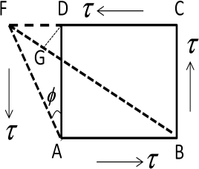
Consider a cube of length l subjected to shear stress (τ) as shown in figure. Consider that one of its diagonal BD elongates and other diagonal
AC reduces due to shear stress.
Let after deformation shear strain „ø‟ produces.

From figure we get,
tanφ = DF ≅ φ
AD

Consider BD = BG ; as the angle between BD and BG is very small. Change in length of the diagonal after deformation
= BF – BD = BF – BG = FG

Consider the deformation is very small and
FG = DF cos 45⁰ = DF
2
∠BFC = ∠BDC = 45⁰

Shear strain for the diagonal BD =
BF − BD = FG

= DF cos 45⁰ = DF
= φ = τ

….(3)

BD BD
2 × AD
2 2C

The diagonal increases due to the direct stresses and also due to the stresses in lateral direction.
AD × 2

Direct strain = σ N
E
Lateral strain = σ N
mE

So, the resultant strain =
σ _{N} + σ _{N}
E mE
----------------- (4) Where σ _{N} = normal stress

From equation -2 we get,
σ _{N} + σ _{N}
= σ N (1 + 1 )

E mE E m
From equation 3 and 4 we get, τ = σ N (1 + 1 )
2C E m
⇒ E = 2C (1 + 1 )
m
- (5)

Relation between E, C and K:

We know that, E = 2C (1 + 1 )
m
⇒ (1 + 1 ) = E
m 2C
- (6)

We know that,
⇒ E = 3K (1 − 2 )
m
⇒ (1 − 2 ) = E
m 3K
- (7)

From equation-6 we get:
1 = E −1
m 2C

Substituting this value in equation-7 we get: 1 − 2 × ( E
2C
−1) = E
3K

⇒ 1 − E + 2 = E
C 3K
⇒ C − E + 2C = E
C 3K
⇒ 3C − E = E
C 3K

⇒ 9KC − 3EK = EC ⇒ EC + 3EK = 9KC

- (8)
⇒ E(3K + C) = 9KC ⇒ E =
9KC
3K + C

This is the required relation between the three elastic constants.

***** PROBLEMS *****
Q -1) A metal bar 4 m long and 100 mm × 200 mm in cross section is subjected to a pull of 50 kN.
If Young’s modulus of the material of the bar is 200 kN/mm², find: (i) stress in the bar
ii) Strain produced iii) elongation of the bar.
Ans) Data Given
Area of cross section (A) = 100 mm × 200 mm = 2 × 10⁴ mm²
E = 200 kN/mm² Length (l) = 4m = 4000 mm Pull/Load (P) = 50 kN
- stress in the bar (σ)

σ = ^{𝑃}
𝐴
= 50
2×104
= 2.5 × 10⁻³ kN/mm²

- strain produced (e)

e = ^{σ}
E
= 2.5 × 10−3
200
= 1.25 × 10⁻⁵

- elongation of the bar (δl)

δl = ^{𝑃𝑙}
𝐴𝐸
= 50 ×4000
2 ×104 ×200
mm = 0.05 mm (ANS)

Q -2) A metal bar 50 mm × 50 mm in section is subjected to an axial compressive load of 500 kN. If the contraction of a 200 mm gauge length is found to be 0.5 mm and the increase in thickness
0.04 mm, find the values of Young’s modulus and Poisson’s ratio for the bar material.
Ans) Data Given
Length (l) = 200 mm, width (b) = 50 mm, thickness (t) = 50 mm Axial compressive load (P) = 500 kN = 500 ×10³ N
change in length (δl) = 0.5 mm change in thickness (δt) = 0.04 mm Young‟s modulus(E)
We know that, contraction of the bar (δl) = ^{𝑃𝑙}
𝐴𝐸

∴ E = 500 ×103 ×200
50 ×50 ×0.5
Poisson‟s ratio ( ¹ )

m
= 80 × 10³ N/mm² = 80 GPa

linear strain (e) = ^{𝛿𝑙} = ^{0.5} = 0.0025
𝑙 200
lateral strain = ¹ × linear strain = ¹ × 0.0025
m m
also increase in thickness (δt) = t × lateral strain
⟹ 0.04 = 50 × ¹ × 0.0025
m

⟹ 1 = 0.04
m 50 ×0.0025
= 0.32 (ANS)

Q – 3) A steel bar 50 mm × 50 mm in cross section is 1.2 m long. It is subjected to an axial pull of 200 kN. What are the changes in length, width and volume of the bar, if the value of Poisson’s ratio is 0.3? Take E = 200 GPa.
Ans) Data Given
Length (l) = 1.2 m = 1200 mm width (b) = 50 mm thickness (t) = 50 mm Axial pull (P) = 200 × 10³ N Poisson‟s ratio ( ¹ ) = 0.3
m
modulus of elasticity (E) = 200 × 10³ N/mm²

Change in length δl = ^{𝑃𝑙}

𝐴𝐸
= 200 ×103 × 1.2 ×103
50 ×50 ×200 ×103
= 0.48 mm

Change in width (δb)

linear strain (e) = ^{𝛿𝑙}
𝑙
= 0.48
1.2 ×103
= 0.0004

lateral strain = ¹ × e = 0.3 × 0.0004 = 0.00012
m
∴ Change in width (δb) = b × lateral strain = 50 × 0.00012 = 0.006 mm
Change in volume (δv)
original volume of the bar (V) = l × b × t
= 1200 × 50 × 50 = 3 × 10⁶ mm³

We know that , ^{𝛿𝑣} = ^{𝑃}
(1 - 2 ) = 200 × 103
( 1 – 2 × 0.3 ) = 0.00016

𝑉 btE
m 50 ×50 × 200 ×103

∴ Change in volume (dv) = 0.00016 V = 0.00016 × (3 × 10⁶) = 480 mm³ (ANS)

Q- 4) In an experiment, a bar of 30 mm diameter is subjected to a pull of 60 kN. The measured extension on gauge length of 200 mm is 0.09 mm and the change in diameter is 0.0039mm. Calculate the Poisson’s ratio and the values of the three moduli.
Ans) Data Given
Diameter (d) = 30 mm length (l) = 200 mm extension (δl)= 0.09 mm Pull (P) = 60 × 10³ change in diameter (δd) = 0.0039 mm
Poisson‟s ratio ( ¹ )
m

linear strain (e) = ^{𝛿𝑙}
𝑙
= ^{0.09} = 0.00045
200

lateral strain = ^{𝛿𝑑}
𝑑
= 0.0039
30
= 0.00013

∴ Poisson’s ratio = ^{0.00013}
0.00045
= 0.289

Values of three moduli

Area of the bar (A) = ^{π} × d² = ^{π} × 30² = 706.9 mm²
4 4

Extension of the bar (δl) = ^{𝑃𝑙}
𝐴𝐸
⟹ 0.09 = 60 × 103 ×200
706 .9 𝐸

= 17 × 103
𝐸

∴ Young‟s modulus (E) = ¹⁷ × ¹⁰3
0.09
From Poisson‟s ratio, we get m = ¹
0.289
= 188.9 × 10³ N/mm²
= 3.46

∴ Modulus of rigidity (C) =
E = 188.9 ×10³
2 × (1 + 0.289)
2(1 + 1m)
= 73.3 × 10³
N/mm²

∴ Bulk modulus (K) =
E 188.9 ×10³
= = 149.2 × 10³
3(1 − 2 m)
3× (1 − 0.289)
N/mm²
(ANS)

***** ASSIGNMENT- 01 *****

GROUP – A (2 marks questions)
- Define stress, strain and Young‟s modulus.
- State Hooke‟s law of elasticity.
- Define modulus of rigidity and bulk modulus.
- Write the relation between three elastic constants.
- What is Poisson‟s ratio?
- State the relation between Young‟s modulus and modulus of rigidity.
- State the relation between Young‟s modulus and Bulk modulus.

GROUP – B (5 marks questions)
- A square steel rod 20 mm ×20 mm in section to carry an axial compressive load of 100 kN. Calculate the shortening in a length of 50 mm. E = 2.14×10⁸ kN/mm². (Ans: 0.0584 mm)
- A material has a Young‟s modulus of 1.25×10⁵ N/mm² and Poisson‟s ratio of 0.25. Calculate the modulus of rigidity and the Bulk modulus.

- Find the change in diameter of the rod 2 cm diameter and 2 m long subjected to a pull of 20 N. Take E = 2×10⁶ N/cm² and Poisson‟s ratio = 0.25.
- For a given material the Young‟s modulus is 110 GN/m² and the modulus of rigidity is 42 GN/m². Find the bulk modulus and the lateral contraction of a round bar of 37.5 mm diameter and 2.4 m length when stretched by 2.5 mm. (Ans: 96.77 GN/m², 0.0121 mm)
- Under what axial load the diameter of a steel bar will reduce from 8 cm to 7.995 cm? Take E=200 kN/mm² and Poisson‟s ratio as 0.3 for steel.
- A hollow steel column of external diameter 250 mm has to support an axial load of 2000 kN. If the ultimate stress for the steel column is 480 N/mm², find the internal diameter of the column allowing a load factor of 4.
- A 20 mm diameter brass rod was subjected to a tensile load of 40 kN. The extension of the rod was found to be 254 divisions in the 200 mm extension meter. If each division is equal to
0.001 mm, find the elastic modulus of brass.

GROUP – C (10 mark questions)
- Derive the relation between three elastic constants.
- The following observations were made during the tensile test on a mild steel specimen 40 mm in diameter and 200 mm long.
Elongation under a load of 40 kN = 0.0304 mm Load at yield point = 161 kN
Maximum load = 242 kN
Length of specimen at fracture = 249 mm
Determine the Young‟s modulus, yield point stress, ultimate stress and percentage elongation.
(Ans: 2.09×10⁸ kN/m², 1208×10⁴ kN/m², 19.2×10⁴ kN/m², 24.5%)
- The following data are related to a bar subjected to a tensile test. Diameter of the bar = 30 mm, tensile load = 54 kN, gauge length = 300 mm, extension of the bar = 0.112 mm, change in diameter = 0.00366 mm. Calculate (i) Poisson‟s ratio; (ii) the values of three moduli.
(Ans: 0.327, 2.05×10⁵ MN/m², 0.77×10⁵ MN/m², 1.97×10⁵ MN/m²)



PRINCIPLE OF SUPERPOSITION:
Consider a bar of uniform area A, Young‟s modulus E and split into three sections 1, 2 and 3 subjected to tensile and compressive forces as shown in figure.
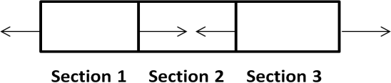
Consider the first section, and determine the tensile/compressive force acting on it. Then find the change in length of the section-1 by using the formula: 𝜟l = ^{𝑃𝑙}
𝐴𝐸

  - Continue the same step for section-2 and section-3 also.
  - Add all the values of change in length to determine the total change in length of the bar.
  - Consider that the change in length for tensile forces is positive and for compressive forces are negative.
  - If area of the bar is given uniform, then the value of area for all three sections is same.
  - The value of Young‟s modulus is same for the same materials.
  - If a bar of different section is given then the area of different sections are not same.

***** PROBLEMS *****
Q-1) A bar having cross sectional area of 500 mm² is subjected to axial forces as shown in figure.
Find the total elongation of the bar. Take E = 80 GPa.
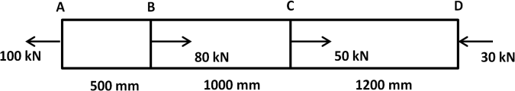

Ans) Data Given
Cross sectional area (A) = 500 mm² Young‟s modulus (E) = 80 kN/mm²
Consider that AB, BC and CD are three sections. The forces acting on each section are shown individually.
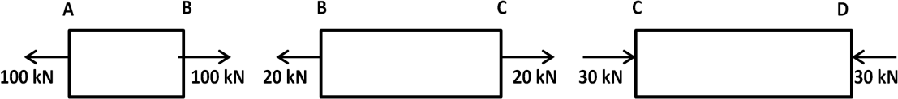

Change in length of section AB = δl_{AB} = ^{𝑃𝐴𝐵} ^{𝐿𝐴𝐵} = ¹⁰⁰ ^{×500} = 1.25 mm (tensile)
𝐴𝐸 500 ×80
Change in length of section BC = δl_{BC} = ^{𝑃𝐵𝐶} ^{𝐿𝐵𝐶} = ²⁰ ^{×1000} = 0.5 mm (tensile)
𝐴𝐸 500 ×80
Change in length of section CD = δl_{CD} = ^{𝑃𝐶𝐷} ^{𝐿𝐶𝐷} = ³⁰ ^{×1200} = 0.9 mm (compressive)
𝐴𝐸 500 ×80
Total change in length (δl) = 1 + 0.5 – 0.9 = 0.6 mm (ANS)

Q-2) A steel rod ABCD 4.5m long and 25mm in diameter is subjected to the forces as shown in figure. If the value of Young’s modulus for the steel is 200 GPa, determine its deformation.

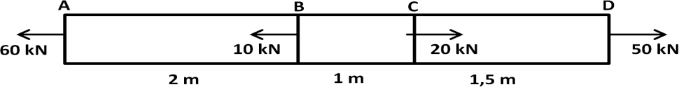

Ans) Data Given
Length of rod (l) = 4.5 m = 4500 mm diameter (d) = 25 mm E = 200 kN/mm² area of cross section (A) = ^{𝜋} d² = ^{𝜋} × (25)² = 491 mm²
4 4
Consider that AB, BC and CD are three sections. The forces acting on each section are shown individually.
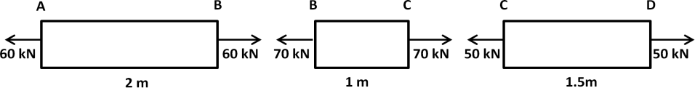

Change in length of section AB = δl_{AB} = ^{𝑃𝐴𝐵} ^{𝐿𝐴𝐵} = ⁶⁰ ^{×2000} = 1.22 mm (tensile)
𝐴𝐸 491 ×200
Change in length of section BC = δl_{BC} = ^{𝑃𝐵𝐶} ^{𝐿𝐵𝐶} = ⁷⁰ ^{×1000} = 0.71 mm (tensile)
𝐴𝐸 491 ×200
Change in length of section CD = δl_{CD} = ^{𝑃𝐶𝐷} ^{𝐿𝐶𝐷} = ⁵⁰ ^{×1500} = 0.76 mm (tensile)
𝐴𝐸 491 ×200
Total change in length (δl) = 1.22 + 0.71 + 0.76 = 2.69 mm (ANS)

STRESSES IN COMPOSITE SECTION:
- A composite bar is consists of two or more materials.
- The load acting on the composite section is equal to the sum of the loads carried by the sections of different materials.
- The deformation per unit length is constant. i.e. strain = constant
- The extension or contraction of the bar is equal.
- Consider a Composite column of outer tube and inner tube having different materials. For different materials the value of young‟s modulus is different.
Let, for outer tube A₁ = area, E₁ = young‟s modulus for inner tube A₂ = area, E₂ = young‟s modulus
Let, the length of the column is l and the column is subjected to axial load of P. So, we may write,
Total load on the column = load on outer tube + load on inner tube
∴ P = σ₁A₁ + σ₂ A₂ (1)
Where σ₁ and σ₂ are the stresses in the outer and inner tube.
σ₁A₁ and σ₂ A₂ are the load on outer and inner tube respectively. Let dl = decrease in length of the column
Strain in each tube (e) = ^{𝑑𝑙}
𝑙
Strain in outer tube = strain in inner tube = ^{𝜎1} = ^{𝜎2} (2)

- ^{𝐸1} = Modular ratio of two materials = m
𝐸2
𝐸1
𝐸2

***** PROBLEMS *****
Q-3) A reinforced concrete circular section of 50 000 mm² cross sectional area carries 6 reinforcing bars whose total area is 500 mm². Find the safe load, the column can carry, if the concrete is not to be stressed more than 3.5 MPa. Take modular ratio for steel and concrete as 18.
Ans) Data Given
Area of the column (A) = 50 000 mm² No. of reinforcing bars = 6
Total area of steel bars (A_{s}) = 500 mm² Max. stress in concrete (σ_{c}) = 3.5 N/mm²
Modular ratio = ^{𝐸𝑠} = 18
𝐸𝑐
Area of concrete (A_{c})= 50 000 – 500 = 49500 mm²

We know that, ^{𝜎𝑠}
𝜎𝑐
= 𝐸𝑠
𝐸𝑐

So the stress in steel (σ_{s}) = ^{𝐸𝑠} × σ_{c} = 18 × 3.5 = 63 N/mm²
𝐸𝑐
For composite section, we can write
Total safe load (P) = load shared by steel (Ps) + load shared by concrete (Pc)
⟹ P = σ_{s} A_{s} + σ_{c} A_{c} = (63 × 500) + (3.5 × 49500) = 204750 N = 204.75 KN (ANS)
Q-4) A reinforced concrete column of 400 mm diameter has 4 steel bars of 20 mm diameter embedded in it. Find the maximum load which the column can carry, if the stresses in steel and concrete are not to exceed 120 MPa and 5 MPa respectively. Take modulus of elasticity of steel as 18 times that of concrete.
Ans) Data Given
Diameter of concrete column (D) = 400 mm No. of reinforcing bars = 4
diameter of steel bars (d) = 20 mm Max. stress in steel (σ_{s})_{max} = 120 N/mm² Max. stress in concrete (σ_{c})_{max} = 5 N/mm² Modulus of elasticity of steel (E_{s}) = 18 E_{c}
Total area of the concrete circular column = ^{𝜋} D² = ^{𝜋} × (400)² = 125660 mm²
4 4
Area of the steel bars (A_{s}) = 4 × ^{𝜋} d² = 4 × ^{𝜋} × 20² = 1257 mm²
4 4
So, area of the concrete (A_{c}) = 125660 – 1257 = 124403 mm² If the stress in steel is 120 N/mm², then
stress in the concrete = ^{𝐸𝑐} × 120 = ¹ × 120 = 6.67 N/mm².
𝐸𝑠 18
This stress is more than the maximum stress in concrete. So it can‟t be considered.
If the stress in concrete is 5 N/mm², then
stress in steel = ^{𝐸𝑠} × 5 = 18 × 5 = 90 N/mm²
𝐸𝑐
This stress is less than the maximum stress in steel, therefore stresses in steel and concrete may be taken as 90 N/mm² & 5 N/mm².
∴ Maximum load (P) = load shared by steel (Ps) + load shared by concrete (Pc)
⟹ P = σ_{s} A_{s} + σ_{c} A_{c} = (90 × 1297) + (5 × 124403) = 735 150 N = 735.15 kN (ANS)

TEMPERATURE / THERMAL STRESS:
- When the temperature of a body increases or decreases, some stresses develop in the body to resist the deformation of the body due to change in temperature. This stress is known as temperature or thermal stress.
- Consider a bar AB of length „l ‟ fixed at one end A, deformed due to change in temperature as shown in figure.
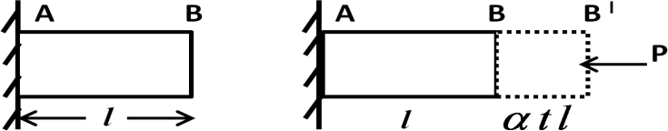
- Let, t = change in temperature
α = coefficient of linear expansion.
Let, the body expands due to rise in temperature „t‟ = BB/ = αtl Let, the load „P‟ is applied at the free end to prevent expansion.
Then compressive stress induce in the body {σ_{c}}= ^{𝑃}
𝐴
- Strain in bar = ^{𝑐𝑕𝑎𝑛𝑔} ^{𝑒} ^{𝑖𝑛} ^{𝑙𝑒𝑛𝑔𝑡} 𝑕 = ^{𝜎𝑡𝑙} = ^{𝜎𝑡𝑙} = l (the value αtl is very small, it is neglected)
𝑜𝑟𝑖𝑔𝑖𝑛𝑎𝑙 𝑙𝑒𝑛𝑔𝑡 𝑕 𝑙+ 𝜎𝑡𝑙 𝑙

We know that, ^{𝑠𝑡𝑟𝑒𝑠𝑠}
𝑠𝑡𝑟𝑎𝑖𝑛
= E ⇒ 𝜎 = E
𝜎𝑡

or σ = αtE = thermal stress
e = αt = temperature strain
P = σA = αTEA = load on the body

***** PROBLEMS *****
Q-5) Two parallel walls 6 m apart are stayed together by a steel rod 25 mm diameter passing through metal plates and nuts at each end. The nuts are tightened when the rod is at a temperature of 100⁰C. Determine the stress in the rod, when the temperature falls down to 60⁰ C, if a) the ends don’t yield b) The ends yield by 1 mm
Take E = 200 GPa and α = 12 × 10 ⁻⁶ per ⁰C.
Ans) Data Given
Length of rod (l) = 6m = 6000 mm Diameter of rod (d) = 25 mm
Change in temperature (t) = 100⁰ - 60⁰ = 40⁰ C Modulus of elasticity (E) = 200 N/mm² Coefficient of linear expansion (α) = 12 × 10 ⁻⁶ per ⁰C
- Stresses in the rod when the ends don‟t yield –
σ₁ = α.t.E = (12 × 10⁻⁶) × 40 × (200 × 10³) = 96 N/mm² = 96 MPa
- Stresses in the rod when the ends yield by 1 mm –

σ2 = [ αt - 𝑎𝑚𝑜𝑢𝑛𝑡 𝑜𝑓 𝑦𝑖𝑒𝑙𝑑 𝑖𝑛 𝑒𝑛𝑑𝑠
𝑙
]× E

= [(12 × 10⁻⁶) × 40 - ¹
6 × 103
] × 200 × 10³ = 62.6 N/mm² = 62.6 MPa (ANS)

Q-6) A gun metal rod 20 mm diameter, screwed at the ends, passes through a steel tube 25 mm and 30 mm internal and external diameters respectively. The nuts on the rod are screwed tightly home on the ends of the tube. Find the intensity of stress in each metal, when the common temperature rises by 200⁰F. Take Coefficient of expansion for steel = 6 × 10 ⁻⁶ per ⁰F, Coefficient of expansion for gun metal = 10 × 10 ⁻⁶ per ⁰F, Modulus of elasticity for steel = 200 GPa, Modulus of elasticity for gun metal = 100 GPa.
Ans) Data Given
Diameter of gun metal rod = 20 mm Internal diameter of steel tube = 25 mm External diameter of steel tube = 30 mm Rise in temperature (t) = 200⁰F Coefficient of expansion for steel (α_{s}) = 6 × 10 ⁻⁶ per ⁰F
Coefficient of expansion for gun metal (α_{G}) = 10 × 10 ⁻⁶ per ⁰F Modulus of elasticity for steel (E_{S}) = 200 GPa = 200 × 10³ N/mm²
Modulus of elasticity for gun metal (E_{G}) = 100 GPa = 100 × 10³ N/mm²
Let, σ_{G} = stress in gun metal rod and σ_{s} = stress in steel tube

area of gun metal rod (A_{G}) = ^{𝜋}
4
× 20² = 100 × π mm²

area of steel tube (A_{s}) = ^{𝜋} [ (30)² – (25)²] = 68.75 π mm²
4

As α_{g} is greater than α_{s} , the expansion of gun metal will be more than steel tube. Since the gun metal will be subjected to compressive stress and the steel tube will be subjected to tensile stress.
Tensile load in steel tube = Compressive load in Gun metal rod
i.e. σ_{s} × A_{s} = σ_{G} × A_{G}

Stress in steel tube (σ ) = 𝐴𝑔 × σ
= 100 𝜋 × σ
= 1.45 σ

s 𝐴𝑠
G 68.75 𝜋 G G

Strain in steel tube (e_{s}) = ^{𝜎𝑠}
𝐸𝑠
Strain in gun metal (e_{G}) = ^{𝜎𝐺}
𝐸𝐺
= 𝜎𝑠
200 × 103
= 𝜎𝐺
100 × 103

We know that, Strain in steel = Strain in Gun metal
⟹ e_{s} + α_{s} t = α_{G} t - e_{G}
⟹ e_{s} + e_{G} = (α_{G} - α_{s} )× t

⟹ 𝜎𝑠
200 × 103
⟹ 1.45 σG
200 × 103
+ 𝜎𝐺
100 × 103
+ 𝜎𝐺
100 × 103
= [ (10 × 10 ⁻⁶) – (6 × 10 ⁻⁶)]× 200
= 200 × (4 × 10 ⁻⁶)

⟹ 3.45 σG
200 × 103
= 800 × 10 ⁻⁶

⟹ 3.45 σ_{G} = 800 × 10 ⁻⁶ × 200 ×10³ = 160

∴ σG = 160 3.45
= 46.4 N/mm² = 46.4 MPa

∴ σ_{s} = 1.45 σ_{G} = 1.45 × 46.4 = 67.3 N/mm² = 67.3 MPa (ANS)

STRAIN ENERGY:
It is the energy stored in a deformed elastic body when external load acts on it. This energy is released when load is removed.

RESILIENCE:
It is the total strain energy stored by the body when external load acts on it within elastic limit. It is measured by the amount of energy absorbed per unit volume of the material within elastic limit.

PROOF RESILIENCE:
It is the maximum strain energy stored by the body per unit volume when the external load acts on it within the elastic limit.

EXPRESSION FOR STRAIN ENERGY:
Consider a bar of area „A‟, length l subjected to load W.
Let, the bar extends by dl due to the load and produces maximum stress σ.
Let U = strain energy stored in the bar = work done by the load so we may write, U = ¹ × W × dl
2

we know that, dl = ^{𝜎} ^{𝑙}
𝐸
substituting the value of dl, we get

U = 𝑊 × 𝜎 𝑙
= 𝜎 𝐴 × 𝜎 𝑙
( ∵ W = σ × A)

2 𝐸
2 𝐸

( ∵ V = A × l)

STRESSES DUE TO GRADUALLY APPLIED LOAD:
U = 𝝈 𝑨 𝒍 = 𝝈 𝑽
𝟐
𝟐
𝟐𝑬 𝟐𝑬
When a load acts upon a body stepwise starting from zero to its last value, then it is known as gradually applied load.
Let, W = gradually applied load on the body dl = change in length
σ = maximum stress
Energy due to external load = ¹ × σ ×A× dl Work done on the body = ¹ × W × dl
2
2
But strain energy stored = work done on the body
⇒ ¹ × σ ×A× dl = ¹ × W × dl

⇒
2 2

- (1)
σ = ^{𝐖}
𝐀

Stress due to suddenly applied load:
When a load acts suddenly on a body it is known as suddenly applied load.
Let, W = suddenly applied load σ_{s} = suddenly applied load dl = increase in length
Strain energy stored = External load acting on the body

W × dl = ¹ × σ_{s} ×A× dl
2
⇒ (2)

Thus stress due to suddenly applied load is double than stress due to gradually applied load.

STRESS DUE TO IMPACT LOAD:
When a load falls from a height and strikes the body with some momentum, it is known as impact load. Consider a weight W is falling from height „h‟ on the collar fitted on the rod.
Let:
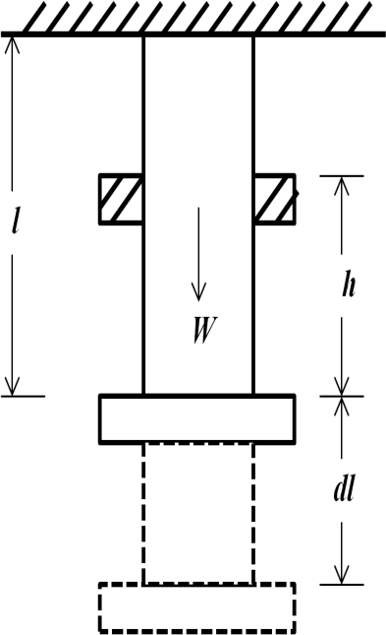
l = length of the rod
A = cross sectional area of rod dl = change in length
σ = maximum stress
External work done on the load = Energy stored in the rod
⇒ W(h + dl) = ¹ × σ ×A× dl
2
⇒ W [ h + ^{𝜎} ^{𝑙} ] = ¹ × σ ×A× ^{𝜎} ^{𝑙} ( ∵ dl = ^{𝜎} ^{𝑙} )
𝐸 2 𝐸 𝐸
⇒ W [ h + ^{𝜎} ^{𝑙} ] = ^{𝜎}2𝐴𝑙

⇒ 𝜎 2𝐴𝑙 2 𝐸
𝐸
- 𝜎 𝑊 𝑙
𝐸
2 𝐸
- Wh = 0

𝑊 𝑙 ± √W 2 𝑙2 + 2𝑊 𝑕𝐴 𝑙
⇒ σ =
2
𝐸 E 𝐸
𝐴𝑙

𝐸

𝑊+𝑊√1+ 2𝑕𝐴 𝐸

𝑊 𝑙 ± 𝑊 𝑙 √1+ 2𝑊 𝑕𝐴 𝑙+ E 2
2 2
=
𝐸 𝐸 𝐸 W 𝑙
𝐴𝑙

𝐸

⇒ σ =
𝑊𝑙
𝐴

Taking positive sign we get,
σs = 𝟐𝐖
𝐀
σ = ^{𝑾} [1 + √𝟏 + 𝟐𝒉𝑨 𝑬 ] (3)
𝑨 𝑾𝒍

***** ASSIGNMENT- 02 *****

GROUP – A (2 mark questions)
- What do mean by composite section?
- Define temperature/thermal stress and strain.
- Define strain energy.
- Define resilience.

GROUP – B (6 mark questions)
- Find the expression for temperature stress for a rise in temperature of t⁰C when the ends don‟t yield. Take α as coefficient of expansion and l as original length.
- A reinforces concrete column is 300 mm × 300 mm in section. The column is provided with 8 steel bars of 20 mm diameter. The column carries a load of 360 KN. find the stresses in concrete and steel bars. Take E_{s} = 2.1 × 10⁵ N/mm² and E_{b} = 0.14 × 10⁵ N/mm².
- A steel rod of 20 m long at a temperature 20⁰C is subjected to rise in temperature to 65⁰C. Find
the temperature stress produced, i) when the expansion of the rod is prevented; ii) when the rod is permitted to expand by 5.8 mm. Take α = 12 × 10⁻⁶ per ⁰C and E = 2 × 10⁵ N/mm².
- Derive the expressions for stresses due to gradually applied load, suddenly applied load and
impact load.

GROUP – C (8 mark questions)
- A compound tube consists of a steel tube 150 mm internal diameter and 10 mm thickness and an outer brass tube 170 mm internal diameter and 10 mm thickness. The two tubes are of the same length. The compound tubes carries an external load of 1000 KN. Find the stresses and load carried by each tube and the amount it reduced. Length of each tube is 100mm.
Take E_{s} = 2 × 10⁵ N/mm² and E_{b} = 1 × 10⁵ N/mm².
- A 15 mm diameter steel rod passes centrally through a copper tube 50 mm external diameter and 40 mm internal diameter. The tube is closed at each end by rigid plates of negligible thickness. The nuts are tightened lightly on the projecting parts of the rod. If the temperature of the assembly is raised by 60⁰C, calculate the stresses developed in copper and steel.
- A steel bar is placed between two copper bars each having the same area and length as the steel bar at 15⁰C. The bars are rigidly connected at both ends when the temperature rises to 315⁰C. The length of the bars increases by 1.50 mm. Determine the original length and the final stresses in the bars. Take E_{s} = 2.1 × 10⁵ N/mm² E_{c} = 1 × 10⁵ N/mm²
α_{s} = 0.000012 per⁰C α_{c} = 0.0000175 per⁰C
- A solid steel bar 50 cm long and 7 cm in diameter is placed inside an aluminium tube having
7.5 cm inside diameter and 10 cm outside diameter. The aluminium tube is 0.015 cm longer than the steel bar. An axial load of 600 kN is applied to the bar and tube through rigid cover plates. Find the stresses developed in the steel bar and aluminium tube. E for steel = 220 GPa. E for aluminium = 70 GPa. (Ans: σ_{s} = 106.82 MN/m², σ_{al} = 54.99 MN/m²)

THIN CYLINDRICAL SHELL

THIN CYLINDER:
If the thickness of the wall of the cylinder is less than 1/20 of its diameter then the cylinder is said to be thin cylinder.

ASSUMPTION FOR THIN SHELLS:
  - A thin cylinder may fail along longitudinal seam or across a transverse section.
  - Hoop or circumferential stresses acting across longitudinal section.
  - Longitudinal or axial stresses acting across at right angles to the longitudinal axis of the cylinder.
  - Radial stresses are neglected.

HOOP OR CIRCUMFERENTIAL STRESS:
When a thin cylindrical shell is subjected to an internal pressure, tensile stresses develop in a tangential direction to its circumference, which may split the shell into two troughs, such stresses are known as hoop or circumference stresses.

Determination of hoop stress:
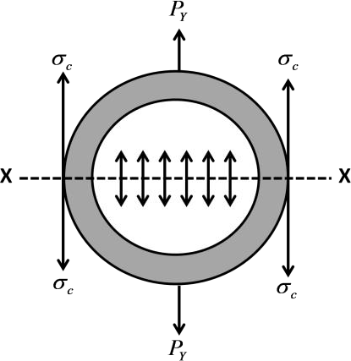
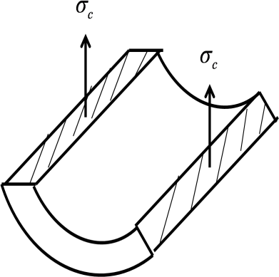
Consider a thin cylinder subjected to an internal pressure (p). Consider any section X-X which divides the cylinder into two parts. Due to internal pressure, force P_{Y} will act normal to the X-X axis. This force P_{Y} will develop the tensile stress σ_{c} which is known as hoop or circumferential stress.

Let l = length of the shell d = internal diameter of the shell t = thickness of the shell p = intensity of internal pressure
Pressure force acting along each side of X-X plane of the shell (P_{Y}) = internal pressure × area on X-X plane = p × (d × l )
Area resisting the bursting force P_{Y} = 2 t l

Circumferential stress in the shell = σ_{c} = ^{Pressure} ^{force}
= pd 𝑙 = 𝐩𝐝

area resisting the internal pressure
2t𝑙 𝟐𝐭

∴
σc = ^{𝐩𝐝}
𝟐𝐭
This tensile stress across X-X axis is also known as Hoop stress.

LONGITUDINAL STRESS:
When a thin cylindrical shell is subjected to an internal pressure, tensile stresses may also develop in longitudinal direction which may split the shell into two halves or into two cylinders, such stresses are known as longitudinal stresses.
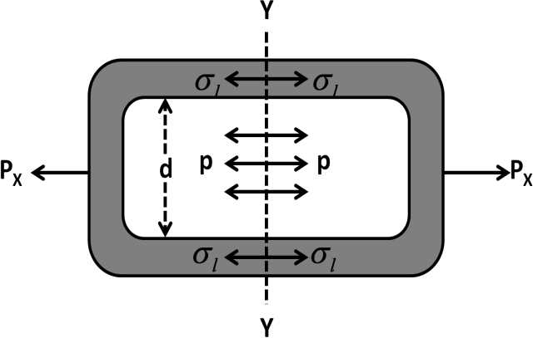
Consider a thin cylinder subjected to an internal pressure (p). Consider any section Y- Y at right angles to the length of the cylinder which divides the cylinder into two half cylinders. Due to internal pressure, force P_{X} will act normal to the Y-Y axis. This force
P_{Y} will develop the tensile stress σ _{l} parallel
to the length of the cylinder. It is known as
longitudinal stress.

Let l = length of the shell d = diameter of the shell
t = thickness of the shell p = intensity of internal pressure
Total pressure force along longitudinal direction = P_{X} = internal pressure × area on Y-Y plane
= p × ^{π} d²
4

Area resisting the bursting force P_{X} = πdt

Longitudinal stress in the shell = σ = ^{total} ^{pressure} ^{force} =
l
area resisting the internal pressure

πdt

= pd
4t
p × π 4 d ²

∴
This tensile stress across Y-Y axis is known as longitudinal stress.

CIRCUMFERENTIAL STRAIN AND LONGITUDINAL STRAIN:
Let δd = change in diameter of the shell δl = change in length of the shell
¹ = Poisson‟s ratio
m
σ_{c} = circumferential stress and σ _{l} = longitudinal stress

Circumferential strain ( e ) = ^{δd} = ^{σc} - ^{σ𝑙} = ^{pd} -
pd
4tEm
=
𝟐𝐦
𝟐𝐭𝐄
^{𝐩𝐝} ( 1- ^{𝟏} )

c d E mE
2tE

Longitudinal strain ( e ) = ^{δ𝑙} = ^{σ𝑙} - ^{σ𝑐} = ^{pd} -
pd
2tEm
=
𝟐𝐭𝐄 𝟐 𝐦
𝐩𝐝 ( 𝟏 - 𝟏 )

l 𝑙
σ = 𝐩𝐝
l
𝟒𝐭
E mE
4tE

CHANGE IN DIMENSION OF THIN CYLINDRICAL SHELL:

We know that,
e = δd = pd

(1- ¹ )

c d 2tE m

∴ Change in diameter (δd) = e × d = ^{pd} (1- ¹ ) × d =
𝟐𝐦
𝟐𝐭𝐄
)
𝐩𝐝𝟐 ( 1- 𝟏

We know that,

e = δ𝑙
c

= pd (1 - 1 )
2tE m

l 𝑙

2tE 2 m

∴ Change in length (δl) = e × l = ^{pd} (¹ - ¹ ) × l =

l 2tE 2 m
Internal volume of the cylinder (V) = ^{π} × d² × l
4

Final volume of the cylinder = V + δV = ^{π} × (d+ δd)² × ( l + δl )
4

Change in Volume = δV = final volume – initial volume = ^{π} × (d+ δd)² × ( l + δl ) – ^{π} × d² × l
4 4

Neglecting the smaller terms we get:

Change in volume (δV) = ^{π} × ( d² . δ l + 2dl . δd)
4

δV π × ( d2 . δ 𝑙 + 2dl . δd )

𝛅𝒍

𝟐 𝛅𝐝
el + 2× ec

∴ Volumetric strain (e_{v}) = = ⁴
V
π × d2 × 𝑙
4
= + =
𝒍 𝒅

∴ Change in volume (δV) = V ( el + 2× ec )

THIN SPHERICAL SHELL:

Stress in spherical shell (σ) = ^{𝐩𝐃}
𝟒𝐭

- (10)

Strain in any section of spherical section (e) = ^{σc} - ^{σ𝑙}
= ^{σc} (1 - ¹ ) = ^{𝐩𝐃}
(1 - ^{𝟏} ) (10)

NOTES:
E mE E
m 𝟒𝐭 𝐄 𝐦

𝐩𝐃𝒍 ( 𝟏 - 𝟏 )
𝟐𝐭𝐄 𝟐 𝐦

Terms | Symbol | Formula | Units
Hoop stress | σ_{c} or f_{y} | p × d  2 × t | Same as Stress
Longitudinal stress | σ_{l} or f_{x} | p × d  4 × t | Same as Stress
Change in diameter | Δd | pd2 (1- ¹ )  2tE 2m | mm or cm
Change in length | Δl | pd 𝑙 (1 - 1 )  2tE 2 m | mm or cm
Change in volume | Δv | V ( e + 2 e ) = ^{pD} ( ⁵ - ² )  l c 2tE 2 m | mm or cm

***** PROBLEM *****

Q-1) A mild steel cylinder contains some fluid under pressure and its diameter is 1.5 m. If the thickness of the cylinder wall is 4 mm, determine the safe pressure inside the cylinder. Assume the maximum allowable tensile stress in M.S as 80 N/mm².
Ans) Data Given
Diameter (d) = 1.5 m = 1500 mm thickness (t) = 4 mm Maximum allowable stress (σ) = 80 N/mm²
Let, p = safe pressure inside the cylinder Hoop stress is given by -

σc = 𝐩 𝐝 = 𝐩 ×𝟏𝟓𝟎𝟎
⟹ 80 = 𝐩 ×𝟏𝟓𝟎𝟎
⟹ p = ^{𝟐} ^{×𝟒} ^{×𝟖𝟎} = 0.4267 N/mm²

𝟐𝐭
𝟐 ×𝟒
𝟐 ×𝟒
𝟏𝟓𝟎𝟎

longitudinal stress is given by -

σl = 𝐩 𝐝 = 𝐩 ×𝟏𝟓𝟎𝟎
⟹ 80 = 𝐩 ×𝟏𝟓𝟎𝟎
⟹ p = ^{𝟒} ^{×𝟒} ^{×𝟖𝟎} = 0.8534 N/mm²

𝟒 𝐭
𝟒 ×𝟒
𝟒 ×𝟒
𝟏𝟓𝟎𝟎

∴ The required safe pressure inside the cylinder is p = 0.4267 N/mm². (ANS)
Q-2) A cylinder is made of a material whose maximum allowable tensile stress is 60 N/mm². The diameter of the cylinder is 100 mm. If pressure of a fluid contained in the cylinder is 20 bar, determine the safe thickness of the cylinder wall.
Ans) Data Given
Maximum tensile stress = 60 N/mm² Diameter (d) = 100 mm Pressure (p) = 20 bar = 2 N/mm²
Hoop stress is given by –

σc = 𝐩 𝐝 = 𝟐 ×𝟏𝟎𝟎
⟹ 60 = 𝟐 ×𝟏𝟎𝟎
⟹ t = 𝟐 ×𝟏𝟎𝟎

∴ t = 1.667 mm

𝟐𝐭
𝟐 × 𝐭
𝟐 × 𝐭
𝟐 ×𝟔𝟎

longitudinal stress is given by -

σl = 𝐩 𝐝 = 𝟐 ×𝟏𝟎𝟎
⟹ 60 = 𝟐 ×𝟏𝟎𝟎
⟹ t = 𝟐 ×𝟏𝟎𝟎

∴ t = 0.833 mm

𝟒 𝐭
𝟒 × 𝐭
𝟒 ×𝐭
𝟒 ×𝟔𝟎

∴ The required safe thickness is 1.667 mm. (ANS)
Q-3) A boiler is 1.5 m in diameter having thickness of plate as 10 mm. The efficiencies of the longitudinal and circumferential joints are respectively 60% and 80%. If the maximum allowable tensile stress in plate be 70 N/mm², calculate the safe steam pressure in the boiler.
Ans) Data Given
Diameter (d) = 1.5 m = 1500 mm thickness (t) = 10 mm efficiency η_{l} = 0.60 & η_{c} = 0.80
Maximum allowable tensile stress = 70 N/mm²
Hoop stress is given by –

σc = 𝐩 𝐝
𝟐𝐭 × 𝛈𝒍
⟹ 70 = 𝐩 ×𝟏𝟓𝟎𝟎
𝟐 ×𝟏𝟎 ×𝟎.𝟔𝟎
⟹ p = 0.56 N/mm²

Longitudinal stress is given by –

σl = 𝐩 𝐝
𝟒 𝐭 × 𝛈𝒍
⟹ 70 = 𝐩 ×𝟏𝟓𝟎𝟎
𝟒 ×𝟏𝟎 ×𝟎.𝟖𝟎
⟹ p = 1.439 N/mm²

∴ The required safe pressure is 0.56 N/mm². (ANS)
Q-4) The internal diameter of a cylindrical shell is 1 m and its length is 3 m, the plates being 1.5 cm thick. Determine the circumferential and longitudinal stresses set up and changes in dimensions of the shell when a fluid is introduced in it at a pressure of 1.5 N/mm².
Take E = 200 kN/mm² and poison’s ratio 0.3.
Ans) Data Given
Diameter (d) = 1 m = 1000 mm length (l) = 3 m = 3000 m thickness (t) = 1.5 cm = 15 mm pressure (p) = 1.5 N/mm²
E = 200 kN/mm² Poisson‟s ratio ( ^{𝟏} ) = 0.3
𝐦

Circumferential/hoop stress (σc) = ^{p} ^{d}
2t
= 1.5 ×1000
2 × 15
= 50 N/mm²

longitudinal stress (σl ) = ^{p} ^{d}
4 t
= 1.5 ×1000
4 × 15
= 25 N/mm²

Change in diameter (δd) = ^{pd}2 (1- ¹ ) = ^{1.5} × ¹⁰⁰⁰ 2 ( 1 - ¹ ) = 0.2125 mm

2tE
2m 2 × 15 ×2 × 105
2 ×0.3

change in length (δl) = ^{pD} ^{𝑙} (¹ - ¹ ) = ^{1.5} ^{×1000} ^{×3000} (¹ - 0.3 ) = 0.15 mm (ANS)

2tE 2 m
2 × 15 × 2 × 105 2

***** ASSIGNMENT – 03 *****

GROUP - A (2 mark questions)

- Define thin cylindrical shell.
- Define hoop and longitudinal stress.
- State the expression of hoop and longitudinal stress.

GROUP - B (6 mark questions)
- Write the assumptions for thin cylindrical shell.

- Derive the expression for hoop and longitudinal stresses for a thin cylindrical shell.

- A steam boiler of 800 mm diameter is made up of 10 mm thick plates. If the boiler is subjected to an internal pressure of 2.5 MPa, find the circumferential and longitudinal stresses induced in the boiler plates.

- A cylindrical air receiver for a compressor is 2 m in internal diameter and made of plates 12 mm thick. If the hoop stress is not to exceed 60 N/mm², find the maximum safe air pressure.

- A boiler is subjected to an internal steam pressure of 2 MPa. The thickness of the boiler plate is 2 cm and the permissible tensile stress is 120 MPa. Find the maximum diameter, when the efficiency of longitudinal joint is 90% and that of circumferential joint is 40%.

GROUP - C (8 marks questions)
- A closed vessel made of steel plates 4 mm thick with plane carries fluid under pressure of
3 N/mm². The diameter of the cylinder is 25 cm and length 75 cm. Calculate the longitudinal and hoop stress. Determine the change in diameter, length and volume of cylinder.
Take E = 2.1 × 10⁵ N/mm² and 1/m = 0.28.

- A thin cylindrical shaft 2 m long, 20 cm diameter and 1 cm thick is subjected to an internal pressure of 200 kg/cm². Take Poisson‟s ratio as 0.25 and E = 2 × 10⁶ kg/cm².
Find i) hoop stress ii) longitudinal stress iii) change in its dimensions and volume.

- A hollow cylindrical drum 600 mm in diameter has a thickness of 10 mm. If the drum is subjected to an internal air pressure of 3 N/mm², determine the increase in volume of the drum. Take E = 2 × 10⁵ N/mm² and 1/m = 0.3.

- A cylindrical thin shell, 80 cm in diameter and 3 m long is having 1 cm metal thickness. If the shell is subjected to an internal pressure of 2.5 MPa, determine (i) change in diameter (ii) change in length (iii) change in volume. Take E = 200 GPa and Poisson‟s ratio = ¼.

TWO DIMENSIONAL STRESS SYSTEM

PRINCIPAL PLANE:
The three mutually perpendicular planes along which the stresses at a certain point in a body can be resolved at right angle to these planes are known as principal planes. These planes carry only normal stresses but no shear stress.
Out of three stresses one is maximum, one is minimum and the third one is lying between these two stresses.
The plane carrying the maximum normal stress is known as Major principal plane and the plane carrying the minimum normal stress is known as the minor principal plane.

PRINCIPAL STRESS:
The normal stresses across the principal planes are known as principal stresses.
The stress across the major principal plane is known as major principal plane and the stress across the minor principal plane is known as minor principal plane.

DETERMINATION OF PRINCIPAL STRESSES:
Sign convention
- All tensile stress and strain are positive.
- All compressive stress and strain are negative.
- The shear stress which tends to rotate the body in clockwise direction is positive.
- The shear stress which tends to rotate the body in anti clockwise direction is negative.
- The shear stresses on the vertical faces are positive and the shear stresses on the horizontal faces are negative.

Case-I: Stresses on an oblique section of a body subjected to direct stress in one plane:
Consider a rectangular body of unit thickness and uniform area of cross section subjected to direct stress along X-X axis as shown in figure.
Consider an oblique section AB inclined at angle Ɵ with the X-X axis.
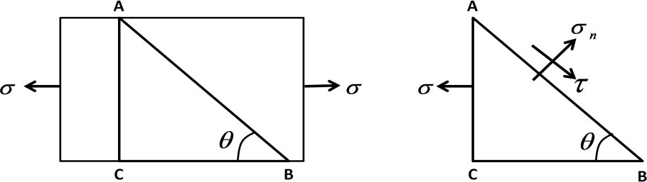

Let σ = tensile stress across the face AC Ɵ = Angle between AB and BC.
Consider the equilibrium of ABC.
The horizontal force acting on the face AC = P = σ × AC Resolving the forces normal to the section AB –
P_{n} = P sin Ɵ = σ × AC × sin Ɵ

Resolving the forces tangentially to the section AB –
P_{t} = P cos Ɵ = σ × AC cos Ɵ
Normal stress across the section AB = σ = 𝑃𝑛 = 𝜎 × 𝐴𝐶 ×𝑠𝑖𝑛 𝚹 = 𝜎 × 𝐴𝐶 ×𝑠𝑖𝑛 𝚹

n 𝐴𝐵
= σ sin²
𝐴𝐵
𝜎
Ɵ =
2
𝐴𝐶

𝑠𝑖𝑛 𝚹
× (1- cos 2Ɵ)

𝝈 𝝈
= -
𝟐 𝟐
× (1- cos 2Ɵ) (1)

Shear stress across the section AB = τ = 𝑃𝑡 = 𝜎 × 𝐴𝐶 ×𝑐𝑜𝑠 𝚹 = 𝜎 × 𝐴𝐶 ×𝑐𝑜𝑠 𝚹

𝐴𝐵
𝐴𝐵
𝐴𝐶

𝑠𝑖𝑛 𝚹

= σ sinƟ cosƟ
= ^{𝝈} sin 2Ɵ (2)
𝟐
Normal stress across the section AB will be maximum, if sin²Ɵ = 1 or Ɵ = 90⁰
Shear stress across the section AB will be maximum, if sin 2Ɵ = 1 or Ɵ = 45⁰ or 135⁰.
Thus maximum shear stress, when Ɵ = 45⁰ or 135⁰ = τ_{max} = σ/2

The resultant stress may be obtain from the relation, σ_{R} = √𝛔_{𝒏}^{𝟐} + 𝝉^{𝟐} (3)

Case-II: Stresses on an oblique section of a body subjected to direct stress in two mutually perpendicular stresses:
Consider a rectangular body of unit thickness and uniform area of cross section subjected to direct tensile stresses along X-X axis and Y-Y axis as shown in figure.
Consider an oblique section AB inclined at angle Ɵ with the X-X axis.
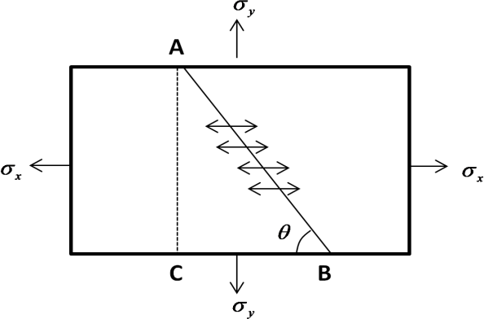
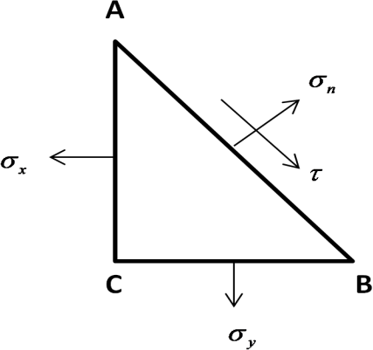
Let σ_{x} = tensile stress along X-X axis σ_{y} = tensile stress along Y-Y axis
Ɵ = angle made by section AB with X-X axis Consider the equilibrium of the section ABC Horizontal force acting on the face AC = P_{x} = σ_{x} ×AC Vertical force acting on the face AC = P_{y} = σ_{y} × BC Resolving the forces normal to the section AB
P_{n} = P_{x} sin Ɵ + P_{y} cos Ɵ = (σ_{x} × AC × sin Ɵ) + (σ_{y} × BC × cos Ɵ)
Resolving the forces tangentially to the section AB –
P_{t} = P_{x} cos Ɵ - P_{y} sin Ɵ = (σ_{x} × AC × cos Ɵ) - (σ_{y} × BC × sin Ɵ)
Normal stress across the section AB = σ_{n}
= 𝑃𝑛 = (𝜎𝑥 × 𝐴𝐶 ×𝑠𝑖𝑛 𝚹 )+(𝜎𝑦 × 𝐵𝐶 ×𝐶𝑂𝑆 𝚹)
𝐴𝐵 𝐴𝐵

= (𝜎𝑥 × 𝐴𝐶 ×𝑠𝑖𝑛 𝚹 ) + (𝜎𝑦 × 𝐵𝐶 ×𝐶𝑂𝑆 𝚹)
𝐴𝐵 𝐴𝐵
= (𝜎𝑥 × 𝐴𝐶 ×𝑠𝑖𝑛 𝚹 ) + (𝜎𝑦 × 𝐵𝐶 ×𝐶𝑂𝑆 𝚹)

𝐴𝐶

𝑠𝑖𝑛𝚹
= σ sin² Ɵ + σ
𝐵𝐶

𝑐𝑜𝑠 𝚹
cos² Ɵ = 𝜎𝑥 (1- cos 2Ɵ) + 𝜎𝑦 (1+ cos 2Ɵ)

x y 2 2
= 𝜎𝑥 - 𝜎𝑥 cos 2Ɵ + 𝜎𝑦 + 𝜎𝑦cos 2Ɵ
2 2 2 2
∴ σ = 𝝈𝒙 + 𝝈𝒚 - 𝝈𝒙− 𝝈𝒚 cos 2Ɵ (1)
n 𝟐 𝟐
Shear stress across the section AB = τ

= 𝑃𝑡
𝐴𝐵
= (𝜎𝑥 × 𝐴𝐶 ×cos 𝚹 )− (𝜎𝑦 × 𝐵𝐶 ×sin 𝚹)
𝐴𝐵

= (𝜎𝑥 × 𝐴𝐶 ×cos 𝚹 ) - (𝜎𝑦 × 𝐵𝐶 ×sin 𝚹)
𝐴𝐵 𝐴𝐵
= (𝜎𝑥 × 𝐴𝐶 ×cos 𝚹 ) - (𝜎𝑦 × 𝐵𝐶 ×sin 𝚹)

𝐴𝐶

𝑠𝑖𝑛𝚹
𝐵𝐶

𝑐𝑜𝑠 𝚹

= σ_{x} sin Ɵ cos Ɵ + σ_{y} sin Ɵ cos Ɵ
= (σ_{x} – σ_{y}) sin Ɵ cos Ɵ

∴ τ = 𝝈𝒙− 𝝈𝒚
𝟐
sin 2Ɵ (2)

Shear stress across the section AB wil be maximum, if Ɵ = 45⁰

Thus maximum shear stress, τ_{max}
= 𝝈𝒙− 𝝈𝒚
𝟐

Resultant stress may be obtain from the relation, σ_{R} = √𝛔_{𝒏}^{𝟐} + 𝝉^{𝟐} (3)

Case-III: Stresses on an oblique section of a body subjected to shear stress:
Consider a rectangular body of unit thickness and uniform area of cross section subjected to a shear stress along X-X axis.
Consider an oblique section AB at an angle Ɵ with the axis X-X as shown in figure. Let τ_{x} = shear stress along X-X axis
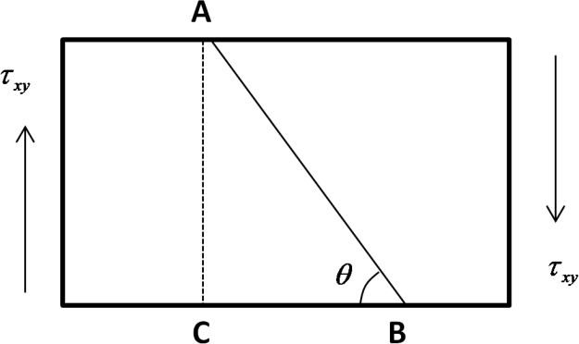
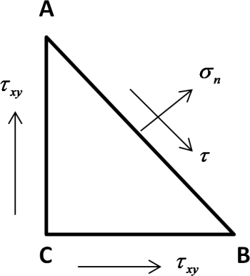

Consider the equilibrium of the section ABC
The vertical force acting on the face BC = P₁ = τ_{x} × AC The horizontal force acting on the face BC = P₂ = τ_{x} ×BC Resolving the forces normal to the section AB

P_{n} = P₁ cos Ɵ + P₂ sin Ɵ = τ_{x} . AC cos Ɵ + τ_{x} . BC sin Ɵ Resolving the forces tangential to the section AB
P_{t} = P₂ sin Ɵ – P₁ cos Ɵ = τ_{x} . BC sin Ɵ - τ_{x} . AC cos Ɵ
Normal stress across the section AB = σ_{n}

= 𝑃𝑛
𝐴𝐵
= (𝜏𝑥 × 𝐴𝐶 ×cos 𝚹 )+(𝜏𝑥 × 𝐵𝐶 ×sin 𝚹)
𝐴𝐵
= (𝜏𝑥 × 𝐴𝐶 ×cos 𝚹 ) + (𝜏𝑥 × 𝐵𝐶 ×sin 𝚹 )

𝐴𝐵 𝐴𝐵
= (𝜎𝑥 × 𝐴𝐶 ×cos 𝚹 ) + (𝜏𝑥 × 𝐵𝐶 ×sin 𝚹 )

𝐴𝐶

𝑠𝑖𝑛𝚹
𝐴𝐶

𝑠𝑖𝑛𝚹

= τ_{x} sin Ɵ.cos Ɵ + τ_{x} sin Ɵ.cos Ɵ
= 2 × τ_{x} sin Ɵ.cos Ɵ
= τ_{x} sin 2Ɵ (1)
Shear stress across the section AB = τ
= 𝑃𝑡 = (𝜏𝑥 × 𝐵𝐶 × sin 𝚹 )− (𝜏𝑥 × 𝐴𝐶 × COS 𝚹)

𝐴𝐵
= (𝜏𝑥 × 𝐵𝐶 ×sin 𝚹 )
𝐴𝐵
𝐴𝐵
- (𝜏𝑥 × 𝐴𝐶 ×cos 𝚹 )
𝐴𝐵

= (𝜎𝑥 × 𝐵𝐶 ×sin 𝚹 ) - (𝜏𝑥 × 𝐴𝐶 × cos 𝚹 )

𝐵𝐶

𝑠𝑖𝑛𝚹
= τ_{x} sin²Ɵ - τ_{x} cos² Ɵ
𝐴𝐶

𝑠𝑖𝑛𝚹

= 𝜏𝑥 (1- cos 2 Ɵ) – 𝜏𝑥 (1 + cos 2Ɵ)
𝟐 𝟐

= 𝜏𝑥 - 𝜏𝑥 cos 2Ɵ - 𝜏𝑥 - 𝜏𝑥
cos 2Ɵ

𝟐 𝟐 𝟐 𝟐
= - τ_{x} cos 2Ɵ (2)
Maximum or minimum shear stress may be obtain by equating - τ_{x} cos 2Ɵ = 0 when Ɵ = 45⁰ or 135⁰.

Case-IV: Stresses on an oblique section of a body subjected to normal stress in one plane and shear stress
Consider a rectangular body of unit thickness and uniform area of cross section subjected to direct tensile stress along X-X axis and followed by a shear stress along X-X axis as shown in figure.
Consider an oblique section AB at an angle Ɵ with the X-X axis.
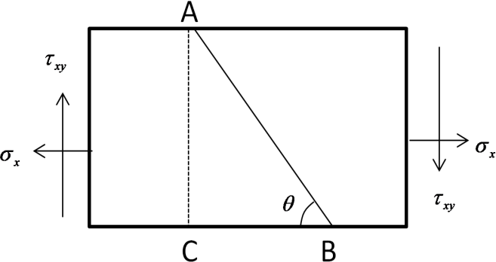
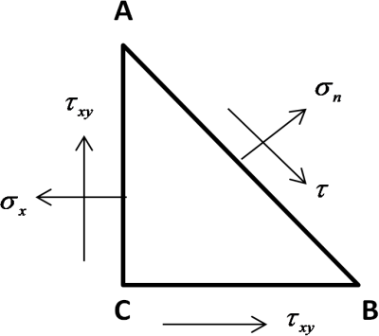

Let σ_{x} = tensile stress along X-X axis τ_{x} = shear stress along X-X axis

Consider the equilibrium of the section ABC Horizontal force acting on the face AC = P_{x} = σ_{x} × AC The vertical force acting on the face AC = P_{y} = τ_{x} × AC
The horizontal force acting on the face BC = P = τ_{x} ×BC Resolving the forces normal to the section AB
P_{n} = P_{x} sin Ɵ – P_{y} cos Ɵ – P sin Ɵ
= σ_{x} × AC sin Ɵ - τ_{x} . AC cos Ɵ - τ_{x} . BC sin Ɵ
Resolving the forces tangential to the section AB
P_{t} = P_{x} cos Ɵ + P_{y} sin Ɵ – P cos Ɵ
= σ_{x} × AC cos Ɵ + τ_{x} . AC sin Ɵ - τ_{x} . BC cos Ɵ
Normal stress across the section AB = σ_{n}

= 𝑃𝑛
𝐴𝐵
= (𝜎𝑥 × 𝐴𝐶 × sin 𝚹 )− (𝜏𝑥 × 𝐴𝐶 × cos 𝚹)− (𝜏𝑥 × 𝐵𝐶 × sin 𝚹)
𝐴𝐵

= (𝜎𝑥 × 𝐴𝐶 ×𝑠𝑖𝑛 𝚹 ) - (𝜏𝑥 × 𝐴𝐶 × cos 𝚹) - (𝜏𝑥 × 𝐵𝐶 × sin 𝚹)

𝐴𝐵
𝐴𝐵
𝐴𝐵

= (𝜎𝑥 × 𝐴𝐶 ×𝑠𝑖𝑛 𝚹 ) - (𝜏𝑥 × 𝐴𝐶 × cos 𝚹) - (𝜏𝑥 × 𝐵𝐶 × sin 𝚹)

𝐴𝐶

𝑠𝑖𝑛𝚹
𝐴𝐶

𝑠𝑖𝑛 𝚹
𝐵𝐶

cos 𝚹

= σ_{x} sin² Ɵ – τ_{x} sin Ɵ. cos Ɵ - τ_{x} sin Ɵ. cos Ɵ

= 𝜎𝑥 (1- cos 2Ɵ) - 2 τ
x
2
sin Ɵ. cos Ɵ

= 𝝈𝒙 - 𝝈𝒙 cos 2Ɵ - τ
sin 2Ɵ (1)

𝟐 𝟐 x
Shear stress across the section AB

= 𝑃𝑡
𝐴𝐵
= (𝜎𝑥 × 𝐴𝐶 × cos 𝚹 )+ (𝜏𝑥 × 𝐴𝐶 × sin 𝚹)− (𝜏𝑥 × 𝐵𝐶 × cos 𝚹)
𝐴𝐵

= (𝜎𝑥 × 𝐴𝐶 × 𝑐𝑜𝑠𝚹 ) + (𝜏𝑥 × 𝐴𝐶 × sin 𝚹) - (𝜏𝑥 × 𝐵𝐶 × cos 𝚹)

𝐴𝐵
𝐴𝐵
𝐴𝐵

= (𝜎𝑥 × 𝐴𝐶 ×cos 𝚹 ) + (𝜏𝑥 × 𝐴𝐶 × sin 𝚹) - (𝜏𝑥 × 𝐵𝐶 × cos 𝚹)

𝐴𝐶

𝑠𝑖𝑛𝚹
𝐴𝐶

𝑠𝑖𝑛 𝚹
𝐵𝐶

cos 𝚹

= σ_{x} sin Ɵ cos Ɵ + τ_{x} sin² Ɵ - τ_{x} cos² Ɵ
= 𝜎𝑥 sin 2Ɵ + 𝜏𝑥 (1- cos 2 Ɵ) – 𝜏𝑥 (1 + cos 2Ɵ)
𝟐 𝟐 𝟐

= 𝜎𝑥 sin 2Ɵ + 𝜏𝑥
- 𝜏𝑥
cos 2 Ɵ – 𝜏𝑥 - 𝜏𝑥 cos 2Ɵ

𝟐 𝟐 𝟐 𝟐 𝟐

= 𝝈𝒙 sin 2Ɵ - τ
cos 2Ɵ (2)

𝟐 x
The maximum and minimum normal stress may be obtained by equating the Shear stress to zero.

Maximum principal stress (σ
) = 𝝈𝒙 + √𝝈𝒙 𝟐 + 𝝉
𝟐 (3)

p1 𝟐 𝟐 𝒙

Minimum principal stress (σ
) = 𝝈𝒙 – √( 𝝈𝒙 ) 𝟐 + 𝝉 ^{𝟐} (4)

p2 𝟐 𝟐 𝒙

Case-V: Stresses on an oblique section subjected to normal stress along two mutually perpendicular directions and followed by shear stress

Normal stress (σ ) = 𝝈𝒙 + 𝝈𝒚 - 𝝈𝒙− 𝝈𝒚 cos 2Ɵ - τ
sin 2Ɵ (1)

n 𝟐 𝟐 x

Shear stress (τ) = 𝝈𝒙− 𝝈𝒚 sin 2Ɵ - τ

cos 2Ɵ (2)

𝟐

Maximum principal stress (σ
x

) 𝝈𝒙 + 𝝈𝒚 √ 𝝈𝒙− 𝝈𝒚 𝟐 𝟐

p1 𝟐
= + ( ) + 𝝉

𝟐 𝒙
- (3)

Minimum principal stress (σ
) 𝝈𝒙 + 𝝈𝒚 √ 𝝈𝒙− 𝝈𝒚 𝟐 𝟐

p2 𝟐
= - ( ) + 𝝉

𝟐 𝒙
- (4)

***** PROBLEM *****

Q-1) A rectangular block 10 cm × 5 cm in section is subjected to a tensile load of 500 kN. Determine the normal stress and shear stress on an oblique plane making an angle of 30⁰ with the length of the block.
Ans) Data Given
Tensile load (P) = 500 kN
angle made by the oblique plane (Ɵ) = 30⁰
area of block (A) = 10 cm × 5 cm = 50 cm² = 5000 mm²
Tensile stress (σ) = P/A = (500/5000) kN/mm² = 0.1 kN/mm² = 100 N/mm²
Normal stress across the section (σ_{n}) = ^{𝜎} - ^{𝜎} × (1- cos 2Ɵ)
2 2
= ¹⁰⁰ - ¹⁰⁰ × (1- cos 2×30) = 25 N/mm²
2 2
Shear stress across the section (τ) = ^{𝜎} sin 2Ɵ = ¹⁰⁰ × sin 2×30 = 43.3 N/mm² (ANS)
2 2

Q-2) A rectangular block of 1000 mm² cross sectional area is subjected to a longitudinal compressive load of 1000 kN. Determine the normal stress across the cross section of the block. If the block is cut by an oblique plane making an angle of 40⁰ with normal section of the block, determine i) normal and tangential stress on the oblique plane ii) resultant stress on the oblique plane.
Ans) Data Given
Compressive load (P) = 1000 kN
area of cross section of block (A) = 1000 mm² angle made by the oblique plane (Ɵ) = 40⁰
compressive stress (σ) = P/A = (1000/1000) kN/mm² = 1 kN/mm²
Normal stress across the section (σ_{n}) = ^{𝜎} - ^{𝜎} × (1- cos 2Ɵ)
2 2
= ¹ - ¹ × (1- cos 2×40) = 0.58 kN/mm²
2 2
Shear stress across the section (τ) = ^{𝜎} sin 2Ɵ = ¹ × sin 2×40 = 0.49 N/mm²
2 2
Resultant stress (σ_{R}) = √σ_{𝑛} 2 + 𝜏² = √(0.58)² + (0.49)² = 0.76 kN/mm² Let α = angle made by the resultant stress with the oblique plane

then tan α = ^{𝜎𝑛} = ^{0.58} = 1.19
𝜏 0.49
∴ α = tan⁻¹ (1.19) = 49.99⁰ (ANS)

Q-3) An element in a strained body is subjected to two mutually perpendicular tensile stresses of 300 N/mm² and 200 N/mm². Determine on a plane inclined at 30⁰ to the direction of smaller stress, i) normal stress ii) shear stress iii) resultant stress.
Ans) Data Given
σ_{x} = tensile stress along X-X axis = 300 N/mm² σ_{y} = tensile stress along Y-Y axis = 200 N/mm² angle made by the oblique plane (Ɵ) = 30 ⁰
Normal stress on the inclined plane (σ ) = 𝜎𝑥 + 𝜎𝑦 - 𝜎𝑥− 𝜎𝑦 cos 2Ɵ
n 2 2
= 300 +200 – 300 −200 cos 2× 300
2 2
= 250 – 25 = 225 N/mm²

Shear stress on the inclined plane (τ) = 𝜎𝑥 − 𝜎𝑦
2
= 300 −200
2
sin 2Ɵ
sin 2× 30⁰ = 43.3 N/mm²

Resultant stress (σ_{R}) = √σ_{𝑛} 2 + 𝜏² = √(225)² + (43.3)² = 303.10 N/mm² Let α = angle made by the resultant stress with the oblique plane

then tan α = ^{𝜎𝑛} = ²²⁵
= 5.19 ∴

𝜏 43.3
α = tan⁻¹ (5.19) = 81.79⁰ (ANS)

Q-4) The stresses at a point in a component are 100 MPa (tensile) ans 50 MPa (compressive). Determine the magnitude of the normal and shear stresses on a plane inclined at an angle of 25⁰ with tensile stress. Also determine the direction of the resultant stress and the magnitude of the maximum intensity of shear stress.
Ans) Data Given
Tensile stress along X-X axis (σ_{x}) = 100 MPa Compressive stress along Y-Y axis (σ_{y}) = 50 Mpa Angle made by the plane with tensile stress (Ɵ) = 25⁰
Normal stress on the inclined plane (σ ) = 𝜎𝑥 + 𝜎𝑦 - 𝜎𝑥− 𝜎𝑦 cos 2Ɵ
n 2 2
= 100 +(−50) – 100 −(−50) cos 2× 250
2 2
= - 23.21 MPa

Shear stress on the inclined plane (τ) = 𝜎𝑥 − 𝜎𝑦
2
sin 2Ɵ

= 100 −(−50)
2
sin 2× 25⁰ = 57.45 MPa

Let α = angle made by the resultant stress with the oblique plane

then tan α = ^{𝜎𝑛} = ^{57.45}
= - 2.4752

𝜏 −23.21
∴ α = tan⁻¹ (- 2.4752) = - 68⁰

Maximum shear stress (τ
) = ± 𝜎𝑥 + 𝜎𝑦
= ± 100 −(−50) = ± 75 MPa (ANS)

max 2 2

Q –5) A plane element in a body is subjected to a tensile stress of 100 MPa accompanied by a shear stress of 25 MPa. Find i) the normal and shear stress on a plane inclined at an angle of 20⁰ with the tensile stress and ii) the maximum shear stress on the plane.
Ans) Data Given
Tensile stress along X-X axis (σ_{x}) = 100 MPa Shear stress (τ_{xy}) = 25 MPa
angle made by the plane with tensile stress (Ɵ) = 20⁰
Normal stress on the inclined plane (σ ) = 𝜎𝑥 - 𝜎𝑥 cos 2Ɵ - τ sin 2Ɵ
n 2 2 xy
= 100 - 100 cos (2×20⁰) – 25 × sin (2×20⁰)
2 2
= - 4.37 MPa
Shear stress on the inclined plane (τ) = 𝜎𝑥 sin 2Ɵ - τ_{xy} cos 2Ɵ
2
= 100 sin (2×20⁰) – 25 × cos (2×20⁰)
2
= 12.99 MPa

Maximum shear stress on the plane (τ
𝜎
) = √( ) + (𝜏
𝑥 2

100
)2 = √ 2 2
( ) + (25)

max 2 𝑥𝑦 2
= 55.9 MPa (ANS)

MOHR’S CIRCLE:
Mohr‟s circle is a graphical method which is used to determine the normal, shear and resultant stresses.

Sign Convention:
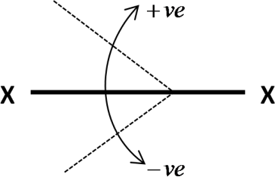
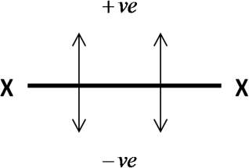
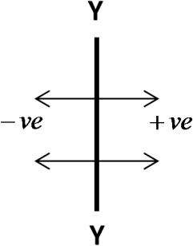
- The angle is taken with respect to X-X axis. All the angles shown in anticlockwise direction to X-X axis are negative and all the angles shown in clockwise direction to X-X axis are positive.
- The measurements above X-X axis are positive and below X-X axis are negative. The measurements to the right of Y-Y axis are positive and to the left of Y-Y axis are negative.

CONSTRUCTION OF MOHR’S CIRCLE

Stresses on an oblique section of a body subjected to a direct stress in one plane:

  - Draw a horizontal line XOX
  - Cut OJ equal to tensile stress (σ) to some suitable scale. Divide OJ into two equal parts as OC and CJ. The point O represents the stress system on plane BC and the plane J represents stress system on plane AC.
  - Take C as the centre and OC as the radius and draw the circle. This is known as Mohr‟s circle for stresses.

  - Through C draw a line CP at an angle of 2Ɵ with CO in clockwise direction meeting the circle at P. The point P represents the section AB.
  - Through P, draw PQ perpendicular to OX. Join OP.
  - In figure OQ, QP and OP gives the value of normal stress, shear stress and resultant stress.
  - The angle POJ is called the angle of obliquity (Ɵ).
  - When 2Ɵ is equal to 90⁰ or 270⁰ then maximum shear stress will obtain. ∠𝑷𝑪𝑸 = 2Ɵ MOHR’S CIRCLE
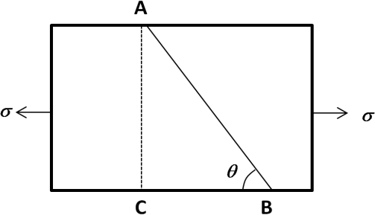
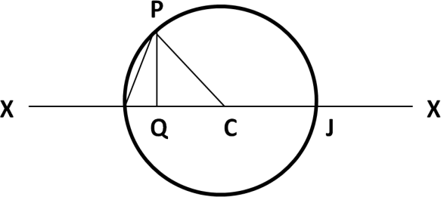

Stresses on an oblique section of a body subjected to direct stresses in two mutually perpendicular directions:

  - Draw a horizontal line OX. Cut off OJ and OK equal to the tensile stresses σx and σy to some suitable scale towards right of O.
  - The point J represents the stress system on the plane AC and point K represents the stress system on the plane BC. Bisect JK at C.
  - Take C as the centre and CJ as the radius and draw a circle. It is known as Mohr‟s circle of stresses.
  - Draw a line CP through C making an angle 2Ɵ with CK in clockwise direction. CP line meets the circle at P. The point P represents the stress systems on the section AB.
  - Draw perpendicular PQ from point P to the axis OX. Join OP.
  - In figure OQ, QP and OP gives the value of normal stress, shear stress and resultant stress.
  - CM and CN give the maximum shear stress to the scale. The angle POC is called as the angle of obliquity.

MOHR’S CIRCLE
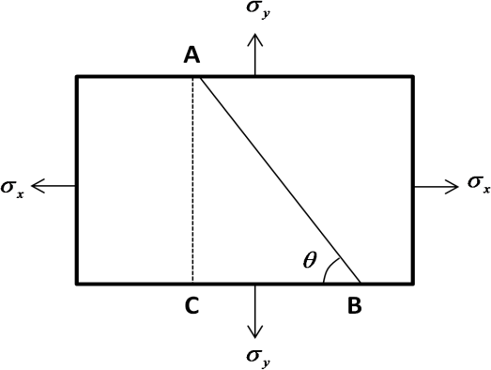
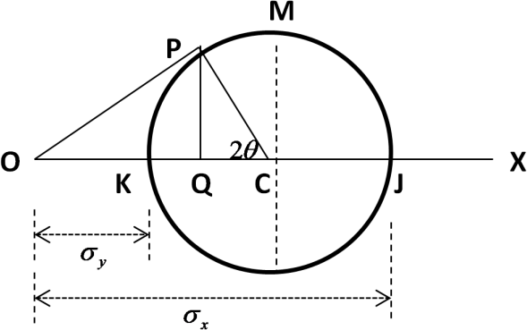

Stresses on an oblique section of a body subjected to a direct stresses in one plane with a shear stress:

  - Draw a horizontal line XOX.
  - Cut off OJ equal to the tensile stress σ_{x} to some suitable scale towards right.
  - Draw a perpendicular from J vertically upward and cut JD equal to τ_{xy} to scale. The point D represents the stress system on plane AC.
  - Draw a perpendicular from O vertically downward and cut OE equal to τ_{xy} to scale. The point E represents the stress system on plane BC.
  - Join DE and bisect it at C.
  - Take C as the centre and CD as the radius and draw a circle. It is known as the Mohr‟s circle of stresses.
  - Draw a line CP through C making an angle 2Ɵ with CE in clockwise direction. The point P will lie on the circle which represents the stress system on plane AB.
  - Draw a perpendicular PQ through P to meet the line XOX at Q. Join OP.
  - In figure OQ, QP and OP give the normal, shear and resultant stresses to scale. The angle POC is called the angle of obliquity.

MOHR’S CIRCLE
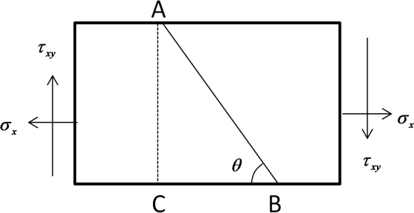
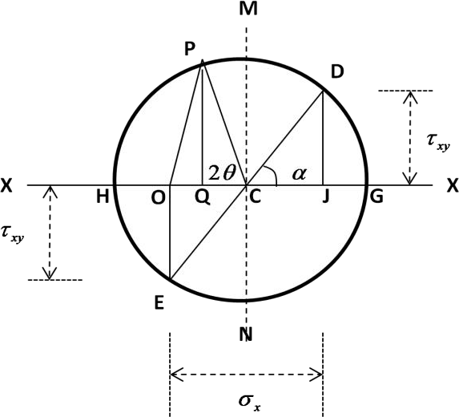

Stresses on an oblique section of a body subjected to direct stresses in two mutually perpendicular directions with a shear stress:

  - Draw a horizontal line OX.
  - Cut off OJ and OK equal to tensile stresses σ_{x} and σ_{y} respectively to some suitable scale towards right.
  - Draw a perpendicular through J vertically upward and cut off JD equal to the shear stress τ_{xy} to scale. The point D represents the stress system on plane AC.
  - Draw a perpendicular through K vertically downward and cut KE equal to the shear stress τ_{xy} to scale. The point E represents the stress system on plane BC.
  - Join DE and bisect it at C.
  - Take C as the centre and radius equal to CD and draw a circle. It is known as Mohr‟s circle of stresses.

  - Draw a line CP through C making an angle 2Ɵ with CE in clockwise direction meeting the circle at P. The point P represents the stress system on section AB.
  - Draw a perpendicular PQ to the line OX through P. Join OP.
  - In figure OQ, QP and OP give the normal, shear and resultant stress respectively to scale.
  - OG and OH give the maximum and minimum principal stresses to scale. The angle POC is called as the angle of obliquity.

τxy

σ_{x}
A σ_{y}

σ_{x}

Ɵ

P M D

τxy

τ_{xy} O H K Q

σ_{y} σ_{x} τ_{xy} E
C J G X

σ_{y} N
MOHR’S CIRCLE

***** ASSIGNMENT – 04 *****

Q-1) The stresses at a point of a machine component are 150 MPa and 50 MPa both tensile. Find the intensities of normal, shear and resultant stresses on a plane inclined at an angle of 55⁰ with the axis of major tensile stress. Also find the magnitude of the maximum shear stresses in the component.
Q- 2) The stresses at a point in a component are 100 MPa (tensile) and 50 MPa (compressive).
Determine the magnitude of the normal and shear stresses on a plane inclined at an angle of 25⁰ with tensile stresses. Also determine the direction of the resultant stresses and the magnitude of the maximum intensity of shear stress.
Q-3) A plane element in a rigid body is subjected to a tensile stress of 100 MPa accompanied by a clockwise shear stress of 25 MPa. Find (i) the normal and shear stress on a plane inclined at an angle of 20⁰ with the tensile stress; and (ii) the maximum shear stress on the plane.
Q-4) An element in a strained body is subjected to a tensile stress of 150 MPa and a shear stress of 50 MPa tending to rotate the element in an anticlockwise direction. Find (i) the magnitude of the normal and shear stresses on a section inclined at 40⁰ with the tensile stress; and (ii) the magnitude and direction of maximum shear stress that can exist on the element.
Q-5) An element in a strained body is subjected to a compressive stress of 200 MPa and a clockwise shear stress of 50 MPa on the same plane. Calculate the values of normal and shear stresses on a plane inclined at 35⁰ with the compressive stress. Also calculate the value of maximum shear stress in the element.

Q-6) A point is subjected to a tensile stress of 250 MPa in the horizontal direction and another tensile stress of 100 MPa in the vertical direction. The point is also subjected to a simple shear stress of 25 MPa, such that when it is associated with the major tensile stress, it tends to
rotate the element in the clockwise direction. What is the magnitude of the normal and shear stresses inclined on a section at an angle of 20⁰ with the major tensile stress?
Q-7) A plane element in a boiler is subjected to tensile stresses of 400 MPa on one plane and 150 MPa on the other at right angle to the former. Each of the above stresses is accompanied by shear stress of 100 MPa such that when associated with the major tensile stress tends to rotate the element in an anticlockwise direction. Find (i) principal stresses and their directions and
(ii) maximum shearing stresses and directions of the plane on which they act.
Q-8) A point in a strained material is subjected to the stresses as shown in figure. Find the normal and shear stresses on the section AB.
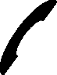
25 MPa 150 MPa

25 MPa
75 MPa

A

550 B

75 MPa

25 MPa

150 MPa 25 MPa
Q-9) A machine component is subjected to the stresses as shown in figure. Find the normal and shearing stresses on the section AB inclined at an angle of 600 with X-X axis. Also find the resultant stress on the section.

100 MPa
50 MPa 25 MPa
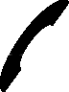
25 MPa
A
60⁰ B
100 MPa

25 MPa
25 MPa

50 MPa

(Refer R.S Khurmi – Strength of Material book)

SHEAR FORCE & BENDING MOMENT

BEAM:
It is a member of a structure which can carry forces or couple acting on it.

TYPES OF BEAM:
- Cantilever beam: It is a beam whose one end is fixed and other end is free.
- Simply supported beam: It is a beam whose both ends are freely supported.
- Overhanging beam: It is a beam which is freely supported at any two points and having one or both ends projected beyond these two supports.
- Continuous beam: It is a beam which is supported at more than two supports.
- Fixed beam: It is a beam whose both ends are fixed or built into its supports.

STATICALLY DETERMINATE BEAMS:
If the reactions of the supports of the beams can be determine by the equations of static equilibrium, such beams are known as statically determinate beams. The value of the support reactions is independent of deformation.

STATICALLY INDETERMINATE BEAMS:
If the reactions of the supports of the beams can‟t be determine by the equations of static equilibrium, such beams are known as statically indeterminate beams. The value of the support reactions are based on deformation.

TYPES OF LOADING:
- Concentrated or point load: It is a load which acts at a point on the beam.
- Uniformly distributed load: It is a load which spreads over the entire length or part of the length of the beam at a uniform rate.
- Non uniformly distributed or uniformly varying load: It is a load which spreads over the entire length or part of the length of the beam at a non uniform rate.

SHEAR FORCE:
Shear force at any cross section of the beam is the algebraic sum of the vertical components of the forces acting on the beam.

BENDING MOMENT:
The bending moment at any point on a loaded beam is the algebraic sum of the moments of all the forces acting on one side of the point about the point.

SHEAR FORCE DIAGRAM:
It is the diagram which represents the variation/distribution of shear force along the length of the beam.

BENDING MOMENT DIAGRAM:
It is the diagram which represents the variation/distribution of bending moment along the length of the beam.

SIGN CONVENTION:
Sign convention is always selected according to the selection of the beam either from the left or right side of the beam.

Sign convention of shear force:
- Shear force is taken as positive, if the left hand portion of the beam tends to slide upwards and right hand side of the beam tends to slide downward. (figure - 1)
- Shear force is taken as negative, if the left hand portion tends to slide downwards and the right hand side tends to slide upwards. (figure - 2)
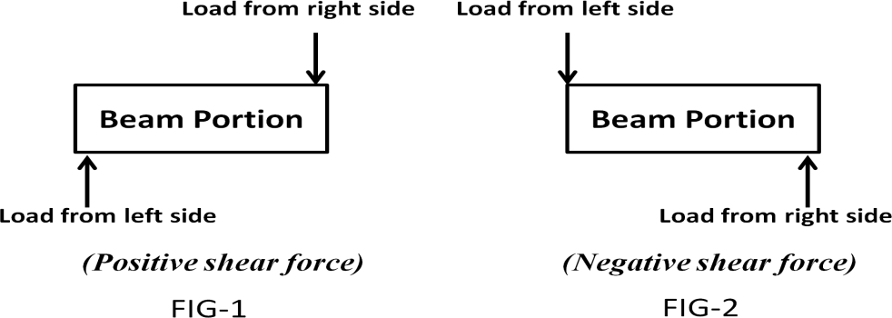

Sign convention of bending moment:
- Moment due to all downward forces is taken as negative (hogging moment) and the moment due to all upward forces (sagging moment) are taken as positive.
- BM is taken as positive, if it is acting in clockwise direction to the left or in anticlockwise direction to the right.
- BM is taken as negative, if it is acting in anticlockwise direction to the left or in clockwise direction to the right.
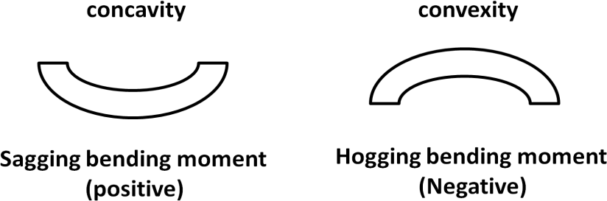

SAGGING BENDING MOMENT:
It represents the positive bending moment. If the bending moment tends to bend the beam to produce concavity at the point of curvature, the bending moment is known as sagging bending moment.

HOGGING BENDING MOMENT:
It represents the negative bending moment. If the bending moment tends to bend the beam to produce convexity at the point of curvature, the bending moment is known as hogging bending moment.

RELATION BETWEEN LOADING, SHEAR FORCE AND BENDING MOMENT:
- If there is a point load at any section of a beam, then the SF suddenly changes but the BM does not change. The SF line is vertical.
- If there is no load between any two points of a beam section SF does not change but the BM changes linearly. The SF line is horizontal but BM line is an inclined straight line.
- If there is a U.D.L between two points, then the SF changes linearly and BM changes according to parabolic law. The SF line is an inclined straight line but the BM line is a parabola.

Determination of Shear force and Bending Moment and Shear force and Bending moment diagram for the following cases:
- Cantilever beam with point load (concentrated loads)

  - Determine the reaction force at the fixed end.
  - Determine the SF at the required points (including the free and fixed end).
  - Determine the BM at the required points (including the free and fixed end).
  - Draw the SFD
  - Draw the BMD

Cantilever beam with Uniformly distributed load (U.D.L)

  - Determine the reaction force at the fixed end.
  - Determine the SF at the required points (including the free and fixed end).
  - Determine the BM at the required points (including the free and fixed end).
  - Draw the SFD.
  - Draw the BMD.

Cantilever beam with U.D.L and point load

  - Determine the reaction force at the fixed end.
  - Determine the SF at the required points (including the free and fixed end).
  - Determine the BM at the required points (including the free and fixed end).
  - Draw the SFD.
  - Draw the BMD.

Simply supported beam with point load

  - Determine the reaction force at the simply supported ends.

  - Determine the SF at the required points (including end points and the point where SF changes its sign).
  - Determine the BM at the required points (including the end points where BM is zero and the point where there is maximum BM).
  - Draw the SFD.
  - Draw the BMD.

Simply supported beam with U.D.L

  - Determine the reaction force at the simply supported ends.
  - Determine the SF at the required points (including end points and the point where SF changes its sign).
  - Determine the BM at the required points (including the end points where BM is zero and the point where there is maximum BM).
  - Draw the SFD.
  - Draw the BMD.

Simply supported beam with U.D.L and point load

  - Determine the reaction force at the simply supported ends.
  - Determine the SF at the required points (including end points and the point where SF changes its sign).
  - Determine the BM at the required points (including the end points where BM is zero and the point where there is maximum BM).
  - Draw the SFD.
  - Draw the BMD.

***** ASSIGNMENT – 05 *****

GROUP – A (2 mark questions)
- Define cantilever beam.
- Name the various types of beams.
- Define Shear force and bending moment diagram.
- Define point of contraflexure.
- What is the maximum bending moment for a simply supported beam with UDL over the entire span?
- What is the maximum bending moment for a simply supported beam carrying a point load at its middle?

GROUP – B (5 mark questions)
- State the relationship between loading, shear force and bending moment.
- Draw the shear force and bending moment diagram for a cantilever beam carrying UDL of w/unit metre over its whole span of l.
- A cantilever beam of 8 m length is loaded with a point load of 50 kg at its free end and UDL of 10 kg/m over 4 m from its fixed end. Sketch the SF and BM diagram.

- A cantilever beam AB, 2 m long carries a uniformly distributed load of 1.5 kN/m over a length of 1.6 m from the free end. Draw the SF and BM diagram for the beam.
- A cantilever beam of length 2 m is subjected to load 500 N at its free end 800 N at a distance
0.5 m from its free end, Determine the SF and BM diagram for the beam.
- Draw the SFD and BMD for a simply supported beam carrying a point load at its middle.
- Draw the SFD and BMD for a simply supported beam carrying a UDL of w/unit meter length over its whole span.

GROUP – C (10 mark questions)
- Draw the shear force and bending moment diagram for a cantilever beam of span 2 m subjected to load 500 N at the free end and loads 800 N, 300 N, 400 N at distance 0.5 m, 1 m, and 1.5 m from its free end.
- A beam AB 10 m long is simply supported at its ends A and B. It carries a UDL of 20 kN/m for a distance of 5 m from the left end A and a concentrated load of 40 kN at a distance of 2 m from the right end B. Draw the S.F and B.M diagrams for the beam.
- A beam AB 10 m long has supports at its ends A and B. It carries a point load of 5 kN at 3 m from A and a point load of 5 kN at 7 m from A and a UDL of 1 kN per metre between the point loads. Draw the S.F and B.M diagrams for the beam.

THEORY OF SIMPLE BENDING

SIMPLE BENDING:
When a straight beam is subjected to a couple at its ends, constant bending moment will produce at every cross section of the beam with no shear stress. This condition the beam is called as pure torsion or simple bending.

ASSUMPTION IN PURE BENDING:
  - The material of the beam is same throughout (homogeneous) and possesses same elastic properties (isotropic) in all direction.
  - The transverse section of the beam which is plane before bending remains same after bending.
  - Young‟s modulus for the material is same in tension and compression.
  - Each layer of the beam is free to expand or contract independently.
  - The radius of curvature of the beam after bending is large as compared to its cross sectional dimensions.
  - Loads act perpendicular to the axis of the beam.
  - The beam is in equilibrium i.e. the resultant pull or thrust on the transverse section of the beam is zero.

VARIOUS TYPES OF SECTIONS:
Various types of engineering sections may be classified as symmetrical, unsymmetrical and built-up sections.
  - Symmetrical sections: In this type of sections the centre of gravity lies at the geometrical centre of the sections. The neutral axis passes through the geometrical centre of the section. Ex – circular/ square/ rectangular sections.
  - Unsymmetrical sections: In this type of sections the centre of gravity does not lies at the geometrical centre of the sections. Neutral axis passes through the centre of gravity.
Ex – T, L, I sections.

THEORY OF SIMPLE BENDING:
A small portion of a beam ABCD is shown in figure-1. AB and CD are the two planes.
Let this portion is subjected to simple bending. Let EF is the length of neutral layer.
Consider another layer GH at a distance „y‟ from the neutral axis. Consider all the layers bend as shown in figure – 2.
The layers AB, CD, EF and GH deformed to A₁B₁, C₁D₁, E₁F₁ and G₁H₁ respectively. All the layers above EF get compressed and the layers below EF get elongated.
As EF is the neutral layer, its length will remain unchanged. So EF = E₁F₁
Let all the layers bend into arcs with centre „O‟ of radius of curvature
„R‟ and angle between the planes is „θ‟.
Before bending lengths of all layers is same i.e. GH = EF = E₁F₁
After deformation G₁H₁ = (R+ y) θ EF = E₁F₁ = R θ

Change in length of the layer GH = (R+ y) θ - R θ = y θ
Strain in the layer GH = e = ^{𝑐𝑕𝑎𝑛𝑔𝑒} ^{𝑖𝑛} ^{𝑙𝑒𝑛𝑔𝑡} 𝑕 = ^{y} ^{𝚹} = ^{y}
𝑜𝑟𝑖𝑔𝑖𝑛𝑎𝑙 𝑙𝑒𝑛𝑔𝑡 𝑕 R 𝚹 R
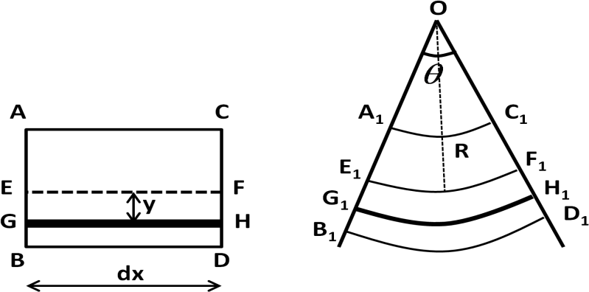

Let, σ = intensity of stress of the layer E = Young‟s modulus
∴ e = ^{y} = ^{𝜎} or ^{𝝈} = ^{𝐄} (1)
R 𝐸 𝒚 𝐑
or σ = ^{E} × y
R

MOMENT OF RESISTANCE:
It is the algebraic sum of the moment about neutral axis of the internal forces developed in a beam due to bending.
Consider a beam section as shown in figure.
Consider a small layer PQ at a distance „y‟ from the neutral axis.
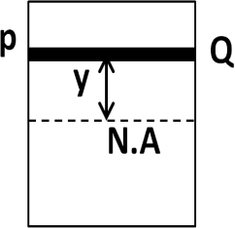
Let, dA = elementary area of PQ
Intensity of shear stress in the layer PQ = σ = ^{E} × y
R
Total stress/thrust in the layer PQ = ^{E} × y × dA
R
Moment of resistance offered by the elementary area = Moment of the-
thrust about the neutral axis = total stress × distance = ^{E} × y² × dA
R
Total moment of resistance offered by the beam section = ^{E} ∑ y² 𝑑𝐴
R
∑ y² 𝑑𝐴= moment of inertia of the beam section about the neutral axis
Thus M = ^{E} × I
R

⇒ 𝐌
𝐈
= ^{𝐄} (2)
𝐑

We know that, ^{𝐄} = ^{𝝈}
𝐑 𝒚

So we may write ^{𝐌} = ^{𝐄} = ^{𝝈}
(3)

𝐈 𝐑 𝒚
This is known as Bending equation.

SECTION MODULUS:
It is the ratio between moment of inertia of the section of the beam and the maximum distance of layer from the neutral axis.
Mathematically, section modulus (Z) = ^{𝐈}
𝐘
So we may write, M = σ × Z (4) POLAR MODULUS:
It is the measure of the strength of the shaft in torsion. It is the ratio between the polar moment of

inertia of the beam section and the radius of curvature. It is denoted by Z_{P.}
Mathematically, Z_{P}
= 𝑰𝒑
𝐑

***** PROBLEM *****

Q – 1) A steel plate is bent into a circular arc of radius 10 m. If the plate section be 120 mm wide and 20 mm thick, find the maximum stress induced and the bending moment which can produce this stress. Take E = 2 × 10⁵ N/mm².
Ans) Data Given
Radius of curvature (R) = 10 m width = 120 mm
thickness = 20 mm E = 2 × 10⁵ N/mm²
Moment of inertia of the section about the neutral axis = I = ^{𝟏𝟐𝟎} × ^{𝟐𝟎}𝟑 = 80000 mm⁴
𝟏𝟐
we know that, ^{𝐌} = ^{𝐄} = ^{𝝈} ⟹ σ = ^{E} × y
𝐈 𝐑 𝒚 R

∴ σmax
= 𝟐 × 𝟏𝟎𝟓
𝟏𝟎 × 𝟏𝟎𝟑
× ( ^{𝟐𝟎} ) = 200 N/mm²
𝟐

Bending moment (M) = ^{E} × l = ^{𝟐} × ^{𝟏𝟎}𝟓 × 8 × 10⁴ = 16 × 10⁵ N-mm (ANS)
R 𝟏𝟎 × 𝟏𝟎𝟑
Q – 2) A cast iron test beam 20 mm × 20 mm in section and 1 m long and supported at the ends fails when a central load of 640 N is applied. What uniformly distributed load will break a cantilever of same material 50 mm wide, 100 mm deep and 2 m long?
Ans) Data Given
Cast iron test beam : Cross section of = 20 mm × 20 mm
length = 1 m = 1000 mm load (W) = 640 N
Cantilever : width = 50 mm depth = 100 mm length = 2 m = 2000 mm
for the test beam, maximum bending moment = M = ^{WL} = ⁶⁴⁰ ^{×1000} = 16 × 10⁴ N-mm
4 4
moment of resistance = 1 σ b d² = 1 σ × 20 × 20² = 4000 × σ N-mm

6
Equating these two we get, ⁴⁰⁰⁰
3
6 3
× σ = 16 × 10⁴
2

∴ σ = 120 N/mm
for the cantilever consider the UDL required is w/metre run
so, maximum bending moment = M = W𝑙2 = ^{W} × ²⁰⁰⁰ 2 = 2000 w N-mm
2 2
moment of resistance of the section = ¹ σ b d² = 1 × 120 × 50 × 100² = 10 × 10⁶ N-mm
6 6
Equating these two we get, 2000 w = 10 × 10⁶
∴ w = 5000 N/m (ANS)

***** ASSIGNMENT – 7 *****

GROUP - A (2 mark questions)
- Define section modulus of a beam.
- What do you mean by symmetrical section? Give some example.
- State bending equation for a beam section.
- Define flexural rigidity.
- Write the relation between bending moment and bending stress.
- Write the expression of section modulus of a rectangular section of dimension (b × d).
- Write the expression of section modulus of a circular section of diameter d.

GROUP – B (6 mark questions)
- Explain the theory of simple bending.
- State the assumption of pure bending.
- A cast iron cantilever at length 1.5 m fails when a load of 1920 N is applied at the free end. Determine the stress at failure if the section of the cantilever is 40 mm × 60 mm.
- A cast iron pipe of external diameter 60 mm, 10 mm thickness and 5 m long is supported at its ends. The pipe carries a point load of 100 N at its centre. Calculate the maximum flexural stress induced due to point load.
- Find the maximum UDL that a beam can support over a span of 10 m if the maximum stress is limited to 500 kg/cm² and section modulus of the beam is 128 cm³.

COMBINED DIRECT & BENDING STRESS

Column: It is a vertical bar or member of a structure, which always subjected to axial compressive forces.
Short column: It is a column whose length is less than 8 times the diameter and slenderness ratio less than 32. This type of column may fail due to direct stress.
Medium column: It is a column whose length varies from 8 to 30 times their diameter and slenderness ratio varies from 32 to 120.
Long column: It is a column whose length is more than 30 times the diameter and
slenderness ratio more than 120. This type of column may fail due to bending stress.
Slenderness ratio: It is the ratio of the length of the column to the minimum radius of gyration of the cross sectional area of the column.
Buckling Load: It is the minimum limiting load acting axially on a column due to which the lateral displacement or buckling may appear on a column. It is also known as crippling or critical load.
Eccentric load: If the line of action of a load does not coincide with the line passing through the body subjected to load, such a load is called eccentric load.
Eccentricity: It is the distance between the line of action of eccentric load from the centroid of the body.

Stress in short column under eccentric loading:
- Load acting eccentrically to one axis:
Consider a short column subjected to an eccentric load „P‟ at a distance „e‟ from its axis as shown in figure. From figure; at point „O‟, there is two equal and opposite loads „P‟.
The downward load „P‟ acting at „O‟ causes a direct stress.
The upward force acting at „O‟ and the eccentric load causes a clockwise couple.

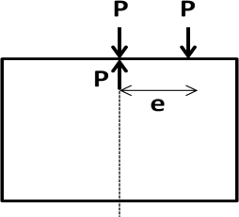 | 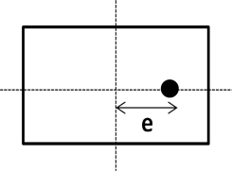 | 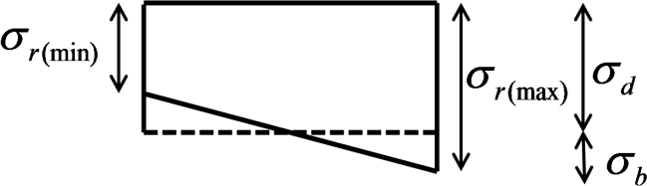

Let A = area of cross section of the column
σ_{d} = direct stress due to load „P‟ applied axially
σ_{b} = bending stress at a distance „y‟ from the neutral axis. σ_{r} = resultant of direct and bending stress

Thus Direct stress = σ_{d} = ^{𝐏}
𝐀
- (1)

Bending stress = σ_{b} = ^{𝐌} ^{.𝐲}
𝒍
= 𝐏 . 𝐞 .𝐲
𝒍
- (2)

Resultant stress = σ_{r} = σ_{d} ± σ_{b} = ^{𝐏}
𝐀
± 𝐏 . 𝐞 .𝐲
𝒍
- (3)

Maximum resultant stress = σ_{d} + σ_{b} , when σ_{b} is tensile Minimum resultant stress = σ_{d} − σ_{b} , when σ_{b} is compressive
Conditions:
- When σ_{d} > σ_{b} ; σ_{r} _{(max)} and σ_{r} _{(min)} both are positive. Compressive stresses act anywhere of the section.
- When σ_{d} = σ_{b} ; σ_{r} _{(max)} = 2 σ_{d} =2 σ_{b} and σ_{r} _{(min)} = 0. Compressive stresses act anywhere of the section and varies from zero at one edge to maximum at other.
- When σ_{d} < σ_{b} ; σ_{r} _{(max)} = σ_{d} + σ_{d} , which is positive and σ_{r} _{(min)} = σ_{d} – σ_{b}, which is negative.
σ_{r} _{(max)} is compressive and σ_{r} _{(min)} is tensile.

- Load acting eccentrically to both axis:
Consider a short column subjected to an eccentric load „P‟ with eccentricity about both axes as shown in figure.
Let A = area of cross section of the column P = load acting on the column
e_{x} = eccentricity of the load about Y-Y axis e_{y} = eccentricity of the load about X-X axis
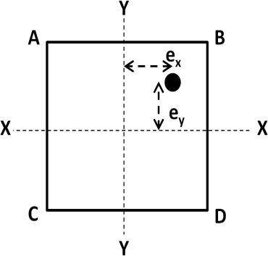

Moment of the load about X-X axis = M_{x} = P × e_{y} Moment of the load about Y-Y axis = M_{y} = P × e_{x}
Direct stress due to load P = σ_{d} = ^{P}
A

Bending stress due to eccentricity e_{x}
Bending stress due to eccentricity e
= σ_{by}

= σ
= P . ex . x
Iyy
= P . ey . y
= My .x
Iyy
= Mx . y

Resultant stress = σ_{r}

= 𝐏
𝐀
y
± 𝐌𝐱 . 𝐲
𝐈𝐱𝐱
bx
± 𝐌𝐲 .𝐱
𝐈𝐲𝐲
Ixx
Ixx

Maximum stress at B = σ
B (max) = P
A
+ Mx . y
Ixx
+ My .x
Iyy
- (1)

Minimum stress at C = σ
C (min) = P
A
− Mx . y
Ixx
− My .x
Iyy
- (2)

Stress at A = σ_{A} = P
A

Stress at D = σ = P
+ Mx . y
Ixx

− Mx . y
− My .x
Iyy

+ My .x
- (3)

- (4)

D A Ixx
Iyy

Limit of eccentricity:
Consider the stresses are compressive and no tensile stress in a column.

For this case σ_{b} ≤ σ_{d}
𝐙

P.e P
⇒
≤
Z A

∴ e ≤
𝐀
- (5)

For rectangular section, e ≤ 𝐛
𝟔
For circular section, e ≤ 𝐝
𝟖
Euler’s formula for various end conditions of the column:

Conditions |  |  | Formula for Cripping load
When | both ends hinged |  | π ² E I  P =  L2 |  | l 2  e
 |  |  | π ² E I  P =  L2 |  | l 2  e | P = least buckling load
When both ends fixed |  |  | 4π ² E I 4π ² E I  P = =  L² (2l )²  e |  |  | E = Young‟s modulus
When | one end | fixed and other | 2π ² E I 2π ² E I  P = =  L² ( 2 l )²  e |  |  | I = moment of inertia
end hinged
 |  |  |  |  |  | L = total length of column
When | one end | fixed and other | π ² E I 4π ² E I  P = =  4L2 ⎛ l ⎞2  4⎜ ^{e} ⎟  ⎝ 2 ⎠ |  |  | L = total length of column
end free |  |  |  |  |  | l_{e} = equivalent length

***** PROBLEM *****

Q-1) A rectangular strut is 150 mm wide and 120 mm thick. It carries a load of 180 kN at an eccentricity of 10 mm in a plane bisecting the thickness. Find the maximum and minimum intensities of stress in the section.
Ans) Data Given
Width (b) = 150 mm thickness (t) = 120 mm load (P) = 180 kN = 180 × 10³ N eccentricity (e) = 10 mm area of the strut = 150 × 120 = 18 000 mm²
maximum intensities of stress in the section (σ ) = P ( 1 + ⁶ ^{e} )
max A b
= ¹⁸⁰ × ¹⁰3 ( 1 + ⁶ ^{×10} ) = 10 (1 + 0.4) = 14 N/mm² = 14 MPa
18000 150
minimum intensities of stress in the section (σ ) = P ( 1 - ⁶ ^{e} )
min A b
= ¹⁸⁰ × ¹⁰3 ( 1 - ⁶ ^{×10} ) = 10 (1 - 0.4) = 6 N/mm² = 6 MPa
18000 150

Q-2) A hollow circular column having external and internal diameters of 300 mm and 250 mm respectively carries a vertical load of 100 kN at the outer edge of the column. Calculate the maximum and minimum intensities of stress in the section.
Ans) Data Given
External diameter (D) = 300 mm internal diameter (d) = 250 mm load (P) = 100 kN = 100 × 10³ N
area of the circular column (A) = ^{π} (D² – d²) = ^{π} [ (300)² – (250)² ] = 21.6 × 10³ mm²

section modulus (z) = ^{π}
4
× [ D4 − d4 ] = π
4
× [ ³⁰⁰4 − 2504 ] = 1372 × 10³ mm³

32 D 32 300
as the column carries the vertical load at its outer edge, so we can write e = 150 mm Moment due to eccentricity of load = M = P . e = (100 × 10³) × 150 = 15 × 10⁶ N-mm
3 6
Maximum intensities of stress in the section (σ ) = ^{P} + ^{M} = ¹⁰⁰ × ¹⁰ + ¹⁵ × ¹⁰

max
A Z 21.6 × 103
1372 × 103

= 4.63 + 10.93 = 15.56 N/mm² = 15.5 MPa
3 6
Minimum intensities of stress in the section (σ ) = ^{P} - ^{M} = ¹⁰⁰ × ¹⁰ - ¹⁵ × ¹⁰ N/mm²

min A Z
21.6 × 103 1372 × 103

= 4.63 - 10.93 = - 6.3 N/mm² = 6.3 MPa (tension)
***** ASSIGNMENT – 6 *****

GROUP – A (2 mark questions)
- What is a column?
- Differentiate between long and short column.
- Define crippling load.
- Write the expressions for crippling load for columns for various end conditions.
- What is eccentric loading?

GROUP – B (5 mark questions)
- Write short notes on crippling load.
- Define a column. State the expression for crippling load under various end conditions.
- A rectangular column 200 mm wide and 150 mm thick is carrying a vertical load of 120 kN at an eccentricity of 50 mm in a plane bisecting the thickness. Determine the maximum and minimum intensities of stress in the section.

GROUP – C (10 mark questions)
- A rectangular column of 240 mm × 150 mm is subjected to a vertical load of 10 kN placed at an eccentricity of 60 mm in a plane bisecting 150 mm side. Determine stress intensities in the section. (Ans: 695 kN/m², -139 kN/m²)
- The line thrust in a compression testing specimen of 2 cm diameter is parallel to the axis of the specimen but is displaced from it. Calculate the distance of the line of thrust from the axis when the maximum stress is 20% greater than the mean stress on a normal section. (Ans: 0.05cm)
- A hollow rectangular masonry pier is 1.2 m × 0.8 m wide and 150 mm thickness. A vertical load of 2 MN is transmitted in the vertical plane bisecting 1.2 m side and at an eccentricity of 100 mm from the geometric axis of the section. Calculate the maximum and minimum stress intensities in the section.

TORSION

TORSION:
When two equal and opposite torques acts at the two ends of the shaft to produce the possibility of shearing of shaft perpendicular to its longitudinal axis, the shaft is said to be in torsion. Due to torsion or twisting moment every section of shaft subjected to some shear stress.

ASSUMPTION OF PURE TORSION:
  - The material of the shaft is uniform throughout.
  - The twist along the length of the shaft is uniform throughout.
  - The shaft circular in section remains circular after twisting.
  - All diameters which are straight before twist remains straight after twist.
  - The plane of the shaft normal to its axis before twist remains plane after twist.
  - Maximum shear stress induced in the shaft does not exceed its elastic limit.

THEORY OF PURE TORSION:
Consider a circular shaft of radius R and length l fixed at one end and its other end is subjected to twisting moment as shown in figure.
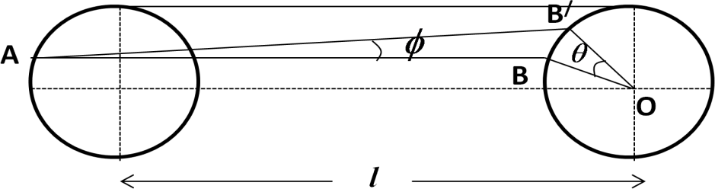

Let, the line AB on the surface of the shaft is deformed to AB/ and OB to OB/. Let, ∠BAB/ = ø = shear strain and ∠BOB/ = Ɵ = angle of twist
∴ shear strain = ø = ^{BB}/ = ^{R𝚹}
𝐿 L
Let, τ = shear stress on the surface of the shaft, C = modulus of rigidity

we know that,
τ = C or
ø
τ = ø =
C
R𝚹 ⇒
L
𝛕 =
𝐑
𝐂 𝚹

𝐋
= constant (1)

For a shaft the value of C,Ɵ and L are constants.
Shear stress is maximum at the outer surface and zero at the centre.

TORSIONAL MOMENT OF RESISTANCE:
Consider an elementary ring of the shaft of thickness „dr‟ at a radius „r‟ from the centre of the shaft as shown in figure.
Let, τ₁ = shear stress at this radius dA = elementary area of the of the ring
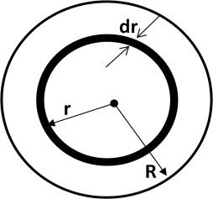

Total force acting on the ring = area of the ring × stress on the ring
= 2 π r × dr × 𝜏₁
Moment of the force about axis of the shaft = 2 π r × dr × 𝜏₁ × r
= 2 π r² × dr × 𝜏₁
= 2 π r² × dr × 𝜏1 × r
𝑅
= 2 π r³ × dr × τ
𝑅
As ^{𝜏} = 𝜏1 = ^{𝐂} ^{𝚹} = constant, we may write 𝝉 = ^{𝝉} × r

𝑅 𝑟 𝐋
𝟏 𝑹

Total moment of resistance of the shaft section = 𝑅 2 π r³ × dr × τ
∫0 𝑅
Total resisting moment = Applied torque So, we may write
T = 𝑅 2 π r³ × dr × τ = 2 π τ 𝑅 r³ × dr
∫

0 𝑅
𝑅 ∫0

= 2 π × τ × [ ^{R}4 ]^{𝑅} = 2 π × τ × ^{R}3

𝑅
= 2 𝜋 𝜏 ( 𝐷/2)2 4
4 0
= 𝜋 16

𝑅 4
× D³ × τ

∴ T = ^{𝝅}
𝟏𝟔

× τ × D³

Relation:

T = ^{𝜋} × τ × D³ × ^{D} × ²

= ^{𝜋} × τ × D⁴ × ²

16
= I_{P} × ^{𝜏}
𝑅
2 D 32 2R

Where Ip = ^{𝜋}
32
×D⁴ = polar moment of inertia of the section of the shaft.

⇒ T = 𝜏
We know that, 𝛕
= 𝐂 𝚹

𝐈𝐏 𝑅 𝐑 𝐋
Comparing the two equation we get

𝐓 = 𝝉 = 𝐂 𝚹

- (2)

𝐈𝐏 𝑹 𝐋
This is known as the torsion equation.

POLAR MOMENT OF INERTIA:
The moment of inertia of a plane area about an axis perpendicular to the plane of the area is called polar moment of inertia of the area with respect to the point at which the axis intersects the plane.

For solid shafts it is given by I_{p} = ^{𝜋}
32
For hollow shafts it is given by I_{p} = ^{𝜋}
32
×D⁴
× (D⁴ – d⁴)

POLAR MODULUS:
It is the ratio of polar moment of inertia to the radius of the shaft.
We know that, ^{𝐓} = ^{𝝉}
𝐈𝐏 𝑹
⇒ T = τ × ^{𝐈𝐏} = τ × Z_{P} where, Z_{P} = polar modulus of the shaft section
𝐑

STRENGTH OF A SOLID SHAFT:
Consider an elementary ring of the shaft of thickness „dr‟ at a radius „r‟ from the centre of the shaft as shown in figure.
Let, τ₁ = shear stress at this radius
dA = elementary area of the of the ring

Total force acting on the ring = area of the ring × stress on the ring
= 2 π r × dr × 𝜏₁
Moment of the force about axis of the shaft = 2 π r × dr × 𝜏₁ × r
= 2 π r² × dr × 𝜏₁
= 2 π r² × dr × 𝜏1 × r
𝑅
= 2 π r³ × dr × τ
𝑅
As ^{𝜏} = 𝜏1 = ^{𝐂} ^{𝚹} = constant, we may write 𝝉 = ^{𝝉} × r

𝑅 𝑟 𝐋
𝟏 𝑹

Total moment of resistance of the shaft section = 𝑅 2 π r³ × dr × τ
∫0 𝑅
Total resisting moment = Applied torque So, we may write
T = 𝑅 2 π r³ × dr × τ = 2 π τ 𝑅 r³ × dr
∫

0 𝑅
𝑅 ∫0

= 2 π × τ × [ ^{R}4 ]^{𝑅} = 2 π × τ × ^{R}3

𝑅
= 2 𝜋 𝜏 ( 𝐷/2)2 4
4 0
= 𝜋 16

𝑅 4
× D³ × τ

∴ T = ^{𝝅}
𝟏𝟔
× τ × D³

STRENGTH OF A HOLLOW SHAFT:
Consider a hollow shaft subjected to torque T.
Let, R = outer radius of shaft r = inner radius of the hollow shaft
D = outer diameter of the hollow shaft d = inner diameter of the hollow shaft τ = maximum shear stress
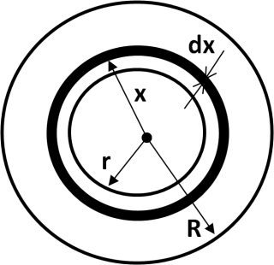
Consider a small circular ring of thickness „dx‟ at a radius x form the centre of the shaft.
τ₁ = shear stress at this radius

Total force acting on the ring = area of the ring × stress on the ring
= 2 π x × dx × 𝜏₁
Moment of resistance of force on the ring = 2 π x × dx × 𝜏₁ × x
= 2 π x² × dr × 𝜏₁
= 2 π x² × dx × 𝜏1 × x
𝑅
= 2 π x³ × dx × τ
𝑅
As ^{𝜏} = 𝜏1 = ^{𝐂} ^{𝚹} = constant, we may write 𝝉 = ^{𝝉} × x

𝑅 𝑥 𝐋
𝟏 𝑹

Total moment of resistance of the shaft section =
^{𝑅} 2 π 𝑥³ × d𝑥 × τ

Total resisting moment = Applied torque
∫𝑟 𝑅

So, we may write T =
^{𝑅} 2 π 𝑥³ × d𝑥 × τ
= 2 π τ
𝑅 𝑥³ × d𝑥

∫𝑟
𝑅 𝑅 ∫0

= 2 π × τ × [ ^{𝑥}4 ]^{𝑅} = 2 π × τ × [^{R}4 - ^{r}4 ]

𝑅 4 𝑟

𝑅 4 4

= 2 π × τ × ( R⁴ – r⁴) = τ × π × ( R⁴ – r⁴)
4𝑅 𝑅 2
= τ × π × ( D⁴ – d⁴) = 𝛑 𝛕× [ ^{𝐃}𝟒− 𝐝𝟒 ]

𝑫 32
𝟐

𝟏𝟔 𝑫

This is the required equation of the hollow shaft.

POWER TRANSMITTED BY A SHAFT:
Work done by the shaft per minute = Torque × angle turned in one minute
= T_{mean} × 2 π N N-m Power transmitted by the shaft (P) = Work done per minute KW
60000

TORSIONAL RIGIDITY:
⇒ P = 𝐓𝐦𝐞𝐚𝐧 × 𝟐 𝛑 𝐍 kW
𝟔𝟎𝟎𝟎𝟎

It is the torque which produces the twist of one radian in a shaft of unit length. It is denoted

by C.I_{P.} Mathematically, ^{T}
IP
= C 𝚹 L
or CƟ = ^{𝐓} × L
𝐈𝐏

COMPARISON BETWEEN STRENGTH OF SOLID AND HOLLOW SHAFT:

We know that, Strength of solid shaft = T_{s} = ^{𝜋}
16
× τ × D ³

Strength of hollow shaft = T_{H} = ^{π}
s
16
τ× [ ^{D}4 − d4 ]
𝐷

π τ× [ D 4− d 4 ]

∴ TH = 16

𝐷 .
= D4 − d4
- (1)

T 𝜋 × τ ×(D )3 16
S
S

𝐷 (DS )3

Let, ^{D} = n or D = nd, substituting this value in equation-1 we get,
d
TH = ^{n}4 d4 − d4 = ⁽ ^{n}4 − 1)d4 = ⁽ ^{n}4− 1)d3 (2)

TS 𝑛 𝑑 (DS )3 𝑛 𝑑 (DS )3
𝑛 (DS )3

(T_{H}/T_{S} ) ratio value is 1.44.
So we consider that, torque transmitted to the hollow shaft is greater than the solid shaft. Thus the hollow shaft is stronger than solid shaft.

COMBINED BENDING AND TORSION:
In general shafts are subjected to both bending and torsion. From torsion equation, ^{𝐓} = ^{𝝉}
𝐈𝐏 𝑹

we know that, T = ^{𝜋} 16
× τ × D³

From bending equation, ^{𝐌} = = ^{𝛔𝐛}
𝐈 𝒚
we know that, M = ^{𝛔𝐛} ^{.𝜋} ^{D}3
32
If a material is loaded and direct stress and shear stress induce in it, then according to principal
stress and maximum shear stress theory we may write –

σ_{max} = ^{𝛔𝐝} + √(𝛔𝐝 )² + τ3 (1)
2 2

τ_{max} = √(𝛔𝐝 )² + τ3 (2)
2
Multiplying both side of equation-1 with ^{𝜋} ^{D}3 , we get
32

σ 𝜋 D3
3
= 𝛔𝐝 × 𝜋 D

+ √(𝛔𝐝 × 𝜋 D3 )² + (τ × 𝜋 D3 )²

max × 32

2 32

2 32 32

⇒ M_{e} = ^{𝐌} + √( 𝐌 )² + (𝐓 )²
𝟐 𝟐 𝟐

∴ 𝐌𝐞 = 𝐌+ √𝑴𝟐+ 𝑻𝟐
𝟐
- (3)

where M_{e} is known as equivalent bending moment.
Multiplying both side of equation-2 with ^{𝜋} ^{D}3 , we get
16

τ 𝜋 D3

= √(𝛔𝐝 × 𝜋 D3 )² + (τ × 𝜋 D3 )²

max × 16

2 16 16

NOTES:
⇒ T_{e} = √( 𝐌)^{𝟐} + (𝐓 )^{𝟐} (4)
where T_{e} is known as equivalent twisting moment.

Shear stress is maximum at the outer surface of shaft and zero at its axis.
The shaft which can resist greatest twisting moment possesses greatest polar
modulus.
Strength of hollow shaft is higher than solid shaft.
When a solid shaft is replaced by hollow shaft or hollow shaft by solid shaft,
the torque transmitted remains same for both shafts.

Terms | Symbol | Formula | Units
Torsion equation | -- | 𝐓 = 𝝉 = 𝐂 Ɵ  𝐈𝐏 𝑹 𝐋 | ------
Polar moment of inertia | Ip | Ip = ^{𝜋} ×D⁴ for  32  solid shaft and | m4  mm⁴ cm⁴
Polar moment of inertia | Ip | Ip = ^{𝜋} ×( D⁴ - d⁴)  32  for hollow  shaft
Torque transmitted | T | ^{𝜋} × τ × D³ for  16  solid shaft | N-m | KN-m | -----
Torque transmitted | T | π τ × [ D4− d4 ]  16 𝐷  for hollow shaft | N-mm | KN-mm | -----
Power transmitted | P | Tmean × 2 π N  60000 | KW
Mean or Average torque | T or Tmean or Taverage | 60 𝑃  2 π N | Watt
Polar modulus | Z_{p} | IP  R | m³ mm³ cm³
Torsional rigidity | k or µ | CI_{p} per unit length | N-m² N-mm²
Equivalent  twisting moment | T_{e} | √( 𝐌)^{𝟐} + (𝐓 )^{𝟐} | Same as twisting  moment
Equivalent  bending moment | M_{e} | 𝐌 + √𝑴^{𝟐} + 𝑻^{𝟐}  𝟐 | Same as bending  moment

***** PROBLEM *****

Q -1) The average torque transmitted by a shaft is 2255 Nm. The maximum torque is 40% of the average torque. If the allowable shear stress in the shaft material is 45 N/mm², determine available diameter of the shaft.
Ans) Data Given
Average torque (T_{av}) = 2255 Nm = 2255 × 10³ N-mm allowable shear stress (τ) = 45 N/mm²
Maximum torque (T) = 1.40 T_{av} = 1.40 × 2255 × 10³ N-mm = 3157 × 10³ N-mm
we know that T = 𝜋 × τ × D³
16
⟹ 3157 × 10³ = 𝜋 × 45 × D³
16
⟹ D3 = 16 × 3157 × 103 = 357299.31
𝜋 × 45
∴ D = 70.96 mm
Q-2) A circular shaft of 60 mm, diameter is running at 150 r.p.m. If the shear stress is not to exceed 50 MPa, find the power which can be transmitted by the shaft.
Ans) Data Given
Diameter (D) = 60 mm speed (N) = 150 r.p.m maximum shear stress (τ) = 50 MPa = 50 N/mm²

Torque transmitted by the shaft (T) = ^{𝜋}
16
× τ × D³ = ^{𝜋}
16
× 50 × 60³ = 2.12 × 10⁶ N-mm = 2.12 kN-m

power transmitted by the shaft (P) = ² ^{𝜋} ^{𝑁} ^{𝑇}
60
= 2 𝜋 ×150 ×2.12
60
= 33.3 kW

Q-3) A hollow shaft is to transmit 200 kW at 80 r.p.m. If the shear stress is not to exceed 60 MPa and internal diameter is 0.6 of the external diameter, find the diameters of the shaft.
Ans) Data Given
Power (P) = 200 kW Speed (N) = 80 r.p.m Maximum shear stress (τ) = 60 MPa = 60 N/mm²
internal diameter of the shaft (d) = 0.6 × external diameter = 0.6 × D

Torque transmitted by shaft (T) = ^{π}
τ× [ ^{D}4− d4 ] = ^{π}
× 60 × [ D4 − (0.6 D)4 ]

16 𝐷 16 𝐷

= 10.3 D³ N-mm
Power transmitted by the shaft (P) = ² ^{𝜋} ^{𝑁} ^{𝑇}
60
⟹ 200 × 103 = 2 𝜋 × 80 ×(10.3 × 𝐷3 )
60

= 86.3 × 10⁻³ D³

⟹ D3 = 200 ×103
86.3 × 10−3
= 2.32 × 10⁶ mm³

∴ D = 1.32 × 10² = 132 mm
and d = 0.6 × 132 = 79.2 mm

Q-4) A solid shaft of 120 mm diameter is required to transmit 200 kW at 100 r.p.m. If the angle of twist not to exceed 2⁰ , find the length of the shaft. Take modulus of rigidity for the shaft material as 90 GPa.
Ans) Data Given
Diameter (D) = 120 mm Power (P) = 200 kW speed (N) = 100 r.p.m angle of twist (Ɵ) = 2⁰ = ² ^{π} = rad modulus of rigidity (C) = 90 GPa = 90 × 10³
180
power transmitted by shaft (P) = ² ^{𝜋} ^{𝑁} ^{𝑇}
60

⟹ 200 = 2 𝜋 ×100 ×T
60
= 10.5 T

⟹ T = 200/10.5 = 19 kN-m = 19 × 10⁶ kN-mm

polar moment of inertia of a solid shaft (I_{p}) = ^{𝜋}
32
×D⁴ = ^{𝜋}
32
×(120)⁴ = 0.4 × 10⁶ mm⁴

we know that, ^{𝐓}
𝐈𝐏
= 𝐂 Ɵ
𝐋

⟹ 19 × 106
20.4 × 105
= 90 × 103 × (2 𝜋/180 )
𝑙

⟹ 0.931 = 3.14 × 103
𝑙
⟹ l = ^{3.14} × ¹⁰3 = 3.37 × 10³ = 3.37 m
0.931

Q – 5) Prove that a hollow shaft is always stronger than a solid shaft of the same material, weight and length subjected to same torque.
Ans) Data Given
Let d = internal diameter of hollow shaft
nd = external diameter of hollow shaft ; n greater than 1 D = diameter of solid shaft
As the two shafts having equal length and weight, their area of cross section will be same.
i.e. ^{π} × D² = ^{π} (n²d² – d²)
4 4
⟹ D² = d² (n² -1) ⟹ D = d √(n² − 1)
Torque transmitted by hollow shaft = ^{π} τ× [ ^{n}4 d4 − d4 ] = ^{π} τ× [ ^{n}4 − 1 ] × d³ (1)
16 nd 16 n

Torque transmitted by solid shaft = ^{π}
16
τ × D³ = ^{π}
16
τ × ( n² – 1 )^{3/2} (2)

If the expression 1 will be greater than 2, then hollow shaft will be stronger than solid shaft.

⟹ n4 − 1 n
> ( n² – 1 )^{3/2}

⟹ n2 + 1 > ( n² – 1 )^{1/2}
n
⟹ (n² + 1)² > n² ( n² – 1 )
⟹ n⁴ + 2 n² + 1 > n⁴ - n²
⟹ 3 n² + 1 > 0, which is true
∴ Hollow shaft is stronger than solid shaft.

***** ASSIGNMENT – 8 *****

GROUP – A (2 mark questions)
- Write the equation of torsion.
- What do you mean by torsion?
- What is polar moment of inertia?
- Define torsional rigidity.
- Write the equation for equivalent bending and twisting moment.
- State the assumptions of pure torsion.

GROUP – B (6 mark questions)
- Derive the torsion equation.
- State the assumptions for pure torsion.
- A solid shaft of 100 mm diameter is transmitting 120 kW at 150 r.p.m. Find the intensity of shear stress in the shaft.
- Calculate the maximum torque that a shaft of 125 mm diameter can transmit, if the maximum angle of twist is 1⁰ in a length of 1.5 m. Take C = 70 GPa.
- Find the angle of twist per metre length of a hollow shaft of 100 mm external and 60 mm internal diameter, if the shear stress is not to exceed 35 MPa. Take C = 85 GPa.
- A solid shaft is subjected to a torque of 1.6 kN-m. Find the necessary diameter of the shaft, if the allowable shear stress is 60 MPa. The allowable twist is is 1⁰ for every 20 diameters of the shaft. Take C = 80 GPa.

GROUP – C (8 mark questions)
- A solid shaft of 200 mm diameter has the same cross-sectional area as that of a hollow shaft of the same material with inside diameter 150 mm. Find the ratio of power transmitted by the two shafts at the same speed.
- A solid shaft transmits 75 kW at 200 r.p.m. Calculate the shaft diameter if the twist in the shaft is not to exceed 1⁰ in 2 m of shaft and the shearing stress is limited to 50 N/mm². Take C = 1 × 10⁵ N/mm².
- A solid steel shaft has to transmit 100 kW at 160 r.p.m. Taking allowable shear stress as 70 MPa, find the suitable diameter of the shaft. The maximum torque transmitted in each revolution exceeds the mean by 20%.
- Determine the diameter of a solid shaft which will transmit 90 KW at 160 r.p.m, if the shear stress in the shaft is limited to 60 N/mm². Find also the length of the shaft, if the twist must not exceed 1⁰ over the entire length. Take C = 8 × 10⁴ N/mm².

The End

