RAJA KISHORE CHANDRA ACADEMY OF TECHNOLOGY,NILAGIRI COURSE CODE- (TH-2) STRUCTURAL DESIGN-2
DEPARTMENT OF
CIVIL ENGINEERING

PREPARED BY :-

ER.DEBASHIS JENA
SYLLABUS
UNIT - I
Materials - Making of iron and steel - Types of structural steel - Mechanical properties of steel - Concepts of plasticity - Yield strength. Loads - Combined loads - Wind loads on roof trusses, Behavior of steel, local buckling. Concept of limit state design - Different limits states as per IS 800-2007- Design strengths - Deflection limits - Serviceability - Bolted connections - Welded connections - Design Strengths - Efficiency of joint - Prying action - Types of welded joints - Design of Tension members - Design strength of members.

UNIT – II
Design of compression members - Buckling class- Slenderness ratio - Strength design Laced and Battened columns - Column spice - Column base - Slab base.
UNIT - III
Design of Beams - Plastic moment - Bending and shear strength laterally / supported beams design - Built-up sections - large plates Web buckling Crippling and Deflection of beams - Design of Purlin.
UNIT – IV
Design of eccentric connections with brackets - End beam connections - Web angle - Unstiffened and stiffened seated connections (bolted and welded types) Design of truss joints.

UNIT - V
Design of welded plate Girders - Optimum depth - Design of main section - Design of end bearing, stiffness bearing and intermediate stiffness. Connection between web and flange - Design of flange splice and web splices.

Suggested Text Books
- Design of Steel Structures by N. Subramanian, Oxford Higher Education University press.
- Design of Steel Structures by S.S. Bhavikatti
- Limit State Design Steel Structures by S.K. Duggal
- Design of steel structures by P. Dayaratnam
- Design of steel structures by L.S. Negi
- Design of Steel Structures by S. Ramamrutham and R. Narayanan
Suggested Reference Books for your Knowledge
  - Design of Steel Structures by S.S. Ray, Blackwell Science
  - Design of Steel Structures by E.H. Gaylord, C.N. Gaylord, and J.E. Stallmeyer, McGrawHill
  - Design of Steel Structures by Elias G. Abu Saba, CBS Publishers and Distributors

Codes:
- Code of Practice for general construction in steel – IS 800 -1984, IS 800-2007.
- Handbook for Structural Engineers – SP 6(1) -1964
- Code of Practice for design loads (other than earthquake) for buildings and structures -IS 875: Part I-V: 1987.

UNIT-I
INTRODUCTION
When the need for a new structure arises, an individual or agency has to arrange the funds required for its construction. The individual or agency henceforth referred to as the owner then approaches an architect. The architect plans the layout so as to satisfy the functional requirements and also ensures that the structure is aesthetically pleasing and economically feasible. In this process, the architect often decides the material and type of construction as well. The plan is then given to a structural engineer who is expected to do locate the structural elements so as to cause least interference to the function and aesthetics of the structure. He then makes the strength calculations to ensure safety and serviceability of the structure. This process is known as structural design.
Finally, the structural elements are fabricated and erected by the contractor. If all the people work as a team then a safe, useful, aesthetic and economical structure is conceived. However in practice, many structures fulfill the requirements only partially because of inadequate coordination between the people involved and their lack of knowledge of the capabilities and limitations of their own and that of others. Since a structural engineer is central to this team, it is necessary for him to have adequate knowledge of the architects and contractors work. It is his responsibility to advise both the architect and the contractor about the possibilities of achieving good structures with economy.
Ever since steel began to be used in the construction of structures, it has made possible some of the grandest structures both in the past and also in the present day (The Hooghly cable stayed bridge, Jogighopa Road-cum-rail bridge across the river Brahmaputra). In the following paragraph, some of the aspects of steel structures, which every structural engineer should know, are briefly discussed.

Steel is by far the most useful material for building structures with strength of approximately ten times that of concrete, steel is the ideal material for modern construction. Due to its large strength to weight ratio, steel structures tend to be more economical than concrete structures for tall buildings and large span buildings and bridges. Steel structures can be constructed very fast and this enables the structure to be used early thereby leading to overall economy. Steel structures are ductile and robust and can withstand severe loadings such as earthquakes.
Steel structures can be easily repaired and retrofitted to carry higher loads. Steel is also a very eco-friendly material and steel structures can be easily dismantled and sold as scrap. Thus the lifecycle cost of steel structures, which includes the cost of construction, maintenance, repair and dismantling, can be less than that for concrete structures. Since steel is produced in the factory under better quality control, steel structures have higher reliability and safety. To get the most benefit out of steel, steel structures should be designed and protected to resist corrosion and fire. They should be designed and detailed for easy fabrication and erection. Good quality control is essential to ensure proper fitting of the various structural elements. The effects of temperature

should be considered in design. To prevent development of cracks under fatigue and earthquake loads the connections and in particular the welds should be designed and detailed properly. Special steels and protective measures for corrosion and fire are available and the designer should be familiar with the options available.

NOTES ON STEEL MATERIAL
Steel is a term given to alloys containing a high proportion of iron with some carbon. Other alloying elements may also be present in varying proportions. The properties of steel are highly dependent on the proportions of alloying elements, so that their levels are closely controlled during its manufacture. The properties of steel also depend on the heat treatment of the metal.

Steel is by far the most important metal, in tonnage terms, in the modern world, with the annual global production of over 700 million tonnes dwarfing the approximately 17 million tonnes of the next most prolific, aluminium. The low price and high strength of steel means that it is used structurally in many buildings and as sheet steel it is the major component of motor vehicles and domestic appliances. The major disadvantage of steel is that it will oxidize under moist conditions to form rust. Typical steel would have a density of about 7.7 g cm⁻³ and a melting point of about 1650ºC.

MAKING OF IRON AND STEEL
Steel refers to any iron-carbon alloy, although steels usually contain other elements as
well.
Iron occurs mainly as oxide ores, though it is also found in smaller quantities as its sulfide and carbonate. These other ores are usually first roasted to convert them into the oxide. On a world scale the most important ore is hematite (Fe2O3). The oxides are reduced with carbon from coal, through the intermediate production of carbon monoxide.
The carbon initially burns in air to give carbon dioxide and the heat, which is necessary for the process. The carbon dioxide then undergoes an endothermic reaction with more carbon to yield carbon monoxide:

C + O2 → CO2 ΔH = -393 kJ mol⁻¹
C + CO2 → 2CO ΔH = +171 kJ mol⁻¹
The oxide ores are then principally reduced by the carbon monoxide produced in this reaction, the reactions involving very small enthalpy changes:

Fe2O3 + 3CO → 2Fe + 3CO2 ΔH = -22 kJ mol⁻¹ Fe3O4 + 4CO → 3Fe + 4CO2 ΔH = -10 kJ mol⁻¹

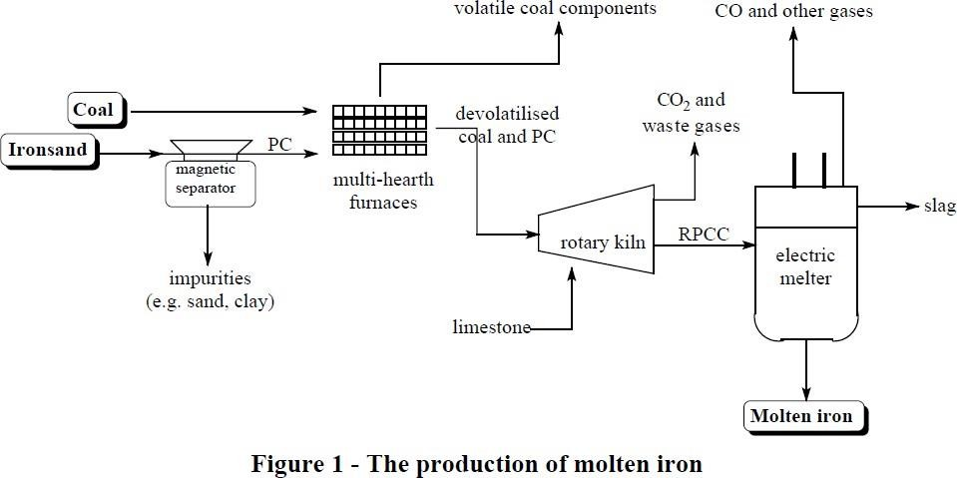
In conventional iron making, this reduction occurs in a blast furnace. The iron produced in this way always contains high levels of impurities making it very brittle. Steel making is mainly concerned with the removal of these impurities. This is done by oxidizing the elements concerned by blowing pure oxygen through a lance inserted into the molten alloy. The oxides produced are either evolved as gases, or combine with limestone to form an immiscible slag which floats on the surface of the liquid metal and so is easily separated.

THE MANUFACTURING PROCESS
Iron ore is converted to steel via two main steps. The first involves the production of molten iron and the second is that of actual steel manufacture. The details of these steps are outlined below.

Step 1 - The production of molten iron
The Primary Concentrate is mixed with limestone and coal and heated. The iron oxides are reduced in the solid state to metallic iron, which then melts, and the impurities are removed either as slag or gas. The flow diagram for this process is shown in Figure 1.

The multi-hearth furnaces
There are four multi-hearth furnaces, each of which feeds a rotary kiln. The furnaces preheat the materials fed into the rotary kiln and reduce the amount of volatile matter present in the coal from about 44% to about 9%. This is important because the large volumes of gas produced during the emission of the volatile matter would otherwise interfere with the processes in the rotary kiln.

There are 12 hearths in each furnace and the feedstock passes down through these. In the first three hearths, hot gases from the lower stages preheat the material in the absence of air to about 450ºC. Air is introduced in hearths 4 to 9 to allow combustion of the volatile material, so as to

increase the temperature to about 650oC. The supply of air is adjusted to control the percentage of residual volatiles and coal char in the product. In the final hearths (10 - 12) the char and the primary concentrate equilibrate and the final temperature is adjusted to 620oC. The total residence time in the multi-hearth furnace is 30 - 40 minutes.
The multi-hearth furnaces also have natural gas burners at various levels. These are used to restart the furnace after shutdown and to maintain the temperature if the supply of materials is interrupted.

The waste gas from the multi-hearth furnace contains water vapour and other volatile compounds from the coal (e.g. carbon dioxide, carbon monoxide and other combustion products) as well as suspended coal and primary concentrate dust particles. These solids are removed and returned to the furnace. This gas along with gas from the melter (mainly carbon monoxide) is mixed with air and burnt. The heat so produced is used to raise steam for the production of electricity. As well as providing a valuable source of energy, this combustion of the waste gases is necessary to meet emission controls.

The pre-heated coal char and primary concentrate from the furnaces is mixed with limestone and fed into the kiln. In the first third of the kiln, known as the pre-heating zone, the feed from the multi-hearth furnace is further heated to 900 - 1000oC. This increase in temperature is partly a result of the passage of hot gases from further along the kiln and partly a result of the combustion of the remaining volatile matter in the coal.

The last two-thirds of the kiln is known as the reduction zone, and is where the solid iron oxides are reduced to metallic iron. In this region the air reacts with the carbon from the coal to produce carbon dioxide and heat:

𝐶 + 𝑂2 → 𝐶𝑂2
The carbon dioxide then reacts with more carbon to produce carbon monoxide, the principal reductant, in an exothermic reaction:

𝐶 + 𝐶𝑂2 → 2𝐶𝑂
Some of the carbon monoxide burns with the oxygen to produce heat, whilst the remainder reduces the magnetite¹ to iron in a reaction that is almost thermo-chemically neutral.

2𝐶𝑂 + 𝑂2 → 2𝐶𝑂2
𝐹𝑒3𝑂4 + 4𝐶𝑂 → 3𝐹𝑒 + 4𝐶𝑂2

Note: ¹Magnetite can be regarded as 1:1 combination of wustite (FeO) and haematite (Fe2O3). The separate reduction processes from these two components are:
𝐹𝑒𝑂 + 𝐶𝑂 → 𝐹𝑒 + 𝐶𝑂2
𝐹𝑒2𝑂3 + 3𝐶𝑂 → 2𝐹𝑒 + 3𝐶𝑂2

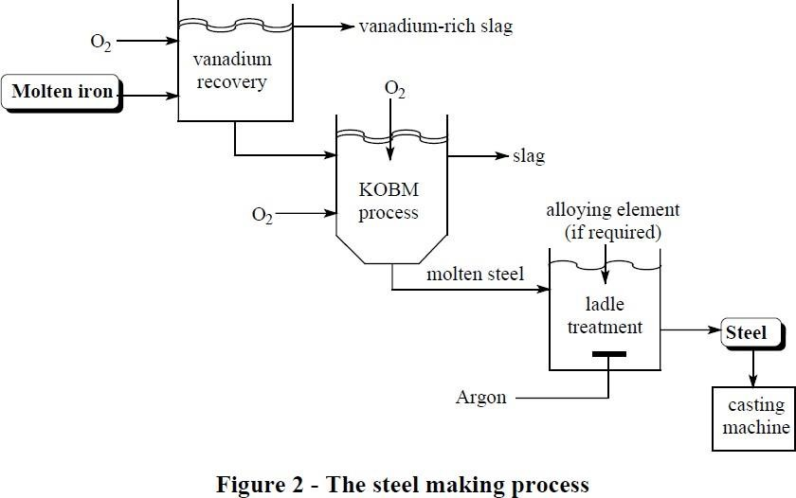
Step 2 - Steel making
The steel making process is shown in Figure 2.

Vanadium recovery
Before conversion into steel, vanadium is recovered from the molten iron. This is done firstly because of the value of the vanadium rich slag produced (15% vanadium as V2O5) and secondly because a high vanadium content can make the steel too hard. In the vanadium recovery unit a ladle containing 75 tonnes of molten iron has oxygen blown over the surface, where it oxidizes silicon, titanium, manganese and vanadium to form a slag that floats on the surface. At the same time argon is blown through the molten metal to stir it. When the composition of the molten metal has reached the required vanadium specification, the slag is scraped off, cooled and crushed. Additional advantages of this pre-treatment are that it causes the molten metal to reheat, so permitting temperature control, and, if required, the procedure can be modified by the addition of lime to reduce sulfur levels.

The Klockner Oxygen Blown Maxhutte process (KOBM Process)
The KOBM steel making process, like most modern processes involves oxidizing dissolved impurities by blowing oxygen through the molten metal. The KOBM is unusual in that it blows oxygen through the bottom of the furnace as well as through a lance inserted from the top. This type of furnace was selected for Glenbrook because of its capacity to cope with high levels of titanium and vanadium coupled with its very fast turn round time. The disadvantage of this type of furnace is that it is technically rather more complex than those that are blown only by a lance.

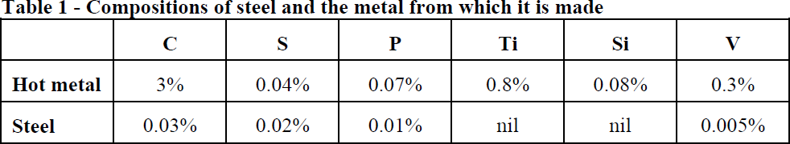
The KOBM is initially charged with about 6 tonnes of scrap steel. 70 tonnes of molten metal from the vanadium recovery unit is then added. Oxygen is then blown through six holes in the base of the furnace, at a total rate of about 1500 lts per second. Oxygen is also blown through a lance inserted from the top of the furnace at a rate of over 2500 lts per second.
The oxygen oxidizes the elements other than iron (including any free carbon) to their oxides. In this way contaminants are removed as the oxides form a slag which floats on the surface of the molten metal. Powdered lime is blown in to help with slag formation and this particularly reduces the levels of sulfur and phosphorous by combining with their acidic oxides. Due to its low melting point, iron(II) sulfide (FeS) is particularly harmful to the high temperature properties of steel. So sulfur level must be reduced before further processing. Typical levels of the major elements in the metal fed into the furnace and in a typical steel are shown in Table 1.

The molten iron is analyzed just before being added to the furnace and the temperature taken. This determines the length of the oxygen blow and it also to a certain extent affects the amount and composition of the scrap added. The length of the oxygen blow required is also judged by monitoring the CO:CO2 ration in the gases from the furnace. Blow times vary, but 15 minutes would be typical. During the oxygen blow the temperature would typically rise from 1500oC to 1700ºC owing to the exothermic reactions that are occurring.

The slag is firstly tipped off and, after cooling, it is broken up so that the iron trapped in it can be recovered magnetically. The slag, which contains sulfur and phosphorous and has a high lime content, is then sold for agricultural use. Aluminium, which removes excess dissolved oxygen, and alloying materials, such as ferro-silicon and ferro-manganese (which increase the hardness of the steel) are added at this point so that they are well mixed as the molten metal is tipped into a ladle. The whole cycle in the KOBM takes about 30 minutes.

The Glenbrook site also has an electric arc furnace for steel making, the feed for this being mainly scrap steel. The cycle time for the final charge of 75 tonne is about 3½ hours, so that is only responsible for a small fraction of the total steel production. It is, however, a very flexible process and it may be economically used to produce small batches of specialized steel.

Ladle treatment
The final stage of steel making is the ladle treatment. This is when fine adjustments are made to bring the composition of the molten steel, from either furnace, into line with the required composition. The bulk of the alloying elements are added in the furnace and, after blowing argon through the molten metal to ensure homogeneity, the temperature is measured and a sample removed for analysis after stirring. The analysis by optical emission spectrometry, which

measures the levels of 15 elements, takes about five minutes. Alloying materials are added to adjust the composition. If the metal requires cooling, scrap steel is added. If the temperature is too low, aluminium is added and oxygen blown through. When all adjustments are complete argon is blown through once again to ensure mixing and the ladle taken to the continuous casting machine. Here it is cast into slabs of 210 mm thickness and a width of between 800 and 1550
mm. This slab is cut into lengths of from 4.5 m to 10 m and sent for further processing. Most of the production is converted to steel coil.

ENVIRONMENTAL IMPLICATIONS
Due to the nature of the steel making process, large amounts of solid, liquid and gaseous wastes are generated in the steel plant. Careful planning is necessary to ensure that these do not have a negative impact on the environment.

The steel mill requires 1.2 to 1.4 million tonnes of ironsand each year, which means that up to 10 million tonnes of pure sand must be mined. The non-magnetic sand is returned to the area from which it was mined, and marram grass and radiata pines planted to stabilise the deposits.

Wet scrubbers and bag houses are the principal means of controlling air pollution. The wet scrubbers (see oil refining article) wash the dust out of the hot process waste gases which result from iron and steel making while the cloth bags inside a bag house filter dust out of the gas. The dust collection system is shared by the steel production and steel processing sections, and collects a total of between five and ten tonnes of dust every hour.

Extensive water recycling is used in the plant to minimise the quantity of waste water produced, and all waste water and storm water is treated in settling ponds on site before being discharged into the Waiuku Estuary.

ADVANTAGES OF STEEL DESIGN
- Better quality control
- Lighter
- Faster to erect
- Reduced site time – Fast track construction
- Large column free space and amenable for alteration
- Less material Handling at site
- Less percentage of floor area occupied by structural elements
- Has better ductility and hence superior lateral load behavior, better earthquake performance

DISADVANTAGES OF STEEL DESIGN
- Skilled labor is required
- Higher cost of construction
- Maintenance cost is high (Due to corrosion)
- Poor fire proofing as at 1000ºF (538ºC) 65% and at 1600ºF (871ºC) 15% of strength remains
- Electricity may be required (to hold joints, etc.)

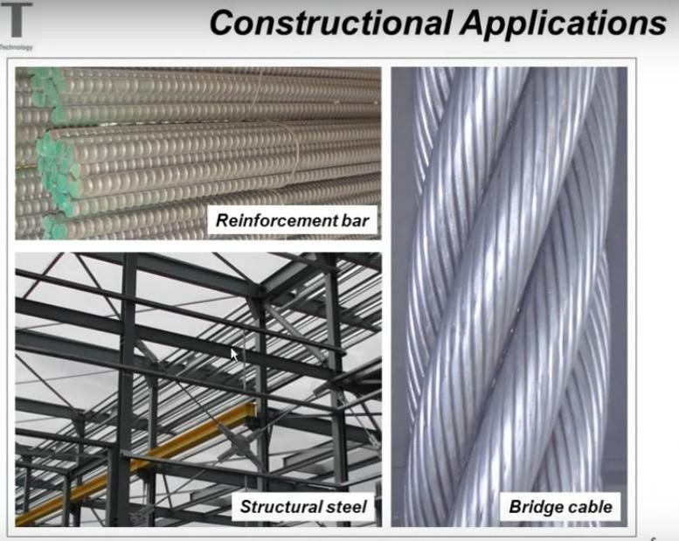








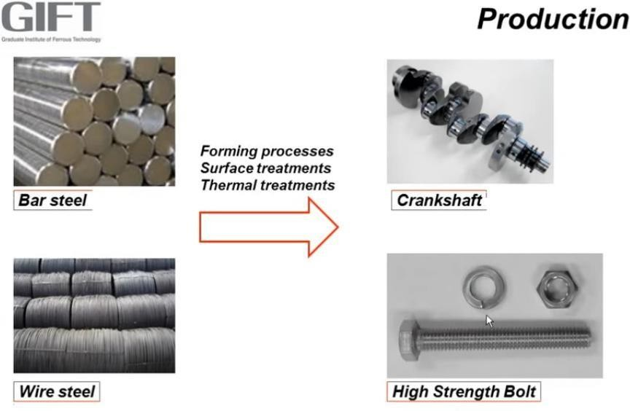

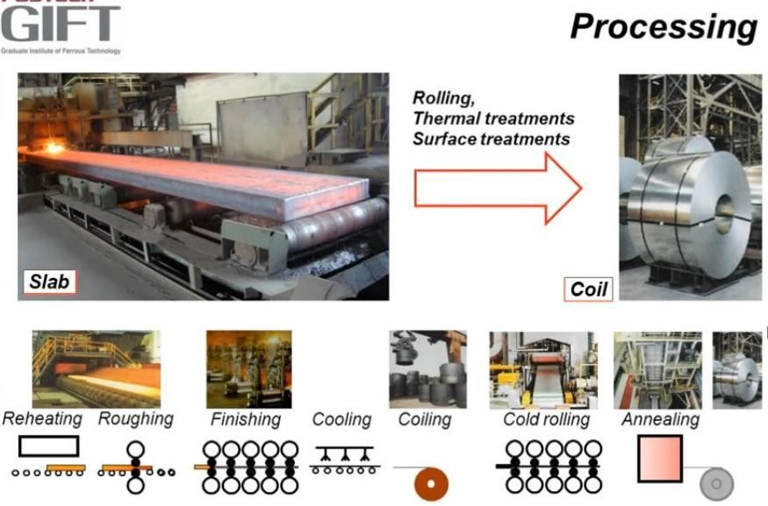

ANATOMY OF A STEEL STRUCTURE
Q. What is the anatomy of a steel structure? Ans.
Beams Columns Floors
Bracing systems-- which is very important for higher rise cases Foundation
Connections
So these are the anatomy of a steel building.
(Anatomy means usually the study or an examination of what something is like, the way it works or why it works)

TYPES OF STRUCTURAL STEEL
Now let us discuss some rolled steel sections

ROLLED STEEL SECTIONS
The steel sections manufactured in rolling mills and used as structural members are known as rolled structural steel sections. The steel sections are named according to their cross sectional shapes. The shapes of sections selected depend on the types of members which are fabricated and to some extent on the process of erection. Many steel sections are readily available in the market and have frequent demand. Such steel sections are known as regular steel sections. Some steel sections are rarely used. Such sections are produced on special requisition and are known as special sections. „SP 6-1 (1964) ISI Handbook for Structural Engineers -Part- 1 Structural Steel Sections gives nominal dimensions, weight and geometrical properties of various rolled structural steel sections.


For Example:
TYPES OF ROLLED STRUCTURAL STEEL SECTIONS
The various types of rolled structural steel sections manufactured and used as structural members are as follows:
- Rolled Steel I-sections (Beam sections).
- Rolled Steel Channel Sections.
- Rolled Steel Tee Sections.
- Rolled Steel Angles Sections.
- Rolled Steel Bars.
- Rolled Steel Tubes.
- Rolled Steel Flats.
- Rolled Steel Sheets and Strips.
- Rolled Steel Plates.
1. Indian Standard Joist/junior Beams ISJB
2. Indian Standard Light Beams ISLB
3. Indian Standard Medium Weight Beams ISMB
4. Indian Standard Wide Flange Beams ISWB

2.3 ROLLED STEEL BEAM SECTIONS
The rolled steel beams are classified into following four series as per BIS : (IS : 808-1989)

The rolled steel columns/heavy weight beams are classified into the following two series as per BIS (IS: 808-1989)

The cross section of a rolled steel beam is shown in Figure below.
1. Indian Standard Column Sections
ISSC
2. Indian Standard Heavy Weight Beams
ISHB

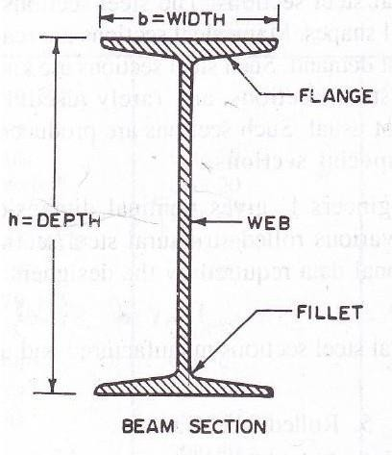

The beam section consists of web and two flanges. The junction between the flange and the web is known as fillet. These hot rolled steel beam sections have sloping flanges. The outer and inner faces are inclined to each other and they intersect at an angle varying from 1½ to 8˚ depending on the section and rolling mill practice. The angle of intersection of ISMB section is 8˚. Abbreviated reference symbols (JB, LB, MB, WB, SC and HB) have been used in designating the Indian Standard Sections as per BIS (IS 808-1989)
The rolled steel beams are designated by the series to which beam sections belong (abbreviated reference symbols), followed by depth in mm of the section and weight in kN per metre length of the beam, e.g., MB 225 @ 0.312 kN/m. H beam sections of equal depths have different weights per metre length and also different properties e.g., WB 600 @ 1.340 kN/m, WB 600 @ 1.450 kN/m, HB 350 @0.674 kN/m, HB 350 @0.724 kN/m.
- sections are used as beams and columns. It is best suited to resist bending moment and shearing force. In an I-section about 80 % of the bending moment is resisted by the flanges and the rest of the bending moment is resisted by the web. Similarly about 95% of the shear force is resisted by the web and the rest of the shear force is resisted by the flanges. Sometimes I-sections with cover plates are used to resist a large bending moment. Two I-sections in combination may be used as a column.

ROLLED STEEL CHANNEL SECTIONS
The rolled steel Channel sections are classified into four categories as per ISI, namely,

The cross section of rolled steel channel section is shown in Figure below.
1. Indian Standard Joist/Junior Channels
ISJC
2. Indian Standard Light Channels
ISLC
3. Indian Standard Medium Weight Channels
ISMC
4. Indian Standard Medium Weight Parallel Flange Channels
ISMCP

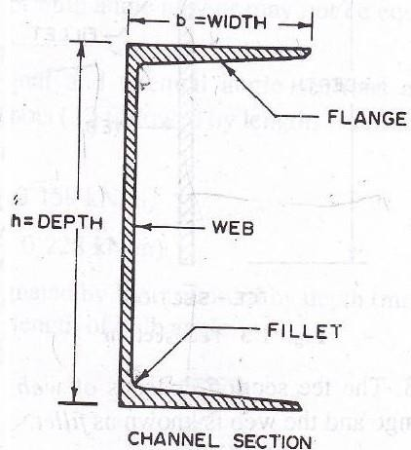

The channel section consists of a web and two flanges. The junction between the flange and the web is known as fillet. The rolled steel channels are designated by the series to which channel section belong (abbreviated reference symbols), followed by depth in mm of the section and weight in kN per metre length of the channel, e.g., MC 225 @ 0.261 kN/m
Channels are used as beams and columns. Because of its shape a channel member affords connection of an angle to its web. Built up channels are very convenient for columns. Double channel members are often used in bridge truss. The channels are employed as elements to resist bending e.g., as purlins in industrial buildings. It is to note that they are subjected to twisting or torsion because of absence of symmetry of the section with regards to the axis parallel to the web, i.e., yy-axis. Therefore, it is subjected to additional stresses. The channel sections are commonly used as members subjected to axial compression in the shape of built-up sections of two channels connected by lattices or batten plates or perforated cover plates. The built-up channel sections are also used to resist axial tension in the form of chords of truss girders.
As per IS : 808-1989, following channel sections have also been additionally adopted as Indian Standard Channel Secions
  - Indian Standard Light Channels with parallel flanges ISLC(P)
  - Medium weight channels MC
  - Medium weight channels with parallel flanges MCP
  - Indian Standard Gate Channels ISPG
In MC and MCP channel sections, some heavier sections have been developed for their intended use in wagon building industry. The method of designating MC and MCP channels is also same as that for IS channels.

ROLLED STEEL TEE SECTIONS
The rolled steel tee sections are classified into the following five series as per ISI:
- Indian Standard Normal Tee Bars
- Indian Standard Wide flange Tee Bars
- Indian Standard Long Legged Tee Bars
- Indian Standard Light Tee Bars
- Indian Standard Junior Tee Bars
ISNT ISHT ISST ISLT ISJT

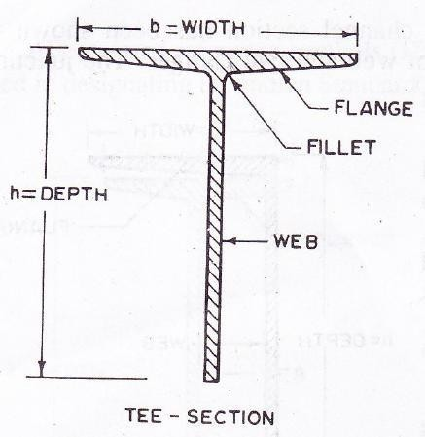
1. Indian Standard deep legged Tee bars ISDT
2. Indian Standard Slit medium weight Tee bars ISMT
3. Indian Standard Slit Tee bars from I-sections ISHT
1. Indian Standard Equal Angles ISA
2. Indian Standard Unequal Angles ISA
3. Indian Standard Bulb Angles ISBA
The cross section of a rolled steel tee section has been shown in Figure below.

The tee section consists of a web and a flange. The junction between the flange and the web is known as fillet. The rolled steel tee sections are designated by the series to which the sections belong (abbreviated reference symbols) followed by depth in mm of the section and weight in kN per metre length of the Tee, e.g., HT 125 @ 0.274 kN/m. The tee sections are used to transmit bracket loads to the columns. These are also used with flat strips to connect plates in the steel rectangular tanks.
A per IS: 808-1984, following T-sections have also been additionally adopted as Indian Standard T-sections.

It is to note that as per IS 808 (part II) 1978, H beam sections have been deleted.

ROLLED STEEL ANGLE SECTIONS
The rolled steel angle sections are classified in to the following three series.

Angles are available as equal angles and unequal angles. The legs of equal angle sections are equal and in case of unequal angle section, length of one leg is longer than the other. Thickness of legs of equal and unequal angle sections are equal. The cross section of rolled equal angle section, unequal angle section and that of bulb angle section is shown in Fig. 2.4. The bulb angle consists of a web a flange and a bulb projecting from end of web.

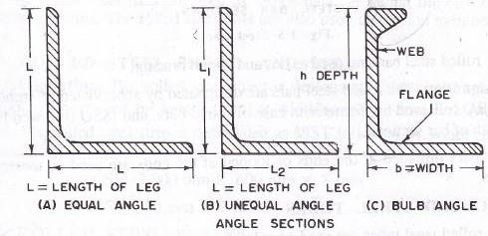

The rolled steel equal and unequal angle sections are designated by abbreviated reference symbols ∟ followed by length of legs in mm and thickness of leg, e.g.,
∟130 x 130 x 8 mm (∟130 x 130 @ 0.159 kN/m)
∟200 x 100 x 10 mm (∟ 200 x 100 @ 0.228 kN/m)
The rolled steel bulb angles are designated by BA, followed by depth in mm of the section and weight in kN per metre length of bulb angle.
Angles have great applications in the fabrications. The angle sections are used as independent sections consisting of one or two or four angles designed for resisting axial forces (tension and compression) and transverse forces as purlins. Angles may be used as connecting elements to connect structural elements like sheets or plates or to form a built up section. The angle sections are also used as construction elements for connecting beams to the columns and purlins to the chords of trusses in the capacity of beam seats, stiffening ribs and cleat angles. The bulb angles are used in the ship buildings. The bulb helps to stiffen the outstanding leg when the angle is under compression.
As per IS : 808-1984, some supplementary angle sections have also additionally adopted as Indian Standard angle sections. However prefix ISA has been dropped. These sections are designated by the size of legs followed by thickness e.g., ∟200 150 x 15.

ROLLED STEEL BARS
The rolled steel bars are classified in to the following two series:
1. Indian Standard Round Bars ISRO
2. Indian Standard Square Bars ISSQ

The rolled steel bars are used as ties and lateral bracing. The cross sections of rolled steel bars are shown in Figure below. The rolled steel bars are designated by abbreviated reference symbol RO followed by diameter in case of round bars and ISSQ followed by side width of bar sections. The bars threaded at the ends or looped at the ends are used as tension members.

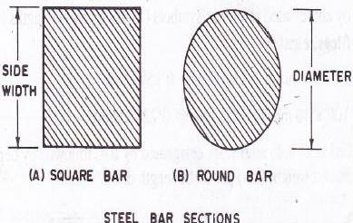
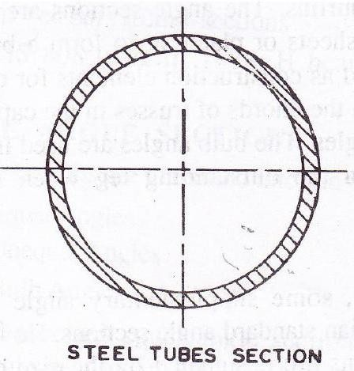

ROLLED STEEL TUBES
The rolled steel tubes are used as columns and compression members and tension members in tubular trusses. The rolled steel tubes are efficient structural sections to be used as compression members. The steel tube sections have equal radius of gyration in all directions. The cross section of rolled steel tube is shown in Figure below.

ROLLED STEEL FLATS
The rolled steel flats are used for lacing of elements in built up members, such as columns and are also used as ties. The cross section of rolled steel flat is shown in Figure below. the rolled steel flats are designated by width in mm of the section followed by letters (abbreviated reference symbol) F and thickness in mm, e.g., 50 F 8. This means a flat of width 50 mm and thickness 8 mm. The rolled steel flats are used as lattice bars for lacing the elements of built up columns. The rolled steel flats are also used as tension members and stays.

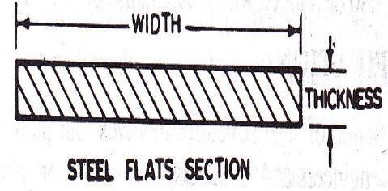

ROLLED STEEL SHEETS AND STRIPS
The rolled steel sheet is designated by abbreviated reference symbol SH followed by length in mm x width in mm x thickness in mm of the sheet. The rolled steel strip is designated as ISST followed by width in mm x thickness in mm, e.g., SH 2000 x 600 x 8 and ISST 250 x 2.

ROLLED STEEL PLATES
The rolled steel plates are designated by abbreviated reference symbol PL followed be length in mm x width in mm x thickness in mm of the plates, e.g., PL 2000 x 1000 x 6.
The rolled steel sheets and plates are widely used in construction. Any sections of the required dimensions, thickness and configuration may be produced by riveting or welding the separate plates. The rolled plates are used in the web and flanges of plate girders, plated beams and chord members and web members of the truss bridge girders. The rolled steel plates are used in special plate structures, e.g., shells, rectangular and circular steel tanks and steel chimneys.

RECENT DEVELOPMENTS IN SECTIONS
The rolled steel beam sections with parallel faces of flanges are recently developed. These beam sections are called as parallel flange sections. These sections have increased moment of inertia, section modulus and radius of gyration about the weak axis. Such sections used as beams and columns have more stability. Theses sections possess ease of connections to other sections as no packing is needed as in beams of slopping flanges. The parallel flange beam sections are not yet rolled in our country.
New welded sections using plates and other steel sections are developed because of welding. The development of beams with tapered flanges and tapered depths is also due to welding. The open web sections and the castellated beams were also developed with the rapid use of welding.
MECHANICAL PROPERTIES OF STEEL
Stress – strain behavior: tensile test
The stress-strain curve for steel is generally obtained from tensile test on standard specimens as shown in Figure below. The details of the specimen and the method of testing is elaborated in IS:

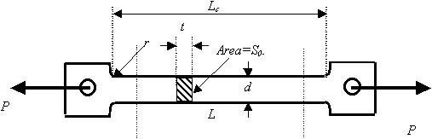
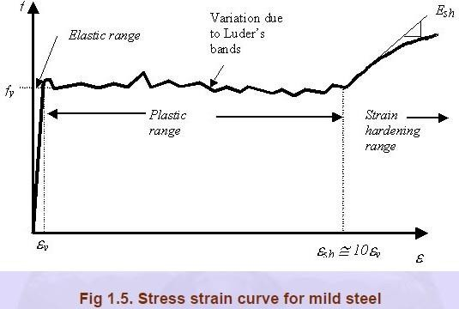
1608 (1995). The important parameters are the gauge length „Lc‟ and the initial cross section area So. The loads are applied through the threaded or shouldered ends. The initial gauge length is taken as 5.65 (So) 1/2 in the case of rectangular specimen and it is five times the diameter in the case of circular specimen. A typical stress-strain curve of the tensile test coupon is shown in Fig.1.5 in which a sharp change in yield point followed by plastic strain is observed. After a certain amount of the plastic deformation of the material, due to reorientation of the crystal structure an increase in load is observed with increase in strain. This range is called the strain hardening range. After a little increase in load, the specimen eventually fractures. After the failure it is seen that the fractured surface of the two pieces form a cup and cone arrangement. This cup and cone fracture is considered to be an indication of ductile fracture. It is seen from Fig.1.5 that the elastic strain is up to ey followed by a yield plateau between strains ey and esh and a strain hardening range start at esh and the specimen fail at eult where ey, esh and eult are the strains at onset of yielding, strain hardening and failure respectively.

Depending on the steel used, εsh generally varies between 5 and 15 εy, with an average value of 10 εy typically used in many applications. For all structural steels, the modulus of elasticity can be taken as 205,000 MPa and the tangent modus at the onset of strain hardening is roughly 1/30th of that value or approximately 6700 MPa. High strength steels, due to their

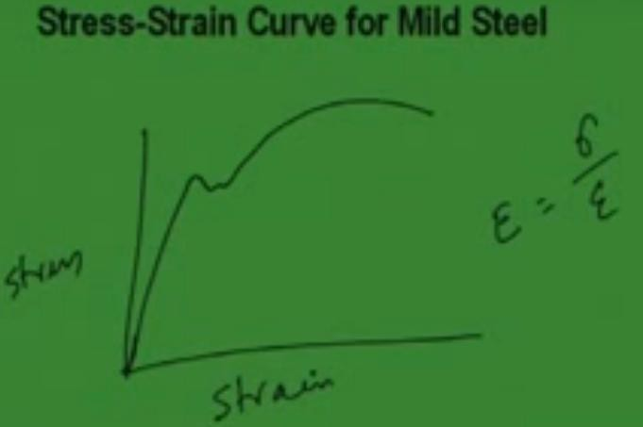
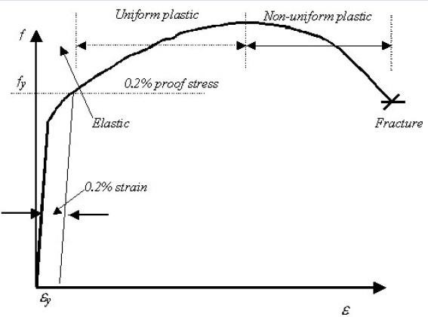
specific microstructure, do not show a sharp yield point but rather they yield continuously as shown in Fig. 1.6. For such steels the yield stress is always taken as the stress at which a line at 0.2% strain, parallel to the elastic portion, intercepts the stress strain curve. This is shown in Fig. 1.6.

The nominal stress or the engineering stress is given by the load divided by the original area. Similarly, the engineering strain is taken as the ratio of the change in length to original length.

MECHANICAL PROPERTIES OF STEEL
- Yield stress of steel (fy) = range from 220 to 540 Mpa
- Ultimate tensile strength = 1.2 fy
- Modulus of Elasticity (Es) = 2 x 10⁵ N / mm²
- Shear Modulus of steel = 0.4 E
- Poissons Ratio
  - Elastic Range = 0.3
  - Plastic Range = 0.5

STRESS STRAIN CURVE FOR MILD STEEL

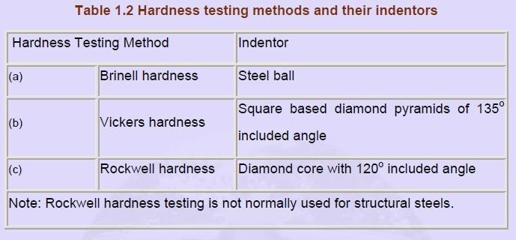
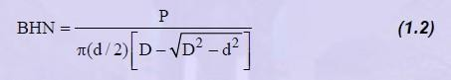
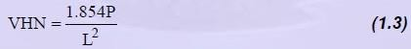
1.3.2 Hardness
Hardness is regarded as the resistance of a material to indentations and scratching. This is generally determined by forcing an indentor on to the surface. The resultant deformation in steel is both elastic and plastic. There are several methods using which the hardness of a metal could be found out. They basically differ in the form of the indentor, which is used on to the surface. They are presented in Table 1.2. In all the above cases, hardness number is related to the ratio of the applied load to the surface area of the indentation formed. The testing procedure involves forcing the indentor on to the surface at a particular road. On removal, the size of indentation is measured using a microscope. Based on the size of the indentation, hardness is worked out. For example, Brinell hardness (BHN) is given by the ratio of the applied load and spherical area of the indentation i.e.

Where P is the load, D is the ball diameter, d is the indent diameter. The Vickers test gives a similar hardness value (VHN) as given by

Where L is the diagonal length of the indent.
Both the BHN and VHN for steel range from 150 to 190.

1.3.3 Notch-toughness
There is always a possibility of microscopic cracks in a material or the material may develop such cracks as a result of several cycles of loading. Such cracks may grow rapidly without detection and lead to sudden collapse of the structure. To ensure that this does not happen,

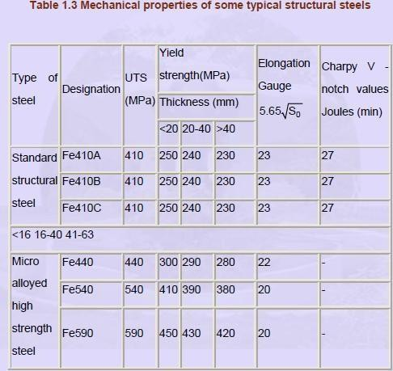
materials in which the cracks grow slowly are preferred. Such steels are known as notch-tough steels and the amount of energy they absorb is measured by impacting a notched specimen with a heavy pendulum as in Izod or Charpy tests. A typical test set up for this is shown in Fig. 1.7 and the specimen used is shown in Fig. 1.8.
The important mechanical properties of steel produced in India are summarized in Table 1.3. In Table 1.3, the UTS represent the minimum guaranteed Ultimate Tensile Strength at which the corresponding steel would fail.

Channel Section with Lacing
This is a channel section face to face lacings are provided. These lacings are provided in a zig-zag way in order to strengthen the column. These lacings are rectangular flats which are attached to fix the column in order to strengthen it making more stable for carrying upcoming load. Safely without displacing the column from its position. This built-up section is commonly used in Huge industries, heavy trusses, and railway stations. This is used as column and made up of steel members.

- Section with Cover Plate

MECHANICAL PROPERTIES OF MATERIALS
Some are commonly or mostly preferred properties are
  - Stiffness
  - Elasticity
  - Plasticity
  - Ductility
  - Brittleness
  - Malleability
  - Toughness
  - Hardness
  - Creep
  - Fatigue

i) STIFFNESS:
It is the ability of materials to resist deformations under the action of loads. That is a material should not change its shape when the load is applied.
*Its unit is N/mm or kN/mm. It is load applied to produce per unit deflection. i.e., in order to produce deflection of 1mm, how much load should be applied i.e., in terms of Newtons.
* It is mostly considered in the design of springs. Stiffness is given by the formula:

ELASTICITY:
K = 𝐿𝑜𝑎𝑑 (𝑊)
𝐷𝑒𝑓𝑙𝑒𝑐𝑡𝑖𝑜𝑛 (𝛿)

It is a property by which a material changes its shape when load is applied and will regain its original shape when load is removed. So this the definition of Elasticity.
For example when we apply load over rubber band, then its shape will change. The moment I removed load over this, the rubberband come back to its original position.
Elasticity is measured by a term called as „Youngs Modulus‟ or „Modulus of Elasticity‟
*Its Unit is „N/mm²‟ (or) „kN/mm²‟
*Young‟s modulus decides how much elastic the material is.

For example, if „Young‟s Modulus‟ or „Elastic Modulus‟ is very high, it means the material is very elastic. If the value of Elastic Modulus is less, it means that material will behave in a less elastic manner.
- PLASTICITY: It is the property by which a material is not able to regain it‟s original shape when the load is removed.
It means here in case of plasticity, the material will not regain it‟s original shape.
For example, if I have a pen and load is applied on this. It will change its shape. On the removal of load, the pen will not regain its original shape.
It is a permanent deformation. Materials used in machines are never allowed to behave in a plastic manner. See this is very important consideration like whatever the materials we are using for the machine design, that materials they should not operate in a region where the deformation would be plastic. i.e., they are not allowed to behave in a plastic manner. That means whatever the machines we are seeing in the machines, they are designed on the concept of elasticity. That is they should regain their original shape when the load is removed. They should not behave in a plastic manner.

DUCTILITY:
It is a property by which materials can be drawn into wires. A very important property that if a material is having ductility it means it can be drawn into wires. Now whatever wires we are seeing like incase of electrical connections those wires the material with the help of material which they are made that material it is called as ductile material. So here I can say that
  - Ductile materials have the ability to flow. To flow means when the load is applied the material will elongate. It will change its shape.
Example: Copper wires used in electric cables.
Aluminum which is soft material is also a ductile material.
- BRITTLENESS: It is ability of a material by which it can break or develop cracks when loaded. Brittle materials are those in which when we are applying load either they can break suddenly or cracks would be developing in that material.

Example: Wood, Concrete, cast-iron (Contains more amount of carbon, the more amount of carbon we add, the more brittle it becomes)
  - Brittle materials can break without any prior warning or they can develop cracks

- MALLEABILITY: It is the property by which materials are able to be beaten or converted into thin sheets. See whatever the sheets of metal which we are seeing that metal it has the property of malleability that is why it is conerted into sheets.

Materials which are elastic are better in malleability
Examples: steel, copper, Aluminum, brass, bronze, Zinc

TOUGHNESS:
It is the property by which a material is able to resist shocks or impact loading. Impact loading refers to load falling from a height.
Like if I can give the example by drawing the diagram.

Load Bar / rod
h
Collar
Here I have height „h‟ through which the load is falling on to this collar. So now toughness means the ability of this collar to resist this load like for example this load is falling from a height „h‟ then this collar should not deform much. By toughness we mean that on the application of this load, this collar should be able to resist this load. It should not go or it should not deflect suddenly. The deflection should be minimum.

If I can draw the diagram, that after deflection it will look something like this. So this much is the amount of deflection „δL‟
This property is very useful in the design of springs. Like previously we have seen the property which was stiffness. Stifness is required in the design of springs. At the same toughness is also considered in the design of springs.

HARDNESS:
Hardness is the opposite of Toughness. It is the property of a material by which it can resist scratches, marks, or wear and tear. Hardness is the independent of the weight of a material. This property is mostly preferred while designing components which slide over one another.
Brittle materials are more hard. It means brittle materials are able to resist scratches more. Like for example, Cast iron, Concrete, Glass, Diamond.
- CREEP: It is the ability of materials to resist high or extremely high temperatures. So as from the definition I think it is very much clear that any material which is able to resist high amount of temperatures that material we will say that it is CREEP RESISTANT. And if the material changes its shape when the temperature is high then it would be called as the material is not able to resist the high temperature, then it would be LESS IN CREEP.

Because of Creep, high amount of temperature stresses are developed. As we know when we have a metal when we heating that metal we know that it will expand. Because of that expansion there is some stress which is stored in the material. That stress would be called as temperature stress.
Examples: I.C. Engines (Internal Combustion Engines), Boilers, Steam-turbines, and Furnaces require creep resistant materials.

What is Rolling Process?
In metalworking, rolling is a metal forming process in which metal stock is passed through one or more pairs of rolls to reduce the thickness and to make the thickness uniform. The concept is similar to the rolling of dough. Rolling is classified according to the temperature of the
metal rolled.
The process of plastically deforming metal by passing it between rolls. Rolling is the most widely used process which provides high production and close control of final product. The metal is subjected to high compressive stresses as a result of the friction between the rolls and the metal surface.
Terminology
An ingot is a piece of relatively pure material, usually metal, that is cast into a shape suitable for further processing. In steelmaking, it is the first step among semi-finished casting products.
Bloom is the product of first breakdown of ingot (Cross sectional area greater than 100 cm²)
Billet is the product obtained from a further reduction by hot rolling (Cross sectional area greater than 40 x 40 mm²)
Slab is the hot rolled ingot (cross sectional area greater than 100 cm² and with a width greater than or equal to 2 x thickness)
Plate is the product with a thickness greater than 6 mm.
Sheet is the product with a thickness less than 6 mm and width greater than 600 mm.
Strip is the product with a thickness greater than 6 mm and width less than 600 mm.
Recrystallization: the formation of new strain-free grain structure from that existing in cold worked metal.



Annealing:
There are different types of heat treatments. Annealing is one of the heat treatments given to metals. Main aim of annealing is to increase the ductility of the metal. Annealing is a heat treatment in which the metal is heated to a temperature above its re-crystallization temperature, kept at that temperature some time for homogenization of temperature followed by very slow cooling to develop equilibrium structure in the metal or alloy. The steel is heated 30 to 50ºC above Ae3 temperature in case of hypo-eutectoid steels and 30 to 50ºC above Acm temperature in case of hyper-eutectoid temperature.
The cooling is done in the furnace itself. In case of annealing of steels, the steel is heated to different temperatures depending upon the aim of annealing followed by furnace cooling.
Annealing is a heat treatment designed to eliminate the effects of cold working. The properties of a metal may revert back to the precold-work states by annealing, through recovery, recrystallization and grain growth.
HOT ROLLING
It is a metal working process that occurs above the re-crystallization temperature of the material. Hot rolled metals generally little directionality in their mechanical properties and deformation induced residual stresses. However, I certain instances non-metallic inclusions will impart some directionality.
Non-uniformed cooling will induce a lot of residual stresses which usually occurs in shapes that have a non-uniform cross-section, such as I – Beams and H-beams.
Application
Hot rolling is used mainly to produce sheet metal or simple cross sections such as rail tracks.
COLD ROLLING
Cold rolling occurs with the metal below its re-crystallization temperature. (usually at room temperature). It also improves the surface finish and holds tighter tolerances. Due to smaller size of the work pieces and their greater strength than hot rolled stock , four-high or cluster mills are used .commonly cold-rolled products include sheets, strips and rods; products being smaller than the same products that are hot rolled.

CONCEPT OF LIMIT STATE DESIGN OF BEAM COLUMNS
Steel structures are important in a variety of land-based applications, including industrial (such as factory sheds, box girder cranes, process plants, power and chemical plants etc.), infrastructural (Lattice girder bridges, box girder bridges, flyovers, institutional buildings, shopping mall etc.) and residential sector. The basic strength members in steel structures include support members (such as rolled steel sections, hollow circular tubes, square and rectangular hollow sections, built-up sections, plate girders etc.), plates, stiffened panels/grillages and box girders. During their lifetime, the structures constructed using these members are subjected to various types of loading which is for the most part operational, but may in some cases be extreme or even accidental.
Steel-plated structures are likely to be subjected to various types of loads and deformations arising from service requirements that may range from the routine to the extreme or accidental. The mission of the structural designer is to design a structure that can withstand such demands throughout its expected lifetime.

The structural design criteria used for the Serviceability Limit State Design (hereafter termed as SLS) design of steel-plated structures are normally based on the limits of deflections or vibration for normal use. In reality, excessive deformation of a structure may also be indicative of excessive vibration or noise, and so, certain interrelationships may exist among the design criteria being defined and used separately for convenience.
The SLS criteria are normally defined by the operator of a structure, or by established practice, the primary aim being efficient and economical in-service performance without excessive routine maintenance or down-time. The acceptable limits necessarily depend on the type, mission and arrangement of structures. Further, in defining such limits, other disciplines such as machinery designers must also be consulted.

The structural design criteria to prevent the Ultimate Limit State Design (hereafter termed as ULS) are based on plastic collapse or ultimate strength. The simplified ULS design of many types of structures has in the past tended to rely on estimates of the buckling strength of components, usually from their elastic buckling strength adjusted by
a simple plasticity correction. This is represented by point A in Figure 7.1. In such a design scheme based on strength at point A, the structural designer does not use detailed information on the post-buckling behavior of component members and their interactions. The true ultimate strength represented by point B in Figure 7.1 may be higher although one can never be sure of this since the actual ultimate strength is not being directly evaluated.

In any event, as long as the strength level associated with point B remains unknown (as it is with traditional allowable stress design or linear elastic design methods), it is difficult to determine the real safety margin. Hence, more recently, the design of structures such as offshore platforms and land-based structures such as steel bridges has tended to be based on the ultimate strength.

The safety margin of structures can be evaluated by a comparison of ultimate strength with the extreme applied loads (load effects) as depicted in Figure 7.1. To obtain a safe and economic

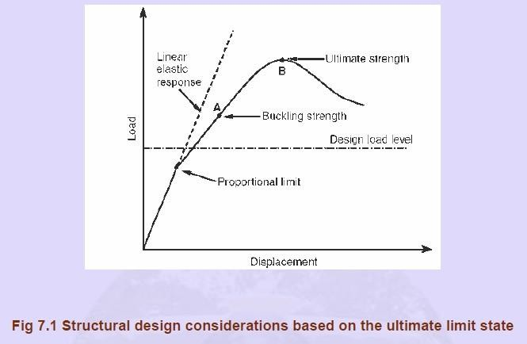
structure, the ultimate load-carrying capacity as well as the design load must be assessed accurately. The structural designer may even desire to estimate the ultimate strength not only for the intact structure, but also for structures with existing or premised damage, in order to assess their damage tolerance and survivability.

In the structural design process, “analysis” usually means the determination of the stress resultants, which the individual structural members must be capable to resist. “Design” can mean the development of the structural layout, or arrangement of members, but it usually means the selection of sizes of members to resist the imposed forces and bending moments. Three methods of analysis are available, i.e. elastic analysis, plastic analysis and advanced analysis. Limit state design is a design method in which the performance of a structure is checked against various limiting conditions at appropriate load levels. The limiting conditions to be checked in structural steel design are ultimate limit state and serviceability limit state.Limit state theory includes principles from the elastic and plastic theories and incorporates other relevant factors to give as realistic a basis for design as possible.

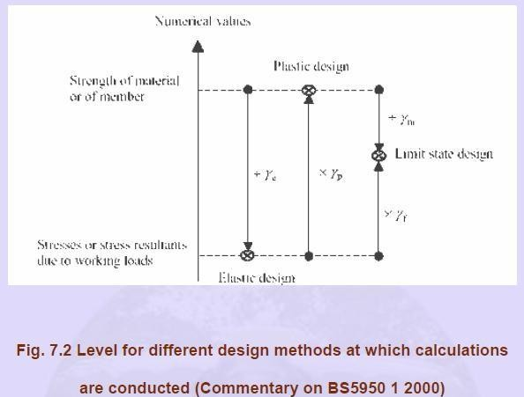

Ultimate Limit State Design of Steel Structures reviews and describes both fundamentals and practical design procedures in this field. Designs should ensure that the structure does not become unfit / unserviceable for the use for which it is intended to. The state at which the unfitness occurs is called a limit state.

Figure 7.2 shows how limit-state design employs separate factors γf, which reflects the combination of variability of loading γl, material strength γm and structural performance γp. In the elastic design approach, the design stress is achieved by scaling down the strength of material or member using a factor of safety γe as indicated in Figure 7.2, while the plastic design compares actual structural member stresses with the effects of factored-up loading by using a load factor of γp.

Special features of limit state design method are:
- Serviceability and the ultimate limit state design of steel structural systems and their components.
- Due importance has been provided to all probable and possible design conditions that could cause failure or make the structure unfit for its intended use.

- The basis for design is entirely dependent on actual behaviour of materials in structures and the performance of real structures, established by tests and long-term observations
- The main intention is to adopt probability theory and related statistical methods in the design.
- It is possible to take into account a number of limit states depending upon the particular instance.
- This method is more general in comparison to the working stress method. In this method, different safety factors can be applied to different limit states, which is more rational and practical than applying one common factor (load factor) as in the plastic design method.
- This concept of design is appropriate for the design of structures since any development in the knowledge base for the structural behavior, loading and materials can be readily implemented.

CONNECTIONS

Today we are going to introduce new topic name is „connections‟. When we are going to design a steel structure completely, first we have to know the elementary design. Elementary design means design of Beam member (flexural member), Design of a compression member (Column member), Design of a tension member, Base plate, the foundations and similarly the
„Connections‟.

The utility of the connection is that to withstand the load and to transfer the load from one member to another member. Like suppose beam and column. Now the load from beam to column is going to pass through that joint. If joint is not sufficiently strong then chances of failure will be there. In general we see we use to give much importance on design of different types of elements. But often we forget to design the connections properly. We must give due importance to the connection aspects because steel structure may fail, if their connections are improper. So the beam member or the column member may be strong enough to send the load. If their joint is weak, then as rule the structure will fail. So we have to consider the connections as important so that failure doesn‟t occur at the joint level.

Now Connections means different type of members are connected at a joint. Different type of members means like say:
  - Beam & column
  - Beam & Beam
  - Beam & cross beam
  - Column & column
  - Column & brackets
  - Column & caps
  - Base plate of trusses
  - Truss member connections through gussets
  - Purlins & rafter
  - Wind braces and columns
  - Rails & columns

I am just showing one picture. Say suppose one column is there and another beam is here. So how to connect it. So this is a column and this is a beam. Now connection is to be made. So what we used to do? That connections can be made either temporarily or permanent in nature. Say suppose we are providing some bolted or riveted connection to with stand the load coming from the beam to column.

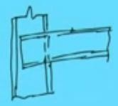
Beam
Column

Now connections means different type of connections are there. As per the requirement in the field, we need to choose the connections like riveted connections, Bolted connections, Pin connections and welding connections. In general Bolted Connection and Pin connections are temporary in nature that means we can use as a temporary basis. Rivetted connection and welded connection are permanent in nature. Other types of connections made like stiffeners in plate girders, Diaphragms in plate girders, Flange and web connections in plate girders, and stiffener plates in column joints.

As I told that method of fabrications is Riveted joints
Welded joints
Bolted joints (or Pin joints we can say)
The combination of two or three of the above (means any of the combinations also can be made)

Now these two (Riveted joints, Welded joints) joints are permanent in nature and these two joints (Bolted joints, The combination of two or three of the above) are temporary.
Now when we are going to talk about the connections, we must know “what are the requirements for the good connections?”. Means what are the points we have to remember to make a good connection.

i.e., 1. it (Connection) should be rigid enough to avoid fluctuating stresses which may cause fatigue failure.
- It should be such that there is the least possible weakening of the parts to be joined.
- It should be such that it can be easily installed, inspected, & maintained.

Now connections we have told. There are three types of connections basically, one is riveting, another is welding and another is bolted connection.

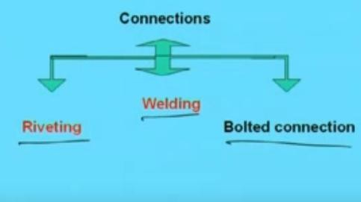
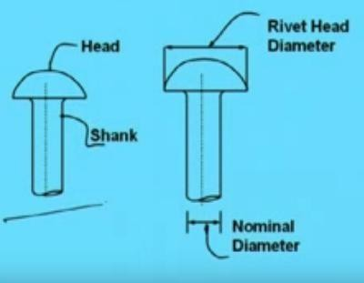

Now we will discuss in details about the Riveted connections.

In case of rivet connections analysis is in general difficult. Certain assumptions have been made to make the analysis simple. What are those assumptions? Assumptions like
  - Friction between the plates is neglected.
  - The shear stress is uniform on the crosssection of the rivet
  - The distribution of direct stress on the portion of the plates between the rivet holes is uniform.
  - Rivets in group subjected to direct loads share the load equally. (that means if the
„n‟ number of rivets are there and then total load is connect by as „P‟, then the load shared by each rivet become „P/n‟
  - Bending stress in the rivet is neglected.
  - Rivets fill completely the holes in which they are driven.
  - Bearing stress distribution is uniform and contact area is d x t. where „d‟ is the diameter of the rivet and „t‟ is the thickness of the plate.
So with these assumptions the analysis would be done. Analysis means, what is the strength of the rivet, how many rivets should be required to connect the particular joint. All these things will be decided under these assumptions.
Now how the rivet look like? As you know,

Rivet

It has a head and another part is shank. So a rivet consist of shank and head. The length of shank is depends or decided based on thickness of the plate. How much shank length is required accordingly shank will be decided.

Now Nominal diameter is the diameter of the shank. Now here another term we will get is the “Gross diameter” which is basically the some clearance that means hole diameter. Hole diameter is made nominal diameter + some additional clearance.
As per the codal provisions, if the nominal diameter is below the 25 mm, then 1.5 mm extra clearance has been taken for calculating the gross diameter and if the nominal diameter is more than 25 mm, then 2.0 mm extra clearance has been taken for calculating the gross diameter.
That means gross diameter will be say „dg‟ = dn + 1.5 (dn is below 25 mm)
= dn + 2.0 (dn is more than 25 mm)

So rivet looks like this.

Now Rivet can be divided into two categories One is power driven riveting or Hot rivet.
Another is Hand driven rivet or Cold rivet.

Now Power driven rivet is of two types One is Power driven shop rivet (PDS) and
another is Power driven field rivet (PDF). In short we use „PDS‟ or „PDF‟.

Similarly in case Hand driven riveting, we use to categorize as „Hand driven shop rivet (HDS) and Hand driven field rivet (HDF).

Now we will show some commonly used rivet head.

1.) One is „Snap Head‟. This is the most commonly used rivet in practice we make and the standard dimension is like this. If the nominal diameter of the rivet is „d‟, the diameter of head will become „1.6d‟ and the height of head will become „0.7d‟.
This is called length ‘l’ whatever is required to fit the connections, to fit the thickness of the plate. So snap head is looking like this.

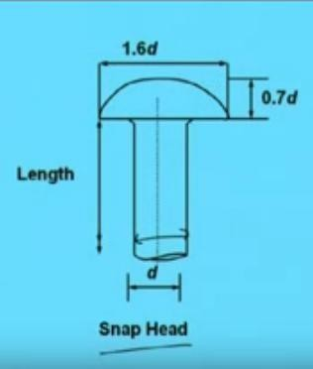
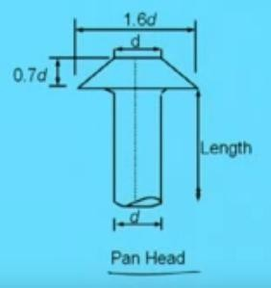
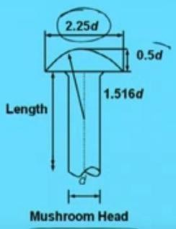

- Another type of rivet is called „PAN Head‟
In this Pan Head, the head will look like this. Here if the diameter is „d‟then the height of head will be „0.7d‟ like the previous one (like the height of head of „Snap Head‟). The maximum width of head will be „1.6d‟. so the specialty of PAN head is that the head will be „0.7d‟ and the maximum width will become „1.6d‟ where the width at the top will become „d‟.

- Another Common head is called „Mushroom Head‟. Mushroom Head means here the maximum diameter of head will be „2.25d‟ and the height of head will become „0.5d‟. The centre of the curve will be at the „1.516d‟. So the specialty of mushroom head is
Height of head will be „0.5d‟ and width of head will become „2.25d‟, where the centre of circle will be at „1.516d‟.

- Another is Countersunk Head 120º. Here if the diameter is „d‟, then the width of the head will become „2d‟, and the height of head will become „0.29d‟, and the slope will be

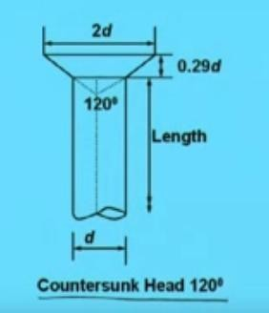
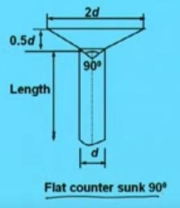
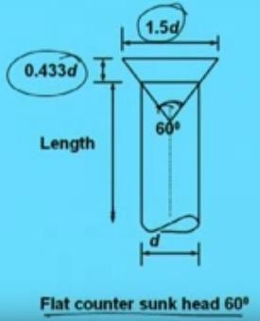
made in such a way that this will become 120º. The angle between this two slopes will become 120º.

- Another type of rivet is „Flat Countersunk 90º. Here if the diameter is „d‟, then the width of the head will become „2d‟, and the height of head will become „0.5d‟, and the slope will be made in such a way that this will become 90º. The angle between this two slopes will become 90º.

- Another type of rivet is „Flat Countersunk head 60º‟. Here if the diameter is „d‟, then the width of the head will become „1.5d‟, and the height of head will become „0.433d‟, and the slope will be made in such a way that the angle will become 60º. The angle between this two will be 60º.

- Another type of rivet is round counter sunk head 60º.

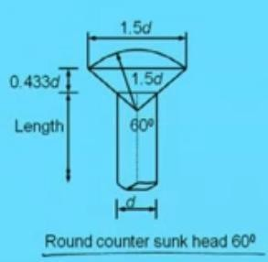
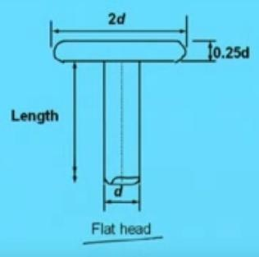
Here the anagle between these two will become 60º. This radius will become „1.5d‟. so the width will become 1.5d of the circle and height of head will become „0.433d‟.

- Another type of rivet is Flat head. In case of flat head, the height of the head will become „0.25d‟ where d is the nominal diameter of the sunk, and the width of head will become „2d‟.

NOW WE WILL DISCUSS ABOUT THE DIFFERENT TYPES OF CONVENTIONAL SYMBOLS
These conventional symbols has to be known for knowing the drawing and the engineer executing the construction at the site, must know how to read the drawing. That means in a drawing some symbols are given for the connections so he should know, what is the meaning and what type of connections the design engineer has made and accordingly he has to make. So for the sake of simplicity certain convention symbols has been used which are given below for our learning purpose.
- One is generally rivet. One plate is this. Another plate is

Section

Connection View
- Suppose Rivet countersunk on backsiRdivee.tTGoenmeeraaln this, the drawing will be something like this. So to represent the Rivet countersunk on backside, the view and section will be looking
like shown below.

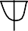
Section

Connection View

Rivet countersunk on backside

- Suppose Rivet countersunk on front side. To mean this, the drawing will be something like this. So to represent the Rivet countersunk on front side, the view and section will be looking like shown below.

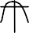
Section

Connection View

Rivet countersunk on backside

4. | 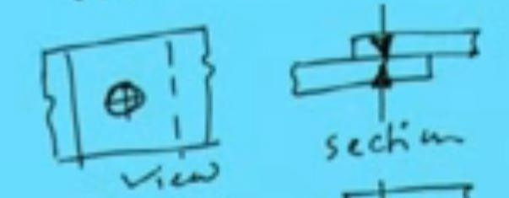 | Rivet Counter sunk on front and back side
5. | 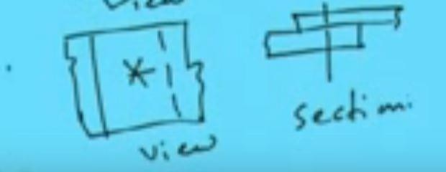 | Bolt General
6. | 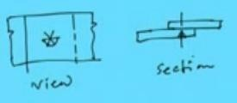 | Bolt head counter sunk on back side
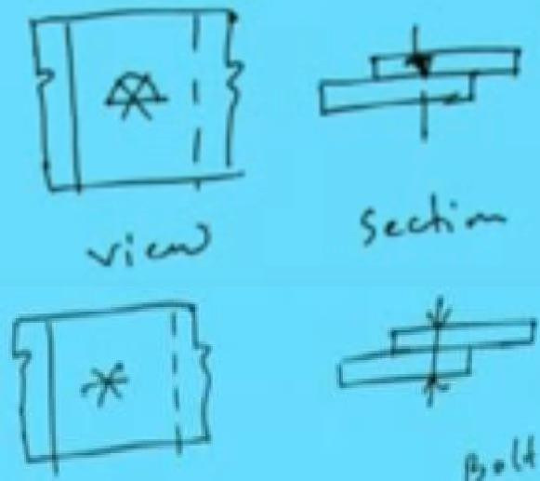  7. |  | Bolt head counter sunk on front side
8. |  | Bolt to distinguished from the rivet
9. | 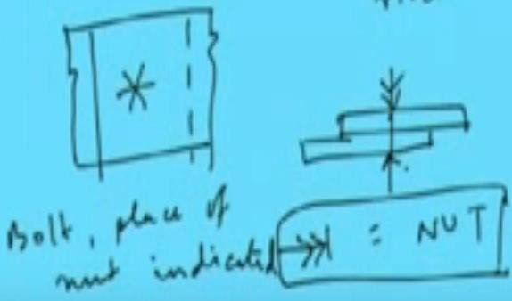 | Bolt, place of Nut indicated

Terminology

What is pitch distance?
For connecting two members, we need to know what will be the Pitch distance, Edge distance and other things.
Pitch distance means the distance between two rivets in a plane in a particular direction and
Edge distance means the distance from the outer most rivet to the edge.
q. What should be the minimum edge distance, What should be maximum pitch, minimum pitch, Min edge distance
Max edge distance
All these things has been given in the code IS 800:1984. In that (this) code, all the details has been given and according to the codal provisions we have to follow and design accordingly. So before designing, before going to analyse the details of the rivet joints, we must know what are the codal provisions and we should know some of the terminology, so that we can know all these things before going to the analysis.

Say this is one plate another plate is here overlapped. Now say rivets are there like this. Now the load is acting in this direction. Then the Pitch will be along the action of load, the distance between two rivets.( Distance between two rivets is called Pitch) and this is called „Lap‟ means Lap length. That means overlapping of two plates. This is one plate and this is another plate. This plate is continue upto this and this plate is continue upto this. So Overlapping is from this to this which is called „Lap‟ and Edge distance is this one.
The distance between two pitch perpendicular to the action of load is called gauge. So this gauge. So we should not mix up with Pitch and Gauge.
This „p‟ basically stands for Pitch. So what are the terminology we got from here.
One is Edge, „e‟, another is Pitch, „p‟, and another is gauge. „g‟. so these three terms will be required frequently for analysis of the rivet joints.

Pitch, p Pitch is the centre to centre distance of adjacent rivets or bolt holes measured in the direction of stress
Gauge, g A row of rivets which is parallel to the direction of stress is called gauge line. The normal distance between two adjacent gauge lines is called gauge.
Edge distance, e The distance between the edge of a member or cover plate from the centre of the nearest rivet hole.
So this three terminology is important and the codal provision has been given that what is the minimum edge distance and gauge distance and pitch distance should be maintained. Those things has been told in Codal provisions we will come to them later through which we have to design the details of the joint.

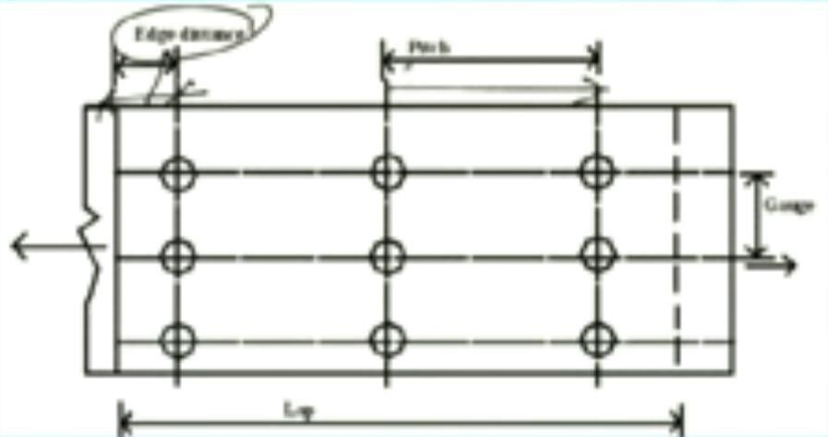
Nominal diameter, d It is the diameter of the shank of the rivet. For bolts the diameter of the unthreaded portion of the shank is called its nominal diameter.

Gross diameter, D The diameter of the rivet hole or bolt hole is called its gross diameter. This gross diameter can be calculated from the given formula.

As per clause 3.6.1.1 of IS 800:
D = d + 1.5 mm for d< 25 mm
= d + 2 mm for d >= 25 mm

So in short if I repeat once again using Figure given below.

This is called edge distance, This is the „Pitch‟, and this is the „gauge‟ and this is the „Lap‟. In short we have to say, if the load, „P‟ is acting in this direction. Remember, see first the load in which direction it is acting, accordingly we have to decide which one will be the pitch and which one will the gauge. Pitch distance is the distance along the action of the load and the gauge distance will be the perpenidcular to the action of the load.

TYPES OF RIVET JOINTS
Now the rivet joints can be classified into three category.

- Depending upon arrangement of rivets and plates (That means how the plates and rivets have been arranged. on that basis the classification can be made.)
- Depending upon mode of load transmission (How that load is transmitted on that basis the rivet joint can be classified)
- Depending upon nature and location of load (that means where is the load and what type of load like whether the load is concentric or eccentric or only tensile coming into picture or only compression force on that basis rivet joint can be classified.)

  - Depending upon arrangement of rivets and plates (This first case it can be divided into two category. Depending upon arrangement of rivets and plates, the rivet joint can be classified as „Lap Joint‟ and „Butt Joint‟.)

Lap Joint (so Lap joint is again classified into three category)
    - Single riveting
    - Chain riveting
    - Staggered or Zig-Zag riveting

Butt Joint
- Single riveting
- Chain riveting
- Staggered or Zig-Zag riveting

  - Depending upon the mode of load transmission, the rivet joints can be classified into four category:
    - Single shear
    - Double shear
    - Multiple shear
    - Bearing
That means in how the load is getting transmitted on that basis the rivet joints has been classified whether it is single shear or double shear or Multiple shear or bearing
  - Depending upon the nature and location of load
    - Direct shear connection
    - Eccentric connection
    - Pure moment connection
    - Moment shear connection

[So all this types will be discussed now. What type of joints should be made in case of different type of rivet thing arrangement. Those things will be discussed now] say first let us consider now say

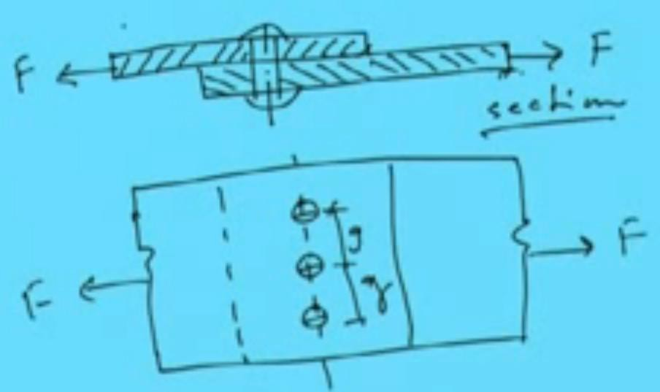
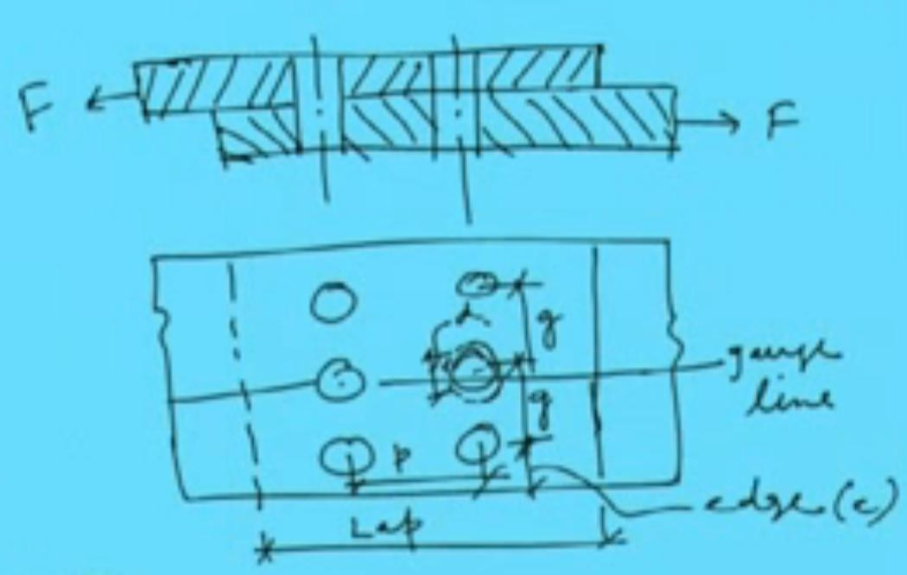
SINGLE RIVETED LAP JOINT

Chain riveting lap JOINT

STAGGERED OR ZIG ZAG RIVETTING LAP JOINT

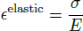
CONCEPTS OF PLASTICITY

There are five basic concepts in the theory of plasticity:
- Yield condition
- Hardening curve
- Incompressibility
- Flow rule
- Loading/unloading criterion
All of the above concept will _rst be explained in the 1-D case and then extended to the general 3-D case.

Hardening Curve and Yield Curve

If we go to the lab and perform a standard tensile test on a round specimen or a at dog- bone specimen made of steel or aluminum, most probably the engineering stress-strain curve will look like the one shown in Fig. (12.1a). The following features can be distinguished:

Point A - proportionality limit Point B - 0.02% yield
Point C - arbitrary point on the hardening curve showing different trajectories on loading/unloading Point D - fully unloaded specimen

For most of material the initial portion of the stress-strain curve is straight up to the proportionality limit, point A. From this stage on the stress-strain curve becomes slightly curved but there is no distinct yield point with a sudden change of slope. There is in international standard the yield stress is mapped by taking elastic slope with 0.02% strain (ε= 0:0002) offset strain. Upon loading, the material hardens and the stress is increasing with diminishing slop until the testing machine (either force or displacement controlled) is stopped. There are two possibilities. On unloading, meaning reversing the load or displacement of the cross-load of the testing machine, the unloading trajectory is straight. This is the elastic unloading where the slop of the stress-strain curve is equal to the initial slope, given by the Young's modulus. At point D the stress is zero but there is a residual plastic strain of the magnitude OD. The experiment on loading/unloading tell us that the total strain _total can be considered as the sum of the plastic strain _plastic and elastic strain _elastic. Thus

The elastic component is not constant but depends on the current stress

The plastic strain depends on how far a given specimen is loaded, and thus there is a di_erence between the total (measured) strain and known elastic strain. Various empirical formulas were

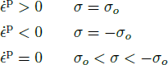
suggested in the literature to _t the measured relation between the stress and the plastic strain.
The most common is the swift hardening law

where A is the stress amplitude, n is the hardening exponent and _o is the strain shift parameter.

In many practical problems the magnitude of plastic strain is mud larger than the parameter _o, giving rise to a simpler power hardening law, extensively used in the literature.

For most metals the exponent n is the range of n = 0:10:3, and the amplitude can vary a lot, depending on the grade of steel. A description of the reverse loading and cycling plastic loading is beyond the scope of the present lecture notes.
Various other approximation of the actual stress-strain curve of the material are in common use and some of then are shown in Fig. (12.3).
A further simplification is obtained by considering the average value _o of the stress- strain curve, illustrated in Fig. (12.3b). This concept gave rise to the concept of the rigid-perfectly plastic material characteristic time, depicted in Fig. (12.4). The material model shown in Fig. (12.4) is adopted in the development of the limit analysis of structures. The extension of the concept of the hardening curve to the 3-D case will be presented later, after deriving the expression for the yield condition.

  - Loading/Unloading Condition
In the 1-D case the plastic ow rule is reduced to the following statement:

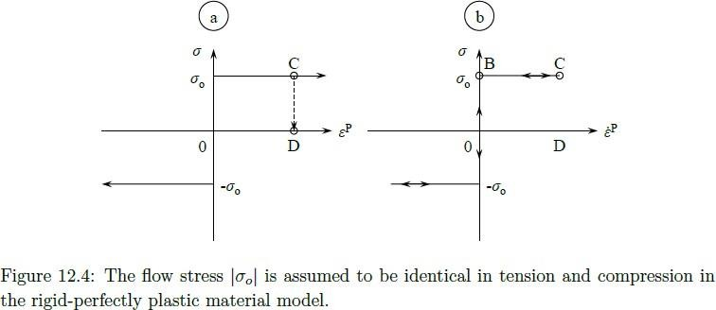
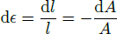
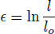

In the case of unloading, the stress follow the path CD on the _-_p graph. If the strain rate is an independent variable, the path of all unloading cases is the same CBO, as shown in Fig. (12.4).

Incompressibility

Numerous experiments performed over the past 100% have shown that metals are practically incompressible in the plastic range. Let's explore the consequences of this physical fact in the case of one-dimensional case. Denote the gauge length of the prismatic bar by l and its cross- sectional area by A. The current volume of the gauge section is V = Al. Incompressibility means that the volume must be unchanged or dV = 0.

From Eq. (12.5) we infer that the strain increment d_ can be calculated either by tracking down the gauge length or the cross-sectional area

Integrating the first part of Eq. (??)

The integration constant is obtained by requiring that the strain vanishes when the length l is equal to the gauge initial, reference length lo, which gives C = ln lo. Thus

which is the logarithmic de_nition of strain, introduced in Lecture 2. Similarly, integrating the second part of Eq. (??) with the initial condition at A = Ao, _ = 0, one gets

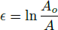
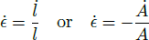
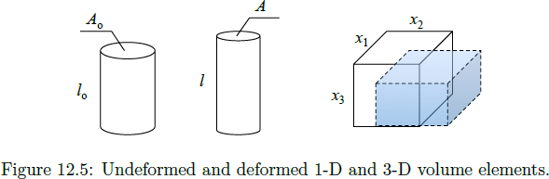
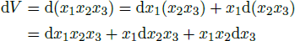
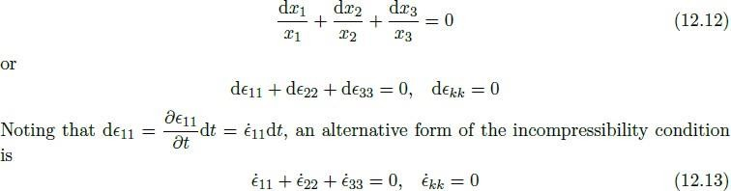
In tension l > lo or A < Ao, so both Eqs. (??) and (??) gives the positive strain. In compression the strain is negative. The same is true for strain increments d_ or strain rates

From the above analysis follows a simple extension of the plastic incompressibility condition into the 3-D case. Consider an infinitesimal volume element V = x1x2x3, Fig. (12.5).

The plastic incompressibility requires that

Dividing both sides of the above equation by the volume, one gets

The sum of the diagonal components of the strain rate tensor must vanish to ensure incompressibility. It follows from the ow rule (to be formulated later) that in uniaxial tension in

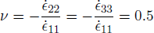
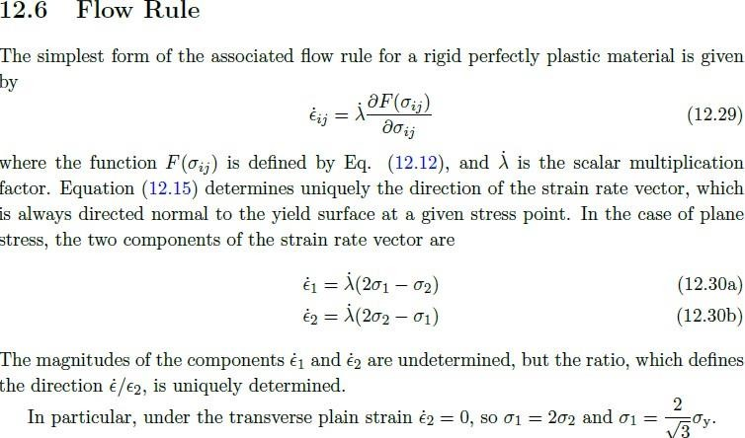
x1 direction the components _ _22 = _ _33. Therefore _ _11 + 2_ _22 = 0 or _ _11 + 2_ _33 = 0. Finally we obtain

The coefficient 0.5 can be interpreted as the Poisson ratio

We can conclude that plastic incompressibility requires that the Poisson ratio be equal to 1=2, which is different from the elastic Poisson ratio, equal to 0:3 for metals. Many other materials such as rubber, polymers and water are incompressible.

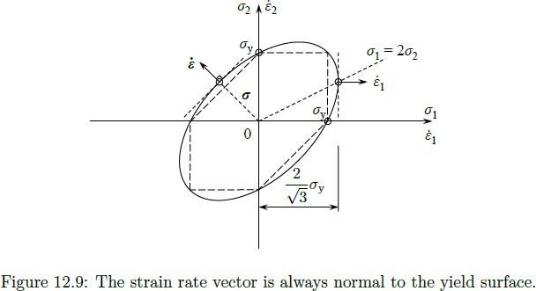
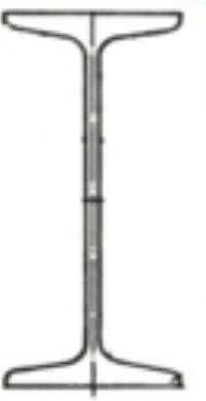
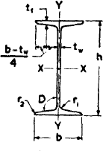
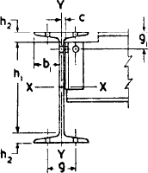

First let us discuss about the I-sections. I section means how does it look and what are the things we have, let us discuss.
Let us draw the I- section how it looks. (Draw it on Board)

This total depth of the I-section is denoted in the code book [means SP: 6-(1): Hand Book for Structural Engineers] is denoted by ‘h’.
and the width of the flange is denoted by ‘b’
and this is called „web‟. Thickness of web is ‘tw’. Another thing is, thickness of flange is written as ‘tf’. This is the X-X direction and this is Y-Y direction.
and this „tf‟. As you see thickness of flange is varying from here to here. Right it is varying! so Where to measure this is a measure at a distance of (b - tw) / 4. All this things details will get in SP: 6-(1). Right. where „b‟ is the width of the flange and „tw‟ is the thickness of the flange
So (b-tw)/4, at a distance of (b-tw)/4 from end of the flange, the thickness of the flange come is called „tf‟ the thickness of flange. Right!.
and „this is the slope of flange. This is termed as „D‟ this is called „r1‟ “radius at root”.
this is called „r2‟ “radius at toe”.
So these are the standard things which are given in the SP: 6-1 code. right So we have to know what are terms and accordingly the specifications has been given and value has been given. Right! now let us see how the terms are coming. Like
We use to say ISJB or JB what is this INDIAN STANDARD JUNIOR BEAM (ISJB) – JB Indian Standard Junior Beam. It is denoted by ISJB or JB
Similarly, INDIAN STANDARD LIGHT BEAM (ISLB) that is denoted by LB Indian Standard Light Beam, denoted by ISLB or LB

Similarly, INDIAN STANDARD MEDIUM WEIGHT BEAM (ISMB) – MB
Similarly Indian Stanadard Medium Weight Beam, denoted by ISMB or MB

Right! So different type of I- section beam means I section is available and mainly these are used for beams

INDIAN STANDARD WIDE FLANGE BEAM (ISWB) – WB
Similarly Indian Standard Wide Flange Beam, denoted by ISWB or WB

INDIAN STANDARD HEAVY WEIGHT BEAM (ISHB) – HB
Similarly Indian Standard Heavy Weight Beam, denoted by ISHB or HB INDIAN STANDARD COLUMN SECTION (ISSC) – SC

Similarly Indian Standard Column Section, denoted by ISSC or SC

Now in Table-1 of SP: 6-1, there you see what the things are given in Table 1.
Suppose for ISMB 550, in Table 1 Corresponding to ISMB 550 we will get several parameter details.
First we will get „w‟ which is weight per meter in Kg. so ISMB 550 when we are telling we know what is the weight of the beam.

Then you will get the „a‟ „a‟ is the section area. i.e., what is the cross-sectional area of ISMB 550 Section. That is also given there.
Then „h‟ i.e., depth of section in mm Then „b‟ i.e., width of flange
Then „tf‟ - thickness of flange Then „tw‟ - thickness of web
So in this way all the details will be given there. Apart from these what the other things are given. Along with these ‘D’, ‘r1’, ‘r2’ are also given

So like Ixx Moments of Inertia about X-direction value, Iyy Moments of Inertia about Y-direction value, rxx – radius of gyration about X direction, ryy radius of gyration about Y-direction.
then section Modulus in X-direction, Zxx , section modulus in Y-direction, Zyy
r1, radius at root, r2 radius at toe,
and D slope of flange
so these are things will be getting from HandBook.
Along with these, other things will get i.e., connection details. Because as it is a rolled section so some standard things are there which is given. so through that, we have to calculate. These are all standard. So for ISMB 550, the values has been given like „h1‟, „h2‟, „b1‟, „C‟, „g (gauge distance)‟, „g1‟ and also maximum size of rivet. So all these you will get in the tabular form.
So if you go through the code you will understand in details.

Similarly for channel section how does it look. For channel section it will be like this.

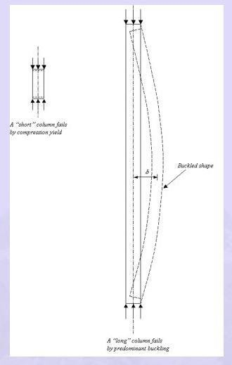
Unit-II

COMPRESSION MEMBERS
Introduction Column, top chords of trusses, diagonals and bracing members are all examples of compression members. Columns are usually thought of as straight compression members whose lengths are considerably greater than their cross-sectional dimensions. An initially straight strut or column, compressed by gradually increasing equal and opposite axial forces at the ends is considered first. Columns and struts are termed “long” or “short” depending on their proneness to buckling. If the strut is “short”, the applied forces will cause a compressive strain, which results in the shortening of the strut in the direction of the applied forces. Under incremental loading, this shortening continues until the column yields or "squashes". However, if the strut is “long”, similar axial shortening is observed only at the initial stages of incremental loading. Thereafter, as the applied forces are increased in magnitude, the strut becomes “unstable” and develops a deformation in a direction normal to the loading axis and its axis is no longer straight. The strut is said to have “buckled”.

Short Columns vs Long Columns
Buckling behaviour is thus characterized by large deformations developed in a direction (or plane) normal to that of the loading that produces it. When the applied loading is increased, the buckling deformation also increases. Buckling occurs mainly in members subjected to compressive forces. If the member has high bending stiffness, its buckling resistance is high. Also, when the member length is increased, the buckling resistance is decreased. Thus the buckling resistance is high when the member is short or “stocky” (i.e. the member has a high bending stiffness and is short) conversely, the buckling resistance is low when the member is long or “slender”.

Elastic buckling of an ideal column or strut with pinned end
The classical Euler analysis of the elastic behaviour of an idealized, pin-ended, uniform strut makes the following assumptions.
- The material is homogeneous and linearly elastic (i.e. it obeys Hooke‟s Law).
- The strut is perfectly straight and there are no imperfections.
- The loading is applied at the centroid of the cross section at the ends

We will assume that the member is able to bend about one of the principal axes. (See Fig. 5.2). Initially, the strut will remain straight for all values of P, but at a particular value
P = Pcr, it buckles. Let the buckling deformation at a section distant x from the end B be y.

The bending moment at this section = Pcr.y
The differential equation governing the deformation can be obtained by considering moment equilibrium about point C as
Strength curve for all ideal strut We will assume that the stress-strain relationship of the material of the column is as shown in Fig. 5.5. Such a strut under compression can therefore resist only a maximum force given by fy.A, when plastic squashing failure would occur by the plastic yielding of the entire cross section; this means that the stress at failure of a column can never exceed fy

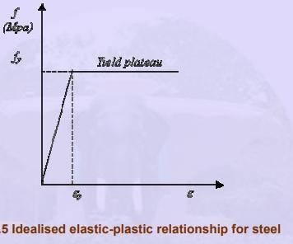
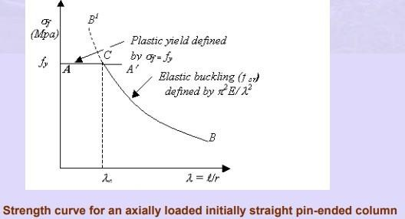

it is obvious that the column would fail by buckling at a stress given by (π 2 EI / λ2 )

Strength of compression members
in practice The highly idealized straight form assumed for the struts considered so far cannot be achieved in practice. Members are never perfectly straight and they can never be loaded exactly at the centroid of the cross section. Deviations from the ideal elastic plastic behaviour defined by Fig. 5 are encountered due to strain hardening at high strains and the absence of clearly defined yield point in some steel. Moreover, residual stresses locked-in during the process of rolling also provide an added complexity. Thus the three components, which contribute to a reduction in the actual strength
of columns (compared with the predictions from the “ideal” column curve) are
- Initial imperfection or initial bow.
- Eccentricity of application of loads.
- Residual stresses locked into the cross section.

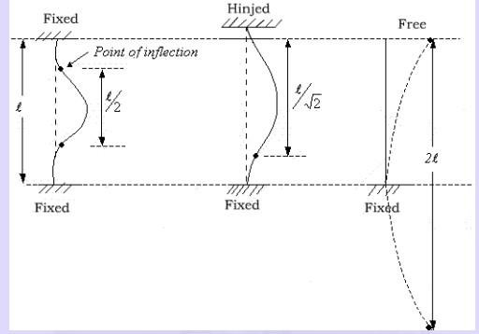
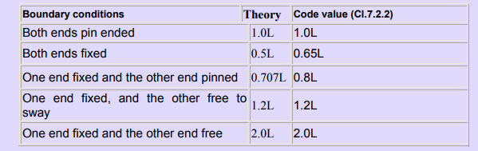
The concepts of effective lengths So far, the discussion in this chapter has been centred around pin-ended columns. The boundary conditions of a column may, however, be idealized in one the following ways
- Both the ends pin jointed (i.e. the case considered before)
- Both ends fixed.
- One end fixed and the other end pinned.
- One end fixed and the other end free. By setting up the corresponding differential equations, expressions for the critical

Buckled mode for different end connections
Using the column, pinned at both ends as the basis of comparison, the critical load in all the above cases can be obtained by employing the concept of “effective length”, Le.

Effective length of compression members

Types of column sections
Rolled Steel Sections
Some of the sections employed as compression members are shown in Fig.
Single angles are satisfactory for bracings and for light trusses. Top chord members of roof trusses are usually made up of double angles back-to-back. The pair of angles used, has to be connected together, so they will act as one unit. Welds may be used at intervals – with a spacer bar between the connecting legs. Alternately “stitch bolts”, washers and “ring fills” are placed

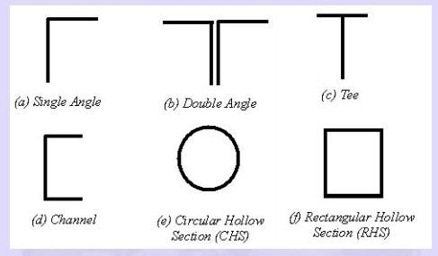
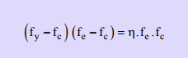
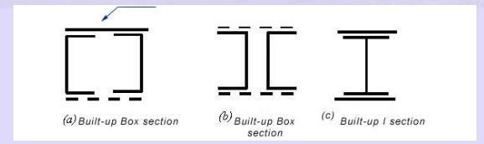
between the angles to keep them at the proper distance apart (e.g. to enable a gusset to be connected). Such connections are called tack connections and the terms tack welding or tacks bolting are used. When welded roof trusses are required, there is no need for gusset plates and T sections can be employed as compression members. Single channels or C-sections are generally not satisfactory for use in compression, because of the low value of radius of gyration in the weak direction. They can be used if they could be supported in a suitable way in the weak direction. Circular hollow sections are perhaps the most efficient as they have equal values of radius of gyration about every axis. But connecting them is difficult but satisfactory methods have been evolved in recent years for their use in tall buildings.

Design strength

Based on the studies of Ayrton & Perry (1886), the compressive strength of the column can be obtained from the following equation

Where, fy = yield stress, fc = compressive strength, fe = Euler buckling stress, λ = Slenderness ratio (l/r) and η = a parameter allowing for the effects of lack of straightness and eccentricity of

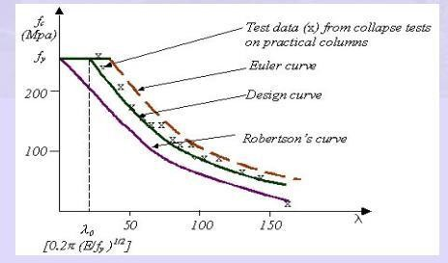
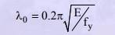
loading and can be expressed as aλ where α is a function of the shape of the cross section. Since Robertson evaluated the mean values of α for many sections, the design method is termed "Perry-Robertson method". Equation (5.8) will result in column strength values lower than fy even in very low slenderness cases as indicated by the Robertson‟s curve in Fig. 5.19. By modifying the slenderness, λ to (λ - λo), a plateau to the design curve can be introduced for low slenderness values. This has the effect of shifting the curve to the right by a value equal to λo. The value of λo may be taken as 0.2(π√E/fy). Thus, the elastic critical stress can be calculated as fe = π 2 E/(λ - λo) 2 . Note that calculations for fe is not needed when λ ≤ λe as the column would fail by squashing at fy.

Column strength curves
Steps in the design of axially loaded columns
The procedure for the design of an axially compressed column is as follows:
(i) Assume a suitable trial section and classify the section in accordance with the classification in chapter. (ii) Arrive at the effective length of the column by suitably considering the end conditions.
- Calculate the slenderness ratios (λ values) in both minor and major axes direction and also calculate λo using the formula given below:

- Calculate fcd values along both major and minor axes from equation 12
- Compute the load that the compression member can resist (pd=Acfcd)
- Calculate the factored applied load and check whether the column is safe against the given loading. The most economical but safe section can be arrived at by trial and error, i.e. repeating the above process.

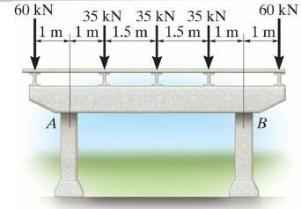
Unit-III DESIGN OF BEAMS

A structural member subjected to transverse loads (Loads perpendicular to its longitudinal axis) is called a beam. See Figure ABOVE

Beams are most critical members in any structure. Their design should therefore not only be economical but also safe. The main considerations in the design of beams are:
  - They should be proportioned for strength in bending keeping in view the lateral and local stability of the compression flange and the capacity of the selected shape to develop the necessary strength in shear and local bearing.
  - They should be proportioned for stiffness, keeping in mind their deflections and deformations under service conditions.
  - They should be proportioned for economy, paying attention to the size and grade of steel to yield the most economical design.
Beam design consists merely of the provision of adequate bending and shear resistance. For optimum bending resistance, as much of the beams material as possible should be displaced as far as practicable from the neutral axis. The web area should be sufficient to resist shear.
Maximum moment and maximum shear usually occur at different sections. Though simple in design, the lateral buckling of beam as a whole, or of its compression flange or its web pose complications. Another problem is of proper depth – an increase in depth may be desirable for moment resistance, it may at the same impair resistance to lateral or web buckling (Figure).

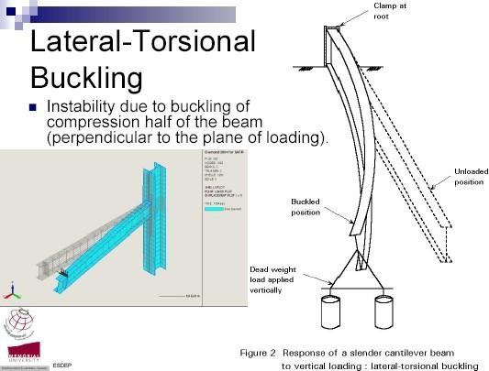
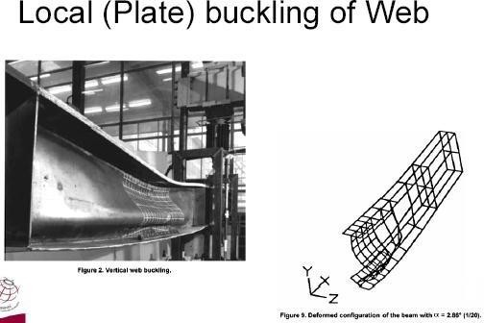

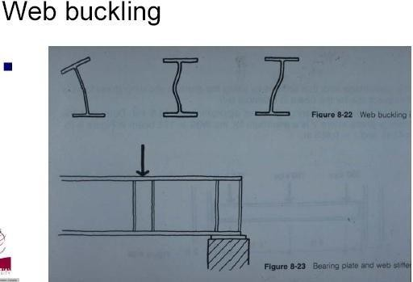
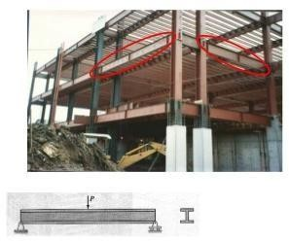

TYPES OF BEAMS:
Beams are generally classified according to their geometry and the manner in which they are supported. They may be straight or curved.

Figure: Straight Beam



Figure: Curved Beam
Girders usually the most important beams which are frequently at wide spacing.
Joists usually less important beams which are closely spaced, frequently with truss type webs.
Stringers- Longitudinal beams spanning between floor beams.
Purlins- Roof beams spanning between trusses
Girts- horizontal wall beams serving principally to resist bending due to wind on the side of an industrial building.
Lintels- Members supporting a wall over window or door openings.

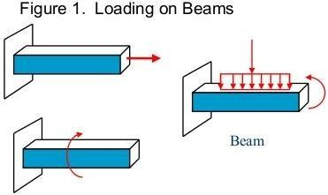
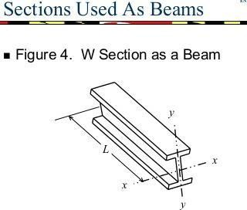

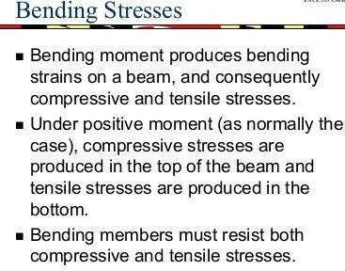
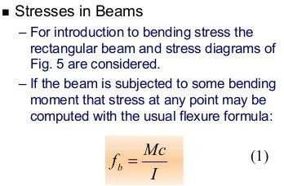

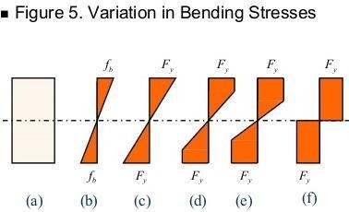
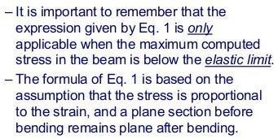
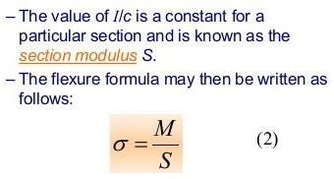

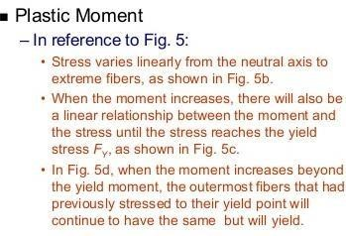
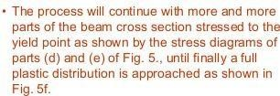
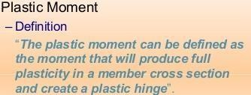

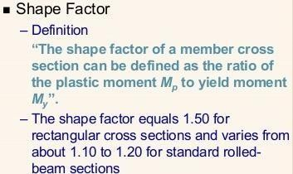


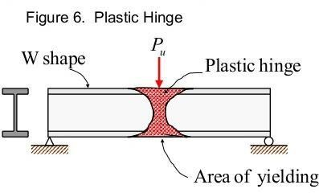
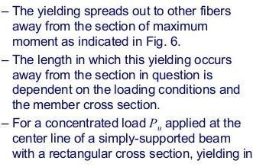
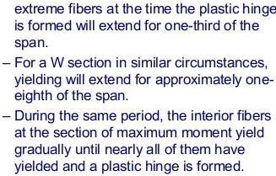

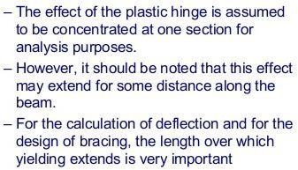

Unit-IV
DESIGN OF ECCENTRIC CONNECTION
Design of eccentric connection, framed, stiffened and seat connection.
- How are the building connections classified based on their moment-rotation characteristics?

- Determine the safe load P that can be carried by the joint shown in Figure. The bolts used are 20 mm diameter of grade 4.6. The thickness of the Flange of I-section is 9.1 mm and that of bracket plate 10 mm. [page No. 717 S.K. Duggal 2nd edition] [ 5 Marks]

40 mm
F₁
F2 θ
200 mm
P
A
A
120 mm
(a)
rn A 160 mm

80mm
80mm 80mm 80mm 40mm
θ
60 mm
(b)

Solution:
For Fe 410 grade of steel: fu = 410 MPa For bolts of grade 4.6: fub = 400 MPa
Partial safety factor for the material of bolt: γmb =1.25
Anb = stress area of 20 mm diameter bolt = 0.78 x ∏x 20²/4 = 245 mm²
Given: diameter of bolt, d = 20 mm; pitch, p = 80 mm; edge distance, e = 40 mm (2 x20 mm), d
= 20 + 2 = 22 mm.

Strength of bolt in single shear, Vdsb = Anb 𝑓𝑢𝑏
1.732 𝑥 1.25

= 245 x 400
1.732 𝑋 1.25

× 10−3 = 45.26 𝑘𝑁

Strength of bolt in bearing, Vdpb = 2.5 kb dt ^{𝑓𝑢}
𝛾𝑚𝑏

Kb is least of ^{𝑒} = ⁴⁰ = 0.606; ^{𝑝} − 0.25 = 80
– 0.25 = 0.96

3𝑑0
3 𝑥 22
3𝑑0
3 𝑥 22

𝑓𝑢𝑏 = 400 =0.975; and 1.0
𝑓𝑢 410

Hence Kb = 0.606
Vdpb = 2.5 kb dt ^{𝑓𝑢} = 2.5 x 0.606 x 20x 9.1 x ⁴¹⁰ × 10⁻³ = 90.44 𝑘𝑁
𝛾𝑚𝑏 1.25

Hence strength of bolt is Vsd = 45.26 kN Let, P1 be the factored load.
Service load, P = 𝑃1 = 𝑃1
𝑙𝑜𝑎𝑑 𝑓𝑎𝑐𝑡𝑜𝑟 1.50

The bolt which is stressed maximum is A Total number of bolts in the joint , n = 10
The force direct force, F1 = ^{𝑃1} = 𝑃1
𝑛 10

The force in the bolt due to torque, F2 =𝑃𝑒0𝑟𝑛
∑ 𝑟 2
r =√(80 + 80)2 + (120 )2 = 170.88 mm
n 2
∑ 𝑟2 = 4 x [(160² + 60²) + (80² + 60²)] + 2 x 60² = 164,000 mm²

F2 =(𝑃1 × 200 × 170.88)/(164,000 )= 0.20839 P1 Cosθ = 60 = 0.3511
√602 +1602
The resultant force on the bolt should be less than or equal to the strength of bolt.
45.26≤ √(𝑃1 )2 + (0.20839𝑃 )2 + 2 × 𝑃1 × 0.20839𝑃

10 1 10 1

Implies P1 = 173.49 kN
× 0.3511

The service load, P = 𝑃1 = 173 .49 = 115.65 kN
𝑙𝑜𝑎𝑑 𝑓𝑎𝑐𝑡𝑜𝑟 1.5

L.Date : 24/march/2015.
- Design a bracket connection to transfer an end reaction of 225 kN due to factored loads as in Figure below. The end reaction from the girder acts at an eccentricity of 300 mm from the face of the column flange. Design bolted joint connecting the Tee-flange with the column flange. Steel is of grade Fe 410 and bolts of grade 4.6. [ 5 Marks] [ Page No. 721, S.K. Duggal 2nd edition]

A
225 kN
300 mm

Tee bracket

A
Solution: For Fe 410 grade of steel: fu = 410 Mpa For bolts of grade 4.6: fub = 400 MPa
Partial safety factor for the material bolt: γmb = 1.25 The bolts along section AA are subjected to
- Shear due to the load, P = 225kN passing through the c.g. of the joint
- Tension due to bending moment, M = 225 x 300 = 67,500 kNmm Let us provide 24 mm diameter bolts for making the connection.

For 24 mm diameter bolts Stress area, Anb = 353 mm²
Minimum pitch, p = 2.5 x 24 = 60 mm ≈ 65 mm
Edge distance = 1.5 x (24+2) = 39 mm ≈ 40 mm

Strength of the bolt in single shear,

Vdsb = Vsd = Anb
𝑓𝑢𝑏 = 353 x 400 𝑥 10−3
1.732 𝑥 𝛾𝑚𝑏 1.732 𝑥 1.25

= 65.22 kN
Strength of bolts in tension Tdb = Tnb/γmb
Tnb = 0.9 fub Anb = 0.9 x 400 x 353 x10⁻³ = 127.08 kN
not greater fyb 𝛾𝑚𝑏 𝐴𝑠𝑏 = 250 x 1.25 𝑥 452 𝑥10−3= 128.40 kN

𝛾𝑚 0
1.10

Hence, Tdb = Tnb/γmb = 127.08 / 1.25 = 101.66 kN
The bolts will be provided in two vertical rows, one on each side of the web of the Tee section, connecting the flanges 0f the two sections.

Number of bolts required in one row , n = √ 6𝑀
𝑝𝑛 ′𝑉𝑠𝑑
=√ 6×67,500
2×65×65.22
=6.91≈ 7

Hence provide 7 bolts in each row at a pitch of 65 mm and edge distance of 40 mm.
Total depth of the bracket plate = 6 x 65 + 2 x 40 = 470 mm h = 470 – 40 = 430 mm
The neutral axis is assumed to lie at h/7 from the bottom of the bracket, i.e., at 430/7 = 61.42 mm
∑ 𝑦𝑖 = 2 x [(65 + 40 – 61.42) + (130 + 40 + 61.42) + (195 + 40 - 61.42) + (260 + 40 -61.42) +
325 + 40 -61.42) +(390 +40 -61.42)]
= 2472.96 mm
∑ 𝑦𝑖 2 = 2 x [43.58² + 108.58² + 173.58² + 238.58² + 303.58² +368.58²]= 657,502.6 mm²

M‟ = 2ℎ ∑ 𝑦 𝑖
𝑀
67.5 × 103
2×430 2472 .96
=
= 58.49 x 10³ kNm

1+
21 ∑ 𝑦 𝑖
2 1+ 21 657502 .6

Tensile force in the critical bolt,
T = 𝑀′ 𝑦𝑛 = 58.49 × 103 × 368.58 = 32.79 kN (y = 368.58mm)
b ∑ 𝑦𝑖 2 657502 .6 n
Shear force in the critical bolt,

Vsb = 𝑃 = 225
= 16.07 𝑘𝑁

𝑛𝑢𝑚𝑏𝑒𝑟 𝑜𝑓 𝑏𝑜𝑙𝑡𝑠

Check
( 𝑠𝑏 )2+ ( 𝑇𝑏 )2 ≤ 1.0
𝑉𝑑𝑠𝑏 𝑇𝑑𝑏
2×7

(16.07
2
) + (
32.79 )2
=0.1647 ≤ 1.0

65.22 101 .66

Which is as it should be.

- An ISLB 300 @ 369.8 N/m transmits an end reaction of 385 kN, under factored loads, to the web of ISMB 450 @710.2 N/m. Design a bolted framed connection. Steel is of grade Fe410 and bolts are of grade 4.6. [5 Marks] [ Page No. 723 S.k. Duggal 2ndb edition]
- Design a stiffened seat connection for an ISMB 350@ 514 N/m transmitting an end reaction of 320 kN (due to factored loads) to a column section ISHB 300 @ 576.8 N/m. The steel is of grade Fe 410 and bolts of grade 4.6. [5 Mark s] [Page No. 727, S.k. Duggal 2ndb edition]

Unit-V

PLATE GIRDERS
Syllabus: Design of Plate Girders, elements, economical depth, design of main section, connections between web and flange, design of stiffness bearing, intermediate stiffeners, design of web splice and flange splice.

- Design a welded plate girder 24 m in span and laterally restrained throughout. It has to support a uniform load of 100 kN/m throughout the span exclusive of self-weight. Design the girder without intermediate transverse stiffners. The steel for the flange and web plates is of grade Fe 410. Yield stress of steel may be assumed to be 250 MPa irrespective of the thickness of plates used. Design the cross section, the end load bearing stiffener and connections. [ 5 Marks]

Solution:
For Fe 410 grade of steel: fu = 410 MPa, fy = fyp = fyw = 250 Mpa μ= 0.3
E = 2 x 10⁵ MPa
Partial safety factors, γmw = 1.50 ( for site welding)
= 1.25 (For shop welding)
ε = εw = εf = √250 = √250 = 1.0
𝑓𝑦 250

Design Forces
Total superimposed load = 100 kN/m
Factored superimposed load = 1.5 x 100 = 150 kN/m
Let, self-weight of plate girder = 𝑊𝐿 = (100 ×24)×24
400 400

Self-weight of plate-girder per meter length = 144 = 6 kN/m
24

=144 kN

Factored self weight = 1.5 x 6 = 9 kN/m
Total uniform factored load = 150 + 9 = 159 kN/m
2

Maximum bending moment = 159 ×24
8
= 11,448 kNm

Maximum shear force = 159 ×24 = 1908 kN
2

Design of web
Optimum depth of plate girder, d = (𝑀𝑧 𝑘)0.33
𝑓𝑦

When intermediate transverse stiffeners are not to be provided; d/tw ≤ 200ε i.e., 200 (from serviceability criteria)
≤ 345 ε ² i.e., 345 (from flange buckling criteria)
f

and
Let us assume k = d/tw = 180
Optimum depth of plate girder, d = (𝑀𝑧 𝑘)0.33
𝑓𝑦

= 1871.9 mm ≈ 1800 mm

= (11448 ×106 ×180
250

0.33
)

Optimum web thickness, t =( 𝑀𝑧 )0.33 11448 ×106

w
𝑓𝑦 𝑘 2
= ( 250 ×1802 ) = 10.95 mm ≈ 12 mm

(Thickness provided is more since intermediate transverse stiffeners are not to be provided) Let us try web plate 1800 x 12 mm in size.

Design of Flanges
Let us assume that bending moment will be resisted by the flanges and shear by the web.
Required area of Flange, A = 𝑀𝑧 𝛾𝑚 0 = 11448 ×106 ×1.10 =27984 mm2
f 𝑓𝑦 𝑑 250 ×1800
Assuming width of flange equal to 0.3 times depth of girder, bf = 0.3 x 1800 = 540 mm ≈ 560 mm
Thickness of flange, tf = ²⁷⁹⁸⁴ = 49.97 ≈ 50 mm
560
Classification of flanges

For the flanges to be classifiable as plastic b/tf ≤ 8.4ε (ε is yield stress ratio)
The outstand of flange, b = 𝑏𝑓 −𝑡𝑤 = 560 −12 =274 mm
2 2
𝑏 274
𝑡𝑓 = 50 = 5.48
< 8.4 (8.4ε = 8.4 x 1 = 8.4)
Hence, the flanges are plastic. (βb = 1.0)

Check for bending strength
The trial section of the plate girder is shown in Figure 1. The plastic section modulus of the section,
Z = 2 b t (𝐷−𝑡 ) =2 x 560 x 50 x 1900 −50 =51.80 x 10⁶ mm³
pz f f 2 2
Moment Capacity,
M = β Z 𝑓𝑦 = 1.0 x 51.80 x 10⁶ x 250 × 10−6= 11772.7 kNm
d b pz
𝛾𝑚 0 1.10

which is safe.

Shear capacity of web
Let us use simple post-critical method.
>11448kNm

560

𝑑 1800
𝑡𝑤 = 12 = 150 7 mm fillet
925

< 200 (200ε = 200 x 1 =200)
and also <345
(345ε² = 345 x 1 = 345)
which is all right.
Elastic critical shear stress,

weld

274
12
1800

50
79

Figure 1.

1900

𝑟𝑐𝑟 ,𝑒
𝑘𝑣𝜋 2 𝐸

𝑑 2

12(1−𝜇2 )( )
=
𝑡𝑤

Transverse Stiffeners will be provided at supports only. Hence, Kv =5.35

𝑟𝑐𝑟 ,𝑒
= 5.35×𝜋 2 ×2×105
12(1−0.32 )(150)2
= 42.98 N/mm²

The non-dimensional web slenderness ratio for shear buckling stress,

λ = √ 𝑓𝑦𝑤 = √ 250 = 1.83 ≈ 1.80
w √3 ×𝑟𝑐𝑟 ,𝑒 √3 ×42.98
>1.20
Shear stress corresponding to buckling (For λw >1.20),
η = 𝑓𝑦𝑤 = 250 = 44.55 N/mm²
b √3×𝜆𝑤 2 √3×1.802
Shear force corresponding to web buckling,
Vcr = dtwτb = 1800 x 12 x 44.55 x 10⁻³ = 962.28 kN < 1908kN
Which is unsafe.

Let us revise the web thickness from 12 mm to 16 mm. New values of 𝑟𝑐𝑟, , λw , ηb, and Vcr will be as follows.

𝑑
𝑡𝑤

1800
=

16
= 112.5

𝑟𝑐𝑟 ,𝑒
= 5.35×𝜋 2 ×2×105 = 76.41 N/mm2
12(1−0.32 )(1)2

λw = √ 𝑓𝑦𝑤 = √ 250 = 1.374 = 1.37 > 1.2
√3 ×𝑟𝑐𝑟 ,𝑒 √3 ×76.41

η = 𝑓𝑦𝑤 = 250 = 76.90 N/mm²
b √3×𝜆𝑤 2 √3×1.372
Vcr = dtwτb = 1800 x 12 x 44.55 x 10⁻³ = 2214.7 kN > 1908kN

Which is safe.

Check for lateral-torsional buckling
Since the compression flange of the girder is laterally restrained throughout, the possibility of lateral-torsional buckling is not there and this check is not required.

Flange to web connection
There will be two weld lengths along the span for each flange to web connection [Figure 1]

𝑞𝑤 =

𝑏_{𝑓} 𝐷3
𝑉𝐴𝑓 𝑦̅ 2 × 𝐼𝑧
(𝑏_{𝑓} − 𝑡_{𝑤} )𝑑3

𝐼_{𝑧} = −
12 12

= 560 ×19003 − (560 −16)1800 3
12 12
= 55702.6 x 10⁶ mm⁴

50
1900 ×560×50×(900+ 2 )
q =
w 2×55702 .6 𝑥 106
Let us provide weld of size, S = 6 mm KS = 0.7 x 6 = 4.2 mm
Strength of shop weld per unit length,

−3
Fwd = 4.2×250×10
√3×1.25
= 0.485 kN/mm > 0.4436 kN/mm

Which is all right.

End bearing stiffener
Local capacity of the web,

F = (b + n ) t 𝑓𝑦𝑤
w 1 2 w 𝛾𝑚 0

B1 = 125 mm
N2 = 50 x 2.5 = 125 mm
F_{w} = (125 + 125) x 16 x 250 × 10−3
1.10
= 909.09 kN
< 1908 kN
Hence, stiffener will be required. Maximum reaction = 1908 kN
Let us try two flat sections, as stiffener, one on each side of web. Maximum width of flat that can be accommodated = 560−16 = 272 mm
2
Let us provide 16 mm thick flat section.
Maximum permissible outstand = 2 x tq ε = 20 x 16 x1 = 224mm Let us try flat section 224 x 16 mm in size [Figure 2]
224
20tw
20tw
16

16

Check for buckling of the stiffener
Effective area of stiffener = 2 x 224 x 16 + (2 x 20 x 16) x 16 = 17408 mm². Moment of Inertia of the stiffener,

16 ×2243
224
16 2

I = 2 x [ + 16 × 224 × ( + ) ] = 13319.1 × 104 𝑚𝑚4
x 12 2 2
Radius of Gyration, r = ^{𝐼𝑥} = √13319 .1 ×104 = 87.47 mm
√
𝐴 17408

Slenderness ratio, λ = 0.7×1800 = 14.41
87.47
For λ = 14.41, f_{y} = 250 N/mm², and buckling curve c, the design compressive stress from Table 8.7,
f_{cd} = 225.67 N/mm2
Buckling resistance, P_{d} = A_{e} f_{cd} = 17408 x 225.67 x 10-3 = 3928.46 kN
- 1908 kN
Which is safe. Hence, stiffener is safe in compression

Check for bearing capacity of the stiffener
Since the stiffener will be coped to accommodate the fillet weld of flange plate to the web, the available effective width of stiffener flat for bearing will be lesser than the actual width. Let the stiffener plate be coped by 15 mm [Figure 3]
Width available for bearing = 224 – 15 = 209 mm
Bearing strength of the stiffener,

Fpsd
𝐴𝑞 𝑓𝑦𝑝
0.8 𝛾𝑚 0
=
≥ F_{c}
- F_{w}

Area of stiffener in contact with flange, A_{q} = 2× 209 × 16 = 6688 𝑚𝑚2
F_{c} – F_{w} = 1908 – 909.09 = 998.91 kN

−3
Fpsd = 6688×250×10
0.8×1.10
Which is safe.
= 1900 kN > 998.91 kN

Check for torsional resistance provided by end bearing stiffener
The ends of the plate girder must have sufficient torsional resistance from transportation and erection view point.
The moment of inertia of the end bearing stiffener at support, Is ≥ 0.34 αs D³Tcf
I = 2𝑡𝑓 𝑏𝑓 3 𝑑𝑡𝑤 3 2×50×5603 1800 ×163 6 4

y 12 + 12 = 12
+ = 1464.08 x 10 mm
12

A = 2 x 560 x 50 + 1800x16 = 84,800 mm2
𝐼𝑦 1464.08 ×106
r = = = 131.40 mm
√ √
y 𝐴 84,800

3
Slenderness ratio, λ = 𝐿𝐿𝑇 = 24×10
𝑟𝑦 131.40
= 182.65 > 100( See section 12.17in S.K. Duggal, 2nd

edition)
For L > 100, α 30 30 = 8.99 × 10−4
= =
LT s 𝜆2 182.652
Is, provided ≥ 0.34× 8.99 × 10⁻⁴ × (1800 + 2 × 50)³ × 50 = 104.82 × 10⁶ 𝑚𝑚⁴

Is,provided
3
= 16×(2×224) = 119.89 × 106 𝑚𝑚4 > 104.82 x 10⁶mm⁴
12

Which is safe.
End-stiffener connection
There will two weld lengths along the depth of web on each side of stiffener plates. bs = 224 – 15 = 209 mm
Tension capacity of one flat,
Tdn = 0.9 𝐴𝑛 𝑓𝑢 = 0.9×(209×16)×410 × 10−3 = 987.15 𝑘𝑁
𝛾𝑚 1 1.25

Shear per unit length q = 987.15 = 0.278 𝑘𝑁/𝑚𝑚
1 2×(1800−2×15)
Let us provide weld of size, S = 5 mm KS = 0.7 x 5 = 3.5 mm

Strength of shop weld per unit length, f

wd1
= 3.5×250
1.732×1.25
× 10−3 = 0.404 𝑘𝑁
𝑚𝑚
> 0.278 kN/mm.

Hence provide 5 mm fillet weld to connect the end bearing stiffener with the web plate (Figure 4).

Design of Gantry Girder

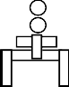
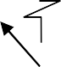
Crane wheel Crab

wheels

Gantry Girder
Crane girder

Stepped Column

Figure: Typical arrangement of gantry girder on a stepped column

- What is Gantry Girder and what are the forces that are acting on it?
Answer: A Gantry girder having no lateral support in its length, has to withstand vertical loads from the weight of crane, hook load and impact and horizontal loads from crane surge. [Meaning of Surge: To move quickly and forcefully in particular direction].

2Q. Where the gantry girders are used?
Answer: Gantry girders or crane girders carry hand operated or electric over head cranes in industrial buildings such as factories, workshops, steel works, etc., to lift heavy materials, equipment etc., to carry them from one location to the other, within the building.

3Q. What is drag force?
Answer: This is caused due to the starting and stopping of the crane bridge moving over the crane rails as the crane moves longitudinally, i.e., in the direction of gantry girders.
4Q. What is the permissible deflection where the electrically overhead cranes operated over 5000 kN.
Answer: The maximum vertical deflection for crane girder, under dead and imposed loads shall not exceed L/1000, where L is the span of the crane runway girder.
5Q. Mention some of the requirements of a good joint.
Answer: 1. The line of thrust should pass through the C.G. of the rivet group and the rivets should be symmetrically arranged about this line.
- For a member, the rivets should be so arranged that the area of the member joined is not reduced more than necessary.
- The number and diameter of rivets should be sufficient to develop the maximum stresses induced in all the members at the connection.
- Members should be straight and bolts used to draw them together before the rivets are driven.

- In what sense the design of plate girders by elastic method and limit state method is different ? [2 marks]
- What is tension field action in plate girders? [ 2 Marks]
- How does a plate girder derive post- buckling strength? [ 2 marks]
- Give the expression for the optimum depth of plate girder. [1 Mark]

- Design a gantry girder to be used in an industrial building carrying a manually operated overhead travelling crane, for the following data:
Crane capacity=200 kN
Self weight of the crane girder excluding trolley = 200 kN Self weight of the trolley, electric motor, hook, etc. = 40 kN
Approximate minimum approach of the crane hook to the gantry girder = 1.20 m

Wheel base = 3.5 m
c/c distance between gantry rails =16 m
c/c distance between columns (span of gantry girder)= 8 m Self weight of rail section = 300 N/m
Diameter of crane wheels = 150 mm
Steel is of grade Fe 410. Design also the field welded connection if required. The support bracket connection need not be designed. [5 marks]

Design of roof Trusses, types of roof trusses, loads on trusses, purlin design, truss design, design of joints and end bearings
- June 2014: Design a channel section purlin for a trussed roof from the following data. Span of roof = 12 m
Spacing of purlin along slope = 2 m Spacing of truss = 4 m
Slope of roof truss = 1 vertical, 2 horizontal Wind load on roof = 800 N/m²
Vertical loads from roof sheets = 150 N/m²

June 2013: Design I-section purlin with and without sag bars for a trussed roof from the following data, (expected in June 2015)-1
Span of roof = 10 m
Spacing of purlin along slope or truss = 25m Spacing of truss = 4 m
Slope of roof truss = 1 vertical, 2 horizontal Wind load on roof = 1100 N/m²
Vertical loads from roof sheets = 150 N/m².
May 2012: Compute the loads on a steel roof truss to suit the following data, (expected in June 2015)
Span of the truss = 12 meters Type of truss = Fan type
Roof cover = Galvanised corrugated G.C. sheeting Spacing of roof truss = 4.5 meters
Wind pressure = 1.2 kN/m²
May 2011(SET-1)- Design I-section purlin with and without sag bars for a trussed roof from the following data, (question repeated from June 2013)
Span of roof = 10 m
Spacing of purlin along slope or truss = 2.5m

Spacing of truss = 4 m
Slope of roof truss = 1 vertical, 2 horizontal Wind load on roof = 1100 N/m²
Vertical loads from roof sheets = 150 N/m².
May 2011(SET-2) Design a channel section purlin with and without sag bars for a trussed roof from the following data, (question repeated from june 2014) (expected in June 2015)
Span of roof = 12 m
Spacing of purlin along slope or truss = 2 m Spacing of truss = 4 m
Slope of roof truss = 1 vertical, 2 horizontal Wind load on roof = 1100 N/m²
Vertical loads from roof sheets = 150 N/m².

May 2011 (SET-3) )- Design I-section purlin with and without sag bars for a trussed roof from the following data, (question repeated from june 2013, May 2011 SET-1)
Span of roof = 15 m
Spacing of purlin along slope or truss = 3 m Spacing of truss = 4 m
Slope of roof truss = 1 vertical, 2 horizontal Wind load on roof = 1200 N/m²
Vertical loads from roof sheets = 160 N/m².

May 2011(SET-4) Design a channel section purlin with and without sag bars for a trussed roof from the following data, (question repeated from June 2014)
Span of roof = 12 m
Spacing of purlin along slope or truss = 2 m Spacing of truss = 4 m
Slope of roof truss = 1 vertical, 2 horizontal Wind load on roof = 1200 N/m²
Vertical loads from roof sheets = 160 N/m².

Expected question
June 2013: Design I-section purlin with and without sag bars for a trussed roof from the following data, (expected in June 2015)-1
Span of roof = 10 m
Spacing of purlin along slope or truss = 2.5m Spacing of truss = 4 m
Slope of roof truss = 1 vertical, 2 horizontal
Wind load on roof surface normal to roof = 1100 N/m² Vertical loads from roof sheets = 150 N/m².

Solution:
Given data,
Span of roof = 10 m
Spacing of purlin along slope or truss = 2.5m Spacing of truss = 4 m
Slope of roof truss = 1 vertical, 2 horizontal
Slope θ = ½ Tan θ = ½
θ = tan⁻¹(1)
2
θ = 26.565 degrees Sinθ = 0.447
Cosθ = 0.894
Tan θ =0.5

Wind load on roof surface normal to roof = 1100 N/m² Vertical load from roof sheets = 150 N/m²

Calculating the Dead Load (D.L.)
Load from roof sheeting = 150 x Spacing of purlin
= 150 x 2.5 = 375 N/m²
Assume self weight = 120 N/m² Total dead weight (WDL) = 495 N/m²
Calculation of Wind Load
Given, Wind Load on roof surface = 1100 N/m²
Total wind load = (Ww.L.) = 1100 x spacing of purlin = 1100 x 2.5 2750 N/m²
(i) Design of I-Section Purlin Without Sag Bars
It is assumed that the load combination of (Dead Load + Wind Load) creates greater effect on purlin than that of load combination of (Dead Load + Live Load)
Consider the load combination (Dead load + Wind load) for I-section purlin.

Dead load + Wind load
WD.Wx = Load normal to the slope

W_{w.L.} + W_{D.L.} Cosθ = 2750 + 495 cos(26.565)
= 3192.742N
W_{D.Wy} = Load parallel to the slope
= W_{D.L.} Sin(26.565) = 495 sin(26.565)
=221.37 N

M = (𝑊.𝑤𝑥 )2 𝐿2 = (3192.742)×42 = 5108.387 x 10³ Nmm
xx 10 10

(𝑊 )2𝐿2 (221.37)×42
Myy = 𝐷.𝑤𝑦 =
10 10

= 354.192 x 10³ Nmm

Assume 𝑍𝑥𝑥 = 6 and ζ_{bt} = 0.66 f_{y} = 0.66 x 250 = 165 N/mm²
𝑍𝑦𝑦

E = 2 x 10⁵ N/mm²

Finding the Required Sectional Modulus
𝑀 𝑍𝑥𝑥 ×𝑀
+

𝑍𝑥 𝑥𝑟𝑒𝑞
= 𝑥𝑥 𝑍 𝑦𝑦
𝜎𝑏𝑡
𝑦𝑦 = 5108 .387 ×103+[6×354.192 ×103] = 43.84 x 103 mm3
165

Select ISMB 100 @ 11.5 kg/m
Z_{xx} = 51.5 x 10³ mm³
Z_{yy} = 10.9 x 10³ mm³

Check for Permissible Stress

𝜎_{𝑏𝑡} =
𝑀𝑥𝑥
+
𝑍𝑥𝑥
𝑀𝑦𝑦
𝑍𝑦𝑦

= 5108.387 ×103 + 354 .192×103 = 131.687 N/mm² < 165 N/mm²

51.5×103
Hence safe.
10.9×103

(ii) Design of I-Section with Sag Bar
Dead load + Wind load
WD.Wx = Load normal to the slope
= Ww.L. + WD.L. Cosθ = 2750 + 495 cos(26.565)
= 3192.742N
WD.Wy = Load parallel to slope
= WD.L. Sin(26.565) = 495 sin(26.565)
=221.37 N

Bending Moment
M = (𝑊 .𝑤𝑥 )2 𝐿2 = (3192.742)×42 = 5108.387 x 10³ Nmm
xx 10 10

(𝑊 2 𝐿 2 4 2
M = .𝑤𝑦 ) (2) = (221.37)×(2)
= 88.548 x 10³ N-mm

yy 10 10

Finding the Required Sectional Modulus
𝑀𝑥𝑥 +𝑍𝑥𝑥 ×𝑀𝑦𝑦 3
𝑍 = 𝑍𝑦𝑦 = 5108 .387 ×10 +[6×88.548 ×103 ] = 34.180 x 103 mm3
𝑥𝑥𝑟𝑒𝑞 𝜎𝑏𝑡 165

Select ISJB 150 @ 7.1 kg/m from steel Tables
Zxx = 42.9 x 10³ mm³
Zyy = 3.7 x 10³ mm³

Check for Permissible Stress

𝜎_{𝑏𝑡} =
𝑀𝑥𝑥
+
𝑍𝑥𝑥

𝑀𝑦𝑦
𝑍𝑦𝑦

= 5108.387 ×103 + 88.548×103 = 143.009 N/mm² < 165 N/mm²

42.9×103
Hence safe.
3.7×103

Expected Question-2
Compute the loads on a steel roof truss to suit the following data, (expected in June 2015)
Span of the truss = 12 meters Type of truss = Fan type
Roof cover = Galvanised corrugated G.C. sheeting Spacing of roof truss = 4.5 meters
Wind pressure = 1.2 kN/m²

Solution:
Given that,
Span of the truss, l = 12 m, Spacing of roof truss, S = 4.5 m Wind pressure = 1.2 kN/m2
Pitch of roof truss, P = ¼ (assumed) Let, Slope of roof truss be „θ‟ Therefore tanθ = 2p
Tanθ = 2 x (¼)
Tanθ = ½
θ = tan⁻¹(1/2) θ = 26.565
Rise of roof truss, R = ¼ x l = ¼ x 12 = 3 m.

Length along the sloping roof, L = [(12)2
2
+ (32)]
1/2

L = 6.708 m
Length/panel = 6.708/4 = 1.677m
- Load at Each Panel

  - Dead Load
Assuming, weight of galvanized corrugated iron sheets, WGI = 0.133 kN/m²
Weight of Purlins, Wp = 0.150 kN/m²
Weight of bracing, Wb = 0.015 kN/m² Self weight of roof truss,
Ws = ^{𝟏} (𝒍+ 𝟓) = ^{𝟏} (𝟏𝟐 + 𝟓)= 0.09kN/m²
𝟏𝟎𝟎 𝟑 𝟏𝟎𝟎 𝟑

Total dead load, WD.L. = WGI +Wp + Wb + Ws
= 0.133 + 0.150 + 0.015 + 0.09 = 0.388 kN/m²
Length of panel in plan, Lp = 1.677 cosθ
Lp = 1.677 cos(26.565)
= 1.499 ≈ 1.5m
Load acting on each intermediate panel, W1 = 0.388 x 4.5 x 1.5 = 2619 kN
Load acting at end panel,
W2 = W1/2 = 2.619/2 = 1.310 KN

  - Live Load
    - Give briefly the design steps to be followed in the design of a roof truss [ 5 Marks] [ Page Number. 770, S.K. Duggal, 2nd edition]
    - Design a steel roof truss to suit the following data: Span of the truss = 10 m
Type of truss = Fan-type
Roof cover = Galvanised corrugated (GC) sheeting Materials : Rolled steel angles
Spacing of roof trusses = 4.5 m Wind pressure Pd = 1.0 kN/m²
Draw the elevation of the roof truss and the details of joints [ 5 Marks] [ Page Number 320; N Krishna Raju, Structural Design and drawing, 3rd edition]

