

LECTURE NOTES

ON

MANUFACTURING TECHNOLOGY
Mechanical Engineering

Prepared by
ER. BADRI NARAYAN PATRA
Lecturer
Department of Mechanical Engineering

DEPARTMENT OF MECHANICAL ENGINEERING

RKCAT,NILGIRI,BALASORE

CONTENTS

Sl.No | Chapter Name | Page No
1. | TOOL MATERIALS | 1-6
2. | CUTTING TOOL | 7-11
3. | LATHE MACHINE | 12-22
4. | SLOTTER | 23-26
5. | DRILLING AND BORING MACHINE | 27-32
6. | BROACHING, PLANNING MACHINE | 33-37
7. | PLANNER AND SHAPER MACHINE | 38-46
8. | GRINDING MACHINE | 47-55
9. | INTERNAL MACHINING OPERATIONS | 56-62
10. | SURFACE FINISH, LAPPING | 63-64

TOOL MATERIALS
- Cutting tool must possess a variety of different properties in order to cut many different metals under various conditions.
- To meet these demands tool have been produced from a variety of materials.

Characteristics of tool materials:
- Hot hardness.
- Wear resistance.
- Toughness
- Strength.
- Impact resistance.
- Heat conductivity.
- Ductility
- Brittleness
- Elasticity
- Plasticity
- Hardness

Cutting tool materials:
- Cutting tool materials implies the material from which various cutting tools are made.
- The best material to use for a certain job is the one that will produce the machined part at lower cost.

Desirable properties of cutting tool:
- Tool should be harder than the material being cut (Hot hardness).
- To resist disintegration of fine cutting edge and also to with stand the stresses developed during cutting in the weakest part of the tool, the tool should have sufficient strength.
- Sufficient toughness to resist fracture.
- Resistance to impact that is ability to absorb shock without permanent deformation.
- A low co-efficient of friction between the tool material chip materials.

- Ability to dissipate rapidly the heat developed at the tool tip while cutting the work piece.

Types of cutting tool materials:
- High carbon steel
- High carbon medium alloy steel
- High speed steel
- Cast nonferrous alloys or satellite.
- Carbide
- Ceramic
- Diamond

High carbon steel:
- It is the oldest known tool material. It is used as cutting tool materials before the development of high speed steel. Carbon steel with carbon content ranging from 0.8 to 1.2%.
- Carbon steel having good hardening ability and with proper heat treatment, attains as great hardness as any of the high speed steel alloys.
- These are not use for production work, because these can’t withstand high temperature.
- These are used for hand tools.
- These are less costly and easy to heat treat.
- The uses of carbon steel tools are limited to cutting of wood and other soft materials.

High carbon medium alloy steel:
- These are carbon contained less than high carbon steel.
- These have greater hot hardness, higher impact resistance and higher wear resistance.
- These properties are acquired by having small amount of tungsten, chromium and molybdenum.
- These can be successfully operated to a temperature of 350°C.

High speed steel:
- High speed steel is a high alloy steel and is marked by superior to high carbon steel in that it retains cutting ability at operating temperature to 594°C,exhibiting so called red hardness.
- This extended operating range compared to carbon steel permitted a nearly 100% increase in cutting speed for equal tool life and give rise to the name high speed steel.

- It contains the alloying element like tungsten, chromium, vanadium, cobalt, molybdenum.
- These alloying elements increase strength, toughness, wear resistance, cutting ability.
- These can be used safely 2 to 3 times higher cutting speeds.
- Although several formulations are in use for making cutting tools, atypical composition is that of 18-4-1 HSS type, which is considered to be one of the best all- purpose steel.
- High speed steel is used in the manufacturing of complicated shaped cutting tools, e.g. reamers, drills, taps, dies and various milling cutters etc.

Various compositions of HSS:

TYPE | TUNGSTEN(W) | CHROMIUM(Cr) | VANDIUM(V) | MOLYBDENUM(Mo) | COBALT(CO) | REMARKS
18-4-1  HSS | 18 | 4 | 1 | - | - | ALL PURPOSE HSS.
Mo-HSS | 6 | 4 | 2 | 6 | - | EXCELLENT TOUGHNESS AND CUTTING  ABILITY
SUPER HSS | 20 | 4 | 2 | - | 12 | FOR HEAVY  DUTY CUTTING OPERATION
Tungsten and chromium increases hardness. Molybdenum increases red hardness.
Vanadium increases wear resistance.
Cobalt extends red hardness but increases brittleness, cobalt retains hardness up to 650°C increases the cutting efficiency.

Cast nonferrous alloys:
- It is nonferrous alloy consisting mainly cobalt, tungsten, chromium and alloying elements are tantalum, molybdenum, boron.
- They possess high red hardness and can maintain good cutting edges on tools at temp. Up to 925°C.
- It possesses good resistance to shock loads.
- Cast nonferrous alloys contain
  - Carbon=1-4%
  - Tungsten=12-25%
  - Cobalt=40-50%
  - Chromium=15-35%
- It does not respond to usual heat treatment process.
- It can be used for machining materials like hard bronzes, cast and malleable iron.

- It can’t be machined by grinding only.

Cemented carbide:-
- Carbide cutting tools are made only by powder metallurgy technique.
- Cemented carbides are usually made by binding tungsten powder and carbon at high temp ^{r} in the ratio of 94%and 6%respectively. This compound is then combine with cobalt and the resulting mixture is compacted and sintered in a furnace at about 1400ºc thus tungsten carbon cobalt material can maintain high hardness value at temp. Up to 1200ºc and therefore be used as much higher cutting speed that HSS.
- Cemented carbides cannot be shaped after sintering.
- Tungsten carbides are tough, strong and wear resistance when machining steels. To overcome this limitation tantalum carbide or titanium carbide are added to basic consumption.
- Superior grades of cemented titanium carbide allow cutting speed approaching these of ceramics and they can be used in the semi-rough cutting of steel and certain cast iron.

Ceramics:-
- Ceramics are made from sintered Al20 and boron nitride powders. These powders are mixed together and sintered at about 1700⁰c.
- Ceramics are usually in the form of disposable tips. They can be operated at 2 to 3 times the cutting speed of carbide.
- These are capable of withstanding high temp.
- Ceramics are very hard and low thermal conductivity.
- Ceramics are extremely brittle & can only be used where shock and vibration do not occur. In order to take full advantages of ceramics tools special or more rigid machine tools are required.

Diamond:-
- Diamond is the hardest material known.
- Diamond used as single point tool for light cuts and high speed and must be rigidly supported because of their high hardness and brittleness.
- It is brittle occurs low resistance to shock and highly wear resistance.
- These are used in the form of bits, inserted or held in a suitable designed wheel or bar.
- Industrial diamond either nature or artificial are commonly used in the machining of hard rubber, plastic, glass, Bakelite, etc

CUTTING TOOL

Cutting Tool:-
- In machining a cutting tool or cutter is any tool which is used to remove the material from the W/P by means of shear difference.
- Cutting tool must be made of a material harder than the material which is to be cut and the tool must be to withstand the heat generated in the metal cutting process.
- The angle of cutting facer is also important, also the tool must have a specific geometry and clearance angles designed so that the cutting edge can contact the W/P surface.

Single point cutting tool
- This type of cutting tools has only one cutting edge. These used for wide application of lathe, shaper planner, slitter, boring M/C Multi point cutting tools
- This type cutting tools have more than cutting edge. These are employed for wide application in twist drills, Reamers, tapes, milling, cutters etc.
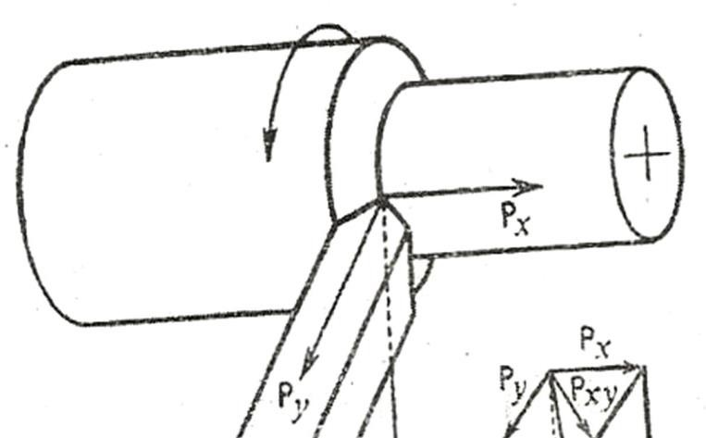
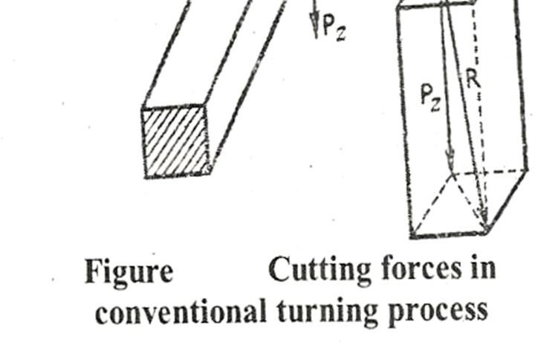

Cutting action of hand tools:

Chisel:
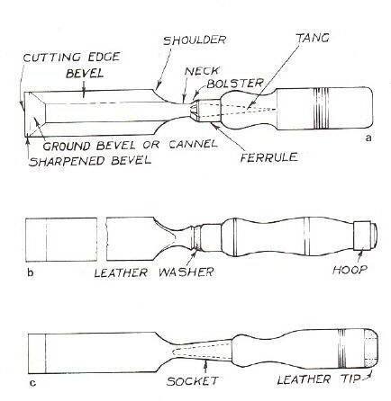
  - A chisel is a hand cutting tools which is shaped cutting edge of blade on its end, for carving, cutting a hard material such as wood, stone, metal by hand with the help of mechanical power.
  - In used the chisels are forced in to the material to linear relative motion.
  - The driving forced into the material may be manually applied by using a hammer. In industrial use, a hydraulic ram or falling weight drives the chisel into the material to be cut.
  - Chisel is employed to use in wood work, metal working etc. In wood & stone working used for carving, cutting, shaving, shaping, trimming.
  - In metal working process chisel use divided into two categories:

Die:
- Hot chisel
- Cold chisel

  - Die cutting is the possess of using die to shear weds of low strength material such as rudder, tidier, cloth, plastic, sheet metal etc.
  - Die cutting can be done on either flat bed or by rotary process. Rotary dry cutting is die cutting using a cylindrical die or rotary processes.

  - Dies are used to cut the external thread or the rod or pipe end. Dies are made of high carbon steel or HSS.
    - The process of cutting external thread by dies is called dieing. Sharing is also known as die cutting, is a prosses which cuts stock without formation of chips or the off during or melting.
    - The die cutting action can be controlled by electric, hydraulic, pressurized or manual surfaces.

Reamer:
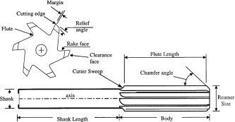
    - It is a multiple edge cutting tools. The process of enlarging the hole is called reaming.
    - There are many different types reamer and there may be designed for used as a hand tool or in a M/C tool such as milling M/C or drill press.
    - A typical reamer consists of a set of parallel straight or helical cutting edge along the length of a cylindrical body.
    - Each cutting edge is grounded at a slight angle and with slight undercut below the cutting edge.
    - This may be used to remove small amount of material.
    - Reamers are made of high Carbon or Plain Carbon Steel.
    - Reamers are of two types
      - Hard Reamers
      - Machine Reamers

Hacksaw blade:

    - Hacksaw bled is a fine toothed saw, originally principally for cutting metal. They can also cut various other materials such as plastic & wood.
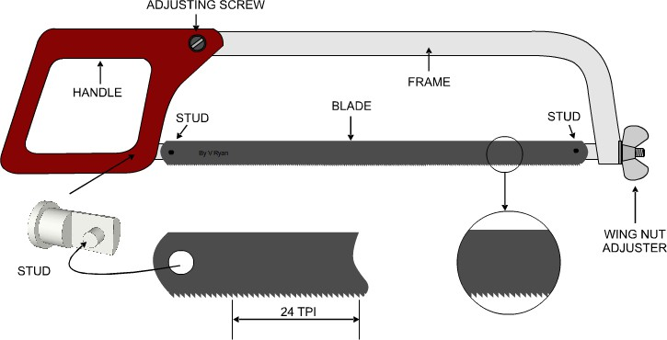

    - On hack-saw the blade can be mounted with the teeth facing toward or away from the handle. Resulting and cutting action on either pushes or pull stroke.
    - In normal use, cutting vertically downwards with work held in a bench, vice, the saw blade should be set to be face forward.

Machining Process Parameters:
Factors affecting tool life:
- The life of a tool is affected by many factors such as: cutting speed, feed, depth of cut, chip thickness tool geometry, material of cutting fluid and rigidity of the machine.

Cutting Speed:
- The cutting speed can be defined as the relative surface speed between the tool and the job or the amount of length that will pass the cutting edge of the tool per unit of time.
- It may be defined as the speed which the cutting edge passes over the material. It is expressed in meters per min (mpm).

Feed:

Depth of cut:

- It is defined as the relation by small movement per cycle of the cutting tool, relative to the work piece in a direction which is usually to the cutting speed direction.

- The depth of cut is the thickness of the layer of metal removed in one cut or pass, measured in one direction to the machined surface. It is the vertical distance the tool advance.

Cutting tool nomenclature:

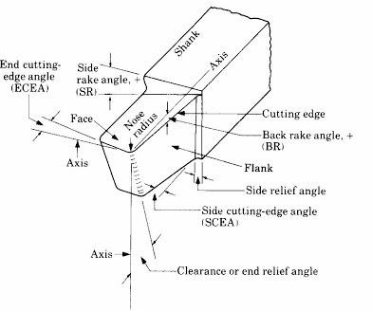

Shank: Flank:

Heel:

It is the main body of the tool.

The surface or surfaces below and adjacent to the cutting edge is called flank of the tool.

It is the intersection of the flank and the base of the tool.

Nose:
It is the point where the side cutting edge and end cutting edge intersection.

Cutting edge:
It is the edge on the face of the tool which removes the material from the work piece. The total cutting edge cutting edge (major), end cutting edge (minor) and the nose.

Face:

Base: Rake:

It is the underside of the shank.

It is the slope of the tap away from the cutting edge. Larger the rake angle, the cutting force and power reduce.

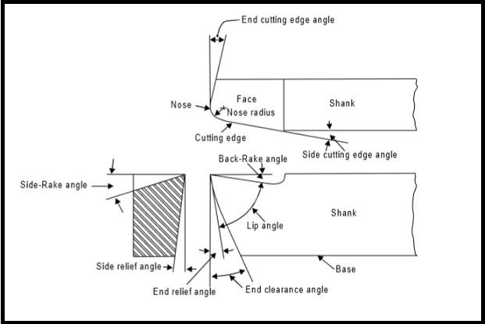

LATHE MACHINE
  - Lathe was the first machine tool which came into being as a useful machine for metal cutting. Thus it formed the basis of production of all the other machine tool which is the results of later development.
  - Lathe is known as the mother machine tool and can be defined as a machine tool in which the job to be machined is held and rotated in the lathe chuck, a single point cutting tool is advanced radically into the job/work piece at a specified depth and moved longitudinally along the axis of the work piece, removing metal in the form of chips.
  - An engine lathe is the most basic and simplest form of lathe which is used for producing cylindrical jobs.
  - Except turning operation engine lathe can be used to carry out other operations such as taper turning, thread cutting, boring, drilling, knurling, grooving, chamfering, grinding, parting off etc.

TYPES OF LATHE

  - Bench lathe
  - Speed lathe

  - Engine lathe
  - Tool room lathe
  - Capstan and turret lathe
  - Automatic lathe
  - Special purpose lathe.

SPECIFICATION OF LATHE MACHINE

Specification means the important parameters required to completely describing the size of lathe machine and maximum size of work piece lathe can handle.
The major parameters are to specify lathe machines are:

  - Distance between centers (live and dead centre): This would specify the maximum length of the work piece that can be turned on a lathe.
  - Swing over the bed: It specifies the largest diameter of work piece that can be rotated on the lathe machine without striking the guide ways.
  - Swing over the carriage: It specifies the largest diameter of work piece that can be turned on the lathe machine without striking the top of carriage.
  - Maximum diameter of work piece through spindle: The maximum diameter of hole through the hollow spindle is specified to mention the maximum diameter of work piece, lathe can handle, when the work piece is fed through the spindle hole.
  - Height of centers over bed.

The following specifications should also be provided to completely specify a lathe machine.
    - Length of bed
    - Width of bed
    - Face plate diameter
    - Size of tool post
    - No. of spindle speeds
    - Range of spindle speeds
    - Power rating of electric motor
    - Lead screw diameter and no. of threads per cm.

PARTS OF LATHE

Basic parts of lathe are
      - Bed
      - Headstock
      - Tailstock
      - Carriage – ( below parts consists by carriage)
        - Saddle
        - Cross slide
        - Compound rest
        - Tool post
        - Apron
        - Feed mechanism
        - Legs
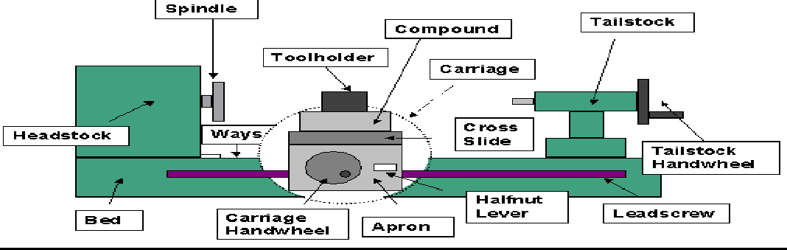

Bed:-

  - Bed is the base of lathe machine on which different parts of lathe like headstock, tailstock, and carriage assembly are mounted.
  - Bed must be rigid as it has to withstand various cutting force transmitted to it during the operation of lathe.
  - It is usually made of single piece casting of grey cast iron or semi steel (toughened cast iron), with the addition of steel scrap to the cast iron during machining – the material cast iron facilitating an easy sliding action.

Headstock:-

  - The headstock is a box like casting mounted permanently on the bed of the engine lathe at the left hand end of the machine.
  - The headstock supports the spindle and contains a gearbox by which the spindle and hence the work piece may rotated at various speeds.
  - The spindle is hollow to accept the bar stock and is built into the headstock with the spindle nose projecting from the housing of the headstock. The spindle nose is threaded so that a faceplate or a chuck can be turned on it to hold and rotate the work piece.

  - For machining different materials, with different cutting tools to obtain rough or finish, different work speeds are necessary. The different work speeds are provided generally by two different types of headstock:
- Belt driven headstock
- All-geared headstock
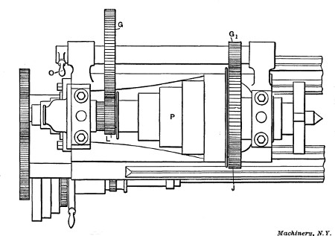

Belt driven headstock:
  - A Belt driven head stock consists of
- Step cone pulley
- Back gear arrangement
  - The cone pulleys (p) are mainly responsible for obtaining different spindle speeds by means of belt.
  - When spindle speeds slower than those obtainable by the direct belt drive are require, especially in case of thread cutting, the back gear should be used.
  - To operate the back gear, first the lock pin (A) should be removed this leaves the permanently joined pulleys and gear wheel E to revolve freely on lathe spindle. Gear wheel is permanently fixed to the spindle. Then the lever B should be turned to bring the back gears C and D those are connected as one unit and rotate freely, mesh with gears E and F.
  - The fig.-3 shows the back gear in the disengaged position, the larger gear and the cone pulley being locked together. This provides four higher speeds and the spindle rotates at the same speed as the pulley. The drive from the cone pulley goes straight to lathe spindle or chuck.

  - The fig.-4 shows the back gear in the engaged position, the large gear and the cone pulley rotate independent of each other that is they are not locked together.

All geared headstock:

  - Modern and generally larger heavy duty lathes are consists of all gear headstocks, enabling the spindle speeds to be readily changed by the operation of external handles or levers.
  - Not only does this enable rapid changes to be made but a larger and more evenly graduated range of spindle speeds is available.
  - The gear wheels are located on spines on the spindle and lay shafts and are brought into mesh by the appropriate levers. They are so arranged that it is impossible to engage more than is necessary for any one spindle speeds.
  - To shift gears while the machine is in running could cause serious damage to the speed. So speed changes on most all geared lathe may be made only while the machine is stopped.

Tailstock:
  - Tailstock is located at the right hand end of lathe bed. The tailstock also known as loose head can be securely clamped in any convenient position.
  - It can also be offset 25mm for cutting small angle plates.
  - For machining, long jobs are held between the headstock and the tailstock so that they do not bend while machined.
  - The tailstock barrel is given longitudinal movement within the tailstock body by means of a screw and hand wheel.
  - Tailstock used for providing a support to the end of the work piece, usually a shaft.
  - It also used for supporting the end of the long work piece in dead centre, when the work piece is held between live centre and dead centre.

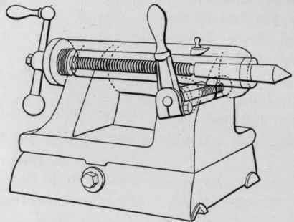

Carriage:
  - The lathe carriage serves the purpose of supporting, guiding and feeding the tool against the job during the operation on the lathe.
  - The carriage carries the cutting tool and controls its movements either parallel to the ways, called straight turning or at right angles to the ways called facing.
  - It can be moved left or right between the head stock and the tailstock by hand wheel.
  - The carriage consists of
- Saddle
- Cross slide
- Compound rest
- Tool post
- Apron

Saddle:
  - It is that part of the carriage which slides along the bed ways and supports the cross slide, compound rest and tool post.
  - The saddle is an H-shaped casting that is machined to fit the outer ways of the lathe bed. The saddle can be moved along the ways either manually or by power through the gear mechanism in the apron box.

Cross slide:
  - The cross slide is mounted on the carriage and has two purpose, it supports the compound rest and also allow the movement of cutting tool at right angle to the lathe centre line.
  - Both the cross slide and the compound slide are fitted with indexing dials.

  - The cross slide can be moved by hand wheel or by power feed.

Compound rest:
  - A compound rest is mounted on the cross-slide and it carries a graduated circular base, called swivel plate used for swivel the tool post to any angle in a horizontal plane.
  - A compound rest has two function:-
- It supports the tool post.
- It allows movement of the tool along a path not parallel to the lathe centre line. This permits the turning of conical or tapered surfaces.

Tool post:
  - It is an essential condition of turning that the cutting tool be rigidly and securely held and the device used for the purpose is known as tool post.
  - It is the important part of the carriage and is used for holding the tool or tool holder in position.
  - The tool post is mounted on the compound slide.
  - The tool post can be moved left or right with the help of compound slide and it can be clamped in place also. The tool post can be rotated at whatever angle is best for the job.

Apron:
  - The Apron is bolted to the front of the saddle. The apron houses the gears and controls for the carriage and the feed mechanism.
  - The control levers held in the apron are – levers which engage and reverse the feed lengthwise or crosswise and the lever which engages the threading gears. The start – stop clutch lever is usually close besides the apron.
  - Manual movement of the carriage along the bed is effected by turning a hand wheel on the front of the apron, which is geared to a pinion on the backside. This pinion engages a rack that is attached beneath the upper front edge of the bed in an inverted position.
  - It carries the clutch mechanism and the slip half nut. Out of these two, the clutch mechanisms used to transmit motion from the feed rod whereas the latter, in conjunction with the lead screw, moves the whole carriage in thread cutting.

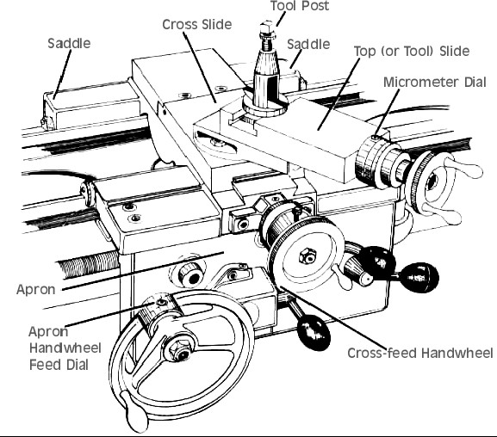

Feed Mechanism:

  - Feed is basically the distances the tool advances in to the work pieces through one revolution of head stock spindle. Feed may be longitudinal or cross feed.
  - The Feed is called longitudinal when the tool travels along the work piece parallel to the direction of lathe bed. Longitudinal Feed is used in cylindrical turning operation and is provided by movement of carriage.
  - In cross feed the tool travels perpendicular to the direction of lathe bed. Cross feed is used in facing operation and provided by movement of cross slide.
The lead screw and the Feed rod is important component of feed mechanism.

Lead screw:

  - It is used for thread cutting operation. Acme type of thread is generally used for manufacturing of lead screw.
  - When half nut lever engages with lead screw, the carriage moves automatically for thread cutting operation.
  - By the help of back gear arrangement, thread cutting operation is done.
  - The lead screw gets its power from the spindle gear through a gear train located at the left end of the lathe.

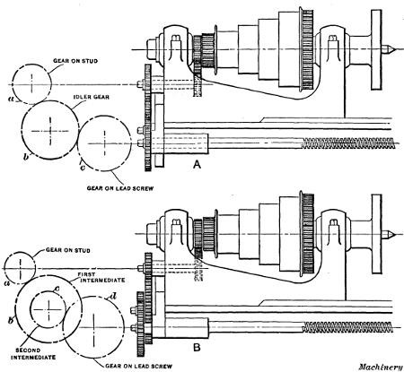

Feed rod

  - The feed rod transmits the motion required to move the saddle or carriage along the bed of lathe, is known as automatic feed when turning work piece.
  - Movement of cross slide may also be achieved through the feed shaft.
  - The fed rod gets its power from the spindle gear through a gear train located at the left end of the lathe.

Legs:

  - These are the supports which carry the entire weight of the machine. These are the casting part which integrated with lathe bed. Both the legs should be of robust construction.

FEED MECHANISM:
  - Feed is the distance the tool advances into the work piece through one revolution of head stock spindle a lathe tool has 3 types i.e. longitudinal, cross and angular.

Longitudinal feed:
  - When the tool moves parallel to the lathe axis, the movement is termed as longitudinal feed. It is used in cylindrical turning operations and is affected by movement of carriage.

Cross feed:

  - When the tool moves parallel to the lathe axis, the movement is termed as cross feed. It is used in facing operation & affected by movement of cross slide.

Angular feed:
  - When the tool moves at an angle to the lathe axis, it is termed as angular feed. It is used in taper turning and affected by movement of compound rest.
  - Angular feed is hand operated where cross feed & longitudinal feed can be both hand & power operated.

Lathe operation:
Lathe operations are performed by following methods. Operations which are performed in a lathe either by holding the work piece between centers or by a chuck:
  - Straight turning
  - Shoulder turning
  - Chamfering
  - Thread cutting
  - Facing
  - Knurling
  - Internal thread cutting
  - Taper turning
  - Polishing
  - Polishing
  - Grooving
  - Drilling
  - Reaming
  - Forming

Facing:
    - Facing is the operation of for generation flat surface perpendicular to the rotational axis of spindle. The tool is fed to the axis of rotation of the work piece.

Turning:
    - Turning in lathe is to remove excess material from the work piece to produce a cone-shaped or a cylindrical surface.

Straight turning:

    - The work is turned straight when it is made to rotate about the lathe axis, and the tool is fed parallel to the lathe axis. It produces a cylindrical surface by removing excess metal from the work piece.

Taper Turning:
    - A taper may be defined as a uniform increase or decrease in diameter of a piece of work mannered along its length.

Knurling:
    - Knurling is the process of embossing a diamond shaped pattern on the surface of a work piece. The purpose of knurling is to provide an effective gripping surface or a work piece to prevent it from slipping when operated by hand.

Drilling:
    - Drilling is the operation of production a cylindrical hole in a work piece by rotating cutting edge of a cutter known as drill.

Boring:
    - It is the operation of enlarging and truing a hole produced by drilling, punching, casting co-forging.

Safety measures during machining:
Some safety precautions should be needed while working on lathe.
    - Before operating the machine, one should fully understand its operations controls and how to stop it.
    - All gears and gear ends of the lathe should be properly guarded.
    - Safety goggles are preferred to avoid damage to eyes by flying chips.
    - Avoid wearing rings, bracelet or watch.
    - Machine should not be left running and operator should be alert during a job.
    - Before starting a lathe spindle by power, spindle should be rotated by one revolution by hand to make it sure that no fouling is there.
    - Safe distance from revolving chuck should be maintained.
    - Sliding parts of the lathe should be cleaned and lubricated periodically.
    - Chips should never be removed by hand. It can be removed by brush.
    - Before starting the machine, the work should be clamped properly.
    - Before moving the carriage, the carriage clamping screw should be unlocked.
    - On hearing unusual noise, machine should be stopped immediately and should not be operated till the fault is clear.

Capstan & Turret lathes:
A capstan or a turret lathe is a production lathe used to manufacture any number of identical pieces in the minimum time. The main feature is the six sided block mounted on one end of the bed replacing the normal tailstock six tools can be mounted on cross slide two tool posts are mounted, one in the font and the other in the rear. Each one can hold four tools .Thus the total carrying capacity is a maximum 14 tools.

Difference between capstan & turret lathe:

Capstan lathe | Turret lathe
- Its turret head is mounted on slide, which moves on the guide  ways produced on the saddle. | - Its turret to head is mounted  `directly on the saddle.
- For feeding the tool to the work,  the saddle is fixed at convenient distance from the work. | - For feeding the tool to the work, the entire saddle unit is moved.
- It is smaller in size compared to  turret lathe. | - It is large in size as compared to  capstan lathe.
- It is suitable for smaller size &  lighter jobs. It is not suitable for heavy cutting condition. | - It is suitable for long and heavy work and severe cutting condition.
- The turret head may hexagonal or  circular. | - Turret head is hexagonal.
- It is suitable to work for smaller  bar up to 60 mm dia. | - It is used to work for large size  bar up to 200mm dia.
- In capstan lathe, Collect is used to  grip the Job. | - In turret lathe, power Jaw chuck  is used to grip the Job.
- The tool traverse is faster and  offer less fatigue to the hands of the operator. | - The tool feeding is relatively  slower and provides more fatigue to operator hands.

Difference between CAPSTAN &TURRET and an ENGINE LATHE

CAPSTAN &TURRET | ENGINE LATHE
- In turret lathe, the tail stock is | - It can accommodate one tool

replaced by a turret which is a  hexagonal block which contains 6 tools on each face. | Of limited size.
- The feed movement of each tool set on square or hexagonal turret is  regularity by stops & feed strips. | - The feed movement is given by hand.
- It require 15 hp power to drive  the spindle. | - It requires 3hp to drive the  Spindle.
- Turret lathes are suitable for producing large no. of identical  pieces. | - The threads are cut by lead Screws.
- The labor cost is less. | - Labor cost is more.
- Combination cuts can be taken by mounted two or more tools on the  same face of the turret. | - Combination cuts cannot be done.

SLOTTING MACHINE
  - A slotting machine or slotted is used for cutting different types of slots, keyways (both internal and External).
  - A slotted machine is also used for machining irregular shapes, circular surfaces, concave and convex surfaces and other pre marked profiles both internally and externally.

Basic parts of slotted:

The main parts of slotter are

- Base:-
  - It is a heavy cast iron construction and is also known as bed.
  - It acts as support for the column, the driving mechanism ram, table and all other fittings.
  - At its top it carries horizontal ways, along which the table can be traversed.

- Column:-

  - It is another heavy cast iron body which acts as a housing for the complete driving mechanism.
  - At its front it carries vertical ways, along which the ram moves up and down.

- Table:-

  - Usually a circular table is provided on slotting machine.
  - On the top of the table T-slots are provided to clamp the work or facilitate the use of fixture etc.
  - Some heavy duty slotter either a rectangular or circular table can be mounted.

- Ram:-

  - It moves in a vertical direction between the vertical guides ways provided in front of the column.
  - At its bottom, it carries the tool post in which the tool is held.
  - The cutting action takes place during the downward movement of the ram.

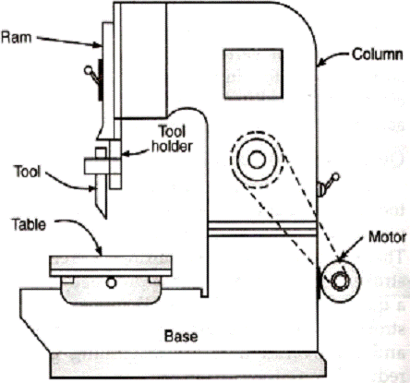

Types of slotting machine:

- Puncher slotter

- Production slotter
- Tool room slotter

Working mechanism:

- In case of slotter machine the machining is done by the downward movement of the cutting tool along with the ram while the job is fixed on the slotter table.
Generally three types of driving mechanism are used in slotting machine for driving ram:

  - Slotted disc mechanism
  - Slotted link mechanism
  - Hydraulic mechanism

Slotted disc mechanism:-

- It is the simplest of all the methods commonly used for driving the ram of slotting machine.
- The driving mechanism consists of a pinion, a gear, a slotted disc and crank.
- The disc carries a T-slot through which the crank pin passes.
- The main driving pulley, generally situated at the rear side of the machine, is driven by the motor through belts. It in turn drives the pinion which drives the gear.
- The gear being on the same shaft as the disc drives the latter.
- The crank and connecting rod mechanism convert the circular motion of the disc into reciprocating motion of the ram.
- The length of stroke of ram can vary by shifting the crank pin towards or away from the centre of the disc.
- The starting and finishing position of the ram stroke can be adjusted by means of the hand lever for stroke adjustment.
- The fly wheel provided at the rear side acts as shock absorber at the end of the stroke.

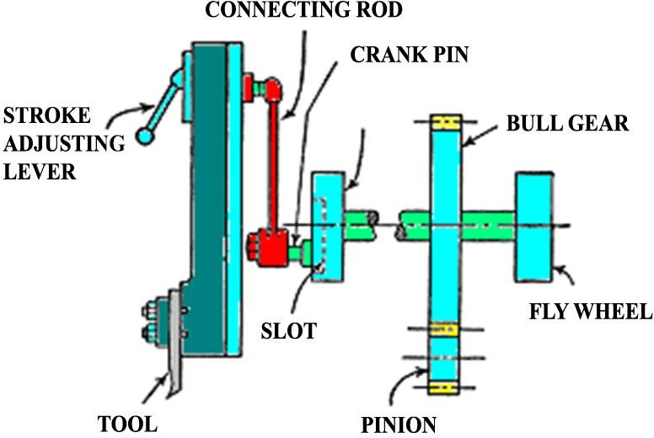

Slotted link gear mechanism:

- This mechanism consists of two driving wheels and both the wheels carry an eccentric each.
- Three bolts are provided by means of which the eccentrics can be made loose or fast with driving wheels as desired.
- A slotted link of bell crank type is provided between the driving wheels.
- The crank pin forms the fulcrum.
- A die usually of bronze works in the slot of the link, it is provided with a hardened steel bush, through which passes one of the three bolts.
- This bolt connects the two eccentrics and carries the above die, so that when the eccentric revolve, along with the driving wheels, the die slides in the slot.
- Other end of the link is attached to the ram by means of a connecting rod.
- A counter weight arm is linked to the top of the ram at one end and other end of arm carries the counter weight.
- In this mechanism when the eccentrics revolve, the die slides inside the slot of the link and in doing so, it makes the link swing about the fulcrum, provided by the crank pin.
- With the result the connecting rod and hence the ram is alternately pushed up and pulled down. This enables the reciprocating motion of the ram and tool.

Hydraulic mechanism:

- The hydraulic drive used in slotter as the same as in case of shapers. Only the axis of the cylinder in this case will be in a vertical direction.

- Both const. pressure and const. volume type drives are also used in this machine. (Follow the hydraulic mechanism of shaper)

Slotter tools:

- Slotter tools are either forged from solid bar of tool steel or are used in the form of bits held in suitable tool holder.
- The cutting action of a slotter is vertical; when a cut is being taken on the slotter there are fewer tendencies to shift the work from work table.
- The action of cutting presses the work on the table and tends to push the tool away from the job. For this reason it is desirable to make the tools or tool holder of stiff section.
- Since the cutting takes place parallel to the shank length. No side rake is provided on slotter tools.
- The back rake is provided at the end.
- Shape of the cutting end of the tool is made according to the shape of the slot to be produced.
DRILLING MACHINING
- Drilling is an operation through which holes are provided in a solid metal by mean of a reversing tool called drill bit and the device which is employed for this purpose is known as drilling machine.

Classification of Drilling machine:-

- Drilling machine is manufacture in various size and verities to suit the different type of work.
They can be broadly classified as:-

  - Portable drilling machine.
  - Bench drilling machine.
  - Up-right drilling machine (single spindle).
  - Up-right drilling machine (turret type).
  - Radial drilling machine.
  - Gang drilling machine.

  - Multiple spindle drilling.
  - Horizontal drilling machine.
  - Automatic drilling machine.

Bench or Sensitive drilling machine:-

Construction:-
- This type of drilling machine is used for very light work. Its construction is very simple and so is the operation.
- It consists of a cast iron base having a fixed column over it.
- The vertical column carries a swiveling table, the height of which can be adjusted vertically along the former. Also it can be swing to any desired position.
- At the top of the column the drive is provided which consist of an endless belt running over two pulleys.
- One of the pulleys mounted the motor shaft and other the machine shaft.
- Vertical moment of spindle is given by the feed handle to a rack and pinion arrangement.
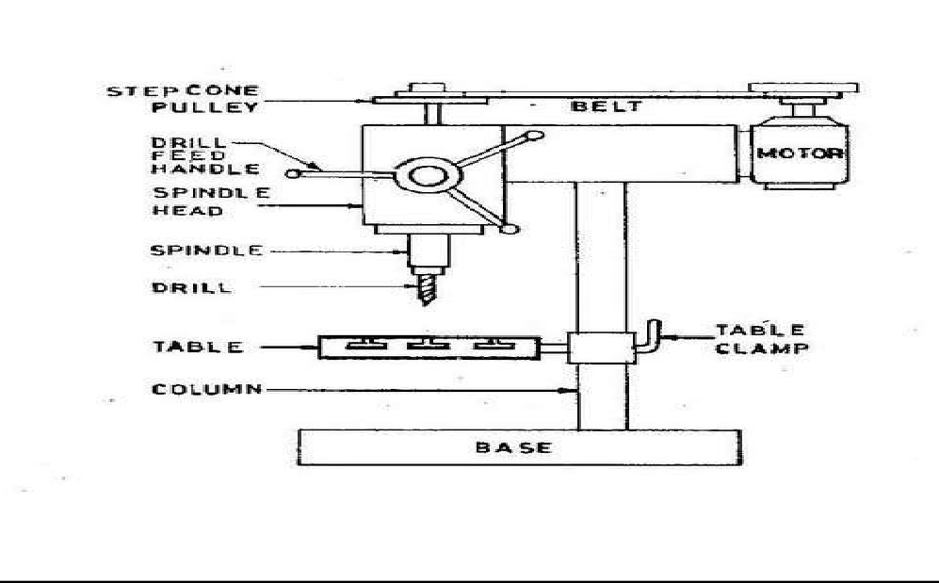
Parts of the Bench drilling machining:

  - Belt housing.
  - Adjustable Table.
  - Electronic motor.
  - Drill Bit.

  - Column.
  - Chuck.
  - Locking handle.
  - Operating Handel.
  - Base
  - Cover over cone pulley.

Working:-

- As the motor is switched on, the motor shaft starts revolving and hence the v-pulley mounted over it.
- This through the v-belt transmits motion and power to the other v-pulley mounted over the drill spindle.
- Thus the spindle starts rotating and therefore the drill.
- When the drill is required to be feed into the work, it is pressed against the work by means of the feed handle or operating handle.
- As the handle rotates which is directly mounted on the pinion shaft the pinion rotates
.It moves the rack longitudinally and hence the spindle and the drill.
- Different spindle speed can be obtained by shifting the v-belt to different parts of driving & driven pulleys, while the motor continuous to rotates on the same speed.
- On these machine the drills rotates at very high speed. So that the required cutting speed can be obtained on the periphery of small drill used on this machine.
- There is no arrangement for automatic feed on the machine.

Radial Drilling Machine:-
- This machine is used for drilling holes in such work which is difficult to be handling frequently.
- The radial drilling machine is heavy duty machine and is used primarily to drill the parts which are too large or heavy to move under a stationary drill spindle like bench drilling machine.
- A radial drilling machine can drill up to 75mm diameter from the solid.

Working:
- The machine consists of a base, on which a cylindrical, vertical column is mounted over it. The column carries a radial arm.

- A separate motor is provided for elevating the lowering the arm in the column and the clamping leavers are for locking the arm at desired height.
- The arm can be swing round the column to any desired angle.
- The drilling head is mounted on the arm along which it can slide horizontally.
- A good radial drilling machine is interring lock with the elevating control. So, that the upward or downward motion will not start until and unless these reverse are released.
- A hole depth strip is incorporated in many radial drills to stops the machine automatically, as soon as the required depth of hole is obtained.
- In this machine the spindle the heads moves on cross rail (R) by means of hand wheel and is provided with locking arrangement to lock the head at any position on the arm.
- Vertical adjustment of the arm is made with the help of elevating motor. Thus the head can be raised, lowered and swing round to any position relative to base, power is transmitted from the motor to the spindle to v-belt drive.
- Based on the type and no of movement as the radial drilling machine can be broadly grouped as :-
  - Plain radial drilling machine will drill only in vertical plane.
  - On semi universal radial drilling machine the head may only swiveled on the arm to drill holes at various angles in a vertical plane.
  - Universal machine has an additional swiveling arrangement in either the head or the arm can drill holes at any angles.

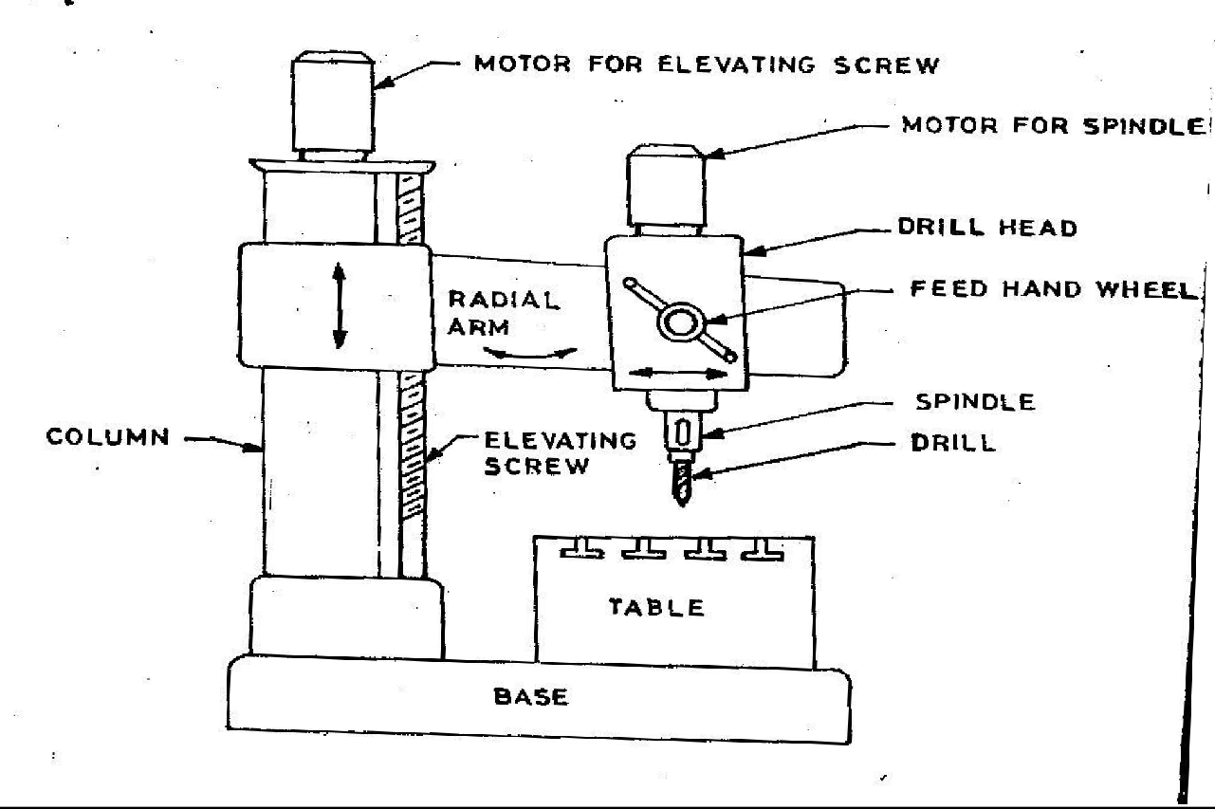

UP-RIGHT DRILLING MACHINE:-
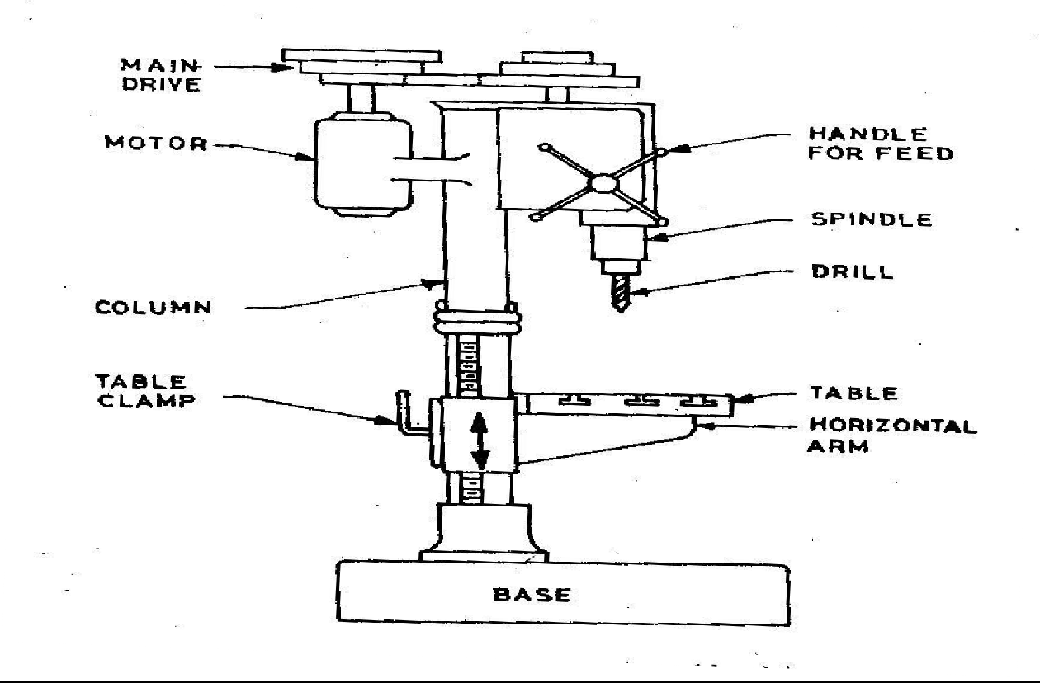

- Pillar drilling machine is also known as upright drilling machine. It is used for heavier work and has back gear arrangement similar to a lathe.
- It’s specially differs from a sensitive drill in weight, rigidity application of power, feed& the Wider range of spindle speed.
- The parts of pillar drilling machines are :-
- Base.
- Pillar.
- Main Drive.
- Drill Spindle.
- Feed Handle.
- Work Table.
- The vertical column can be either round or box type. Box type column is usually provided when the machine is constructed for relatively heaver work whereas round column are provided for lighter work.
- These machines are manufactured in various sizes having different drill capability up to a maximum hub 75mm. The most commonly used size is 38 mm steel.
- Cylindrical vertical pillars facilitate the swinging of table to any position and in combination with the rotary movement of the table. It enables any part of the surface to come under the tool without disturbing the work.
Working:-
- The Pillar drilling machine consists of a round column that raises from the base an arm around the table assembly and a drill head assembly.
- The arm and the table have 3 adjustments for locating work piece under the spindle.
- The arm and the table may be moved up and down on the column by the help of cross rail for accommodating work piece of different height.
- The table and the arm may be moved in an arc up to 180⁰around the column and may be clamped any position.
- The table may be rotates 360⁰ , about its own center , independent of the position of arm for locating work piece under the spindle this permits the setting of work below the spindle .
- Heavy and odd size work may be supported directly on the base of the machine and drill after the arm is swung out of the way.

BORING

Boring is the process of using single point tool to enlarge and locate a previously made hole.

Basic Principle:-
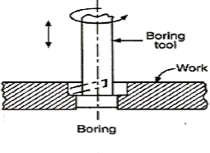

- The operation of boring differs from drilling in that it implies the enlargement of an already existing hole.
- This hole can be due to previous drilling produce in casting or forging parts.
- The tool rotates within a stationary work piece and as fed axially in order to cut metal for enlarging the already existing hole on the work piece.
- When small holes are to be bored particularly in small job which can be conveniently held in chicks or face plate, can easily be done on centre lathe or capstan and turret medium size lathe.
- There are 3 types of boring machine
  - Horizontal boring machine
  - Vertical boring machine
  - Jig boring machine
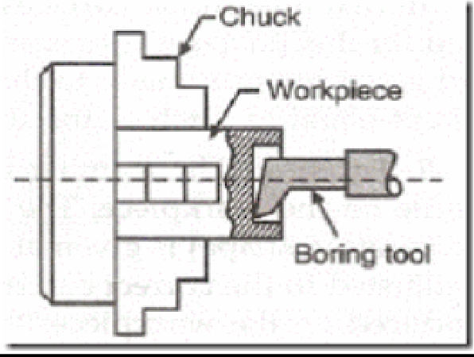

DIFFERENCE BETWEEN DRILLING AND BORING:

Drilling | Boring
- Drilling is used for creating a hole of required size in Work piece. | - Boring is used for enlarging the existing the hole which is made by  Drilling.
- Drilling is a rough machining work. | - Boring is a finishing operation.
- A multi-point cutting tool required is  called drill bit or twist drill. | - A single point cutting tool required is  called boring tool.
- Ex:-Pillar drilling machine  - Bench drilling machine  - Radial drilling machine. | - Ex:- Horizontal boring machine  - Vertical boring machine  - Jig boring machine
BROACHING MACHINING

- It is a machining operation in which a tool having a series of cutting teeth called broach is either pull or pushed by the broaching machine passed the surface of work piece. In doing so, each tooth of tool takes a small cut through the metal surface.
- Most of the cutting is done by the first and intermediate teeth whereas the last few teeth finish the surface to the required size.
- The surface to be cut may be external or internal when the operation is performed on internal surface it is called internal or whole broaching and in case of external surface it is called external or surface broaching.
- According to the method of operation it is divided in to 2 types , they are :-
  - Pull type.
  - Push type.
- The operation of broaching involves the use of multi cutter called broach.
- The teeth of the broaching is so designed that the height of the cutting edge of the following cutting tool is slightly more, equal to speed per tooth, then that of the preceding tooth.
- Thus then when the broach is feed in a straight line, either over an external surface or through an internal surface. The metal is cat in several successive layers by the successive teeth of the broach.
- The thickness of each layer is same & is known as feed per tooth. The sum of the thickness of all layers taken together is called depth of cut of broaching tool.

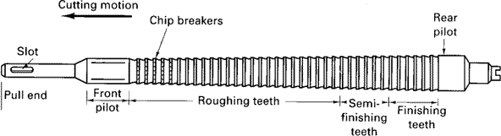

PULL TYPE BROACHING:-
- Figure shows a pull type broach being feed into a hollow work piece, on a vertical cool down type machine to machine internal surface of the work piece.
- In such machine the broaching tool is pulled through across the work piece which is stationary, the broach may be pulled up or pulled down across the work piece.
- A vertical pull down machine consist of work piece a broach elevator above the table and a puller machine below the table.
- When the elevator raises the broach above the table the work can be placed in to position. The elevator then lowers the pilot end of the broach through the whole by the work piece, where it is engaged by the puller.
- The elevator raises the upper end of the broach and the broach is pulled through the work piece there by giving to the hole in the work piece of required shape and size. Then the work piece is removed from the table. The broach is raised upward to see enlarged by the elevator mechanism.
- In vertical pull up machine the pulling ram is above the work table and the broach handling machine is below it. While the broach is lowered, the work is placed over the pilot.
- The handling mechanism raises the broach until it engages the puller head. Comes to rest against the underside of the table where it is held until the broach has been pulled through.

PUSH TYPE BROACHING:-
- In push type broaching machine the broaching tool is pushed through or across the work piece stationary.

- Fig shows push type broach being feed to stationary work on a horizontal broaching machine, to machine an external surface on the work piece.
- Like pull broaching machine the work piece is loaded on the work table or fixture.
- Then start the front end pilot through the work or pushed the work if it is surface broach. Then the broach is pushed through the work piece.
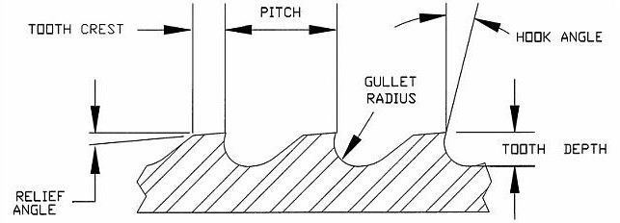

Advantages of Broaching:-

  - Rate of production is very high.
  - Job is completed in one stroke of the broach ( Rough machining & finishing operation )
  - Both internal and external surface can be machine.
  - Finishes about 0.8 microns can be obtained.
  - Broaching operation, it requires little skill the part of the operator.
  - Less time consumption.

Application of Broaching:-
  - A wide vertical of shapes, regular or irregular can be produce by both internal and external broaching process.
  - Broaching can be used for many jobs that are done on drilling, boring, shaping, planning.
  - Broaching is used to produce a wide verity of components in rifle and gun manufacturing parts for aircraft engines.
  - Broaching is widely used in the manufacture of :- I.Turbine Blades.
II.Rotors. III.Special Gear.

PLANNER MACHINE

    - The planner like a shaper is a machine tool to produce plane and flat surfaces by a single point cutting tool.
    - The planer is a machine tool designed to produce plane and flat surface on a work piece which is too large or too heavy. The work piece is securely fixed on a table called platen, and it reciprocates horizontally against a single edged cutting tool.
    - The surface machined may be horizontal, vertical or at an angle.

OPERATIONS OF PLANER MACHINE:
The planer is used for:
      - Planning flat horizontal, vertical and curved surfaces.
      - Planning at an angle and machining dovetails.
      - Planning slots and grooves.
The planer are available in different types for doing different types and sizes of job; the most common being the standard and double housing planer.
SIZE & SPECIFICATION

- Horizontal distance between the two vertical housings.
- Vertical distance between the table top and cross rail.
- Maximum length of the table travel or length of the stroke.
- Length of bed.
- Length of table.
- H.P of motor.
- Method of driving table:-geared or hydraulic.

PARTS OF A PLANER

The main parts of a planer is

- Bed
- Table or Platen
- Housings or Columns
- Cross rail

- Tool heads
- Controls
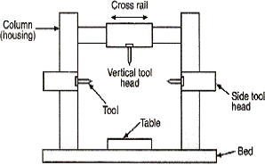

Bed:
    - The bed is a long heavy base and table made of cast iron.
    - Its top surface is flat and machined accurately. The flat top surface has slots in which the work piece can be securely clamped. The work piece needs rigid fixing so that it does not shift out of its position.
    - The standard clamping devices used on planer machine are: Heavy duty vice, T- holders and clamps, angle plate, planer jack, step blocks and stop.
    - The table movement may be actuated by a variable speed drive through a rack and pinion arrangement, or a hydraulic system.

Housing or Column:-

    - These vertical members are situated on both side in case of a double housing planner and on one side only in case of an open side planer.
    - Inside them, they carry the different mechanism for transmissions of power to the upper parts of the machine, from the main drive viz. cross rail elevating screws, vertical feed shaft and cross feed bar etc.
    - At their front, they are very accurately machined to from vertical ways along which the cross rail slides up and down, where side tool-heads are used, they also slide vertically along the same guide ways.

CROSSRAIL:-
    - It is a horizontal member of heavy structure which connects the two vertical housings of the machine. It provides additional rigidity to the machine.
    - By means of the elevating screws it can be moved up and down along the ways provided on the housings.
    - Clamps are provided to lock the cross rail in any desired position along the column.
    - Accurately finished ways are provided at the front of the cross rail for the two vertical tool head.
    - Inside the rail the feed rods are provided for vertical feed and cross feed to the tools.

Controls:-
    - Various controls for starting, operating and stopping the various mechanism, automatic cutting off speed and feed regulation and similar other functions are usually provided within a quick approach of the operator of the machine.
TOOL HEAD:
    - The tool head of the planer is similar to that of a shaper in construction and operation. CLAMPING OF JOB:
    - There are three important points to be hosted while clamping the job on the planer table.
    - The work should be connected rigidly to the table so that it may not be shifted out of its position while cutting progresses.
    - Proper clamping should be done all round the job.
    - The job should be so held that the surface planed should remain in proper position with other surface.
    - The job may be located on the planning machine table by the following methods.
    - By standard clamping devices.
    - By special fixtures.
    - The standard clamping devices are t-bolts, stops, planer jacks, heavy duty vises, angle plates & planner centers etc.
PLANER TOOLS:
    - The cutting tools which are uses in planer are single point cutting tool which are used in lathe and shaper.
    - Planer tools may be solid forget type or bit type.
    - The bit may be brazed, welded or mechanically held on a MS bar.

    - As a planer tool has to take up heavy cuts, the tools are made heavier and larger in cross section.

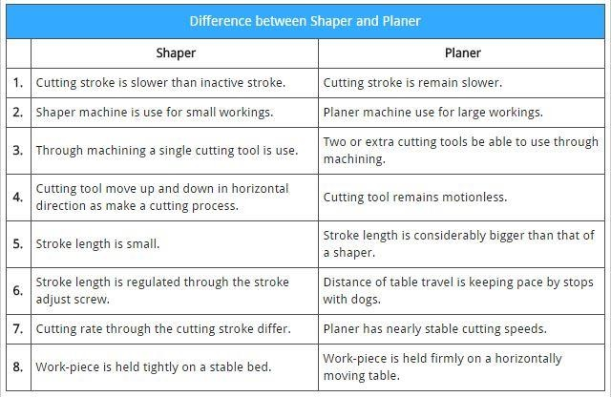
SHAPER MACHINE

- A shaping machine is a versatile machine used to generate flat surface by means of single point cutting tool held in a properly designed tool box mounted on a reciprocating ram moves the cutting tool forward and backward in straight line.
- Shaper machine intended for producing flat surface, these surfaces may be horizontal, vertical or inclined.

Working Principle:-

  - In case of shaper the job is rigidly held in a suitable vice or clamp directly on the machine table. The tool is held on the tool post mounted on the ram of the machine.

  - The ram reciprocates to and fro and, in doing so makes the tool to cut the material in the forward stroke.
  - No cutting of materials takes place during the return stoke of the ram. Hence it is turned as ideal stroke.
  - The job is given an indexed feel (equal amount after each cut) in a direction normal to the line of action of the cutting tool.

Classification of Shaper:-

  - According to the length of shaper, type of driving mechanism, direction of travel of ram, the type of work, the type of design of table, shapers are classified many ways.
  - The main classifications are :-
    - Standard shaper.
    - Horizontal shaper.
    - Vertical shaper.
    - Draw cut shaper.
    - Gear shaper.
    - Crank shaper.
    - Counter shaper.
    - Hydraulic shaper.
    - Travelling head shaper.
    - Universal shaper.

Principal Part of Shaper:-

- Base 5. Ram

- Column. 6. Tool Head.

- Cross rail. 7. Vice

- Table. 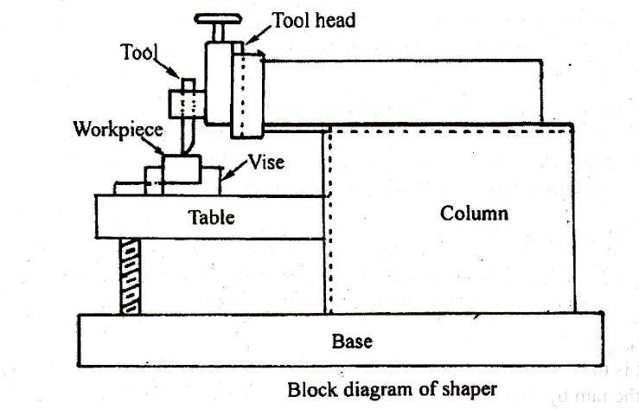

Base:-

  - It is a heavy & robust cast iron body which acts as a support for all the other parts of the machine which are mounted over it.
  - It withstands all the machine pressure or vibration of the machine.

Column:-

  - It is a box type cast iron body mounted on the base and acts as housing for operating mechanism of the machine and the electrical motor.
  - It also acts as a supports for other parts of machine such as cross rail, ram, etc.
  - On its top it carries machined ways in which the ram reciprocates & vertical guide ways at its front.
Cross rail:-

  - It is a very heavy cast iron constriction attached to the column at its front on the vertical guide ways.
  - It carries two mechanism one for elevating of the table or second is for transverse of table.

Table:-

- It is made up of cast iron and having box type construction. It holds and supports the work during the operation and slides along the cross rail to provide feed to the work.

  - T-slots are provided on the top and side to holding the work to cut.

Ram:-

  - It is also an iron casting semicircular and provided with ribbed construction inside for rigidity and strength. It carries the tool head and travels in dove tail guide ways to provide a straight line motion to the tool.
  - It also carries the mechanism for adjustment of the ram for inside of it.

Tool Head:-

    - It is a device in which the tool is held.
    - It can slide up & down and it can be swung to ma desired angle to shake for a desired operation.
Vice:-

    - It is a job holding device and is mounted upon the table.
    - It holds & supports the work during the machining.

Working of shaper:
🞂​ Shaper machine works on the quick return mechanism. It is used to shape the metal or make flat surfaces, making grooves and slots.
🞂​ It cuts the metal in one stroke in back motion or in froth motion and the remaining one is useless. The working of shaper machine can be described as follow.
🞂​ First the job is fixed to the machine table. The single point cutting tool is mounted on the tool post situated on the ram.
🞂​ Now the motor start by manually which create reciprocating motion of ram by quick return mechanism.
🞂​ When the ram is in reciprocating motion, the tool rubs the work piece, which removes unwanted material from it. It cuts the metal in forward stroke.
🞂​ While return strokes the clapper provide the clearance between tool and work piece, which make sure no cutting in return stroke. If the tool cuts material in both in forward and return stroke it give poor surface finish and also cause for tool wear.

Size and Specification of shaper:-

According m/s copper engineering pvt.ltd INDIA the complete specification of shaper is:-

  - Length of the stroke.
  - Maximum horizontal travel of table.
  - Maximum vertical travel of table.
  - Maximum distance from table to ram
  - Maximum vertical travel of tools slide.
  - Length and width of table tough.
  - Length and depth of table side.
- Power of motor.
- Number of ram cycle per minute.
- Range of ram cycle per minute.
- Maximum vice opening.
- Toolbox travels size of tool.
- Approximate net weight.
- Floor space.

Quick Return Mechanism:-

- In case of shaper machine the forward stroke is the cutting stroke and return strokes as the ideal stroke.
- No metal cutting is done during ideal stroke.
- The time spent in this stroke is obviously wastage, however fast this ideal stroke is made. It will definitely take some time and it is not possible, therefore to reduce it to ‘zero’ value.
- The objective is to use some such mechanism that will reduce its ideal time to minimum. Such mechanism is known as quick return mechanism.
- The three common mechanism used in this purpose are :-
  - Crank and slotted link mechanism.
  - Hydraulic quick return mechanism.
  - With worth quick return mechanism

Hydraulic Quick Return Mechanism:-

Parts of hydraulic shaper

- Hydraulic gear pump.6) Ram.
- Relief Valve. 7) Piston.

- Throttle Valve. 8) Cylinder.
- Control Valve. 9) Reservoir.
- Tool Head.
- The hydraulic control system used as a quick return mechanism for the longitudinal movement of shaper. Shaper ram basically operated into 2 types:-
  - Constant volume hydraulic mechanism.
  - Constant pressure Hydraulic mechanism.
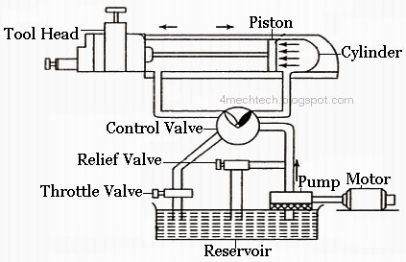

Construction:-
- The shaper ram consist of a piston cylinder arrangement by which it moves to and fro motion longitudinally and a control valve.
- The oil stored in the reservoir is drawn through an oil filter by the double gear hydraulic pump which is driven by an electric motor .the reservoir is kept open to atmospheric pressure.
- Pump delivers a constant quantity of oil to control valve at a moderate pressure.
- From the control valve the oil can be delivering to either side of the piston in the feed control cylinder situated under the ram.
- Position of the control liver of the control valve determines as to which side of the piston the oil will be delivered.

Working:-
- The control lever is in position p1 and the oil under pressure is being deliver to the left hand side of the cylinder through the pipe opening at a .

- With the result the piston being fired from left to right in forward stroke of the ram.
- Oil on the right hand side of the piston, as the piston moves, is forced through the pipe connection at b to the control valve and then to the reservoir through the pipe connection ‘c’
- A rotary type of ported valve is in corporate in the control valve and the same is attached to the control lever. It carries the oil return ports. Through which the returning oil from the cylinder pipe to pipe ‘c’ and then back to reservoir.
- At the end of the stroke the stop attached to the ram body throws the control lever from piston p1 to p2 to rivers to control valve connection.
- The oil now flows in a reverse direction i.e. through the control value to the right hand side of the cylinder to enter into the latter into `B’.
- The return force of the ported value are opened towards the other side to allow the oil from left hand side of the piston to pipe `c’ and then to the reservoir.
- Thus makes the piston to move from right to left and ram to make its return stroke.
- At the end of the return stroke another stop is actuates the control lever from `b’ to
`p1’ and again starts the forward stroke.

Crank and Slotted Link Mechanism:- Construction:-
- The crank and slotted link driving mechanism consist of a slotted link called rocker arm, pivoted at its bottom end which forms the fulcrum.
- At its upper end it carries another short link which is attached to the block `B’ block
`B’ can be clamped at the desired position by mean of hand lever `H’ .
- The rocker arm provided with a slide block in which revolves the crank pin `P’ the slide block can freely slide in the slot, provided in the rocker arm.
- At the back of the rocker arm a large cast steel gear called bull gear as provided, which is mounted on a pin attached to the frame of the machine.
- A slotted disk carrying a `T’ slot is secured to the bull gear at its front. The crank pin
`P’ is fitted In this slot and can be moved to any desired position along the same by means of bevel gear `B1’,`B2’ and the adjusting screw `S’ .
- The bull gear pinion mounted on the power shaft drives the bull gear which, while rotating on account of the eccentricity between its center and that of the crankpin marks the rocker arm swing about the fulcrum. Thus in turns moves the ram to and fro.

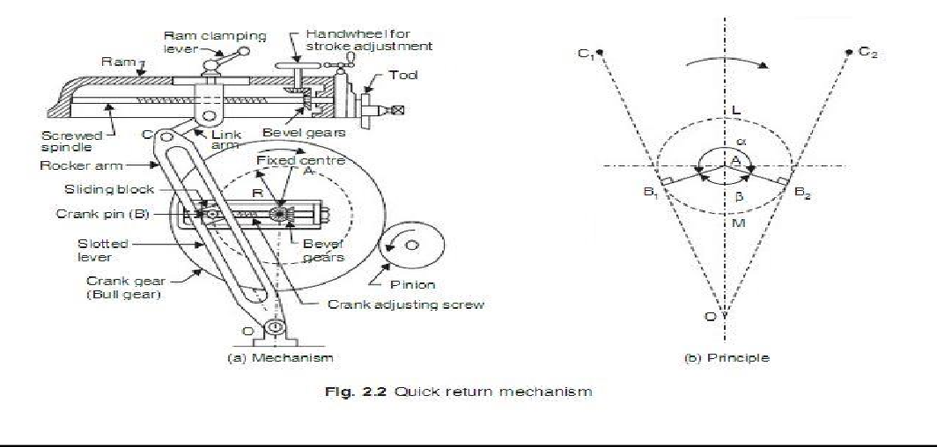

Working Principle:-
- The motion or power is transmitted to the bull gear through a pinion which receives is motion from an individual motor or overhead line shaft through speed control mechanism. Speed can be changed by shifting gears.
- A radial slide is bolted to the centre of the bull gear, carries a sliding block into which the crank pin is fitted. Rotation of the bull gear causes the crank pin to rotate at a uniform speed.
- Sliding block which is invented on the crank pin is fitted within the slotted link. The slotted link is pivoted at its bottom end attached to the frame of the column. The upper end is forked and connected to the ram block by a pin.
- As bull gear rotates causes the crank pin to rotate, the sliding block fastened to the crank pin will rotate on the crank pin circle, and at same time will move up and down in the slot giving a rocking movement which is communicated to the ram. The rotary motion of the bull gear converted to reciprocating movement of the ram.

Tool Head of Shaper:-
- Tool head is mounted at the front end of the ram and consist of a vertical slide which can be move up and down by rotates at its position inside a nut provided at the back of the slide. Thus casing the slide to move.
- At the back of the slide a graduated plate is provided called swivel plate. Which is bolted to the front of ram?

- The tool head is inclined with the vertical slide for machining inclined surface and the inclination can be red directly from the graduation on swivel plate.
- In front of the slide the apron is provided which carry the clapper box at its bottom. The apron is secured to the side by means of the bolt (B) & the bolt (b) passes through a slot.
- Bolt (B) facilitated swiveling the apron also to either slide, for this reason the bolt (B) is UN secured & clamp again after swiveling the apron.
- The clapper box to carries to parallel, vertical position at its front through which passes the pin (p).

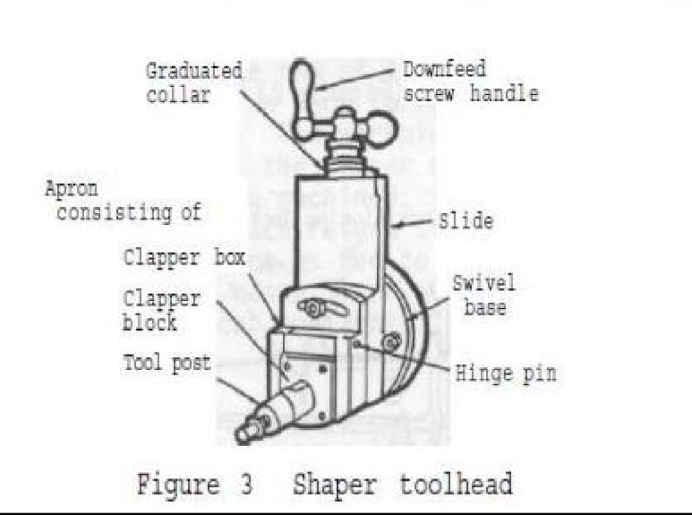
- The clapper box carrying the tool holder is hanging about this pin such that in the forward stroke of the ram is gets a rigid support at its back by being a butted against the vertical surface of the clapper box & it’s return stroke it swing out ward to prevent scratching of the wall by the tool .
- The tool is held vertically in the tool holder & clamped in position by means of tightening screw.

Automatic Table Feed Mechanism:-

- The automatic cross feed mechanism of the table is very simple & done by rotating a wheel mounted on the cross feed screw.
- It consists of a slotted disk which carries a T- slot and an adjustable pin is fitted in this slot.

- The adjustable pin is an attached to a connecting rod one side & other end of the connecting rod is attached to the liver end of the rocker arm of pawl mechanism.
- The rocker arm swinging about the screw ‘c’ & at its upper end carries a spring loaded pawl.
- Adjustable pin is set eccentric with the slotted disk center.
- The slotted disk at its back carries a spear gear, which is driven by the bull gear as the disk rotates through this gear the adjustable pin being eccentric with the disk center, causes the connecting rod to reciprocate.
- This in term makes the rocker arm to swing about the screw ‘c’. To move the pawl even one or more teeth and thus transmit an intermittent motion to the cross feed screw which moves the table.

GRINDING MACHINE

- Grinding is a process of removing material by the abrasive action of a revolving wheel on the surface of a work piece, in order to bring it to the required shape and size.
- The wheel used for performing the grinding operation is known as grinding wheel.
- The grinding wheel consists of sharp crystals called abrasives, held together by a binding material or bond.

GRINDING WHEELS:
Grinding wheels are produced by mixing the appropriate grain size of the abrasive with the required bond and pressed into shape. The characteristics of the grinding wheel depend upon a no. of variable they are:
- Abrasive types
- Grain size or Grit
- Bond
- Grade
- Structure

Abrasive types:
These are the extremely hard materials consisting of very small particles called grain which carry a no. of sharp cutting edge.
  - These hard materials with high toughness and also have the ability to machining Smaller pieces when the force increases.
  - The abrasives are of two types
    - Natural (ii) Artificial

- Natural Abrasives:
  - They are obtained directly from mine
  - The common natural abrasives are sand stone, emery, corundum, quartz and diamond.
  - Except Diamond all the natural abrasives are now considered absolute.

- Artificial Abrasives:
  - They are manufactured under controlled condition in closed electric furnaces in order to avoid the introduction of impurities & to achieve necessary mechanical properties. The artificial abrasives are.
  - Aluminum oxide (Al2O3) = this abrasives carries very hard & tough grains having sharp cutting edge. It is obtained by fusing the impure aluminum oxide, called Bauxite mixed with ground coke & iron chips in an electric arc furnace.
  - Silicon carbide (sic) = It is made from silicon dioxide, coke, sawdust and salt, mixed together and heated in an electric furnace at a temperature of 26000C.
  - CBN- Cubic Boron Nitride is the hard abrasives which are produced in the4 laboratory using high temperature & high pressure process.
  - CBN is less reactive with materials like hardened steels, nickel base & cobalt based super alloys. This is very expensive.
  - Diamond: Diamond is the hardest known material that can be used as a cutting tool material. It has a very high chemical resistance capacity along with a low co-efficient of thermal expansion.

Grain or Grit:
- The term grain or grit denotes the approximate size of the abrasive particles & gives an idea of the coarseness or fineness of the grinding wheel.
- The choice of grain size or grit depends upon many factors
  - Quality of finish required.

  - Amount of stock material removed.
  - Physical properties of the material to be ground.
- The coarser grit will remove the stock at a faster rate & finer finish will always require a fine grit.
- Coarse grit wheels are more suitable for grinding soft & ductile materials whereas hard & brittle materials are best ground with fire grit wheels.

SELECTION OF GRINDING WHEELS:
- Selection of grinding wheel is a vital necessity to perm various different functions.
  - Quick material removes.
- High class surface finish.
- Maintain close dimensional tolerances.
- It is necessary; therefore that proper grain size, bond, grade, strength, shape and size of the wheel should be selected to meet the specific requirements of a job.

The factors upon which the selection will depend are as follows:-
- Properties of the material to be machined i.e. its hardness, toughness, strength etc.
- Quality of surface finish.
- Grinding allowance provided on the work piece.
- Dimensional accuracy required.
- Method of grinding wet or dry.
- Rigidity, size and type of machine
- Relative sizes of wheel and job.
- Type of grinding to be done.
- Speed & feed of the wheel.

Methods of grinding:
According to type surface to be grounded main kinds of grinding methods are as follow:
- External cylindrical grinding: produces a straight or tapered surface on a w/p when it is rotated about its own axis between centers as it passes lengthwise across the face of a revolving grinding wheel.
- Internal cylindrical grinding: it produces internal cylindrical holes & tapers. The work is chucked & rotated on its axis, while the grinding wheel rotates ages the work.

Surface grinding:

It produces flat surfaces & the work may be grounded either by periphery or by end face of the grinding wheel.

Face grinding:
It is a method of grinding vertical flat surface & the wheel spindle may be vertical or horizontal.

From grinding:
It is done by specially shaped grinding wheels to grind formed surfaces as gear teeth, threads, shaft, dovetails etc.

Set wheel grinding:
It is a method of grinding short w/p without changing the grinding wheel.

Centre less grinding:
It is a method of grinding external & internal cylindrical surfaces in which the work is supported among a regulating wheel, a grinding wheel & a work rest blade.

Off-hand grinding:
It is rough grinding method in which work is held in hand and pressed against the rotating grinding wheel. For example grinding a chisel on pedestal grinder
Grinding operations are generally classified based on the type of surface produced. The grinding operation can be classified as:
- Cylindrical grinding for generating cylindrical surfaces.
- Surface grinding for generating flat surfaces.
- Centre less grinding for generating axis-symmetric surface.

Cylindrical grinding:
- Cylindrical grinding machine is used generally for producing external cylindrical surfaces. The machine is very similar to a centre lathe.
- In cylindrical grinding the work piece in rigidly held between two centres, in a chuck or in a suitable fixture. (One of these centres is in the head stock and the other in the fail stock).
- The work piece is rotated about its axis and feeding fast revolving grinding wheel. If the work surface to be ground in longer than the face width of the grinding wheel the work is traversed past the wheel or the wheel past the work.
- Traversing of wheel or work is done either by hydraulic or mechanical power or by hand.

- Feed is given to the work or the wheel at the end of each traversing movement. While mounting the work between centers, the headstock centre is not disturbed. It is the tailstock centre which is moved in or out, manually or hydraulically to insert & hold the work.

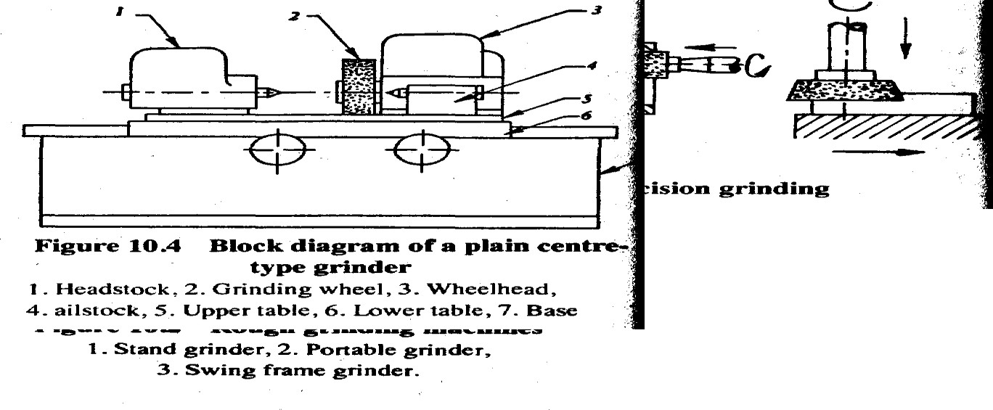

SURFACE GRINDER:-

- A surface grinder produces and finishes flat surfaces by employing a revolving abrasive wheel.
- A surface grinder does operation smaller to those done on a shaper, planner or milling machine, but is capable of producing surface more accurately both as to size and surface quality.
- A surface grinder is basically a move able table with a horizontal spindle (or vertical spindle) grinding wheel mounted above it, these machine are made fully hand operated, partly automatic and fully automatic.
- The grinding wheel is mounted on column which always it to be raised and lowered at least 300 mm and more on the larger machine.
- The table can move longitudinally or cross wise.
- Work holding is usually by means by magnetic chuck or table.

Surface grinders fall into two generally classification

Rotary type
  - Horizontal spindle using the periphery of the grinding wheel.
  - Vertical spindle using rim of the wheel.

Planner type
  - Horizontal spindle using the rim of the wheel.
  - Vertical spindle using the rim of the wheel.
  - Horizontal spindle using the periphery the wheel.

Rotary type surface grinders
  - Such machine have circular work table which revolve under the rotating grinding wheel.
  - The horizontal rotary grinder also known as ring grinder consist of horizontal wheel spindle having a reciprocating motion similar to that of the shaper ram, and a revolving magnetic chuck table supported by columns at the front of the machine.
  - The work table can be raised or lowered and has provisions for tilting the table for can cave or convex grinding.
  - The machine is equipped with a coolant supply tank and pump for wet grinding.
  - This machine is used for the production of flat, concave or convex surface which make it readily adaptable for either tool room or multiple production purpose.
  - The vertical spindle rotary grinder has a cylindrical wheel mounted on a vertical spindle and supported on a vertical column. This vertical column provides a means rising a lowering the wheel.
  - The work table consists of revolving magnetic chuck supported on ways or slides, which provided a means of moving the work to and from the wheel.
  - The machine is used a cup, cylindrical and segmented grinding wheel and is widely used for high production applications, for finishing application the wheel axis should be exactly perpendicular to the surface to be ground and for roughing purpose the axis is kept slightly tilled.
This machine does not give as good a surface finish as the horizontal rotary grinder.

Planner type surface grinders
  - Planner type surface grinder or reciprocating table type surface grinder make use of a reciprocating motion to move the work table back an fourth under the grinding wheel. The grinding wheel may have horizontal spindle or vertical spindle.

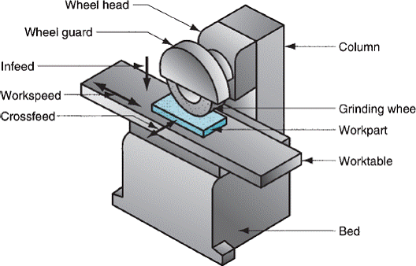
  - Horizontal spindle planner type surface grinder has a horizontal spindle carrying the grinding wheel rectangular work table. The table is provided with a longitudinally feed movement. The cross-feed is provided either on the table or on the wheel head. The table top has T-slots for mounting magnetic chuck, vice, fixtures, etc.
  - Vertical spindle planner type grinders use cup, cylinder or segmented wheels for faster stock removal and where accuracies are not stringent.
Such machines are usually of higher capacity and are used as production machine.

This machine performs an operation similar to face milling. The worktable reciprocated and the tool fed intermittently downward; these motion are known as travels and in feed respectively.

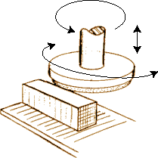
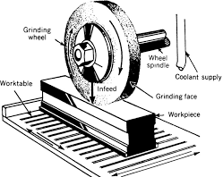

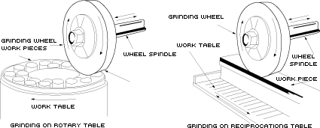

CENTRE LESS GRINDING:
- Centre less grinding makes it possible to grind the cylindrical work pieces without actually fixing the work piece using centres or a chuck. As a result no work rotation in separately provided
- It carries a heavy base and two wheel heads, one carrying the grinding wheel (larger one) and the other regulating wheel (smaller one)
- This process consist of two wheels, one larger grinding wheel & another smaller regulating wheel and the work is held on a work rest blade.
- The regulating wheel is mounted at an angle to the plane of the grinding wheel. The centre of the work piece is slightly above the centre of the grinding wheel.
- The work piece is supported by the rest blade and held against the regulating wheel by the grinding force.
- As a result the work rotates at the same surface speed as that of the regulating wheel.
- The axial feed of the work piece is controlled by the angle of tilt of the regulating wheel. Typical work speeds are about 10-50 m/min.
- The regulating wheel essentially carries rubber bore and helps in rotation of work piece due to friction.
- There are three types of centre-less grinding operations. They are through feed, in feed and end feed centre less grinding.

Through feed:
- In this method, the work piece is supported & revolved in between two wheels one grinding wheel and another is regulating wheel.
- Simultaneously the work is given an axial movement also by the regulating wheel.

- For this, the axis of the regulating wheel is inclined at 2 to 10 degrees with the vertical. The amount of stock to be removed determines as to how many time a work piece has to pass between the wheels.

In feed grinding:
- This method is similar to the plunge cut grinding method used on cylindrical grinders. Both regulating and grinding wheels are more in width than the work length to be ground.
  - Axis of the regulating wheel is inclining a little, about half degree from the horizontal.
  - This method is used for grinding shouldered or formed components.

End feed grinding:
- In this method both the wheels i.e. the grinding wheel and the regulating wheel are dressed to contain the required shape or form.
- The work piece is fed longitudinally from the side of the wheels. As it advances between the revolving wheels, its surface is ground till its farther end touches the end stop.
- This method can be used for grinding of both spherical and tapered surfaces, but it suits best to the grinding of short tapered surfaces.

Advantages:
- There is no need for having and maintaining centre & centre holes.
- Work pieces can be loaded & unloaded from the machine rapidly. Grinding is almost continuous for through feed grinding.
- Backing up the work piece by the regulating wheel and work rest blade practically eliminates and deflection of the work piece. This permits maximum material removal rates.

Disadvantages:
- The set-up time for a centre less grinding operation is usually large.
- This process is useful only for large volume production.
- This process is not suitable for large work piece.

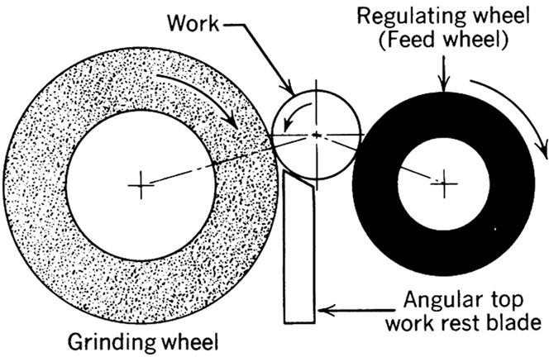

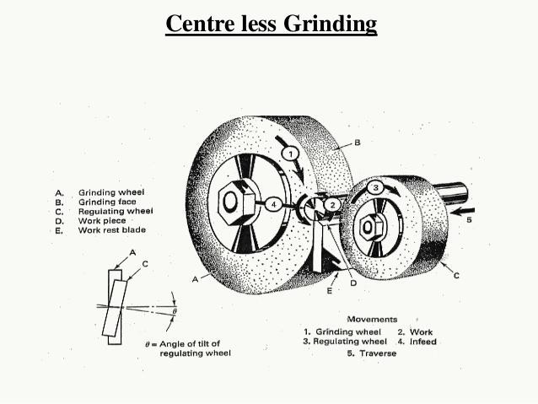

MILLING MACHINE

- Milling in the name given to the machining process in which the removal of metal takes place due to the cutting action of a revolving cutter when the work in fed past it.
- A milling m/c is a type of metal cutting device which remove metal with a fast rotating multi-touch cutter.

- Generally smaller jobs are employed for machining in milling m/c. If larger jobs are handled, then the m/c will perhaps be slower. Because of using multi tooth cutters & various forms of cutters, a milling m/c can be economically employed for generating verities of surfaces quite speedily.

Working principle:
- As shown in figure the work in rigidly clamped on the table of the machine and revolving multi teeth cutter mounted either on a spindle or an arbor. The cutter revolves at a high speed and the work fed slowly past the cutter. The work can be fed in a vertical longitudinal or cross direct Types of milling machines.
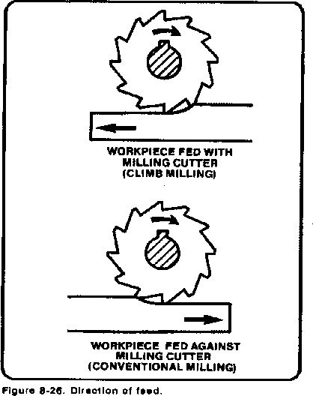

Types of milling machines:
Milling machines are classified as follows:
- Column & knee type milling machine.
- Fixed bed type or manufacturing type milling machine.
- Planer type milling machine.
- Production milling machine.
- Special purpose milling machine.

Column & knee type milling machines are further divided into following types.
–Hand milling machine
–Plain or Horizontal milling machine
–Vertical milling machine.
–Universal milling machine.
–Universal milling machine

Fixed bed type milling machines are divided into following types.

–Plain type (having single horizontal spindle)
–Duplex head (having double horizontal spindle)
–Triplex head (having two horizontal & one vertical spindle)
Planer type milling machines are used for heavy work up to a maximum of four tool heads can be mounted over it which can be adjusted vertically & transverse directions.
Production milling machines are further divided into following types.
–Rotary table or continuous type
–Drum type
–Tracer controlled

Special purpose milling machines are also divided into following types.
–Thread milling machine
–Profile milling machine.
–Gear milling or gear hobbling machine
–Cam milling machine
- Planetary type milling machine
- Double end milling machine
- Skin milling machine
Column and knee type milling machine: This milling machine has two main structural elements.
- A column shaped main frame.
- A knee shaped projection.
- Column contains the spindle and its driving mechanism
- Knee moves vertically on the column.

Horizontal milling Machine:
- In this type milling machine the vertical column serves as housing for electrical, the main drive, spindle bearings etc.
- The knee acts as a support for the saddle work table and other accessories like indexing head etc.
- Over aim provides support for the yoke which, turn supports the free end of the arbor. The arbor carrying the cutter rotates about an axis.
- The table can be given straight motions in three dire longitudinal, cross & vertical but can’t be swiveled.

- For giving vertical movement to the table the knee itself, together with the whole unit above it, slides up & down along the ways provided in front of the column.
- For giving cross movement to the table, the saddle in moved towards or away from the column along with the whole unit above it.

Vertical Milling Machine:
- It derives its name from the vertical position of the spindle. This machine is available in both types the fixed bed type as well as column & knee type.
- It carries a vertical column on a heavy base. The over arm in this machine is made integral with the column and carries a housing at its front. This housing, called head can be of fixed type or swiveling type.
- In fixed type, the spindle always remains vertical & can be adjusted up & down. In swiveling type of head can be swiveled to any desired angle to machine the inclined surface.
- The knee carries an enclosed screw jack, by means of which it is moved up & down along the parallel vertical guide ways provided on the front side of the column.
- The saddle is mounted on the knee & can be moved along the horizontal guide ways provided on the knee, towards or away from the column. This enables the table to move in cross direction.
- The table is mounted on guide ways, provided on the saddle, which are in a direction normal to the direction of the guide ways on the knee.
- By means of a lead screw, provided under the table, the table can be moved in longitudinal direction.
- Thus the work gets up and down movement by the knee, cross movement by the saddle & longitudinal movement by the table.

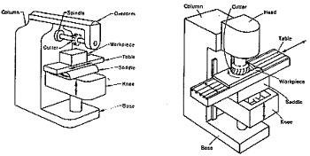

Universal milling machine:
  - It is the most versatile of all the milling machines its table can be swiveled on the saddle in a horizontal plane.
  - For this, circular guide ways are provided on the saddle along which it can be swiveled.
  - A graduated circular base is in corporate under the table, with a datum mark on the saddle, to read directly the angle through which the table has been swiveled.
  - This special feature enables the work to be set at an angle with the cutter for milling helical & spiral flutes & grooves.
  - It’s over arm can be pushed back or remove & a vertical milling head can be fitted in place of the arbor to use it as a vertical milling machine.
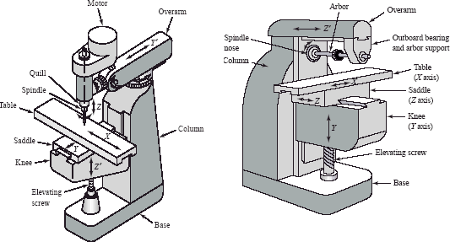

Main parts of Universal milling machine:

    - Base: It is a heavy casting provided at the bottom if the machine, it is accurately machined on both the top & bottom surface.
    - It is actually acts as load bearing member for all other parts of the machine. Column of the machine is secured to it.
    - Also it carries the screw jack which supports & moves the knee. In addition to this, it also serves as a reservoir for the coolant.
    - Column: It is a very prominent part of milling machine; all the various parts & controls are fitted to this.
    - On the front face of the column are made the vertical parallel ways in which the knee moves up & down. At its rear side it carries the in closed motor drive.
    - Top of the column carries dovetail horizontal ways for the over arm.
    - Knee: It is a rigid casting, which is capable of sliding up & down along the vertical ways on the front face of the column. This enables the adjustment of the table height or in other words the distance between the cutter and job mounted on the table are adjusted.
    - The adjustment is provided by operating the elevating jack, provided below the knee, by means of hand wheel or power feed.
    - Machined horizontal ways are provided on the top surface of the knee for the cross traverses of the saddle, hence the table.
    - Saddle: It is the intermediate part between the knee & the table & acts as a support for the table.
    - It can be adjusted cross wise, along the ways provided on the top of the knee, to prove cross feed to the table.
    - At its top, it carries horizontal ways, along which moves the table during the longitudinal traverse.
    - Table: It acts as a support for the work. The work is mounted on it either directly or held in the dividing head.
    - It is made of cast iron, with its top surface accurately machined.
    - Its top carries longitudinal T-slots to accommodate the clamping bolts for fixing the work or securing the fixtures.
    - Longitudinal feed is provided to it by means of a hand wheel fitted on side of the feed screw.

    - In universal milling machine the table is made to have a graduated circular base resting on the saddle. Such table can be swiveled in a horizontal plane.
    - Over arm: It is the heavy support provided on the top of the milling machine. It can slide horizontally, along the ways provided on the top of the column and adjusted to a desired position in order to provide support to the projecting arbor by accommodating its free end in the yoke. Braces can be employed to correct the over arm & the knee.

Milling Machine attachments:
The milling machine attachments are used for the following purposes:
- To hold the cutters: including arbors, collects, adaptors etc.
- To hold the work piece on the table in a desired position and impart additional movements, if regd. such as vices, circular table, indexing head tail stock etc.
- To act as auxiliary spindles; in conjunction with the main spindle, in order to avoid the necessity various special types of machines, such as vertical milling attachment, spiral milling attachment, etc.
- Arbors, Adaptors & collects: They all are used for holding the milling cutters during the operation. This is a common method of mounting the cutters, although they are made on the M/c spindle directly also.
- Vices: Vices are the common devices used for holding the work on milling machine, such as plain vice, swivel vice, vertical vice, precision angelica.

INDEXING METHODS:
By indexing we mean, division of the job periphery into a desired number of equal divisions. It is accomplish by a controlled movement of the crank such that the job rotates through a definite angle after each cut is over.

Methods of Indexing:
(1) Direct Indexing (2) Simple Indexing
(3) Compound Indexing (4) Differential Indexing
- Angular Indexing

DIRECT INDEXING:

  - The index plate is directly mounted on the spindle and rotated by hand. It can be used only where the number of divisions to be obtained is such that the number of slots on the periphery of the index plate is a multiple of the former.
Required ratio = N/n
Where ‘N’ = No. of slots on the periphery of the Index plate ‘N’ = No. of divisions required to be obtained.
for example, if the circumference of a job has to be divided into 6 equal divisions and the index plate has 24 slots, then the required ratio will be = 24/6 = 4 i.e. the index plate will be required to move through 4 slots after each cut is over.

SIMPLE INDEXING:
  - This method of Index is used when the direct method of Indexing cannot be employed for obtaining the required number of divisions on the work for this a universal dividing head is used. This method of indexing involves the use of the crank, worm wheel and index plate.
Let us consider that the work has to be divided into 23 equal divisions, then the corresponding crank movement will be given by crank movement = 40 /N
Where ‘N’ = Number of divisions required
= 40/23 = 1 ¹⁷ turns
23
Now, in the obtained result the whole number indicates the number of full turns the crank has to move through and the fraction represents the part of the turn that the crank has to make. I.e. 17/23 of a revolution.
Thus, for the above indexing for each division on the job, the crank will make one complete revolution and will move further through 17 holes on 23 holes circle.

COMPOUND INDEXING:
- This method of indexing is employed when the number of divisions required is outside the range that can be obtained by simple indexing. It involves the use of two separate simple indexing movements and is performed in two stages.
- By turning the crank a definite amount in one direction in the same way as in simple indexing.

- By turning the index plate together with the index crank in the same direction or in the opposite direction through the calculated number of spaces of another whole circle.
- The effective indexing movement will be the algebraic sum of the movement of the index crank and of the index plate.
For example the work has to be divided into 96 equal divisions.
So, the crank is turned 3 holes on a 18 holes circle and the index plate and crank both turned further 5 holes on 20 holes circles on account of these two 3/18 + 5/20 = (30+45) / 180 = 75/180 = 5/12 of a revolution
So, ‘1’ revolution of crank, make the work piece 40 equal division.
5/12 revolution of crank, the work will divided 40/ (5/12) or 40 x 12 / 5 = 96 divisions.
The various types of milling operations are:
- Slab milling – Angular milling
- Face milling – Form milling
- Straddle milling – Gang milling

SURFACE FINISHING
- The parts produced through different types of metal machining operation like, turning, boring, drilling, milling, shaping, etc., although fairly accurate in sizes but do not carry a very high degree of surface finish.
- As such many cases, they do not readily suit the service they are intended for and are to be subjected to one or further operations to obtain the desire surface finish on them.
- Surface finish is a precision operation which is employed for producing extremely high surface finish. This process is also called micro finishing operation for these reason that the surface finished through these process are specified in micro units such as microns or micro-inches.
- The surface finish is needed when very close dimensional accuracy is required in addition to a high degree of finish. The surface finishing operations are:-
  - Lapping
  - Some grinding operation

  - Honing d.Surface finishing

SUPER FINISHING:-
- Super finishing is an abrasive process which utilizes either a bonded abrasive like for cylindrical surface or a cup wheel for flat surfaces.
- It is generally used for:-
  - Reducing surface stresses and burns and thus restoring surface integrity
  - Correcting in equalities in geometry
  - Achieves higher surface finish
  - Removes chatter marks
- Super finishing produces a high wear resistant surface on any object which is symmetrical
- Typical surfaces that are super finished are cylindrical, flat; conical, spherical, super finishing is used for both internal as well as external surfaces.
- Stock removal in the super finishing process is of the order of 0.005 to 0.025mm on diameter.
- An abrasive block shaped to the appropriate from reciprocates across the face of the work with a similar amount of over run at each of the stroke. At the same time the work piece rotates about its axis. This two motions impacts to the work –a super finish.

LAPPING
- Lapping is a low speed, low pressure final finishing operation done with loose abrasive grains.
- The process is employed to get:-
  - Extreme accuracy of dimension
  - Correct of minor imperfection of shape
  - Refinement of the surface finish
- It is an abrading process employed for improving the surface finish by reducing roughness and other irregular activities on the surface.
- The basic purpose of lapping in to minimize the extremely minute irregularities left on the job surface after some machining operations.

- The service life of components which are in close contact during machining can be greatly increased by the lapping process which removes valleys and hills present on the machined surface.
- Stock removal rates with silicon carbide are generally more compound to aluminum oxide. Similarly aluminum oxide gives a better surface finish for the same grain size.
- Lapping is done by charging a lap made of soft material with abrasive particles and rubbing it over the work piece surface with a slight pressure. Lapping is done manually or by specially designed machine, the lap materials generally used are cast iron, soft steel, and brass, bronze.
- Lapping operations can be classified as EQUALISING LAPPING:-
- It is the operation of running to mating parts or shapes together with an abrasive between them. When to such surfaces run together in contact with the abrasive, their surface finish is improved and any deviation of shape corrected.
FORM LAPPING:-
- The name itself indicates it is the shape of lap. The lap used in the operation will be a form lap that is containing the shape to be lapped.
- Lapping is done by the following methods :-
- Hand lapping
- Machine lapping HAND LAPPING:-
- In hand lapping, either the lap or the work piece is held by hand and the motion of the other enables the rubbing of the two surfaces in contact.
- This method is widely used in lapping process work dies, molding dies and metals molds for casting.
- EX:-Lapping Of Surface Plates, Engine Valves, and Valve Seat Etc. MACHINE LAPPING: -
- Machine lapping is performed for obtaining highly finished surface on many articles like races of ball and roller bearing, gears, crank shafts, pistons, gauge blocks, automobile parts etc.
- A typical vertical spindle machine consists of two wheels, one above and the other below

