

LECTURE NOTES

ON

INDUSTRIAL ENGINEERING & MANAGEMENT

COMPILED BY :

ER. GAGAN KUMAR SINGH

DEPARTMENT OF MECHANICAL ENGINEERING

RKCAT POLYTECHNIC,NILGIRI,BALASORE

UNIT 1: PLANT ENGINEERING

SELECTION OF SITE OF INDUSTRY OF PLANT LOCATION

🞂​ First we have to define industry before selecting its location of site.
🞂​ An industry of plant is an organization which produces row-materials, goods of services using men, materials, money and machinery.
🞂​ At the time of setting up of an industry suitable site has to be selected.
🞂​ Selection of site involves two major activities.
🞂​ 1. To select a proper geographic region.
🞂​ 2. Selection of a specific site within the region.

Factors affecting plant location:-
🞂​ Nearness to raw material :-
It will reduce the cost of transporting raw material from the vendor’s end to the plant, this factor is essential for selection of site for sugar, cement, jute and cotton textile industries.

🞂​ Transport facilities :–
A lot of money is spent both in transporting the raw material and the finished goods speedy transport facilities ensure timely supply of raw materials to the company and finished goods to the customers, There are five basic modes of physical transportation air, road, rail, water and pipe line.

🞂​ Nearness to market:-
It reduces the cost of transportation as well as the chances of the finished products getting damaged and spoiled in the way.

Availability of labour:-
- Suitable labour force, of right kind, of adequate size (number), and at reasonable rates
- With its proper attitude towards work are a few factors which govern plant location to major extent.
- The purpose of the management is to face less boycotts, strikes or lockout and achieve lower labour cost per unit of production.

Availability of fuel and power: –
- Steel industries are located near source of fuel (coal) to cut down fuel transportation costs.
- Electric power should remain available continuously in proper quantity and at reasonable rates.

Availability of water: -
Depending on the nature of the plant, water should be available in adequate quantity and should be of proper quality water is essential for paper and chemical industries.

Climatic condition:–
Climate greatly influence human efficiency and behavior. For example textile mills require humidity. Moreover certain industry require a specific climatic condition ventilating and air conditioning, climate of the region doesn’t present much problem of Course control of climate needs money and increases the cost of the product.

Financial and other aids:–
- Certain states give aids as loans, feed money, machinery, built up sheds etc. to attract industrialist.
Land: - Topography, area, the shape of the site, cost, drainage and other facilities, the probability of floods, earthquakes etc.
- Influence the selection of plant location.

Community attitude
- Community attitude towards their work and towards the prospective industries cab make or mar the industry.
- Success of an industry depends on the attitude of the local People whether they want to work or not.

Supporting industries
- All industries will not make all the components and parts by itself and it subcontracts the work to vendors

Social Infrastructures:–
Availability of community facilities like
- Housing facilities
- Recreational facilities
- Educational facilities
- Medical facilities are to be considered.

Law and taxation
The policies of the state govt and local bodies concerning labour laws, building codes, safety etc. are the factors that demand attention.

PLANT LAYOUT
🞂​ Plant layout means the disposition of the various facilities (equipments, material, manpower etc) and services of the plant within the area of the site selected previously.
🞂​ It begins with the design of the factory building and goes up to the location and movement of a work table. All the facilities like equipments, raw materials, machinery, tools, fixtures, workers etc are given a proper place.
🞂​ Plant layout is a plan of an optimum arrangement of facilities including personnel, operating equipment, storage space, material handling equipment and all other supporting services along with the design of best structure to contain all these facilities.

OBJECTIVE OF PLANT LAYOUT:-
🞂​ Material handling and transportation is minimized and efficiently controlled.

🞂​ Bottle necks and points of congestions are eliminated so that the raw material and semi finished goods move fast from one work station to another.
🞂​ Workstations are designed suitably and properly.
🞂​ Suitable places are allocated to production centers and service centers.
🞂​ Movements made by the workers are minimized.
🞂​ Waiting time of semi finished products is minimized.
🞂​ Working conditions are safer, better and improved.
🞂​ Increased flexibility of changes in product design and for future expansion.
🞂​ Utilization of cubic space (length, width and height).
🞂​ These are improved work methods and reduced production cycle times.
🞂​ Plant maintenance is simpler.
🞂​ Increased productivity and better product quality with reduced capital cost.
🞂​ A good layout permits materials to move through the plant at the desired speed with the lowest cost.

PRINCIPLES OF PLANT LAYOUT:-

🞂​ Principle of integration:
A good layout is one that integrates men, materials, machines and supporting services and other in order to get the optimum utilization of resources and maximum effectiveness.

🞂​ Principle of minimum movements and material handling:
The facilities should be arranged such that the total distances travelled by the men and materials should be minimum and as far as possible straight line movement is preferred. It is better to transport materials in bulk rather than in small amounts.

🞂​ Principle of smooth and continuous flow :
A good layout makes the materials to move in forward direction towards the completion stage. Bottle necks, congestion points and back tracking should be removed by proper line balancing techniques.

🞂​ Principle of cubic space utilization :
The good layout utilizes both horizontal and vertical space. Besides using the floor space of a room the ceiling height is also utilized. Boxes and bags containing raw material or goods can be stacked one above the other to store more items in the same room.

🞂​ Principle of safety , security and satisfaction :
Working places must be safe, well ventilated and free safe work space from dust, noise, fumes, odours, and other hazardous conditions, increases the operating efficiency of the workers and improve their morale.

🞂​ Principle of maximum flexibility :
The good layout is one that can be altered without much cost and time. The machinery is arranged in such a way that the changes of the production process can be achieved at least cost or disturbance.

PROCESS LAYOUT(FUNCTION LAYOUT)
  - The layout is recommended for batch production. All machines performing similar type of operations are grouped at one location in the process layout. Ex-all lathes, milling machine kept at one place.
  - The arrangements of facilities are grouped together according to their functions.
Lathe section

Store room | Inspection department |  | Broaching section |  | Milling section

Advantages:
drill
Store room
- Wide flexibility exists during allotment of work to equipment and workers.
- Better utilization of equipments.
- Lower investments on account of comparatively less no. Of machine are used.
- Better product quality because to attend one type of machine.
- Varieties of jobs coming as different job order make the work more challenging and interesting.
- Workers in one section are one affected by the nature of another section.

Disadvantages:
  - For the same amount of production, more space is required.
  - Automatic materials handling is difficult.
  - More materials in process remain in queue for further operation.
  - Completion of same product takes more time.
  - Work-in-process inventory is large.
  - Production planning and control is difficult.

  - Raw materials have to travel larger distances for being processed to finished goods. Thus increases cost.
  - It means more inspections and different co-ordination.

Product layout (line layout)
🞂​ The various operations on raw materials are performed in a sequence and the machines are arranged in the sequence in which the raw materials will be operated upon.
lathe
mill
drill
grinder
drill
mill

Advantages:
lathe
- Less space requirements for the same volume of production.
- Automatic materials handling, less movements, so cost is reduced.
- Less in process inventory.
- Product completes in lesser time.
- Simplified production, planning and control.
- Smooth and continuous work flow.
- Less skilled workers can learn and serve and serve the purpose.

Disadvantage:
- Lack of flexibility.
- Excessive idle time due to slowest machine.
- More machines to be purchased and kept which require high capital investment.
- One inspector has to attend a no. of machine in a production line.
- It is difficult to increase production beyond the capacities of the production lines.

COMBINATI0N LAYOUT:-
This is called the mixed type of layout usually a process layout is combined with the product layout.
Ex-refrigerator manufacturing uses a combination layout. Manufacturing various components  process Layout for assembly of component product
Layout
wsw

S T O R E R O O M
F-1 H-1 GF-1 HT-1
S T O R E R O O M
EX-files, hacksaw, circular metal saws, wood saws

TOOLS & TECHNIQUES USED TO IMPROVE INDUSTRIAL LAYOUT
There are 6 tools & techniques used for layout planning.
    - Operation process charts
    - Flow process charts
    - Process flow diagram
    - Machine date cards
    - Templates
    - Scale models Operation process charts:
      - Manufacturing process is divided into separate operation with help of operation process chart.
      - This chart represents basic activities required for producing product.
Flow process charts:
      - This chart is a graphical representation of all production activities occurring on the shop floor.

      - It provides complete information for the analysis & improvement of plant operation as a whole on the basis of this analysis operations may be combined, rearranged or eliminated.
      - This chart used to verify efficiency of a new layout.

Process flow diagram:
      - This diagram is used to supplement the flow process chart.
      - It is the diagram of building plan representing graphically the relative position of productive machinery storage space, gangways & path followed by men or materials.
      - It help in improving layout. Machine date cards:
      - These card give complete specification of each machine to be installed showing its capacity, space & other requirements, foundation method of operation, maintenance & handling devices of machine.
Templates:
      - After studying the flow process chart, process flow diagram & machine data card a floor plan is prepared by firing aria occupied by each item (machine, benches, racks, material handling equipment) to be erected on the shop.
      - The thick sheets of cardboard, plywood or plastic on same scale pieces of sheet are cut to represent various item which are to be housed in the plants & placed on floor at suitable locations.
      - These templates are arranged in such a way so as to provide best layout.
Scale models:
      - In this tools, instead of templates, 3D scale model is utilized.
      - These models wood, plastic or metal.
      - Series of additional information about the height & of the projected components of machine are obtained.

Principles of Material Handling Equipment.

In an organization, a considerable amount of material handling is done manually or through automated process.
Objectives of material Handling are:
- It should be able determine appropriate distance to be covered.
- Facilitate reduction in material damage as to improve quality.
- Reduce manufacturing time.
- Improve material flow control.
- Improve productivity & efficiency.
- Better utilization of time & equipment.

Principles of material Handling:
- Orientation Principle: -- Study of all available system relationships before moving towards preliminary planning.
- Planning principle: -- It produce a plan includes basic requirements, desirable alternates & planning for contingency.
- System Principle: -- It integrates handling & storage activities, which is cost effective into integrated system design.
- Unit load Principle: -- Handle product in a unit load as large as possible.
- Space utilization Principle: -- effective utilization of all space.
- Standardization Principle: -- standardization of handling methods & equipments.
- Ergonomic Principle: -- Recognizes human capabilities & limitation by design effective handling equipment.
- Energy Principle
- Ecology Principle
- Mechanization Principle: -- Mechanization of handling process wherever possible to encourage efficiency.
- Flexibility Principle: -- Method & equipment which are possible to utilize in all types of condition.
- Simplification Principle: -- By removing unnecessary movements.
- Gravity principle: -- Use gravity principle in movement of goods.
- Safety principle.
- System flow principle: -- Integration of data flow with physical material flow.
- Layout principle: -- Encourages preparation of operational sequence of all systems.
- Cost principle: -- Cost benefit analysis.
- Maintenance principle: -- Encourages preparation of plan for preventive maintenance.
- Obsolescence principle: -- Encourage preparation of equipment policy as to enjoy appropriate economic advantage.

Plant maintenance:
Plant maintenance consists of a set of activities by which the machinery, buildings and services are always ready to perform their functions at optimum return on investment.
In other words the main objective of plant maintenance is to achieve minimum breakdown and to keep the plant in good working condition at the lowest possible cost.

Importance of plant maintenance:
- The importance of plant maintenance varies with the type of production of the plant.
- In a flow production factory, a single fault in a line will cease the activities of different work station of that line as well as may stop the activities of other production line.
This results an inevitable loss of production.
- An un-properly maintained plant will demand expensive repairs at a particular time as all machines and other facilities including buildings will need to be maintained to function properly.
- Plant maintenance has a vital role in production management because plant breakdown creates problems such as :
  - Loss in production time
  - Rescheduling of production
  - Damage of in-process material
  - Temporary work shortages
  - Need for overtime
  - Need for subcontracting work

Type of Maintenance:
- Corrective or breakdown maintenance
- Scheduled maintenance
- Preventive maintenance
- Predictive maintenance

Corrective or Breakdown maintenance:

In corrective or breakdown maintenance the repair of the equipment is done only when the equipment fails to perform its normal duty, e.g. an electric motor will not start.
Breakdown maintenance practice is economical for those equipments whose down time and repair cost is less compared to overhead cost of production by adopting any other type of maintenance.
Breakdown type of maintenance involves little administrative work, few records and a comparative small staff.
There is no planned interference with production programmes. This type of maintenance is quite suitable for small factories.

Disadvantages of Breakdown Maintenance:
- If breakdown occurs at the time when the equipment has to be operated to fulfil the supply of demand then the situation leads to hurried maintenance.
- Reduction of output.
- Increases chances of accidents and provides less safety workplace.
- Results direct loss of profit.
- Breakdown maintenance practice cannot be employed for those plant items which are regulated by statutory provisions, for example: cranes, lifts, hoists and pressure vessels.

Scheduled Maintenance:
In scheduled maintenance the causes of equipment breakdown has been analyzed and some maintenance work has been planned to be taken up at a scheduled time to minimize the possibility of breakdown of the equipment.
In this type of maintenance, lubrication overhauling of machines, clearing of water and other tanks, white-washing of buildings are conducted.

Preventive maintenance:
In preventive maintenance, inspection plays a key role.
Using suitable statistical techniques the frequency of inspection has been determined.
With the help of periodic inspection, the conditions which lead to production breakdown has been uncovered and the weak spots of all equipments have been repaired before breakdown of the equipment.

By this maintenance optimum productive efficiency and operational accuracy of the plant equipment has been obtained.
The main objectives of preventive maintenance is
- To achieve maximum production at minimum repair cost.
- To ensure safety of life and limbs of the workmen.
- To maintain the quality of the product.

However, a perfect coordination between production department and preventive maintenance personnel is highly essential for the success of the preventive maintenance practice.

UNIT 2: OPERATION RESEARCH

Optimization techniques:
The word optimization is from optimum which implies a point at which the conditions are best and most favorable. An optimum point may represent a maximum position or minimum position.
Method for optimizing:

  - Search
  - Differential calculus
  - Statistical methods
  - Linear programming
    - Graphical method
    - Transportation method
    - Simplex method
  - Queuing theory
  - Dynamic programming
Application of optimization:
Load allocation problems, component selection and dynamic, load sharing problems.

Operation research:
Operation research signifies research on operations. It is the organized application of modern science, mathematics and computer techniques to complex military, government, business or industrial problems arising in the direction and management of large systems of men, materials, money and machines.

Methodology
- Understand the actual real situation, capture the same and define the problem
- Formulate a mathematical model
- Develop a mathematical solution
- Interpret the solution and prepare the information in such a form that it is meaningful, and quantitative. Translate it in to a decision.
- Implement the decision to the real situation.
- Verify the results
Methods of operation research
Various techniques used to solve optimization problems are as follows:
- Linear programming
  - Graphical linear programming
  - Transportation method
  - Simplex method
- Wait line or queuing theory
- Game theory
- Dynamic programming
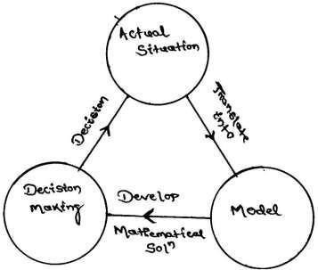

Linear programming
Linear programming is powerful mathematical technique for finding the best use of limited resources of a concern. Overall profit or minimum overall cost to minimize this technique can be used to maximize of a company.
LP can be applied effectively only if

- The objectives can be stated mathematically
- Resources can be measured as quantities (no. weight etc)
- There are too many alternate solutions to be evaluated conveniently
- The variables of the problem bear a linear relationship i.e. doubling the units of resources will double the profit.
Problem solving is based upon the system of linear equation:

Standard form of linear programming problem:

Let x1, x2, x3 xn are the decision variables.

Optimize (maximum or minimize)

Z = c1x1 + c2x2 + + cnxn (objective function)
Subject to constraints
a11x1 + a12x2 + ............ + a1nxn ≤ b1
a21x1 + a22x2 +............. + a2nxn ≤ b2
. . . .
. . . .
. . . .
am1x1 + am2x2 + + amnxn ≤ bn
x1, x2, x3 xn ≥ 0 (non-negative restriction)
where c1, c2, c3, cn are cost or profit coefficients.
aij (i=1, 2, 3, n)
(j=1,2, 3, n)
b1, b2, bm are called requirement or availability.

LPP can solved by two methods.

  - Graphical method: when two decision variables are involved. This is simple.
  - Simplex method: useful for any no. of decision variable in the problem and no. of constraints.
Formulation of LP problem:

- From the given problem, identify the key decisions to be made.
- Identify the decision variables, whose values give the solution to the problem.
- Write the objective in the quantitative terms and express it as a function oflinear variables.
- Study the constraints and express them as a linear equation.
Graphical method:

Simple two dimensional linear programming problems can be easily and rapidly solved by this technique. This method can be easily be applied up to 3 variables.
Example 1: A furniture manufacturer makes two products X1 & X2 namely chair and tables. Each chair contributes a profit of Rs 20 and each table that of Rs 40. Chairs and tables from raw material to finished product, are processed in 3 sections S1, S2, S3. In section S1 each chair (X1) requires 1 Hr and each table (X2) requires 4 Hrs of processing. In section S2, each chair requires 3 Hrs and each table 1 Hr and in section S3 the times are 1 and 1 Hr respectively. The manufacturer wants to optimize his profits if sections S1, S2, S3 can be availed for not more than 24, 21 and 8 Hrs respectively.

ANS:

Let no of Chair = X1 & no of Table = X2
Then the mathematical model for maximizing net profit will be Maximum Z = 20X1 + 40X2

 | Maximum Chair | Table | Total
S1 | 1 | 4 | 24
S2 | 3 | 1 | 21
S3 | 1 | 1 | 8
Subject to:

X1 + 4 X2 ≤ 24 3X1 + X2 ≤ 21 X1 + X2 ≤ 8 X1, X2 ≥ 0

Problem:
Maximize Z = X + 5Y when 5X + 6Y≤ 30
3X + 2Y ≤ 12 X, Y ≥ 0
First step: convert the constraint inequalities temporarily, into equations i.e. 5X + 6Y = 30 C1
3X + 2Y = 12 C2

Second step: Axes are marked on the graph paper and are labeled with variables X and Y.
Third step: Draw straight lines on the graph paper using constraint equations. We have to find two points to draw a straight line.

On X axis the Y coordinate of the point will be zero and on Y axis the X coordinate of the point will be zero.
Using equation C1 two points will be found the equation is 5X + 6Y = 30

Here to find the point on X axis Y =0 Putting Y=0 in the equation we have
5X + 0 =30
X =6
So the point on X axis is (6, 0)
Similarly the X coordinate of the point on Y axis =0 Putting X =0
we have 0 + 6Y = 30 Y= 5
So the point on Y axis is (0, 5) joining (6, 0) & (0, 5) We will obtain one straight line named as C1
Similarly equation C2 will be solved and another two points will be obtained as follows
3 X 0 + 2Y =12 Y = 6
Point is (0, 6)
And 3X + 2X0 = 12 X = 4
Point is (4, 0)
Joining (0, 6) and (4, 0) another straight line is obtained.

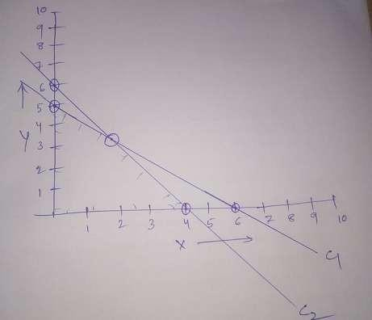

NETWORK ANALYSIS

It is a system which plans projects both large and small by analyzing the project activities. Projects are broken down to individual tasks or activities, which are arranged in logical sequence. A network diagram is constructed for visual presentation of the relationship between all the activities involved in the project. It had its early roots in World War II but becomes a useful tool for enhancing production maximizing profit and assuring quality of the product.
Projects:

Project is any task which has definable beginning and definable end. It is essential to manage effectively the projects through proper planning, scheduling and control as project requires a heavy investment, and is associated with risk and uncertainties.
Network scheduling:
It is a technique used for planning and scheduling large projects in the field of constructions, maintenance, fabrication and any other areas.
This technique is the method of minimizing the bottlenecks, delays and interruptions by determining the critical factors and coordinating various activities.

There are two basic planning and control techniques. They are Critical Path Method (CPM) and Program Evaluation and Review Techniques (PERT).

Objective of Network Analysis:

- A powerful coordinating tool for planning, scheduling and controlling of projects.
- Minimization of total project cost and time.
- Effective utilization of resources and minimization of effective resources.
- Minimization of delays and interruption during implementation of the project.

Application of Network Analysis (PERT and CPM):

- Research and development projects.
- Equipment maintenance and overhauling.
- Construction projects (building, bridges, dams)
- Setting up new industries
- Planning and launching of new products.
- Design of plants, machines and systems
- Organization of big programs
Terms related to network planning methods:

Event (node):
An event is a specific instant of time which marks the start and the end of an activity. Event consumes neither time nor resources. It is represented by a circle and the event no. is written within the circle.
Ex – start the motor, loan approved.

Activity:
Every project consists of a no. of job operations or tasks which are called activities. An activity is an element of project and it may be a process, a material handling or material procurement cycle.
Ex – install machinery, arrange foreign exchange.

It is shown by an arrow and it begins and ends with an event. An activity is

normally given a name like A, B, C etc i.e. marked below the arrow and the estimated time to accomplish the activity is marked above the arrow.
Activities are classified as:

- Critical activities:
In a network diagram, critical activities are those which if consume more than their estimated time the project will be delayed. An activity is called critical if its earliest start time plus the time taken by it is equal to the latest finishing time. A critical activity is marked either by a thick arrow or (//).
- Non critical activities:
Such activities have provision (slack or float) so that even if they consume a specified time over and above the estimated time, the project will not be delayed.
- Dummy activities:
When two activities start at the same instant of time, the head events are joined by a dotted arrow and this is known as dummy activity. It does not consume time. It may be non-critical or critical. It becomes a critical activity when its EST = LFT.

Critical path:

It is that sequence of activities which decide the total project duration. It is formed by critical activities. A critical path consumes maximum resources. It is the longest path and consumes maximum time. It has zero float. The expected completion date cannot be met, if even one critical activity is delayed. A dummy activity joining two critical activities is also a critical activity.
Duration:
Duration is the estimated or actual time required to complete a task or an activity.
Total project time:
It is the time which will be taken to complete the project and is found from the sequence of critical activities. It is the duration or critical path.
Earliest start time (EST):
It is the earliest possible time at which activity can start and is calculated by moving from first to last event in a network diagram.
Earliest finish time (EFT):
It is the earliest possible time at which activity can finish. i.e. (EST + D)

Latest finish time (LFT):
It is calculated by moving backward i.e. from last event to first event of the network diagram. It is the last event time of the head event
Latest start time (LST):

It is the least possible time by which an activity can start.
LST = LFT – duration of that activity

Float or slack:

Slack is with reference to an event and float is with respect to an activity. It means spare time, a margin of extra time over and above its duration which a noncritical activity can consume without delaying the project.
Float is the difference between the time available for completing an activity and the time necessary to complete the same.
There are three type of float.

- Total float:
It is the additional time which a non-critical activity can consume without increasing the project duration.
TF = LST – EST or LFT – EFT and it can be – ve.
- Free float:
If all the non critical activities start as early as possible, the time is the free
float.
FF = EST of tail event – EST of head event – activity duration

- Independent float:
The use of independent float of an activity does not change the float in other activities. Independent float can be used to reduce the effort on a non- critical activity in order to apply the effort on a critical activity to reduce the project duration.

IF = EST of tail event – LFT of head event – activity duration. If is negative, then taken as 0.
Numbering of events (Fulkerson’s rule):

- The initial event which has all outgoing arrows with no incoming arrow is numbered ‘1’.
- Delete all arrows coming out from node 1. This will convert some more nodes into initial events number these events 2, 3 etc.
- Delete all the arrows going out from these numbered events to create more

initial events. Assign next number to these events.
- Continue until the final or terminal node which has all arrows coming in, with no arrow going out is numbered.

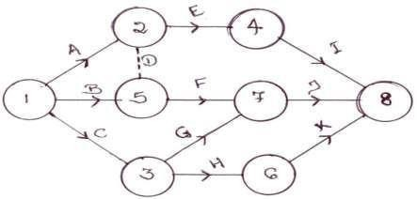

- Construct the network from the information.

Activity | Immediate predecessor | Time
A | ------ | 6
B | ------ | 10
C | ------ | 14
D | C | 6
E | A, B | 14
F | E, D | 6
G | D | 4
H | F, G | 4

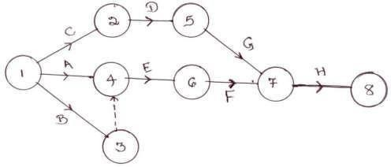

- Construct the network from the information.

Activity  No. | Duratio  n | Activity  No. | Duratio  n
0-1 | 2 | 0-6 | 1
1-2 | 4 | 3-7 | 8
2-3 | 2 | 6-7 | 3
3-4 | 5 | 5-8 | 3
2-5 | 1 | 7-8 | 5
4-5 | 1

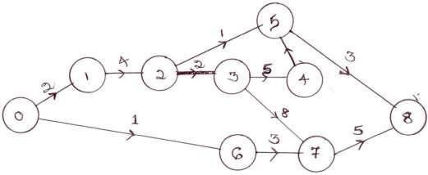

- Construct the network from the information.
Activity | Time | Activity | Time
1-2 | 6 | 3-5 | 11
1-6 | 5 | 4-5 | 6
2-3 | 13 | 6-7 | 11
2-4 | 4 | 5-8 | 3
------ | ---- | 7-8 | 15

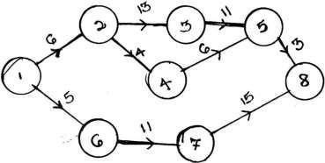

Critical Path Method:

In the critical path method the activity times are known with certainty. For each activity EST and LST are computed. The path with the longest time sequence is called critical path. The length of the critical path determines the minimum time in which the entire project can be completed. The activities on the critical path are called critical activities.

Objective:

- Determining the completion time for the project.
- Earliest time when each activity can start.
- Latest time when each activity can start without delaying the total project.
- Determining the float for each activity.
- Identification of the critical activities and critical path.
Example:

A small engineering project consists of 6 activities namely A, B, C, D, E & F with duration 4, 6, 5, 4, 3 & 3 days respectively. Draw the network diagram and calculate EST, LST, EFT, LFT and floats. Mark the critical path and find total project duration

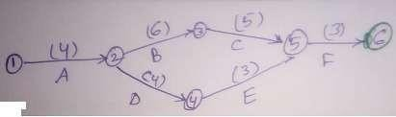

Activit y | Duratio n  (days) | ES T | LST  (LFT - D) | EFT  (EST + D) | LFT | TF
A | 4 | 0 | 0 | 4 | 4 | 0
B | 6 | 4 | 4 | 10 | 10 | 0
C | 5 | 10 | 10 | 15 | 15 | 0
D | 4 | 4 | 8 | 8 | 12 | 4
E | 3 | 8 | 12 | 11 | 15 | 4
F | 3 | 15 | 15 | 18 | 18 | 0

Critical path = 1-2-3-5-6

Total project duration = 4+6+5+3 = 18 days

Programme Evaluation Review Technique (PERT):

PERT takes into account the uncertainty of activity times. It is a probabilistic model with uncertainty in activity duration.
It makes use of three time estimates.
  - Optimistic time (t0)
  - Most likely time (tm)
  - Pessimistic time (tp)
- Optimistic time (t0):
It is the shortest possible time in which an activity can be completed if everything goes perfectly without any complications.
It is an estimate of minimum possible time to complete the activity under ideal condition.

- Pessimistic time (tp):
It is the longest time in which an activity can be completed if everything goes wrong.
- Most likely time(tm);
It is the time in which the activity is normally expected to complete under normal contingencies.

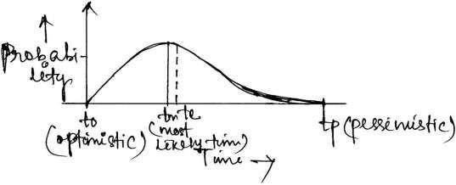

According to the distribution curve

T0 + 4tm + tp te =
6

The standard deviation of time required to complete each activity.
tp - to Standard deviation = -------------
6
tp - to 2
Variance = ------------
6
Standard deviation of the time te to complete the project

Mean, variance, standard deviation:

No. of days taken to dig a certain length of trench under varying condition.
48 | 76 | 52 | 40 | 50
49 | 60 | 62 | 53 | 50
53 | 56 | 67 | 62 | 60
61 | 46 | 72 | 70 | 58

Mean time or average time = 52.5 days Standard deviation for each entry:

48 – 52.5 =-4.5
49 – 52.5 =-3.5
.
.
Square the variation
(-4.5)² = 20.25
(-3.5)² = 12.25 so on
= 6.52
Square the deviations, add them and divide by no. of jobs to get variance. Square rating the variance standard deviation can be found.

Probability of completion of the project within a scheduled time:

Time:
The probability of completion of the project within scheduled is computed as
- Calculate the mean of the event time (te) by adding the times of the activities along the critical path leading to the event.
- Calculate the variance of the event time by adding up the variances of the activities on the critical path. Take the square root of this variances to get T (standard deviation)
- Compute standard normal variate

D - Te
Z =
St
For value of Z find the corresponding value of probability from the table. Standard Normal Distribution
Z | Probability of meeting due or scheduled date | Z | Probability of meeting due or  scheduled date
2.8 | 0.997 | -0.2 | 0.421
2.6 | 0.995 | -0.4 | 0.345
2.4 | 0.992 | -0.6 | 0.274
2.2 | 0.986 | -0.8 | 0.212
2.0 | 0.977 | -1.0 | 0.159
1.8 | 0.964 | -1.2 | 0.115
1.6 | 0.945 | -1.4 | 0.081
1.4 | 0.919 | -1.6 | 0.055
1.2 | 0.885 | -1.8 | 0.036
1.0 | 0.841 | -2.0 | 0.023
0.8 | 0.788 | -2.2 | 0.014
0.6 | 0.726 | -2.4 | 0.008
0.4 | 0.655 | -2.6 | 0.005
0.2 | 0.579 | -2.8 | 0.003
0.0 | 0.500

  - Construct the PERT network. Find the critical path.

ANS:
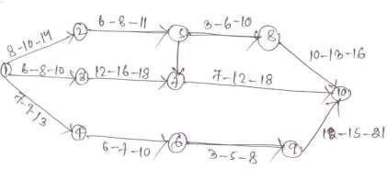

There are 4 paths to reach 1 to 10.
A ⇒1-2-5-8-10
B ⇒ 1-2-5-7-10
C ⇒ 1-3-7-10
D ⇒1-4-6-9-10

 | Activit  y | t0 | tm | Tp | Te | Sum of te
Path A | 1-2 | 8 | 10 | 14 | 10.33 | 37.67
Path A | 2-5 | 6 | 8 | 11 | 8.17 | 37.67
Path A | 5-8 | 3 | 6 | 10 | 6.17 | 37.67
Path A | 8-10 | 10 | 13 | 16 | 13 | 37.67
Path D | 1-4 | 7 | 9 | 13 | 9.33 | 37.34
Path D | 4-6 | 6 | 7 | 10 | 7.33 | 37.34
Path D | 6-9 | 3 | 5 | 8 |  | 37.34
Path D | 9-10 | 12 | 15 | 21 |  | 37.34
Path C | 1-3 | 6 | 8 | 10 |  | 35.84
Path C | 3-7 | 12 | 16 | 18 |  | 35.84
Path C | 7-10 | 7 | 12 | 18 |  | 35.84
Path B | 1-2 | 8 | 10 | 14 |  | 37.84
Path B | 2-5 | 6 | 8 | 11 |  | 37.84
Path B | 5-7 | 5 | 7 | 10 |  | 37.84
Path B | 7-10 | 7 | 12 | 18 |  | 37.84
Maximum time consumed is 37.84 is the critical path. So path B is the critical path.

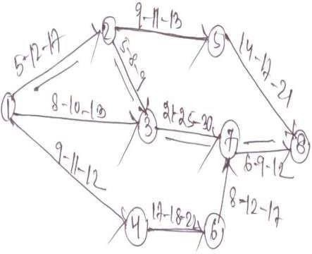

Example – 2:

Construct the PERT network. Find the critical path and variance of each event. Find the project duration at 95 % probability.

Activity | Optimistic  time | Pessimistic  time | Most likely  time
1-2 | 1 | 5 | 1.5
2-3 | 1 | 3 | 2
2-4 | 1 | 5 | 3
3-5 | 3 | 5 | 4
4-5 | 2 | 4 | 3
4-6 | 3 | 7 | 5
5-7 | 4 | 6 | 5
6-7 | 6 | 8 | 7
7-8 | 2 | 6 | 4
7-9 | 5 | 8 | 6
8-10 | 1 | 3 | 2
9-10 | 3 | 7 | 3

Solution:

Activity | to | tp | tm | te | Variance
1-2 | 1 | 5 | 1.5 | 2 | 4/9
2-3 | 1 | 3 | 2 | 2 | 1/9
2-4 | 1 | 5 | 3 | 3 | 4/9
3-5 | 3 | 5 | 4 | 4 | 4/9
4-5 | 2 | 4 | 3 | 3 | 1/9
4-6 | 3 | 7 | 5 | 5 | 4/9
5-7 | 4 | 6 | 5 | 5 | 1/9
6-7 | 6 | 8 | 7 | 7 | 4/9
7-8 | 2 | 6 | 4 | 4 | 4/9
7-9 | 5 | 8 | 6 | 6.16 | 1/4
8-10 | 1 | 3 | 2 | 2 | 1/9
9-10 | 3 | 7 | 3 | 5 | 4/9

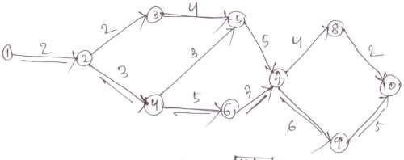

The critical path is 1-2-4-6-7-9-10.

Expected duration of the project = 2+3+5+7+6.16+5 = 28.16 days Project variance = 4/9+4/9+4/9+4/9+1/4+4/9 = 89/36
D - Te
Z =
St

D= Expected duration of the project for 95% probability of completion. Where Te = sum of most likely time of activities in the critical path.
St= Standard deviation = √Project variance From the table for 95% probability
Z = 0.8289
D - 28.16

⇒ 0.8289 = ---------------
√ 2.47
⇒ D = 0.8289 X √2.47 + 28.16
= 1.30 + 28.16
= 29.46

Example- 3:

A small engineering project consists of an activity. Three time estimates for each activity are given
    - Calculate values of expected time (te), standard deviation (st) and variance (vt) for each activity.
    - Draw the network diagram and mark te on each activity.
    - Calculate EST and LFT and mark te on each activity.
    - Calculate total slack for each activity.
    - Indentify the critical paths and mark on the network diagram.
    - Find the length of critical paths or total project duration.
    - Calculate variance of critical path.
    - Calculate the probability that the jobs on the critical path will be finished by the due date of 38 days.
    - Calculate the approx probability that the jobs on the next most critical path will be completed by the due date of 38 days.
    - Estimate the probability that the entire project will be completed by the due date of 38 days.
    - If the project due date changes to 35 days what is the probability of not meeting the due date.
    - Find the due date which has a probability of 94.5 % of being met.

Solution:

Activit y | To | Tm | Tp | Te | Vt
1-2 | 2 | 5 | 14 | 6 | 4
1-6 | 2 | 5 | 8 | 5 | 1

2-3 | 5 | 11 | 29 | 13 | 16
2-4 | 1 | 4 | 7 | 4 | 1
3-5 | 5 | 11 | 17 | 11 | 4
4-5 | 2 | 5 | 14 | 6 | 4
6-7 | 3 | 9 | 27 | 11 | 16
5-8 | 2 | 2 | 8 | 3 | 1
7-8 | 7 | 13 | 31 | 15 | 16

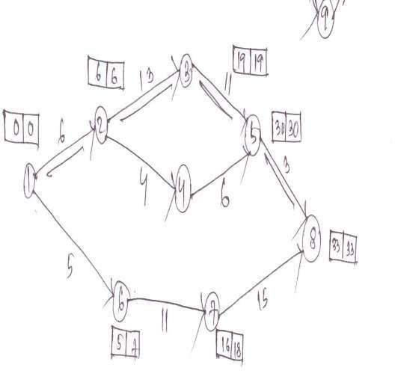

Activity | EST | LST | LST -EST
1-2 | 0 | 0 | 0
1-6 | 0 | 2 | 2
2-3 | 6 | 6 | 0
2-4 | 6 | 20 | 14
3-5 | 19 | 19 | 0
4-5 | 10 | 24 | 14
6-7 | 5 | 7 | 2
5-8 | 30 | 30 | 0
7-8 | 16 | 18 | 2

- Critical path is 1-2-3-5-8 and it is marked on the network diagram.

- The length of the critical path or total project duration (Te) is the sum of the duration of each critical activity = 6 + 13 + 11 + 3 = 33 days
- Variance of the critical path is two of the each critical activity = 4 + 16 + 4 + 1
= 25

- The probability that the project will meet the scheduled or due date is calculated from the
D - Te
Z =
St

38 - 33
Z= = 1
5

Where Te = total project duration

St = standard deviation = √ variance D = Due or scheduled deviations
For Z =1, probability = 0.841
- The next most critical path is 1-6-7-8 of 31 days. Variance = 1+16+16 = 33

st = √33 = 5.74
D - Te 38 -31
Z = = = 1.22
St 5.74
From the table
For Z = 1.22, probability = 0.888
- To complete the project, there are three paths from first to last event,
- 1-2-3-5-8 (33 days)
- 1-2-4-5-8 (19 days)
- 1-6-7-8 (31 days)
Path (b) involves much less time, so its probability of completing in 38 days is very high.
Paths (a) and (c) are independent of each other and the probabilities of paths (a) and (c) to complete in due time of 38 days are 0.841 and 0.888 respectively.
Therefore the probability of heir both being completed in 38 days is = 0.841 X 0.888
= 0.7468.

D – Te 35 - 33
- Again Z = = = 0.4
St 5
From table for Z = 0.4 the probability of meeting due date is 0.655, and hence the probability of not meeting the due date
= 1- 0.655 = 0.345
- From table for the probability of 94.5% or 0.945 , the value of Z = 1.6 D -Te D - 33
And Z = ----------- , therefore 1.6 = --------------
St 5
And thus D = 41 days Difference Between PERT and CPM
The fundamental network of PERT and CPM are though identical, yet there are (certain) differences in details as mentioned below:

 | PERT | CPM

1. | A probabilistic model with uncertainty in activity duration. Expected time is calculated from to , tm and tp | A deterministic model with well- known activity (single) times based upon past experience. It assumes  that the expected time is actually the time taken.
2. | An event-oriented approach. | An activity-oriented approach.
3. | PERT terminology uses words like network diagram, events and slack. | CPM terminology employs works like arrow diagram, nodes, and  float.
4. | The use of dummy activities is required for representing the proper sequencing. | The use of dummy activities is not necessary. The arrow diagram thus  becomes slightly simpler.
5. | PERT basically does not demarcate between critical and non-critical  activities. | CPM marks critical activities.
6. | PERT finds applications in projects where resources (men, materials and specially money) are always made  available as and when required. | CPM is employed to those projects where minimum overall costs is of primary importance. There is better  utilization of resources.
7. | Especially suitable in defence projects and R & D where activity times cannot  be reliably predicted | Suitable for problems in industrial setting, plant maintenance , civil  construction projects , etc.

UNIT 3: INVENTORY CONTROL

Introduction:
- To maximize profit and to establish reputation each industry has to focus on material planning. The materials which are procured and stocked to act as buffer for efficient operation of the system and the finished products which are stocked to meet the demand of the customer is termed as inventory.
In other words inventory can be defined as
- Inventory is a detailed list of those movable items which are necessary to manufacture a product and to maintain the equipment and machinery in good working order.
- It represents those items which are either stocked for sale or they are in the process of manufacturing or they are in the form of materials which are yet to be utilized.
Ex – money kept in the shape of HSS tool or bit MS rod.

Classification of inventories:

- Raw inventories (raw materials):
  - Raw materials and semi-finished products supplied by another firm which are raw items for present industry.
  - Raw materials are those basic unfabricated materials which have not undergone any operation since they are received from the suppliers. Ex – round bars, angles, channels, pipes etc
- Work-in-progress inventories:
  - Semi-finished products at various storages of manufacturing cycle
  - The items or materials in partially completed condition of manufacturing
- Finished inventories:
They are the finished goods lying in stock rooms and waiting dispatch.
- Indirect inventories:
  - The inventories refer to those items which do not form the part or the final product but consumed in the production process.

Eg – machine spares, oil, grease, spare parts, lubricants
  - For proper operation, repair and maintenance during manufacturing cycle.
Functions of inventories:
  - To stabilize production
  - To take advantage of price discount
  - To meet the demand during replenishment period
  - To prevent loss of orders
  - To keep pace with changing market conditions
Inventory control:
- Keeping track of inventory
- It is a planned approach of determining what to order, when to order and how much to order and how much to stock so that costs associated with buying and storing are optimal without interrupting production and sales.
- When should an order placed
- How much should be ordered or economic order quantity

Objective of inventory control:
- Purchasing material at economical price at proper time and in sufficient quantity as not to run slow
- Providing a suitable and secure storage location
- To maintain timely record of inventories of all the items
- A definite inventory identification system
- Adequate and responsible store room staff
- Suitable requisition procedure
- To provide a reserve stock
Advantages or benefits of inventory control
- One does not face shortage of materials
- Materials of good quality and procured in time minimized defect in finished goods.
- Delays in production schedules are avoided
- Production targets are achieved
- Accurate delivery dates
- Economy in purchasing
Inventory control terminology:

- Demand:
It is the no. of items (products) required per unit of time. The demand may be either deterministic or probabilistic in nature.
- Order cycle:
The time period between two successive orders is called order cycle.
- Lead time:
The length of the time between placing an order and receipt of items is called lead time.
- Safety stock:
It is also called buffer stock or minimum stock. It is the stock or inventory needed to account for delays in materials supply and to account for sudden increase in demand due to rush orders.
- Inventory turnover:
If the company maintains inventories equal to 3 months consumption it means that inventory turnover is 4 times a year
i.e. the entire inventory is used up and replaced 4 times a year.

- Reorder level:
It is the point at which the replenishment action is initiated. When the stock level reaches ROL the order is placed for the item.
- Reorder quantity:
This is the quantity of material to be ordered at the reorder level. This quantity equals to the EOQ.
Cost associated with inventory

- Purchase (or production) cost:
The value of an item is its unit purchasing or production cost.

- Capital cost:
The amount invested in an item is an amount of capital not available for other purchases.
- Ordering cost:
It is also known as procurement cost or replenishment cost or acquisition cost.

Two type of costs- Fixed costs and variable costs.
Fixed costs don’t depend on the no. of orders whereas variable costs change
w. r. t the no. of orders placed.
  - Purchasing:
The clerical and administrative cost associated with the purchasing, the cost of requisition material, placing the order, follow up, receiving and evaluating quotations.
  - Inspection:
The cost of checking material after they are received by the supplier for quantity and quality and maintaining records of the receipts.
  - Accounting:
The cost of checking supply against a given level of hand and this cost vary in direct proportion to the amount of holding and period of holding the stock in stores.
This includes-
- Storage costs (rent, heating, lighting etc.)
- Handling costs (associated with moving the items. Such as labour cost, equipment for handling)
- Depreciation, taxes and insurance
- Product deterioration and obsolescence
- Spoilage, breakage
Economic order quantity:
How much materials may be ordered at a time. An industry making bolts will definitely like to know the length of steel bars to be purchased at any one time. i.e. called EOQ.
An economic order quantity is one which permits lowest cost per unit and is most advantageous.

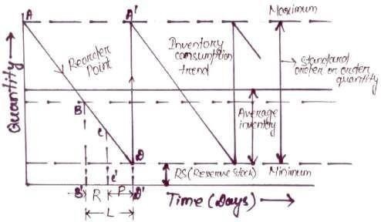

Starting from an instant when inventory OA is in the stores, it consumes gradually in quantity from A along AD at a uniform rate. We know it takes L no. of days between initiating order and receiving the required inventory. As quantity reaches point B, purchase requisition is initiated which takes form B to C that is time R. from C to D is the procurement time P. At the point D when only resource stock is left, the ordered material is supposed to
reach and again the total quantity shoots to its maximum value i.e. the point A’(A=A’)
Maximum quantity- OA is the upper or max limit to which the inventory can be kept in the stores at any time.
Minimum quantity- OE is the lower or minimum limit of the inventory which must be kept in the stores at any time.

Standard order (A’D) - It is the difference between maximum and minimum quantity and is known as economical purchase inventory size.
Reorder point (B)- It indicates that it is high time to initiate a purchase order if not done so the inventory may exhaust, even reserve stock utilized before the new material arrives.

From B’ to D’ it is lead time and it may be calculated on the basis of past experience. It includes-
- Time to prepare purchase requisition and placing the order.
- Time taken to deliver purchase order to the seller
- Time for seller to get or prepare inventory
- Time for inventory to be dispatched from the vendor’s end and to reachthe costumer

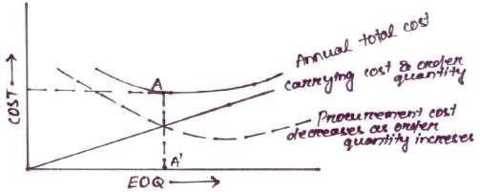

Inventory procurement cost:

- Receiving quotations
- Processing purchase requisition
- Following up and expediting purchase order
- Receiving material and then inspect it
- Processing seller’s invoice
Procurement cost decrease as order quantity increases.
Inventory carrying cost:

- Interest on capital investment
- Cost of storage facility, up-keep of material, record keeping
- Cost involving deterioration and obsolescence
- Cost of insurance, property tax.

Carrying cost directly proportional to the order size or order quantity

Mathematical derivation of EOQ:
Let Q is the economic lot size or EOQ C is the cost for one item.
I is the cost of carrying inventory in percentage per period P is the procurement cost associated with one order
U is the total quantity used per period. Say annually
Total quantity U
No. of purchase orders to be furnished = = -------
E.O.Q Q

Total procurement cost = No. of orders × cost involved in one order U
= X P
Q
Average annual inventory = Q/2
Inventory carrying cost = average inventory × cost per item × cost of carrying inventory in % per period Q
= X C X I
2
Total cost (T) = a + b U Q
= ----- X P + X C X I
Q 2
To minimize the total cost, differentiate T with respect to Q and put it equal to zero. dT d U Q
∴ ------- = ------- ------ X P + ------ X C X I = 0
dQ dQ Q 2
CI
UPQ⁻² + = 0
2
UP CI

=
Q² 2
∴Q
2 . U . P
= --------- C. I

Problem- 1: given that

  - Annual usage (U) = 60 units
  - Procurement cost (P) = Rs 15 per order
  - Cost per price (C) = Rs 100
  - Cost of carrying inventory (I) = 10 % Calculate EOQ.
Answer:

∴Q
2 . U . P
= --------- C. I
2 X 60 X 15
= = 13.41
100 X .1

60
No. of orders per year = --------- = 4.47 ∼ 5
13.41
60
So E.O.Q = = 12 (rounded)
5
Problem-2:

The rate of use of a particular raw material from stores is 20 units per year. The cost of placing and receiving an order is Rs 40. The cost of each unit is Rs 100. The cost of carrying inventory in percent per year is 0.16 and it depends upon the average stock.
Determine the economic order quantity. If the lead time is 3 month, calculate the reorder point.
Answer: given that

U =
20units
P = Rs 40

= Rs100 /- I = 0.16

EOQ =
2U X P 2 X 20 5 X 40 10
=
C X I 100 X .16 4

L= 3 months

Use in 12 months = 20 units

= 10

Use in 3 months = = 5 units
∴Recorder point is 5 units in hand
Problem3:

Find economic order quantity from following data. Average annual demand = 30000 units
Inventory carrying cost = 12 % of the unit value per year Cost of unit = Rs 2 /-
Cost of placing an order = Rs 70.
Answer:

Given, U = 30000

I =12% P = 70/-
C = 2 /-
2 X U X P 2 X 30000 X 70 EOQ = =
C X I 2 X .12

= 4183.3

30000
No. of orders = ------------ = 7.17 ∼ 7 4183.3

30000
EOQ = ------------ = 4285.7 = 4286 (rounded) 7

ABC analysis:

ABC analysis helps differentiating the item from one another and tells how much valued the item is and controlling it to what extent is in the interest of an organization.

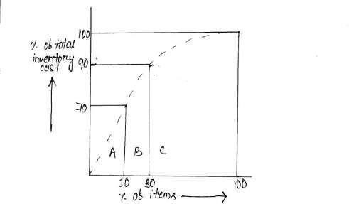

- A-items:
A items are high valued but are limited or few in number. They need careful and close inventory control and proper handling and storage facilities should be provided for them.
A items generally 70-80 % of the total inventory cost and 10 % of the total items.
- B-items;
B-items are medium valued and their umber lies in between A and C items. They need moderate control. They are purchased on the basis of past requirements.
B-items generally 20-15 % of total inventory cost and 15-20 % of the total items.

- C-items:
C-items are low valued, but maximum numbered items. These items do not need any control. These are least important items,

like clip, all pins, washers, rubber bands. No record keeping is done.
C-items generally 10-5 % of the total inventory cost and constitute 75 % of the total items

Advantage

  - Better planning and control
  - Increase inventory turn over
  - Effective management and control Disadvantage

- Periodic review to be done Procedure

- Identify all the items used In industry
- List all the items as per their value.
- Count the no. of high valued, medium valued and law valued items
- Find the % of high, medium and low valued items High valued contribute – 70% of total inv. Cost Medium valued contribute -20% of total inv. Cost Low valued contribute-10% of total inv. Cost
- A graph can be plotted between % of items and % of total inventory cost .

UNIT 4: INSPECTION & QUALITY CONTROL
Inspection adds to the expenditure of a production shop, but it is an integral part of the production unit to control the quality of the product. In other words inspection and quality control create norms for standardization and result in interchangeability in the items.
Inspection is the art of comparing materials, processes and products with established standard.
- It separates defective components from non-defective ones.
- It prevents further work on spoiled in process product.
- It control workmanship of worker.
- It builds industries reputation by maintaining the quality of the final product.
- It promotes economy by preventing expenditure on post sale activities.
PLANNING OF INSPECTION:
Planning of inspection includes
  - Place of inspection
  - Time of inspection
  - Method of inspection
  - Degree of inspection considering the allowed limit of deviation of the final product.
  - Parameters which are to be measured and compared with standards.
  - Persons who will inspect at which location and will be responsible for measurement of which parameters.

In planning of inspection all above factors have to be considered and accordingly proper method of inspection is to be developed.
In the first phase of inspection, studying the processes involved in manufacturing and the quality to be maintained different parameters have chosen. These parameters are treated as the variables to be studied in case of statistical analysis.
DESCRIBE TYPES OF INSPECTION

INSPECTION
ACCORDING TO
LABOUR INVOLVED
AREA OF PERFORMING
INSPECTION
OPERATION OF
INSPECTION
MANUAL
PROCESS
PETROL
VISUAL
BATCH
FIRST PIECE
FINAL
TEST
SAMPLING
RECEIVING
AUTOMATIC
100%
TOOL AND
GAUGE

Process / working inspection
The inspection being carried out while in process are:
- Setting of limit gauges and checking the correct setting of machine.
- Checking frequently of the gauges and leveling them suitably.
- Inspector should check products at different interval to ensure that they are being produced according to specifications.

Floor /Petrol Inspection:

In this method a qualified inspector, keeps on patrolling on the shop floor constantly to keep an eye or inspect the part produced by machine immediately.
The floor inspection, keeps a constant check thereby discovering the faulty work as early as possible.
The other advantages are enlisted as:
- Spoilage of material is prevented.
- The final product is almost inspected already.
- Transportation is reduced.
- Reduction in labour cost.
- The inspection can help in removing the troubles in doing work.
Besides there are some disadvantages such as:
- The time of inspector is wasted in moving from one area to another.
- The inspection of production cannot be done with modern costly equipments. (difficult to carry on dirty floor)
- It becomes difficult to keep a track of good or bad products.
- Due to delay in inspection work for any reason, the work may be piled up at the work stations.
- Highly skilled and quick inspectors are required.
- Personnel emotions can influences the inspector and he may favour some worker.
Centralized / Fixed Inspection:
In centralized inspection, he worker and inspector do not come face to face with each other but the work is brought to a fixed place such as inspection room. This type of inspection is best suited at place where the precision and costly equipment cannot be brought to the shop floor. However, the time taken in transporting the material to the inspection room can be reduced by location inspection room or inspection counter parallel to the flow of work through shop.
The main advantages of this centralized inspection are as under:
- As there is no direct contact between workers and inspectors hence, the quality achieved is much better.
- Less skilled inspectors can be engaged.
- The automation in inspection can be done due to fixed place of inspection.
- Delicate inspection instruments can be used within a closed room.

- The shop floor remains tidy and clean so the finished parts are sent to inspection room to avoid piling up of finished part.
The disadvantages of this type of inspection are as under:
- Material handling cost is increased.
- The defects in jobs are detected after the completion of job. Hence the critical point where the defect occur repeatedly cannot be amended immediately.
- More spoilage of the work due to non detection of defects at early stage.
- More wastage of time due to delay in inspection room.
- Extra scheduling, routing and dispatching work is done to include the inspection place.
Remedial and Preventive Inspection:
Preventive inspection lays emphasis on removing assignable variables by paying special attention to the accuracy of manufacturing process so that possibility of defects and waste is eliminated to the maximum possible extent.
Operative / Stage Inspection (Key point inspection)
The inspection which takes place at each stage or at the end of some functional operation.
Incoming or Receiving Inspection:
Incoming inspection it examines everything coming into the plant e.g materials, parts, assemblies, equipments etc. the received material is generally checked for:
  - Requirement laid down in purchase order
  - Damages, corrosion, cracks etc.
  - Test reports in case of raw materials.

Sampling Inspection:
In sampling inspection a small number of parts are drawn which are representative of the entire load. The result of inspection of these samples judge the quality of whole lot.

The percentage of pieces to be inspected largely depend upon the requirement of the product and statistical experience.
Cage Inspection:
This is the latest and advanced type of inspection in which the machines are arranged in a circle inside which the inspection staff remain inside a fence. The part after worked on one machine is passed to a corresponding inspector inside a case. If the part is proper within limits then it is retained within the cage other it is passed back for rectification or rejection.
First piece Inspection:
In this type of inspection, the machine usually automatic or CNC is set to the parameters and only first four or five pieces are inspected. If any of them is found defective then the parameters are changed accordingly. Otherwise it is assumed that working conditions remaining same, the whole lot or batch of production will be correct to the specification.
Pilot Piece Inspection:
This type of inspection is almost similar to the first piece except that the product is passed through a series of machine performing entire sequence of operations. Now each machine and their tools are checked and adjusted or replaced. This is continued until a perfect piece is produced. This gives an indication of a good production to start.
Functional Inspection:
After the completion of assembly, it is checked for its functioning i.e it will withstand the working conditions imposed upon it while performing its function e.g the functional testing of a locomotive boiler to ensure its designed power production.

Endurance Inspection:
This is the time based inspection imposed to test the duration for which an assembly will perform its function satisfactorily.

Tool Inspection:
In addition to the inspection of material, the inspection of tool, jigs and fixtures and gauge is also necessary to eliminate the wrong processes. It is based on the principle that the proper tools result in proper product. This types of inspection is very much necessary for CNC or automatic machines. The scraping of old, obsolete and worn out tools should be replaced immediately.
FACTORS INFLUENCING THE QUALITY OF MANUFACTURE:
The following nine M’s directly affect the quality of products and services, and thus these must be thoroughly recognized and dealt with.

    - Market for products , services
    - manpower

    - materials iv) money
v) management vi) machines and method
vii) motivation of employees viii) modern information
approaches
ix) mounting products needs.

- Market Demand: It occurs as per customers demand for a particular product type, quality and quantity.
- Manpower: Both for quality designs and for production of quality goods right type of men with required knowledge are essential.
- Materials: Due to pressure on production cost and quality requirements, it becomes necessary to work with wide variety of materials having right specification.
- Money: Increased competition, more mechanization and lower profit margins have made scrap and rework losses as very serious. Cost of maintenance and improvement of quality have increased to a great extent. Money crunch touches the quality.
- Management: Without management’s interest and active co-operation there can be no adequate quality.
- Machines and Methods: Manufacturing equipment have become more complex in order to meet high volume of production and high level of quality goals. The machines and technologies required are highly sensitive to meet quality goals.
- Motivation of employees: A motivated worker can produce better quality products and he can also increase and better the production

rate. The motivation of the employees can be done by financial (Bonus, increments etc) or non- financial (Praising etc) benefits.
- Modern information approaches: By implementing modern information approaches to the various production and Marketing process the quality of products can be improved.
- Mounting product needs: The right operation at right time in the production process can also improve quality of products.
Control charts (X, R, P, and C – charts)
- X- Charts: The chart is based on the measurement data instead of data that arise simply from classification and counting. Sample size can be smaller also. It is constructed to show the fluctuations of the means of samples about the mean of the processes. This chart will help the user in tracking down the assignable causes.
The control chart has the following advantages:
  - It shows changes in process average and is affected by changes in process variability.
  - It is a chart for the measure of central tendency.
  - It shows erratic or cycle shifts in the process.
  - It defects steady progress changes, like tool wear.
  - It is the most commonly used variables chart.
  - When used along with R chart:
    - It tells when to leave the process alone and when to chase and go for the causes leading to variation.
    - It secures information in establishing or modifying processes specifications or inspection procedures and
c. It controls the quality of incoming material.
  - X and R chars when used together form a powerful instrument for diagnosing quality problems.
The control limits of X chart are given as: Upper control limit (UCL) = X + A2 R Central line (CL) = X
Lower control limit (LCL) = X - A2 R

Where , X = mean (average) of sample means

Σ X X1 + X2 + X3 + …… Xn
= = n n

= arithmetic mean of X1 , X2 , X3 etc.
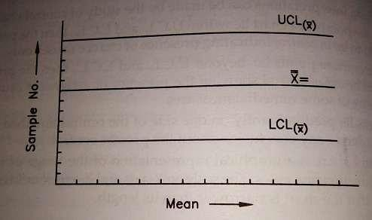

R = Range = Difference between the largest observed data and he smallest observed data.
= XH – XL

Σ R
R = = mean (average ) of range
n
R1 + R2 + R3 + …… Rn
=
n
A2 = Chart factor for mean chart.

- R chart: It is used to show fluctuations of the ranges of the samples about the average range R. This control general variability of the process and affected by the changes in variability. It is a char for measure of spread. It is generally used along with an X chart.
The control limits for R chart are given as: Upper control limit (UCL) = D4 R
Lower control limit (LCL) = D3 R

Where , R = Average of sample ranges D4 = control factor for UCL of R- chart
D3 = control factor for LCL or R- chart
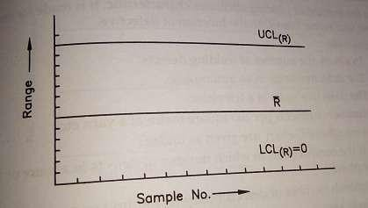
The value of D3 and D4 depends on sample size chosen and their value are available from standard table.

Factors for determining the 3 sigma control limits for x and R charts

umber of  observations in sub-group n | ctor for c chart, A2 | Factor for R chart
umber of  observations in sub-group n | ctor for c chart, A2 | wer control limit D3 | er control limit D4
2 | 1.88 | 0. | 3.27
3 | 1.02 | 0. | 2.57
4 | 0.73 | 0. | 2.28
5 | 0.58 | 0. | 2.11
6 | 0.48 | 0. | 2.00
7 | 0.42 | 0.08 | 1.92
8 | 0.42 | 0.14 | 1.86

9 | 0.37 | 0.18 | 1.82
10 | 0.34 | 0.22 | 1.78
11 | 0.31 | 0.26 | 1.74
12 | 0.29 | 0.28 | 1.72
13 | 0.27 | 0.31 | 1.69
14 | 0.25 | 0.33 | 1.67
15 | 0.24 | 0.35 | 1.65
16 | 0.22 | 0.36 | 1.64
17 | 0.21 | 0.38 | 1.62
18 | 0.20 | 0.39 | 1.61
19 | 0.19 | 0.40 | 1.61
20 | 0.18 | 0.41 | 1.59

3. P- Chart: The chart shows the variation in the fraction defectives of output. It also known as control chart for “Go”and “Not Go”data. It is a tool for process quality control and hence it is quality control by attributes, sometimes it is also known as “control chart for attributes”. The P-chart have following advantages given as under:
- It can be a fraction defective chart or % defective chart (100 P).
- Each item is classified as good or bad.
- This chart is used to control the general quality of the component parts and it checks if the fluctuations in product quality (level) are due to chance cause alone.
- It can be used even if samples size is variable but calculating control limits for each sample is rather cumbersome.
P-chart is plotted by calculating the fraction defective first and then the control limits.

Lot No | Sample Size (a) | No. of Defects (P) | Fraction Defectives  P  = a
1
2
3
4

.
.
.
.
.
.
Total no. of items , n = Total no. of lots X sample size He control limits for P-chart are given as :
Pq Upper control limit (UCL) = P - 3 √ --------
n Pq
Lower control limit (LCL) = P - 3 √ --------
n Where P = overall fraction defective.
Total number of items defective
= Total number of items inspected

q = (1-P)
n = sample size.

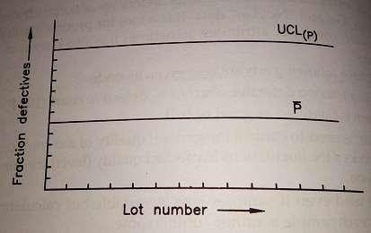
The P-chart can also be prepared in the following two forms:
  - Number of defective (np) chart:

Pq
UCL = nP + n X 3 √ ------
n
Pq
LCL = n P - n X 3 √ ----------
n

  - Present defective chart:
Pq
UCL = 100 P + 100 X 3 √ ---------
n Pq
LCL = 100 P - 100 X 3 √ ----------
n
C chart: It is the method of plotting attributes characteristic. It is made for number of defects per unit rather than with the function of defective. For example:
    - In a turn, the number of welding defects.
    - The defective units in an automobile.
    - The defective units in a television.
    - Number of defects per 100 square meter of a yarn etc.
The advantages of C – chart are given as under:
- It is the control chart in which number of defects in a piece or a sample are plotted.
- It controls number of defects observed per unit or per sample.
- Sample size is constant.
- The chart is used where average number of defective prices in a given sample, C chart takes in to account the number of defects in each defective piece or and a given sample. A defective piece may contain more than one defect.
- Whereas , P chart considers the number of defective pieces in a given sample, C chart takes into account the number of defects in each defective piece or and a given sample. A defective piece may contain more than one defect.
- C chart is preferred for large and complex parts.
- It has limited use.
The control limits for C chart are given as:

Upper control limit (UCL) = C + √ C Lower control limit (LCL) = C – 3 √ C
Where C = average number of defects per sample
Total number of defects in all the samples
= Total number of samples inspected

Lot/Sample Number | No. of Defects
1
2
3
4
.
.
.
.
.
.
Σn = | ΣC =

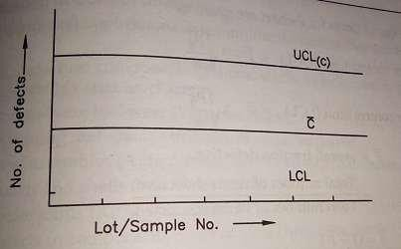

UNIT 5:Production planning and control
Production –Production are manufactured by the transformation of raw material into finished goods
Planning- planning looks ahead, anticipates possible difficulties and decides in advance as to how the production is to be carried out.
Control- the control phase makes sure that programmed production is constantly maintained
Need for PPC-
- To achieve effective utilization of firms resources
- To achieve the production objectives with respect to quality, quantity, costand timeliness of delivery.
- To obtain the uninterrupted production flow in order to meet customers demand
w.r.t quality and committed delivery schedule.
- To help the company to supply a good quality products to the customer on the continuous basis at competitive rates

Objectives of PPC-
- Systematic planning of production activities to achieve the highest efficiency in production of goods
- To organize the production facilities like machines, men, etc. to achievestated production objectives
- Optimum scheduling of resources
- To confirm to delivery commitments
- Materials planning & control
- To be able to make adjustments due to changes in demand and rush orders

Functions of production planning & control

Forecasting

Prior planning Order writing Product design
- Planning phase Process planning & routing Material control
Active planning Tool control Loading Schedulin g

- Action phase Dispatching

Process reporting Data processing

- Control phase Expediting

Corrective action Replanning
  - Forecasting- estimation of type, quantity and quality of future work.
  - Order writing- giving authority to one or more persons to undertake a

particular job.
  - Product design- collection of information regarding specifications, bill of materials, drawings etc.
  - Process planning & routing- finding the most economical process of doing a work and then deciding how & where the work will be done
  - Material control- it involves determining the requirements and control of materials
  - Tool control- it involves determining the requirement and control of tools used
  - Loading- assignment of work to manpower machinery etc.

  - Scheduling- it is the time phase of loading & determines when and in what sequence the work will be required out. It fixes the starting as well as the finishing time for the job
  - Dispatching- it is the transition from planning to action phase. In this phase the worker is ordered to start the actual work.
  - Progress reporting- Data regarding the job progress is collected.
-It is interpreted by comparison with the preset level of performance.
  - Corrective action- 1. Expanding means taking action if the progress reporting indicates deviation of the plan from the originally set targets
  - Replanning of the whole affair becomes essential, in case expediting fails to bring the deviated plan to its actual path

Process planning-

Definition and concept
Process planning means the preparation of work detail plan
Since a process is required to manufacture a product, it is necessary to plan the process
PP is determining the most economical method of performing an operation or activity
Process planning comes after it has been decided as what is to be made Process planning develops the broad plan of manufacture for the
component or product
Process planning takes as its input the drawings or other specifications which show what is to be made and forecasts or orders which indicate the product quantity to be manufactured
Information required to do process planning-
Quantity of work to be done along with product specification Quality of work to be completed
Availability of equipments, tools and personnel etc.
Sequence in which operations will be performed on the raw material

Names of equipments on which the operations will be performed Standard time for each operation
When the operations will be performed Process planning procedure-

- Selection of process
a process is necessary in order to shape, form, condition and join materials and components with the help of machines and labour in order to convert raw material into a finished product.
One should select the most economical process and sequence that satisfies the product specifications
The selection of process depends upon
  - Current production commitments-
Its enough work has already been allocated to more efficient equipments, the current work may have to be passed on to less efficient m/c s to complete the same in time
  - Delivery date-
    - an early delivery date may
    - force the use of less efficient m/c s
    - rule out the use of special tools & jigs as they will take time for design and fabrication
  - quantity to be produced- Small quantity will not probably justify the high cost of preparation and efficient set-ups. Thus, they may gave to be made on less efficient machines and vice-versa.
  - Quality standards- Quality standards may limit the choice of making the product on a particular machine
- Selection of material-
Material should be of right quality and chemical composition as per the product specifications
Shape and size of material should restrict the scrap(i.e. material removed for getting the product shape)
- Selection of jigs, fixtures and other special attachments These supporting devices are necessary
To give higher production rate
To reduce cost of production per piece
- Selection of cutting tools and inspection gauges- Reduce production time
Inspect accurately and at a faster rate

- Make the process layout indicating every operation and the sequence in

which each operation is to be carried out
- Find sit-up time and standard time for each operation

- Manifest process planning by documents such as operation and route sheets, which gives information about the operations required, the preferred sequence of operations, auxiliary tools required estimated operation times
Routing
taking from raw material to the finished product, routing decides the path and sequence of operations to be performed on the job form one machine to another
it determines what work is to be done and where and how it will be done Procedure
the finished product is analyzed from the manufacturing stand point in order to decide how many components can be made in the plant and how many others will be purchased from the outside through vendors, by sub contracting etc. make/buy decisions depends upon the work load in the plant, availability of equipment and personnel to manufacture all components and the economy associated with making all components within the plant itself
A parts list and a BOM is prepared showing name of the part, quantity, material specifications amount of materials required etc. The necessary materials thus can be produced
From production standards m/c capacities, m/c characteristics and the operations which must be performed at each stage of manufacture are established and listed in proper sequence on an operation and route sheet. the place of operations is also decided
Operation and route sheet are separate. An operation sheet shows everything about the operation, i.e. operation description, their sequence, type of machinery, tools, setup and operation times, where as a route sheet besides listing the sequence of operations and relation between operation and machine, also details the section and the m/c to whom the work will flow

Operation and route
sheet
Component No. |  |  |  |  | Drawing
Name of component |  |  |  |  | Quality
Material |  |  |  |  | To be completed on
Routing |  | Operatio n  No. | Operation descriptio n | Tools require d | Fixture s | Tim e
Sectio  n | Machin  e |  |  |  |  | Set  up | Operati  on | tota  l

The difference between an operation sheet and a route sheet is that an operation sheet remains same for the components it the order is repeated but the route sheet may have to be revised it certain machines are already committed to other jobs.
The next step is to determine the lot size or the number of components tobe manufactured in one lot or batch.
Standard scrap factors and the places where scrap is very likely occur are identified causes for points out of control limits are explored and corrected. The variables like workers, machinery and schedules may adjust to minimize scrap.
The cost of the component is analyzed and estimated through the information obtain in steps. The costs consist of material and labour charges and other specific and general indirect expenses.
Scheduling:
Scheduling means when and in what sequence the work will be done. It involves deciding as to when the work will start and in a certain duration of time how much work will be finished.
It determines which order will be taken up on which machine and in which department by which operator.

Scheduling procedure and techniques:

Master schedule:

Master schedule for the foundry shop Maximum production – 100 Hr
Minimum production – 8 Hr
Week-  1 | Week-  2 | Week-  3 | Week-  4
15 | 15 | 20 | 15
25 | 25 | 12 | 10
20 | 28 | 32
35

A master schedule resembles central office which possesses information about all the orders in hand.
As the orders are received, depending upon their delivery dates they are worked on the master schedule when the shop capacity is full for the present week the newly acquired orders are carried over to due next week and so on.
A master schedule updated continuously.
Advantages:
It is simple and easy to understand. It can be kept current.
It involves less cost to make it and maintain. It can be maintained by non-technical staff.
A certain percentage of total weekly capacity can be allocated for rush orders.
Disadvantages:
It provides only overall picture.
It does not give detailed information.

Applications:
For the purpose of loading the entire plant. In research and development organizations.
For the overall planning in foundries, computer entries, repair shops etc.

Scheduling technique:

a) Perpetual schedule:
It is similar to master scheduling. It is simple and easy to understand. It involves less cost and can be maintained by clerical staff. The information is not clear when work will take place.
- Preparation of load analysis sheet from the orders in hand.
LOAD ANALYSIS
SHEET
LOAD IN
Hr/DAYS
ORDER  No. | SEC  A | SEC B | SEC C
X-320 | 25 | 10 | 16
Y-210 | 10 | 15 | 10
Y-314 | 18 | 20 | 8
Z-150 | 8 | 25 | ------
. | . | . | .
. | . | . | .
. | . | . | .
. | . | . | .
. | . | . | .
- Weekly capacity of section is calculated by adding total load against each

WEEK 1
section.
 | GANIT LOA |  | D
 | CHART
SEC A |  | WEEK 2 WEEK 3 |  | WEEK 4

SEC B SEC C
Color bars are shows the actual work load against each section.
Dispatching:
  - Dispatching is the physical handing over of a manufacturing order to the operating facility through the release of orders and instructions

previously developed plan of activity (time and sequence) established by the scheduling section of the production planning and control department.
  - Dispatcher transmits orders to the various shops.
  - Dispatcher determines by whom the job shall be done and it coordinates production.
  - It creates a direct link between production and sales.

Procedure:

The product is broken into different components and components into operations. A route sheet for the part C having three operations on it is shown.

ROUTE SHEET PART C
MATERIAL
OPERATION-1
OPERATION-2
OPERATION-3
- Store issue order:
Authorize stores to deliver required raw material.
- Tool order:
Authorize tool store to release the necessary tools. The tools can be collected by the tool room attendant.

- Job order:
Instruct the worker to proceed with the operations and forms the basis for worker’s pay.
- Time ticket:
It records the beginning and ending time of the operations and forms the basis for worker’s pay.
- Inspection order:
Notify the inspectors to carry out necessary inspections and report the quality of the component.
- Move order:
Authorized the movement of materials and components from one facility to another for further operations.
Process control:

It means trying to achieve the standards set i.e. a certain level of efficiency or a certain volume of production in a specified duration. The system of progress control should be such that it furnishes timely, adequate and accurate information about the progress made, delays and under or overloading.

Steps:

- Setting up a system to watch and record the progress of the operatingfacility.
- Making a report of the work progress or work accomplishment.
- Transmission of report to
  - Control group for necessary control action
  - Accounting group for recording material and labour expenditures.
- Interpretation of the information contained in the progress report by thecontrol group.
- Taking corrective action if necessary.

