RAJA KISHORE CHANDRA ACADEMY OF TECHNOLOGY,NILAGIRI

DEPARTMENT OF CIVL ENGINEERING

Hydraulics & Irrigation Engineering 4TH SEMESTER
PREPARED BY: ER. BAIDYANATH TUDU

PART-A (HYDRAULICS)
CHAPTER:-01 [HYDROSTATICS]

INTRODUCTION
Hydraulics: It is that branch of Engineering-science, which deals with water(at rest or in motion).
Fluid Mechanics: It may be defined as that branch of Engineering-science which deals with the behaviour of fluid under the conditions of rest and motion.
The fluid mechanics may be divided into three parts: Statics, kinematics and dynamics.
Statics. The study of incompressible fluids under static conditions is called hydrostatics and that dealing with the compressible static gases is termed as aerostatics.
Kinematics. It deals with the velocities, accelerations and the patterns of flow only.
Forces or energy causing velocity and acceleration are not deal under this heading.

Dynamics. It deals with the relations between velocities, accelerations of fluid with the forces or energy causing them.
FLUID: A fluid is a substance which deforms continuously when subjected to external shearing force.
A fluid has the following characteristics:
- It has no definite shape of its own, but conforms to the shape of the containing vessel.
- Even a small amount of shear force exerted on a liquid/fluid will cause it to undergo a deformation which continues as long as the force continues to be applied.
A fluid may be classified as follows:
  - (i) Liquid, (ii) Gas, (iii) Vapour.
  - (i) Ideal fluids (ii) Real fluids.
Liquid. A liquid is a fluid which possesses a definite volume (which varies only slightly with temperature and pressure).
Gas. It possesses no definite volume and is compressible.

Vapour. It is a gas whose temperature and pressure are such that it is very near the liquid state(e.g., steam).
Ideal fluids. An ideal fluid is one which has no viscosity and surface tension and is incompressible. In true sense no such fluid exists in nature.
Real fluids. A real practical fluid is one which has viscosity, surface tension and compressibility in addition to the density. The real fluids are actually available in nature.
Properties of fluid:
DENSITY
Mass Density:
- The density (also known as mass density or specific mass) of a liquid may be
𝒎
𝑽

defined as the mass per unit volume
- It is usually denoted by (rho).
- Its units are kg/m³.
- 𝒎
𝑽
at a standard temperature and pressure.

Weight Density:
- The weight density (also known as specific weight) is defined as the weight per
unit volume at the standard temperature and pressure.
𝒘
𝑽
- It is usually denoted by w.
- Mathematically, w = 𝒘
𝑽
- Its units are N/m³.
- For the purposes of all calculations, relating to Hydraulics and hydraulic machines, the specific weight of water is taken as follows:
- In S.I. Units: w = 9.81 kN/m³ (or 9.81 ×10⁻⁶ N/mm³)
- In M.K.S. Units: w = 1000 kg/m³ Specific volume:
- It is defined as volume per unit mass of fluid.
- It is denoted by v.

- Mathematically, v =
𝑽 𝟏
=
𝒎 𝝆

SPECIFIC GRAVITY:
- Specific gravity is the ratio of the specific weight of the liquid to the specific weight of a standard fluid.
- It is dimensionless and has no units.
- It is represented by S.
For liquids, the standard fluid is pure water at 4°C.
𝐒𝐩𝐞𝐜𝐢𝐟𝐢𝐜 𝐰𝐞𝐢𝐠𝐡𝐭 𝐨𝐟 𝐥𝐢𝐪𝐮𝐢𝐝
Specific gravity = 𝐒𝐩𝐞𝐜𝐢𝐟𝐢𝐜 𝐰𝐞𝐢𝐠𝐡𝐭 𝐨𝐟 𝐩𝐮𝐫𝐞 𝐰𝐚𝐭𝐞𝐫 = wliquid /wwater
Example: Calculate the specific weight, specific mass, specific volume and specific gravity of a liquid having a volume of 6 m³ and weight of 44 kN.
Solution: Volume of the liquid = 6 m³
Weight of the liquid = 44 kN

Specific weight, w: w=
𝐖𝐞𝐢𝐠𝐡𝐭 𝐨𝐟 𝐥𝐢𝐪𝐮𝐢𝐝
=
𝐕𝐨𝐥𝐮𝐦𝐞 𝐨𝐟 𝐥𝐢𝐪𝐮𝐢𝐝
𝟒𝟒

𝟔
= 7.333 kN/m³ (Ans.)

Specific mass or mass density, p:

𝒘 𝟕.𝟑𝟑𝟑 × 𝟏𝟎𝟎𝟎
= =
𝒈 𝟗.𝟖𝟏
= 747.5 kg/m³ (Ans.)

𝟏
Specific volume, v : v =
𝝆
Specific gravity, S:
𝟏
=
𝟕𝟒𝟕.𝟓
= 0.00134 m³/kg (Ans.)

Surface Tension ( σ )
S = wliquid /wwater =
𝟕.𝟑𝟑𝟑
=0.747 (Ans.)
𝟗.𝟖𝟏

Cohesion. Cohesion means intermolecular attraction between molecules of the same liquid. "Surface tension" is due to cohesion between particles at the free surface.
Adhesion. Adhesion means attraction between the molecules of a liquid and the molecules of a solid boundary surface in contact with the liquid. This property enables a liquid to stick to another body.
- Surface tension is caused by the force of cohesion at the free surface. A liquid molecule in the interior of the liquid mass is surrounded by other molecules all around and is in equilibrium.

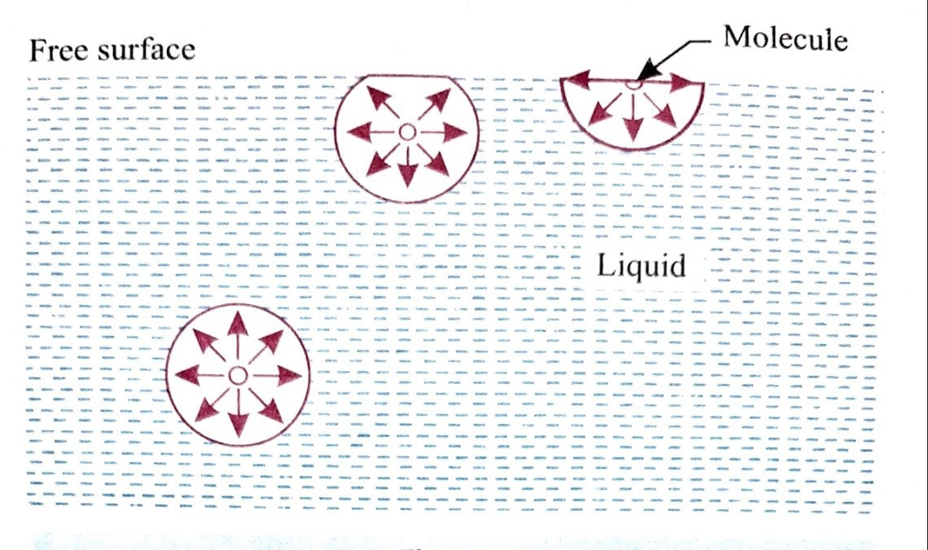
- At the free surface of the liquid, there are no liquid molecules above the surface to balance the force of the molecules below it.
- Consequently, there is a net inward force on the molecule. The force is normal to the liquid surface.
- At the free surface a thin layer of molecules is formed. This is because of this film that a thin small needle can
float on the free surface (the layer acts as a membrane).
- It is usually expressed in N/m.
Some important examples of phenomenon of surface tension are as follows:
- Rain drops (A falling rain drop becomes spherical due to cohesion and surface tension).
- Rise of sap in a tree.
- Bird can drink water from ponds.

- Capillary rise and capillary siphoning. (v) Collection of dust particles on water surface.
(vi) Break up of liquid jets.

Pressure Inside a Water Droplet, Soap Bubble and a Liquid Jet
Case I. Water droplet:
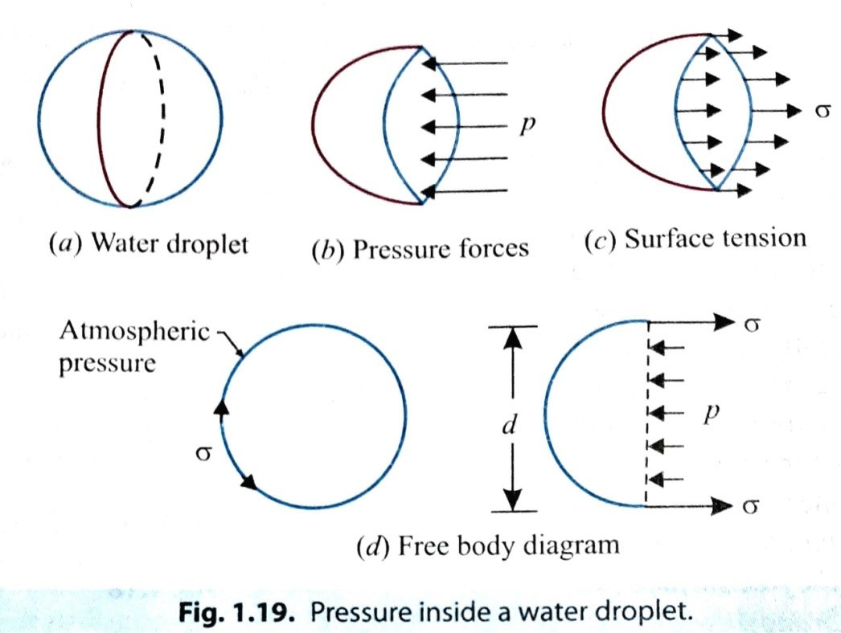
Let, p = Pressure inside the droplet above outside pressure d = Diameter of the droplet and
σ = Surface tension of the liquid.
From free body diagram, we have:

(i) Pressure force = p ×
𝛑d2
𝟒
, and

(ii) Surface tension force acting around the circumference = σ x πd.
Under equilibrium conditions these two forces

will be equal and opposite,

i.e.,
p × 𝛑d²
𝟒
= σ x πd
𝛔 𝐱 𝛑𝐝 𝟒𝝈

p = _{𝛑}𝒅² = 𝒅
𝟒
𝟒𝝈
p =
𝒅
- with an increase in size of the droplet the pressure intensity decreases.
Case II. Soap (or hollow) bubble:
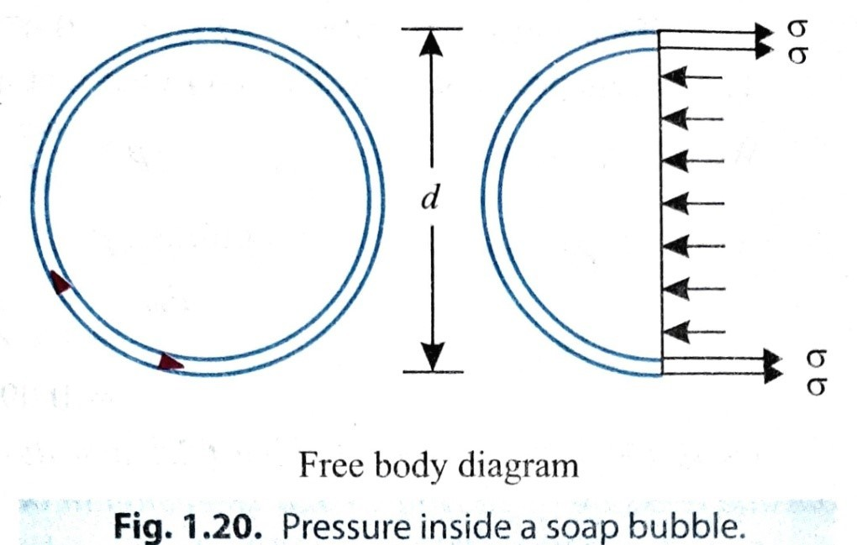
Soap bubbles have two surfaces on which surface tension σ acts. From the free body diagram, we have

p × 𝛑d²
𝟒
=2 × (σ x πd)

𝟐𝛔 𝐱 𝛑𝐝 𝟖𝝈
p = _{𝛑}𝒅² = 𝒅
𝟒

𝟖𝝈
p =
𝒅

- Since the soap solution has a high value of surface tension σ, even with small pressure of blowing a soap bubble will tend to grow larger in diameter (hence formation of large soap bubbles).
Case III. A Liquid jet:
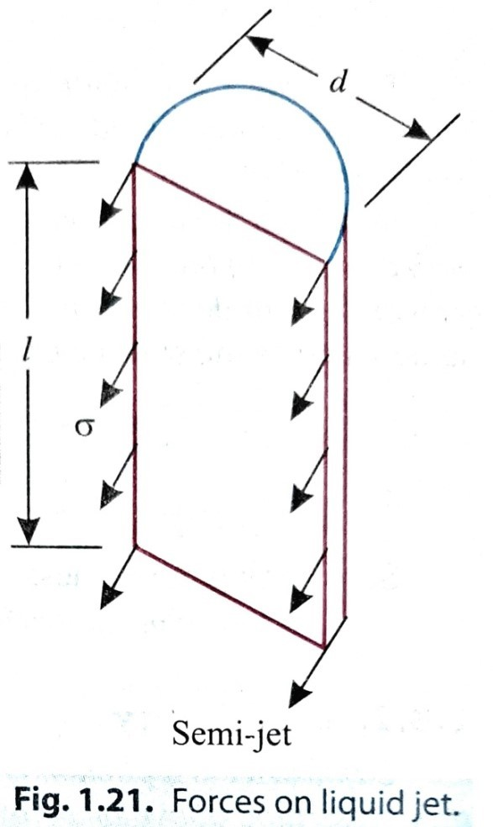
Let us consider a cylindrical liquid jet of diameter d and length l.
Pressure force = p x l x d
Surface tension force =σ x 2l
Equating the two forces, we have:
p x l x d = σ x 2l

𝝈 𝒙 𝟐𝒍
p =
𝒍 𝒙 𝒅
𝟐𝝈
=
𝒅

𝟐𝝈
p =
𝒅

Example. If the surface tension at air-water interface is 0.069 N/m, what is the pressure difference between inside and outside of an air bubble of diameter 0.009 mm?
Solution. Given: = 0.069 N/m; d = 0.009 mm An air bubble has only one surface. Hence,
𝟒𝝈
p =
𝒅
𝟒×𝟎.𝟎𝟔𝟗
= 𝟎.𝟎𝟎𝟗×𝟏𝟎—𝟑 
=30.667 kN/m² or kPa (Ans.)
Example. A soap bubble 62.5 mm diameter has an internal pressure in excess of the outside pressure of 20 N/m². What is tension in the soap film?
Solution. Given: Diameter of the bubble, d = 62.5 mm = 62.5 × 10⁻³ m; Internal pressure in excess of the outside pressure, p = 20 N/m².
Surface tension, :

Using the relation, p =
𝟖𝝈

𝒅

𝟖𝝈

i.e., 20 = 𝟔𝟐.𝟓 ×𝟏𝟎—𝟑
𝟔𝟐.𝟓 ×𝟏𝟎—𝟑
= 20 ×
𝟖

= 0.156 N/m (Ans.)

Capillarity:
- Capillarity is a phenomenon by which a liquid (depending upon its specific gravity) rises into a thin glass tube above or below its general level.
- This phenomenon is due to the combined effect of cohesion and adhesion of liquid particles.
Fig. 1.22 shows the phenomenon of rising water in the tube of smaller diameters. Let, d = Diameter of the capillary tube,
Ө = Angle of contact of the water surface,
= Surface tension force for unit length, and
w = Weight density (g).

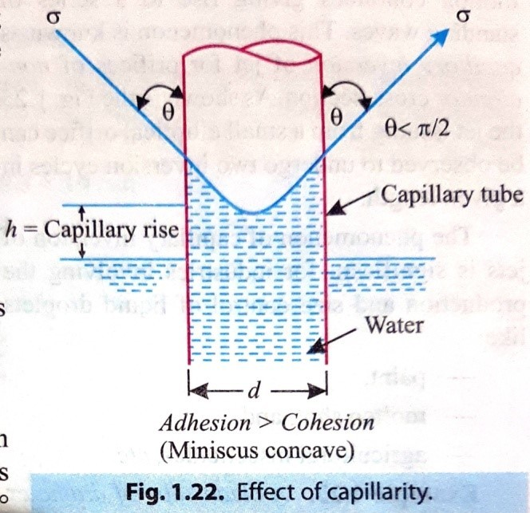
Now, upward surface tension force (lifting force) = weight of the water column in the tube (gravity force)

πd. cosӨ =
𝛑d 2
𝟒
× h ×w

h=
For water and glass: Ө = 0.
𝟒𝝈𝒄𝒐𝒔Ө

𝒘𝒅

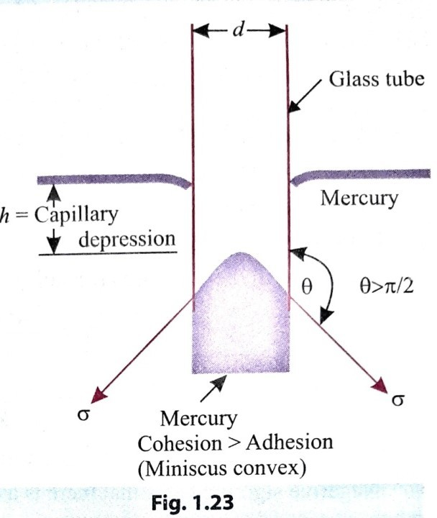
Hence the capillary rise of water in the glass tube,
𝟒𝝈
h=
𝒘𝒅
In case of mercury there is a capillary depression as shown in Fig. 1.23, and the angle of depression is Ө = 140°.
Following points are worth noting:
- Smaller the diameter of the capillary tube, greater is the capillary rise or depression.
- The measurement of liquid level in laboratory capillary (glass) tubes should not be smaller than 8 mm.

- Capillary effects are negligible for tubes longer than 12 mm.
Example. A clean tube of diameter 2.5 mm is immersed in a liquid with coefficient of surface tension =0.4 N/m. The angle of contact of the liquid with the glass can be assumed to be 135°. The density of the liquid=13600 kg/m³.
What would be the level of the liquid in the tube relative to the free surface of the liquid inside the tube.
Solution. Given: d = 2.5 mm; = 0.4 N/m, Ө = 135°;  = 13600 kg/m³ Level of the liquid in the tube, h:
The liquid in the tube rises (or falls) due to capillarity. The capillary rise (or fall),
𝟒𝝈𝒄𝒐𝒔Ө
h=
𝒘𝒅
𝟒×𝟎.𝟒×𝒄𝒐𝒔𝟏𝟑𝟓°
= (𝟗.𝟖𝟏×𝟏𝟑𝟔𝟎𝟎)×𝟐.𝟓×𝟏𝟎—𝟑
= -3.39 × 10⁻³m or -3.39mm
Negative sign indicates that there is a capillary depression (fall) of 3.39 mm. (Ans.)

Example. Assuming that the interstices in a clay are of size equal to one tenth the mean diameter of the grain, estimate the height to which water will rise in a clay soil of average diameter of 0.048 mm. Assume surface tension at air-water interface as
0.074 N/m.

Solution. Given: Diameter of the pores, d =
Assuming Ө = 0°
𝟏

𝟏𝟎
x 0.048 = 0.0048 mm; = 0.074 N/m

𝟒𝝈 𝟒×𝟎.𝟎𝟕𝟒
h= 𝒘𝒅 = (𝟗.𝟖𝟏×𝟏𝟎𝟎𝟎)×𝟎.𝟎𝟎𝟒𝟖×𝟏𝟎—𝟑 = 6.286 m (Ans.)
Example. Determine the minimum size of glass tubing that can be used to measure water level, if the capillary rise in the tube is not to exceed 0.3 mm. Take surface tension of water in contact with air as 0.0735 N/m.
Solution. Given: Capillary rise, h = 0.3 mm = 0.3 x 10⁻³ m Surface tension, = 0.0735 N/m
Specific weight of water, w = 9810 N/m³.
Size of glass tubing, d:

Capillary rise, h h=
(Assuming = 0 for water)
𝟒𝝈𝒄𝒐𝒔Ө

𝒘𝒅
𝟒𝝈
=
𝒘𝒅

VISCOSITY
0.3 × 10-3 = 𝟒×𝟎.𝟎𝟕𝟑𝟓
𝟗𝟖𝟏𝟎 ×𝒅
𝟒×𝟎.𝟎𝟕𝟑𝟓
d = 𝟎.𝟑×𝟏𝟎—𝟑×𝟗𝟖𝟏𝟎 = 0.1m = 100mm (Ans.)

- Viscosity may be defined as the property of a fluid which determines its resistance to shearing stresses.
- It is a measure of the internal fluid friction which causes resistance to flow.
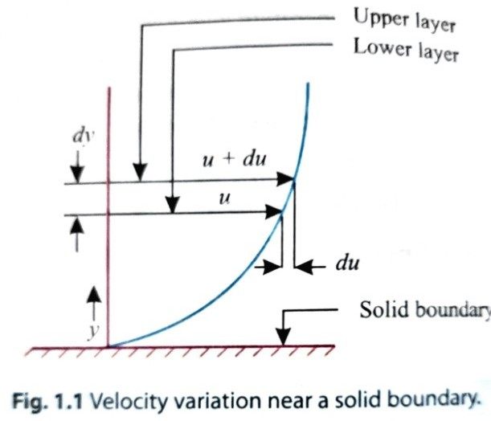
- It is primarily due to cohesion and molecular momentum exchange between fluid layers, and as flow occurs, these effects appear as shearing stresses between the moving layers of fluid.
- An ideal fluid has no viscosity. There is no fluid which can be classified as a perfectly ideal fluid.
- When two layers of fluid, at a distance 'dy' apart, move one over the other at different velocities, say u and u + du, the

viscosity together with relative velocity causes a shear stress acting between the fluid layers.
- The top layer causes a shear stress on the adjacent lower layer while the lower layer causes a shear stress on the adjacent top layer.
- This shear stress is proportional to the rate of change of velocity with respect to
y.
- It is denoted by τ (called Tau).

Mathematically τ α
𝒅𝒖

𝒅𝒚

Or τ = μ.
𝒅𝒖

𝒅𝒚

where, µ = Constant of proportionality and is known as co-efficient of dynamic viscosity or only viscosity.

𝒅𝒖

𝒅𝒚
= Rate of shear stress or rate of shear deformation or velocity gradient.
𝛕

From Fig. 1.1, we have μ =

𝒅𝒖
𝒅𝒚]
[

Thus viscosity may also be defined as the shear stress required to produce unit rate of shear strain.
Units of Viscosity:
In S.I. Units: N.s/m²
In M.K.S. Units: kg.sec/m²

𝐟𝐨𝐫𝐜𝐞/𝐚𝐫𝐞𝐚
[ μ = _{𝟏}
(𝐥𝐞𝐧𝐠𝐭𝐡/𝐭𝐢𝐦𝐞)×
𝐥𝐞𝐧𝐠𝐭𝐡
𝒇𝒐𝒓𝒄𝒆/𝒍𝒆𝒏𝒈𝒕𝒉𝟐
= 𝟏
𝒍𝒆𝒏𝒈𝒕𝒉
𝒇𝒐𝒓𝒄𝒆×𝒕𝒊𝒎𝒆
= (𝒍𝒆𝒏𝒈𝒕𝒉)𝟐 ]

𝒅𝒚𝒏𝒆–𝒔𝒆𝒄

The unit of viscosity in C.G.S. is also called poise =
𝟏
𝒄𝒎𝟐

One poise =

𝟏𝟎
N.s/m²

Kinematic Viscosity:
- Kinematic viscosity is defined as the ratio between the dynamic viscosity and density of fluid.
- It is denoted by ν (called nu).
- Mathematically, ν = 𝑽𝒊𝒔𝒄𝒐𝒔𝒊𝒕𝒚 = 𝝁
𝑫𝒆𝒏𝒔𝒊𝒕𝒚 𝝆

Units of kinematic viscosity: In SI units: m²/s
In M.K.S. units: m²/sec.
In C.G.S. units the kinematic viscosity is also known as stoke (= cm²/sec.) One stoke= 10⁻⁴ m²/s

Newton's Law of Viscosity
This law states that the shear stress (τ) on a fluid element layer is directly proportional to the rate of shear strain. The constant of proportionality is called the co-efficient of viscosity.
𝒅𝒖
Mathematically, τ = μ
𝒅𝒚
The fluids which follow this law are known as Newtonian fluids.
Types of Fluids

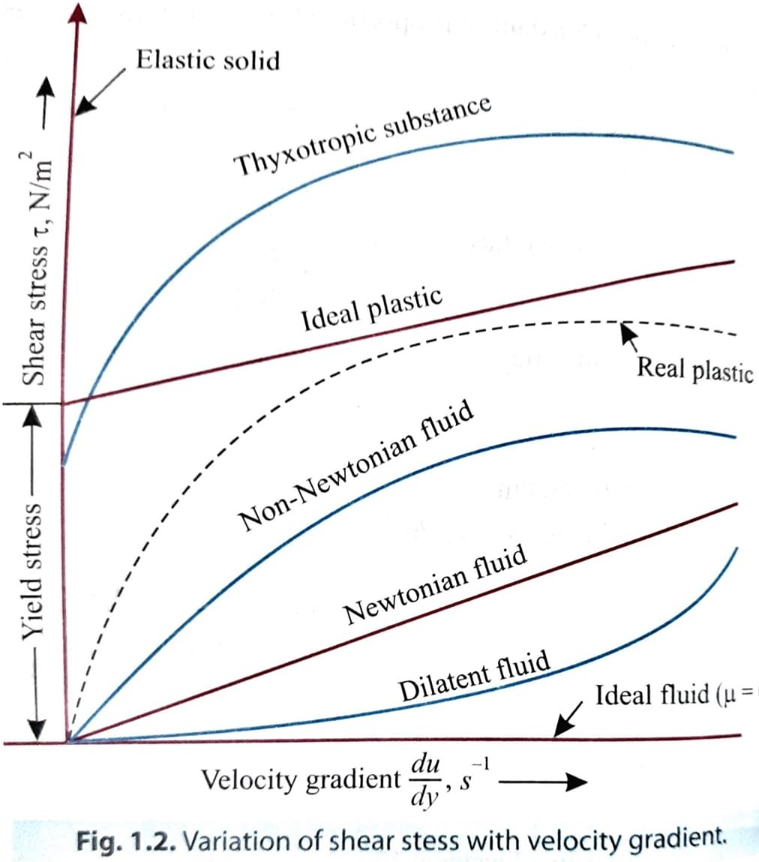
- Newtonian fluids. These fluids follow Newton's viscosity equation. For such fluids μ does not change with rate of deformation.
Examples. Water, kerosene, air etc.
- Non-Newtonian fluids.
Fluids which do not follow the linear relationship between shear stress and rate of deformation are termed as Non Newtonian fluids. Such fluids are relatively uncommon.
Examples. Solutions or suspensions (slurries), mud flows, polymer solutions, blood etc.
- Plastic fluids.
In the case of a plastic substance which is non-Newtonian fluid an initial yield stress is to be exceeded to cause a continuous deformation. These substances are represented by straight line intersecting the vertical axis at the "yield stress".

An ideal plastic (or Binigham plastic) has a definite yield stress and a constant linear relation between shear stress and the rate of angular deformation. Examples: Sewage sludge, drilling muds etc.
A thyxotropic substance, which is non-Newtonian fluid, has a non-linear relationship between the shear stress and the rate of angular deformation, beyond an initial yield stress. The printer's ink is an example of thyxotropic substance.
- Ideal fluid. An ideal fluid is one which is incompressible and has zero viscosity (or in other words shear stress is always zero regardless of the motion of the fluid). Thus an ideal fluid is represented by the horizontal axis (τ = 0).
Summary of relations between shear stress (t) and rate of angular deformation for various types of fluids:

  - Ideal fluids: τ =0, (ii) Newtonian fluids: τ = µ.
𝒅𝒖

𝒅𝒚
𝒅𝒖
𝒅𝒚

𝒅𝒖
(iii) Ideal plastics: =const. + µ.
𝒅𝒚

(v) Non-Newtonian fluids: τ = )
𝒅𝒖
𝒅𝒚
(iv) Thyxotropic fluids: =const. + µ.

n .
)^{n}, and

Example. A plate 0.05 mm distant from a fixed plate moves at 1.2 m/s and requires a force of 2.2 N/m² to maintain this speed. Find the viscosity of the fluid between the plates.
Solution: Velocity of the moving plate, µ = 1.2 m/s Distance between the plates, dy = 0.05 mm = 0.05 x 10⁻³m Force on the moving plate, F= 2.2 N/m²
Viscosity of the fluid, µ:

We know, τ = µ.
𝒅𝒖

𝒅𝒚

where τ = shear stress or force per unit area = 2.2 N/m²,
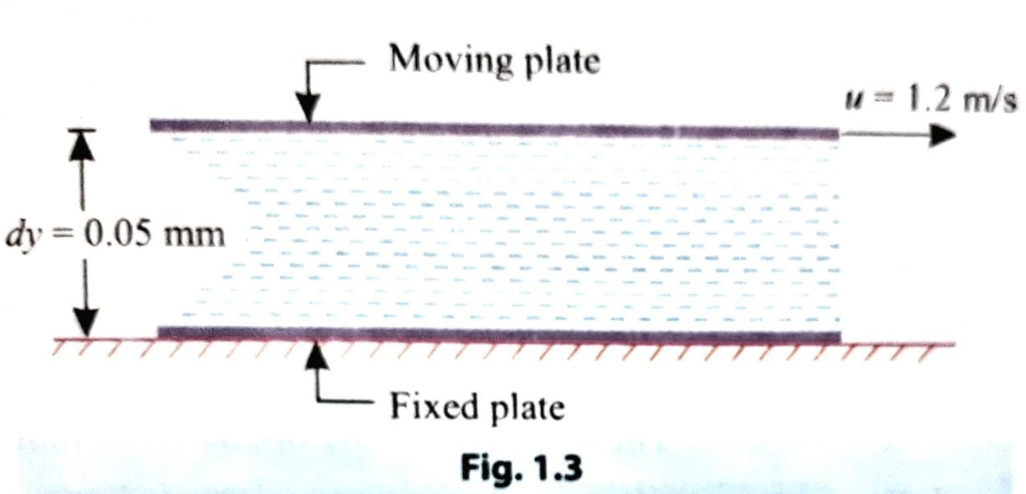
du = change of velocity
=u-0 = 1.2 m/s and
dy = change of distance
= 0.05 × 10⁻³ m.

𝟏.𝟐
2.2= μ x 𝟎.𝟎𝟓 ×𝟏𝟎—𝟑
μ = 𝟐.𝟐 ×𝟎.𝟎𝟓×𝟏𝟎—𝟑 = 9.16 × 10⁻⁴ poise (Ans.)
𝟏.𝟐
Example. The space between two square flat parallel plates is filled with oil. Each side of the plate is 720 mm. The thickness of the oil film is 15 mm. The upper plate, which moves at 3 m/s requires a force of 120 N to maintain the speed. Determine:
- The dynamic viscosity of the oil;
- The kinematic viscosity of oil if the specific gravity of oil is 0.95. Solution. Each side of a square plate 720 mm = 0.72 m
The thickness of the oil, dy = 15 mm = 0.015 m Velocity of the upper plate = 3 m/s
.’. Change of velocity between plates, du = 3-0 =3 m/s Force required on upper plate, F = 120 N

𝒇𝒐𝒓𝒄𝒆
.’. Shear stress, τ =
𝒂𝒓𝒆𝒂
𝟏𝟐𝟎

𝟎.𝟕𝟐×𝟎.𝟕𝟐
= 231.5 N/m²

- Dynamic viscosity, :
We know that,

τ = µ.
𝒅𝒖

𝒅𝒚

231.5 = µ.
𝟑

𝟎.𝟎𝟏𝟓

𝟐𝟑𝟏.𝟓 × 𝟎.𝟎𝟏𝟓
µ =
𝟑
= 1.16 N.s/m² (Ans.)

- Kinematic viscosity, ν:
Weight density of oil, w = 0.95 x 9.81 kN/m² = 9.32 kN/m² = or 9320 N/m³

𝒘
Mass density of oil, =
𝒈
𝟗𝟑𝟐𝟎
=
𝟗.𝟖𝟏
= 950

𝝁
Using the relation: ν =
𝝆
𝟏.𝟏𝟔
=
𝟗𝟓𝟎
= 0.00122 m²/s

Hence ν = 0.00122 m²/s (Ans.)

***end***


PART-A (HYDRAULICS)
CHAPTER:-01 [HYDROSTATICS]

Pressure and its measurements:
PRESSURE OF A LIQUID
When a fluid is contained in a vessel, it exerts force at all points on the sides and bottom and top of the container. The force per unit area is called pressure.
If, P = The force, and
A = Area on which the force acts; then
𝑷
intensity of pressure, p =
𝑨
The pressure of a fluid on a surface will always act normal to the surface.
PRESSURE HEAD OF A LIQUID
A liquid is subjected to pressure due to its own weight, this pressure increases as the depth of the liquid increases.

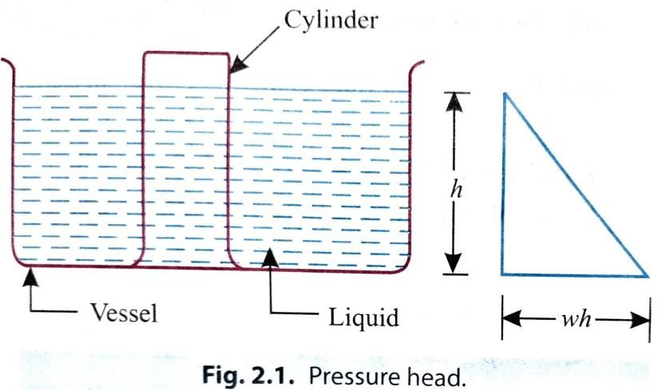
Consider a vessel containing liquid, as shown in Fig. 2.1. The liquid will exert pressure on all sides and bottom of the vessel. Now, let cylinder be made to stand in the liquid, as shown in the figure.
Let, h= Height of liquid in the cylinder,
A= Area of the cylinder base,
w= Specific weight of the liquid, and, p = Intensity of pressure.
Now, Total pressure on the base of the cylinder = Weight of liquid in the cylinder i.e., p.A. = wAh

𝒘𝑨𝒉
p =
𝑨
=wh

i.e., p = wh
As p=wh, the intensity of pressure in a liquid due to its depth will vary directly with depth.
𝒑
h =
𝒘

The height of the free surface above any point is known as the static head at that point.In this case, static head is h.
Hence, the intensity of pressure of a liquid may be expressed in the following two ways:
  - As a force per unit area (i.e., N/mm², N/m²),and
  - As an equivalent static head (i.e., metres, mm or cm of liquid).
Example. Find the pressure at a depth of 15 m below the free surface of water in a reservoir.
Solution. Depth of water, h = 15 m Specific weight of water, w = 9.81 kN/m³
Pressure p:
We know that, p = wh = 9.81 x 15 = 147.15 kN/m²
i.e., p= 147.15 kN/m² = 147.15 kPa (Ans.)
Example. Find the height of water column corresponding to a pressure of 54 kN/m².

Solution. Intensity of pressure, p = 54 kN/m² Specific weight of water, w = 9.81 kN/m³
Height of water column, h:

𝒑
Using the relation: p = wh; h = =
𝒘
PASCAL'S LAW
The Pascal's law states as follows:
𝟓𝟒

𝟗.𝟖𝟏
= 5.5 m (Ans.)

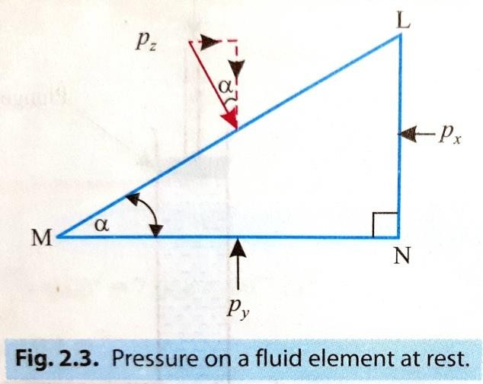
"The intensity of pressure at any point in a liquid at rest, is the same in all directions".
P_{x} = P_{y} = P_{z}

Example. The diameters of ram and plunger of an hydraulic press are 200 mm and 30 mm respectively. Find the weight lifted by the hydraulic press when the force applied at the plunger is 400 N.
Solution. Diameter of the ram, D = 200 mm = 0.2 m

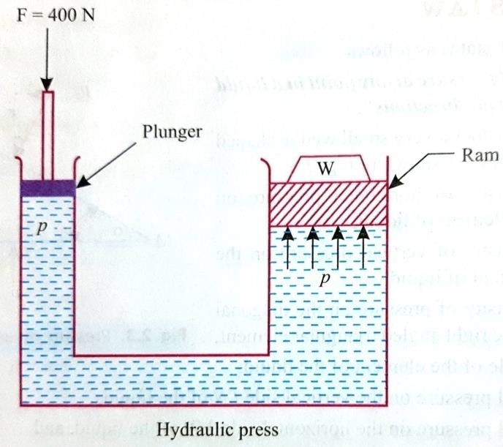
Diameter of the plunger, d = 30 mm = 0.03 m Force on the plunger, F = 400 N
Load lifted, W:

𝝅
2
Area of ram, A = D
𝟒
𝝅
= ×0.2
𝟒
² = 0.0314 m²

𝝅
2
Area of plunger, a = = d
𝟒
Intensity of pressure due to plunger,
= = × 0.03²= 7.068 × 10⁻⁴ m²
𝟒
𝝅

𝑭 𝟒𝟎𝟎 5
p = 𝑨= 𝟕.𝟎𝟔𝟖×𝟏𝟎−𝟒 = 5.66 × 10 N/m²
Since the intensity of pressure will be equally transmitted (due to Pascal's law), therefore the intensity of pressure at the ram is also
= p = 5.66 × 10⁵ N/m²

𝑾𝒆𝒊𝒈𝒉𝒕
But intensity of pressure at the ram =
𝑾 𝑾
= =
N/m²

𝑨𝒓𝒆𝒂 𝒐𝒇 𝒓𝒂𝒎 𝑨 𝟎.𝟎𝟑𝟏𝟒

𝑾
.’.
𝟎.𝟎𝟑𝟏𝟒
= 5.66 × 10⁵ or W = 0.0314 × 5.66 × 10⁵ N = 17.77 × 10³ N or 17.77 kN (Ans.)

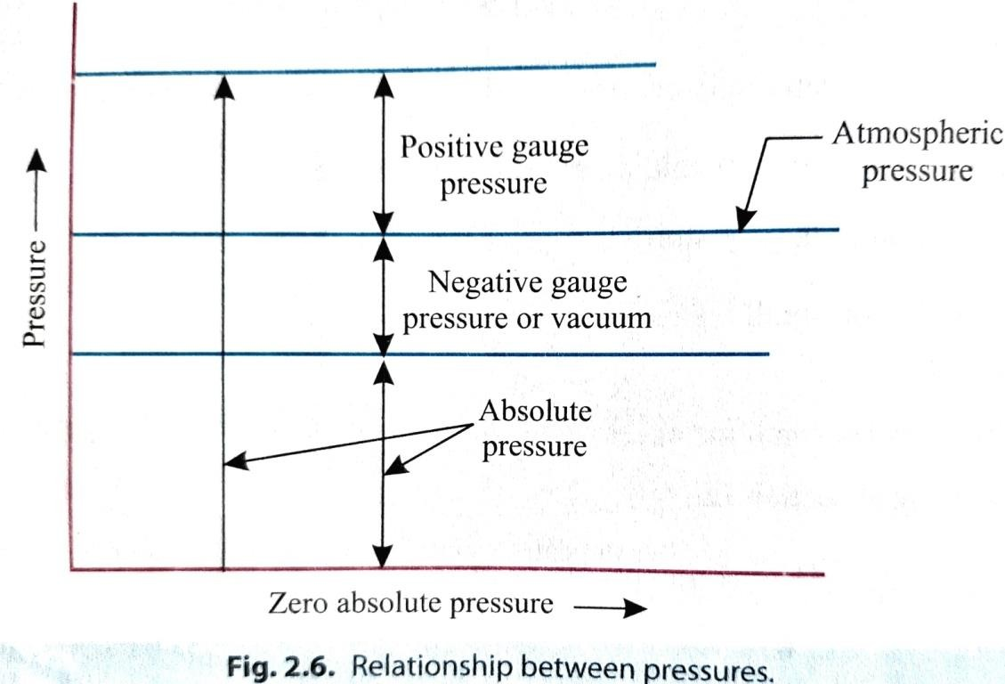
Atmospheric pressure:
- The atmospheric air exerts a normal pressure upon all surfaces with which it is in contact, and it is known as atmospheric pressure.
- The atmospheric pressure is also known as 'Barometric pressure'.
- The atmospheric pressure at sea level (above absolute zero) is called Standard atmospheric pressure".

Gauge pressure:
- It is the pressure, measured with the help of pressure measuring instrument, in which the atmospheric pressure is taken as datum.
- The atmospheric pressure on the scale is marked as zero.
- Gauges record pressure above or below the local atmospheric pressure, since they measure the difference in pressure of the liquid to which they are connected and that of surrounding air.

Vacuum pressure:
- If the pressure of the liquid is below the local atmospheric pressure, then the gauge is designated as 'vacuum gauge' and the recorded value indicates the amount by which the pressure of the liquid is below local atmospheric pressure,
i.e. negative pressure.
(Vacuum pressure is defined as the pressure below the atmospheric pressure).

Absolute pressure:
- It is necessary to establish an absolute pressure scale which is independent of the changes in atmospheric pressure. A pressure of absolute zero can exist only in complete vacuum.
- Any pressure measured above the absolute zero of pressure is termed as an
‘absolute pressure'.
Relationship between atmospheric pressure, absolute pressure and gauge pressure;
- Absolute pressure = Atmospheric pressure + gauge pressure

i.e., Pabs = Patm + Pgauge
- Vacuum pressure = Atmospheric pressure - absolute pressure
i.e., Pvac. = Patm – Pabs
Units for pressure:
- The fundamental S.I. unit of pressure is Newton per square metre (N/m²). This is known as also Pascal.
- Low pressures are often expressed in terms of mm of water or mm of mercury. Standard atmospheric pressure has the following equivalent values:
101.3 kN/m² or 101.3 kPa; 10.3 m of water; 760 mm of mercury; 1013 mb (millibar) = 1 bar = 100 kPa = 10⁵ N/m².
Example. Given that.
Barometer reading = 740 mm of mercury;
Specific gravity of mercury = 13.6; Intensity of pressure = 40 kPa. Express the intensity of pressure in S.I. units, both gauge and absolute.

Solution. Intensity of pressure, p = 40 kPa Gauge pressure:
- p = 40 kPa = 40 kN/m² = 0.4 × 10⁵ N/m² = 0.4 bar (Ans.)
(1 bar = 10⁵ N/m²)

𝒑
- h= =
𝒘
𝟎.𝟒 𝐱 𝟏𝟎𝟓
𝟑 = 4.077 m of water (Ans.)
𝟗.𝟖𝟏 × 𝟏𝟎

𝒑
- h= =
𝟎.𝟒 𝐱 𝟏𝟎𝟓
𝟑
= 0.299 m of mercury (Ans.)

𝒘 𝟗.𝟖𝟏 × 𝟏𝟎
×𝟏𝟑.𝟔

[ Where, w = specific weight; For water: w = 9.81 kN/m³
For mercury : w = 9.81 x 13.6kN/m³ ]

Absolute pressure:
Barometer reading (atmospheric pressure)

= 740 mm of mercury = 740 × 13.6 mm of water

𝟕𝟒𝟎 ×𝟏𝟑.𝟔
=
𝟏𝟎𝟎𝟎
= 10.6 m of water

Absolute pressure (P_{abs}) = Atmospheric pressure (P_{atm} ) + gauge pressure (P_{gauge}).
P_{abs} = 10.06 + 4.077 = 14.137 m of water (Ans.)
=14.137 × (9.81 × 10³) = 1.38 x 10⁵ N/m² (Ans.) (p = wh)
=1.38 bar (Ans.) (1 bar = 10⁵ N/m²)

𝟏𝟒.𝟏𝟑𝟕
=
𝟏𝟑.𝟔
= 1.039 m of mercury. (Ans.)

Example. The inlet to pump is 10.5 m above the bottom of sump from which it draws water through a suction pipe. If the pressure at the pump inlet is not to fall below 28 kN/m² absolute, work out the minimum depth of water in the tank.
Assume atmospheric pressure as 100 kPa.
Solution. Given: P_{atm}. = 100 kPa = 100 kN/m²; P_{abs} = 28 kN/m².
Minimum depth of water in the tank:

Let, P_{vac.} = The vacuum (suction) pressure at the pump inlet.
Then, Pvac. = Patm – Pabs
= (100-28) = 72 kN/m² or 72000 N/m²
Further, let h be the distance between the pump inlet and free water surface in the sump.
Invoking hydrostatic equation, we have:
p = wh
72000 = 9810 × h

or. h =
.’. Minimum depth of water in the tank
𝟕𝟐𝟎𝟎𝟎

𝟗𝟖𝟏𝟎
= 7.339 m

= 10.5-7.339 = 3.161 m (Ans.)
MEASUREMENT OF FLUID PRESSURE:
The pressure of a fluid may be measured by the following devices:

Manometers:
- Manometers are defined as the devices used for measuring the pressure at a point in a fluid by balancing the column of fluid by the same or another column of liquid.
- These are classified as follows:
  - Simple manometers:
(i) Piezometer, (ii) U-tube manometer, and (iii) Single column manometer.
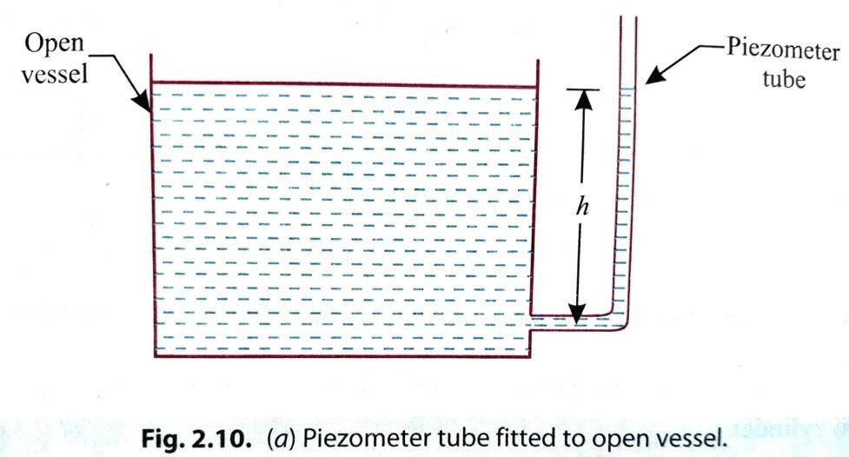
  - Differential manometers.
    - Piezometer:
      - It consists of a glass tube, open at one end to the atmosphere and another end inserted in the wall of a pipe or a vessel.
      - The height upto which the liquid rises in the tube is called pressure head and the pressure
      - It is suitable for measuring moderate gauge pressures of liquids.

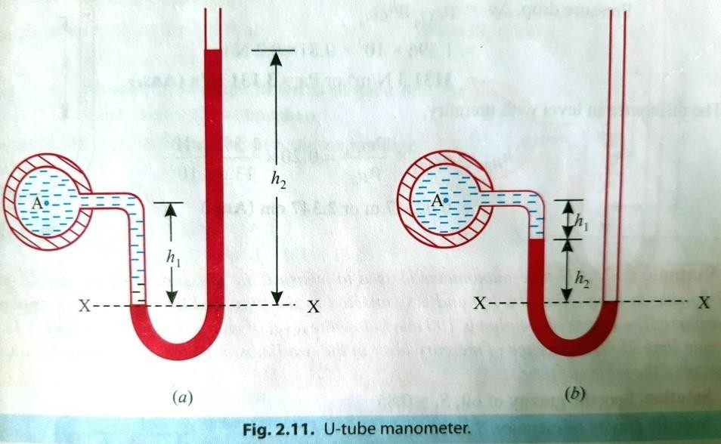
      - p = wh=pgh
    - U-tube manometer:
      - It consists a U-shaped bend whose one end is attached to the gauge point 'A' and other end is open to the atmosphere.
      - It can measure both positive as well as negative (suction) pressures.
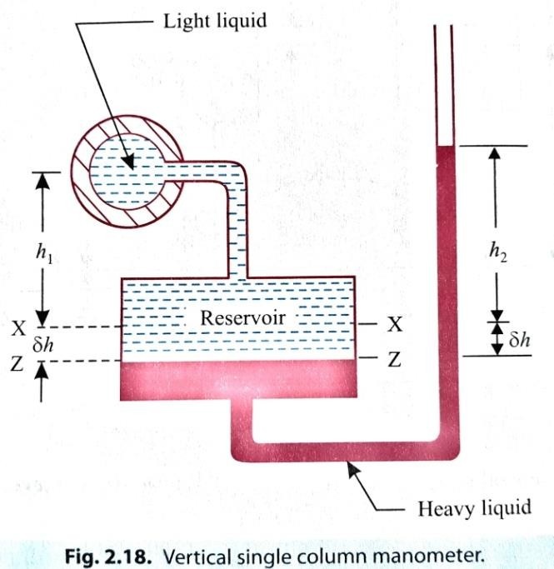
      - It contains liquid of specific gravity greater than that of the fluid of which the pressure is to be measured.
    - Single column manometer (micro-manometer):
      - A single column manometer is a modified form of a U-tube manometer in which a shallow reservoir having a large cross-sectional area (about 100 times) as compared to the area of the tube is connected to one limb of the manometer.
      - For any variation in pressure, the change in the liquid level in the reservoir will be so small that it may be neglected,
and the pressure is indicated by the height of the liquid in the other limb.

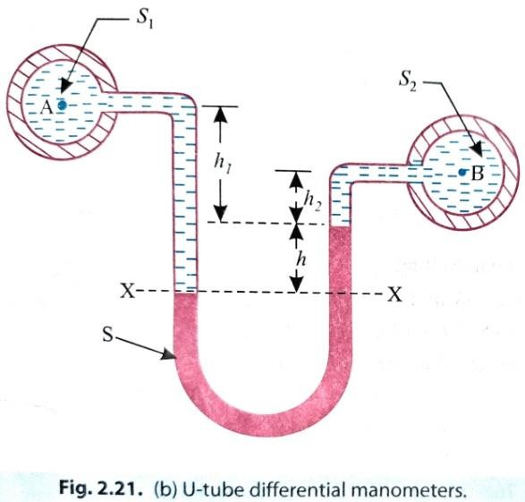
      - As such only one reading in the narrow limb of the manometer need be taken for all pressure measurements.
Differential Manometers
      - A differential manometer is used to measure the difference in pressures between two points in a pipe, or in two different pipes.
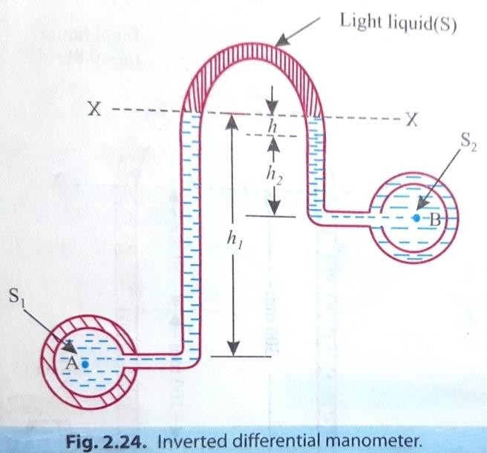
      - In its simplest form a differential manometer consists of a U- tube, containing a heavy liquid, whose two ends are connected to the points, whose difference of pressures is required to be found out.
      - Following are the most commonly used types of differential manometers:
- U-tube differential manometer.
- Inverted U-tube differential manometer.

***end***

PART-A (HYDRAULICS)
CHAPTER:-01 [HYDROSTATICS]

Pressure exerted on an immersed surface:
HYDROSTATICS:
The term 'hydrostatics' means the study of pressure, exerted by a liquid at rest.
The direction of such a pressure is always perpendicular to the surface, on which it acts.
Total pressure (P):
      - It is defined as the force exerted by static fluid on a surface (either plane or curved) when the fluid comes in contact with the surface.
      - This force is always at right angle (or normal) to the surface.
Centre of pressure (𝒉̅):
      - It is defined as the point of application of the total pressure on the surface.
Now we shall discuss the total pressure exerted by a liquid on the immersed surface. The immersed surfaces may be:

1. Horizontal plane surface; 2. Vertical plane surface;
3. Inclined plane surface; 4. Curved surface.

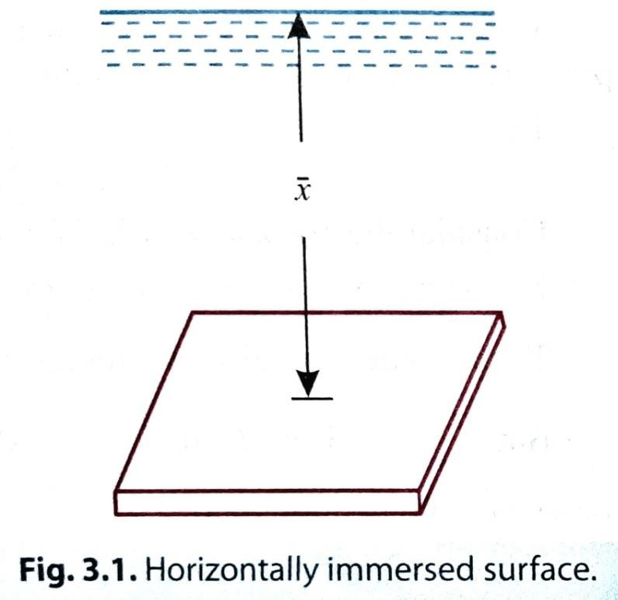
Total pressure exerted on horizontal immersed surface.
Consider a plane horizontal surface immersed in a liquid.
As every point of the surface is at the same depth from the free surface of the liquid.
Let, A = Area of the immersed surface,
𝒙̅ = Depth of horizontal surface from the liquid,and
𝒘 = Specific weight of the liquid.
The total pressure on the surface,
P = Weight of the liquid above the immersed surface
= Specific weight of liquid volume of liquid
= Specific weight of liquid area of surface depth of liquid
=wA𝒙̅
w=𝜌g
P=wA𝒙̅
P=𝜌gA𝒙̅

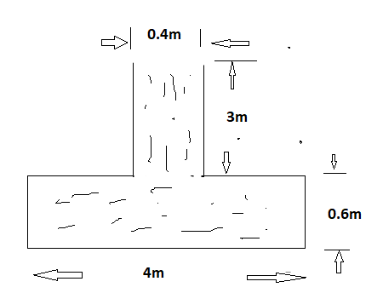
Problem:
Figure shows A tank full of water, Find
  - total pressure on the bottom of the tank
  - weight of water in the tank. Width of tank is 2m.
Solution: Given data,

A= b×d= 4×2=8m²
𝒙̅= 3+0.6=3.6m
P=𝜌gA𝒙̅ = 1000 ×9.81×3.6×8
=282528kN.
Weight of tank =w × volume
= 𝜌g × volume Volume= 0.4×3×2+4×0.6×2 =7.2m
= 1000×9.81×7.2 = 70632.

Total pressure exerted on vertical immersed surface.
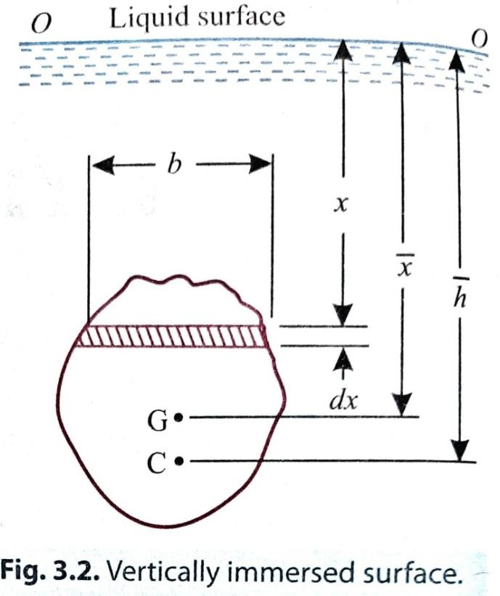
Consider a plane vertical surface of arbitrary shape immersed in a liquid Let, A = Total area of the surface,
G = Centre of gravity of the area of the surface,
𝒙̅ = Depth of centre of gravity of area,
OO = Free surface of liquid, and
𝒉̅ = Distance of centre of pressure from free surface of liquid.
- Total pressure (P):
Consider a thin horizontal strip of the surface of thickness
dx and breadth b.
Let the depth of the strip be x. Let the intensity of pressure on strip be p; this may be taken as uniform as the strip is extremely small. Then,

p = wx
where, w = specific weight of the liquid.
Total pressure on the strip = p.b.dx. = wx. b.dx
Total pressure on the whole area, P = ∫ 𝒘𝒙 .b.dx = w ∫ 𝒃. 𝒅𝒙.x
But, ∫ 𝒃. 𝒅𝒙.x = Moment of the surface area about the liquid level
= Total area of the surface × Depth of centre of gravity of area
= A𝒙̅
.’.
P = w.A𝒙̅
- Centre of pressure (𝒉̅ ):
The point through which this resultant pressure acts is known as ‘centre of pressure’
and is always expressed in terms of depth from the liquid surface.
Let C be the centre of pressure of the immersed figure. Then the resultant pressure P will act through the point.
Let, 𝒉̅ = Depth of centre of pressure below free liquid surface, and

I_{o} = Moment of inertia of the surface about OO.
Consider the horizontal strip of thickness dx. Total pressure on strip = w.x. b.dx
Moment of this pressure about free surface OO = (w.x. b.dx) x = w.x².b.dx
Total moment of all such pressures for whole area, M = ∫ 𝒘.x².b.dx.= 𝒘 ∫ 𝒙^{𝟐}.b.dx
But, ∫ 𝒙^{𝟐}.b.dx = I_{o} = Moment of inertia of the surface about the free surface OO
M = wI_{o} (i)
The sum of the moments of the pressure is also equal to P× 𝒉̅ (ii)
Now equating eqns. (i) and (ii), we get:
P × 𝒉̅ = wI_{o}
w.A𝒙̅ × 𝒉̅ = wI_{o}
.’. 𝒉̅ = 𝑰𝒐
𝑨𝒙̅
Also, I_{o}= I_{G} + Ah²

where, I_{G} = Moment of inertia of the figure about horizontal axis through its centre of gravity, and
h=Distance between the free liquid surface and the centre of gravity of the figure (𝒙̅ in this case)

𝒉̅ = 𝑰𝒐
= 𝑰𝑮 + 𝑨𝒙̅²
= 𝑰𝑮
+ 𝑨𝒙̅² = 𝑰𝑮
+ 𝒙̅

.’.
𝑨𝒙̅
𝑨𝒙̅
𝑨𝒙̅
𝑨𝒙̅ 𝑨𝒙̅

The Centre of Gravity (G) and Moment of Inertia (I) of Some Important Geometrical Figures:
𝒉̅ = 𝑰𝑮 + 𝒙̅
𝑨𝒙̅

S.No. | Name of figure | C.G. from the base | Area | I about an axis passing through C.G. and parallel to the base | I about base
1. | Triangle  Fig. 3.3 | ℎ  x=  3 | 𝑏ℎ  2 | 𝑏ℎ³  36 | 𝑏ℎ³  12

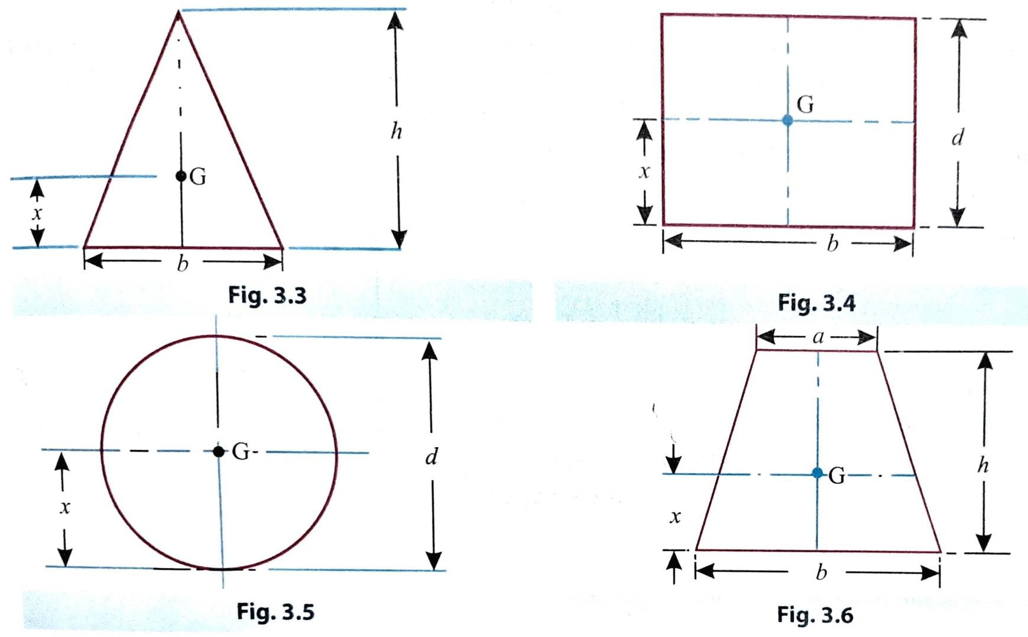
2. | Rectangle  Fig. 3.4 | 𝑑  x=  2 | 𝑏𝑑 | 𝑏𝑑³  12 | 𝑏𝑑³  3
3. | Circle Fig. 3.5 | 𝑑  x=  2 | л𝑑²  4 | л𝑑⁴  64 | -
4. | Trapezium Fig. 3.6 | x=[2𝑎+𝑏] ℎ  𝑎+𝑏 3 | 𝑎+𝑏)ℎ  (  2 | 𝑎2+4𝑎𝑏+𝑏2 2  ( ) × ℎ  3𝑏(𝑎+𝑏) | -

Example3.1. Fig. 3.7 shows a circular plate of diameter 1.2 m placed vertically in water in such a way that the centre of the place is 2.5 m below the free surface of water.
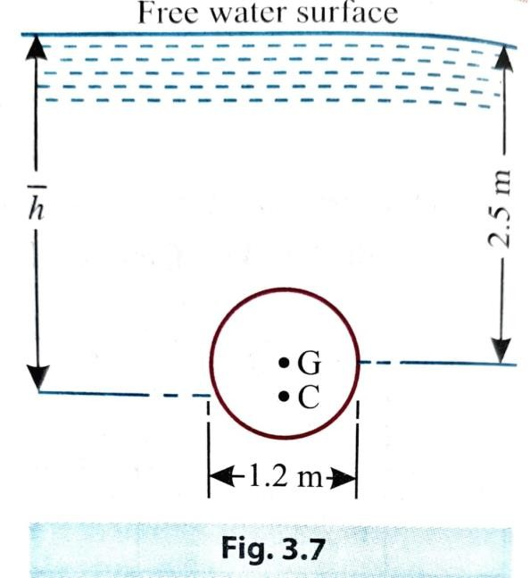
Determine: (i) Total pressure on the plate. (ii) Position of centre of pressure. Solution. Diameter of the plate, d = 1.2 m

л𝒅𝟐
Area, A=
𝟒
= л × 1.2²
𝟒
= 1.13m²

𝒙̅ = 2.5m
  - Total pressure, P:
Using the relation:
P = w.A𝒙̅ = 9.81 × 1.13 ×2.5 = 27.7 kN (Ans.)
  - Position of centre of pressure, 𝒉̅ : Using the relation:

𝒉̅ = 𝑰𝑮
𝑨𝒙̅
+ 𝒙̅

𝟒
Where, 𝑰 = л𝒅 = л × 1.2⁴ = 0.1018m⁴

𝑮 𝟔𝟒

𝟔𝟒

𝒉̅ = 𝟎.𝟏𝟎𝟏𝟖
𝟏.𝟏𝟑 ×𝟐.𝟓
+ 2.5 = 2.536m

.’. 𝒉̅ = 2.536m (Ans.)
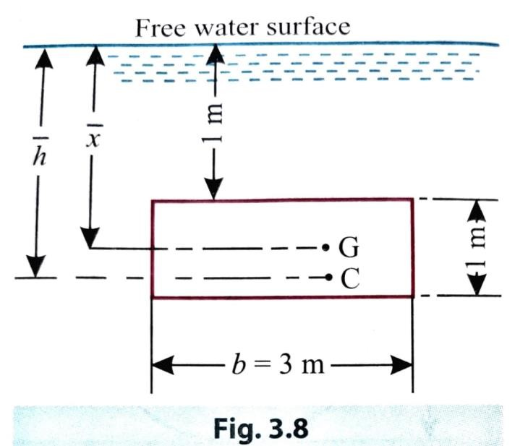
Example 3.2. A rectangular plate 3 metres long and 1 metre wide is immersed vertically in water in such a way that its 3 metres side is parallel to the water surface and is 1 metre below it. Find: (i) Total pressure on the plate, and (ii) Position of centre of pressure.
Solution. Width of the plane surface, b = 3 m Depth of the plane surface, d = 1 m
Area of the plane surface,
A = b x d=3× 1 = 3 m²

- Total pressure P: Using the relation:
𝒙̅ = 1+ 𝟏
𝟐
= 1.5 m

P = w.A𝒙̅ = 9.81 × 3 × 1.5 = 44.14 kN (Ans.)
- Centre of pressure, 𝒉̅ : Using the relation:

𝒉̅ = 𝑰𝑮
𝑨𝒙̅
+ 𝒙̅

𝟑 𝟑
But, 𝑰 = 𝒃𝒅 = 𝟑 ×𝟏 = 0.25m⁴

𝑮 𝟏𝟐

𝟏𝟐

𝒉̅ = 𝟎.𝟐𝟓
𝟑 ×𝟏.𝟓
= 𝟏. 𝟓𝟓𝟔 𝐦

.’. 𝒉̅ = 1.556 m (Ans.)

***end***

PART-A (HYDRAULICS)
CHAPTER:-02 [KINEMATICS OF FLUID FLOW]

Fluid Kinematics:
It is a branch of fluid mechanics which deals with motion of the fluids such as the displacement, velocity, acceleration, flow rates and other related aspects of space time relations without considering the forces and energies causing that fluid motion. Types of fluid Flow:
  - Steady and unsteady flows;
  - Uniform and non-uniform flows;
  - Laminar and turbulent flows;
IV: Compressible & incompressible flows.
- Steady and unsteady flows;
  - Steady Flow: It is at any points of the flowing fluid, various characteristics such as velocity, pressure, density, temperature etc., do not change with time. Mathematically,

𝝏𝒗
( )
𝝏𝒕
= 𝟎,
𝝏𝒑
( )
𝝏𝒕
= 𝟎,
𝝏𝝆
( )
𝝏𝒕
= 𝟎,
𝝏𝑻
( )
𝝏𝒕
= 𝟎.

Ex: Flow of fluid through a pipe at constant rate of discharge.

  - Unsteady Flow: Flow parameters at any point change with time.

𝝏𝒗
( )
𝝏𝒕
≠ 𝟎,
𝝏𝒑
( )
𝝏𝒕
≠ 𝟎,
𝝏𝝆
( )
𝝏𝒕
≠ 𝟎,
𝝏𝑻
( )
𝝏𝒕
≠ 𝟎.

Ex: Flow in which the quantity of liquid per second is not constant.

- Uniform and non-uniform flows:
  - Uniform Flow: When the velocity of flow of fluid only does not change both in magnitude and direction from point to point in the flowing fluid, at any given instant of time.

i.e., (
^{𝝏𝑽} = 𝟎.
𝝏𝒔
)

Ex: Flow of liquids under pressure through long pipe lines of constant diameter.
  - Non Uniform Flow: If the velocity of flow of fluid changes from point to point in the flowing fluid at any instant of time.
𝝏𝑽
i.e., ( ) ≠ 𝟎.
𝝏𝒔

Type of flow | Example
(i) Steady and Uniform flow | Flow through a long pipe of constant diameter at a constant  rate
(ii) Steady and Non Uniform Flow | Flow through a tapering pipe at a constant rate
(iii) Unsteady and Uniform Flow | Constant diameter, at  either increasing or decreasing rate
(iv) Unsteady and Non- uniform flow | Flow through a tapering pipe at either increasing or  decreasing rate
III: Laminar and Turbulent flows:
- Laminar flow:
  - Laminar flow is defined as that type of flow in which the fluid particles move along well-defined paths or stream line.

  - Thus the particles move in laminas or layers gliding smoothly over the adjacent layer.
  - This type of flow is also called stream-line flow or laminar flow.
- Turbulent flow:
  - Turbulent flow is that type of flow in which the fluid particles move in a zigzag way.
  - Due to the movement of fluid particles in a zigzag way, the eddies formation takes place which are responsible for high energy loss.
For a pipe flow, the type of flow is determined by Reynolds number (𝑹𝒆).
𝑽𝑫
𝑹𝒆 = 𝝂

Where, V = Means velocity of flow in pipe D = Diameter of pipe
𝝂 =Kinematic viscosity of fluid.
If, 𝑹𝒆 < 2000 → laminar or steady flow
2000< 𝑹𝒆 < 4000 → may be laminar or turbulent (transitional flow).
𝑹𝒆 > 𝟒𝟎𝟎𝟎 → turbulent flow.

IV: Compressible & incompressible flows.
- Compressible flow: Compressible flow is that type of flow in which the density of the fluid changes from point to point.
Mathematically, 𝜌 ≠ Constant. Ex: Flow of gases through a nozzle.
- Incompressible flow:
  - Incompressible flow is that type of flow in which the density is constant for the fluid flow.
  - Liquids are generally incompressible while gases are compressible. Mathematically, 𝜌= Constant.
Ex: Flow of liquids like water and oil.

RATE OF FLOW OR DISCHARGE
    - Rate of flow (or discharge) is defined as the quantity of a liquid flowing per second through a section of pipe or a channel.
    - It is generally denoted by Q.
Let us consider a liquid flowing through a pipe.
Let, A = Area of cross-section of the pipe, and V = Average velocity of the liquid.

Discharge, Q = Area × average velocity = A.V
Q=A.V
    - Units: (m³/sec or cumec) and liters/sec (lps)

CONTINUITY EQUATION
1m³ = 1000L
    - The continuity equation is based on the principle of conservation of mass.
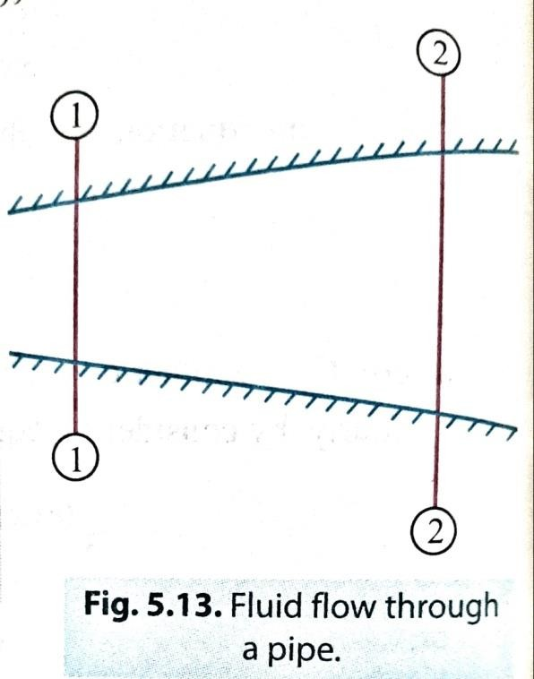
    - It states as follows: "If no fluid is added or removed from the pipe in any length then the mass passing across different sections shall be same.”
Consider two cross-sections of a pipe as shown in Fig 5.13 Let, A₁ = Area of the pipe at section 1-1,
V₁ = Velocity of the fluid at section 1-1,
𝜌₁ = Density of the fluid at section 1-1, and A₂, V₂, 𝜌₂ are corresponding values at sections 2-2.
The total quantity of fluid passing through section 1-1 = 𝜌₁ A₁ V₁ and, the total quantity of fluid passing through section 2-2 = 𝜌₂ A₂V₂
From the law of conservation of mass (theorem of continuity), we have:

=> for compressible fluids.
𝜌₁ A₁ V₁ = 𝜌₂ A₂ V₂

=> For incompressible fluids, 𝜌₁ = 𝜌₂ , ( as density is constant)
A₁ V₁ = A₂ V₂
Example 5.11. The diameters of a pipe at the sections 1-1 and 2-2 are 200 mm and 300 mm respectively. If the velocity of water flowing through the pipe at section 1-1 is 4m/s, find:
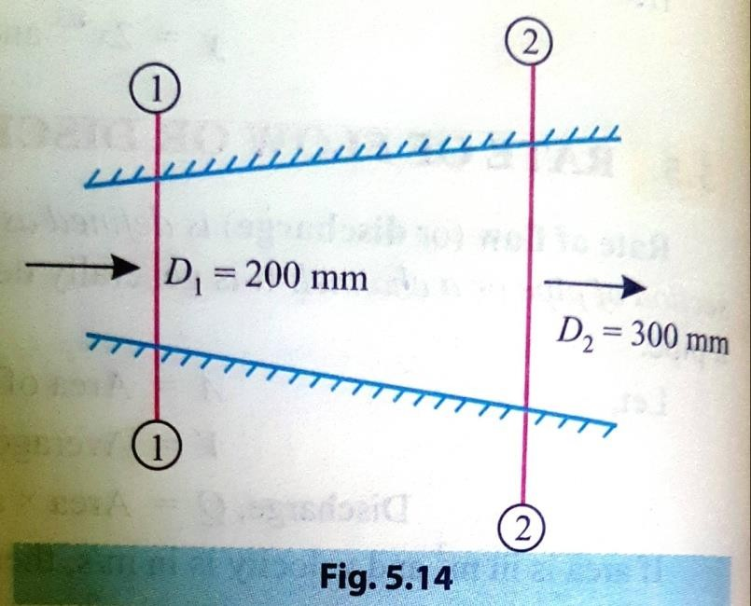
- Discharge through the pipe, and (ii) Velocity of water at section 2-2

Solution. Diameter of the pipe at section 1-1,
D₁ = 200 mm = 0.2 m

.’.
𝝅
Area, A₁ =
𝟒
× D ² =
𝝅
×0.2
2
𝟒
= 0.0314 m²

Velocity, V₁ = 4 m/s Diameter of the pipe at section 2-2,
1
D₂ = 300 mm = 0.3m

.’. Area, A₂ =
𝝅 𝝅
× D₂² =
𝟒 𝟒
x 0.3² = 0.0707 m²

- Discharge through the pipe, Q: Using the relation,
Q = A₁ V₁ , we have:
Q = 0.0314 × 4 = 0.1256 m³/s (Ans.)

- Velocity of water at section 2-2, V₂:
Using the relation,
A₁ V₁ = A₂ V₂, we have:

V₂ =
𝑨₁ 𝑽₁
𝐀𝟐
𝟎.𝟎𝟑𝟏𝟒𝒙𝟒
=
𝟎.𝟎𝟕𝟎𝟕
= 1.77 m/s (Ans.)

Example 5.12. A pipe (1) 450 mm in diameter branches into two pipes (2 and 3) of diameters 300 mm and 200 mm respectively as shown in Fig. 5.15. If the average velocity in 450 mm diameter pipe is 3 m/s find:
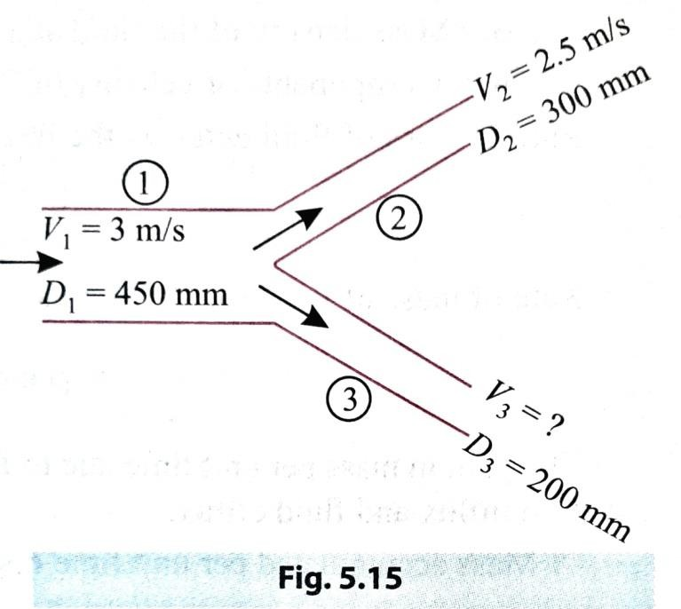
  - Discharge through 450 mm diameter pipe;
  - Velocity in 200 mm diameter pipe if the average velocity in 300 mm pipe is 2.5 m/s.
Solution. Diameter, D₁ = 450 mm = 0.45 m

.’.
𝝅
Area, A₁ =
𝟒
× D₁² =
𝝅
×0.45
2
𝟒
= 0.159 m²

Velocity, V₁ = 3 m/s

Diameter, D₂ = 300 mm = 0.3 m

.’. Area, A₂ =
𝝅 𝝅
× D₂² =
𝟒 𝟒
x 0.3² = 0.0707 m²

Velocity, V₂ = 2.5 m/s

Diameter, D₃ = 200 mm = 0.2 m

𝝅
.’. Area, A₃ =
𝟒
𝝅
× D₃² =
𝟒
× 0.2² = 0.0314 m²

- Discharge through pipe (1) Q₁:
Using the relation, Q₁ = A₁ V₁ = 0.159 × 3
= 0.477 m³/s (Ans.)
- Velocity in pipe of diameter 200 mm i.e. V₃:
Let Q₁ Q₂ and Q, be the discharge in pipes 1, 2 and 3 respectively.
Then, according to continuity equation:
Q₁ = Q₂ +Q₃
Where, Q₁ = 0.477 m³/s
And, Q₂ = A₂V₂ = 0.0707 x 2.5=0.1767 m³/s

.’. 0.477 = 0.1767+Q₃
Or, Q₃ = 0.477-0.1767 ≈ 0.3 m³/s But, Q₃ = A₃ V₃

.’. V₃
= 𝑸𝟑
𝑨𝟑
𝟎.𝟑
=
𝟎.𝟎𝟑𝟏𝟒
= 9.55 m/s

i.e. V₃ = 9.55 m/s (Ans.)

DIFFERENT TYPES OF HEADS (OR ENERGIES) OF A LIQUID IN MOTION

There are three types of energies or heads of flowing liquids:

- Potential head or potential energy:
  - This is due to configuration or position above some suitable datum line.
  - It is denoted by z.
- Velocity head or kinetic energy:

This is due to velocity of flowing liquid and is measured as of flow and 'g' is the acceleration due to gravity (g = 9.81)
𝑽𝟐

𝟐𝒈
where, V is the velocity

- Pressure head or pressure energy:
This is due to the pressure of liquid and reckoned as is the weight density of the liquid.

𝒑
where, p is the pressure, and w
𝒘

Total head/energy:
Total head of a liquid particle in motion is the sum of its potential head, kinetic head and pressure head. Mathematically,

Total head, H = z +
𝑽𝟐
+
𝟐𝒈
𝒑
m of liquid
𝒘

Total energy, E = z +
𝑽𝟐 𝒑
+
𝟐𝒈 𝒘
Nm/kg of liquid

Example 6.1. In a pipe of 90 mm diameter water is flowing with a mean velocity of 2 m/s and at a gauge pressure of 350 kN/m². Determine the total head, if the pipe is 8 metres above the datum line. Neglect friction.

Solution. Diameter of the pipe = 90 mm
Pressure, p = 350 kN/m² Velocity of water, V = 2 m/s

Datum head, z = 8 m
Specific weight of water, w = 9.81 kN/m³

Total head of water, H:

H = z +

𝑽𝟐 𝒑
+
𝟐𝒈 𝒘

= 8+
𝟐𝟐
+
𝟐×𝟗.𝟖𝟏
𝟑𝟓𝟎

𝟗.𝟖𝟏
= 43.88 m

.’. H = 43.88 m (Ans.)

PART-A (HYDRAULICS)
CHAPTER:-02 [KINEMATICS OF FLUID FLOW]

BERNOULLI'S EQUATION
Bernoulli's equation states as follows:
"In an ideal incompressible fluid when the flow is steady and continuous, the sum of pressure energy, kinetic energy and potential (or datum) energy is constant along a stream line."

Mathematically,
Where,
𝒑 𝑽𝟐
+
𝒘 𝟐𝒈
+ z =constant
𝒑
=Pressure energy,
𝒘

𝑽𝟐

𝟐𝒈
= Kinetic energy, and

z = Datum (or elevation) energy.
Assumptions:
- The liquid is ideal and incompressible.
- The flow is steady and continuous.
- The flow is along the stream line, i.e., it is one-dimensional.
- The velocity is uniform over the section and is equal to the mean velocity.

- The only forces acting on the fluid are the gravity forces and the pressure forces.

Example 6.7. The water is flowing through a tapering pipe having diameters 300 mm and 150 mm at sections 1 and 2 respectively. The discharge through the pipe is 40 litres/sec. The section 1 is 10 m above datum and section 2 is 6 m above datum. Find the intensity of pressure at section 2 if that at section 1 is 400 kN/m².
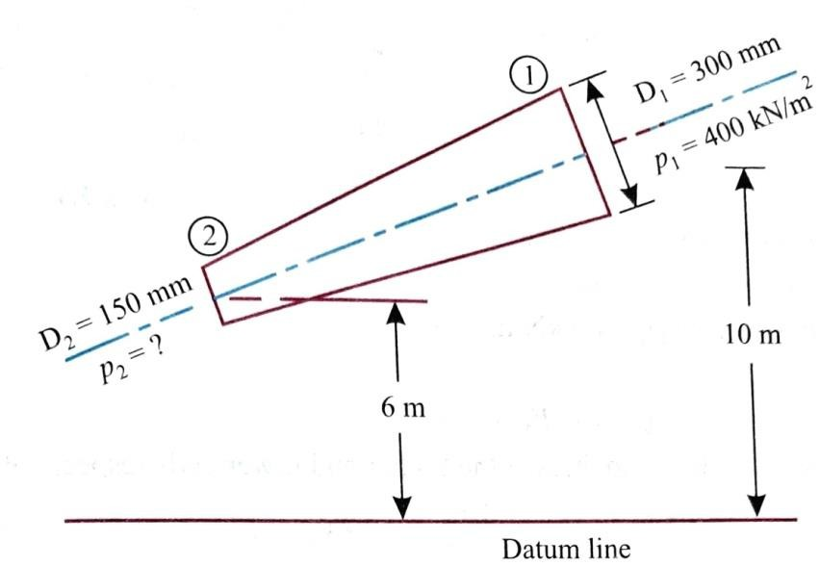
Solution. At Section 1:
Diameter, D₁ = 300 mm = 0.3 m
𝝅

.’. Area, A₁ =
x 0.3² = 0.0707 m²
𝟒

Pressure, p₁ = 400 kN/m² Height of upper end above the datum, z₁ = 10 m

At Section 2:

Diameter, D₂ = 150 mm = 0.15m
𝝅

Area, A₂ =
𝟒
x 0.15² = 0.01767 m²

Height of upper end above the datum, z₂ = 6 m Rate of flow (i.e., discharge),

Q = 40 litres/sec = 𝟒𝟎 ×𝟏𝟎𝟑 = 0.04 m³/s.
𝟔
𝟏𝟎
Intensity of pressure at section 2, p₂:
Now, Q = A₁ V₁ = A₂ V₂

.’. V₁ =
𝑸

𝑨₁
𝟎.𝟎𝟒
=
𝟎.𝟎𝟕𝟎𝟕
𝑸
= 0.566 m/s
𝟎.𝟎𝟒

and, V₂ =

𝐀𝟐
=
𝟎.𝟎𝟏𝟕𝟔𝟕
= 𝟐. 𝟐𝟔𝟒 𝐦/𝐬

Applying Bernoulli's equation at sections 1 and 2, we get:

𝒑𝟏

𝒘
𝒑𝟐
𝑽𝟐
+
𝟏
𝟐𝒈
𝒑𝟏
+ z₁ =
𝑽𝟐
𝒑𝟐

𝒘
𝑽𝟐
+
𝟐
𝟐𝒈
𝑽𝟐
+ z₂

And,
=
𝒘 𝒘
+ 𝟏 −
𝟐𝒈
𝟐
𝟐𝒈
+ ( z₁ – z₂ )

𝟒𝟎𝟎
=
𝟗.𝟖𝟏
𝟏
+
𝟐 ×𝟗.𝟖𝟏
(𝟎. 𝟓𝟔𝟔² – 2.264²) + (10 - 6)

= 40.77 - 0.245 + 4= 44.525 m
.’. p₂= 44.525 × w = 44.525 x 9.81 = 436.8 kN/m² (Ans.)

PRACTICAL APPLICATIONS OF BERNOULLI'S EQUATION
- Venturimeter 3. Pitot tube.
- Orificemeter 4. Rotameter and elbow meter

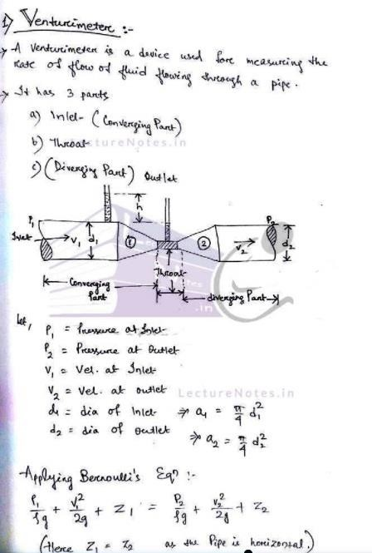

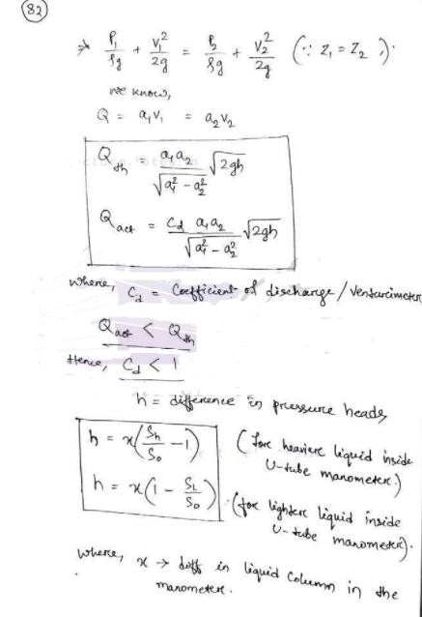

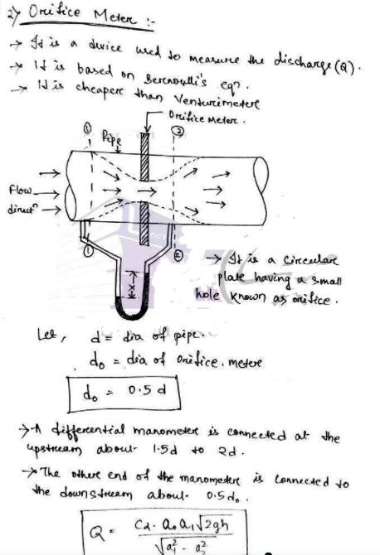

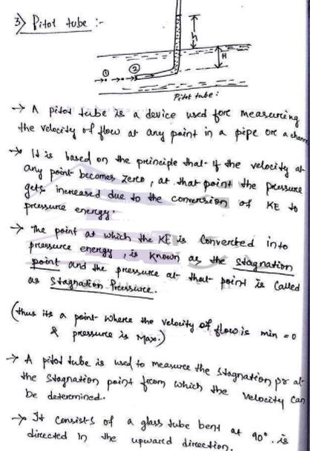

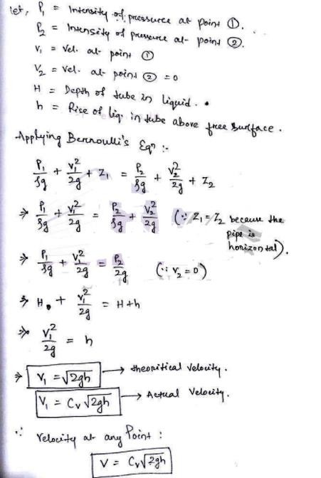

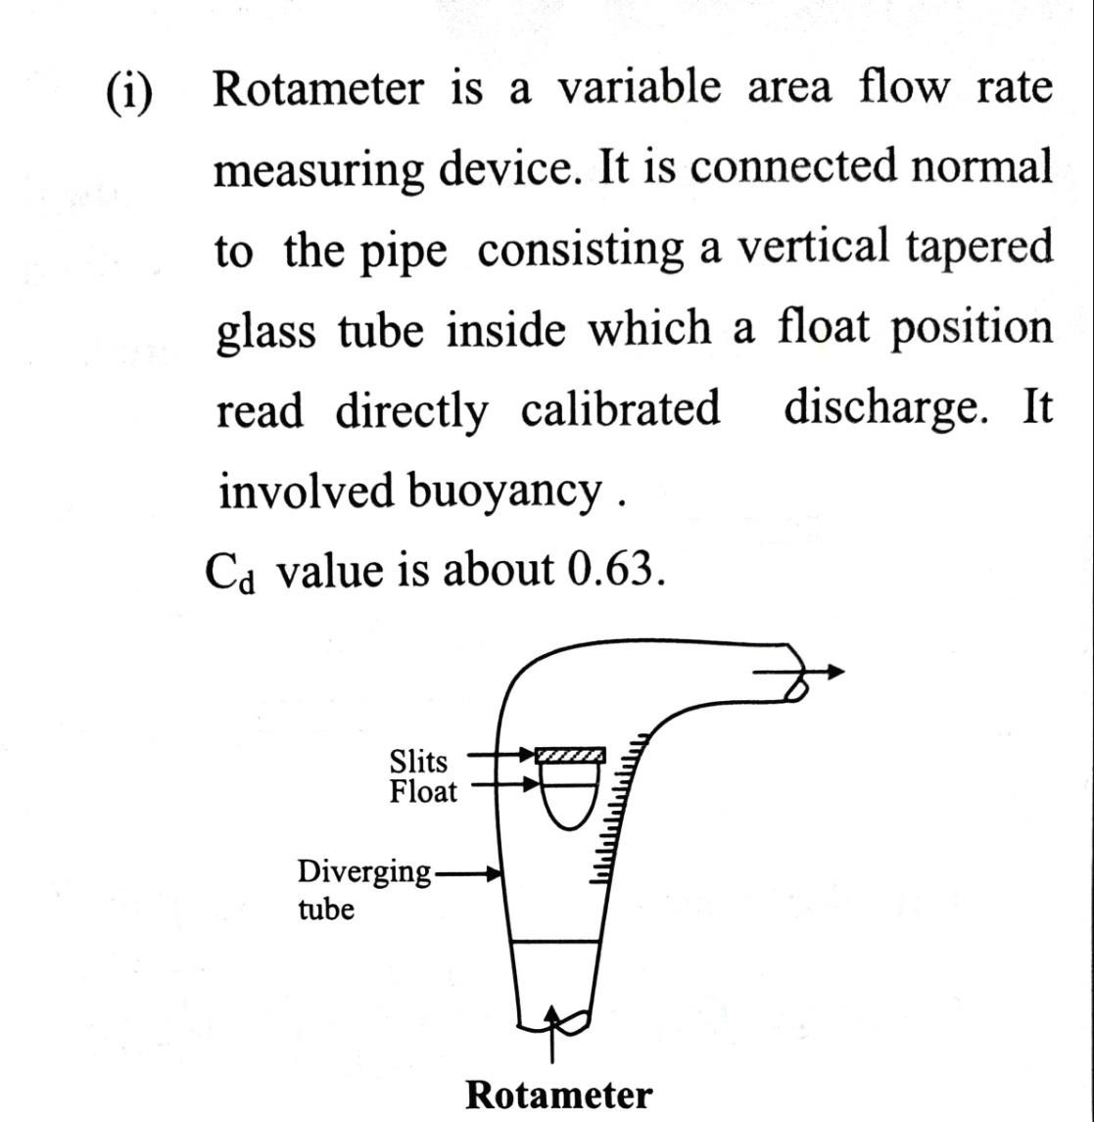
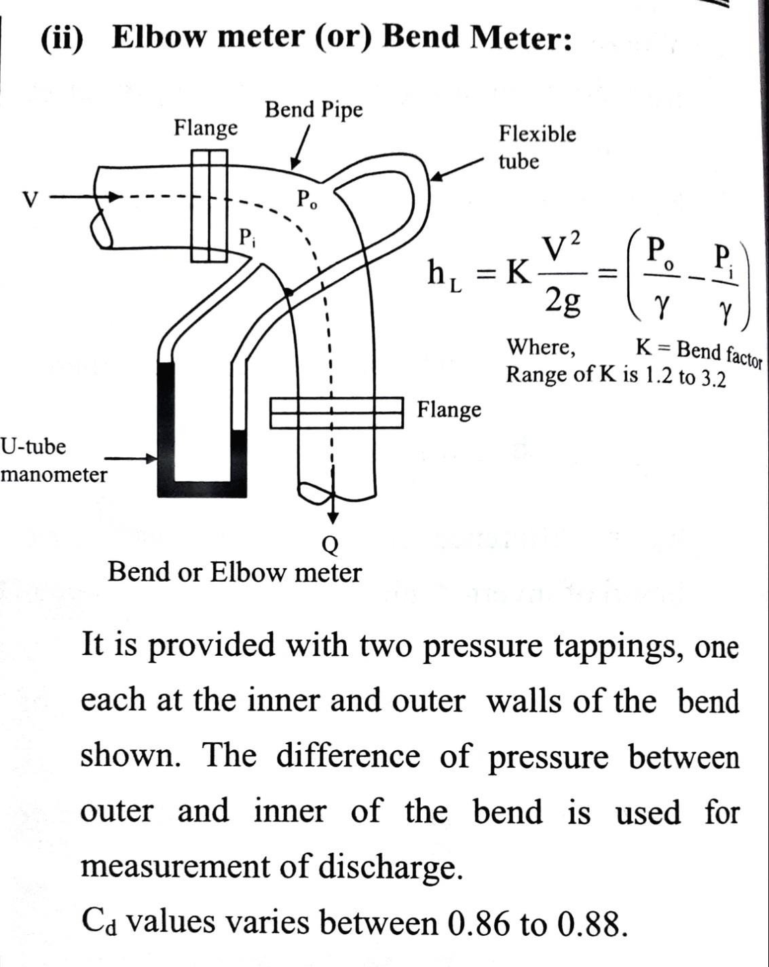
- Rotameter and elbow meter

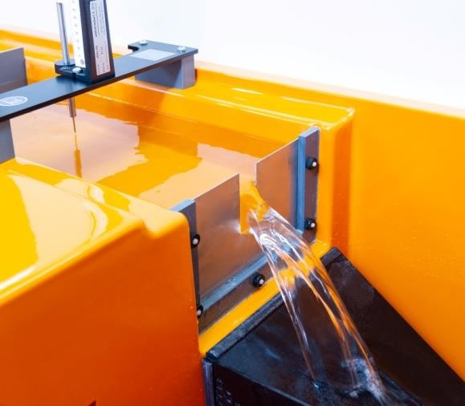
PART-A (HYDRAULICS) CHAPTER:-02 [KINEMATICS OF FLUID FLOW]

FLOW OVER NOTCHES AND WEIRS
Notch.
  - A notch may be defined as an opening provided in the side of a tank or vessel such that the liquid surface in the tank is below the top edge of the opening.
  - It is generally made of metallic plate.
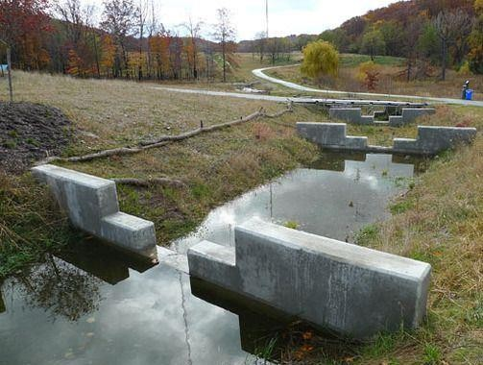
  - It is used for measuring the rate of flow of a liquid through a small channel or a tank.
  - The notch is of small in size. Weir.
  - A weir may be defined as any regular obstruction in an open stream over which the flow takes place.
  - It is made of masonry or concrete.

  - The conditions of flow in the case of a weir are practically the same as those of a rectangular notch.
  - The weir is of bigger in size.
  - Weirs may be used for measuring the rate of flow of water in rivers or streams.
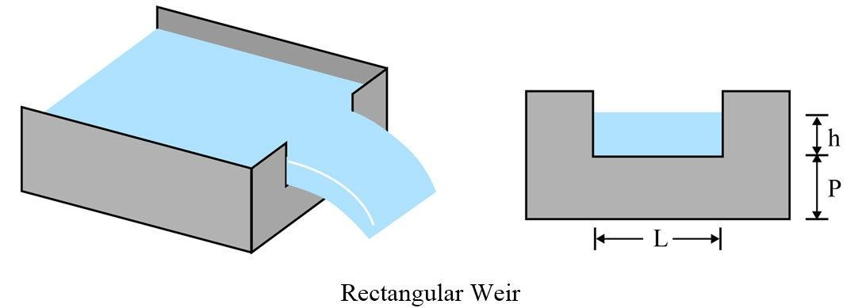
Nappe or vein. The sheet of water flowing through a notch or over a weir is known as the nappe or vein.
Sill or crest. The top of the weir over which the water flows is known as the sill or crest.

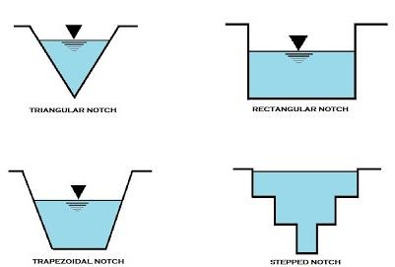
TYPES/CLASSIFICATION OF NOTCHES AND WEIRS
Types of Notches:
There are several types of notches, depending upon their shapes.
- Rectangular notch, 2. Triangular notch,
3. Trapezoidal notch, and 4. Stepped notch.

Types of Weirs:
There are several types of weirs depending upon their shapes, nature of discharge, width of crest or nature of crest.
- According to shape:
  - Rectangular weir, and
  - Cippoletti weir.
- According to nature of discharge:
  - Ordinary weir, and
  - Submerged or drowned weir.
- According to the width of crest:
  - Narrow-crested weir, and
  - Broad-crested weir.
4. According to the nature of crest:

- Sharp-crested weir, and
- Ogee weir.
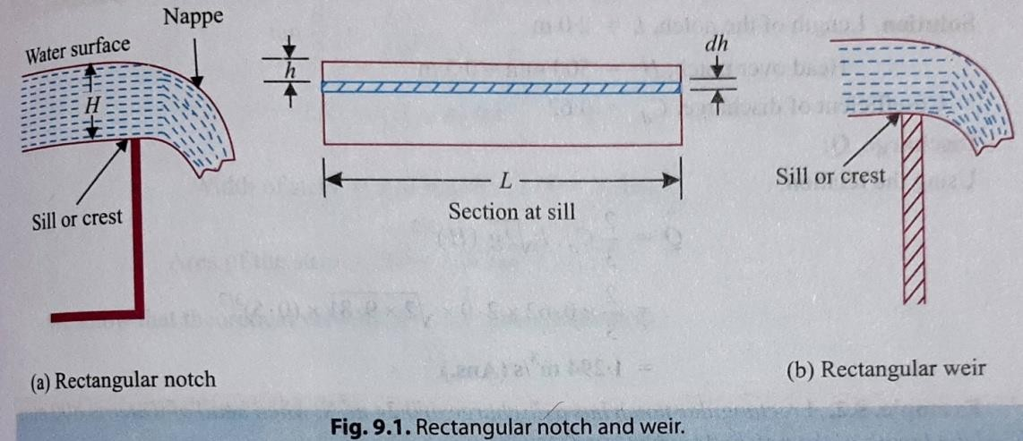
DISCHARGE OVER A RECTANGULAR NOTCH OR WEIR
Q =
𝟐
𝟑
𝟑
× 𝑪_{𝒅} × L × √𝟐𝒈 × (𝑯)𝟐
Where, H = Height of water above sill of
the notch,
L = Length of notch or weir, and
𝑪𝒅 = Co-efficient of discharge.
Example. A rectangular notch 2.0 m wide has a constant head of 500 mm. Find discharge over the notch, if co-efficient of discharge for the notch is 0.62.
Solution. Length of the notch, L = 2.0 m
Head over notch, H = 500 mm = 0.5 m Co-efficient of discharge, 𝑪𝒅= 0.62

Discharge, Q:
Using the relation,
𝟐 𝟑
Q = 𝟑 × 𝑪_{𝒅} × L × √𝟐𝒈 × (𝑯)𝟐
𝟐 𝟑
= x0.62 × 2.0 × √𝟐 × 𝟗. 𝟖𝟏 × (𝟎. 𝟓)𝟐
𝟑
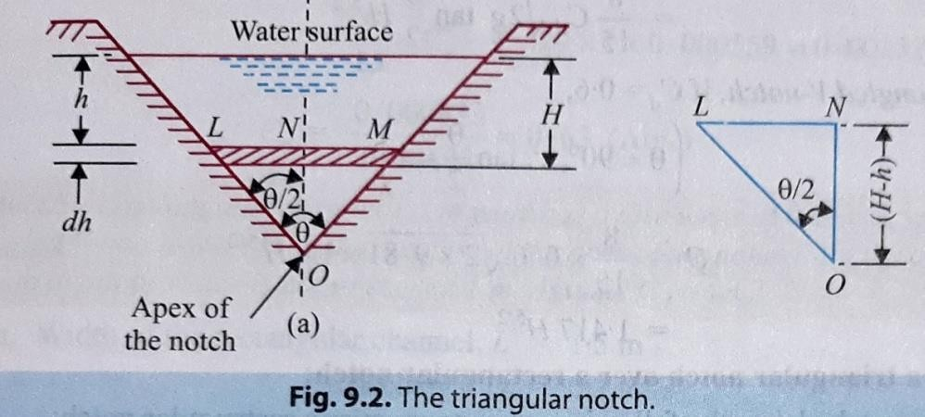
= 1.294 m³/s (Ans.) DISCHARGE OVER A TRIANGULAR NOTCH OR WEIR
A triangular notch is also called a V-notch.

Q =
𝟖
𝟏𝟓
× 𝑪_{𝒅} × √𝟐𝒈 × 𝒕𝒂𝒏
𝜽
𝟐
𝟓
×(𝑯)𝟐

Where,

H = Head of water above the apex of the notch,
𝜽 = Angle of the notch, and
𝑪𝒅 = Co-efficient of discharge.

Example . Find the discharge over a triangular notch of angle 60° when the head over the triangular notch is 0.2 m. Assume 𝑪𝒅 = 0.6.
Solution. Angle of notch, 𝜽 = 60°
Depth of water, H = 0.2 m Co-efficient of discharge, 𝑪𝒅= 0.6
Discharge, Q:
Using the relation:
𝟖 𝜽 𝟓

Q = 𝟏𝟓 × 𝑪_{𝒅} × √𝟐𝒈 × 𝒕𝒂𝒏
𝟖
×(𝑯)𝟐
𝟐

𝟔𝟎° 𝟓

=
𝟏𝟓
𝟖
× 𝟎. 𝟔 × √𝟐 × 𝟗. 𝟖𝟏 × 𝒕𝒂𝒏
×(𝟎. 𝟐)𝟐
𝟐

=
𝟏𝟓
× 𝟎. 𝟔 × 4.429 × 0.577 × 0.01788

= 0.01462 m³/s (Ans.)

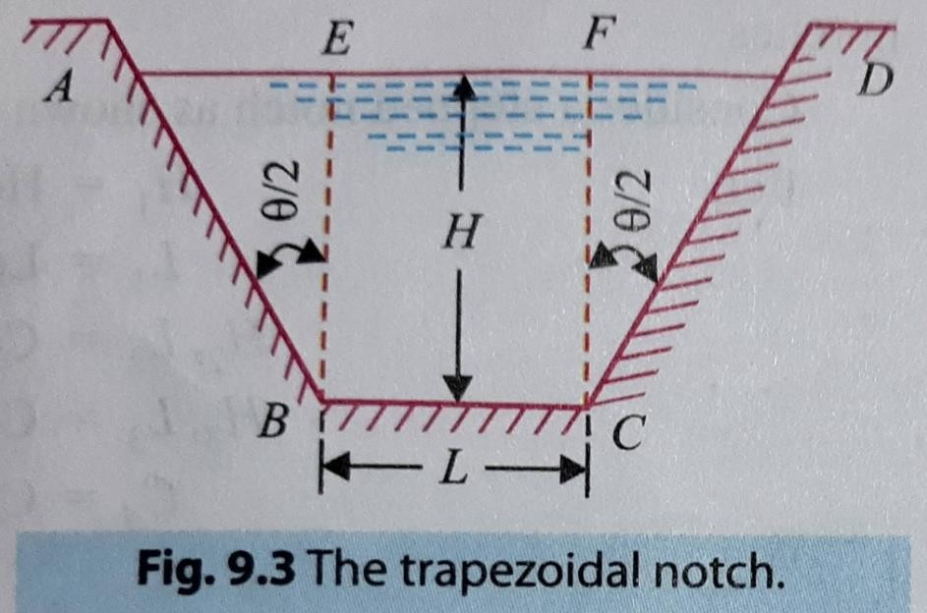
Q =
𝟐
𝟑
𝟑
× 𝑪_{𝒅𝟏} × L × √𝟐𝒈 × (𝑯)𝟐 +
𝟖
𝟏𝟓
× 𝑪_{𝒅𝟐} × √𝟐𝒈 × 𝒕𝒂𝒏
𝜽
𝟐
𝟓
× (𝑯)𝟐

DISCHARGE OVER A TRAPEZOIDAL NOTCH OR WEIR
A trapezoidal notch or weir which is a combination of a rectangular and a triangular notch or weir.

Where, H = Height of water over the notch,
L = Length of the rectangular portion (or crest) of the notch..
𝑪𝒅𝟏 = Co-efficient of discharge for rectangular portion, and
𝑪𝒅𝟐 = Co-efficient of discharge for triangular portion.
Example. Find the discharge through a trapezoidal notch which is 1.2 m wide at the top and 0.50 m at the bottom and is 0.4 m in height. The head of water on the notch is
0.3 m. Assume 𝑪𝒅 for rectangular portion = 0.62, while for triangular portion = 0.60.

Solution.

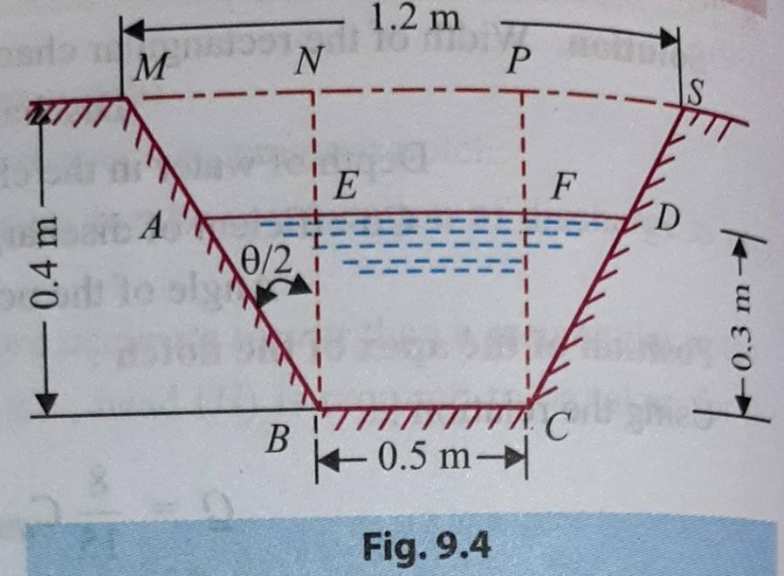
Top width =1.2 m Base width, L = 0.5 m
Head of water, H = 0.3 m

For rectangular portion, 𝑪𝒅𝟏= 0.62 For triangular portion, 𝑪𝒅𝟐= 0.60
Discharge, Q:
From ∆ MNB, we have:

𝒕𝒂𝒏 𝜽
𝑴𝑵 (𝑴𝑺−𝑵𝑷)/𝟐 (𝟏.𝟐−𝟎.𝟓)/𝟐
= = = = = 0.875

𝟐 𝑵𝑩
𝑵𝑩
𝟎.𝟒

Discharge through the trapezoidal notch is given by,

𝟐 𝟑 𝟖
𝜽 𝟓

Q = 𝟑 × 𝑪_{𝒅𝟏} × L × √𝟐𝒈 × (𝑯)𝟐 + 𝟏𝟓 × 𝑪_{𝒅𝟐} × √𝟐𝒈 × 𝒕𝒂𝒏
× (𝑯)𝟐
𝟐

𝟐 𝟑
Q = × 𝟎. 𝟔𝟐 × 0.5 × √𝟐 × 𝟗. 𝟖𝟏 × (𝟎. 𝟑)𝟐 +
𝟑
𝟖

𝟏𝟓
𝟓

× 𝟎. 𝟔 × √𝟐 × 𝟗. 𝟖𝟏 × 𝟎. 𝟖𝟕𝟓 ×(𝟎. 𝟑)𝟐

= 0.1504 + 0.0611 = 0.2115 m³/s (Ans.)

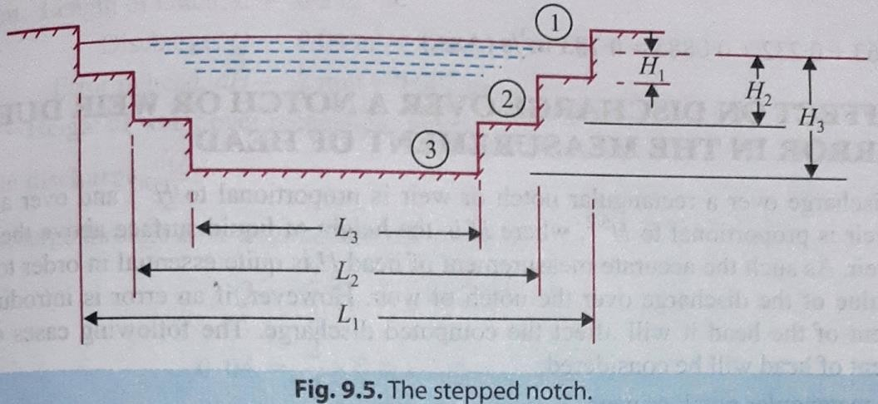
DISCHARGE OVER A STEPPED NOTCH
A stepped notch is a combination of rectangular notches.
Total discharge, Q = Q₁+Q₂+Q₃
× 𝑪_{𝒅} × L₁ × √𝟐𝒈 × (𝑯_{𝟏})𝟐 + × 𝑪_{𝒅} × L₂ × √𝟐𝒈 × [ 𝑯𝟐
𝟐
𝟑/𝟐
𝟑
− 𝑯𝟏 ] +
𝟐
𝟑
× 𝑪_{𝒅} × L₃ × √𝟐𝒈 ×
[ 𝑯𝟑/𝟐 − 𝑯𝟑/𝟐 ]
𝟑
𝟐
𝟑/𝟐
Q =
𝟐
𝟑
𝟑

Where, H₁ = Height of water above sill of notch 1,
L₁ = Length of notch 1,
H₂, L₂ =Corresponding values for notch 2,
H₃, L₃ =Corresponding values for notch 3, and
𝑪𝒅 = Co-efficient of discharge for all notches.
Example. Find the discharge over a stepped rectangular notch, as shown in Fig. 9-6. Co-efficient of discharge for all the portions as 0.62.

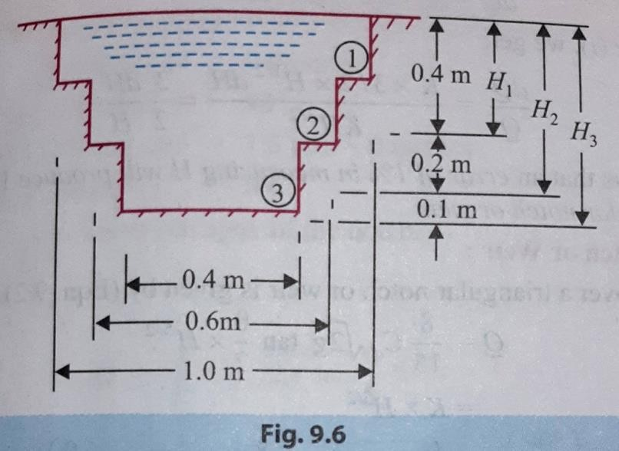
Solution. Co-efficient of discharge, 𝑪𝒅 = 0.62 Let, Q₁ = Discharge over the top portion,
Q₂ = Discharge over the middle portion, and
Q₃ = Discharge over the bottom portion.
The total discharge over the notch,
Q = Q₁+2₂+Q₃

𝟐 𝟑 𝟐
𝟑/𝟐
𝟑/𝟐 𝟐

= 𝟑 × 𝑪_{𝒅} × L₁ × √𝟐𝒈 × (𝑯_{𝟏})𝟐 + 𝟑 × 𝑪_{𝒅} × L₂ × √𝟐𝒈 × [ 𝑯𝟐
× [ 𝑯𝟑/𝟐 − 𝑯𝟑/𝟐 ]
− 𝑯𝟏
] + 𝟑 × 𝑪_{𝒅} × L₃ × √𝟐𝒈

𝟑 𝟐
𝟐

𝟑 𝟐 𝟑

= × 𝟎. 𝟔𝟐 × 1.0 × √𝟐 × 𝟗. 𝟖𝟏 × (𝟎. 𝟒)𝟐 +
𝟑 𝟑
× 𝟎. 𝟔𝟐 × 0.6 × √𝟐 × 𝟗. 𝟖𝟏 × [ 𝟎. 𝟔𝟐 −

𝟑 𝟐
𝟑 𝟑

𝟎. 𝟒𝟐] +
× 𝟎. 𝟔𝟐 × 0.4 × √𝟐𝒈 × [ 𝟎. 𝟕𝟐 − 𝟎. 𝟔𝟐 ]
𝟑

= 0·463 + 0·232 +0.0885 = 0.783 m³/s (Ans.)


PART-A (HYDRAULICS) CHAPTER:-02 [KINEMATICS OF FLUID FLOW]

Losses of head of a liquid flowing through pipes:
When water flows in a pipe, it experiences some resistance to its motion, due to which its velocity and ultimately the head of water available is reduced.
This loss of energy (or head) is classified as follows:
- Major Energy Losses
This loss is due to friction.
- Minor Energy Losses
These losses are due to: 1. Sudden enlargement of pipe,
- Sudden contraction of pipe,
- Bend of pipe,
- An obstruction in pipe,
- Pipe fittings, etc.
Major Energy Losses: Darcy-Weisbach Formula:-

The loss of head (or energy) in pipes due to friction is calculated from Darcy- Weisbach formula which is given by:
𝒉
𝒇
𝟒𝒇𝑳𝑽
=
𝟐
𝑫×𝟐𝒈
Where, 𝒉_{𝒇} = Loss of head due to friction,
f = Co-efficient of friction, (a function of Reynolds number, Re)

𝟎.𝟎𝟕𝟗𝟏
= (𝑹𝒆)𝟏/𝟒
𝟏𝟔
for Re varying from 4000 to 10⁶

=
𝑹𝒆
for Re< 2000 (laminar/viscous flow)

L = Length of the pipe,
V = Mean velocity of flow, and
D = Diameter of the pipe.
Example. In a pipe of diameter 350 mm and length 75 m water is flowing at a velocity of 2.8 m/s. Find the head lost due to friction using, Darcy-Weisbach formula; Assume kinematic viscosity of water as 0.012 stoke.
Solution.
Diameter of the pipe, D = 350 mm=0.35 m Length of the pipe, L = 75 m

Velocity of flow, V = 2.8 m/s
Kinematic viscosity of water, ν =0.012 stoke=0.012 × 10⁻⁴ m²/s.
( ‘.’ 1 stoke=1 cm²/s = 1 × 10⁻⁴ m²/s )
Head lost due to friction, 𝒉_{𝒇} :
Darcy-Weisbach formula is given by:

𝒉𝒇
𝟒𝒇𝑳𝑽𝟐
=
𝑫×𝟐𝒈

Where, f= coefficient of friction (a function of Reynolds number, Re)

𝑹 = 𝑽 × 𝑫 = 𝟐.𝟖 ×𝟎.𝟑𝟓
= 8.167 × 10⁵

𝒆
.’. f =

𝝂
𝟎.𝟎𝟕𝟗𝟏
(𝑹𝒆)𝟏/𝟒 =

𝟎.𝟎𝟏𝟐 × 𝟏𝟎−𝟒
𝟎.𝟎𝟕𝟗𝟏
(𝟖.𝟏𝟔𝟕 × 𝟏𝟎𝟓)𝟏/𝟒 = 0.00263

.’. Head lost due to friction,
𝒉_{𝒇}

𝟒 ×𝟎.𝟎𝟎𝟐𝟔𝟑 ×𝟕𝟓 ×(𝟐.𝟖)𝟐
= = 0.9m (Ans.)
𝟎.𝟑𝟓 ×𝟐 ×𝟗.𝟖𝟏

Example. Water flows through a pipe of diameter 300 mm with a velocity of 5 m/s. If
𝟎.𝟎𝟖
the co-efficient of friction is given by f = 0.015+(𝑹𝒆)𝟎.𝟑 where Re is the Reynolds
number, find the head lost due to friction for a length of 10 m. Take kinematic viscosity of water as 0.01 stoke.
Solution. Diameter of the pipe, D = 300 mm=0.3 m

Velocity of flow, V = 5 m/s Length of the pipe, L = 10 m
Kinematic viscosity of water, ν = 0.01 stoke = 0.01 x 10⁻⁴ m²/s.
( ‘.’ 1 stoke=1 cm²/s = 1 × 10⁻⁴ m²/s )

Head lost due to friction, 𝒉_{𝒇} :

𝟎.𝟎𝟖

Co-efficient of friction, f = 0.015 + (𝑹𝒆)𝟎.𝟑

But, Reynolds number, 𝑹
= 𝑽 × 𝑫 = 𝟓 × 𝟎.𝟑
= 1.5 × 10⁶

𝒆 𝝂

𝟎.𝟎𝟏 × 𝟏𝟎−𝟒
𝟎.𝟎𝟖

.’. f = 0.015 + (𝟏.𝟓 × 𝟏𝟎𝟔)𝟎.𝟑 = 0.0161
.’. Head lost due to friction,

𝒉_{𝒇}
𝟒𝒇𝑳𝑽𝟐
=
𝑫×𝟐𝒈
𝟒 ×𝟎.𝟎𝟏𝟔𝟏 × 𝟏𝟎 × 𝟓𝟐
=
𝟎.𝟑 ×𝟐 ×𝟗.𝟖𝟏
= 2.735 m (Ans.)

HYDRAULIC GRADIENT AND TOTAL ENERGY LINES

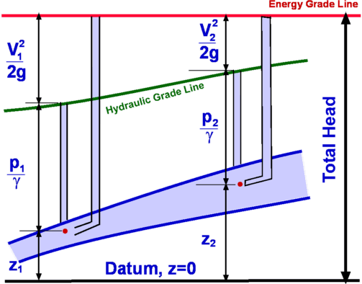
HYDRAULIC GRADIENT LINE (H.E.L):
It is defined as the line which gives the sum of
𝒑

pressure head (
𝒘
) & datum head (z) of a flowing
𝒑

fluid in a pipe w.r.t some reference line. (i.e.,
+ z)
𝒘

TOTAL ENERGY LINES / ENERGY GRADIENT LINE (E.G.L.) / (T.E.L):
It is defined as the line which gives the sum of
the elevation (potential) head, pressure head and velocity head of a flowing fluid in a pipe w.r.t some reference line.

Assumptions;
Total head =
𝒑
+ z +
𝒘
𝑽𝟐

𝟐𝒈

- Energy gradient line (E.G.L.) always drops in the direction of flow because of loss of head .
- Hydraulic gradient line (H.G.L.) may rise or fall depending on the pressure changes.
- Hydraulic gradient line (H.G.L.) is always below the energy gradient line (E.G.L.)

Flow through the Open Channels:

Definition:
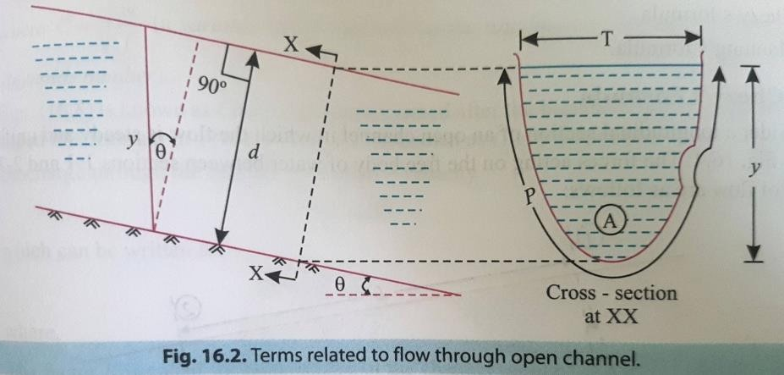
An open channel may be defined as a passage in which liquid flows with its upper surface exposed to atmosphere.
In open channels the flow is due to gravity, thus the flow conditions are greatly influenced by the slope of the channel.
- Depth of flow (y). It is the vertical distance of the lowest point of a channel section (bed of the channel) from the free surface.
- Top width (T). It is the width of the channel section at the free surface.
- Wetted area (A). It is the cross-sectional area of the flow section of the channel.
- Wetted perimeter (P). It is the length of the channel boundary in contact with the flowing water at any section.
- Hydraulic radius (R). It is ratio of the cross-sectional area of flow to wetted perimeter. It is also called hydraulic mean depth.
𝑨
i.e. R =
𝑷
- Hydraulic depth (D). It is the ratio of the wetted area A to the top width T.

𝑨
i.e. D =
𝑻

Discharge through open channel by Chezy's formula:
Discharge through the channel, Q = Area x velocity
Q = AC √𝑹𝑺

From Chezy's formula,

V = C √𝑹𝑺
Where, A = Area of the flow of water C = Chezy's constant.
R = Hydraulic radius or hydraulic mean depth.
S = slope of the channel bed

Empirical formula for the value of Chezy's Constant
- Bazin's formula:
𝟏𝟓𝟕.𝟔
C = 𝟏𝟖𝟏+ 𝑲
√𝑹
Where, K = Bazin's constant whose value depends on surface roughness.
R = Hydraulic radius or hydraulic mean depth.

- Kutter's formula:
𝟐𝟑+ 𝟎.𝟎𝟎𝟏𝟓𝟓+ 𝟏
C = 𝑺 𝑵
𝟏+(𝟐𝟑+ 𝟎.𝟎𝟎𝟏𝟓𝟓 𝑵
)
𝑺 √𝑹
Where, N = Kutter's constant whose value depends upon the type of the channel surface.
R = Hydraulic radius or hydraulic mean depth.
S = slope of the channel bed
- Manning’s formula:
C = 𝟏 . 𝑹^{𝟏/𝟔}
𝑵
Where, N = Manning's constant whose value depends upon the type of the channel surface.
R = Hydraulic radius or hydraulic mean depth.

MOST ECONOMICAL SECTION OF A CHANNEL
The most economical section (also called the best section or most efficient section) is one which gives the maximum discharge for a given amount of excavation.
A section of a channel is said to be most economical when the cost of construction of the Channel is Minimum, But the cost of construction of a channel

depends upon the excavation and the lining. To keep the cast down on minimum, the wetted perimeter, for a given discharge, should be minimum.

Q = AC √𝑹𝑺

Discharge, Q =AC √𝑨×𝑺
𝑷

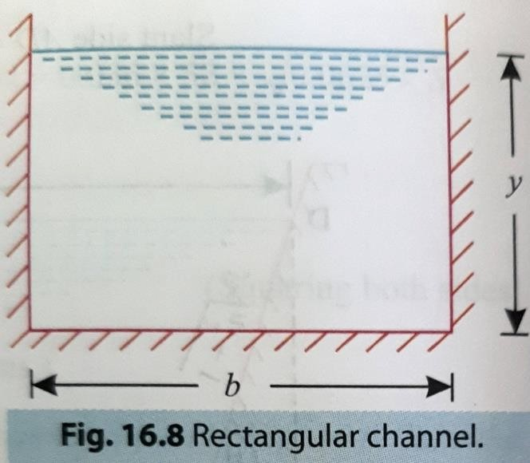
𝑨
Where, R =
𝑷

Q will be maximum, when the wetted perimeter P is minimum.

Most Economical Rectangular Channel Section:
Let b and y be the base width and depth of flow respectively.
Area of flow, A = b x y, (i)
Wetted perimeter, P = b + 2y (ii)
𝑨

Substituting the value of b ( =
) from eqn. (i) in eqn. (ii), we get:
𝒚
𝑨

P = + 2y
𝒚

For the section to be most economical/efficient, the wetted perimeter P must be a minimum.

i.e.,
𝒅𝑷

𝒅𝒚
𝑨
= 0 or
𝒅 [
𝒅𝒚
^{𝑨} + 𝟐𝒚 ] = 0
𝒚

or, -
𝒚
+ 𝟐 = 𝟎 or A = 2y² or b x y = 2y² [‘.’ A = b x y]

𝒃
or, b = 2y or y=
𝟐

Hydraulic radius, R :
Hydraulic radius, R =

𝑨 𝒃 ×𝒚
=
𝑷 𝒃+𝟐𝒚

𝒚
i.e., R =
𝟐
𝟐𝒚 ×𝒚
=
𝟐𝒚+𝟐𝒚
𝟐𝒚𝟐 𝒚
= =
𝟒𝒚 𝟐
[‘.’ b = 2y ]

Thus the rectangular channel section will be most economical when:

𝒃
- The depth of flow is equal to half the base width ( y=
𝟐
) , or

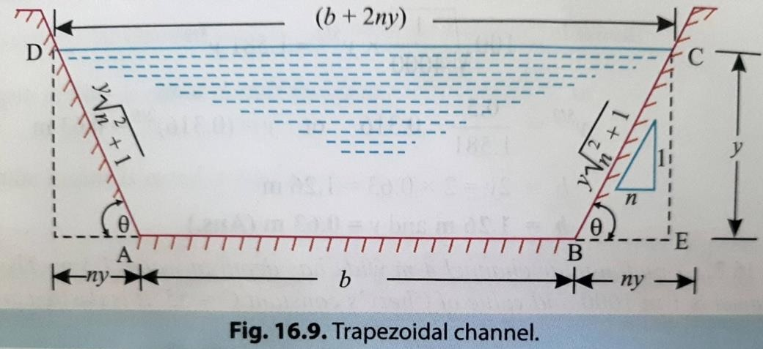
- Hydraulic radius is equal to half the depth of
𝒚
flow ( R= ).
𝟐

Most Economical Trapezoidal Channel Section:
Let b = Base width of the channel, y= Depth of flow, and
Ө = Angle made by the sides with horizontal.
Side slope = 1 vertical to n horizontal.

Area of flow, A = (
𝑨𝑩+𝑪𝑫

𝟐
)× y =
𝒃+(𝒃+𝟐𝒏𝒚)

𝟐
× y = (𝒃 + 𝒏𝒚)y (i)

.’.
^{𝑨} = 𝒃 + 𝒏𝒚
𝒚
𝑨

Or, b =
– ny (ii)
𝒚

Wetted perimeter, P = AD + AB+ BC = AB+ 2BC (‘.’ AD=BC)

=b+2√𝑩𝑬² + 𝑪𝑬²

= b + 2√𝒏²𝒚² + 𝒚²

Or, P = b + 2y √𝒏² + 𝟏 (iii)
Substituting the value of ‘b’ from eqn. (ii) in eqn. (iii), we get:

𝑨
P = – ny+ 2y
𝒚

√𝒏² + 𝟏 (iv)

The section of the channel will be most economical when its wetted perimeter (P) is minimum,

i.e.,
𝒅𝑷
=0
𝒅𝒚

𝒅 𝑨
or, [
𝒅𝒚 𝒚
– ny + 2y

√𝒏² + 𝟏] = 0

𝑨
or, − 𝒚𝟐

– n + 2 √𝒏² + 𝟏 = 0

𝑨
or, 𝒚𝟐

+ n = 2 √𝒏² + 𝟏

Substituting the value of A from eqn. (i), in the above equation, we get:

^{(𝒃+𝒏𝒚)𝒚} + n = 2 √𝒏² + 𝟏
𝒚
𝟐

Or, (𝒃+𝒏𝒚) + n = 2 √𝒏² + 𝟏
𝒚

𝒃+𝒏𝒚+𝒏𝒚
Or,
𝒚

= 2 √𝒏² + 𝟏

𝒃+𝟐𝒏𝒚
Or,
𝒚
𝒃+𝟐𝒏𝒚
Or,
𝟐

= 2 √𝒏² + 𝟏

= y √𝒏² + 𝟏

[i.e. Half of top width = One of the sloping sides...] Hydraulic radius, R:

𝑨
Hydraulic radius, R =
𝑷

A = (𝒃 + 𝒏𝒚)y

P = b + 2y √𝒏² + 𝟏

But, 2y √𝒏² + 𝟏 = 𝒃 + 𝟐𝒏𝒚
.’. P = b + (b+2ny) = 2(b + ny)

.’. Hydraulic radius, R =
(𝒃+𝒏𝒚)𝒚 𝒚
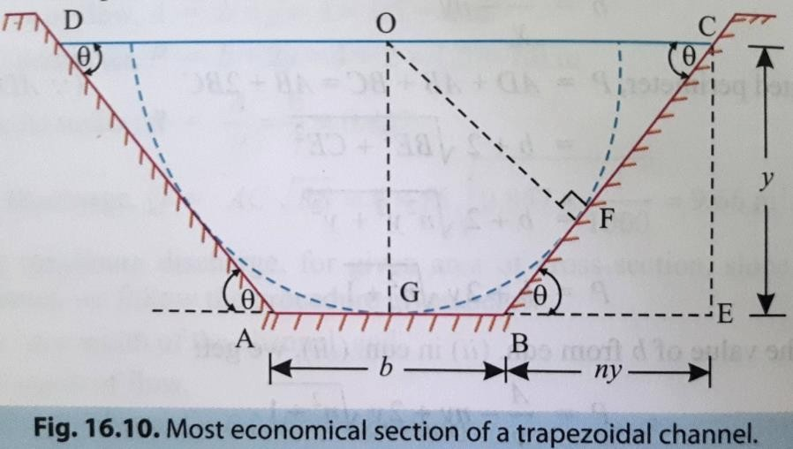
=
𝟐(𝒃 + 𝒏𝒚) 𝟐

i.e., The hydraulic radius equals half the flow depth.

Let, Ө = Angle made by the sloping side with the horizontal,
O = Centre of the top width DC, and
OF = A perpendicular to the sloping side BC.

The ∆OCF is then a right angled triangle with ∠OCF = Ө
𝑶𝑭
.’. sinӨ = or OF = OC sinӨ (iv)
𝑶𝑪

Also, from ∆BCE, sinӨ = 𝑪𝑬 = 𝒚
𝒚 𝟏
= =

𝑩𝑪
√𝒚² + 𝒏² 𝒚 ²
𝒚√𝒏² + 𝟏
√𝒏² + 𝟏

Substituting the value of sinӨ in eqn. (iv), we have

𝟏
OF = OC ×
√𝒏² + 𝟏

= 𝒚√𝒏² + 𝟏 × 𝟏
√𝒏² + 𝟏
= y, depth of flow

Thus a circle with centre O and radius equal to the depth of flow will be tangential to the three sides of a most economical trapezoidal section; this condition stipulates that the most economical section of a trapezoidal channel will be a half-hexagon.

Hence conditions for most economical trapezoidal section are:

𝒃+𝟐𝒏𝒚

𝟐

= y √𝒏² + 𝟏 (i.e. Half of top width = One of the sloping sides.)
𝒚

- Hydraulic radius, R =
𝟐
- A semicircle drawn from O with radius equal to depth of flow will touch the three sides of the trapezoidal channel.

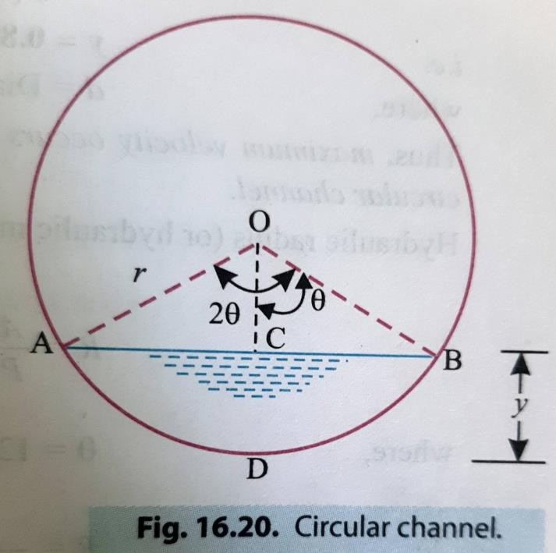
Most Economical Circular Channel Section:
d = Diameter of the circular channel
Condition for maximum discharge:
R = 0.29 d y = 0.93 d
Condition for max. mean velocity of flow: R = 0.30 d y = 0.81 d

***end***

PART-A (HYDRAULICS)
CHAPTER:-03 [PUMPS]
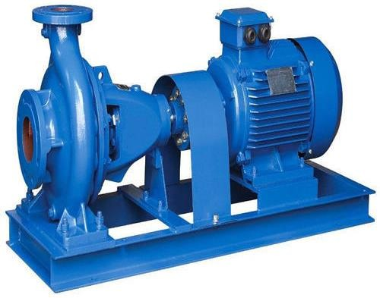
- Pump is a hydro- mechanical device which converts the mechanical energy into hydraulic energy. The pumps are used as water handling device.

Type of pumps
- Centrifugal pump
- Reciprocating pump
- Centrifugal pump:
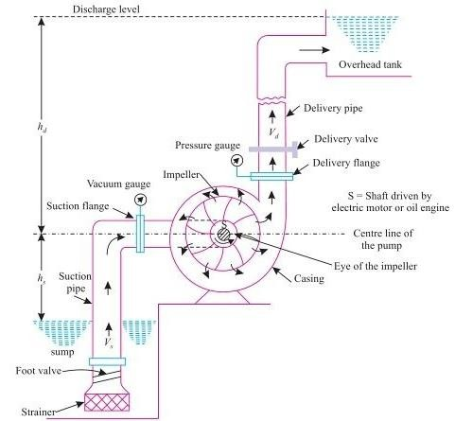
  - If the mechanical energy is converted into hydraulic energy, by means of centrifugal force acting on the liquid, the pump is known as centrifugal pump.
Main Parts of Centrifugal tamp
The following are the main parts of centrifugal pump:
- Impeller
- Casing
- Suction pipe with foot Valve

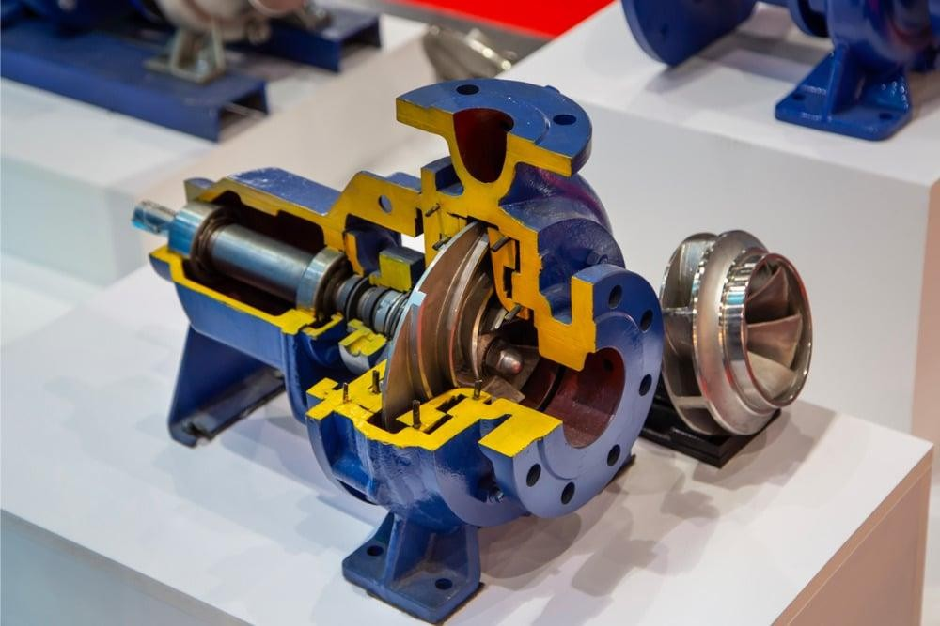
- Delivery Pipe.
- Impeller:
  - The rotating part of the centrifugal pump is called as Impeller. It consists of series of backward curved vanes.
  - It is mounted on a shaft which is connected to the shaft of an electric motor.
- Casing:
  - It is an air tight passing covering surrounding the impeller and is designed in such a way that the kinetic energy of the water discharged at the outlet of the impeller is converted into pressure energy before the water leaves the casing and enters the delivery pipe.
  - The casings are of 3 types: 1.Volute Casing.
- Vortex Casing.
- Casing with guide blades.

- Suction pipe with foot Valve:
  - This is a pipe whose one end is connected to the inlet of the pump and other end is dip in the sump.
  - A foot valve which is a non returning valve or one way valve fitted at the lower end of suction pipe.
- Delivery Pipe:
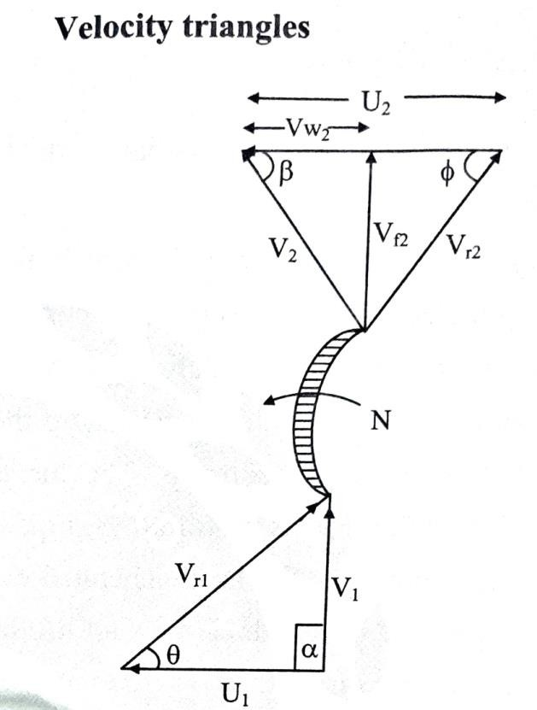
  - A pipe pump whose one end is connected to the outlet of the pump and other end delivers water to required height.

Let,
N = Speed of the impeller in r.p.m.
D₁ = Diameter of impeller at inlet
U = Tangential velocity of impeller at inlet, = 𝝅𝑫𝟏𝑵
1
𝟔𝟎
D₂ = Diameter of impeller at outlet.
U = Tangential velocity of impeller at outlet, = 𝝅𝑫𝟐𝑵
2
𝟔𝟎

V₁ = Absolute velocity of water at inlet. V_{r1} = Relative velocity of water at inlet.
𝜶 = Angle made by absolute velocity (v₁) at inlet with the direction of motion of vane.
𝜽= Angle made by relative velocity (V_{r1}) at inlet with the direction of motion of vane. And V₂, V_{r2}, 𝜷 and ∅ are corresponding values at outlet.
As the water enters the impeller radially which means the absolute velocity of water at inlet is in the radial direction and hence,
𝜶 = 90° , V_{w1} = 0
Work done by impeller on water per second = . V_{w2} . U₂
𝑾
𝒈
Where, W = weight of water
Discharge through pump = 𝝅𝑫𝟐𝑩𝟐𝑽𝒇𝟐 = 𝝅𝑫𝟏𝑩𝟏𝑽𝒇𝟏

Where, B₁ and B₂ = width of impeller at inlet and outlet
𝑽𝒇𝟏 and 𝑽𝒇𝟐 = Velocity of flow at inlet & outlet respectively
Head developed by the impeller is 𝐕𝐰𝟐 .𝐔𝟐 .
𝒈
(Losses neglected)

Manometric Efficiency:

Պ𝒎𝒂𝒏𝒐
𝐦𝐚𝐧𝐨𝐦𝐞𝐭𝐫𝐢𝐜 𝐡𝐞𝐚𝐝
=
𝐇𝐞𝐚𝐝 𝐝𝐞𝐯𝐞𝐥𝐨𝐩𝐞𝐝 𝐭𝐡𝐞 𝐢𝐦𝐩𝐞𝐥𝐥𝐞𝐫
= 𝑯𝒎
𝐕𝐰𝟐 .𝐔𝟐 .
𝒈

Manometric head (H_{m}) = Difference in pressure gauges across the pump impeller in
meter.
𝑽𝟐
𝒅
H_{m}=h_{s}+h_{d}+h_{fs}+ h_{fd} +
𝟐𝒈
Where, h_{s} = Suction head.
h_{d} = Delivery head
h_{fs} = frictional head loss in Suction
h_{fd} = frictional head loss in delivery pipe V_{d} = Velocity of water in delivery pipe.

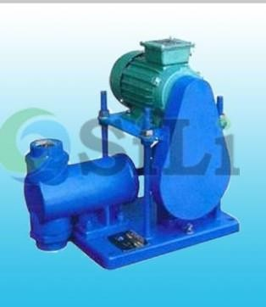
Reciprocating pump:
  - But if the mechanical energy is converted into hydraulic energy (or pressure energy) by sucking the liquid into a cylinder in which a piston is reciprocating (moving backwards and forwards), which exerts the thrust on the liquid and increases its hydraulic energy (pressure energy), the pump is known as reciprocating pump.

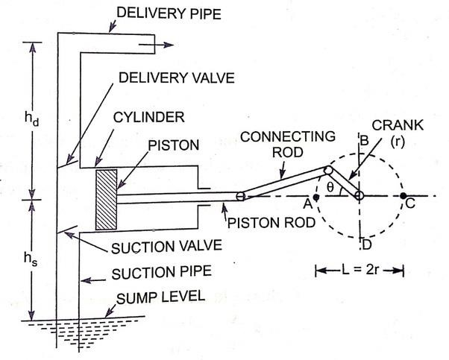
MAIN PARTS OF A RECIPROCATING PUMP
- A cylinder with a piston, piston rod, connecting rod and a crank,
- Suction pipe,
- Delivery pipe,
- Suction valve, and
- Delivery valve.
WORKING OF A RECIPROCATING PUMP
  - The crank is rotated by means of an electric motor.
Suction and delivery pipes with suction valve and
delivery valve are connected to the cylinder. The suction and delivery valves are one way valves or non-return valves, which allow the water to flow in one direction only.
  - Suction valve allows water from suction pipe to the cylinder which delivery valve allows water from cylinder to delivery pipe only.
  - When crank starts rotating, the piston moves to and fro in the cylinder. The movement of the piston towards right creates a partial vacuum in the cylinder.
  - But on the surface of the liquid in the sump atmospheric pressure is acting, which is more than the pressure inside the cylinder. Thus, the liquid is forced in the suction pipe from the sump. This liquid opens the suction valve and enters the cylinder.
  - The movement of the piston towards left increases the pressure of the liquid inside the cylinder more than atmospheric pressure.
  - Hence suction valve closes and delivery valve opens. The liquid is forced into the delivery pipe and is raised to a required height.

Discharge through Reciprocating Sump:
(For single acting Pump) (For double acting Pump)
𝐀𝐋𝐍
Q =
𝟔𝟎
𝟐𝐀𝐋𝐍
Q =
𝟔𝟎

Where, A = c/s area of piston or Cylinder L = length of stroke = 2 × r
N = speed of pump

Power (P):
For Single Acting, P = 𝛒𝐠(𝐡𝐬+𝐡𝐝)𝐀𝐋𝐍
𝟔𝟎

For double Acting, P = 𝟐𝛒𝐠(𝐡𝐬+𝐡𝐝)𝐀𝐋𝐍
𝟔𝟎

Watt

Watt

CLASSIFICATION OF RECIPROCATING PUMPS
- According to the contact of water:
  - Single-acting pump, and (ii) Double-acting pump.
- According to the number of cylinder provided:
(i) Single cylinder pump, (ii) Double cylinder pump, and (iii) Triple cylinder pump.
***end***

PART-B (IRRIGATION ENGINEERING)
CHAPTER:-01 [HYDROLOGY]
DEFINITION
The science of studying the different forms of water available above the earth surface or below the earth surface is known as hydrology. It includes the following points.
- The measurement of precipitation, (i.e. rainfall).
- The study of water losses due to transpiration, evaporation, absorption and infiltration.
- Estimation of run-off and peak flow.
- The procedure of river gauging.
- Preparation of hydrograph to predict maximum food discharge.
- The procedure of river training works.
- The procedure of flood forecasting and flood control works.
- Availability of underground water.

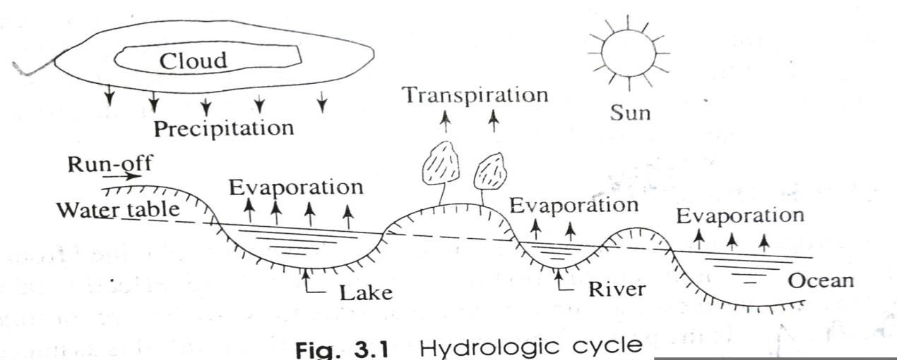
HYDROLOGIC CYCLE
- The water of the universe always changes from one state to other under the effect of the sun.
- The water from the surface sources like lakes, rivers, ocean, etc. converts to vapour by evaporation due to solar heat.
- The vapour goes on accumulating continuously in the atmosphere. This vapour is again condensed due to the sudden fall of temperature and pressure.
- Thus clouds are formed. These clouds again causes the precipitation (i.e. rainfall).
- Some of the vapour is converted to ice at the peak of the mountains. The ice again melts is summer and flows as rivers to meet the sea or ocean.
- These processes of evaporation, precipitation and melting of ice go on continuously like an endless chain and thus a balance is maintained in the atmosphere.
- This phenomenon is known as hydrologic cycle.

PRECIPITATION/RAINFALL AND ITS MEASUREMENT
Definition:
- From the principle of hydrologic cycle we have seen that water goes on evaporation continuously from the water surfaces on earth, (e.g. river, lake, sea, ocean, etc), by the effect of sun.
- The water vapour goes on collecting in the atmosphere up to a certain limit. When this limit exceeds and the temperature and pressure fall to a certain value, the water vapour will get condensed and thereby cloud is formed.
- Ultimately droplets are formed and returned to earth in the form of rain, snowfall, hail, etc. This is known as precipitation.
Types of Precipitation or Rainfall
Depending upon the various atmospheric conditions the precipitation may be of the following types.
- Cyclonic Precipitation:
  - This type of precipitation is caused by the difference of pressure within the air mass on the surface of the earth.
  - If low pressure is generated at some place the warm moist air from the surrounding area rushes to the zone of low pressure with violent force.

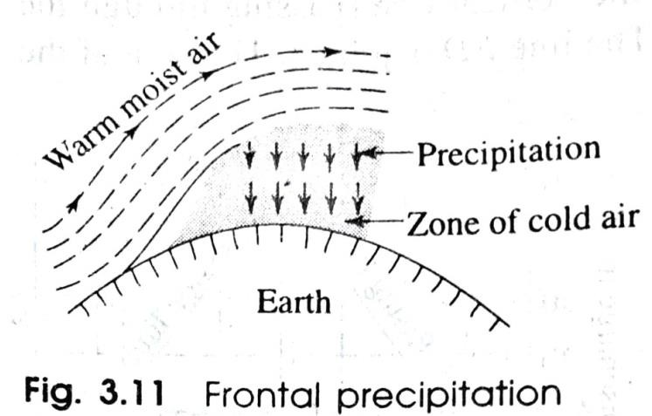
  - The warm moist air rises up with whirling motion and get condensed at higher altitude and ultimately heavy rain fall occurs.
  - This may be of two types.
- Frontal Precipitation
When the moving warm moist air mass is obstructed by the zone of cold air mass, the warm moist air rises up (as it is lighter than cold air mass) to higher altitude where it gets condensed and heavy rainfall occurs. This is known as frontal precipitation.

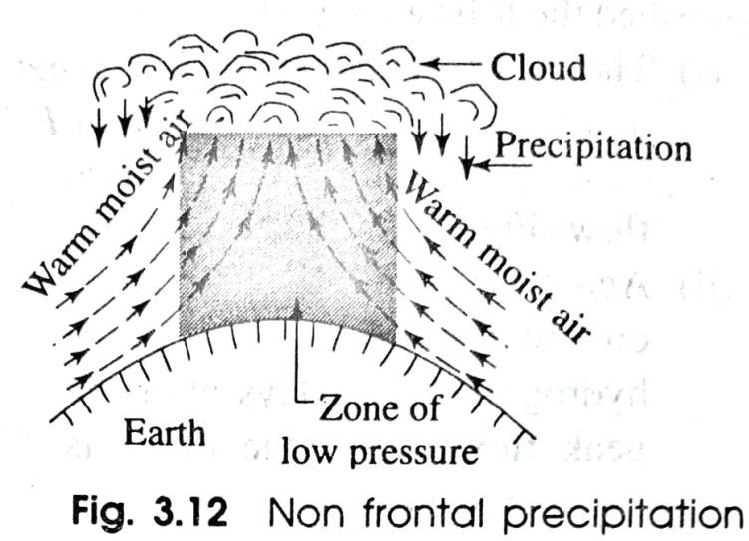
- Non Frontal Precipitation
When the warm moist air mass rushes to the zone of low pressure from the surrounding area, a pocket is formed and the warm moist air rises up like a chimney towards higher altitude. At higher altitude this air mass gets condensed and heavy rainfall occurs. This is known as non frontal precipitation.

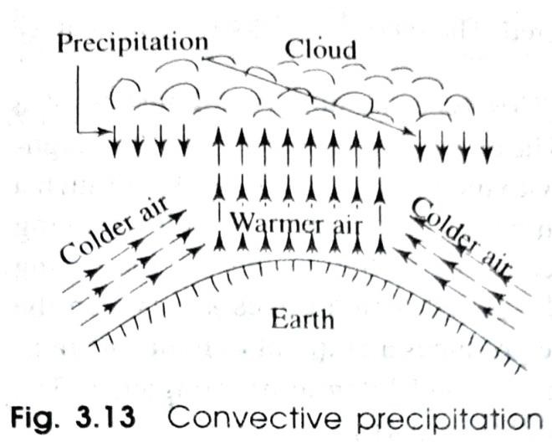
- Convective Precipitation:
  - In tropical countries when on a particular hot day the ground surface gets heated unequally, the warm air is lifted to high altitude and the cooler air takes its place with high velocity.
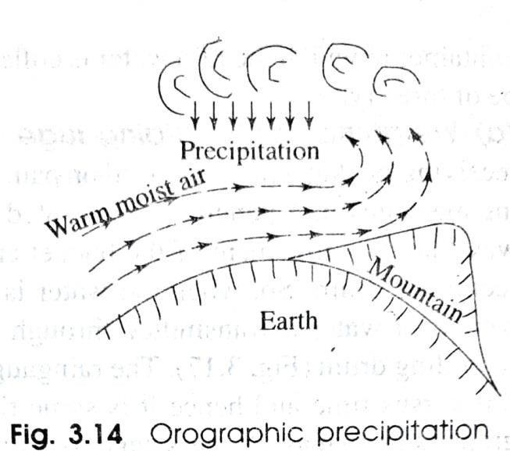
  - Thus, the warm moist air mass is condensed at the high altitude causing heavy rainfall. This is known as convective precipitation.
- Orographic Precipitation:
  - The moving warm moist air when obstructed by some mountain rises up to a high altitude. It then gets condensed and precipitation occurs. This is known as orographic precipitation.
Measurement of Rainfall (i.e. Precipitation)
  - The instrument which is used to measure the amount of rainfall is known as raingauge.
  - The principle of raingauge is that the amount of rainfall in a small area will represent the amount of rainfall in a large area provided the meteorological characteristics of both small and large area are similar.
  - The raingauges are of the following types.

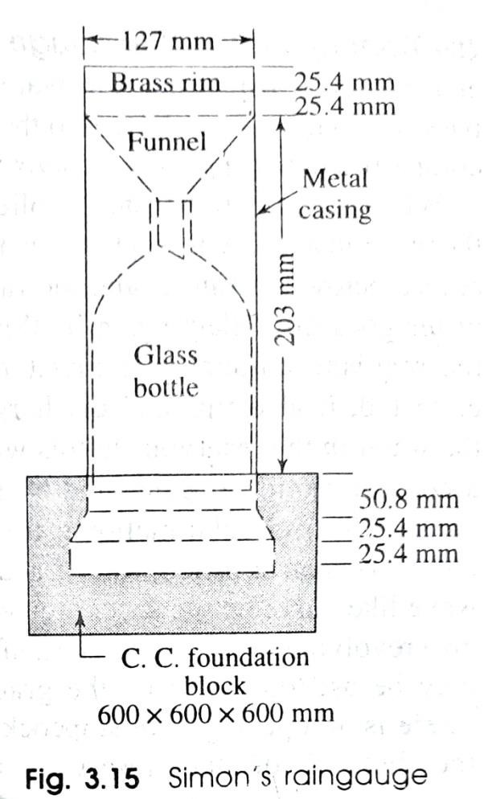
- Non-Recording Type Raingauge:
  - Simon's raingauge is a non-recording type of raingauge which is most commonly used.
  - It consists of metal casing of diameter 127 mm which is set on a concrete foundation A glass bottle of capacity about 100 mm of rainfall is placed within the casing. A funnel with brass rim is placed on the top of the bottle.
  - The rainfall is recorded at every 24 hours. Generally, the measurement is taken at 8.30 a.m. everyday.
  - In case of heavy rainfall the measurement should be taken 2 or 3 times daily so that the bottle does not overflows.
  - To measure the amount of rainfall the glass bottle is taken off and the collected water is measured in a measuring glass, and recorded in the raingauge record book.
  - When the glass bottle is taken off it is immediately re placed with a new bottle of same capacity.

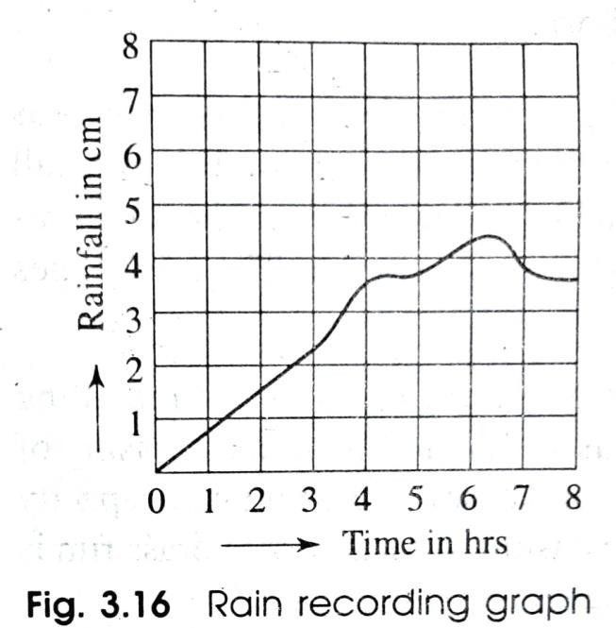
- Recording Type Raingauge:
  - In this type of raingauge, the amount of rain fall is automatically recorded on a graph paper by some mechanical device.
  - Here, no person is required for measuring the amount of rainfall from the container in which the rain water is collected.
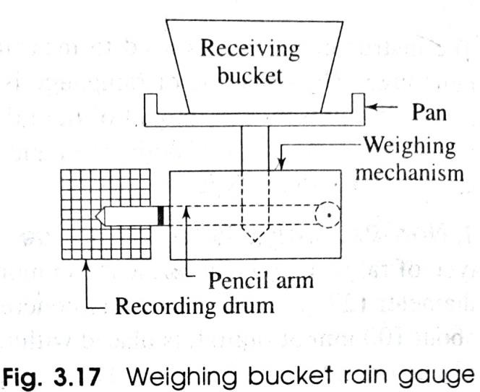
  - The recording type raingauge may be of three types.
- Weighing Bucket Raingauge
  - This type of raingauge consists of a receiving bucket which is placed on pan.
  - The pan is again fitted with some weighing mechanism. A pencil arm is pivoted with the weighing mechanism in such a way that the movement of the bucket can be traced by a pencil on the moving recording drum.
  - So, when the water is collected in the bucket the increasing weight of water is transmitted through the pencil which traces a curve on the recording drum.

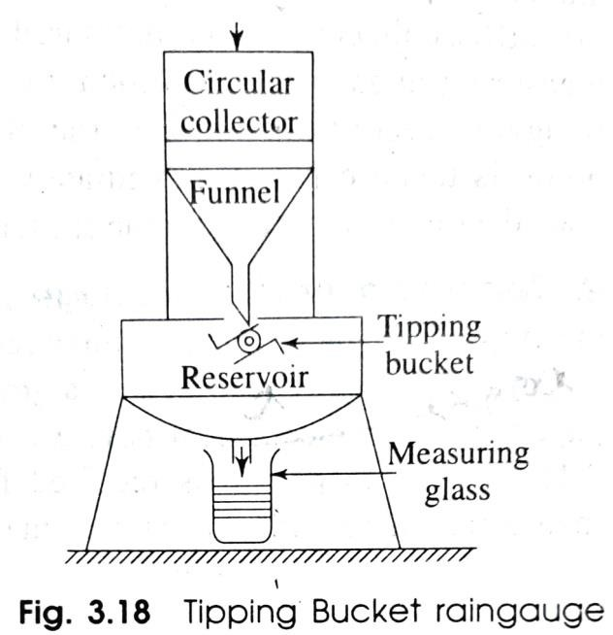
  - The raingauge produces a graph of cumulative rain fall versus time and hence it is sometimes called Integrating raingauge. The graph is known as the mass curve of rainfall.
- Tipping Bucket Raingauge:
  - It consists of a circular collector of diameter 30 cm in which the rain water is initially collected.
  - The rain water then passes through a funnel fitted to the circular collector and gets collected in two compartment tipping buckets pivoted below the funnel.
  - When 0.25 mm rain water is collected in one bucket then it tips and discharges the water in a reservoir kept below the buckets.
  - At the same time the other bucket comes below the funnel and the rainwater goes on collecting in it.
  - When the requisite amount of rainwater is collected, it also tips and discharges the water in the reservoir.
  - In this way, a circular motion is generated by the buckets.

  - This circular motion is trans mitted to a pen or pencil which traces a wave like curve on the sheet mounted on a revolving drum.
  - The total rainfall may be ascertained from the graph.
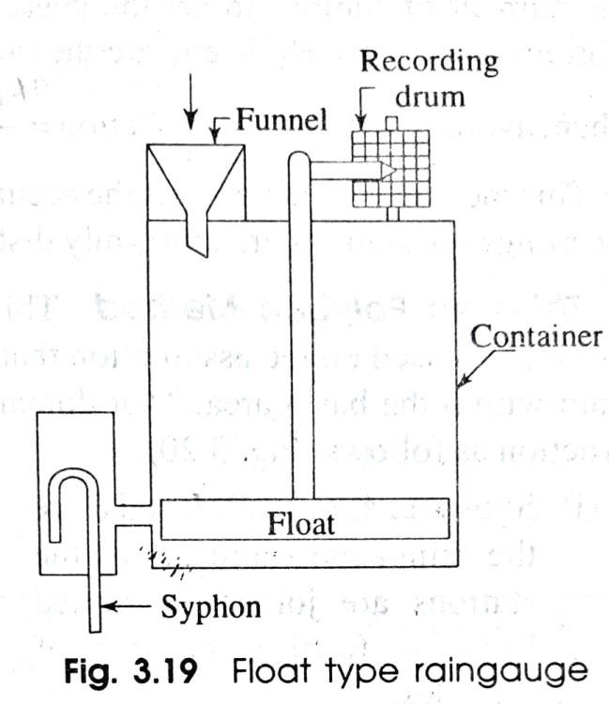
  - There is an opening with stopcock at the bottom of the reservoir for discharging the collected rainwater. Sometimes a measuring glass is provided to verify the results shown by the graph.
- Float Type Raingauge:
  - In this type of rain gauge, a funnel is provided at one end of a rectangular container and a rotating recording drum is provided at the other end.
  - The rain water enters the container through the funnel. A float is provided within the container which rises up as the rain water gets collected there.
  - The float consists of a rod which contains a pen arm for recording the amount of rainfall on the graph paper wrapped on the recording drum.
  - It consists of a syphon which starts functioning when the float rises to some definite height and the container goes on emptying gradually.

Catchment Area:
  - The catchment area of a river means the area from where the surface run off flows to that river through the tributaries, streams, springs etc. The area is bounded by watershed line.
Run-off:
  - When it rains, some portion of rain water infiltrates into the soil, some is intercepted by vegetation, some evaporates and the remaining portion flows over the ground surface to join the rivers, streams, lakes etc.
  - This portion of water which flows over the ground surface is known as surface run off or run-off.
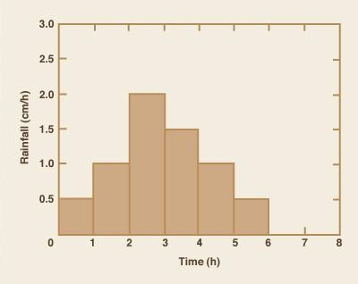
  - The surface run off is also designated by rainfall excess or effective rainfall.
Rainfall intensity:
  - Rainfall intensity is defined as the ratio of the total amount of rain (rainfall depth) falling during a given period to the duration of the period.
  - It is expressed in depth units per unit time, usually as mm per hour (mm/h).

HYETOGRAPH
  - The graphical representation of rainfall and run-off is known as hyetograph.
  - The graph is prepared with intensity of rainfall (in cm/hr) as ordinate and time (in hrs) as abscissa.
Estimation of flood discharge by Dicken's and Ryve's formulae
- Dicken's Formula
Q = C x A^{3/4}
where, Q = Discharge in cumec;
A = Catchment area in sq.km;
C = A constant depending upon the factors affecting the flood discharge. An average value of C is considered as 11.5.
- Ryve's Formula
Q = C x A^{2/3}
where, Q = Discharge in cumec;
A = Catchment area in sq.km;
C = A constant. The average value of C is considered as 6.8.

***end***

PART-B (IRRIGATION ENGINEERING)
CHAPTER:-02 [Water Requirement of Crops]
DEFINITION OF IRRIGATION
- The process of artificial application of water to the soil for the growth of agricultural crops is termed as irrigation.
- It is practically a science of planning and designing a water supply system for the agricultural land to protect the crops from bad effect of drought or low rainfall.
- It includes the construction of weirs, dams, barrages and canal systems for the regular supply of water to the culturable (i.e. cultivable) lands.

NECESSITY OF IRRIGATION
  - Insufficient Rainfall: - When the seasonal rainfall is less than the minimum requirement for the satisfactory growth of crops, the irrigation system is essential.
  - Uneven Distribution of Rainfall: - When the rainfall is not evenly distributed during the crop period or throughout the culturable area, the irrigation is extremely necessary.

  - Improvement of Perennial Crops: - Some perennial crops like sugarcane, cotton, etc. require water throughout the major part of the year. But the rainfall may fulfil the water requirement in rainy season only. So, for the remaining part of the year, irrigation becomes necessary.
  - Development of Agriculture in Desert Area: - In desert area where the rainfall is very scanty, irrigation is required for the development of agriculture.

BENEFITS OF IRRIGATION
The following are the important benefits of irrigation:
- Yield of Crops: - In the period of low rainfall or drought, the yield of crop may be increased by the irrigation system.
- Protection from Famine: - The food production of a country can be improved by ensuring the growth of crops by availing the irrigation facilities. This helps a country to prevent famine situation.
- Improvement of Cash Crops: - Irrigation helps to improve the cultivation of cash crops like vegetables, fruits, tobacco, etc.

- Prosperity of Farmers: - When the supply of irrigation water is assured, the framers can grow two or more crops in a year on the same land. Thus the farmers may earn more money and improve their living standard.
- Source of Revenue: - When irrigation water is supplied to the cultivators in lieu of some taxes, it helps to earn revenue which may be spent on other development schemes.
- Navigation: - The irrigation canals may be utilised for inland navigation which is further useful for communication and transportation of agricultural goods.
- Hydroelectric Power Generation: - In some river valley projects, multi-purpose reservoirs are formed by constructing high dams where hydroelectric power may be generated along with the irrigation system.
- Water Supply: - The irrigation canals may be the source of water supply for domestic and industrial purposes.
- General Communication: - The inspection road along the canal banks may serve as a communication link with the otherwise remote villages.
- Development of Fishery: - The reservoir and the canals can be utilised for the development of fisher projects.

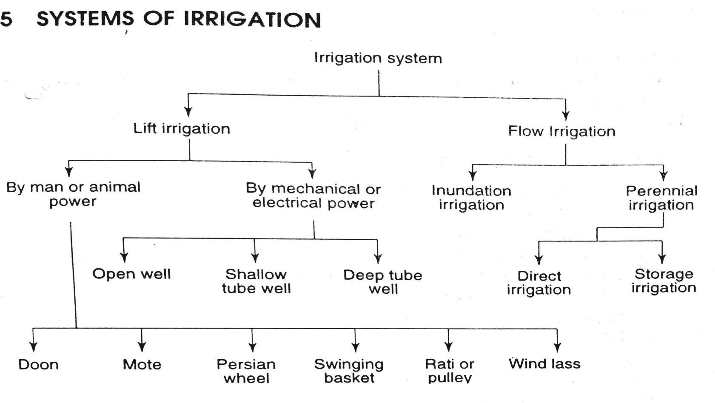
Lift Irrigation
  - When water is lifted from surface sources or underground sources by man or animal power, mechanical or electrical power and directly supplied to the agricultural land, then it is known as lift irrigation.
  - Lift irrigation can be divided into two groups:
- Lifting of water by man or animal power.
- Lifting of water by mechanical or electrical power.

Flow Irrigation
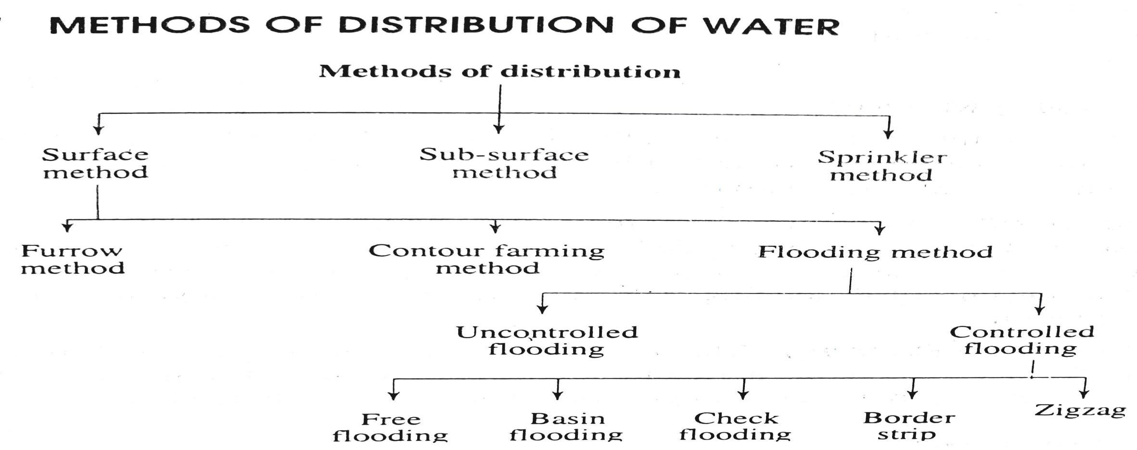
  - When water flows under gravitational pull through the artificial canal towards the agricultural land, it is termed as flow irrigation.

Surface Method
  - In this method, the irrigation water is distributed to the agricultural land through the small channels which flood the area up to the required depth.
  - The surface method is again sub-divided into 3 categories:
  - Furrow Method
  - Contour Farming
  - Flooding Method
Sub-Surface Method
  - In this method, the water is applied to the root zone of the crops by underground network of pipes.
  - The perforated pipes allow the water to drip out slowly and thus the soil below the root zone of the crops absorbs water continuously.
  - This method is suitable for permeable soil like sandy soil. Sub-surface method
  - In this method, the water is applied to the land in the form of spray like rain.
  - The spraying of water is achieved by the network of main pipe, sub-main pipes and lateral pipes.
  - The following are different forms of sprinklers:

Crop Season:
- Perforation on lateral pipes
- Fixed nozzles on lateral pipes
- Rotating sprinklers

  - The period during which some particular types of crops can be grown every year on the same land is known as crop season.
  - The following are the main crop seasons.
- Kharif Season: -
  - This season ranges from June to October. The crops are sown in the very beginning of monsoon and harvested at the end of autumn.
  - The major kharif crops are-Rice, Millet, Maize, Jute, Groundnut, etc.
- ​Rabi Season: -
  - This season ranges from October to March. The crops are sown in the very beginning of winter and harvested at the end of spring.
  - The major Rabi crops are-Wheat, Gram, Mustard, Rapeseed, Linseed, Pulses, Onion, etc.
BASE, DELTA AND DUTY
Base: -

  - The base is defined as the period from the first to the last watering of the crop just before its maturity. It is also known as base period.
  - It is denoted by 'B' and expressed in number of days. Delta: -
  - Each crop requires certain amount of water per hectare for its maturity.
  - The total amount of water supplied to the crop (from first to last watering) is stored on the land without any loss, then there will be a thick layer of water standing on that land. This depth of water layer is known as Delta for the crop.
  - It is denoted by '∆' and expressed in cm. Duty: -
  - The duty of water is defined as number of hectares that can be irrigated by constant supply of water at the rate of one cumec throughout the base period.
  - It is expressed in hectares/cumec. and is denoted by 'D'. RELATION BETWEEN BASE, DELTA AND DUTY
Let,
D = Duty of water in hectares/cumec B = Base in days.
∆ = Delta in m

From definition, one cumec of water flowing continuously for 'B' days gives a depth of water ∆ over an area 'D' hectares. That is,
1 cumec for B days gives ∆ over D hectares
𝑫

Or 1 cumec for 1 days gives ∆ over
𝑩
𝑫
hectares

Or 1 cumec for 1 day =
𝑫
x ∆ hectare-metre
𝑩

So, 1 cumec-day =
x ∆ hectare-metre (1)
𝑩

Again, 1 cumec-day = 1 x 24 x 60 x 60 = 86400 m³
= 8.64 hectare-metre (2)
(1 hectare = 10,000 m²)

From (1) and (2)

^{𝑫} x ∆ = 8.64
𝑩

.’. ∆ =
𝟖.𝟔𝟒 ×𝑩

𝑫
= in m.

Problem 1: A channel is to be designed for irrigating 5000 hectares in Kharif crop and 4000 hectares in Rabi crop. The water requirement for Kharif and Rabi are 60 cm and 25 cm, respectively. The Kor period for Kharif is 3 weeks and for Rabi is 4 weeks.
Determine the discharge of the channel for which it is to be designed.

Solution: Using the relation.
∆ = 𝟖.𝟔𝟒 ×𝑩
𝑫
Discharge for Kharif Crop
Here, ∆ = 60 cm = 0.60 m
B = 3 weeks = 21 days
𝟖.𝟔𝟒 ×𝟐𝟏

.’. Duty =
𝟎.𝟔𝟎
= 302.4 hectares/cumec

Area to be irrigated = 5000 hectares
𝟓𝟎𝟎𝟎
Required discharge of channel=
𝟑𝟎𝟐.𝟒

= 16.53 cumec

Discharge for Rabi Crop
Here, ∆ = 25 cm = 0.25 m
B = 4 weeks = 28 days,
𝟖.𝟔𝟒 ×𝟐𝟖

.’. Duty =
𝟎.𝟐𝟓
= 967.68 hectares/cumec,

Area to be irrigated = 4000 hectares.
𝟒𝟎𝟎𝟎

Required discharge of channel=

𝟗𝟔𝟕.𝟔𝟖
= 4.13 cumec

So, the channel is to be designed for the maximum discharge of 16.53 cumec, because this discharge capacity of the channel will be able to supply water to both the seasons.
Overlap Allowance
- Sometimes a crop of one season may overlap the next crop season by a few days more which it requires to mature.
- During this period of overlapping the irrigation water is to be supplied simultaneously to the crops of both the seasons. Due to the extra demand of water during this period, the discharge of the canal has to be increased.
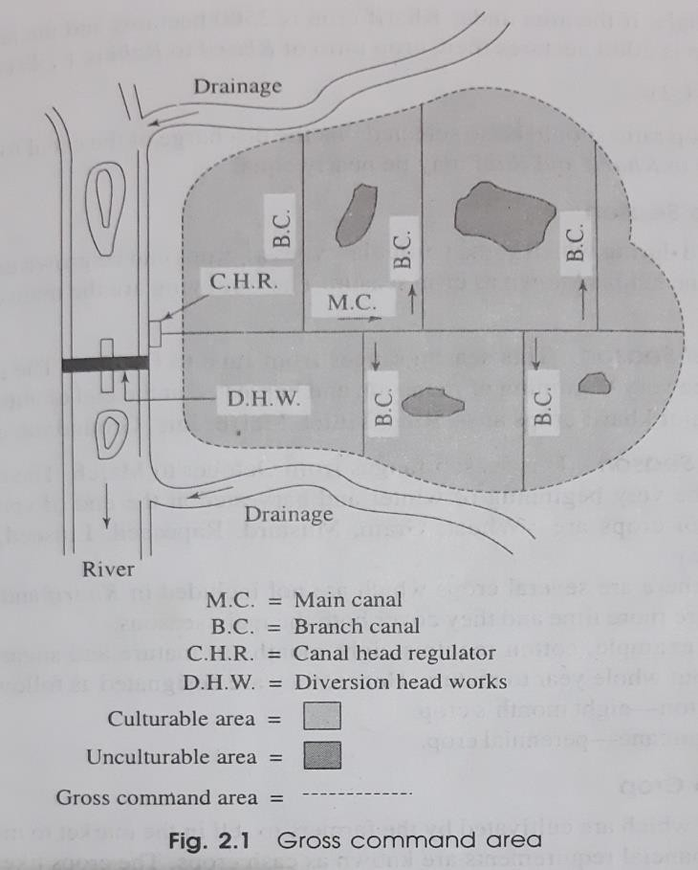
- So, for the purpose of canal design, a provision should be made for this extra demand. This provision is termed as overlap allowance.
- This is expressed in percentage. DEFINITION OF IMPORTANT TERMS
- Gross Command Area (G.C.A.)
  - The whole area enclosed between an imaginary boundary line which can be included in an irrigation project for

supplying water to agricultural land by the network of canals is known as Gross Command Area (G.C.A.).
  - It includes both the culturable and unculturable areas
- Unculturable Area
The area where the agriculture cannot be done and crops cannot be grown is known as unculturable area. The marshy lands, barren lands, lakes, ponds, forests, villages, etc. are considered as unculturable area.
- Culturable Area
The area where the agriculture can be done satisfactorily is known as culturable area.
- Culturable Command Area (C.C.A.)
  - The total area within an irrigation project where the cultivation can be done and crops can be grown is known as Culturable Command Area (C.C.A).
  - Again C.C.A. may be of two categories
- Culturable Cultivated Area: - It is the area within C.C.A. where the cultivation has been actually done at present.
- Culturable Uncultivated Area: - It is the area within the C.C.A. where cultivation is possible but it is not being cultivated at present due to some reasons.

Intensity of Irrigation
  - The intensity of irrigation may be defined as a ratio of cultivated land for a particular crop to the total culturable command area.
  - It is expressed as a percentage of C.C.A.
For example, if total culturable command area is 1000 hectares where wheat is cultivated in 250 hectares, then,

Time Factor
Intensity of irrigation for wheat =
𝟐𝟓𝟎

𝟏𝟎𝟎𝟎
× 100 = 25%.

  - The ratio of the number of days the canal has actually been kept open to the number of days the canal was designed to remain open during the base period is known as Time factor.
For example, a canal was designed to be kept open for 15 days, but it was practically kept open for 10 days for supplying water to the culturable area.
Then,

So,
The time factor is
𝟏𝟎
.
𝟏𝟓

Time factor =
𝑵𝒐 .𝒐𝒇 𝒅𝒂𝒚𝒔 𝒕𝒉𝒆 𝒄𝒂𝒏𝒂𝒍 𝒑𝒓𝒂𝒄𝒕𝒊𝒄𝒂𝒍𝒍𝒚 𝒌𝒆𝒑𝒕 𝒐𝒑𝒆𝒏

𝑵𝒐.𝒐𝒇 𝒅𝒂𝒚𝒔 𝒕𝒉𝒆 𝒄𝒂𝒏𝒂𝒍 𝒘𝒂𝒔 𝒅𝒆𝒔𝒊𝒈𝒏𝒆𝒅 𝒕𝒐 𝒌𝒆𝒆𝒑 𝒐𝒑𝒆𝒏
𝒂𝒄𝒕𝒖𝒂𝒍 𝒅𝒊𝒔𝒄𝒉𝒂𝒓𝒈𝒆
=
𝒅𝒆𝒔𝒊𝒈𝒏𝒆𝒅 𝒅𝒊𝒔𝒄𝒉𝒂𝒓𝒈𝒆

Crop Ratio
It is defined as the ratio of the areas of the two main crop seasons, e.g. Kharif and Rabi.
For example, if the area under Kharif crop is 2500 hectares and the area under Rabi crop is 5000 hectares then,
Crop ratio of Kharif to Rabi is 1 : 2.

***end***

PART-B (IRRIGATION ENGINEERING)
CHAPTER:-03 [FLOW IRRIGATION]
INTRODUCTION
  - The irrigation system in which the water flows under gravity from the source to the agricultural land is known as flow irrigation.
  - The flow irrigation involves,
- The construction of weir or barrage across a river (known as diversion head works).
- The construction of dam across a river valley (to form a storage reservoir).
- The excavation of canal system (Network of canals to cover the command area).
Irrigation Canal:
  - The canal which is constructed to carry water from the source to the agricultural land for the purpose of irrigation is known as irrigation canal such as Bhakra Canal, Rajasthan Canal, etc.
Canal is divided into 2 parts based on the nature of supply,
The canals are designated as (a) Inundation canal
(b) Perennial canal.

- Inundation Canal:
  - The canal which is excavated from the banks of the inundation river to carry water to the agricultural land in rainy season only when the river flows to its full capacity is known as inundation canal.
  - No regulator is provided at the head of such canal. The flow of water through the canal depends on the fluctuation of water level in the river.
  - When the water level rises above the bed level of the canal the water starts flowing through the canal. When the water level falls below the bed level of the canal, the flow of water through the canal stops.
- Perennial Canal:
  - The canal which can supply water to the agricultural land throughout the year is known as perennial canal.
  - This type of canal is taken from the upstream side of the diversion head works (weir or barrage) or from the storage reservoir with regulator at the head of the canal.
TYPES OF CANALS
Based on Purpose Based on the purpose of service, the canals are designated as
- Irrigation canal
- Navigation canal
- Power canal
- Feeder canal.

- Irrigation Canal: The canal which is constructed to carry water from the source to the agricultural land for the purpose of irrigation is known as irrigation canal such as Bhakra Canal, Rajasthan Canal, etc.
- Navigation Canal: The canal which is constructed for the purpose of inland navigation is known as navigation canal. This type of canal is also utilised for irrigation such as Ganga-Bramhaputra nagivation cum irrigation canal.
- Power Canal: The canal which is constructed to supply water with very high force to the hydroelectric power station for the purpose of moving turbine to generate electric power is known as power canal or hydel canal such as Nangal Hydel Canal.
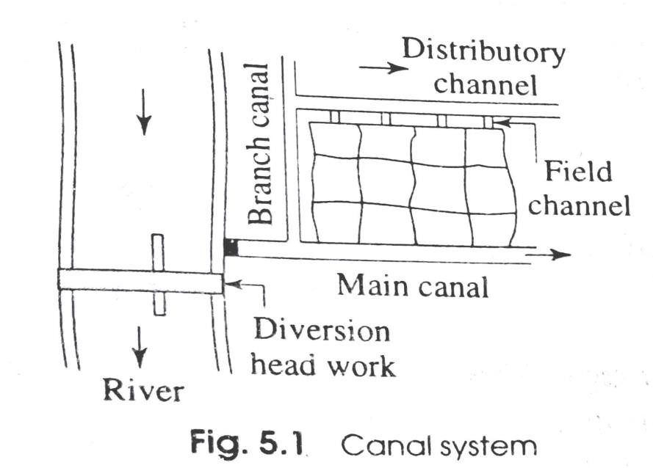
- Feeder Canal: The canal which is constructed to feed another canal or river for the purpose of irrigation or navigation is known as feeder canal such as Farakka barrage feeder canal.
Different components of irrigation canals

Their functions:
- Main Canal:
  - The large canal which is taken directly from the diversion head work or from storage reservoir to supply water to the network of other small canals is known as main canal.
  - The irrigation water is not directly supplied to the field from the main canal. The water is taken to the field through the branch canal, distributory channel and field channel.
  - So the main canal is the backbone of the canal system.
- Branch Canals:
  - The branch canals are taken from either side of the main canal at suitable points so that the whole command area can be covered by the network.
  - The discharge capacity of the branch canal is smaller than that of the main canal. The discharge varies from 5 to 10 cumec.
- Distributory Channels:
  - The distributory channels are taken from the branch canals to supply water to different sectors. The discharge capacity of these channels varies from 0.25 to 3 cumec.

  - Again, these are designated as major distributory and minor distributory
according to their function in the total network.
- Field Channels:
  - These channels are taken from the outlets of the distributory channels by the cultivators to supply water to their own lands.
  - These channels are maintained by the cultivators.

Sketches of different canal cross-sections
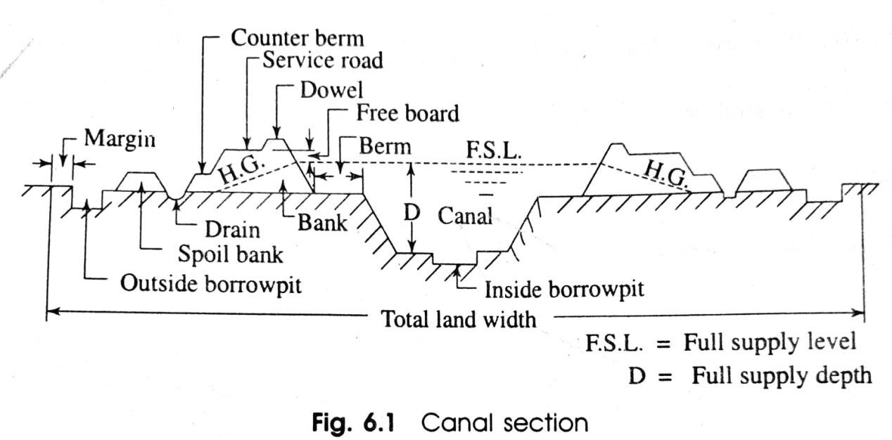
  - The canal section may be in fully cutting or fully banking or partial cutting and partial banking according to the natural ground surface and the permissible bed slope of the canal.
  - But there are several terms in the canal section with which a civil engineer should be acquainted to
design the section and to execute the work.

The following are the different terms related to the canal section
- Canal bank
- Berm
- Hydraulic gradient
- Counter berm
- Free board
- Side slope
- Service road or inspection road
- Dowel or Dowla
- Borrowpit
- Spoil bank
- Land width
- CANAL BANK
  - The canal bank is necessary to retain water in the canal to the full supply level. But the section of the canal bank is different for different site conditions.
The following are the different forms for different site conditions.

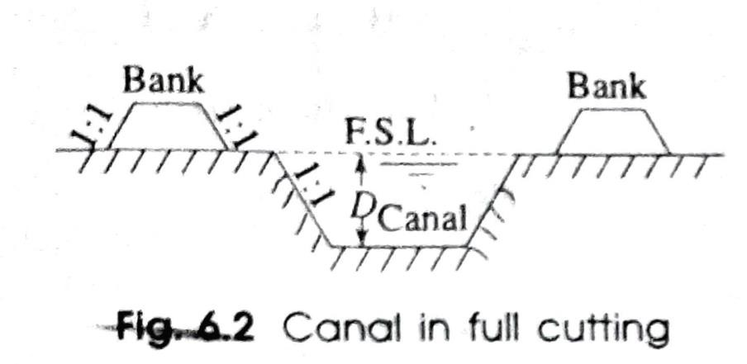
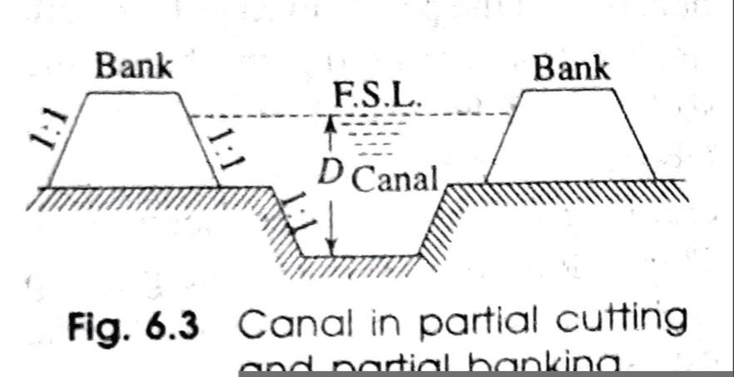
- When the Canal Fully in Cutting: In this case, the banks are constructed on both sides of the canal to provide only a inspection road. So, the height of the bank will be low and the top width will be minimum just to provide the road way.
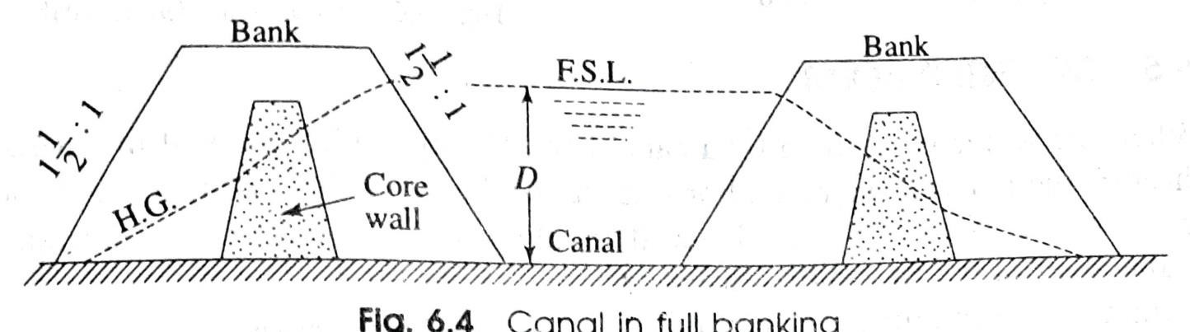
- When the Canal in Partial Cutting and Banking: In this case, the banks are constructed on sides of the canal to retain water. The height of the banks depend on the fully supply level of the canal. The top width and the side slope of the bank should be such that the hydraulic gradient should have a minimum cover of 0.5m.
- When the Canal in Full Banking: In this case, the canal and both the canal banks are constructed above the ground level. The height of the bank
will be high and its section will be large due to the hydraulic gradient.

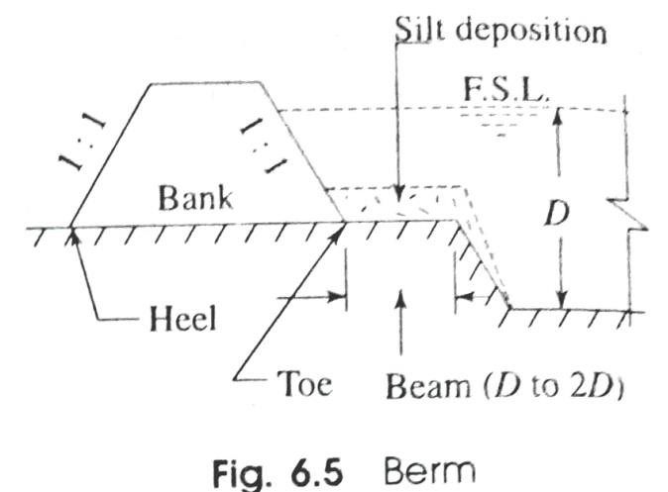
- BERM
The distance between the toe of the bank and the top edge of cutting is termed as berm.
The berm is provided for the following reasons,
- To protect the bank from erosion.
- To provide a space for widening the canal section in future if necessary.
- To protect the bank from sliding down towards the canal section.
- The silt deposition on the berm makes an impervious lining.
- If necessary borrowpit can be excavated on the berm.
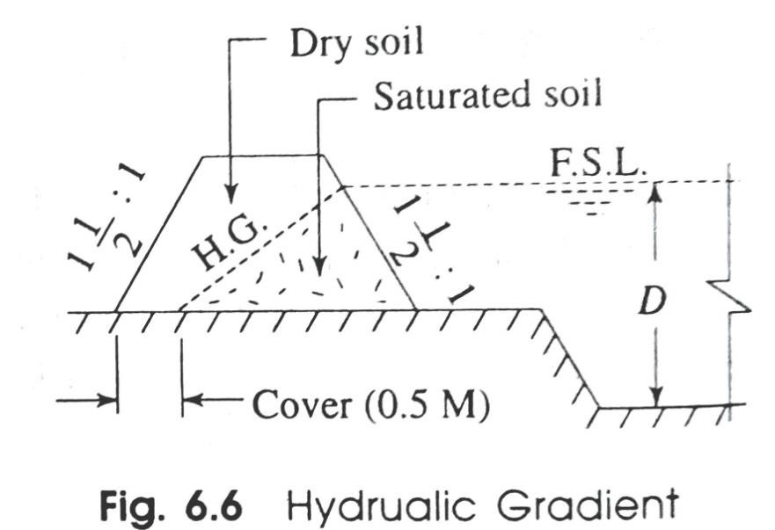
- HYDRAULIC GRADIENT
  - When the water is retained by the canal bank, the seepage occurs through the body of the bank. Due to the resistance of the soil, the saturation line forms a sloping line which may pass through countryside of the bank. This sloping line is known as the hydraulic gradient or saturation gradient.
  - The hydraulic gradient depends on the permeability of the soil.

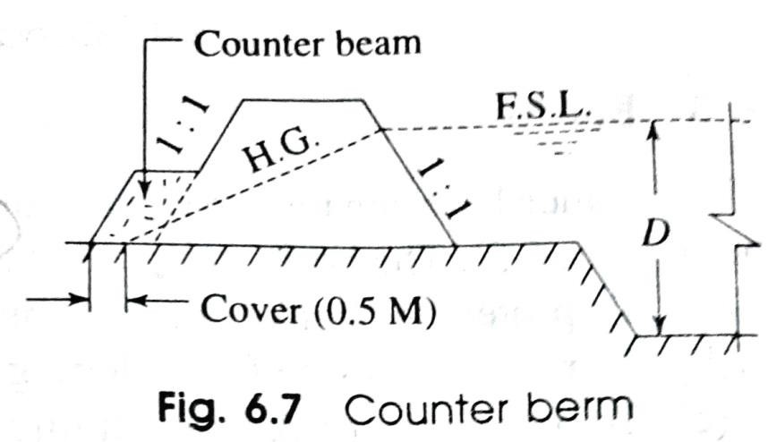
- COUNTER BERM
  - When the water is retained by a canal bank the hydraulic gradient line passes through the body of the bank.
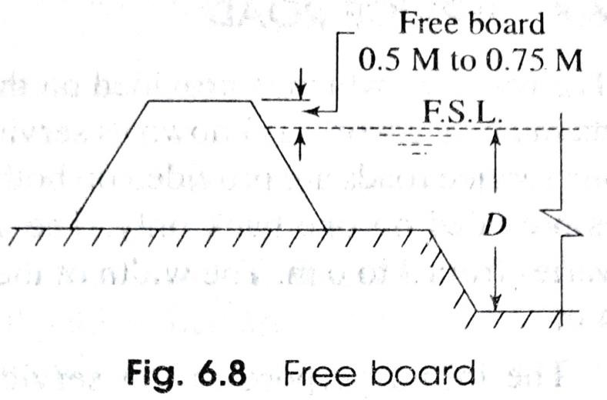
  - To counter act the hydraulic gradient line extra widening of soil has been provided which is known as Counter berm.
- FREE BOARD
  - It is the distance between the full supply level and top of the bank.
  - The amount of free board varies from 0.6 m to 0.75 m.
It is provided for the following reasons,
- To keep a sufficient margin so that the canal water does not overtop the bank in case of heavy rainfall or fluctuation in water supply.
- To keep the saturation gradient much below the top of the bank.
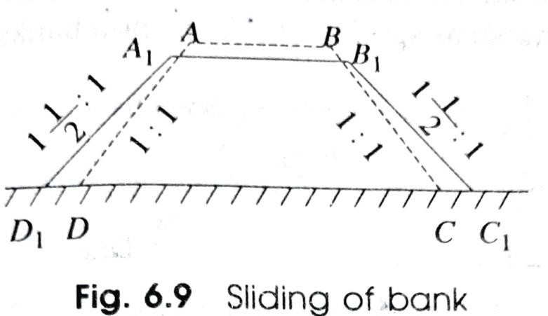
- SIDE SLOPE
  - The side slopes of the canal bank and canal section depend on the angle of repose of the soil existing on the site.

  - So, to determine the side slopes of different sections, the soil samples should be collected from the site and should be tested in the soil testing laboratory.
- SERVICE ROAD
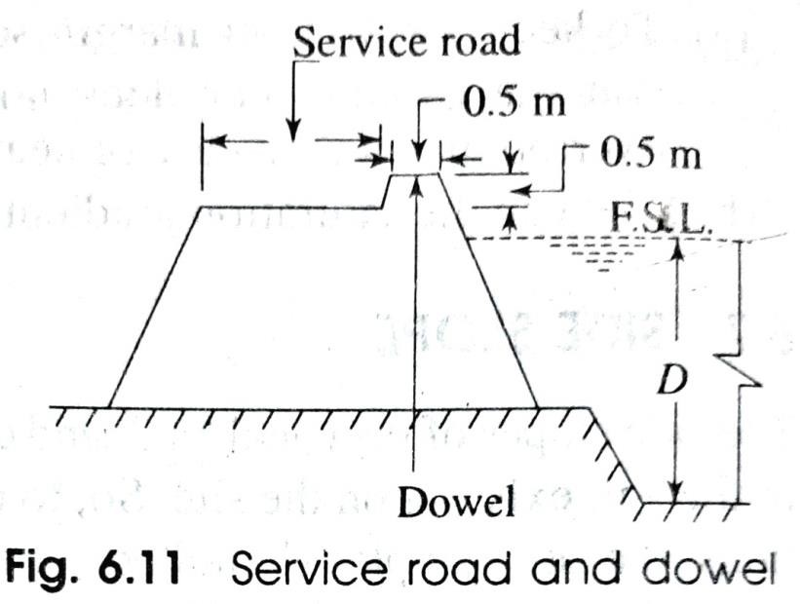
  - The roadway which is provided on the top of the canal bank for inspection and maintenance works is known as service road or inspection road.
  - For main canal, the service roads are provided on both the banks. But for branch canals, the road is provided on one bank only.
  - The width of the service roads for main canal varies from 4 to 6 m. The width of the road for the branch canal varies from 3 to 4 m.
- DOWEL OR DOWLA
  - The protective small embankment which is provided
on the canal side of the service road for the safety of the vehicles plying on it is known as dowel or dowla.
  - The top width is generally 0.5 m and the height above the road level is about 0.5m.

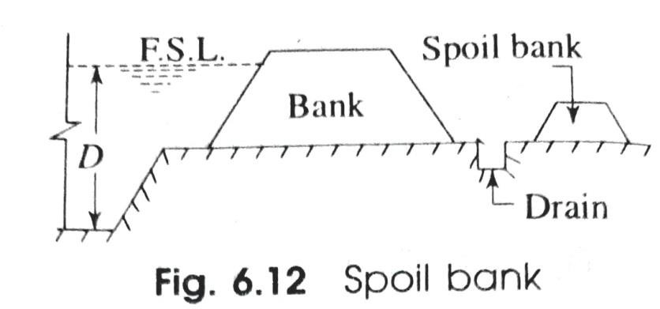
- SPOIL BANK
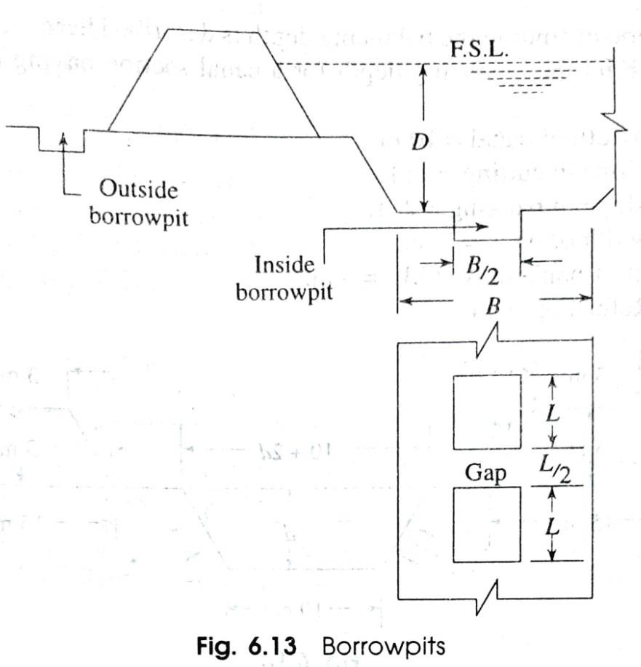
  - When the canal is constructed in full cutting, the excavated earth may not be completely required for forming the bank.
  - In such a case, the extra earth is deposited in the form of small banks which are known as spoil banks.
- BORROWPIT
  - When the canal is constructed in partial cutting and partial banking, the excavated earth may not be sufficient for forming the required bank.
  - In such a case, the extra earth required for the construction of banks is taken from some pits which are known as borrowpits.
  - The borrowpits may be inside or outside, the canal.

- LAND WIDTH
  - The total land width required for the construction of a canal depends on the nature of the site condition, such as fully in cutting or fully in banking or partly in cutting and partly in banking.
  - These conditions arise according to the designed bed level of the canal and the natural ground surface.
  - So, total land width differs with the site condition.
  - To determine the total land width the following dimensions should be added
- Top width of the canal.
- Twice the berm width.
- Twice the bottom width of banks.
- A margin of one metre from the heel of the bank on both sides.
- Width of external borrowpit if any.
- a margin of 0.5 m from the outer edge of borrowpit on both sides, if external borrowpit becomes necessary.
Classification of canals according to their alignment
  - Ridge or watershed canal
  - Contour canal,

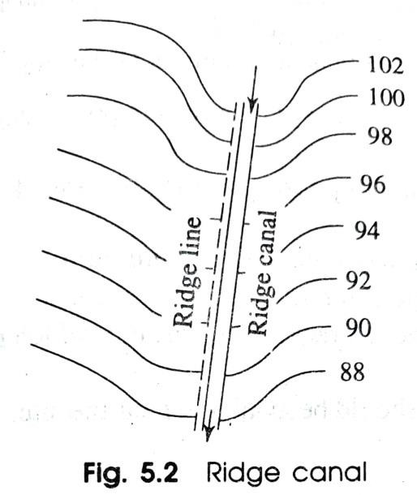
  - Side slope canal.
- Ridge or Watershed Canal:
  - The canal which is aligned along the ridge line (watershed line) is known as ridge canal or watershed canal.
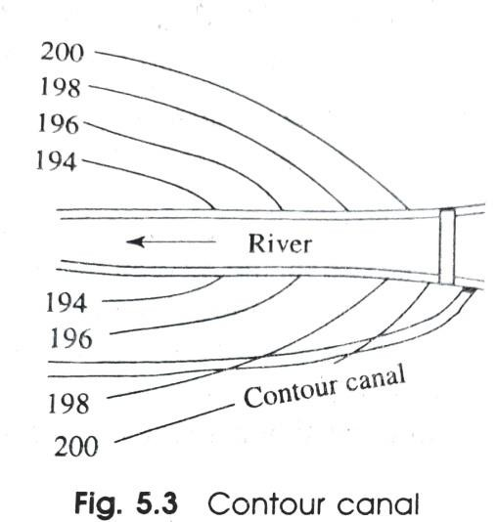
  - The advantage of this type of canal is that it can irrigate the areas on both sides. Again there is no possibility of crossing any natural drainage and hence no cross-drainage work is necessary.
- Contour Canal:
  - The canal which is aligned approximately parallel to the contour lines is known as contour canal.
  - This canal can irrigate the areas on one side only. This canal may cross natural drainage and hence cross-drainage works are necessary.
- Side Slope Canal:
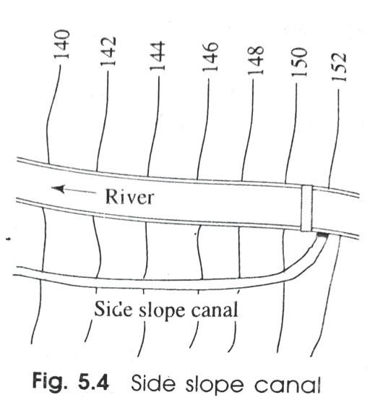
  - The canal which is aligned approximately at right angles to the contour lines is known as side slope canal.

  - It can irrigate the areas on one side only. Again, it does not cross any natural drainage and hence the cross drainage works are not necessary.
Various types of canal lining
- Cement concrete lining
- Pre-cast concrete lining
- Cement mortar lining
- Lime concrete lining
- Brick lining
- Boulder lining
- Shot crete lining
- Asphalt lining
- Bentonite and clay lining
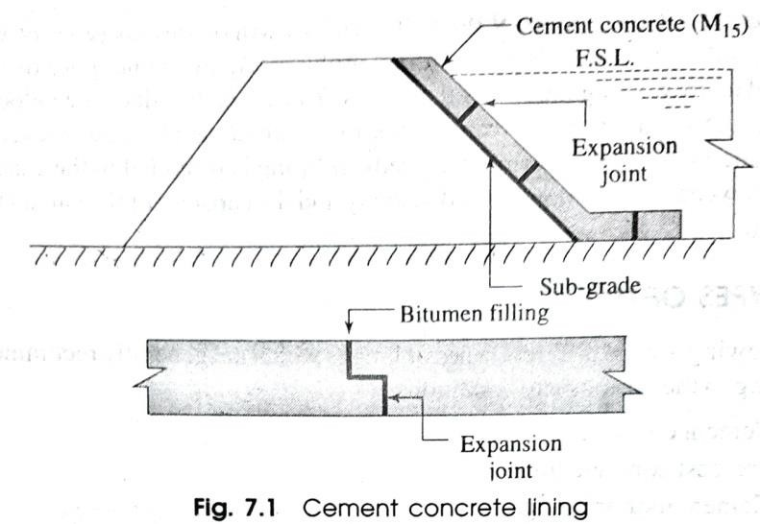
- Soil-cement lining
- CEMENT CONCRETE LINING
  - This lining is recommended for the canal in full banking.
  - The cement concrete lining (cast in-situ) is widely accepted as the best impervious lining.

  - It can resist the effect of scouring and erosion very efficiently.
  - The velocity of flow may be kept above 2.5 m/sec.
  - It can eliminate completely growth of weeds.
- PRE-CAST CONCRETE LINING
  - This lining is recommended for the canal in full banking.
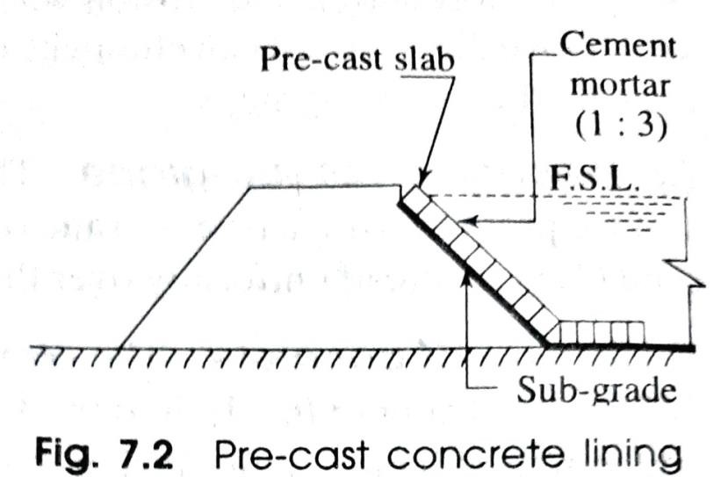
  - It consists of pre-cast concrete slabs of size 60 cm x 60 cm x 5 cm which are set along the canal bank and bed with cement mortar (1:6).
  - A network of 6 mm diameter rod is provided in the slab with spacing 10 cm centre of centre.
  - The proportion of the concrete is recommended as 1:2:4.
  - The joints are finished with cement mortar (1:3).
  - Expansion joints are provided at a suitable interval.
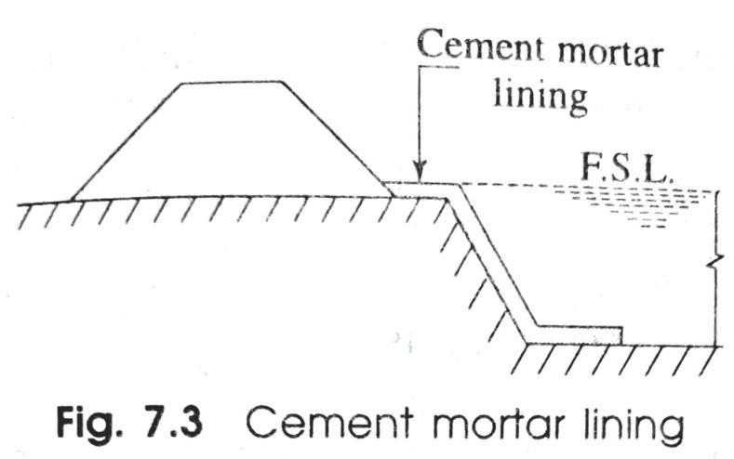
- CEMENT MORTAR LINING
  - This type of lining is recommended for the canal fully in cutting where hard soil or clayey soil is available.

  - The thickness of the cement mortar (1:4) is generally 2.5 cm.
  - The sub-grade is prepared by ramming the soil after cutting.
  - Then, over the compacted sub-grade, the cement mortar is laid uniformly and the surface is finished with neat cement polish.
  - This lining is impervious, but is not durable.
- LIME CONCRETE LINING
  - When hydraulic lime, surki and brick ballast are available in plenty along the course of the canal or in the vicinity of the irrigation project, then the lining of the canal may be made by the lime concrete of proportion 1:1:6.
  - The thickness of concrete varies from 150 mm to 225 mm and the curing should be done for longer period.
  - This lining is less durable than the cement concrete lining.
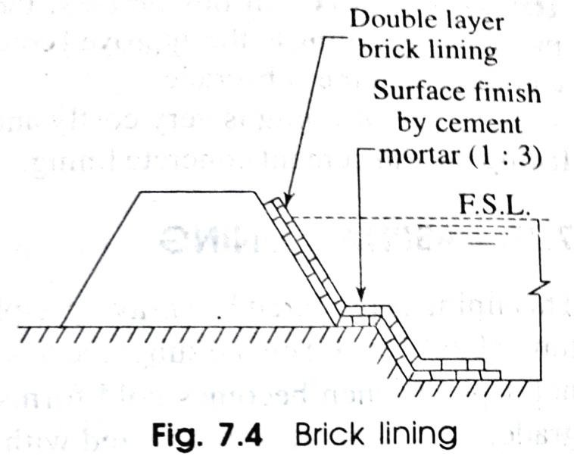
- BRICK LINING
  - This lining is prepared by the double layer brick flat soling laid with cement mortar (1:6) over the compacted sub-grade.
  - The first class bricks should be recommended for the work.

  - The surface of the lining is finished with cement plaster (1:3)
  - The curing should be done perfectly.
- BOULDER LINING
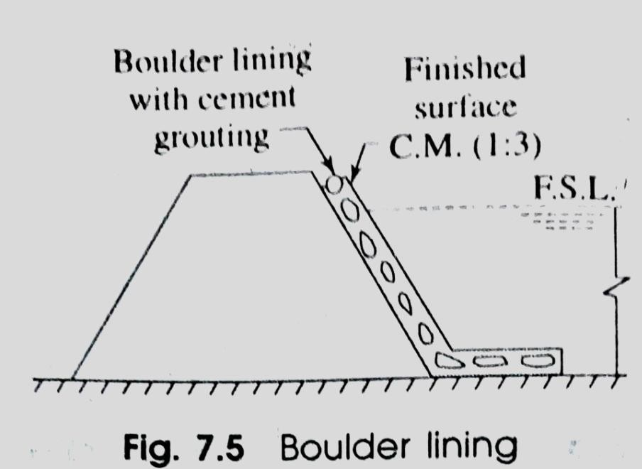
  - In hilly areas where the boulders are available in plenty, this type of lining is generally recommended.
  - The boulders are laid in single or double layer maintaining the slope of the banks and the bed level of the canal.
  - The joints of the boulders are grouted with cement mortar (1:6).
  - The surface is finished with cement mortar (1:3).
  - The transporting cost of the material is very high. So, it cannot be recommended for all cases.
- SHOT CRETE LINING
  - In this system, the cement mortar (1:4) is directly applied on the sub-grade by equipment known as cement gun.
  - The mortar is termed as shot crete and the lining is known as shot crete lining.
  - This type of lining is very costly and it is not durable.
  - It is suitable for resurfacing the old cement concrete lining.

- ASPHALT LINING
  - This lining is prepared by spraying asphalt (i.e. bitumen) at a very high temperature (about 150°C) on the subgrade to a thickness varies from 3 mm to 6 mm.
  - The hot asphalt when becomes cold forms a water proof membrane over the sub grade.
  - This membrane is covered with a layer of earth and gravel.
  - The lining is very cheap and can control the seepage of water very effectively but it cannot control the growth of weeds.
- BENTONITE AND CLAY LINING
  - In this lining a mixture of bentonite and clay are mixed thoroughly to form a sticky mass.
  - This mass is spread over the sub-grade to form an impervious membrane which is effective in controlling the seepage of water, but it cannot control the growth of weeds.
  - This lining is generally recommended for small channels.
- SOIL-CEMENT LINING
  - This lining is prepared with a mixture of soil and cement.
  - The usual quantity of cement is 10 per cent of the weight of dry soil.

  - The soil and cement are thoroughly mixed to get an uniform texture.
  - The lining is efficient to control the seepage of water, but it cannot control the growth of weeds.
  - So, this is recommended for small channels only. ADVANTAGES AND DISADVANTAGES OF CANAL LINING
Advantages
- It reduces the loss of water due to seepage and hence the duty is enhanced.
- It controls the water logging and hence the bad effects of water-logging are eliminated.
- It provides smooth surface and hence the velocity of flow can be increased.
- Due to the increased velocity the discharge capacity of a canal is also increased.
- Due to the increased velocity, the evaporation loss also be reduced.
- It eliminates the effect of scouring in the canal bed.
- The increased velocity eliminates the possibility of silting in the canal bed.
- It controls the growth of weeds along the canal sides and bed.
- It provides the stable section of the canal.
- It reduces the requirement of land width for the canal, because smaller section of the canal can produce greater discharge.

- It prevents the sub-soil salt to come in contact with the canal water.
- It reduces the maintenance cost for the canals. Disadvantages
- The initial cost of the canal lining is very high. So, it makes the project very expensive with respect to the output.
- It involves much difficulties for repairing the damaged section of lining.
- It takes too much time to complete the project work,
- It becomes difficult, if the outlets are required to be shifted or new outlets are required to be provided, because the dismantling of the lined section is difficult.

***end***

PART-B (IRRIGATION ENGINEERING)
CHAPTER:-04 [WATER LOGGING AND DRAINAGE] INTRODUCTION
In agricultural land, when the soil pores within the root zone of the crops get saturated with the subsoil water, the air circulation within the soil pores gets totally stopped. This phenomenon is termed as water logging.
CAUSES OF WATER LOGGING
The following are the main causes of water logging:
- Over Irrigation: In inundation irrigation since there is no controlling system of water supply it may cause over irrigation. The excess water percolates and remains stored within the root zone of the corps. Again, in perennial irrigation system if water is supplied more than what is required. This excess water is responsible for the water logging.
- Seepage from Canals: In unlined canal system, the water percolates through the bank of the canal and gets collected in the low lying areas along the course of the

canal and thus the water table gets raised. This seepage is more in case of canal in banking.
- Inadequate Surface Drainage: When the rainfall is heavy and there is no proper provision for surface drainage the water gets collected and submerges vast area. When this condition continues for a long period, the water table is raised.
- Obstruction in Natural Water Course: If the bridges or culverts are constructed across a water course with the opening with insufficient discharge capacity, the upstream area gets flooded and this causes water logging.
- Obstruction in Sub-soil Drainage: If some impermeable stratum exists at a lower depth below the ground surface, then the movement of the subsoil water gets obstructed and causes water logging in the area.
- Nature of Soil: The soil having low permeability, like black cotton soil, does not allow the water to percolate through it. So, in case of over irrigation or flood, the water retains in this type of land and causes water logging.

- Incorrect Method of Cultivation: If the agricultural land is not levelled properly and there is no arrangement for the surplus water to flow out, then it will create pools of stagnant water leading to water logging.
- Seepage from Reservoir: If the reservoir basin consists of permeable zones, cracks and fissures which were not detected during the construction of dam, these may cause seepage of water. This sub-soil water will move towards the low-lying areas and cause water logging.
- Poor Irrigation Management: If the main canal is kept open for a long period unnecessarily without computing the total water requirement of the crops, then this leads to over irrigation which shall result in water logging.
- Excessive Rainfall: If the rainfall is excessive and the water gets no time to get drained off completely, then a pool of stagnant water is formed which might lead to water logging.
- Topography of the Land: If the agricultural land is flat, i.e. with no country slope and consists of depressions or undulations, then this leads to water logging.

- Occasional Flood: If an area gets affected by flood every year and there is no proper drainage system, the water table gets raised and this causes water logging.
EFFECTS OF WATER LOGGING
The following are the effects of water logging:
- Salinization of Soil:
  - Due to water logging the dissolved salts like sodium carbonate, sodium chloride and sodium sulphate come to the surface of the soil.
  - When the water evaporates from the surface, the salts are deposited there. This process is known as salinization of soil.
  - Excessive concentration of salt makes the land alkaline. It does not allow the plants to thrive and thus the yield of crop is reduced. This process is also known as salt efflorescence.

- Lack of Aeration:
  - The crops require some nutrients for their growth which are supplied by some bacteria or micro-organisms by breaking the complex nitrogenous compounds into simple compounds which are consumed by the plants for their growth.
  - But the bacteria require oxygen for their life and activity.
  - When the aeration in the soil is stopped by water logging, these bacteria cannot survive without oxygen and the fertility of the land is lost which results in reduction of yield.
- Fall of Soil Temperature:
  - Due to water logging the soil temperature is lowered.
  - At low temperature of the soil the activity of the bacteria becomes very slow and consequently the plants do not get the requisite amount of food in time.
  - Thus, growth of the plants is hampered and the yield also is reduced.
- Growth of Weeds and Aquatic Plants:
  - Due to water logging, the agricultural land is converted to marshy land and the weeds and aquatic plants are grown in plenty.

  - These plants consume the soil foods in advance and thus the crops are destroyed.
- Diseases of Crops: Due to low temperature and poor aeration, the crops get some diseases which may destroy the crops or reduce the yield.
- Difficulty in Cultivation: In water logged area it is very difficult to carry out the operation of cultivation such as tilling, ploughing, etc.
- Restriction of Root Growth: When the water table rises near to root zone the soil gets saturated. The growth of the roots is confined only to the top layer of the soil. So, the crops cannot be matured properly and the yield is reduced.
CONTROL OF WATER LOGGING
The following measures may be taken to control water logging:
- Prevention of Percolation from Canals: The irrigation canals should be lined with impervious lining to prevent the percolation of water through the bed and banks of the canals. Thus the water logging may be prevented.
- Prevention of Percolation from Reservoirs: During the construction of dam, the geological survey should be conducted on the reservoir basin to detect the zone

of permeable formations through which water may percolate. These zones should be treated properly to prevent the seepage.
- Control of Intensity of Irrigation: The intensity of irrigation may cause water logging. So, it should be controlled in a planned way so that there is no possibility of water logging in a particular area.
- Economical Use of Water: If the water is used economically, then it may control the water logging and the yield of crops may be high. It helps them to get more crops by eliminating the possibility of water logging.
- Fixing of Crop Pattern: Soil survey should be conducted to fix the crop pattern. The crops having high rate of evapotranspiration should be recommended for the area susceptible to water logging.
- Providing Drainage System: Suitable drainage system should be provided in the low lying areas so that the rain water does not stand for long days. A network of sub-surface drains are provided which are connected to the surface drains. The surface drains discharge the water to the river or any water course.

- Improvement of Natural Drainage: Sometimes, the natural drainage may be completely silted up or obstructed by weeds, aquatic plants, etc. The affected section of the drainage should be improved by excavating and clearing the obstructions.
- Pumping of Ground Water: A number of open wells or tube wells are constructed in the water logged area and the ground water is pumped out until the water table goes down to a safe level. The lifted ground water may be utilised for irrigation or may be discharged to the river or any water course.
- Construction of Sump Well: Sump wells may be constructed within the water logged area and they help to collect the surface water. The water from the sump wells may be pumped to the irrigable lands or may be discharged to any river.

***end***

PART-B (IRRIGATION ENGINEERING)
CHAPTER:-05 [DIVERSION HEAD WORKS AND REGULATORY STRUCTURES] INTRODUCTION
The water flows through the irrigation canal under the force of gravity. So, the elevation of the head of the canal must higher than the command area of the irrigation project. Now, to form a storage reservoir or to raise the water level at the head of the canal, some structures are constructed which are known as canal head works.
The canal head works may be of two forms.
- Storage Head Works:
  - When a dam is constructed across a river valley to form a storage reservoir, it is known as storage head work.
  - The water is supplied to the canal from this reservoir through the canal head regulator.
  - Again, this reservoir serves the multipurpose functions such as hydro-electric power generation, flood control, fishery, etc.

- Diversion Head Works:
  - When a weir or barrage is constructed across a perennial river to raise the water level and to divert the water to the canal, then it is known as diversion head work.
  - The flow of water in the canal is controlled by canal head regulator. OBJECT OF DIVERSION HEAD WORKS
The following are the objects of diversion of head works
- To raise the water level at the head of the canal.
- To form a storage by constructing dykes on both the banks of the river so that water is available throughout the year.
- To control the entry of silt into the canal and to control the deposition of silt at the head of the canal.
- To control the fluctuation of water level in the river during different seasons.

SELECTION OF SITE FOR DIVERSION HEAD WORKS
The following points should be remembered while selecting the site for the diversion head works
- At the site, the river should be straight and narrow.
- The river banks should be well defined.
- The valuable land should not be submerged when the weir or barrage is constructed.
- The elevation of the site should be much higher than the area to be irrigated.
- The site should be easily accessible by roads or railways.
- The materials of construction should be available in vicinity of the site.
- The site should not be far away from the command area of the project, to avoid transmission loss.
COMPONENTS PARTS OF DIVERSION HEAD WORKS
The following are the component parts of the diversion head works
  - Weir or barrage.

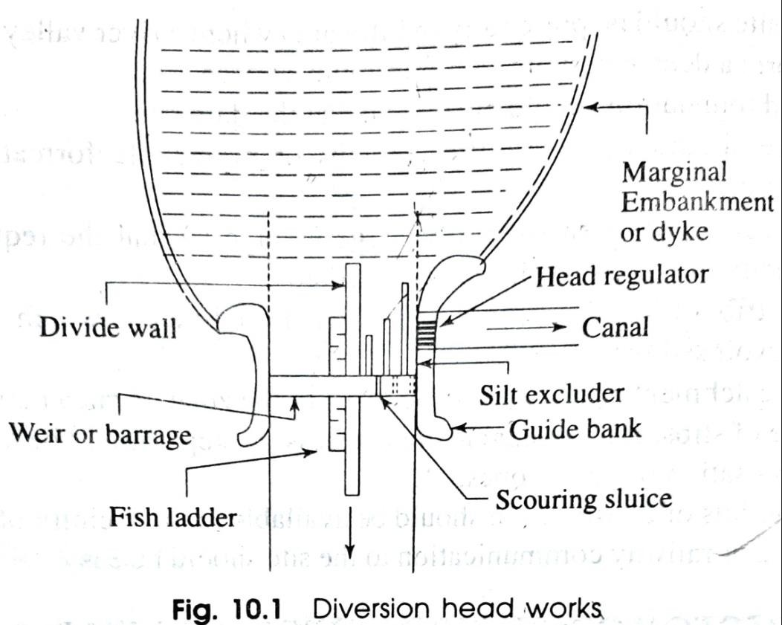
  - Divide wall.
  - Scouring sluices or under sluices.
  - Fish ladder.
  - Canal head regulator.
  - Silt excluder.
  - Guide bank.
  - Marginal embankment or Dyke.
- Weir or barrage.
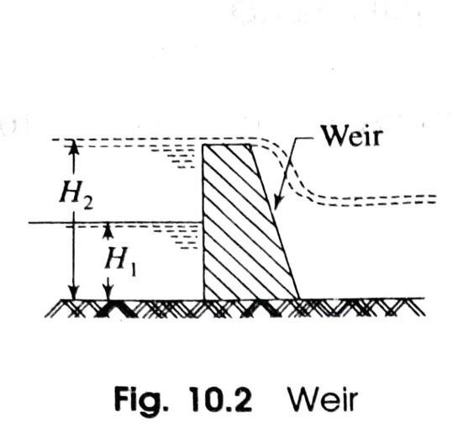
  - Weir:
    - Normally, the water level of any perennial river is such that it cannot be diverted to the irrigation canal. The bed level of the canal may be higher than the existing water level of the river.
    - In such a case, a weir is constructed across the river to raise the water level from H₁ to H₂. Then, the water can be easily diverted to the canal.

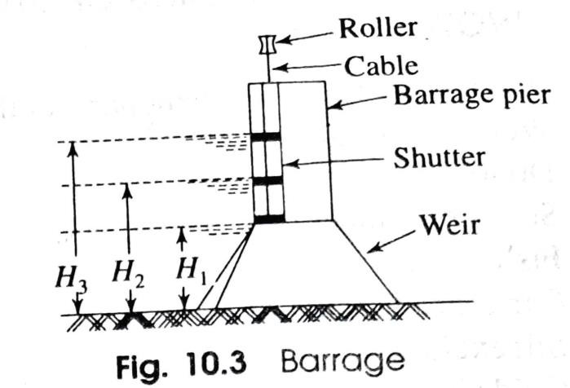
    - The surplus water passes over the crest of the weir.
    - The weir may be constructed with masonry or concrete.
  - Barrage:
    - When the water level on the upstream side of the weir is required to be raised to different levels at different time, then the barrage is constructed.
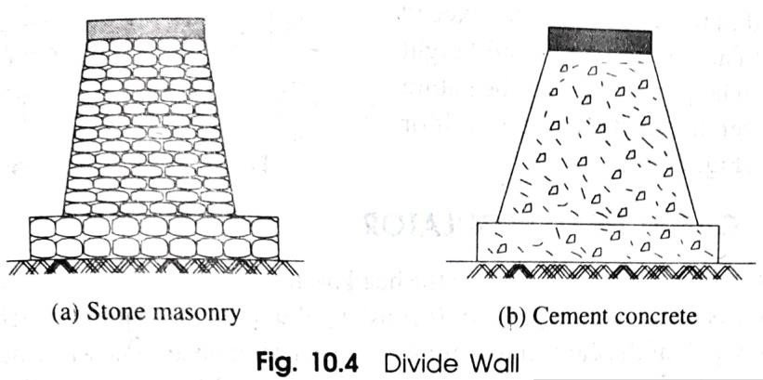
    - Practically a barrage is an arrangement of adjustable gates or shutters at different tiers over the weir.
- Divide wall.
- The divide wall is a long wall constructed at right angles to the weir or barrage, it may be constructed with stone masonry or cement concrete.
- On the upstream side, the wall is extended just to cover the canal head regulator and on the downstream side, it is extended up to the launching apron.
- Scouring sluices or under sluices.
- The scouring sluices are the openings provided at the base of the weir or barrage.

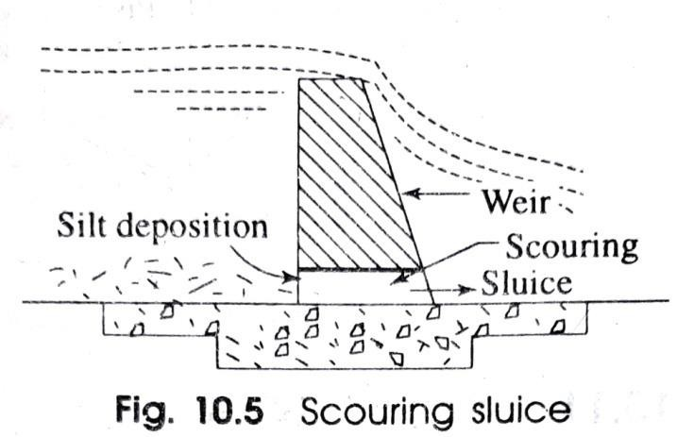
- These openings are provided with adjustable gates.
- Normally, the gates are kept closed. The suspended silt goes on depositing in front of the canal head regulator.
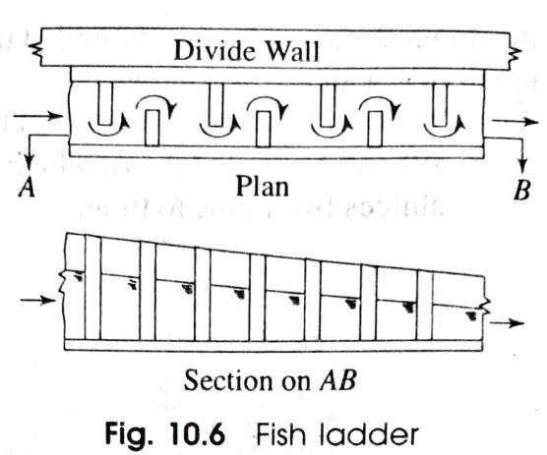
- When the silt deposition becomes appreciable the gates are opened and the deposited silt will be removed.
- Fish ladder.
- The fish ladder is provided just by the side of the divide wall for the free movement of fishes.
- The tendency of fish is to move from upstream to downstream in
winters and from downstream to upstream in monsoons. This movement is essential for their survival.
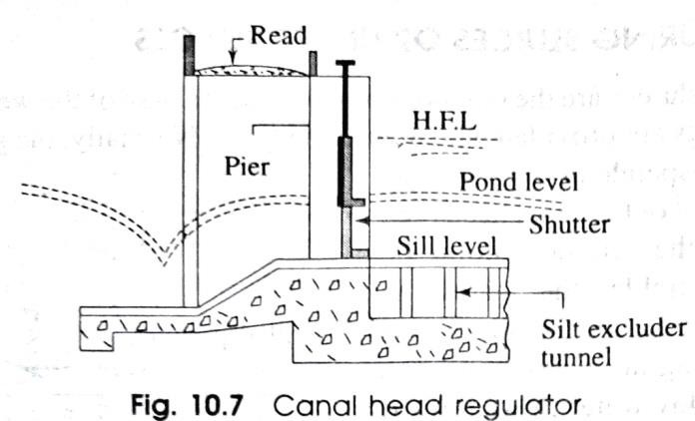
- In the fish ladder, the baffle walls are constructed in a zig-zag manner so that the velocity of flow within the ladder does not exceed 3m/sec.
- Canal head regulator.
A structure which is constructed at the head of the canal to regulate flow of water is known as canal head regulator.

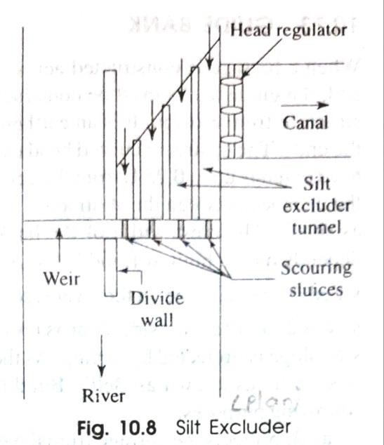
- Silt excluder.
- To eliminate the suspended heavy silt, the silt excluder is provided.
- It consists of a series of tunnels starting from the side of the head regulator up to the divide wall.
- Guide bank.
- When a barrage is constructed across a river which flows through the alluvial soil, the guide banks must be constructed on both the approaches to protect the structure from erosion.
- It is an earthen embankment with curved heads on both the ends.
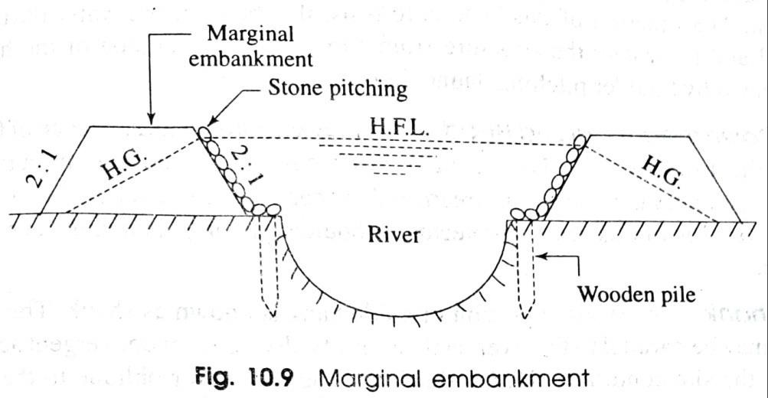
- Marginal embankment or Dyke.
- The marginal embankments or dykes are earthen embankments which are constructed parallel to the river bank on one or both the banks according to the condition.

- It prevents the flood water or storage water from entering the surrounding area.
- It protects the towns and villages from devastation during the heavy flood and also protects valuable agricultural lands.

General layout, functions of different parts of barrage
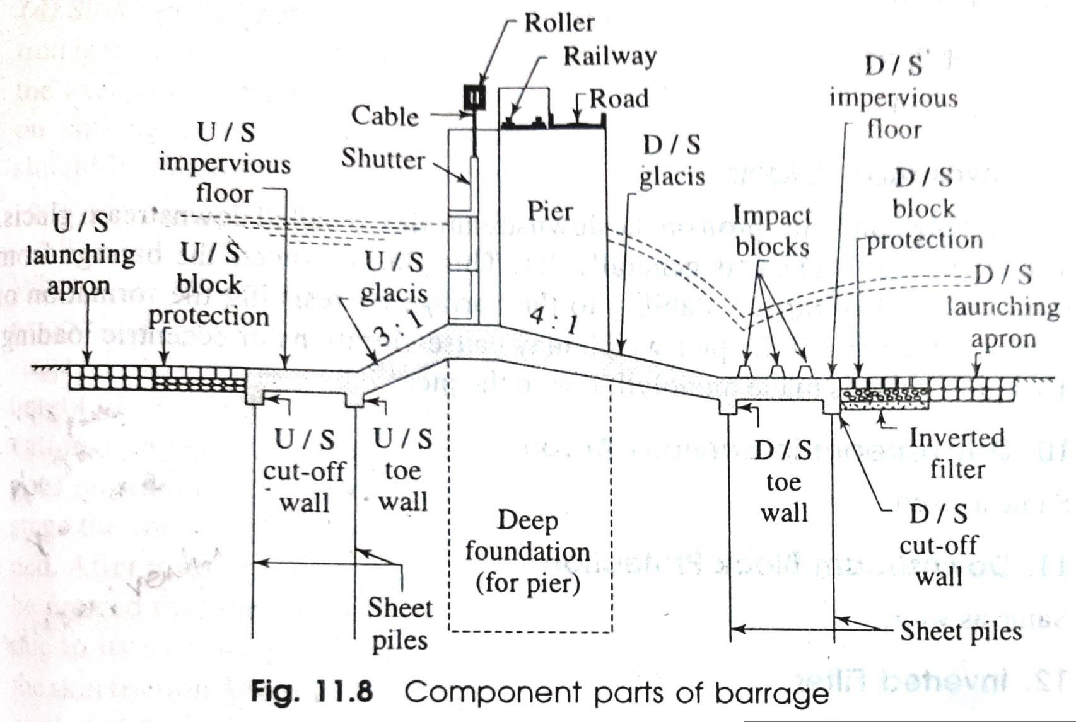

COMPONENT PARTS OF BARRAGE
The following are the component parts of the barrage and then functions.
- Barrage Piers
  - These are the main component parts of the barrage. Depending on the width of the river, the length of the barrage is ascertained.
  - The total length is then divided into a number of compartments by constructing piers. Each compartment is known as a bay.
  - The piers are constructed over the deep foundation like well foundation or pneumatic caisson foundation.
- Adjustable Gates
  - The gates or shutters are made of steel plates welded on the fabricated steel frame work.
  - The thickness of the plates depends on the water pressure to be resisted.
  - Each shutter consists of rollers on both sides which can move within the grooves in the piers.

  - Rubber bearings are provided at the bottom and the edges of the shutter to prevent the leakage of water.
  - The shutters may be raised or lowered from the cabin according to the requirement.
- Upstream Glacis
  - The sloping concrete apron on the upstream side is called upstream glacis. The slope of the glacis is generally 3:1.
  - This is provided to protect the base of the barrage from scouring.
  - On the top of the barrage, the railway line and roads can cause vibration on the piers and any eccentric load may lead to cracks on the base of piers.
  - Due to the formation of cracks the subsoil water may get entry to the foundation which may endanger the stability of the structure.
  - So, the sloping glacis is made monolythic with the pier for the stability of the barrage.

- Upstream Impervious Floor or Apron
  - Impervious floor or apron is provided to protect the main body of the weir from the scouring effect.
  - The floor is constructed with reinforced cement concrete.
  - In case of masonry weir, this floor covers the total designed length of upstream and downstream apron.
  - It acts as a base plate of the weir but in case of concrete weir, the floor is made monolythic with the main body by providing reinforcement.
  - The floor is made sloping on both sides. So, it is also known as sloping glacis.
- Upstream Block Protection
  - This block protects the impervious floor from the effect of scouring.
  - This is constructed with concrete blocks or dressed stone blocks over a bed of loose stone packing.
  - The joints are finished with cement mortar. The width of this protection work is taken equal to the length of sheet piles.

- Upstream Launching Apron
  - This apron is constructed with boulders or stones (not less than 30 kg) arranged in layers without any joint.
  - It protects the impervious floor and the sheet piles from the scour holes which may develop and proceed towards the weir.
  - The size of stones and the depth of apron depend on the velocity of flow and the probable scour depth.
- Cut-off and Toe Walls
  - The cut-off walls are provided at the upstream end and the downstream end of the impervious floor.
  - Walls are also provided at the upstream and the downstream toe of the weir.
  - The functions of the cut-off and toe walls are to provide proper anchorage to the impervious floor and to provide sufficient bearing to the sheet piles.
- Sheet Pile's
  - The sheet piles are provided on the upstream and downstream cut-off walls and on the intermediate toe walls.

  - The function of the sheet piles is to lengthen the path of the seepage flow.
  - Thus the uplift pressure of the seepage water on the foundation is reduced considerably and the scouring effect on the exit gradient is also reduced.
- Downstream Glacis
  - The sloping concrete apron on the downstream side is called downstream glacis.
  - The slope of this glacis is generally 4:1. This glacis protects the barrage from scouring.
  - It also imparts stability to the barrage by resisting the formation of cracks at the base of the pier which may cause vibrations or eccentric loading.
  - This glacis also is made monolythic with the pier.
- Downstream Impervious Floor or Apron
  - The function of this impervious floor is to protect the weir from the scouring effect which is caused by the formation of hydraulic jump.
  - Again, it protects the weir from the effect of piping or undermining which may occur on the downstream side due to the seepage flow.

- Downstream Block Protection
  - This protection block is constructed with cement concrete blocks or dressed stones by placing them with open joints.
  - The joints are filled up with small gravels or bajri.
  - The seepage water can escape through the joints. Below these concrete or stone blocks, the inverted filter is provided.
- Inverted Filter
  - It consists of layers of materials having the increasing grade or permeability from the bottom towards the top. for example, medium sand-coarse sand-bajri- gravels-ballast are arranged from the bottom to the top, layer by layer.
  - Thus, it is similar to a filter, but in inverted position.
  - The function on this filter is to allow the seepage water to escape without dislocating the soil particles.
- Downstream Launching Apron
  - This apron is constructed with loosely packed stones or boulders (weight not less than 30 kg).

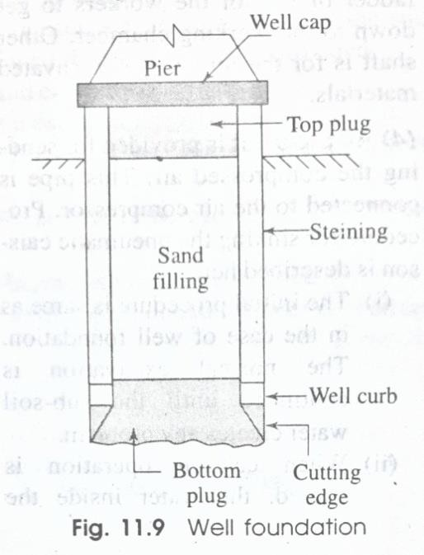
  - It covers completely the zone of exit gradient.
  - This apron protects the weir from the effect of piping or undermining which may occur due to seepage of water.
- Deep Foundation
Deep foundation for the pier may be of two types,
- Well Foundation
  - Depending upon the base of the piers, the shape of the well foundation is ascertained.
  - The common shapes are circular, twin-circular, dumb well, double-D. etc.
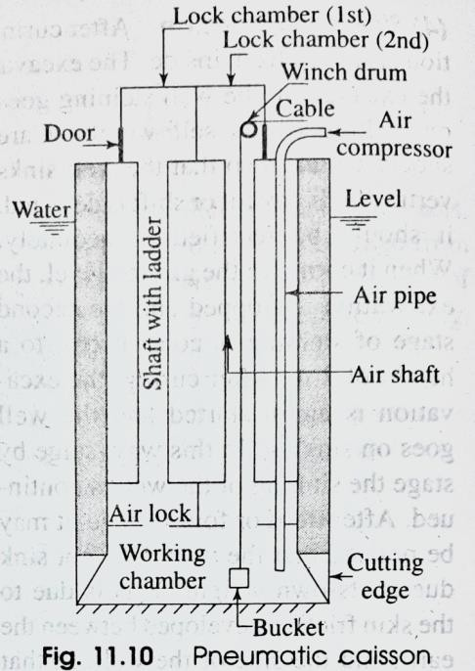
- Pneumatic Caisson Foundation
  - When the depth of water in the river is more than 10 m, then the open caisson or well foundation is not feasible due to various difficulties.

  - In such a case the pneumatic caisson foundation is adopted. It is a box like compartment having opening at the bottom. The top end consists of lock chambers.

Regulatory structures
Canal regulation works are those hydraulic structures constructed cross the canals which facilitate complete control over the flow in a canal irrigation system.
Functions of regulatory structures
- Canal fall helps in adjusting the available ground slope with the canal bed slope, thus preventing the canal from going into excessive filling.
- A canal regulator regulates the flow of a canal by releasing measured quantity of water from the canal or into the canal.
- A canal escape is the tail channel in an irrigation system, which carries the surplus excess water from the irrigation canals back into the river.
- A metering flume, and a gauge-well help in measuring the canal discharge at the point of their installation.
- A canal outlet (or a module) releases the measured discharge from the government owned canal into the water courses of the cultivators for irrigating crops.
***end***

PART-B (IRRIGATION ENGINEERING)
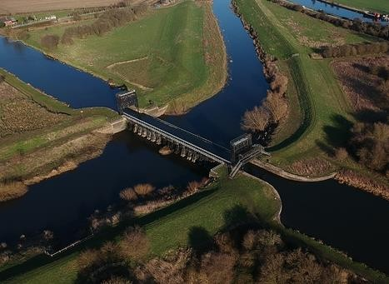
CHAPTER:-06 [CROSS DRAINAGE WORKS]
Definition:-
Suitable structures must be constructed at the crossing point for the easy flow of water of the canal and drainage in the respective directions. These structures are known as cross drainage works.
NECESSITY OF CROSS-DRAINAGE WORKS
The following factors justify the necessity of cross drainage works,
  - The water shed canals do not cross natural drainages. But in actual orientation of the canal network, this ideal condition may not be available and the obstacles like natural drainages may be present across the canal. So, the cross drainage works must be provided for running the irrigation system.
  - At the crossing point, the water of the canal and the drainage get intermixed. So, for the smooth running of the canal with its design discharge the cross drainage works are required.

  - The site condition of the crossing point may be such that without any suitable structure, the water of the canal and drainage cannot be diverted to their natural directions. So, the cross drainage works must be provided to maintain their natural direction of flow.
TYPES OF CROSS-DRAINAGE WORKS
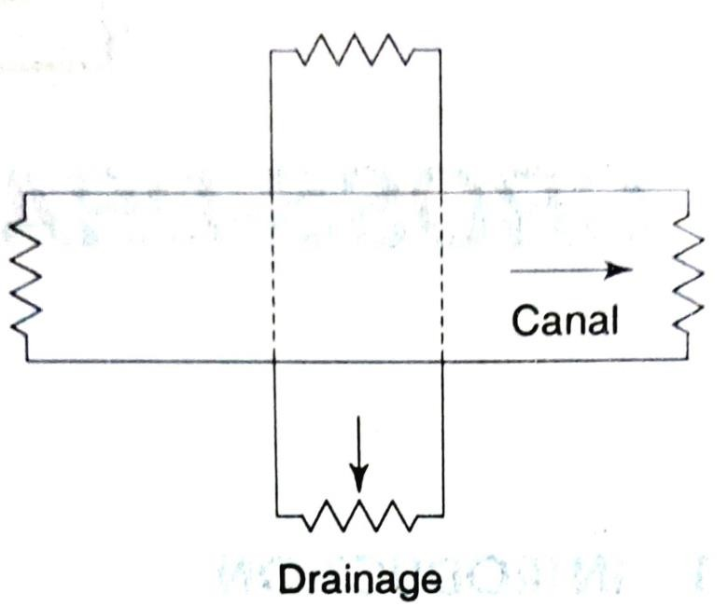
According to the relative bed levels, maximum water levels and relative discharges of the canals and drainages the cross drainage works may be of the following types.
Type-l Irrigation Canal Passes over the Drainage
- Aqueduct
  - The hydraulic structure in which the irrigation canal is taken over the drainage (such river, stream, etc.) is known as aqueduct.
  - This structure is suitable when bed level of canal is above the highest flood level of drainage.
  - In this case, the drainage water passes clearly below the canal.

- Siphon Aqueduct
  - In a hydraulic structure where the canal is taken over the drainage, but the drainage water cannot pass clearly below the canal. It flows under siphonic action. So, it is known as siphon aqueduct.
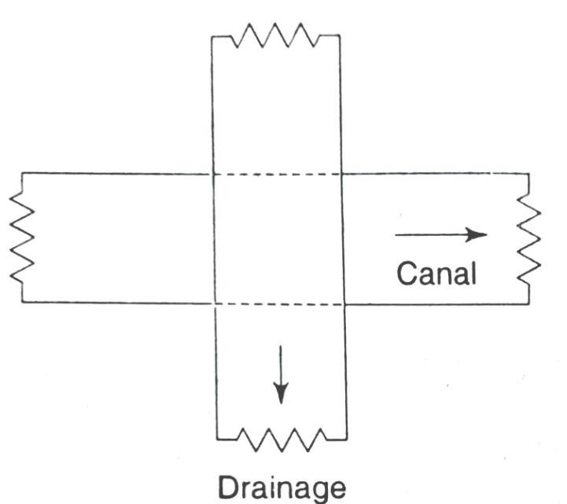
  - This structure is suitable when the bed level of canal is below the highest flood level of the drainage.
Type-II Drainage Passes over the Irrigation Canal
- Super Passage
  - The hydraulic structure in which the drainage is taken over the irrigation canal is known as super passage.
  - The structure is suitable when the bed level of drainage is above the full supply level of the canal.
  - The water of the canal passes clearly below the drainage.
- Siphon Super Passage
  - The hydraulic structure in which the drainage is taken over the irrigation canal, but the canal water passes below the drainage under siphonic action is known as siphon super passage.

  - This structure is suitable when the bed level of drainage is below the full supply level of the canal.
Type-III Drainage and Canal intersection Each Other at the Same Level
- Level Crossing
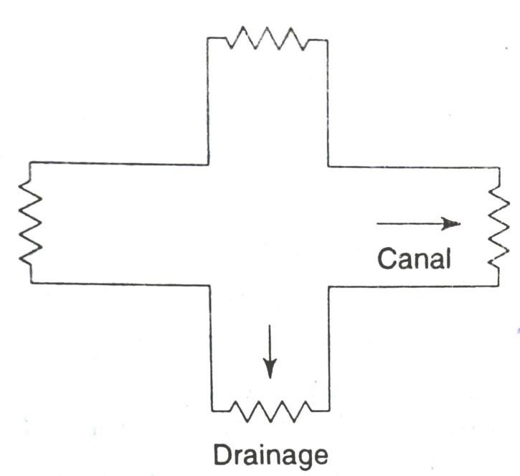
  - When the beds of the drainage and canal are practically at the same level, then a hydraulic structure is constructed which is known as level crossing.
  - This is suitable for the crossing of large drainage with main canal.
- Inlet and Outlet
  - In the crossing of small drainage with small channel no hydraulic structure is constructed. Simple openings are provided for the flow of water in their respective directions. This arrangement is known as inlet and outlet.
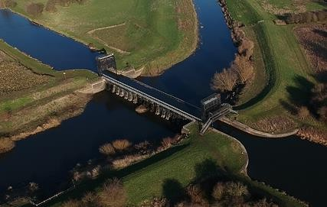
AQUEDUCT
  - The aqueduct is just like a bridge where a canal is taken over the deck supported by piers instead of a road or railway.

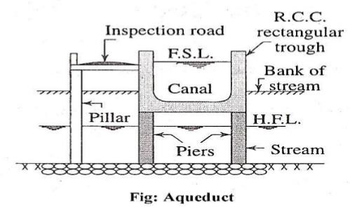
  - Generally, the canal is in the shape of a rectangular trough which is constructed with reinforced cement concrete. Sometimes, the trough may be of trapezoidal section.
  - An inspection road is provided along the side of the trough.
  - The bed and banks of the drainage below the trough is protected by boulder pitching with cement grouting. The section of the trough is designed according to the full supply discharge of the canal.
  - A free board of about 0.50 m should be provided.
  - The height and section of piers are designed according to the highest flood level and velocity of flow of the drainage.
  - The piers may be of brick masonry, stone masonry or reinforced cement concrete.
  - Here, deep foundation (like well foundation) is not necessary for the piers. The concrete foundation may be done by providing the depth of foundation according to the availability of hard soil.

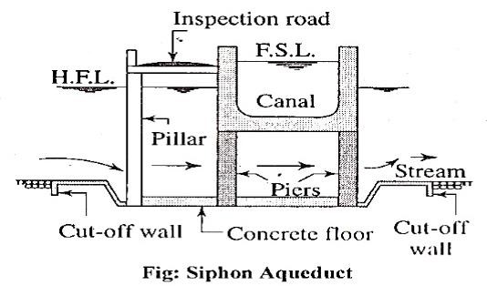
SIPHON AQUEDUCT
  - The siphon aqueduct, the bed of the drainage is depressed below the bottom level of the canal trough by providing sloping apron on both sides of the crossing. The sloping apron may be constructed by stone pitching or cement concrete.
  - The section of the drainage below the canal trough is constructed with cement concrete in the form of tunnel. This tunnel acts as a siphon.
  - Cut off walls are provided on both sides of the apron to prevent scouring.
  - Boulder pitching should be provided on the upstream and downstream of the cut-off walls.
  - The other components like canal trough, piers, inspection road, etc. should be designed according to the methods adopted in case of aqueduct.
SUPER PASSAGE
  - The super passage is just opposite of the aqueduct. In this case, the bed level of the drainage is above the fully supply level of the canal.

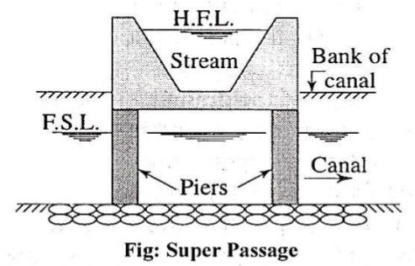
  - The drainage is taken through a rectangular or trapezoidal trough of channel which is constructed on the deck supported by piers. The section of the drainage trough depends on the high flood discharge.
  - A free board of about 1.5 m should be provided for safety.
  - The trough should be constructed of reinforced cement concrete.
  - The bed and banks of the canal below the drainage trough should be protected by boulder pitching or lining with concrete slabs.
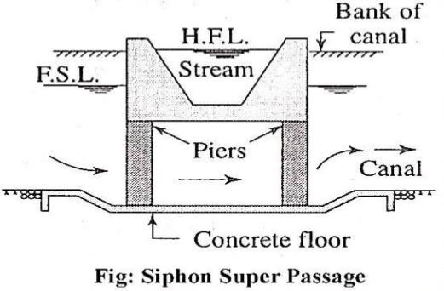
  - The foundation of the piers will be same as in the case of aqueduct. SIPHON SUPER PASSAGE
  - It is just opposite siphon aqueduct. In this case, the canal passes below the drainage trough.
  - The section of the trough is designed according to high flood discharge.

  - The bed of the canal is depressed below the bottom level of the drainage trough by providing sloping apron on both sides of the crossing.
  - The sloping apron may be constructed with stone pitching or concrete slabs.
  - The section of the canal below the trough is constructed with cement concrete in the form of tunnel which acts as siphon.
  - Cut-off walls are provided on upstream and downstream side of sloping apron. Other components are same as in the case of siphon aqueduct.
LEVEL CROSSING
The level crossing is an arrangement provided to regulate the flow of water through the drainage and the canal when they cross each other approximately at the same bed level.
The level crossing consists of the following components,
- Crest Wall: It is provided across the drainage just at the upstream side of the crossing point. The top level of the crest wall is kept at the full supply level of the canal.
- Drainage Regulator: It is provided across the drainage just at the downstream side of the crossing point. The regulator consists of adjustable shutters at different tiers.

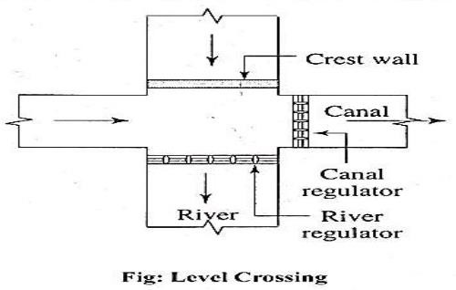
- Canal regulator: It is provided across the canal just at the downstream side of the crossing point. This regulator also consists of adjustable shutters at different tiers.
Operation:
  - In dry season, when the discharge of the drainage is very low, the drainage regulator is kept closed and the canal water is allowed to flow as usual.
  - In rainy season, when the discharge of the drainage is very high, the drainage regulator is kept completely open and the canal regulator is adjusted according to requirement.
  - The level crossing is recommended for the crossing of main canal with large drainage.
INLET AND OUTLET
  - In case of crossing of a small irrigation channel with a small drainage, no hydraulic structure is constructed.
  - Because, the discharges of the drainage and the channel are practically low and these can be easily tackled by easy system like inlet and outlet arrangement.

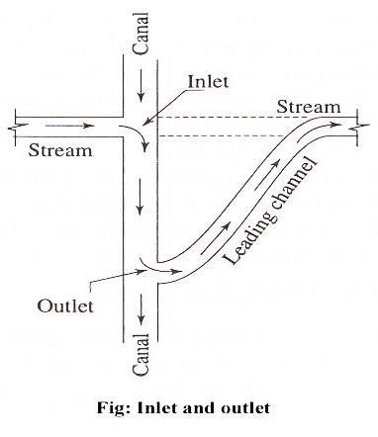
  - In this system an inlet is provided in the channel bank simply by open cut and the drainage water is allowed to join the channel.
  - Then at a suitable point on the downstream side of the channel an outlet is provided by open cut and the water from the irrigation channel is allowed to flow through a leading channel towards the original course of the drainage.
  - At the points of inlet and outlet the bed and banks of the drainage are protected by stone pitching. The bed and banks of the irrigation channel between inlet and outlet points should also be protected by stone pitching.

***END**

PART-B (IRRIGATION ENGINEERING)
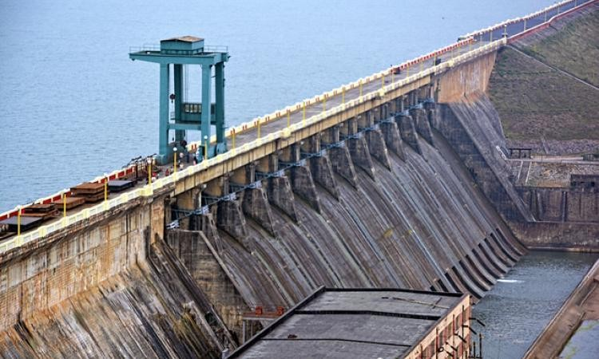
CHAPTER:-07 [DAMS] I
Necessity of storage reservoirs
The storage reservoir is formed for the following purposes:
- Flood control
- Irrigation
- Water supply
- Hydroelectric power generation
- Development of fishery
- Navigation
- Soil conservation. CLASSIFICATION OF DAM
Dams may be classified on the following basis,
- Based on Materials of Construction
  - Rigid dam: It is constructed with rigid materials like masonry, concrete, steel or timber. It is designated as, (a) masonry dam, (b) concrete dam, (c) steel dam,
(d) timber dam.

  - Non rigid dam: It is constructed with non-rigid materials such as earth, clay, rock materials, etc. It is designated as, (a) earthen dam, (b) rock-fill dam, (c) composite dam.
- Based on Structural Behaviour
  - Solid gravity dam: It is constructed with masonry or concrete. It resists the forces acting on it by its own weight. It is approximately triangular in section.
  - Arch dam: It is a curved masonry or concrete dam which resists the forces acting on it by the principle of arch action.
  - Buttress dam: It behaves like a retaining wall. It consists of sloping deck on the upstream side which is supported by a number of buttresses in the form of triangular reinforced concrete wall or counterforts. It resists the forces acting on it by the buttresses.
  - Embankment dam: It is non-rigid dam constructed simply by earth work in trapezoidal section. Sometimes, it may be of earth work with clay core wall or rock fill. It resists forces acting on it by its shear strength.
- Based on Functions
  - Storage dam: It is constructed to form a reservoir in which the water is stored during the period of rainy season or flood and utilised for the irrigation in the

period of draught. The water is also utilised for the generation of hydroelectric power, water supply, etc.
  - Detention dam: It is mainly constructed to detain the flood water temporarily in a reservoir and then released gradually so that the downstream area may not be damaged due to sudden flood water.
  - Diversion dam: It is constructed to divert the water from a perennial river to a channel for the purpose of irrigation or to a conduit for the purpose of generation of hydroelectric power.
  - Coffer dam: When an area in the river bed is enclosed temporarily by sheet piling for excluding water for the sake of construction of well foundation (i.e. pier foundation) then it is known as coffer dam.
- Based on Hydraulic Behaviour
  - Over flow dam: The dam which consists of crest shutters or waste weirs on the top to allow the surplus water to overflow is known as overflow dam.
  - Non overflow dam: The dam in which spill ways are provided to discharge the surplus water and the water is not allowed to flow over the crest is known as non-overflow dam.

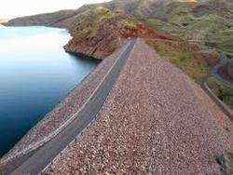
EARTHEN DAM
Earthen dams are constructed purely by earth work in trapezoidal section. These are most economical and suitable for weak foundation.
Classification
Based on Method of Construction Rolled Fill Dam:
    - In this method, the dam is constructed in successive layers of earth by mechanical compaction.
    - The selected soil is transported from borrowpits and laid on the dam section, to layers of about 45 cm.
    - The layers are thoroughly compacted by rollers of recommended weight and type.
    - When the compaction of one layer is fully achieved, the next layer is laid and compacted in the usual way.
    - The designed dam section is completed layer by layer.

Hydraulic Fill Dam:
    - In this method, the dam section is constructed with the help of water. Sufficient water is poured in the borrowpit and by pugging thoroughly, slurry is formed.
    - This slurry is transported to the dam site by pipe line and discharged near the upstream and downstream faces of the dam.
    - The coarser material gets deposited near the face and the finer material move towards the centre and gets deposited there.
    - Thus the dam section is formed with faces of coarse material and central core is of impervious materials like clay and silt.
    - In this case, compaction is not necessary. Semi-Hydraulic Fill Dam:
    - In this method the selected earth is transported from the borrowpit and dumped within the section of the dam, as done in the case of rolled fill dam.
    - While dumping no water is used. But, after dumping the water jet is forced on the dumped earth.
    - Due to the action of water the finer materials move towards the centre of the dam and an impervious core is formed with fine materials like clay.
    - The outside body is formed by coarse material.

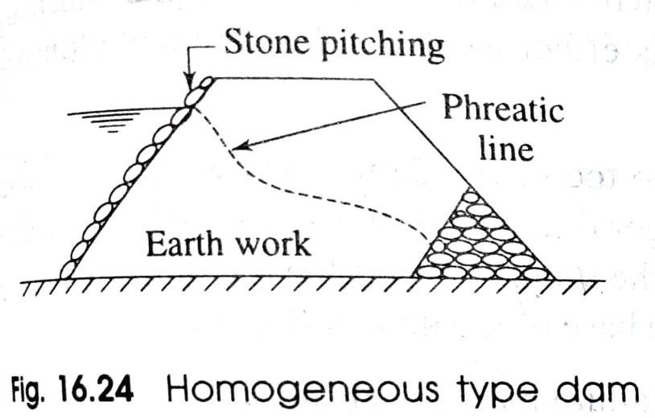
    - In this case also compaction is not necessary. Homogeneous Type Dam:
    - This type of dam is constructed purely with earth in trapezoidal section having the side slopes according to the angle of repose of the soil.
    - The top width and height depends on the depth of water to be retained and the gradient of the seepage line.
    - The phreatic line (top level of seepage line) should pass well within the body of the dam.
    - This type of dam is completely pervious.
    - The upstream face of the dam is protected by stone pitching.
    - Now-a days, the earthen dam is modified by providing horizontal drainage blanket or rock toe.
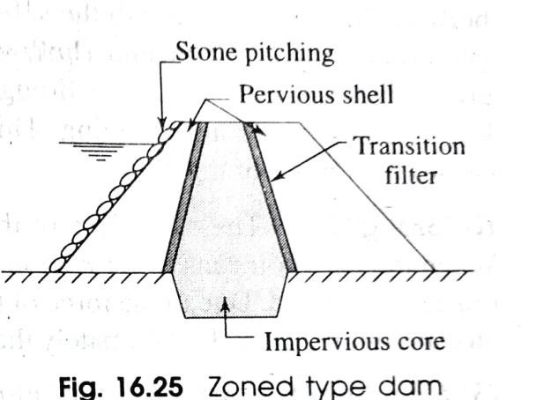
Zoned Type Dam:
    - This type of dam consists of several materials. The impervious core is made of puddle clay and the outer previous shell is constructed with the mixture of earth, sand, gravel, etc.
    - The core is trapezoidal in section and its width depends on the seepage characteristics of the soil mixture on the upstream

side. The core is extended below the base of the dam to control the sub-soil seepage.
    - Transition filters are provided on both sides of the impervious core to control the seepage. The transition filter is made of gravel and coarse sand.
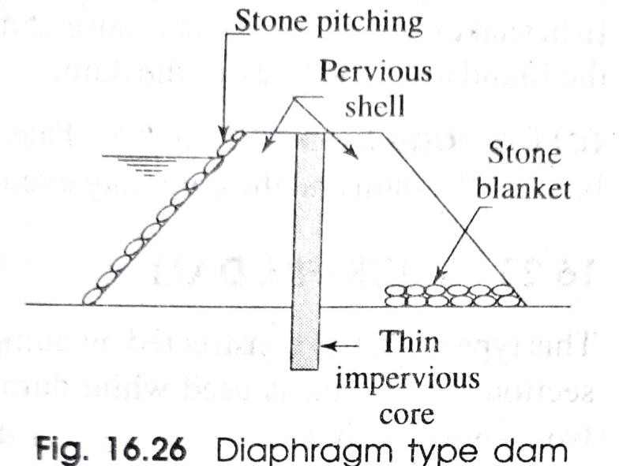
    - The upstream face of the dam is protected by stone pitching. Diaphragm Type Dam:
    - In this type of dam, a thin impervious core or diaphragm is provided which may consist of puddle clay or cement concrete or bituminous concrete.
    - The upstream and downstream body of the dam is constructed with pervious shell which consists of the mixture of soil, sand, gravel, etc.
    - The thickness of the core is generally less than 3m.
    - A blanket of stones is provided on the toe of the dam for the drainage of the seepage water without damaging the base of the dam.
    - The upstream face is protected by stone pitching.
    - The side slope of the dam should be decided according to the angle of repose of the soil mixture.

CAUSES OF FAILURE OF EARTHEN DAM
The failure of the earthen dam may be caused due to the reasons,
- Hydraulic Failure This type of failure may be caused by:
  - Overtopping: If the actual flood discharge is much more than the estimated flood discharge or the free board is kept insufficient or there is settlement of the dam or the capacity of spill way is insufficient, then it results in the overtopping of the dam. During the overtopping the crest of the dam may be washed out and the dam may collapse.
  - Erosion: If the stone protection of the upstream side is insufficient, then the upstream face may be damaged by erosion due to wave action. The downstream side also may be damaged by tail water, rainwater, etc. The toe of the dam may also get damaged by the water flowing through the spill ways.
- Seepage Failure This type of failure may be caused by:
  - Piping or undermining: Due to the continuous seepage flow through the body of the dam and through the sub-soil below the dam, the downstream side gets eroded or washed out and a hollow pipe like groove is formed which extends gradually towards the upstream through the base of the dam. This phenomenon

is known as piping or undermining. This effect weakens the dam and ultimately causes the failure of the dam.
  - Sloughing: The crumbling of the toe of the dam is known as sloughing. When the reservoir runs full, for a longer time, the downstream base of the dam remains saturated. Due to the force of the seepage water the toe of the dam goes on crumbling gradually. Ultimately the base of the dam collapses.
- Structural Failure This type of failure may be caused by
  - Sliding of the side slopes: Sometimes, it is found that the side slope of the dam slides down to form some steeper slope. The dam goes on depressing gradually and then overtopping occurs which leads to the failure of the dam.
  - Damage by burrowing animals: Some burrowing animals like craw fish, snakes, squirrel, rats, etc cause damage to the dam by digging holes through the foundation and body of the dam.
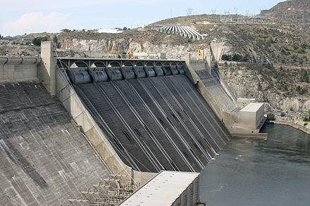
  - Damage by earthquake: Due to earthquake cracks may develop on the body of the dam and the dam may eventually collapse.
SOLID GRAVITY DAM
    - The solid gravity dam may be constructed with rubble masonry or concrete.

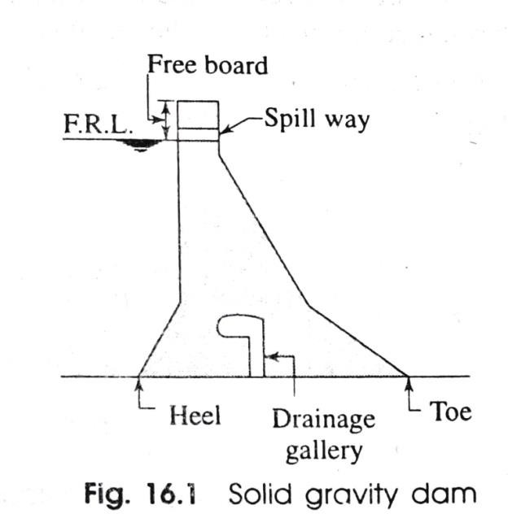
    - The rubble masonry is done according to the shape of the dam with rich cement mortar.
    - The upstream and downstream faces are finished with rich cement mortar.
    - The solid gravity dam resists all the forces acting on it by its self weight.
FORCES ACTING ON GRAVITY DAM
The following forces act on a gravity dam:
- Weight of the Dam
The weight of the dam is the main stabilising force which counters balances all the external forces acting on the dam. So, the dam should be constructed with heavy materials of high specific gravity.
- Water Pressure
On the upstream face the pressure is exerted by the water stored up to full reservoir level and on the downstream face the pressure is exerted by the tail water. Again, the upstream face of the dam may be completely vertical or partly vertical and partly inclined. But the downstream face is always inclined.

- Uplift Pressure
The stored water on the upstream side of the dam has a tendency to seep through the soil below the foundation. While seeping, the flowing water exerts uplift pressure on the base of the dam which depends on the head of water.
- Seismic Force
When the selected dam site comes under the seismic zone, the effect of earthquake waves should be taken into account as it endangers the structure. The vertical and horizontal components of the earthquake waves are considered for the design of a dam coming in seismic zone.
- Silt Pressure
The silt carried by the river and its tributaries gets deposited against the upstream base of the dam year after year. After considerable deposition of silt, it exerts pressure on the dam. So, provisions should be made to resist this silt pressure.
- Wave Pressure
When very high wind or tornado flows over the water surface of the reservoir, waves are formed which exert pressure on the upper part of the dam.

- Ice Pressure
This pressure should be counted only in places where the formation of ice is expected on the reservoir surface. When the sheet of ice is formed on the entire water surface of the reservoir, then it exerts pressure on the dam at the point of contact during the process of contraction and expansion with the change of temperature.
- Wind Pressure
The top exposed portion of the dam is not much and the wind pressure on the surface area of this portion is negligible.
CAUSES OF FAILURE OF GRAVITY DAM
The solid gravity dam may fail because of the following reasons,
- By Over Turning:
The solid gravity dam may fail by over turning at its toe when the total horizontal forces acting on the dam are greater than the total vertical force (i.e. its, self weight). In such a case, the resultant force passes through a point outside the middle-third of the base of the dam. The overturning may be caused at the downstream edge of any horizontal section.

- By Sliding:
The total horizontal forces acting on a dam tend to slide the entire dam at its base or along any horizontal section of the dam. The sliding may take place when the total horizontal forces acting on the dam are greater than the combined resistance offered by shearing resistance of the joint and the static friction.
- By Over Stressing:
If the permissible working compressive stress of concrete or masonry exceeds due to some adverse conditions, then the dam may fail by crushing due to overstressing of the concrete or masonry.
- By Cracking:
The tensile stresses should not be allowed to develop on the upstream face of the dam. If due to some reasons, the tension is developed in the dam section, crack will form in the body of the dam and ultimately this will cause the failure of the dam.
PRECAUTIONS AGAINST FAILURE
To avoid failure of the dam, the following precautions should be taken while designing the dam section,

- To avoid overturning, the resultant of all forces acting on the dam should remain within the middle-third of the base width of the dam. This condition should be achieved in both the cases, when the reservoir is full and also when it is empty.
- In the dam, the sliding should be fully resisted when the condition for no sliding exists in the dam section.
- In the dam section, the compressive stresses of concrete or masonry should not exceed the permissible working stresses to avoid failure due to crushing.
- There should be no tension in the dam section to avoid the formation of cracks. This condition may be achieved by maintaining the middle-third rule.
- The factor of safety should be taken 4 to 5.

PART-B (IRRIGATION ENGINEERING)
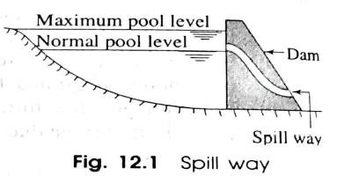
CHAPTER:-07 [DAMS] II SPILL WAYS
Definition:
The spill ways are openings provided at the body of the dam to discharge safely the excess water or flood water when the water level rises above the normal pool level.
NECESSITY OF SPILL WAYS
The spill ways are provided on the dam for the following reasons,
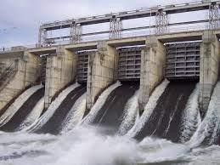
- The height of the dam is always fixed according to the maximum reservoir capacity. The normal pool level indicates the maximum capacity of the reservoir. The water is never stored in the reservoir above this level. The dam may fail by over turning so, for the safety of the dam the spill ways are essential.
- The top of the dam is generally utilised by making road. The surplus water in not be allowed to over top the dam, so to stop the over topping by the surplus water, the spill ways become extremely essential.

- To protect the downstream base and floor of the dam from the effect of scouring and erosion, the spillways are provided so that the excess water flows smoothly.
TYPES OF SPILL WAYS
The following are the common types of spill ways.
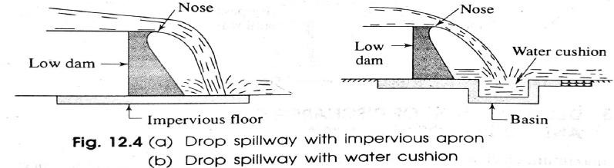
Drop Spill Way
- In drop spill way, the over flowing water falls freely and almost vertically on the downstream side of the hydraulic structure.
- This type of spill way is suitable for weirs or low dams.
- The crest of the spill way is provided with nose so that the water jet may not strike the downstream base of the structure.
- To protect the structure from the effect of scouring horizontal impervious apron should be provided on the downstream side.
- Sometimes a basin is constructed on the downstream side to form a small artificial pool which is known as water cushion. This cushion serves the purpose of energy dissipater.

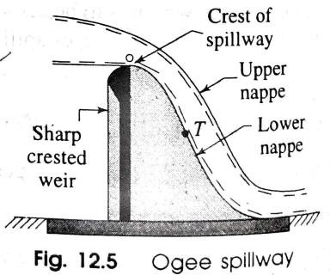
Ogee Spillway
- The ogee spill way is a modified form of drop spill way.
- In this case, the shape of the lower nappe is similar to a projectile and hence downstream surface of the ogee spill way will follow the parabolic path where '0' is the origin of the parabola.
- The downstream face of the spill way forms a concave curve from a point 'T" and meets with the downstream floor. This point 'T' is known as point of tangency.
- Thus the spill way takes the shape of the letter 'S' (i.e. elongated form). Hence, this spill way is termed as ogee spillway.
Siphon Spill Way
The spill way which acts on the principle of siphon is known as siphon spill way. The siphon spill way may be of two types,
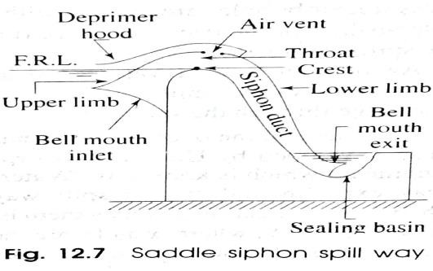
  - Saddle Siphon Spill Way:
    - It consists of a reinforced concrete hollow pipe in the shape of an inverted 'U'.
    - The upper limb is short and consists of a bell mouth inlet. The lower limb is longer and consists of a bell mouth exit.

    - The inlet mouth is kept submerged below the full supply level (F.S.L.) to control the entry of floating debris into the siphon duct which may disturb the siphonic action.
    - The exit mouth is also kept submerged below the water level of the sealing basin. The idea is to stop the entry of air into the siphon duct through the exit end.
    - An air vent is provided on the top of siphon hood. The air vent is again covered by another hood known as deprimer hood.
    - The inlet end of this hood is kept slightly above the full reservoir level.
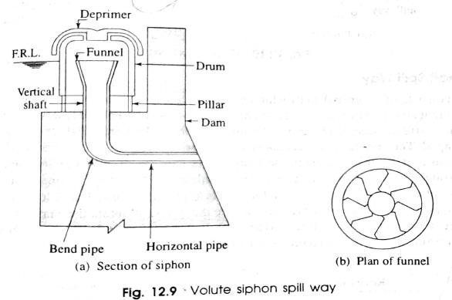
  - Volute Siphon Spill Way:
    - It consists of a vertical shaft having a funnel at the top end and the bottom end is connected to a bend pipe.
    - The bend pipe again is connected to a horizontal pipe which carries the flowing water away from the base of the dam.
    - The top level of the funnel is kept just at the full
reservoir level. The funnel consists of several volutes (curved vanes or blades). Thus the water has a spiral motion while passing through the funnel.

    - A circular drum is placed over the funnel. The drum is supported on pillars. Its bottom end is completely open and the top end consists of a small opening, which acts as air inlet.
    - The water enters the drum through the bottom.
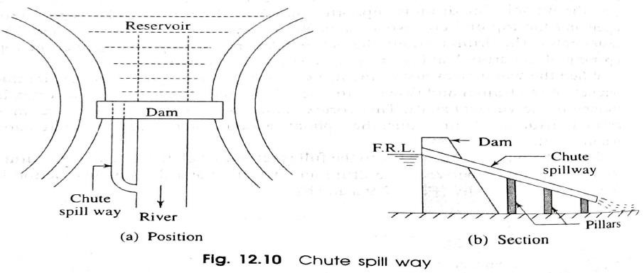
    - A deprimer is provided over the top opening of the drum leaving on air space between the two.
Chute or Trough Spill Way
    - This spill way is simply a rectangular open channel or trough (known as chute) provided on the dam to discharge the surplus water from the reservoir to the same river on the downstream side.
    - The spill way may be provided along the
abutment of the dam or along the edge of the reservoir at the full supply level.
    - The chute is constructed by joining pre-cast R.C.C. channels in a longitudinal slope of 1 in 4 or 1 in 6.
    - The channels are supported on pillars. The section of the channel is designed according to the volume of surplus water or flood discharge.
    - This spill way may be provided at one side or both sides of the dam.

    - Apron should be provided at the downstream end of the chute. The apron is made of boulder pitching with cement grouting.
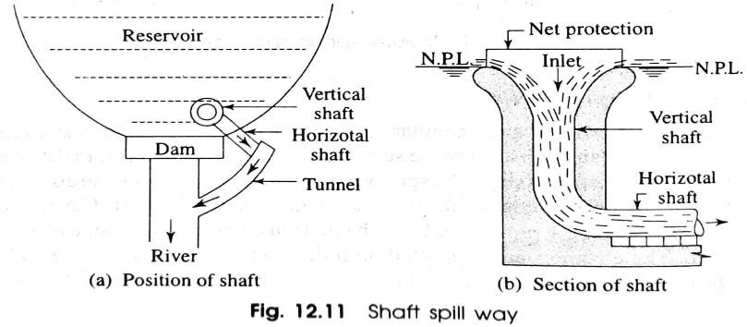
Shaft Spill Way
    - It consists of a vertical shaft which is constructed with masonry work or plain cement concrete or reinforced cement concrete on the bed of the reservoir just at the upstream side of the dam.
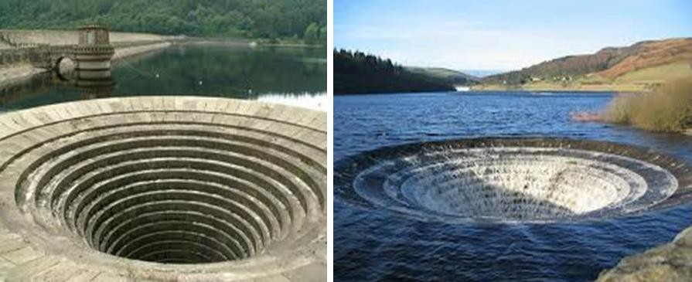
    - The inlet mouth of the vertical shaft is conical shaped. The vertical shaft is connected with horizontal shaft.
    - The horizontal shaft again may be taken through the body of the dam (in case of gravity dam) or through the base of the dam (in case of earthen
dam) or may be connected to a tunnel outside the dam.
    - The inlet mouth is kept at the normal pool level of the reservoir.

    - So, when the water rises above the N.P.L. it enters the shaft from all directions and flows out through the shaft. In order to arrest the floating debris, a net protection is provided on the inlet mouth.
Side Channel Spill Way
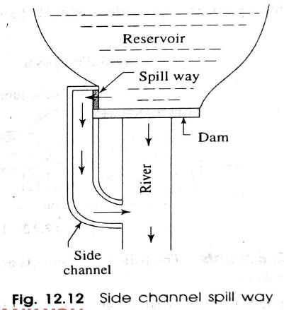
    - The side channel spill way is completely separate from the main body of the dam.
    - The spill way is constructed at right angle to the dam and at any side according to the site condition.
    - The crest of the spill way is kept at the normal pool level of the reservoir.
    - When the water rises above the N.P.L. it spills over the crest of the spill way and flows through the side channel and ultimately meets the same river on the downstream side.
    - This type of spill way is recommended for the sites where other types of spill ways are found unsuitable.
    - The side walls of the channel may be constructed with brick masonry or stone masonry.
    - The longitudinal slope of the channel depends on the available space or length.

***end***

