

LECTURE NOTES ON
FLUID MECHANICS

Compiled by

ER. NIMAIN PRASAD DHAMUDIA

Department Of Mechanical Engineering
RKCAT POLYTECHNIC,NILGIRI,BALASORE

FLUID MECHANICS

SL. No. | CONTENTS | PAGE NO.
1 | Properties of Fluid | 1-08
2 | Fluid Pressure and It’s Measurements | 08-16
3 | Hydrostatics | 16-23
4 | Kinematics of flow | 23-46
5  6 | Orifices, Notches and Weirs  Flow Through pipes | 46-54  54-59

Fluid

FLUID MECHANICS
- It is the branch of engineering science which deals with the behavior of the fluid at rest as well as in motion.
- The study of fluid at rest is called fluid statics.
- The study of fluid in motion where pressure forces are not considered is called fluid Kinematics.
- The study of fluid in motion where the pressure forces are considered is called fluid Dynamics.

- It is the substance that continuously deforms under the applied shear stress.
- A substance that has no fixed shape and yields easily to external pressure.
- Fluid, which is state of matter such as liquid or gas can flow easily and confirm to the shape of their container.
- Fluid having particles that can easily move and change their relative motion.
Fluids are broadly classified into two types.
  - Ideal fluids
  - Real fluids

Ideal fluid:
An ideal fluid is one which has no viscosity and surface tension andis incompressible actually no ideal fluid exists.

Real fluids:
A real fluid is one which has viscosity, surface tension andcompressibility in addition to the density.

PROPERTIES OF FLUID

Density or mass density or specific density
Mass density: density of a fluid is defined as the ration of the mass of a fluid to its volume simply it is the mass per unit volume.
It is denoted by the symbol Ꝭ and unit of mass density is kg/m³ in S.I. system.
Mathematically, Ꝭ = ^{𝑚𝑎𝑠𝑠} ^{𝑜𝑓} ^{𝑡ℎ𝑒} ^{𝑓𝑙𝑢𝑖𝑑}
𝑣𝑜𝑙𝑢𝑚𝑒 𝑜𝑓 𝑡ℎ𝑒 𝑓𝑙𝑢𝑖𝑑
Density of water is 1000 kg/m³ (Standard volume)

Specific weight or weight density
Specific weight of a fluid is the ratio between the weights of a fluid to its volume.
It is denoted by ‘w’
Mathematically, w= ^{𝑤𝑒𝑖𝑔ℎ𝑡} ^{𝑜𝑓} ^{𝑎} ^{𝑓𝑙𝑢𝑖𝑑} N/m³
𝑣𝑜𝑙𝑢𝑚𝑒 𝑜𝑓 𝑎 𝑓𝑙𝑢𝑖𝑑

= 𝑚𝑎𝑠𝑠 𝑋 𝑎𝑐𝑐𝑒𝑙𝑒𝑟𝑎𝑡𝑖𝑜𝑛 𝑑𝑢𝑒 𝑡𝑜 𝑔𝑟𝑎𝑣𝑖𝑡𝑦
𝑣𝑜𝑙𝑢𝑚𝑒 𝑜𝑓 𝑎 𝑓𝑙𝑢𝑖𝑑
= Ꝭ X g

Value of specific weight for water is 1000x9.81= 9810 N/m³

Specific volume
Specific volume of a fluid is defined as the volume of a fluid occupied by a unit mass.

Specific volume= ^{𝑣𝑜𝑙𝑢𝑚𝑒} ^{𝑜𝑓} ^{𝑓𝑙𝑢𝑖𝑑}
𝑚𝑎𝑠𝑠 𝑜𝑓 𝑓𝑙𝑢𝑖𝑑
1
=

𝑚𝑎𝑠𝑠 𝑜𝑓 𝑓𝑙𝑢𝑖𝑑

𝑣𝑜𝑙𝑢𝑚𝑒 𝑜𝑓 𝑓𝑙𝑢𝑖𝑑
= 1
◻
m³/kg

The specific volume is the reciprocal of mass density is expressed as m³/kg, is commonly applied to gases.

Specific gravity
It is defined as the ratio of the weight density or density of fluid to the weight density or density of standard fluid.
  - For liquid standard fluid is taken as water and for gases standard fluid is taken as gases.
  - Specific gravity is also called as relative density.

Mathematically, S= 𝑑𝑒𝑛𝑠𝑖𝑡𝑦 𝑜𝑟 𝑠𝑝𝑒𝑐𝑖𝑓𝑖𝑐 𝑤𝑒𝑖𝑔ℎ𝑡 𝑜𝑓 𝑔𝑟𝑎𝑣𝑖𝑡𝑦 𝑜𝑓 𝑓𝑙𝑢𝑖𝑑
𝑑𝑒𝑛𝑠𝑖𝑡𝑦 𝑜𝑟 𝑠𝑝𝑒𝑐𝑖𝑓𝑖𝑐 𝑤𝑒𝑖𝑔ℎ𝑡 𝑜𝑓 𝑔𝑖𝑣𝑒𝑛 𝑠𝑡𝑎𝑛𝑑𝑎𝑟𝑑 𝑓𝑙𝑢𝑖𝑑
Sliquid= 𝑑𝑒𝑛𝑠𝑖𝑡𝑦 𝑜𝑟 𝑠𝑝𝑒𝑐𝑖𝑓𝑖𝑐 𝑤𝑒𝑖𝑔ℎ𝑡 𝑜𝑓 𝑔𝑎𝑠
𝑑𝑒𝑛𝑠𝑖𝑡𝑦 𝑜𝑟 𝑠𝑝𝑒𝑐𝑖𝑓𝑖𝑐 𝑤𝑒𝑖𝑔ℎ𝑡 𝑜𝑓 𝑔𝑖𝑣𝑒𝑛 𝑙𝑖𝑞𝑢𝑖𝑑

Sgas= 𝑑𝑒𝑛𝑠𝑖𝑡𝑦 𝑜𝑟 𝑠𝑝𝑒𝑐𝑖𝑓𝑖𝑐 𝑤𝑒𝑖𝑔ℎ𝑡 𝑜𝑓 𝑔𝑖𝑣𝑒𝑛 𝑔𝑎𝑠
𝑑𝑒𝑛𝑠𝑖𝑡𝑦 𝑜𝑟 𝑠𝑝𝑒𝑐𝑖𝑓𝑖𝑐 𝑤𝑒𝑖𝑔ℎ𝑡 𝑜𝑓 𝑎𝑖𝑟

From above formula,
Density or specific weight of liquid= S_{liquid} X specific weight of water Density or specific weight of gas= S_{gas} X density of specific weight of air

Viscosity
It is defined as the property of liquid which offers resistance to the movement of one layer of fluid over another adjacent layer of that fluid.
- When two layers of a fluid at a distance ‘dy’ apart move one over the other at a different velocity ‘u’ and u + du.
- The velocity together with relative velocity causes a shear stress acting between the fluid layers.
- The top layer causes a shear stress on the adjacent lower layer while the lower layer causes a shear stress on the adjacent top layer.
- The shear stress (Ꞇ ) caused is proportional to the rate of change of velocity with respect to y.
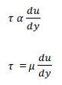
Mathematically,
◻

µ = 𝑑𝑢
𝑑𝑦
where, µ is the constant proportionality and it is known as co-efficient of dynamic viscosity on simple viscosity.

𝑑𝑢

𝑑𝑦
Represents the rate of shear stress or velocity gradient.

Viscosity is also defined as the shear stress required to produce unit rate of shear stress.

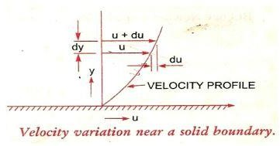

Unit of Viscosity

𝑠ℎ𝑒𝑎𝑟 𝑠𝑡𝑟𝑒𝑠𝑠
µ=
𝑐ℎ𝑎𝑛𝑔𝑒 𝑖𝑛 𝑣𝑒𝑙𝑜𝑐𝑖𝑡𝑦

𝑐ℎ𝑎𝑛𝑔𝑒 𝑖𝑛 𝑑𝑖𝑠𝑡𝑎𝑛𝑐𝑒

𝑓𝑜𝑟𝑐𝑒

𝑎𝑟𝑒𝑎
𝑙𝑒𝑛𝑔𝑡ℎ
= 𝑡𝑖𝑚𝑒
𝑙𝑒𝑛𝑔𝑡ℎ

𝑓𝑜𝑟𝑐𝑒

= 𝑎𝑟𝑒𝑎
𝑡𝑖𝑚𝑒

= 𝑓𝑜𝑟𝑐𝑒 𝑋 𝑡𝑖𝑚𝑒
𝑎𝑟𝑒𝑎
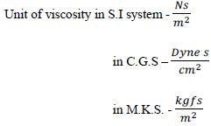

- The unit of viscosity in CGS system is also called poise.

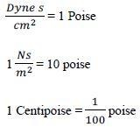

Kinematic Viscosity
It is defined as the ration between the dynamic viscosity and density of fluid.
- It is denoted by symbol ‘v’.
Mathematically, v= ^{𝑑𝑦𝑛𝑎𝑚𝑖𝑐} ^{𝑣𝑖𝑠𝑐𝑜𝑠𝑖𝑡𝑦} = ^{µ}
𝑑𝑒𝑛𝑠𝑖𝑡𝑦 𝑜𝑓 𝑓𝑙𝑢𝑖𝑑 ◻
Unit of Kinematic viscosity:

𝑓𝑜𝑟𝑐𝑒 𝑋 𝑡𝑖𝑚𝑒
V=
𝑎𝑟𝑒𝑎
𝑚𝑎𝑠𝑠
𝑣𝑜𝑙𝑢𝑚𝑒

𝑚𝑎𝑠𝑠 𝑋 𝑙𝑒𝑛𝑔𝑡ℎ 𝑋 𝑡𝑖𝑚𝑒
𝑡𝑖𝑚𝑒2
= 𝑙𝑒𝑛𝑔𝑡ℎ2

= (𝑙𝑒𝑛𝑔𝑡ℎ)2 = 𝑚2

𝑚𝑎𝑠𝑠
𝑙𝑒𝑛𝑔𝑡ℎ3
𝑡𝑖𝑚𝑒

𝑠𝑒𝑐

- In M.K.S. and S.I., the unit of Kinematic viscosity is ^{𝑚}2 .
𝑠𝑒𝑐
- In C.G.S. unit, the unit of Kinematic viscosity is ^{𝑐𝑚}2.
𝑠𝑒𝑐
The unit of Kinematic viscosity in C.G.S. in called stoke. 1 stoke= ^{𝑐𝑚}2
𝑠𝑒𝑐
= 10⁻⁴ ^{𝑚}2
𝑠𝑒𝑐

1 centistoke= ¹
100
stoke.

Newton’s Law of Viscosity
It states that shear stress (Ꞇ ) on a fluid element layer is directly proportional to rate of shear strain. The constant of proportionality is called co-efficient of viscosity. Ꞇ
= µ 𝑑𝑢
𝑑𝑦

Variation of viscosity with temperature-
Temperature affects the viscosity. The viscosity of fluids decreases with the increase of temperature.

Types of fluid:
- Ideal fluid: a fluid which is incompressible and having no viscosity is known as an ideal fluid.
It is imaginary fluids as all the fluids exist have some viscosity.
- Real fluid: Fluids, which possess viscosity is known as real fluid. All the fluids in actual practice are real fluids.
Real fluids are again sub divided into two types:-
Newtonian fluid: a real fluid in which the shear stress is directly proportional to the rate of shear strain is known as Newtonian fluid.
Non-Newtonian fluid: the fluid in which the shear stress as not proportional to the rate of shear strain is known as non-Newtonian fluid.
Surface Tension: It is defined as the tensile force action on the surface of a liquid in contact with a gas or on the surface between two immiscible liquids such that the contact surface behaves like a membrane under tension.
It is denoted by the symbol sigma (𝜎).
Units:
In M.K.S. unit= ^{𝐾𝑔𝑓}
𝑚
In CGS unit= ^{𝑑𝑦𝑛𝑒}
𝑐𝑚
In SI unit= ^{𝑁}
𝑚
Capillarity: It is defined as a phenomenon of rise or fall of a liquid surface in a small tube relative to the adjacent general level of liquid when the tube is held vertical in liquid.
- The rise of liquid surface is known as Capillary rise while he fall of liquid surface is known as capillary depression or capillary fall.
- It is expressed in terms of cm or mm.
Mathematically, Capillarity (h) = ^{4𝜎}
◻𝑔𝑑

Where, 𝜎= surface tension acting on liquid
Ꝭ = density of the liquid
g= acceleration due to gravity d= diameter of tube

Problem: - 1
Calculate the specific weight, density and specific gravity of one litre of a liquid which weighs 7N.
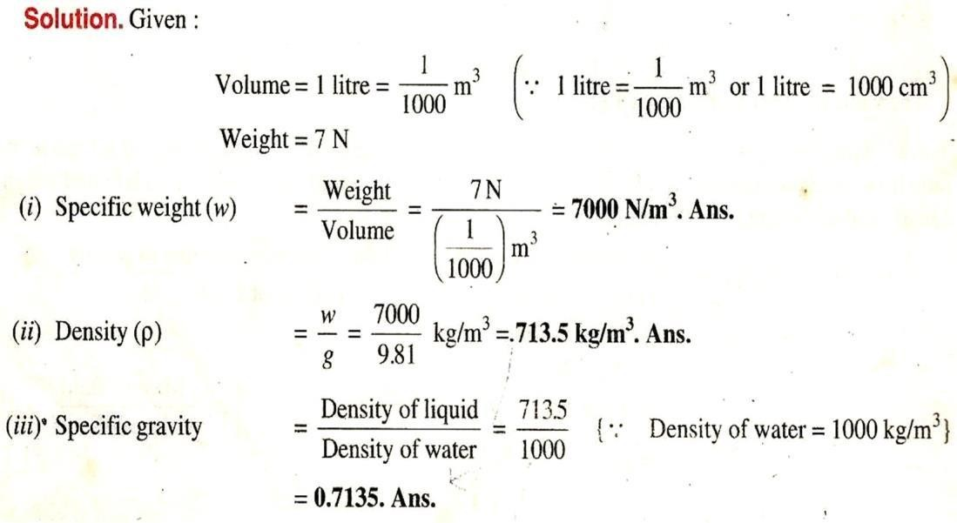

Problem: - 2
Calculate the density, specific weight and specific gravity of one litre of petrol of specific gravity = 0.7

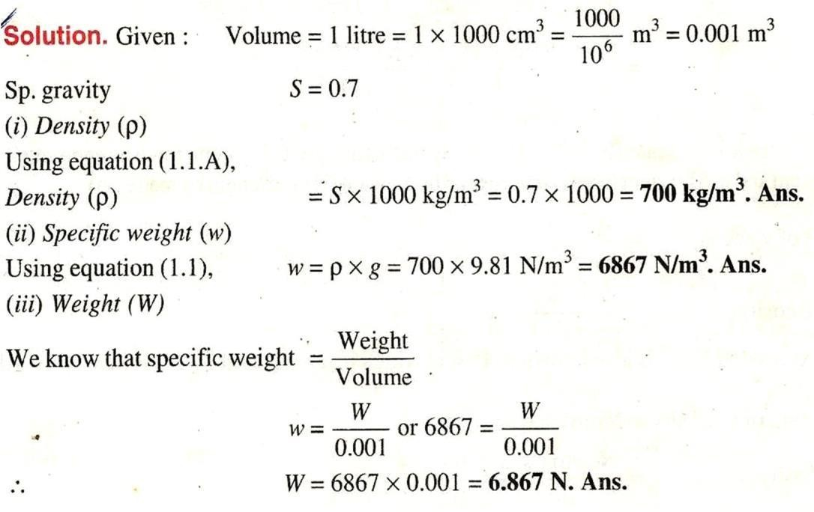

FLUID PRESSURE & ITS MEASUREMENTS

Fluid pressure
- When a fluid is contained in a vessel/container it exerts force at all points on the sides and bottom of the container.
- The force acting per unit area of that container is called pressure.
- Simply, pressure may be defined as force per unit area.
- Pressure at a point is called intensity of pressure.
Mathematically, P= ^{𝐹}
𝐴
Where, F= force acting
A= area on which the force acts.
The pressure of a fluid on a surface will always act normal to the surface.

Pressure Head
A liquid is subjected to pressure due to its own weight, this pressure increases as the depth of liquid increases.
Consider a vessel containing liquid, this liquid will exhaust pressure on all sides and bottom of the container.
Now, let a cylinder be made to stand in liquid,

Let, h= height of the liquid in cylinder A= area of the base of cylinder W= specific weight of liquid = Ꝭ g P= intensity of pressure
Total force or pressure force= weight of the liquid in cylinder. P.A.= w.v
P.A.= w.Ah P.A= Ꝭ gAh
P= Ꝭ gh
A liquid pressure by the height of the free surface which would cause the pressure. The height of the free surface above any point is known as static pressure head.

Pressure head(h)= ^{𝑃}
◻𝑔
or ^{𝑃}
𝑊

Units- m or mm.

Classification of Pressure

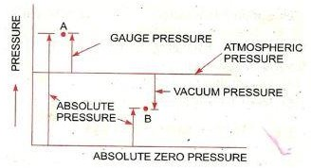
The pressure on a fluid is measured into different system
- In one system it is measured above the absolute zero or complete vacuum and it is called as absolute pressure.
- In other system pressure is measured above the atmospheric pressure it is called gauge pressure.

Atmospheric Pressure
- The atmospheric air exerts a normal pressure upon all surfaces with which it is in contact and it is known as atmospheric pressure.
- The atmospheric pressure is also known as barometric pressure.
- The atmospheric pressure at sea level is called as standard atmospheric pressure.

Absolute Pressure: It is defined as the pressure which is measured with reference to absolute vacuum pressure.
Gauge Pressure: It is the pressure measured with the help of pressure measuring instrument in which atmospheric pressure is taken as datum.
- The atmospheric pressure on the scale is marked as zero.
Vacuum Pressure: It is defined as the pressure below the atmospheric pressure. According to the graph the following relation can be obtained:
Pabsolute= Patm + Pgauge

Pvacuum= Patm - Pabs
- The atmospheric pressure at sea level at 1500⁰C is 101.3 ^{𝑘𝑁} or 10.13 ^{𝑁} in SI

unit.
- In case of MKS unit it is equal to 1.033 ^{𝐾𝑔𝑓},
𝑚2
𝑚2
𝑚2

According to pressure head of actual practice fluid pressure are divided into two types:
Low pressure: when pressure head is low in pipe cross section. High pressure: when pressure head is high in pipe cross section.

Pressure Measuring Devices
Basically, manometers and pressure gauge are used for measuring the fluid pressure.
Manometers are used for measuring low pressure of pipe while pressure gauge is used for measuring the high pressure of fluid.
Manometer: manometers are defined as the device used for measuring the pressure a point in a fluid by balancing the column of fluid by the same or another column of fluid.
Types of manometers:
- Piezometer
- U-tube manometer
- Single column manometer

Simple Manometer: A simple manometer is one which consists of a glass tube whose one end is connected to a point where pressure is to be measured and the other end remains open to the atmosphere.
- Piezometer
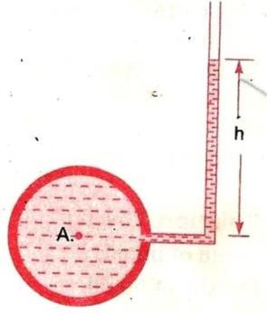

A piezometer is the simplest form of manometer which measure moderate pressure or low pressure.
The pressure at any point in the liquid is indicated by the height of the liquid of the liquid in the liquid in the tube above that point, which can be reached on the scale attached to it.
- U-tube manometer
It consists of a glass tube bent in U-shape, one end of which is connected to the pipe where pressure is to be determined and other end is open to atmosphere.
The tube generally contains mercury or any other liquid whose specific gravity is greater than the whose pressure is to be determined.
Let, h₁= height of the liquid above datum line. h₂= height of heavy liquid above datum line. Ꝭ ₁= density of lighter liquid
Ꝭ ₂= density of heavy liquid.
Let, ‘A’ be the point at which pressure is to be determined.
The pressure in the left limb and right limb above the datum line X-X are equal. Pressure above, X-X in the left limb= pressure above X-X in right limb.
P= pressure at point A.
- Ꝭ ₁gh₁=Ꝭ ₂gh₂
- P= Ꝭ ₂gh₂-Ꝭ ₁gh₁

The negative pressure or vacuum pressure.
Pressure above X-X in the left limb= Pressure above X-X in the right limb.
- P+ Ꝭ ₂gh₂+Ꝭ ₁gh₁=0
- P=-( Ꝭ ₁gh₁+Ꝭ ₂gh₁)

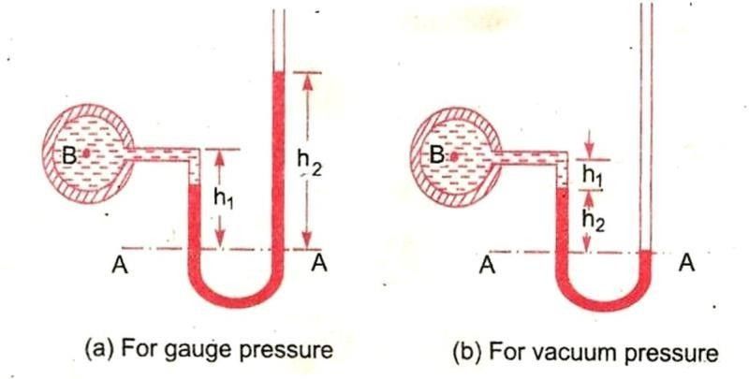

Differential Manometer
Differential manometer are the devices which are used for measuring the difference of pressure between two points in a pipe or in two different pipes.
Most common types of differential manometers are-
  - U-tube differential manometers.
  - Inverted U-tube differential manometers.

U-tube differential manometers
Let the two points A and B are at different levels and also contains liquids of different specific gravity. These points are connected to the U-tube differential manometer.
Let the pressure at A and B are P_{A} and P_{B} respectively
h= difference of mercury level in the U-tube.
y= distance of the centre of B from the mercury level in the right limb. x= distance of the center of A from the mercury level in the left limb. Ꝭ ₁= density of liquid at A.
Ꝭ ₂= density of liquid at B.
Ꝭ _{g}= density of heavy liquid or mercury. Taking datum line X-X.
So, pressure above X-X in left limb= Ꝭ ₁g(h+x)+P_{A} (1)

Pressure above X-X in right limb= Ꝭ ₂gh+Ꝭ _{g}gy+P_{B} (2)
Equating the two-pressure equation (1) & (2)
- Ꝭ ₁g(h+x) +P_{A} = Ꝭ ₂gh+Ꝭ _{g}gy+P_{B}
- P_{A}-P_{B} = Ꝭ ₂gh + Ꝭ _{g}gy - Ꝭ ₁g(h+x)
- P_{A}-P_{B} = Ꝭ ₂gh + Ꝭ ₃gy - Ꝭ ₁g(h+x)
- P_{A}-P_{B} = Ꝭ ₂gh + Ꝭ _{g}gy - Ꝭ ₁gh - Ꝭ ₁gx
- P_{A}-P_{B} = Ꝭ ₂gh - Ꝭ ₁gh + Ꝭ _{g}gy - Ꝭ ₁gx
- P_{A}-P_{B} = gh(Ꝭ _{g}- Ꝭ ₁) + Ꝭ ₂gy - Ꝭ ₁gx
In next figure, pipes A and B are at the same level and contains the same liquid of density Ꝭ ₁.
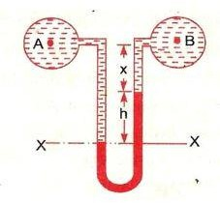

Pressure above datum X-X in the left limb= P_{A} + Ꝭ ₁g(h+x) (1)
Pressure above datum X-X in the right limb= P_{B} + Ꝭ ₁gx + Ꝭ _{g}gh (2)
Equating above two equations, we get:
P_{A} + Ꝭ ₁g(h+x) = P_{B} + Ꝭ ₁gx + Ꝭ _{g}gh P_{A}- P_{B}= Ꝭ ₁gx + Ꝭ _{g}gh - Ꝭ ₁g(h+x) P_{A}- P_{B}= Ꝭ ₁gx + Ꝭ _{g}gh - Ꝭ ₁gh - Ꝭ ₁gx P_{A}- P_{B}= gh(Ꝭ _{g} - Ꝭ ₁)

Inverted U-tube differential manometer
It consist of an inverted U-tube containing a light liquid. The two ends of the tube are connected to the points whose difference of pressure is to be measured.

It is used for measuring difference of low pressure.
In figure U-tube differential manometer aconnected to the two tubes A and B. Let,
h₁= height of liquid in the left limb below the datum line X-X. h₂= height of liquid in right limb.
h= difference of height of light liquid.
Ꝭ ₁= density of liquid at A. Ꝭ ₂= density of liquid at B. Ꝭ _{g}= density of mercury.
P_{A}= pressure at A. P_{B}= pressure at B.
Pressure of pipe A below datum X-X at left limb= P_{A}-Ꝭ ₁gh₁ (1)
Pressure of pipe B below datum X-X at right limb= P_{B} - Ꝭ _{g}gh - Ꝭ ₂gh₂ (2)
Equating above equation, we get:
P_{A} - Ꝭ ₁gh₁ = P_{B} - Ꝭ _{g}gh - Ꝭ ₂gh₂
- P_{A} – P_{B} = - Ꝭ _{g}gh - Ꝭ ₂gh₂ + Ꝭ ₁gh₁
- P_{A} – P_{B} = - Ꝭ ₁gh₁ - Ꝭ _{g}gh + Ꝭ ₂gh₂

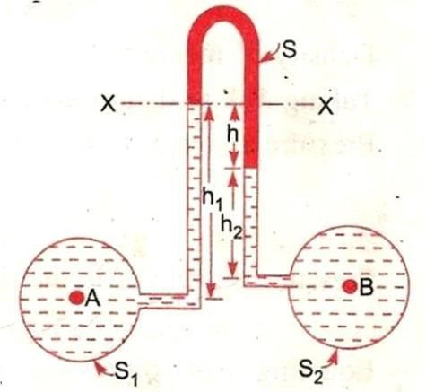

Mechanical Gauge
Whenever a very high fluid pressure is to be measured a mechanical gauge is best sited for the purpose.
Mechanical gauge is also used for the measurement of pressure in boilers, turbines or in other pipes where manometres cannot be conviently used.

There are three types of gauge used for measuring high pressure-

- Bourdon’s Tube pressure gauge
- Diaphragm pressure gauge
- Dead weight type pressure gauge

Bourdon’s Tube Pressure Gauge
The pressure above or below the atmospheric pressure may be easily measured with the hepl of Bourdon’s tube pressure gauge.
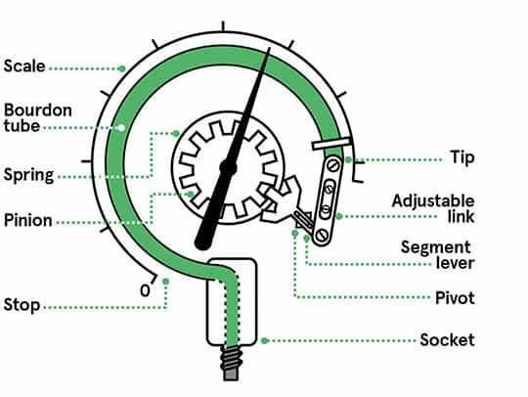
  - A bourdon’s tube pressure gauge
consist of an eliptical tube bent into an arc of a circle. This bent- up tube is called bourdon’s tube.
    - When the gauge tube is connected to the fluid (whose pressure is required to be found out), the fluid under pressure
flows into the tube.
  - The Bourdon’s tube as a result of the increased pressure tends to straighten itself. Since the tube is encased in a circular cover, therefore it tends to become circular instead of straight.
  - With the help of simple pinion and sector arrangement the elastic deformation of the Bourdon’s tube rotates the pointer.
  - These pointer moves over a calibrated scale which directly gives the pressure.

Numerical problems:
  - The right limb of a simple U-tube manometer containing mercury is open to the atmosphere while the left limb is connected to a pipe in which a fluid of sp gravity 0.9 is flowing. The centre of the pipe is 12cm below the level of mercury in the right limb. Find the pressure of fluid in the pipe if the deference of mercury level in the two limbs is 20 cm.
  - A single column manometer is connected to a pipe containing a liquid of sp. Gravity 0.9 find the pressure in the pipe if the area of the reservoir is 100 times the area of the tube for manometer reading. The sp. Gravity of mercury is 13.6.

  - a deferential manometer is connected at the two points A and B of twopipes. The pipe A contains a liquid of sp. Gravity =1.5 wile pipe B containsa liquid of sp. Gravity 0.9 the pressure at A and B are 1kg/ cm² and 1.80 kg/cm² respectively. Find the deference in mercury level in the deferential manometer.
Q.4water is flowing through two deference pipes to which an inverted deferential manometer having an oil of sp. Gravity 0.8 is connected. The pressure head in the pipe A is 2m of water, find the pressure in the pipe B for the manometer readings.

HYDROSTATICS
It is defined as the study of pressure exerted by a liquid at rest. The drection of such pressure is always perpendicular to the surface on which in acts.
Total Pressure: It is defined as the force exerted by a static fluid on a surface either plane or curved when the fluid comes in contact with the surface.
Centre of pressure: It is defined as the point of application of the total pressure on the surface.
There are four cases of submerged surfaces on which the total pressure force and the centre of pressure is to be dtermined.
This submerged surface may be-
- Horizontal plane surface
- Vertical plane surface
- Inclined surface
- Curve surface

Total pressure force & depth of centre of pressure on horizontal immersed surface.

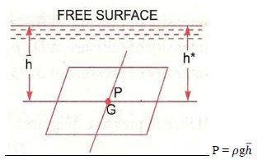

Consider a plane horizontal surface immersed in a static fluid as every point of the surface is at the same depth from the free surface of the liquid.
The pressure intensity will be equal on the entire surface and equal to P= Ꝭ gh Where, Ꝭ = density of the liquid
h= depth of surface
Total pressure force F on the surface, F= P X Area
= Ꝭ gh X Area
F
Where, h*= depth of centre of pressure from free surface equal to h. h(bar)= depth of C.G. from free surface of liquid h.

Total pressure force & depth of centre of pressure on horizontal immersed surface.

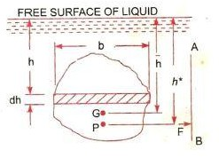
Consider a vertical plane surface of any shape immersed in a liquid. Let,
A= total area of the surface
h(bar)= distance of C.G. of the area from free surface of liquid. G= centre of gravity of plane surface.
h* = distance of centre of pressure(P) from the surface of liquid.
Total Pressure: The total pressure on the surface may be determined by dividing the entire surface into a number of small parallel strip.
The force on small strip calculated and the total pressure force on the hole area is calculated by integrating the force on small strip.
Consider a strip of thickness ‘dh’ and width ‘b’ at a depth ‘h’ from free surface of liquid.
Area of the small strip= b X dh
Total pressure on step => dF= P X Area
= Ꝭ gh X bdh Total pressure force on the whole surface,
F= ∫ 𝑑𝐹
= ∫ ◻𝑔ℎ 𝑋 𝑏𝑑ℎ
= Ꝭ g∫ ℎ 𝑋 𝑏𝑑ℎ
= Ꝭ g∫ ℎ 𝑋 𝑑𝐴
But, ∫ ℎ 𝑋 𝑑𝐴= moment of surface area about the free surface of liquid.
= area of the surface X distance of C.G. from free surface.
F= Ꝭ gAℎ¯

Depth of centre of pressure
The intensity of pressure on an emmersed surface is not uniform.

The intensity of pressure is higher at the lower posrtion of vertical surface as comapred to upper surface, when the vertical surface is emmersed in static liquid,
Centre of pressure is calculated by using the principle of moments which states that, “the moment of the resultant force about an axis is equal to the sum of moments of the components about the same axis”.
The resultant force ‘F’ acting at a point P at a distance ‘h*’ from free surface of the liquid.
Hence moment of the force F about free surface of the liquid = FXh* (1)
Moment of force dF acting on a stream about the free surface of liquid.
= dF X h
= P x bdh x h
= Ꝭ gh x dA x h
= Ꝭ gh²dA
Sum of moment of all such surface about free surface of liquid
= ∫ ◻𝑔ℎ²𝑑𝐴
= Ꝭ g∫ ℎ²𝑑𝐴
= Ꝭ gI₀ (2)
I₀= integration of h²dA= moment of inertia of the surface about free surface of liquid.
Now equating two equations we get:
Fxh* = Ꝭ gI_{o}
Ꝭ gAh̄x h*= Ꝭ gI_{o}
h*= ◻𝑔𝐼𝑜
◻𝑔𝐴ℎ՟
h* = ^{𝐼𝑂} (3)
𝐴ℎ՟
According to parallel axis theorem of moment of inertia, I_{o}= I_{G} + Ah⁻²
Putting the value of I_{o} in equation (3),
h*= 𝐼𝐺+𝐴ℎ̄2
𝐴ℎ՟

h*= ^{𝐼𝐺} + ℎ՟
𝐴ℎ՟
Therefore, centre of pressure lies below the centre of gravity ‘g’.
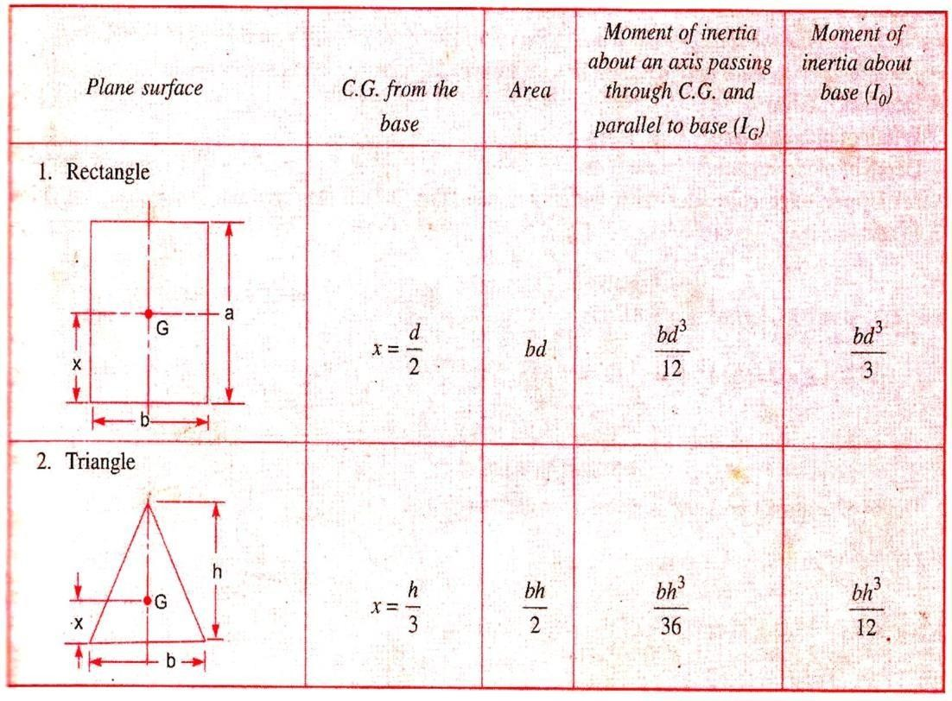

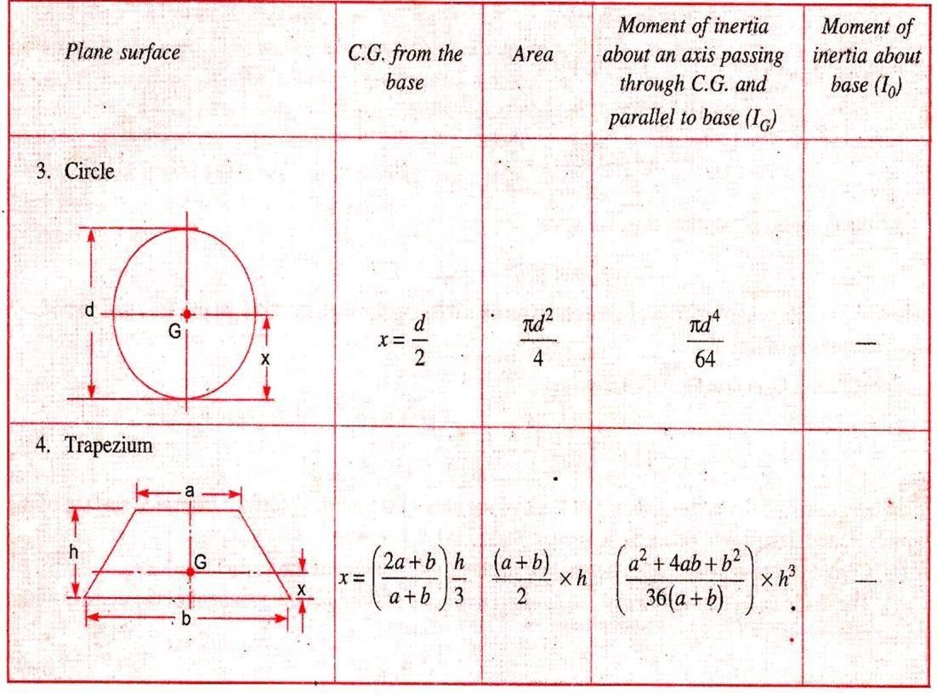

Horizontal plane surface submerged in liquid:
Consider a plane horizontal surface immersed in a static fluid as every point of the surface is at the same depth from the free surface of the liquid, the pressure intensity will be equal on the entire surface.

liquid
P = ρgℎ¯
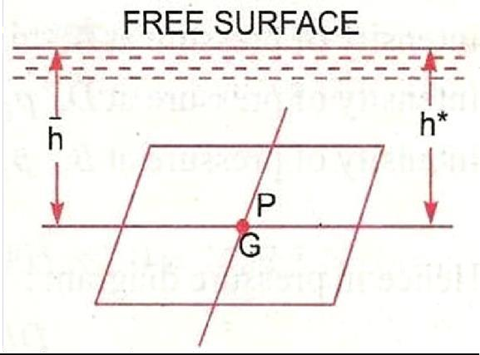
We know that pressure force, F = P × A
Then total pressure force acting on horizontal surface immersed in a
= ρgAℎ¯

Archimedes principle:
When a body is immersed in a fluid either wholly or partially,it is buoyed or lifted up by a force, which is equal to the weight of fluid displaced by the body.

Buoyancy:
Whenever a body is immersed wholly or partially in a fluid it is subjected to an upward force which tends to lift it up. This tendency for an immersed body to be lifted up in the fluid due to an upward force oppositeto action of gravity is known as buoyancy this upward force is known as force of buoyancy.

Centre of Buoyancy:
It is defined as the point through which the forced of buoyancy is supposed to act. The force of buoyancy is a vertical force and is equal to theweight of the fluid displaced by the body.
Canter of buoyancy will be the centre of gravity of the fluid displaced.

Meta-centre;
It is defined as the point about which a body starts oscillating when the body is tilted by a small angle. The mate centre may also be defined as the point at which the line of action of the force of buoyancy will melt the normal axis. Of the body when the body is given a small angular displacement.
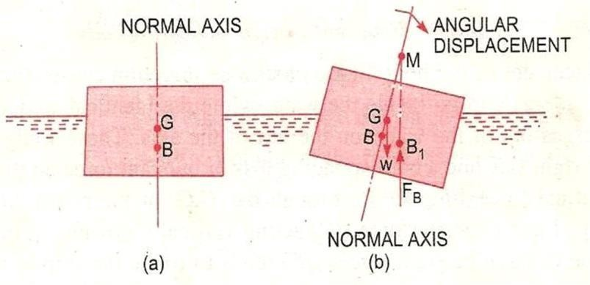

Mate centre height:
The distance between the meta centre of a floating body and the centre of gravity of the body is called meta-centric height i.e the distance MG.

Concept of flotation:
Flotation:
When a body is immersed in any fluid, it experiences two forces. First one is the weight of body W acting vertically downwards, second isthe buoyancy force Fþ acting vertically upwards in case W is greater than Fþ, the weight will cause the body to sink in the fluid. In case W = Fþ the body will remain in equilibrium at any level. In case W is small than Fþ the body will move upwards in fluid. The body moving up will come to rest or top moving up in fluid when the fluid displaced by its submerged part is equal to its weight W, the body in this situation is said to be floating andthis phenomenon is known as flotation.

Principle of flotation:
The principle of flotation states that the weight of the floating body is equal to the weight of the fluid displaced by the body.

Numerical
1. Find the volume of the water displaced & position of centre of buoyancy for a wooden block of width 2.5m & of depth 1.5m when it flats horizontally in water. The density of wooden block is 650 kg/m3. & Its length 6.0m.
- A rectangular plane surface 2m wide and 3m deep lies in water in such a way that its plane makes an angle of 30◦ with the free surface of water. Determine the total pressure and position of center of pressure when the upper edge is 1.5m below the free water surface
- Determine the total pressure on a circular plate of diameter 1.5 m which is placed vertically in water in such a way that the centre of plate is 2 m below the free surface of water. Find the position of centre of pressure also.

KINEMATICS OF FLOW

TYPES OF FLOW: -
The fluid flow is classified as follows:
  - Steady And Unsteady Flow
  - Uniform And Non- Uniform Flows
  - Laminar And Turbulant Flows
  - Compressible And Incompressible Flows
  - Rotational And Irrotational Flows
  - One, Two, Three-Dimensional Flow

STEADY AND UNSTEADY FLOW: -

- Steady flow: -
Steady flow is defined as that type of flow in which the fluid characteristics like velocity, pressure, density at a point do not change with time.

Thus, mathematically
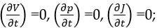

Unsteady flow: -
Unsteady flow is defined as that type of flow in which the velocity,pressure, and density at a point changes w.r.t time.
Thus, mathematically
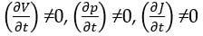

UNIFORM AND NON- UNIFORM FLOWS: -

Uniform flow: -
It is defined as the flow in which velocity of flow at any given timedoes not change w.r.t length of flow or space.
Mathematically,
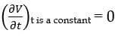

Non- uniform flows: -
It is defined as the flow in which velocity of flow at any given timechanges
w.r.t length of flow. Mathematically,
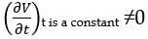

LAMINAR AND TURBULANT FLOWS: -

Laminar flow: -
Laminar flow is that type of flow in which the fluid particles are moved in a well-defined path called streamlines. The paths are parallel and straight to each other.

Turbulent flow: -
Turbulent flow is that type of flow in which the fluid particles

are moved in a zig-zag manner.
For a pipe flow the type of flow is determined by Reynolds number

(Re) =
𝑉𝐷

𝑣

Where V = mean velocity of flow D = diameter of pipe
ν= kinematic viscosity
If Re< 2000, then flow is laminar flow. If Re> 4000, then flow is turbulent flow.
If Re lies in between 2000 and 4000, the flow may be laminar orturbulent.

COMPRESSIBLE AND INCOMPRESSIBLE FLOWS:-

Compressible flow: -
Compressible flow is that type of flow in which the density of fluidchanges from point to point.
So, ρ≠ constant.

Incompressible flow: -
Incompressible flow is that type of flow in which the density isconstant for the fluid flow.
So, ρ=constant

ROTATIONAL AND IRROTATIONAL FLOWS: -

Rotational flow: -
Rotational flow is that of flow in which the fluid particles whileflowing along stream lines also rotate about their own axis.

Ir-rotational flow: -
Irrotational flow is that type of flow in which the fluid particleswhile flowing along streamlines do not rotate about their own axis.

ONE, TWO, THREE-DIMENSIONAL FLOW: -

One dimensional flow: -
One dimension flow is defined as that type of flow in which velocityis a function of time and one space co-ordinate only.
For a steady one-dimensional flow, the velocity is a function of onespace co-ordinate only.
So, U =
f(x),V
= 0,
W = 0
U, V and W are velocity components in x, y, z direction respectively.

Two-dimensional flow: -
Two-dimensional flow is the flow in which velocity is a function of time and 2- space co- ordinates only. For a steady 2- dimensional flow the velocity is a function of two – space co-ordinate only.

So, U = f1(x,y) ,
V = f2(x,y)
,W = 0

Three-dimensional flow: -
Three – dimensional flow is the flow in which velocity is a function of time and 3- space co-ordinates only. For steady three- dimensional flow, the velocity is a function of three space co-ordinates only.
So, U = f1(x, y, z)
V = f2(x, y, z)
W = f3(x, y, z)

Rate of flow or discharge

It is defined as the quantity of a fluid flowing per second

through asection of pipe.
For an incompressible fluid the rate of flow or discharge is expressed as the volume of fluid flowing across the section per second.
For compressible fluids, the rate of flow is usually expressed as theweight of fluid flowing across the section.
Q = A. V
Where A = cross sectional area of the pipe V = velocity of fluid across the section

Equation of continuity:
It is based on the principle of conservation of mass. For a fluid flowing through the pipe at all the cross-section, the quantity of fluid per second is constant.
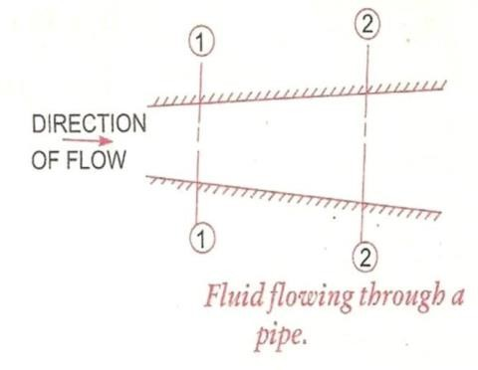

Let V1= average velocity at cross-section 1-1. ρ₁ = density at cross-
section1-1
A₁ = area of pipe at section 1-1
V₂= average velocity at cross-section 2-2 ρ₂ = density at cross-section
2-2
A₂ = area of pipe at section 2-2

The rate of flow at section 1-1 =ρ₁ A₁ V₁ The rate of flow at section 2-2 =ρ₂ A₂ V₂
According to laws of conservation of mass rate of flow at section 1-1 is equal to the rate of flow at section 2-2,
ρ₁ A₁ V₁ = ρ₂ A₂ V₂
This is called continuity equation.
If the fluid is compressible, then ρ₁=ρ₂,
so A₁ V₁ = A₂ V₂
“If no fluid is added removed from the pipe in any length, then themass passing across different sections shall be same”

Simple Problems
Problem: -1
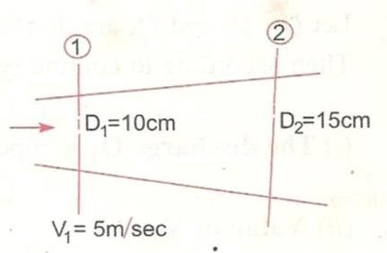
The diameters of a pipe at the sections 1 and 2 are 10cm and 15cm respectively. Find the discharge through the pipe if the velocity of the water flowing through the pipe at section 1 is 5m/s. Determine also the velocity at section 2.

Problem: -2
A 30m diameter pipe conveying water branches into two pipes of diameter 20cm and 15cm respectively. If the average velocity in the 340cmdiameter pipe is 2.5 m/s, find the discharge in this pipe. Also determine thevelocity in 15cm pipe if the
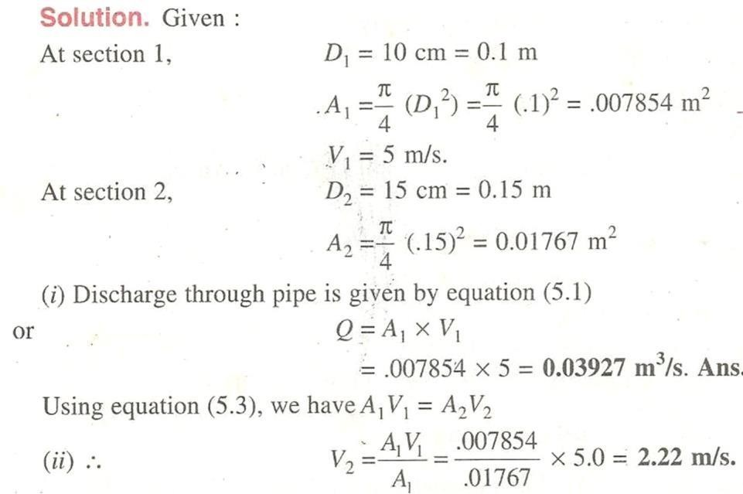
average velocity in 20cm diameter pipe is 2m/s.

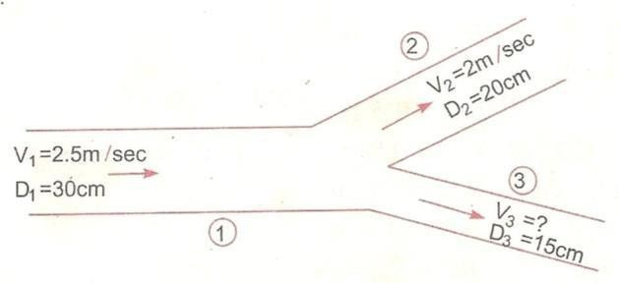

Given Data:
D₁ = 30cm = 0.30m A₁ = π (D ² )/4
1
= π (0.3) ² /4= 0.07068 m²
V₁ = 2.5 m/s

D₂ = 20cm = 0.2m
A₂ = π (0.2)² /4= 0.0314 m²
V₂ = 2m/s
D₃ = 15cm = 0.15m
A₃ = π (0.15² )/4= 0.01767 m²
Let Q₁, Q₂, Q₃ are discharges in pipe 1, 2, 3 respsctively Q₁ = Q₂ + Q₃
The discharge Q₁ in pipe 1 is given as Q₁ = A₁ V₁
= 0.07068 ×2.5 m³/s Q₂ = A₂V₂
= 0.0314 × 2.0 0.0628 m³/s

Substituting the values of Q₁ and Q₂ on the above equation we 0.1767 = 0.0628 + Q₃
Q₃ = 0.1767 – 0.0628
= 0.1139 m3/s
Again Q₃ = A₃ V₃
= 0.01767 × V₃ => 0.1139 = 0.01767 × V₃ V₃ = 0.1139/0.01767
= 6.44m/s

Problem: -4
A 25 cm diameter pipe carries oil of sp. Gr. 0.9 at a velocity of 3m/s. At another section the diameter is 20cm. Find the velocity at this section and also mass rater of flow of oil.
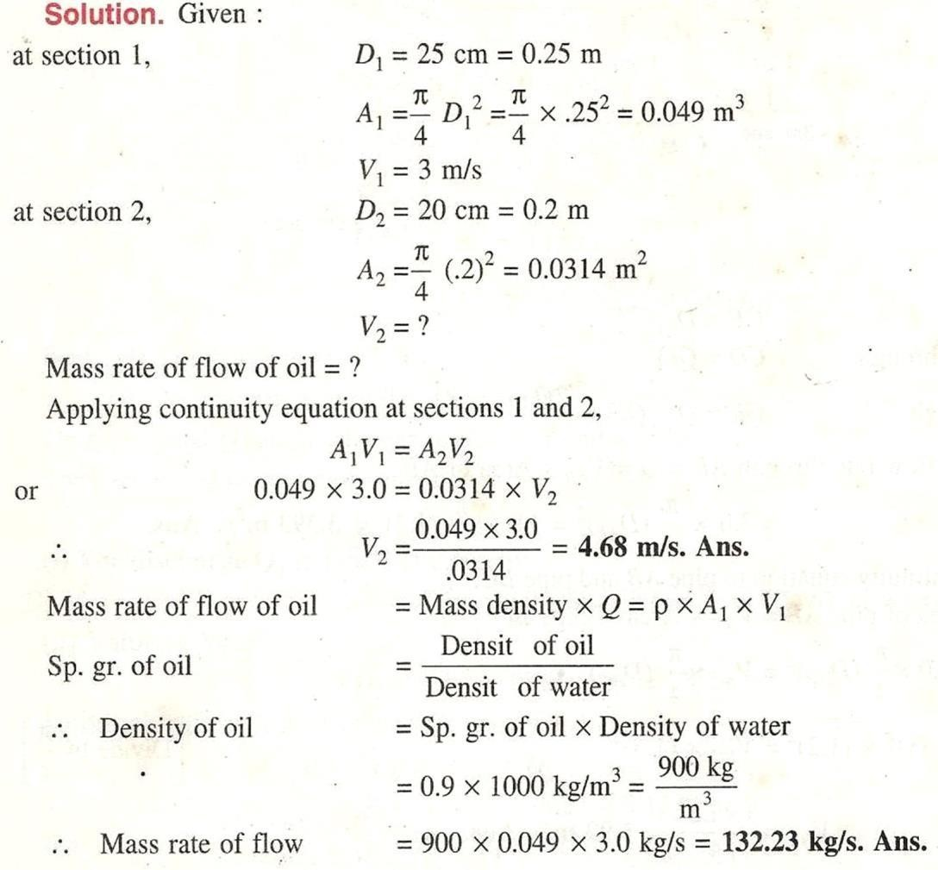

Bernoulli's Theorem:
According to Bernoulli's theorem, the sum of the energies possessed by a flowing ideal liquid at a point is constant provided that the liquid is incompressible and non-viscous and flow in streamline.
Potential energy + Kinetic energy + Pressure energy = Constant Mathematically, Z + V²/2g + p/w =constant
Where, Z = potential energy, V²/2g =Kinetic energy, P/W= pressure energy
Prove: - Consider a perfect incompressible liquid, flowing through a non-uniform pipe as shown in the figure.
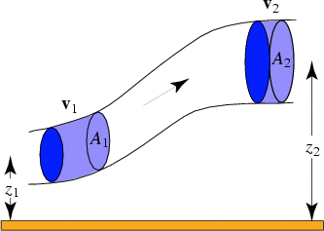
Let us consider two sections AA & BB of the pipe. Now let us assume that the pipe is running full and there is a continuity of flow between the two sections.
Let Z₁ = Height of AA above the datum.
P₁ = Pressure at AA.
V₁ = Velocity of liquid at AA,
a ₁= cross-sectional area of the pipe at AA, and Z_{2,} P_{2,} V₂, a₂ = corresponding values at BB.
Let the liquid between the two sections AA and BB moves to A¹A¹ and B¹B¹ through very small lengths
d l ₁ and d l₂ as shown in fig. This movement of the liquid between AA & BB is equivalent to the movement of the liquid between AA and A¹A¹ to BB and B¹B¹ the remaining liquid between A¹A¹ and BB being un effected.
Let W be the weight of the liquid between AA and A¹A¹. Since the flow is continuous,

Therefore W = wa₁d l₁ =w a₂ d l₂ ⟹a₁ dl₁=a₂ dl₂= W/w (1)
Or a₁ d l₁ = a₂ d l₂ (ii)
We know that work done by pressure at AA in moving the liquid to A¹A¹ = force× distance = p₁a₁d l₁
Similarly, work done by pressure at BB, in moving the liquid to B¹B¹ = - P₂a₂d l₂ (minus sign is taken as the direction of p₂ is opposite to that of p₁)
Total work done by the pressure = P₁a₁dl₁ – P₂a₂dl₂
= P₁a₁dl₁ – P₂a₁dl₁, {Due to a₁dl₁ = a₂ dl₂}
= a₁dl₁ (P₁- P₂) =W/w (P₁- P₂), {Due to a₁dl₁ = W/w} Loss of potential energy = w (z₁- z₂) & again in kinetic energy =w (V ²/2g- V ²/2g)
2 1
= w/2g(V ²- V ²)
2 1
We know that loss of potential energy + work done by pressure W (Z₁- Z₂) + W/w(P₁-P₂) = W/2g (V ² – V²₁)
2
(Z₁ – Z₂) + P₁/w - P₂/w = V ²/2g – V ²/2g
2 1
Or Z₁ + V ²/2g + P /w = Z + V ²/2g + P /w
1
1
2
2
2
Which proves the Bernoulli’s equation

Assumptions
The following are the assumptions made in the derivation of Bernoulli’s equation. (i)The fluid is ideal, i.e., viscosity is zero.
- The flow is steady
- The flow is incompressible
- The flow is ir rotational
Limitations of Bernoulli’s equation: The Bernoulli’s theorem or Bernoulli’s equation has been derived on certain assumptions, which are rarely possible. Thus, the Bernoulli’s theorem has the following limitations.

  - The Bernoulli’s equation has been derived under the assumption that the velocity of every liquid particle across any cross-section of a pipe, is uniform. But in actual practice, it is not so. The velocity of liquid particle in the centre of a pipe is maximum & gradually decreases towards the walls of the pipe due to the pipe friction. Thus, while using the Bernoulli’s equation, only the mean velocity of the liquid should be taken into account.
  - The Bernoulli’s equation has been derived under the assumption that no external force, except the gravity force is acting on the liquid. But in actual practice, it is not so. There are always some external force (such as pipe friction etc) acting the liquid, which effect the flow of the liquid.
Thus, while using the Bernoulli’s equation, all such external force should be neglected. But if some energy is supplied to, or, extracted from the flow the same should also be taken into account.
  - The Bernoulli’s equation has been derived, under the assumption that there is no loss of energy of the liquid particle while flowing. But in actual practice, it is rarely so. In a turbulent flow, some kinetic energy is converted into heat energy. And in a viscous flow, some energy is lost due to shear forces. Thus, while using Bernoulli’s equation, all such losses should be neglected.
  - If the liquid is flowing in a curved path, the energy due to centrifugal force should also be taken into account.

Problem: - 5
Water is flowing through a pipe of 5cm diameter under a pressure of 29.43 N/cm2 (gauge) and with mean velocity of 2.0 m/s. Find the total head or total energy per unit weight of the water at a cross-section, which is 5m above the datum line.
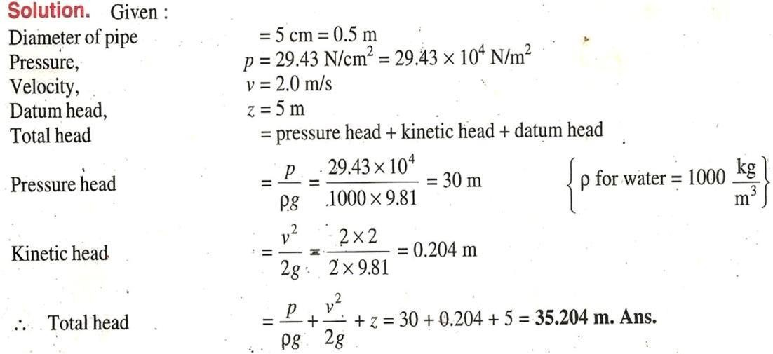

Problem: - 6
A pipe, through which water is flowing, is having diameters, 20cm and 10cm at the cross sections 1 and 2 respectively. The velocity of water at section 1 is given 4.0 m/s. Find the velocity head atsections 1 and 2 and also rate of discharge.
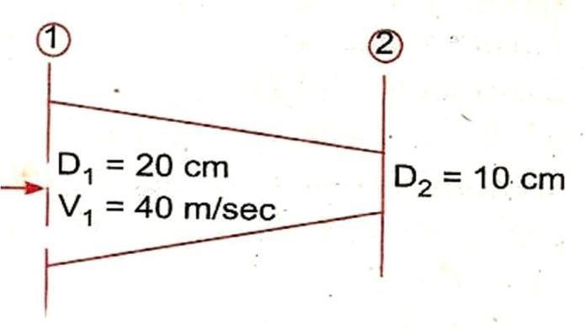

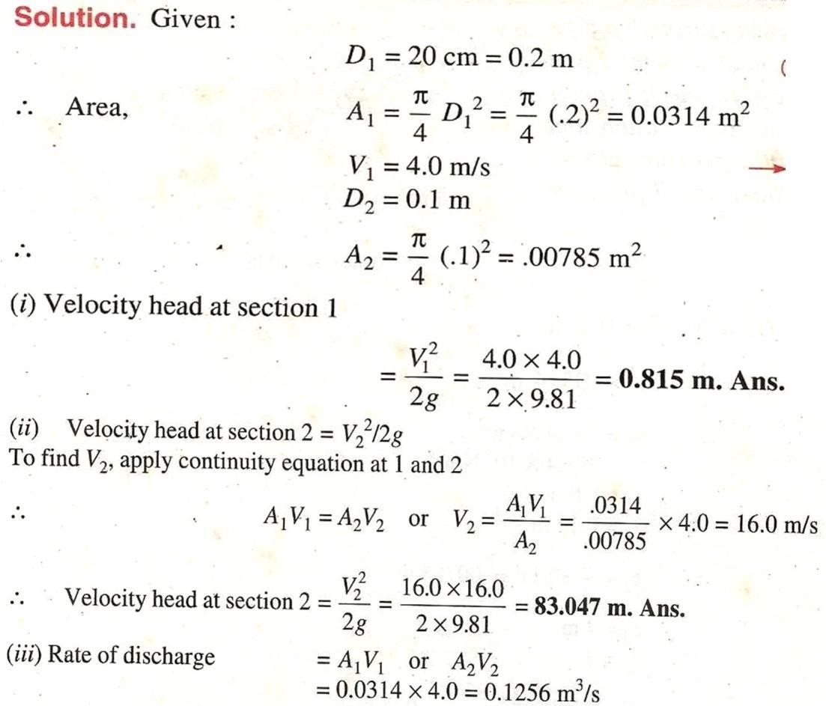

Application of Bernoulli’s equation:
Bernoulli’s equation is applied in all problems of incompressible fluid flow where energy consideration is involved.
It is also applied to following measuring devices
    - Venturi meter
    - Orifice meter
    - Pitot tube

Venturi meter:
A venturi meter is a device used for measuring the rate of a flowof a fluid flowing through a pipe it consists of three parts.
- Short converging part
- Throat
- Diverging part

Expression for rate of flow through venturi meter:
Consider a venturi meter is fitted in a horizontal pipe through whicha fluid flowing
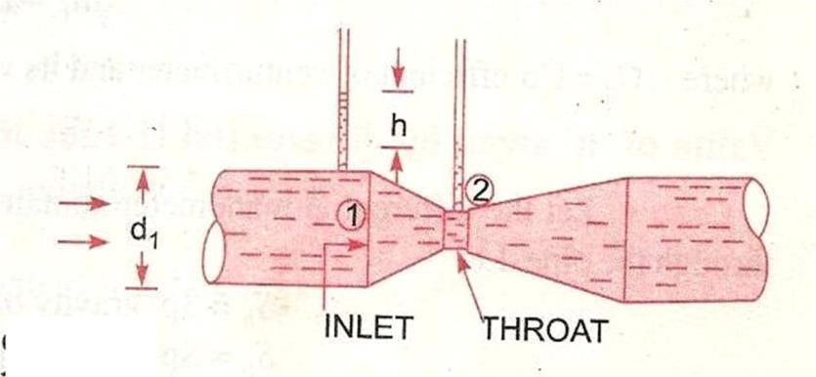

Let d₁ = diameter at inlet or at section (1)(2) P₁ = pressure at section (1)
V₁ = velocity of fluid at section (1) A₁= area at section (1) =πd₁²/4
D2, p2, v2, a2 are corresponding values at section 2 applyingBernoulli’s equation at sections 1 and 2 we get
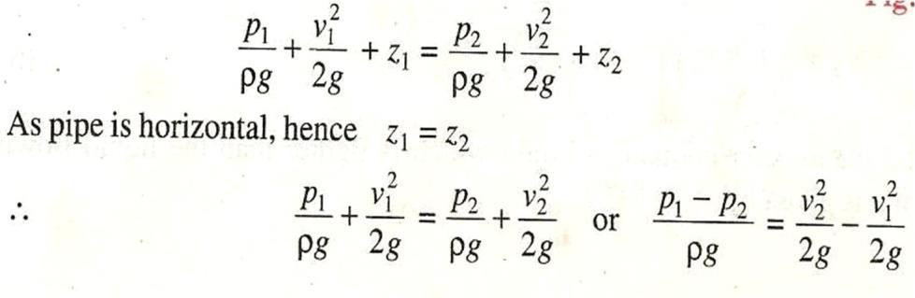

But P1– P2 is the difference of pressure heads at sections 1 and 2
ρg
and it is equal to h
2 2
So, h = V2 -V 1
2g 2g
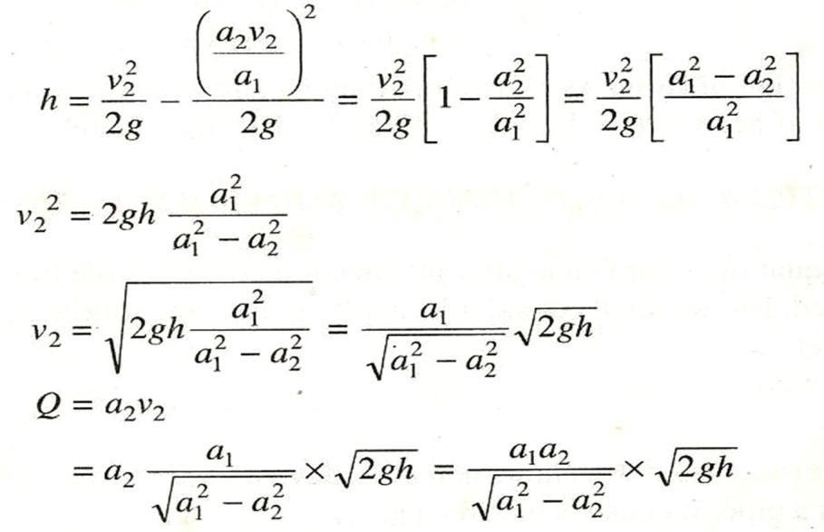
Now applying continuity equation at sections 1 & 2 a1v1 = a2v2 v₁ = a₂v₂ /a₁

Where Q = Theoretical discharge

Actual discharge will be less than theoretical discharge
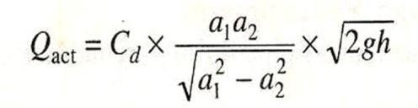

Where Cd = co-efficient of venturimetre and value is less than 1

PITOT TUBE:
A pitot tube an instrument to determine the velocity of flow at the required point in a pipe or a stream in its simplest form a pitot tube consists of a glass tube bent through 90⁰ as shown in figure.

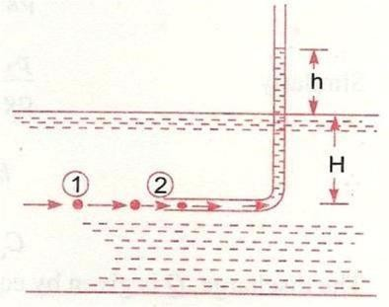
The lower end of the tube poses the direction of the flow as shown in figure. The liquid rises up in the tube due to pressure exerted by the flowing liquid by measuring the rise of liquid in the tube, we can find out the velocity of the liquid flow.

Let h- height of the liquid in the pitot tube above the surface.
H- depth of tube in the liquid end V- velocity of the liquid
Applying Bernoulli’ s equation for the section 1 and 2. H+V₂/2g =H+h (Z₁=Z₂)
H= v₂ /2g V=√𝟐𝒈𝒉

Problem: - 7
Water is flowing through a pipe of 5cm diameter under a pressure of
29.43 N/cm² (gauge) and with mean velocity of 2.0 m/s. Find the total head or total energy per unit weight of the water at a cross-section, which is 5m above the datum line.
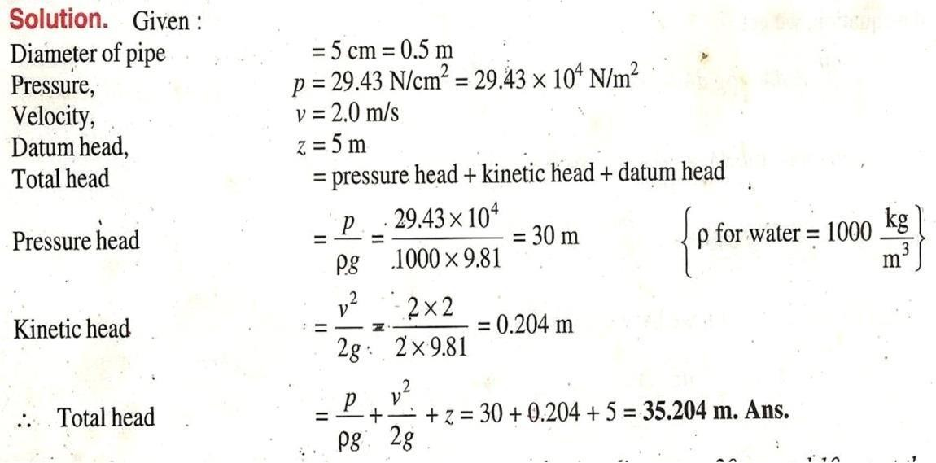

Problem: - 8
The water is flowing through a pipe having diameters 20 cm and 10 cm
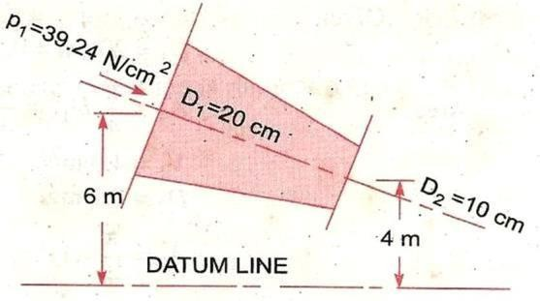
at sections 1 and 2 respectively. The rate of flow through pipe is 35lit/s. The section 1 is 6m above datum and section 2 is 4m above datum. If the pressure at section 1 is 39.24 N/cm². Find the intensity of pressure
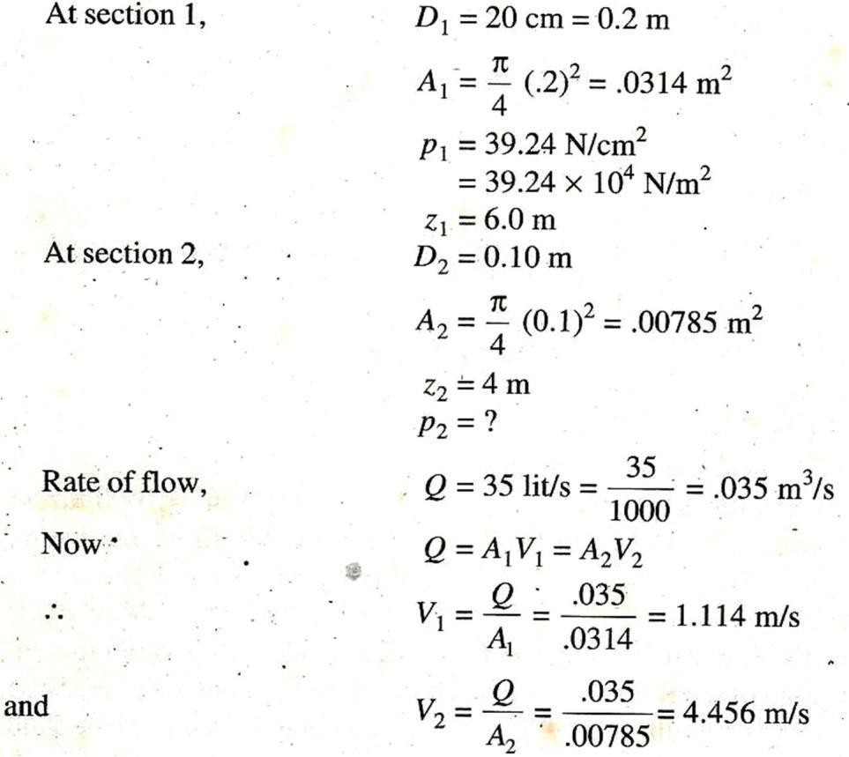
at section 2

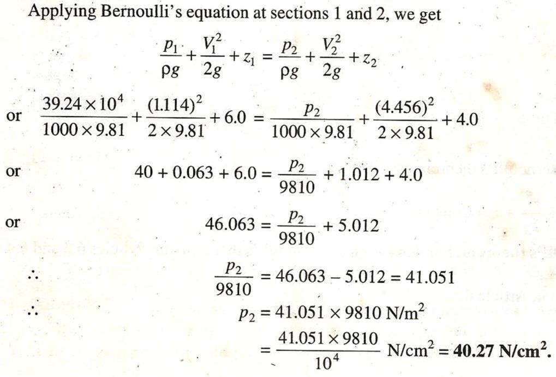

Problem: - 9
Water is flowing through a pipe having diameter 300mm and 200 mm at the bottom and upper end respectively. The intensity of pressure at the bottom end is 9.81N/m². Determine the difference in datum head if the rate of flow through pipe is 40 lit/s
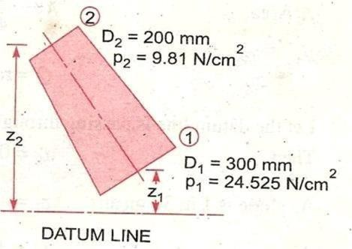
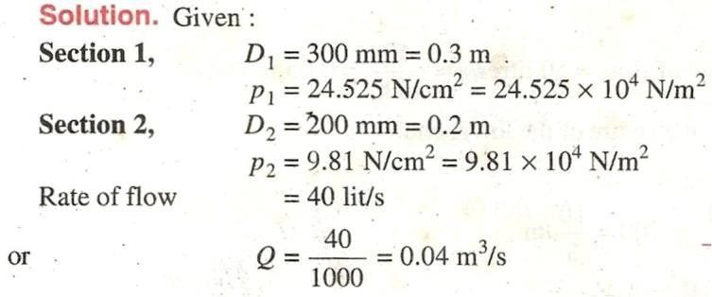
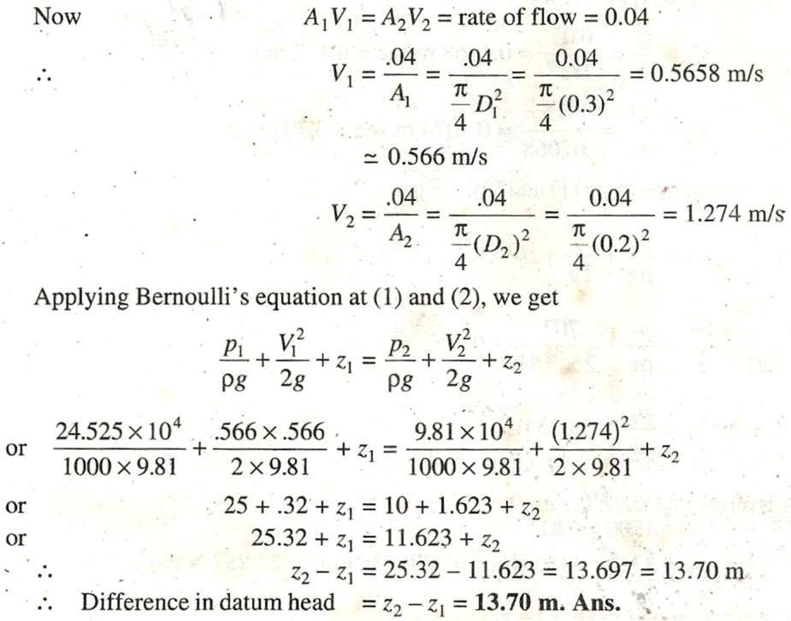

Problem: - 10
A horizontal venturimetre with inlet and throat diameters 10cm and 15 cm respectively is used to measure the flow of water. The reading of differential manometer connected to the inlet and throat is 20cm of mercury. Determine the rate of flow. Take Cd = 0.98

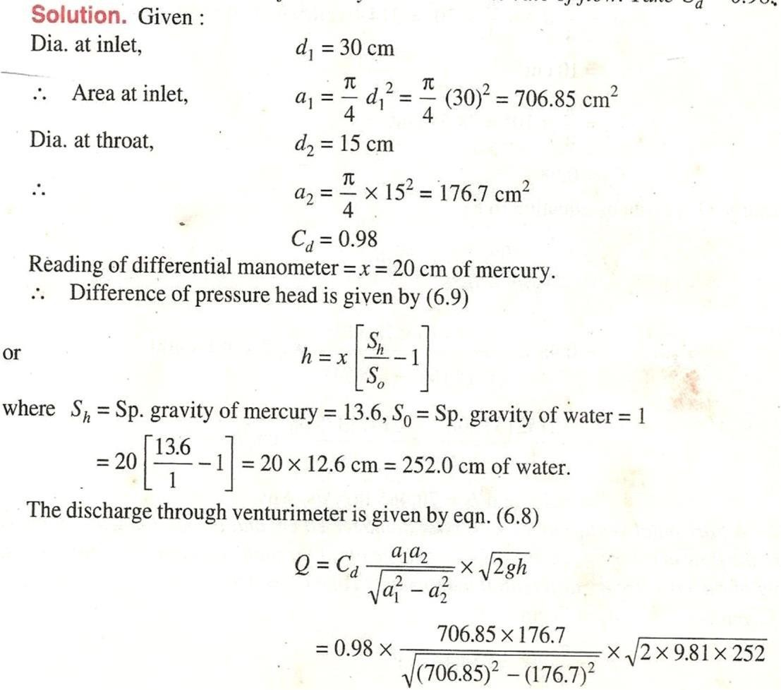
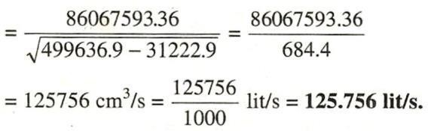

Problem: - 11
An oil of Sp.gr. 0.8 is flowing through a horizontal venturimrtre having inlet diameter 20cm and throaty diameter 10 cm. The oil mercury differential manometer shows a reading of 25cm. Calculate the discharge ofoil through the horizontal venturimetre. Take Cd = 0.98

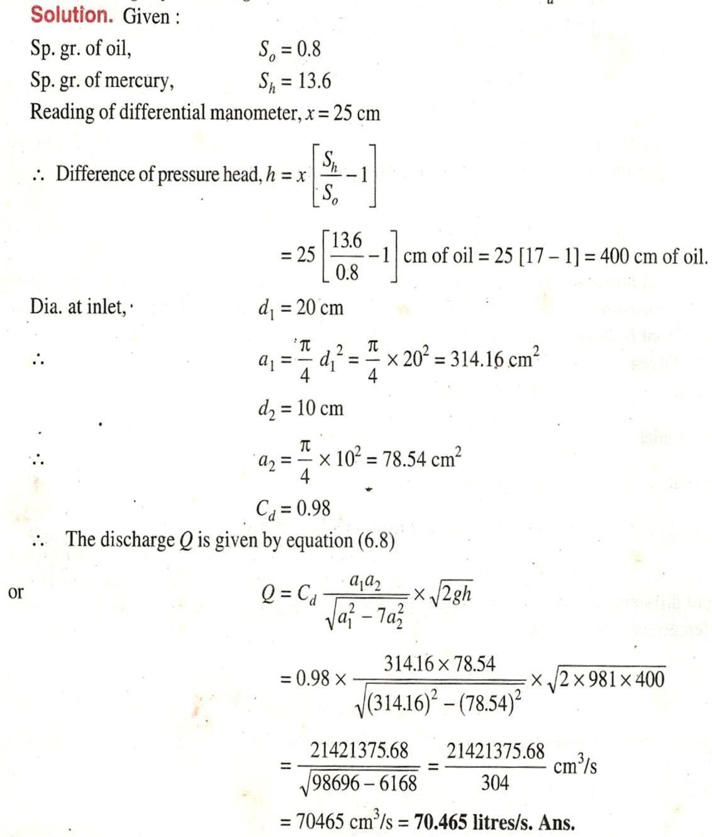

Problem: - 12
A horizontal venturimetre with inlet and throat diameters 20cm and 10 cm respectively is used to measure the flow of oil of Sp. gr.
0.8. The discharge of oil through venturimetre is 60lit/s. Find the reading of oil-mercury differential manometer. Take C_{d} = 0.98

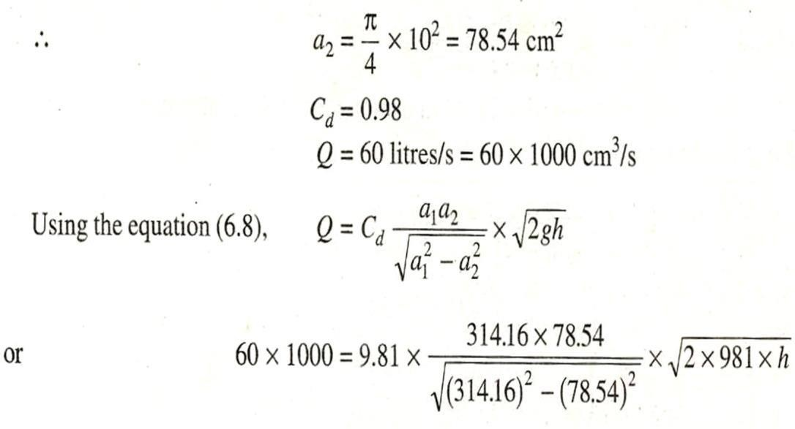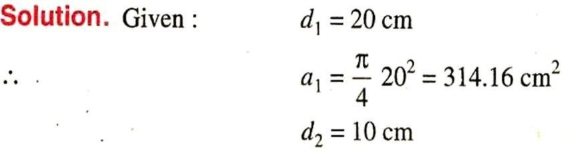
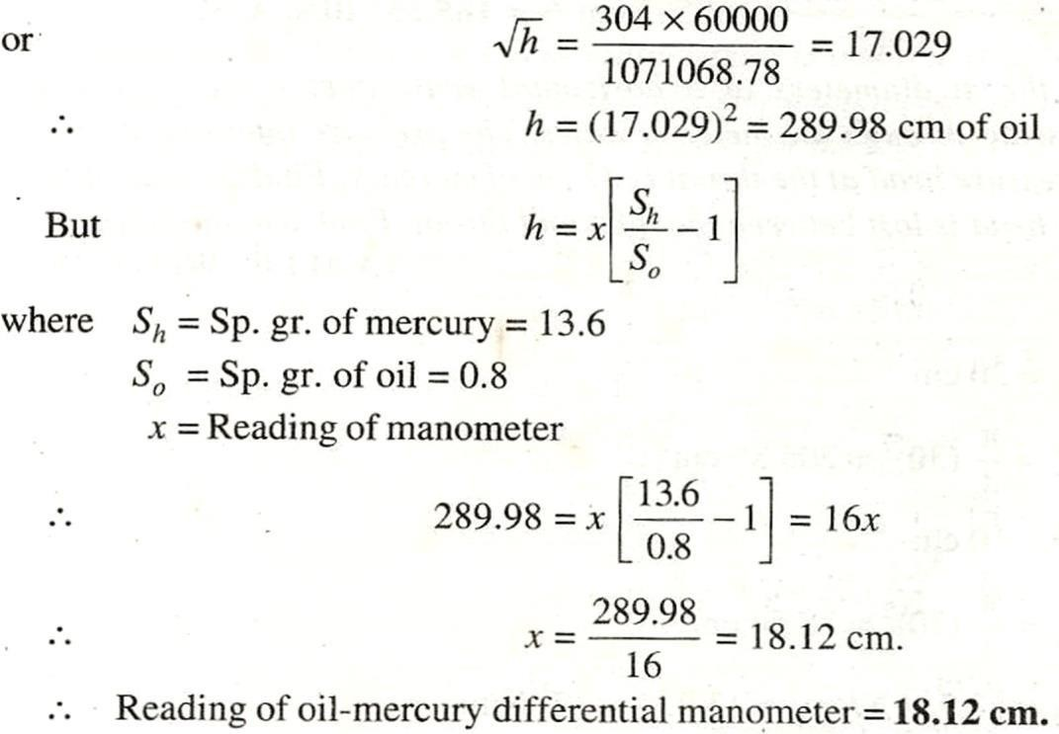

Problem: -13
A static pitot-tube placed in the centre of a 300 mm pipe line has one orifice pointing upstream and is perpendicular to it. The mean velocity in the pipe is 0.80 of the central velocity. Find the discharge through the pipe if the pressure difference between the two orifices is
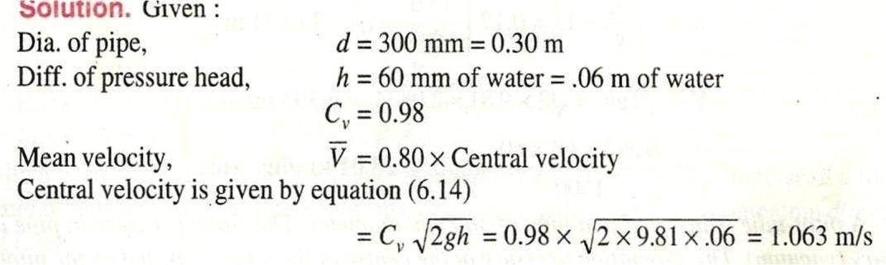

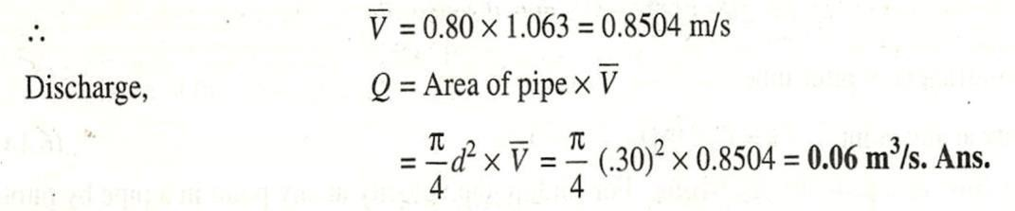
60mm of water. Take Cv = 0.98

FLOW THROUGH ORIFICES, NOTCHES AND WEIRS
Orifice in a small opening of any cross section such as circular, triangular rectangular etc . on the side or at the bottom of a tank through which a fluid is flowing. Orifices are used for measuring the rate of flow of fluid.

- Mouth piece is a short length of a pipe which is two or three times its diameter in length, fitted in a tank or vessel containing the fluid.
- Orifices as well as mouth piece are used for measuring the rate of flow of fluid.
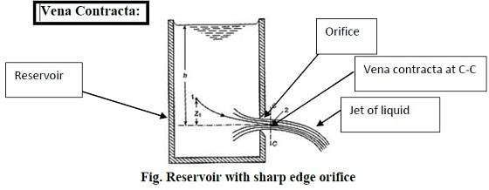

JET OF WATER
The continues stream of a liquid, that comes out or flows out of an orifice is known as the jet of water.

VENNA CONTRACTA
Consider a tank fitted with a circular orifice is one of its sides as shown in fig.
Let H be the head of the liquid above the centre of the orifice. The liquid flowing through the orifice forms a jet of liquid whose area of cross section is less than that of orifice the area of jet of fluid goes on decreasing and at a section c-c, the area is minimum. thus, section is approximately at a distance of half of diameter of the orifice at this section, the stream lines are straight and parallel to each other and perpendicular to the plane of the orifice. This section is called vena contracta beyond this section the jet diverges and is attracted in the down ward direction by the gravity.

Consider two points A & B as shown in figure, point-A is inside the tank and point-B at the Vena-contracta. Let the flow is steady and at a constant head H. Applying Bernoulli’s equation at points A & B,

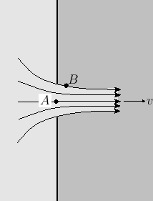
From Bernoullis theorem:
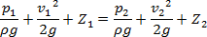
Placing values at points A and B
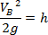

Hydraulic Co-efficients:- The hydraulic coefficients are
- Coefficient of velocity (C_{V}): - It is defined as the ratio between the actual velocity of a jet of liquid at Vena contracta and the theoretical velocity of jet. It is denoted by C_{V}.
Mathematically, CV = Actual velocity of jet at vena−contracta
Theoretical Velocity
= 𝑽
√𝟐𝒈𝑯

Where V= Actual velocity, √𝟐𝒈𝑯 =Theoretical velocity.
The value of C_{V} varies from 0.95 to 0.99 for different orifices. Generally, the value of C_{V} =0.98 is taken for sharp edged orifices.
- Coefficient of contraction (C_{C}): - It is defined as the ratio of the area of the jet at vena-contracta to the area of the orifice. It is denoted by C_{C}
Let a = area of orifice and a_{c} = area of jet at vena-contracta Mathematically,

CC = area of jet at ven−contracta
area of orifice
= ac
𝑎

The value of C_{C} varies from 0.61 to 0.69.
It general the value of C_{C} may be taken as 0.64
- Coefficient of discharge (C_{d}): - It is defined as the ratio of the actual discharge from an orifice to the theoretical discharge from the orifice. It is denoted by C_{d.}

Let Q is actual discharge and Q_{th} is the theoretical discharge. Mathematically, C_{d} = ^{Actual} ^{Discharge} =Q/Q_{th}
Theoritical Discharge
The value C_{d} varies from 0.61 to 0.65. The value of C_{d} is taken as 0.62.

Relation between CC, CV and Cd
Cd = 𝐀𝐜𝐭𝐮𝐚𝐥 𝐃𝐢𝐬𝐜𝐡𝐚𝐫𝐠𝐞
𝐓𝐡𝐞𝐨𝐫𝐢𝐭𝐢𝐜𝐚𝐥 𝐃𝐢𝐬𝐜𝐡𝐚𝐫𝐠𝐞
Cd = 𝐀𝐜𝐭𝐮𝐚𝐥 𝐯𝐞𝐥𝐨𝐜𝐢𝐭𝐲 × 𝐀𝐜𝐭𝐮𝐚𝐥 𝐚𝐫𝐞𝐚
𝐓𝐡𝐞𝐨𝐫𝐞𝐭𝐢𝐜𝐚𝐥 𝐯𝐞𝐥𝐨𝐜𝐢𝐭𝐲× 𝐓𝐡𝐞𝐨𝐫𝐞𝐭𝐢𝐜𝐚𝐥 𝐚𝐫𝐞𝐚
= Cc × Cv

Classification
Orifices are classified on the basis of their size, shape and nature ofdischarge

According to size
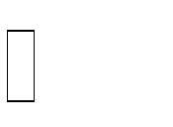
Small orifice (If the head of liquid above the centre of orifice is morethan 5 times the depth of orifice)
Large orifice (If head is less than 5 times the depth of orifice)

According to shape
- Circular
- Triangular
- Rectangular
- Square

According to the shape of upstream edge:
Sharp edged orifice Bell mouthed orifice

According to nature of discharge:
Free discharge orifices Drowned or submerged orifices
  - Partially submerged orifices
  - Fully submerged orifices

Q.1):- The head of water over an orifice of diameter 40mm is 10m. Find the actual discharge and actual velocity of the jet at vena-contracta. Take C_{d}=0.6 and C_{V}
=0.98.
ANS:- Given: H=10cm, Dia. Of orifice, d=40mm=0.04m, Area, a =^{𝜋}×(0.04)² =
4
0.001256m²,C_{d}=0.6, C_{V}=0.98

Cd = 𝑨𝒄𝒕𝒖𝒂𝒍 𝒅𝒊𝒔𝒄𝒉𝒂𝒓𝒈𝒆 =0.6
𝑻𝒉𝒆𝒐𝒓𝒆𝒕𝒊𝒄𝒂𝒍 𝒅𝒊𝒔𝒄𝒉𝒂𝒓𝒈𝒆

But Theoretical discharge= V_{th}× Area of orifice

V_{th} = theoretical velocity, where V_{th}=√𝟐𝒈𝑯=√𝟐 × 𝟗. 𝟖 × 𝟏𝟎= 14m/sec Theoretical discharge =14×0.001256 = 0.01758m²/sec
Actual discharge = 0.6 ×theoretical discharge
= 0.6 ×0.1758 = 0.01054 m³/sec

Cv = 𝑨𝒄𝒕𝒖𝒂𝒍 𝒗𝒆𝒍𝒐𝒄𝒊𝒕𝒚
𝑻𝒉𝒆𝒐𝒓𝒆𝒕𝒊𝒄𝒂𝒍 𝒗𝒆𝒍𝒐𝒄𝒊𝒕𝒚
= C_{V} =0.98

⟹ Actual velocity =0.98×14= 13.72 m/sec
- The head of water over an orifice of diameter 50 mm is 12m. Find actual discharge and actual velocity of jet at Vena-contracta. Take C _{d}= 0.6 and C _{V}=0.98.

- The head of water over the centre of an orifice of diameter 30 mm is 1.5 m. The actual discharge through the orifice is 2.35 litres/sec. Find the co-efficient of discharge.

FLOW THROUGH NOTCHES AND WEIRS
A Notch is a device used for measuring the rate of flow of a liquid through a small channel or a tank. It may be defined as an opening in the side of a tank or a small channel in such a way that the liquid surface in the tank or channel is below the top edge of the opening.
A Weir is a concrete or masonry structure, placed in an open channel over which the flow occurs. It generally in the form of vertical wall, with a sharp edge at the top, running all the way across the open channel.
The notch is of small size while the weir is of a bigger size. The notch is generally made of metallic plate while weir is made of concrete or masonry structure.
Notch- is a device used for measuring the rate of flow or discharge of a liquid through small channel or tank.
Weir- is a concrete or masonry structure, placed in an open channel over which the flow occurs.
It is form of vertical wall, with the sharp edge at the top, running all the way across the open channel.
- NAPPE OR VEIN- The sheet of water flowing through a notch or over a weir is called nappe or vein.
- CREST OR SILL- The bottom edge of notch or a top of a weir over which the water flows, is known the sill or crest.

Classification of Notches and Weirs
Notches are classified as:
- According to the shape of opening
  - Rectangular notch
  - Triangular notch
  - Trapezoidal notch
  - Stepped notch
- According to the effect of the sides on the nappe
  - Notch with end contraction
  - Notch without end contraction or suppressed notch
Weir are classified according to the shape of the opening, the shape of the crest, the effect of the sides on the nappe and the nature of discharge

- According to the shape of the opening:
  - Rectangular weir
  - Triangular weir
  - Trapezoidal weir
- According to the shape of the crest
  - Sharp-crested weir
  - Broad-crested weir
  - Narrow-crested weir
  - Ogee-shaped weir
- according to the effect of the sides on the emerging nappe
  - weir with end contraction
  - weir without end contraction

Discharge over rectangular notch or weir:
The expression for discharge over a rectangular notch or weir is the same.

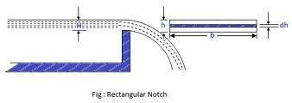
Consider a rectangular notch or weir provided in a channel carrying water as shown in figure----
Let H - Head of water over the crest L –Length of the notch or weir
For finding the discharge of water flowing over the weir or notch, consider an elementary horizontal strip of water of thickness dh and length L at a depth h from the free surface of water as shown in figure.
The area of strip = L x dh

And theoretical velocity of water flowing through strip = √𝟐𝒈𝒉
The discharge dQ , through strip is
dQ = C_{d} x area of strip x Theoretical velocity C_{d} × L × dh× √𝟐𝒈𝒉 …. (i)
Where C_{d} = co efficient of discharge.

The total discharge, Q, for the whole notch or weir is determined by integrating equation (i) between the limit 0 and H.

Q=∫𝑯 𝑪_{d}.L.√𝟐𝒈𝒉. d h
𝟎

=C_{d}×L.√𝟐𝒈
∫𝑯 𝒉^{1/2}dh

=2/3 C_{d}×L×√𝟐𝒈 (H)^{3/2}
𝟎

Discharge over a triangular notch or weir
The expression for the discharge over a triangular notch or weir is the same. It is derived as:
Let H= head of water above the V-notch Ø = angle of notch
Consider a horizontal strip of water of thickness d h at a depth of h from the free surface of water as shown in fig.
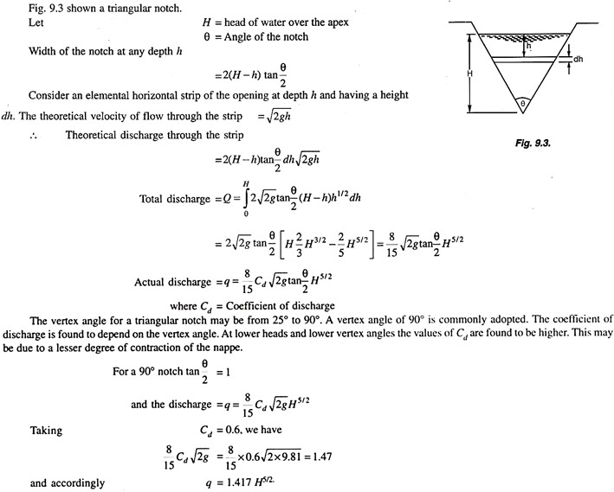

Q: - Find the discharge of water flowing over a rectangular notch of 2m length when the constant head over the notch is 300mm. Take C_{d} = 0.60

Ans: -
Given: Length of the notch, L=2.0m, Head over notch, H =300mm = 0.30m, C_{d}=0.60
Discharge, Q=2/3C_{d}×L×√𝟐𝒈(𝑯)^{3/2}

=2/3×0.6×2.0×√𝟐 × 𝟗. 𝟖𝟏 (0.30)^{1.5}m³/sec
=
Q: -Find the discharge over a triangular notch of angle 60⁰ when the head over the V-notch is 0.3 m. Assume C_{d} =0.6
Ans: - Given:
Angle of V-notch, ø =60⁰ , Head over notch, H= 0.3m , C_{d} =0.6 Discharge, Q over a V-notch is given by equation

Q = 8/15×0.6 tan ø/2 ×√𝟐𝒈 × H^{5/2}

= 8/15×0.6 tan60/2 ×√𝟐 × 𝟗. 𝟖𝟏 × (0.3)^{5/2}
=0.8182 × 0.0493 = 0.040 m³/sec

FLOW THROUGH PIPES

Pipe:
A pipe is a closed conduit, generally of circular cross-section used to carry water or any other fluid.
When the pipe is running full, the flow is under pressure but if thepipe is not running full the flow is nit under pressure (culverts, sewer pipes).

Loss of fluid friction:
The frictional resistance of a pipe depends upon the roughness ofthe inside surface of the pipe more the roughness more is the resistance. This friction is known as fluid friction and the resistance is known as frictional resistance

According Froude
The frictional resistance varies with the square of the velocity.
The friction resistance varies with the natural of the surface.
Among varies laws, the Darcy-weisbatch formula & Chezy’s formula.

Loss of energy in pipes:
When a fluid is flowing through a pipe, the fluid experiences some,resistance due to which some if energy is loss.

Energy losses
Major losses due to Minor losses due
to friction
it is calculated by 1-subben expansion of pipe
    - Darcy-weisbatch formula 2-sudden contraction ofpipe
    - Chezy’s formula 3-bend in pipe
      - pipe fittings etc
      - an obstruction in pipe.

Darcy- weisbatch formula:
The loss of head in pipes due to friction calculated from darcy-weisbath equation.
h _{f} =4. f.L. V²/d×2g

where h_{f} ⁼loss of head due to friction, f = Co-efficient of friction which is a function of Reynold number
= 16/R_{e} for R_{e}< 2000(viscous flow)
=0.079/R_{e}^{1/4} for R_{e} varying from 4000 to 10⁶ Where L = length of pipe,
V=mean velocity of flow, d= diameter of pipe

Chezy ’s formula for loss of head due to friction in pipes
As we know the expression for loss of head due to friction in pipes is

h_{f} = ^{𝒇𝟏} × ^{𝑷} × L ×V² …….(1)
𝝆𝒈 𝑨
Where h_{f} =loss of head due to friction, p= wetted perimeter of pipe, A= area of cross section of pipe,
L= length of pipe, and V= mean velocity of flow .

Hydraulic mean depth, m= ^{𝑨} =
𝑷
𝝅𝒅𝟐
𝟒 =
𝐝
𝝅𝒅 𝟒

Substituting ^{𝑨} = m or ^{𝑷} = ^{𝟏}
in the equation (1), we get,

𝑷
Hf = 𝒇𝟏 × 𝑳×𝑽𝟐 ,
𝑨 𝒎

𝝆𝒈 𝒎

or V² = h_{f} × ^{𝝆𝒈} × m × ^{𝟏} = ^{𝝆𝒈} × m ×^{𝒉𝒇}
𝒇𝟏 𝑳 𝒇𝟏 𝑳

V = √𝝆𝒈Xmx^{𝒉𝒇} = √𝝆𝒈/𝒇𝟏√𝒎𝒉𝒇/𝑳
𝒇𝟏 𝑳

Let √𝝆𝒈/𝒇𝟏 =C, where C is a constant known as Chezy, s constant and h_{f}/L= i , where i is loss of head per unit length of pipe.
Substituting the values of √𝝆𝒈/𝒇𝟏 and √𝒉_{f}/L

V =C √𝒎𝒊

This equation is known as Chezy,s formula.
Q: - Find the head lost due to friction in a pipe of diameter 300mm and length 50m, through which is flowing at a velocity of 3m/sec using (i)Darcy formula, (ii)Chezy, s formula for which C = 60.Take ν for water = 0.01 stoke.
Ans: - Given:
Dia. Of pipe, d=300mm=0.30m, Length of pipe, L=50M, Velocity of flow, V=3m/sec, Chezy,s constant, C=60, kinematic viscosity, ν =0.01 stoke=0.01 cm²/sec=0.01×10⁻⁴m²/sec
  - Darcy formula:
h _{f} =4.f.L.V²/d×2g
where f =co-efficient of friction is a function of Reynold number, R_{e}
But R_{e} = V×d/ν=3.0×0.30/0.01×10⁻⁴=9×10⁵
Value of f =0.079/R_{e}^{1/4}=0.079/(9×10⁵)^{1/4}=0.00256
Head lost, h_{f} =4×0.00256×50×3²/0.3×2.0×9.81 =0.7828m.
  - Chezy,s formula:

V=C√𝒎𝒊 , where C=60, m=d/4=0.30/4=0.075m

⟹ 3=60√𝟎. 𝟎𝟕𝟓 × 𝒊 or, i= (3/60)²×1/0.075 = 0.0333
But i= h_{f}/L=h_{f}/50⟹h_{f}/50 =0.0333⟹h_{f}= 50×0.0333=1.665m.
Q:- A crude oil of kinematic viscosity 0.4 stoke is flowing through a pipe of diameter 300mm at the rate of 300 litres per sec. Find the head lost due to friction for a length of 50m of the pipe.
Ans:- Given:-
Kinematic viscosity, ν =0.4 stoke = 0.4 cm²/sec=0.4×10⁻⁴m²/sec Dia. Of pipe, d= 300mm=0.30m
Discharge, Q=300litres/sec =0.3 m³/sec Discharge, Q= 300litres/sec=0.3m³/sec

Length of pipe, L= 50m
Velocity of flow, V=Q/Area=0.3/∏/4(0.3)²= 4.24m/sec Reynold number, R_{e}=V×d/ν=4.24×0.30/0.4×10⁻⁴=3.18×10⁴
As R_{e} lies between 4000 and 100,000, the value of f is given by
f =0.079/(R_{e})^{1/4}=0.079/(3.18×10⁴)^{1/4}=0.00591
Head lost due to friction, h_{f}=4.f.L.V²/d×2g=4×0.00591×50×4.24²/0.3×2×9.81=3.61m.

Hydraulic gradient line:
It is defined as the line which gives the sum of pressure head P/W & datum head (Z) if a flowing fluid in a pipe with respect to the reference line or it is the line which is obtained by joining of the top of all vertical ordinates showing pressure head (P/W)of a flowing fluid in a pipe from the centre of the pipe. It is briefly written as H.G.L .

Total energy line:
It is defined as the line which gives the sum of pressure head, dutum head & kinetic head of a flowing fluid in a pipe with respect to some reference line or it is the line which is obtained by joining the tops of all vertical ordinates showing the sum of pressure head & kinetic head fromthe centre of the pipe. It is also written as T.E.L

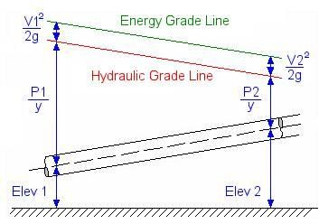
: - i) A textbook of Fluid mechanics
and Hydraulic machines by R.K. Bansal

