RAJA KISHORE CHANDRA ACADEMY OF TECHNOLOGY,NILAGIRI

DEPARTMENT OF CIVIL ENGINEERING
EASTIMATION &COST EVALUATION-I SEMESTER-3rd
PREPARED BY:-ER. BAIDYANATH TUDU

CHAPTER -1

Introduction
WHAT IS AN ESTIMATE ……
 Before taking up any work for its execution, the owner or builder should have a thorough knowledge about the volume of work that can be completed within the limits of his funds or the probable cost that may be required to complete the proposed work.

It is therefore necessary to prepare the probable cost or estimate for the proposed work from its plan and specification.

Otherwise, it may so happen that the work has to be stopped before its completion due to the shortage of funds or of materials.

Besides the above, an estimate for any public construction work is required to be prepared and submitted beforehand so that sanction of necessary funds may be obtained from the authority concerned .

Thus, an estimate for any construction work may be defined as the process of calculating the quantities and costs of the various items required in connection with the work.

It is prepared by calculating the quantities, from the dimensions on the drawings for the various items required to complete the project and multiplied by unit cost of the item concerned.

To prepare an estimate , drawing consisting of the plan , the elevation and the section through important points, along with a detailed specification giving specific description of all workmanship , properties and proportion of materials , are required.

PURPOSE OF ESTIMATING:-
To ascertain the necessary amount of money required by the owner to complete the proposed work
. For public construction work, estimates are required in order to obtain administrative approval , allotment of funds and technical sanction.

To ascertain quantities of materials required in order to programme their timely procurement.
To calculate the number of different categories of workers that is to be employed to complete the work within the scheduled time of completion.

To assess the requirements of tool , plants and equipment required to complete the work according to the programmed.
To fix up the completion period from the volume of works involved in the estimate.

To draw up a construction schedule and programmed and also to arrange the funds required according to the programming.

To justify the investment from benefit cost ratio.(for ideal investment ,this ratio should be more than one)

To invite tenders and prepare bills for payment.

An estimate for an existing property is required for valuation

TYPES OF ESTIMATE
ROUGH COST ESTIMATE

PLINTH AREAESTIMATE

CUBICAL CONTENT ESTIMATE

A QUANTITY ESTMATE

APPROXIMATE QUANTITY METHOD

DETAILED OR ITEM RATE ESTIMATE

REVISED ESTIMATE

SUPPLEMENTARY ESTIMATE

REPAIR AND MAINTENANCEESTIMATE

A COMPLETE ESTIMATE

ROUGH COST ESTIMATE
IT is prepared to decide the financial policy matter.it is prepared on basis of practical knowledge and cost of similar works. The competent sanctioning authority accords “Administrative approval
These estimates are also referred to as rom estimate and are useful for go /no kind decision making which essential refers to whether the project should or should not be pursued
Some of the methods they can be useful for such estimates are investment per annual capacity turnover and capital ratio .

PLINTH AREA ESTIMATE
IT Is prepared on the basis of plinth area of the building multiplied by plinth area rate prevalent in the region.

Plinth area rates are fixed from the cost of similar buildings constructed in the locality having similar finishing’s and amenities

The cost of construction is determined by multiplying plinth area with plinth area rate. The area is obtained by multiplying length and breadth (outer dimensions of building). In fixing the plinth area rate, careful observation and necessary enquiries are made in respect of quality and quantity aspect of materials and labor, type of foundation, height of building, roof, wood work, fixtures, number of stores etc.

CUBICAL CONTENT ESTIMATE
This estimate is worked out on the basis of the cubical contents of proposed building to be constructed and then applying to it the rate per cubic meter.

This is more accurate than plinth area estimate.

The cubic content rates are deduced from the cost of similar buildings constructed in the same locality

This method is generally used for multi-storied buildings. It is more accurate that the other two methods viz., plinth area method and unit base method.

The cost of a structure is calculated approximately as the total cubical contents (Volume of buildings) multiplied by Local Cubic Rate.

The volume of building is obtained by Length x breadth x depth or height. The length and breadth are measured out to out of walls excluding the plinth off set
Under Review

A QUANTITY ESTIMATE OR QUANTITY SURVEY
This is complete estimate or list of quantities for all items of work required to complete the concerned project.
The quantity of each individual items of work is worked out form respective dimensions on the drawing of the structure to find the cost of an item in quantity is multiplied by the rate per unit from that item.

The purpose of the bill quantity i.e. to provide a complete list of quantities necessary for the competition of any engineering project and when price given to the estimated cost of the project.

APPROXIMATE QUANTITIES
Regarded as the most reliable and accurate method of estimating, provided that there is sufficient information to work on. Depending on the experience of the surveyor, measurement can be carried out fairly quickly using composite rates to save time.

The rules of measurement are simple, although it must be said; they are not standardized and tend to vary slightly from one surveyor to another.

One approach involves grouping together items corresponding to a sequence of operations and relating them to a common unit of measurement; unlike the measurement for a bill of quantities,
where items are measured separately

Composite rates are then built up from the data available in the office for that sequence of operations All measurements are taken as gross over all but the very large openings

Initially, the composite rates require time to build up, but once calculated they may be used on a variety of estimating needs
Reasonably priced software packages are now available. An example for a composite is shown below for substructure:
This is an approximate estimate to find out an approximate cost in the short time and thus enable the authority concerned to consider the financial aspect of the scheme for according sanctioned the same.

Such an estimate is framed after knowing the rates of similar works and form practical knowledge in various ways for various types of work such as

Plinth area or square meter method. Cubic rate or cubic meter method. Serve unit or unit rate method.

Bay method.

Approximate quantities with bill method. Cost comparison method

Cost from materials and labor.

DETAILED OR ITEM RATE ESTIMATE
This estimate is an accurate and is based on the plan and sanctions of the building.
The quantity of items under each sub head of work are calculated from the dimensions taken from drawing and then total cost is worked out in a form called abstract of cost

This include the detailed particulars for the quantities ,rate and cost of all the items involved for satisfactory completion of a project
Quantities of all items of work are calculated from their respective dimension on the drawing on a measurement sheet .multiplying these quantities by their respective rate in separate sheet, the cost of all items of work are worked out individually and then summarized
A detail estimate is accompanied by

Report Specification
Detailed drawing showing plane Design data and calculation Basis of rates adopted in the estimate

REVISED ESTIMATE
IT Is also a detailed estimate and is prepared a fresh when the original sanctioned detailed estimate exceeds by 10% or more ,either due to rates being found insufficient or due to some other reasons
It is always possible that in spite of all precaution in the planning stages it becomes clearly during execution the actual cost of a project will exceed the original estimate ,now generally a certain cushion of the cost is available ,if the exceedance is higher

It is prepared on the basis on estimate on which sanction was obtained showing the existing sanction and the progress made up to date
The revised estimate should be accompanied by comparative statement showing the original and revised rate and quantity

SUPPLEMENTARY ESTIMATE
This is a fresh detailed estimate of the additional work in additional work in addition to the original one and is prepared when additional work is required to supplement the original work
There is always a like hood that while executing a certain project it may be considered worthwhile
to carry out additional work ,which was not foreseen in initial stages and therefore not actual for the preliminary estimate
Execution of such work required drawing up and approval of supplementary estimate and the exercise is essential similar to that of drawing up the estimate for the main work it is naturally expected that the cost of additional work will be much smaller than the main work
In case where a substantial section of a project in abandoned or where material deviation from the original proposals are expected to result in substantial savings the estimate is revised by the department and intimated to engineer in charge for execution of work
But in case where the saving is due to a material deviation of structural nature from the design originally approved supplement estimate is prepared for a revised technical sanction

The method of preparation of supplementary estimate is the same as that of detail estimate and it should be accompanied by full report of the circumstances which render it necessity.
The abstract must show the amount of original estimate and the total of sanctioned required including the supplementary amount.

REPAIR AND MAINTENANCE ESTIMATE
In order to keep the structure roads etc in proper condition annual repairs and carried out annually for which an estimate is prepared. The estimated amount should not be more than 1.5%of the capital cost of work
There are more than 10,000 maintenance, repair and preventive maintenance tasks for all types of facilities. With advances in telecommunications, computers and other workplace technologies, the list is growing rapidly. In a downsized, fiscally conservative environment, facilities are seen as vital capital assets that affect employee productivity. The demands for technical expertise and cost-effective plant operations have increased dramatically.

After completion of a work it necessary to maintain the same for the proper function and for the same an estimate is prepared for items which required renewal, placement, repairs, etc in form of detailed estimate

For building, such items of work like white washing, color and painting of doors and windows etc. quantities are based on the previous measurement recorded in measurement book as standard measurement books .for pretty works such as replacement of glass panes, repairs of floors patch repairs to cement plaster walls and changing roof tiles or similar natural works

The total estimate coat of maintenance of structural is generally kept within the prescribe limits on percentage basis of the cost of the construction of the structure and its imp.
The total estimated cost of maintenance of structure is generally kept within the prescribed

limits on percentage basis (Variable according to the age and importance of the structure) of the cost of the construction of the

Under Review

structure and its importance.

COMPLETE ESTIMATE
This is an estimated cost of all items which are related to the work in addition to main contractor to the detailed estimate
One may think that an estimate of a structure includes only the cost of land and the cost items to be included.
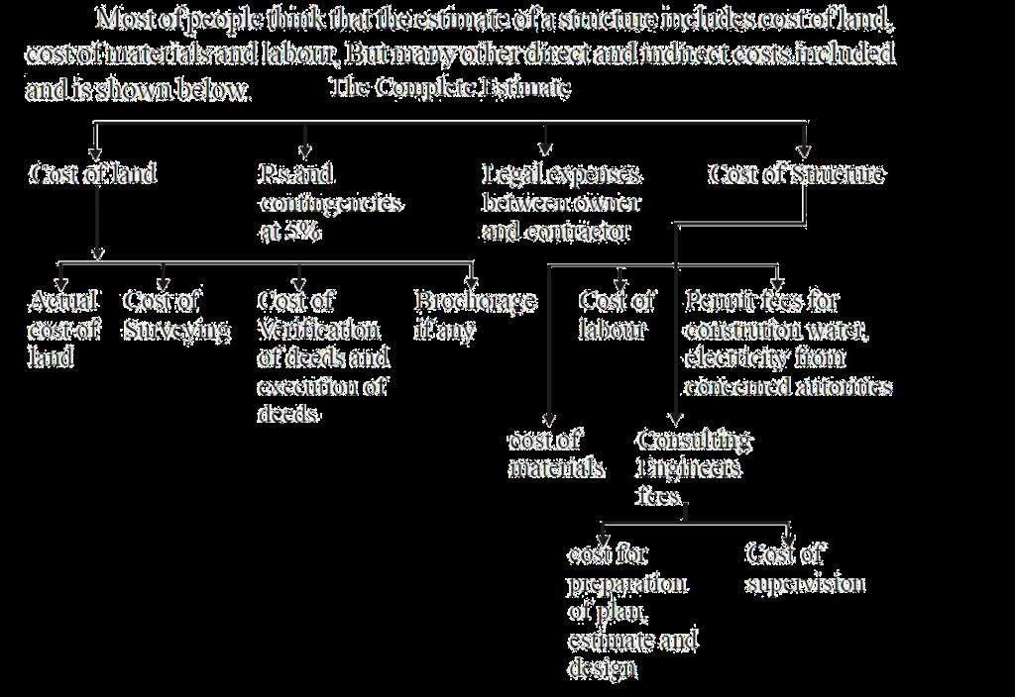

Basic SI Units
Units of Length- Metre(M)- The metre is the length equal to 1650673.73 wave lengths in vacuum of the radiation corresponding to the transition between the levels 2 p 10 and 5 d 5 of the Krypton 86 atom.

Unit of Mass-Kilogram (Kg)- The kilogram is the unit of mass and is equal to the mass of the international prototype of the Kilogram.

Unit of Time- Second(s)- The second is the duration of 9192 631 770 periods of the radiation corresponding to the transition between the hyperfine levels of the ground state of the Cesium 133 atom.

Unit of Electric Current- Ampere(A)- The ampere is that constant current which, if maintained in two straight parallel conductors of indefinite length, of negligible circular cross-section and placed one metre apart in vacuum, would produce between these conductors of force equal to 2 x 10-7 Newton per unit length.

Unit of Thermodynamic Temperature- Kelvin (K)-The Kelvin unit of the thermodynamic temperature of the triple point of water. Kelvin may be used for expressing a temperature interval. The degree Celsius (0C) is a unit of the International

Unit of Luminous Intensity- Candela (cd)- The candela is the luminous intensity, in the perpendicular direction of a surface of 1/600,000 square metre of a black body at the temperature of freezing platinum, under a pressure of
101.325 Newton’s per square metre

CHAPTER-2

METHOD OF ESTIMATING
The quantities like earth work, foundation concrete, brickwork in plinth and super structure etc., canbe workout by any of following two methods:
- Long wall - short wall method
- Centre line method.
- Partly centre line and short wall method.

LONG WALL-SHORT WALL METHOD:
In this method, the wall along the length of room is considered to be long wall while the wall perpendicular to long wall is said to be short wall. To get the Measurement of Materials and Works length of long wall or short wall, calculate first the centre line lengths of individual walls. Then the length of long wall, (out to out) may be calculated after adding half breadth at each end to its centre line length. Thus the length of short wall measured into in and may be found by deducting half breadth from its centre line length at each end. The length of long wall usually decreases from earth work to brick work in super structure while the short wall increases. These lengths are multiplied by breadth and depth to get quantities
- CENTRE LINE METHOD:
This method is suitable for walls of similar cross sections. Here the total centre line length is multiplied by breadth and depth of respective item to get the total quantity at a time. When cross walls or partitions or verandah walls join with main all, the centre line length gets reduced by half of breadth for each junction. such junction or joints are studied carefully while calculating total centre line length. The estimates prepared by this method are most accurate and quick.
- PARTLY CENTRE LINE AND PARTLY CROSS WALL METHOD:
This method is adopted when external (i.e., alround the building) wall is of one thickness and the internal walls having different thicknesses. In such cases, centre line method is applied to external walls and long wall-short wall method is used to internal walls. This method suits for different thicknesses walls and different level of foundations. Because of this reason, all Engineering departments are practicing this method.
HOW TO PREPARE A DETAILED ESTIMATE
Detailed Estimate:The unit-quantity method is followed to prepare a DETAILS OF MEASUREMENT AND CALCULATION OF QUANTITIES . MEASUREMENT FORM

Item no Description -Nolength Breadth- Height Content Remark

or or Depth or particulars quantity Abstract of estimate form
Sl | Description or Quatity | Unit | Rate Unit | of | Amount
.no | particulars Rs. P. rate Rs. P.

Functions of an abstract of estimate
The main functions of an abstract of estimate are:
The total estimated cost and the different items of works required to complete project can be known.

Basis on which % rate tenders are called after excluding the amount for contingency and work-charged establishment.
A part of tender document and a contractor can arrive at his own rates from the schedule of work described in the description column.

This is the basis on which bills are prepared for payement. Comparative costs of different items of works can be known.

Data required for preparing detailed estimate
- DRAWING
- SPECIFICATIONS(both general and detailed)
- RATES
- UPDATED MODE OF MEASUREMENT
- STANDING CIRCULARS

FACTORS CONSIDERED DURING DETAILED ESTIMATION
  - Quantity of materials

  - Availability of materials

  - Transportation of materials

  - Location of site

  - Local labour charges

Principle of Units for Various Items Of Works-
The units of different works depend on their nature, size and shape. In general, the units of different items of work are based on the following principle:-
- Mass, voluminous and thick works shall be taken in square unit or volume. The measurement of length and breadth or height shall be taken to compute the volume or cubic contents.Shallow, thin and surface works shall be taken in square units or in area. The measurement of length and breadth or height shall be taken to compute the area.

- Long and thin work shall be taken in linear or running unit, and linear measurement shall be taken.

- Piece work, job work, etc.,shall be taken in number.

The units of payments and measurement of various items of work in metric system are same except for earthwork. Earthwork is measurement in cu m but payment is made per 100 cu m(per % cu m).
THE UNITS OF MEASUREMENTS AND PAYMENTS FOR VARIOUS ITEMS OF WORK AND MATERIALS
SL. Particulars of Items Units ofUnits Unita of NO. measurements in payment in payment in FPS MKS MKS
Earthwork-
- Earthwork in excavation in ordinary soil, earthwork in
mixed soil with kankar cu m Per % cu m % cu ft bajri,etc.earthwork in hard soil.
- Rock excavation cu m Per % cu m % cu ft
- Earth filling in excavation
in foundation. cu m Per % cu m % cu ft
- Earth filling in foundation cu m Per % cu m trenches % cu ft
- Earth filling in plinth cu m Per % cu m % cu ft
- Earthwork in
banking,cutting,in road and cu m Per % cu m % cu ft irrigation channel.
- Surface dressing and
levelling,cleaning,etc sq m Per sq m % sq ft
- Cutting of trees(Girth no. specified) Per no. Per no.
- Pudding,puddle clay core cu m Per % cu m % cu ft
- Sand filling cu m Per cu m % cu ft
- Quarrying of stone or cu m Per cu m % cu ft boulder
- Blasting of rock (blastedstone stacked and then cu m Per cu m % cu ft measured)

Concrete-
- Lime concrete(L.C)in cu m Per cu m % cu ft foundation
- Lime concrete(L.C) in roof sq m per sq m % sq ft terracing,thickness specified
- Cement concrete(C.C)cu m per cu m per cu ft
- Reinforced cement cu m per cu m per cu ft concrete(R.C.C.)
- C.C. or R.C.C. Chujja,sun cu m per cu m per cu ft shade
- Precast C.C.or R.C.C. cu m per cu m per cu ft
- Jali work or jaffri work or
C.C. tracery sq m per sq m per sq ft panels(Thickness specified)
- Cement
concrete bed cu m per cu m per cu ft

- Damp proof course-Cement
concrete,rich cemen sq m per sq m % sq ft mortar.asphalt,etc.(Thicknes s specified) Brickwork-
  - Brickworkin foundation and
plinth in super structure,in cu m per cu m % cu ft arches,etc., in cement,lime or mud mortar
  - Sun dried brickwork cu m per cu m % cu ft
  - Honey-comb sq m per sq m %sq ft brickwork,thickness specified
  - Brickwork in jack arches,if cu m per cu m % cu ft measured separatly
  - Jack arch roofing including sq m per sq m % sq ft top finishing
  - Brickwork in well steining cu m per cu m % cu ft
  - Half-brickwork with or sq m per sq m % sq ft without reinforcement
  - Thin partition wall sq m per sq m % sq ft
  - Reinforced brickwork cu m per cu m % cu ft (R.B.WORK)
  - String course,drip course,weather meter per m per r ft course,coping etc.(Projection specified)
  - Cornice(Projection and type meter per m per r ft specified)

  - Brickwork in Fire cu m per cu m % cu ft place,Chullah,Chimney
  - Pargetting Chimney,fire meter per m per r ft place flue
  - Brick edging (by road side) meter per m per r ft STONE WORK-
- Stone masonry,Random
Rubble masonry,Coursed cu m per cu m % cu ft Rubble masonry,Ashlar masonry in walls, in arches,etc.
- Cut stone work in lintel cu m per cu m per cu ft beam,etc.
- Stone slab in
roof,shelve,etc.,stone sq m per sq m % sq ft chujjas,stone sun shed etc.

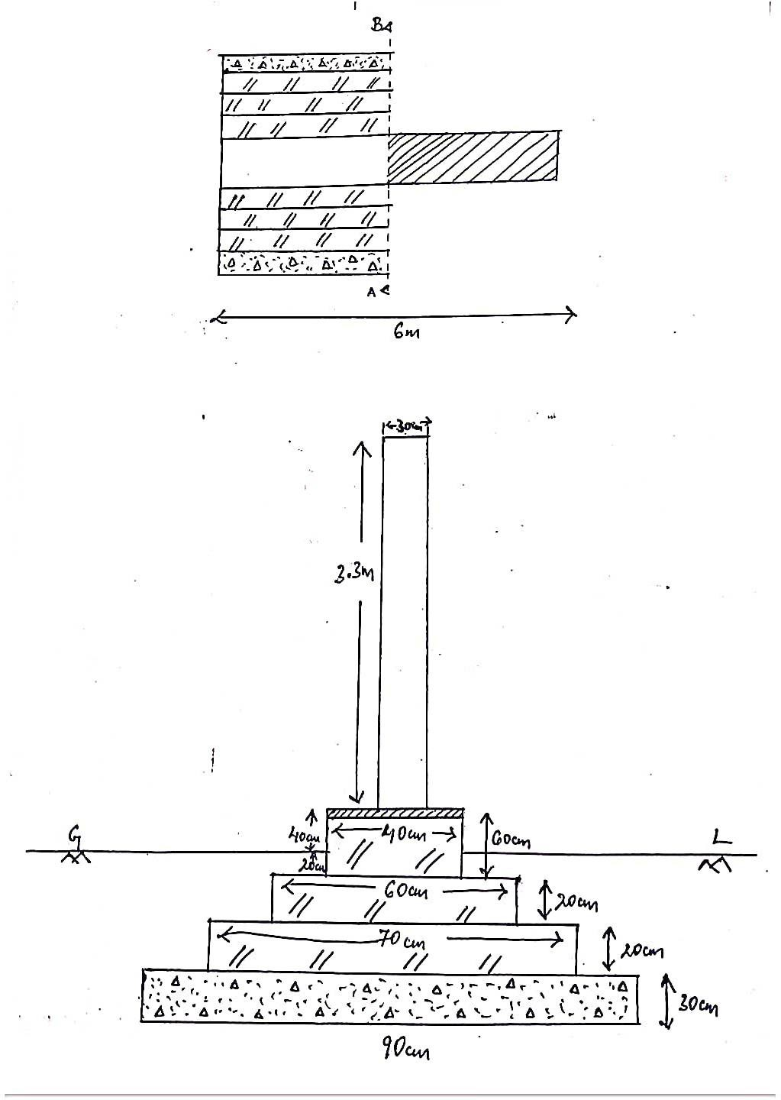
- Stone work in wall facing or sq m per sq m per sq ft lining( Thickness specified)

(
SINGLE WALL QUANTITY ESTIMATION
m no. | Particulars of Item | No. | Length | Breadth | Height | Quantity | Explanatory Note
1 | E/W Excation in foundation | 1 | 6M | 0.9M | 0.9M | 4.86M3 | H=0.3+0.2+0.2+0.2=0.9M
2 | Concrete in foundation | 1 | 6M | 0.9M | 0.3M | 1.62M3 | ---------------
3 | B/W in foundation & footing
(i) | 1st footing | 1 | 6M | 0.7M | 0.2M | 0.84M3 | ---------------
(ii) | 2nd footing | 1 | 6M | 0.6M | 0.2M | 0.72M3 | ----------------
iii) | Plinth | 1 | 6M | 0.4M | 0.6M | 1.44M3 | H=0.4+0.2=0.6M
 |  |  |  |  | Total= | 3M3
4 | DPC | 1 | 6M | 0.4M |  | 2.4M2 | ------------------
5 | B/W in Superstucture | 1 | 6M | 0.3M | 3.3M | 5.94M3 | ------------------
6 | Plastering
(i) | Inside | 1 | 6M | --- | 3.3M | 19.8M3 | -----------------
(ii) | Outside | 1 | 6M | --- | 3.8M | 22.8M3 | H=3.3+0.4+0.1=3.8M
 |  |  |  |  | Total= | 42.6M3
SINGLE WALL WITH WINDOW QUANTITY ESTIMATION
m no. | Particular of Item | No. | Length | Breadth | Height | Quantity | Explanatory Note
1 | E/W Excavation in foundation | 1 | 5.5M | 1.1M | 1.3M | 7.86M3 | H=0.3+0.2+0.2+0.3+0.3=1.3M
2 | Concrete in foundation | 1 | 5.5M | 1.1M | 0.3M | 1.81M3 | ------------
3 | B/W in foundation & footing
(i) | 1st footing | 1 | 5.5M | 0.7M | 0.3M | 1.15M3 | ----------
(ii) | 2nd footing | 1 | 5.5M | 0.6M | 0.2M | 0.66M3 | ----------
iii) | 3rd footing | 1 | 5.5M | 0.5M | 0.2M | 0.55M3 | ------------
iv) | Plinth | 1 | 5.5M | 0.4M | 0.9M | 1.98M3 | H=0.6+0.3=0.9M
 |  |  |  |  | Total= | 4.34M3
4 | DPC | 1 | 5.5M | 0.4M | ---- | 2.2M2 | -----------
5 | B/W in Superstructure | 1 | 5.5M | 0.3M | 3.2M | 5.28M3 | ------------
 | Deduction
(i) | Window | 1 | 1M | 0.3M | 2.2M | 0.66M3 | --------------

(

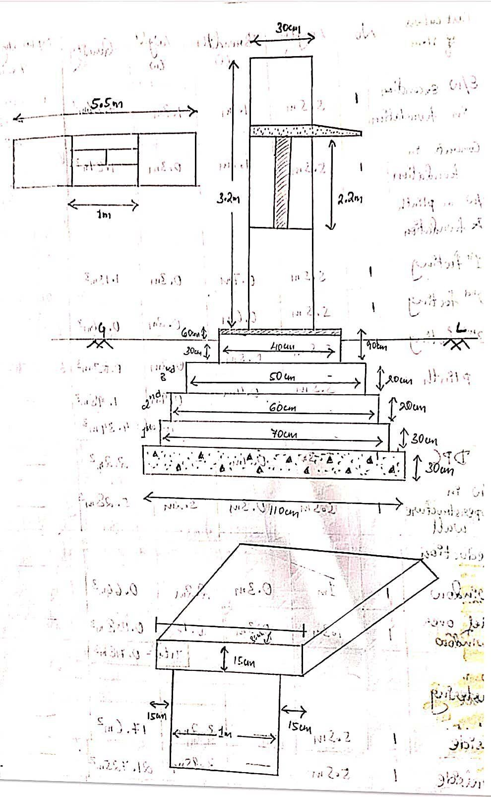

SINGLE ROOM BUILDING QUANTITY ESTIMATE

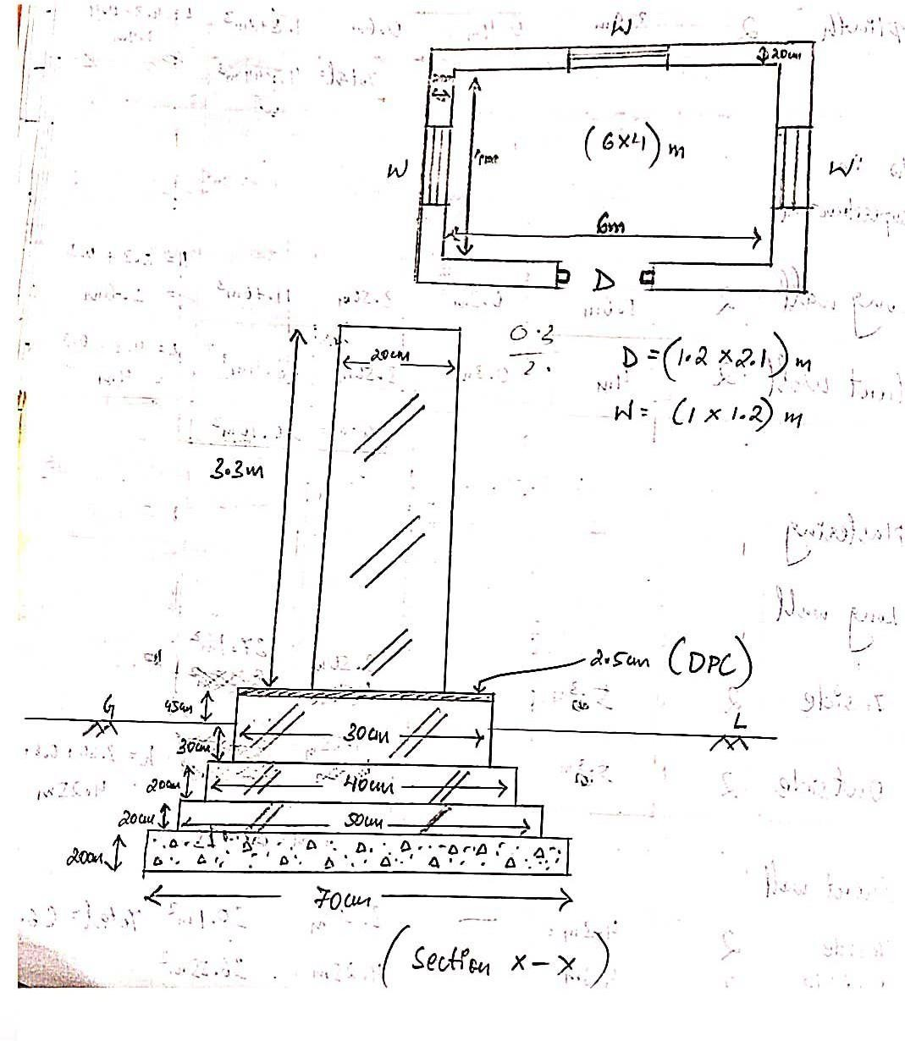

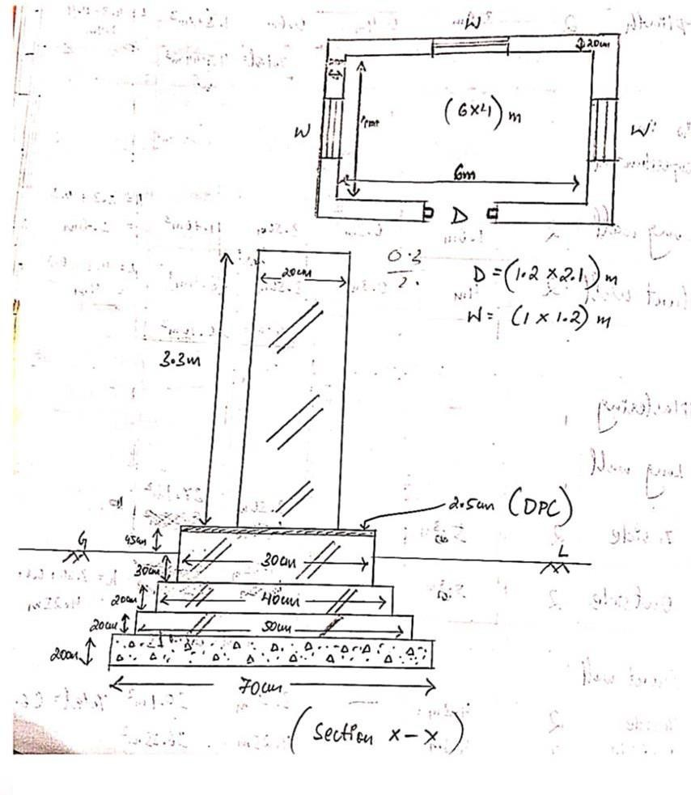

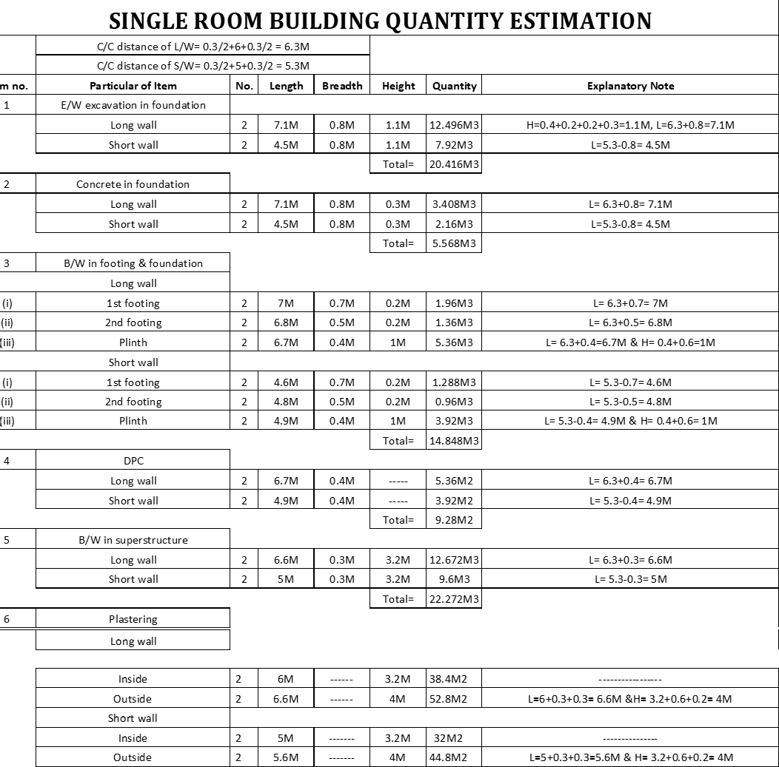

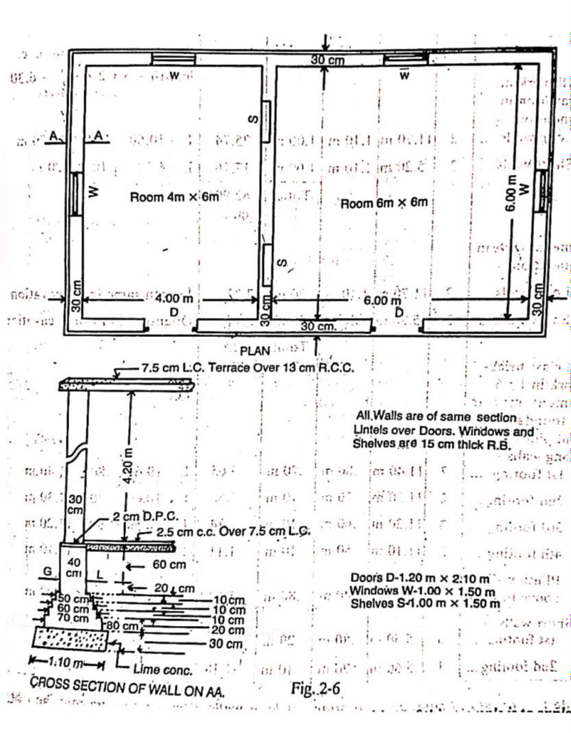

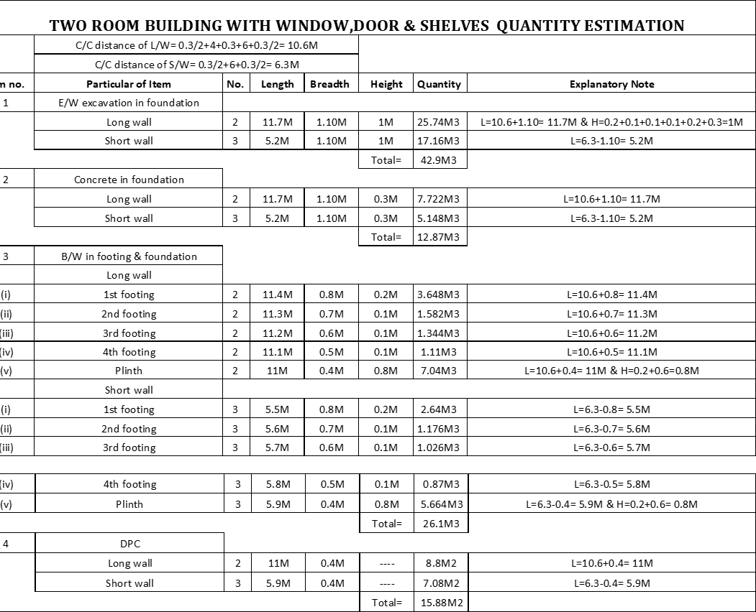

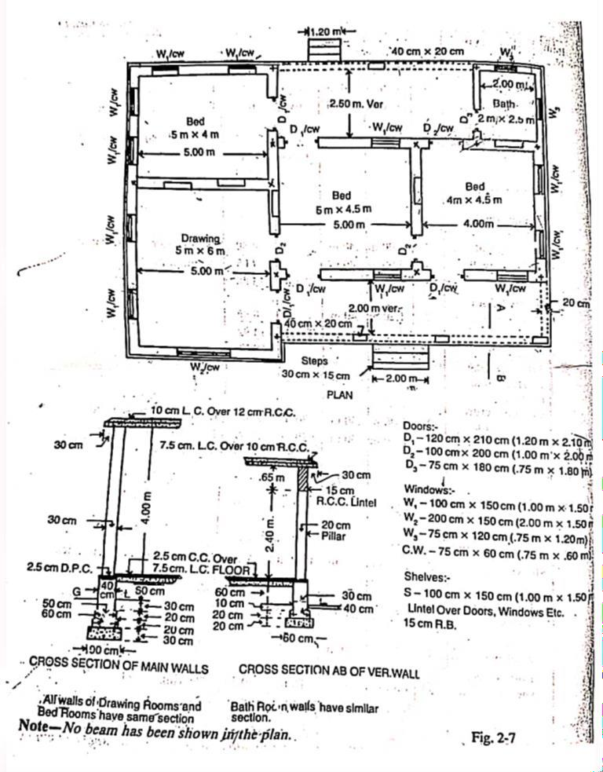

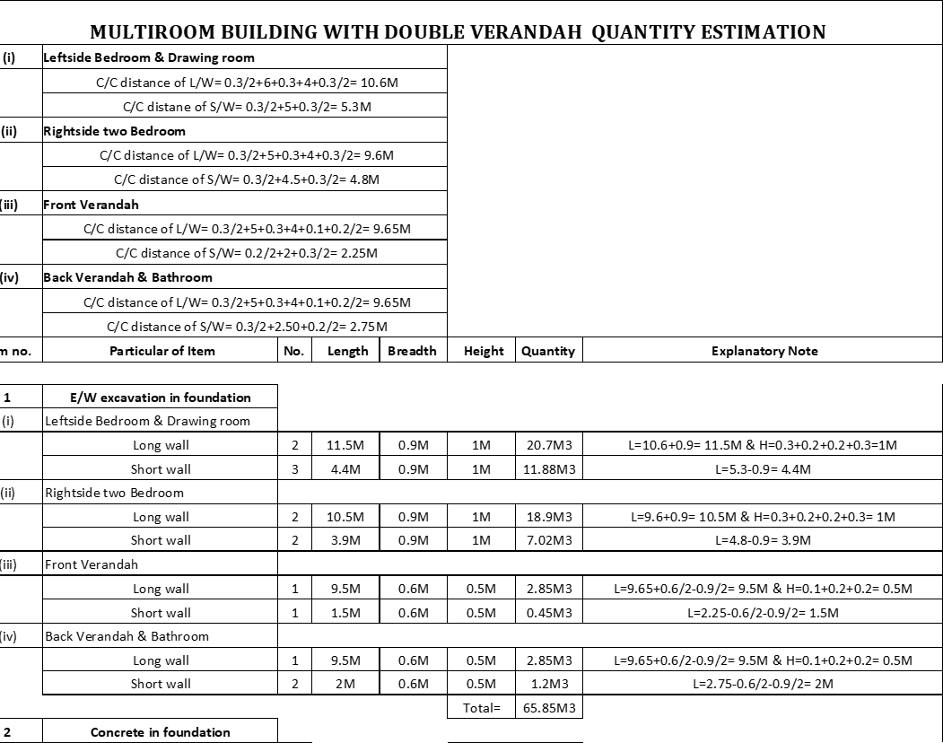

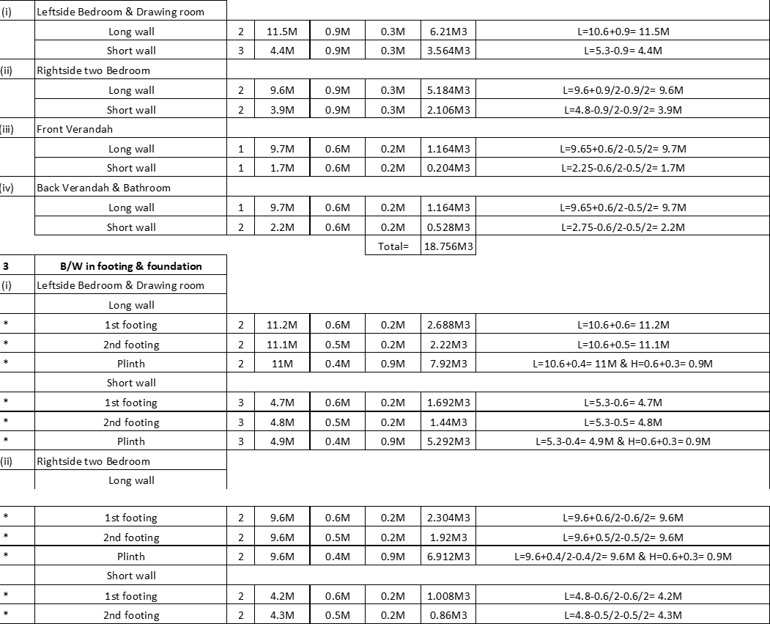

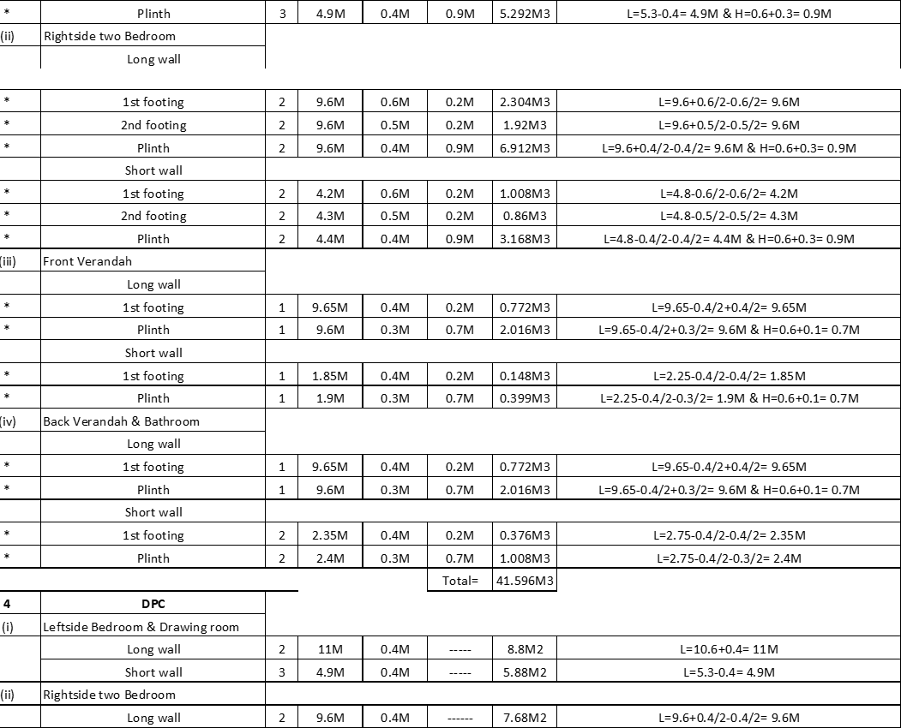

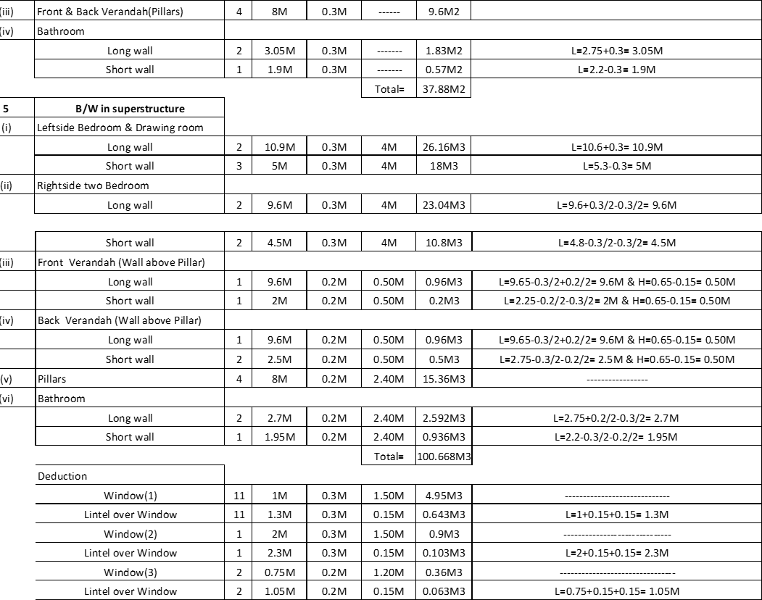

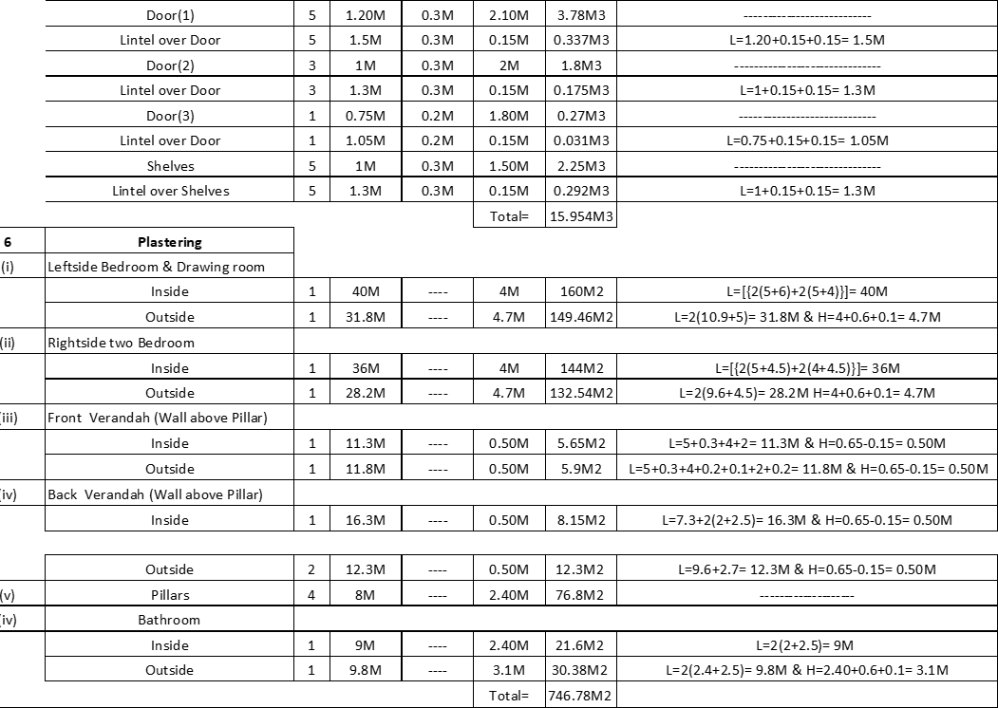

CHAPTER-3
Rate analysis
Definition: In order to determine the rate of a particular item, the factors affecting the rate of that item are studied carefully and then finally a rate is decided for that item. This process of determining the rates of an item is termed as analysis of rates or rate analysis. The rate of particular item of work depends on the following.
- Specifications of works and material about their quality, proportion and constructional Operation method.
- Quantity of materials and their costs.
- Cost of labours and their wages.
- Location of site of work and the distances from source and conveyance charges.
- Overhead and establishment charges
- Profit
Dry material calculation
Let us assume the mix proportion is 1 : 2: 4 (Cement : Sand : Stone = a:b:c) Volume of wet concrete = 1 m3 Volume of dry concrete = 1 × 1.54 = 1.54 m3 Calculation For Cement
Formula, Cement = (Volume of dry concrete/a+b+c) × a
• = (1.54/a+b+c) × a = [(1.54/1+2+4)] × 1 = 0.22 cum
Now density of cement = 1440 kg/cu.m
∴ Volume of cement = 0.22 × 1440 =316.8 kg.
As we know, 1 bag of cement contains 50 kg of cement.

∴ Cement bags required = 316.8/50 = 6.33 bags. Calculation For Sand Formula, Sand = (Volume of dry concrete/a+b+c) × b
• = (1.54/a+b+c) × b = (1.54/1+2+4) × 2 = 0.44 cu.m.
Calculation For Aggregates
Formula, Aggregatess = (Volume of dry concrete/a+b+c) × c
• = (1.54/a+b+c) ×c = (1.54/1+2+4) × 4 = 0.88 cu.m.
Calculation For Water Content
Let us assume the water cement ratio of concrete is 0.45.
- w/c = 0.45
- Required water for 1 bag cement = 0.45 × 0.0353 = 0.0159 cu.m. Where volume of 50 kg cement = 0.0353 cu.m
- 1 m3 water = 1000 Litre
Required water for 1 bag cement=0.0159 × 1000 = 15.9 Litre.

∴ Required water for 6.33 bags cement = 6.33 × 15.9 = 101 Litre. Summary
- Cement = 6.33 bags.
- Sand = 0.44 cum
- Aggregates = 0.88 cum
- Water = 101 litre.

DRY MATERIAL CALCULATION OF BRICKWORK

Assuming,
  - Volume of brickwork = 1 m3
  - Grade of mortar = 1:6 (cement : sand)
  - First class brick (190 mm x 90 mm x 90 mm)
  - Thickness of mortar = 10 mm = 0.01 m

No. Of Bricks:
No. of bricks = (Volume of brickwork / Volume of one brick with mortar) Volume of one brick without mortar = 0.19×0.09×0.09 = 0.001539 m3 Volume of brick with mortar = (0.19+0.01) x (0.09+0.1)x (0.09+0.1)
= 0.2×0.1×0.1 = 0.002 m3
No.of bricks = 1.0/ (0.002) = 500 Consider 10% to 15 % bricks as wastage.
∴ Total no. of bricks = 500 + (10 x 500 )/100 = 550 Quantity Of Mortar:
Volume occupied by bricks = No. of bricks x Volume of one brick Volume of bricks = 500 x 0.001539 = 0.7695 m3 Volume of mortar = Volume of brickwork – Volume of bricks
∴ Volume of Mortar = 1.0 – 0.7695 = 0.2305 m3 Quantity Of Cement:
Cement = (Dry volume of mortar x Cement ratio)/ Sum of the ratio
Dry volume of Mortar = 1.54 x 0.2305 = 0.35497 m3 (54% increment due to volume shrink after adding water) Cement= (0.35497 x 1) / (1+6) = 0.35497/7= 0.05071 m3
Cement = 0.043795 x 1440 = 73.0224 kg
∴ No. of cement bags = 73.0224 / 50 = 1.45 bags (1 bag cement contains 50 kg cement) Quantity of Sand:
Sand = (Dry volume of mortar x Sand ratio)/Sum of the ratio Sand = (0.35497 x 6)/7 = 2.12982/7 = 0.30426 m3
∴ Sand = 0.30426 x 35.3147 = 10.7448 cft.
Summery:
Number of Bricks = 550 Cement = 1.45 bags of 50 Kg, Sand = 0.30426 m3 or10.7448 cft.

CHAPTER-4

DUTIES AND RESPONSIBILITIES OF JUNIOR ENGINEER

- To assist in checking of all type of estimates, DPR in accordance of Designs and drawings and submit them to the higher authority for sanction/ process.
- Carrying out of survey work of areas for development and preparation of Survey plans.
- Custody of Mathematical and survey instruments, tools and plant including their receipt and issue and maintenance of their account.
- Carrying out Laboratory test on materials such as cement, steel, timber, metal, soil, aggregates or any other material as directed by higher authorities.
- Carrying out field tests on soils etc. as directed by higher authorities.
- To prepare estimates as directed by his higher authority and submit them to the higher authority for sanction.
- To assist in checking of Schedule of Rates, Analysis of rates and specification of schedule of works.
- To assist in preparation and checking of Specifications of work.
- To assist in checking of theoretical consumption of materials.
- To assist in checking of supplementary, substituted and deviation item statements.

DUTIES AND RESPONSIBILITIES OF ASSISTANT ENGINEER

  - Assist in designing, developing and executing construction projects.
Work with Project Manager in reviewing project specification and in preparing project plan and design sheet.
  - Visit sites, prepare construction drawings and develop samples. Work with engineering team in developing construction plan.
  - Determine budget, schedule, manpower and material and equipment requirements to execute construction project.
  - Report all expenses to Project Manager on timely basis. 5.Maintain quality assurance standards for projects.
- Provide technical assistance to field staff when needed.
- Analyze construction problems and recommend corrective actions. 8.Order and stock construction materials to avoid shortage

REFERENCES

: ESTIMATING & COSTING IN CIVIL ENGINEERING (B.N DUTTA) ESTIMATING, COSTING, SPECIFICATION &VALUATION IN CIVIL
ENGINEERING (M.CHAKRABORTY)

