RAJA KISHORE CHANDRA ACADEMY OF TECHNOLOGY,NILAGIRI

DEPARTMENT OF CIVIL ENGINEERING LECTURE NOTES
Year&Semester: 3rdYear, 5TH Semester
Subject: Estimation and Cost Evaluation – II (TH 5)

PREPARED By ER. DEEPIKA BEHERA

COURSE CONTENTS

Unit – 1 : Detailed estimate of culverts and bridges
- Definition of culvert and bridge
- Types and components of a culvert
- Bar bending schedule
- Detailed estimate of RCC deck slab culvert with right angled wingwall
- Detailed estimate of a simple Humepipeculvert with right angled wingwalls
- Detailed estimate of RCC deck slab culvert with splayed wingwall

Unit – 2 : Estimate of irrigation structures
- Concept and necessity of canal fall
- Types of canal fall
- Detailed estimate of simple type of vertical fall to given specification
- Definition and types of cross drainage work
- Detailed estimate of drainage siphon to given specification

Unit – 3 : Detailed estimates of roads

- Concept of lead and lift
- Different methods of calculation of earthwork
- Detailed estimate of roads to given specification

Unit – 4 : PWD Accounts Work
- Classification of work-original
- Method of execution of works through the contractors, departmentally, contract and agreement, work order, item rate contract, lump sum contract, labour contract and daily labour, piece work agreement, scheduled contract, cost plus percentage contract
- Explanation of various terms:
Administrative approval, technical sanction, contingency budget, tender, preparation of notice inviting tender, earnest money, security deposit, advance payment, on account payment, intermediate payment, final payment, running bill, final, regular and temporary establishment, cash, temporary advance, issue rate, storage, supervision charges, suspense account, debit, credit,voucher
- Measurement book : use and maintenance, procedure of making entries in MB, standard measurement book and common irregularities.
- Acquitance Roll:Itspreparation&useformakingpaymentofpay&wages
- Labour& labourreport,methodoflabourpayment
- Classification of store

,

Detailed estimate of culvert and bridges

Culvert :
- According to IRC specification, a culvert is one which has a linear waterway up to 6m.
- It is a permanent drainage structure mainly constructed to carry roadway or railway track over small stream or channel.

Bridge :
- According to IRC specification, a structure having a linear waterway above 6m but below 30m are Minor Bridge and structures having a linear waterway of 3om or more are Major Bridge.

Types of culvert :
Culverts are classified into the following four types
  - Arch culvert
  - Slab culvert
  - Pipe culvert
  - Box culvert

Arch culvert:

- The culvert having its superstructure consisting of one or two arches constructed of any suitable masonry is known as arch culvert.
- In these culverts segmental arches consisting of brick masonry, stone masonry or concrete are commonly used.
- These arches can be easily and cheaply constructed.
- The abutments and piers of these arches are constructed sufficiently strong to take their lateral thrust.
- Arch culverts are specially suitable where the approaches are to be constructed in cutting.

Slab Culvert:

- The culvert having its superstructure consisting of RCC slab which carries the bridge floor , is known as slab culvert.

- Inthis type of culvert, the RCC slab of suitable thickness is provided as simply supported over abutments and piers which are constructed of any suitable type of masonry.
- These are suitable for maximum span of 3m.

Pipe Culvert:
- The culvert which consists of one or more pipes placed side by side over a concrete base below the embankment of a roadway or railway track is known as pipe culvert.
- In this type of culvert, one or more pipes consisting of cast iron, steel or RCC are held in position over a concrete base by fixing their both the ends into masonry wall.
- In this type, generally more than one pipe of diameter not less than 30 cm is used.

Box culvert:
- The culvert consisting of one or more numbers of rectangular or square opening, having their floor and top slab constructed monolithically with abutments and pier is known as box culvert.
- These are usually constructed of precast RCC slab. Small span box culverts may be constructed of stone slab, supported on masonry abutments, with brick or stone flooring.
- These culverts provide the least interference to traffic during construction.
- These are mainly constructed where the soil is soft and the load has to be distributed over a wider foundation area.

Components of a culvert:
- Abutment : it is a masonry or reinforced concrete wall that constitutes the end support of bridges or similar structure by which it joints the banks of waterway.
- Wing wall: wing wall is a retaining wall which sustains the embankments of the approaches where they join the bridge.
- Return wall: a return wall is a retaining wall built parallel to the centre line of a road to fretain the embankment.
- Curtain wall : cross walls are built across the stream on the up-stream or down stream in order to protect the structure from erosion due to strong current of water induced by the restriction of free passage of water through the water way.

Bar bending schedule:
- The schedule of bars is a list of reinforcement bars in a tabular form giving the particulars of bars, shape of bending with sketches, length of each, total length and total weight.
- For each type of R.C.C work a schedule of bars is usually prepared. From the schedule of bars the requirement of different sizes and lengths of bars may be known and may be arranged and bent up during the time of construction.
- The length of one hook may be taken as 9 dia. of bars and the total length of straight bar hooked at both ends may be taken as L+18 dia.
- For 45® cranked or bent up bar(Fig) the additional length for one bent up is
= difference in length of hypotenuse and base
𝑑

=
sin 45
1
− 𝑑

= d( − 1)
0.707
= d (1.42-1)
= 0.42 d

=0.45d
For two bent ups additional length is equal to 2x0.45d=0.9d, where d is the vertical distance between the centre of the upper and lower arms of the bent up bar, which is equal to total depth of beam or slab minus bottom and top covers.
- For 30® cranked or bent up bar inclined length of crank
= d/sin 30® = 2d

Horizontal length of crank = d/tan 30®= 1.73d

The extra length required for one crank = 2d – 1.73d=0.27d=0.3d
For a bar cranked at both ends at 30® the additional length is equal to 2 x 0.3d = 0.6d

Question 1:
Prepare a detailed estimate of a slab culvert of 1.5 m span and 4 m roadway from the given drawing. The general specifications are as follows:
Foundation concrete shall be of cement concrete 1:3: 6 with stone ballast and coarse sand. Masonry shall be of first class brickwork in 1:4 cement coarse sand mortar. Slab shall be of R.C.C 1:2:4 with reinforcement as per drawing. Exposed surface of brick masonry shall be cement pointed 1:2. Road shall be provided with 10 cm thick wearing coat of 1:2:4 cement concrete.

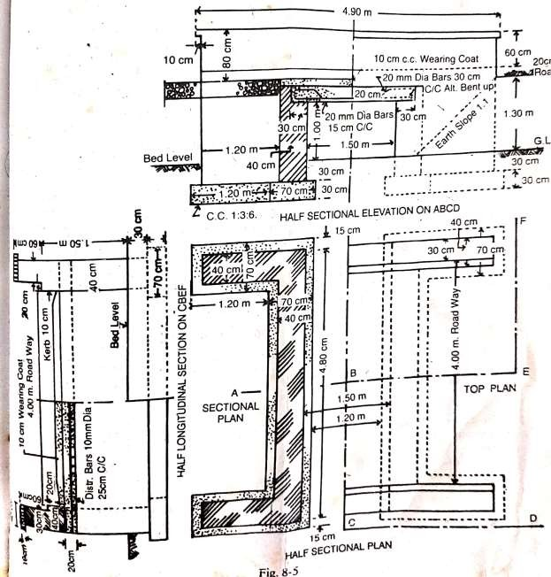

Details of measurement and calculation of quantities

Item  no. | Particulars of  item | No. | Length | Breadth | Depth | Quantity | Remark
1 | Earthwork in excavation in  foundation
1 | Abutments | 2 | 5.10 | 0.70 | 0.60 | 4.28
1 | Wing walls | 4 | 1.20 | 0.70 | 0.60 | 2.02
1 |  |  |  |  | Total | 6.30 cum
2 | Cement concrete 1:3:6  in foundation

with stone
ballast
 | Abutments | 2 | 5.10 | 0.70 | 0.30 | 2.14
 | Wing walls | 4 | 1.20 | 0.70 | 0.30 | 1.01
 |  |  |  |  | Total | 3.15 cum
3 | I class brickwork in 1:4 cement  mortar
3 | Abutments | 2 | 4.80 | 0.40 | 1.50 | 5.76
3 | Wing walls | 4 | 1.20 | 0.40 | 1.50 | 2.88
3 | Parapets upto  kerb | 2 | 4.70 | 0.40 | 0.30 | 1.13
3 | Parapet above  kerb | 2 | 4.70 | 0.30 | 0.50 | 1.41
3 | Parapet coping | 2 | 4.90 | 0.40 | 0.10 | 0.39
3 |  |  |  |  | Total | 11.57 cum
3 | Deduct
3 | Bearing of RCC slab in  abutment | 2 | 4.80 | 0.30 | 0.2 | 0.57
3 |  |  |  |  | Net total | 11.00 cum
4 | RCC work 1:2:4 in slab excluding steel and its bending but including centering and shuttering and  binding steel | 1 | 4.80 | 2.10 | 0.20 | 2.016 cum
5 | Steel bars including bending in RCC work
5 | 20 mm dia bars Main straight bars 30 cm c/c | 17 | 2.38 | - | - | 40.46 m | No. = (4.80/0.3)+1 = 17  L = 2.10-  2 side covers+2 hooks = 2.10 –  (2x0.04)+(18x0.02) =  2.38 m
5 | Main bent up bars 30 cm c/c | 16 | 2.54 | - | - | 40.64 m | No. = 4.80/0.3 = 16  Adding one depth, 16 cm for two bent ups  L = 2.38+0.16 = 2.54  m
5 |  |  |  |  | total | 81.10  m@2.47kg/m=

 |  |  |  |  |  | 200.32 kg
 | 10 mm dia bars Distributing bottom bars 25  cm c/c | 9 | 4.90 | - | - | 44.10 m | L = 4.80 – 2 end  covers + 2 hooks =  4.80 – (2x0.04) + (18  x 0.01) = 4.90
 | Distributing top  bars | 4 | 4.90 | - | - | 19.60 m
 |  |  |  |  | Total | 63.70 m @  0.62 kg =  39.49 kg
6 | Cement concrete 1:2:4 wearing coat | 1 | 4.00 | 2.30 | 0.10 | 0.92 cum
7 | Cement pointing 1:2 in  walls
7 | Face wall from 10 cm below  G.L upto bottom of  coping | 2 | 4.70 | - | 2.10 | 19.74
7 | Inner side of parapet excluding  coping | 2 | 4.70 | - | 0.80 | 7.52
7 | Coping (inner edge, top, outer edge,  side) | 2 | 4.90 | 0.70 | - | 6.86
7 | Ends of parapet | 4 | - | 0.4 | 0.20 | 0.32
7 | Ends of parapet | 4 | - | 0.30 | 0.50 | 0.60
7 | Ends of coping | 4 | - | 0.40 | 0.20 | 0.32
7 | Inner face of  abutment | 2 | 4.80 | - | 1.01 | 9.70
7 |  |  |  |  | Total | 45.06 sqm
7 | Deduct Rectangular  opening | 2 | 1.50 | - | 1.30 | 3.90
7 | Triangular portion below  earth slope | 2 | (1/2) x 1.30  x1.30 |  |  | 1.69
7 |  |  |  |  | Total of  deduction | 5.59
7 |  |  |  |  | Net total | 39.47 sqm

Question 2:
Prepare a detailed estimate of Hume pipe culvert of three pipes each of 60 cm diameter from the given plan and elevation . Foundation concrete shall be of 1:4:8 cement concrete and brickwork shall be of first class in 1:6 cement sand mortar. Exposed surfaces shall be pointed with 1:2 cement sand mortar.
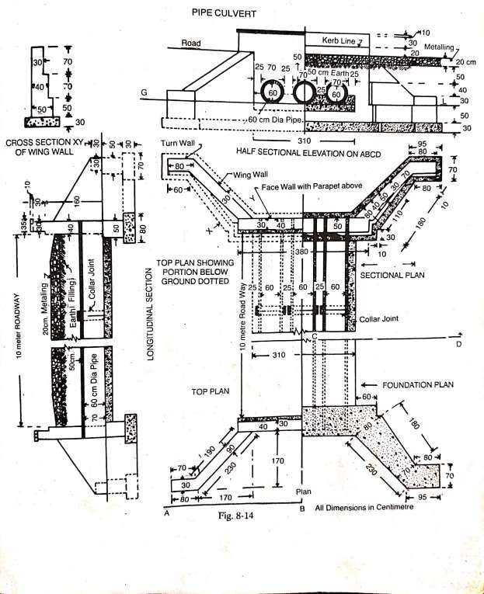

Details of measurement and calculation of quantities

Item  no | Particulars  of item | No | Length | Breadth | Depth | Quantity | Remark
1 | Earthwork in  excavation
 | Face wall | 2 | 3.10 | 0.80 | 0.80 | 3.97
 | Wing wall inclind  portion | 4 | 2.3 + 1.80  2 | 0.8 + 0.70  2 | 0.80 | 4.92
 | Wing wall triangular  corner | 4 | (½x0.60x0.80) |  | 0.80 | 0.77
 | Turn wall | 4 | 0.95 + 0.80  2 | 0.70 | 0.80 | 1.96
 | Under  pipe | 1 | 9.80 | 3.10 | 0.15 | 4.56
 |  |  |  |  | Total | 16.18  cum
2 | Cement concrete 1:4:8 in  foundation
 | Face wall | 2 | 3.10 | 0.80 | 0.30 | 1.49
 | Wing wall inclind  portion | 4 | 2.3 + 1.8  2 | 0.80 + 0.70  2 | 0.30 | 1.85
 | Wing wall triangular  portion | 4 | (½x0.6x0.80) |  | 0.30 | 0.29
 | Turn wall | 4 | 0.95 + 0.80  2 | 0.70 | 0.30 | 0.74
 | Upper pipe and in between pipe upto  half height | 1 | 9.80 | 3.10 | 0.5 | 15.19
 |  |  |  |  | Total | 19.56
 | Deduct half of  pipes | 3 | 9.80x½ | 𝜋0.7² 4 |  | 5.66
 |  |  |  |  | Net total | 13.90

 |  |  |  |  |  | cum
3 | First class brickwork in 1:6 cement sand  mortar
 | Face wall
 | Footing –  50 cm breadth | 2 | 4.00 | 0.50 | 0.50 | 2.00
 | Above footing 40 cm  breadth | 2 | 3.80 | 0.40 | 1.60 | 4.86
 | Parapet 30  cm breadth | 2 | 3.80 | 0.30 | 0.30 | 0.68
 | Coping 35 cm  breadth | 2 | 4.00 | 0.35 | 0.10 | 0.28
 | Wing walls
 | 1st step- 50 cm  breadth | 4 | 1.10 | 0.50 + 0.30  2 | 0.50 | 0.55
2nd step 40 cm
breadth
 | Straight  portion | 4 | 1.80 | 0.40 | 0.30 | 0.86
 | Sloping  portion | 4 | 1.80 | 0.40 | 0.40 + 0  2 | 0.58
 | 3rd step – 30 cm  breadth | 4 | 1.90 | 0.30 | 0.7 + 0  2 | 0.80
 | Turn wall – 40 cm  breadth | 4 | 0.80 + 0.70  2 | 0.40 | 0.50 | 0.60
 | Turn wall – 30 cm  breadth | 4 | 0.80 + 0.75  2 | 0.30 | 0.30 | 0.28
 |  |  |  |  | Total | 11.49  cum
4 | Cement pointing 1:2 in exposed surface  above G.L
 | Face wall  outer side | 2 | 3.10 | - | 1.40 | 8.68 | Upto road level

 | Facewall parapet  outer side | 2 | 3.80 | - | 0.65 | 4.94 | D=20+30+10+5  =65cm  =0.65m
 | Parapet  inner faces | 2 | 3.80 | - | 0.70 | 5.32 | Including kerb  offset of 10 cm
 | Wing wall vertical  face | 4 | 2.3 | - | 1.40 + 0.50  2 | 8.74
 | Wing wall  top | 4 | 2.30 | 0.30 | - | 2.76
 | Turn wall vertical face three  sides | 4 | 1.80 | - | 0.30 | 2.16 | L = perimeter  =80+30+70=180  =1.80m
 | Turn wall  top | 4 | 0.8 + 0.7  2 | 0.3 | - | 0.90
 |  |  |  |  | Total | 33.50  sqm
5 | Hume pipe heavy type 60 cm dia including  collar joint | 3 | 10.80 | - | - | 32.40 | L = 10+0.4+0.4  = 10.80 m

Question 3:
Estimate the quantities of the following items from the drawing of a splayed wing wall shown in figure.
- Earthwork in excavation
- Cement concrete (1:3:6) in foundation
- First class brickwork in cement mortar (1:6)
- R.C.C M15 in deck slab
- 10 cm thick cement concrete (1:1½:3) wearing coat

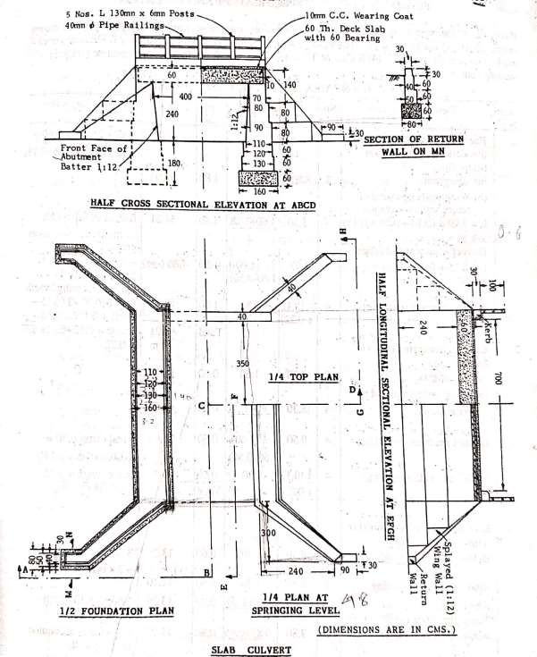

Details of measurement and calculation of quantities

Item no. | Description of item | No. | Length | Breadth | Depth | Quantity | Remark
1 | Earthwork in excavation depth upto 2m below G.L
 | Abutment | 2 | 8.80 | 1.60 | 1.80 | 50.69 | 8.80 =
 |  |  |  |  |  |  | 2(3.50+0.40+(2.40/2)+0.10
 |  |  |  |  |  |  | +0.05+0.15)
 | Wing wall upto end of | 4 | 3.30 | 1.60 + 1.28 | 1.80 | 34.21 | 0.80 is trench width
 | return wall excavation |  |  | 2 |  |  | Inclind width upto end 1.28
 | L =
 | 3.00+(0.10+0.05+0.15) =
 | 3.30
 | Deduct abutment end | 4 | 0.50 | ½(1.60+1.6- | 1.80 | (-)4.86 | 0.80x√1.25²+1²
 | offset |  |  | 0.5) |  |  | Splay is 1.25:1
 | L =
 | 0.15+0.05+0.10+0.4/2=0
 | .50
 | Return wall (remaining) | 4 | ½(0.12+0.2 | 0.80 | 1.80 | 0.97 | Outside remaining length
 |  |  | 2) |  |  |  | 0.12=0.90+2(0.15+0.05)+0.
 |  |  |  |  |  |  | 10-1.28
 |  |  |  |  |  |  | 2.40
 |  |  |  |  |  |  | Inside = 0.12+0.12x
 |  |  |  |  |  |  | 3.0
 |  |  |  |  |  |  | = 0.22
 |  |  |  |  | Total | 81.01 cum
2 | Cement concrete (1:3:6) in foundation
 | Abutments | 2 | 8.80 | 1.60 | 0.60 | 16.90
 | Wing walls upto end of | 4 | 3.30 | 1.60 + 1.28 | 0.6 | 11.40
 | return wall |  |  | 2
 | Deduct abutment end | 4 | 0.50 | ½(1.60+1.6 | 0.60 | 1.62 | Total offset
 | offsets |  |  | 0-0.50) |  |  | 0.50=0.10+0.05+0.15
 | Return wall(remaining) | 4 | ½(0.12+0.2 | 0.80 | 0.60 | 0.32 | Inner length =0.22
 |  |  | 2) |  |  |  | 2.4  0.12+0.12x
 |  |  |  |  | Total | 27.00 cum
3 | Brickwork in cement  mortar (1:6)
 | Abutment
 | Below G.L 1st footing | 2 | 8.50 | 1.30 | 0.60 | 13.26 | 8.80-(2x0.15)
 | Below G.L 2nd footing | 2 | 8.40 | 1.20 | 0.60 | 12.10

 | Above G.L 1st offset Top width =  0.90+1.60/12 = 1.03 | 2 | 7.80 | 1.03 + 1.10  2 | 0.80 | 13.29 | 7.80=2(3.50+0.40)
 | Above G.L 2nd offset | 2 | 7.80 | 0.87 + 0.93 | 0.80 | 11.23
 | Bottom width = |  |  | 2
 | 0.80+1.60/12=0.93
 | Top width =
 | 0.80+0.80/12 = 0.87
 | Above G.L top wall | 2 | 7.80 | 0.77 + 0.70 | 1.40 | 16.05
 | Bottom width = |  |  | 2
 | 0.70+0.80/12 = 0.77
 | Deduct bearing of deck  slab | 2 | 7.80 | 0.60 | 0.60 | -5.62
Wing walls upto end of
return wall
 | Below G.L 1st footing | 4 | 3.15 | 1.30 + 0.80  2 | 0.60 | 7.94 | 0.80=0.5√1.25²+1²
 | Below G.L 2nd footing | 4 | 3.10 | 1.20 + 0.64  2 | 0.60 | 6.84 | 0.64 = 0.40√1.25²+1²
Deduct abutment end
offsets
 | For 1st footing | 4 | 0.35 | ½(1.30+1.3  0-0.28) | 0.60 | -0.97
 | For 2nd footing | 4 | 0.3 | ½(1.20+1.2  0-0.24) | 0.60 | -0.78
 | Above G.L
 | The whole section with | 4 | 2.70/3 | (1.92+0.20 |  | 9.86 | Top inclined width =
 | parallel inclined width |  |  | +√1.92x0.2 |  |  | 0.40x1.60=0.64
 | considered as Frusta of |  |  | 0) |  |  | Bottom width at abutment
 | pyramid |  |  |  |  |  | 2.4  = 0.64+ x1.6= 0.96
 | Vol. = h/3(A1+A2+√A1A2)  A1 = ½(0.96+0.64)x2.4 = 1.92 |  |  |  |  |  | 12  Bottom width at the end =  0.3  0.64+ x0.3=0.68  2
 | A2 = ½(0.68+0.64)x0.30
 | = 0.20
 | Return wall (remainng | 4 | 0.90 + 1.54 | 0.30 | 0.30 | 0.44
 | portion of a trapezium) |  | 2
 | 1.54 = 0.9+(0.9-
 | 0.4√1²+1.25²)
 |  |  |  |  | Total | 83.64 cum
4 | R.C.C M15 in deck slab | 1 | 7.80 | 5.20 | 0.60 | 24.34 cum
5 | 10 cm thick cement concrete (1:1½:3)  wearing coat | 1 | 7.00 | 4.40 | 0.10 | 3.08 cum

Estimate of irrigation structure

Concept of fall:
- Irrigation canals are constructed with some permissible bed slopes so that there is no silting or scouring in the canal bed.
- But it is not always possible to run the canal at the desired bed slope throughout the alignment due to the fluctuating nature of the natural ground surface slope.
- Generally the slope of the natural ground surface is not uniform throughout the alignment.
- Sometimes the ground surface may be steep and sometimes it may be very irregular with abrupt change in grade.
- In such cases, a vertical drop is provided to step down the canal bed and then it is continued with permissible slope until another step down is necessary.
- Such vertical drops are known as canal falls.

Necessity of canal fall:
The canal falls are necessary in following conditions:
- When the slope of the ground suddenly changes to steeper slope, the permissible bed slope cannot be maintained. It requires excessive earthwork in filling to maintain the slope. In such a case canal falls are provided to avoid excessive earth work in filling.
- When the slope of the ground is more or less uniform and the slope is greater than the permissible bed slope of canal. In that case also the canal falls are necessary.
- In cross drainage works, when the difference between bed level of canal and that of drainage is small or when the F.S.L of the canal is above the bed level of drainage then the canal fall is necessary to carry the canal water below the stream or drainage.

Types of canal fall:
The following are the different types of canal fall that may be adopted according to the site condition:
  - Ogee fall
  - Rapid fall
  - Stepped fall
  - Trapezoidal notch fall
  - Vertical drop fall or Sarada fall
  - Glacis fall

Ogee fall:
  - In this type of fall, an ogee curve is provided for carrying the canal water from higher level to lower level.
  - This fall is recommended when the natural ground surface suddenly changes to a steeper slope along the alignment of the canal.

Rapid fall:
  - The rapid fall is suitable when the slope of the natural ground surface is even and long.

Stepped fall:
  - Stepped fall consists of a series of vertical drops in the form of steps.
  - This fall is suitable in places where the sloping ground is very long and requires long glacis to connect the higher bed level to lower bed level.
  - This fall is practically a modification of the rapid fall.

Trapezoidal notch fall:
  - In this type of fall a body wall is constructed across the canal.
  - The body wall consists of several trapezoidal notches between the side piers and the intermediate pier.
  - The sills of the notches are kept at the upstream bed level of the canal.

Vertical drop fall or Sarada Fall:
  - It consists of a vertical drop wall which is constructed with masonry work.
  - The water flows over the crest of the wall.
  - A water cistern is provided on the down stream side which acts as a water cushion to dissipate the energy of falling water.
  - A concrete floor is provided on the downstream side to control the scouring effect of the flowing water.

Glacis fall:
  - It consists of a straight sloping glacis provided with a crest.
  - A water cushion is provided on the downstream side to dissipate the energy of flowing water.
  - This type of fall is suitable for drops upto 1.5 m.

Question 1:
Prepare a detailed estimate of a 60 cm fall for a distributor of 360 cm bed width and 90 cm depth of water from the given drawing. Side slope of bank and channel are 1½:1. The general specifications are as follows:
Foundation and apron concrete – cement concrete 1:3:6 with stone ballast. Masonry – all brickwork shall be of I-class in 1:4 cement mortar
Pointing – all exposed surfaces shall be pointed with 1:4 cement and sand mortar Pitching – pitching shall be of dry brick with straight over burnt bricks

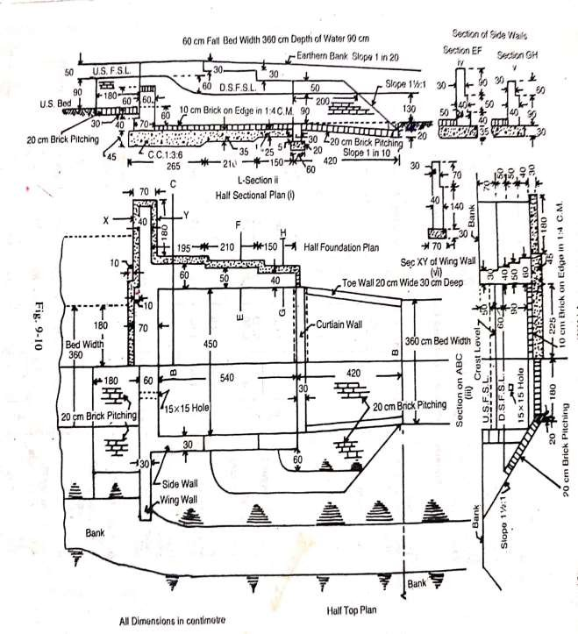

Details of measurement and calculation of quantities

Ite m  no. | Particulars of item | No. | Length | Breadth | Depth | Quantity | Remark
1 | Earthwork in excavation crest wall, side wall and floor(taken together)
 | (i) | 1 | 2.65 | 6.00 | 1.15 | 18.29 | B = 4.5+(2x0.6)+(2x0.15)=6.00m
 | (ii) | 1 | 2.10 | 5.80 | 1.05 | 12.79 | B=4.5+(2x0.5)+(2x0.15)= 5.80m
 | (iii) | 1 | 1.50 | 5.60 | 0.95 | 7.98 | B = 4.5+(2x0.4)+(2x0.15) =  5.60 m
 | Wing walls beyond side walls | 2 | 1.80 | 0.70 | 1.00 | 2.52
 | Curtain walls | 1 | 4.50 | 0.60 | 1.20 | 3.24
 | Up stream pitching 20 cm depth
 | Bed | 1 | 1.80 | 3.60 | 0.20 | 1.30
 | Side slopes(upto F.S.L) | 2 | 1.80 | 1.62 | 0.20 | 1.17 | Slopping breadth = h√s²+1  = 0.9√(1½²+1)= 1.62 m
 | Down stream | (4.05x | X 3.90 |  |  | 16.38 | 4.5+3.6  Average breadth =  2  = 4.05 m  0.60+1.00  Average depth = =  2  0.80 m
 | channel beyond | 0.8+1
 | curtain wall | ½x0.8
 | Trapezium | 2)
 | section(BD+sd²)L
 | (L = 4.2 – 0.3 =
 | 3.90m)
 | Down stream | 1 | 3.90x | X 0.20 |  | 2.85 | Sloping breadth at middle
 | pitching 20 cm  depth, excluding |  | 4.1+3.2  2
 | toe wall –
 | Bed

 | Side slopes upto  F.S.L (upper length = 2 m) | 2 | 4.2 + 2.0  2 | X 1.44 | X0.20 | 1.79 | = d√s²+1  = 0.8√1½²+1 = 1.44 m
 | Curved portion top wall | 2 | π x 0.6² | (Area) | X0.2 | 0.45
 | Top wall | 2 | 3.90 | 0.20 | 0.30 | 0.47
 |  |  |  |  | Total | 69.23
 | Deduct for set back of wing  wall | 2 | 0.60 | 0.10 | 1.15 | 0.14
 |  |  |  |  | Net total | 69.09 cum
2 | Cement concrete 1:3:6 in foundation and floor – crest wall side walls and  floor
 | (i) | 1 | 2.65 | 6.00 | 0.45 | 7.16
 | (ii) | 1 | 2.10 | 5.80 | 0.35 | 4.26
 | (iii) | 1 | 1.50 | 5.60 | 0.25 | 2.10
 | Wing wall beyond side wall | 2 | 1.80 | 0.70 | 0.30 | 0.76
 | Curtain wall | 1 | 4.50 | 0.60 | 0.20 | 0.54
 |  |  |  |  | Total | 14.82
 | Deduct for set back of wing  wall | 2 | 0.60 | 0.10 | 1.15 | 0.14
 |  |  |  |  | Net total | 14.68 cum
3 | I class brickwork in 1:4 cement  mortar

 | Crest wall -
 | 1st step | 1 | 4.50 | 0.70 | 0.40 | 1.26
 | 2nd step | 1 | 4.50 | 0.60 | 1.00 | 2.70
 | Side wall
 | (i)1st step | 2 | 2.35 | 0.60 | 0.40 | 1.13
 | 2nd step | 2 | 2.35 | 0.50 | 0.50 | 1.18
 | 3rd step | 2 | 2.35 | 0.40 | 0.50 | 0.94
 | 4th step | 2 | 2.35 | 0.30 | 0.70 | 0.99
 | (ii)1st step | 2 | 2.10 | 0.50 | 0.40 | 0.84
 | 2nd step | 2 | 2.10 | 0.40 | 0.50 | 0.84
 | 3rd step | 2 | 2.10 | 0.30 | 0.90 | 1.13
 | (iii)1st step | 2 | 1.50 | 0.40 | 0.90 | 1.08
 | 2nd step | 2 | 1.50 | 0.30 | 0.60 | 0.54
 | 3rd step
 | Wing wall beyond side wall | 2 | 1.80 | 0.40 | 0.40 | 0.58
 |  | 2 | 1.90 | 0.40 | 0.50 | 0.76
 |  | 2 | 2.00 | 0.40 | 0.50 | 0.80
 |  | 2 | 2.10 | 0.30 | 0.70 | 0.88
 | Curtain wall | 1 | 4.50 | 0.30 | 0.40 | 0.54

 | Toe wall | 2 | 3.90 | 0.20 | 0.30 | 0.47
 |  |  |  |  | Total | 16.66 cum
4 | Brick – on – edge floor in 1:8 cement mortar including  pointing | 1 | 5.40 | 4.50 | - | 24.30 sqm
5 | Cement pointing in 1:3 cement  mortar
 | Crest wall (up stream face top and down  stream face) | 1 | 4.50 | - | 2.40 | 10.80
 | Side wall inner face (i) | 2 | 1.80 | - | 2.00 | 7.20
 | (ii) | 2 | 2.10 | - | 1.70 | 7.14
 | (iii) | 2 | 1.50 | - | 1.40 | 4.20
 | Side wall portion above crest wall | 2 | 0.60 | - | 0.80 | 0.96
 | Vertical faces3 of steppings | 2x2 | - | 0.30 | 0.30 | 0.36
 | Vertical face of end | 2 | - | 0.40 | 0.90 | 0.72
 |  | 2 | - | 0.30 | 0.60 | 0.36
 | Top of side wall | 2 | 6.00 | 0.30 | - | 3.6 | Full length of 30 cm wall
 | Top of curtain wall | 1 | 4.50 | 0.30 | - | 1.35
 | Top of toe wall | 2 | 3.90 | 0.20 | - | 1.56
 | Wing wall top face | 2 | 2.10 | 0.30 | - | 1.26
 | Wing wall upstream side triangular portion above  slope | 2 | ½(2.10x1. 40) |  | - | 2.94 | Triangular portion of slope

 |  |  |  |  | Total | 42.45 sqm
6 | Brick pitching
 | Upstream bed | 1 | 1.80 | 3.60 | 0.20 | 1.30
 | Upstream side slope | 2 | 1.80 | 1.62 | 0.20 | 1.17
 | Down stream bed | 1 | 3.90 | 4.1 + 3.2  2 | 0.20 | 2.85
 | Downstream side slope | 2 | 4.2 + 2.0  2 | 1.44 | 0.20 | 1.79
 | Side curved portion | 2 | Πx0.6² |  | 0.20 | 0.45
 |  |  |  |  | Total | 7.56 cum

Question 2:
Prepare a detailed estimate of a 1m fall for a branch canal having 1.68 m bed width 76 cm depth of water from the given figure. The general specifications are as follows:
- Foundation of abutment, wing and drop walls and flooring shall be cement concrete (1:4:8)
- Wearing coat, floor between u/s wing walls and crest shall be cement concrete (1:2:4)
- All brickwork shall be of 1st class in cement mortar (1:4)
- All exposed surface of brickwork shall be made flush pointed in cement mortar (1:3)

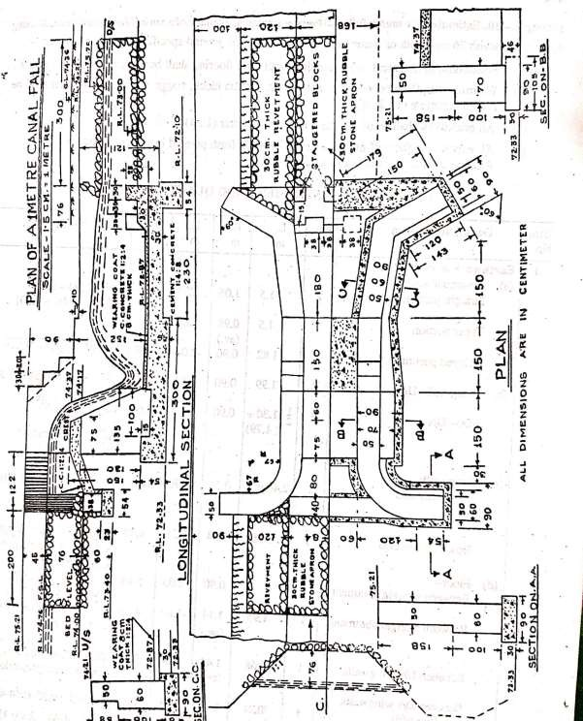

Details of measurement and calculation of quantities

Item  no. | Description of  item | No. | Length | Breadth | Depth | Quantity | Remark
1 | Earthwork in  excavation
 | Abutment wall  Straight portion | 2 | 1.5 | 1.05 | 2.03 | 6.39 | 1.05=0.9+0.15
 | Taper portion | 2 | 1.5 | 0.98 | 2.03 | 5.97 | 0.98=½(1.05+0.90)
 | Splayed portion | 2 | 1.82 | 0.90 | 2.03 | 6.65 | 1.82=√1.8²(1.68-  2  0.6)²
 | Wing wall u/s | 2 | 1.99 | 0.90 | 2.03 | 7.27 | 1.99 =  0.15+0.54+1.3
 | Wing wall D/s | 2 | ½(1.30+1.79) | 0.90 | 2.03 | 5.64 | 2𝜋×0.83  1.30=  4  0.83 in mean  radius for earthwork
 | Drop wall
 | Up stream side | 1 | 2.4 | 0.54 | 4.49 | 1.24 | 2.4=½ × 2(0.6+1.8)
 | Down stream side | 1 | 3.68 | 0.54 | 2.26 | 4.49 | 3.68 is the centre length  = 1.68+2×(0.76-  0.38/2)×tan 60®
 | Floor
 | Between straight  abutment | 1 | 3 | 0.90 | 2.03 | 5.48 | 0.90= 2×(0.60-  0.15)
 | Between straight abutment | 1 | 1.95 | 1.14 | 1.87 | 4.16 | 1.95=1.8+0.15  1.14=½×2(0.6-  1.68  0.15+( − 0.15))  2
 | Between u/s wingwall | 1 | 0.58 | 1.44 | 0.36 | 0.30 | 0.58=0.80-0.07-  0.15 i.e concrete projection
 | Between d/s wingwall and  drop wall | 1 | 0.21 | 1.38 | 1.87 | 0.54 | 0.21= 3×0.3-0.54-  0.15  1.38=1.68-(2×0.15)
 | Floor stone  apron u/s | 1 | 2 | 1.68 | 0.30 | 1.0
 | Rivetment u/s | 2 | ½(2+2.4) | 1.07 | 0.3 | 1.4 | 1.07=√0.76²+0.76²
 | Apron d/s | 1 | 3 | 1.68 | 0.3 | 1.5
 | Rivetment d/s | 2 | ½(3+3.76) | 0.91 | 0.30 | 1.9
 |  |  |  |  | Total | 53.91  cum
2 | Cement concrete in  foundation(1:4:8)
 | Abutments
 | Straight portion | 2 | 1.5 | 1.05 | 0.3 | 0.95
 | Taper portion | 2 | 1.5 | 0.98 | 0.3 | 0.88
 | Splayed portion | 2 | 1.82 | 0.90 | 0.30 | 0.98

 | Wing wallu/s | 2 | 1.99 | 0.90 | 0.30 | 1.08
 | Wing wall d/s | 2 | ½(1.35+1.79) | 0.90 | 0.30 | 0.85
 | Drop wall u/s side | 1 | 2.4 | 0.54 | 0.23 | 3.30
 | Drop wall d/s  side | 1 | 3.68 | 0.54 | 0.69 | 1.37 | 0.69=72.87-0.08-  72.10
 | Floor between
 | Straight abutment | 1 | 1.5 | 0.90 | 0.54 | 0.73
 | Straight  abutment | 1 | 1.5 | 0.90 | 0.46 | 0.62
 | Splyed abutment | 1 | 1.95 | 1.14 | 0.30 | 0.67
 | Between d/s wings | 1 | 0.21 | 1.38 | 0.30 | 0.09
 | Deduction for grooving below  breast wall | 1 | 1 | 1.20 | 0.15 | 0.18
 |  |  |  |  | Total | 8.34  cum
3 | Cement concrete  1:2:4
 | Between u/s  wing walls | 1 | 0.88 | 1.44 | 0.20 | 0.25
 | Portion laid on drop wall (left  out) | 1 | 1.68 | 0.08 | 0.10 | 0.01
Wearing coat
between
 | Straight  abutments | 1 | 1.5 | 1.20 | 0.08 | 0.14
 | Splayed  abutment | 1 | 1.95 | 1.14 | 0.08 | 0.18
 | Sloping top  portion | 1 | 0.15 | 1.68 | 0.037/2 | 0.02
 | Between d/s  wings | 1 | 0.61 | 1.68 | 0.30 | 0.31 | 0.61=0.76-0.15
 | Friction block | 2 | 0.38 | 0.3 | 0.23 | 0.05
 | Straggered block | 3 | 0.38 | 0.3 | 0.23 | 0.08
 | Top of breast  wall | 1 | 0.75 | 1.20 | 0.20 | 0.18
 |  |  |  |  | Total | 1.22  cum
4 | 1st class brickwork in  cement mortar
 | Wingwall u/s 60 cm | 2 | 3.43 | 0.60 | 1.00 | 4.12 | Mean radius 0.92  3.43=0.54+ 2𝜋×0.92  2
 | Wing wall u/s 50  cm | 2 | 3.43 | 0.50 | 1.58 | 5.42
 | Wing wall d/s 60  cm | 2 | ½(1.2+1.5) | 0.60 | 1.00 | 1.62

 | Wing wall d/s 50  cm | 2 | ½(1.2+1.5) | 0.50 | 0.58 | 0.78
 | Abutment
 | Straight portion 70cm | 2 | 1.35 | 0.70 | 1.00 | 1.89 | 1.35=0.75+0.60
 | Straight portion  50 cm | 2 | 1.35 | 0.50 | 1.58 | 2.13
 | Taper portion  bottom | 2 | 1.5 | 0.75 | 1.00 | 2.25
 | Taper portion  stepping 50 cm | 2 | 0.30 | 0.50 | 1.28 | 0.38 | 1.28=1.58-0.30
 | Taper portion  stepping 50 cm | 2 | 0.30 | 0.50 | 0.9 | 0.29
 | Taper portion  stepping 50 cm | 2 | 0.90 | 0.50 | 0.68 | 0.61 | 0.90=1.5-(2×0.30)
 | Splayed portion  60 cm | 2 | 1.82 | 0.60 | 1.00 | 2.18
 | Splayed portion  50 cm | 2 | 1.82 | 0.50 | 0.58 | 1.06
 | Drop wall u/s | 1 | 2.4 | 0.4 | 0.37 | 0.36
 | Drop wall d/s | 1 | 3.68 |  | 0.40 | 0.15 | 0.22
 | Breast wall | 1 | 1.2 | 1.05 | 1.45 | 1.83
 | Deduction for  grooving | 1 | 1.2 | 0.35 | 0.15 | 0.06
Total 25.20
cum
5 | Flush pointing to exposed joints of brickwork in cement  mortar(1:3)
 | Wing wall u/s top | 2 | 3.34 | 0.50 | 1.34 | 3.34 | Top radius = 0.92  3.34 =  π×0.92+0.54
 | Wing wall u/s  inner side | 2 | 2.65 | - | 1.34 | 7.10
 | Wing wall u/s  outer side | 2 | 2.32 | - | 0.85 | 3.94 | 0.85=75.21-74.36
 | Wing wall d/s top | 2 | ½(1.2+1.5) | 0.5 | - | 1.35
 | Wing wall d/s  inner side | 2 | 1.5- | - | 1.34 | 4.02
 | Abutments
 | Top of straight  portion | 2 | 2.85 | 0.50 | - | 2.85
 | Inner side  portion | 2 | 1.35 | - | 2.50 | 6.75
 | Inner side  stepping | 2 | 0.30 | - | 2.20 | 1.32
 | Inner side  stepping | 2 | 0.30 | - | 1.90 | 1.14

 | Inner side  stepping | 2 | 0.90 | - | 1.60 | 2.88
 | Top of splayed  portion | 2 | 1.82 | 0.50 | - | 1.82 | 2.1=√1.95²+0.84²
 | Inner side  splayed portion | 2 | 2.1 | - | 1.34 | 5.63
 | Breast wall | 1 | 1.2 | - | 1.3 | 1.56
 | Breast wall inner  side | 1 | 1.2 | - | 1.43 | 1.72
 | Deduction for breast wall joining  abutmments | 2 | 1.06 | - | 1.3 | 2.76
 |  |  |  |  | Total | 42.49  sqm
6 | Rubble stone  pitching
 | Upstream apron | 1 | 2.0 | 1.68 | - | 3.36
 | u/s rivetment | 2 | ½(2+2.40) | 1.07 | - | 4.71 | 1.07=√0.76²+0.76²
 | d/s apron | 1 | 3.0 | 1.68 | - | 5.04
 | d/s revetment | 2 | ½(3+3.76) | 1.07 | - | 7.23
 |  |  |  |  | Total | 20.34  sqm

Cross drainage works:
- In an irrigation project, when the network of main canals, branch canals, distributaries etc are provided, then these canals may have to cross the natural drainage like rivers, streams, etc at different points within the command area of the project.
- The crossing of the canals with such obstacles cannot be avoided. So, suitable structures must be constructed at the crossing point for the easy flow of water of the canal and drainage in the respective directions. These structures are are known as cross drainage works.

Types of cross drainage works:
  - Irrigation canal passes over the drainage: this condition involves the construction of following:
    - Aqueduct:The hydraulic structure in which the irrigation canal is taken over the drainage is known as aqueduct. This structure is suitable when bed level of canal is above the highest flood level of drainage. In this case, the drainage water passes clearly below the canal.
    - Siphon aqueduct: In a hydraulic structure where the canal is taken over the drainage, but the drainage water cannot pass clearly below the canal. It flows under siphonic action. So it is known as siphon aqueduct. This structure is suitable when the bed level of canal is below the highest flood level of the drainage.
  - Drain passes over the irrigation canal: this condition involves the construction of the following :
    - Superpassage: the hydraulic structure in which the drainage is taken over the irrigation canal is known as superpassage. The structure is suitable when the bed level of drainage is

above the full supply level of the canal. The water of the canal passes clearly below the drainage.
    - Siphon superpassage: the hydraulic structure in which the drainage is taken over the irrigation canal, but the canal water passes below the drainage under siphonic action is known as siphon super passage. The structure is suitable when the bed level of drainage is below the full supply level of the canal.
  - Drainage and canal intersection each other at the same level: this condition involves the construction of the following:
    - Level crossing: when the beds of the drainage and canal are practically at the same level, then a hydraulic structure is constructed which is known as level crossing. This is suitable for the crossing of large drainage with main canal.
    - Inlet and outlet : in the crossing of small drainage with small channel no hydraulic structure is constructed. Simple openings are provided for the flow of water in their respective direction.

Question 3:
Prepare a detailed estimate of a Drainage Syphon across a minor from the given drawing.
Foundation concrete shall be of 1:4:8 cement concrete with brick ballast. All brickwork shall be of 1:4 cement mortar. Exposed surfaces of brickwork shall be struck pointed with 1:2 cement mortar. Brick pitching shall be of dry brick with straight over burnt bricks.

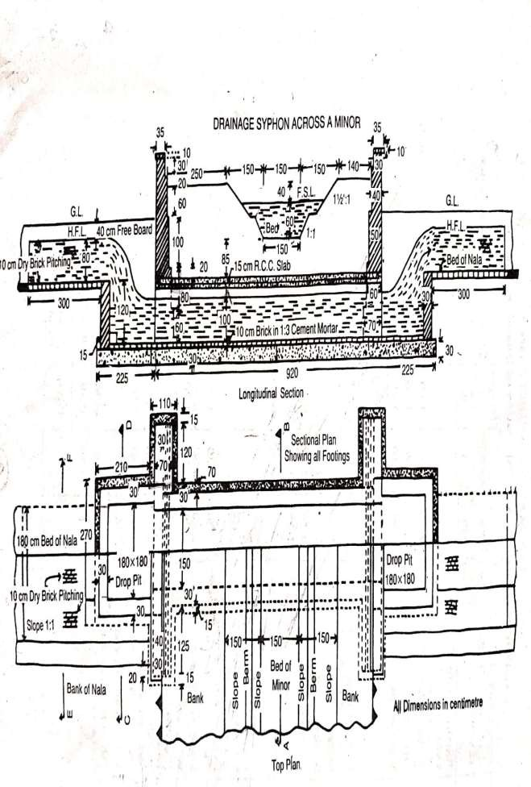

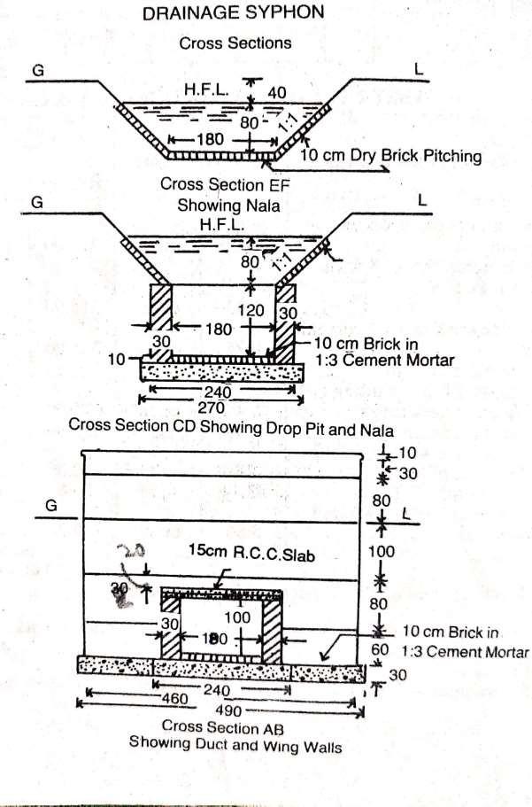

 | Details of Measurement and Calculation of Quantities
Item No. | Particulars of items and details of works | No. | Length m | Breadth m | Height or  Depth m | Quantity | Explanatory notes
1 | Earthwork in excavation in foundation-
 | Syphon duct … | 1 | 9.50 | 2.40 | 1.60 | 36.48 | For bed level of nala.
 | Drop pit … | 2 | 2.10 | 2.70 | 1.60 | 18.14
 | Wing walls … | 4 | 1.25 | 1.10 | 1.60 | 8.80
 |  |  |  |  | Total | 63.42
 |  |  |  |  |  | cu m
2 | Cement concrete 1:4:8 with brick ballast-
 | Syphon duct … | 1 | 9.50 | 2.40 | 0.30 | 6.84
 | Drop pit … | 2 | 2.10 | 2.70 | 0.30 | 3.40
 | Wing walls … | 4 | 1.25 | 1.10 | 0.30 | 1.65
 |  |  |  |  | Total | 11.89
 |  |  |  |  |  | cu m
3 | First class brick work in 1:4 cement mortar-
 | Syphpn duct side wall | 2 | 9.20 | 0.30 | 1.30 | 7.18
 | Drop pit walls … | 2x2 | 2.10 | 0.30 | 1.30 | 3.28
 | Wing walls … | 2 | 1.80 | 0.30 | 1.30 | 1.40
 | 1st step 70 cm  walls | 4 | 1.25 | 0.70 | 0.70 | 2.45
 | 2nd step 60 cm  walls | 4 | 1.25 | 0.60 | 0.60 | 1.80 | Upto top slab.
 | 2nd step 60 cm walls above slab | 2 | 4.60 | 0.60 | 0.20 | 1.10
 | 3rd step 50 cm  wall | 2 | 4.60 | 0.50 | 1.00 | 4.60
 | 4 th step 40 cm wall | 2 | 4.60 | 0.40 | 0.80 | 2.94
 | 5 th step 30 cm wall (parapet) | 2 | 4.60 | 0.30 | 0.30 | 0.83
 | Coping | 2 | 4.70 | 0.35 | 0.10 | 0.33
 |  |  |  |  | Total | 25.91  cu m

4 | R.C.C. slab of syphon duct incuding steel reinforcement  complete work | 1 | 9.20 | 2.10 | 0.15 | 2.9 cu m
5 | 10 cm thick brick floor in 1:3 cement mortar including 1:2 cement  pointing-
 | Floor of syphon duct | 1 | 9.20 | 1.50 | _ | 13.80
 | Floor of drop pit … | 2 | 1.80 | 1.80 | _ | 6.48
 |  |  |  |  | Total | 20.28
 |  |  |  |  |  | sq m
6 | Cement struck pointing 1:2 -
 | Syphon duct inner faces | 2 | 9.20 | _ | 1.00 | 18.40
 | Drop pit 3 vertical faces | 2X3 | 1.80 | _ | 1.20 | 12.96
 | Drop pit 3 top  faces | 2 | 5.70 | _ | 0.30 | 3.42 | L=2X180+210
 |  |  |  |  |  |  | = 570 cm
 | Parapet wall inner face topand outer face up to G.L | 2 | 4.60 | _ | 2.30 | 21.16 | Ht.  =20+10+30+10+35+  10+5+110 = 230 cm
 | Outer face of wing wall above slab … | 2 | 1.80 | _ | 1.20 | 4.32
 | Triangular portion of outer face of  wing wall | 2X2 | (1/2  x.8 | x.8) | = | 1.26
 |  |  |  |  | Total | 61.54 sq  m
7 | 10 cm dry brick pitching with straight over burnt  bricks- |  |  |  |  |  | Thin pinching, unit in area basis
 | Bed of nala | 2 | 3.00 | 1.80 | _ | 10.80 | Up and down  streams.
 | Side slopes of nala | 2x2 | 3.00 | 1.13 | - | 13.56 | Sloping breadth =  √.8² + .8² = 1.13 m
 |  |  |  |  | Total | 24.36  sq m

Question 4
Prepare a detailed estimate of a siphon aqueduct from the given figure. The general specifications : cement concrete in foundation shall be 1:3:6 with brick ballast.
Brickwork shall be of cement mortar 1:4.
All exposed surface of the brickwork shall be tuck pointed with 1:3 cement mortar. 10 cm thick dry brick pitching shall be provided for both U/S & D/S sides.

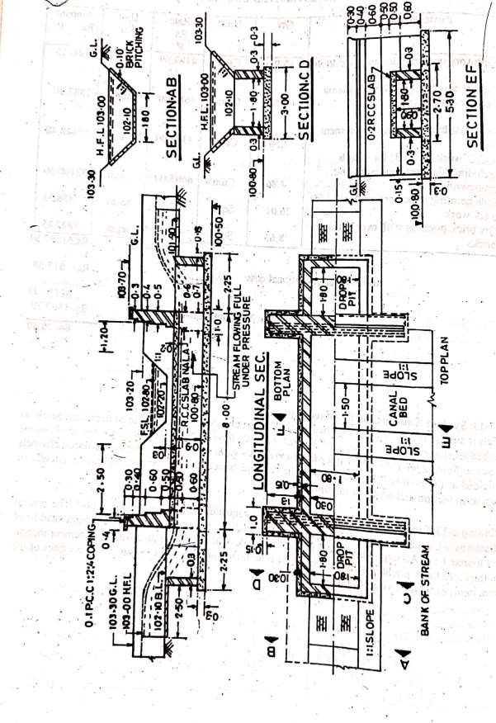

Details of measurement and calculation of quantities

Sl. No | Description of  the item | No. | Length | Breadth | Depth or  height | Quantity | Remark
1 | Earthwork in excavation in foundation
 | Siphon duct | 1 | 8.00 | 2.70 | 1.60 | 34.56 | 1.6 = 102.1 –  100.50  2.7 = 1.8 + 2 (0.3  + 0.15)
 | U/S drop pit | 1 | 2.25 | 2.7 | 1.6 | 9.72
 | D/S drop pit | 1 | 2.25 | 2.7 | 1.4 | 8.51
 | Wing walls | 4 | 1.3 | 1.00 | 1.6 | 8.32
 |  |  |  |  | Total | 61.11  cum
2 | Cement concrete work  in foundation
 | Siphon duct | 1 | 8.00 | 2.70 | 0.30 | 6.48
 | Drop pits | 2 | 2.25 | 2.70 | 0.30 | 3.64
 | Wing walls | 4 | 1.30 | 1.00 | 0.30 | 1.56
 |  |  |  |  | Total | 11.68  cum
3 | First class brickwork in  cement mortar (1:4)
 | Siphon duct walls | 2 | 8.00 | 0.30 | 0.90 | 4.32 | Ht = 0.90  considering full bearing of duct slab over the  side walls
 | U/S drop pit long sides | 1 x 2 | 2.10 | 0.30 | 1.30 | 1.64 | 2.10 = 1.80 +  0.30  1.30 = 102.10 –  100.80
 | U/S drop pit  short side | 1 | 1.80 | 0.30 | 1.30 | 0.70
 | D/S drop pit  long side | 1 x 2 | 2.10 | 0.30 | 1.10 | 1.39
 | D/S drop pit  short side | 1 | 1.80 | 0.30 | 1.10 | 0.59
 | Wing walls 1st footing 70  cm walls | 4 | 1.30 | 0.70 | 0.60 | 2.18
 | 2nd footing 60 cm walls up to  top of deck | 4 | 1.30 | 0.60 | 0.50 | 1.56

 | slab
 | Above deck  slab | 2 | 5.00 | 0.60 | 0.50 | 3.00
 | 3rd footing 50 cm walls | 2 | 5.00 | 0.50 | 0.60 | 3.00
 | 4th footing 40  cm walls | 2 | 5.00 | 0.40 | 0.40 | 1.60
 | Parapet 30 cm walls | 2 | 5.00 | 0.30 | 0.20 | 0.60 | Ht 20 cm  excluding 0.10  coping
 |  |  |  |  | Total | 20.58  cum
4 | R.C.C (1:2:4)  deck slab including reinforcement and  shuttering | 1 | 8.00 | 2.40 | 0.20 | 3.84 cum | 2.40 = 1.80 + (2 x  0.30)
5 | P.C.C (1:2:4)  copings | 2 | 5.30 | 0.40 | 0.10 | 0.42 cum | 5.30 =2  (1.30+0.15+0.30)  + 1.80
6 | Tuck pointing  with cement mortar (1:3) | 2 | 8.00 | ----- | 0.90 | 14.40
 | U/S drop pit (three inner  vertical sides) | 1 x 3 | 1.80 | ------ | 1.30 | 7.02 | 1.30 = 102.10 –  100.80
 | D/S drop pit | 1 x 3 | 1.80 | ----- | 1.10 | 5.94
 | U / S & D/S drop pits top  surfaces | 2 | 5.70 | 0.30 | ----- | 3.42
 | Parapet walls above G.L  Inner face | 2 | 5.30 | ---- | 0.70 | 7.42 | 0.70 = 0.40 +  0.10 + 0.20
 | Outer faces | 2 | 5.30 | ---- | 0.30 | 3.18 | 0.30 = 103.70 –  103.30 – 0.10  (coping)
 | Edges | 2 x 2 | --- | 0.40 | 0.40 | 0.64
 | Edges | 2 x 2 | ---- | 0.30 | 0.20 | 0.24
 | Outer faces for the portions of drop pits  above deck slab | 2 | 1.80 | ---- | 1.40 | 5.04
 | Triangular  portion of outer faces | 2 x 2 | ½ x 1.10 | X 1.10 |  | 2.42 | 1.10 = 103.30 –  102.10
 |  |  |  |  | Total | 49.72  sqm
7 | 10 cm thick

brick pitching
for stream
 | Bed | 2 | 2.50 | 1.80 | ----- | 9.00
 | Side slopes | 2 x2 | 2.50 | 1.27 | ----- | 12.70 | 1.27 = √(0.9)² +  (0.9)²
 |  |  |  |  | Total | 21.70  sqm

Detailed estimate of road

Concept of Lead & Lift:
- Lead shall be a horizontal straight practicable distance through which the earth can be carried or transported from the source to the place of spreading.
- Normally earthwork is estimated for 30 metre lead and for greater lead the rates will be higher for every unit of 30m lead.
- Lift shall be measured from ground level.
- Normal earthwork is estimated for 1.5 m lift and for greater.

Different methods of calculation of earth work:
The quantity of earthworkmay be calculated by the following methods

Method 1 Mid – Sectional Area method:
Quantity = area of mid section x length
Let d1& d2 be the height of bank at two end portions of embankment L = length of the section
B = the formation width
S:1 (horizontal:vertical) = side slope
Area of mid section = area of rectangular portion + area of two triangular portion
= Bdm + 1/2sd ² + 1/2sd ²
m m
=Bdm+ sd ²
m
Quantity of earthwork =( Bdm+ sd ²) x L
m
Q = ( Bd+ sd²) x L, where d stands for mean height or depth
The quantities of earthwork may be calculated in tabular form as below

Station or chainage | Depth or height | Mean depth or height  “d” | Area of central portion  Bd | Area of sides Sd² | Total sectional area  Bd+ sd² | Length between stations  L | Quantity  ( Bd+ sd²) x L
 |  |  |  |  |  |  | embankment | cutting

Area of side sloping surface :
The aea of sides which may require pitching may be found by multiplying the mean sloping breadth by the length.
The mean sloping breadth = √(sd²+d²)

Area of both side slope = 2L x d√(s²+1)
This also may be calculated in tabular form

Station or chainage | Depth or height | Mean depth or height “d” | Breadth of siede slopes d√(s²+1) Sloping breadth | Length between stations L | Total Area of both side slope 2L x d√(s²+1)

Method II – Mean Sectional Area Method Quantity = mean sectional area x length Sectional area at one end = A1 = Bd1 + sd12 Sectional area at the other end = A2 =Bd2 + sd22 Where d1& d2 are the depth at the two ends

The mean sectional area = A =
𝐴1+𝐴2

2

Quantity Q = =
𝐴1+𝐴2 2
× 𝐿

This also may be calculated in tabular form

Station or chainage | Depth or height | Area of central portion  Bd | Area of sides Sd² | Total sectional area  Bd+ sd² | Mean sectional area | Length between stations  L | Quantity  ( Bd+ sd²) x L
 |  |  |  |  |  |  | embankment | cutting

Method – III Prismoidal Formula Method

𝐿
Quantity or volume =
6
(𝐴1 + 𝐴2 + 4𝐴𝑚)

Where A1& A2 are the cross sectional areas at the two ends of a portion of embankment of road of length L and Am is the mid sectional area
Let d1& d2 = height of banks at the two ends dm = mean height at the mid section
B = formation width S:1 = side slope
Cross sectional area at one end – A1 = Bd1 + sd12

Cross Sectional area at the other end = A2 =Bd2 + sd22

Cross section at middle = dm =

Am =Bdm + sd ²
m
𝑑1+𝑑2 2

= 𝐵 (𝑑1+𝑑2)
𝑑1+𝑑2 2

+ 𝑆( )
2 2

𝐿
Quantity = =
6
(𝐴1 + 𝐴2 + 4𝐴𝑚)

- Earthwork calculated by the Prismoidal Formula is more accurate than calculated by method – I &
II. As the earthwork is a cheap item Method I & II is generally used as it is simple but where rates are high and greater accuracy is required Prismoidal formula may be used.

Question 1:
Calculate the quantity of earthwork for200 mtr length for a portion of a road in an uniform ground the heights of banks at the two ends being 1.00m and 1.60m. The formation width is 10 mtr and side slopes 2:1 (Horizonta l: Vertical). Assume that there is no transverse slope.

Solution:-
By Method –I
- Quantity = (Bd + sd²) X length B=10 m, S= 2, L= 200 m, d=mean depth
=(10 X 1.3 X + 2 X 1.3² ) X 200
=16.38 x 200 =3276 cu m
By Method II-
A 1 = Sec. area at one end = Bd1 + Sd12 = 10 X 1 + 2 X 1²=12 sq m
A2 = Sec .area at other end = Bd2 + Sd2 = 10 x 1.60 + 2 X 1.6² = 21. 12 sq m Mean sec . area = A1+A2 = ( 12+ 21.12)/2 =16.56 sq m
2
Quantity = Mean sec. area x length = 16.56 x 200 = 3312 cu m Method III, by Prismoidal Formula –
Quantity = L( A1 + A2 + 4 Am)/6
A1 = Sec. area at one end
= Bd1 + Sd12 = 10 X 1 + 2 X 1²=12 sq m
A2 = Sec .area at other end = Bd2 + Sd2
= 10 x 1.60 + 2 X 1.6² = 21. 12 sq m

Am = Mid. Sec. area
= Bdm +Sd ² where dm = (d1+d2)/2 =(1.00+1.60)/2 =1.3 m
m
= 10 x1.30 + 2 x 1.30² =16.38 sq m
So Quantity = 200(12 + 21.12 + 4x 16.38)/6 =3288 cu m

Note- The difference by methods I and III is less than ½ percent, the difference by methods II and III is less than 1 percent.

Question 2:
  - Calculate the area of the slide slopes of portion of a bank for a length of 200 meter, the heights of banks at the two ends being 2.50 m and 3.50 m and the ratio of the side slope 2 : 1.
  - If the side slopes are to be provided with 15 cm thick stone pitching, calculate the cost of pitching at the rate of Rs. 150/- per cu m.

Solution.-
    - Mean height d = (2.5 + 3.5)/2 = 3 m
Sloping breadth at the mid-section = d√(S² +1) =3√(2² +1) = 6.71
Area of the two side slopes = 2L x d√(S² +1) = 2 x 200 x 6.71 = 2684 sq m
    - Quantity of pitching = Area x thickness = 2684 x .15 = 402.6 cu m Cost of stone pitching = 402.6 x 150.00 =Rs. 60390.00

Question .-3
Reduced level (R.L) of ground along the centre line of a proposed road from chainage 10 to chainage 20 are given below. The formation level at the 10th chainage is 107 and the road is in downward gradient of 1 in 150 up to the chainage 14 and then the gradient changes to 1 in 100 downward. Formation width of road is 10 metre and side slopes of bankings are : 1 9(Horizontal : vertical) Length of the chain is 30 metre.
Draw longitudinal section of the road and a typical cross-section and prepare an estimate of earthwork at the rate of Rs. 275.00 % cu m.
(i) Find also the area of the side slopes and the cost of turfing the side slopes at the rate of Rs.
60.00 per sqm

chainage | 10 | 11 | 12 | 13 | 14 | 15 | 16 | 17 | 18 | 19 | 20
R.L of  ground | 105.0 | 105.6 | 105.44 | 105.9 | 105.42 | 104.3 | 105.0 | 104.1 | 104.62 | 104.0 | 103.3
Down  gradient | 1in 150 |  |  |  |  | 1in 100
R.L of formation – 107.00

Solution:

Stati on or chain age  m | Leng th  m | R.L of groun d | R.L of format ion | Height or depth Diff. of  G.L & F.L  m | Mean height or depth d  m | Centra l area Bd  m2 | Side area Sd²  m2 | Total sec. area  Bd+ Sd²  m2 | Length in between stations L  m | Quantity (Bd+ Sd²)L
 |  |  |  |  |  |  |  |  |  | Banking  m3 | Cutting  m3
10 | 300 | 105.00 | 107.00 | 2.00 | - | - | - | - | - | - | -
11 | 330 | 105.60 | 106.80 | 1.2 | 1.6 | 16.0 | 5.12 | 21.12 | 30 | 633.6 | -
12 | 360 | 105.44 | 106.60 | 1.16 | 1.18 | 11.80 | 2.78 | 14.58 | 30 | 437.4 | -
13 | 390 | 105.90 | 106.40 | 0.50 | 0.83 | 8.30 | 1.38 | 9.68 | 30 | 290.4 | -
14 | 420 | 105.42 | 106.20 | 0.78 | 0.64 | 6.40 | 0.82 | 7.22 | 30 | 216.6 | -
15 | 450 | 104.30 | 105.90 | 1.60 | 1.19 | 11.90 | 2.83 | 14.73 | 30 | 441.9 | -
16 | 480 | 105.00 | 105.60 | 0.60 | 1.10 | 11.0 | 2.42 | 13.42 | 30 | 402.6 | -
17 | 510 | 104.10 | 105.30 | 1.20 | 0.90 | 9.0 | 1.62 | 10.62 | 30 | 318.6 | -
18 | 540 | 104.62 | 105.00 | 0.38 | 0.79 | 7.90 | 1.25 | 9.15 | 30 | 274.5 | -
19 | 570 | 104.00 | 104.70 | 0.70 | 0.54 | 5.40 | 0.58 | 5.98 | 30 | 179.4 | -
20 | 600 | 103.30 | 104.40 | 1.10 | 0.90 | 9.00 | 1.62 | 10.62 | 30 | 318.6 | -
 |  |  |  |  |  |  |  |  | Total | 3513.6

Abstract of estimated cost

Item no. | Particulars of  item | Quantity | Unit | Rate | Per | Cost
1 | Earthwork in  banking | 3513.6 | Cum | 275.00 | Cum | 9662.40
 |  |  |  |  | Total | 9662.40
Add 5 % (3% for contigencies and 2% for workcharged establishment) |  |  |  |  |  | 483.12
 |  |  |  |  | Grand total | 10145.52

Calculation of areas of side slope S = 2, √(s²+1) = 2.236
Station or chainage | Height or depth  m | Mean height or depth d  m | Sloping breadth of side slope  d√(s²+1) m | Length L  m | Area of both side slope 2Ld√(s²+1)  m2
10 | 2.00 | - | - | - | -
11 | 1.20 | 1.60 | 3.58 | 30 | 214.80
12 | 1.16 | 1.18 | 2.64 | 30 | 158.40
13 | 0.50 | 0.83 | 1.86 | 30 | 111.60
14 | 0.78 | 0.64 | 1.43 | 30 | 85.80
15 | 1.60 | 1.19 | 2.66 | 30 | 159.6

16 | 0.6 | 1.10 | 2.46 | 30 | 147.60
17 | 1.20 | 0.90 | 2.01 | 30 | 120.60
18 | 0.38 | 0.79 | 1.77 | 30 | 106.20
19 | 0.70 | 0.54 | 1.21 | 30 | 72.60
20 | 1.10 | 0.90 | 2.01 | 30 | 120.60
 |  |  |  | Total | 1297.80

Abstract of cost of turfing
Turfing side slopes 1297.80@Rs.60.00 per sqm = Rs.778.68 Add 5% for contingencies =Rs. 38.93
Grand total = Rs. 817.61

Question 4 :

Estimate the cost of earthwork for a portion oof road for 400 metre length from the following data: Formation width of the road is 10m. side slopes are 2:1 in banking and 1½:1 in cutting
Station | Distance in metre | R.L of ground | R.L of formation
25 | 1000 | 51.00 | 52.00
26 | 1040 | 50.90 | Downward gradient of 1 in 200
27 | 1080 | 50.50 | Downward gradient of 1 in 200
28 | 1120 | 50.80 | Downward gradient of 1 in 200
29 | 1160 | 50.60 | Downward gradient of 1 in 200
30 | 1200 | 50.70 | Downward gradient of 1 in 200
31 | 1240 | 51.20 | Downward gradient of 1 in 200
32 | 1280 | 51.40 | Downward gradient of 1 in 200
33 | 1320 | 51.30 | Downward gradient of 1 in 200
34 | 1360 | 51.00 | Downward gradient of 1 in 200
35 | 1400 | 50.60 | Downward gradient of 1 in 200

The road passes from banking to cutting in between the stations 30 (1200m) and 31 (1240 m). The distance where it passes through zero i.e ground level may be determined as follows:
The two triangles on either side of zero point are symmetrical x/0.3 = (40-x)/0.4
0.4x = 0.3(40-x)
0.4x = 12 – 0.3x
0.7x = 12
X = 12/0.7 =17.14 m = 17 m
Therefore the length of banking portion is 17 m and the length of cutting portion is 40 – 17 = 23m Estimate of earthwork
B = 10 m, s = 2 for banking and s = 1½ for cutting

Abstract of cost

Stati on | Distan ce | R.L of ground | R.L of formati on | Height or depth Differenc e of G.L & F.L  m | Mean ht. or depth d  m | Central area Bd  M2 | Area of sides sd²  M2 | Total sectional area Bd+sd²  M2 | Distance in between stations L  m | Quantity (Bd+sd²)L
 |  |  |  |  |  |  |  |  |  | Banking M3 | Cuttin g  M3
25 | 1 – 00 | 51.00 | 52.00 | 1.00 | - | - | - | - | - | - | -
26 | 1 – 40 | 50.90 | 51.80 | 0.90 | 0.95 | 9.50 | 1.8 | 11.31 | 40 | 452.40 | -
27 | 1 – 80 | 50.50 | 51.60 | 1.10 | 1.00 | 10.00 | 2.00 | 12.00 | 40 | 480.00 | -
28 | 1 –  120 | 50.80 | 51.40 | 0.60 | 0.85 | 8.50 | 1.45 | 9.95 | 40 | 398.00 | -
29 | 1 –  160 | 50.60 | 51.20 | 0.60 | 0.60 | 6.00 | 0.72 | 6.72 | 40 | 268.80 | -
30 | 1 –  200 | 50.70 | 51.00 | 0.30 | 0.45 | 4.50 | 0.41 | 4.91 | 40 | 196.40 | -
Passes from banking to cutting
- | 1 –  217 |  |  | 0.00 | 0.15 | 1.50 | 0.05 | 1.55 | 17 | 26.35 | -
31 | 1 –  240 | 51.20 | 50.80 | -0.40 | -0.20 | 2.00 | 0.06 | 2.06 | 23 | - | 47.38
32 | 1 –  280 | 51.40 | 50.60 | -0.80 | -0.60 | 6.00 | 0.54 | 6.54 | 40 | - | 261.60
33 | 1 –  320 | 51.30 | 50.40 | -0.90 | -0.85 | 8.50 | 1.08 | 9.58 | 40 | - | 383.20
34 | 1 –  360 | 51.00 | 50.20 | -0.80 | -0.85 | 8.50 | 1.08 | 9.58 | 40 | - | 383.20
35 | 1 –  400 | 50.60 | 50.00 | -0.60 | -0.70 | 7.00 | 0.74 | 7.74 | 40 | - | 309.60
 |  |  |  |  |  |  |  | -ve sign indicates  cutting | Total | 1821.95 | 1384.9  8

Item no. | Particulars  of item | Quantity | Unit | Rate | Per | Cost
1 | Earthwork in  banking | 1821.95 | Cum | 275.00 | Cum | 5010.36
2 | Earthwork in  cutting | 1384.98 | Cum | 350.00 | Cum | 4847.43
 |  |  |  |  | Total | 9857.79
Add 3% for  contingencies |  |  |  |  |  | 295.73
Add 2% for workcharged  establishment |  |  |  |  |  | 197.16
 |  |  |  |  | Grand total | 10350.68

Question 5:

Distance  in m | 0 | 100 | 200 | 300 | 400 | 500 | 600 | 700 | 800 | 900 | 1000 | 1100 | 1200
R.L of  ground | 114.50 | 114.75 | 115.  25 | 115.2  0 | 116.  10 | 116.85 | 118.00 | 118.25 | 118.10 | 117.80 | 117.75 | 117.90 | 119.50
R.L of formati  on | 115
Upward gradient 1in 200 |  |  |  |  |  |  |  | Downward gradient 1in 400
Prepare a detailed estimate for earthwork for a portion of a road from the following data Formation width of road is 10m, side slope 2:1 in banking and 1½:1 in cutting.
Solution :

Station | Distance | R.L of ground | R.L of formation | Height or depth Diff of  G.L & F.L | Mean ht. or depth d | Central area Bd | Area of sides sd² | Total sectional area Bd+sd² | Distance in between stations  L | Quantity (Bd+sd²)L
 |  |  |  |  |  |  |  |  |  | Banking | Cutting
0 | 0 | 114.50 | 115.0 | 0.50 | - | - | - | - | - | - | -
1 | 100 | 114.75 | 115.50 | 0.75 | 0.625 | 6.25 | 0.78 | 7.03 | 100 | 703
2 | 200 | 115.25 | 116.00 | 0.75 | 0.750 | 7.50 | 1.13 | 8.63 | 100 | 863
3 | 300 | 115.20 | 116.50 | 1.30 | 1.025 | 10.25 | 2.10 | 12.35 | 100 | 1235
4 | 400 | 116.10 | 117.00 | 0.90 | 1.100 | 11.00 | 2.42 | 13.42 | 100 | 1342
5 | 500 | 116.85 | 117.50 | 0.65 | 0.775 | 7.75 | 1.20 | 8.95 | 100 | 895
6 | 600 | 118.0 | 118.0 | 0 | 0.325 | 3.25 | 0.21 | 3.46 | 100 | 346
7 | 700 | 118.25 | 117.75 | -0.50 | 0.250 | 2.50 | 0.09 | 2.59 | 100 | - | 259
8 | 800 | 118.10 | 117.50 | -0.60 | 0.550 | 5.50 | 0.45 | 5.95 | 100 | - | 595
9 | 900 | 117.80 | 117.25 | -0.55 | 0.575 | 5.75 | 0.50 | 6.25 | 100 | - | 625
10 | 1-000 | 117.75 | 117.00 | -0.75 | 0.650 | 6.50 | 0.63 | 7.13 | 100 | - | 713
11 | 1-100 | 117.90 | 116.75 | -1.15 | 0.950 | 9.50 | 1.35 | 10.85 | 100 | - | 1085
12 | 1-200 | 117.50 | 116.50 | -1.00 | 1.075 | 10.75 | 1.73 | 12.48 | 100 | - | 1248
-ve sign  indicates cutting |  |  |  |  |  |  |  |  | Total | 5384 | 4525

Abstract of estimated cost
Item no. | Particulars  of item | Quantity | Unit | Rate | Per | Cost
1 | Earthwork in  banking | 5384 | Cum | 275.00 | Cum | 14806
2 | Earthwork in  cutting | 4525 | Cum | 350.00 | Cum | 15837.50
 |  |  |  |  | Total | 30643.50
Add 5% for |  |  |  |  |  | 1532.18

contingencies and workcharged
establishment
 |  |  |  |  | Grand total | 32175.68

Question 6 :

Estimate the cost of earthwork for a portion of a road from the following data.
Road width at the formation surface is 8 metre. Side slope 2:1 in banking and 1½:1 in cutting. Length of the chain is 30 metre.

chainage | 20 | 21 | 22 | 23 | 24 | 25 | 26 | 27 | 28 | 29 | 30
Ground  level | 71.20 | 71.25 | 70.90 | 71.25 | 70.80 | 70.45 | 70.20 | 70.35 | 69.10 | 69.45 | 69.70
Formation  level | 70.00 | Upward gradient 1in 200
Take the rate of earthwork as Rs. 275.00 per cum in banking and Rs. 350.00 per cum in cutting. Calculation of quantities of earthwork
B = 8 m, s = 2 in banking and s = 1½ in cutting

Solution :

station | R .L of ground  m | R .L of formation  M | Depth or height Diff. of  G.L and F.L  M | Central area Bd  M2 | Side area sd²  M2 | Whole section area Bd+sd²  M2 | Mean sectional area  M2 | Length in between station L  m | Quantity (Bd+sd²)L |  | Remark
 |  |  |  |  |  |  |  |  | Cutting  M3 | Banking  M3
20 | 71.20 | 70.00 | -1.20 | 9.60 | 2.16 | 11.76 | - | - | - | - | -
21 | 71.25 | 70.15 | -1.10 | 8.80 | 1.82 | 10.62 | 11.19 | 30 | 335.7
22 | 70.90 | 70.30 | -0.6 | 4.80 | 0.54 | 5.34 | 7.98 | 30 | 239.4
23 | 71.25 | 70.45 | -0.80 | 6.40 | 0.96 | 7.36 | 6.35 | 30 | 190.5
24 | 70.80 | 70.60 | -0.20 | 1.60 | 0.06 | 1.66 | 4.51 | 30 | 135.3
Passes from cutting to
banking
25 | 70.45 | 70.75 | 0.30 | 2.40 | 0.18 | 2.58 | 1.29 | 18 | - | 23.2
26 | 70.20 | 70.90 | 0.70 | 5.60 | 0.98 | 6.58 | 4.58 | 30 | - | 137.4
27 | 70.35 | 71.05 | 0.70 | 5.60 | 0.98 | 6.58 | 6.58 | 30 | - | 197.4
28 | 69.10 | 71.20 | 2.10 | 16.80 | 8.82 | 25.62 | 16.10 | 30 | - | 483.0
29 | 69.45 | 71.35 | 1.90 | 15.20 | 7.22 | 22.42 | 24.02 | 30 | - | 720.6
30 | 69.70 | 71.50 | 1.80 | 14.40 | 6.48 | 20.88 | 21.65 | 30 | - | 649.5

-ve sign indicates  cutting |  |  |  |  |  |  |  | Total | 910.80 | 2211.10

Abstract of estimated cost

Item no. | Particulars  of item | Quantity | Unit | Rate | Per | Cost
1 | Earthwork in  cutting | 910.8 | Cum | 350.00 | Cum | 3187.80
2 | Earthwork in  banking | 2211.1 | Cum | 275.00 | Cum | 6080.53
 |  |  |  |  | Total | 9268.33
Add 5% for contingencies and  workcharged establishment |  |  |  |  |  | 463.42
 |  |  |  |  | Grand total | 9731.75

PWD Accounts Work
WORKS
- For any original work, the Engineering Department prepares a proposal on the basis of preliminary estimate, from the requirements and informations supplied by the Department concerned.
- The department after due consideration approves the proposal with respect to the work and fund and convey their approval or administrative sanction to the Engineering dept.
- The Engineering dept. then prepares the detailed estimate after necessary surveying, preparing plan and design.
- The detailed estimate is then technically sanctioned by the Engg. Dept.
- On sanction of the estimate technically and on allotment of fund the execution of the work is taken up.
- The contract is arranged by inviting sealed tenders and allotting the work usually to the lowest tender.

Classification of works:
- According to their nature – the works according to their nature are classified under the two main classes as original work and repair or maintenance work.

Original work :
The original work may be of different types :
- Entirely new construction as construction of new building, bridge, road etc.
- Addition and alteration to the existing works will increase the value of the property.
- Special repairs for renovation or for thorough repairs of the damaged work – as changing of roof, changing of floor, changing of doors and windows etc.

Repair work :
The repair work may be of following types –

Annual repair or maintenance work (A.R. work)-
  - All works and structures are repaired and maintained in proper condition. The normal repair works done annually, come under A.R. work.
  - All buildings are white washed, colour washed and repaired for minor repairs once in every year. For annual repair of building 1 to 1.5 % of the original constructional cost of the whole building is provided.
  - A.R work is usually done by contract by inviting tender or quotation. For maintenance and repair, money is allotted in the budget under Annual Repair and maintenance Head.

Quadrennial repair-
- Besides annual repair work of white washing and colour washing, every fourth year special repair works are done for thorough as repainting of doors and windows, patch repair of plastering, etc.
- Special repair work every fourth year is known as Quadrennial Repair.

Special repair (S.R) :
- Special repair work consist of renovations or renewals of structures or damaged works. It generally consists of renewal of floor, roofs and other items of work involving replacements occourring at long intervals.
- Special repairs also comprise minor improvements in the buildings, etc. Repair of monsoon or flood damage works also comes under special repair work.
Methods of carrying out works
In department, the following methods are adopted to carry out the work
- Departmentally by engaging labour on daily wages
- Through contractor

Works executed departmentally
In this method, the work is got executed by employing labour on daily wages and making them payment by by marking their attendance on “Muster Roll”. The supervision of the work is done by field staff of PWD.
The following are the reason which are responsible for the execution of the work departmentally :
- When no contractor is willing to take the owing to less margin of safety.
- When no contractor is competent to carry out the work as per the requirement of the department.

Daily labour:
- It is defined as skilled or unskilled labour employed on daily wages to carry out the work. Their daily attendance is marked on “Muster Roll”.
- Before engaging any labour , their prior sanction is obtained from the competent authority i.e Divisional Engineer. This approval includes category of labour, their rates and time period for which it is required.

Muster Roll :
It is a roll (DFR (PW) 18) commonly used in the department to make payment to the labour engaged on daily wages. It is an important document being the record of labour engaged, it should be properly maintained as payment to the labour is made on this roll.
It has three parts :
Part I – nominal roll
Part II – register of arrears of wages
Part III – details of measurement of completed work.

Part I – Nominal Roll

- This part of the muster roll gives detailed information about labour engaged, skilled or unskilled their attendance, rates per day, no. of days his presence, total amount to be paid as wages, signature column etc. The labour is grouped together as per their skill and nature of work.
- A muster roll is used for a certain period i.e seven, ten or fifteen days or as mutually decided by the labour and the department.
- The M.R on which payment is made to the labour becomes a proof of payment i.e “voucher”. A certificate is given by the disbursing officer such as “Payment made to the right person in my presence”.

Part – II – Register of Arrears
- In this part, record of unpaid wages of the labour is entered. It has two parts, first part of this form is used to make payment of unpaid wages of the previous muster roll for the same work.
- The second part is also to enter the wages not paid due to one reason or other, of the current muster roll. These unpaid wages of the current M.R will be carried over to the next M.R and entered in the first page as above.
- Unpaid wages for a period of more than three months are brought to the notice of the Divisional Engineer.

Part – III – Details of the measurement –
- This part of the muster roll is used to record the completed work for which the payment is to be made to the engaged labour.
- The detailed entry of the work done and duly measured should have a cross reference with the entry in Measurement Book.
- In case if the work is of such nature that it can’t be measured such as removal of garbage, grass cutting, hedge cutting etc., a remark is given in the muster roll that “ the work is not susceptible of measurement”

How to maintain a Muster Roll
There are certain fixed norms in the dept. to maintain this important document, involving finance. These are
- One or more M.R can be used for each work depending upon the number of labour engaged on daily wages.
- It should never be prepared in duplicate.
- The daily attendance of the labour should be taken twice i.e one in morning and second in afternoon.
- The attendance of the labour and fine inflicted on them should be recorded daily in part I of the muster roll.
- Sub – Divisional Engineer passes the M.R after it has been submitted by the Junior Engineer for payment. The payment must be made within 15 days from the closing of M.R.
- Unpaid wages should subsequently be carried forward from M.R to M.R in part – II till these are paid off to the right person.
- The Executive Engineer should be informed about the wages which remain unpaid for 3 months.
- A certificate by the competent authority is given stating “ paid in my presence to the right person”

- The progress of the work is recorded in part III of the M.R. in case the work done cannot be measured, a note is given stating “ work is not susceptible of measurement”

Common irregularities in muster roll:
The following are the common irregularities which can occur, if the M.R is not maintained by the incharge carefully
- The labour employed not grouped as per their class
- Attendance of the labour not marked regularly
- Erasing and overwritings of the original entries
- Correction not attested by the incharge
- Daily report not sent regularly by J.E
- Pay order not given by S.D.E within stipulated time
- Muster Roll not submitted within 3 days of its closing by Junior Engineer
- Muster Roll not passed for payment within 10 days of its closing

Labour engaged through a contractor:
- In case, if the labour is engaged through a contractor for such types of work, then contractor’s profit should also be included alongwith payment to the labour.
- This is included in the rates allowed or paid separately in lump sum or at percentage rates. A daily report of the progress of the progress of the work is sent to the S.D.E regularly.

Contract.-
- An agreement enforceable by law is Contract.
- The contract invariably follows a proposal from one party and its acceptance by the other. In absence of any of the above element of a contract it becomes void, i.e without a legal effect or voidable.
- The work may be for the construction or maintenance and repairs, for the supply of materials, for the supply of labour, for the transport of materials, etc.

Types of Engineering contract :
Following are the different types of contract for execution of civil works
- Item rate contract
- Lump – sum contract
- Labour contract
- Piece-work aggrement
- Cost plus percentage rate contract
- Measured contract or scheduled contract

Item rate contract :
  - For item rate contract, contractors are required to quote rates for I ndividual items of work on the basis of schedule of quantities furnished by the department.

  - This schedule indicates full nomenclature of the items as per sanctioned estimate, estimated quantities and unit.
  - While filling up the rates, the contractors are required to express the amount in figures and words and also to work out the cost against each item.
  - The final total of the amount tendered for the work is also drawn up by them.

Advantages :
- This form of contract ensures a more detailed analysis of cost by the contractor.
- Since the contractors are to write down their individual rates of separate items in figures as well as in words, it is not easy to form a ring during submission of tender and to allot a work to one of the contractor without competition.

Disadvantages :
Comparative statement of item rate tenders is more elaborate and intelligent scrutiny is required. A mistake in it, may lead to the work being awarded to a contractor who is not the lowest tenderer.

Lump – sum contract:
  - In this form of contract, contractors are required to quote a fixed sum for execution of work complete in all respect i.e according to the drawing, design and specifications supplied to them with the tender within the specified time.

Advantages :
- It has the advantage that the owner knows beforehand exactly what the work will cost.
- Detailed measurement of the work done are not required to be recorded except in respect of addition or alteration.
- Since the complete picture of the work from detailed drawings and also total cost of work are known beforehand, excellent planning and efficient management for execution of work is more convenient.

Disadvantages :
- Under such a contract it is essential that the work be accurately and completely shown on the drawing and described in the specification and that full information as to site condition should be available, otherwise dispute can easily arise.
- Difficulty arises in making any intermediate payment.

Labour contract :

This is a contract where the contractors quotes rates for item work exclusive of the element of materials which are supplied by the Department free of cost.

Advantages :
- The materials stored by the Govt. are thus utilized.
- The increase in the cost of the work is checked inspite of any rise in the prices of such material in the market.

Disadvantages :
- There may be delay in obtaining the materials by the department consequently the contractor is required to keep himself in touch with the day to day position regarding the supply of materials from the department.
- A large storage area is required to store the different kinds of material. Beside this constant accounting of materials by employing additional staff is necessary.
- Theft from store, shortage of materials, difficulty during handing over storage charge, accounting all materials are constant worries for a department.

Piece – work aggrement :
  - The piece – work agreement is that for which only a rate is agreed upon without reference to the total quantity of work to be done.
  - In case of petty work valued upto Rs. 10,000.00 each inclusive of cost of material may be carried out through contractors by Piece – work agreement.
  - In this type of agreement detailed specifications and the total cost of the whole work to be done are mentioned.
  - It is terminable from either side at anytime and can’t be called a contract in true sense.

Advantages :
- Urgent small work may be taken up for execution without inviting tender and considerable time is saved.
- If a contractor delays to execute the work or uses inferior quality of material or leaves the work partially complete, another contractor may be engaged at any time.

Disadvantages :
- For this type of work approved contractors find little interest and as such work is entrusted to petty contractors having less experience and adequate knowledge to carry out the work according to departmental procedure.

Cost plus percentage rate contract :
  - In tendering for work on a “ cost plus” basis the contractor is paid the actual cost of the work, plus an agreed percentage in addition to allow for profit.
  - This type of work of contract is generally adopted when conditions are such that the labour and material rates are liable to fluctuate.
  - In adopting this system of tendering no “ bill of quantities” or “schedule of rates” has to be framed but the owner or the department should carefully define the actual cost ad record exactly what is permissible in the cost of the work.

Advantages :
(i) It has the merit that contracts can quickly be drawn up and agreed and also work of an urgent nature put in hand completed without delay.

Disadvantages :

(i) Close supervision and checking of delivery notes and invoices which it involves, makes it unsuitable for works where the necessary staff is not available.

Measured contract or schedule contract :
  - Except lump – sum contract all other types of contracts are measured contracts. In this case the total cost of a work is worked out by detailed measurement of different items of work after its completion.
  - A bill is then prepared by multiplying the measured quantities by their respective rates.

Administrative approval :
- For any work or project required by a department, an approval or sanction of the competent authority of the department, with respect to the cost and work is necessary at the first instance.
- The formal acceptance of the proposal by that authority is termed Administrative Approval of the work.
- The engineering department is required to submit an approximate estimate and preliminary plans to obtain administrative approval and to take up the work within the sanctioned amount.
- After receiving the administrative approval detailed drawings, design and the estimated cost etc. are prepared by the engineering department (keeping the estimated cost within the administrative approval) and submitted to the administrative department for sanction.

Technical Sanction :
- This is the approval of the competent authority of PWD sanctioning the detailed estimate of a project for which administrative approval has already been taken.

Preparation for contracts :
Tender :
- Tender is a written offer submitted by the contractors in pursuance of the notification given, to execute certain work or supply of some specified articles or transport of materials at certain rates with the terms and condition laid down in the tender document.
- This form in which it is to be submitted is supplied by the department by the department to eligible contractors on usual payment of cost.
- The tender duly filled in is placed in the Tender Box with locking arrangements kept in the room of the officer inviting tender on or before the specified hours and date notified through the tender notice.

Pre tender planning :
Before floating a tender , the department must have the following conditions fulfilled, so as the allotment of contract to the contractor becomes a smooth process.
- A set of detailed drawings of the proposed work, with complete data (technical)
- Material statement mentioning material to be supplied by the department and the material to be brought by the contractor.
- The time required to complete the project.

- Mode of payment and deduction to be done from each bill as security.
- Penalty to be imposed on the contractor in case of delay on the part of the contractor.
- Complete specification of scheduled and non scheduled items as per P.W.D specification.
- Conditions regarding arrangement of stay of labour and rates of minimum wages as fixed.

Notice Inviting Tenders (NIT):
- It is prepared by the administrative wing after the completion of pre tender formalities including administrative approval, technical sanction, funds, land acquisition etc.
- Sealed tenders are invited by giving advertisement in leading news papers, by sending letters to reputed contractors and displaying notice on notice board of the department.
- The date of issue of the notice should be about 4 weeks before the receipt of tenders and mode to send the earnest money should be mentioned clearly.
- Time, date and place, where the drawings can be seen, should also be mentioned in the advertisement.
- Cost of tender form and its availability should be mentioned.
- Incomplete tender forms are likely to be rejected as per conditions mentioned.

Opening of tenders :
- The tenders are opened at the place mentioned in the tender form i.e in the Office of Executive Engineer, on the due date and time mentioned.
- Executive Engineer, Divisional Accountant and Office Superintendent represent the department on one side and contractors or their representatives are on the other side.
- The lock of the box in which sealed tenders are dropped by the contractors is opened in the presence of all.
- After checking the seals of the tender covers, these are opened and are signed by both the parties.
- Comparative statement is prepared item wise and the work is allotted to the lowest bidder.
- The competent authority has powers to reject the lowest bidder but he has to give reasons and confidential remarks.
- Earnest money to the bidders of rejected tenders is returned.
- Signature of each contractor is taken as a token of certificate that tenders were opened in their presence and the allotment has been done to the right bidder.

Earnest money :
- While submitting a tender the contractor is to deposit a certain amount, about 2% of the estimated cost, with the department, as earnest money as guarantee of the tender.
- This amount is for a check so that the contractor may not refuse to accept the work or run away when his tender is accepted.
- In case the contractor refuse to take up the work his earnest money is forfeited.
- Earnest money of the tenderer whose tender has not been accepted is refundable.

Security money :.
- On acceptance of the tender, the contractor has to deposit 10% of the tendered amount as security money with the department which is inclusive of the earnest money already deposited.

- This amount is kept as a check so that the contractor fulfils all the terms and conditions of the contract and carries out the work satisfactorily according to the specifications and maintain progress and completes the work in time.
- If the contractor fails to fulfil the terms of contract his whole or part of the security money is forfeited by the department.
- The security money is refunded to the contractor after the satisfactory completion of the whole work after a specified time, usually after six months of the completion of the work.

On account or running payment :
- This means payment made on a running account to a contractor for works done or supplies made by him duly measured and entered in M.B when only a part of the whole work or supply has been done and the work or supply is in progress.
- During the progress of work the contractor is paid time to time and when the contractor has done some progress he is paid up to the extent of work done by him.

Final payment :
- This means the payment made on running account, made to a contractor on the completion of his contract and in full settlement of the account. The bill on which final payment is made is known as final bill.

Advance payment :
- This means payment made on a running account to a contractor for work done by him but not measured.
- Advance payment is not generally made to the contractor, but may be made under special cases when the work is sufficiently progressed but measurement cannot be taken for certain valid reason, on the certificate of the Assistant Engineer In charge of work that the value of work done is no case less than the advance payment made or proposed to be made and detailed measurement will be taken as soon as possible.

Regular Establishment :
Regular establishment includes

Permanent establishment :
Employees appointed against permanent posts are paid regularly in prescribed form – “Detailed pay bill of permanent establishment”. No extension of post to draw the pay and allowances for regular establishment is necessary. These posts are sanctioned to run a department. Employees can be permanent against the sanctioned post only.

Temporary establishment:
When new projects are sanctioned by Govt. this includes temporary posts with a consideration that the extra work load cannot be carried by the existing permanent employees. These posts are sanctioned usually for six or twelve months and extension for retention of service is prayed to the Govt. by the department regularly during expiry of the term until the project is completed. In many cases experienced employees paid from regular establishment are transferred to temporary

establishment to for efficient execution of the project. Salary, allowances and leave conditions are same as that of permanent establishment.

Cash :
- The term cash includes legal tender coins notes, cheques payable on demand, remittance transfer receipts and demand drafts.
- A small supply of revenue stamps (required for a acknowledgement of receipt) may be kept as part of the cash balance.

Temporary advance :
- Temporary Advance also known as “Temporary Imprest” is the amount which is advanced by Disbursing Officer to a “Sub Ordinate Officer” to enable him to make a number of specific payment out of a muster roll or any other voucher which has already been passed for payment.
- The amount of temporary advance should be closed as soon as possible.

Issue rate :
- This term denotes the cost per unit fixed on the articles of stock for the purpose as calculating the amount creditable to the sub-head concerned of stock account when issued from stock.
- An issue rate is fixed for each article of stock on the basis of actual cost plus other expenses including storage charges.
- The issue rate is fixed on the principle that there may not be ultimate profit or loss in the stock account and the rate should include the actual cost of materials in procuring, handling them and storage charges.
- That means the issue rate should include the actual cost of material, cost of transport, expenditure on workcharged establishment for handling and keeping initial record expenditure on the custody of stock, watch and ward, expenditure on the maintenance of stores, losses for depreciation or wastage etc.

Storage Charges :
- This means expenditure incurred on store materials after the acquisition of stores, on workcharged establishment employed on handling and keeping initial accounts, the custody of stock and the maintenance of store etc. and added on a percentage basis of the cost, so as to form part of the issue rate.

Supervision Charges :
- This term is ordinarily applied to the charges which are levied, in addition to book value and storage charges (issue rate), in respect of stock materials sold or transferred and are intended to cover such items of expenditure incurred on the stores as do not enter in their book value and are not included in storage charges.
- When the stock materials are sold or transferred a certain percentage, about 10% is charged over issue rate as supervision charges which is meant for expenditure on regular establishment.

Suspense Accounts:
- Suspense accounts are such accounts which are reserved for the temporary booking of the transactions of the following nature:
  - When the final head of account, to which the cost is ultimately debitable cannot be determined at once.
  - When the materials have been received from a supplier or some other division and bills of the same have not been received. In such cases the approximate cost of material is debited to work or “stock” as the case may be and credited to “purchase”, the last two being suspense heads. When the bill is received, the cost is debited “purchases” and payment made to the party concerned. This procedure is followed every month to ensure the timely booking of the cost of materials received.
  - To watch recovery of cost of materials on their sale and of other shortages, pending adjustment by recovery or otherwise. In such cases suspense head “ Miscellaneous P.W Advances” is operated upon.

Suspense Sub-heads:
Suspense head is sub divided into five sub heads
- Purchase
- Stock
- Miscellaneous P.W advances
- London stores
- Workshop suspense

Debit and credit :
- Debit means expenditure and credit means receipts.
- When an amount is to be debited to a work means that the amount is to be shown as expenditure on the work.
- Similarly when an amount is to be credited to a work means that the amount is to be shown as receipt under the work.

Voucher :
- Voucher is a written document with details which is kept in record as a proof of payment.
- For any payment first a bill is prepared and payment is made on the bill duly checked and acknowledged by the payee by signature on revenue stamp as required and after the payment is made bill becomes voucher document which is kept in record.

Measurement Book (MB)

- It is form DFR (PW) 20 of very important nature.
- It is a book showing original record of work done or count i.e supply of material received duly weighed, measured or counted.
- It involves finance. So the record should be lucid, clear to the extent so that if required, the work executed or supplies received could be physically checked with the entries made.

- It can also be produced in court of law as a valid document i.e. as an evidence in case of disput.
- Being a record book of very important nature, it should be kept carefully.
Page of an MB as follow

Particulars  1 | Number  2 | Details of Measurement |  |  | Contents  4
 |  | L | B | D

Types of Measurement Books

There are three types of MB
- Ordinary Measurement Book (MB)
- Standard Measurement Book (SMB)
- Check Measurement Book (CMB)

Ordinary Measurement Book

Particulars  1 | Number  2 | Details of Measurement |  |  | Contents  4
Particulars  1 | Number  2 | L | B | D | Contents  4
- Standard Measurement book (SMB)

Normally this M.B is used when record of entries for maintenance of Govt. building is required. The following point hold good for an S.M.B
  - The M.B used as standard measurement book should be numbered in alphabetical series, so that the numbers may readily be distinguished from those assigned to ordinary M.Bs in which detailed measurement of the works done are actually recorded.
  - The entries of Measurement in standard measurement book should be recorded legibly in ink and certified “ correct” by a responsible Govt. employee.
  - An assurance should be obtained periodically from the Divisional Officer that all S.M.Bs in the division have been inspected by him.
  - When a payment is based on S.M.B the gazetted govt. employee, preparing the bills for payment should be required to certify that whole of the work as per standard measurements has been done and that it has not been billed previously for anywhere.
Sl. No  alphabetical | Sub-  division | Particulars  of work
 |  | Name of the  building | pages

Check measurement book :
This is generally maintained by S.D.E and serves in the following way:
- The main object of C.M.B is to detect errors and fraudulent entries in the measurements recorded for work done.

- Check measurements should therefore be conducted with discretion, by selecting such of works which appear to prone to be incorrect, easily susceptible of fraud and would seriously affect the total of the bill if inaccurate.
- Generally it is necessary on the part of S.D.E to check measure all works under his control. It is also necessary for Executive Engg. to check measure atleast 2 works under his control during each month.
- During their tour, the inspecting officer of the rank of Executive Engineer and above should make it special duty to check measure as many works as possible to see the actual measurements of work done have been recorded by their sub ordinate officer correctly.
- The officer who check measure works should invariably record the fact of the check measurements in M.B on top of left hand side of M.B with their dated signature and designation at the time of checking.
- The difference of check measurements and measurements done by J.E should not differ by more than 2% in original work, 2 to 5% in case of repair works and 5 to 10% in case of earth work. If the difference is more than mentioned then it should be got corrected and a certificate given in J.E’s measurement book as “ corrected vide C.M.B no on dated”

General instructions for recording measurements :
- All measurements whether for work done or for supplies of materials received should be taken down neatly, clearly and accurately at the work Spot itself where measurements are taken by the officer authorized for this purpose directly into M.B.
- All measurements in M.B should be an actual record of work done or supplies made at the time of entry in M.B
- All measurements i.e length, breadth, depth and quantity etc. should possibly be made in ink.
- Each set of measurements should begin with entries showing
  - In case of work done
    - Full name of the work as given in estimate.
    - Situation of work
    - Name of contractor
    - No. if any and date of agreement
    - Date of commencement of work
    - Date of completion of work
    - Date of measurement
  - In case of material supplied:
    - Name of supplier
    - No. and date of his agreement if any or of the order
    - Purpose of supply
    - Date of written order to begin supplies
    - Date of actual completion of supplies
    - Date of measurement

- Each set of measurements should end with the dated signature and designation of the Govt. servant who takes the measurement.

- If the measurements are taken in connection with a running contract on which work has been measured previously, he will also be held responsible for recording a reference to the last set of measurements. If the measurements taken are the first set of measurements on a running account or the first and final measurements, this fact should be noted suitably against the entries in the measurement book and in the latter case the actual date of completion should be noted in prescribed place.
- No blank page be left and torn out. Any page left blank must be cancelled by diagonal lines with attested cancellation.
- No entry should be erased, if a mistake be made, it should be corrected by crossing out the incorrect word and rewriting the correct word with dated initials.
- No line may be left blank. Any line not required should be carefully crossed out in ink, in order to prevent additional entries being made afterward.
- The signature of contractor should be obtained in measurement book after each set of measurements, with the addition, “ I accept all measurements” .

Common irregularities in writing measurement book:
The following are few irregularities:
- Recording measurements on pages other than MB and then transferring to MB.
- Blank space left between entries.
- Over writing or correcting entries without dated initials.
- Name of the work not tallying with the name given on the detailed estimate.
- The pages of MB not crossed after the payment has been made.
- Incomplete pages of MB and not machine numbered.
- Page torn off from MB.
- Index incomplete.
- Entries made in pencil, inked over.
- Issuance of MB without certificate of issue, duly signed by SDE.

Acquittance Roll:
- The payment of salary to persons of regular establishment working outstation is drawn on the regular pay bill, but the payment is made on a separate receipt form known as Acquittance Roll, after taking duly stamped signatureof the person.
- The Acquittance Roll is a receipt in evidence of payment in a prescribed for having five columns as Item no., name, designation, net amount payable, and dated signature.
- The Acquittance roll is prepared for the total amount as per Establishment Bill are passed by the Drawing Officer.
- After the payment has been made the paying officer returns it after certifying that proper receipt (signature) has been taken from the person entitled to receive payment, which is then attached to the original Establishment Bill as a record of payment.

Labour Report-

- For large work or a group of works which is done through daily labour, a consolidated labour report showing the labourers employed day-to-day is prepared by the overseer from the Muster Roll in a prescribed form and is submitted daily to the S.D.O or Executive Engineer for control and check as follow.

Labour Report
Daily report of the day……….. of 20……….

Labour work on which  employed | Class of labour | No. of each | Rate | Approx. quantity of  work done
Signature………………………Date……………

Running account Bill C, Form 27 White-
- This form is used for making on account of payment or running payment for measured works or supplies, i.e, both for works and supplies which are measured.
- Payment of 1st running, 2nd running, etc. of measured works or supplies are made on this form.

Final bill C, Form 27 yellow-
- The final payment when no advance is outstanding and when intermediate payment s have been made, is made on this form.

Running account bill A, Form 25 white-
- This form is used for advance payment without any measurement, for works only (not for supply).
- It may be used for running bill payment for advance for unmeasured work only or combination of unmeasured work and measured work.

Running account bill B, Form 26 white-
- This form is used for secured advanced payment for works only.
- This form is also used for running payments partly for secured advance, partly for advance and partly for measured works, that is a combination of secured advance together with other payment.

Classification of stores:
Stores can be classified as under for recording and maintenance of accounts
- Stock :
This covers the items which are consumable such as building materials. These items are clubbed under “suspense Head”. Their cost is debited to the work on which these materials are consumed or issued.
- Tools and plants (T&P) :
The material and machinery are chargeable to final head of accounts as these items are purchased for the specific work to be carried out.
- Road metal :
This is also chargeable to final head of accounts as it is purchased for a particular road to be constructed.
- Material at Site Accounts:
This also come under final head of accounts. In this the material is purchased specially for the works under construction. The material thus purchased is directly sent at site for consumption but account is maintained.

Stock:
- The stock of a division is generally kept in a single godown or yard under the charge of a store keeper or other government employee.
- The main purpose of keeping stock is to have building materials such as cement, steel, timber and many other items used in building construction of some specification, from standard firms, because at the time of construction, it may not e possible to acquire material immediately at the time of need, which may result in unnecessary delay in completion of project and more cost of work.

Suspense Account:
- It is the rule of accounts in P.W.D to debit any expenditure to final head immediately.
- But in case of stock purchase, generally the final head is not known and expenditure can not be debited under any head.
- In this case, this expenditure is charged to minor head “suspense”, when the material is issued to a particular work then the account is debited to that work, thus the final head of account is known.

Sub head of stock:
The stock has following sub heads to facilitate recording of items of stock which are grouped together according to their similarity in nature. The following are various sub heads.
- Small stores: screws, hinges, nails, tower bolt, door handle etc.
- Building materials : cement, sand, aggregate etc
- Timber : deodar, teak etc
- Metals : M.S bar, flats, G.I sheet, channels, angle etc
- Fuels : kerosene oil, coal, fuel wood etc
- Painter’s store : paints, varnishes, white lead, brushes, oil etc
- House fitting : basin, towel stand, W.C seat etc

Quantity Account:
  - Receipts:
Materials may be received on stock from the following sources:
    - From supplier
    - Other divisions, sub divisions
    - From manufacturer
In all cases there should be a proper authority for the receipt, by the store keeper or J.E concerned, if the material is to be brought on stock. The authority should be given in writing by the Divisional Engineer or if so authorized by S.D.E.

How to receive the stock:
- All material received should be examined and counted, weighed or measured as the case may be, when the delivery is taken.
- The record of detailed count or measurements should be kept in M.B as all payments for the supplies are done only after its entry in M.B and bills made. It is also necessary to record the quantities clearly and accurately.

- The quantity received should simultaneously be entered in register of stock receipt giving cross reference in M.B, of stick register entry and in stock register, giving cross reference of M.B entry i.e
M.B number and page number.

Issue of stock:
The materials may be issued from the stock for the following purpose:
    - For use on works either by issue to the contractor
    - For dispatch to other sub-divisions, divisions, department or government
    - For sale to contractors, employees or persons
The items should only be issued on receipt of an indent, signed by Divisional or Sub-Divisional engineer.

Reference:
Estimating book by B.N Dutta Estimating book by M.Chakrabati Internet

END

