R.K.C.A. T (POLYTECHNIC)
BALASORE

LECTURE NOTES ON
ELECTRICAL MACHINE
DEPARTMENT OF ELECTRONICS
& TELECOMMUNICATION
4TH SEMESTER



PREPARED BY
ER. PRIYA RANJAN SEN

ELECTRICAL MATERIAL
- Properties & uses of different conducting material.
- Properties & use of various insulating materials used electrical engineering.
- Various magnetic materials & their uses
DC GENERATOR
- Construction, Principle & application of DC Generator.
- Classify DC generator including voltage equation.
- Derive EMF equation & simple problems.
- Parallel operation of DC generators.
DC MOTOR
- Principle of working of a DC motor.
- Concept of development of torque & back EMF in DC motor including simple problems.
- Derive equation relating to back EMF, Current, Speed and Torque equation
- Classify DC motors & explain characteristics, application.
- Three point & four point stator/static of DC motor by solid State converter.
- Speed of DC motor by field control and armature control method.
- Power stages of DC motor & derive Efficiency of a DC motor.
- Power stages of DC motor & derive Efficiency of a DC motor.
AC CIRCUITS
- Mathematical representation of phasors, significant of operator “J” 2.Addition, Subtraction, Multiplication and Division of phasor quantities.
3. AC series circuits containing resistance, capacitances, Conception of active, Reactive and apparent power and Q-factor of series circuits & solve related problems.
4Find the relation of AC Parallel circuits containing Resistances, Inductance and Capacitances Q-factor of parallel circuits.
TRANSFORMER
- Ideal transformer.
- Construction & working principle of transformer

3Derive of EMF equation of transformer, voltage transformation ratio.
- Discuss Flux, Current, EMF components of transformer and their phasor diagram under no load Condition.
- Phasor representation of transformer flux, current EMF primary and secondary Voltages under loadedcondition.
- Types of losses in Single Phase (1-ø) Transformer.
- Open circuit & short-circuit test (simple problems)
- Parallel operation of Transformer.
- Auto Transformer
INDUCTION MOTOR
- Construction feature, types of three-phase induction motor. 2.Principle of development of rotating magnetic field in the stator.
- Establish relationship between synchronous speed, actual speed and slip of induction motor.
- Establish relation between torque, rotor current and power factor.
- Explain starting of an induction motor by using DOL and Star-Delta stator. State industrial use of induction motor.
SINGLE PHASE INDUCTION MOTOR
- Construction features and principle of operation of capacitor type and shaded pole type of single-phase induction motor.
2 .Explain construction & operation of AC series motor.
3.Concept of alternator & its application.

ELECTRICAL MACHINE : Course outcome

Course outcome: the student will be able to
CO1: | Explain the working & construction of Generator and Motor with their parts also could explain the losses and efficiency.
CO2: | Distinguish between back emf & generated emf, they could also control the speed of the motor & calculate their efficiency.
CO3: | Analyse the method to reverse the direction of rotation of motor
CO4: | Design equivalent circuit diagram of transformer with their resistance shifted from primary to secondary and vice versa.
CO5: | Acquire the concept of saving of copper in an auto transformer and the operation of onload tap changers and offload tap changers

ELECTRICAL MATERIAL

PROPERTIES OF CONDUCTING MATERIALS:
- Conductivity (σ) :

The conductivity (σ) is the reciprocal of electrical resistivity of the material. The units of conductivity are mhos/cm. It is the property of a material due to which the electric current flows easily through the material. In other words it provides an easy path to the flow of electric current through the material.

Tensile Strength :
Strength of a material is defined as the ability to resist load without failure. Tensile strength is therefore tie ability of the material resist a stretching (tensile) load without fracture. Therefore the tensile strength gives an indication of the conductor limit within which it has to be used and beyond which excessive deformation or fracture takes place. It is expressed in load per unit cross sectional area. (tonnes / cm2).

Ductility :
It is the ability of the material to be deformed plastically without rupture under tensile load. A ductile material can be drawn out into a fine wire without fracture and can also be bent, twisted or changed in shape without fracture. Gold, silver, copper, aluminium, nickel, tin, lead etc., are ductile materials.

Corrosion Resistance :
Corrosion is a gradual process in a material due to electro-chemical attack. Due to the chemicals present in the atmosphere and if the material is exposed, the metal is generally converted into an oxide, salt or some other compound, thus the metal- does not serve the purpose it is intended to. It may also occur in elevated temperature in media which are inert when near or below the room temperature.

Effect of Alloying on Resistivity :
Any impurity whether metallic or non-metallic increases resistivity. The effect of metal impurities on resistivity of a given metal is dependent on the nature of alloy formed. When the metal differs widely in atomic volumes and melting points the alloy comprises of crystals of both metals. Such alloys are called mechanical mixtures. The resistivity and temperature co-efficient of resistivity in these alloys vary linearly with percentage content of impurity.
When the atomic volumes of both do not differ by more than 15% the alloy comprises of single crystal in structure in which the crystal lattice accommodates the atoms of both metals. This is called solid solution alloy. In this type of alloy, the resistivity increases and temperature co-efficient decreases upon certain percentage of impurity content. After this, if the impurity is increased the resistivity decreases and temperature co-efficient increases.
When the metals combine chemically, it is called chemically combined alloy. The variation of resistivity and temperature co-efficient of resistivity with percentage of impurity content is very complicated. The alloying will increase the mechanical strength to a considerable extent and the material will become hard.

Effect of Alloying on Mechanical Properties :
Addition of even a small percentage of certain alloys improves mechanical and physical properties. Some of the effects are summarized below:

Copper :
It increase the strength and hardness and lowers the ductility. It also increases the corrosion resistance.

Aluminium:
It acts as de-oxider and restricts grain growth and aids nitriding.

Lead :
It increases machinability.

Nickel :
It increases tensile strength without sacrificing ductility. Increases toughness lowers the co-efficient of thermal expansion. Increases hardness slightly and decreases rusting.

Tungsten :
Carbide forming tendency high inhibits grain growth and considerably increases cohesive force.

Silicon :
Improves magnetic permeability and electrical resistivity. Increases the resistance to oxidization. Raises the ultimate strength. Acts as a ferrite strengthener.

Chromium :
Increases strength and hardness without affecting ductility. Increases wear and corrosion resistance. Increases the critical temperature and improves toughness.

Manganese :
Lowers melting point of iron decreases critical temperature increases the hardenability of steel.

Cobalt :
Imparts excellent magnetic properties, increases hardness in high speed steel.

Solderability :
Solder is a fusible alloy used to join the surfaces of metals. The property is useful at places where the two pieces of metals are to be joined as in the case of wires.

Brittleness:
It is opposite to the property of toughness and is the tendency of a metal to break on receiving a hammer blow. The brittle material has a poor resistance to shock loads.

Applications of Low resistivity Materials:
- House wiring
- Transmission and Distribution
- Knife switches
- Current carrying springs
- Sliding contacts
- ACSR conductor is used for transmission and distribution purpose as it has less sag.

Properties of Insulation Materials
Thermal insulation is based on the use of substances with very low thermal conductivity and low surface emissivity. It is important to note that the factors influencing performance may vary over time as material ages or environmental conditions change. Key properties of insulation materials are:

Thermal Conductivity
Thermal conductivity, measured in W/mK describes how well a material conducts heat. Note that Fourier’s law applies for all matter, regardless of its state (solid, liquid, or gas), therefore, it is also defined for liquids and gases. It is the amount of heat (in watts) transferred through a square area of material of given thickness (in metres) due to a difference in temperature. The lower the thermal conductivity of the material the greater the material’s ability to resist heat transfer, and hence the greater the insulation’s effectiveness. In general, gases have a low thermal conductivity (e.g., air has 0.025 W/mK) whilst metals has a high values (e.g., copper has 400 W/mK). Commonly used insulants tend to have a thermal conductivity between 0.019 W/mK and 0.046 W/mK.

R-Value – Thermal Resistance.
R-value (thermal insulance factor) is a measure of thermal resistance. The higher the R-value, the greater the insulating effectiveness. Thermal insulance has the units [(m2.K)/W] in SI units or [(ft2·°F·hr)/Btu] in imperial units. It is the thermal resistance of unit area of a material. The R-value depends on the type of insulation, its thickness, and its density. An area and a temperature difference is required to solve for heat transferred. The construction industry makes use of units such as the R-value (resistance), which is expressed as the thickness of the material normalized to the thermal conductivity, and under uniform conditions it is the ratio of the temperature difference across an insulator and the heat flux density through it: R(x) = ∆T/q. The higher the R-value, the more a material prevents heat transfer. As can be seen, the resistance is dependent on the thickness of the product.

U-value – Thermal Transmittance.
Thermal Transmittance describes how well the material conducts heat. Thermal Transmittance is the inverse of the R-value (i.e., 1/R) and the lower the U-value the better the insulation. The U-value is defined by an expression analogous to Newton’s law of cooling.

Surface Emissivity.
As was written, heat transfer through any of these insulation systems may include several modes: conduction through the solid materials, conduction or convection through the air in the void spaces and radiation exchange between the surfaces of the solid matrix. Therefore the emissivity of a material plays also very important role. The emissivity, ε, of the surface of a material is its effectiveness in emitting energy as thermal radiation and varies between 0.0 and 1.0. Emissivity is simply a factor by which we multiply the black body heat transfer to take into account that the black body is the ideal case. The surface of a blackbody emits thermal radiation at the rate of approximately 448 watts per square metre at room temperature (25 °C, 298.15 K). Real objects with emissivities less than 1.0 (e.g., aluminium foil) emit radiation at correspondingly lower rates (e.g., 448 x 0.07 = 31.4 W/m2).

Fire resisitance.
Thermal insulating materials must have a fire resistance classification. This classification is important because it can be of influence on the application of insulating materials. Normally the fire resistance

classification is followed by as a time limit in minutes 15, 30, 45, 60, 90, 120, 180, 240, or 360 which shows the time the performance criteria is fulfilled during a standardized fire test.

Applications of Insulating Material
- The applications of insulating material are
- Cable and transmission lines
- Electronic systems
- Power systems
- Domestic portable appliances
- Electrical cable insulating tape
- Personal protective equipment
- Electrical rubber mats
All types of materials and substances posses some kind of magnetic properties which are listed further down in this article. But normally the word “magnetic materials” is used only for ferromagnetic materials ( description below), however, materials can be classified into following categories based on the magnetic properties shown by them:

Paramagnetic materials
The materials which are not strongly attracted to a magnet are known as paramagnetic material. For example: aluminium, tin magnesium etc. Their relative permeability is small but positive. For example: the permeability of aluminium is: 1.00000065. Such materials are magnetized only when placed on a super strong magnetic field and act in the direction of the magnetic field.

Paramagnetic materials have individual atomic dipoles oriented in a random fashion as shown below:

Magnetic Domains in Paramagnetic Materials
The resultant magnetic force is therefore zero. When a strong external magnetic field is applied , the permanent magnetic dipoles orient them self parallel to the applied magnetic field and give rise to a positive magnetization. Since, the orientation of the dipoles parallel to the applied magnetic field is not complete , the magnetization is very small.

Diamagnetic materials
The materials which are repelled by a magnet such as zinc. mercury, lead, sulfur, copper, silver, bismuth, wood etc., are known as diamagnetic materials. Their permeability is slightly less than one. For example the relative permeability of bismuth is 0.00083, copper is 0.000005 and wood is 0.9999995. They are slightly magnetized when placed in a very string magnetic field and act in the direction opposite to that of applied magnetic field.

In diamagnetic materials , the two relatively weak magnetic fields caused due to the orbital revolution and and axial rotation of electrons around nucleus are in opposite directions and cancel each other. Permanent magnetic dipoles are absent in them, Diamagnetic materials have very little to no applications in electrical engineering.

Ferromagnetic materials
The materials which are strongly attracted by a magnetic field or magnet is known as ferromagnetic material for eg: iron, steel , nickel, cobalt etc. The permeability off these materials is very very high ( ranging up to several hundred or thousand).

The opposite magnetic effects of electron orbital motion and electron spin do not eliminate each other in an atom of such a material. There is a relatively large contribution from each atom which aids in the establishment of an internal magnetic field, so that when the material is placed in a magnetic field, it’s value is increased many times thee value that was present in the free space before the material was placed there.
For the purpose of electrical engineering it will suffice to classify the materials as simply ferromagnetic and and non-ferromagnetic materials. The latter includes material of relative permeability practically equal to unity while the former have relative permeability many times greater than unity. Paramagnetic and diamagnetic material falls in the non-ferromagnetic materials.

Soft Ferromagnetic materials
They have high relative permeability, low coercive force, easily magnetized and demagnetized and have extremely small hysteresis. Soft ferromagnetic materials are iron and it’s various alloys with materials like nickel, cobalt, tungsten and aluminium . ease of magnetization and demagnetization makes them highly suitable for applications involving changing magnetic flux as in electromagnets, electric motors, generators, transformers, inductors, telephone receivers, relays etc. They are also useful for magnetic screening. Their properties may be greatly enhanced through careful manufacturing and and by heating and slow annealing so as to achieve a high degree of crystal purity. Large magnetic moment at room temperate makes soft ferromagnetic materials extremely useful for magnetic circuits but ferromagnetics are very good conductors and suffer energy loss from eddy current produced within them. There is additional energy loss due to the fact that magnetization does not proceed smoothly but in minute jumps. This loss is called magnetic residual loss and it depends purely on the frequency of the changing flux density and not on it’s magnitude.

Hard Ferromagnetic materials
They have relatively low permeability, and very high coercive force. These are difficult o magnetize and demagnetize. Typical hard ferromagnetic materials include cobalt steel and various ferromagnetic alloys of cobalt, aluminium and nickel. They retain high percentage of their magnetization and have relatively high hysteresis loss. They are highly suited for use as permanent magnet as speakers, measuring instruments etc.

Ferrites

Ferrites are a special group of ferromagnetic materials that occupy an intermediate position between ferromagnetic and non-ferromagnetic materials. They consist of extremely fine particles of a ferromagnetic material possessing high permeability , and are held together with a binding resin. The magnetization produced in ferrites is large enough to be of commercial value but their magnetic saturation are not as high as those of ferromagnetic materials. As in the case of ferro magnetics, ferrites may be soft or hard ferrites.

Soft Ferrites
Ceramic magnets also called ferromagnetic ceramics, are made of an iron oxide, Fe2O3, with one or more divalent oxide such as NiO , MnO or ZnO. These magnets have a square hysteresis loop and high resistance and demagnetization are valued for magnets for computing machines where a high resistance is desired. The great advantage of ferrites is their high resistivity. Commercial magnets have resistivity as high as 10^9 ohm-cm. Eddy currents resulting from an alternating fields are therefore, reduced to minimum, and the range of application of these magnetic materials is extended to high frequencies , even to microwaves .
Ferrites are carefully made by mixing powdered oxides, compacting and sintering at high temperature.
High-frequency transformers in televisions and frequency modulated receivers are almost always made with ferrite cores.

Hard Ferrites
These are ceramic permanent magnetic materials. The most important family of hard ferrites has the basic composition of MO.Fe2O3 where M is barium(Ba) ion or strontium (Sr) ion. These materials have a hexagonal structure and low in cost and density. Hard ferrites are used in generators, relays and motors.
Electronic applications include magnets for loud speakers, telephone ringers and receivers. They are also used in holding devices for door closer, seals, latches and in several toy designs.

Magnet Applications in Traditional Industry
In describing the magnetic sources, electromagnetic induction, and magnetic devices of magnetic materials, we have mentioned the practical application of some magnetic materials. In fact, magnetic materials have been widely used in various aspects of the traditional industry.
For example, without magnetic materials, electrification would be impossible because generators, transformers for power transmission, and speakers for electric motors, telephones, radios, and televisions would be used for power generation. Magnetic steel voice coil structure is used in many instruments. All of this has already been said in other parts of the story.

Magnet Applications in Medicine
In medicine, the use of nuclear magnetic resonance (NMR) can diagnose abnormal tissues of the human body and judge diseases. This is the familiar technology of nuclear magnetic resonance imaging.
Its basic principle is as follows: the nucleus has positive charges and spins. Normally, the arrangement of nuclear spin axes is irregular, but when placed in an external magnetic field, the orientation of nuclear spin space transits from disorder to order. The magnetization vector of the spin system increases gradually from zero. When the system reaches equilibrium, the magnetization reaches a stable value.

If the nuclear spin system is subjected to external action, such as a certain frequency of radiofrequency excitation of the nucleus can cause resonance effect. After stopping the radio frequency pulse, the nuclei which have been intensified by the spin system cannot maintain this state. They will return to the original arrangement state in the magnetic field and release weak energy to become radio signals.
When these signals are detected and spatially resolved, the image of the distribution of the nuclei in motion can be obtained. Nuclear magnetic resonance (NMR) is characterized by the absence of signals from flowing liquids called flow effects or flow blank effects. Therefore, the blood vessel is a gray-white tubular structure, while the blood is black without signal. This makes it easy for blood vessels to separate soft tissues.
Magnetite is a kind of traditional Chinese medicine. Red blood cells and white blood cells are separated by magnetic differences of different components in the blood. In addition, the interaction between the magnetic field and human meridians can achieve magnetic therapy, which has a unique role in the treatment of a variety of diseases.
There are already applications of magnetic therapy pillow, magnetic therapy waistband, and so on. The iron remover made of the magnet can remove iron particles in flour, etc., magnetized water can prevent boiler scaling, and magnetized seeds can increase crop production to a certain extent.

Magnet Applications in the Field of Astronomy
Sunspots are areas of intense magnetic activity on the sun. The outbreak of sunspots will have an impact on our lives, such as the temporary disruption of radio communications. Therefore, the study of sunspots is of great significance to us.
Geomagnetic changes can be used to explore deposits. Because all substances have strong or weak magnetism, if they gather together to form deposits, they will inevitably interfere with the geomagnetic field in the vicinity and cause anomalies in the geomagnetic field. According to this point, we can measure the magnetism of the earth on the land, ocean, or in the air, obtain the geomagnetic map, analyze and further explore the magnetic anomaly area on the geomagnetic map, and often find unknown mineral deposits or special geological structures.
Rocks of different geological ages often have different magnetism. Therefore, we can judge the change of geologic age and crustal change according to the magnetism of rocks.
Many mineral resources are symbiotic, that is to say, several minerals are mixed together and they have different magnetism. Using this characteristic, people have developed magnetic separators. By using the different magnetism of minerals with different components and the difference of magnetic strength, magnets attract these substances, then their attraction will be different. As a result, different magnetic minerals mixed together can be separated and magnetic mineral processing can be realized.

Magnet Applications in the Military Field
Magnetic materials such as neodymium magnets have also been widely used in the military field. Ordinary mines, for example, can only explode when they come into contact with a target, so their role is limited. If magnetic sensors are installed on mines, because tanks or warships are made of steel, when they approach

(without touching targets), the sensors can detect changes in the magnetic field, which makes mines explode and increases their lethality.

DC GENERATOR
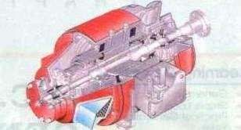
An electrical generator is a machine which converts mechanical energy (or power) into electrical energy (or power).
The energy conversion is based on the principle Of the production Of dynamically (or motionally) induced e.m.f. As seen from fig. 26. I , whenever a conductor cuts magnetic flux. dynamically induced em-f. is produced in it according to Faraday's Laws of Electromagnetic Induction. This em-f. causes a current to now if the conductor circuit is closed.
Hence, two basic essential parts Of an electrical generator are a magnetic field and (ii) a conductor or conductors which can so move as to cut the flux.
CONSTRUCTION:-
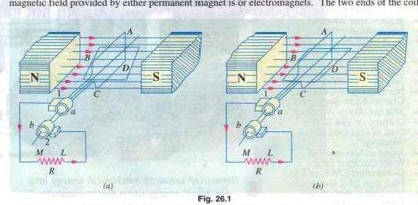
In fig. 26. I is shown a single-turn rectangular coil ABCD rotating about its own axis in a

magnetic field provided by either magnet is or electromagnets. The two ends of the coil are joined to two slip-rings 'a' and •b' which are insulated from each Other and from the-
central shaft. Two collecting brushes (of carbon or copper) press against the slip-rings. Their function is to collect the current induced in the coil and to convey il to the external load resistance R.
The rotating coil may bc called •armature' and the magnets as 'field magnets .

Imagine the coil to be rotating in clock-wise direction (Fig. 26.2). As the coil assumes successive positions in the field. the flux linked with it Ehanges. Hence. an e.m.f. is induced in it which is

proportional to the rate Of change Of flux linkages (e = NdcÞdt). When the plane Of the coil is at right angles to lines of flux i.e. when it is in position, I, then flux linked with the coil is maximum butrate Ofchange Offlux linkages is minimum.
It is so because in this position, the coil sidesAB and CD do not cutor shear the flux, rather they slide along them they move parallel to them. Hence, there is no induced e.m.f. in the coil. Let us take this no-e.m.f. or vertical position of the coil as the starting position. The angle of rotation or time will be measured from this position.
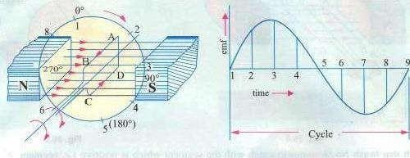
Fig. 26.2 Fig, 26.3
As the coil continues rotating further, the rate Of change Of flux linkages (and hence induced e_mf. in it) increases. till position 3 is reached where 6 = 90⁰. Here, the coil plane is horizontal
i.e. parallel to the lines Of flux. As seen. the flux linked with the coil is minimum butrate ofchange Of 'lax linkages is maximum. Hence, maximum e.m.f. is induced in the coil when in this position (Fig. 26.3).
In the next quarter revolution i.e. from 900 to 1800, the flux linked With the coil gradually increnses but the rate Of change Of flux linkages decreases. Hence, the induced c.m.f. decreases gradually till in position 5 ofthe coil, it is reduced to zero value.
So, we find that in the first half revolution Of the coil, no (or minimum) e.m.f. is induced in it when in position l, maximum when in position 3 and noe.m.f. when in position 5. The direction Of this induced e.m.f. can be found by applying Fleming's Right-hand rule which gives its direction from A to B and C to D. Hence, the direction of current flow is ABMLCD (fig. 26. l). The current through the load resistance R flows from M to L during the first half
revolution of the coil.
In the next half revolution i.e. from ISV to 360. the variations in the magnitude of are similar to those in the first half revolution. Its value is maximum when coil is in position 7 and

minimum when in position I. But it will be found that the direction of the induced current is from D to C and B to A as shown in Fig. 26.1 Hence, the path Of current flow is along DUMBA which is just the reverse of the previous direction of now.
Therefore, we find that the current which we obtain from sueh a simple generator reverses its direction after every half revolution, Such a current undergoing periodic reversals is known as alternatingcurrent. It is. obviously, different from a direct current which continuously flows in one and the same direction. It should be noted that alternating current not only reverses its direction, it noteven keep its magnitude constant while flowing in any one direction. The two half-cycles may be called positive and negative half-cycles respectively (Fig. 26.3).
For making the now Of current unidirectional in the external circuit. the slip-rings are replaced by split-rings (Fig. 26.4). The split-rings are made out of a conducting cylinder which is cut into two halves or segments insulated from each other by a thin sheet of mica or some other insulating material (Fig. 26.5).
As before. the coil endsare joined to these segments on Which rest thecarbon or brushes. It is seen IFig. 26,6 that in the first half revolution current flows along BMNI_CDJ i:e. the brush NO. I in contact with segment 'a' acts as the positive end of the supply and •b' the negative end. In the next half revolution IFig. 26.6 (b)l. the direction Of the induced current in the coil has
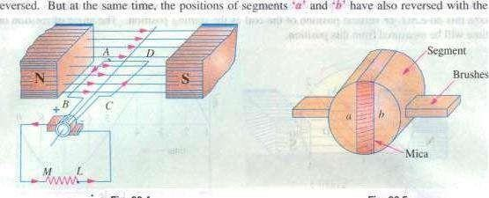
reversed.

Fig. 26.4 Fig. 26.5 result that brush No. I comes in touch with the segment which is positive i.e. segment in this case. Hence. current in the load resistance again flows from M to
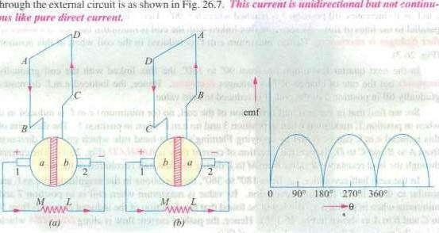
L. The Waveform of the current through the external circuit is as shown in Fig. 26.7. This current should be noted that the position ofbrushes is so arranged that the change over Of segments •a' and from one brush to the other takes place when the plane of the rotating coil is at right angles to the plane of the lines of It is so because in that position. the induced
e.m.f. in the coil is zero.
Another important point worth remembering is that even now the current induced in the coil sides is alternating as before. It is only clue to the rectifying action of the split-rings (also called commutator) that it becomes unidirectional in the external Circuit. Hence. it should be clearly undEr• stood that in the armature Of a generator. the induced voltage is alternating.

Generator-
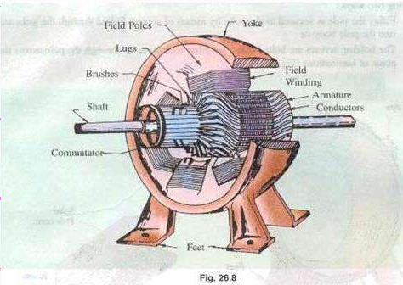

Pole Cores and Pole Shoes
The field Consist or pole Cores and pole shoes. The pole shoes SCñre two purposes

- they spread out the flux in the air gap and also, Of larger cross-section, reduce the
reluctance Of the magnetic path • ii) they supiX3rt the exciting coils (or field coils) as shown in fig. 26.14.
There are two main types Of pole construction.
  - The pole core itself may a solid piece made out Of eithercast iron Or cast steel butthe pole shoe is laminated and is fastened to the pole face by means of counter sunk screws as shown in fig. 24.10.
  - In modern design. the complete Ne cores and pole shoes are built of thin laminationsof annealed steel which aœ rivetted together under hydraulic pressure (Fig. 26_11). The thickness Of laminations varies from I mm to 0.25 mm- The laminated poles may be secured to the yoke in any of the following two Ways
    - Either the pole is secured to the yoke by means of screws bolted through theyoke and into the polebody or
    - The holding screws are bolted into a bar which passes through the poleacross the plane of laminations (Fig. 26.12).
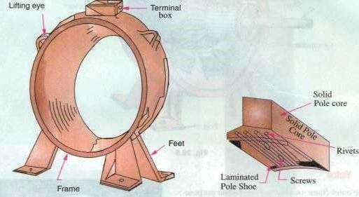
Fig. 26,9 Fig. 26.10

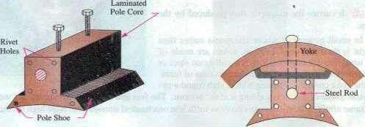

pole coas
The field coils or pole coils, which consist of copper wire or strip. are former-wound for the correct dimension (Fig. 26.13). Then. the former is removed and wound coil is put into place over the core as shown in Fig. 26.14.
When current is passed through these coils, they electromagnetise the poles which produce the necessary flux that is cut by revolving armature conductors.
Armature Core
It houses the armature conductors or coils and causes them to rotate and hence cut the magnetic flux Of the field magnets In addition to this, its most important function is to provide a path of very low reluctance to the flux through the armature from a tv-pole to a S- pole.
It is cylindrical or drum-shiped and is built up of usually circular sheet steel discsorlaminations approximately 0.5 mm thick (Fig. 26.15). It is keyed to the shaft.
The slots are either die-cut or punched on the outer periphery Of the disc and the keyway is located on the inner shown. In small machines, the armature stampings are keyed directly to the shaft. Usually. these laminations are perforated for air ducts which permits axial now of air through the armature for cooling purposes. Such ventilating channels are clearly Visible in the laminations shown in Fig. 26.16 and Fig. 26.17.
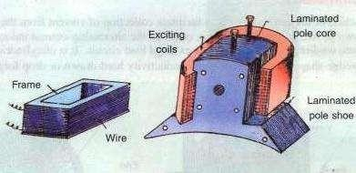
Fig. 26.13 Fig. 26.14

Up to armature diameters Of about one metre, the circular stampings are cut out in one piece as shown in Fig. 26.16, But above this size. these circles, especially of such thin sections, are difficult to handle because they tend to distort and become wavy when assembled together. Hence. the circular laminations. instead of being cut out in one piece, are cut in number Of suitable sections or segments which form part ofa complete ring (Fig. 26.17).

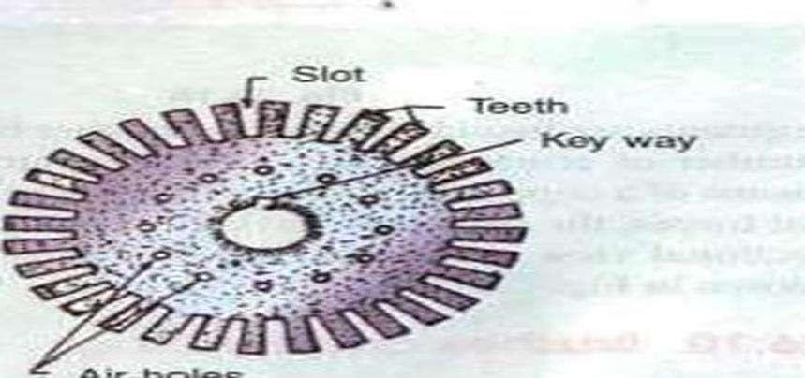

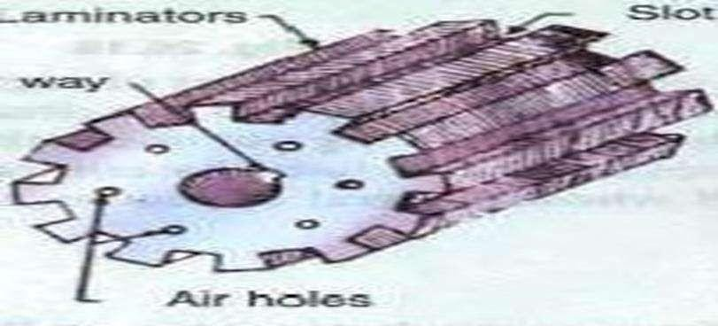

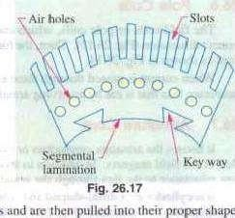
A complete circular lamination is made up Of four or six or even eight segmental laminations. Usually. two keyways are notched in each segment ana are dove-tailed or wedge-shaped to make the laminations self-locking in position,
The purpose of using laminations is to reduce the loss due to eddy currents. Thinner the laminations. greater is the resistance offered 10 the induced e_rn.f., smaller the current and hence lesser the R loss in the core.
Armature Windings
The armature windings are usually former-wound.
These are first wound in the form of nat rectangular coils and are then pulled into their in a coil puller. Various conductors Of the coils are insulated from each other. The conductors are placed in the armature slots which are lined With tough insulating material. This Slot insulation is folded over above the armature conductors placed in the slot and is secured in place by special hard wooden or fibre wedges,
Commutator
The function ofthe is to facilitate collection of current from the armature conduc• torS. As shown in Art. 26.2, rectifiedie•. converts the alternating current induced in the armature
conductors into unidirectional current in the external load circuit. It is of cylindrical structure and is built up of wedge-shaped segrtients of high•conductivity hard-drawn or drop forged copper. These
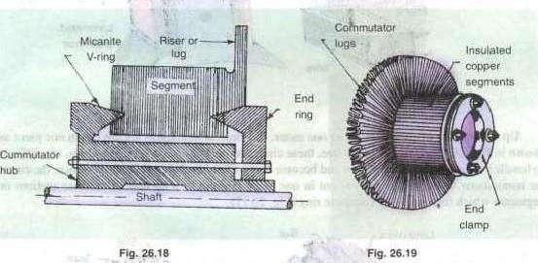
segments areinsulated from each Other by thin layers Oftliiea. ^{L} The number Of segments is equal to the number of armature-coils. F.qch commutator segment is connecled to the

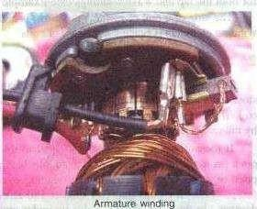
armature conductor by means of a copperÌugoi strip (or riseth To prevent them from flying out under the action of centrifugal forces, the Segments have V-grooves. these grooves being insulated by conical micanite rings. A sectional view Of commutator is in fig. 26. IS Whose general When completed is shown in Fig. 26.19.
Brushes and •Bearings
The brushes function is to collect current from commutator.are usually made Of carbon or graphite and are in the shape of a rectangular block. These brushes are housed in brush-holders usually of the box-type variety. As shown in Fig.
26.20. the brush-holder is mounted a spindle and the brushesean slide in the rectangular-box Open at both ends. The bruéhes madeto bear down On the Commutator by a spring whose tension Cán be adjusted by Changing the 1Sositioñ Of lever in the notches. A flexible copper pigtail mounted at the top of the brush conveys current from the brushes to the holder. The number of brushes per spindle depends on the magnitude Of the corrcnt to be collected from the commutator_
Flexible
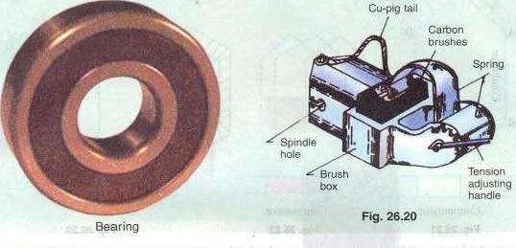
Because Oftheirreliahility, hall-bearings are frequently eniployed. though for heavýdutieS, roller bearingsare preferable. The ball and rollers are generally packed in hard oil for quieter operation and for reduced bearing wear, sleeve bearingé are used which are lubricated by ring oilers fed from Oil reservoir in the bearing bracket.
Armature Windings
NOW, We Will discuss the winding Of an actual armature. But before doing this, the meaning Of the following terms used in connection With armature winding should be clearly kept
in mind,

Pole-pitch
It may be variously defined as :
The periphery Of the armature divided by the number of poles orthe generator i.e. thedistance between two adjacent poles.
- It is equal to the number Of armature
•conductors and 4 poles, the pole pitehis 48/4 12.
Conductor
The length Of a Wire lying in the magnetic field and in which an e.mf. is induced, is calleda conductor (or iyduçtot) for example, length AB orCD in Fig. 26_21_

With reference to Fig. 26.21 , the two conductors AB and CD along With their end connections constitute one coil Of the armature winding. The coil may be single-turn coil (Fig. 26.21 ) or multiturn coil (Fig. 26.22). A single-turn coil will have two conductors. But a multi-turn coil may have many conductors per coil side, In Fig, 2622, for example. each coil side has 3 conductors, The
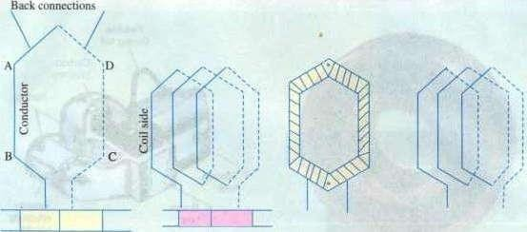
Cornmutator Commutator
Fig. 26.21 Fig. 26.22 Fig. 26.23
group of wires or conductors constituting a coil side of a multi-turn coil is wrapped with a tape as a unit (Fig. 26.23) and is placed in the armature slot. It may noted that since the beginning and the end Of each coil must be connected to a commutator bar. there are as many commutaror bars as coils for both the lap and wave windings (see Example 26. I
The side of a coil (I-turn or multiturn) is.illed a winding element. Obviously, the number of winding elements is twice the number of coils.

Col-spm or Coil-pitch CYs)
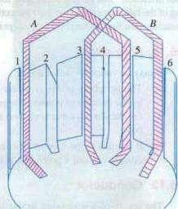
It is the distance, measured in terms of armature slots for armature conductors) between two sides of a coil. It is, in fact, the periphery of the armature spanned by the two sides of the coil.
If the pole span or coil pitch is equal to the pole pitch (as in the case of coil A in Fig. 26.24 where polepitch of 4 has been assumed). then winding is called fall-pitched. It means that coil span is ISO electrical degrees. In this case. the coil sides lie under opposite poles, hence the induced e.rn.fs. in them are additive. Therefore, maximum e.m.f. is induced in the coil as a Whole. it being the sum Of
the e.m.f.s induced in the two coil sides. For example. if there are 36 slots and 4 poles. then coil span is 36/4 = 9 slots. If number of slots is 35, then Ys = 35/4 = 8 because it is customary to drop
If the coil span is less than the pitch (as in Coil Fig. 26.24 B where coil pitch is 314th of the pole pitch), then the
winding is fractional-pitchea_L In this case, there is a phase difference sides of the
Hence, the total e_m.f. round the coil Which is the vector sum of e.m.fs. inAhe two coil sides, is less in this caseas compared to that in the first case.
Pitch of a Winding (Y)
In general, it may be defined as the distance round the armature between two successive conductors which directly connected together. Or, it is the distance between the beginnings Of two consecutive turns.
—for lap winding —-„.for wave winding
In practice. coil-pitches as low as eight-tenths of a pole pitch are employed without much serious reduction in the e.m.f. Fractional-pitched windings are purposelyused to effect substantialsaving in the copper Of thecnd connections and for improving commutation.
Back Pitch
The distance, measured in terms of the armature conductors, which a coil advances on the back of the armature is called back pitch and is denoted by YR

As scen from fig_ 26_28, element I is connected on the back Of the armature to element 8. Hence. 7.
Front Pitch (Yr)
The number of armature conductors or elements spanned by a coil on the front (or commutator end of an armature' is called the front pitch and is designated by Again in Fig.
26.28. element 8 is connected to elemcnt 3 on the front Of the armature, the connections made at the commutator segment. Hence, YF = 8 — 3 = 5.
Alternatively. the front pitch may be defined as the distance (in terms Of armature conductors) between the second conductor of one coil and the first conductor of the next coil which are connected together at the front i.e. commutator end of the annature. Both front and back pitches for lap and wave-winding are shown in fig. 26.25 and 26_26.
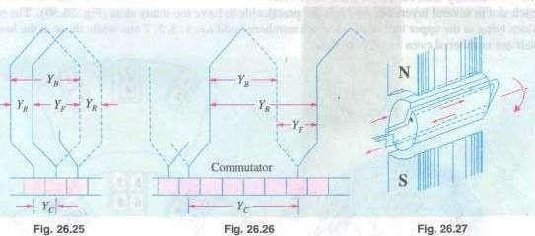
Resultant Pitch
It is the distance between the beginning of one coil and the beginning of the next coil to which it is connected (Fig. 2625 and 26.26).
As a matter of precaution. it should be kept in mind that all these pitches. though normally stated in terms Of armature conductors. are also sometimes given in terms Of armature slots or commutator bars because commutator is, after all, an image Of the winding.

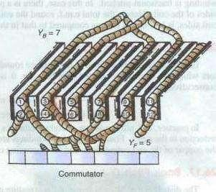
Cornmutator Pitch
It is the distance (measured in commutator bars or segments) between the segments to which the two ends of a coil are connected. From Fig. 26.25 and 26.26 it is clear that for lap winding. Yc is the difference of YB and whereas for wavewinding it is thesum of and Yr Obviously, commutator pitch is equal to the
number of bars between coil leads. In general, equals the 'plex• of the lap-wound armature. Hence, it is equal l, 2, 3, 4 etc. for simplex-. duplex, triplex—and quadruplex etc. lap-windings. Fig. 26.28
26-21. Single-layer Winding
It is that winding in which one conductoror one coil side is placed in each armature slot as shown in Fig. 26.27. Such a winding is not much used.
Two-layer Winding
In this of winding, there are two conductors or coil sides Ixr slot arranged in two layers. Usually, one side of every coil lies in the upper half of one slot and other side lies in the lower half of some other slot al a distance of approximately one pitch away (Fig. 26.28). The transfer of the coil from one slot to another is usually made in a radial plane by means of a peculiar bend or twist at the back end as shown in Fig, 26.29. Such windings in which two coil sides occupy each slot are most commonly used for all medium-sized machines. Sometimes 4 Or 6 or 8 coil sides are used in each slot in several layers because it is not practicable to have too many slots (fig. 26.30). The coil sides lying at the upper half of the slots are numbered odd i.e. I
, 3.5, 7 etc. while those at the lower

half are numbered even i.e. 2, 4. 6, 8 etc.
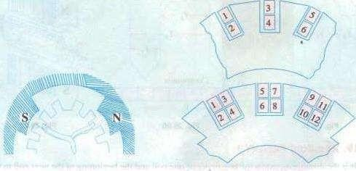
Fig. 26.29 Fig. 26.30
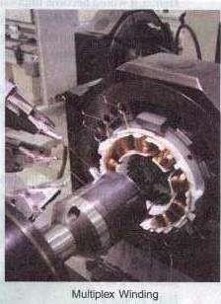
Degree of Re-entrant Of an Armature WindingA winding is Saidto be Single re-entrant if on
tracing through it once, all armature conductors are included on returning to the starting point. It is double re-entrant if only half the conductors are included in tracing through the winding once and so On,
Multiplex Winding
Insuch windings. there are several sets ofcompletely closed and independent windings. If there is only one set of closed winding, it is called simplex wave winding. If there are two such windings on the same armature, it is called duplex winding and so on. The multiplicity affects a number of parallel paths in the armature. For a given number of armature slots and coils, as the
multiplicity increases, the number Of parallel paths in the armature increases thereby current rating but decreasing the voltage rating.
Lap and Wave Windings

Two types ofwindings mostly employed for drum-type armatures are known as Lap Winding and Wave Winding. The difference between the two is merely due to the dtfferentarrangement of the end connections at the front or end of armature.

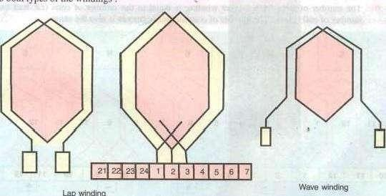
Lapwinding
Each winding can be arranged progressively or retrogressively and connected in simplex, duplex and triplex. The following rules, however, apply to both types of the windings :
(i) The front pitch and back pitch are each approximately equal to the pole-pitch i.e. windings should be full-pitched. This results in increased e.m.f, round the coils. For pur-

poses. fractional-pitched windings are deliberately used (Art_ 26.15).
(in Both pitches should be odd, otherwise it would be difficult to place the coils (which are former-wound) properly on the armature. Forexmaple, ifYB and YFwere both even, the all the coil Sides and conductors would lie either in the upper half Of the slots Or in the lower
half. Hence. it would become impossiblefor one Aidèxsfthe coil in the upper half. Hence. it would become impossible One side of the coil to lie in the upper half of one slot and the other side of the same coil to lie in the lower half of other slot.
riii', The of commutator segmentsis equal to the number of slots or coils (or half the number Of conductors) because the front endsÃ'f conductors are joined to the segments in
The winding mustclose uponitselfi.e. if we start frotnû given point and move from onecoi] to•another, then all conductors should he traversed and we should reach the same
poinragain Without a break or discontinuity io between.
Simplex Lap-winding*

It is shown in fig: 26-25 which employs single-turn coils. In lapwinding, the finishing end of one coil is connected to a commutator segment and to the starting end of the adjacent coil situated underthe same pole and so on, till and the coils have been connected. This type Of winding derives its name from the fact it doubles or laps hack With its succeeding cods.
Following points regarding simplex lap winding should be

The back and front pitches are •odd•and Of opposite Sign. But they Cannot They differ by 2 Or Some multiple thereof.
- Both and should be nearly equal toa pole pitch.

- The average pitch YA = . It equgls pole pitch = z
- pitch = ± I (In keneral, = ± m)
S. Resultant pitch YR is even, being the arithmetical difference of two odd numbers, i.e.,
- The number of slots for a 2-layer winding is equal to the number bf coils(i.e. half the
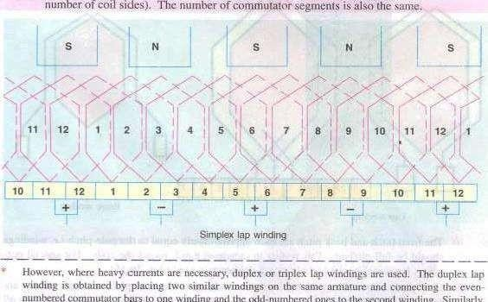

commutatorbarstoone winding and 'heodd-numberedones tothesecond winding. Similarly.

in triples Winding. there would three Windings, cach connected to third of the commututor bars,

- The numberofpárallel pathsin the armature where m is the multiplicityofthe winding and P the number of poles.
Taking the firstcondition. we have Yo =
(a) If YB > YF i.e. = YF • 2, then We get a progressive or right-handed winding i.e. a winding which progresses in the clockwise direction as seen from the commutator end.o this case, obviously,

If YB < YF i.e. YF —2, then we geta or left-handed winding i.e. one which advances in the anti-clockwise direction When seen from the commutator side. In this Case, Yc+
(c) Hence, it is obvious that
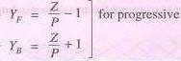
SQinding ûild 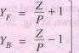— + 1
forretrogfesgive winding
Obviously, up must be even to make the winding possible.
Numbering Of Coils and Commutator Segments
In the d.c. Winding diagrams to follow. we Will number the coils only (not individual turns). The upper side Of the coil Will be shown by a firm continuous I inc whereas the lower side Will be shown by a broken line. The numbering of coil sides will be consecutive i.e. l, 2, 3 etc. and such that odd numbers are assigned to the top conductors and even numbers to the lower sides for a two-layer winding. The commutator segments Will also be numbered consecutively, the of the ments will be the same as that of the upper side connected to it.
Example 26.1. Draw a developed diagram ofa simple 2-laýer lap-windingfor "-pole generator With 16 coilÅ. Hence, point out the chamcteristics Of a lap-winding.
(Elect. Engineering, Madras Univ. 1981)
Solution. The number of commutator segments = 16
Number Of conductors or coil sides 16 x 2 32 : pole pitch 32/4 = 8
Now remembering that (i) YB and YF have to be Odd and (ii) have to differ by 2, We get for a progressive winding YB = 9 ; YF — —7 (retrogressive winding Will result if YR 7 and YF =
Obviously, commutator pitch Yc —
(Otherwise, as shown in An. 26.26, for progressive winding

32
The Simple winding table is given as under
Beck Connections Front Connections
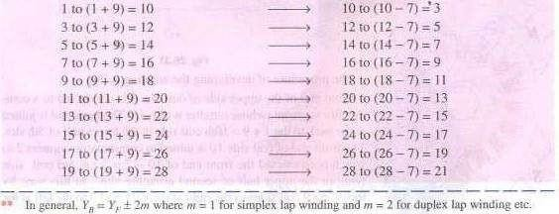

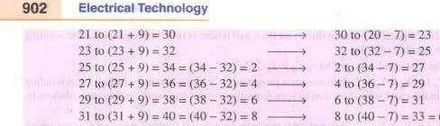
= (33- 32) = 1
The winding ends here because we come back to the conductor from where we started.
We will now discuss the developed diagram which is one that is obtained by imagining the armature surface to be removed and then laid out flat so that the slots and conductors can be viewed without the necessity of turning round the armature in order to trace out the armature windings. Such a diagram is shown in Fig. 26.31.
Front end of the upper side of coil No. 1 is connected to a commutatorsegment (whose number is also I The backend is joined at the back to the I + 10th coil side in the lower half of5th slot. The front end Of coil side 10 is joined to commutator segment 2 to which is connected the front end of 10 —7 3 i.e. 3rd coil side s N lying in the upper half of second armature slot. In this way. by 26.32 travelling 9 coil sides to the right at the back and 7 to the left at the
front we complete the winding, thus including every coil side once till we reach the coil side I from where we started. Incidentally, it should be noted that all upper coil sides have been given Odd numbers, whereas lower ones have been given even numbers as shown in the polar diagram (Fig. 26.32) Of the Winding of Fig. 26.31.

Brush positions can be located by finding the directionofcurrents flowing in the various conductors. Ifcurrents in the conductors under the influence of a N-pole are assumed to flow downwards shown), then these will now upwards in conductors under the influence of S.pole. By putting proper arrows on the conductors (shown separately in the equivalent ring diagram), il is found that commutator bars NO. I and 9 are the meeting points Of c.m_fs. and hence currents are flowing out Of these conductors. The positive brushes should, therefore. be placed at these commutator bars. Similarly, commutator bars No. 5 and 13 are the separating points of e.m.fs. hence negative brushes are placed there. In all. there are four brushes, two positive and two negative. If brushes of the same polarity are connected together, then all the armature conductors are divided iuto four parallel paths.
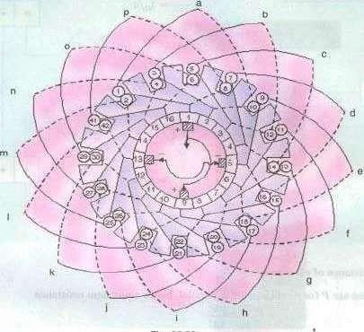
Fig. 26.33
Division of conductors into parallel paths is shown separately in the schematic diagram of Fig.
26.34. Obvi0LLsIy, if is the total current supplied by the Eenerator, then current carried by each parallel path is
Summarizing these conclusions, we have
- The total number of brushes is equal to the number of poles.
- Thereareas many parallel paths in the armature as the numberofpoles. Thatis why such a winding is sometimes as 'multiple circuit' or •parallel' winding. general, number Of parallel paths in armature mp where m is the multiplicity (plex) Of the lap winding. For example, a duplex lap winding has (6 x 2) = 12 parallel paths in its armature.
- The e.m.f. between the +veand—ve brushesisequa/ to the e.m.f- generatedin any one of the parallel paths. If Z is the total number of armature conductors

and p the number of poles, then the number of armature conductors (connected in series) in any parallel path is Z"

Resistance of each path— PIZ
There are P (or A) such paths in parallel, hence equivalent resistance
If is the total armature current. then current per parallel path (or carried by each conductor) is a/P.
Simplex Wave Winding•
From fig. 26.31. it is clear that in lap Winding, a Conductor (or coil side) under one pole is connected at the back to a conductor which occupies an almost corresponding position under the next pole of opposite' polarity (as conductors 3 and 12). Conductor NO. 12 is then connected to conductor No. 5 under the original pole but which is a little removed from the initial conductor No. 3. If, instead of returning to the same At-pole, the conductor No. 12 were takenfonvard lothe next N.pnle, it would make no difference so fartLs the direction and magnitude of the e.m_f. induced in the circuit are concerned
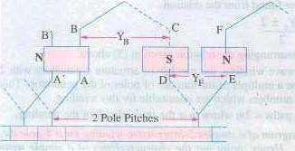
Like lap winding. a wave winding may be duplex, triplcž or may have any degree Of multiplicity. A simplex wave winding has two paths. a duplex A',eave Winding four paths and a triplex paths etc.

As shown in Fig. 26.35. conductor AB Lis connected to CD lying under S- pole and then to EF under the next N•p01e, In this way, the winding, progresses, passing successively under every N-pole and S-pole till it returns to a conductor A 'B' lying under the original pole. Because the winding progresses in one direction
round the armature in series of •waves' , it is known as wave Winding.
Fig. 26.35 If. after passing once round the armature. the winding falls in a slot to the left of its starting point A'B' in Fig. 26.35) then the winding is said to bc retrogressive. If, however, it falls one slot to the right. then it is progressive.
Assuming a 2-layer winding and supposing that conductor AB lies in the upper half of the slot. then going once round the armature, the Winding ends at Which most be atThe upper

half of the slot at the left orTight. Counting in terms of conductors, it means that AB and A'B' differ by two conductors (although they diner by one slot).
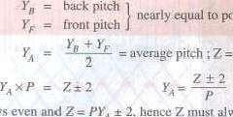
From the above, we can deduce the
following polepitch relations. If P —No.
Ofpoles, then total No. Of conductors
orcoil Sides
Since p is always even and
alwaysbeeven. Put
in another way. PYR ± Z it

means that must an even integer.
The plus sign will give a progressive winding and the negative sign a retrogressive winding. Points to Note :
Both pitches YB and YFare odd and of the same sign.
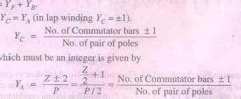
- Back and front pitches are nearly equal to the pole pitch and unay be equal or differ by 2, in which case. they are respectively one more or one less than the average40itch. Resultant pitch YR
- Commutator pitch, Also.
The average pitch which
It is clear that 10 he an integer.
there is a restriction on the.alue
of Z With Z = 32. this winding i'. impossible for 4-polc machine (though lap winding is possible). Valuesor Z = 30 or 34 would be perfectly ah-ight_
i.a NC can be found from the relation, PYA ±2
This relation has been found by rearranging the relation given in (5) above.
- rt is obvious from (5) that for a wave winding, the number of armature conductors with 2 either added or subtracted must be a multiple of the number of poles of the generator. This restriction eliminates many even numbers which are unsuitable for this winding.
S. Thé number of armature parallel paths = 2m where m is the multiplicity of the winding.
Example 26.2. Draw a developeddiagram Ofa simplei a 4-pole dc. generator With 30 armature conductors. Henée, point Out the characteristics Of a simple wave

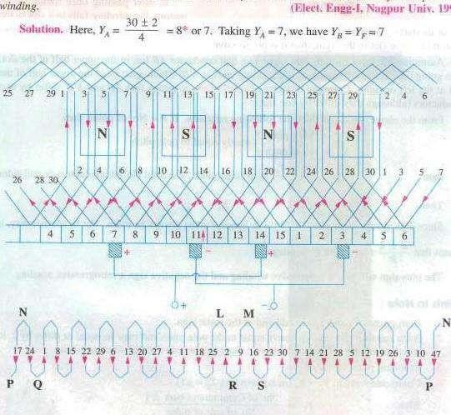
1991)
Fig. 26.36
As shown in fig. 26.36 and 26.37, conductor No. 5 is taken to conductor No. 5 4 7 12 at the back and is joined to commutator segment 5 at the front. Next. the conductor No. 12 is joined to commutatorSegment5 + 7 = 12 ( Yc = 7) to which isjoined conductor No. 12+ 7 =
19. Continuing this Way, we come back NO. 5from where We started. Hence. the winding Closes itself.
If we take S, then the pitches would be : Yn 9 and YF 7 or Yb = 7 and YF 9. Incidentally, if YA
= Yc is taken as 7, art-nature Vill rotate in one direction and if Yc = 8, it Will rotate in the Opposite direction.

The simple winding table is as under ;
Back Connections Front Connections

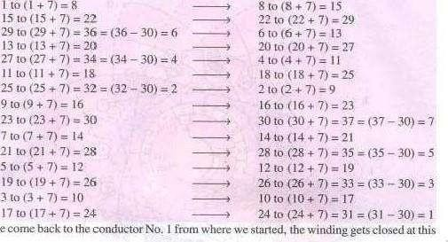
Sincewe stage.
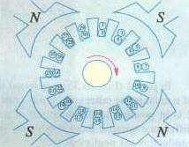
Brush Position
Location of brush position in wave-winding is slightly difficult. In Fig. 26.36 conductors are supposed to be moving from left to right over the polcs_ By applying Fleming's Right-hand rule. the directions of the induced e.m.fs in various armature conductors can be found. The directions shown in the figure have been found in this manner. In the lower part of Fig.
26.36 is shown the equivalent ring or spiral diagram
which is very helpful in understanding the formation of various parallel paths in the armature. It is seen that the winding is electrically divided into two portions. One portion consists ofconductors lying between points N and L and the other of conductors lying

between N and M. In the first portion, the general trend of Fig. 26.37 the induced e.m.fs, is from left to right whereas in the second

portion it is from right to left. Hence, in general, there are only two parallel paths through the winding, so that two brushes are required, one positive and one negative.
From the equivalent ring diagram. it is seen that point N is the separatiqg point Of the e.m.fs. induced in the two portions of the winding. Hence, this fixes the position of the negative brush. But as it is at thc back and not at the commutator end of the armature, the

negative brush has two alternative positions i. e, either at point P or Q. These points on the equivalent diagram correspond to commutator segments NO. 3 and ll.
Now, we will find the position of the positive brush. It is found that there are two meeting points of the induced e.m.fs. i.e. points L and M but both these points are at the back or non-commutator end of the armature. These two points are separated by one loop only. namely. the loop composed of conductors 2 and 9, hence the middle point R of this loop fixes the position of the positive brush. which should be placed in touch with commutator segment No. 7. We find that for one position Of the brush, there are two alternative positions for the —ve brush.
Taking the -eve brush at point R and negative brush at point p, the winding is seen to be divided into the following two paths.

In path 1 (Fig. 26.36) it is found that e.m.r. in conductor 9 is in opposition to the general trend ofe.m.fs. in the Other conductor"s comprising this path. Similarly, in path 2. the e.m.f. in conductor 2 is in position to the direction Of e.rn.fs. in the path as a whole. However, this will make no difference because these conductors lie almost in the interpolar gap and, therefore e.m.fs. in these conductors are negligible.

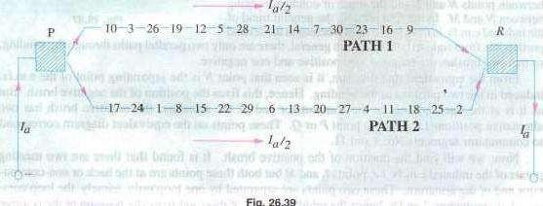
Fig.26
Again, take the case of conductors 2and 9situated between points L and M. Since the armature conductors are in continuous motion over the pole faces, their positions as shown in the figure are only instantaneous. Keeping in this.nind. itis obvious that conductor 2 is about to move from the influence Of S-pole to that of the next N-pole. Hence, the e.m.f. in it is at the point Of reversing. However, conductor 9 has already passed the position of reversal, hence its e.m_f_ will not reverse. rather it will increase in magnitude gradually. It means that in a very short interval, point M will

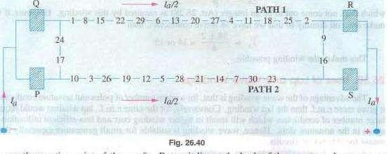
become the meeting point of the c.m_fs. But as it lies at the back Of the armature, there are two alternative positions for the -Eve brush i.e. either point R which has already been considered or point Suhich corresponds to commutator segment 14. This is thesecond alternative position of the positive brush. Arguing in the same way. it can be shown that after another Short interval Of time. the alternative position Of the positive Will shift from segment 14 to segment 15. Therefore, if one positive brush is in the contact With segment 7, then the second positive bnlSh if used, should be in touch with both segments 14 and 15.
Il may be noted that if brushes are placed in both alternative positions for both positive and negative (i.e. if in 4 brushes are used, two -eve and two —ve), then the effect is merely to shortcircuit the loop lying between brushes of the same polarity. This is shown in Fig. 26.40 it Will also be noted that irrespective of whether only two or four brushes are used, the number of parallel pallLS through the armature winding is still two.
Summarizing the above facts, we get
Only two brushes are necessary. though their number may beequal tothe number of poles. The number of paths through the armature winding is two irrespective Ofthe number of generator poles. That ig why this winding is sometimes called •two-circuit' or
•series'
The generator e.m.f. is equal to the e.m.f. induced in any one ofthe two parallel paths. •If eav is the e.m.f. induced/conductor, then generator e.nl.f. is E x "2.
The equivalent armature resistance is nearly one-fourth Of the total resistance Of the armature winding,

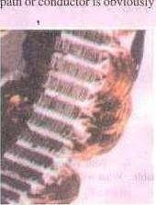
- If is the total armature current, then current carried byeach path orconductor is obviously 1/2 whatever the number of poles.
Dummy or Idle Coils
These are used with wave-winding and are resorted to when the requirements of the winding are not met by the standard armature punchings available in armature- winding shops.
These dummy coils do not influence the electrical characteristics Of the winding because they are not connected to the commutator. They are exactly similar to the other coils except that their ends are cut short and
taped. They are there simply to provide mechanical balance for the armature because an armature having some slots without windings would be out Of balance mechanically. For example. suppose number Of armature Slots is 15, each containing 4 sides and the number of poles is 4. For a simplex wave-windings, Dummy coils
60±2
4 which does not come out tobe an integer (Art. 26.28) as required by this winding. However, if we make one coil dummy so that we have 58 active conductors. then
58 ± 2
— 14 or 15 4
This makesthe winding possible.
Uses Of Lap and Wave Windings
The advantage of the wave winding is that, for a given number ofpoles and armature conductors, it gives more e.m.f. than the lap winding. Conversely, for the same e.m.f., lap winding would require large number Of conductors which will result in higher winding cost and less efficient utilization of space in the armature slots. Hence, wave winding is suitable for small generators especially those meant for 500-600 V circuits.
Another advantage is that in Wave winding. equalizing connections are not necessary whereas in a lap winding they definitely are. It is so because each Of the two paths contains conductors lying under all the poles whereas in lap-wound armatures, each of the P parallel paths contains conductors which lie under one pair of poles. Any inequality of pole fluxes affects two paths equally, hence their induced e.m.fs. are equal. In lap-wound armatures, unequal voltages are produced which set up a circulating current that produces sparking at brushes.

However, when laœe currents are required, it is necessary to use lap winding, because it gives more parallel paths.
Hence, lap winding is suitable forcomparatively low-voltage but high-currentgenerators whereas wave-winding is used for high-voltage, low-current machines.
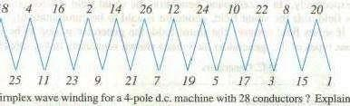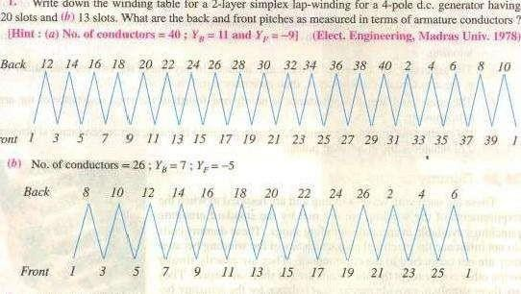
(a)
l.
Write down thewinding
a
Front
18
Tutorial Problem No. 26.1simplex
2. With a simplex 2-1ayer Wave winding having 26 conductors and 4-poles. write down
the Winding table. What will be the front and back pitches of the winding ?
(Electric Machinery-I, Madras Univ. Nov. 1979'

segments
Types of Generators
Generators are usually classified according to the way in which their fields are excited. Generators may be divided into separately-excited generators and self-excited generators.
Separately-excited generators are those whose field magnets are energised from an independent external source Of d.c. current. It is shown diagramatically in fig. 26.41.

Self-excited generators are those whose field magnets are energised by the current produce.d by the generators themselves. Due to residual magnetism, there is always
present some flux in the When the armature is rotated, some and hence some induced current is produced which is partly or fully passed through the field coils thereby strengthening the residual pole flux,
There are three types of self-excited generators named according to the manner in which their field coils (or windings) are connected to the armature. lib Shunt wound
The field windings are connected across or in parallel with the armature conductors
Example 26.9. An 8•p01e dc. generator has 5(H) armature conductors, and a useful flux Of
O. 05 Wb per pole. What Will be the e.m.f. generated ifit is lap-connected and runs at 4200 rpm ? What must be the speed at which is to be driven produce the same it is Wave- wound?
[U.P. Technical Univ. 2001)
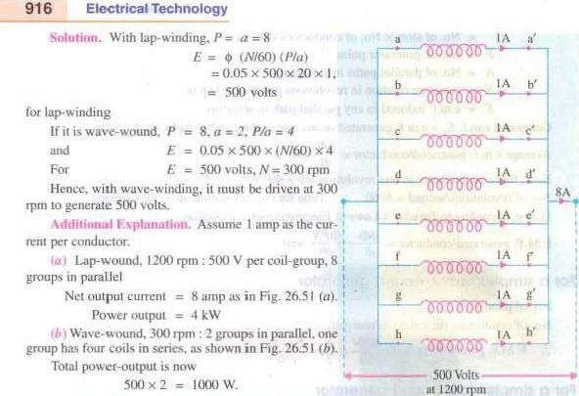
It is reduced to one fourth. being proportional to the
Example 26.26. A long-shunt dynamo, running ut 1000 voltage Of 220 V. The resistances
0.06 Q respectively. The overall efficiency at the above load is friction losses (c) the torque exerted by theprime,mover.

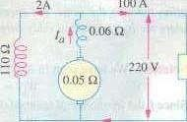(Elect. Machinery-I. Bangalore Univ. 1987) Solution. The generator is shown in Fig. 26.64. 220/110=2 A
100A
1 - 100 A.
= 102 A
220 v
Drop in series field winding = 102 x = 6.12 V
- 1022 xo.05 =520.2 W
Series field loss — 0.06 = 624.3 W Shunt field loss = 4k 110=440 w
Example 26.28. A long-shunt compound-wound generator gives 240 volts at EL output of100 A. The resislances of various windings ofthe machine are : armature (including brushcontact) O. J series field 0.02 Q interpole field 0.025 shunt field (including regulating resistance' 100 Q. The iron loss EL is 1000 W ; windage andfriction losses 10101 SOO W. Calculate EL efficiency of the machine. i Electrical Machinery-I, Indot•e Univ. 1989)
output 240x
Total armature circuit resistance = 0.1 + 0.02 + 0.025 0.145 n
240/100=2ÅA 2.4= 102.4 A
Armature circuit loss = 102.4² x O. 1,521 W

Shunt field copper loss = 2.4 x 240=576 W
Iron loss = W ; Friction loss 500 W
24.000
Total loss = 1,521 -087
24.000 1597

DC MOTOR

Principle of Operation
DC motor operates on the principle that when a current carrying conductor is placed in a magnetic field, it experiences a mechanical force given by F = BIL newton. Where ‘B’ = flux density in wb, ‘I’ is the current and ‘L’ is the length of the conductor. The direction of force can be found by Fleming’s left hand rule. From the point of construction, there is no difference between a DC generator and DC motor.
Figure 3.1 shows a multipolar DC motor. Armature conductors are carrying current down1w0a1r0ds under North Pole and upwards under South Pole. When the field coils are excited, with current carrying

armature conductors, a force is experienced by each armature conductor whose direction can be found by Fleming’s left hand rule. This is shown by arrows on top of the conductors. The collective force produces a driving torque which sets the armature into rotation. The function of a commutator in DC motor is to provide a continuous and unidirectional torque.In DC generator the work done in overcoming the magnetic drag is converted into electrical energy. Conversion of energy from electrical form to mechanical form by a DC motor takes place by the work done in overcoming the opposition which is called the ‘back emf’.
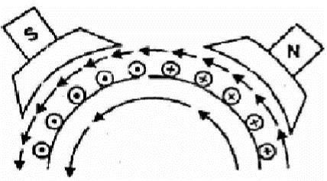
Fig. 3.1 Generation of force in DC motor

Back EMF
It is the dynamically induced emf in the armature conductors when the armature rotates following principle of DC motor. The direction of this induced emf can be determined using Fleming’s right hand rule. This emf act in opposition to the supply voltage of the armature. It opposes the supply voltage that is why it is called back emf. The value of this induced emf is same as the value of the emf
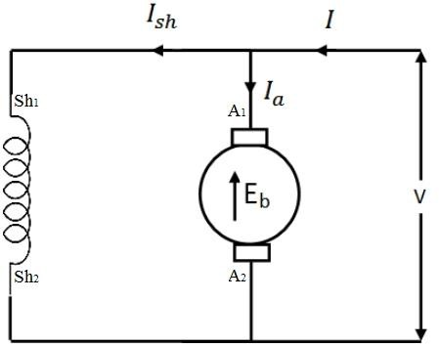
induced in dc generator. The work done in overcoming this opposition is converted into mechanical energy.

Fig. 3.2 Schematic diagram of DC shunt motor
Fig shown 3.2 a DC shunt motor the rotating armature generating the back emf Eb. The armature current can be written as

Where ra is armature resistance,

V -E
Ia= Tr b
a

1011

E = PφZN
^{b} 60A
Armature current is proportional to back emf. So back emf is a controlling factor of armature current.

Torque Equation
Let Ta = armature torque in N –m developed by the armature of a motor running at N.rps.
Therefore P = Ta X 2πN Watts
60
Electrical equivalent of mechanical power developed Pm =Eb Ia 2πN
Pm =E b I a =P=Ta × 60

T = | E b Ia | ×60 Also, on substituting for Eb i.e., E | = | PφZN
a | 2πN | b |  | 60A

Therefore,

I

Ta=
a

×60
×
PφZN
2

πN 60A

I
Ta= a
PφZ
× 2π A
Ta = PφZIaN-m

2πA
From the above equation for torque, it is seen that

- Ta =kφIa
- Ta∝ I ² - For series motor (becauseφ∝ Ia ) before saturation. After saturation Ta∝Ia
a
- Ta∝ Ia - For shunt motor. (because φ is constant in a shunt motor)

Characteristics of DC Motors

There are three important characteristics-

- Armature torque vs armature current Ta vs la(Electrical characteristics)
- Speed vs armature current characteristic N vs Ia
- Speed vs torque N vs Ta (Mechanical characteristics)

Characteristics of DC shunt motor

Armature torque vs armature current Tavs Ia characteristics
For a shunt motor flux can be assumed practically constant (at heavy loads, decreases, due to increased armature reaction)
Ta =kφIa
φ is constant,Ta∝Ia
Therefore electrical characteristic of a shunt motor is a straight line through origin shown by dotted line in figure 3.3. Armature reaction weakens the flux hence Tays la characteristic bends as shown by dark line in figure 3.3, Shunt motors should never be started on heavy loads, since it draws heavy current under such condition.

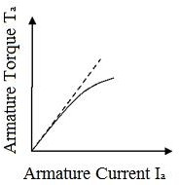

Fig. 3.3 Torque Current Characteristic of DC shunt motor

Speed vs armature current Navs Ia characteristics
N ∝Eφb

V-I
N= r a
a kφ
V I r N= - a a
kφ kφ
V is constant and in dc shunt motor φ is also constant. Thus with armature current speed drops and the speed current characteristics is drooping in nature is shown in figure 3.4.

Fig. 3.4 Speed vs armature current characteristics of DC shunt motor

Speed vs armature torque Navs Ta characteristics

V I r
N= - a a
kφ kφ

Ia=Tφª k

N=kVφ-krφa 2 Ta

Thus with increase with torque the speed of DC shunt motor decreases. The nature of the characteristics is drooping in nature shown in figure 3.5.
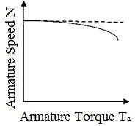
Fig. 3.5 Speed vs armature torque characteristics of DC shunt motor

Characteristics of DC series motor

Armature torque vs armature current Tavs Ia characteristics
Ta =kφIa
Ta∝ I ² - For series motor (becauseφ∝ Ia ) before saturation After saturation φ becomes constant thus Ta∝Ia
a
At light loads, Ia and hence φ is small. But as Ia increases Ta increases as the square of the current up-to saturation. After saturation φ becomes constant, the characteristic becomes a straight line as shown in Figure 3.6. Therefore a series motor develops a torque proportional to the square of the armature current. This characteristic is suited where huge starting torque is required for accelerating heavy masses.

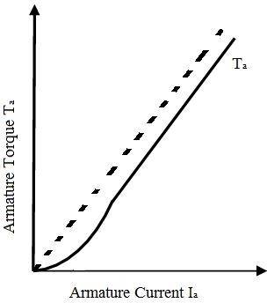

Fig. 3.6 Torque Current Characteristic of DC series motor

Speed vs armature current Navs Ia characteristics
N ∝Eφb

V-I
N= r a
a kφ
V I r N= - a a
kφ kφ
Ia∝φ

V
N= -
k r
1 a

kk1 Ia k

1
N ∝
Ia

If Ia increases, speed decreases. This characteristic is shown in figure 3.7. Therefore the speed is inversely proportional to armature current Ia. When load is heavy Ia ia heavy thus speed is low. When load is low Ia is low thus speed becomes dangerously high. Hence series motor should never started without load on it.

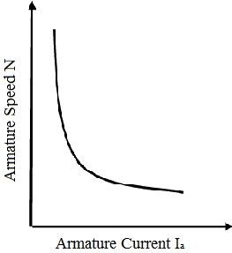

Fig. 3.7 Speed vs armature current characteristics of DC series motor

3.4.2.2 Speed vs armature torque Navs Ta characteristics
N= V - Ia ra and φ= k I
kφ kφ ¹ ª

V
∴ N= kk1 Ia
V
Ia ra
-kk1 Ia
ra

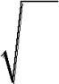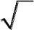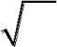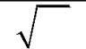⇒ N= kk1 Ia - kk1
Now, T =kI ²∴ I = Ta
a a a k Substituting Ia
V k ra
N= kk T - kk
1 a 1
⇒ N= Const. -Const.
Ta
Thus Speed is inversely proportional to torque. The characteristics is shown in figure 3.8.

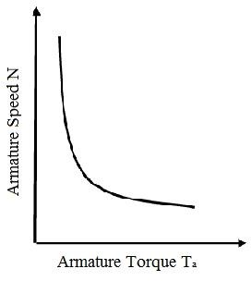

Fig. 3.8 Speed vs armature torque characteristics of DC series motor

Characteristics of DC compound motor
There are two different types of compound motors in common use, they are the cumulative compound motor and the differential compound motor. In the cumulative compound motor, the field produced by the series winding aids the field produced by the shunt winding. The speed of this motor falls more rapidly with increasing current than does that of the shunt motor because the field increases. In the differential compound motor, the flux from the series winding opposes the flux from the shunt winding. The field flux, therefore, decreases with increasing load current. Because the flux decreases, the speed may increases with increasing load. Depending on the ratio of the series-to-shunt field ampere-turns, the motor speed may increases very rapidly.

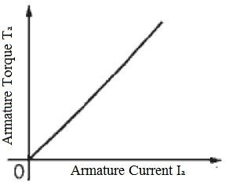

Fig. 3.9 Armature torque vs armature current characteristics of DC compound motor
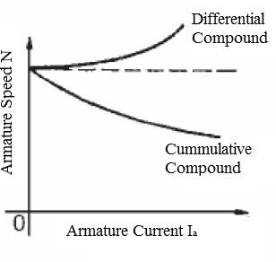
Fig. 3.10 Speed vs armature current characteristics of DC compound motors

The torque-speed (c/s) of a cumulatively compound D.C motor
In the cumulative compounded D.C. motor, there is a component of flux which is constant and another component which is proportional to its armature current (and thus to its load). Therefore, the cumulatively compounded motor has a higher starting torque than a shunt motor (whose flux is constant) but a lower starting torque than a series motor (whose entire flux is proportional to armature current). At light loads, the series field has a very small effect, so the motor behaves approximately as a shunt D.C. motor. As the load gets very large, the series flux becomes quite important and the torque- speed curve begins to look like a series motor's (c/s). A comparison of the torque-speed (c/s) of

.
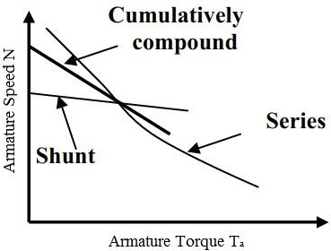
Fig. 3.11 Speed vs armature torque characteristics of DC motors

The torque-speed (c/s) of a differentially compound D.C motor
In a differentially compound D.C. motor, the shunt magneto motive force and series magneto motive force subtract from each other. This means that as the load on the motor increases, Ia increases and the flux in the motor decreases. But as the flux decreases, the speed of the motor increases. This speed increases causes anther increases in load, which further increases Ia, further decreasing the flux, and increasing the speed again. The result is that a differentially compounded motor is unstable and tends to run away. It is so bad that a differentially compounded motor is unsuitable for any application. The torque speed characteristics is shown in figure 3.12.
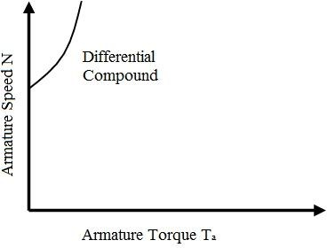
Fig. 3.12 Speed vs armature torque characteristics of DC differential compound motor

Application of DC motors
    - Application of DC shunt motor
The characteristics of a DC shunt motor give it a very good speed regulation, and it is classified as a constant speed motor, even though the speed does slightly decrease as load is increased. Shunt wound motors are used in industrial and automotive applications where precise control of speed and torque are required.

Application of DC series motor
For a given input current, the starting torque developed by a DC series motor is greater than that developed by a shunt motor. Hence series motors are used where huge starting torques are necessary. Ex. Cranes, hoists, electric traction etc. The DC series motor responds by decreasing its speed for the increased in load. The current drawn by the DC series motor for the given increase in load is lesser than DC shunt motor. The drop in speed with increased load is much more prominent in series motor than that in a shunt motor. Hence series motor is not suitable for applications requiring a constant speed.

Application of DC compound motor
Cumulative compound wound motors are virtually suitable for almost all applications like business machines, machine tools, agitators and mixers etc. Compound motors are used to drive loads such as shears, presses and reciprocating machines.
Differential compound motors are seldom used in practice (because of rising speed characteristics).

Armature Reaction
The action of magnetic field set up by armature current on the distribution of flux under main poles of a DC machine is called armature reaction.
When the armature of a DC machines carries current, the distributed armature winding produces its own mmf. The machine air gap is now acted upon by the resultant mmf distribution caused by the interaction of field ampere turns (ATf) and armature ampere turns (ATa). As a result the air gap flux density gets distorted.

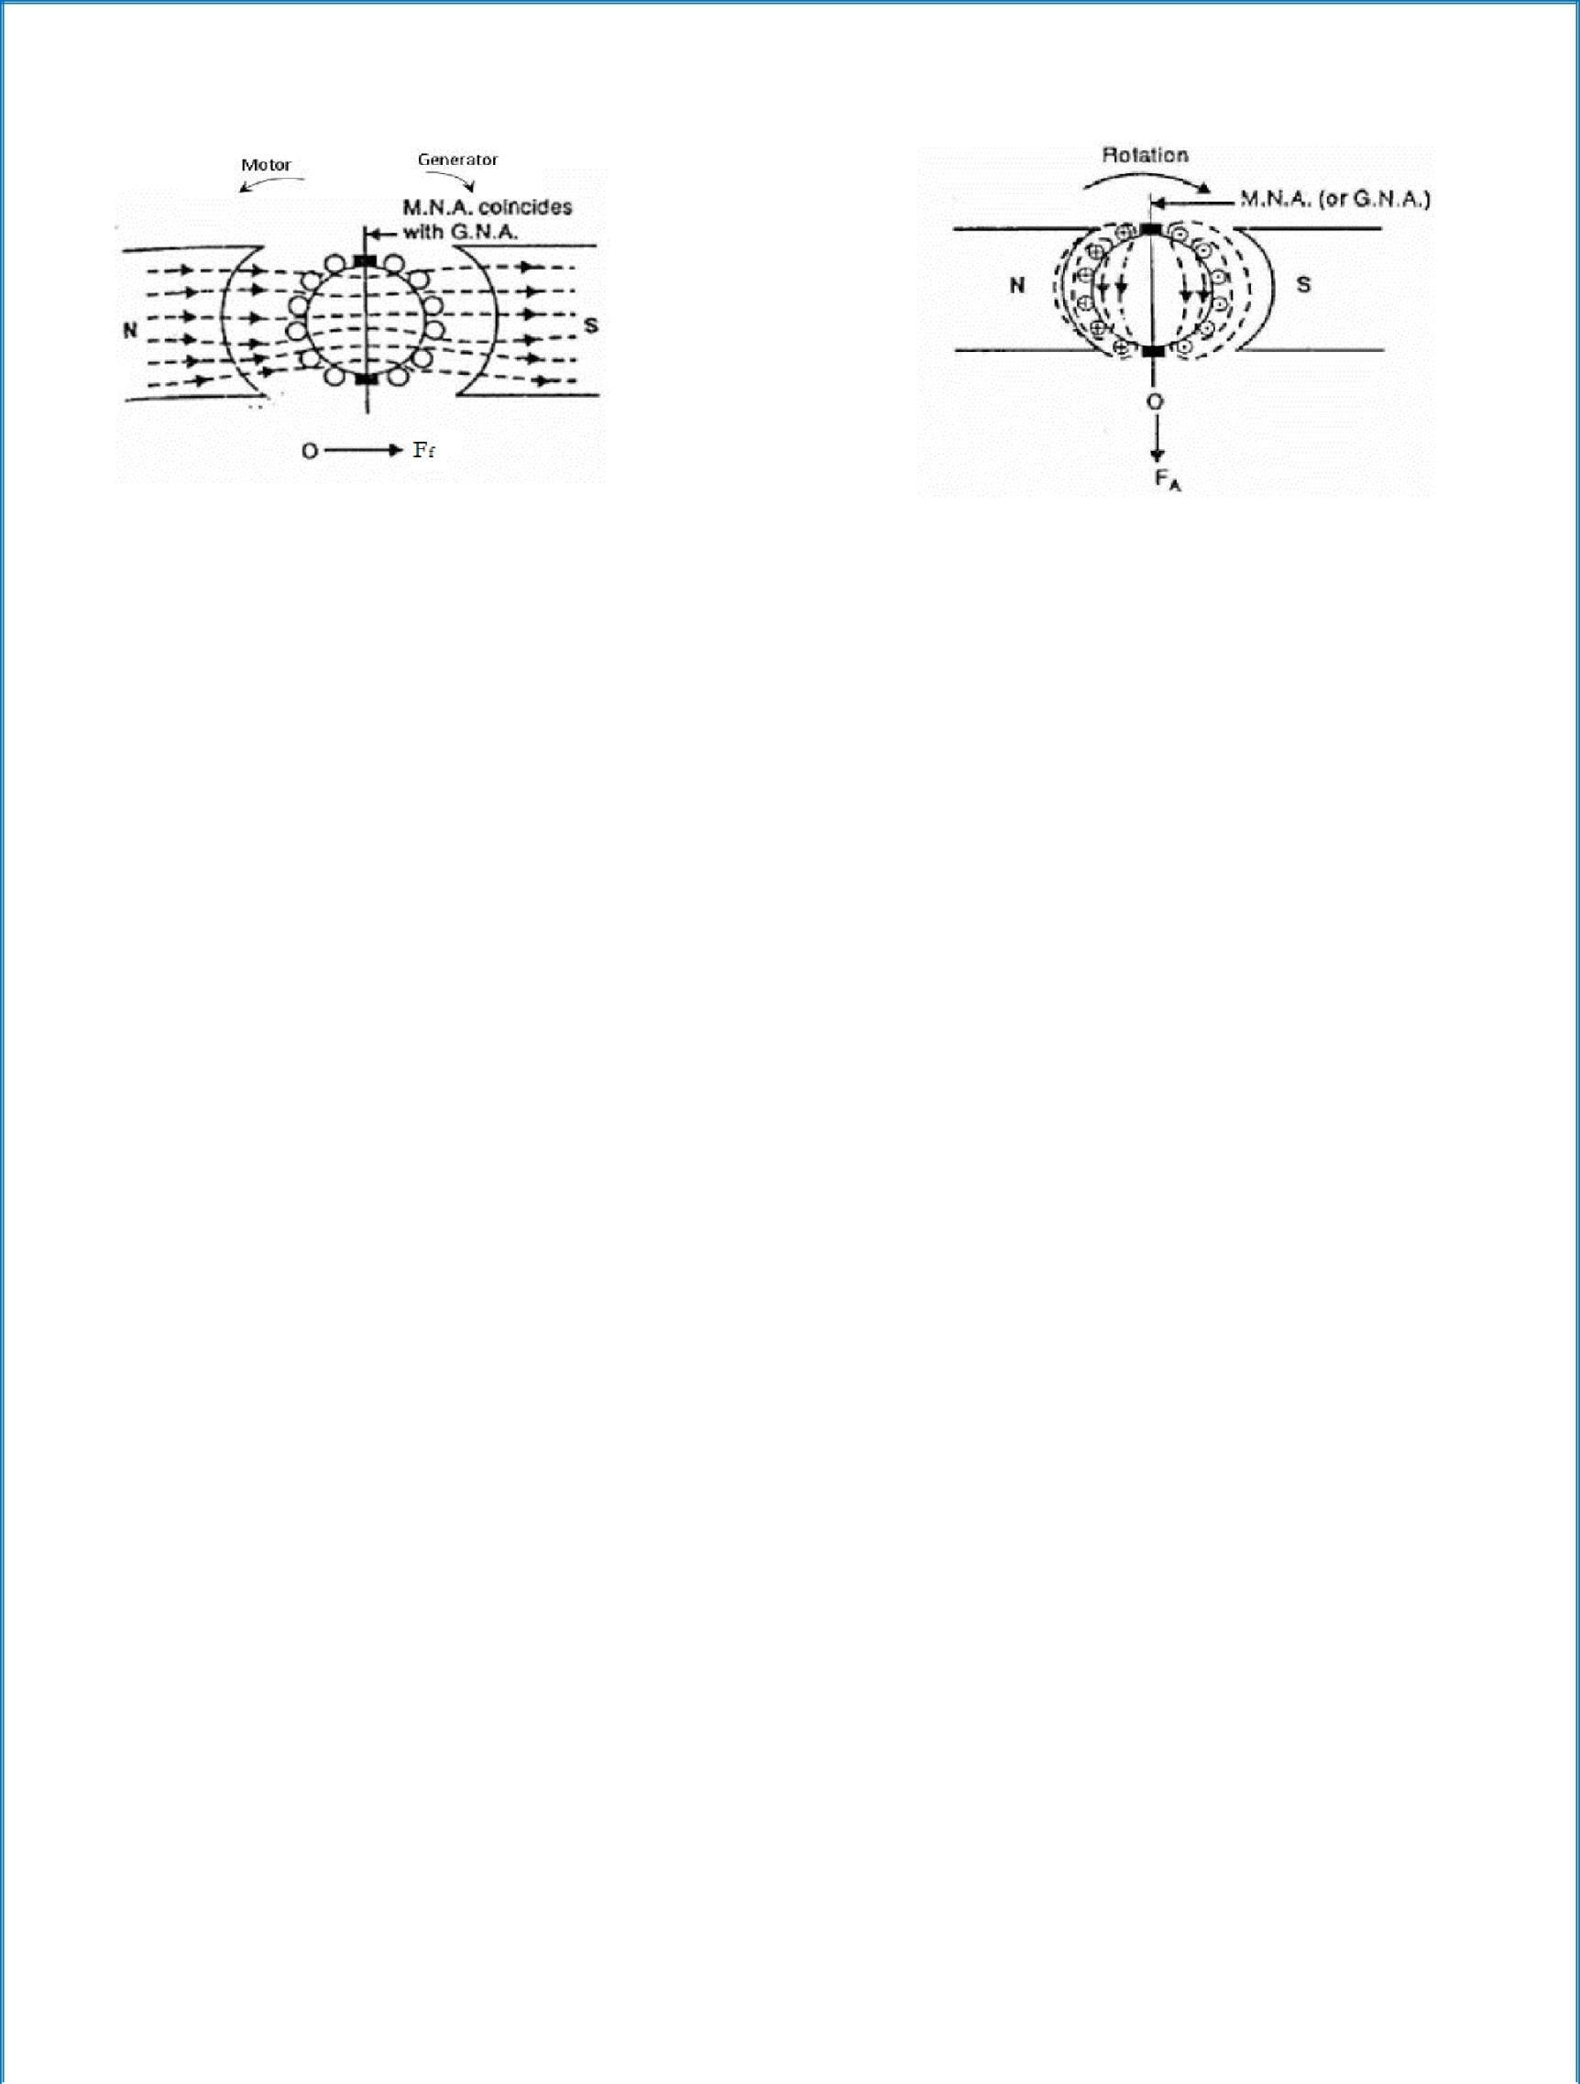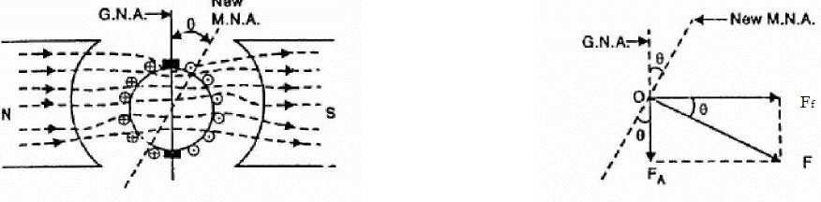

Fig. a Fig. b

Fig. c Fig. d

Figure a shows a two pole machine with single equivalent conductor in each slot and the main field mmf (Ff) acting alone. The axis of the main poles is called the direct axis (d-axis) and the interpolar axis is called quadrature axis (q-axis). It can be seen from the Figure b that armature mmf (Fa) is along the interpolar axis. Fa which is at 900 to the main field axis is known as cross magnetizing mmf.
Figure c shows the practical condition in which a DC machine operates when both the Field flux and armature flux are existing. Because of both fluxes are acting simultaneously, there is a shift in brush axis and crowding of flux lines at the trailing pole tip and flux lines are weakened or thinned at the leading pole tip. (The pole tip which is first met in the direction of rotation by the armature conductor is leading pole tip and the other is trailing pole tip).
If the iron in the magnetic circuit is assumed unsaturated, the net flux/pole remains unaffected by the armature reaction though the air gap flux density distribution gets distorted. If the main pole excitation is such that the iron is in the saturated region of magnetization (practical case) the increase in flux density at one end of the poles caused by armature reaction is less than the decrease at the other end, so that there is a net reduction in the flux/pole. This is called the demagnetizing effect.
1024

18

Thus it can be summarized that the nature of armature reaction in a DC machine is

- Cross magnetizing with its axis along the q-axis.

- It causes no change in flux/pole if the iron is unsaturated but causes reduction in flux/pole in the presence of iron saturation. This is termed as demagnetizing effect. The resultant mmf ‘F’ is shown in figure d.

Commutation

The process of reversal of current in the short circuited armature coil is called ‘Commutation’. This process of reversal takes place when coil is passing through the interpolar axis (q-axis), the coil is short circuited through commutator segments and brush.
The process of commutation of coil ‘CD’ is shown Fig. 3.13. In sub figure ‘c’ coil ‘CD’ carries 20A current from left to right and is about to be short circuited in figure ‘d’ brush has moved by a small width and the brush current supplied by the coil are as shown. In figure ‘e’ coil ‘CD’ carries no current as the brush is at the middle of the short circuit period and the brush current in supplied by coil ‘AB’ and coil ‘EF’. In sub figure ‘f’ the coil ‘CD’ which was carrying current from left to right carries current from right to left. In sub fig ‘g’ spark is shown which is due to the reactance voltage.
As the coil is embedded in the armature slots, which has high permeability, the coil possess appreciable amount of self inductance. The current is changed from +20 to –20. So due to self inductance and variation in the current from +20 to –20, a voltage is induced in the coil which is given by L dI/dt. This emf opposes the change in current in coil ‘CD’ thus sparking occurs.

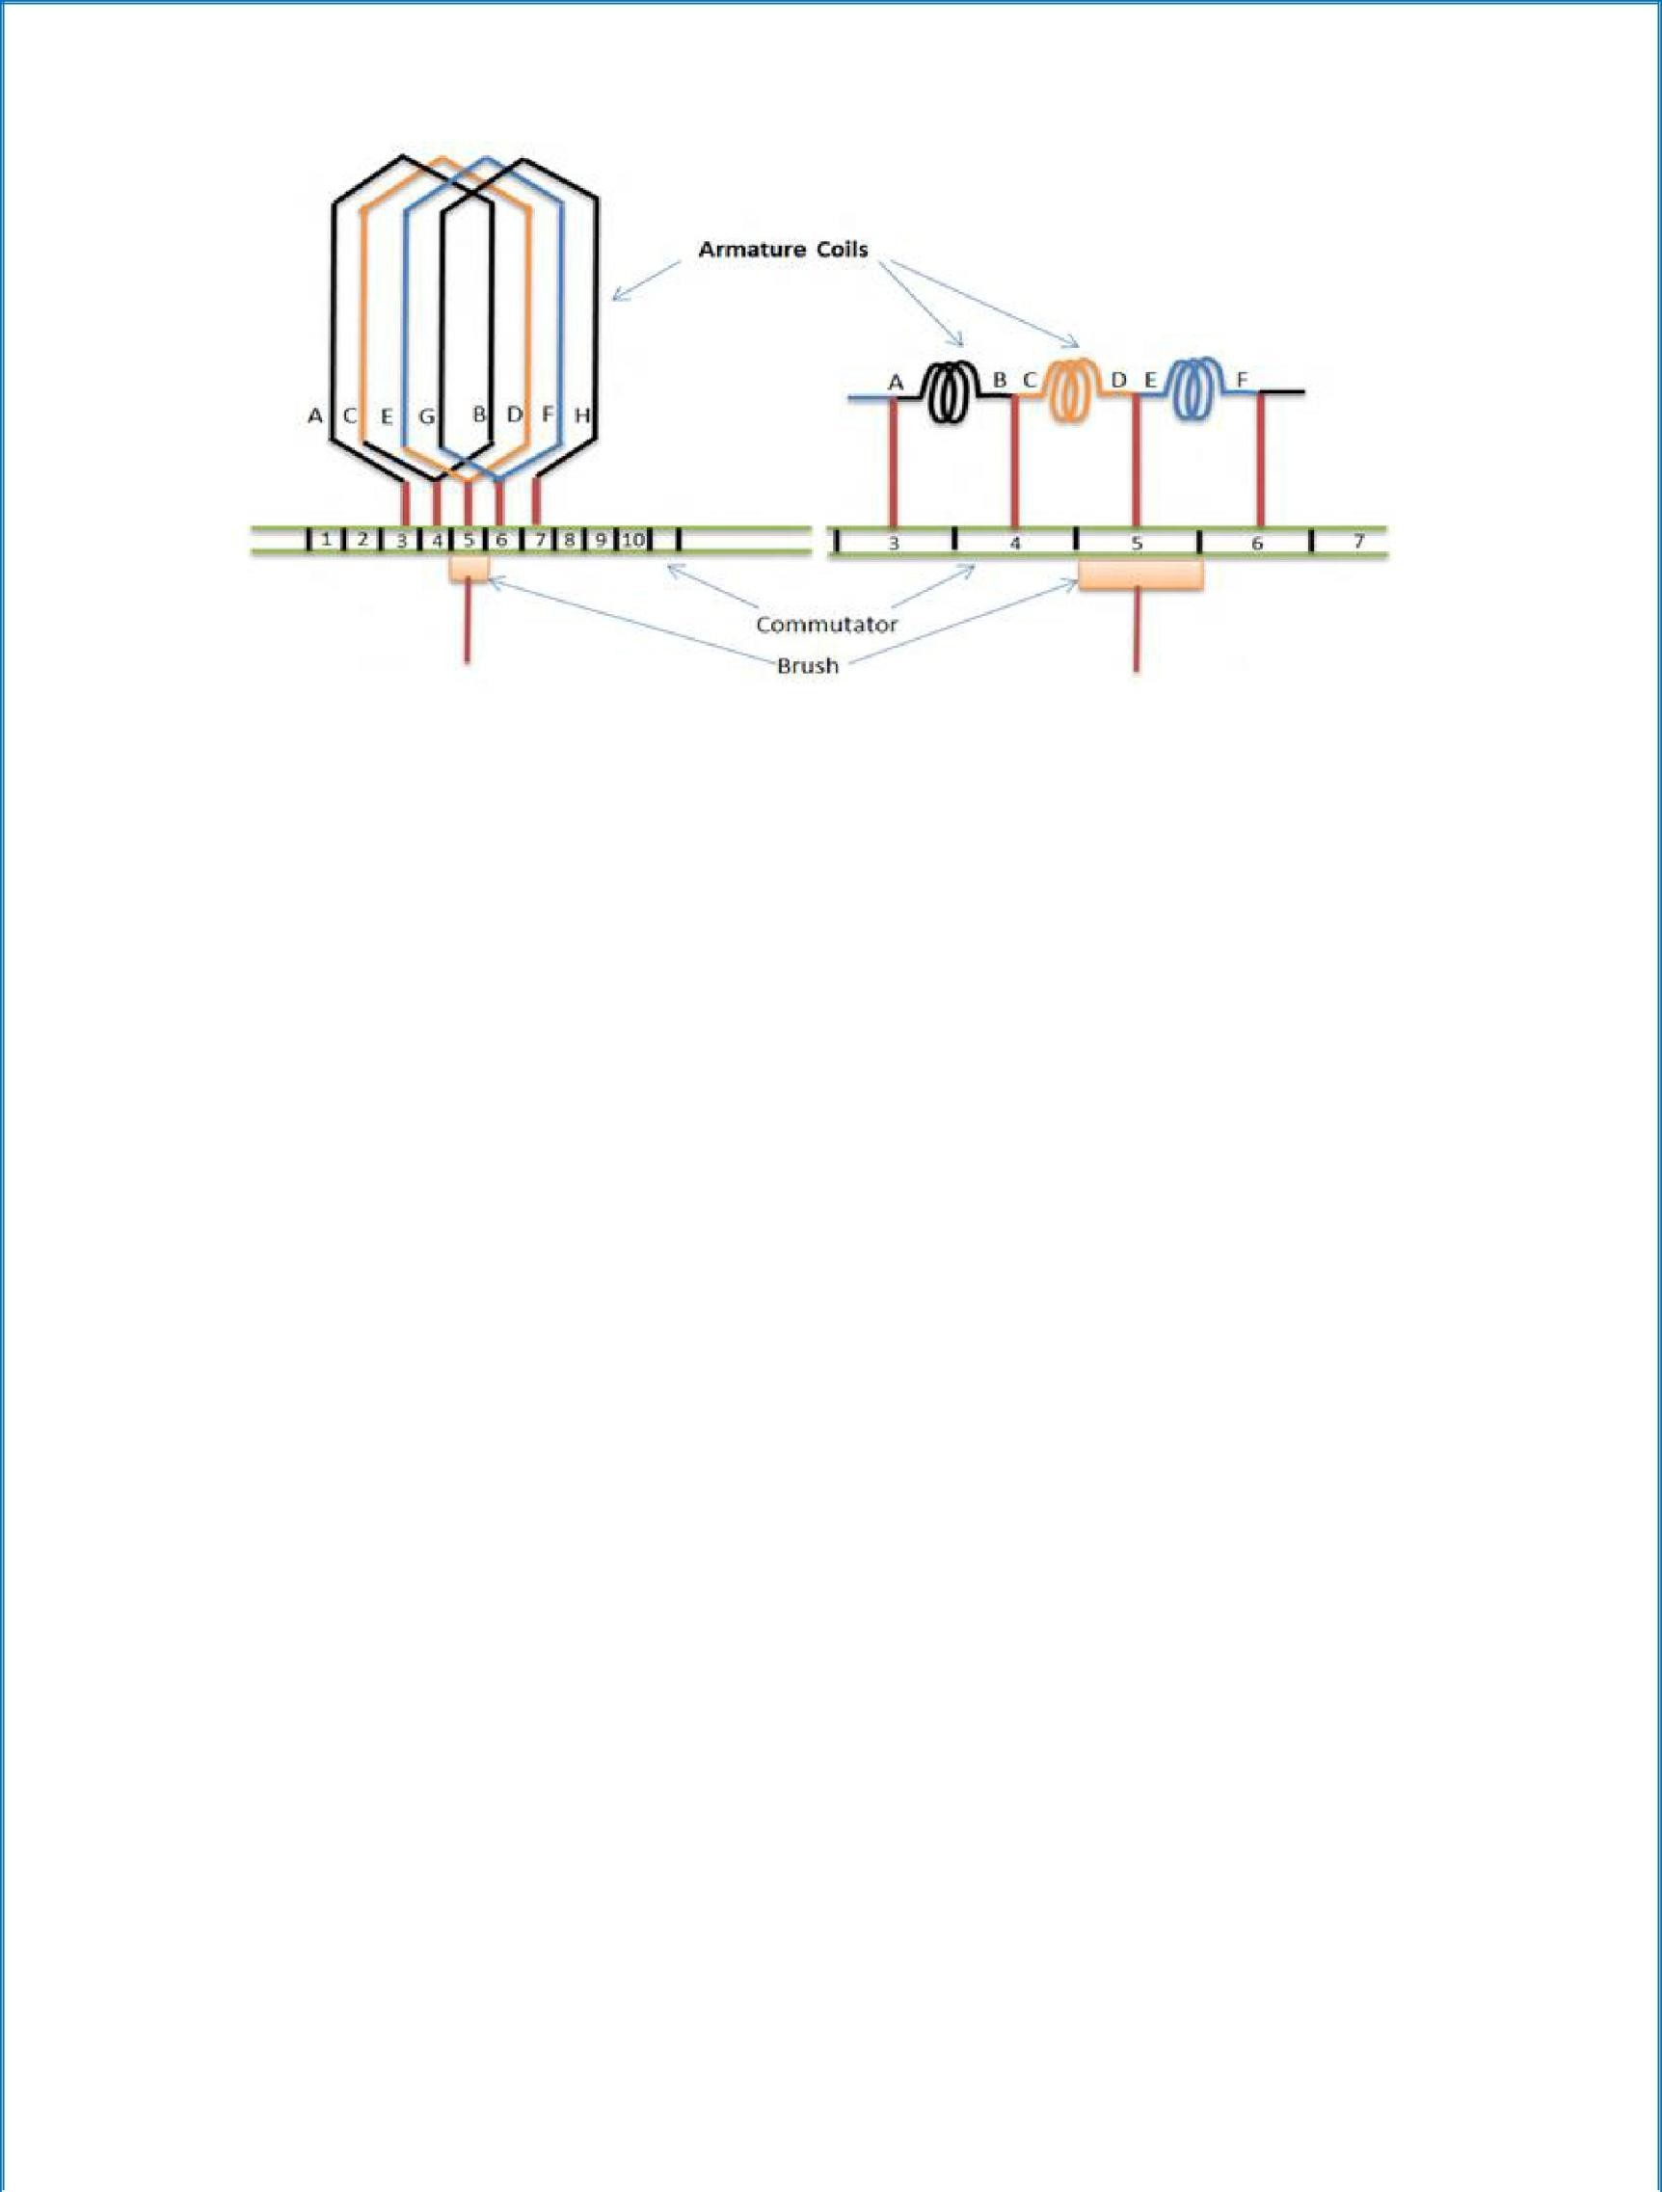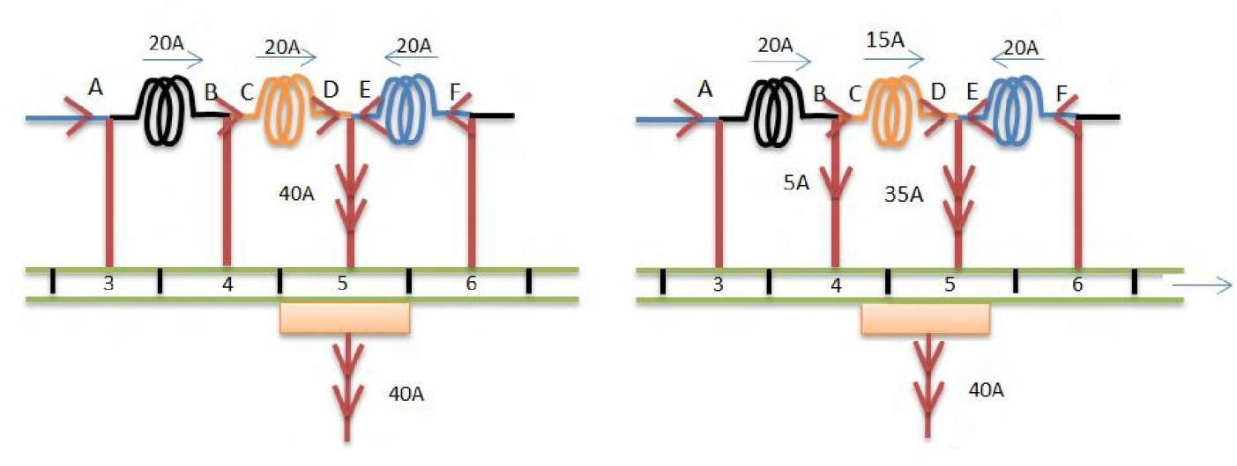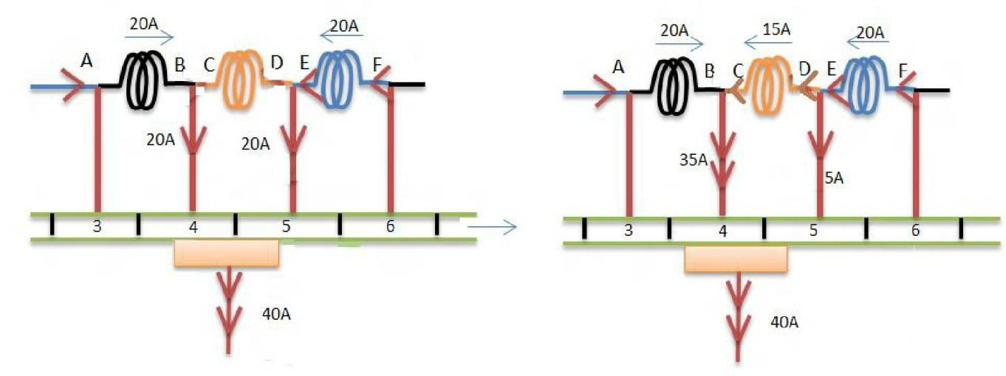

Fig a Fig b

Fig.c Fig.d

Fig.e Fig.f

20
1027

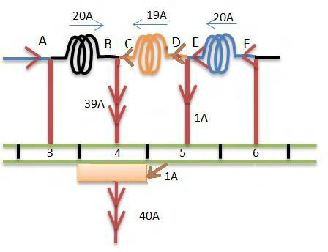
Fig.g
Fig. 3.13 a-g shows the process of commutation

3.8 Starting of DC Motor

Necessity of starter:
The current drawn by the armature is given by

V -E

Ia= r
T
b
a
At starting, as N=0 so Eb = 0 thus

Ia = VT
ra
Armature resistance will be very low. Therefore, the current drawn by the motor will be very high. In order to limit this high current, a starting resistance is connected in series with the armature. The starting resistance will be excluded from the circuit after the motor attains its rated speed. From there on back emf limits the current drawn by the motor.

Three Point Starter
The arrangement is shown in the figure 3.14 shows a three point starter for shunt motor.

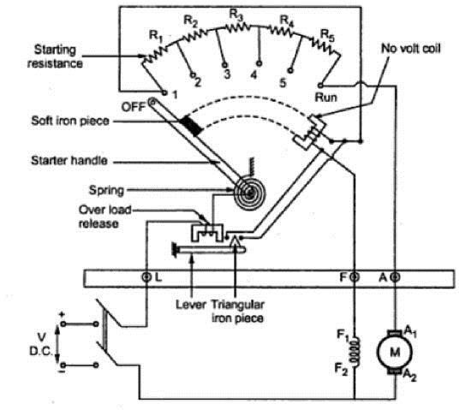
Fig. 3.14 Internal view of three point starter

It consists of resistances arranged in steps, R1 to R5 connected in series with the armature of the shunt motor. Field winding is connected across the supply through a protective device called ‘NO – Volt Coil’. Another protection given to the motor in this starter is ‘over load release coil’. To start the motorthe starter handle is moved from OFF position to Run position gradually against the tension of a hinged spring. An iron piece is attached to the starter handle which is kept hold by the No-volt coil at Run position. The function of No volt coil is to get de-energized and release the handle when there is failure or disconnection or a break in the field circuit so that on restoration of supply, armature of the motor will not be connected across the lines without starter resistance. If the motor is over loaded beyond a certain predetermined value, then the electromagnet of overload release will exert a force enough to attract the lever which short circuits the electromagnet of No volt coil. Short circuiting of No volt coil results inde- energisation of it and hence the starter handle will be released and return to its off position due to the tension of the spring.

Four Point Starter
One important change is the No Volt Coil has been taken out of the shunt field and has been connected directly across the line through a Protecting resistance ‘R’. When the arm touches stud one. The current divides into three paths, 1. Through the starter resistance and the armature, 2. Through shunt field and the field rheostat and 3.Through No-volt Coil and the protecting resistance ‘R’. With this arrangement, any change of current in shunt field circuit does not affect the current passing though the NO-volt coil because, the two circuits are independent of each other. Thus the starter handle will not be released to its off position due to changes in the field current which may happen when the field resistance is varied. Fig 3.15 shows internal view of 4-point starter.
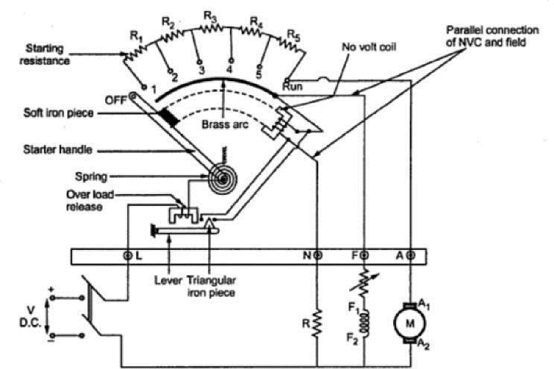
Fig. 3.15 Internal view of three point starter

DRUM CONTROLLERS
Drum controllers are used when an operator is controlling the motor directly. The drum controller is used to start, stop, reverse, and vary the speed of a motor. This type of controller is used on crane motors, elevators, machine tools, and other applications in heavy industry. As a result, the drum controller must be more rugged than the starting rheostat.

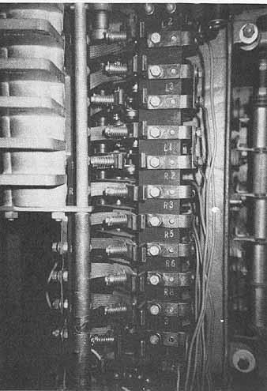

Fig. 3.16 Drum type controller shows contact fingers.
A drum controller with its cover removed is illustrated in 3.16. The switch consists of a series of contacts mounted on a movable cylinder. The contacts, which are insulated from the cylinder and from one another, are called movable contacts. There is another set of contacts, called stationary contacts, located inside the controller. These stationary contacts are arranged to touch the movable contacts as the cylinder is rotated. A handle, keyed to the shaft for the movable cylinder and contacts, is located on top of the drum controller. This handle can be moved either clockwise or counterclockwise to give a range of speed control in either direction of rotation. The handle can remain stationary in either the forward or reverse direction due to a roller and a notched wheel. A spring forces the roller into one of the notches at each successive position of the controller handle to keep the cylinder and movable contacts stationary until the handle is moved by the operator.

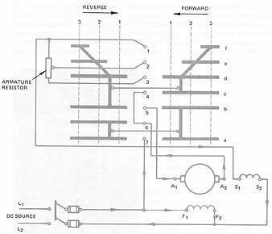

Fig. 3.17 Schematic diagram of a drum controller connected to a compound-wound motor
A drum controller with two steps of resistance is illustrated in 3.17. The contacts are represented in a flat position in this schematic diagram to make it easier to trace the circuit connections. To operate the motor in the forward direction, the set of contacts on the right must make contact with the center stationary contacts. Operation in the reverse direction requires that the set of movable contacts on the left makes contact with the center stationary contacts.
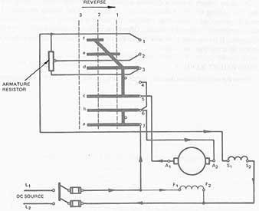

Fig. 3.18 First position of controller for reverse direction

Note in figure 3.17 that there are three forward positions and three reverse positions to which the controller handle can be set. In the first forward position, all of the resistance is in series with the armature. The circuit path for the first forward position is as follows:
- Movable fingers a, b, c, and d contact the stationary contacts 7, 5, 4, and 3.
- The current path is from the positive side of the line to contact 7, from 7 to a, from a to b, from b to 5, and then to armature terminal A1.
- After passing through the armature winding to terminal A the current path is to stationary contact 6, and then to stationary contact 4.
- From contact 4 the current path is to contact c, to d, and then to contact 3.
- The current path then goes through the armature resistor, to the series field, and then back to the negative side of the line.
The shunt field of the compound motor is connected across the source voltage. On the second forward position of the controller handle, part of the resistance is cut out. The third forward position cuts out all of the resistance and puts the armature circuit directly across the source voltage.
In the first reverse position, all of the resistance is inserted in series with the armature. Fig. 3.18 shows the first position of the controller in the reverse direction. The current in the armature circuit's reversed. However, the current direction in the shunt and series fields is the same as the direction for the forward positions. A change in current direction in the armature only resulted in a change in the direction of rotation.
The second reverse position cuts out part of the resistance circuit. The third reverse position cuts out all of the resistance and puts the armature circuit directly across the source. Drum controllers with more positions for a greater control of speed can be obtained. However, these controllers all use the same type of circuit arrangement shown in this unit.
DC series motors require a different starting controller than shunt or compound motor. The holding circuit for the controller is in series with the starting resistance. If there is a low-voltage or no-voltage condition, the starter is returned to the off position. Drum controllers are still used frequently. Often

drum controllers are used with ac as well as dc motors. It is important to be able to read the connection diagrams and the sequence diagrams on drum-type controllers.

3.10 Losses and efficiency of DC Machines
It is convenient to determine the efficiency of a rotating machine by determining the losses than by direct loading. Further it is not possible to arrange actual load for large and medium sized machines. By knowing the losses, the machine efficiency can be found by

 | Output
η = | Output+Losses | (for Generator)
η= I nput-Losses (for Motor)
Input
In the process of energy conversion in rotating machines-current, flux and rotation are involved which cause losses in conductors, ferromagnetic materials and mechanical losses respectively.
Various losses occurring in a DC machine are listed below- Total losses can be broadly divided into two types.
- Constant losses
- Variable losses
These losses can be further divided as
- Constant losses –
  - Core loss or iron loss
    - Hysteresis loss
    - Eddy current loss
  - Mechanical loss
    - Windage loss
    - Friction loss – brush friction loss and Bearing friction loss.
- Variable losses –

  - copper loss (I2 r)
    - Armature copper loss
    - Field copper loss
    - Brush contact loss
  - Stray load loss
    - Copper stray load loss
    - Core stray load loss
Core loss or iron loss occurs in the armature core is due to the rotation of armature core in the magnetic flux produced by the field system. Iron loss consists of a) Hysteresis loss and b) Eddy current loss.
Hysteresis loss: This loss is due to the reversal of magnetization of armature core as the core passesunder north and south poles alternatively. This loss depends on the volume and grade of iron, maximum value of flux density and frequency. Hysteresis loss is given by Steinmetz formula.
Wh= K h B ^{1.6} f V Joule/sec or watt
m

Where Kh = Constant of proportionality- depends on core material.
Bm = Maximum flux density in Wb/m2
f = Frequency in Hz
V = Volume of the armature core in m3
Eddy Current Loss: Eddy currents are the currents set up by the induced emf in the armature corewhen the core cuts the magnetic flux. The loss occurring due to the flow of eddy current is known as eddy current loss. To reduce this loss the core is laminated, stacked and riveted. These laminations are insulated from each other by a thin coating of varnish. The effect of lamination is to reduce the current path because of increased resistance due to reduced cross section area of laminated core. Thus the magnitude of eddy current is reduced resulting in the reduction of eddy current loss.
Eddy Current loss is given by

We= K e B ² f ²t ²V Watt
m

Where Ke = Constant of proportionality
Bm = Maximum flux density in Wb/m2
f = Frequency in Hz
V = Volume of the armature core in m3
t = Thickness of the lamination in meters
ii) Mechanical loss: these losses include losses due to windage, brush friction and bearing friction losses.
2) Variable losses: Variable losses consist of
- Copper loss:
  - Armature copper loss: This loss occurs in the armature windings because of the resistance of armature windings, when the current flows through them. The loss occurring is termed as copper loss or r loss. This loss varies with the varying load.
  - Field copper loss: This is the loss due to current flowing in the field windings of the machine. c) Brush contact drop: This is due the contact resistance between the brush and the commutator. This loss remains constant with load.
- Stray load loss: The additional losses which vary with the load but cannot be related to current in a simple manner are called stray load loss. Stray load losses are.
Copper stray load loss: the loss occurring in the conductor due to skin effect and loss due to the eddy currents in the conductor set up by the flux passing through them are called copper stray load loss.
Core stray load loss: When the load current flows through the armature conductors, the flux densitydistribution gets distorted in the teeth and core. The flux density decreases at one end of the flux density wave and increases at the other. Since the core loss is proportional to the square of the flux density, the decrease in flux density will be less than the increase due to the increase in flux density, resulting in a net increase in the core loss predominantly in the teeth, is known as stray load loss in the

core.

Further under highly saturated conditions of teeth, flux leaks through the frame and end shields causing eddy current loss in them. This loss is a component of stray load loss. Stray load loss is difficult to calculate accurately and therefore it is taken as 1 % of the output of a DC machine.

3.11EFFICIENCY OF A DC GENERATOR:
Power flow in a DC generator is shown in figure 3.19.
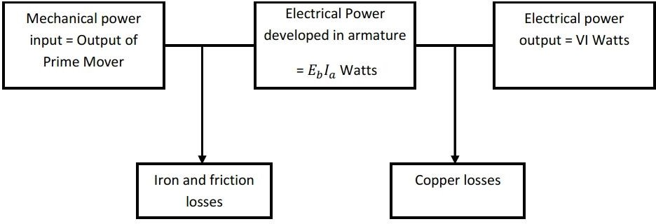
Fig. 3.19 Power flow in a DC generator

3.12 CONDITION FOR MAXIMUM EFFICIENCY
Generator output = VI; Generator input = VI + losses.
I n p u t = VI+Ia2ra+wc
If the shunt field current is negligible, then Ia =I For maximum efficiency d(η)=0
dI
I a2ra= wc

Hence efficiency is maximum when variable loss = constant loss.
wc
The load current corresponding to maximum efficiency is I= r
a

EFFICIENCY OF DC MOTOR:
The power flow in a DC motor is shown in figure 3.20.
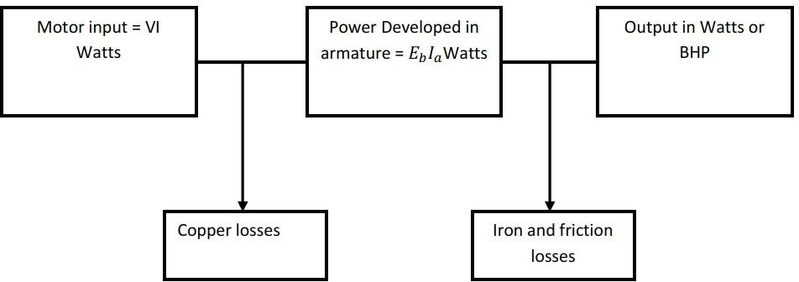

Input-Losses
Fig. 3.20 Power flow in a DC generator

Efficiency η=
(for Motor)
Input

η= VI − I _{a}²r_{a}− w_{c}
VI
Efficiency is maximum when variable loss = constant loss.

Speed Control of DC Motor
DC motors are in general much more adaptable speed drives than AC motors. Speed of a DC motor can be controlled in a wide range.
N= E =V-I r
b
a a
Kφ Kφ
The speed equation shows that speed can be controlled by-
- Variation of field current which varies the flux/pole (φ ) and is known as field control.
- Variation of armature resistance known as armature voltage control.
- Variation of terminal voltage ‘V’ known as Ward Leonard method.

Field Control
For a fixed terminal voltage, N
φ If
2 2 2
= =

N1 φ1 If1
Limitations of speed control by field control:

- ‘N’ below rated speed is not possible. Because φ can be decreased and cannot increase.

1
- N ∝φ & T ∝φ for a given armature current, this method suits for constant kW drives only
where ‘T’ decreases if speed decreases.

- Not suited for speed reversal.

DC Shunt Motor
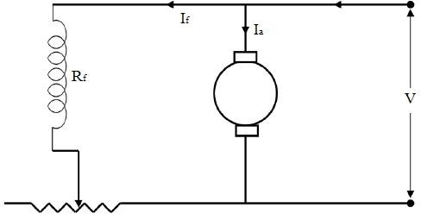
Fig. 3.21 Circuit diagram for speed control using field control method
Speed control is achieved by means of a rheostat in the field circuit as shown in the figure 3.21. The working range of the speed torque characteristics reduces with increasing speed in order for the armature current not to exceed the full load value with a weakening field.

DC Series Motor
Speed control is achieved by adjusting the field ampere turns. There are three ways for varying the field ampere turns.
- Diverter field control
Diverter resistance Rd is connected across the field winding as shown in figure 3.22. By varying Rd the field current and hence the field ampere turns can be reduced.
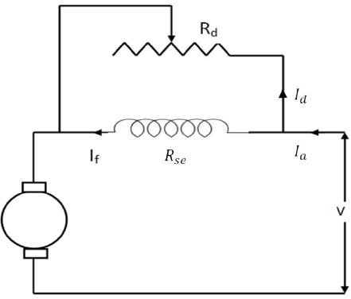

Fig. 3.22 Field diverter circuit

Tapped field control:
The field ampere turns are adjusted in steps by varying the number of turns included in the circuit as shown in figure 3.23. By changing number of field winding turns effective ampere turns of the field is changed thus field flux can be controlled.
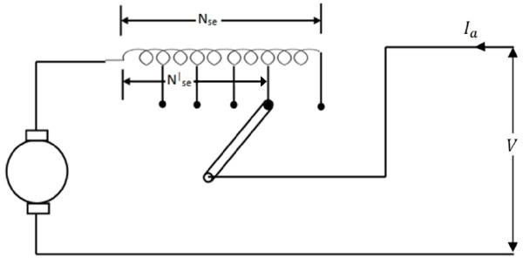

Fig. 3.23 Tapped field circuit

Series parallel control
In this method, the field windings are divided into two equal halves and then connected in series or parallel to control the field ampere turns as shown in figure 3.24 and 3.25respectively.
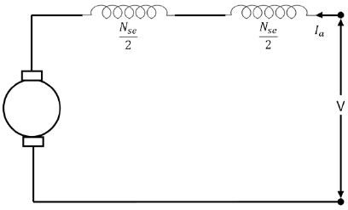
Fig. 3.24 Field circuit connected in series
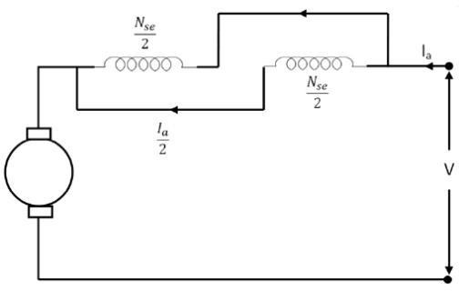
Fig. 3.25 Field circuit connected in parallel

Armature Voltage Control
In this method, applied voltage across the armature of the DC motor is varied. This method is superior to field control in the following aspects:
- This method provides a constant torque drive.(if the φ and Ia are maximum, maximum torque can be obtained as T ∝φIa )
- Since main field ampere turns are maintained at large value, flux density distortion caused by armature reaction is limited.
- Unlike field control scheme, speed reversal can be easily implemented.
- This method requires a variable voltage supply which makes this method costlier.

3.12.2.1 DC Shunt Motor
Following are the armature control schemes for DC shunt motor.

Rheostatic control:
Here the applied armature voltage is varied by placing an adjustable resistance ‘R’ in series with the armature as shown in the figure 3.26. N vs T for varying ‘R’ is shown in figure 3.27.
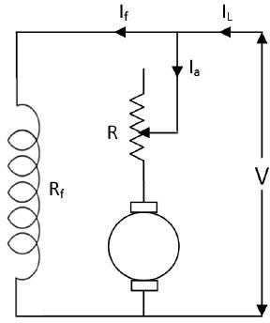
Fig. 3.27 Circuit diagram for armature resistance control

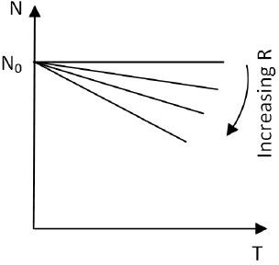

Fig. 3.28 Speed variation with torque for different resistance
Some of the limitations of the rheostatic method are:

Speeds only below rated speed

- Range of speeds is limited because efficiency reduces drastically for large speed reductions
- Speed regulation is poor. Because for a given resistance re, N varies directly with load.
- Therefore this method is suitable for very small (fractional kW) or for short-time, intermittent slowdowns for medium sized motors.

Shunted armature control
In the armature rheostatic control method, the change in armature current due to change in load will affect the speed. Hence in this method the armature is shunted by an adjustable resistance as shown in figure 3.28.
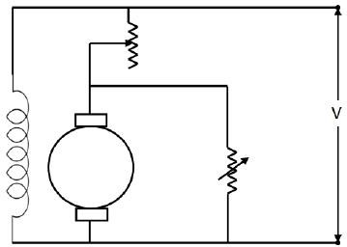
Fig. 3.28 Shunted armature control circuit
Advantages of this method are

  - Speed regulation will be better.

  - The changes in the armature current due to load will not be as effective as the armature is connected across a resistance.

Ward-Leonard Method
It is a combined armature and field control and is therefore operationally the most efficient method of speed control with a wide range. ‘M1’ is the main motor whose speed control is required. The field of this motor is permanently connected across the DC supply lines. Its armature is supplied by a variable voltage derived by a Motor-Generator set. The motor M2 act as prime mover for the generator can be AC motor or DC motor. The field of the DC generator is separately excited. The entire arrangement is shown in the figure 3.29. The reversible switch provided for the generator field makes it possible to easily reverse the generator excitation thereby reversing the voltage polarity for reversing the direction of rotation of motor. Though expensive, this arrangement can be easily adapted to feedback schemes for automatic control of speed. This method provides both constant torque and constant HP (or kW) drive.
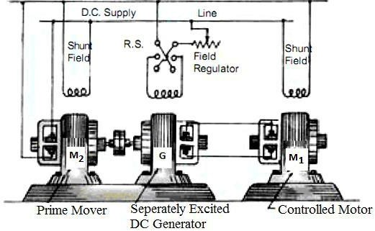
Fig. 3.29 Ward-Leonard speed control scheme

The armature and field winding of the motor are fed at maximum values at the base speed Nbase. When armature voltage is reduced a constant torque speed control is obtained where the speed can be reduced below the base value, while the motor has full torque capability. When speed above Nbase is required then the field is gradually weakened. The motor torque therefore reduces as its speed increases which corresponds to constant kW (or HP) drive. This is shown in the figure 3.30.

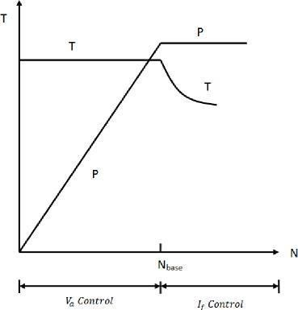

Fig. 3.30 Speed torque relation during Ward –Leonard speed control
Some of the features of the Ward Leonard system are given below:

- As this method does not required any external resistance thus the efficiency is improved at all speeds and also when the generator emf becomes less than the back emf of the motor, the electrical power flows back from motor to generator, is converted to mechanical form and is returned to the mains via the driving AC motor.
- Motor starts up smoothly therefore starting device is not required.
- Reversal of speed is smoothly carried out.
- Fine speed control from zero to rated value in both the directions are possible.
This method of speed control is used in
  - High speed elevators
  - Colliery winders

Testing of DC machines
Testing of DC machines can be broadly classified as
- Direct method of Testing
- Indirect method of testing

Direct method of testing
In this method, the DC machine is loaded directly by means of a brake applied to a water cooled pulley coupled to the shaft of the machine. The input and output are measured and efficiency is determined by η=OutputInput

It is not practically possible to arrange loads for machines of large capacity.

BRAKE TEST:
This is a direct method of testing. In this method of testing motor shaft is coupled to a Water cooled pulley which is loaded by means of weight as shown in figure 3.31.
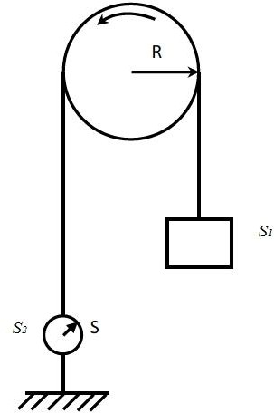
Fig. 3.31 Brake pulley arrangement for direct load test
S1= suspended weight in kg
S2= Reading in spring balance in kg R = radius of pulley
n = speed in rps
V = Supply voltage
I = Full Load Current
Net pull due to friction = (S1−S2) kg =
9.81 (S1−S2) Newton
Shaft torque = (S1−S2) R kg-mt

= 9.81 (S1 — S2) R N-mt
Motor output power = Tsh X 2Πn Watt
= (S1 — S2) R X 2Πn watts

Or 9.81 (S1 — S2)R X 2Πn watt.

Input power = VI watts

Therefore efficiency =η=

Output Input

9.81 (S1 — S2)R X 2Πn
= VI

This method of testing can be used for small motors only because for a large motor it is difficult to arrange for dissipation of heat generated at the brake.

Indirect method of testing:
In this method, the machine is not actually loaded. The losses are determined. If the losses are known, then efficiency can be determined. Swinburne’s test and Hopkinson’s test are commonly used on shunt motors. But, as series motor cannot be started on No-load, these tests cannot be conducted on DC series motor.

Swinburne’s Test
For a d.c shunt motor change of speed from no load to full load is quite small. Therefore, mechanical loss can be assumed to remain same from no load to full load. Also if field current is held constant during loading, the core loss too can be assumed to remain same.
In this test, the motor is run at rated speed under no load condition at rated voltage. The current drawn from the supply IL0 and the field current If are recorded. Now we note that:

Input power to the motor, Pin = VIL0 Cu loss in the field circuit Pfl = VIf
Power input to the armature, = VIL0 – VIf = V(IL0 – If) = VIa0 Cu loss in the armature circuit = I2 0ra
a
Gross power developed by armature = VIa0 - I2 0ra= (V - Ia0ra)Ia0 = Eb0Ia0
a

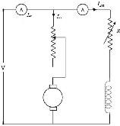

Fig. 3.32 Circuit diagram for Swinburne’s Test

Since the motor is operating under no load condition, net mechanical output power is zero. Hence the gross power developed by the armature must supply the core loss and friction & windage losses of the motor. Therefore,
P core + P friction= ( V- I a 0 r a) I a 0= E b 0 I a 0
Since, both Pcore and Pfriction for a shunt motor remains practically constant from no load to full load, the sum of these losses is called constant rotational loss i.e.,
Constant rotational loss, Prot = Pcore + Pfriction
In the Swinburne's test, the constant rotational loss comprising of core and friction loss is estimated from the above equation.
After knowing the value of Prot from the Swinburne's test, we can fairly estimate the efficiency of the motor at any loading condition. Let the motor be loaded such that new current drawn from the supply is IL and the new armature current is Ia. To estimate the efficiency of the loaded motor we proceed as follows:
Input power to the motor, Pin = VIL
Cu loss in the field circuit Pfl = VIf
Power input to the armature, = VIL – VIf =V(IL – If) = VIa

Cu loss in the armature circuit = I2 ra
a
Gross power developed by armature = VIa −I2 ra =(V−Iara )Ia = EbIa
a
Net mechanical output power, Pnet mech = EbIa-Prot
Efficiency of the loaded motor,

E I −P P
η= b a rot =

t mech

ne
VI L Pin
The estimated value of Prot obtained from Swinburne’s test can also be used to estimate the efficiency of the shunt machine operating as a generator.
Output power of the generator, Pout = VIL
Cu loss in the field circuit Pfl = VIf
Output power of the armature, = VIL + VIf = V Ia
Mechanical input power, Pin mech = VIa +I2 ra +Prot
a
Efficiency of the generator,
η= VI L = VIL 2
P VI + VI + I r + P
in mech L f a ar ot
As this test is done at no-load condition thus the power required is very less. From the test effect of armature reaction, temperature rise, commutation etc. cannot be predicted as the machine is not actually loaded.

Load Test
To assess the rating of a machine a load test has to be conducted. When the machine is loaded, certain fraction of the input is lost inside the machine and appears as heat, increasing the temperature of the machine. If the temperature rise is excessive then it affects the insulations, ultimately leading to the breakdown of the insulation and the machine. The load test gives the information about the efficiency of a given machine at any load condition. Also, it gives the temperature rise of the machine. If the temperature rise is below the permissible value for the insulation then the machine can be safely operated at that load, else the load has to be reduced. The maximum continuous load that can be delivered by the machine without exceeding the temperature rise for the insulation used, is termed as

the continuous rating of the machine. Thus the load test alone can give us the proper information of the rating and also can help in the direct measurement of the efficiency.

Hopkinson’s Test
Here power drawn from the supply only corresponds to no load losses of the machines, the armature physically carries any amount of current (which can be controlled with ease). Two similar DC shunt motors are mechanically coupled. Electrically these two machines are eventually connected in parallel and controlled in such a way that one machine acts as a generator and the other as motor.
Two similar (same rating) machines are connected and coupled as shown in figure 3.33. With switch is open initially, the first machine is run as a shunt motor at rated speed. It may be noted that the second machine is operating as a separately excited generator because its field winding is excited and it is driven by the first machine. The value of the voltage across the switch is either close to twice supply voltage or small voltage. In fact the voltmeter practically reads the difference of the induced voltages in the armature of the machines. In case if the voltmeter reading is high, then the armature connection of the generator should be reversed and start afresh. Now if the voltmeter is found to read small voltage then any attempt to close the switch may result into large circulating current as the armature resistances are small. By adjusting the field current Ifg of the generator the voltmeter reading may be adjusted to zero (Eg ≈ Eb) and switch is now closed. Both the machines are now connected in parallel as shown in figure 3.33.
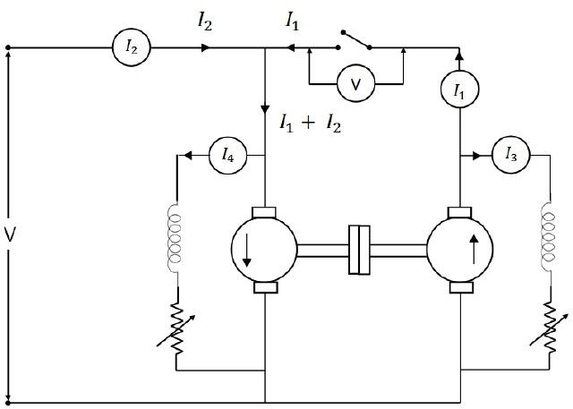
Fig. 3.33 Connection of Hopkinson’s Test

After the machines are successfully connected in parallel, if the field current of generator is increased (by decreasing generator field resistance), then Eg becomes greater than Eb and both armature current of generator and motor increase, Thus by increasing field current of generator (alternatively decreasing field current of motor) one can make Eg>Eb so as to make the second machine act as generator and first machine as motor. In practice, it is also required to control the field current of the motor to maintain speed constant at rated value. The interesting point to be noted here is that the armature current of generator and motor are not reflected in the supply side line. Thus current drawn from supply remains small (corresponding to losses of both the machines). The loading is sustained by the output power of the generator running the motor and vice versa. The machines can be loaded to full load current without the need of any loading arrangement.

Calculation
V= supply voltage
Motor input = V(I1+I2) Generator output = VI1
If it is assumed both machines have the same efficiency ‘η’, then,
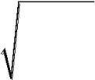
Output of motor = η x input = η x V (I1+I2) = input to generator Output of generator = η x input = η x ηV (I1+I2) = η2V(I1+I2) VI1 = η2V(I1+I2)
Therefore, η= | I1
I | + I
1 | 2

Armature copper loss in motor = (I1 + I2 – I4)2ra Shunt field copper loss in motor = VI4
Armature copper loss in generator = (I1 + I3)2ra Shunt field copper loss in generator = VI3 Power drawn from supply = VI2
Therefore stray losses = VI2 – [(I1 + I2 – I4)2ra +VI4+(I1 + I3)2ra+ VI3]= W (say)

Stray losses/motor = W2

Therefore for generator
Total losses= (I1+I2)2ra+VI3+W =Wg
2
Output = VI1, therefore

VI1
ηgenerator = VI +W
1g
output
=output+losses

For motor,
Total losses = (I1+I2-I4)2ra+VI4+W =Wm
2

Input to motor = V(I1+I2)
V(I +I )-W
Thereforeηmotor= 1 2 m
V(I1 +I2 )

Field’s Test
Figure 3.34 shows the circuit for fields test. This test is applicable to two similar series motor. One of the machine runs as a motor and drives a generator whose output is wasted in a variable load ‘R’.
Both machine field coils are in series and both run at same speed so that iron and friction losses are made equal.
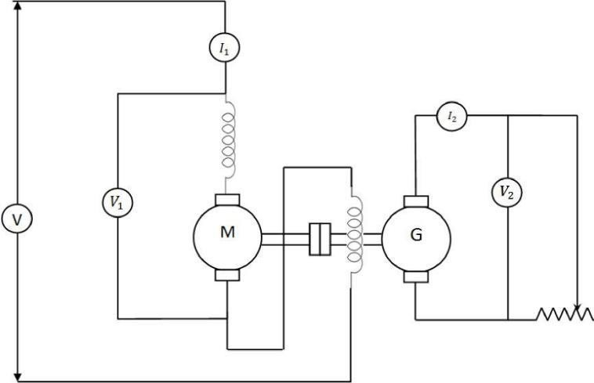
3.34 Circuit diagram for Field’s test on DC series motor
Load resistance ‘R’ is varied till the motor current reaches its full load value. V = Supply voltage

I1 = Motor current
V2 = Generator terminal voltage I2 = Load current
Input = VI1 and output = V2I2 Ra and Rse = hot resistances.
Total losses in the set Wt = VI1 – V2I2
Armature and Field copper losses Wc = (Ra + 2 rse) I12 + Ia2Ra Stray losses for the set = Wt – Wc
Stray losses per machine Ws = Wt-Wc
2

Motor efficiency :

Input=V1I1
Losses= (Ra +Rse)I12 +Ws =Wm (say)

η  motor | VI1 +Wm
η  motor | = | VI1
Generator efficiency:ηof generator is of little use, because its field winding is separately excited Generator output = VI2
Field copper loss = I12rse Armature copper loss = I12ra
Total losses = I12rse +I12ra +Ws= Wg (say)

η  generator |  | VI2
η  generator | = | V2 | +Wg

3.12.2.5 Reatardation Test
This method is applicable to shunt motors and generators and is used for finding the stray losses. If armature and shunt copper losses are known for a given load, efficiency can be calculated. The circuit is shown in figure 3.35.
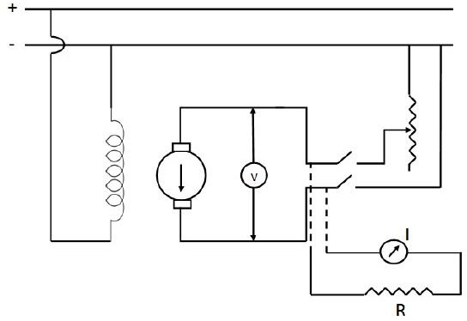
Fig. 3.35 Circuit diagram for Retardation test on DC motor
Machine is speeded up slightly beyond its rated speed and then supply is cut off from the armature while keeping the field excited. Armature will slow down and its kinetic energy is needed to meet rotational losses. i.e., friction and windage losses.
Kinetic energy of the armature = 12Iω2
I = Moment of inertia of the armature ω = Angular velocity.
Rotational losses;
N = Rate of loss of K.E.
Rate of loss of Kinetic energy W = d ⎡ 1 Iω ²⎤ = Iω dω
⎢ ⎥
dt ⎣2 ⎦ dt
Two quantities need to be known
- Moment of Inertia ‘I
- d ω or dN (because ω∝N )

dt dt

- Finding d ω :
dt
The voltmeter “V” in the circuit shown in Fig. 3.35 is used as per speed indicator by suitably grading it because E∝N . Then the supply is cut off, the armature speed and hence voltmeter reading falls. Voltage and time at different interval are noted and a curve is drawn between time and speed as shown in fig. 3.36.

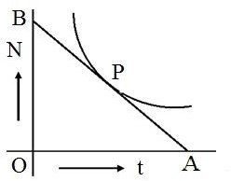
Fig. 3.36 Change of speed with time
In the fig. 3.36 AB- tangent drawn at P Therefore dNdt=OB(rpm)OA(sec)
W=I×ω× d ω
dt

2 πN
ω= 60
⎛ 2πN ⎞ d ⎛ 2πN ⎞
W=I ⎜ ⎟ ⎜ ⎟⎝ 60 ⎠ dt
⎝ 60 ⎠
⎛ | 2π ⎞² | dN
W= ⎜ | ⎟ | .I.N.
⎝ | 60 ⎠ | dt

- Finding Moment of Inertia “I”:
There are two methods of finding the moment of inertia ‘I’

I is calculated:
  - Slowing down curve with armature alone is calculated.
  - A fly wheel is keyed to the shaft and the curve is drawn again
For any given speed, dN and dN are determined as before.
dt dt1

⎛ 2π ⎞² dN
Therefore
W= ⎜ ⎟ .I.N. 1st case
⎝ 60 ⎠ dt1
⎛2π ⎞2 (I+I )N. dN
W= ⎜ ⎟ 1 2nd Case
⎝ 60 ⎠ dt2
The two cases are equal because losses in two cases will be almost same.

I = (I+I1)
dN
dN I+I1 ⎛ dN ⎞ dN
. ⎜ ⎟ =

dt dt I
I+I1 = dN I dt2
I = I × t2
¹ t1 − t2

I is eliminated:
⎝dt2 ⎠
dt1

In this method, time taken to slow down is noted with armature alone and then a retarding torque is applied electrically i.e., a non-inductive resistance is connected to the armature.
The additional loss is I ²(Ra+R)orVIa
a
Let W1 be the power then
⎛ 2π | ⎞2 | dN
W= ⎜ | ⎟ IN.
⎝ 60 | ⎠ | dt1
1 | ⎛ 2π | ⎞2 | dN
W+W = ⎜ |  | IN.
 | ⎝ 60 | ⎠ | dt2

⎟

dN
= rate of change of speed without electrical load dt1 dN= rate of change of
speed with electrical load dt2

W+W¹ W
dN dt ₂
= dN
dt1

or, W=W¹× dt2
dt − dt

1 2
or W=W¹×t1t−2t2

1059

A.C. CIRCUIT
Every alternating wave has a positive half cycle and a negative half cycle in its complete cycle of revolution, along with the coordinate axis. Of course, the phasor also represents the wave properties in coordinate plane only. The phase of the waveform for one complete revolution is 2π or 3600. In a phasor, we represent the instantaneous voltage (or amplitude) with a moving vector, as shown in figure below.
In the above picture, the line A represents the maximum amplitude of the wave form and the line ‘I’ is the magnitude at the point P, of the phasor vector representation. The vector represents the values from 00 to3600 in the axis, at different instances of time.The vector represents both magnitude and the phase of the waveform. The magnitude is represented along vertical axis and phase of the waveform is represented along with the Horizontal axis. The phase of a waveform may be represented in either degrees or radians.
Phase Difference
When we are analysing two wave forms or two characteristics of a single wave form, then we compare these two wave forms in same coordinate plane. Then we need to analyze each wave form at each position. For example, while comparing the voltage and current of a wave form, we represent them with the same axis, as shown below.
Assume a circuit with voltage and current, for our analysis. Here, the wave ‘I’ represents the current characteristics and wave ‘v’ represents the voltage characteristics of the wave. The phase difference of the 2 waveforms is shown as “θ”. The current wave leads by the voltage wave with a phase difference of θ. The equations for expressing the voltage and current mathematically are given below.
Vt = Vm sin (ωt)
It = Im sin (ωt – Φ)
Where Vm is maximum voltage and Φ is the phase angle Phasor Diagram of Sinusoidal Waveform
To draw the phasor diagrams we should follow some rules that the phasor vector always rotates in clock wise direction and the zero phase of the waveform is represented on the positive X axis.
The phasor diagram corresponds to both phase and magnitude of the wave form. We represent the time period or phase angle on X axis and magnitude on Y axis. The length of phasor vector is proportional to voltage or current values at any instance of time.
As we already know that, in case of resistors, there is no phase difference between voltage wave and current wave. But in case of inductors, the current phasor lags voltage phasor by Φ phase angle and these two phasors rotate in anti clock wise direction.
This is because the voltage lags in the direction of negative coordinates. So the phase angle also measured in anti clockwise direction.
If we stop the voltage and current phasors at an angle of 300, then the phasor vectors will look like the picture shown below
As the two waveforms have same frequency they will maintain the same phase difference all the time. So, even at 300 angle, we can observe that the current phasor lags by the voltage phasor. In other words, voltage phasor leads by current phasor.
But, to say that one phasor is leading and another vector or, lagging another phasor; first we should make one of the 2 phasor vectors as reference. Based on that, we can say the leading or lagging phasor vectors.
Phasor Algebra
Every phasor has magnitude and angular displacement or phase difference along their X axis and Y axis. If we want to perform mathematical operations like addition or subtraction and multiplication or division, on these phasors, first we need to split the vectors into its vector components, like X component: VA cos ϕ and Y component: VAsin ϕ by using trigonometric basics.
Phasor Addition
To analyze two or more waves, we need to add or subtract the phasors of the waveforms. If we are analyzing the Alternating Current Circuits, the in phased waves do not have any phase difference and the phase difference of out of phased waves is measured in Φ degrees or radians.
Ex: If two voltage waveforms are of 25 volts and 32 volts with same frequency, and assume that the1y060 are in- phase. We can add two voltages , to find the sum of the voltages, we get 57 volts.

If the two voltages have different phases, which means when the wave forms are out of phase then we cannot add the them directly to find the overall voltage. This is because, the two wave forms having different directions.
In this case, we can find the total voltage of the AC circuit by adding the two wave forms by vector method. This is called “Vector sum” or “Resultant phasor” by using a trigonometric law called “Parallelogram law”.
Addition of Two Phasors
Let’s see an example to understand about the phasor addition.
Assume that an AC circuit has two voltage waveforms like 20 volts and 30 volts, say V1 and V2 respectively. If the voltage wave V1 leads V2 by 600 phase. Let’s find the total voltage of the AC circuit by phasor addition or vector addition method.
First we should draw the phasor vector diagram with the two voltage vectors, a parallelogram. As shown below.
After this, find the voltage sum in normal addition method like V1 + V2 and then find the length of the diagonal. This is called “Resultant vector” or ‘r vector’. This resultant vector is represented by ‘VT’. It is drawn from the origin (zero) to the poi (point of intersection) of the two voltage phasors, say OA. Though the graphical method of the phasor addition gives us the accurate results about the circuit, it is very time taking to draw and scale all the voltage vectors to the scale. If these phasors are not drawn accurately, we may get the erroneous report of the AC circuit. Then we should follow the analytical method.
In phasor addition method, we should add the voltage phasors in the consideration of their vertical and horizontal directions. The method of using the sine components and cosine components is called “Rectangular form method”.
In this method, the phasor complex number Z = a ± by is divided into two parts, one is imaginary part and the other is real part.
Definition of a Complex Sinusoid
The magnitude of the voltage in analytical method is given as Vm = cos (Φ) + j Vm (sin Φ)
The vector addition is given below.
If the first vector is V1 = a + jb and the second vector is V2 = x + jy; then the resultant vector sum is given as
Vr = V1 + V2 = (a + x) + j (b + y)
Phasor Addition Using Rectangular Form
The voltage of second vector is 30 volts in the horizontal direction and 0 in vertical direction. So its real part and imaginary parts can be explained as
Horizontal Component = 30 cos 00 = 30 volts Vertical Component = 30 sin00 = 0 volts
So the voltage V2 in complex form is V2 = 30 + j0
Similarly, the voltage of second vector is 20 volts in the horizontal direction and as it leads voltage by 600 in vertical direction. So its real part and imaginary parts can be explained as
Horizontal Component = 20 cos 600 = 20 x 0.5 = 10 volts
Vertical Component = 20 sin 600 = 20 x 0.866 = 17.32 volts So the voltage V1 in complex form is V1 = 10 + j17.32
The resultant voltage, VT can be calculated by adding the horizontal and vertical components. That is VHorizontal = sum of real parts of V1 and V2 = 30 + 10 = 40 volts
VVertical = sum of imaginary parts of V1 and V2 = 0 + 17.32 = 17.32 volts
Now, the magnitude of the resultant vector VT can be calculated by using Pythagoras’s Theorem for triangle..
Phasor Subtraction
As we said earlier, we can do all mathematical operations like addition, subtraction and multiplication, division etc. We learned how to add two phasors and finding resultant vector. Now let’s have a look at subtraction of two phasors.
Phasor or phasor vector subtraction is very much similar to the addition of vectors. In vector subtraction, the difference of the two vectors V1 and V2 is the diagonal of the parallelogram. It is shown in figure.
The vector subtraction is given below.
If the first vector is V1 = a + jb and the second vector is V2 = x + jy; then the resultant vector

difference is given as
Vr = V1 + V2 = (a + x) – j (b + y)
3 Phase Phasor Representation
1061

We have learned about the single phase AC coil generated sine waves, i.e. single phase sine waves. Now there is another phase which we use most in power transmission in electronics. That is “Three phase”. We generally come across this word in our regular life many times. Now let’s see what actually 3 phase means?
In single phase, only one coil or wire will rotate in magnetic field, but in three phase there will be three shafts rotating in magnetic field which are at an angle of 1200 to each other, and are connected to same shaft.
These 3 coils will have the same number of coli turns. So we can say, the current generated by the three coils connected to the single (same) rotor, separated by an angle of 1200 is called “3 phase current”.
The 3 phase voltage supply will have 3 individual sine wave voltages with equal frequency and magnitude (amplitude) with different phases. To understand and identify the 3 phase concept easily, we represent the three phasors with different colours.
As single phase phasors, the three phase phasors also rotate in counter clock wise direction with the angular velocity, ω radians / sec.
The 3 phase balanced phasor in delta connection is shown below. Requirements for 3 Phase Balanced System
To set the 3 phase system in balance, we should set the 3 sine waves according to the conditions listed below.
- All the 3 variables should have the same amplitude.
- All the 3 variables should have the same amplitude.
- All the 3 variables should be separated in a phase of 1200. The 3 phase sine wave representation is shown in below figure.
From the above figure, we can say that, the wave form with phase ‘a’ (in blue colour) is out of phase with the wave form of phase ‘b’ (in violet colour) and this wave form is out of phase with the third waveform of phase ‘c’ (in green colour).
The phase difference between these three waveforms is 1200. These wave forms may represent current or voltages of the AC circuit.
3 Phase Voltage Equations
The voltages of the three wave forms are represented as Va = √2Vm cos ( ωt + Φ )
Vb = √2Vm cos ( ωt + Φ – 1200 )
Vc = √2Vm cos (ωt + Φ- 2400 ) = √2Vm cos ( ωt + Φ +1200 )
Simply, we can say that, the phase “b” follows 1200 behind “a” and phase “c” follows 1200 behind phase “b”.
j Operator and Its Significance What is j Operator?
j Operator is a mathematical operator which when multiplied with any vector, rotates that vector by 90 degree in anti-clock wise direction. Just like symbols x, +, – etc. are used with numbers for indicating certain operations to be performed on those numbers, j operator is used to indicate the counter-clock wise rotation of a vector through 90°.
j operator has been assigned a value of √(-1). Thus, it is an imaginary number. The double operation of j on a vector rotates it in counter-clock wise direction through 180°. Thus, the direction of vector gets reversed when double operation of j is performed on a vector. Therefore, we can write,
Explanation of j Operator:
When operator j is operated on vector E, we get the new vector jE. This new vector jE is displaced from the original vector E by 90° in anti-clockwise direction. It may be noted that, the magnitude of vector remains unchanged when the vector is operated by j. This is shown in figure below.
If the “j” is applied on the vector jE, the new vector j2E will be the 180° apart in anti-clockwise direction. This means, new vector j2E is in opposite to the original vector E. Hence, we can say that, j2E = –E. For better understanding, you may refer the figure below.
Similarly, when j2E is operated with j, the new vector so produced (j3E) will be 270° ahead of
the E. Note that, this new vector is opposite to vector jE. Hence, we can say, j3E = jE. Similarly, j4E = E.
From the above discussion, we can list some of the important property of j operator. They are as follows:
j2 = -1

j3 = (j2) x j = -j j4 = (j2)2 = 1
(1/j) = -j
1062

Significance:
In Electrical Engineering, j operator has a great significance and application. You will encounter this operator often in electrical machine, power system, AC Network etc.
As we know that impedance of a circuit is a complex quantity i.e. it is having real part and imaginary part. Real part signifies resistive portion whereas imaginary part denotes reactance part of the impedance. As current through reactance either lags or lead the voltage by 90°, therefore, this reactance is represented by using j operator. The current through resistance remain in phase with the voltage, hence resistance is taken as reference and reactance (say X) is rotated with respect to this reference when operated with j operator. Hence, impedance Z is written as Z = (R ± jX). It may be noted that the capacitive and inductive reactance are (-j/ωC) and jωL.
Addition and Subtraction of Phasors
The rectangular form is best suited for addition or subtraction of phasors. If the phasors are given in polar form, they should be first converted into rectangular form. Once the phasors are in rectangular form, the in-phase components and the quadrature components can be algebraically added or subtracted. The answer (sum or difference) can be left in rectangular form or it can be converted back to polar form if desired.
- Addition. For the addition of phasors in the rectangular form, the in-phase components are *added together and the quadrature components are added together. Consider two voltage phasors represented as

Fig (a) shows graphically ,the addition of two phasors V1 and V2 in rectangular form.

(a)
(b)
- Subtraction. Like addition, the subtraction of phasors is done by using ordinary rules of phasor algebra

Fig. (b) shows graphically the phasor difference of phasors V1 and V2 in rectangular form. Phasor Multiplicatoin:
The preferred method for the multiplication of vectors is polar form because of simplicity in phasor algebra. The magnitude of the vectors is multiplied where the angle between they are added. Suppose the following two vectors are converted to polar form, where we want to multiply them
Ap=|A|∠ 0o Bp=|B|∠ 30o
The resultant vector will be Rp=Ap×Bp
Rp=[|A|∠ 0o]×[|B|∠ 30o] Rp=|A||B|∠ 30o
Phasor Division:
The division of phasor is a reciprocal process of multiplication. In polar form, the magnitude of the vector is divide where their angles are subtracted. Continuing the above example phasors and their stationary vectors, let me show you mathematically how to perform the division of phasors.
Suppose the above stationary vector in the polar form Ap=|A|∠ 0o
Bp=|B|∠ 30o
And we are interested in finding the B/A division of the phasor, the resultant stationery vector will be Rp=BpAp
Rp=|B|∠ 30o|A|∠ 0o Rp=|B||A|∠(30−0)o Rp=|B||A|∠ 30o

A. C. Circuits Containing Resistance and Capacitance | Electrical Engineering
Let an a.c. circuit contain a resistance of R ohm in series with a capacitor of capacitance C farad. This circuit is shown in fig. 32(a).

Let, I = r.m.s. value of current flowing though the circuit, ADVERTISEMENTS:
VR = r.m.s. voltage across the resistance
1063

= IR is phase with I,
VC = r.m.s. voltage across the capacitor
= IXC lagging I by 90°, ADVERTISEMENTS:
And v = r.m.s. voltage applied across the whole circuit and is the vector sum of VR and VC.
The vector diagram of the circuit is shown in fig. 32(c). In this diagram the current leads the applied voltage (or the voltage lags behind the current) by an angle θ, such that,
tan θ = XC/R
This is also shown in the wave diagram in fig. 32(b). ADVERTISEMENTS:
In the vector diagram VR, VC and V have formed a right-angled triangle in which VR represents the adjacent side or the base, VC represents the opposite side or the perpendicular and V represents the hypotenuse.
is the opposition to the flow of current offered jointly by the resistance and the capacitive reactance of the circuit and is called the Impedance of the circuit. It is denoted by Z and is expressed in ohm. Thus, Impedance of the Circuit,

Current flowing through the circuit, I = V/Z ampere, and
Voltage applied across the circuit, V = IZ volt.
ADVERTISEMENTS:
Power absorbed by the Circuit:
Since the average power absorbed by a capacitor is nil, power absorbed by the whole circuit is equal to power absorbed by the resistance alone. Again, voltage across the resistance is VR volt and the current flowing through it is I ampere. Therefore,
power absorbed by the circuit = power absorbed by the resistance, or P = VRI watt.
But VR = IR volt.
... P = IR x I = I2R watt.
From the vector diagram, cos θ = VR/V
or, VR = V cos θ volt.
Hence, P = Vcos θ x I
= VI cos θ watt.
cos θ is the power factor of the circuit. Since the current leads the applied voltage, the phase angle θ is a leading angle and the power factor cos θ is a leading power factor.
From the vector diagram,
cos θ = VR/V = IR/IZ = R/Z leading. Reactive Power
We know that reactive loads such as inductors and capacitors dissipate zero power, yet the fact that they drop voltage and draw current gives the deceptive impression that they actually do dissipate power.
This “phantom power” is called reactive power, and it is measured in a unit called Volt-Amps- Reactive (VAR), rather than watts.
The mathematical symbol for reactive power is (unfortunately) the capital letter Q. True Power
The actual amount of power being used, or dissipated, in a circuit is called true power, and it is measured in watts (symbolized by the capital letter P, as always).
Apparent Power
The combination of reactive power and true power is called apparent power, and it is the product of a circuit’s voltage and current, without reference to phase angle.
Apparent power is measured in the unit of Volt-Amps (VA) and is symbolized by the capital letter S. Calculating for Reactive, True, or Apparent Power
As a rule, true power is a function of a circuit’s dissipative elements, usually resistances (R). Reactive power is a function of a circuit’s reactance (X).

Apparent power is a function of a circuit’s total impedance (Z). Since we’re dealing with scalar quantities for power calculation, any complex starting quantities such as voltage, current, and
1064

impedance must be represented by their polar magnitudes, not by real or imaginary rectangular components.
For instance, if I’m calculating true power from current and resistance, I must use the polar magnitude for current, and not merely the “real” or “imaginary” portion of the current.
If I’m calculating apparent power from voltage and impedance, both of these formerly complex quantities must be reduced to their polar magnitudes for the scalar arithmetic.
Equations Using Scalar Quantities
There are several power equations relating the three types of power to resistance, reactance, and impedance (all using scalar quantities):
There are three equations available for the calculation of apparent power, P=IE being useful only for that purpose.
The Q factor is a parameter that describes the resonance behavior of an underdamped harmonic oscillator (resonator). Sinusoidally driven resonators having higher Q factors resonate with greater amplitudes (at the resonant frequency) but have a smaller range of frequencies around that frequency for which they resonate; the range of frequencies for which the oscillator resonates is called the bandwidth. Thus, a high-Q tuned circuit in a radio receiver would be more difficult to tune, but would have more selectivity; it would do a better job of filtering out signals from other stations that lie nearby on the spectrum. High-Q oscillators oscillate with a smaller range of frequencies and are more stable. (See oscillator phase noise.)
The quality factor of oscillators varies substantially from system to system, depending on their construction. Systems for which damping is important (such as dampers keeping a door from slamming shut) have Q near 1⁄2. Clocks, lasers, and other resonating systems that need either strong resonance or high frequency stability have high quality factors. Tuning forks have quality factors around 1000. The quality factor of atomic clocks, superconducting RF cavities used in accelerators, and some high-
Q lasers can reach as high as 1011[3] and higher.[4]
There are many alternative quantities used by physicists and engineers to describe how damped an oscillator is. Important examples include: the damping ratio, relative bandwidth, linewidth and bandwidth measured in octaves.
The concept of Q originated with K. S. Johnson of Western Electric Company's Engineering Department while evaluating the quality of coils (inductors). His choice of the symbol Q was only because, at the time, all other letters of the alphabet were taken. The term was not intended as an abbreviation for "quality" or "quality factor", although these terms have grown to be associated with it. [5][6][7]
In the context of resonators, there are two common definitions for Q, which aren't exactly equivalent. They become approximately equivalent as Q becomes larger, meaning the resonator becomes less damped. One of these definitions is the frequency-to-bandwidth ratio of the resonator:[5]
{\displaystyle Q\ {\stackrel {\mathrm {def} }{=}}\ {\frac {f_{r}}{\Delta f}}={\frac {\omega
_{r}}{\Delta \omega }},}
where fr is the resonant frequency, Δf is the resonance width or full width at half maximum (FWHM)
i.e. the bandwidth over which the power of vibration is greater than half the power at the resonant frequency, ωr = 2πfr is the angular resonant frequency, and Δω is the angular half-power bandwidth. Under this definition, Q is the reciprocal of fractional bandwidth.
Stored energy definition[edit]
The other common nearly equivalent definition for Q is the ratio of the energy stored in the oscillating resonator to the energy dissipated per cycle by damping processes:[8][9][5]
{\displaystyle Q\ {\stackrel {\mathrm {def} }{=}}\ 2\pi \times {\frac {\text{energy stored}}{\text{energy dissipated per cycle}}}=2\pi f_{r}\times {\frac {\text{energy stored}}{\text{power loss}}}.}
The factor 2π makes Q expressible in simpler terms, involving only the coefficients of the second-order differential equation describing most resonant systems, electrical or mechanical. In electrical systems, the stored energy is the sum of energies stored in lossless inductors and capacitors; the lost energy is the sum of the energies dissipated in resistors per cycle. In mechanical systems, the stored energy is the sum of the potential and kinetic energies at some point in time; the lost energy is the work done by an external force, per cycle, to maintain amplitude.
More generally and in the context of reactive component specification (especially inductors), the frequency-dependent definition of Q is used:[8][10][failed verification – see discussion][9]

{\displaystyle Q(\omega )=\omega \times {\frac {\text{maximum energy stored}}{\text{power loss}}},}
1065

where ω is the angular frequency at which the stored energy and power loss are measured. This definition is consistent with its usage in describing circuits with a single reactive element (capacitor or inductor), where it can be shown to be equal to the ratio of reactive power to real power.
(See Individual reactive components.) Q factor and damping[edit]
A system with low quality factor (Q < 1⁄2) is said to be overdamped. Such a system doesn't oscillate at all, but when displaced from its equilibrium steady-state output it returns to it by exponential decay, approaching the steady state value asymptotically. It has an impulse response that is the sum of
two decaying exponential functions with different rates of decay. As the quality factor decreases the slower decay mode becomes stronger relative to the faster mode and dominates the system's response resulting in a slower system. A second-order low-pass filter with a very low quality factor has a nearly first-order step response; the system's output responds to a step input by slowly rising toward
an asymptote.
A system with high quality factor (Q > 1⁄2) is said to be underdamped. Underdamped systems combine oscillation at a specific frequency with a decay of the amplitude of the signal. Underdamped systems with a low quality factor (a little above Q = 1⁄2) may oscillate only once or a few times before dying out. As the quality factor increases, the relative amount of damping decreases. A high-quality bell rings with a single pure tone for a very long time after being struck. A purely oscillatory system, such as a bell that rings forever, has an infinite quality factor. More generally, the output of a second-order low- pass filter with a very high quality factor responds to a step input by quickly rising above, oscillating around, and eventually converging to a steady-state value.
A system with an intermediate quality factor (Q = 1⁄2) is said to be critically damped. Like an overdamped system, the output does not oscillate, and does not overshoot its steady-state output (i.e., it approaches a steady-state asymptote). Like an underdamped response, the output of such a system responds quickly to a unit step input. Critical damping results in the fastest response (approach to the final value) possible without overshoot. Real system specifications usually allow some overshoot for a faster initial response or require a slower initial response to provide a safety margin against overshoot. In negative feedback systems, the dominant closed-loop response is often well-modeled by a second- order system. The phase margin of the open-loop system sets the quality factor Q of the closed-loop system; as the phase margin decreases, the approximate second-order closed-loop system is made more oscillatory (i.e., has a higher quality factor).

TRANSFORMER
An ideal transformer is very efficient so they don’t have energy losses, which means the power supplied to the transformer’s input terminal must be equivalent to the power supplied to the transformer’s output terminal. So the input power and output power in an ideal transformer are equal including zero energy losses. But in practice, both the input and output powers of the transformer will not equal due to electrical losses within the transformer. It is a static device because it doesn’t have any movable parts, so we cannot observe mechanical losses but electrical losses will occur like copper and iron. This article discusses an overview of different types of losses in a transformer.
Types of Losses in a Transformer
There are different kinds of losses that will be occurred in the transformer such as iron, copper, hysteresis, eddy, stray & dielectric. The copper loss mainly occurs due to the resistance in the transformer winding whereas hysteresis losses will be occurred due to the magnetization change within the core.

Iron Loss
Iron losses mainly occur through the alternating flux within the transformer’s core. Once this loss occurs within the core then it is called core loss. This kind of loss mainly depends on the material’s magnetic properties within the core of the transformer. The core in the transformer can be made with iron, so these are called iron losses. This type of loss can be categorized

into two types like hysteresis as well as eddy current. Hysteresis Loss
1066

This kind of loss mainly occurs when the alternating current is applied to the core of the transformer then the magnetic field will be reversed. This loss mainly depends on the core material used in the transformer. To reduce this loss, the high-grade core material can be used. CRGO- Cold rolled grain oriented Si steel can be used commonly like the core of the transformer so that Hysteresis loss can be reduced. This loss can be represented by using the following equation.

Where
Ph = Khf Bx m

‘kh’ is the constant that depends on the quality & volume of the core

material in the transformer
‘Bm’ is the highest flux density within the core
‘f’ is the alternating flux frequency otherwise supply
‘x’ is the constant of the Steinmetz and the value of this constant mainly changes from 1.5 to 2.5.
Eddy Current Loss
Once the flux is connected to a closed circuit, then an e.m.f can be induced within the circuit and there is a supply in the circuit. The flow of current value mainly depends on the sum of an
e.m.f and resistance in the region of the circuit.
The core of the transformer can be designed with a conducting material. The flow of current in the emf can be supplied within the body of the material. This flow of current is known as eddy current. This current will occur once the conductor experiences an altering magnetic field.
When these currents are not accountable for doing any functional task, then it generates a loss within the magnetic material. So it is called as an Eddy Current Loss. This loss can be reduced by designing the core using slight laminations. The eddy current equation can be derived by using the following equation.
Pe = KeBm2t2f2V watts
Where,
‘Ke’ is the co-efficient of eddy current. This value mainly depends on the magnetic material’s nature like resistivity and volume of the core material & the width of laminations
‘Bm’ is the highest rate of flux density in wb/m2 ‘T’ is the width of lamination within meters
‘F’ is the frequency of reverse of the magnetic field measured in Hz ‘V ‘is the amount of magnetic material in m3
Copper Loss
Copper losses occur because of the Ohmic resistance in the windings of the transformer. If the primary and secondary windings of the transformer are I1 and I2, then the resistance of these windings is R1 & R2. So the copper losses that occurred in the windings are I12R1 & I22R2 respectively. So, the entire copper loss will be
Pc = I12R1 + I22R2
These losses also called variable or ohmic losses because these losses will change based on the load.
Stray Loss
These types of losses in a transformer can be occurred because of the occurrence of the leakage field. As compared with copper and iron losses, the percentage of stray losses are less, so these losses can be neglected.
Dielectric Loss
This loss mainly occurs within the oil of the transformer. Here oil is an insulating material. Once the oil in the transformer gets deteriorates otherwise when oil quality diminishes then the transformer’s efficiency will be affected.
An Auto Transformer is a transformer with only one winding wound on a laminated core. An auto transformer is similar to a two winding transformer but differ in the way the primary 1an0d67 secondary winding are interrelated. A part of the winding is common to both primary and secondary sides.

On load condition, a part of the load current is
directly from the supply and the remaining part is obtained by transformer action. An Auto transformer works as a voltage regulator.
Explanation of Auto Transformer with Circuit Diagram
In an ordinary transformer, the primary and the secondary windings are electrically insulated from each other but connected magnetically as shown in the figure below. While in auto transformer the primary and the secondary windings are connected magnetically as well as electrically. In fact, a part of the single continuous winding is common to both primary and secondary.
There are two types of auto transformer based on the construction. In one type of transformer, there is continuous winding with the taps brought out at convenient points determined by the desired secondary voltage. However, in another type of auto transformer, there are two or more distinct coils which are electrically connected to form a continuous winding. The construction of Auto transformer is shown in the figure below
AUTO TRANSFORMER
The primary winding AB from which a tapping at C is taken, such that CB acts as a secondary winding. The supply voltage is applied across AB, and the load is connected across CB. The tapping may be fixed or variable. When an AC voltage V1 is applied across AB, an alternating flux is set up in the core, as a result, an emf E1 is induced in the winding AB. A part of this induced emf is taken in the secondary circuit.
Let,
V1 – primary applied voltage
V2 – secondary voltage across the load I1 – primary current
I2 – load current
N1 – number of turns between A and B N2 – number of turns between C and B
Neglecting no-load current, leakage reactance and lyosses, V1 = E1 and V2 = E2
Therefore, the transformation ratio:
K=V1/V2=E2/E1
As the secondary ampere-turns are opposite to primary ampere-turns, so the current I2 is in phase opposition to I1. The secondary voltage is less than the primary. Therefore current I2 is more than the current I1. Therefore, the resulting current flowing through section BC is (I2 – I1).
Advantages of Auto transformer Less costly
Better regulation
Low losses as compared to ordinary two winding transformer of the same rating.

Disadvantages of Auto transformer
There are various advantages of the auto transformer, but then also one major disadvantage, why auto transformer is not widely used, is that
The secondary winding is not insulated from the primary winding.
If an auto transformer is used to supply low voltage from a high voltage and there is a break in the secondary winding, the full primary voltage comes across the secondary terminal which is dangerous to the operator and the equipment. So the auto transformer should not be used for interconnecting high voltage and low voltage systems.
Used only in the limited places where a slight variation of the output voltage from input voltage is required.
Applications of Auto transformer
It is used as a starter to give up to 50 to 60% of full voltage to the stator of a squirrel cage 1068
induction motor during starting.
It is used to give a small boost to a distribution cable, to correct the voltage drop.

It is also used as a voltage regulator
Used in power transmission and distribution system and also in the audio system and railways.
For supplying a load in excess of the rating of an existing transformer, two or more transformers may be connected in parallel with the existing transformer. The transformers are connected in parallel when load on one of the transformers is more than its capacity. The reliability is increased with parallel operation than to have single larger unit. The cost associated with maintaining the spares is less when two transformers are connected in parallel.
It is usually economical to install another transformer in parallel instead of replacing the existing transformer by a single larger unit. The cost of a spare unit in the case of two parallel transformers (of equal rating) is also lower than that of a single large transformer. In addition, it is preferable to have a parallel transformer for the reason of reliability. With this at least half the load can be supplied with one transformer out of service.
Condition for Parallel Operation of Transformer
For parallel connection of transformers, primary windings of the transformers are connected to source bus-bars and secondary windings are connected to the load bus-bars. Various conditions that must be fulfilled for the successful parallel operation of transformers are Same voltage ratio and turns ratio (both primary and secondary voltage rating is same)
– Same percentage impedance and X/R ratio. Identical position of tap changer
Same KVA ratings
Same phase angle shift (vector group are same) Same frequency rating
Same polarity
Same phase sequence.
Some of these conditions are convenient and some are mandatory. The convenient are same voltage ratio and turns ratio, same percentage impedance, same kva rating, and same position of tap changer. The mandatory conditions are same phase angle shift, same polarity, same phase sequence and same frequency. When the convenient conditions are not met, paralleled operation is possible but not optimal.
Same voltage Ratio & Turns Ratio (on each tap)
If the transformers connected in parallel have slightly different voltage ratios, then due to the inequality of induced emfs in the secondary windings, a circulating current will flow in the loop formed by the secondary windings under the no-load condition, which may be much greater than the normal no-load current. The current will be quite high as the leakage impedance is low. When the secondary windings are loaded, this circulating current will tend to produce unequal loading on the two transformers, and it may not be possible to take the full load from this group of two parallel transformers (one of the transformers may get overloaded).
If two transformers of different voltage ratio are connected in parallel with same primary supply voltage, there will be a difference in secondary voltages. Now, when the secondary of these transformers are connected to same bus, there will be a circulating current between secondary’s and therefore, between primaries also. As the internal impedance of transformer is small, a small voltage difference may cause sufficiently high circulating current causing unnecessary extra I2R loss. The ratings of both primaries and secondaries should be identical. In other words, the transformers should have the same turn ratio i.e. transformation ratio.
Same percentage impedance and X/R ratio
If two transformers connected in parallel with similar per unit impedances, they will mostly share the load in the ration of their KVA ratings. Here, load is mostly equal, because it is possible to have two transformers with equal per unit impedances but different X/R ratios. In this case, the line current will be less than the sum of the transformer currents and the combined capacity will be reduced accordingly. A difference in the ratio of the reactance 1069 value to resistance value of the per unit impedance results in a different phase angle of the currents carried by the two paralleled transformers; one transformer will be working with a

higher power factor and the other with a lower power factor than that of the combined output. Hence, the real power will not be proportionally shared by the transformers.
The current shared by two transformers running in parallel should be proportional to their MVA ratings. The current carried by these transformers are inversely proportional to their internal impedance.
From the above two statements it can be said that impedance of transformers running in parallel are inversely proportional to their MVA ratings. In other words, percentage impedance or per unit values of impedance should be identical for all the transformers run in parallel.
When connecting single-phase transformers in three-phase banks, proper impedance matching becomes even more critical. In addition to following the three rules for parallel operation, it is also a good practice to try to match the X/R ratios of the three series impedances to keep the three-phase output voltages balanced.
When single-phase transformers with the same KVA ratings are connected in a Y bank, impedance mismatches can cause a significant load unbalance among the transformers. Let’s examine following different type of case among impedance, ratio and KVA.
If single-phase transformers are connected in a Y-Y bank with an isolated neutral, then the magnetising impedance should also be equal on an ohmic basis. Otherwise, the transformer having the largest magnetising impedance will have a highest percentage of exciting voltage, increasing the core losses of that transformer and possibly driving its core into saturation.
Case 1: Equal Impedance, Ratios and Same kVA
The standard method of connecting transformers in parallel is to have the same turn ratios, percent impedances, and kVA ratings. Connecting transformers in parallel with the same parameters results in equal load sharing and no circulating currents in the transformer windings.
Example: Connecting two 2000 kVA, 5.75 per cent impedance transformers in parallel, each with the same turn ratios to a 4000 kVA load.
Loading on the transformers-1 =KVA1=[( KVA1 / %Z) / ((KVA1 / %Z1)+ (KVA2 /
%Z2))]X KVAl
kVA1 = 348 / (348 + 348) x 4000 kVA = 2000 kVA.
Loading on the transformers-2 =KVA1=[( KVA2 / %Z) / ((KVA1 / %Z1)+ (KVA2 /
%Z2))]X KVAl
kVA2 = 348 / (348 + 348) x 4000 kVA = 2000 kVA Hence KVA1=KVA2=2000KVA
Case 2: Equal Impedances, Ratios and Different kVA
This parameter is not in common practice for new installations, sometimes two transformers with different kVAs and the same percent impedances are connected to one common bus. In this situation, the current division causes each transformer to carry its rated load. There will be no circulating currents because the voltages (turn ratios) are the same.
Example: Connecting 3000 kVA and 1000 kVA transformers in parallel, each with 5.75% impedance, each with the same turn ratios, connected to a common 4000 kVA load.
Loading on Transformer-1=kVA1 = 522 / (522 + 174) x 4000 = 3000 kVA
Loading on Transformer-1=kVA2 = 174 / (522 + 174) x 4000 = 1000 kVA
From above calculation, it is seen that different kVA ratings on transformers connected to one common load, that current division causes each transformer to only be loaded to its kVA rating. The key here is that the percent impedance is the same.
Case 3: Unequal Impedance but Same Ratios & kVA
Mostly this parameter is used to enhance plant power capacity by connecting existing transformers in parallel that have the same kVA rating, but with different percent impedances. This is common when budget constraints limit the purchase of a new transformer with the same parameters. It is important to understand that the current divides in inverse proportions
to the impedances and larger current flows through the smaller impedance. Thus, the lowe1r 070 percent impedance transformer can be overloaded when subjected to heavy loading while the other higher percent impedance transformer will be lightly loaded.

Example: Two 2000 kVA transformers in parallel, one with 5.75 per cent impedance and the other with 4 per cent impedance, each with the same turn ratios, connected to a common 3500 kVA load.
Loading on Transformer-1=kVA1 = 348 / (348 + 500) x 3500 = 1436 kVA
Loading on Transformer-2=kVA2 = 500 / (348 + 500) x 3500 = 2064 kVA
It can be seen that because transformer percent impedances do not match, they cannot be loaded to their combined kVA rating. Load division between the transformers is not equal. At below combined rated kVA loading, the 4% impedance transformer is overloaded by 3.2%, while the 5.75% impedance transformer is loaded by 72%.
Case 4: Unequal Impedance & KVA Same Ratios
This particular of transformers used rarely in industrial and commercial facilities connected to one common bus with different kVA and unequal percent impedances. However, there may be that one situation where two single-ended substations may be tied together via bussing or cables to provide better voltage support when starting large load.
If the percent impedance and kVA ratings are different, care should be taken when loading these transformers.
Example: Two transformers in parallel with one 3000 kVA (kVA1) with 5.75 per cent impedance, and the other a 1000 kVA (kVA2) with 4 per cent impedance, each with the same turn ratios, connected to a common 3500 kVA load.
Loading on Transformer-1=kVA1 = 522 / (522 + 250) x 3500 = 2366 kVA
Loading on Transformer-2=kVA2 = 250 / (522 + 250) x 3500 = 1134 kVA
Because the percent impedance is less in the 1000 kVA transformer, it is overloaded with a less than combined rated load.
Case 5: Equal Impedance & KVA Unequal Ratios
Small differences in voltage cause a large amount of current to circulate. It is important to point out that paralleled transformers should always be on the same tap connection.
Circulating current is completely independent of the load and load division. If transformers are fully loaded, there will be a considerable amount of overheating due to circulating currents. The point which should be remembered that circulating currents do not flow on the line, they cannot be measured if monitoring equipment is upstream or downstream of the common connection points.
Example: Two 2000 kVA transformers connected in parallel, each with 5.75 per cent impedance, same X/R ratio (8), transformer 1 with tap adjusted 2.5 per cent from nominal and transformer 2 tapped at nominal. What is the percent circulating current (%IC)?
%Z1 = 5.75, So %R’ = %Z1 / √[(X/R)2 + 1)] = 5.75 / √((8)2 + 1)=0.713
%R1 = %R2 = 0.713
%X1 = %R x (X/R)=%X1= %X2= 0.713 x 8 = 5.7
Let %e = difference in voltage ratio expressed in percentage of normal and k = kVA1/ kVA2 Circulating current %IC = %eX100 / √ (%R1+k%R2)2 + (%Z1+k%Z2)2.
%IC = 2.5X100 / √ (0.713 + (2000/2000)X0.713)2 + (5.7 + (2000/2000)X5.7)2
%IC = 250 / 11.7 = 21.7
The circulating current is 21.7 per cent of the full load current. Case 6: Unequal Impedance, KVA & Different Ratios:
This type of parameter would be unlikely in practice. If both the ratios and the impedance are different, the circulating current (because of the unequal ratio) should be combined with each transformer’s share of the load current to obtain the actual total current in each unit.
For unity power factor, 10 per cent circulating current (due to unequal turn ratios) results in only half per cent to the total current.
At lower power factors, the circulating current will change dramatically.
Example: Two transformers connected in parallel, 2000 kVA1 with 5.75 per cent impedance, X/R ratio of 8, 1000 kVA2 with 4 per cent impedance, X/R ratio of 5, 2000 kVA1 with tap adjusted 2.5 per cent from nominal and 1000 kVA2 tapped at nominal.

%Z1 = 5.75, So %R’ = %Z1 / √[(X/R)2 + 1)] = 5.75 / √((8)2 + 1)=0.713
%X1= %R x (X/R)=0.713 x 8 = 5.7
%Z2= 4, So %R2 = %Z2 /√ [(X/R)2 + 1)]= 4 / √((5)2 + 1) =0.784
1071

%X2 = %R x (X/R)=0.784 x 5 = 3.92
Let %e = difference in voltage ratio expressed in percentage of normal and k = kVA1/ kVA2 Circulating current %IC = %eX100 / √ (%R1+k%R2)2 + (%Z1+k%Z2)2.
%IC = 2.5X100 / √ (0.713 + (2000/2000)X0.713)2 + (5.7 + (2000/2000)X5.7)2
%IC = 250 / 13.73 = 18.21.
The circulating current is 18.21 per cent of the full load current. Same Polarity
Polarity of transformer means the instantaneous direction of induced emf in secondary. If the instantaneous directions of induced secondary emf in two transformers are opposite to each other when same input power is fed to the both of the transformers, the transformers are said to be in opposite polarity.
The transformers should be properly connected with regard to their polarity. If they are connected with incorrect polarities then the two emfs, induced in the secondary windings which are in parallel, will act together in the local secondary circuit and produce a short circuit. Polarity of all transformers run in parallel should be same otherwise huge circulating current flows in the transformer but no load will be fed from these transformers. If the instantaneous directions of induced secondary emf in two transformers are same when same input power is fed to the both of the transformers, the transformers are said to be in same polarity.
Same Phase Sequence
The phase sequence of line voltages of both the transformers must be identical for parallel operation of three-phase transformers. If the phase sequence is an incorrect, in every cycle each pair of phases will get short-circuited. This condition must be strictly followed for parallel operation of transformers.
Same Phase Angle Shift: (zero relative phase displacement between the secondary line voltages)
The transformer windings can be connected in a variety of ways which produce different magnitudes and phase displacements of the secondary voltage. All the transformer connections can be classified into distinct vector groups.
Group 1: Zero phase displacement (Yy0, Dd0, Dz0) Group 2:180° phase displacement (Yy6, Dd6, Dz6) Group 3: -30° phase displacement (Yd1, Dy1, Yz1) Group 4: +30° phase displacement (Yd11, Dy11, Yz11)
In order to have zero relative phase displacement of secondary side line voltages, the transformers belonging to the same group can be paralleled. For example, two transformers with Yd1 and Dy1 connections can be paralleled.
The transformers of groups 1 and 2 can only be paralleled with transformers of their own group. However, the transformers of groups 3 and 4 can be paralleled by reversing the phase sequence of one of them. For example, a transformer with Yd1 1 connection (group 4) can be paralleled with that having Dy1 connection (group 3) by reversing the phase sequence of both primary and secondary terminals of the Dy1 transformer.
One can only parallel Dy1 and Dy11 by crossing two incoming phases and the same two outgoing phases on one of the transformers, so if one has a DY11 transformer, he can cross B&C phases on the primary and secondary to change the +30-degree phase shift into a -30- degree shift which will parallel with the Dy1, assuming all the other points above are satisfied.
Same KVA Ratings
If two or more transformers are connected in parallel, then load sharing per centage between them is according to their rating. If all are of same rating, they will share equal loads.
Transformers of unequal kVA ratings will share a load practically (but not exactly) in proportion to their ratings, providing that the voltage ratios are identical and the percentage impedances (at their own kVA rating) are identical, or very nearly so in these cases a total of than 90 per cent of the sum of the two ratings is normally available. It is recommended tha1t072 transformers, the kVA ratings of which differ by more than 2:1, should not be operated permanently in parallel.

Transformers having different kVA ratings may operate in parallel, with load division such that each transformer carries its proportionate share of the total load To achieve accurate load division, it is necessary that the transformers be wound with the same turns ratio, and that the percent impedance of all transformers be equal, when each percentage is expressed on the kVA base of its respective transformer. It is also necessary that the ratio of resistance to reactance in all transformers be equal. For satisfactory operation, the circulating current for any combinations of ratios and impedances probably should not exceed ten percent of the full-load rated current of the smaller unit.
Open and short circuit tests are performed on a transformer to determine the: Equivalent circuit of transformer
Voltage regulation of transformer Efficiency of transformer
The power required for open circuit tests and short circuit tests on a transformer is equal to the power loss occurring in the transformer.
Open Circuit Test on Transformer
The connection diagram for open circuit test on transformer is shown in the figure. A voltmeter, wattmeter, and an ammeter are connected in LV side of the transformer as shown. The voltage at rated frequency is applied to that LV side with the help of a variac of variable ratio auto transformer.

The HV side of the transformer is kept open. Now with the help of variac, applied voltage gets slowly increased until the voltmeter gives reading equal to the rated voltage of the LV side. After reaching rated LV side voltage, we record all the three instruments reading (Voltmeter, Ammeter and Wattmeter readings).
The ammeter reading gives the no load current Ie. As no load current Ie is quite small compared to rated current of the transformer, the voltage drops due to this current that can be taken as negligible.
Since voltmeter reading V1 can be considered equal to the secondary induced voltage of the transformer, wattmeter reading indicates the input power during the test. As the transformer is open circuited, there is no output, hence the input power here consists of core losses in transformer and copper loss in transformer during no load condition. But as said earlier, the no-load current in the transformer is quite small compared to the full load current so, we can neglect the copper loss due to the no-load current. Hence, can take the wattmeter reading as equal to the core losses in the transformer.
These values are referred to the LV side of the transformer due to the tests being conducted on the LV side of transformer. These values could easily be referred to HV side by multiplying these values with square of transformation ratio.
Therefore it is seen that the open circuit test on transformer is used to determine core losses in transformer and parameters of the shunt branch of the equivalent circuit of the transformer.
Short Circuit Test on Transformer
The connection diagram for the short circuit test on the transformer is shown in the figure below. A voltmeter, wattmeter, and an ammeter are connected in HV side of the transformer as shown. A low voltage of around 5-10% is applied to that HV side with the help of a variac (i.e. a variable ratio auto transformer). We short-circuit the LV side of the transformer. Now with the help of variac applied voltage is slowly increased until the wattmeter, and an ammeter gives reading equal to the rated current of the HV side.

After reaching the rated current of the HV side, we record all the three instrument readings (Voltmeter, Ammeter and Watt-meter readings). The ammeter reading gives the primary equivalent of full load current IL. As the voltage applied for full load current in a short circuit test on the transformer is quite small compared to the rated primary voltage of the transformer, the core losses in the transformer can be taken as negligible here.
Let’s say, voltmeter reading is Vsc. The watt-meter reading indicates the input power duri1n0g73 the test. As we have short-circuited the transformer, there is no output; hence the input power here consists of copper losses in the transformer. Since the applied voltage Vsc is short circuit

voltage in the transformer and hence it is quite small compared to the rated voltage, so, we can neglect the core loss due to the small applied voltage. Hence the wattmeter reading can be taken as equal to copper losses in the transformer. Let us consider wattmeter reading is Psc.
These values are referred to the HV side of the transformer as the test is conducted on the HV side of the transformer. These values could easily be converted to the LV side by dividing these values with the square of transformation ratio.

Hence the short-circuit test of a transformer is used to determine copper losses in the transformer at full load. It is also used to obtain the parameters to approximate the equivalent circuit of a transformer.

3 PHASE INDUCTION MOTOR
Construction of Three Phase Induction Motor
The three phase induction motor is the most widely used electrical motor. Almost 80% of the mechanical power used by industries is provided by three phase induction motors because of its simple and rugged construction, low cost, good operating characteristics, the absence of commutator and good speed regulation. In three phase induction motor, the power is transferred from stator to rotor winding through induction. The induction motor is also called a synchronous motor as it runs at a speed other than the synchronous speed.

3 Phase Induction Motor Construction
Like any other type of electrical motor induction motor, a 3 phase induction motor is constructed from two main parts, namely the rotor and stator:
Stator: As its name indicates stator is a stationary part of induction motor. A stator winding is placed in the stator of induction motor and the three phase supply is given to it.
Rotor: The rotor is a rotating part of induction motor. The rotor is connected to the mechanical load through the shaft.The rotor is a rotating part of induction motor. The rotor is connected to the mechanical load through the shaft. The rotors of the three phase induction motor are further classified as:
Squirrel Cage Rotor
Slip Ring Rotor or Wound Rotor or Phase Wound Rotor
Depending upon the type of rotor used the three-phase induction motor is classified as: Squirrel Cage Induction Motor
Slip Ring Induction Motor or Wound Rotor Induction Motor or Phase Wound Induction Motor
The construction of stator for both the kind of three phase induction motor remains the same and is discussed in brief below.
Stator of Three Phase Induction Motor
The stator of the three phase induction motor consists of three main parts: Stator frame
Stator core
Stator winding or field winding Stator Frame
It is the outer part of the three-phase induction motor. Its main function is to support the stator core and the field winding. It acts as a covering and provides protection and mechanical strength to all the inner parts of the machine. The frame is either made up of die-cast or fabricated steel. The frame of three phase induction motor should be strong and rigid as the
air gap length of three phase induction motor is very small. Otherwise, rotor will not remain

concentric with stator which will give rise to unbalanced magnetic pull. Stator Core
1074

The main function of the stator core is to carry alternating flux. In order to reduce the eddy current losses the stator core is laminated. This laminated type of structure is made up of stamping which is about 0.4 to 0.5 mm thick. All the stamping are stamped together to form the stator core, which is then housed in a stator frame. The stampings are generally made up of silicon steel, which reduces the hysteresis loss.
Stator Winding or Field Winding
The slots on the periphery of stator core of the three phase induction motor carries three phase windings. This three phase winding is supplied by three phase ac supply. The three phases of the winding are connected either in star or delta depending upon which type of starting method is used.
The squirrel cage motor is mostly started by star-delta stater and hence the stator of squirrel cage motor are delta connected. The slip ring three phase induction motor are started by inserting resistances so, the stator winding can be connected either in star or delta. The winding wound on the stator of three phase induction motor is also called field winding and when this winding is excited by three phase ac supply it produces a rotating magnetic field. Torque of a three phase induction motor is proportional to flux per stator pole, rotor current and the power factor of the rotor.
T ∝ ɸ I2 cosɸ2 OR T = k ɸ I2 cosɸ2 . where, ɸ = flux per stator pole,
I2 = rotor current at standstill,
ɸ2 = angle between rotor emf and rotor current, k = a constant.
Now, let E2 = rotor emf at standstill
we know, rotor emf is directly proportional to flux per stator pole, i.e. E2 ∝ ɸ. therefore, T ∝ E2 I2 cosɸ2 OR T =k1 E2 I2 cosɸ2.
Synchronous speed, Slip, Rotor speed Synchronous speed
The speed of the stator magnetic field in the three phase induction motor is known as synchronous speed.
The synchronous speed is given by Ns = 120f / p
Where
Ns = Synchronous speed in RPM f = Supply frequency and
p = Number of poles Slip
The difference between synchronous speed and actual speed of the induction motor as a percentage of synchronous speed is known as slip. Let the actual speed of the motor is N RPM.

S = [ ( Ns – N ) / Ns ]
% S = [ ( Ns – N ) / Ns ] × 100 %
Slip at starting
The slip at the standstill condition or starting is unity because the rotor speed at the starting is zero in the three phase induction motor.
S = [ ( Ns – 0 ) / Ns ] S = 1
Slip in running condition
As the induction motor or rotor speed increases, the slip decreases. The value of slip under running condition is always less than unity. Slip speed
The difference between stator magnetic field speed or synchronous speed and actual speed1o0f75 the motor is known as slip speed.
Slip speed = SNs

= ( Ns – N )
Rotor speed The slip
S = [ ( Ns – N ) / Ns ] N = Ns – SNs
N = ( 1 – S ) Ns
Therefore the rotor speed is given by N = ( 1 – S ) Ns
The slip at starting is unity i.e. S = 1 therefore the rotor speed at starting is zero. Direct online or DOL Motor Starter
The Direct On Line starter is the simplest form of motor starter. The direct online starter is a basic and simple starter used for starting the induction motor. In DOL Starter, we connect the stator winding of the induction motor directly to three phase supply voltage. Thus, the stator winding receives full line voltage.
The DOL motor starter is suitable for starting small rating motors because the motor draws about 6 to 8 times of its full rated current at starting time when stator winding gets the full rated voltage.
Why induction motor draws 6 times starting current with DOL starter? The reasons of drawing high starting current are as follows;
The rotor is highly inductive because the rotor current frequency is slip times the stator frequency. The slip of the rotor current is unity at start. Thus, the rotor reactance is very high(XL =2πsfs). Therfore, the rotor of the induction motor draws very high current at start. At start, the induced voltage across the stator winding is zero and there is no opposing EMF against the applied voltage, and thus the current limiting is through the stator winding resistance only.
In the absence of EMF at the time of starting, the motor draws about 6 to 8 times current of its full load current.Moreover, the power factor of the motor is very low and it draws large magnetizing current. The motor takes about 6-8 times when it is started and the magnitude of the current decreases as the motor gets accelerated towards its base speed(full rated speed).
Even though motor draws large current at start, it delivers very low starting torque. The DOL starting is suitable for the small rating induction motors.If large rating induction motors are started with DOL starting method, a heavy starting current can cause voltage dip in the supply system and may damage the motor.
The large rating induction motor can be started on DOL if the capacity of power network permits. If the large rating transformer is used for distribution of three phases 440 volts, the large rating motor up to 90 KW can be started on DOL. However, in domestic connections the DOL starting of 5.5 KW motor is feasible.
The Direct on Line Starter usually mainly consists of two parts Control Part – Contactors and Push Buttons Protection Part – Overload Relay
Working Principle of DOL Starter
The full line voltage is applied to stator for starting of three phase induction motor. The DOL starter is suitable for small rating three phase squirrel cage induction motor.
Working of DOL Starter
When the start push button is pressed the contactor C2(main Contactor of AC3 rating ) operates if overload relay is healthy and stop push button is in released state, then the full voltage is applied to the motor. The main contactor C2 remains in its on state through holding contact of the main contactor C2, after releasing the start push button. Thus the supply to stator is available after releasing the start button. We can stop the motor by pressing the stop switch. If load on the motor exceeds above its rated capacity, the overload relay signals and trip the contactor C2 and the motor trips.
Star Delta Starter
The Star Delta Starter is a very common type of starter and is used extensively as compare1d0t7o6 the other type of starting methods of the induction motor. A star delta is used for a cage motor

designed to run normally on the delta-connected stator winding. The connection of a three- phase induction motor with a star-delta starter is shown in the figure below:

star-delta-starter
When switch S is in the START position, the stator windings are connected in the star as shown below:

Star-Delta-Starter-Fig-2When the motor picks up the speed, about 80 percent of its rated speed, the switch S is immediately put into the RUN position. As a result, a stator winding which was in star connection is changed into DELTA connection now.
Firstly, the stator winding is connected in star and then in Delta so that the starting line current of the motor is reduced to one-third as compared to the starting current with the windings connected in delta. At the starting of an induction motor when the windings of the stator are star-connected, each stator phase gets a voltage VL/√3. Here VL is the line voltage. Since the developed torque is proportional to the square of the voltage applied to an induction motor. Star delta starter reduces the starting torque to one-third that is obtained by direct delta starting.
Theory of Star Delta Starter with method of starting of Induction Motor
At the starting of the induction motor, stator windings are connected in star and, therefore, the voltage across each phase winding is equal to 1/√3 times the line voltage.
Let,

VL is the line voltage,
Istyp is the starting current per phase with the stator windings connected in star, Istyl is the starting line current with the stator winding in the star.
For star connection, the line current is equal to the phase current. Therefore, If,

V1 is the phase voltage, VL is the line voltage,
IstΔp is the starting current per phase by direct switching with the stator windings connected in delta,
IstΔl is the starting line current by direct switching with the stator windings in delta,
IscΔp is the short circuit phase current by direct switching with the stator windings in delta, Ze10 is the standstill equivalent impedance per phase of the motor, referred to as stator.
For Delta connection, the line current is equal to the root three times the phase current. Thus, with star delta starter, the starting current from the main supply is one-third to that of direct switching in the delta.
Also,star-delat-starter-eq-4Hence, with star delta starting, the starting torque is reduced to

one-third of the starting torque obtained with the direct switching in the delta. Where,
1077

IflΔp is the full load phase current with the winding in the Delta .Hence, equation (4) shown above gives the starting torque of an induction motor in the star delta starting method.
Applications of 3-Phase Wound-Rotor Induction Motor
The slip-ring or wound-rotor 3-phase induction motors are used in the following applications
−
Slip ring induction motors are suitable for loads requiring high starting torque and for applications where the starting current is low.
Slip ring induction motors are used for loads having high inertia, which results in very high rotor energy losses during acceleration.
The slip ring induction motors are also used for loads which require a gradual build-up of load.
They are used for loads that requires speed control.
Typical applications of wound rotor or slip ring induction motors are crushers, plunger pumps, cranes & hoists, elevators, compressors and conveyors.
Applications of 3-Phase Squirrel Cage Induction Motors
In order to meet the various starting and running requirements of variety of industrial applications, several standard designs of squirrel-cage induction motors are available in the market. The most significant design parameter in the squirrel cage motors is the effective resistance of the rotor cage circuit.
The applications of different classes of squirrel cage induction motors are given as follows − Class-A Motors
The class-A squirrel cage induction motors have normal starting torque, high starting current and low operating slip (from 0.005 to 0.015). This motor design has a low-resistance single- cage rotor. The full-load efficiency of class-A motors is high. Therefore, these motors are suitable for loads such as −
Blowers, Fans,
Machine tools, and Centrifugal pumps etc. Class-B Motors
Class-B motors have normal starting torque, low starting current and low operating slip. By increasing the leakage reactance, the starting current can be reduced and the starting torque is maintained by using double-cage or deep bar rotor. These motors are most popular and used for full-voltage starting. Therefore, these are also used for loads such as fans, blowers, machine tools and centrifugal pumps etc.
Class-C Motors
The class-C motors have high starting torques and low-starting current. These motors have a high-resistance double-cage or deep-bar rotor construction. The applications of class-C motors are for practically constant-speed loads that require fairly high torque with low starting current. Hence, these motors are used for driving the loads such as compressors, crushers, conveyors and reciprocating pumps.
Class-D Motors
The class-D motors have the highest starting torque of all squirrel cage induction motors. T1h0e78 rotor conductor bars of these motors are made up of high resistance material like brass instead of copper or aluminium. The class-D squirrel cage motors have low starting current and high

operating slip (from 0.08 to 0.15), therefore, the running efficiency is low. Hence, these motors are used for driving intermittent loads requiring rapid acceleration and high impact such as punch presses, bulldozers, die-stamping machines and shears. To provide the kinetic energy during impact, the motor is to be coupled with a flywheel.

1-PHASE INDUCTION MOTOR

Construction of Single-Phase Induction Motor
A single phase induction motor is similar to the three phase squirrel cage induction motor except there is single phase two windings (instead of one three phase winding in 3-phase motors) mounted on the stator and the cage winding rotor is placed inside the stator which freely rotates with the help of mounted bearings on the motor shaft.
The construction of a single-phase induction motor is similar to the construction of a three- phase induction motor.
Similar to a three-phase induction motor, single-phase induction motor also has two main parts;
Stator
In stator, the only difference is in the stator winding. The stator winding is single-phase winding instead of three-phase winding. The stator core is the same as the core of the three- phase induction motor.In a single-phase induction motor, there are two winding are used in stator except in shaded-pole induction motor. Out of these two windings, one winding is the main winding and the second is auxiliary winding.The stator core is laminated to reduce the eddy current loss. The single-phase supply is given to the stator winding (main winding) Rotor
Rotor of single-phase induction motor is the same as a rotor of squirrel cage induction motor. Instead of rotor winding, rotor bars are used and it is short-circuited at the end by end-rings. Hence, it makes a complete path in the rotor circuit. The rotor bars are braced to the end-rings to increase the mechanical strength of the motor.
The rotor slots are skewed at some angle to avoid magnetic coupling. And it also used to make a motor run smooth and quiet.
The following fig shows the stator and rotor of a 1-phase induction motor.
A Capacitor Start Motors is a single phase Induction Motor that employs a capacitor in the auxiliary winding circuit to produce a greater phase difference between the current in the main and the auxiliary windings. The name suggests that the motor uses a capacitor to start.
Capacitor Start Induction Motor Working Principle
When the stator windings are energized from a 1-phase supply, the main winding and the starting winding, carry two different currents. There is a 90° time-phase difference and 90° space difference between the two currents. These two currents produce a rotating magnetic field that starts the motor.
The main and auxiliary windings are connected in parallel during motor starting. A start capacitor stays in the circuit long enough to rapidly bring the motor up to a predetermined speed, which is usually about 70 to 80 % of the full speed.
Then the auxiliary winding is disconnected from the supply often by a centrifugal switch and the motor remains powered by a single winding creating a pulsating magnetic field. In this
1079sense, the auxiliary winding in this design can be regarded as a starting winding, since it i
s
only used during motor startup.

Note that the motor will not work properly if the centrifugal switch is broken. If the switch is always open, the start capacitor is not part of the circuit, so the motor does not start. If the switch is always closed, the start capacitor is always in the circuit, so the motor windings will likely burn out. If a motor does not start, the capacitor is far more likely the problem than the switch.
The shaded pole induction motor is a split-phase type single-phase induction motor. The shaded pole motor is very popular for ratings below 0.05 HP (~ 40 W) because of its extremely simple construction. This motor is self-starting with one of the poles shaded by the copper ring. This simple, maintenance-free, and low-cost motor is generally being used in a wide variety of small power applications. In this article, we find the best answer to the question of what are shaded pole induction motors and discuss an overview of this type of AC single-phase induction motor. Follow this new blog in Linquip to find out more.
Working Principle of Shaded Pole Motor
When power is supplied to the stator, flux is induced in the main part of the pole. This flux induces a voltage in the shading coil. This acts as a secondary winding. By Lenz’s law, the current direction should be in such a way that, is opposing the flux entering into the coil. This acts as a secondary winding of a transformer.
Working of Shaded Pole Motor
In the core, when a single phase is applied an alternating flux is generated. This flux links with the shaded coil in fraction amounts. Then voltage gets induced in the coil due to the variation in the flux linking. Hence, the shaded portion is short-circuited due to which it produces the circulating current in it. In such a way, the direction is opposing the main flux.
The main core flux is opposed by the flux in the ring that is developed by the circulating current. Hence, flux is induced in the shaded portion of the motor along with the unshaded portion with a phase difference, which is lagging behind the unshaded pole flux. There is also a space displacement that is less than 90 degrees between a shaded ring flux and the main motor flux. Due to this space displacement, a rotating magnetic field is produced which leads to a torque on the cage motor. In order to obtain reversal in the direction of rotation, we have to provide two shading coils.
Construction of AC series Motor

The construction of the ac series motor is very identical to the dc series motor except for some changes as given follows:
The magnetic circuit must be laminated.
Field circuit must be designed for much lower reactance than dc motor field in order to reduce the reactance voltage drop of field and improve power factor.
Distributed compensation winding is required to minimize the reactance of armature winding. The compensating winding may be connected in series with the field and armature winding called conductively compensated and conductively compensation required armature which is designed to operate on ac and dc voltage.
If compensation winding short-circuited to itself and received excitation voltage by transformer action called inductively coupled.
Principle of Operation of A.C. Series Motor :
An ordinary d.c.series motor will run in the same direction regardless of the polarity of the supply. The direction of the torque depends upon the relative directions in space of flux and armature current. If the line terminals are reversed, both the field and armature current are reversed, the direction of torque remains unchanged. Therefore, the motor continues to rotate in the same direction.
So when normal d.c. series motor is connected to an a.c. supply, both field and armature currents reverse simultaneously and unidirectional torque is produced in the motor.
Consider the case of a two-pole motor and let the alternating current be in its positive half, then the polarity of the field poles and the currents flowing through the armature conducto1rs080 be as indicated in Figure. The armature conductors carry inward currents +ve under N-pole

and outward currents -ve under S-pole. By applying Fleming's left-hand rule it will be seen that the torque developed in the armature will try to rotate in an anti-clockwise direction.

During the next instant, the alternating current goes through the negative half cycle Now the current through the field winding and armature will also change. It will be again seen that the armature will tend to rotate in the same direction because of the uniform torque produce by the two halves of the cycle.
Thus a series motor can run on both the d.c. supply and a.c. supply. The performance of dc Series motor works on A.C. Supply is not satisfactory due to the following reasons,
The efficiency is low. This is because of the increase in core losses due to alternating flux. The reactance of the field and armature winding increases as the supply given is alternating, which makes the machine run at a low power factor.
Considerable sparking at brushes will occur. This is due to poor commutation. The voltage induced by transformer action in the coil undergoing commutation further intensifies commutation difficulties.
An alternator is an electrical generator that converts mechanical energy to electrical energy in the form of alternating current. For reasons of cost and simplicity, most alternators use a rotating magnetic field with a stationary armature.
Types of Alternators
Automotive alternators – used in modern automobiles. Diesel-electric locomotive alternators – used in diesel-electric multiple units. Marine alternators – used in marine applications.
Brushless alternators – used in electrical power generation plants as the main source of power.
Principle
electromagnetic induction
All the alternators work on the principle of electromagnetic induction. According to this law, for producing the electricity we need a conductor, magnetic field and mechanical energy.
Every machine that rotates and reproduces Alternating Current. Applications of alternator
Battery Recharge
No matter what types of alternator we have, the key feature of any alternator is the generation of battery electricity. Depending on the terrain and whether you use other electricity drain functions such as headlights or radio, it could take about 20 to30 minutes to get a new car battery with a non-properly functioning alternator. The alternator recharges the battery while using the car to make sure your battery is good for a long time.
From Mechanical Energy to Electrical Energy
The pistons in the crankshaft, where the combustion happens, are taken out of the gas tank. The crankshaft transmits the explosive energy from the combustion to an alternator-connected serpentine belt. When the pulley on the alternator rotates, a magnet and a coil convert mechanical energy into electric energy and generate electricity.
Powering Accessories
Most of the electrical systems consist of an alternator, although some power can be taken from the battery directly. One of the components of the electrical part of any car is the alternator, and if it is suspected as not working properly, you can use the least electricity to go where you can fix your alternator.

1081

