R.K.C.A.T (POLYTECHNIC)
BALASOR

LECTURE NOTES ON
DIGITAL SIGNAL PROCESSING
DEPARTMENT OF ELECTRONICS & TELECOMMUNICATION
6th SEMESTE
PREPARED
BY
ER. NILADRI BIHARI NAYAK
LECTURER (ETC)

Signal:

A signal is any physical quantity that carries information, and that varies with time, space, or any other independent variable or variables. Mathematically, a signal is defined as a function of one or more independent variables.

- – Dimensional signals mostly have time as the independent variable. For example, Eg., S1 (t) = 20 t²
- – Dimensional signals have two independent variables. For example, image is a 2 – D signal whose
independent variables are the two spatial coordinates (x,y) Eg., S2 (t) = 3x + 2xy + 10y²
Video is a 3 – dimensional signal whose independent variables are the two spatial coordinates, (x,y) and time
(t).
Similarly, a 3 – D picture is also a 3 – D signal whose independent variables are the three spatial coordinates (x,y,z).

Signals S1 (t) and S2 (t) belong to a class that are precisely defined by specifying the functional dependence on the independent variables.
Natural signals like speech signal, ECG, EEG, images, videos, etc. belong to the class which cannot be described functionally by mathematical expressions.

System
A system is a physical device that performs an operation on a signal. For example, natural signals are generated by a system that responds to a stimulus or force.
For eg., speech signals are generated by forcing air through the vocal cords. Here, the vocal cord and the vocal tract constitute the system (also called the vocal cavity). The air is the stimulus.
The stimulus along with the system is called a signal source.
An electronic filter is also a system. Here, the system performs an operation on the signal, which has the effect of reducing the noise and interference from the desired information – bearing signal.
When the signal is passed through a system, the signal is said to have been processed.

Processing
The operation performed on the signal by the system is called Signal Processing. The system is characterized by the type of operation that it performs on the signal. For example, if the operation is linear, the system is called linear system, and so on.

Digital Signal Processing
Digital Signal Processing of signals may consist of a number of mathematical operations as specified by a software program, in which case, the program represents an implementation of the system in software.
Alternatively, digital processing of signals may also be performed by digital hardware (logic circuits). So, a digital system can be implemented as a combination of digital hardware and software, each of which performs its own set of specified operations.

Basic elements of a Digital Signal Processing System
Most of the signals encountered in real world are analog in nature .i.e., the signal value and the independent variable take on values in a continuous range. Such signals may be processed directly by appropriate analog systems, in which case, the processing is called analog signal processing. Here, both the input and output signals are in analog form.

These analog signals can also be processed digitally, in which case, there is a need for an interface between the analog signal and the Digital Signal Processor. This interface is called the Analog – to – Digital Converter (ADC), whose output is a digital signal that is appropriate as an input to the digital processor.
In applications such as speech communications, that require the digital output of the digital signal processor to be given to the user in analog form, another interface from digital domain to analog domain is required. This interface is called the Digital – to – Analog Converter (DAC).
In applications like radar signal processing, the information extracted from the radar signal, such as the position of the aircraft and its speed are required in digital format. So, there is no need for a DAC in this case.


Block Diagram Representation of Digital Signal Processing

Analog - to - Digital Converter (ADC)

Digital Signal Processor (DSP)

Digital - to - Analog Converter (DAC)

analog input signal



Analog output signal

Advantages of Digital Signal Processing over Analog Signal Processing
  - A digital programmable system allows flexibility in reconfiguring the digital signal processing operations simply by changing the program.
Reconfiguration of an analog system usually implies a redesign of the hardware followed by testing and verification.
  - Tolerances in analog circuit components and power supply make it extremely difficult to control the accuracy of analog signal processor.
A digital signal processor provides better control of accuracy requirements in terms of word length, floating – point versus fixed – point arithmetic, and similar factors.
  - Digital signals are easily stored on magnetic tapes and disks without deterioration or loss of signal fidelity beyond that introduced in A/D conversion. So the signals become transportable and can be processed offline.
  - Digital signal processing is cheaper than its analog counterpart.
  - Digital circuits are amenable for full integration. This is not possible for analog circuits because inductances of respectable value (μH or mH) require large space to generate flux.
  - The same digital signal processor can be used to perform two operations by time multiplexing, since digital signals are defined only at finite number of time instants.

  - Different parts of digital signal processor can work at different sampling rates.
  - It is very difficult to perform precise mathematical operations on signals in analog form but theseoperations can be routinely implemented on a digital computer using software.
  - Several filters need several boards in analog signal processing, whereas in digital signal processing,same DSP processor is used for many filters.

Disadvantages of Digital Signal Processing over Analog Signal Processing
- Digital signal processors have increased complexity.
- Signals having extremely wide bandwidths require fast – sampling – rate ADCs. Hence the frequencyrange of operation of DSPs is limited by the speed of ADC.
- In analog signal processor, passive elements are used, which dissipate very less power. In digital signal processor, active elements like transistors are used, which dissipate more power.

The above are some of the advantages and disadvantages of digital signal processing over analog signalprocessing.

Discrete – time signals
A discrete time signal is a function of an independent variable that is an integer, and is represented by x [ n ] ,where n represents the sample number (and not the time at which the sample occurs).
A discrete time signal is not defined at instants between two successive samples, or in other words, for non –integer values of n. (But, it is not zero, if n is not an integer).

Continuous- time signal:
The signals that are defined for every instant of time are known as continuous time signals. They are denoted by x(t).

Digital signal:
The signals that are discrete in time and quantized in amplitude are digital signals.

Continuous valued versus Discrete valued signals:
- The values of a continuous time or discrete time signal can be continuous or discrete. If signal takes on all possible values on a finite or an infinite range , it is said to be a continuous valued signal.
- Alternatively, if signal takes on values from a finite set of possible values , it is said to be a discrete valued signal.

Multichannel and Multidimensional Signals:
- In some application signals are generated by multiple sources or multiple sensors. Such signals, in turn can be represented in vector form.
- Example , Earthquake : The acceleration is the result of three basic types of elastic waves. The primary (P) waves and the secondary (s) waves propagates within the body of rock and are longitudinal and transversal respectively. The third type of elastic waves is called the surface wave, because it propagates near the ground surface. Such a vector of signals is called

Multichannel signal.
- If the signal is a function of a single independent variable , the signal is called a one dimensional signal. On the other hand , a signal is called multidimensional / M- dimensional if its value is a function of M independent variables. E.g Video signal

Concept of Frequency in Continuous time and discrete time signals:

- For design of a radio receiver , a high fidelity system or a spectral filter for color photography.
- From physics we know that the frequency is closely related to a specific type of periodic motion called harmonic oscillation, which is described by sinusoidal functions. The concept of frequency is directly related to concept of time. It has the dimension of inverse time. Thus we should except the nature of time (continuous or discrete) would affect the nature of the frequency accordingly.

Continuous –Time Sinusoidal Signals:
A simple harmonic oscillation is mathematically described by the following continuous time sinusoidal signal;

Xa(t)= A cos (Ωt + ∅) −∞ < 𝑡 < +∞

The signal is completely characterized by three parameters: “ A” is the amplitude of the sinusoid ,
”Ω ” is the frequency in radians per second(rad/s), ∅ is the phase in radians. Instead of ”Ω ” , we often use the frequency F in cycles per second or hertz(Hz), where
Ω = 2𝜋𝐹

Discrete time Sinusoidal Signals :
A discrete time sinusoidal signal may be expressed as
X(n) = A cos (wn + ∅ ) “W” is the frequency in radians per sample
If instead of “w” we use the frequency variable “ f” defined by
W= 2𝜋𝑓 where f has dimensions of cycles per sample.

Analog to Digital Conversion:
Three steps involved in conversion of analog signal to digital signal
- Sampling
- Quantization
- Encoding

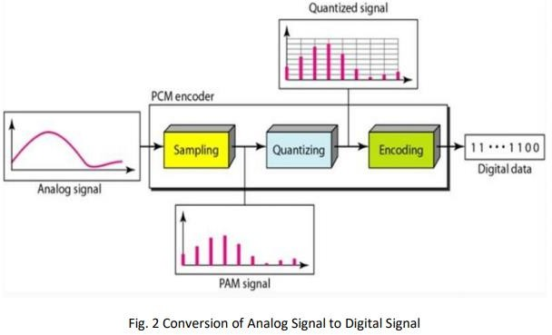

Sampling of analog signal:

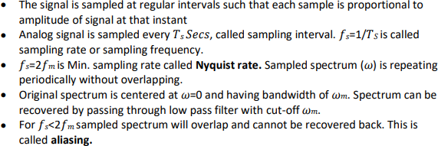

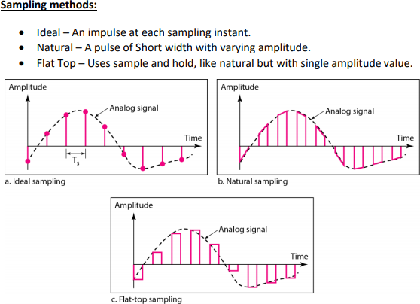
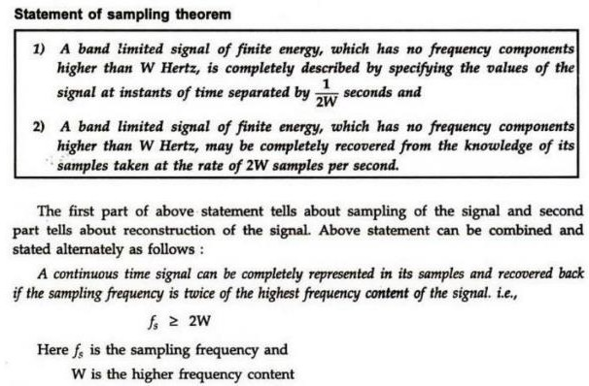

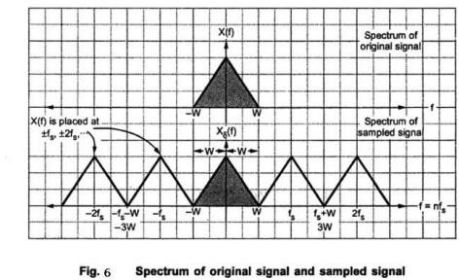
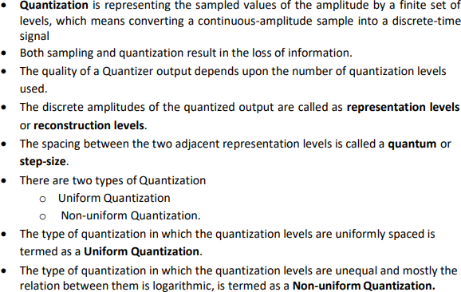
Quantization:

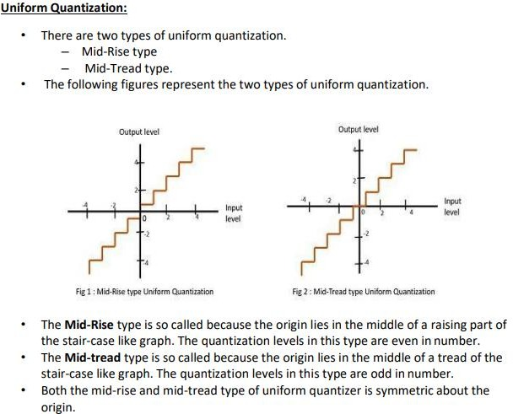

Coding of Quantized Samples(Encoding):
  - The coding process in an A/D converter assigns a unique binary number to each quantization level. If we have L levels we need at least L different binary numbers .
  - With a word length of “b” bits we can create 2^{b} different binary numbers
  - Hence we have 2^{b} >= L or equivalently b>= log2L.
  - For example if we have 16 quantized voltage level then we need at least 4 bits to encode each quantized voltage level with a unique binary code

Digital to Analog Conversion :
  - To convert a Digital signal into an Analog signal we can use a Digital to analog converter(D/A)
  - For a practical view point the simplest D/A converter is the zero order hold circuit which simply holds constant value of one sample until the next one is received.
  - Some practical example of Digital to analog converter circuit is R-2R ladder and weighted resistor D/A converter.

Analysis of Digital Signals and Systems Vs Discrete Time Signals and Systems:
We have seen that a digital signal is defined as a function of an integer independent variable and its values are taken from a finite set of possible values. The usefulness of such signals is a consequence of the possibilities offered by digital computers. Computers operate on numbers which are represented by a string of 0’s and 1’s. The length of this string(word length) is fixed and finite and usually is 8, 16, 32 bits
.The effects of finite word length in computations cause complications in the analysis of digital signal processing systems. To avoid these complications we neglect the quantized nature of digital signals and systems in much of our analysis and consider then as discrete- time signals and systems.

UNIT- 2

Representation of Discrete time signals:
There are different types of representation for discrete time signals. They are
- Graphical representation
- Functional representation
- Tabular representation
- Sequence representation
Graphical representation : Let us consider a signal x(n) with values x(-1)=1; x(0)=2; x(1)=2; x(2)=0.5 and x(3)=1.5 .This discrete time signal can be represented graphically as shown
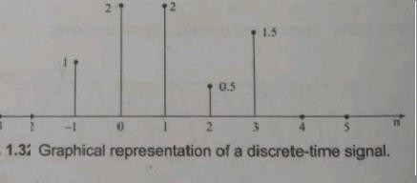

Functional Representation :
The discrete time signal shown in fig 1.3 can be represented as below
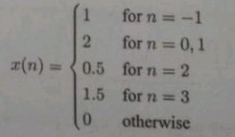

Tabular representation :
The discrete time signal can also be represented as

n | -1 | 0 | 1 | 2 | 3
X(n) | 1 | 2 | 2 | 0.5 | 1.5

Sequence Representation:
A finite duration sequence with time origin(n=0) indicated by the symbol ↑ is represented as X(n)={1, 2, 2 , 0.5 , 1.5 }
↑

Elementary Discrete- time signals
Unit step sequence: The unit step sequence is defined as u(n) = 1 for n ≥ 0
= 0 for n ≤ 0
The graphical representation of u(n) as shown
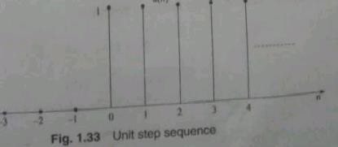

Unit Ramp Sequence :
The unit ramp sequence is defined as
r(n)= n for n≥0
= 0 for n≤ 0 The graphical representation of r(n) is shown
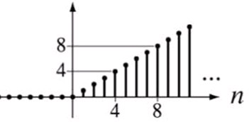

Unit impulse sequence:
The unit impulse sequence is defined as

δ [ n ]= 1 for n=0
= 0 for n ≠ 0
The graphical representation of δ [ n ] is shown

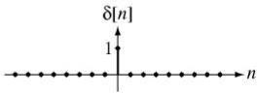
The unit impulse function has the following properties
(𝑛) = (𝑛) − (𝑛 − 1)

Exponential Sequence:
It is defined as x(n) = a^{n} for all n
Case 1: If a is real x[n] is real exponential For a>1
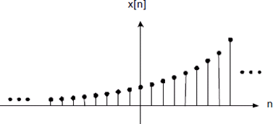
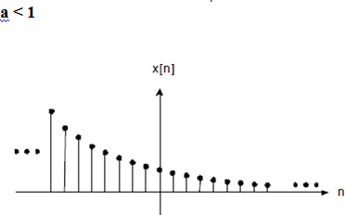

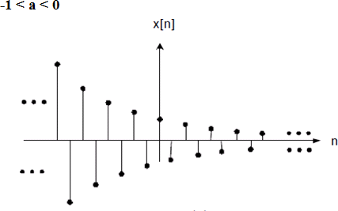
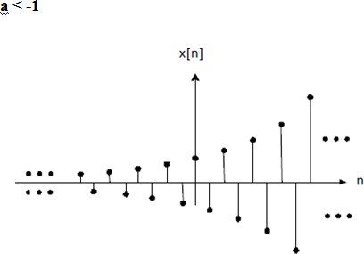

Case 2: If “a” is complex valued then a can be expressed as a = re^{jθ}, so that x[n] can be represented as [𝑛] = 𝑟𝑛𝑒𝑗𝑛𝜃
= [cos 𝑛𝜃 + 𝑗 sin 𝑛𝜃]

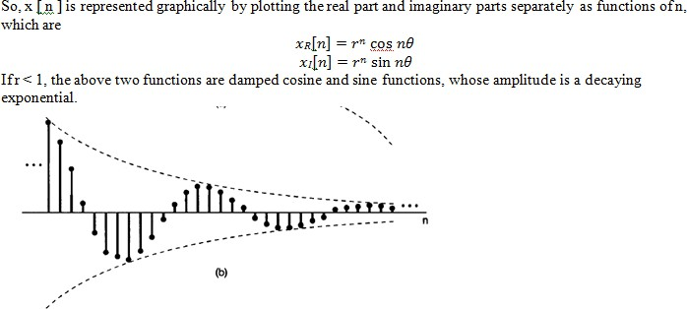
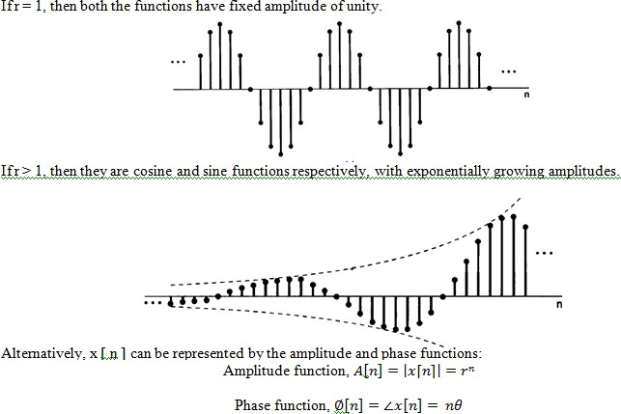

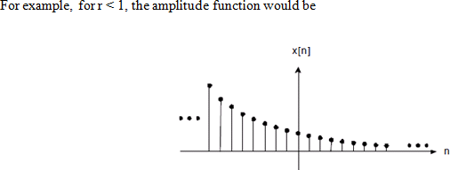

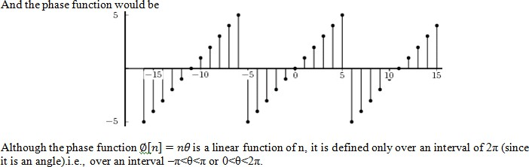

Classification of Discrete time signal:
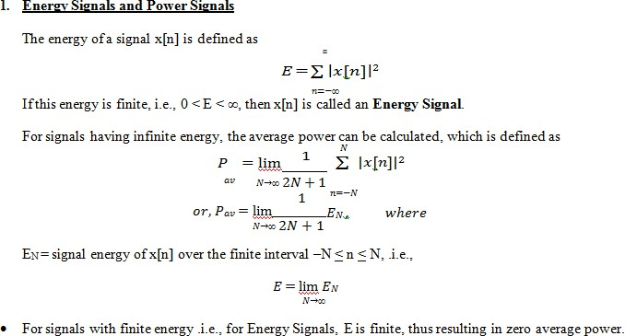

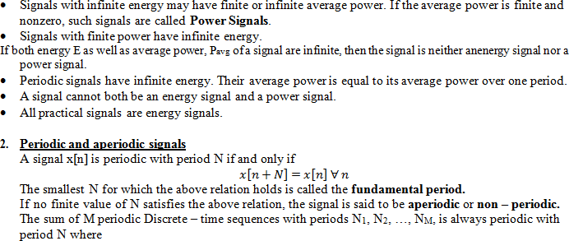

N= LCM ( N1,N2, NM )
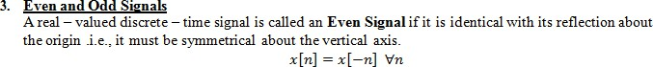
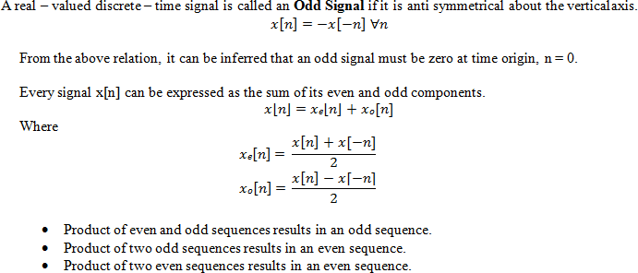
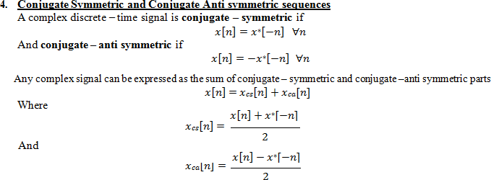

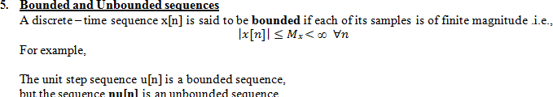

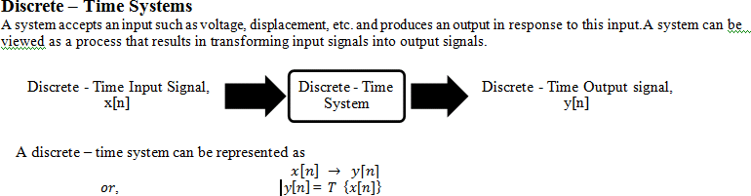

Classification of Discrete time systems
Discrete time system are classified according to their general properties and characteristics. They are
- Static and Dynamic systems
- Causal and Non causal systems
- Linear and Non-linear systems
- Time invariant and Time variant systems
- FIR and IIR systems
- Stable and Unstable system

Static and Dynamic systems
  - A discrete time system is called static or memory less if its output at any instant “n” depends on the input samples at the same time , but not on the past or future samples of the input.
  - In any other case the system is said to be dynamic or to have memory.
The system described by the following equations
y(n)= ax(n)
y(n)= a x²(n)
are static.
On the other hand , the systems described by the following euations
y(n)= x(n-1) + x(n-2)
y(n)= x(n+1) + x(n)

are dynamic systems.

Causal and Non causal Systems
  - A system is said to be causal if the output of the system at any instant of time “n” depends only at present and past inputs, but does not depend on future inputs. This can be represented mathematically as
y(n)= F[x(n), x(n-1),x(n-2)… ]
  - If the output of a system depends on future inputs, the system is said to be non causal or anticipatory.
Example
y(n)= x(n) + x(n-1) causal system y(n)= x(2n) Non causal system
  - It is not possible to build a practical system that responds to future inputs .Hence a non causal system is physically unrealizable.

Linear and Non linear Systems
  - A system that satisfies the superposition principles is said to be a linear system. Superposition principle states that the response of the system to a weighted sum of signals should be equal to the corresponding weighted sum of the outputs of the system to each of the individual signals.
  - A system is linear if and only if
T[a1x1(n) + a2x2(n)] = a1T [x1(n)] + a2T[x2(n)] For any arbitary constant a1 and a2
  - A system that does not satisfy the superposition principle is called non linear.

Time variant and Time invariant systems
A system is said to be time- invariant or shift invariant if the characteristics of the system do not change with time. For a time invariant system if y(n) is the response of the system to the input x(n), then the response of a system to the input x(n-k) is y(n-k). That is if the input sequence is shifted by “k” samples the generated output sequence is the original sequence shifted by “k” samples.
To test if any given system is time invariant, first apply an arbitrary sequence x(n) and find y(n). Now delay the input sequence by “k” samples and find output sequence
y(n,k) =T[x(n-k)]
Delay the output sequence by “k” samples , denote it as y(n-k) , if
y(n,k) = y(n-k) for all possible value of k , the system is time invariant.

On the other hand if the output y(n,k)≠y(n-k) even for one vale of k, the system is time variant.

FIR and IIR system
FIR system: If the impulse response of the system is of finite duration, then the system is called a Finite Impulse Response.
An example of FIR system is
h(n)={ 1 for n=-1,2
0 , otherwise
IIR system: An infinite impulse response (IIR) system has an impulse response for infinite duration.
An example for an IIR system is
h(n)= a^{n} u(n)
Stable and Unstable systems:
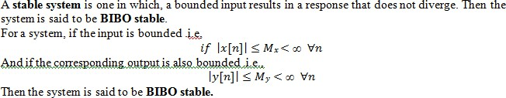

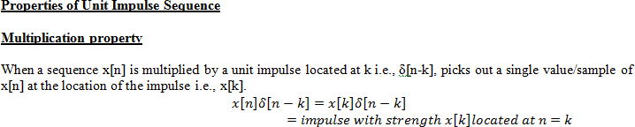

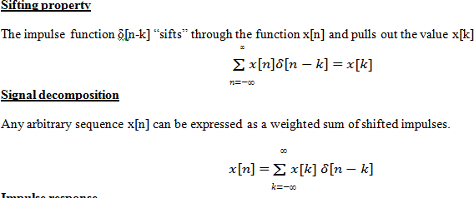
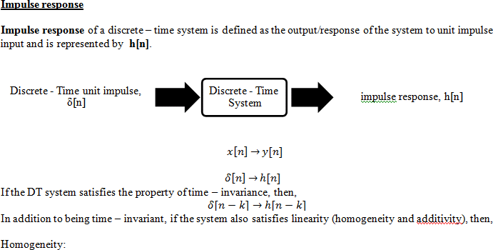

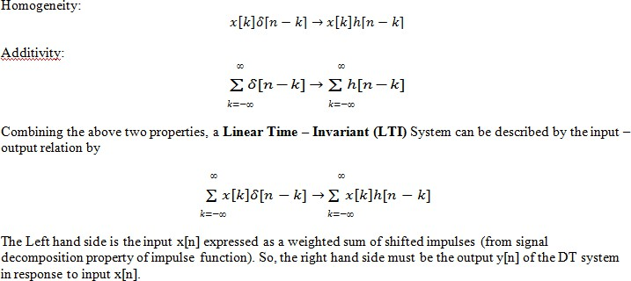

Interconnection of Discrete time system
- Parallel connection of systems
Consider two LTI systems with impulse response h1(n) and h2(n) connected in parallel as shown
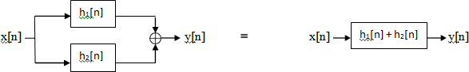

If two systems are connected I parallel, then the overall impulse response is equal to sum of two impulse response.
- Cascade connection of two systems
Consider two LTI systems with impulse responses h1(n) and h2(n) connected in cascade as shown

The impulse response of of two LTI system connected in cascade is the convolution of the individual impulse responses.

Response of LTI system to arbitrary inputs using convolution sum
The input signal x(n) is the system excitation , and y(n) is the system response
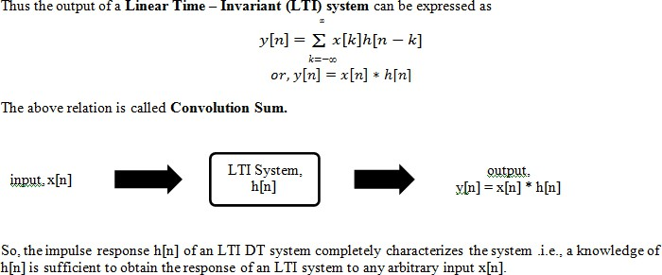

Convolution and interconnection of LTI system properties
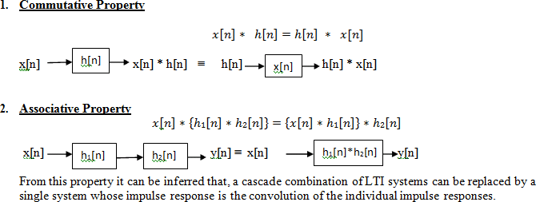

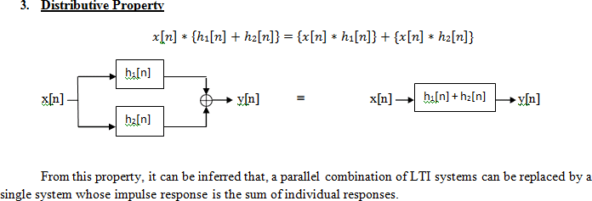
Study system with finite duration and infinite duration impulse response
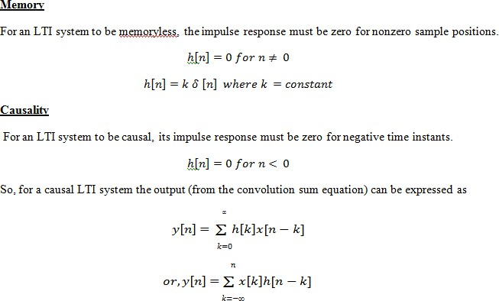

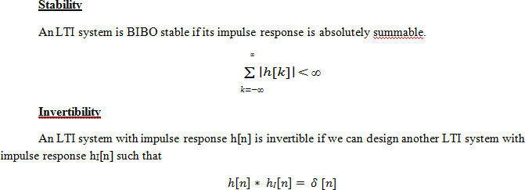

Study systems with finite duration and infinite duration impulse response.

Finite impulse Response(FIR):
If the impulse response of the system is of finite duration, then the system is called a Finite Impulse Response. An example of a FIR system is
h(n)= { 1 for n=-1,2
2 for n=1
0 otherwise }

Infinite Impulse Response(IIR):
An Infinite Impulse Response (IIR) system has an impulse response for infinite duration. An example of an IIR system is
h(n)= a^{n} u(n)

UNIT 3 – Z-Transform

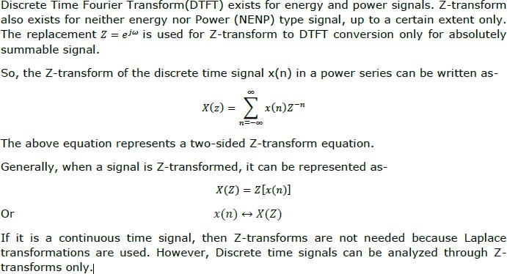

Region of Convergence:
Region of Convergence is the range of complex variable Z in the Z-plane. The Z- transformation of the signal is finite or convergent. So, ROC represents those set of values of Z, for which X(Z) has a finite value.
Properties of ROC
- ROC does not include any pole.
- For right-sided signal, ROC will be outside the circle in Z-plane.
- For left sided signal, ROC will be inside the circle in Z-plane.
- For stability, ROC includes unit circle in Z-plane.
- For Both sided signal, ROC is a ring in Z-plane.
- For finite-duration signal, ROC is entire Z-plane. The Z-transform is uniquely characterized by:
  - Expression of X(Z)
  - ROC of X(Z)

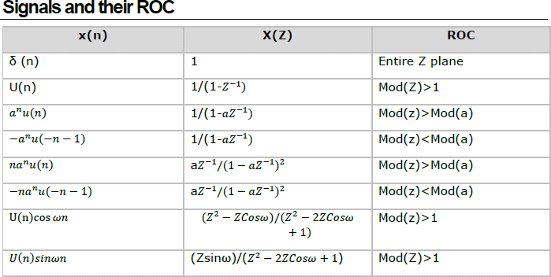

3.1.1 Direct Z-transform
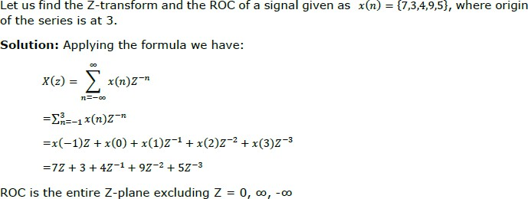

Properties of Z-Transform:

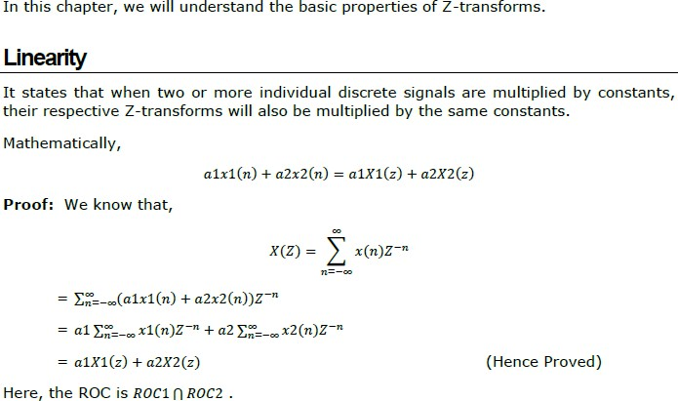

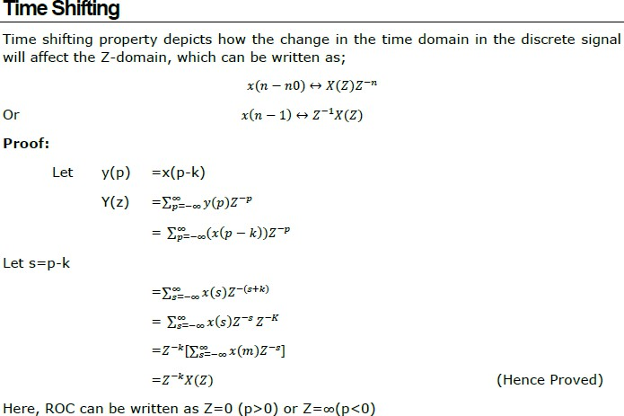

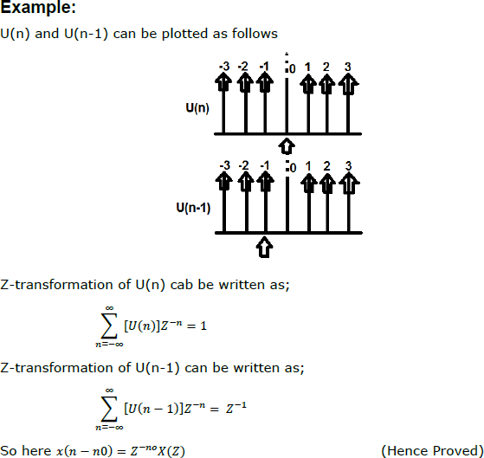
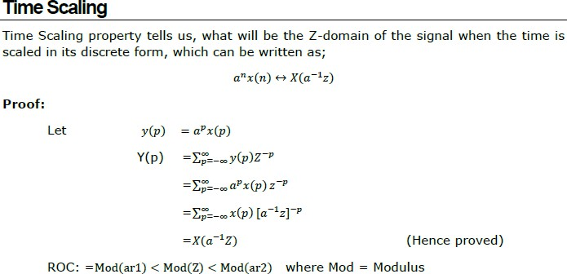

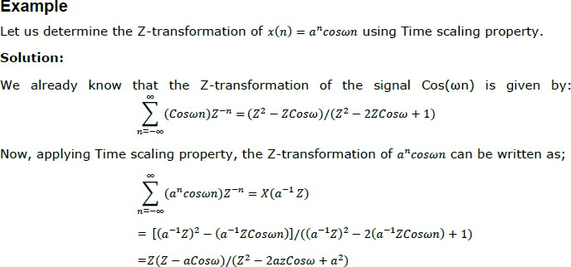
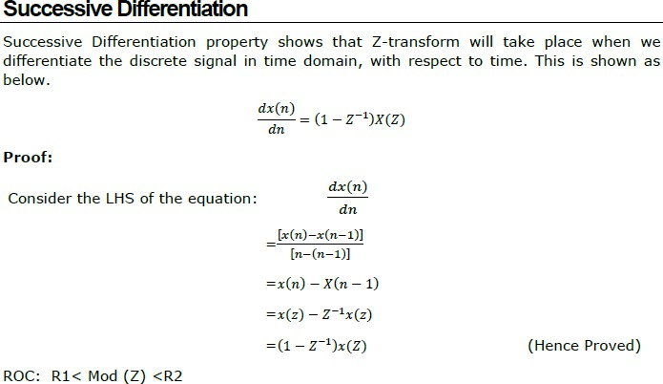

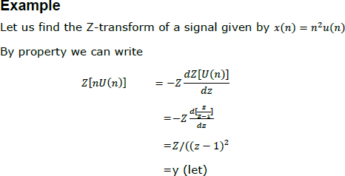
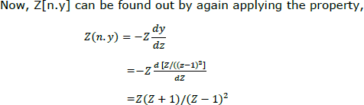
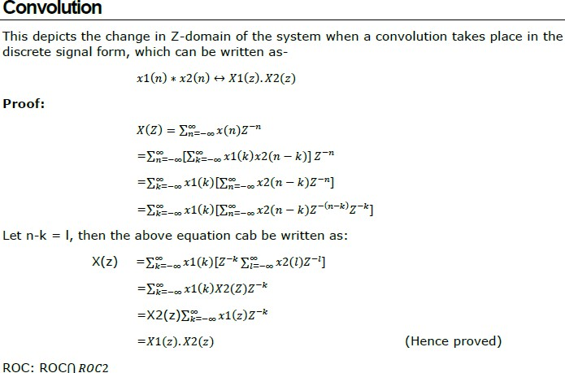

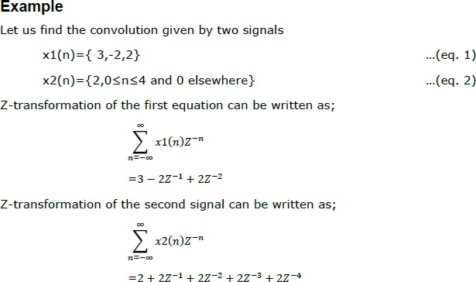
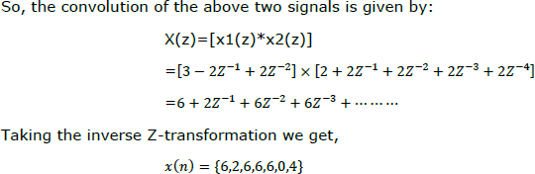
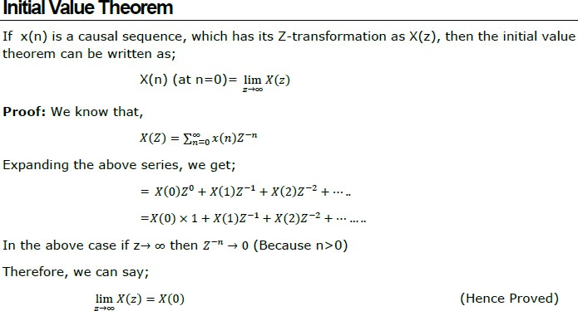

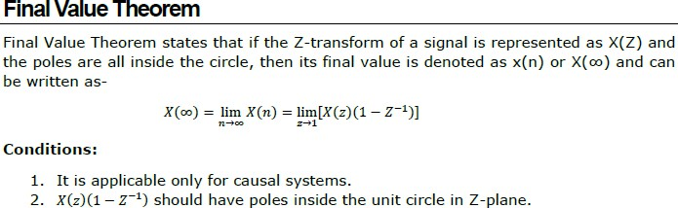
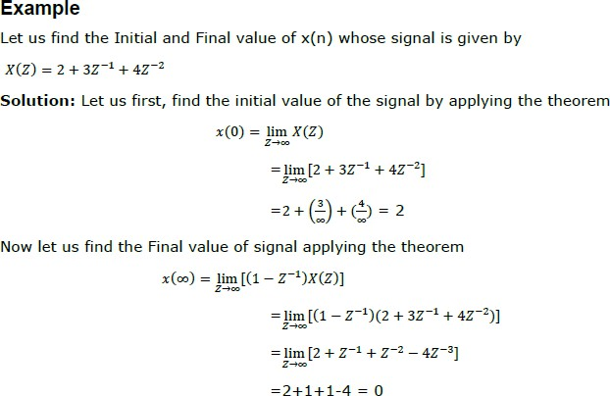
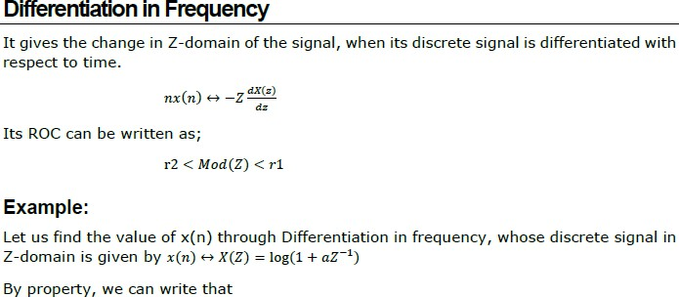

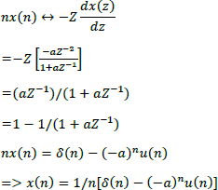
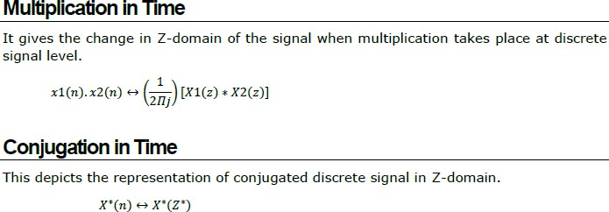
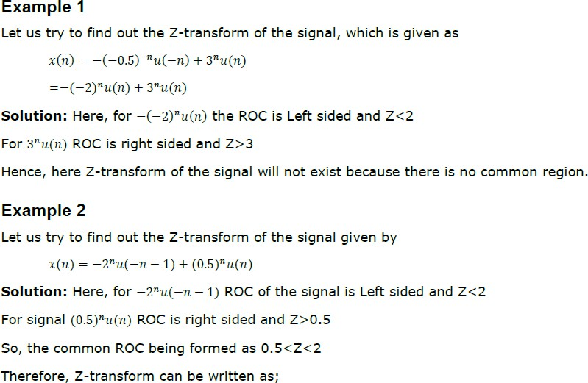

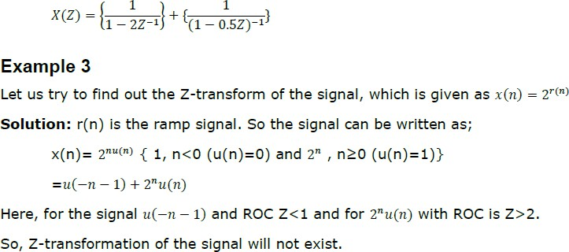

Rational Z-transform. :

Poles & Zeros:
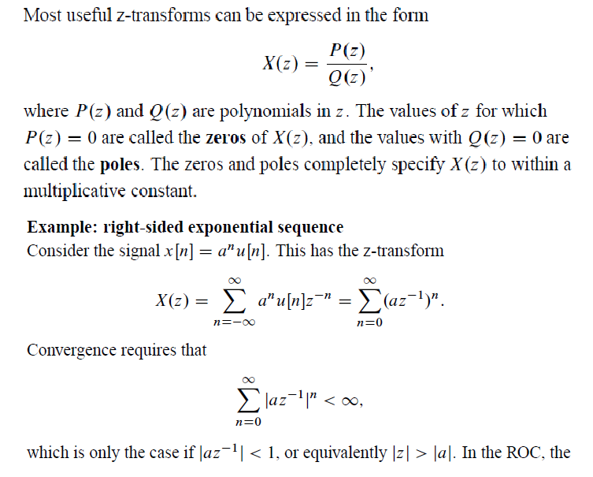

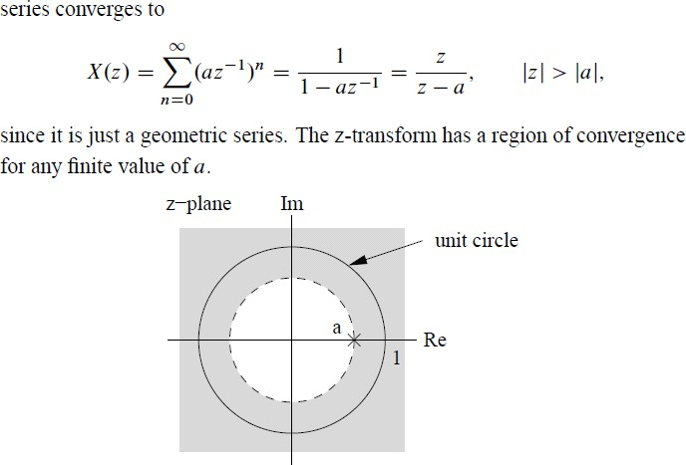

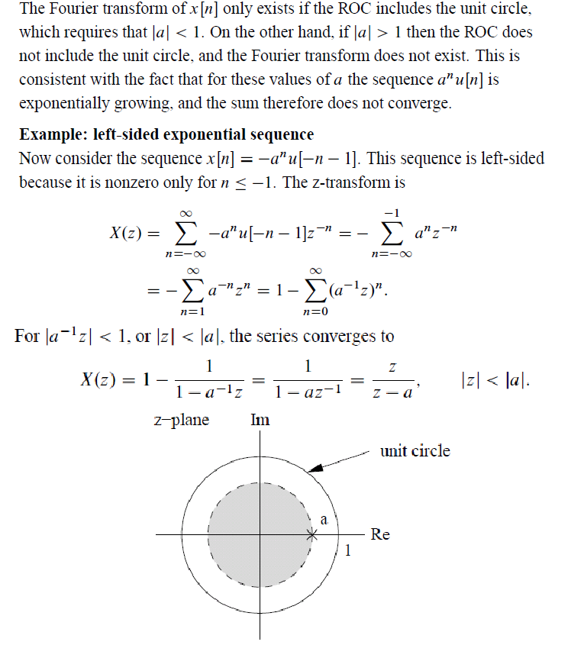

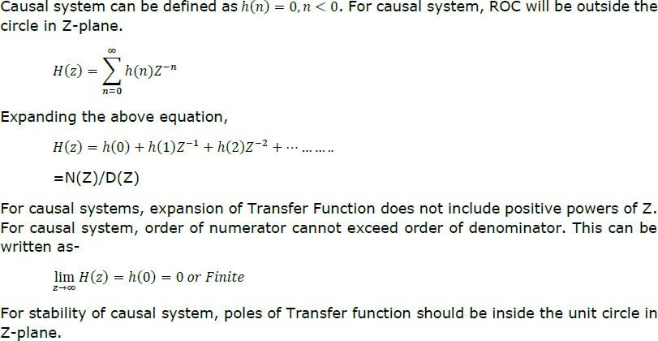
Pole location & Time domain behavior for causal Signal:

Inverse Z-Transform
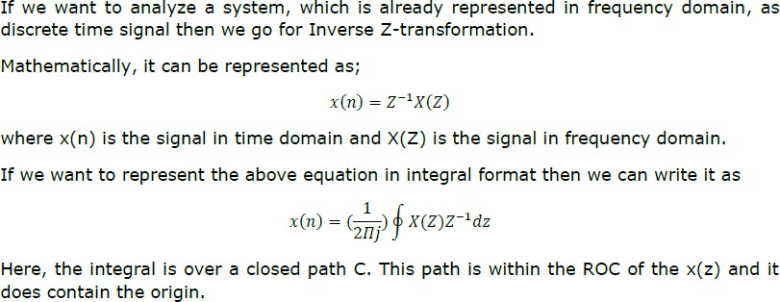
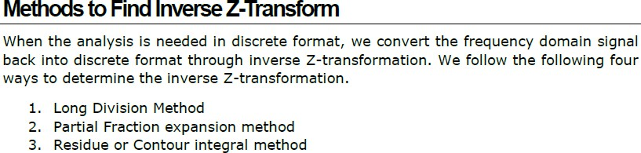

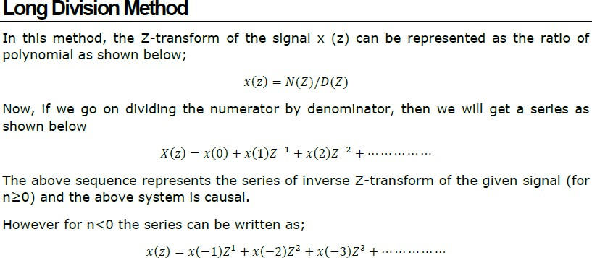
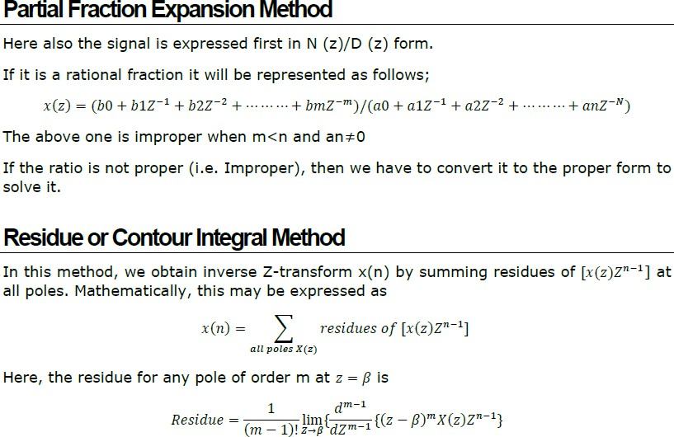

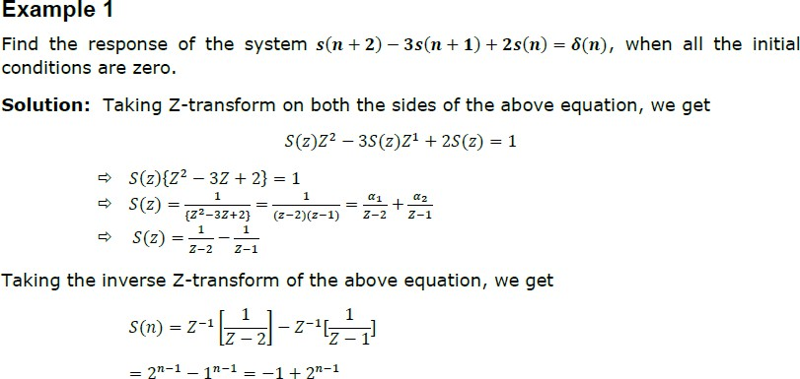

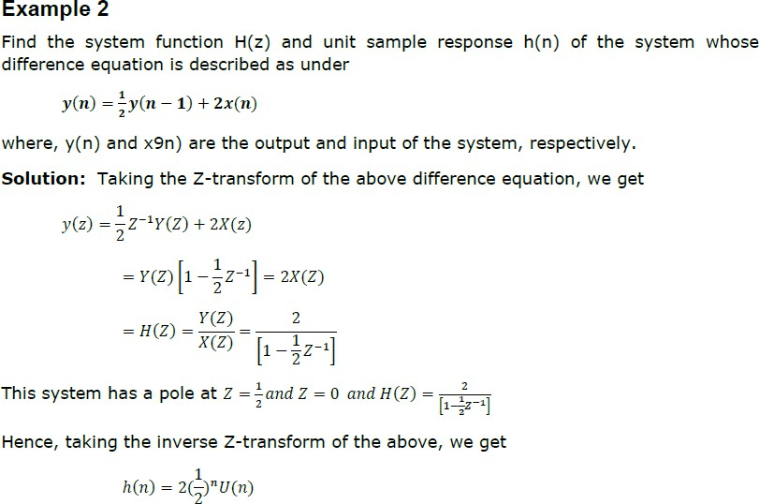

UNIT-4
www.vidyarthiplus.com
EE6403 DISCRETE TIME SYSTEMS & SIGNAL PROCESSING
Any signal can be decomposed in terms of sinusoidal (or complex exponential) components. Thus the analysis of signals can be done by transforming time domain signals into frequency domain and vice-versa. This transformation between time and frequency domain is performed with the help of Fourier Transform(FT) But still it is not convenient for computation by DSP processors hence Discrete Fourier Transform(DFT) is used.
Time domain analysis provides some information like amplitude at sampling instant but does not convey frequency content & power, energy spectrum hence frequency domain analysis is used.
For Discrete time signals x(n) , Fourier Transform is denoted as x(ω) & given by
∞

X(ω) = ∑ x (n) e ^{–jωn} FT (1)
n=-∞
DFT is denoted by x(k) and given by (ω= 2 ∏ k/N)
N-1

X(k) = ∑ x (n) e ^{–j2} ∏ ^{kn} / ^{N} DFT (2)
n=0
IDFT is given as

x(n) =1/N ∑ X (k) e ^{j2} ∏ ^{kn} / ^{N} IDFT……(3) DIFFERENCE BETWEEN FT & DFT
S. No | Fourier Transform (FT) | Discrete Fourier Transform (DFT)
1 | FT x(ω) is the continuous function of x(n). | DFT x(k) is calculated only at discrete values of ω. Thus DFT is discrete in nature.
2 | The range of ω is from - ∏ to ∏ or 0 to 2∏. | Sampling is done at N equally spaced points over period 0 to 2∏. Thus DFT is sampled version of FT.
3 | FT is given by equation (1) | DFT is given by equation (2)

www.vidyarthiplus.com
EE6403 DISCRETE TIME SYSTEMS & SIGNAL PROCESSING
4 FT equations are applicable to most DFT equations are applicable to causal, finite

 | of infinite sequences. | duration sequences
5 | In DSP processors & computers applications of FT are limited because x(ω) is continuous function of ω. | In DSP processors and computers DFT‘s are mostly used.  APPLICATION  - Spectrum Analysis  - Filter Design

Tutorial problems:
Q) Prove that FT x(ω) is periodic with period 2∏.
Q) Determine FT of x(n)= a^{n} u(n) for -1< a < 1.
Q) Determine FT of x(n)= A for 0 ≤ n ≤ L-1.
Q) Determine FT of x(n)= u(n)
Q) Determine FT of x(n)= δ(n)
Q) Determine FT of x(n)= e^{–at} u(t)

CALCULATION OF DFT & IDFT
For calculation of DFT & IDFT two different methods can be used. First method is using mathematical equation & second method is 4 or 8 point DFT. If x(n) is the sequence of N samples then consider WN= e ^{–j2} ∏ / ^{N} (twiddle factor)

Four POINT DFT ( 4-DFT)
S. No | WN=W4=e –j ∏/2 | Angle | Real | Imaginary | Total
1 | W4 0 | 0 | 1 | 0 | 1
2 | W4 1 | - ∏/2 | 0 | -j | -j
3 | W4 2 | - ∏ | -1 | 0 | -1
4 | W4 3 | - 3 ∏ /2 | 0 | J | J

k=0 | n=0  W4 0 | n=1  W4 0 | n=2  W4 0 | n=3  W4 0
[WN] = | W4 0 | W4 1 | W4 2 | W4 3
k=2
k=3
Thus 4 point DFT is given as XN = [WN ] XN
SCE www.vidyarthiplus.co4m0 DEPT OF EEE
W4 0 | W4 2 | W4 4 | W4 6
W4 0 | W4 3 | W4 6 | W4 9

 | 1 | 1 | 1 | 1
[WN] = | 1 | –j | -1 | j
 | 1 | -1 | 1 | -1
 | 1 | j | -1 | -j

SCE www.vidyarthiplus.co4m1 DEPT OF EEE

EIGHT POINT DFT ( 8-DFT)
www.vidyarthiplus.com
EE6403 DISCRETE TIME SYSTEMS & SIGNAL PROCESSING

S. No | WN = W8= e –j ∏/4 | Angle | Magnitude | Imaginary | Total
1 | W8 0 | 0 | 1 | ---- | 1
2 | W8 1 | - ∏/4 | 1/√2 | -j 1/√2 | 1/√2 -j 1/√2
3 | W8 2 | - ∏/2 | 0 | -j | -j
4 | W8 3 | - 3 ∏ /4 | -1/√2 | -j 1/√2 | - 1/√2 -j 1/√2
5 | W8 4 | - ∏ | -1 | ---- | -1
6 | W8 5 | - 5∏ / 4 | -1/√2 | +j 1/√2 | - 1/√2 + j 1/√2
7 | W8 6 | - 7∏ / 4 | 0 | J | J
8 | W8 7 | - 2∏ | 1/√2 | +j 1/√2 | 1/√2 + j 1/√2
Remember that W8 0 = W8 8 = W8 16 = W8 24 = W8 32 = W8 40 (Periodic Property) Magnitude and phase of x(k) can be obtained as,
|x(k)| = sqrt ( Xr(k)² + XI(k)²)
Angle x(k) = tan ⁻¹ (XI(k) / XR(k))
Tutorial problems:
Q) | Compute DFT of x(n) = {0,1,2,3} | Ans: x4=[6, -2+2j, -2, -2-2j ]
Q) | Compute DFT of x(n) = {1,0,0,1} | Ans: x4=[2, 1+j, 0, 1-j ]
Q) | Compute DFT of x(n) = {1,0,1,0} | Ans: x4=[2, 0, 2, 0 ]
Q) | Compute IDFT of x(k) = {2, 1+j, 0, 1-j } | Ans: x4=[1,0,0,1]

DIFFERENCE BETWEEN DFT & IDFT

S.No | DFT (Analysis transform) | IDFT (Synthesis transform)
1 | DFT is finite duration discrete frequency  sequence that is obtained by sampling one period of FT. | IDFT is inverse DFT which is used to calculate time  domain representation (Discrete time sequence) form of x(k).
2 | DFT equations are applicable to causal finite duration sequences. | IDFT is used basically to determine sample response of a filter for which we know only transfer function.
3 | Mathematical Equation to calculate DFT is given by  N-1  X(k) = ∑ x (n) e ^{–j2} ∏ ^{kn} / ^{N}  n=0 | Mathematical Equation to calculate IDFT is given by  N-1  x(n) = 1/N ∑ X (k)e ^{j2} ∏ ^{kn} / ^{N}  n=0
4 | Thus DFT is given by  X(k)= [WN][xn] | In DFT and IDFT difference is of factor 1/N & sign of exponent of twiddle factor.  Thus  x(n)= 1/N [ WN]⁻¹[XK]

PROPERTIES OF DFT
www.vidyarthiplus.com
EE6403 DISCRETE TIME SYSTEMS & SIGNAL PROCESSING
DFT

Periodicity
x(n) x(k)

N

Let x(n) and x(k) be the DFT pair then if
x(n+N) = x(n) for all n then
X(k+N) = X(k) for all k
Thus periodic sequence xp(n) can be given as
∞
xp(n) = ∑ x(n-lN) l=-∞

Linearity
The linearity property states that if

DFT
x1(n) X1(k) And

N DFT
x2(n) X2(k) Then

N
Then DFT
a1 x1(n) + a2 x2(n) a1 X1(k) + a2 X2(k) N
DFT of linear combination of two or more signals is equal to the same linear combination of DFT of individual signals.

Circular Symmetries of a sequence
  - A sequence is said to be circularly even if it is symmetric about the point zero on the circle. Thus X(N-n) = x(n)

  - A sequence is said to be circularly odd if it is anti symmetric about the point zero on the circle. Thus X(N-n) = - x(n)

  - A circularly folded sequence is represented as x((-n))N and given by x((-n))N = x(N-n).
  - Anticlockwise direction gives delayed sequence and clockwise direction gives advance sequence. Thus delayed or advances sequence x`(n) is related to x(n) by the circular shift.

Symmetry Property of a sequence

  - Symmetry property for real valued x(n) i.e xI(n)=0
This property states that if x(n) is real then X(N-k) = X*(k)=X(-k)
SCE www.vidyarthiplus.co4m2 DEPT OF EEE

Real and even sequence x(n) i.e xI(n)=0 & XI(K)=0
www.vidyarthiplus.com
EE6403 DISCRETE TIME SYSTEMS & SIGNAL PROCESSING
This property states that if the sequence is real and even x(n)= x(N-n) then DFT becomes N-1
X(k) = ∑ x(n) cos (2∏kn/N) n=0

Real and odd sequence x(n) i.e xI(n)=0 & XR(K)=0
This property states that if the sequence is real and odd x(n)=-x(N-n) then DFT becomes N-1
X(k) = -j ∑ x(n) sin (2∏kn/N) n=0

Pure Imaginary x(n) i.e xR(n)=0
This property states that if the sequence is purely imaginary x(n)=j XI(n) then DFT becomes N-1
XR(k) = ∑ xI(n) sin (2∏kn/N) n=0

N-1
XI(k) = ∑ xI(n) cos (2∏kn/N) n=0

Circular Convolution
The Circular Convolution property states that if

DFT
x1(n) X1(k) And

N

DFT
x2(n) X2(k) Then

N DFT
Then x1(n) x2(n) x1(k) x2(k) N
It means that circular convolution of x1(n) & x2(n) is equal to multiplication of their DFT‘s. Thus circular convolution of two periodic discrete signal with period N is given by
SCE www.vidyarthiplus.co4m3 DEPT OF EEE

N-1
www.vidyarthiplus.com
EE6403 DISCRETE TIME SYSTEMS & SIGNAL PROCESSING

y(m) = ∑ x1 (n) x2 (m-n)N (4)
n=0
Multiplication of two sequences in time domain is called as Linear convolution while Multiplication of two sequences in frequency domain is called as circular convolution. Results of both are totally different but are related with each other.

x(k) x(k)*h(k) x(n)*h(n)
x(n)
IDFT
DFT
*
h(n)
DFT
h(k)

There are two different methods are used to calculate circular convolution
- Graphical representation form
- Matrix approach

DIFFERENCE BETWEEN LINEAR CONVOLUTION & CIRCULAR CONVOLUTION

 | S. No | Linear Convolution | Circular Convolution
 | 1 | In case of convolution two signal sequences input  signal x(n) and impulse response h(n) given by the same system, output y(n) is calculated | Multiplication of two DFT‘s is called as  circular convolution.
 | 2 | Multiplication of two sequences in time domain is  called as Linear convolution | Multiplication of two sequences in frequency  domain is called as circular convolution.
 | 3 | Linear Convolution is given by the equation y(n)  = x(n) * h(n) & calculated as  ∞  y(n) = ∑ x (k) h(n – k ) k= -∞ | Circular Convolution is calculated as  N-1  y(m) = ∑ x1 (n) x2 (m-n)N n=0
 | 4 | Linear Convolution of two signals returns N-1  elements where N is sum of elements in both sequences. | Circular convolution returns same number of  elements that of two signals.

Tutorial problems:
Q) The two sequences x1(n)={2,1,2,1} & x2(n)={1,2,3,4}. Find out the sequence x3(m) which is equal to circular convolution of two sequences. Ans: X3(m)={14,16,14,16}
SCE www.vidyarthiplus.co4m4 DEPT OF EEE

Q) x1(n)={1,1,1,1,-1,-1,-1,-1} & x2(n)={0,1,2,3,4,3,2,1}. Find out the sequence x3(m) which is equal to circular convolution of two sequences. Ans: X3(m)={-4,-8,-8,-4,4,8,8,4}
www.vidyarthiplus.com
EE6403 DISCRETE TIME SYSTEMS & SIGNAL PROCESSING

Q) Perform Linear Convolution of x(n)={1,2} & h(n)={2,1} using DFT & IDFT.

Q) Perform Linear Convolution of x(n)={1,2,2,1} & h(n)={1,2,3} using 8 Pt DFT & IDFT.

Multiplication
The Multiplication property states that if

DFT
X1(n) x1(k) and

N

DFT
X2(n) x2(k) then

N
DFT
Then x1(n) x2(n) 1/N x1(k) x2(k) N
It means that multiplication of two sequences in time domain results in circular convolution of their DFT‘s in frequency domain.

Time reversal of a sequence
The Time reversal property states that if

DFT
X(n) x(k) and

N

DFT
Then x((-n))_{N} = x(N-n) x((-k))_{N} = x(N-k) N
It means that the sequence is circularly folded its DFT is also circularly folded.

Circular Time shift
The Circular Time shift states that if

DFT
X(n) x(k) And

N DFT
Then x((n-l))N x(k) e ^{–j2} ∏ ^{k} ^{l} / ^{N}

N

Thus shifting the sequence circularly by ‗l‘ samples is equivalent to multiplying its DFT by e –j2 ∏ k l / N
SCE www.vidyarthiplus.co4m5 DEPT OF EEE

Circular frequency shift
www.vidyarthiplus.com
EE6403 DISCRETE TIME SYSTEMS & SIGNAL PROCESSING
The Circular frequency shift states that if

DFT
X(n) x(k) And

N DFT
Then x(n) e ^{j2} ∏ ^{l} ^{n} / ^{N} x((n-l))_{N} N
Thus shifting the frequency components of DFT circularly is equivalent to multiplying its time domain sequence by e ^{–j2} ∏ ^{k} ^{l} / ^{N}

Complex conjugate property
The Complex conjugate property states that if

DFT
X(n) x(k) then

N DFT
x*(n) x*((-k))_{N} = x*(N-k) And N

DFT
x*((-n))N = x*(N-k) x*(k) N

Circular Correlation
The Complex correlation property states

DFT
r_{xy}(l) R_{xy}(k)= x(k) Y*(k)

N
Here rxy(l) is circular cross correlation which is given as

N-1
rxy(l) = ∑ x (n) y*((n – l ))N
n=0
This means multiplication of DFT of one sequence and conjugate DFT of another sequence is equivalent to circular cross-correlation of these sequences in time domain.

Parseval’s Theorem
The Parseval‘s theorem states

N-1
∑ X(n) y*(n) = 1/N ∑ x (k) y*(k) n=0 n=0
SCE www.vidyarthiplus.co4m6 DEPT OF EEE

This equation give energy of finite duration sequence in terms of its frequency components.
www.vidyarthiplus.com
EE6403 DISCRETE TIME SYSTEMS & SIGNAL PROCESSING

APPLICATION OF DFT

- DFT FOR LINEAR FILTERING
Consider that input sequence x(n) of Length L & impulse response of same system is h(n) having M samples. Thus y(n) output of the system contains N samples where N=L+M-1. If DFT of y(n) also contains N samples then only it uniquely represents y(n) in time domain. Multiplication of two DFT‘s is equivalent to circular convolution of corresponding time domain sequences. But the length of x(n) & h(n) is less than N. Hence these sequences are appended with zeros to make their length N called as
―Zero padding‖. The N point circular convolution and linear convolution provide the same sequence. Thus linear convolution can be obtained by circular convolution. Thus linear filtering is provided by DFT.

When the input data sequence is long then it requires large time to get the output sequence. Hence other techniques are used to filter long data sequences. Instead of finding the output of complete input sequence it is broken into small length sequences. The output due to these small length sequences are computed fast. The outputs due to these small length sequences are fitted one after another to get the final output response.

UNIT- 5

Efficient Computation of the DFT: FFT algorithms
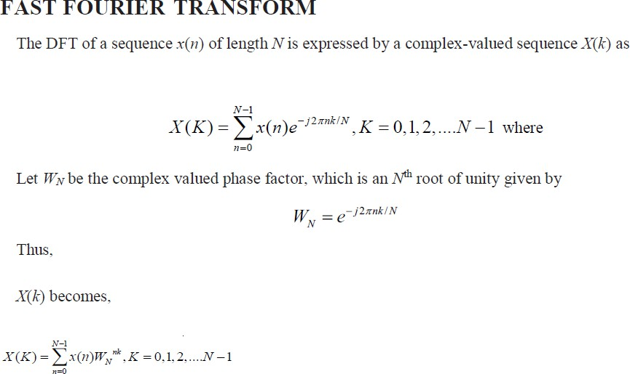
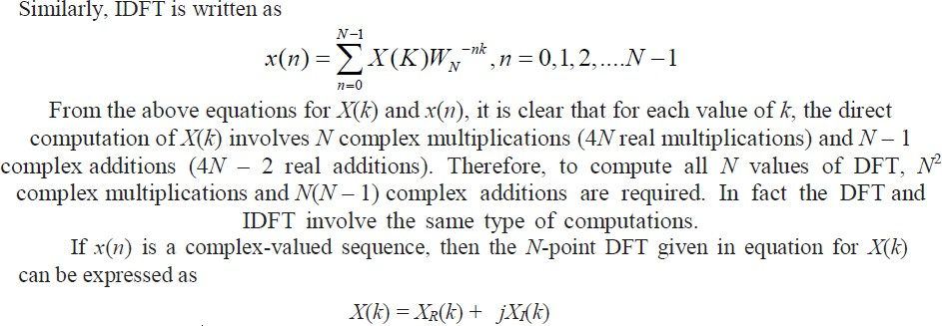
The N-point DFT of a sequence x(n) converts the time domain N-point sequence x(n) to a frequency domain N-point sequence X(k). The direct computation of an N-point DFT requires N x N complex multiplications and N(N – 1) complex additions. Many methods were developed for reducing the number of calculations involved. The most popular of these is the Fast Fourier Transform (FFT), a method developed by Cooley and Turkey. The FFT may be defined as an algorithm (or a method) for computing the DFT efficiently (with reduced number of calculations). The computational efficiency is achieved by adopting a divide and conquer approach. This approach is based on the decomposition of an N-point DFT into successively smaller DFTs and then combining them to give the total transform. Based on this basic approach, a family of computational algorithms were developed and they are collectively known as FFT algorithms. Basically there are two FFT algorithms; Decimation- in-time (DIT) FFT algorithm and Decimation-in-frequency (DIF) FFT algorithm. In this chapter, we discuss DIT FFT and DIF FFT algorithms and the computation of DFT by these methods.

Direct Computation of DFT:
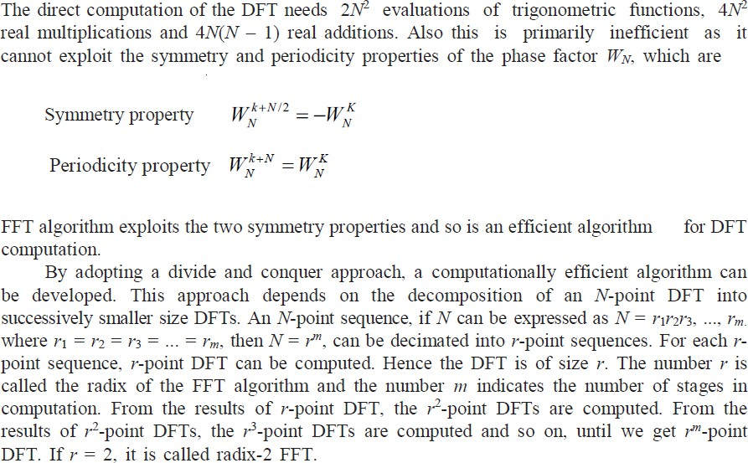

Divide & Conquer approach to computation of the DFT
