RAJAKISHORE CHANDRA ACADEMY OF TECHNOLOGY
(POLYTECHNIC)

DEPARTMENT OF ELECTRONICS AND TELECOMMUNICATION ENGINEERING

LECTURE NOTES
Year & Semester:2nd Year, III Semester Subject Code/
Name: TH-3,
Digital Electronics

Prepared by ER. PRIYA RANJAN SEN
, Lect. (E&TC)

VISION -
To be a centre of excellence in the field of E&TC Engg. by providing quality technical education as well as inculcating entrepreneurial skill, self- learning attitude and human values.

MISSION -

- To create an excellent infrastructure and teaching-learning environment for making the student acquire the knowledge needed.
- To inculcate self-learning attitude, entrepreneurial skill and human values.
- To impart knowledge required for recent & advanced Engg.

PROGRAM EDUCATIONAL OBJECTIVE-

- To apply knowledge of E&TC Engg. and principles of basic science & mathematics for analyzing the circuit of different electronics devices.
- To compete for employment both in public and private sector.
- To pursue higher study in E&TC as well as any other related branch for carrier enhancement.
- To establish own assembly or service section with innovative, entrepreneurial ideas.
- To work with team spirit and social ethics.

PROGRAM SPECIFIC OUTCOME-

- Use techniques and skills to design, analyze, synthesize and simulate electronics components and systems.
- Architect, partition and select appropriate technology for implementation of a specified communication system.

CONTENTS

UNIT 1: Basics of Digital Electronics
  - Number System-Binary, Octal, Decimal, Hexadecimal - Conversion from one system to another number system.
  - Arithmetic Operation-Addition, Subtraction, Multiplication, Division, 1’s & 2’s complement of Binary numbers& Subtraction using complements method
  - Digital Code & its application & distinguish between weighted & non-weight Code, Binary codes, excess-3 and Gray codes.
  - Logic gates: AND,OR,NOT,NAND,NOR, Exclusive-OR, Exclusive-NOR--Symbol, Function, expression, truth table & timing diagram
  - Universal Gates& its Realisation
  - Boolean algebra, Boolean expressions, DeMorgan’s Theorems.
  - Represent Logic Expression: SOP & POS forms
  - Karnaugh map (3 & 4 Variables) & Minimization of logical expressions, don’t care conditions

UNIT 2: Combinational Logic Circuits
  - Half adder, Full adder, Half Subtractor, Full Subtractor, Serial and Parallel Binary 4- bit adder.
  - Multiplexer (4:1), De- multiplexer (1:4), Decoder, Encoder, Digital comparator (3 Bit)
  - Seven segment Decoder
(Definition, relevance, gate level of circuit Logic circuit, truth table, Applications of above)

UNIT 3: Sequential Logic Circuits
  - Principle of flip-flops operation, its Types,
  - SR Flip Flop using NAND, NOR Latch (un clocked)
  - Clocked SR,D,JK,T,JK Master Slave flip-flops-Symbol, logic Circuit, truth table and applications
  - Concept of Racing and how it can be avoided.

UNIT 4: Registers, Memories & PLD
  - Shift Registers-Serial in Serial -out, Serial- in Parallel-out, Parallel in serial out and Parallel in parallel out
  - Universal shift registers-Applications.
  - Types of Counter & applications
  - Binary counter, Asynchronous ripple counter (UP & DOWN), Decade counter. Synchronous counter, Ring Counter.
  - Concept of memories-RAM, ROM, static RAM, dynamic RAM, PS RAM
  - Basic concept of PLD & applications

UNIT 5: A/D & D/A Converters
  - Necessity of A/D and D/A converters.
  - D/A conversion using weighted resistors methods.
  - D/A conversion using R-2R ladder (Weighted resistors) network.

  - A/D conversion using counter method.
  - A/D conversion using Successive approximate method

UNIT 6: Logic Families
  - Various logic families &categories according to the IC fabrication process
  - Characteristics of Digital ICs- Propagation Delay, fan-out, fan-in, Power Dissipation, Noise Margin, Power Supply requirement &Speed with Reference to logic families.
  - Features, circuit operation &various applications of TTL (NAND), CMOS (NAND & NOR)

PROGRAM OUTCOME (PO)-

PO1: Basic and Discipline specific knowledge- Apply knowledge of basic mathematics, science and engineering fundamentals and engineering specialization to solve the engineering problems.

PO2: Problem Analysis- Identify and analyze well defined engineering problems using codified standard methods.
PO3: Design/ development of solutions- Design solutions for well-defined technical problems and assist with the design of systems components or processes to meet specified needs.

PO4: Engineering Tools, Experimentation and Testing- Apply modern engineering tools and appropriate technique to conduct standard tests and measurements.

PO5: Engineering Practices for society, sustainability and environment- Apply appropriate technology in context of society, sustainability, environment and ethical practices.

PO6: Project Management- Use engineering management principles individually, as a team member or a leader to manage projects and effectively communicate about well-defined engineering activities.
PO7: Life-long learning- Ability to analyze individual needs and engage in updating in the context of technological changes.

COURSE OUTCOME (CO)-
CO1- Apply the knowledge of Boolean algebra and K-map for logic function minimization.
CO2- Design combinational circuits and sequential circuits and implement them with logic gates.
CO3- Implement logic gates by using different logic family.
CO4- Apply the fundamental knowledge of Analog and Digital Electronics for analog to digital conversion and vice versa.
CO5- Analyze and apply the nomenclature and technology of memory devices and various types registers in digital circuits for real world application.

UNIT-1
BASICS OF DIGITAL ELECTRONICS

Introduction to Digital Electronics:
- Digital electronics deals with the electronic manipulation of numbers, or with the manipulation of varying quantities by means of numbers.
- Because it is convenient to do so, today’s digital systems deal only with the numbers ‘zero’ and ‘one’, because they can be represented easily by ‘off and ‘on’ within a circuit.
- This is not the limitation it might seem, for the binary system of counting can be used to represent any number that we can represent with the usual decimal (0 to 9) system that we use in everyday life.
- Digital Electronics is very important in today's life because if digital circuits compared to analog circuits are that signals represented digitally can be transmitted without degradation due to noise.

Advantages of Digital Circuits
- High accuracy and programmability
- Storage of digital data is easy
- Immune to noise
- Can be implemented in the form of integrated circuits (ICs)
- Greater reliability and flexibility

Disadvantages of Digital Circuits
- Expensive
- Operate on digital signals only
- Complex circuitry

Applications of Digital Circuits
- Mobile Phones, Calculators and Digital Computers
- Radios and communication Devices
- Signal Generator
- Smart Card
- Cathode Ray Oscilloscope (CRO)
- Analog to digital converters (ADC)
- Digital to analog converters (DAC), etc.

Number system:
    - A number system is defined as a system of writing to express numbers.
    - It is the mathematical notation for representing numbers of a given set by using digits or other symbols in a consistent manner.
    - It provides a unique representation of every number and represents the arithmetic and algebraic structure of the figures.
    - It also allows us to operate arithmetic operations like addition, subtraction and division. The value of any digit in a number can be determined by:
    - The digit
    - Its position in the number
    - The base of the number system

Types of number system:
There are various types of number systems in mathematics. The four most common number system types are:
    - Decimal number system (Base- 10)

    - Binary number system (Base- 2)
    - Octal number system (Base-8)
    - Hexadecimal number system (Base- 16) A number N in base or radix ‘r’ can be written as:
(N)b = dn-1 dn-2 -- -- -- -- d1 d0 . d-1 d-2 d-m
In the above, dn-1 to d0 is the integer part, then follows a radix point, and then d-1 to d-m is the fractional part.
Dn-1 = Most significant bit (MSB) d-m = Least significant bit (LSB) Decimal number system:
The base or radix of Decimal number system is 10. So, the numbers ranging from 0 to 9 are used in this number system.
Mathematically, we can write it as
1358.246 = (1 × 10³) + (3 × 10²) + (5 × 10¹) + (8 × 10⁰) + (2 × 10⁻¹) +(4 × 10⁻²) + (6 × 10⁻³)

Binary number system:
All digital circuits and systems use this binary number system. The base or radix of this number system is 2. So, the numbers 0 and 1 are used in this number system.
Mathematically, we can write it as
1101.011 = (1 × 2³) + (1 × 2²) + (0 × 2¹) + (1 × 2⁰) + (0 × 2⁻¹) +(1 × 2⁻²) + (1 × 2⁻³)

Octal number system:
The base or radix of octal number system is 8. So, the numbers ranging from 0 to 7 are used in this number system.
Mathematically, we can write it as
1457.236 = (1 × 8³) + (4 × 8²) + (5 × 8¹) + (7 × 8⁰) + (2 × 8⁻¹) +(3 × 8⁻²) + (6 × 8⁻³)

Hexadecimal number system:
The base or radix of Hexa-decimal number system is 16. So, the numbers ranging from 0 to 9 and the letters from A to F are used in this number system. The decimal equivalent of Hexa- decimal digits from A to F are 10 to 15.
Mathematically, we can write it as
1A05.2C4 = (1 × 16³) + (10 × 16²) + (0 × 16¹) + (5 × 16⁰) + (2 × 16⁻¹) +(12 × 16⁻²) + (4 × 16⁻³)

Conversion from one system to another number system:
Decimal number system to other number system:
If the decimal number contains both integer part and fractional part, then convert both the parts of decimal number into another base individually. Steps for converting the decimal number into its equivalent number of any base ‘r’-
    - Do division of integer part of decimal number and successive quotients with base ‘r’ and note down the remainders till the quotient is zero. Consider the remainders in reverse order to get the integer part of equivalent number of base ‘r’. That means, first and last remainders denote the least significant digit and most significant digit respectively.
    - Do multiplication of fractional part of decimal number and successive fractions with
base ‘r’ and note down the carry till the result is zero or the desired number of equivalent digits is obtained. Consider the normal sequence of carry in order to get the fractional part of equivalent number of base ‘r’.
Decimal to binary:
Example- (152.25)10
Step 1:
Divide the number 152 and its successive quotients with base 2.
Operation | Quotient | Remainder

152/2 | 76 | 0 (LSB)
76/2 | 38 | 0
38/2 | 19 | 0
19/2 | 9 | 1
9/2 | 4 | 1
4/2 | 2 | 0
2/2 | 1 | 0
1/2 | 0 | 1(MSB)

(152)10 = (10011000)2
Step 2:
Now, perform the multiplication of 0.27 and successive fraction with base 2.
Operation | Result | carry
0.25×2 | 0.50 | 0
0.50×2 | 0 | 1

(0.25)10 = (.01)2

Decimal to octal:
Example- (152.25)10
Step 1:
Divide the number 152 and its successive quotients with base 8.
Operation | Quotient | Remainder
152/8 | 19 | 0
19/8 | 2 | 3
2/8 | 0 | 2
(152)10 = (230)8

Step 2:
Now perform the multiplication of 0.25 and successive fraction with base 8.
Operation | Result | carry
0.25×8 | 0 | 2
(0.25)10=(2)8
So, the octal number of the decimal number 152.25 is 230.2 Decimal to hexadecimal:

Example- (152.25)10

Step 1:
Divide the number 152 and its successive quotients with base 8.
Operation | Quotient | Remainder
152/16 | 9 | 8
9/16 | 0 | 9
(152)10 = (98)16

Step 2:
Now perform the multiplication of 0.25 and successive fraction with base 16.

Operation | Result | carry
0.25×16 | 0 | 4

(0.25)10 = (4)16
So, the hexadecimal number of the decimal number 152.25 is 230.4. Binary to other number system:

Binary to decimal:
The process starts from multiplying the bits of binary number with its corresponding positional weights. And lastly, we add all those products.

Example- (10110.001)2
(10110.001)2=(1×2⁴)+(0×2³)+(1×2²)+(1×2¹)+(0×2⁰)+(0×2⁻¹)+(0×2⁻²)+(1×2⁻³) (10110.001)2=(1×16)+(0×8)+(1×4)+(1×2)+(0×1)+(0×1⁄2)+(0×1⁄4)+(1×1⁄8) (10110.001)2=16+0+4+2+0+0+0+0.125

(10110.001)2=(22.125 )10
Binary to octal:
In a binary number, the pair of three bits is equal to one octal digit. Two steps to convert a binary number into an octal number which are as follows:
    - In the first step, we have to make the pairs of three bits on both sides of the binary point. If there will be one or two bits left in a pair of three bits pair, we add the required number of zeros on extreme sides.
    - In the second step, we write the octal digits corresponding to each pair.

Example- (111110101011.0011)2
- Firstly, we make pairs of three bits on both sides of the binary point.
111 110 101 011.001 1
On the right side of the binary point, the last pair has only one bit. To make it a complete pair of three bits, we added two zeros on the extreme side.
111 110 101 011.001 100
- Then, we wrote the octal digits, which correspond to each pair.

(111110101011.0011)2 = (7653.14)8
Binary to hexadecimal:
The base numbers of binary and hexadecimal are 2 and 16, respectively. In a binary number, the pair of four bits is equal to one hexadecimal digit. There are also only two steps to convert a binary number into a hexadecimal number which are as follows:
  - In the first step, we have to make the pairs of four bits on both sides of the binary point. If there will be one, two, or three bits left in a pair of four bits pair, we add the required number of zeros on extreme sides.
  - In the second step, we write the hexadecimal digits corresponding to each pair.

Example- (10110101011.0011)2
- Firstly, we make pairs of four bits on both sides of the binary point. 111 1010 1011.0011
On the left side of the binary point, the first pair has three bits. To make it a complete pair of four bits, add one zero on the extreme side.
0111 1010 1011.0011
- Then, we write the hexadecimal digits, which correspond to each pair.
(011110101011.0011)2=(7AB.3)16
Octal to other number system:
Octal to decimal:
The process starts from multiplying the digits of octal numbers with its corresponding positional weights. And lastly, we add all those products.

Example- (152.25)8
Step 1:
We multiply each digit of 152.25 with its respective positional weight, and last, we add the products of all the bits with its weight.
(152.25)8=(1×8²)+(5×8¹)+(2×8⁰)+(2×8⁻¹)+(5×8⁻²) (152.25)8=64+40+2+(2×1⁄8)+(5×1⁄64) (152.25)8=64+40+2+0.25+0.078125
(152.25)8=106.328125
So, the decimal number of the octal number 152.25 is 106.328125 Octal to binary:
The process of converting octal to binary is the reverse process of binary to octal. We write the three bits binary code of each octal number digit.

Example- (152.25)8
We write the three-bit binary digit for 1, 5, 2, and 5.
(152.25)8 = (001101010.010101)2
So, the binary number of the octal number 152.25 is (001101010.010101)2 Octal to hexadecimal:
For converting octal to hexadecimal, there are two steps required to perform, which are as follows:
- In the first step, we will find the binary equivalent of number.
- Next, we have to make the pairs of four bits on both sides of the binary point. If there will be one, two, or three bits left in a pair of four bits pair, we add the required number of zeros on extreme sides and write the hexadecimal digits corresponding to each pair.

Example- (152.25)8
Step 1:
We write the three-bit binary digit for 1, 5, 2, and 5.
(152.25)8 =(001101010.010101)2
So, the binary number of the octal number 152.25 is (001101010.010101)2 Step 2:
- Now, we make pairs of four bits on both sides of the binary point.
0 0110 1010.0101 01
On the left side of the binary point, the first pair has only one digit, and on the right side, the last pair has only two-digit. To make them complete pairs of four bits, add zeros on extreme sides.
0000 0110 1010.0101 0100
- Now, we write the hexadecimal digits, which correspond to each pair.

(0000 0110 1010.0101 0100)2 = (6A.54)16
Hexadecimal to other number system: Hexadecimal to decimal:

The process of converting hexadecimal to decimal is the same as binary to decimal. The process starts from multiplying the digits of hexadecimal numbers with its corresponding positional weights. And lastly, we add all those products.
Let's take an example to understand how the conversion is done from hexadecimal to decimal.

Example- (152A.25)16 Step 1:
We multiply each digit of 152A.25 with its respective positional weight, and last we add the products of all the bits with its weight.
(152A.25)16=(1×16³)+(5×16²)+(2×16¹)+(A×16⁰)+(2×16⁻¹)+(5×16⁻²) (152A.25)16=(1×4096)+(5×256)+(2×16)+(10×1)+(2×16⁻¹)+(5×16⁻²) (152A.25)16=4096+1280+32+10+(2×1⁄16)+(5×1⁄256) (152A.25)16=5418+0.125+0.125
(152A.25)16=5418.14453125
So, the decimal number of the hexadecimal number 152A.25 is 5418.14453125 Hexadecimal to binary:
The process of converting hexadecimal to binary is the reverse process of binary to hexadecimal. We write the four bits binary code of each hexadecimal number digit.

Example - (152A.25)16
We write the four-bit binary digit for 1, 5, A, 2, and 5.

(152A.25)16 = (0001 0101 0010 1010.0010 0101)2
So, the binary number of the hexadecimal number 152.25 is (1010100101010.00100101)2
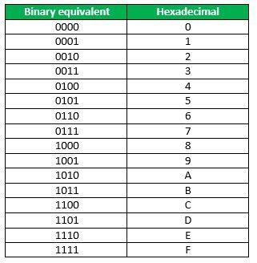

Hexadecimal to octal:
For converting hexadecimal to octal, there are two steps required to perform, which are as follows:
- In the first step, we will find the binary equivalent of the hexadecimal number.
- Next, we have to make the pairs of three bits on both sides of the binary point. If there will be one or two bits left in a pair of three bits pair, we add the required number of zeros on extreme sides and write the octal digits corresponding to each pair.

Example- (152A.25)16 Step 1:
We write the four-bit binary digit for 1, 5, 2, A, and 5.

(152A.25)16 = (0001 0101 0010 1010.0010 0101)2
So, the binary number of hexadecimal number 152A.25 is (0011010101010.010101)2 Step 2:
- Then, we make pairs of three bits on both sides of the binary point. 001 010 100 101 010.001 001 010

- Then, we write the octal digit, which corresponds to each pair.

(001010100101010.001001010)2 = (12452.112)8
So, the octal number of the hexadecimal number 152A.25 is 12452.112

Arithmetic operation:
Two types of operation that are performed on binary data include arithmetic and logic operations. Basic arithmetic operations include addition, subtraction, multiplication and division.

Binary addition:
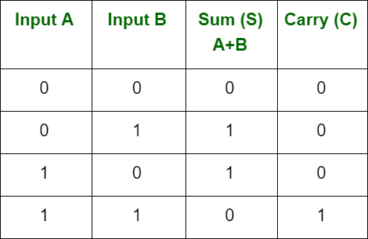
There are four rules for binary addition:

Example-
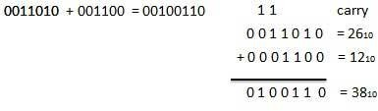
Binary subtraction:
There are four rules for binary subtraction:
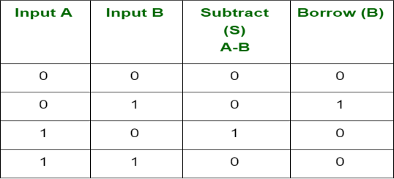

Example-
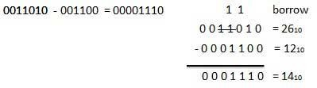
Binary multiplication:
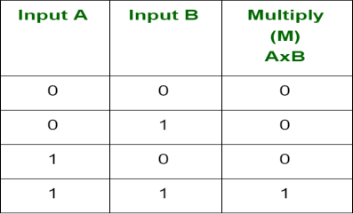
There are four rules of binary multiplication.

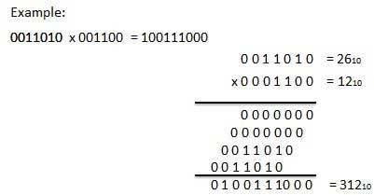

Binary division:
There are four parts in any division: Dividend, Divisor, quotient, and remainder.
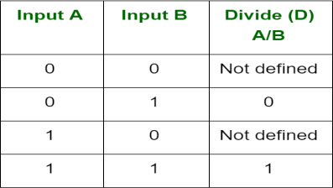

Example-
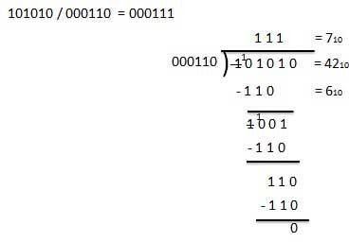
Signed binary number representation:
- In mathematics, positive numbers (including zero) are represented as unsigned numbers.
- That is, we do not put the +ve sign in front of them to show that they are positive numbers.
- However, when dealing with negative numbers we do use a -ve sign in front of the number to show that the number is negative in value and different from a positive unsigned value, and the same is true with signed binary numbers.
- However, in digital circuits there is no provision made to put a plus or even a minus sign to a number, since digital systems operate with binary numbers that are represented in terms of “0’s” and “1’s”.
- For signed binary numbers the most significant bit (MSB) is used as the sign bit.
- If the sign bit is “0”, this means the number is positive in value.
- If the sign bit is “1”, then the number is negative in value. 3 ways to represent negative binary number-
- Sign magnitude
- 1’s compliment
- 2’ compliment

Sign magnitude:
Left most digit is used to indicate the sign and the remaining digits the magnitude or value of the number.
Example-
Positive sign magnitude:

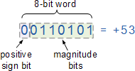

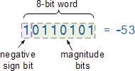
Negative sign magnitude:
The disadvantage here is that whereas before we had a full range n-bit unsigned binary number, we now have an n-1 bit signed binary number giving a reduced range of digits from:
-2(n-1) to +2(n-1)

1’s complement:
- The one’s complement of a negative binary number is the complement of its positive counterpart.
- Thus, the one’s complement of “1” is “0” and vice versa, then the one’s complement of 100101002 is simply 011010112 as all the 1’s are changed to 0’s and the 0’s to 1’s.
- For representing the positive numbers, there is nothing to do.
- But for representing negative numbers, we have to use 1's complement technique.
- For representing the negative number, we first have to represent it with a positive sign, and then we find the 1's complement of it.
Example- 11010.1101
For finding 1's complement of the given number, change all 0's to 1 and all 1's to 0. So, the 1's complement of the number 11010.1101 comes out 00101.0010.

2’s complement:
- 2's complement is also used to represent the signed binary numbers.
- For finding 2's complement of the binary number, we will first find the 1's complement of the binary number and then add 1 to the least significant bit of it.
Example- 110100
For finding 2's complement of the given number, change all 0's to 1 and all 1's to 0. So, the 1's complement of the number 110100 is 001011. Now add 1 to the LSB of this number, i.e., (001011)+1=001100.

Addition and subtraction using 1’s complement:
There are three different cases possible when we add two binary numbers which are as follows:

Case 1: Addition of the positive number with a negative number when the positive number has a greater magnitude.
Initially, calculate the 1's complement of the given negative number. Sum up with the given positive number. If we get the end-around carry 1, it gets added to the LSB.
Example: 1101 and -1001
- First, find the 1's complement of the negative number 1001. So, for finding 1's complement, change all 0 to 1 and all 1 to 0. The 1's complement of the number 1001 is 0110.
- Now, add both the numbers, i.e., 1101 and 0110; 1101+0110=1 0011
- By adding both numbers, we get the end-around carry 1. We add this end around carry to the LSB of 0011.
0011+1=0100

Case 2: Adding a positive value with a negative value in case the negative number has a higher magnitude.

Initially, calculate the 1's complement of the negative value. Sum it with a positive number. In this case, we did not get the end-around carry. So, take the 1's complement of the result to get the final result.
Note: The resultant is a negative value. Example: 1101 and -1110
- First find the 1's complement of the negative number 1110. So, for finding 1's complement, we change all 0 to 1, and all 1 to 0. 1's complement of the number 1110 is 0001.
- Now, add both the numbers, i.e., 1101 and 0001; 1101+0001= 1110
- Now, find the 1's complement of the result 1110 that is the final result. So, the 1's complement of the result 1110 is 0001, and we add a negative sign before the number so that we can identify that it is a negative number.

Case 3: Addition of two negative numbers
In this case, first find the 1's complement of both the negative numbers, and then we add both these complement numbers. In this case, we always get the end-around carry, which get added to the LSB, and for getting the final result, we take the 1's complement of the result.
Note: The resultant is a negative value. Example: -1101 and -1110 in five-bit register
- Firstly, find the 1's complement of the negative numbers 01101 and 01110. So, for finding 1's complement, we change all 0 to 1, and all 1 to 0. 1's complement of the number 01110 is 10001, and 01101 is 10010.
- Now, we add both the complement numbers, i.e., 10001 and 10010; 10001+10010= 1 00011
- By adding both numbers, we get the end-around carry 1. We add this end-around carry to the LSB of 00011.
00011+1=00100
- Now, find the 1's complement of the result 00100 that is the final answer. So, the 1's complement of the result 00100 is 110111, and add a negative sign before the number so that we can identify that it is a negative number.

Addition and subtraction using 2’s complement:
There are three different cases possible when we add two binary numbers using 2's complement, which is as follows:

Case 1: Addition of the positive number with a negative number when the positive number has a greater magnitude.
Initially find the 2's complement of the given negative number. Sum up with the given positive number. If we get the end-around carry 1 then the number will be a positive number and the carry bit will be discarded and remaining bits are the final result.
Example: 1101 and -1001
- First, find the 2's complement of the negative number 1001. So, for finding 2's complement, change all 0 to 1 and all 1 to 0 or find the 1's complement of the number 1001. The 1's complement of the number 1001 is 0110, and add 1 to the LSB of the result 0110. So the 2's complement of number 1001 is 0110+1=0111
- Add both the numbers, i.e., 1101 and 0111; 1101+0111=1 0100
- By adding both numbers, we get the end-around carry 1. We discard the end-around carry. So, the addition of both numbers is 0100.

Case 2: Adding of the positive value with a negative value when the negative number has a higher magnitude.
Initially, add a positive value with the 2's complement value of the negative number. Here, no end-around carry is found. So, we take the 2's complement of the result to get the final result.
Note: The resultant is a negative value.

Example: 1101 and -1110
- First, find the 2's complement of the negative number 1110. So, for finding 2's complement, add 1 to the LSB of its 1's complement value 0001.
0001+1=0010
- Add both the numbers, i.e., 1101 and 0010; 1101+0010= 1111
- Find the 2's complement of the result 1110 that is the final result. So, the 2's complement of the result 1110 is 0001, and add a negative sign before the number so that we can identify that it is a negative number.

Case 3: Addition of two negative numbers
In this case, first, find the 2's complement of both the negative numbers, and then we will add both these complement numbers. In this case, we will always get the end-around carry, which will be added to the LSB, and forgetting the final result, we will take the2's complement of the result.
Note: The resultant is a negative value. Example: -1101 and -1110 in five-bit register
- Firstly, find the 2's complement of the negative numbers 01101 and 01110. So, for finding 2's complement, we add 1 to the LSB of the 1's complement of these numbers. 2's complement of the number 01110 is 10010, and 01101 is 10011.
- We add both the complement numbers, i.e., 10001 and 10010; 10010+10011= 1 00101
- By adding both numbers, we get the end-around carry 1. This carry is discarded and the final result is the 2.s complement of the result 00101. So, the 2's complement of the result 00101 is 11011, and we add a negative sign before the number so that we can identify that it is a negative number.

Digital codes:
In the coding, when numbers or letters are represented by a specific group of symbols, it is said to be that number or letter is being encoded. The group of symbols is called as code. The digital data is represented, stored and transmitted as group of bits. This group of bits is also called as binary code.

Advantages of Binary Code:
    - Binary codes are suitable for the computer applications.
    - Binary codes are suitable for the digital communications.
    - Binary codes make the analysis and designing of digital circuits if we use the binary codes.
    - Since only 0 & 1 are being used, implementation becomes easy.

Classification of binary codes:
The codes are broadly categorized into following four categories.
    - Weighted Codes
    - Non-Weighted Codes
    - Binary Coded Decimal Code
    - Alphanumeric Codes
    - Error Detecting Codes
    - Error Correcting Codes

Weighted Codes:
Weighted binary codes are those binary codes which obey the positional weight principle. Each position of the number represents a specific weight. Several systems of the codes are used to express the decimal digits 0 through 9. In these codes each decimal digit is represented by a group of four bits.

Decimal Digit | 8421 Code | 2421 Code | 84-2-1 Code
0 | 0000 | 0000 | 0000
1 | 0001 | 0001 | 0111
2 | 0010 | 0010 | 0110
3 | 0011 | 0011 | 0101
4 | 0100 | 0100 | 0100
5 | 0101 | 1011 | 1011
6 | 0110 | 1100 | 1010
7 | 0111 | 1101 | 1001
8 | 1000 | 1110 | 1000
9 | 1001 | 1111 | 1111

8 4 2 1 code
- The weights of this code are 8, 4, 2 and 1.
- This code has all positive weights. So, it is a positively weighted code.
- This code is also called as natural BCD Binary Coded Decimal code.
- In this code each decimal digit is represented by a 4-bit binary number.
- BCD is a way to express each of the decimal digits with a binary code.
- In the BCD, with four bits we can represent sixteen numbers (0000 to 1111).
- But in BCD code only first ten of these are used (0000 to 1001).
- The remaining six code combinations i.e., 1010 to 1111 are invalid in BCD.
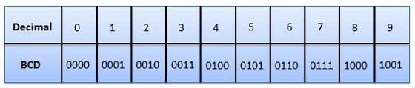

Example

Let us find the BCD equivalent of the decimal number 786. This number has 3 decimal digits 7, 8 and 6. From the table, we can write the BCD 84218421 codes of 7, 8 and 6 are 0111,
1000 and 0110 respectively.
78610 = 0111 1000 0110BCD
There are 12 bits in BCD representation, since each BCD code of decimal digit has 4 bits.

Advantages of BCD Codes
- It is very similar to decimal system.
- We need to remember binary equivalent of decimal numbers 0 to 9 only.

Disadvantages of BCD Codes
- The addition and subtraction of BCD have different rules.
- The BCD arithmetic is little more complicated.
- BCD needs more number of bits than binary to represent the decimal number. So, BCD is less efficient than binary.

Non-weighted code:
n this type of binary codes, the positional weights are not assigned. The examples of non- weighted codes are Excess-3 code and Gray code.
Excess-3 code
- The Excess-3 code is also called as XS-3 code.
- It is non-weighted code used to express decimal numbers.
- The Excess-3 code words are derived from the 8421 BCD code words adding (0011)2 or (3)10 to each code word in 8421.
- The excess-3 codes are obtained as follows –
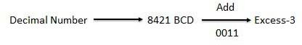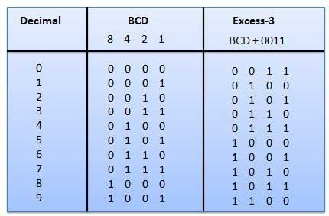

Gray Code
- It is the non-weighted code and it is not arithmetic codes.
- That means there are no specific weights assigned to the bit position.
- It has a very special feature that, only one bit will change each time the decimal number is incremented as shown in fig.
- As only one-bit changes at a time, the gray code is called as a unit distance code.
- The gray code is a cyclic code. Gray code cannot be used for arithmetic operation.

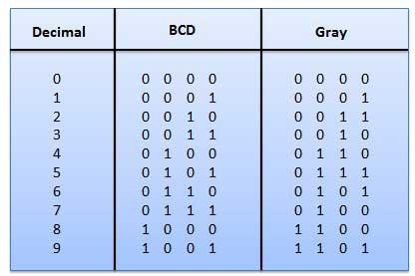

Binary code to Gray Code Conversion:
- Consider the given binary code and place the MSB of binary to the left of MSB.
- Compare the successive two bits starting from MSB. If the 2 bits are same, then the output is zero. Otherwise, output is one.
- Repeat the above step till the LSB of Gray code is obtained. Example-
From the table, we know that the Gray code corresponding to binary code 1000 is 1100. Now, let us verify it by using the above procedure.
Given, binary code is 1000.
Step 1 − By placing same MSB to the left of MSB, the binary code will be 1000.
Step 2 − By comparing successive two bits of new binary code, we will get the gray code as 1100.

Application of Gray code:
- Gray code is popularly used in the shaft position encoders.
- A shaft position encoder produces a code word which represents the angular position of the shaft.

Alphanumeric codes:
- A binary digit or bit can represent only two symbols as it has only two states '0' or '1'.
- But this is not enough for communication between two computers because there we need many more symbols for communication.
- These symbols are required to represent 26 alphabets with capital and small letters, numbers from 0 to 9, punctuation marks and other symbols.
- The alphanumeric codes are the codes that represent numbers and alphabetic characters.
- Mostly such codes also represent other characters such as symbol and various instructions necessary for conveying information.
- An alphanumeric code should at least represent 10 digits and 26 letters of alphabet
i.e. total 36 items.
- The following two alphanumeric codes are very commonly used for the data representation.

  - American Standard Code for Information Interchange (ASCII).
  - Extended Binary Coded Decimal Interchange Code (EBCDIC).
- ASCII code is a 7-bit code whereas EBCDIC is an 8-bit code.

- ASCII code is more commonly used worldwide while EBCDIC is used primarily in large IBM computers.

Error detection codes:
- Error detection codes are used to detect the errors present in the received data bitstream.
- These codes contain some bits, which are included appended to the original bit stream.
- These codes detect the error, if it is occurred during transmission of the original data bitstream.
- Example − Parity code, Hamming code.

Error correction codes:
- Error correction codes are used to correct the errors present in the received data bitstream so that, we will get the original data.
- Error correction codes also use the similar strategy of error detection codes.
- Example − Hamming code.
Therefore, to detect and correct the errors, additional bits are appended to the data bits at the time of transmission.

Logic gates:
    - Logic gates play an important role in circuit design and digital systems.
    - It is a building block of a digital system and an electronic circuit that always have only one output.
    - These gates can have one input or more than one input, but most of the gates have two inputs.
We can classify these Logic gates into the following three categories.
- Basic gates
- Universal gates
- Special gates

Basic gates:
The basic gates are AND, OR & NOT gates.

AND gate:
An AND gate is a digital circuit that has two or more inputs and produces an output, which is the logical AND of all those inputs. It is optional to represent the Logical AND with the symbol ‘.’.
The following table shows the truth table of 2-input AND gate.
A | B | Y = A.B
0 | 0 | 0
0 | 1 | 0
1 | 0 | 0
1 | 1 | 1
Here A, B are the inputs and Y is the output of two input AND gate. If both inputs are ‘1’, then only the output, Y is ‘1’. For remaining combinations of inputs, the output, Y is ‘0’.
The following figure shows the symbol of an AND gate, which is having two inputs A, B and one output, Y.

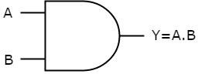

OR gate:
An OR gate is a digital circuit that has two or more inputs and produces an output, which is the logical OR of all those inputs. This logical OR is represented with the symbol ‘+’.
The following table shows the truth table of 2-input OR gate.
A | B | Y = A + B
0 | 0 | 0
0 | 1 | 1
1 | 0 | 1
1 | 1 | 1
Here A, B are the inputs and Y is the output of two input OR gate. If both inputs are ‘0’, then only the output, Y is ‘0’. For remaining combinations of inputs, the output, Y is ‘1’.
The following figure shows the symbol of an OR gate, which is having two inputs A, B and one output, Y.
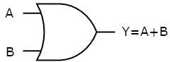

This OR gate produces an output Y, which is the logical OR of two inputs A, B.

NOT gate:
A NOT gate is a digital circuit that has single input and single output. The output of NOT gate is the logical inversion of input. Hence, the NOT gate is also called as inverter.
The following table shows the truth table of NOT gate.
A | Y = A’
0 | 1
1 | 0
Here A and Y are the input and output of NOT gate respectively. If the input, A is ‘0’, then the output, Y is ‘1’. Similarly, if the input, A is ‘1’, then the output, Y is ‘0’.
The following figure shows the symbol of NOT gate, which is having one input, A and one output, Y.
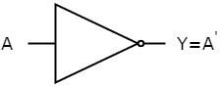

This NOT gate produces an output Y, which is the complement of input, A.

Universal gates
NAND & NOR gates are called as universal gates.

NAND gate
NAND gate is a digital circuit that has two or more inputs and produces an output, which is the inversion of logical AND of all those inputs.
The following table shows the truth table of 2-input NAND gate.

A | B | Y = (A.B)’
0 | 0 | 1
0 | 1 | 1
1 | 0 | 1
1 | 1 | 0
The following image shows the symbol of NAND gate, which is having two inputs A, B and one output, Y.
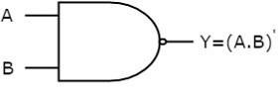

NAND gate operation is same as that of AND gate followed by an inverter. That’s why the NAND gate symbol is represented like that.

NOR gate:
NOR gate is a digital circuit that has two or more inputs and produces an output, which is the inversion of logical OR of all those inputs.
The following table shows the truth table of 2-input NOR gate
A | B | Y = (A+B)’
0 | 0 | 1
0 | 1 | 0
1 | 0 | 0
1 | 1 | 0
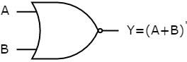
The following figure shows the symbol of NOR gate, which is having two inputs A, B and one output, Y.

NOR gate operation is same as that of OR gate followed by an inverter. That’s why the NOR gate symbol is represented like that.

Special Gates
Ex-OR & Ex-NOR gates are called as special gates. Because, these two gates are special cases of OR & NOR gates.

Ex-OR gate:
The full form of Ex-OR gate is Exclusive-OR gate. Its function is same as that of OR gate except for some cases, when the inputs having even number of ones.
The following table shows the truth table of 2-input Ex-OR gate.

A | B | Y = A⊕B
0 | 0 | 0
0 | 1 | 1
1 | 0 | 1
1 | 1 | 0
The output of Ex-OR gate is ‘1’, when only one of the two inputs is ‘1’. And it is zero, when both inputs are same.
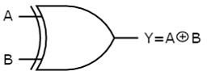
Below figure shows the symbol of Ex-OR gate, which is having two inputs A, B and one output, Y.

The output of Ex-OR gate is ‘1’, when odd number of ones present at the inputs. Hence, the output of Ex-OR gate is also called as an odd function.

Ex-NOR gate:
The full form of Ex-NOR gate is Exclusive-NOR gate. Its function is same as that of NOR gate except for some cases, when the inputs having even number of ones.
The following table shows the truth table of 2-input Ex-NOR gate.
A | B | Y = A⊙B
0 | 0 | 1
0 | 1 | 0
1 | 0 | 0
1 | 1 | 1

The output of Ex-NOR gate is ‘1’, when both inputs are same. And it is zero, when both the inputs are different.
The following figure shows the symbol of Ex-NOR gate, which is having two inputs A, B and one output, Y.
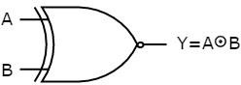

The output of Ex-NOR gate is ‘1’, when even number of ones present at the inputs. Hence, the output of Ex-NOR gate is also called as an even function.
From the above truth tables of Ex-OR & Ex-NOR logic gates, we can easily notice that the Ex-NOR operation is just the logical inversion of Ex-OR operation.

Universal gates and its realization:
We can realise all of the other gates by using just one single type of universal logic gate, the NAND (NOT AND) or the NOR (NOT OR) gate, thereby reducing the number of different types of logic gates required, and also the cost. Thus, the NAND and the NOR gates are commonly referred to as Universal Logic Gates.
Implementation of logic gates using NAND gate only:
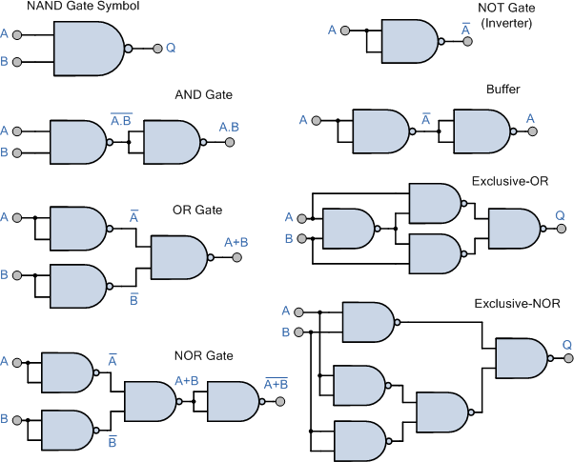

Implementation of logic gates using NOR gate only:
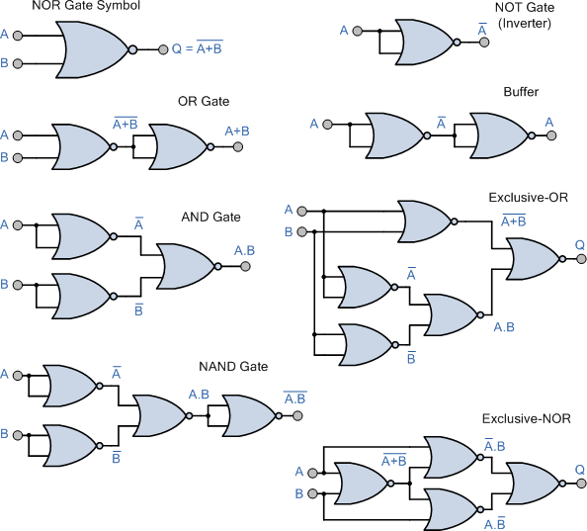

Boolean Algebra:
Boolean Algebra is used to analyse and simplify the digital (logic) circuits. It uses only the binary numbers i.e., 0 and 1. It is also called as Binary Algebra or logical Algebra. Boolean algebra was invented by George Boole in 1854.

Boolean Laws
There are six types of Boolean Laws.

Commutative law
Any binary operation which satisfies the following expression is referred to as commutative operation.
Commutative law states that changing the sequence of the variables does not have any effect on the output of a logic circuit.

Associative law
This law states that the order in which the logic operations are performed is irrelevant as their effect is the same.

Distributive law
Distributive law states the following condition.

AND law
These laws use the AND operation. Therefore, they are called as AND laws.

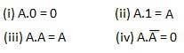

OR law
These laws use the OR operation. Therefore, they are called as OR laws.
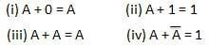

INVERSION law
This law uses the NOT operation. The inversion law states that double inversion of a variable results in the original variable itself.

Boolean Function:
Boolean algebra deals with binary variables and logic operation. A Boolean Function is described by an algebraic expression called Boolean expression which consists of binary variables, the constants 0 and 1, and the logic operation symbols. Consider the following example.
Here the left side of the equation represents the output Y. So we can state equation no. 1

Truth Table Formation
A truth table represents a table having all combinations of inputs and their corresponding result.
It is possible to convert the switching equation into a truth table. For example, consider the following switching equation.
The output will be high (1) if A = 1 or BC = 1 or both are 1. The truth table for this equation is shown by Table (a). The number of rows in the truth table is 2^{n} where n is the number of input variables (n=3 for the given equation). Hence there are 2³ = 8 possible input combination of inputs.
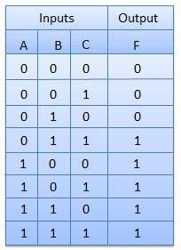

De Morgan's Theorem:

De Morgan’s 1st theorem states that the complement of the product of all the terms is equal to the sum of the complement of each term.
(A.B)’ = A’ + B’
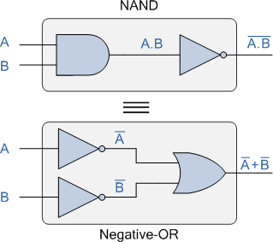
De Morgan’s 2nd theorem states that the complement of the sum of all the terms is equal to the product of the complement of each term.
(A + B)’ = A’. B’
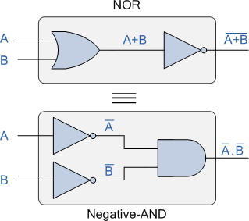

Duality Theorem:
This theorem states that the dual of the Boolean function is obtained by interchanging the logical AND operator with logical OR operator and zeros with ones. For every Boolean function, there will be a corresponding Dual function.

Group1 | Group2
x + 0 = x | x.1 = x
x + 1 = 1 | x.0 = 0
x + x = x | x.x = x
x + x’ = 1 | x.x’ = 0
x + y = y + x | x.y = y.x

Example-1:
Given Boolean function, f = p’qr + pq’r + pqr’ + pqr.
Step 1 − Use the Boolean postulate, x + x = x. That means, the Logical OR operation with any Boolean variable ‘n’ times will be equal to the same variable. So, we can write the last term pqr two more times.
⇒ f = p’qr + pq’r + pqr’ + pqr + pqr + pqr
Step 2 − Use Distributive law for 1st and 4th terms, 2nd and 5th terms, 3rd and 6th terms.
⇒ f = qrp′+pp′+p + prq′+qq′+q + pqr′+rr′+r
Step 3 − Use Boolean postulate, x + x’ = 1 for simplifying the terms present in each parenthesis.
⇒ f = qr11 + pr11 + pq11
Step 4 − Use Boolean postulate, x.1 = x for simplifying the above three terms.
⇒ f = qr + pr + pq
⇒ f = pq + qr + pr Therefore, the simplified Boolean function is f = pq + qr + pr. Example-2:

Let us find the complement of the Boolean function, f = p’q + pq’.
The complement of Boolean function is f’ = p′q+pq′p′q+pq′’.
Step 1 − Use DeMorgan’s theorem, x+yx+y’ = x’.y’.
⇒ f’ = p′qp′q’.pq′pq′’
Step 2 − Use DeMorgan’s theorem, x.yx.y’ = x’ + y’
⇒ f’ = {p′p′’ + q’}.{p’ + q′q′’}
Step3 − Use the Boolean postulate, x′x′’=x.
⇒ f’ = {p + q’}.{p’ + q}
⇒ f’ = pp’ + pq + p’q’ + qq’
Step 4 − Use the Boolean postulate, xx’=0.
⇒ f = 0 + pq + p’q’ + 0
⇒ f = pq + p’q’
Therefore, the complement of Boolean function, p’q + pq’ is pq + p’q’.

Representation of Logic Expression (SOP and POS form):

Sum of Product (SOP):
    - The Sum of Product expression is equivalent to the logical AND function which Sums two or more Products to produce an output.
    - We will get four Boolean product terms by combining two variables x and y with logical AND operation.
    - These Boolean product terms are called as min terms or standard product terms.
    - If the binary variable is ‘0’, then it is represented as complement of variable and ‘1’ as normal form in min term. The min terms are x’y’, x’y, xy’ and xy.

Product of Sum (POS):
    - The Product of Sum expression is equivalent to the logical OR-AND function which gives the AND Product of two or more OR Sums to produce an output.

    - We will get four Boolean sum terms by combining two variables x and y with logical OR operation.
    - These Boolean sum terms are called as Max terms or standard sum terms.
    - If the binary variable is ‘1’, then it is represented as complement of variable and ‘0’ as normal form in Max term. The Max terms are x + y, x + y’, x’ + y and x’ + y’.

x | y | Min terms | Max terms
0 | 0 | m0=x’y’ | M0=x + y
0 | 1 | m1=x’y | M1=x + y’
1 | 0 | m2=xy’ | M2=x’ + y
1 | 1 | m3=xy | M3=x’ + y’

Canonical SOP and POS forms:
    - A truth table consists of a set of inputs and outputs.
    - If there are ‘n’ input variables, then there will be 2^{n} possible combinations with zeros and ones.
    - So, the value of each output variable depends on the combination of input variables.
    - So, each output variable will have ‘1’ for some combination of input variables and ‘0’ for some other combination of input variables.
Therefore, we can express each output variable in following two ways.
    - Canonical SOP form
    - Canonical POS form

Canonical SOP form:
    - Canonical SOP form means Canonical Sum of Products form.
    - In this form, each product term contains all literals.
    - So, these product terms are nothing but the min terms. Hence, canonical SOP form is also called as sum of min terms form.
    - First, identify the min terms for which, the output variable is one and then do the logical OR of those min terms in order to get the Boolean expression function corresponding to that output variable. This Boolean function will be in the form of sum of min terms.
    - Follow the same procedure for other output variables also, if there is more than one output variable.

Example
Consider the following truth table.
Inputs |  | Output
p | Q | r | F
0 | 0 | 0 | 0
0 | 0 | 1 | 0

0 | 1 | 0 | 0
0 | 1 | 1 | 1
1 | 0 | 0 | 0
1 | 0 | 1 | 1
1 | 1 | 0 | 1
1 | 1 | 1 | 1

    - Here, the output f is ‘1’ for four combinations of inputs.
    - The corresponding min terms are p’qr, pq’r, pqr’, pqr.
    - By doing logical OR of these four min terms, we will get the Boolean function of output f.
Therefore, the Boolean function of output is, f = p’qr + pq’r + pqr’ + pqr.
This is the canonical SOP form of output, f. We can also represent this function in following two notations.
f = m3+m5+m6+m7 f=∑m(3,5,6,7)
In one equation, we represented the function as sum of respective min terms. In other equation, we used the symbol for summation of those min terms.

Canonical POS form:
    - Canonical POS form means Canonical Product of Sums form.
    - In this form, each sum term contains all literals. So, these sum terms are nothing but the Max terms. Hence, canonical POS form is also called as product of Max terms form.
    - First, identify the Max terms for which, the output variable is zero and then do the logical AND of those Max terms in order to get the Boolean expression function corresponding to that output variable. This Boolean function will be in the form of product of Max terms.
    - Follow the same procedure for other output variables also, if there is more than one output variable.

Example
    - Consider the same truth table of previous example.
    - Here, the output f is ‘0’ for four combinations of inputs.
    - The corresponding Max terms are p + q + r, p + q + r’, p + q’ + r, p’ + q + r.
    - By doing logical AND of these four Max terms, we will get the Boolean function of output f.
Therefore, the Boolean function of output is, f = (p+q+r). (p+q+r′). (p+q′+r). (p′+q+r).
This is the canonical POS form of output, f.
We can also represent this function in following two notations.
f=M0.M1.M2.M4 f=∏M(0,1,2,4)
In one equation, we represented the function as product of respective Max terms. In other equation, we used the symbol for multiplication of those Max terms.
The Boolean function,
f = (p+q+r). (p+q+r′). (p+q′+r). (p′+q+r) is the dual of the Boolean function,

f = p’qr + pq’r + pqr’ + pqr.
Therefore, both canonical SOP and canonical POS forms are Dual to each other. Functionally, these two forms are same. Based on the requirement, we can use one of these two forms.

Standard SOP and POS forms
We discussed two canonical forms of representing the Boolean outputs. Similarly, there are two standard forms of representing the Boolean outputs. These are the simplified version of canonical forms.
    - Standard SOP form
    - Standard POS form
The main advantage of standard forms is that the number of inputs applied to logic gates can be minimized. Sometimes, there will be reduction in the total number of logic gates required. Standard SOP form:
Standard SOP form means Standard Sum of Products form. In this form, each product term need not contain all literals. So, the product terms may or may not be the min terms. Therefore, the Standard SOP form is the simplified form of canonical SOP form.
We will get Standard SOP form of output variable in two steps.
    - Get the canonical SOP form of output variable
    - Simplify the above Boolean function, which is in canonical SOP form.
Follow the same procedure for other output variables also, if there is more than one output variable. Sometimes, it may not possible to simplify the canonical SOP form. In that case, both canonical and standard SOP forms are same.

Example
Convert the following Boolean function into Standard SOP form.
f = p’qr + pq’r + pqr’ + pqr
The given Boolean function is in canonical SOP form. Now, we have to simplify this Boolean function in order to get standard SOP form.
Step 1 − Use the Boolean postulate, x + x = x. That means, the Logical OR operation with any Boolean variable ‘n’ times will be equal to the same variable. So, we can write the last term pqr two more times.
⇒ f = p’qr + pq’r + pqr’ + pqr + pqr + pqr
Step 2 − Use Distributive law for 1st and 4th terms, 2nd and 5th terms, 3rd and 6th terms.
⇒ f = qr (p′+p) + pr (q′+q) + pq (r′+r)
Step 3 − Use Boolean postulate, x + x’ = 1 for simplifying the terms present in each parenthesis.
⇒ f = qr 1 + pr 1 + pq 1
Step 4 − Use Boolean postulate, x.1 = x for simplifying above three terms.
⇒ f = qr + pr + pq
⇒ f = pq + qr + pr
This is the simplified Boolean function. Therefore, the standard SOP form corresponding to given canonical SOP form is f = pq + qr + pr

Standard POS form:
Standard POS form means Standard Product of Sums form. In this form, each sum term need not contain all literals. So, the sum terms may or may not be the Max terms. Therefore, the Standard POS form is the simplified form of canonical POS form.
We will get Standard POS form of output variable in two steps.
    - Get the canonical POS form of output variable
    - Simplify the above Boolean function, which is in canonical POS form.
Follow the same procedure for other output variables also, if there is more than one output variable. Sometimes, it may not possible to simplify the canonical POS form. In that case, both canonical and standard POS forms are same.

Example
Convert the following Boolean function into Standard POS form.

f = (p+q+r). (p+q+r′). (p+q′+r). (p′+q+r)
The given Boolean function is in canonical POS form. Now, we have to simplify this Boolean function in order to get standard POS form.
Step 1 − Use the Boolean postulate, x.x = x. That means, the Logical AND operation with any Boolean variable ‘n’ times will be equal to the same variable. So, we can write the first term p+q+r two more times.
⇒ f = (p+q+r). (p+q+r). (p+q+r). (p+q+r′). (p+q′+r). (p′+q+r)
Step 2 − Use Distributive law, x + y.z = (x+y). (x+z) for 1st and 4th parenthesis, 2nd and 5th parenthesis, 3rd and 6th parenthesis.
⇒ f = (p+q+rr′). (p+r+qq′). (q+r+pp′)
Step 3 − Use Boolean postulate, x.x’=0 for simplifying the terms present in each parenthesis.
⇒ f = (p+q+0). (p+r+0). (q+r+0)
Step 4 − Use Boolean postulate, x + 0 = x for simplifying the terms present in each parenthesis
⇒ f = (p+q). (p+r). (q+r)
⇒ f = (p+q). (q+r). (p+r)
This is the simplified Boolean function. Therefore, the standard POS form corresponding to given canonical POS form is
f = (p+q). (q+r). (p+r). This is the dual of the Boolean function,
f = pq + qr + pr.
Therefore, both Standard SOP and Standard POS forms are Dual to each other.

Karnaugh map:
    - Karnaugh introduced a method for simplification of Boolean functions in an easy way.
    - This method is known as Karnaugh map method or K-map method.
    - It is a graphical method, which consists of 2n cells for ‘n’ variables.
    - The adjacent cells are differed only in single bit position.

Variable K-Map:
The number of cells in 2 variable K-map is four, since the number of variables is two.
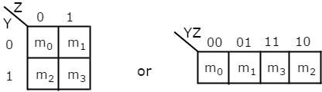
  - There is only one possibility of grouping 4 adjacent min terms.
  - The possible combinations of grouping 2 adjacent min terms are {(m0, m1), (m2, m3), (m0, m2) and (m1, m3)}.

Variable K-Map:
The number of cells in 3 variable K-map is eight, since the number of variables is three.
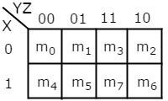
  - There is only one possibility of grouping 8 adjacent min terms.
  - The possible combinations of grouping 4 adjacent min terms are {(m0, m1, m3, m2), (m4, m5, m7, m6), (m0, m1, m4, m5), (m1, m3, m5, m7), (m3, m2, m7, m6) and (m2, m0, m6, m4)}.

  - The possible combinations of grouping 2 adjacent min terms are {(m0, m1), (m1, m3), (m3, m2), (m2, m0), (m4, m5), (m5, m7), (m7, m6), (m6, m4), (m0, m4), (m1, m5), (m3, m7)
and (m2, m6)}.
  - If x=0, then 3 variable K-map becomes 2 variable K-map.

Variable K-Map:
The number of cells in 4 variable K-map is sixteen, since the number of variables is four.
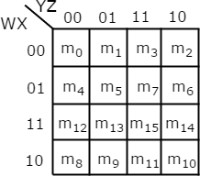
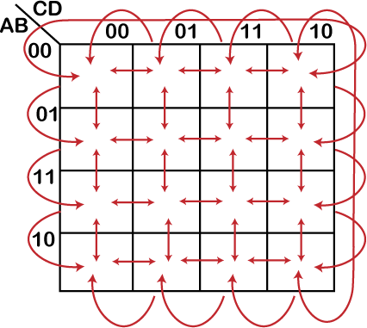

  - There is only one possibility of grouping 16 adjacent min terms.
  - Let R1, R2, R3 and R4 represents the min terms of first row, second row, third row and fourth row respectively. Similarly, C1, C2, C3 and C4 represents the min terms of first column, second column, third column and fourth column respectively. The possible combinations of grouping 8 adjacent min terms are {(R1, R2), (R2, R3), (R3, R4), (R4, R1), (C1, C2), (C2, C3), (C3, C4), (C4, C1)}.
  - If w=0, then 4 variable K-map becomes 3 variable K-map.

Example-
f(W,X,Y,Z)= ∑m(2,6,8,9,10,11,14,15) using K-map.
The given Boolean function is in sum of products form. It is having 4 variables W, X, Y & Z. So, we require 4 variable K-map.
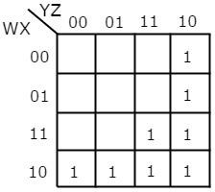
The 4 variable K-map with three groupings is

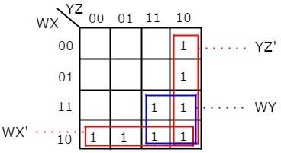
Therefore, the simplified Boolean function is

f = WX’ + WY + YZ’
Example-
f(X,Y,Z)=∏M(0,1,2,4) using K-map.
The given Boolean function is in product of Max terms form. It is having 3 variables X, Y & Z. So, we require 3 variable K-map.
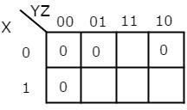
The 3 variable K-map with three groupings is
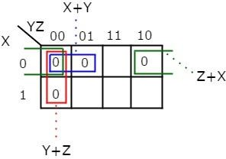
Therefore, the simplified Boolean function is
f = (X+Y). (Y+Z). (Z+X)

Don’t care condition:
  - The "Don't care" condition says that we can use the blank cells of a K-map to make a group of the variables.
  - To make a group of cells, we can use the "don't care" cells as either 0 or 1, and if required, we can also ignore that cell.
  - We mainly use the "don't care" cell to make a large group of cells.
  - The cross(X) symbol is used to represent the "don't care" cell in K-map.
  - This cross symbol represents an invalid combination.
  - The "don't care" in excess-3 code are 0000, 0001, 0010, 1101, 1110, and 1111 because they are invalid combinations.
  - Apart from this, the 4-bit BCD to Excess-3 code, the "don't care" are 1010, 1011, 1100, 1101, 1110, and 1111.

Example 1: Minimize f = ∑m(1,5,6,12,13,14) + d(4) in SOP minimal form

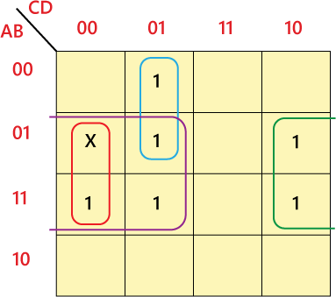
So, the minimized SOP form of the function is:
f = BC' + BD' + A'C'D
Example-2:
Minimize the following function in SOP minimal form using K-Maps: F(A, B, C, D) =
∑m(1, 2, 6, 7, 8, 13, 14, 15) + d(3, 5, 12)
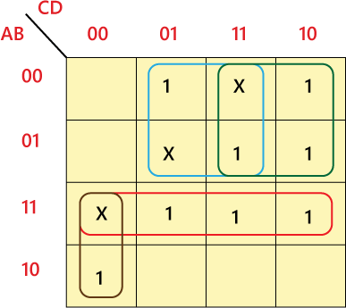
F = AC'D' + A'D + A'C + AB

UNIT-2
Combinational logic circuit
Combinational circuit is a circuit in which we combine the different gates in the circuit, for example encoder, decoder, multiplexer and demultiplexer. Some of the characteristics of combinational circuits are following −
  - The output of combinational circuit at any instant of time, depends only on the levels present at input terminals.
  - The combinational circuit do not use any memory. The previous state of input does not have any effect on the present state of the circuit.
  - A combinational circuit can have an n number of inputs and m number of outputs. Block Diagram:
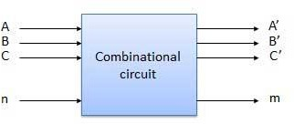

Half Adder
Half adder is a combinational logic circuit with two inputs and two outputs. The half adder circuit is designed to add two single bit binary number A and B. It is the basic building block for addition of two single bit numbers. This circuit has two outputs carry and sum.

Block diagram
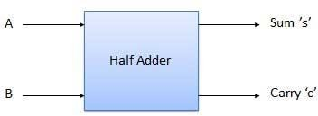

Truth Table
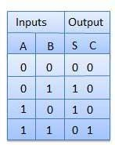

Circuit Diagram
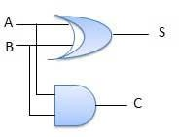

Full Adder
Full adder is developed to overcome the drawback of Half Adder circuit. It can add two one- bit numbers A and B, and carry c. The full adder is a three input and two output combinational circuit.

Block diagram

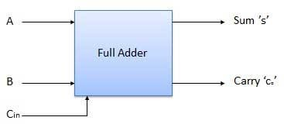

Truth Table
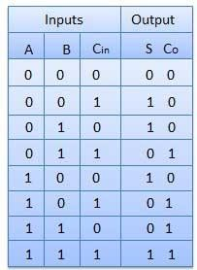

Circuit Diagram
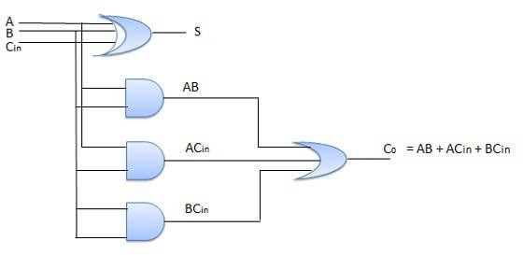

Implementation of Full Adder using Half Adders
2 Half Adders and a OR gate is required to implement a Full Adder.

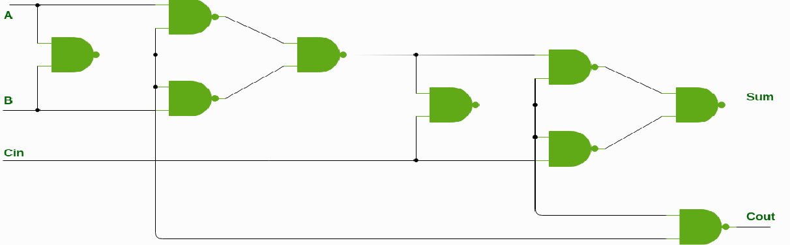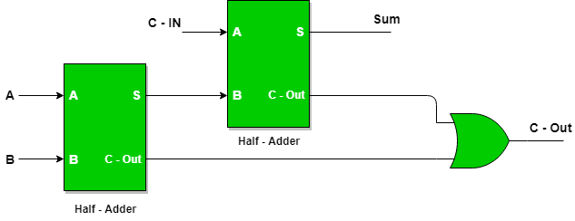

With this logic circuit, two bits can be added together, taking a carry from the next lower order of magnitude, and sending a carry to the next higher order of magnitude.
Implementation of Full Adder using NAND gates:

N-Bit Parallel Adder
The Full Adder is capable of adding only two single digit binary number along with a carry input. But in practical we need to add binary numbers which are much longer than just one bit. To add two n-bit binary numbers we need to use the n-bit parallel adder. It uses a number of full adders in cascade. The carry output of the previous full adder is connected to carry input of the next full adder.
4 Bit Parallel Adder
In the block diagram, A0 and B0 represent the LSB of the four bit words A and B. Hence Full Adder-0 is the lowest stage. Hence its Cin has been permanently made 0. The rest of the connections are exactly same as those of n-bit parallel adder is shown in fig. The four-bit parallel adder is a very common logic circuit.

Block diagram
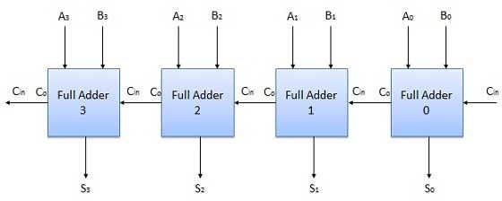

Half Subtractors
Half subtractor is a combination circuit with two inputs and two outputs (difference and borrow). It produces the difference between the two binary bits at the input and also produces an output (Borrow) to indicate if a 1 has been borrowed. In the subtraction (A-B), A is called as Minuend bit and B is called as Subtrahend bit.

Truth Table
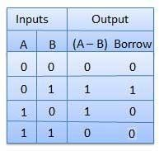

Circuit Diagram
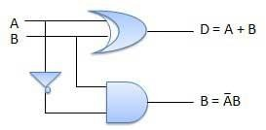

Full Subtractors
The disadvantage of a half subtractor is overcome by full subtractor. The full subtractor is a combinational circuit with three inputs A,B,C and two output D and C'. A is the 'minuend', B is 'subtrahend', C is the 'borrow' produced by the previous stage, D is the difference output and C' is the borrow output.

Truth Table
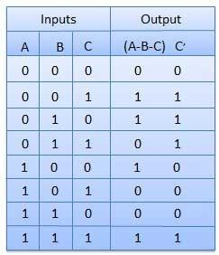

Circuit Diagram
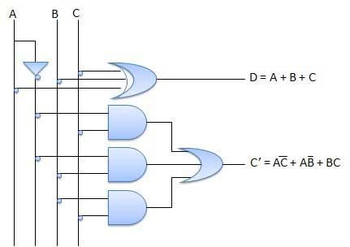
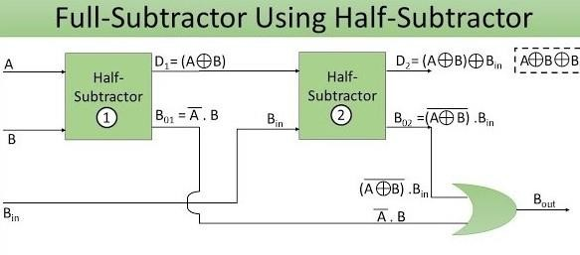

Multiplexers
Multiplexer is a special type of combinational circuit. There are n-data inputs, one output and m select inputs with 2m = n. It is a digital circuit which selects one of the n data inputs and routes it to the output. The selection of one of the n inputs is done by the selected inputs. Depending on the digital code applied at the selected inputs, one out of n data sources is selected and transmitted to the single output Y. E is called the strobe or enable input which is useful for the cascading. It is generally an active low terminal that means it will perform the required operation when it is low.

Block diagram

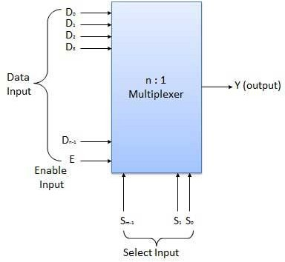

Multiplexers come in multiple variations

    - 2 : 1 multiplexer
    - 4 : 1 multiplexer
    - 16 : 1 multiplexer
    - 32 : 1 multiplexer Block Diagram
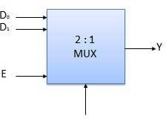

Truth Table
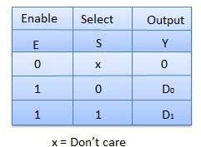

Demultiplexers
A demultiplexer performs the reverse operation of a multiplexer i.e. it receives one input and distributes it over several outputs. It has only one input, n outputs, m select input. At a time only one output line is selected by the select lines and the input is transmitted to the selected output line. A de-multiplexer is equivalent to a single pole multiple way switch as shown in fig.
Demultiplexers comes in multiple variations.

    - 1 : 2 demultiplexer
    - 1 : 4 demultiplexer
    - 1 : 16 demultiplexer
    - 1 : 32 demultiplexer Block diagram

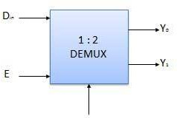

Truth Table

4:1 Multiplexer
4:1 Multiplexer has four data inputs I3, I2, I1 & I0, two selection lines s1 & s0 and one output Y. The block diagram of 4x1 Multiplexer is shown in the following figure.
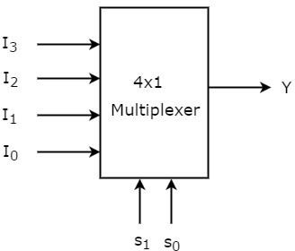

One of these 4 inputs will be connected to the output based on the combination of inputs present at these two selection lines.
Truth table of 4:1 Multiplexer is shown below.

Selection Lines |  | Output
S1 | S0 | Y
0 | 0 | I0
0 | 1 | I1
1 | 0 | I2
1 | 1 | I3
From Truth table, we can directly write the Boolean function for output, Y as
𝑌 = 𝑆1′𝑆0′𝐼₀ + 𝑆1′𝑆0𝐼₁ + 𝑆1𝑆0′𝐼₂ + 𝑆1𝑆0𝐼₃
We can implement this Boolean function using Inverters, AND gates & OR gate.

The circuit diagram of 4:1 multiplexer is shown in the following figure.
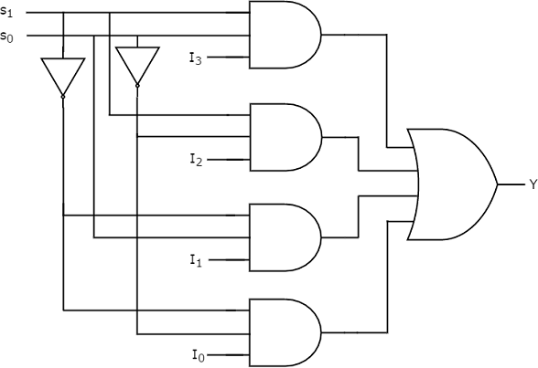

We can easily understand the operation of the above circuit. Similarly, you can implement 8x1 Multiplexer and 16x1 multiplexer by following the same procedure.
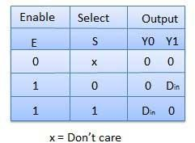

1:4 De-Multiplexer
1:4 De-Multiplexer has one input I, two selection lines, s1 & s0 and four outputs Y3, Y2, Y1 &Y0. The block diagram of 1:4 De-Multiplexer is shown in the following figure.
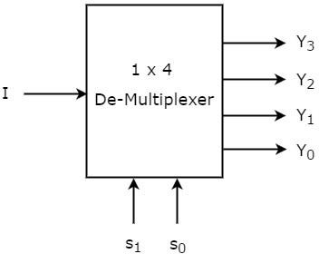

The single input ‘I’ will be connected to one of the four outputs, Y3 to Y0 based on the values of selection lines s1 & s0. The Truth table of 1x4 De-Multiplexer is shown below.

Selection Inputs |  | Outputs
S1 | S0 | Y3 | Y2 | Y1 | Y0

0 | 0 | 0 | 0 | 0 | I
0 | 1 | 0 | 0 | I | 0
1 | 0 | 0 | I | 0 | 0
1 | 1 | I | 0 | 0 | 0

From the above Truth table, we can directly write the Boolean functions for each output as
𝑌3 = 𝑠₁𝑠₀𝐼
𝑌2 = 𝑠1𝑠0′𝐼
𝑌1 = 𝑠1′𝑠0𝐼
𝑌0 = 𝑠1′𝑠0′𝐼
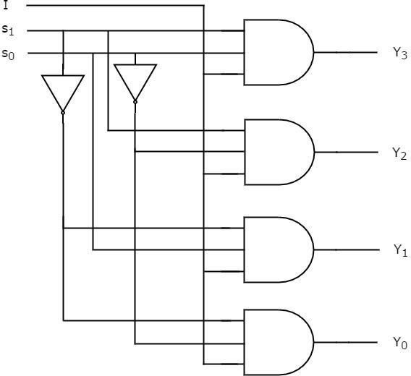
We can implement these Boolean functions using Inverters & 3-input AND gates. The circuit diagram of 1:4 De-Multiplexer is shown in the following figure.

Decoder
A decoder is a combinational circuit. It has n input and to a maximum m = 2n outputs. Decoder is identical to a demultiplexer without any data input. It performs operations which are exactly opposite to those of an encoder.
Block diagram

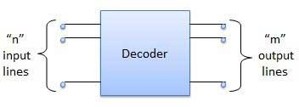
Examples of Decoders are following.

- Code converters
- BCD to seven segment decoders

2 to 4 Decoder
Let 2 to 4 Decoder has two inputs A1 & A0 and four outputs Y3, Y2, Y1 & Y0. The block diagram of 2 to 4 decoder is shown in the following figure.
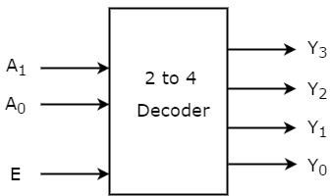

One of these four outputs will be ‘1’ for each combination of inputs when enable, E is ‘1’. The Truth table of 2 to 4 decoder is shown below.
Enable | Inputs |  | Outputs
E | A1 | A0 | Y3 | Y2 | Y1 | Y0
0 | x | X | 0 | 0 | 0 | 0
1 | 0 | 0 | 0 | 0 | 0 | 1
1 | 0 | 1 | 0 | 0 | 1 | 0
1 | 1 | 0 | 0 | 1 | 0 | 0
1 | 1 | 1 | 1 | 0 | 0 | 0
From Truth table, we can write the Boolean functions for each output as

𝑌3 = 𝐸. 𝐴1. 𝐴0
𝑌2 = 𝐸. 𝐴1. 𝐴0′
𝑌1 = 𝐸. 𝐴1′. 𝐴0
𝑌0 = 𝐸. 𝐴1′. 𝐴0′
Each output is having one product term. So, there are four product terms in total. We can implement these four product terms by using four AND gates having three inputs each & two inverters. The circuit diagram of 2 to 4 decoder is shown in the following figure.
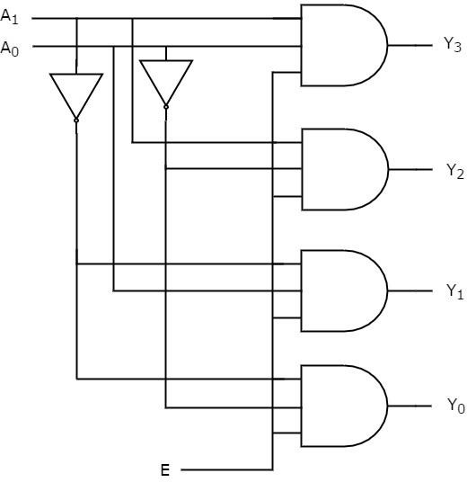
Therefore, the outputs of 2 to 4 decoder are nothing but the min terms of two input variables A1 & A0, when enable, E is equal to one. If enable, E is zero, then all the outputs of decoder will be equal to zero.
Similarly, 3 to 8 decoder produces eight min terms of three input variables A2, A1 & A0 and 4 to 16 decoder produces sixteen min terms of four input variables A3, A2, A1 & A0.

Encoder
Encoder is a combinational circuit which is designed to perform the inverse operation of the decoder. An encoder has n number of input lines and m number of output lines. An encoder produces an m bit binary code corresponding to the digital input number. The encoder accepts an n input digital word and converts it into an m bit another digital word.

Block diagram
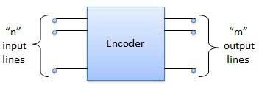
Examples of Encoders are following.

- Priority encoders
- Decimal to BCD encoder
- Octal to binary encoder
- Hexadecimal to binary encoder

to 2 Encoder
Let 4 to 2 Encoder has four inputs Y3, Y2, Y1 & Y0 and two outputs A1 & A0. The block diagram of 4 to 2 Encoder is shown in the following figure.
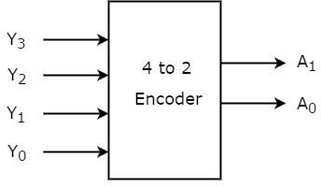
At any time, only one of these 4 inputs can be ‘1’ in order to get the respective binary code at the output. The Truth table of 4 to 2 encoder is shown below.

Inputs |  |  |  | Outputs
Y3 | Y2 | Y1 | Y0 | A1 | A0
0 | 0 | 0 | 1 | 0 | 0
0 | 0 | 1 | 0 | 0 | 1
0 | 1 | 0 | 0 | 1 | 0
1 | 0 | 0 | 0 | 1 | 1
From Truth table, we can write the Boolean functions for each output as
𝐴1 = 𝑌3 + 𝑌2
𝐴0 = 𝑌3 + 𝑌1
We can implement the above two Boolean functions by using two input OR gates. The circuit diagram of 4 to 2 encoder is shown in the following figure.
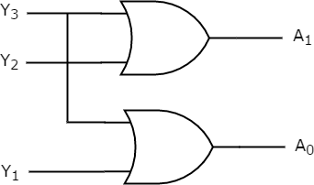

The above circuit diagram contains two OR gates. These OR gates encode the four inputs with two bits

Octal to Binary Encoder
Octal to binary Encoder has eight inputs, Y7 to Y0 and three outputs A2, A1 & A0. Octal to binary encoder is nothing but 8 to 3 encoder.
The block diagram of octal to binary Encoder is shown in the following figure.
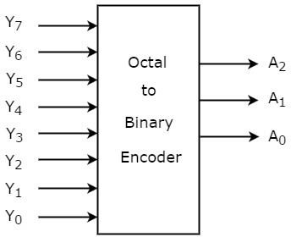

At any time, only one of these eight inputs can be ‘1’ in order to get the respective binary code. The Truth table of octal to binary encoder is shown below.

Inputs |  |  |  |  |  |  |  | Outputs
Y7 | Y6 | Y5 | Y4 | Y3 | Y2 | Y1 | Y0 | A2 | A1 | A0
0 | 0 | 0 | 0 | 0 | 0 | 0 | 1 | 0 | 0 | 0
0 | 0 | 0 | 0 | 0 | 0 | 1 | 0 | 0 | 0 | 1
0 | 0 | 0 | 0 | 0 | 1 | 0 | 0 | 0 | 1 | 0
0 | 0 | 0 | 0 | 1 | 0 | 0 | 0 | 0 | 1 | 1
0 | 0 | 0 | 1 | 0 | 0 | 0 | 0 | 1 | 0 | 0
0 | 0 | 1 | 0 | 0 | 0 | 0 | 0 | 1 | 0 | 1
0 | 1 | 0 | 0 | 0 | 0 | 0 | 0 | 1 | 1 | 0

1 | 0 | 0 | 0 | 0 | 0 | 0 | 0 | 1 | 1 | 1
From Truth table, we can write the Boolean functions for each output as
𝐴2 = 𝑌7 + 𝑌6 + 𝑌5 + 𝑌4
𝐴1 = 𝑌7 + 𝑌6 + 𝑌3 + 𝑌2
𝐴0 = 𝑌7 + 𝑌5 + 𝑌3 + 𝑌1
We can implement the above Boolean functions by using four input OR gates. The circuit diagram of octal to binary encoder is shown in the following figure.
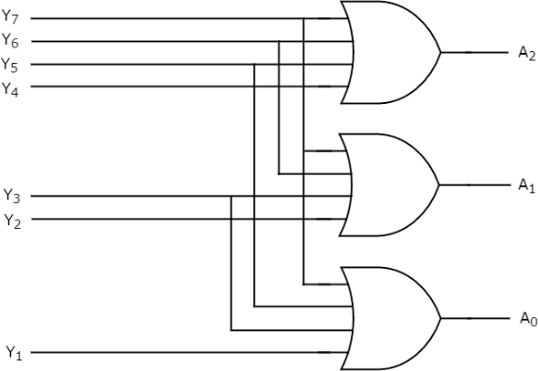
The above circuit diagram contains three 4-input OR gates. These OR gates encode the eight inputs with three bits.
Digital comparator
The Digital Comparator is another very useful combinational logic circuit used to compare the value of two binary digits.

bit Digital Comparator Circuit
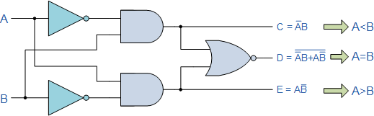

Then the operation of a 1-bit digital comparator is given in the following Truth Table.

Digital Comparator Truth Table

Inputs |  | Outputs
B | A | A > B | A = B | A < B
0 | 0 | 0 | 1 | 0
0 | 1 | 1 | 0 | 0
1 | 0 | 0 | 0 | 1
1 | 1 | 0 | 1 | 0

- bit Magnitude Comparator
A comparator that compares two binary numbers (each number having 2 bits) and produces three outputs based on the relative magnitudes of given binary bits is called a 2-bit magnitude comparator.

Truth Table

A1 | A0 | B1 | B0 | A<B | A=B | A>B
0 | 0 | 0 | 0 | 0 | 1 | 0
0 | 0 | 0 | 1 | 1 | 0 | 0
0 | 0 | 1 | 0 | 1 | 0 | 0
0 | 0 | 1 | 1 | 1 | 0 | 0
0 | 1 | 0 | 0 | 0 | 0 | 1

0 | 1 | 0 | 1 | 0 | 1 | 0
0 | 1 | 1 | 0 | 1 | 0 | 0
0 | 1 | 1 | 1 | 1 | 0 | 0
1 | 0 | 0 | 0 | 0 | 0 | 1
1 | 0 | 0 | 1 | 0 | 0 | 1
1 | 0 | 1 | 0 | 0 | 1 | 0
1 | 0 | 1 | 1 | 1 | 0 | 0
1 | 1 | 0 | 0 | 0 | 0 | 1
1 | 1 | 0 | 1 | 0 | 0 | 1
1 | 1 | 1 | 0 | 0 | 0 | 1
1 | 1 | 1 | 1 | 0 | 1 | 0
The truth table derives the expressions of A<B, A>B, and A=B as below

𝐴 < 𝐵 – 𝐴1’𝐵1’ + 𝐴0’𝐵1𝐵0 + 𝐴1’𝐴0’𝐵0
𝐴 > 𝐵 – 𝐴1𝐵1’ + 𝐴0𝐵1’𝐵0’ + 𝐴1𝐴0𝐵0’
𝐴 = 𝐵 – (𝐴0 𝐸𝑥 − 𝑁𝑜𝑟 𝐵0) (𝐴1 𝐸𝑥 − 𝑁𝑜𝑟 𝐵1)
With these expressions, the Circuit diagram can be as follows

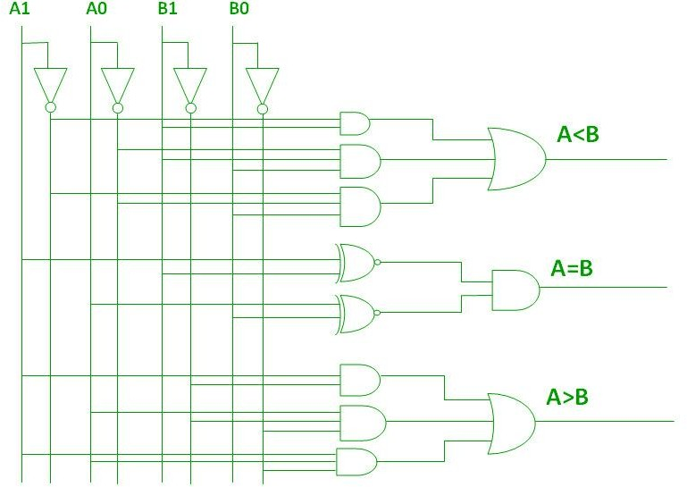

bit Magnitude Comparator
A comparator that compares two binary numbers (each number having 3 bits) and produces three outputs based on the relative magnitudes of given binary bits is called a 3-bit magnitude comparator.

The equal functions are 𝐴0 = 𝐵0, 𝐴1 = 𝐵1, 𝐴2 = 𝐵2
Then 𝐴 = 𝐵 = (𝐴0’𝐵0’ + 𝐴0𝐵0)(𝐴1’𝐵1’ + 𝐴1𝐵1)(𝐴2’𝐵2’ + 𝐴2𝐵2)
The output is 𝐴 < 𝐵 in the cases of
𝐴2 < 𝐵2
𝐴2 = 𝐵2 𝑡ℎ𝑒𝑛 𝐴1 < 𝐵1
𝐴2 = 𝐵2, 𝐴1 = 𝐵1 𝑡ℎ𝑒𝑛 𝐴0 < 𝐵0
𝐴 < 𝐵 = 𝐴2’𝐵2 + [(𝐴2’𝐵2’ + 𝐴2𝐵2) ∗ 𝐴1’𝐵1] + [(𝐴2’𝐵2’ + 𝐴2𝐵2) ∗ [(𝐴1’𝐵’ + 𝐴1𝐵1)
∗ 𝐴0’𝐵0]
𝑇ℎ𝑒 𝑜𝑢𝑡𝑝𝑢𝑡 𝑖𝑠 𝐴 > 𝐵 𝑖𝑛 𝑡ℎ𝑒 𝑐𝑎𝑠𝑒𝑠 𝑜𝑓
𝐴2 > 𝐵2
𝐴2 = 𝐵2 𝑡ℎ𝑒𝑛 𝐴1 > 𝐵
𝐴2 = 𝐵2, 𝐴1 = 𝐵1 𝑡ℎ𝑒𝑛 𝐴0 > 𝐵0
𝐴 > 𝐵 = 𝐴2𝐵2’ + + [(𝐴2’𝐵2’ + 𝐴2𝐵2) ∗ 𝐴1𝐵1’] + + [(𝐴2’𝐵2’ + 𝐴2𝐵2) ∗ [(𝐴1’𝐵’
+ 𝐴1𝐵1) ∗ 𝐴0𝐵0’]

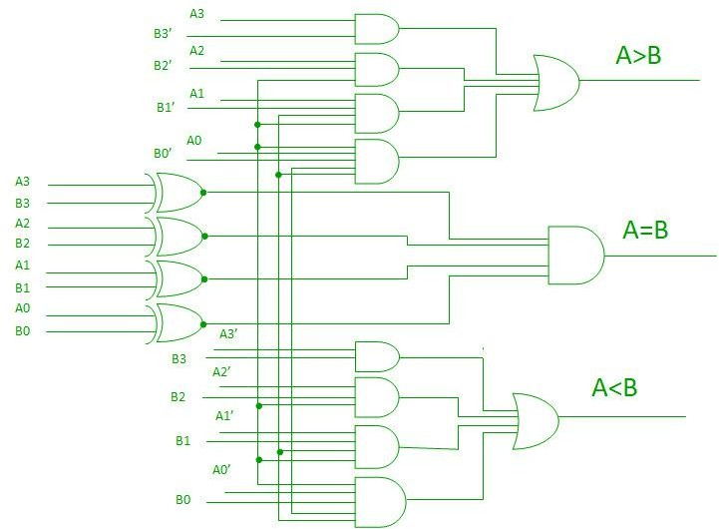

Seven segment decoder
Seven Segment Displays
Seven segment displays are the output display device that provide a way to display information in the form of image or text or decimal numbers which is an alternative to the more complex dot matrix displays. It is widely used in digital clocks, basic calculators, electronic meters, and other electronic device that display numerical information. It consists seven segments of light emitting diodes (LEDs) which is assembled like numerical 8.
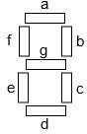
Working of Seven Segment Displays
The number 8 is displayed when the power is given to all the segments and if you disconnect the power for ‘g’, then it displays number 0. In seven segment display, power (or voltage) at different pins can be applied at the same time, so we can form combinations of display numerical from 0 to 9. Since seven segment display cannot form alphabet like X and Z, so it cannot be used for alphabet and it can be used only for displaying decimal numerical magnitudes. However, seven segment displays can form alphabets A, B, C, D, E, and F, so it can also used for representing hexadecimal digits.

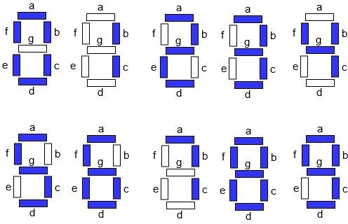
We can produce a truth table for each decimal digit.

Decimal Digit | Individual Segments Illuminated
Decimal Digit | a | b | c | d | e | f | g
0 | 1 | 1 | 1 | 1 | 1 | 1 | 0
1 | 0 | 1 | 1 | 0 | 0 | 0 | 0
2 | 1 | 1 | 0 | 1 | 1 | 0 | 1
3 | 1 | 1 | 1 | 1 | 0 | 0 | 1
4 | 0 | 1 | 1 | 0 | 0 | 1 | 1
5 | 1 | 0 | 1 | 1 | 0 | 1 | 1
6 | 1 | 0 | 1 | 1 | 1 | 1 | 1

7 | 1 | 1 | 1 | 0 | 0 | 0 | 0
8 | 1 | 1 | 1 | 1 | 1 | 1 | 1
9 | 1 | 1 | 1 | 1 | 0 | 1 | 1

Therefore, Boolean expression for each decimal digit which requires respective light emitting diodes (LEDs) are ON or OFF.

UNIT-3
Sequential Logic Circuits

principles of flip-flops:
Sequential circuit contains a set of inputs and outputs. The outputs of sequential circuit depend not only on the combination of present inputs but also on the previous outputs. Previous output is nothing but the present state. Therefore, sequential circuits contain combinational circuits along with memory storage elements. Some sequential circuits may not contain combinational circuits, but only memory elements.
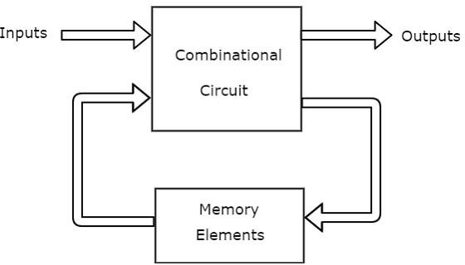
Following table shows the differences between combinational circuits and sequential circuits.

Combinational Circuits | Sequential Circuits
Outputs depend only on present inputs. | Outputs depend on both present inputs and present state.
Feedback path is not present. | Feedback path is present.

Memory elements are not required. | Memory elements are required.
Clock signal is not required. | Clock signal is required.
Easy to design. | Difficult to design.

Types of Sequential Circuits
Following are the two types of sequential circuits −

    - Asynchronous sequential circuits
    - Synchronous sequential circuits Asynchronous sequential circuits
If some or all the outputs of a sequential circuit do not change affect with respect to active transition of clock signal, then that sequential circuit is called as Asynchronous sequential circuit. That means, all the outputs of asynchronous sequential circuits do not change affect at the same time. Therefore, most of the outputs of asynchronous sequential circuits are not in synchronous with either only positive edges or only negative edges of clock signal.

Synchronous sequential circuits

If all the outputs of a sequential circuit change affect with respect to active transition of clock signal, then that sequential circuit is called as Synchronous sequential circuit. That means, all the outputs of synchronous sequential circuits change affect at the same time. Therefore, the outputs of synchronous sequential circuits are in synchronous with either only positive edges or only negative edges of clock signal.

Clock Signal and Triggering Clock signal
Clock signal is a periodic signal and its ON time and OFF time need not be the same. We can represent the clock signal as a square wave, when both its ON time and OFF time are same. This clock signal is shown in the following figure.
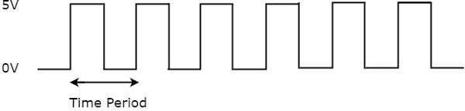

Types of Triggering
Following are the two possible types of triggering that are used in sequential circuits.

    - Level triggering
    - Edge triggering Level triggering

There are two levels, namely logic High and logic Low in clock signal. Following are the two types of level triggering.

    - Positive level triggering
    - Negative level triggering
If the sequential circuit is operated with the clock signal when it is in Logic High, then that type of triggering is known as Positive level triggering. It is highlighted in below figure.
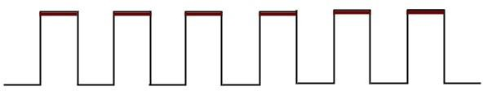

If the sequential circuit is operated with the clock signal when it is in Logic Low, then that type of triggering is known as Negative level triggering. It is highlighted in the following figure.
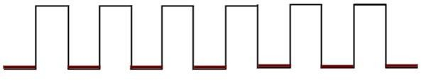

Edge triggering

There are two types of transitions that occur in clock signal. That means, the clock signal transitions either from Logic Low to Logic High or Logic High to Logic Low.
Following are the two types of edge triggering based on the transitions of clock signal.

    - Positive edge triggering
    - Negative edge triggering
If the sequential circuit is operated with the clock signal that is transitioning from Logic Low to Logic High, then that type of triggering is known as Positive edge triggering. It is also called as rising edge triggering. It is shown in the following figure.
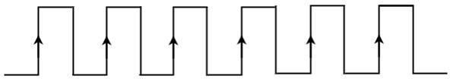

If the sequential circuit is operated with the clock signal that is transitioning from Logic High to Logic Low, then that type of triggering is known as Negative edge triggering. It is also called as falling edge triggering. It is shown in the following figure.
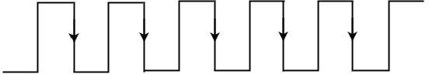

There are two types of memory elements based on the type of triggering that is suitable to operate it.

    - Latches

    - Flip-flops
Latches operate with enable signal, which is level sensitive. Whereas, flip-flops are edge sensitive.
There are 4 types of flip flops:

    - SR Flip-Flop
    - D Flip-Flop
    - JK Flip-Flop
    - T Flip-Flop

SR Flip-Flop
SR flip-flop operates with only positive clock transitions or negative clock transitions. Whereas, SR latch operates with enable signal.
The circuit diagram of SR flip-flop is shown in the following figure.
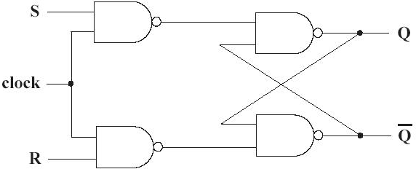

This circuit has two inputs S & R and two outputs Q& Q’. The operation of SR flipflop is similar to SR Latch. But, this flip-flop affects the outputs only when positive transition of the clock signal is applied instead of active enable.
The following table shows the state table of SR flip-flop.

S | R | Qt+1
0 | 0 | Q
0 | 1 | 0
1 | 0 | 1
1 | 1 | -
Here, Q & Qt+1 are present state & next state respectively. So, SR flip-flop can be used for one of these three functions such as Hold, Reset & Set based on the input conditions, when positive transition of clock signal is applied.

D Flip-Flop
D flip-flop operates with only positive clock transitions or negative clock transitions. Whereas, D latch operates with enable signal. That means, the output of D flip-flop is insensitive to the changes in the input, D except for active transition of the clock signal.
The circuit diagram of D flip-flop is shown in the following figure.
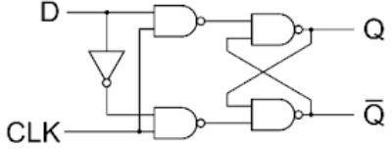

This circuit has single input D and two outputs Q & Q’. The operation of D flip-flop is similar to D Latch. But, this flip-flop affects the outputs only when positive transition of the clock signal is applied instead of active enable.
The following table shows the state table of D flip-flop.

D | Qt + 1
0 | 0
1 | 1
Therefore, D flip-flop always Hold the information, which is available on data input, D of earlier positive transition of clock signal.
D flip-flops can be used in registers, shift registers and some of the counters.

JK Flip-Flop
JK flip-flop is the modified version of SR flip-flop. It operates with only positive clock transitions or negative clock transitions.
The circuit diagram of JK flip-flop is shown in the following figure.
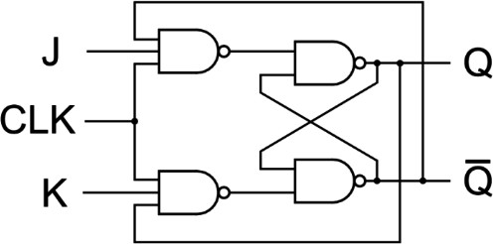

This circuit has two inputs J & K and two outputs Q & Q’. The operation of JK flip-flop is similar to SR flip-flop.
The following table shows the state table of JK flip-flop.

J | K | Qt+1
0 | 0 | Q
0 | 1 | 0
1 | 0 | 1
1 | 1 | Q'
Here, Q & Qt+1 are present state & next state respectively. So, JK flip-flop can be used for one of these four functions such as Hold, Reset, Set & Complement of present state based on the input conditions, when positive transition of clock signal is applied.

Master-Slave JK Flip Flop

In "JK Flip Flop", when both the inputs and CLK set to 1 for a long time, then Q output toggle until the CLK is 1. Thus, the uncertain or unreliable output produces. This problem is referred to as a race-round condition in JK flip-flop and avoided by ensuring that the CLK set to 1 only for a very short time.

Explanation

The master-slave flip flop is constructed by combining two J K flip flop. These flip flops are connected in a series configuration. In these two flip flops, the 1st flip flop work as "master", called the master flip flop, and the 2nd work as a "slave", called slave flip flop.

In "master-slave flip flop", apart from these two flip flops, an inverter or NOT gate is also used. For passing the inverted clock pulse to the "slave" flip flop, the inverter is connected to the clock's pulse. In simple words, when CP set to false for "master", then CP is set to true for "slave", and when CP set to true for "master", then CP is set to false for "slave".
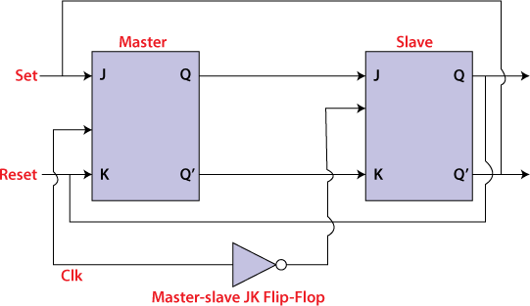

Working:

- When the clock pulse is true, the slave flip flop will be in the isolated state, and the system's state may be affected by the J and K inputs. The "slave" remains isolated until the CP is 1. When the CP set to 0, the master flip-flop passes the information to the slave flip flop to obtain the output.
- The master flip flop responds first from the slave because the master flip flop is the positive level trigger, and the slave flip flop is the negative level trigger.
- The output Q'=1 of the master flip flop is passed to the slave flip flop as an input K when the input J set to 0 and K set to 1. The clock forces the slave flip flop to work as reset, and then the slave copies the master flip flop.
- When J=1, and K=0, the output Q=1 is passed to the J input of the slave. The clock's negative transition sets the slave and copies the master.
- The master flip flop toggles on the clock's positive transition when the inputs J and K set to 1. At that time, the slave flip flop toggles on the clock's negative transition.
- The flip flop will be disabled, and Q remains unchanged when both the inputs of the JK flip flop set to 0.
Timing Diagram of a Master Flip Flop:
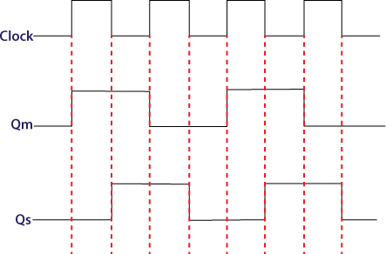

- When the clock pulse set to 1, the output of the master flip flop will be one until the clock input remains 0.
- When the clock pulse becomes high again, then the master's output is 0, which will be set to 1 when the clock becomes one again.
- The master flip flop is operational when the clock pulse is 1. The slave's output remains 0 until the clock is not set to 0 because the slave flip flop is not operational.
- The slave flip flop is operational when the clock pulse is 0. The output of the master remains one until the clock is not set to 0 again.
- Toggling occurs during the entire process because the output changes once in the cycle.

T Flip-Flop
T flip-flop is the simplified version of JK flip-flop. It is obtained by connecting the same input ‘T’ to both inputs of JK flip-flop. It operates with only positive clock transitions or negative clock transitions.
The circuit diagram of T flip-flop is shown in the following figure.
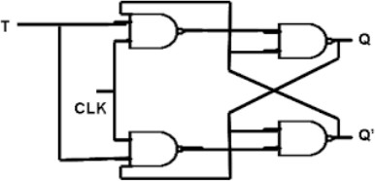
This circuit has single input T and two outputs Q & Q’. The operation of T flip-flop is same as that of JK flip-flop. Here, we considered the inputs of JK flip-flop as J = T and K = T in order to utilize the modified JK flip-flop for 2 combinations of inputs. So, we eliminated the other two combinations of J & K, for which those two values are complement to each other in T flip- flop.
The following table shows the state table of T flip-flop.

D | Qt+1
0 | Q
1 | Q’
Here, Q & Qt+1 are present state & next state respectively. So, T flip-flop can be used for one of these two functions such as Hold, & Complement of present state based on the input conditions, when positive transition of clock signal is applied.
The output of T flip-flop always toggles for every positive transition of the clock signal, when input T remains at logic High 11. Hence, T flip-flop can be used in counters.

UNIT-4
Registers, memories and PLD

Shift register
    - Flip flops can be used to store a single bit of binary data (1or 0).
    - However, in order to store multiple bits of data, we need multiple flip flops. N flip flops are to be connected in an order to store n bits of data.
    - A Register is a device which is used to store such information. It is a group of flip flops connected in series used to store multiple bits of data.
    - The information stored within these registers can be transferred with the help of shift registers.
    - Shift Register is a group of flip flops used to store multiple bits of data. The bits stored in such registers can be made to move within the registers and in/out of the registers by applying clock pulses.
    - An n-bit shift register can be formed by connecting n flip-flops where each flip flop stores a single bit of data.

Shift registers are basically of 4 types. These are:
      - Serial In Serial Out shift register
      - Serial In parallel Out shift register
      - Parallel In Serial Out shift register
      - Parallel In parallel Out shift register

Serial-In Serial-Out Shift Register (SISO) –
The shift register, which allows serial input (one bit after the other through a single data line) and produces a serial output is known as Serial-In Serial-Out shift register. Since there is only one output, the data leaves the shift register one bit at a time in a serial pattern, thus the name Serial-In Serial-Out Shift Register. The circuit consists of four D flip-flops which are connected in a serial manner. All these flip-flops are synchronous with each other since the same clock signal is applied to each flip flop. The main use of a SISO is to act as a delay element.
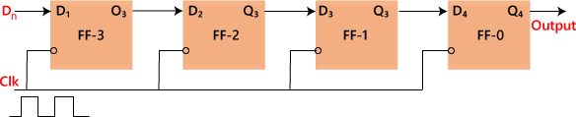
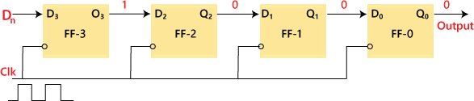

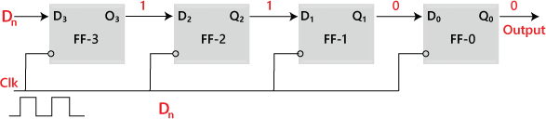
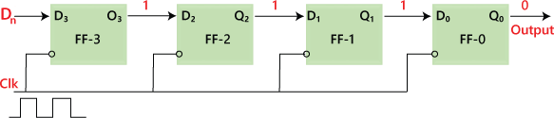

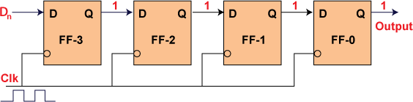

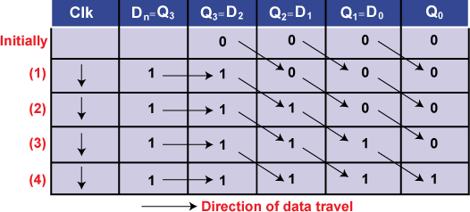
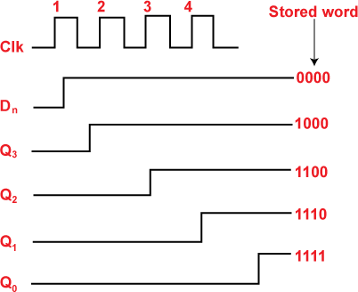

Serial-In Parallel-Out shift Register (SIPO) –
The shift register, which allows serial input (one bit after the other through a single data line) and produces a parallel output is known as Serial-In Parallel-Out shift register. The circuit consists of four D flip-flops which are connected. The clear (CLR) signal is connected in addition to the clock signal to all the 4 flip flops in order to RESET them. The output of the first flip flop is connected to the input of the next flip flop and so on. All these flip -flops are synchronous with each other since the same clock signal is applied to each flip flop. They are used in communication lines where demultiplexing of a data line into several parallel lines is required because the main use of the SIPO register is to convert serial data into parallel data.

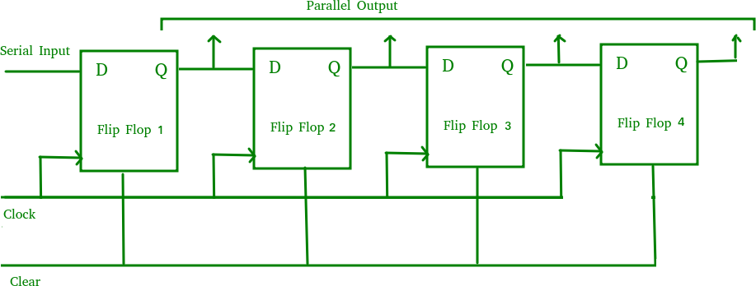

Parallel IN Serial OUT (PISO)
In the "Parallel IN Serial OUT" register, the data is entered in a parallel way, and the outcome comes serially. A four-bit "Parallel IN Serial OUT" register is designed below. The input of the flip flop is the output of the previous Flip Flop. The input and outputs are connected through the combinational circuit. Through this combinational circuit, the binary input B0, B1, B2, B3 are passed. The shift mode and the load mode are the two modes in which the "PISO" circuit works.

Load mode
The bits B0, B1, B2, and B3 are passed to the corresponding flip flops when the second, fourth, and sixth "AND" gates are active. These gates are active when the shift or load bar line set to
0. The binary inputs B0, B1, B2, and B3 will be loaded into the respective flip-flops when the edge of the clock is low. Thus, parallel loading occurs.

Shift mode
The second, fourth, and sixth gates are inactive when the load and shift line set to 0. So, we are not able to load data in a parallel way. At this time, the first, third, and fifth gates will be activated, and the shifting of the data will be left to the right bit. In this way, the "Parallel IN Serial OUT" operation occurs.
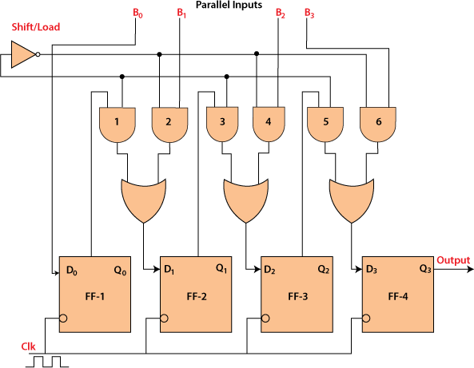

A Parallel in Serial out (PISO) shift register us used to convert parallel data to serial data.

Parallel IN Parallel OUT (PIPO)
In "Parallel IN Parallel OUT", the inputs and the outputs come in a parallel way in the register. The inputs A0, A1, A2, and A3, are directly passed to the data inputs D0, D1, D2, and D3 of the respective flip flop. The bits of the binary input is loaded to the flip flops when the negative clock edge is applied. The clock pulse is required for loading all the bits. At the output side, the loaded bits appear.
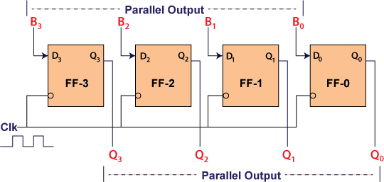

Universal shift register
A Universal shift register is a register which has both the right shift and left shift with parallel load capabilities. Universal shift registers are used as memory elements in computers. A Unidirectional shift register is capable of shifting in only one direction. A bidirectional shift register is capable of shifting in both the directions. The Universal shift register is a combination design of bidirectional shift register and a unidirectional shift register with parallel load provision
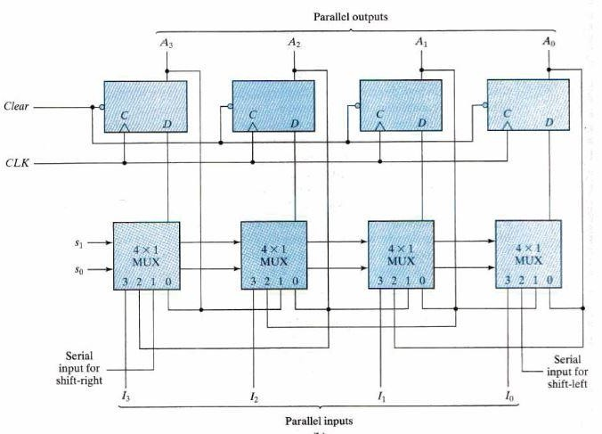

Basic connections –
- The first input (zeroth pin of multiplexer) is connected to the output pin of the corresponding flip-flop.
- The second input (first pin of multiplexer) is connected to the output of the very - previous flip flop which facilitates the right shift.
- The third input (second pin of multiplexer) is connected to the output of the very-next flip-flop which facilitates the left shift.
- The fourth input (third pin of multiplexer) is connected to the individual bits of the input data which facilitates parallel loading.
The working of the Universal shift register depends on the inputs given to the select lines. The register operations performed for the various inputs of select lines are as follows:
S1 | S0 | Operation
0 | 0 | No change
0 | 1 | Shift right
1 | 0 | Shift left
1 | 1 | Parallel load

Counters
Counter is a sequential circuit. A digital circuit which is used for a counting pulses is known counter. Counter is the widest application of flip-flops. It is a group of flip-flops with a clock signal applied. Counters are of two types.

    - Asynchronous or ripple counters.
    - Synchronous counters.

Asynchronous or ripple counters
The Asynchronous counter is also known as the ripple counter. Below is a diagram of the 2-bit Asynchronous counter in which we used two T flip-flops or two JK flip flop by setting both of the inputs to 1 permanently. The external clock pass to the clock input of the first flip flop, i.e., FF-A and its output, i.e., is passed to clock input of the next flip flop, i.e., FF-B.
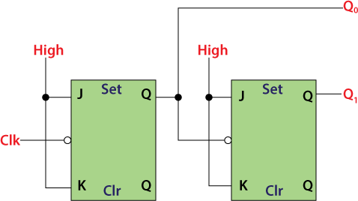
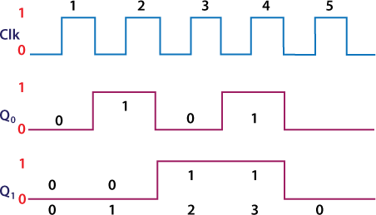

Operation:

- Condition 1: When both the flip flops are in reset condition.
Operation: The outputs of both flip flops, i.e., QA QB, will be 0.
- Condition 2: When the first negative clock edge passes.
Operation: The first flip flop will toggle, and the output of this flip flop will change from 0 to 1. The output of this flip flop will be taken by the clock input of the next flip flop. This output will be taken as a positive edge clock by the second flip flop. This input will not change the second flip flop's output state because it is the negative edge triggered flip flop.
So, QA = 1 and QB = 0
- Condition 3: When the second negative clock edge is applied.
Operation: The first flip flop will toggle again, and the output of this flip flop will change from 1 to 0. This output will be taken as a negative edge clock by the second flip flop. This input will change the second flip flop's output state because it is the negative edge triggered flip flop.
So, QA = 0 and QB = 1.
- Condition 4: When the third negative clock edge is applied.
Operation: The first flip flop will toggle again, and the output of this flip flop will change from 0 to 1. This output will be taken as a positive edge clock by the second flip flop. This input will not change the second flip flop's output state because it is the negative edge triggered flip flop.
So, QA = 1 and QB = 1
- Condition 5: When the fourth negative clock edge is applied.
Operation: The first flip flop will toggle again, and the output of this flip flop will change from 1 to 0. This output will be taken as a negative edge clock by the second flip flop. This input will change the output state of the second flip flop.
So, QA = 0 and QB = 0

Classification of counters
Depending on the way in which the counting progresses, the synchronous or asynchronous counters are classified as follows −

    - Up counters
    - Down counters
    - Up/Down counters

UP/DOWN Counter
Up counter and down counter is combined together to obtain an UP/DOWN counter. A mode control (M) input is also provided to select either up or down mode. A combinational circuit is required to be designed and used between each pair of flip-flop in order to achieve the up/down operation.

    - Type of up/down counters
    - UP/DOWN ripple counters
    - UP/DOWN synchronous counter

UP/DOWN Counter
Up counter and down counter is combined together to obtain an UP/DOWN counter. A mode control (M) input is also provided to select either up or down mode. A combinational circuit is required to be designed and used between each pair of flip-flop in order to achieve the up/down operation.

    - Type of up/down counters
    - UP/DOWN ripple counters
    - UP/DOWN synchronous counter

UP/DOWN Ripple Counters
In the UP/DOWN ripple counter all the FFs operate in the toggle mode. So, either T flip-flops or JK flip-flops are to be used. The LSB flip-flop receives clock directly. But the clock to every other FF is obtained from (Q = Q bar) output of the previous FF.
    - UP counting mode (M=0) − The Q output of the preceding FF is connected to the clock of the next stage if up counting is to be achieved. For this mode, the mode select input M is at logic 0 (M=0).
    - DOWN counting mode (M=1) − If M = 1, then the Q bar output of the preceding FF is connected to the next FF. This will operate the counter in the counting mode.

Example
3-bit binary up/down ripple counter.
    - 3-bit − hence three FFs are required.
    - UP/DOWN − So a mode control input is essential.
    - For a ripple up counter, the Q output of preceding FF is connected to the clock input of the next one.
    - For a ripple up counter, the Q output of preceding FF is connected to the clock input of the next one.
    - For a ripple down counter, the Q bar output of preceding FF is connected to the clock input of the next one.
    - Let the selection of Q and Q bar output of the preceding FF be controlled by the mode control input M such that, If M = 0, UP counting. So, connect Q to CLK. If M = 1, DOWN counting. So, connect Q bar to CLK.
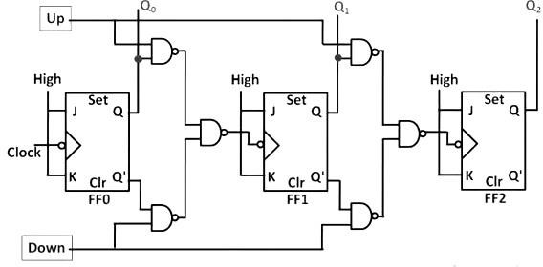

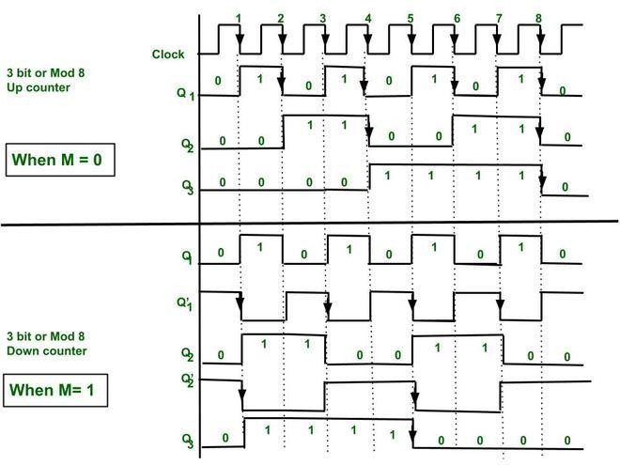

Modulus Counter (MOD-N Counter)
The 2-bit ripple counter is called as MOD-4 counter and 3-bit ripple counter is called as MOD- 8 counter. So, in general, an n-bit ripple counter is called as modulo-N counter. Where, MOD number = 2^{n}.

Type of modulus
    - 2-bit up or down (MOD-4)
    - 3-bit up or down (MOD-8)
    - 4-bit up or down (MOD-16)

Application of counters
    - Frequency counters
    - Digital clock
    - Time measurement
    - A to D converter
    - Frequency divider circuits
    - Digital triangular wave generator.

Decade counter
A decade counter counts ten different states and then reset to its initial states. A simple decade counter will count from 0 to 9 but we can also make the decade counters which can go through any ten states between 0 to 15 (for 4 bit counter).

Clock pulse | Q3 | Q2 | Q1 | Q0
0 | 0 | 0 | 0 | 0
1 | 0 | 0 | 0 | 1
2 | 0 | 0 | 1 | 0
3 | 0 | 0 | 1 | 1

4 | 0 | 1 | 0 | 0
5 | 0 | 1 | 0 | 1
6 | 0 | 1 | 1 | 0
7 | 0 | 1 | 1 | 1
8 | 1 | 0 | 0 | 0
9 | 1 | 0 | 0 | 1
10 | 0 | 0 | 0 | 0

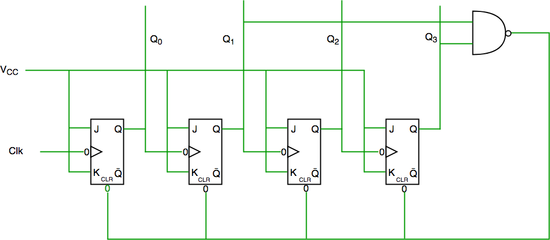
We see from circuit diagram that we have used NAND gate for Q3 and Q1 and feeding this to clear input line because binary representation of 10 is—1010
And we see Q3 and Q1 are 1 here, if we give NAND of these two bits to clear input then counter will be clear at 10 and again start from beginning.

Synchronous counters
If the "clock" pulses are applied to all the flip-flops in a counter simultaneously, then such a counter is called as synchronous counter.

2-bit Synchronous up counter
The JA and KA inputs of FF-A are tied to logic 1. So, FF-A will work as a toggle flip-flop. The JB and KB inputs are connected to QA.
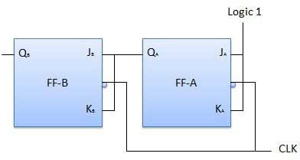

Operation

S.N. | Condition | Operation
1 | Initially let both the FFs be in the reset state | QBQA = 00 initially.
2 | After 1st negative clock edge | As soon as the first negative clock edge is applied, FF-A will toggle and QA will change from 0 to 1.  But at the instant of application of negative clock edge, QA , JB = KB = 0. Hence FF-B will not change its state. So QB will remain 0.  QBQA = 01 after the first clock pulse.
3 | After 2nd negative clock edge | On the arrival of second negative clock edge, FF-A toggles again and QA changes from 1 to 0.  But at this instant QA was 1. So JB = KB= 1 and FF-B will toggle. Hence QB changes from 0 to 1.  QBQA = 10 after the second clock pulse.
4 | After 3rd negative clock edge | On application of the third falling clock edge, FF-A will toggle from 0 to 1 but there is no change of state for FF-B.  QBQA = 11 after the third clock pulse.
5 | After 4th negative clock edge | On application of the next clock pulse, QA will change from 1 to 0 as QB will also change from 1 to 0.  QBQA = 00 after the fourth clock pulse.

4-bit synchronous counter
- The external clock pulses (pulses to be counted) are fed directly to each of the J-K flip- flops in the counter chain and that both the J and K inputs are all tied together in toggle mode, but only in the first flip-flop, flip-flop FFA (LSB) are they connected HIGH, logic “1” allowing the flip-flop to toggle on every clock pulse.
- Then the synchronous counter follows a predetermined sequence of states in response to the common clock signal, advancing one state for each pulse.
- The J and K inputs of flip-flop FFB are connected directly to the output QA of flip- flop FFA, but the J and K inputs of flip-flops FFC and FFD are driven from separate AND gates which are also supplied with signals from the input and output of the previous stage.

- These additional AND gates generate the required logic for the JK inputs of the next stage.
- If we enable each JK flip-flop to toggle based on whether or not all preceding flip-flop outputs (Q) are “HIGH” we can obtain the same counting sequence as with the asynchronous circuit but without the ripple effect, since each flip-flop in this circuit will be clocked at exactly the same time.
- Then as there is no inherent propagation delay in synchronous counters, because all the counter stages are triggered in parallel at the same time, the maximum operating frequency of this type of frequency counter is much higher than that for a similar asynchronous counter circuit.
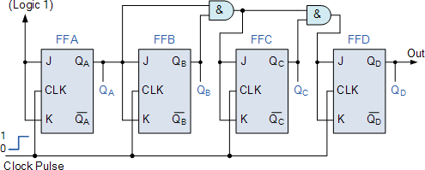
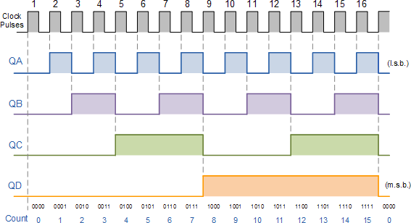

Ring counter
- Ring counter is a typical application of Shift resister.
- Ring counter is almost same as the shift counter. The only change is that the output of the last flip-flop is connected to the input of the first flip-flop in case of ring counter but in case of shift resister it is taken as output.
- No. of states in Ring counter = No. of flip-flop used

4-bit ring counter

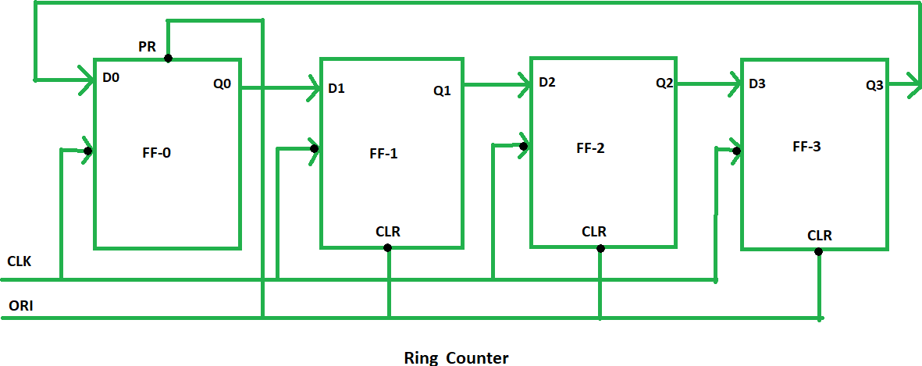

- The clock pulse (CLK) is applied to all the flip-flop simultaneously. Therefore, it is a Synchronous Counter.
- Also, here we use Overriding input (ORI) to each flip-flop. Preset (PR) and Clear (CLR) are used as ORI.
- When PR is 0, then the output is 1. And when CLR is 0, then the output is 0. Both PR and CLR are active low signal that is always works in value 0.
PR = 0, Q = 1
CLR = 0, Q = 0
- These two values are always fixed. They are independent with the value of input D and the Clock pulse (CLK).

Working–
- Here, ORI is connected to Preset (PR) in FF-0 and it is connected to Clear (CLR) in FF-1, FF-2, and FF-3.
- Thus, output Q = 1 is generated at FF-0 and rest of the flip-flop generate output Q = 0.
- This output Q = 1 at FF-0 is known as Pre-set 1 which is used to form the ring in the Ring Counter.
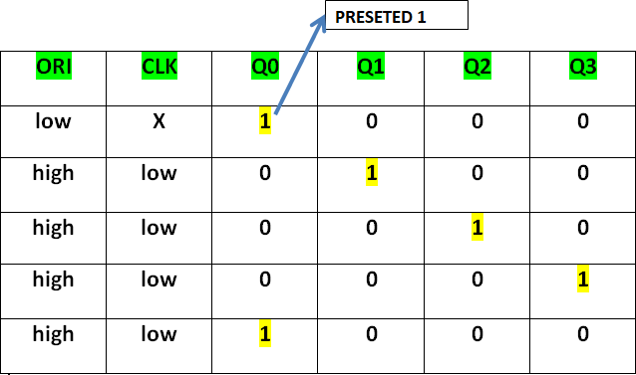

- This Preseted 1 is generated by making ORI low and that time Clock (CLK) becomes don’t care.

- After that ORI made to high and apply low clock pulse signal as the Clock (CLK) is negative edge triggered.
- After that, at each clock pulse the preseted 1 is shifted to the next flip -flop and thus form Ring.
From the above table, we can say that there are 4 states in 4-bit Ring Counter. 4 states are:
1 0 0 0
0 1 0 0
0 0 1 0
0 0 0 1

Concept of memories
A memory is just like a human brain. It is used to store data and instruction. Computer memory is the storage space in computer where data is to be processed and instructions required for processing are stored.
The memory is divided into large number of small parts. Each part is called a cell. Each location or cell has a unique address which varies from zero to memory size minus one.
For example if computer has 64k words, then this memory unit has 64 * 1024 = 65536 memory location. The address of these locations varies from 0 to 65535.
Memory is primarily of two types
    - Internal Memory − cache memory and primary/main memory
    - External Memory − magnetic disk / optical disk etc.

RAM
A RAM constitutes the internal memory of the CPU for storing data, program and program result. It is read/write memory. It is called random access memory (RAM).
Since access time in RAM is independent of the address to the word that is, each storage location inside the memory is as easy to reach as other location & takes the same amount of time. We can reach into the memory at random & extremely fast but can also be quite expensive.
RAM is volatile, i.e. data stored in it is lost when we switch off the computer or if there is a power failure. Hence, a backup uninterruptible power system (UPS) is often used with computers. RAM is small, both in terms of its physical size and in the amount of data it can hold.
RAM is of two types

    - Static RAM (SRAM)
    - Dynamic RAM (DRAM) Static RAM (SRAM)
The word static indicates that the memory retains its contents as long as power remains applied. However, data is lost when the power gets down due to volatile nature. SRAM chips use a matrix of 6-transistors and no capacitors. Transistors do not require power to prevent leakage, so SRAM need not have to be refreshed on a regular basis.

Because of the extra space in the matrix, SRAM uses more chips than DRAM for the same amount of storage space, thus making the manufacturing costs higher.
Static RAM is used as cache memory needs to be very fast and small. Dynamic RAM (DRAM)
DRAM, unlike SRAM, must be continually refreshed in order for it to maintain the data. This is done by placing the memory on a refresh circuit that rewrites the data several hundred times per second. DRAM is used for most system memory because it is cheap and small. All DRAMs are made up of memory cells. These cells are composed of one capacitor and one transistor.

ROM
ROM stands for Read Only Memory. The memory from which we can only read but cannot write on it. This type of memory is non-volatile. The information is stored permanently in such memories during manufacture.
A ROM, stores such instruction as are required to start computer when electricity is first turned on, this operation is referred to as bootstrap. ROM chip are not only used in the computer but also in other electronic items like washing machine and microwave oven.
Following are the various types of ROM −

MROM (Masked ROM)

The very first ROMs were hard-wired devices that contained a pre-programmed set of data or instructions. These kind of ROMs are known as masked ROMs. It is inexpensive ROM.

PROM (Programmable Read Only Memory)

PROM is read-only memory that can be modified only once by a user. The user buys a blank PROM and enters the desired contents using a PROM programmer. Inside the PROM chip there are small fuses which are burnt open during programming. It can be programmed only once and is not erasable.

EPROM (Erasable and Programmable Read Only Memory)

The EPROM can be erased by exposing it to ultra-violet light for a duration of upto 40 minutes. Usually, an EPROM eraser achieves this function. During programming an electrical charge is trapped in an insulated gate region. The charge is retained for more than ten years because the charge has no leakage path. For erasing this charge, ultra-violet light is passed through a quartz crystal window (lid). This exposure to ultra-violet light dissipates the charge. During normal use the quartz lid is sealed with a sticker.

EEPROM (Electrically Erasable and Programmable Read Only Memory)

The EEPROM is programmed and erased electrically. It can be erased and reprogrammed about ten thousand times. Both erasing and programming take about 4 to 10 ms (millisecond). In EEPROM, any location can be selectively erased and programmed. EEPROMs can be erased one byte at a time, rather than erasing the entire chip. Hence, the process of re-programming is flexible but slow.

Programmable Logic Devices (PLD)

Programmable Logic Devices are the integrated circuits. They contain an array of AND gates & another array of OR gates. There are two types of PLDs based on the type of array, which has programmable feature.
    - Programmable Array Logic (PAL)
    - Programmable Logic Array (PLA)
The process of entering the information into these devices is known as programming. Basically, users can program these devices or ICs electrically in order to implement the Boolean functions based on the requirement. Here, the term programming refers to hardware programming but not software programming.

Programmable Array Logic (PAL)
PAL is a programmable logic device that has Programmable AND array & fixed OR array. The advantage of PAL is that we can generate only the required product terms of Boolean function instead of generating all the min terms by using programmable AND gates. The block diagram of PAL is shown in the following figure.
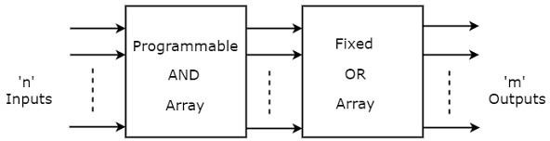
Here, the inputs of AND gates are programmable. That means each AND gate has both normal and complemented inputs of variables. So, based on the requirement, we can program any of those inputs. So, we can generate only the required product terms by using these AND gates.
Here, the inputs of OR gates are not of programmable type. So, the number of inputs to each OR gate will be of fixed type. Hence, apply those required product terms to each OR gate as inputs. Therefore, the outputs of PAL will be in the form of sum of products form.

Example
Let us implement the following Boolean functions using PAL. A=XY+XZ′
B=XY′+YZ′
The given two functions are in sum of products form. There are two product terms present in each Boolean function. So, we require four programmable AND gates & two fixed OR gates for producing those two functions. The corresponding PAL is shown in the following figure.

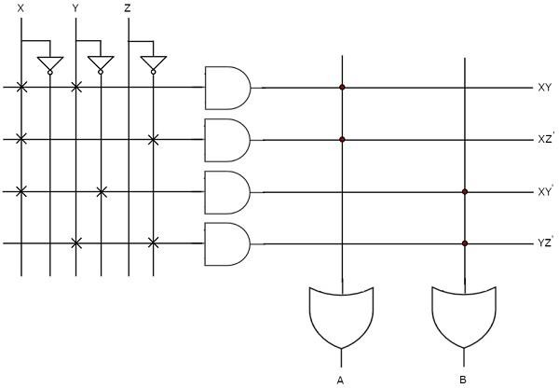
The programmable AND gates have the access of both normal and complemented inputs of variables. In the above figure, the inputs X, X′, Y, Y′, Z & Z′, are available at the inputs of each AND gate. So, program only the required literals in order to generate one product term by each AND gate. The symbol ‘X’ is used for programmable connections.
Here, the inputs of OR gates are of fixed type. So, the necessary product terms are connected to inputs of each OR gate. So that the OR gates produce the respective Boolean functions. The symbol ‘.’ is used for fixed connections.

Programmable Logic Array (PLA)
PLA is a programmable logic device that has both Programmable AND array & Programmable OR array. Hence, it is the most flexible PLD. The block diagram of PLA is shown in the following figure.
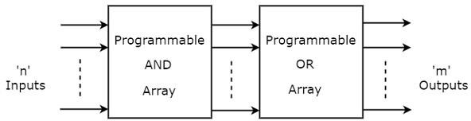
Here, the inputs of AND gates are programmable. That means each AND gate has both normal and complemented inputs of variables. So, based on the requirement, we can program any of those inputs. So, we can generate only the required product terms by using these AND gates.
Here, the inputs of OR gates are also programmable. So, we can program any number of required product terms, since all the outputs of AND gates are applied as inputs to each OR gate. Therefore, the outputs of PAL will be in the form of sum of products form.

Example

Let us implement the following Boolean functions using PLA. A=XY+XZ′
B=XY′+YZ+XZ′

The given two functions are in sum of products form. The number of product terms present in the given Boolean functions A & B are two and three respectively. One product term, Z′X is common in each function.
So, we require four programmable AND gates & two programmable OR gates for producing those two functions. The corresponding PLA is shown in the following figure.
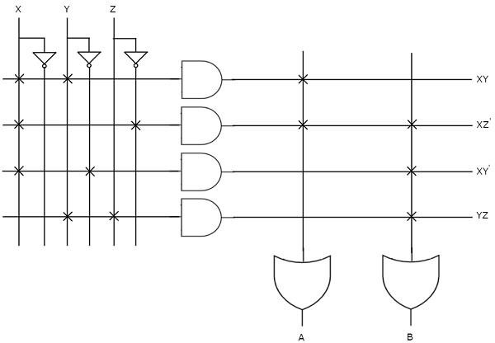
The programmable AND gates have the access of both normal and complemented inputs of variables. In the above figure, the inputs X, X′, Y, Y′, Z & Z′, are available at the inputs of each AND gate. So, program only the required literals in order to generate one product term by each AND gate.
All these product terms are available at the inputs of each programmable OR gate. But, only program the required product terms in order to produce the respective Boolean functions by each OR gate. The symbol ‘X’ is used for programmable connections.

UNIT-5
A/D and D/A converter

ADC & DAC
Analog to Digital Converter (ADC) and Digital to Analog Converter (DAC) are very important components in electronic equipment. Since most real-world signals are analog, these two converting interfaces are necessary to allow digital electronic equipment to process the analog signals.
Digital to analog converter (DAC)
A Digital to Analog Converter (DAC) converts a digital input signal into an analog output signal. The digital signal is represented with a binary code, which is a combination of bits 0 and 1. This chapter deals with Digital to Analog Converters in detail.
The block diagram of DAC is shown in the following figure −

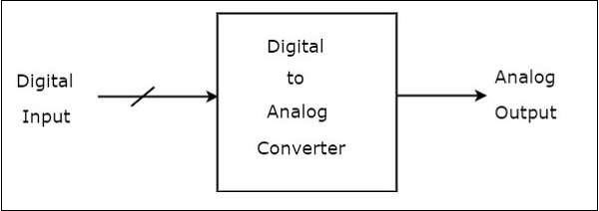
A Digital to Analog Converter (DAC) consists of a number of binary inputs and a single output. In general, the number of binary inputs of a DAC will be a power of two.

Types of DACs

There are two types of DACs

- Weighted Resistor DAC
- R-2R Ladder DAC

Weighted resistor DAC
A weighted resistor DAC produces an analog output, which is almost equal to the digital (binary) input by using binary weighted resistors in the inverting adder circuit. In short, a binary weighted resistor DAC is called as weighted resistor DAC.
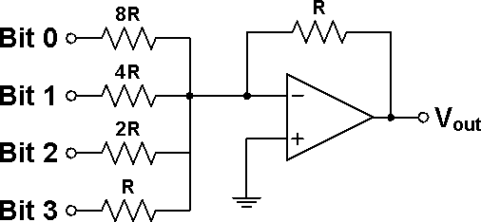

The resistor with the lowest value R corresponds to the highest weighted binary input Bit 3 (MSB) [2³ = 8], and 2R, 4R, 8R correspond to the binary weights of Bit 2 (2² = 4), Bit 1 (2¹ = 2), and Bit 0 (LSB) [2⁰ = 1] respectively. The relationship between the digital inputs (Bit 0 to Bit 3) and the analog output VOUT is as follow:
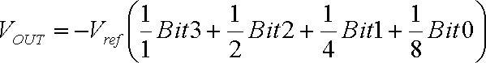

R-2R ladder DAC

R-2R Digital-to-Analogue Converter, or DAC, is a data converter which use two precision resistors to convert a digital binary number into an analogue output signal proportional to the value of the digital number. A R-2R resistive ladder network provides a simple means of converting digital voltage signals into an equivalent analogue output. Input voltages are applied to the ladder network at various points along its length and the more input points the better the resolution of the R-2R ladder. The output signal as a result of all these input voltage

points is taken from the end of the ladder which is used to drive the inverting input of an operational amplifier.
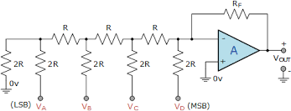

Lets assume all the binary inputs are grounded at 0 volts, that is: VA = VB = VC = VD = 0V (LOW). The binary code corresponding to these four inputs will therefore be: 0000.
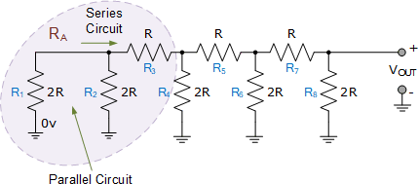

Resistors R1 and R2 are in “parallel” with each other but in “series” with resistor R3. Then we can find the equivalent resistance of these three resistors and call it RA for simplicity
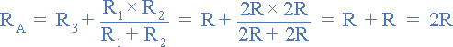
Then RA is equivalent to “2R”. Now we can see that the equivalent resistance “RA” is in parallel with R4 with the parallel combination in series with R5.
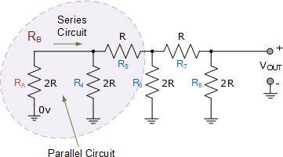

Again, we can find the equivalent resistance of this combination and call it RB.
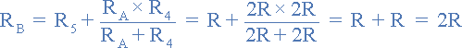

So, RB combination is equivalent to “2R”. Hopefully we can see that this equivalent resistance RB is in parallel with R6 with the parallel combination in series with R7 as shown.
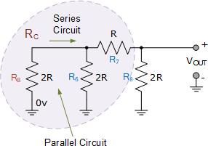

As before we find the equivalent resistance and call it RC.
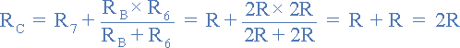

Again, resistor combination RC is equivalent to “2R” which is in parallel with R8 as shown.
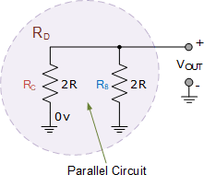

As we have shown above, when two equal resistor values are parallel together, the resulting value is one-half, so 2R in parallel with 2R equals an equivalent resistance of R. So, the whole 4-bit R-2R resistive ladder network comprising of individual resistors connected together in parallel and series combinations has an equivalent resistance (REQ) of “R” when a binary code of “0000” is applied to its four inputs.
Therefore, with a binary code of “0000” applied as inputs, our basic 4-bit R-2R digital-to- analogue converter circuit would look something like this:

Counter type ADC

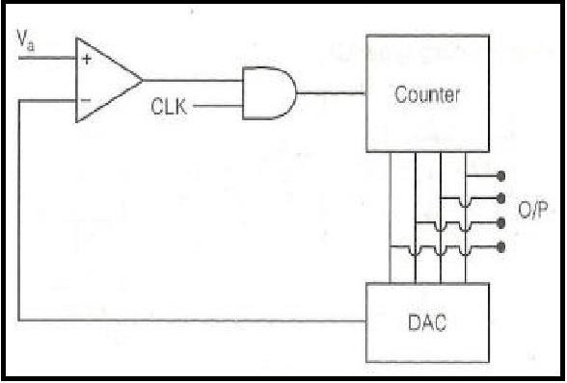

The circuit functions as follows.
Firstly, to begin with, the counter is reset to all 0s.
Secondly, when a convert signal appears on the start line, the input gate is enabled and the clock pulses are applied to the clock input of the counter. The counter advances through its normal binary count sequence.
Thirdly, the counter output feeds a D/A converter and the staircase waveform generated at
the output of the D/A converter forms one of the inputs of the comparator. The other input to the comparator is the analogue input signal.
Fourthly, Whenever the D/A converter output exceeds the analogue input voltage, the comparator changes state.
Finally, the gate is disabled and the counter stops. The counter output at that instant of time is then the required digital output corresponding to the analogue input signal.

Successive Approximation ADC
    - Successive Approximation type ADC is the most widely used and popular ADC method.
    - The conversion time is maintained constant in successive approximation type ADC, and is proportional to the number of bits in the digital output, unlike the counter and continuous type A/D converters.
    - The basic principle of this type of A/D converter is that the unknown analog input voltage is approximated against an n-bit digital value by trying one bit at a time, beginning with the MSB.
    - The principle of successive approximation process for a 4-bit conversion is explained here.
    - This type of ADC operates by successively dividing the voltage range by half, as explained in the following steps.
      - The MSB is initially set to 1 with the remaining three bits set as 000. The digital equivalent voltage is compared with the unknown analog input voltage.
      - If the analog input voltage is higher than the digital equivalent voltage, the MSB is retained as 1 and the second MSB is set to 1. Otherwise, the MSB is set to 0 and the second MSB is set to 1. Comparison is made as given in step (1) to decide whether to retain or reset the second MSB.
    - The above steps are more accurately illustrated with the help of an example.
    - Let us assume that the 4-bit ADC is used and the analog input voltage is Vin = 11 V. when the conversion starts, the MSB bit is set to 1.
Now Vin = 11V > Vref = 8V = [1000]2
Since the unknown analog input voltage VA is higher than the equivalent digital voltage VD, as discussed in step (2), the MSB is retained as 1 and the next MSB bit is set to 1 as follows
VD = 12V = [1100]2

Now VA = 11V < VD = 12V = [1100]2
Here now, the unknown analog input voltage VA is lower than the equivalent digital voltage VD. As discussed in step (2), the second MSB is set to 0 and next MSB set to 1 as
VD = 10V = [1010]2

Now again VA = 11V > VD = 10V = [1010]2
Again as discussed in step (2) VA>VD, hence the third MSB is retained to 1 and the last bit is set to 1. The new code word is
VD = 11V = [1011]2
Now finally VA = VD , and the conversion stops.
The functional block diagram of successive approximation type of ADC is shown below.
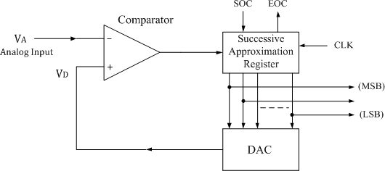

It consists of a successive approximation register (SAR), DAC and comparator. The output of SAR is given to n-bit DAC. The equivalent analog output voltage of DAC, VD is applied to the non-inverting input of the comparator. The second input to the comparator is the unknown analog input voltage VA. The output of the comparator is used to activate the successive approximation logic of SAR. When the start command is applied, the SAR sets the MSB to logic 1 and other bits are made logic 0, so that the trial code becomes 1000.

Advantages:
- Conversion time is very small.
- Conversion time is constant and independent of the amplitude of the analog input signal VA.

Disadvantages:
- Circuit is complex.
- The conversion time is more compared to flash type ADC.

UNIT-6
Logic families

Logic Families
In Digital Designs, our primary aim is to create an Integrated Circuit (IC). A Circuit configuration or arrangement of the circuit elements in a special manner will result in a particular Logic Family.
Different types of logic families
    - Resistor Transistor Logic (RTL)

    - Diode Transistor Logic (DTL)
    - Transistor- Transistor Logic (TTL)
    - Emitter Coupled Logic (ECL) or Current Mode Logic (CML)
    - Integrated Injection Logic (IIL)

Characteristics of logic families

Input /Output voltage level:

The following currents and voltages are specified which are very useful in the design of digital systems.
High-level input voltage, VIH: This is the minimum input voltage which is recognized by the gate as logic 1.
Low-level input voltage, VIL: This is the maximum input voltage which is recognized by the gate as logic 0.
High-level output voltage, VOH: This is the minimum voltage available at the output corresponding to logic 1.
Low-level output voltage, VOL: This is the maximum voltage available at the output corresponding to logic 0.
High-level input current, IIH: This is the minimum current which must be supplied by a driving source corresponding to 1 level voltage.
Low-level input current, IIL: This is the minimum current which must be supplied by a driving source corresponding to 0 level voltage.
High-level output current, IOH: This is the maximum current which the gate can sink in 1 level.
Low-level output current, IOL: This is the maximum current which the gate can sink in 0 level.

Propagation Delay:
The time required for the output of a digital circuit to change states after a change at one or more of its inputs. The speed of a digital circuit is specified in terms of the propagation delay time. The delay times are measured between the 50 percent voltage levels of input and output waveforms. There are two delay times, TpHL: when the output goes from the HIGH state to the LOW state and TpLH, corresponding to the output making a transition from the LOW state to the HIGH state. The propagation delay time of the logic gate is taken as the average of these two delay times.

Fan-in
Fan-in (input load factor) is the number of input signals that can be connected to a gate without causing it to operate outside its intended operating range. expressed in terms of standard inputs or units loads (ULs).

Fan-out
Fan-out (output load factor) is the maximum number of inputs that can be driven by a logic gate. A fanout of 10 means that 10-unit loads can be driven by the gate while still maintaining the output voltage within specifications for logic levels 0 and 1.

Noise Margin
Ability of the gate to tolerate fluctuations of the voltage levels. The input and output voltage levels defined above point. Stray electric and magnetic fields may induce unwanted voltages, known as noise, on the connecting wires between logic circuits. This may cause the voltage at the input to a logic circuit to drop below VIH or rise above VIL and may produce undesired operation. The circuit’s ability to tolerate noise signals is referred to as the noise immunity, a quantitative measure of which is called noise margin.

TTL logic family
A two-input standard TTL NAND gate is a multiple emitter transistor for the inputs A and B. the output transistors Q3 and Q4 form a totem-pole output arrangement.

Operation:
If A or B is low, the base-emitter junction of Q1 is forward biased and its base-collector junction is reverse biased. Then there is a current from Vcc through R1 ti the base emitter junction of Q1 and into the LOW input, which provides a path to the ground for the current. Hence there is no current into the base of Q2 and making it into cur-off. The collector of Q2 is HIGH and turns Q3 into saturation. Since Q3 acts as a emitter follower, by providing a low impedance path from Vcc to the output, making the output into HIGH. At the same time, the emitter of Q2 is at ground potential, keeping Q4 OFF. When A and B are high, the two input base emitter junctions of Q1 are reverse biased and its base collector junction is forward biased. This permits current through R1 and the base collector junction of Q1 into the base of Q2, thus driving Q2 into saturation. As a result, Q4 is turned ON by Q2, and producing LOW output which is near ground potential. At the same time, the collector of Q2 is sufficiently at LOW voltage level to keep Q3 OFF.
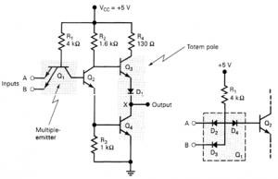

TTL outputs: Totem pole/ active pull-up

It is possible in TTL gates the charging of output capacitance without corresponding increase in power dissipation with the help of an output circuit arrangement referred to as an active pull- up or totem-pole output. In this case,

- Outputs must never be connected together.

- Connecting outputs causes excessively high currents to flow.

- Outputs will eventually be damaged.

- The standard TTL output configuration with a HIGH output and a LOW output transistor, only one of which is active at any time.

- A phase splitter transistor controls which transistor is active.

CMOS logic family
CMOS stands for “Complementary Metal Oxide Semiconductor”. This is one of the most popular technology in the computer chip design industry and it is broadly used today to form integrated circuits in numerous and varied applications. Today’s computer memories, CPUs, and cell phones make use of this technology due to several key advantages. This technology makes use of both P channel and N channel semiconductor devices.

CMOS NAND gate
2-input Complementary MOS NAND gate is shown in figure below. It consists of two series NMOS transistors between Y and Ground and two parallel PMOS transistors between Y and VDD.

If either input A or B is logic 0, at least one of the NMOS transistors will be OFF, breaking the path from Y to Ground. But at least one of the pMOS transistors will be ON, creating a path from Y to VDD.
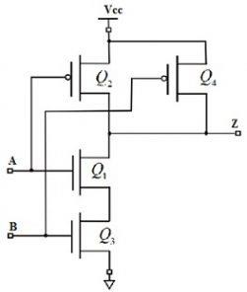
Hence, the output Y will be high. If both inputs are high, both of the nMOS transistors will be ON and both of the pMOS transistors will be OFF. Hence, the output will be logic low. The truth table of the NAND logic gate given in the below table.

A | B | Pull-Down  Network | Pull-up  Network | OUTPUT Y
0 | 0 | OFF | ON | 1
0 | 1 | OFF | ON | 1
1 | 0 | OFF | ON | 1
1 | 1 | ON | OFF | 0

CMOS NOR gate
A 2-input NOR gate is shown in the figure below. The NMOS transistors are in parallel to pull the output low when either input is high. The PMOS transistors are in series to pull the output high when both inputs are low, as given in the below table. The output is never left floating.

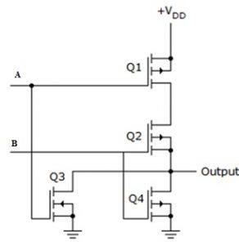
The truth table of the NOR logic gate given in the below table.

A | B | Y
0 | 0 | 1
0 | 1 | 0
1 | 0 | 0
1 | 1 | 0

