R.K.C.A. T(POLYTECHNIC)

BALASORE


LECTURE NOTES ON

CONTROL SYSTEMS & COMPONENT
DEPARTMENT OF ELECTRONICS
& TELECOMMUNICATION
6TH SEMESTER
PREPARED BY

ER. PRIYA RANJAN SEN

COURSE CONTENTS:
- FUNDAMENTAL OF CONTROL SYSTEM
  - Classification of Control system
  - Open loop system & Closed loop system and its comparison
  - Effects of Feed back
  - Standard test Signals(Step, Ramp, Parabolic, Impulse Functions)
  - Servomechanism
- MATHEMATICAL MODEL OF A SYSTEM
  - Transfer Function & Impulse response,
  - Properties, Advantages & Disadvantages of Transfer Function
  - Poles & Zeroes of transfer Function
  - Simple problems of transfer function of network.
  - Mathematical modeling of Electrical Systems(R, L, C, Analogous systems)
- CONTROL SYSTEM COMPONENTS
  - Components of Control System
  - Gyroscope, Synchros, Tachometer, DC servomotors, Ac Servomotors.
- BLOCK DIAGRAM ALGEBRA & SIGNAL FLOW GRAPHS
  - Definition: Basic Elements of Block Diagram
  - Canonical Form of Closed loop Systems
  - Rules for Block diagram reduction
  - Procedure for of Reduction of Block Diagram
  - Simple Problem for equivalent transfer function
  - Basic Definition in Signal Flow Graph & properties
  - Construction of Signal Flow graph from Block diagram
  - Mason‘s Gain formula
  - Simple problems in Signal flow graph for network
- TIME RESPONSE ANALYSIS.
5 . 1 Time response of control system. 5 . 2 Standard Test signal.
    - Step signal,
    - Ramp Signal
    - Parabolic Signal
    - Impulse Signal
5 . 3 Time Response of first order system with:
    - Unit step response
    - Unit impulse response.
5 . 4 Time response of second order system to the unit step input.
    - Time response specification.
    - Derivation of expression for rise time, peak time, peak overshoot, settling time and steady state error.
    - Steady state error and error constants.
5 . 5 Types of control system.[ Steady state errors in Type-0, Type-1, Type-2 system]
5 . 6 Effect of adding poles and zero to transfer function. 5 . 7 Response with P, PI, PD and PID controller
- ANALYSIS OF STABILITY BY ROOT LOCUS TECHNIQUE
6 . 1 Root locus concept.
6 . 2 Construction of root loci.
6 . 3 Rules for construction of the root locus.
6 . 4 Effect of adding poles and zeros to G(s) and H(s).
- FREQUENCY RESPONSE ANALYSIS.
7 . 1 Correlation between time response and frequency response. 7 . 2 Polar plots.
7 . 3 Bode plots.

7 . 4 All pass and minimum phase system.
7 . 5 Computation of Gain margin and phase margin. 7 . 6 Log magnitude versus phase plot.
7 . 7 Closed loop frequency response.
- NYQUIST PLOT
  - Principle of argument.
  - Nyquist stability criterion.
  - Niquist stability criterion applied to inverse polar plot.
  - Effect of addition of poles and zeros to G(S) H(S) on the shape of Niquist plot.
  - Assessment of relative stability.
  - Constant M and N circle
  - Nicholas chart.

COURSE OUTCOME:
After the completion of the course the students will be able to-
CO1- Acquire the basic concept of control system, pole and zero and can analyze system stability.
CO2- Implement mathematical tools to analyze a complete system.
CO3- Understand different time domain specification parameters & thus can apply that knowledge to analyze system stability in time domain using root locus technique.
CO4- Analyze systems absolute, relative and local stability using different frequency domain methods such as polar plot, Nyquist plot, Bode plot and Nicholas chart
CO5- Identify the needs of different types of controllers

Learning Resources:
Sl.No | Name of Authors | Title of the Book | Name of Publisher
1. | A. Ananda Kumar | Control System | PHI
2. | K. Padmanavan | Control System | IK
3. | I. J. Nagarath, M. Gopal | Control system Engineering | WEN
4. | A Natrajan,Ramesh Babu | Control system Engineering | Scientific
5. | D N Manik | Control Systems | Cengage

TRANSFER FUNCTION

Introduction:
Transfer function of a linear time-invariant system is defined as the ratio of the Laplace transform of output variable to the Laplace transform of input variable assuming all the initial conditions to be zero. The figure 1a shows the system in time domain whereas figure 1b shows the system in Laplace domain.

Figure 1a. system in time domain Fig1b. system in Laplace domain.

Figure 1. Transfer Function of a system
If G(s) be the transfer function of the system, we can write mathematically as

G(s) = Laplace transform of output Laplace transform of input
(all initial conditions are zero)

= 𝐶(𝑠)
𝑅(𝑠)
(all initial conditions are zero) (1)

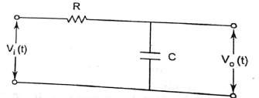
Example: Determine the transfer function of figure 2 shown below. Vi(t) is the input to the system and Vo(t) is the output of the system.

Figure 2
Solution- Let i(t) be the current flowing through the circuit using KVL we can write
V (t)= Ri(t) + ¹ 𝑡 𝑖(𝑡)𝑑𝑡
i 𝐶 ∫−∞
And V (t) = ¹ 𝑖(𝑡)𝑑𝑡
o 𝐶 ∫−∞
Taking Laplace transfer of the above equation by assuming zero initial condition, we get

Vi(s) = RI(s) + 1
𝑠𝐶
I(s)

And Vo(s) = 1
𝑠𝐶
I(s)

∴ 𝑇𝑟𝑎𝑛𝑠𝑓𝑒𝑟 𝐹𝑢𝑛𝑐𝑡𝑖𝑜𝑛 = (𝑠) = Vo(s) = ¹
Vi(s) 1+𝑠𝐶𝑅

BLOCK DIAGRAMS

Block diagram is the pictorial representation of system. It consists of a single block or a combination of blocks. Each block is a functional block.
Basic Elements of Block Diagram
The basic elements of a block diagram are a block, the summing point and the take-off point. Let us consider the block diagram of a closed loop control system as shown in the following figure to identify these elements.
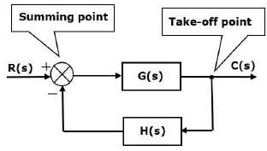
The above block diagram consists of two blocks having transfer functions G(s) and H(s). It is also having one summing point and one take-off point. Arrows indicate the direction of the flow of signals. Let us now discuss these elements one by one.
Block
The transfer function of a component is represented by a block. Block has single input and single output.
The following figure shows a block having input X(s), output Y(s) and the transfer function G(s).
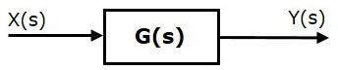

Transfer Function, G(s)=Y(s)/X(s)
⇒Y(s)=G(s)X(s)
Output of the block is obtained by multiplying transfer function of the block with input. Summing Point
The summing point is represented with a circle having cross (X) inside it. It has two or more
inputs and single output. It produces the algebraic sum of the inputs. It also performs the

summation or subtraction or combination of summation and subtraction of the inputs based on the polarity of the inputs. Let us see these three operations one by one.
The following figure shows the summing point with two inputs (A, B) and one output (Y). Here, the inputs A and B have a positive sign. So, the summing point produces the output, Y as sum of A and B.
i.e.,Y = A + B.
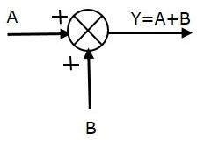

The following figure shows the summing point with two inputs (A, B) and one output (Y). Here, the inputs A and B are having opposite signs, i.e., A is having positive sign and B is having negative sign. So, the summing point produces the output Y as the difference of A and B.
Y = A + (-B) = A - B.
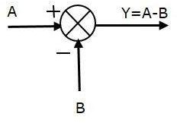

The following figure shows the summing point with three inputs (A, B, C) and one output (Y). Here, the inputs A and B are having positive signs and C is having a negative sign. So, the summing point produces the output Y as
Y = A + B + (−C) = A + B − C.
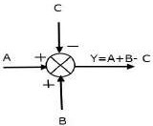

Take-off Point
The take-off point is a point from which the same input signal can be passed through more than one branch. That means with the help of take-off point, we can apply the same input to one or more blocks, summing points.
In the following figure, the take-off point is used to connect the same input, R(s) to two more blocks.
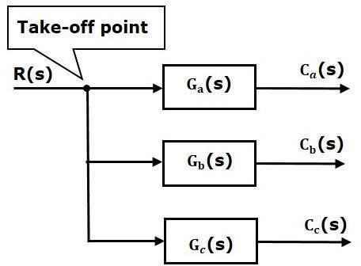

In the following figure, the take-off point is used to connect the output C(s), as one of the inputs to the summing point.
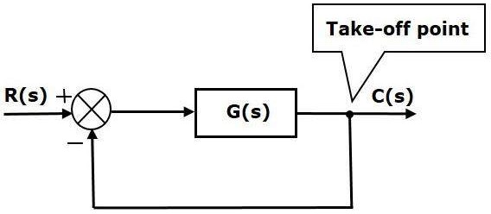

Block Diagram Representation of Electrical Systems
In this section, let us represent an electrical system with a block diagram. Electrical systems contain mainly three basic elements — resistor, inductor and capacitor.

Consider a series of RLC circuit as shown in the following figure. Where, Vi(t) and Vo(t) are the input and output voltages. Let i(t) be the current passing through the circuit. This circuit is in time domain.
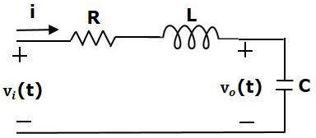

By applying the Laplace transform to this circuit, will get the circuit in s-domain. The circuit is as shown in the following figure.
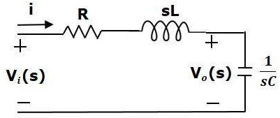

From the above circuit, we can write
I(s)=[Vi(s)−Vo(s)]/R+sL
⇒I(s)={1/R+sL}{Vi(s)−Vo(s)} (Equation 1)
Vo(s)=(1/sC)I(s) (Equation 2)
Let us now draw the block diagrams for these two equations individually. And then combine those block diagrams properly in order to get the overall block diagram of series of RLC Circuit (s-domain).
Equation 1 can be implemented with a block having the transfer function, 1/R+sL. The input and output of this block are {Vi(s)−Vo(s)} and I(s). We require a summing point to get {Vi(s)−Vo(s)}. The block diagram of Equation 1 is shown in the following figure.

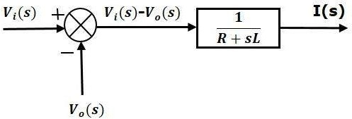

Equation 2 can be implemented with a block having transfer function, 1/sC. The input and output of this block are I(s) and Vo(s). The block diagram of Equation 2 is shown in the following figure.
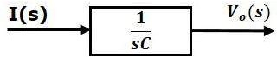

The overall block diagram of the series of RLC Circuit (s-domain) is shown in the following figure.
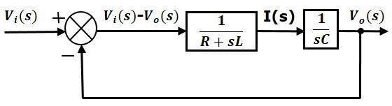

Similarly, you can draw the block diagram of any electrical circuit or system just by following this simple procedure.
- Convert the time domain electrical circuit into an s-domain electrical circuit by applying Laplace transform.
- Write down the equations for the current passing through all series branch elements and voltage across all shunt branches.
- Draw the block diagrams for all the above equations individually.
- Combine all these block diagrams properly in order to get the overall block diagram of the electrical circuit (s-domain).

Block diagram reduction rules:
There are three basic types of connections between two blocks. Rule 1: Series Connection
Series connection is also called cascade connection. In the following figure, two blocks having transfer functions G1(s) and G2(s) are connected in series.
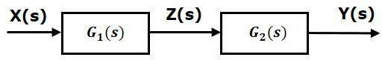

For this combination, we will get the output Y(s) as
Y(s) = G2(s) Z(s)
Where, Z(s) = G1(s) X(s)
⇒Y(s) = G2(s) [G1(s) X(s)] = G1(s) G2(s) X(s)
⇒ Y(s) = {G1(s) G2(s)} X(s)
Compare this equation with the standard form of the output equation, Y(s) = G(s) X(s). Where, G(s) = G1(s) G2(s).
That means we can represent the series connection of two blocks with a single block. The transfer function of this single block is the product of the transfer functions of those two blocks. The equivalent block diagram is shown below.
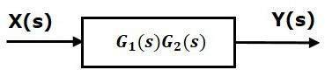

Similarly, you can represent series connection of ‘n’ blocks with a single block. The transfer function of this single block is the product of the transfer functions of all those ‘n’ blocks.
Rule 2: Parallel Connection
The blocks which are connected in parallel will have the same input. In the following figure, two blocks having transfer functions G1(s) and G2(s) are connected in parallel. The outputs of these two blocks are connected to the summing point.

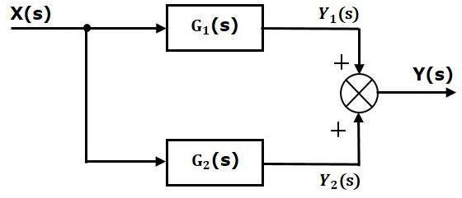

For this combination, we will get the output Y(s) as
Y(s) = Y1(s) + Y2(s)
Where, Y1(s) = G1(s) X(s)) and Y2(s) = G2(s) X(s)
⇒Y(s) = G1(s) X(s) + G2(s) X(s) = {G1(s) + G2(s)} X(s)
Compare this equation with the standard form of the output equation, Y(s) = G(s) X(s)
Where, G(s) = G1(s) + G2(s)
That means we can represent the parallel connection of two blocks with a single block. The transfer function of this single block is the sum of the transfer functions of those two blocks. The equivalent block diagram is shown below.
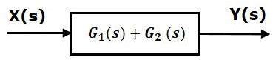

Similarly, you can represent parallel connection of ‘n’ blocks with a single block. The transfer function of this single block is the algebraic sum of the transfer functions of all those ‘n’ blocks.
Rule 3: Feedback Connection
As we discussed in previous chapters, there are two types of feedback — positive feedback and negative feedback. The following figure shows negative feedback control system. Here, two blocks having transfer functions G(s) and H(s) form a closed loop.

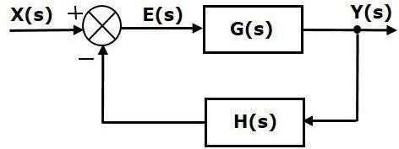

The output of the summing point is -
E(s) = X(s) − H(s) Y(s)
The output Y(s) is -
Y(s) = E(s) G(s)
Substitute E(s) value in the above equation.
Y(s) = {X(s) − H(s)Y(s)} G(s)}
Y(s) {1 + G(s) H(s)} = X(s) G(s)
⇒Y(s)/X(s) = G(s) / [1 + G(s) H(s)]
Therefore, the negative feedback closed loop transfer function is G(s) / [1+G(s) H(s)]
This means we can represent the negative feedback connection of two blocks with a single block. The transfer function of this single block is the closed loop transfer function of the negative feedback. The equivalent block diagram is shown below.
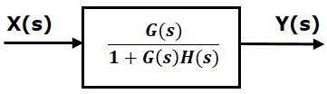

Similarly, you can represent the positive feedback connection of two blocks with a single block. The transfer function of this single block is the closed loop transfer function of the positive feedback, i.e., G(s) / [1 − G(s) H(s)]
Rule 4: Block Diagram Algebra for Summing Points
There are two possibilities of shifting summing points with respect to blocks −

- Shifting summing point after the block
- Shifting summing point before the block
Let us now see what kind of arrangements need to be done in the above two cases one by one.

Rule 4a: Shifting Summing Point after the Block
Consider the block diagram shown in the following figure. Here, the summing point is present before the block.
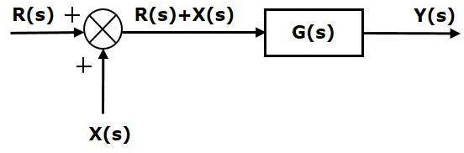
Summing point has two inputs R(s) and X(s). The output of it is {R(s)+X(s)} So, the input to the block G(s) is {R(s)+X(s)} and the output of it is –
Y(s) = G(s){R(s)+X(s)}
⇒Y(s) = G(s)R(s) + G(s)X(s) (Equation 1)
Now, shift the summing point after the block. This block diagram is shown in the following figure.
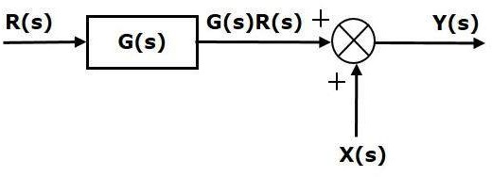

Output of the block G(s) is G(s)R(s) The output of the summing point is
Y(s)=G(s)R(s)+X(s) (Equation 2)
Compare Equation 1 and Equation 2.
The first term ‘G(s)R(s)′ is same in both the equations. But, there is difference in the second term. In order to get the second term also same, we require one more block G(s). It is having the input X(s) and the output of this block is given as input to summing point instead of X(s). This block diagram is shown in the following figure.

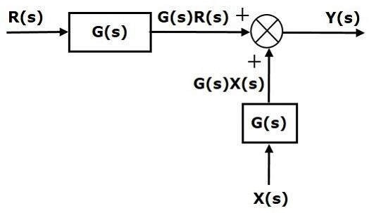
Rule 4b: Shifting Summing Point Before the Block
Consider the block diagram shown in the following figure. Here, the summing point is present after the block.

Output of this block diagram is -
Y(s) = G(s) R(s) + X(s) (Equation 3)
Now, shift the summing point before the block. This block diagram is shown in the following figure.
Output of this block diagram is -

Y(S) = G(s) R(s) + G(s) X(s) (Equation 4)
Compare Equation 3 and Equation 4,
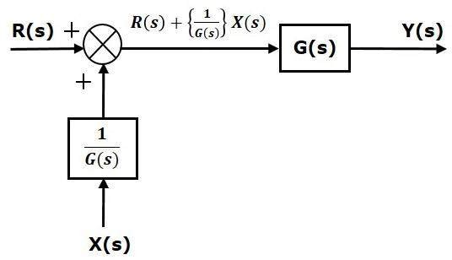
The first term ‘G(s) R(s)′ is same in both equations. But, there is difference in the second term. In order to get the second term also same, we require one more block 1/G(s). It is having the input X(s) and the output of this block is given as input to summing point instead of X(s). This block diagram is shown in the following figure.

Rule 5: Block Diagram Algebra for Take-off Points
There are two possibilities of shifting the take-off points with respect to blocks −

- Shifting take-off point after the block
- Shifting take-off point before the block
Let us now see what kind of arrangements are to be done in the above two cases, one by one. Rule5a: Shifting Take-off Point after the Block
Consider the block diagram shown in the following figure. In this case, the take-off point is
present before the block.
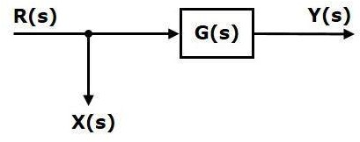

Here, X(s) = R(s) and Y(s) = G(s)R(s)
When you shift the take-off point after the block, the output Y(s) will be same. But, there is difference in X(s) value. So, in order to get the same X(s) value, we require one more

block 1/G(s). It is having the input Y(s) and the output is X(s). This block diagram is shown in the following figure.
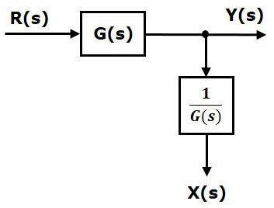
Rule 5b: Shifting Take-off Point Before the Block
Consider the block diagram shown in the following figure. Here, the take-off point is present after the block.
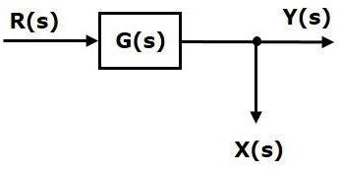
Here, X(s) = Y(s) = G(s)R(s)
When you shift the take-off point before the block, the output Y(s) will be same. But, there is difference in X(s) value. So, in order to get same X(s) value, we require one more block G(s). It is having the input R(s) and the output is X(s). This block diagram is shown in the following figure.
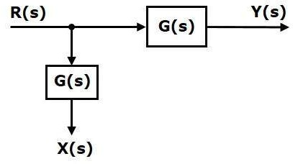

Rule 6: Associative Law For Summing Point

This can be better explained by taking below diagram
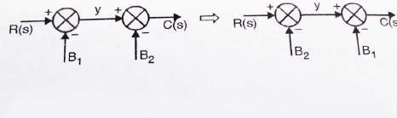
Y= R(s) – B1
C(s) = y – B2 = R(s) – B1 – B2
This law is applicable only to summing points which are connected directly to each other.
Note: If there is a block present between two summing points(and hence they are not connected directly) then this rule can’t be applied.

Procedure for finding TF by using Block Diagram Reduction Rules
Follow these rules for simplifying (reducing) the block diagram, which is having many blocks, summing points and take-off points.
- Rule 1 − Check for the blocks connected in series and simplify.
- Rule 2 − Check for the blocks connected in parallel and simplify.
- Rule 3 − Check for the blocks connected in feedback loop and simplify.
- Rule 4 − If there is difficulty with take-off point while simplifying, shift it towards right or left of the given block which one is suitable.
- Rule 5 − If there is difficulty with summing point while simplifying, shift it towards right or left of the given block which one is suitable.
- Rule 6 − Repeat the above steps till you get the simplified form, i.e., single block.

Example
Consider the block diagram shown in the following figure. Let us simplify (reduce) this block diagram using the block diagram reduction rules.

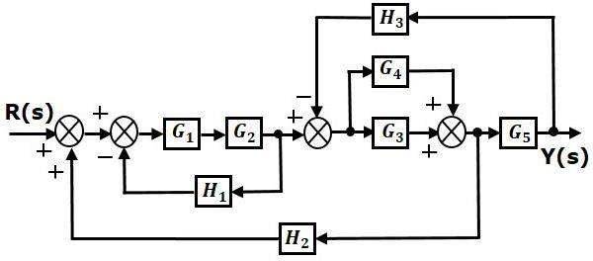

Step 1 − Use Rule 1 for blocks G1 and G2. Use Rule 2 for blocks G3 and G4. The modified block diagram is shown in the following figure.
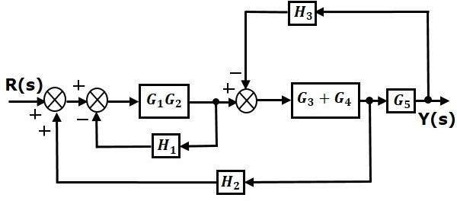

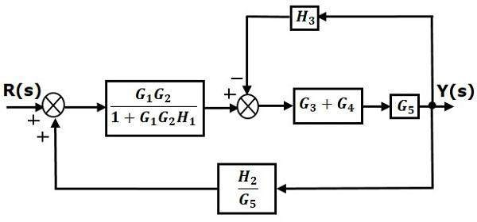
Step 2 − Use Rule 3 for blocks G1G2 and H1. Use Rule 4 for shifting take-off point after the block G5. The modified block diagram is shown in the following figure.

Step 3 − Use Rule 1 for blocks (G3+G4) and G5. The modified block diagram is shown in the following figure.
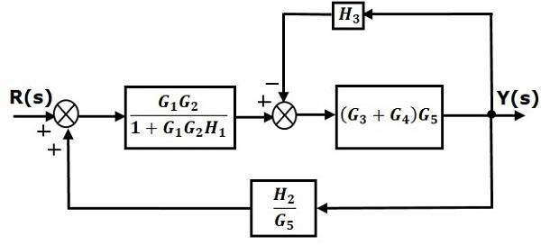

Step 4 − Use Rule 3 for blocks (G3+G4)G5 and H3. The modified block diagram is shown in the following figure.
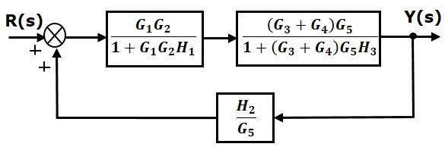
Step 5 − Use Rule 1 for blocks connected in series. The modified block diagram is shown in the
following figure.

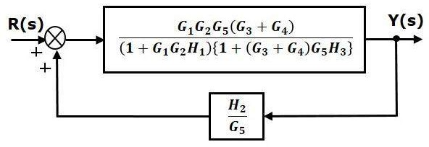

Step 6 − Use Rule 3 for blocks connected in feedback loop. The modified block diagram is shown in the following figure. This is the simplified block diagram.

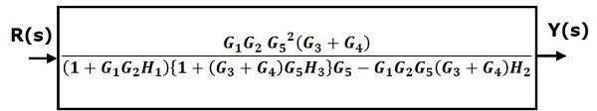

Therefore, the transfer function of the system is
Y(s)/R(s)=G1G2G52 (G3 + G4)/(1+ G1G2 H1){1+( G3+ G4) G5H3}G5− G1G2G5 (G3+ G4)H2

Note − Follow these steps in order to calculate the transfer function of the block diagram having multiple inputs.
- Step 1 − Find the transfer function of block diagram by considering one input at a time
and make the remaining inputs as zero.
- Step 2 − Repeat step 1 for remaining inputs.
- Step 3 − Get the overall transfer function by adding all those transfer functions.

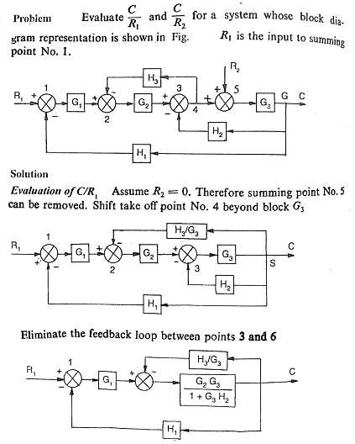
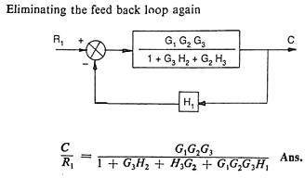

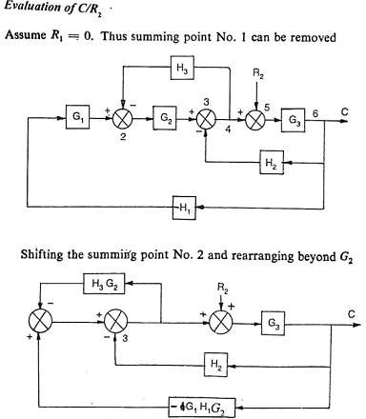
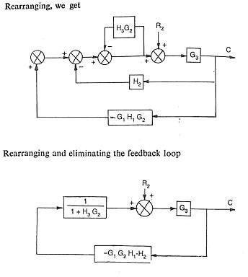

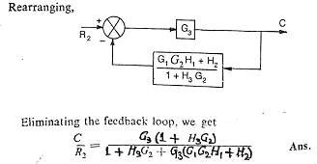

The block diagram reduction process takes more time for complicated systems. Because, we have to draw the (partially simplified) block diagram after each step. So, to overcome this drawback, use signal flow graphs (representation).

SIGNAL FLOW GRAPHS
Signal flow graph is a graphical representation of algebraic equations. In this chapter, let us discuss the basic concepts related signal flow graph and also learn how to draw signal flow graphs.

Characteristics of SFG: SFG is a graphical representation of the relationship between the variables of a set of linear algebraic equations. It doesn't require any reduction technique or process.

- It represents a network in which nodes are used for the representation of system variable which is connected by direct branches.
- SFG is a diagram which represents a set of equations. It consists of nodes and branches such that each branch of SFG having an arrow which represents the flow of the signal.
- It is only applicable to the linear system.
Terminology used in SFG
Nodes and branches are the basic elements of signal flow graph.
- Node
Node is a point which represents either a variable or a signal. There are three types of nodes —
input node, output node and mixed node.
  - Input Node or source− It is a node, which has only outgoing branches.
  - Output Node or sink − It is a node, which has only incoming branches.
  - Mixed Node − It is a node, which has both incoming and outgoing branches.

Example
Let us consider the following signal flow graph to identify these nodes.
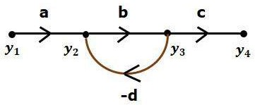

  - The nodes present in this signal flow graph are y1, y2, y3 and y4.
  - y1 and y4 are the input node and output node respectively.
  - y2 and y3 are mixed nodes.
- Branch
Branch is a line segment which joins two nodes. It has both gain and direction. For example, there are four branches in the above signal flow graph. These branches have gains of a, b, c and -d.
- Forward Path
It is a path from an input node to an output node in the direction of branch arrow.

- Loop: It is a path that starts and ends at the same node.

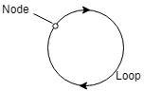

- Non-touching loop: Loop is said to be non-touching if they do not have any common node.

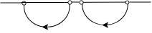

- Forward path gain: A product of all branches gain along the forward path is called Forward path gain.

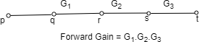

- Loop Gain: Loop gain is the product of branch gain which travels in the loop.

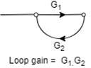

Construction of Signal Flow Graph
Let us construct a signal flow graph by considering the following algebraic equations −
y2 = a12 y1 + a42 y4 y3 = a23 y2 + a53 y5 y4 = a34 y3
y5 = a45 y4 + a35 y3 y6 = a56 y5
There will be six nodes (y1, y2, y3, y4, y5 and y6) and eight branches in this signal flow graph. The gains of the branches are a12, a23, a34, a45, a56, a42, a53 and a35.
To get the overall signal flow graph, draw the signal flow graph for each equation, then
combine all these signal flow graphs and then follow the steps given below −
Step 1 − Signal flow graph for y2 = a12 y1 + a42 y4 is shown in the following figure.

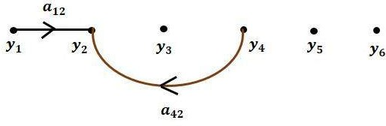

Step 2 − Signal flow graph for y3 = a23 y2 + a53 y5 is shown in the following figure.

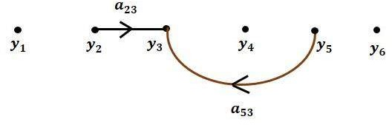

Step 3 − Signal flow graph for y4 = a34 y3 is shown in the following figure.
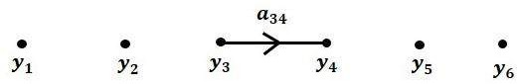

Step 4 − Signal flow graph for y5 = a45 y4 + a35 y3 is shown in the following figure.
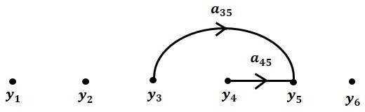

Step 5 − Signal flow graph for y6 = a56 y5 is shown in the following figure.
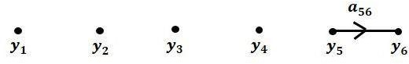

Step 6 − Signal flow graph of overall system is shown in the following figure.

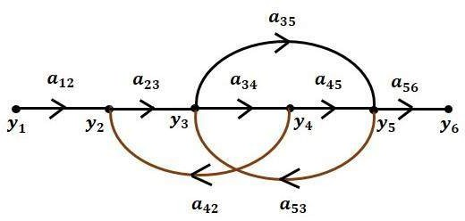

Conversion of Block Diagrams into Signal Flow Graphs
Follow these steps for converting a block diagram into its equivalent signal flow graph.
- Represent all the signals, variables, summing points and take-off points of block diagram as nodes in signal flow graph.
- Represent the blocks of block diagram as branches in signal flow graph.
- Represent the transfer functions inside the blocks of block diagram as gains of the branches in signal flow graph.
- Connect the nodes as per the block diagram. If there is connection between two nodes (but there is no block in between), then represent the gain of the branch as one. For example, between summing points, between summing point and takeoff point, between input and summing point, between take-off point and output.
- ​
Example
Let us convert the following block diagram into its equivalent signal flow graph.
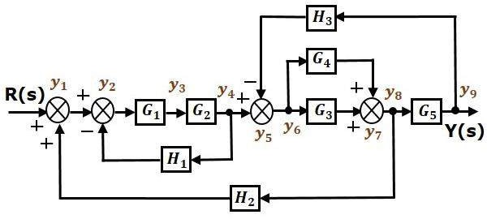

Represent the input signal R(s) and output signal C(s) of block diagram as input node R(s) and output node C(s) of signal flow graph.
Just for reference, the remaining nodes (y1 to y9) are labelled in the block diagram. There are nine nodes other than input and output nodes. That is four nodes for four summing points, four nodes for four take-off points and one node for the variable between blocks G1 and G2.
The following figure shows the equivalent signal flow graph.
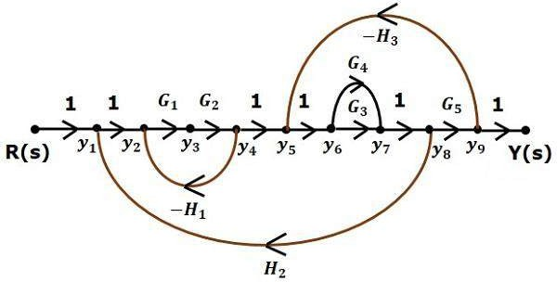

With the help of Mason’s gain formula (discussed in the next chapter), you can calculate the transfer function of this signal flow graph. This is the advantage of signal flow graphs. Here, we no need to simplify (reduce) the signal flow graphs for calculating the transfer function.
Note: 1. If summing point is present before a take off point it may be assume as same node.
2. If there is a present of summing point in series (no block with in it), it may be take ias same node.
Ex: Determine transfer function by using Mason’s gain formula.
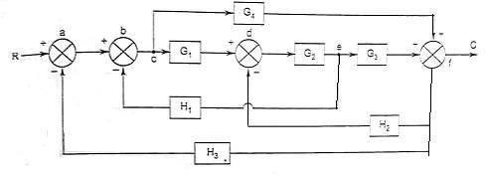

Solution:

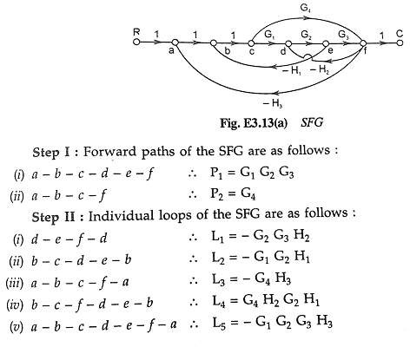

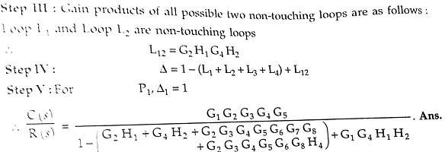

Mason's Gain Formula
Let us now discuss the Mason’s Gain Formula. Suppose there are ‘N’ forward paths in a signal flow graph. The gain between the input and the output nodes of a signal flow graph is nothing but the transfer function of the system. It can be calculated by using Mason’s gain formula.

Mason’s gain formula is

T=C(s)/R(s)= (1) ∑^{𝑁}

PiΔi

Where,
- C(s) is the output node
- R(s) is the input node
Δ 𝑖=1

- T is the transfer function or gain between R(s)R(s) and C(s)C(s)
- Pi is the i^{th} forward path gain

Δ=1−(sum of all individual loop gains) + (sum of gain products of all possible two non touching loops) − (sum of gain products of all possible three non touching loops)+...
Δi is obtained from Δ by removing the loops which are touching the i^{th} forward path.
Consider the following signal flow graph in order to understand the basic terminology involved here.
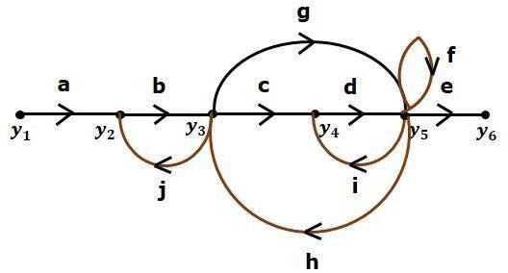

Path
It is a traversal of branches from one node to any other node in the direction of branch arrows. It should not traverse any node more than once.
Examples y2→y3→y4→y5 and y5→y3→y2
Forward Path
The path that exists from the input node to the output node is known as forward path. Examples − y1→y2→y3→y4→y5→y6 and y1→y2→y3→y5→y6.
Forward Path Gain
It is obtained by calculating the product of all branch gains of the forward path.
Examples – abcde is the forward path gain of y1→y2→y3→y4→y5→y6 and abge is the forward path gain of y1→y2→y3→y5→y6.
Loop
The path that starts from one node and ends at the same node is known as loop. Hence, it is a closed path.
Examples y2→y3→y2 and y3→y5→y3. Loop Gain
It is obtained by calculating the product of all branch gains of a loop.
Examples − bj is the loop gain of y2→y3→y2 and gh is the loop gain of y3→y5→y3.

Non-touching Loops
These are the loops, which should not have any common node.
Examples − The loops y2→y3→y2 and y4→y5→y4 are non-touching.
Calculation of Transfer Function using Mason’s Gain Formula
Let us consider the same signal flow graph for finding transfer function.

Number of forward paths, N = 2.
- First forward path is - y1→y2→y3→y4→y5→y6.
- First forward path gain, p1=abcde.
- Second forward path is - y1→y2→y3→y5→y6.
- Second forward path gain, p2=abge. Number of individual loops, L = 5.
Loops are - y2→y3→y2, y3→y5→y3, y3→y4→y5→y3 , y4→y5→y4 and y5→y5. Loop gains are - l1=bj, l2=gh, l3=cdh, l4=di and l5=f
Number of two non-touching loops = 2.
- First non-touching loops pair is - y2→y3→y2, y4→y5→y4.
- Gain product of first non-touching loops pair, l1l4= bjdi
- Second non-touching loops pair is - y2→y3→y2, y5→y5
- Gain product of second non-touching loops pair is - l1l5=bjf
Higher number of (more than two) non-touching loops are not present in this signal flow graph. We know,
Δ=1− (sum of all individual loop gains)
+ (sum of gain products of all possible two non touching loops)
−(sum of gain products of all possible three non touching loops)+...
Substitute the values in the above equation,
Δ=1 − (bj+gh+cdh+di+f) + (bjdi+bjf)−(0)
⇒Δ=1− (bj+gh+cdh+di+f) + bjdi+bjf

There is no loop which is non-touching to the first forward path.
So, Δ1=1
Similarly, Δ2=1. Since, no loop which is non-touching to the second forward path.
Substitute, N = 2 in Mason’s gain formula
T=C(s)R(s)=[P1Δ1+P2Δ2]/Δ
Substitute all the necessary values in the above equation.
T=C(s)R(s)=(abcde)1+(abge)1/[1−(bj+gh+cdh+di+f)+bjdi+bjf]
⇒T=C(s)R(s)=(abcde)+(abge)/[1−(bj+gh+cdh+di+f)+bjdi+bjf] Therefore, the transfer function is -
T=C(s)R(s)=(abcde)+(abge)/[1−(bj+gh+cdh+di+f)+bjdi+bjf]



Time Response Analysis

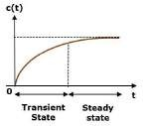
The variation of output with respect to time is known as time response. The time response consists of two parts.

- Transient response
- Steady state response
Here, both the transient and the steady states are indicated in the figure 1. The responses corresponding to these states are known as transient and steady state responses.
Mathematically, we can write the time response c(t) as
C(t)=Ctr(t)+Css(t) (1) Figure 1 Time response of a system Where,
- ctr(t) is the transient response
- css(t) is the steady state response

Transient Response
The transient response is the part of the tie response which goes to zero after large interval of time ‘t’. Ideally, this value of ‘t’ is infinity and practically, it is five times constant.
Mathematically, we can write it as

Steady state Response

𝑡→∞
lim 𝐶𝑡𝑟(𝑡)=0

The part of the time response that remains even after the transient response has zero value for large values of ‘t’ is known as steady state response. This means, the transient response will be zero even during the steady state.

Example
Let us find the transient and steady state terms of the time response of the control system c(t)=10+5e−t
Here, the second term 5e−t will be zero as t denotes infinity. So, this is the transient term. And the first term 10 remains even as t approaches infinity. So, this is the steady state term.
Standard Test Signals
The standard test signals are impulse, step, ramp and parabolic. These signals are used to know the performance of the control systems using time response of the output.
Unit Impulse Signal
A signal which has zero value everywhere except at t= 0, where its magnitude is infinite. It is
also known as δ-function. Mathematically:
δ(t) = 0 ; t≠0
= ∞ ; t = 0 (2)

and ∫−∊ δ(t)dt = 1 where ∊ tends to zero
+∊
The figure (2a) shows unit impulse signal.
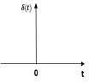
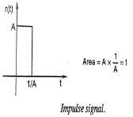
Figure (2a) Figure (2b)
Practically a perfect impulse signal cannot be achieved. It is generally approximated be a pulse of unit area as shown in figure (2b).
An unit impulse signal is the derivative of a step signal i.e.,

δ (t) = 𝑑 𝑢(𝑡)
𝑑𝑡

Laplace transform of a unit impulse is
(3)

L [δ (t)] = L [𝑑 (𝑡)] = s R(s) = 1 (As for step input R(s) = 1/s) (4)
𝑑𝑡

Unit Step Signal
A unit step signal is defined as r(t) = A u(t) (5)
Where u(t)=1; t≥0
0; t<0
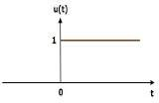
u(t) is called as unit step signal.
By taking Laplace transform of r(t), we have
R(s) = A/s (6)
Following figure 3 shows unit step signal.
So, the unit step signal exists for all positive values of ‘t’
including zero Figure 3: unit step signal

Unit Ramp Signal
A unit ramp signal, r(t) is defined as
r(t)= At ; t≥0
=0 ; t<0 (7)
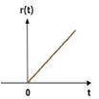
The ramp signal starts from zero and increases linearly with time. A ramp signal is the integral of a step signal. i.e

Ramp Signal = ∫ step signal
The figure 4 shows unit ramp signal.

Figure 4 : ramp signal

Unit Parabolic Signal
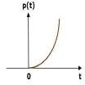
A unit parabolic signal, r(t) is defined as,
r(t)= At²/2;t≥0
0 ; t<0 (8)
By taking the Laplace transform of equation 8, R(s) = A/s³ (9)
Parabolic signal is integral of a ramp signal. i.e Parabolic signal = ∫ ramp signal
The figure 5 shows the unit parabolic signal. Figure 5: unit parabolic signal

So, the unit parabolic signal exists for all the positive values of ‘t’ including zero. And its value increases non-linearly with respect to ‘t’ during this interval. The value of the unit parabolic signal is zero for all the negative values of ‘t’.

Time Response of the First Order System
Let us discuss the time response of the first order system. Consider the following block diagram of the closed loop control system. Here, an open loop transfer function, 1/sT is connected with a unity negative feedback.

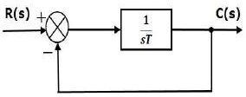

Figure (6) : Block diagram of a first order system
We know that the transfer function of the closed loop control system has unity negative feedback as,
C(s) = G(s)

Substitute, G(s)= ¹
𝑇𝑠
R(s) 1+G(s)H(s)

in the above equation.

C(s) =
R(s)
1

𝑇𝑠

1+ 1
𝑇𝑠
= 1 1+Ts

(10)

The power of s is one in the denominator term. Hence, the above transfer function is of the first order and the system is said to be the first order system.
We can re-write the above equation as

Where,
C(s) = 1 1+Ts
R(s) (11)

- C(s) is the Laplace transform of the output signal c(t),
- R(s) is the Laplace transform of the input signal r(t), and
- T is the time constant.

Impulse Response of First Order System
For unit impulse signal R(s) = 1

Consider the equation (11), C(s) = 1
1+Ts
R(s)

Substitute, R(s) = 1 in the above equation.
C(s) = 1 1+Ts
Rearrange the above equation in one of the standard forms of Laplace transforms.

(12)

C(s) =
1

𝑇
s+ 1

(13)

𝑇

Apply inverse Laplace transform on both sides.

c(t)=
𝑡

𝑒− 𝑇 (14)
𝑇
1

The unit impulse response is shown in the figure 7. The unit impulse response, c(t) is an
exponential decaying signal for positive values of ‘t’ and it is zero for negative values of ‘t’.

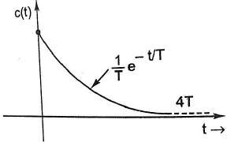
figure 7: Impulse Response of First Order System

Step Response of First Order System
For unit step signal R(s) = 1/s
Consider the equation (11), C(s) = 1
1+Ts

R(s)

؞ C(s) = 1 1 = 1
(15)

1+Ts s s(1+Ts)

Taking Partial fractions of Equ. (15)

C(s) = 1 s(1+Ts)

= A +
s

B 1+Ts

(16)

⇒ 1 =
s(1+Ts)
A(1+Ts)+ Bs s(1+Ts)

By solving Equ. (17), we get
⇒ 1 = A (sT+1) + Bs (17)

A = 1 ; B = −T

Substitute, A = 1 and B = −T in Equ. (16), we get

C(s) = 1 + (−T)
s 1+Ts

⇒ C(s) = 1 -
s
1

1 +s
T

Apply inverse Laplace transform on both the sides.
c(t) = 1−𝑒^{−𝑡/𝑇} (18)
The following figure shows the unit step response.
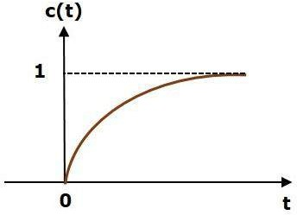

The value of the unit step response, c(t) is zero at t = 0 and for all negative values of t. It is gradually increasing from zero value and finally reaches to one in steady state. So, the steady state value depends on the magnitude of the input.

Time Response of Second Order System

Consider the following block diagram of closed loop control system. Here, an open loop
transfer function, ω ² / s(s+2ζωn) is connected with a unity negative feedback.
n
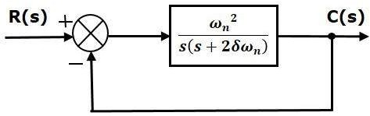

We know that the transfer function of the closed loop control system having unity negative feedback as

C(s) = G(s)
R(s) 1+G(s)H(s)

2
𝜔
Substitute, G(s) = ^{𝑛}
(𝑠+2ζ𝜔𝑛)
in the above equation.

C(s)/R(s) =
𝜔2
(𝑠+2𝜻𝜔𝑛)
𝑛
=
2

2
𝑛 2 (19)
𝜔

1+ 𝜔𝑛
(𝑠+2𝜻𝜔𝑛)
𝑠2+2ζ𝜔𝑛s+𝜔𝑛

The power of ‘s’ is two in the denominator term. Hence, the above transfer function is of the
second order and the system is said to be the second order system. The characteristic equation is -
s2+2ζωns+ω ² =0 (20)
n
The roots of characteristic equation are - S1, S2 = [−2ωn ζ ± √(2ζωn)2 − 4ωn2 ] /2
- The two roots are imaginary when ζ = 0.
- The two roots are real and equal when ζ = 1.
- The two roots are real but not equal when ζ > 1.
- The two roots are complex conjugate when 0 < ζ < 1. We can write C(s) equation as,
𝜔

C(s) =
2
𝑛 2 R(s) (21)

𝑠2+2ζ𝜔𝑛s+𝜔𝑛

Step Response of Second Order System
Consider the unit step signal as an input to the second order system. Laplace transform of the unit step signal is,
R(s)=1/s
We know the transfer function of the second order closed loop control system is,
𝝎𝟐
C(s)/R(s) = 𝒏 𝟐

Case 1: ζ = 0 ( undamped system) Substitute, δ=0 in the transfer function.
C(s)/R(s) =

2
𝑛
𝜔
𝑠2+𝜔2
𝑛
𝒔𝟐+𝟐𝛇𝝎𝒏𝐬+𝝎𝒏

𝜔2

⇒C(s)= R(s) Substitute, R(s)=1/s in equation 22
𝑛 (22)
𝑠2+𝜔𝑛
2

C(s)=
2
𝑛
𝜔
𝑛

(𝑠2+𝜔2)
(23)

By using partial fraction the equation4 can be written as

C(s) = ^{𝐴} + ^{𝐵𝑠+𝐶}

(24)

𝑠 𝑠2+𝜔2
𝑛

After partial fraction A = 1; B = -1; C= 0 ؞ C(s) = ¹ - ^{𝑠}
(25)

𝑠 𝑠2+𝜔2
𝑛

Apply inverse Laplace transform on both the sides.
c(t) = 1−cos(ωn t) (26)

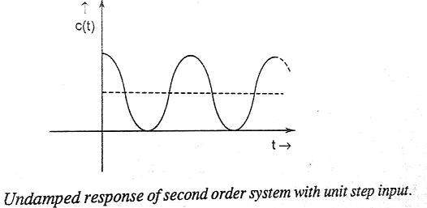
So, the unit step response of the second order system when ζ = 0 will be a continuous time signal with constant amplitude and frequency. Since there is no damping with the time, this response does not die out with time. This response is known as undamped response as shown in the figure.

Case 2: ζ = 1 (critically damped)

Substitute, ζ = 1 in the transfer function.
C(s)/R(s)=

2 2
𝑛 2 = 𝑛 2
𝜔
𝜔

⇒C(s) = R(s)
𝑠2+2ζ𝜔𝑛s+𝜔𝑛
2
𝜔
𝑛
[s + 𝜔𝑛]²
𝑠2+2𝜔𝑛s+𝜔𝑛

(27)

Substitute, R(s)=1/s in equation 27
𝜔2

C(s) =
𝑛
s[s + 𝜔𝑛]²
(28)

Do partial fractions of Equation 28

C(s)=
2
𝑛
𝜔
s[s + 𝜔𝑛]²
= 𝑨
s
+ 𝑩
s + 𝜔𝑛
+ 𝑪
[s + 𝜔𝑛]²
(29)

After simplifying, you will get the values of A, B and C as 1, −1 and and−ωn respectively. Substitute these values in the above partial fraction expansion of C(s).

C(s)= 𝟏 + −𝟏 + −𝜔𝑛
(30)

s s + 𝜔𝑛 [s + 𝜔𝑛]²
Apply inverse Laplace transform on both the sides of Eqs 30
c(t)=(1−𝑒^{−ω𝚗t} – ωn t𝑒^{−ω𝚗t}) = 1 - 𝑒^{−ω𝚗t}(1 + ωn t ) (31)
So, the unit step response of the second order system will try to reach the step input in steady state.
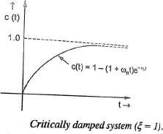
Case 3: 0 < ζ < 1 (underdamped system)

From Equation (21) C(s) =
2
𝑛 2 R(s)
𝜔

𝑠2+2ζ𝜔𝑛s+𝜔𝑛
2
𝜔
Substitute, R(s)=1/s , Hence C(s) = 𝑛 2
(𝑠2+2ζ𝜔𝑛s+𝜔𝑛)
Putting 𝑠² + 2ζ𝜔_{𝑛}s + 𝜔² = [s + ζ𝜔 ]² + 𝜔²(1 − ζ²), we get

𝑛 𝑛
1
𝑛
𝜔2

C(s) =
. 𝑛
[s + ζ𝜔𝑛]2+ 𝜔2 (1−ζ2)
𝑛
(32)

Put 𝜔²(1 − ζ²) = 𝜔² and by doing partial fractions of Equation 32

𝑛 𝑑
C(s) = ^{𝐴} + 𝐵𝑠+𝐶
(33)

𝑠 [s + ζ𝜔𝑛]2+𝜔2
𝑑

After partial fractions we get

A= 1
B= -1
C = -2ζ𝜔_{𝑛}

Putting the values of A, B,C in Equation 33, we have

C(s) = 1 - 𝑠+2ζ𝜔𝑛
= 1 - 𝑠+ζ𝜔𝑛
- ζ𝜔𝑛

𝑠 [s + ζ𝜔𝑛]2− 𝜔2
𝑑
𝑠 [s + ζ𝜔𝑛]2+ 𝜔2
[s + ζ𝜔𝑛]2+𝜔2

= 1 - 𝑠+ζ𝜔𝑛 - 𝜁 𝜔𝑛√1−𝜁²
𝑑
𝑑
𝑠 [s + ζ𝜔𝑛]2+ 𝜔2 √1−𝜁² [s + ζ𝜔𝑛]2+ 𝜔2
𝑑
𝑑

= 1 - 𝑠+ζ𝜔𝑛
- 𝜁
𝜔𝑑
(34)

𝑠 [s + ζ𝜔𝑛]2+ 𝜔2 √1−𝜁² [s + ζ𝜔𝑛]2+ 𝜔2
𝑑
𝑑
Taking inverse laplace transform of Equation 34

C(t) = 1 - 𝑒^{−ζω}𝚗t Cos (ω_{d}
𝐭) - ^{𝜁}
√1−𝜁²
𝑒^{−ζω}𝚗t Sin (ω_{d}
𝐭)

= 1 - ^{𝑒}−𝜻ω𝚗t [√1 − 𝜁²Cos (ω
d
√1−𝜁²
𝐭) - ζ Sin (ω_{d}
𝐭)] (35)

Now putting ζ = Cos ф ; √1 − 𝜁² = Sin ф Since ф = tan⁻¹ ^{√1−𝜁²} , hence equation 35
ζ

becomes
C(t) = 1 - ^{𝑒}−𝜻ω𝚗t [Sin ф Cos (ω
d
√1−𝜁²

𝐭) - Cos ф Sin (ω_{d}

𝐭)]

= 1 - ^{𝑒}−𝜻ω𝚗t sin (ω
d
√1−𝜁²
𝐭 + ф) (36)

Equation (36) represents the solution for 0 < ζ < 1 and it is represented in figure as given below.

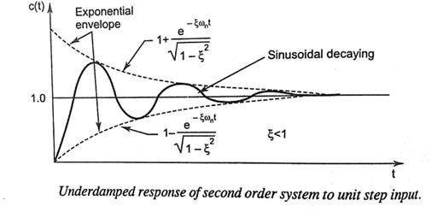

Case 4: ζ > 1
We can modify the denominator term of the second order transfer function as follows −
𝑠² + 2ζ𝜔_{𝑛}s + 𝜔² = [s + ζ𝜔 ]² − 𝜔²(ζ² − 1)
𝑛 𝑛 𝑛
Hence from equation (32)

C(s) =
2
1 . 𝑛
𝜔
[s + ζ𝜔𝑛]2− 𝜔2 (ζ2−1)
𝑛
2
= 1 . 𝑛
𝜔
(s + ζ𝜔𝑛+𝜔𝑛√𝜁²−1) (s + ζ𝜔𝑛−𝜔𝑛√𝜁²−1)
(37)

by doing partial fractions of Equation 37

𝐴 𝐵 𝐶

C(s) = =
+ +
(38)

𝑠 (s + ζ𝜔𝑛+𝜔𝑛√𝜁²−1) (s + ζ𝜔𝑛−𝜔𝑛√𝜁²−1)

After simplifying, you will get the values of

A =1

B = 1 𝜁−√𝜁²−1)

2 √𝜁²−1)
C = - 1 𝜁+√𝜁²−1)
2 √𝜁²−1)
Substitute the value of A, B, C in equation (38)

C(s) = = 1 + 1 𝜁−√𝜁²−1) 1
− 1 𝜁+√𝜁²−1) 1
(39)

𝑠 2 √𝜁²−1) (s + ζ𝜔𝑛+𝜔𝑛√𝜁²−1)
2 √𝜁²−1) (s + ζ𝜔𝑛−𝜔𝑛√𝜁²−1)

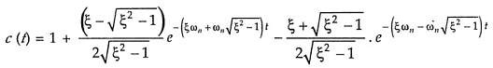
Apply inverse Laplace transform of equation (29) we have

(40)
Equation (40) represents the solution for ζ > 1 and it is represented in figure as given below.
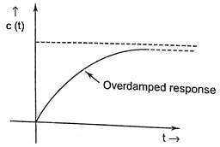

Time Domain Specifications
Let us discuss the time domain specifications of the second order system. The step response of the second order system for the under damped case is shown in the following figure.
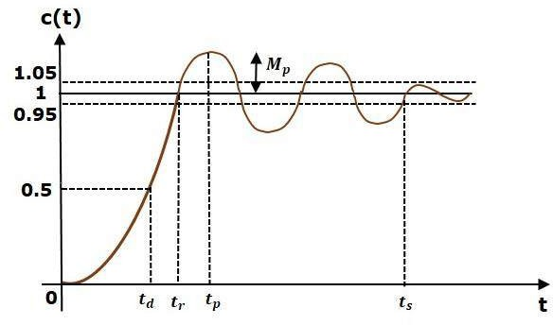

All the time domain specifications are represented in this figure. The respse up to the settling time is known as transient response and the response after the settling time is known as steady state response.

Delay Time
It is the time required for the response to reach 50% of its final value in first attempt. It is denoted by td.
Consider the step response of the second order system for t ≥ 0, when ‘ζ’ lies between zero and
one. From equation (36)

c(t) = 1 - 𝑒−𝜻ω𝚗t sin (ω
d
√1−𝜁²
𝐭 + ф)

The final value of the step response is one.
Therefore, at t = td, the value of the step response will be 0.5. Substitute these values in the above equation.

c(t ) = 0.5 = 1 - 𝑒−𝜻ω𝚗t sin (ω 𝑡 + ф)

d
√1−𝜁²
d 𝑑

⇒𝑒−𝜻ω𝚗t sin (ω
√1−𝜁²
d𝑡𝑑
+ ф) = 0.5

By using linear approximation, you will get the delay time td as
td =(1+0.7ζ)/ωn (40)

Rise Time
It is the time required for the response to rise from 10% to 90% of the final value for overdamped system and 0% to 100% of its final value for the under-damped systems. Rise time is denoted by tr.
At t = tr, c(t) = 1
Hence from equation (36)

c(t) = 1 - 𝑒−𝜻ω𝚗t sin (ω
d
√1−𝜁²
𝐭 + ф)

c(t ) =1 = 1 - 𝑒−𝜻ω𝚗t sin (ω 𝑡 + ф)

r
√1−𝜁²
d 𝑟

⇒ 𝑒−𝜻ω𝚗t sin (ω
√1−𝜁²
d𝑡𝑟
+ ф) = 0

⇒sin(ωd tr + ф)=0
⇒ ωd tr + ф =π
⇒ tr = (π −ф)/ωd (41)
From above equation, we can conclude that the rise time tr and the damped frequency ωd are inversely proportional to each other.

Peak Time
It is the time required for the response to reach the peak value for the first time. It is denoted by tp.
We know the step response of second order system for under-damped case is (from equation 36)

c(t) = 1 - 𝑒−𝜻ω𝚗t sin (ω
d
√1−𝜁²
𝐭 + ф)

At t = tp, the first derivate of the response is zero. Hence

𝑑(𝑡𝑝) =0
𝑑𝑡

⇒ 0 –
𝑒−𝜻ω𝚗𝑡𝑝 (−ζω𝚗)𝑖𝑛(ωd𝑡𝑝+ ф)
√1−𝜁²
- 𝑒−𝜻ω𝚗𝑡𝑝 ωdcos(ωd𝑡𝑝+ ф) = 0
√1−𝜁²

𝑒−𝜻ω𝚗𝑡(−ζω𝚗)𝑠𝑖𝑛(ωd𝑡𝑝 + ф)
+
⇒
√1−𝜁²
𝑒−𝜻ω𝚗𝑡𝑝 ωdcos(ωd𝑡𝑝+ ф) = 0
√1−𝜁²

⇒ ζω_{n}𝑠𝑖(ω_{d}𝑡_{𝑝} + ф) = ω_{d}cos(ω_{d}𝑡_{𝑝} + ф)
⇒ tan (ω_{d}𝑡_{𝑝} + ф) = ω_{d}/ ζω_{n}

By putting ω_{d}
= ω_{n}

√1 − 𝜁² and ф = tan⁻¹ ^{√1−𝜁²}
ζ

tan (ω_{n}

√1 − 𝜁²𝑡_{𝑝}

+ ф) = ^{ω𝚗√1−𝜁²} = tan ф
ζω𝚗

or ω_{n}√1 − 𝜁²𝑡_{𝑝} + ф = nπ + ф
for n = 1

𝑡_{𝑝}
= 𝜋
ωn√1−𝜁²
(42)

Peak Overshoot
Peak overshoot Mp is defined as the deviation of the response at peak time from the final value of response. It is also called the maximum overshoot.
Mathematically, we can write it as
Mp=c(tp)−c(∞)
Where,
c(tp) is the peak value of the response.
c(∞) is the final (steady state) value of the response.
−𝜻ω t
𝑒 𝚗
From equation (36) c(t) = 1 - sin (ω_{d}𝐭 + ф)
√1−𝜁²

Put t = tp
𝜋
=
ω𝚗√1−𝜁²
and ω_{d}
= ω_{n}

√1 − 𝜁²

؞ c(tp) =
𝑒−𝜻ω𝚗𝑡𝑝
- sin (ω_{n}
√1−𝜁²

√1 − 𝜁²𝑡_{𝑝} + ф)

= 1 - 𝑒
−𝜻ω𝚗 𝜋
ω𝚗√1−𝜁²
sin (ω_{n}
√1−𝜁²

√1 − 𝜁² 𝜋
ω𝚗√1−𝜁²

+ ф)

𝜁𝜋
−
𝑒 √1−𝜁²
− 𝜁𝜋
𝑒 √1−𝜁²

= 1 - sin (𝜋 + ф) = 1 + sin ф
√1−𝜁² √1−𝜁²

𝑒
= 1 +
𝜁𝜋
−
√1−𝜁²
√1 − 𝜁² since sinф = √1 − 𝜁²

؞ c(tp) = 1 +
√1−𝜁²

𝜁𝜋
−
√1−𝜁²

؞ % MP

= c(tp)−c(∞) c(∞)

x 100 = 1 + 𝑒
𝜁𝜋
−
√1−𝜁²− 1 x 100
1

Or % MP = 𝑒

Settling time
𝜁𝜋
−

√1−𝜁² x 100 (43)

It is the time required for the response to reach the steady state and stay within the specified tolerance bands around the final value. In general, the tolerance bands are 2% and 5%. The settling time is denoted by t_{s}.
As seen from equation 26 the time constant of the exponential envelope is T= 1/ ζωn.
The settling time of the second order system for 2% tolerance band is appx. Four times the time constant T i.e.
t_{s} = 4/ ζω_{n} =4T The settling time for 5% tolerance band is -

t_{s} = 3/ ζω_{n} = 3T

Steady State Error
It indicate the error between the actual output and the desired output as t tends to infinity i.e. ess = lim[𝑟(𝑡) − 𝑐(𝑡)]= lim 𝑟(𝑡) - lim 𝑐(𝑡)

𝑡→0
𝑡→0
𝑡→0

𝑒−𝜻ω𝚗t
= lim 1 - lim [1 - sin (ω_{d}𝐭 + ф)] = 1-1 = 0

𝑡→0
𝑡→0
√1−𝜁²

Thus second order system has zero steady state error to unit step input. Example
Let us now find the time domain specifications of a control system having the closed loop transfer function 4s² +2s+4 when the unit step signal is applied as an input to this control system.
We know that the standard form of the transfer function of the second order closed loop control system as
C(s)/R(s) = ω ² /s²+2ζω s+ω ²
n n n
By equating these two transfer functions, we will get the un-damped natural frequency ωn as 2 rad/sec and the damping ratio ζ as 0.5.
We know the formula for damped frequency ωd as
ωd = ωn√1 − ζ ²
Substitute ωn and δ values in the above formula.

⇒ ωd =2√1 − 0.5²
⇒ ωd =1.732rad/sec Substitute, δ value in following relation
Ф = cos⁻¹ ζ
⇒ф = cos⁻¹ (0.5) = π/3rad
Substitute the above necessary values in the formula of each time domain specification and simplify in order to get the values of time domain specifications for given transfer function.

Steady State Error Analysis

The deviation of the output of control system from desired response during steady state is known as steady state error. It is represented as e_{ss}. We can find steady state error using the final value theorem as follows.
e_{ss} =limt→∞ e(t) = lims→0 sE(s)
Where,
E(s) is the Laplace transform of the error signal, e(t)
Let us discuss how to find steady state errors for unity feedback and non-unity feedback control systems one by one.
Steady State Errors for Unity Feedback Systems
Consider the following block diagram of closed loop control system, which is having unity negative feedback.
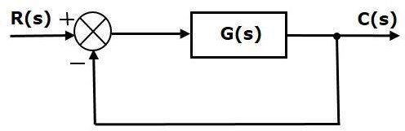

Where,

- R(s) is the Laplace transform of the reference Input signal r(t)
- C(s) is the Laplace transform of the output signal c(t)
We know the transfer function of the unity negative feedback closed loop control system as
C(s)/R(s) = G(s)/1+G(s)
⇒C(s) = R(s)G(s)/1+G(s)
The output of the summing point is -
E(s) = R(s)−B(s)= R(s) – C(s)H(s) = R(s) – E(s)G(s)H(s)
⇒E(s)[1+ G(s)H(s)] = R(s)
⇒E(s)=R(s)/ [1+ G(s)H(s)]
For H(s) = 1 E(s)=R(s)/ [1+ G(s)]

Substitute E(s) value in the steady state error formula

ess = lim_{𝑠→0} sR(s)/1 + G(s)

The following table shows the steady state errors and the error constants for standard input signals like unit step, unit ramp & unit parabolic signals.

Input signal | Steady state error ess | Error constant
unit step signal | 1/1+kp | Kp = lim_{𝑠→0}G(s)
unit ramp signal | 1/Kv | Kv = lim_{𝑠→0}sG(s)
unit parabolic signal | 1/Ka | Ka = lim_{𝑠→0}s2G(s)
Where Kp, Kv and Ka are position error constant, velocity error constant and acceleration error constant respectively.

Note –
- If any of the above input signals has the amplitude other than unity, then multiply corresponding steady state error with that amplitude.
- We can’t define the steady state error for the unit impulse signal because, it exists only at origin. So, we can’t compare the impulse response with the unit impulse input as t denotes infinity.
Example
Let us find the steady state error for an input signal r(t)=(5+2t+t²/2)u(t) of unity negative feedback control system with G(s)=5(s+4)/s²(s+1)(s+20)
The given input signal is a combination of three signals step, ramp and parabolic. The following table shows the error constants and steady state error values for these three signals.

Input signal | Error constant | Steady state error
r1(t)=5u(t) | Kp=lim_{𝑠→0} G(s)=∞ | ess1=5/1+kp = 0
r2 (t)=2tu(t) | Kv=lim_{𝑠→0}sG(s)=∞ | ess2 =2/Kv=0
r3 (t)=t²/2 u(t) | Ka=lim_{𝑠→0} s² G(s)=1 | ess3 =1/ka=1
We will get the overall steady state error, by adding the above three steady state errors.
ess= ess1+ ess2+ ess3

⇒ e_{ss} = 0+0+1=1

Therefore, we got the steady state error e_{ss} as 1 for this example.
Steady state error for different types of input for Type-0, Type- 1and Type-2 systems.
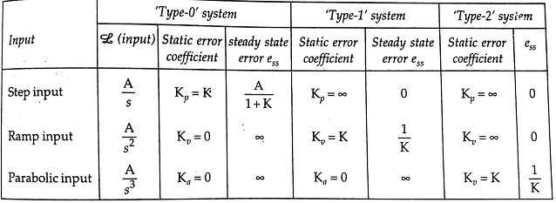

Effect of adding poles and zero to transfer function

Effect of addition of pole to transfer function:
- As the pole moves towards the origin in s plane, the rise time increases and the maximum overshoot decreases, as far as the overshoot is concerned, adding a pole to the closed loop transfer function has just the opposite effect to that of adding a pole to forward path transfer function as discussed in the last article.
- The addition of left half pole tends to slow down the system response.
- The effect of addition of pole becomes more pronounced as pole location drifts away from imaginary axis.
- Addition of right half pole will make overall system response to be an unstable one. Effect of addition of zero to transfer function:
  - Makes the system overall response faster.
  - Rise time, peak time, decreases but overshoot increases.
  - Addition of right half zeros means system response slower and system exhibits inverse response. Such systems are said to be non-minimum phase systems.

CHAPTER III
Analysis of stability by Root Locus Technique

What is Stability?
A system is said to be stable, if its output is under control. Otherwise, it is said to be unstable. A stable system produces a bounded output for a given bounded input.
The following figure shows the response of a stable system.
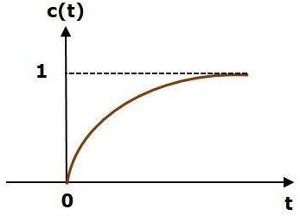

This is the response of first order control system for unit step input. This response has the values between 0 and 1. So, it is bounded output. We know that the unit step signal has the value of one for all positive values of t including zero. So, it is bounded input. Therefore, the first order control system is stable since both the input and the output are bounded.
Types of Systems based on Stability
We can classify the systems based on stability as follows.

- Absolutely stable system
- Conditionally stable system
- Marginally stable system
Absolutely Stable System
If the system is stable for all the range of system component values, then it is known as the absolutely stable system. The open loop control system is absolutely stable if all the poles of the open loop transfer function present in left half of ‘s’ plane. Similarly, the closed loop control system is absolutely stable if all the poles of the closed loop transfer function present in the left half of the ‘s’ plane.
Conditionally Stable System
If the system is stable for a certain range of system component values, then it is known as conditionally stable system.

Marginally Stable System
If the system is stable by producing an output signal with constant amplitude and constant frequency of oscillations for bounded input, then it is known as marginally stable system. The open loop control system is marginally stable if any two poles of the open loop transfer function is present on the imaginary axis. Similarly, the closed loop control system is marginally stable if any two poles of the closed loop transfer function is present on the imaginary axis.
Condition for stability
Let us consider a transfer function of a closed loop system:

(𝑠) = 𝑎0 𝑠𝑚+𝑎1 𝑠𝑚−1+𝑎2𝑠𝑚−2+...+𝑎𝑚−1 𝑠1 +𝑎𝑚𝑠0 ;
(𝑠) 𝑎0 𝑠𝑛+𝑎1 𝑠𝑛−1+𝑎2 𝑠𝑛−2+...+𝑎𝑛−1 𝑠1 +𝑎𝑛 𝑠0
Here the characteristics Equation : 𝑎₀ 𝑠^{𝑛}+𝑎₁ 𝑠^{𝑛−1}+𝑎₂ 𝑠^{𝑛−2}+. . . +𝑎_{𝑛−1} 𝑠¹ +𝑎_{𝑛} 𝑠⁰ = 0 Necessary and sufficient conditions for stability:
- All the coefficients of the ch. Equation should have same sign.
- There should be no missing term.

Routh-Hurwitz Stability Criterion
This criterion is based on ordering the coefficients of the characteristics equation into an
array called Routh’s array. The Routh’s array is formed as follows. Follow this procedure for forming the Routh table.
  - Fill the first two rows of the Routh array with the coefficients of the characteristic polynomial as mentioned in the table. Start with the coefficient of sn and continue up to the coefficient of s0.
  - Fill the remaining rows of the Routh array with the elements as mentioned in the table . Continue this process till you get the first column element of row s0 is an. Here, an is the coefficient of s0 in the characteristic polynomial.
Note − If any row elements of the Routh table have some common factor, then you can
divide the row elements with that factor for the simplification will be easy.
Consider the characteristic equation of the order ‘n’ is - a0 s^{n}+a1 s^{n-1}+a2 s^{n-2}+...+an-1 s¹ +an s⁰ =0
sn | a0 | a2 | a4 | a6 | ... | ...
sn-1 | a1 | a3 | a5 | a7 | ... | ...
sn-2 | b1=(a1a2−  a3a0)/a1 | b2=(a1a4−a5a0  )/a1 | b3=(a1a6−a7 a0)/a1 | ... | ... | ...
sn-3 | c1=(b1a3−b2  a1)/b1 | c2=(b1a5−b3a  1)/b1 | ⋮⋮

⋮⋮ | ⋮⋮ | ⋮⋮ | ⋮⋮
S1 | ⋮⋮ | ⋮⋮
S0 | an

Sufficient Condition for Routh-Hurwitz Stability
The sufficient condition is that all the elements of the first column of the Routh array should have the same sign. This means that all the elements of the first column of the Routh array should be either positive or negative.

Example
Let us find the stability of the control system having characteristic equation, S⁴+3s³+3s²+2s+1=0
Step 1 − Verify the necessary condition for the Routh-Hurwitz stability.
All the coefficients of the characteristic polynomial, S⁴+3s³+3s²+2s+1 are positive. So, the control system satisfies the necessary condition.
Step 2 − Form the Routh array for the given characteristic polynomial.

S4 | 1 | 3 | 1
S3 | 3 | 2
S2 | (3×3)−(2×1) = 7/3  3 | (3×1)−(0×1) =1  3
S1 | (7/3×2)−(1×3) =5/7  7/3
S0 | 1
Step 3 − Verify the sufficient condition for the Routh-Hurwitz stability.
All the elements of the first column of the Routh array are positive. There is no sign change in the first column of the Routh array. So, the control system is stable.
Special Cases of Routh Array
The two special cases are −

  - The first element of any row of the Routh array is zero.
  - All the elements of any row of the Routh array are zero.
Let us now discuss how to overcome the difficulty in these two cases, one by one.
First Element of any row of the Routh array is zero
If any row of the Routh array contains only the first element as zero and at least one of the remaining elements have non-zero value, then replace the first element with a small positive

integer, ϵ. And then continue the process of completing the Routh table. Now, find the number of sign changes in the first column of the Routh table by substituting ϵ tends to zero.

Example
Let us find the stability of the control system having characteristic equation, S⁴+2s³+s²+2s+1=0
Step 1 − Verify the necessary condition for the Routh-Hurwitz stability.
All the coefficients of the characteristic polynomial, S⁴+2s³+s²+2s+1are positive. So, the control system satisfied the necessary condition.
Step 2 − Form the Routh array for the given characteristic polynomial.

S4 | 1 | 1 | 1
S3 | 2 | 2
S2 | 0 | 1
S1
S0
Special case (i) − Only the first element of row s² is zero. So, replace it by ϵ and continue the process of completing the Routh table
.
s4 | 1 | 1 | 1
s3 | 1 | 1
s2 | ϵ | 1
s1 | [(ϵ×1)−(1×1])/ϵ = (ϵ−1)/ϵ
s0 | 1
Step 3 − Verify the sufficient condition for the Routh-Hurwitz stability. As ϵ tends to zero, the Routh table becomes like this.
s4 | 1 | 1 | 1
s3 | 1 | 1
s2 | 0 | 1

s1 | -∞
s0 | 1
There are two sign changes in the first column of Routh table. Hence, the control system is unstable.
All the Elements of any row of the Routh array are zero
In this case, follow these two steps −
  - Write the auxilary equation, A(s) of the row, which is just above the row of zeros.
  - Differentiate the auxiliary equation, A(s) with respect to s. Fill the row of zeros with these coefficients.

Example
Let us find the stability of the control system having characteristic equation, S⁵+3s⁴+s³+3s²+s+3=0
Step 1 − Verify the necessary condition for the Routh-Hurwitz stability.
All the coefficients of the given characteristic polynomial are positive. So, the control system satisfied the necessary condition.
Step 2 − Form the Routh array for the given characteristic polynomial.

s5 | 1 | 1 | 1
s4 | 3 1 | 3 1 | 3 1
s3 | 0 | 0
s2
s1
s0
The row s4 elements have the common factor of 3. So, all these elements are divided by 3. Special case (ii) − All the elements of row s3 are zero. So, write the auxiliary equation, A(s) of the row s4.
A(s)=s⁴+s²+1
Differentiate the above equation with respect to s.
^{dA(s)} = 4s3+2s
𝑑𝑠
Place these coefficients in row s³.
s5 | 1 | 1 | 1

s4 | 1 | 1 | 1
s3 | 4 | 2
s2 | 0.5 | 1
s1 | −3
s0 | 1
Step 3 − Verify the sufficient condition for the Routh-Hurwitz stability.
There are two sign changes in the first column of Routh table. Hence, the control system is unstable.
In the Routh-Hurwitz stability criterion, we can know whether the closed loop poles are in on left half of the ‘s’ plane or on the right half of the ‘s’ plane or on an imaginary axis. So, we can’t find the nature of the control system. To overcome this limitation, there is a technique known as the root locus. We will discuss this technique in the next two chapters.

Root Locus

In the root locus diagram, we can observe the path of the closed loop poles. Hence, we can identify the nature of the control system. In this technique, we will use an open loop transfer function to know the stability of the closed loop control system.
The Root locus is the locus of the roots of the characteristic equation by varying system gain K from zero to infinity.
Angle Condition and Magnitude Condition
The points on the root locus branches satisfy the angle condition. So, the angle condition is used to know whether the point exist on root locus branch or not. We can find the value of K for the points on the root locus branches by using magnitude condition. So, we can use the magnitude condition for the points, and this satisfies the angle condition.
Characteristic equation of closed loop control system is 1+G(s)H(s)=0
⇒G(s)H(s) = −1 + j0
The phase angle of G(s)H(s) is
∠G(s)H(s)=tan⁻¹ 0/(−1)=(2n+1)π
The angle condition is the point at which the angle of the open loop transfer function is an odd multiple of 180⁰.
Magnitude of G(s)H(s) is -
|G(s)H(s)| =√(−1)² + 0² =1

The magnitude condition is that the point (which satisfied the angle condition) at which the magnitude of the open loop transfer function is one.

Rules for Construction of Root Locus
Follow these rules for constructing a root locus.
Rule 1 − Locate the open loop poles and zeros in the ‘s’ plane.
Rule 2 − Find the number of root locus branches.
We know that the root locus branches start at the open loop poles and end either at open loop zeros or at ∞. So, the number of root locus branches N is equal to the number of finite open loop poles P or the number of finite open loop zeros Z, whichever is greater.
Mathematically, we can write the number of root locus branches N as N=P if P≥Z
N=Z if P<Z
Rule 3 − Identify and draw the real axis root locus branches.
A point or segment on the real axis lies on the root locus if the sum of open loop poles and open loop zeros to the right of this point or segment is odd.
Rule 4 − Find the centroid and the angle of asymptotes.
Asymptotes give the direction of these root locus branches. Number of Asymptotes= P -Z
The intersection point of asymptotes on the real axis is known as centroid. We can calculate the centroid 𝝈_{𝑨} by using this formula,

𝝈_{𝑨}
= ∑Real part of finite open loop poles−∑Real part of finite open loop zeros P−Z

The formula for the angle of asymptotes is
ФA = (2q+1)180
P−Z
Where, q=0,1,2, ,(P−Z−1)
Rule 5 − Find the intersection points of root locus branches with an imaginary axis.
We can calculate the point at which the root locus branch intersects the imaginary axis and the value of K at that point by using the Routh array method
Rule 6 − Find Break-away and Break-in points.
  - If there exists a real axis root locus branch between two open loop poles, then there will be a break-away point in between these two open loop poles.
  - If there exists a real axis root locus branch between two open loop zeros, then there will be a break-in point in between these two open loop zeros.
Note − Break-away and break-in points exist only on the real axis root locus branches. Follow these steps to find break-away and break-in points.
  - Write K in terms of s from the characteristic equation 1+G(s)H(s)=0

  - Differentiate K with respect to s and make it equal to zero. Substitute these values of s in the above equation.
  - The values of s for which the K value is positive are the break points. Rule 7 − Find the angle of departure and the angle of arrival.
The Angle of departure and the angle of arrival can be calculated at complex conjugate open loop poles and complex conjugate open loop zeros respectively.
The formula for the angle of departure ϕd is
Φd = 180 –sum of the angles of vectors drawn to this pole to other poles + sum of the angles of vectors drawn to this pole to zeros
The formula for the angle of arrival ϕa is
Φa = 180 –sum of the angles of vectors drawn to this zero to other zeros + sum of the angles of vectors drawn to this zero to poles
Example
Let us now draw the root locus of the control system having open loop transfer function G(s)H(s)= ^{𝑘}
s(s+1)(s+5)
Step 1 − The given open loop transfer function has three poles at s=0, s=−1 and s=−5. It doesn’t have any zero. Therefore, the number of root locus branches is equal to the number of poles of the open loop transfer function.

N=P=3
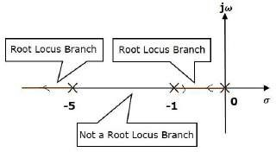
The three poles are located are shown in the above figure. The line segment between s=−1 and s=0 is one branch of root locus on real axis. And the other branch of the root locus on the real axis is the line segment to the left of s=−5 i.e in between -5 and ∞.
Step 2 − We will get the values of the centroid and the angle of asymptotes by using the
given formulae.

Centroid 𝝈𝑨
= 0−1−5 = −2
3−0

(2q+1)180

(2q+1)180

The angle of asymptotes ФA =
are θ=60⁰,180⁰ and 300⁰
P−Z
=
3−0
for q= 0, 1, 2 angle of asymptotes

The centroid and three asymptotes are shown in the following figure.

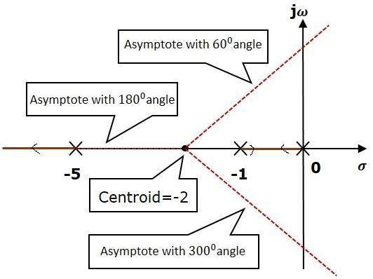
Step 3 − Since two asymptotes have the angles of 60ᵒ and 300ᵒ, two root locus branches intersect the imaginary axis. By using the Routh array method and special case(ii), the intersects of root locus branches to the imaginary axis can be found out as below

The characteristics equation of the given TF is 1+G(s)H(s)= 0
Or 1+ ^{𝑘} = 0
s(s+1)(s+5)
Or s³+6s²+5s+K = 0
Routh array

s3 | 1 | 5
s2 | 6 | k
s1 | 30 − 𝑘  6 | 0
s0 | k
For system stability the coefficient of Routh’s array having positive and non zero value hence:
K > 0
^{30−𝑘} > 0 or k< 30
6
The range of K for which the system became stable is 0< k <30
At k = 30, the system auxiliary equation is 6s² + 30= 0
Or s = ± 𝑗√5

Hence the root locus intersect the imaginary axis at ± 𝑗√5
Step 4 − There will be one break-away point on the real axis root locus branch between the poles s=−1 and s=0. By following the procedure given for the calculation of break-away point,
The characteristics equation s³+6s²+5s+K = 0
Or K= -(s³+6s²+5s)

𝑑𝑘 = 0
𝑑𝑠

Or 3 s²+ 12s+5=0
The roots of s= -0.473, -3.52
Since breakaway point must lie between 0 and -1, it is clear that s=−0.473is actual breakaway point.
The root locus diagram for the given control system is shown in the following figure.
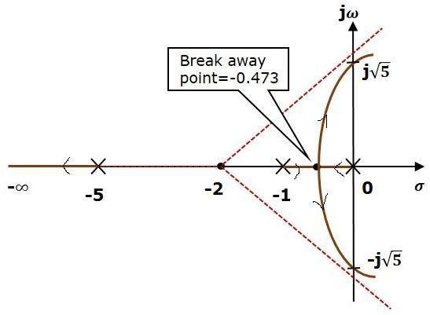

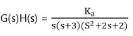
Example :- A feedback control system has open-loop transfer function
Draw root locus as K is varied from 0 to ∞ .

Solution:
Step-1 :- Find OL poles and OL zeros from the OLTF

OL poles are S=0,-3, (-1+j1) and (-1-j1) There are no finite OL zeros.
Mark OL pole with cross and OL zero with circle in S-plane as shown.

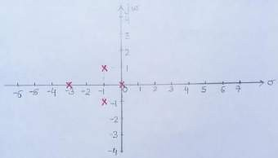
Step-2 Find the parts of the real axis at which root locus lies.
A point on real axis lies on root locus if the number of OL poles+OL zeros on the real axis to the right of the point is odd.Hence the Root locus exist between s=0 and s= -3 in the real axis.
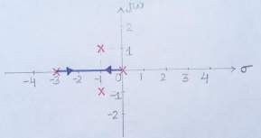
Step-3 Number of root locus branches N = P= 4 Step-4 Find number of asymptotes:
Number of asymptotes = P - Z = 4 (where P,Z = nos of open loop pole and zero) Step-5Calculation for cetroid

𝝈_{𝑨}
= ∑Real part of finite open loop poles−∑Real part of finite open loop zeros P−Z

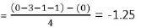
Step-6 Calculation for asymptotic angle:

ФA = (2q+1)180
P−Z
For q=0; For q=1;

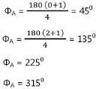
For q=2;

For q=3;
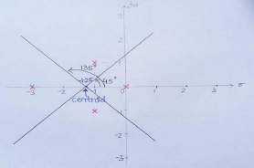
So, from steps 2,3 and 4 , four asymptotes cut the real axis at -1.25 and make angles 45⁰, 135⁰, 225⁰ and 315⁰ , as shown below.

Step-7: Find the breakaway
points (points at which two or more root locus branches meet)

Breakaway points are the solutions of (dKa/ds)=0
The characteristic equation will be S(S+3)(S²+2S+2)+Ka =0
From the characteristic equation,
Ka = -S(S+3)(S²+2S+2) = -(S⁴+5S³+8S²+6S)
We get, S = -2.3 , (-0.725±j0.365)

Not all values obtained as solutions of (dKa/ds)=0 need to be necessarily the breakaway points. Out of the obtained s values only those values of S which satisfy angle condition are the actual breakaway points.

On checking angle condition we find that (-0.725±j0.365) do not satisfy it. Therefore, only S= -2.3 is the only breakaway point. So, the real axis from 0 to -3 contains root locus which breakdown at -2.3 as shown.

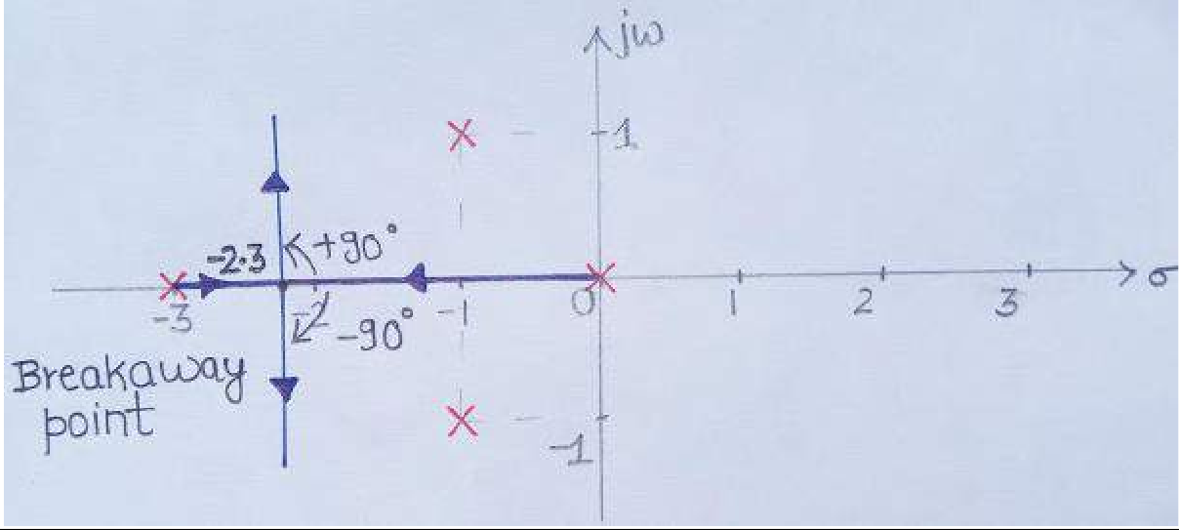

Step-8 :- Find angles of departure as there is a presence of pole in complex plane (angle which a root locus branch starting from an open loop pole, makes with a line parallel to the asymptotic line.
The formula for the angle of departure ϕd is
Φd = 180 –sum of the angles of vectors drawn to this pole to other poles + sum of the angles of vectors drawn to this pole to zeros
Or Φd = 180 – ( 90⁰+135⁰+26.6⁰ ) = -71.6⁰
So, root locus branch starts from (-1+j1) at an angle -71.6⁰ . Since root locus is always mirror image about real axis , therefore, root locus starts from (-1-j1) at +71.6⁰.
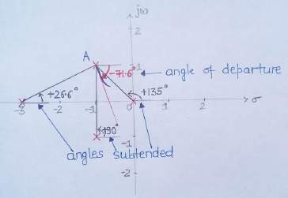

Step-9 :- Find the points at which root locus branches intersect jw axis. The characteristic equation will be S(S+3)(S²+2S+2)+Ka =0
Or S⁴+5S³+8S²+6S+ Ka=0, Make rouths array;

S4 | 1 | 8 | Ka
S3 | 5 | 6
S2 | (5×8)−(6×1) = 6.8  5 | Ka
S1 | (6.8 × 6) − (Ka × 5)  6.8
S0 | Ka

For the system to be stable all the coefficient of the first column of the Routh’s array having
positive and non zero value. Hence for system stability
Ka> 0
(6.8×6)−(Ka×5) >0
6.8
Or 0 < Ka <8.16
For Ka = 8.16 the Auxiliary equation is 6.8s²+ 8.16 = 0
Or s²= - 1.2
Or s = ± j1.1 The points of intersection comes out to be +j1.1 and –j1.1 The complete root locus is shown below.
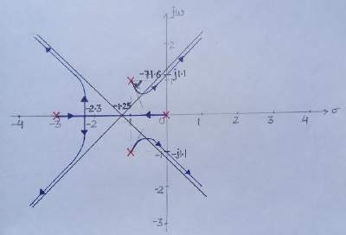

Effects of Adding Open Loop Poles and Zeros on Root Locus
Effect of addition of open loop pole | Effect of addition of open loop zero
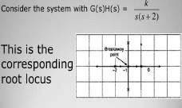  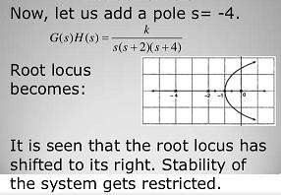  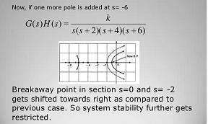 | 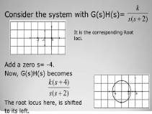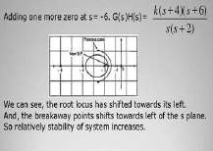

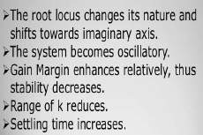 | 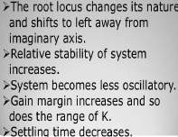

MODULE – IV
Frequency Response Analysis

Introduction:
The response of a system can be partitioned into both the transient response and the steady state response. We can find the transient response by using Fourier integrals. The steady state response of a system for an input sinusoidal signal is known as the frequency response. In this chapter, we will focus only on the steady state response.
If a sinusoidal signal is applied as an input to a Linear Time-Invariant (LTI) system, then it produces the steady state output, which is also a sinusoidal signal. The input and output sinusoidal signals have the same frequency, but different amplitudes and phase angles.
Let the input and output signal be −
r(t)=Asin(ωt) (1)
c(t)=Bsin(ωt+ ф) (2)
The open loop transfer function will be −
G(s)=G(jω)
We can represent G(jω) in terms of magnitude and phase as shown below.
G(jω)=|G(jω)|∠G(jω)
The output signal is
c(t)=A|G(jω)|sin(ωt+∠G(jω)) (3)
- The amplitude of the output sinusoidal signal is obtained by multiplying the amplitude of the input sinusoidal signal and the magnitude of G(jω) at ω.
- The phase of the output sinusoidal signal is obtained by adding the phase of the input sinusoidal signal and the phase of G(jω) at ω
Where,
- A is the amplitude of the input sinusoidal signal.
- Ω is angular frequency of the input sinusoidal signal. We can write, angular frequency ω as shown below.
ω=2πf
Here, f is the frequency of the input sinusoidal signal. Similarly, you can follow the same procedure for closed loop control system.

Correlation between time and frequency response:
The frequency domain specifications are resonant peak, resonant frequency and bandwidth. Consider the transfer function of the second order closed loop control system as,

T(s) = C(s)/R(s)=ωn2/( s2+2ζωns+ωn2 )
Substitute, s= jω in the above equation.
T(jω)= ωn2 /(jω)²+2ζωn(jω)+ ωn2

𝜔2
𝜔2 1

⇒T(jω)= ^{𝑛} = ^{𝑛}

−𝜔2+2𝑗ζωω𝑛+ω2
𝜔2
𝜔2 ω

𝑛 𝑛 (− 2 )+2𝑗𝜁( )+1
𝜔 ω𝑛
𝑛
⇒T(jω)= ¹

(4)

(1− 𝜔2)+𝑗2( ω )
2 ω𝑛
𝜔
𝑛

Let, ^{𝛚}
𝛚𝒏
=u Substitute this value in the above equation.
T(jω)= 1
(1−𝑢2)+𝑗2𝜁𝑢
(5)

Magnitude of T(jω) is -
M=|T(jω)|= ¹
√(1−𝑢2)2+(2𝜁𝑢)²
(6)

Phase of T(jω) is -
T(jω)=−tan−1 ²𝜁𝑢
(1−𝑢2)
∠
(7)

The steady-state output of the system for a sinusoidal input of unit magnitude and variable frequency ω is given by

C(t) = ¹
Sin(ωt- tan⁻¹ 2𝜁𝑢
) (8)

√(1−𝑢2)2+(2𝜁𝑢)²
(1−𝑢2)

Resonant Frequency:
It is the frequency at which the magnitude of the frequency response has peak value for the first time. It is denoted by ωr. At ω=ωr the first derivate of the magnitude of T(jω) is zero.
Differentiate M with respect to u.

𝑑𝑀
1 −4(1−𝑢2)𝑢 +8𝜁²𝑢

|u=ur = − ^{𝑟} = 0

𝑑𝑢
2 [ 2 2 (
)2 3/2

(1−𝑢𝑟) + 2𝜁𝑢 ]
⇒4𝑢³ - 4ur +8𝜁2 =0
𝑟 𝑟

⇒ ur = √1 − 2𝜁² (9)

i.e, ωr = ωn√1 − 2𝜁² (10)

Resonant Peak:
It is the peak (maximum) value of the magnitude of T(jω). It is denoted by Mr. At u=ur, the Magnitude of T(jω) is -

M=|T(jω)|= ¹
√(1−𝑢2)2+(2𝜁𝑢)²
Substitute, ur = √1 − 2𝜁² in the above equation, we get
Mr= ¹
2𝜁√1−𝜁2
The phase angle of T(jω) at resonant frequency ur obtained from equation 7 is

(11)

Фr = -tan⁻¹ [√1 − 2𝜁² / 𝜁] (12)
Resonant peak in frequency response corresponds to the peak overshoot in the time domain transient response for certain values of damping ratio . So, the resonant peak and peak overshoot are correlated to each other.
Bandwidth:
It is the range of frequencies over which, the magnitude of T(jω) drops to 70.7% (0.707) from its zero frequency value.
At ω=0, the value of u will be zero. Substitute, u=0 in M, frm equation 6

M= ¹
√(1−02 2
) +
= 1
(2𝜁0)²

Therefore, the magnitude of T(jω) is one at ω=0.
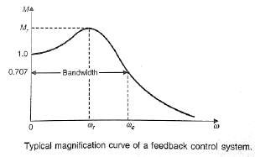
At 3-dB frequency, the magnitude of T(jω) will be 70.7% of magnitude of T(jω) at ω=0. i.e., at ω=ωb, M=0.707(1) =1/√2

From Equation 6: M = ¹ = 1
√2 √(1−𝑢2)2+(2𝜁𝑢𝑏)2
𝑏

Let, ub2 =x
⇒2 =(1−ub2)² +(2 𝜁)² u ²
⇒2 = (1−x)² +(2 𝜁)² x ⇒x² +(4 𝜁 ² −2)x−1=0
b

⇒x =

Consider only the positive value of x.

−(4𝜁2−2)±√(4𝜁2−2)2−4

2

x = −(4𝜁2−2)+√(4𝜁2−2)2−4
2

or X = 1 − 2𝜁²√2 −4𝜁² + 4𝜁⁴
Substitute, x= u ² =ω ²/ω ²
b b n
b n

ω 2/ω 2 = 1 − 2𝜁²√2 −4𝜁² + 4𝜁⁴

⇒ωb=ωn √1 − 2𝜁²√2 − 4𝜁² + 4𝜁⁴ (13)
Bandwidth ωb in the frequency response is inversely proportional to the rise time tr in the time domain transient response.

Bode Plots
Sinusoidal transfer function is graphically represented by Bode plot for determining the stability of the control system. Bode plot is a logarithmic plot and consists of two plots.

- A plot of the logarithmic (base 10) of magnitude (in decibel) Vs frequency in logarithmic scale i.e. log ω.
- A plot of Phase plot (ф) Vs frequency in logarithmic scale i.e. log ω.
In both the plots, x-axis represents angular frequency (logarithmic scale). Whereas, y-axis represents the magnitude (linear scale) of open loop transfer function in the magnitude plot and the phase angle (linear scale) of the open loop transfer function in the phase plot.
The magnitude of the open loop transfer function in dB (decibel) is -
M=20log|G(jω)H(jω)| (1)
The phase angle of the open loop transfer function in degrees is -
ϕ=∠G(jω)H(jω) (2)
Note − the base of logarithm is 10.

Basic of Bode Plots
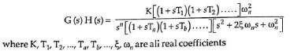
Let the generalised expression for open-loop transfer function of a system be given by:

(3)

Put s= jω in equation 3, we get
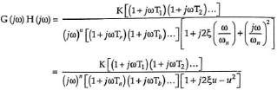

Where u= ω/ωn
From equation 5, the magnitude of G(jω)H(jω) in decibels is given by

(4)

(5)

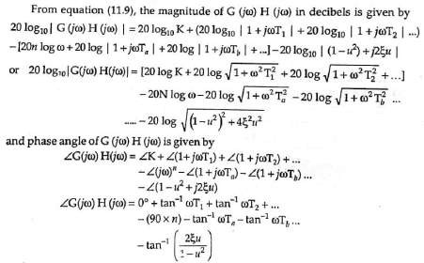
(6)

(7)

(8)

(9)
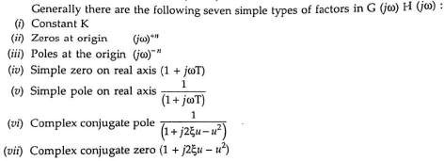

Procedure for plotting Bode plot:
Step 1: Rewrite the open loop transfer function in the time constant form as given in equation 4. Step 2: Identify the corner frequencies associated with each factor of the transfer function.
Step 3: After knowing the corner frequencies, draw the asymptotic magnitude plot. This plot consists of straight line segments with line slope changing at each corner frequency as follows.
(i) + 20 db / decade for a zero and + 20n db/decade for a zero of multiplicity n.
(ii) -20db/decade for a pole and - 20n db/decade for a pole of multiplicity n.
(iii) + 40db/decade for a complex conjugate zero and + 40n db/decade for a complex Conjugate zero of multiplicity n.
(iv)-40db/decade for a complex conjugate pole and - 40n db/decade for a complex Conjugate pole of multiplicity n.
Step 3: Initial slope of Bode plot are calculated as follows.
(i) For type zero system draw a line up to first (lowest) corner frequency having 0 db/decade slope.
(ii) For type one system dra w a line having slope of -20db/decade up to ω=K. Mark first
(lowest) corner frequency.
(ii) For type two system draw a line having slope of -40db/decade up to ω=√K and so on.
Mark first (lowest) corner frequency.
Step 4: Draw a line up to second corner frequency by adding the slope of next pole or zero to the previous slope and so on.
Step 5: Calculate phase angle for different values of ω from the equation 9 and join all points.

Note − The corner frequency (ω=1/K) is the frequency at which there is a change in the slope of the magnitude plot.
Example 1: Draw the bode plot for unity feedback control system having G(s)= ¹⁰⁰⁰ .

Solution:
Step1: Open-loop transfer function in time constant form is given by
G(s)H(s)= ¹⁰⁰⁰
(𝑠+100)
(𝑠+100)

= 1000 100(𝑠+100)
100

Put s= jω G(jω)H(jω)= ¹⁰
= 10
(1+0.01𝑠)
(Time constant form)

(1+𝑗0.01ω)
Step 2: Corner frequency ω = 1/0.001 = 100
Step 3: There is one pole on the real axis hence magnitude plot is a straight line having slope of - 20 db/decade.
Step 4: As the system is type zero system so magnitude plot is a straight line parallel to o db axis and having magnitude 20log10K= 20log1010= 20db.
Step 5: phase angle ф = -tan⁻¹ 0.01ω. The table shows value of ф when ω varies from 0 to ∞.

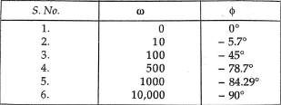
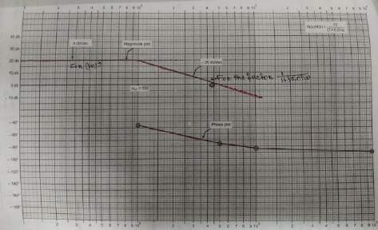
Example 2: Draw the bode plot for unity feedback control system having G(s) = 5(s+2)/s(s+10)
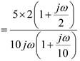
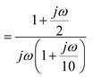
Put s= jω

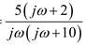
G(jω)=

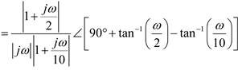
|G(jω)|∠G(jω)

Magnitude plot:

Sl.  No | Factor | Corner  Frequency | Slope | Asymptotic log magnitude
1 | 1  𝑗𝜔 | None | -20  db/decade | Straight line of slope -20 db/decade and  intersecting the 0 dB axis at ω=K=1and extend  upto first corner frequency 2.
2 | 1+0.5 𝑗𝜔 | 2 | +20  db/decade | Draw a net slope (-20) + (+20)= 0 db/decade from corner frequency 2 to the next corner  frequency 10.
3 | 1  1 + 0.1 𝑗𝜔 | 10 | -20  db/decade | Draw the net slope of 0+(-20)= -20 db/decade  from corner frequency 10 to ∞.
Note: Arrange the table in increasing order of corner frequency.
For different value of ω calculate phase angle ∠G(jω) and join all the points by free hand.
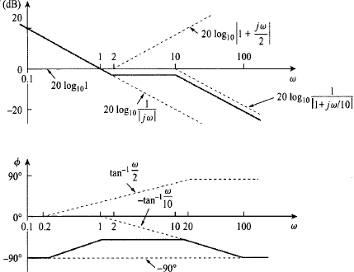

Computation of Gain Margin and Phase Margin
From the Bode plots, we can say whether the control system is stable, marginally stable or unstable based on the values of these parameters.

- Gain cross over frequency and phase cross over frequency
- Gain margin and phase margin

Phase Cross over Frequency
The frequency at which the phase plot is having the phase of -180⁰ is known as phase cross over

Gain Cross over Frequency
The frequency at which the magnitude plot is having the magnitude of zero dB is known as gain cross over frequency. It is denoted by ωgc. The unit of gain cross over frequency is rad/sec.
The stability of the control system based on the relation between the phase cross over frequency and the gain cross over frequency is listed below.
- If the phase cross over frequency ωpc is greater than the gain cross over frequency ωgc, then the control system is stable.
- If the phase cross over frequency ωpc is equal to the gain cross over frequency ωgc, then the control system is marginally stable.
- If the phase cross over frequency ωpc is less than the gain cross over frequency ωgc, then the control system is unstable.
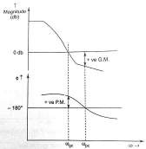
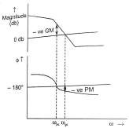
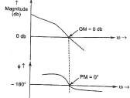

ωpc >ωgc, GM & PM are +ve | ωpc <ωgc, GM & PM are –ve | ωpc =ωgc, GM= PM=0
Stable System | Un-stable System | marginally stable system

Gain Margin
Gain margin GM is defined as the margin in gain allowable by which gain can be increased till system reaches on the verge of instability. It is equal to negative of the magnitude in dB at phase cross over frequency. Mathematically

GM=20log10 ( 1
|𝐺(𝑗𝜔)|𝜔=𝜔𝑝𝑐

The unit of gain margin (GM) is dB.

Phase Margin
)= - 20log10 |𝐺(𝑗𝜔)|

𝜔=𝜔𝑝𝑐

Phase margin can be defined as the amount of additional phase lag which can be introduced in the system till the system reaches on the verge of instability. The formula for phase margin PM is
PM=[∠𝐺(𝑗𝜔)|_{𝜔=𝜔}𝑔𝑐 ] – (-180⁰)

= 180ᵒ+ [∠(𝑗𝜔)|_{𝜔=𝜔}𝑔𝑐 ]

The stability of the control system based on the relation between gain margin and phase margin is listed below.
- If both the gain margin GM and the phase margin PM are positive, then the control system is stable.
- If both the gain margin GM and the phase margin PM are equal to zero, then the control system is marginally stable.
- If the gain margin GM and / or the phase margin PM are/is negative, then the control system is unstable.
Example3: A unity feedback control system has
G(s)= ^{𝟐𝟎}
𝒔(𝟏 +𝟎.𝟏𝒔)(𝟏+𝟎.𝟎𝟏𝒔)
Draw the bode plot. Find Gain crossover frequency, phase crossover frequency, gain margin and phase margin.
Solution: Put s= jω in open loop transfer function

G(s)= ^{𝟐𝟎}
jω(𝟏 +𝟎.𝟏jω)(𝟏+𝟎.𝟎𝟏jω)

|G(jω)|∠G(jω)= 20
−𝜔2√1+(𝟎.𝟏ω)2√1+(𝟎.𝟎𝟏ω)2
∠ − 90° − 𝑡𝑎𝑛⁻¹0.1𝜔 − 𝑡𝑎𝑛⁻¹0.01𝜔

Sl.  No | Factor | Corner  Frequency | Slope | Asymptotic log magnitude
1 | 20  𝑗𝜔 | None | -20  db/decade | Straight line of slope -20 db/decade and  intersecting the 0 dB axis at ω=K=20 and  extend upto first corner frequency 10.
2 | 1  1 + 0.1 𝑗𝜔 | 10 | 20 db/decade | Draw a net slope (-20) + (-20)= -40 db/decade  from corner frequency 10 to the next corner frequency 100.
3 | 1  1 + 0.01 𝑗𝜔 | 100 | -20  db/decade | Draw the net slope of (- 40)+(-20)= -60 db/decade from corner frequency 100 to ∞.

The table shown below shows phase angle for the different value of ω.
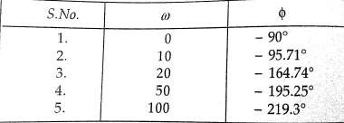

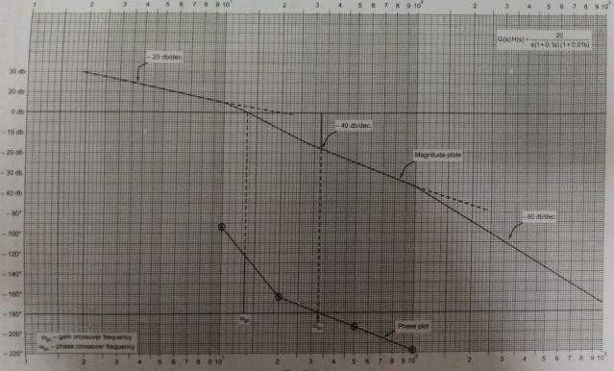
From the plots
- Gain crossover frequency ωgc = 13.5
- Phase crossover frequency ωpc = 33
- ωpc >ωgc, GM & PM are +ve, hence the system become stable.
- Gain Margin = + 15 db
- Phase Margin= 180ᵒ-(+124ᵒ)= +56ᵒ

All pass and minimum phase system

If all the poles and zeros of any transfer function lie o the left half of s-plane, such type of transfer function is known as minimum phase transfer function.
The transfer function having a pole-zero pattern which is antisymmetric about the imaginary axis i.e for every pole in the left half plane, there is a zero in the mirror image position. This type of transfer function is known as all pass transfer function.
A common example of such transfer function is

G(𝑗𝜔)= ¹⁻ ^{𝑗𝜔𝑇}
1+ 𝑗𝜔𝑇
(1)

Pole zero configuration of equation 1is shown below:

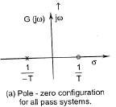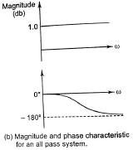
Figure 1. All pass system

All pass transfer function has a magnitude of unity at all frequency and a phase angle of (- 2 tan⁻¹𝜔𝑇)which varies from 0ᵒ to -180ᵒ as 𝜔 increases from 0 to ∞. The property of unit magnitude at all frequencies applies to all transfer function with antisymmetric pole-zero pattern. Physical systems with this property are called all-pass system.
Now consider the case where the transfer function has poles in the left half s-plane and zero in both left and right half s-plane. Poles are not permitted to lie in the right half s-plane because such a system would be unstable. Consider the following transfer function

G1(jω)= 1− 𝑗𝜔𝑇 (1+𝑗𝜔𝑇1)(1+𝑗𝜔𝑇2)
Whose pole zero pattern is shown in figure . This transfer function may be rewritten as
(2)

G1(jω)= [ 1+𝑗𝜔𝑇 ] [1− 𝑗𝜔𝑇] = G2(jω) G(jω) (3)
(1+𝑗𝜔𝑇1)(1+𝑗𝜔𝑇2) 1+ 𝑗𝜔𝑇
Which is now become the product of two transfer function G2(jω) i.e minimum phase transfer function shown in figure (2b) and G(jω) i.e all pass transfer function shown in figure (2c). It is clear that G1(jω) and G2(jω) have identical curve of magnitude Vs frequency but their phase Vs frequency curve are different as shown in figure(3). G2(jω) having a smaller range of phase angle than G1(jω). A transfer function which has one or more zeros and no pole in the right half s-plane is known as non- minimum phase transfer function.
In general if the transfer function has any zeros in the right half s-plane, it is possible to extract them one by one by associating them with all-pass transfer function as shown in figure(2a).
A common example of a non-minimum phase element is transportation lag which has transfer function
G(𝑗𝜔)= 𝑒^{−𝑗}ωT= 1∠ − 𝜔𝑇 rad = 1∠ − 57.3𝜔𝑇 degree Other possible non-minimum transfer function are:
- where more than one possible signal paths are available between input and output as in
lattice network.
- When there is inductive coupling between input and output in addition to conduction.

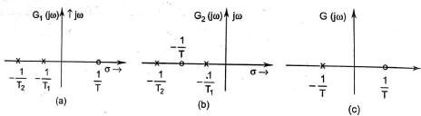
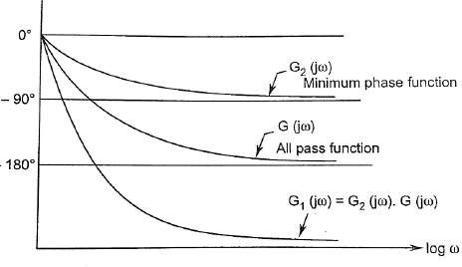
Figure 2
Figure 3 Phase Vs frequency graph

Polar Plots
Polar plot is a plot which can be drawn between magnitude and phase. It is a plot of magnitude
|(𝑗𝜔)| versus phase angle∠𝐺(𝑗𝜔)on polar co-ordinates as input frequency (ω) is varied from 0 to ∞. Here, the magnitudes are represented by normal values only.
The polar form of G(jω) is
G(jω)= |G(jω)| ∠G(jω)

Rules for Drawing Polar Plots
Follow these rules for plotting the polar plots.
Step1. Substitute, s=jω in the open loop transfer function.
Step2. Write the expressions for magnitude and the phase of G(jω)

Step3. Find the starting magnitude and the phase of G(jω) by substituting ω=0. So, the polar plot starts with this magnitude and the phase angle.
Step4. Find the ending magnitude and the phase of G(jω) by substituting ω=∞. So, the polar plot ends with this magnitude and the phase angle.
Step5. Check whether the polar plot intersects the real axis, by making the imaginary term of G(jω) equal to zero and find the value(s) of ω.
Step6. Determine the intersection of polar plot with real axis and imaginary axis, as follows:
  - Rationalise the function G(jω) and separate the real and imaginary parts.
  - Intersection with imaginary axis: equate the real term of |G(jω)| to zero and find the value of frequency (ω) at which the polar plot intersects the imaginary axis. Now put this value of ω into |G(jω)|. Which gives |G(jω)| at this point of intersection.
  - Intersection with real axis: equate the imaginary term of |G(jω)| to zero and find the value of frequency (ω) at which the polar plot intersects the real axis. Now put
this value of ω into |G(jω)|. Which gives |G(jω)| at this point of intersection.
Step7. By using this information, plot the points on the complex plane. Make the arrow on the plot for increasing frequency from 0 to ∞.

Example1: Consider the open loop transfer function of a closed loop control system.
G(s)= ¹
(1+𝑠𝑇1)(1+𝑠𝑇2)
Draw the polar plot.
Step 1 − Substitute, s=jω in the open loop transfer function.
G(jω)= ¹
(1+𝑗𝜔𝑇1)(1+𝑗𝜔𝑇2)
The magnitude of the open loop transfer function is
|G(jω)|= ¹
√1+(𝜔𝑇1)2√1+(𝜔𝑇2)2

The phase angle of the open loop transfer function is
∠G(jω)=−tan⁻¹ 𝜔𝑇₁−tan⁻¹ 𝜔𝑇₂
Step 2 − The following table shows the magnitude and the phase angle of the open loop transfer
function at ω=0 rad/sec and ω=∞ rad/sec.
Frequency (rad/sec) | Magnitude | Phase angle(degrees)
0 | 1 | 0
∞ | 0 | -180ᵒ

So, the polar plot starts at (1,0⁰) and ends at (0,−180⁰). The first and the second terms within the brackets indicate the magnitude and phase angle respectively.
Step 3 − This polar plot will intersect the negative imaginary axis. The phase angle corresponding to the negative imaginary axis is −90⁰ or 270⁰. So, by equating the phase angle of the open loop transfer function to either −90⁰ or 270⁰, we will get the ω value as
∠G(jω)=−tan⁻¹ 𝜔𝑇₁−tan⁻¹ 𝜔𝑇₂= −90⁰
⇒ 𝑇1+ 𝜔𝑇2 = ∞ ⇒ 𝜔 = 1
1−𝜔²𝑇1𝑇2 √𝑇1𝑇2

By substituting ω= ¹
√𝑇1𝑇2
in the magnitude of the open loop transfer function, we will get
|G(jω)|= ¹ = √𝑇1𝑇2

1 2
1 2
𝑇1+𝑇2

√1+( 𝑇1) √1+( 𝑇2)
√𝑇1𝑇2 √𝑇1𝑇2

So, we can draw the polar plot with the above information on the polar graph sheet.
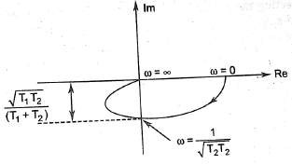

The following table shows polat plot for different type of control system:
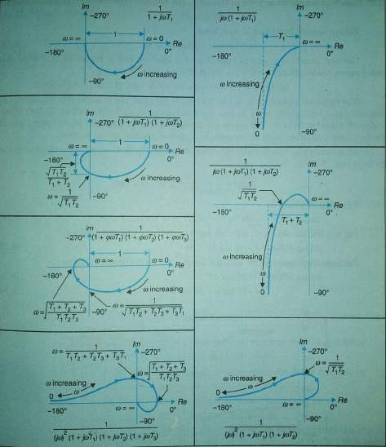

Introduction:

CHAPTER- V
Nyquist Plots

Nyquist plots are the continuation of polar plots for finding the stability of the closed loop control systems by varying ω from −∞ to ∞. That means, Nyquist plots are used to draw the complete frequency response of the open loop transfer function.

Principle of argument
The Nyquist stability criterion works on the principle of argument. It states that if there are P poles and Z zeros are enclosed by the ‘s’ plane contour, then the corresponding G(s)H(s) plane must encircle the origin P−Z times. So, we can write the number of encirclements N as,
N=P−Z
- If the ‘s’ plane contour contains only poles, then the direction of the encirclement in the q(s) plane will be opposite (counter clock wise) to the direction of ‘s’ plane contour.
- If the ‘s’ plane contour contains only zeros, then the direction of the encirclement in the q(s) plane will be in the same (clock wise) direction as that of ‘s’ plane contour.

For example, in case of 1 zero and 3 poles enclosed by the s- plane contour, the net encirclement of the origin by the q(s) plane contour is (3-1) two counter-clockwise revolution as shown in figure below. This relationship between the enclosure of poles and zeros of G(s)H(s) b the s-plane contour and the encirclement of the origin by G(s)H(s) contour is commonly known as principle of argument.
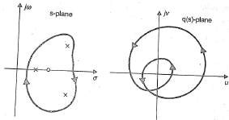

Nyquist stability criterion

The characteristics equation of a system is q(s) = 1+G(s)H(s)
The standard pole zero form of the OLTF G(s)H(s) is

G(s)H(s) = 𝐾 (𝑠+𝑧1)(𝑠+𝑧2)−−−−−−−(𝑠+𝑧𝑚)
(𝑠+𝑃1)(𝑠+𝑃2)−−−−−−−−(𝑠+𝑃𝑛)
(1)

؞ q(s) = 1+ 𝐾 (𝑠+𝑧1)(𝑠+𝑧2)−−−−−−−(𝑠+𝑧𝑚)
(𝑠+𝑃1)(𝑠+𝑃2)−−−−−−−−(𝑠+𝑃𝑛)

= (𝑠+𝑃1)(𝑠+𝑃2)−−−−−−−−(𝑠+𝑃𝑛)+𝐾(𝑠+𝑧1)(𝑠+𝑧2)−−−−−−−(𝑠+𝑧𝑚) (𝑠+𝑃1)(𝑠+𝑃2)−−−−−−−−(𝑠+𝑃𝑛)

(𝑠+𝑧′)(𝑠+𝑧′)−−−−−−−−−(𝑠+𝑧′ )
1 2 𝑛
=
(𝑠+𝑃1)(𝑠+𝑃2)−−−−−−−−(𝑠+𝑃𝑛)
(2)

From the above equation it is seen that the zeros of q(s) are the root of the characteristics equation and the poles q(s) are same as the poles of open loop system. For the system to be stable, the roots of the characteristics equation and hence the zeros of q(s) must lie in the left half s-plane. It is important to note that even if some of the open-loop poles lie in the right half s-plane all the zeros of q(s) i.e, the closed-loop poles may lie in the left half s-plane. It means that an open-loop unstable system may lead to a closed-loop stable system.
In order to investigate the presence of any zero of q(s) in the right half of s-plane, a contour to be chosen which completely encloses the right half of s-plane called as Nyquist contour. It is directed clockwise and consist of an infinite line segment C1 and an arc C2 of infinite redius.
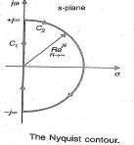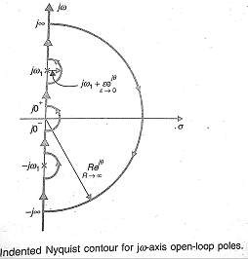

As the Nyquist contour encloses all the right half s-plane poles and zeros of q(s), let there are ‘z’ zeros and ‘P’ poles in the right half of s-plane. As s moves along the nyquist contour in the s- plane, a closed contour Γq is traversed in q(s) plane which encloses the origin N (=P-Z) times in anticlockwise direction.
For the system to be stable, there should be no zeros of q(s) in the right half of s-plane i.e,
Z = 0 So N= P
The above equation implies that for a close loop system to be stable, the number of counter- clockwise encirclement of the origin of the q(s) plane by the contour Γq should be equal the number of the right half s-plane poles of q(s) which are also the poles of open-loop transfer function G(s)H(s).
The open-loop transfer function can be written as
G(s)H(s)=q(s)- 1= [1+ G(s)H(s)]-1 (3)

Therefore the contour ΓGH of G(s)H(s) corresponding to the nyquist contour in the s-plane is the same as contour Γq of q(s) (=1+ G(s)H(s)) drawn from the point (-1+j0). Thus the encirclement of the origin by the contour Γq of q(s) is equivalent to the encirclement of the point (-1+j0) by the contour ΓGH of G(s)H(s) as shown below.
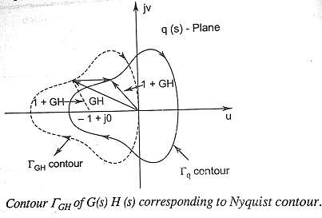

Statement of nyquist stability criterion:
- If the contour ΓGH corresponding to the Nyquist contour in the s-plane encircles the point (- 1+j0) in the counter-clockwise direction as many times as the number of right half s-plane pole of G(s)H(s), the close loop system is stable.
- The closed loop system is stable if the contour ΓGH does not encircles the point (-1+j0).

Mapping of Nyquist contour into the contour ΓGH of G(s)H(s):
- For imaginary axis: Put s= jω in G(s)H(s) where s varies from –j∞ to +j∞ .
- For infinite semi circle: put s= 𝑅𝑒^{𝑗𝜃} where R→∞ and θ varies from + 90ᵒ to -90ᵒ.
- For presence of pole at origin: put s= ∊ 𝑒^{𝑗𝜃}where ∊→∞ and θ varies from - 90ᵒ to +90ᵒ.
- For presence of pole at imaginary axis: put s= jω1+ ∊ 𝑒^{𝑗𝜃}where ∊→∞ and θ varies from - 90ᵒ to
+90ᵒ.
Hence the complete contour ΓGH is the polar plot of G(jω)H(jω) with varies from ω -∞ to +∞.

Nyquist stability criterion applied to inverse Polar plot:
It is more convenient to work with inverse function 1/ G(jω)H(jω) rather than the direct function G(jω)H(jω). Here we will see that the Nyquist stability criterion for direct polar plot can be extended for use to inverse polar plot after minor modification.
Let us consider a open-loop transfer function:

G(s)H(s) = 𝐾 (𝑠+𝑧1)(𝑠+𝑧2)−−−−−−−(𝑠+𝑧𝑚)
(𝑠+𝑃1)(𝑠+𝑃2)−−−−−−−−(𝑠+𝑃𝑛)
(4)

For the system to be stable none of the roots of the characteristics equation should lie in the right half s-plane or on the jω-axis. The characteristics equation is

(𝑠+𝑧′)(𝑠+𝑧′)−−−−−−−−−(𝑠+𝑧′ )
1 2 𝑛
q(s)= 1+ G(s)H(s) =
(𝑠+𝑃1)(𝑠+𝑃2)−−−−−−−−(𝑠+𝑃𝑛)
Dividing equation 5 by 4, we get
(5)

q’(s)=
1

G(s)H(s)
(𝑠+𝑧′)(𝑠+𝑧′)−−−−−−−−−(𝑠+𝑧′ )
+1=
1 2 𝑛
(𝑠+𝑧1)(𝑠+𝑧2)−−−−−−−(𝑠+𝑧𝑚)
(6)

From equation 5 and 6 it is seen that the zeros of q’(s) is same as the q(s), which are the roots of
the characteristics equation. It is further noticed that the poles of q(s) are same as the poles of

G(s)H(s), while the poles of q’(s) are same as the poles of ¹
G(s)H(s)
or the zeros of G(s)H(s).

It can be concluded that if ¹
G(s)H(s)
has P right half s-plane poles and the characteristics

equation has Z right half s-plane zeros, the locus of ¹
G(s)H(s)
encircle the point (-1+j0) N times in

counter-clockwise direction where N= P-Z.
Since for system stability no zeros of the characteristics equation locate on right half s- plane i.e , Z=0, the Nyquist stability criterion for inverse polar plots can be stated below:

“It the Nyquist plot of ¹
G(s)H(s)
corresponding to the Nyquist contour in the s-plane, encircles

counter-clockwise the point (-1+j0) as many times as are the number of right half s-plane pole of
¹ , the closed-loop system is stable. “
G(s)H(s)

In special case where ¹
G(s)H(s)
has no pole in the right half s-plane, the close loop system is

stable provided the net encirclement of (-1+j0) point by the Nyquist plot of ¹
G(s)H(s)
is zero.

Assessment of relative stability using Nyquist criterion:
The measure of relative stability of a closed-loop systems which are open-loop stable can be analysed through the study of Nyquist plots. The stability of such system can be determined by polar plot of G(s)H(s). It can be imagined that as the polar plot gets closer to (-1+j0) point, the system tends towards instability.
Consider two different systems whose closed loop poles are shown on the s-plane in figure a and b respectively. It is seen that system A is more stable than system B because its closed-loop poles are located comparatively away to the left from jω-axis. The open-loop frequency response (polar) plots for system A and B are shown in figure ‘c’ and ‘d’, respectively. The comparison of the closed-loop pole location of these two system with their corresponding polar plot shows that as a polar plot moves closer to (-1+j0) point, the system closed-loop poles move closer to the jω- axis and hence the system becomes relatively less stable and vice versa.

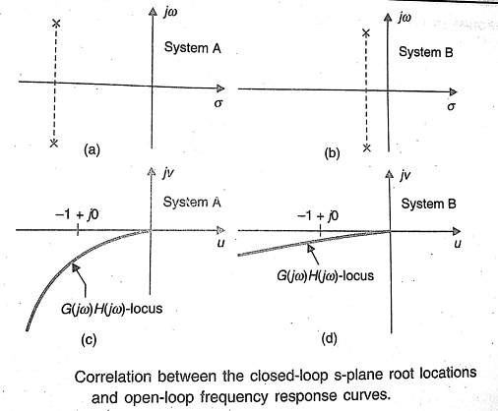
The figure as given below shows a G(jω)H(jω) locus which crosses the negative real axis at a frequency ω=ω2 with an intercept of a. Let a unit circle centred at origin (passes through point - 1+j0) intersect the G(jω)H(jω) locus at a frequency ω=ω1 and let the phasor G(jω1)H(jω1) makes an angle of ф with the negative real axis measured positively in counter-clockwise direction. It is observed that as G(jω)H(jω) locus approaches (-1+j0) point, the relative stability reduces.
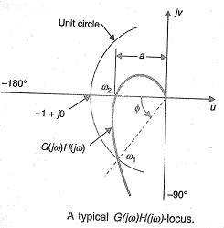

Constant Magnitude Loci or Constant M Circle

The closed loop transfer function of a unity feedback system is given by

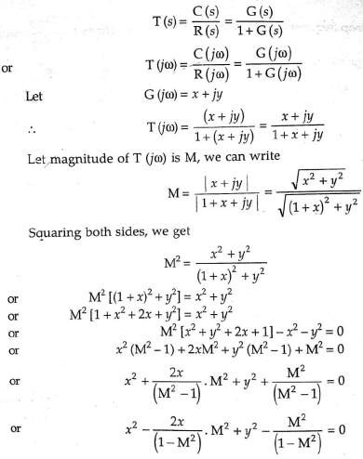
(1)

(2)

(3)

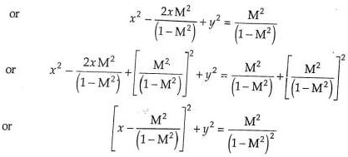
(4)

Equation 2 represents the equation of a circle with centre at [ 2
(1−𝑀2)
, 0] having radius of ^{𝑀}
(1−𝑀2)

If M=1, then Equation 3 becomes(1 + 𝑥)² + 𝑦² = 𝑥² + 𝑦² or x= − 1
2

It is a equation for straight line parallel to the y-axis and passing through

(− 1
2

, 0)
(5)

in the G(jω)

plane. For each value of M (except M=1) we get a circle. These circles are known as Constant Magnitude Loci or Constant M Circle.

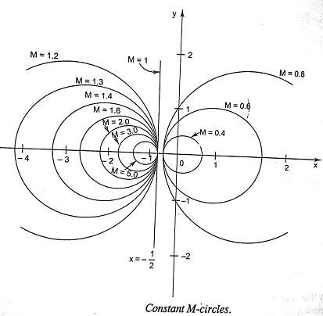

Constant Phase Loci or Constant N Circle
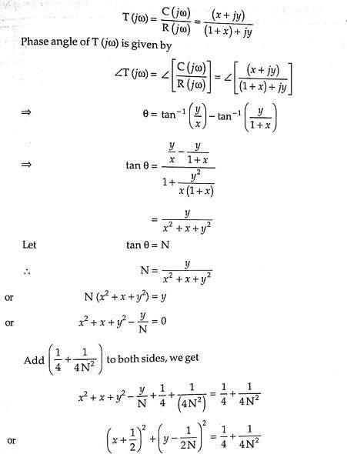
From equation 1

(6)

(7)

(8)

(9)

(10)

Equation 10 represents the equation of circle with it centre at (− 1 , 1 ) with radius √ 1 1 )

2 2𝑁
4
( + 4𝑁2

For different values of N i.e, phase angle θ, equation 10 represents the family of the circles. For a particular circle, the value of N i.e, phase angle θ remain constant on it. Therefore these circle are known as constant phase loci or N circles.

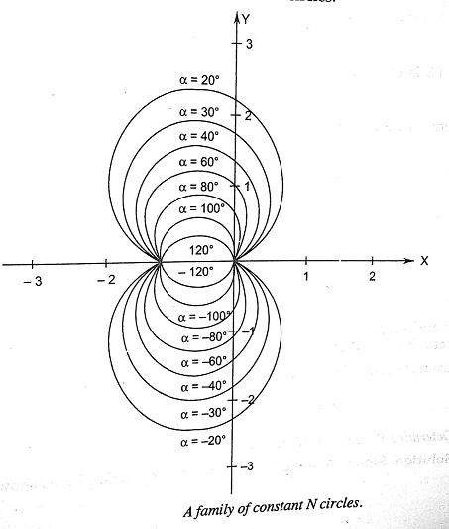

Nichols Plot

Constant magnitude loci that are M-circles and constant phase angle loci that are N-circles are the fundamental components in designing the Nichols chart. The constant M and constant N circles in G (jω) plane can be used for the analysis and design of control systems. However the constant M and constant N circles in gain phase plane are prepared for system design and analysis as these plots supply information with fewer manipulations. Gain phase plane is the graph having gain in decibel along the ordinate (vertical axis) and phase angle along the abscissa (horizontal axis). The M and N circles of G (jω) in the gain phase plane are transformed into M and N contours in rectangular co-ordinates. A point on the constant M loci in G (jω) plane is transferred to gain phase plane by drawing the vector directed from the origin of G (jω) plane to a particular point on M circle and then measuring the length in db and angle in degree. The critical point in G (jω), plane corresponds to the point of zero decibel and -180º in the gain phase plane. Plot of M and N circles in gain phase plane is known as Nichols chart /plot.

The Nichols plot is named after the American engineer N.B Nichols who formulated this plot. Compensators can be designed using Nichols plot. Nichols plot technique is however also used in

designing of dc motor. This is used in signal processing and control design. Nyquist plot in complex plane shows how phase of transfer function and frequency variation of magnitude are related. We can find out the gain and phase for a given frequency. Angle of positive real axis determines the phase and distance from origin of complex plane determines the gain.
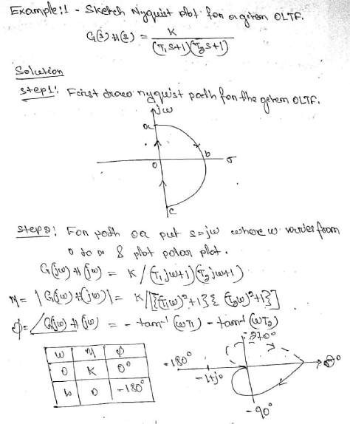

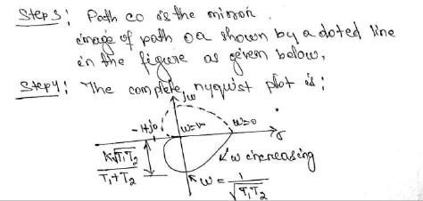
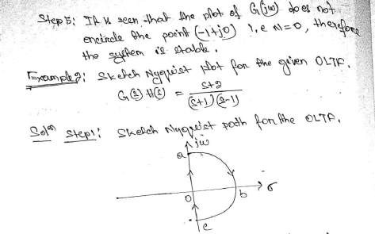
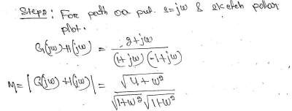

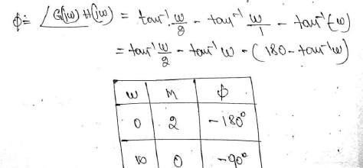
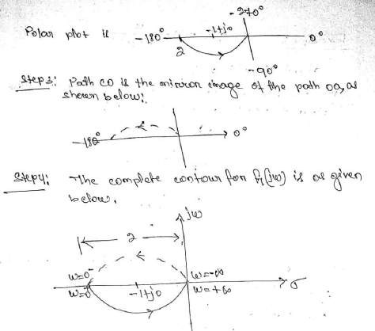

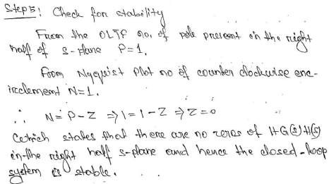
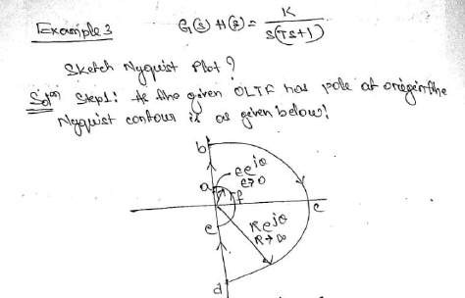

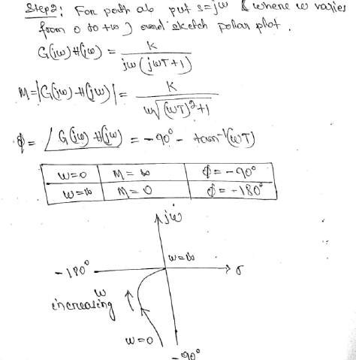
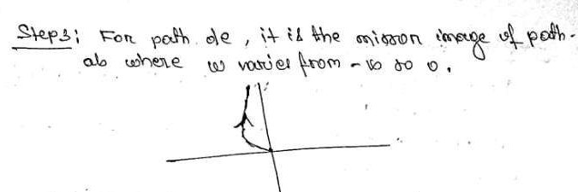

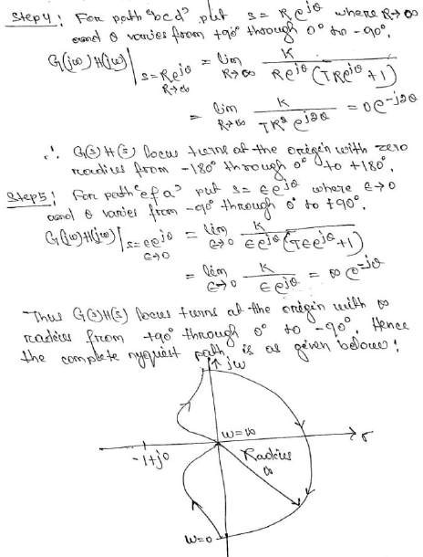

Step-6: Check for stability:
As P= 0; N=0; Hence Z=0, System is stable.

