RAJAKISHORE CHANDRA ACADEMY OF TECHNOLOGY
(POLYTECHNIC)



LECTURE NOTES ON
CIRCUIT THEORY
DEPARTMENT OF ELECTRONICS & TELECOMMUNICATION
3rd SEMESTER
PREPARED BY
ER. NILADRI BIHARI NAYAK
LECTURER (ETC)

CHAPTER -1

CIRCUIT ELEMENTS& ENERGY SOURCES

An electric circuit is an interconnection of electrical elements such as resistors, capacitors, inductors, voltage source etc. In electrical engineering, transfer of energy takes place from one point to another, which requires interconnection of electrical devices. Such interconnection is known as electric circuit and each component of the circuit is known as an element.

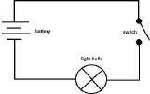
EXAMPLE # Consider an electrical circuit as shown in the figure. This electric circuit consists of four elements a battery, a lamp, switch & connecting wires. Circuit and network theorem is the study of the behaviour of the circuit: Its behaviour tells us how does it respond to a given input how do the interconnected elements and devices in the circuit interact?

ELECTRIC CURRENT:
Electric current may be defined as the time rate of net motion of an electric charge across a cross sectional boundary as shown in the figure given below. A random motion of electrons in a metal does not constitute a current unless there is a net transfer of charge with time i.e. electric current.

i = Rate of transfer of electric charge
= Quantity of electric charge transferred during a given time duration/ Time duration
= 𝑑Q
𝑑𝑡
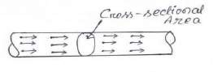
Coulomb is the practical as well as SI unit for measurement of electric charge. Since current is the rate of flow of electric charge through conductor and coulomb is the unit of electric charge, the current may be specified in coulombs per second. In practice the ampere is used as the unit of current. Coulomb is the practical as well as SI unit for measurement of electric charge. Since current is the rate of flow of electric charge through conductor and coulomb is the unit of electric charge, the current may be specified in coulombs per second. In practice the ampere is used as the unit of current.

VOLTAGE:
The voltage is the potential difference between two points of a
conductor carrying a current of one ampere when the power dissipated between these two points is equal to one watt. The practical unit of voltage is volt.

POWER:
Power is defined as the rate of doing work or rate at which it can perform
work. So Power = work done/ Time in seconds P = 𝑑w= 𝑑w 𝑑𝑞= v i
𝑑𝑡 𝑑𝑞 𝑑𝑡
Absolute unit of power is watt. One watt is that power which is required to perform one joule of work in one second. The practical unit of power is horse power (HP). This value in metric system is 75kg meters per second and in British system is 550 Foot Pounds/second. Therefore
1 HP (Metric) = 75 Kg meters per second= 735.5 watt 1 HP (British) = 550 Foot Pound/ second = 746 watt

ENERGY:
Energy of a body is its capacity of doing work.
𝑡

𝐸 = ∫
0
𝑃𝑑𝑡

The unit of energy in MKS system is joule and in SI system is KWH. A system can have this energy in various forms, such as electrical, mechanical, heat, chemical, atomic energy etc. Energy of one form can be transformed to other form, but cannot be created nor be destroyed. If one form of energy disappeared, it reappears in another form. This principle is known as law of conservation of energy.

CIRCUIT ELEMENTS/PARAMETERS:
- RESISTANCE:
Resistance restricts the flow of electric current through the material. Unit of Resistance(R) is Ohm. From Ohm’s law
R=V/I
When an electric current flows through any conductor, heat is generated due to collision of free electrons with atoms. If I amp is the strength of current for potential difference V volts across a conductor, the power observed by resistor is :
P=VI= (IR).I=𝐼2𝑅 watts
Energy lost in the resistor in form of heat is then
2

𝑡
E= =
𝑡
𝑅 𝑑𝑡=𝐼
2 𝑉2

∫0 𝑝. 𝑑𝑡
- INDUCTANCE:
∫0 𝐼
𝑅t= x t
𝑅

It opposes any change of magnitude or direction of electric current passing through the conductor. Unit is Henry (H).When a current will flow through the coils/Inductor an electromagnetic field is created. However in the event of any change

of flow on direction of current, the electromagnetic field also changes. This change of field induces a voltage (V) across the coil & is given by

𝑉 = 𝐿. 𝑑i
𝑑𝑡
Where ‘i’ is current through the inductor.
- (1)

Voltage across an inductor is zero when current is constant. Hence an inductor acts like short circuit to dc.
Power absorbed by inductor
P=V x i=Li i watts (2)
𝑑𝑡
Energy absorbed. 𝑡
E=∫ 𝑝. 𝑑𝑡 = 1 Li2 (3)
0 2

From equation (2) & (3): The inductor can store finite amount of energy, even the voltage across it may be nil. A pure inductor does not dissipate energy but can only store it.
- CAPACITANCE:
It is the property of capacitor, which have the capability to store electric charge in its electric field established by the two polarities of charges on the two electrodes of a capacitor.
The amount of charge store by capacitor is q = cv
i= 𝑑𝑞 =>i=c 𝑑𝑣
𝑑𝑡 𝑑𝑡
Therefore if voltage across capacitor is constant, current through it is zero. Hence capacitor acts like a open circuit to dc.
Power absorbed P=V.I= VC𝑑𝑣
Energy stored E= 𝑝. 𝑑𝑡𝑑𝑡 1 2
∫ = CV
0 2
A capacitor can store finite amount of energy. Even if the current through it is zero. It never dissipates energy.

TYPES OF ELEMENTS:
ACTIVE AND PASSIVE ELEMENT:
An active element has capability to generating energy while passive elements have not.
Ex: Active Element: Generators, Batteries, And Amplifiers.
Passive Element: Resistor, Inductor, capacitor.
BILATERAL AND UNILATERAL ELEMENT:
If the magnitude of current passing through the element is affected due to change in the polarity of the applied voltage, the element is called unilateral element. And if the current magnitude remains same, it is called as bilateral element.
Ex: Unilateral Element: - Diodes, Transistors. Bilateral Element: - Resistor, Inductor, Capacitor

LINEAR AND NON-LINEAR ELEMENTS:
A linear element shows linear characteristics of voltage Vs current. Resistors, Inductor, Capacitor are linear elements and their property does not change in applied voltage on circuit current.
For non-linear elements the current passing through it does not change linearly with the time as change in applied voltage at a particular frequency.
Ex: Semiconductor devices.
ENERGY SOURCES:
Independent Energy sources: The voltage & current sources whose values or strength of voltage and current does not change by any variation in the connected network are called independent sources.
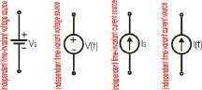

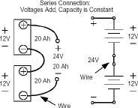
Series connected independent sources: Consider the series connection of two voltage sources as shown in the figure. By KVL the total voltage between the terminals is equal to algebraic sum of individual sources i.e. the voltage sources connected in series may be replaced by a single voltage source whose voltage is equal to the algebraic sum of the individual sources.

Dependent Energy sources: When the strength of voltage and current changes in the sources for any change in the connected network, they are called dependent sources. There four different types of dependent sources
  - Voltage controlled voltage source (VCVS)
  - Voltage controlled current source (VCCS)
  - Current controlled voltage source (CCVS)
  - Current controlled current source (CCCS)
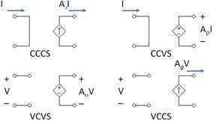

SOURCE TRANSFORMATION:
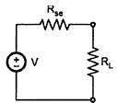
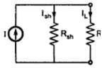
The voltage and current sources are mutually transferable as shown in the figure below.

KIRCHHOFF’S LAW:
These laws are more comprehensive than Ohm’s law and are used for solving electrical networks which may not be readily solved by latter. Kirchhoff’s law is of two types, Kirchhoff’s current law and Kirchhoff’s voltage law. Kirchhoff’s current law is used when voltage is chosen as variable while Kirchhoff’ voltage law is used when current is chosen as variable.

KCL: According to Kirchhoff’s current law the algebraic sum of currents at any node of a circuit is zero. From the figure given below:

Hence:
-I1-I2+I3-I4+I5=0
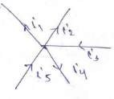
=>I1+I2+ I4=I3+I5

Algebraic sum of currents entering a node = Algebraic sum of current leaving a node.

Example1: Find the magnitude and direction of the unknown current as shown in figure given I1= 10 A, I2= 6A, I5= 4A
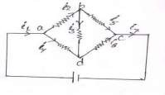
Solution: Assume direction of current in the network
- I1= I7= 10 A
- I1= I2 + I4=> I4= I1- I2= 10- 6= 4 A
- At node b: I2 - I3 - I5= 0
=> 6 - I3- 4=0 => I3= 2A
- At noded: I4 + I3 - I6= 0
=>4 + 2 – I6 =0
=> I6 = 6 A

Assume direction of all current are correct because of their positive magnitude. Assume directions of unknown current are arbitrary and any direction can be taken.
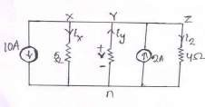
Example2: Find v and the magnitude and direction of the unknown currents in the branch xn, yn and zn as shown in figure.

Solution:

At node y: 10 + Ix + Iz = Iy + 2 Ix – Iy + Iz= -8
𝑉 + 𝑉 + 𝑉 = -8 [since Ix = , Iy=− 𝑉 , Iz= 𝑉 ]
5 2 4 5 5 5
𝑉 = −8.42 volt

Negative magnitude shows that n to be positive.

Therefore Ix = -8.42 = -1.684 A (i.e. from flowing current n to x)
5
Iy = - (−8.42)= 4.21 A (ie Current flowing from n to y)
2
Iz = −8.42= -2.1 A (ie current flowing from n to z)
4

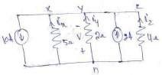
The circuit can be redrawn as given below

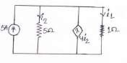
Example3: Find i1 and i2 as shown in figure Solution: The circuit is redrawn in figure
According to KCL: i1 + i2 = 5 + 4 i2 (1)
i1- 3 i2 = 5 (2)

Here i1 = ; i2 = 𝑉

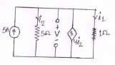
1 5
Therefore equation 2: V - 3𝑉 = 5
5
=> V = 12.5 volt Therefore i1 = 12.5 A and i2 = 2.5 A

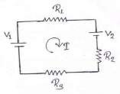
KIRCHHOFFS VOLTAGE LAW:
This law can be stated as
“The algebraic sum of voltage in any closed path of a network that is traversed in single direction is zero.”
Explanation: According to KVL
V1 – IR1 – V2 – IR2 – IR3 = 0 IR1 + IR2 + IR3 = V1 – V2
I= 𝑉1−𝑉2
𝑅1+𝑅2+𝑅3

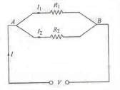
CURRENT DIVISION RULE:
Two resistors are joined in parallel across a voltage V. The current in each branch, as given in ohm’s law is
I1=V/R1 and I2= V/ R2
Therefore I1/I2 = R2/ R1 = G1/ G2
Hence the division of current in the branch of parallel circuit is directly proportional to the
conductance of the branches or inversely proportional to their resistances. We may also express the branch currents in terms of the total circuit current thus:
Now I1 + I2 = I
=> I2 =I - I1
Therefore I1 = 𝑅2 or I1 R1 = R2(I - I1 )

I−I1
𝑅1

Therefore I1 = I 𝑅2 and I2 =I 𝑅1
𝑅1+𝑅2 𝑅1+𝑅2
Thus current division rule is stated as
“The current in any of the parallel branches is equal to the ratio of the opposite branch resistance to the total resistance, multiplied by the total current.”

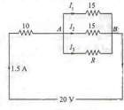
Example4: A resistance of 10 ohm is connected in series with two resistances each of 15 ohm arranged in parallel. What resistance must be shunted across this parallel combination so that the total current taken shall be 1.5 A with 20 volt applied?
Solution: The circuit connected in figure Drop across 10 ohm resister = 1.5 * 10=15V
Drop across parallel combination, VAB= 20-15=5V Hence voltage across each parallel resistance is 5V.
I1= 5/15 = 1/3 A
I2= 5/15= 1/3 A
I3= 1.5-(1/3+1/3)= 5/6 A

Therefore I3R = 5 or (5/6) R = 5 or R=6 ohm

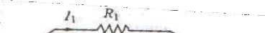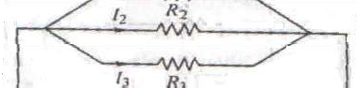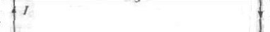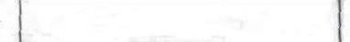Example5: Calculate the value of different current for the circuit shown in given figure.
Solution: Total current I = I1 + I2 + I3
Let the equivalent resistance be R. Then V= I R
Also V = I1 R1 Therefore I R = I 1 R1
Or I 1= I R/R1 (1)
Now (1/R) = (1/R1) + (1/R2) + (1/R3)

R= 𝑅1 𝑅2 𝑅3
𝑅1 𝑅2 + 𝑅2 𝑅3+ 𝑅3 𝑅1
From equation 1: I 1= 𝑅2 𝑅3
𝑅1 𝑅2 + 𝑅2 𝑅3+ 𝑅3 𝑅1
Similarly I 2 = 𝑅1 𝑅3
𝑅1 𝑅2 + 𝑅2 𝑅3+ 𝑅3 𝑅1

I 3 = 𝑅1 𝑅2
𝑅1 𝑅2 + 𝑅2 𝑅3+ 𝑅3 𝑅1

VOLTAGE DIVISION RULE:
A voltage divider circuit is a series network which is used to feed other networks with a number of different voltages and is derived from a single input voltage source. Figure shows a simple voltage divider circuit which provide two output voltages V1 and V2. Since no load is connected across the output terminals, it is called an unloaded voltage divider. We may also express the branch voltages in terms of the total circuit voltage thus:
Now V1 + V2 = V
=> V2 =V - V1
Therefore V1 = 𝑅1 or V1 R2 = R1 (V – V1)
V−V1 𝑅2
Therefore V1 ₌ 𝑉 ^{𝑅1} and V2 = V 𝑅2
𝑅1+𝑅2 𝑅1+𝑅2
Thus Voltage division rule is stated as
“The voltage across a resistor in series circuit is equal to the value of that resistor times the total impressed voltage across the series elements divided by the total resistance of the series elements.”

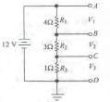
Example9: Find the value of different voltages that can be obtained from a 12 V battery with the help of voltage divider circuit of figure.
Solution:
R= R1 + R2 + R3 = 4 + 3+ 1 = 8 ohm
Drop across R1=VR1 = 12 × (4/8) = 6 volt Drop across R2=VR2 = 12 × (3/8) = 4.5 volt Drop across R3=VR3 = 12 × (1/8) = 1.5 volt

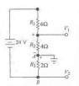
Example10: What are the output voltages of the unloaded voltage divider shown in figure what is the direction of current Through AB?

Solution:
It may be remember that both V1 and V2 are with respect to ground.
R= 6+ 4 + 2 = 12 ohm
Therefore
V1= Drop across R2= 24 × (4/12) = 8 volt V2 = Drop across R3= -24 × (2/12) = -4 volt
It should be noted that point B is negative potential with respect to the ground. Current flows from A to b i.e. from a point at a higher potential to appoint at a lower potential.
Problem 1
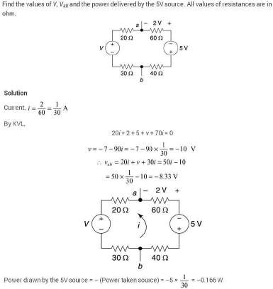

STAR DELTA TRANSFORMATIONS

Figure shows a Y (star or wage) connected resistance circuit. Let
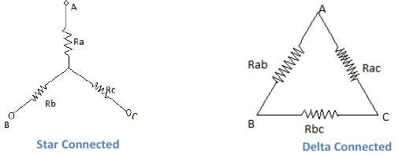
the resister value of Y network are Ra, Rb and Rc. Figure shows a (delta) connected resistances and Let the resistor values are Rab , Rbc and Rca .

It is possible to substitute a star connected system of resistance for a delta system and vice-versa if proper values are given to the substituted resistances.

DELTA TO STAR CONVERSION
The two systems will be exactly equivalent if the resistance between any pair of terminals A, B and C in figure for the star is the same as that between the corresponding pair for the delta connection when the third terminal is isolated.

For the Y-network resistance between the terminal

A and B is Rab = Ra + Rb eq. (i)

For the Δ network resistance between the terminals AB is

Rab = Rab II (Rac + Rbc)

= Rab(Rac+Rbc) eq. (ii)
Rab+Rac+Rbc

Hence Ra + Rb =Rab (Rac+Rbc) _eq. (iii) Rab+Rac+Rbc
Simalarly for Y-network resistance between terminal B and C is

Rbc = Rb+Rc

For the Δ network resistance between terminal B and C is Rbc = Rbc II (Rab+Rac)
Rb+Rc = Rbc (Rab+Rac) eq. (iv) Rbc+Rab+Rac

Similarly we can find Rac between terminal A and C is

Ra+Rc = Rac(Rab+Rbc) eq. (v) Rac+Rab+Rac
Subtracting eq.(v) from the sum of eq.(iii) and eq.(iv) yields

2 Rb = 2 Rab . Rbc
Rab+Rbc+Rca

Rb = Rab . Rbc
Rab+Rbc+Rca

Subtracting eq.(iv) from the sum of eq.(iii) & eq.(v) yields

2 Ra = 2 Rab . Rac
Rab+Rbc+Rac

Ra = Rab . Rac
Rab+Rbc+Rac

Similarly subtracting eq.(iii) from the sum of eq.(iv) and eq.(v) yields

2 Rc = 2. Rbc . Rca
Rab+Rbc+Rca

Rc = Rbc . Rca
Rab+Rbc+Rca
Therefore, the equivalent impedance of each arm of the star is given by the product of the impedance of the two delta sides that meet at its ends divided by the sum of
there delta impedance

STAR TO DELTA CONVERSION

Similarly we can find conversion formula for Y to Δ as

Rab = Ra . Rb + Rb .Rc + Rc . Ra
Rc

Rbc = Ra . Rb + Rb .Rc + Rc . Ra
Ra

Rca = Ra . Rb + Rb .Rc + Rc . Ra
Rb

Problem-1
Convert the Y network to an equivalent Δ network.
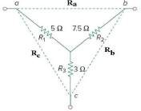
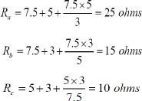
Problem-2
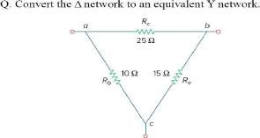
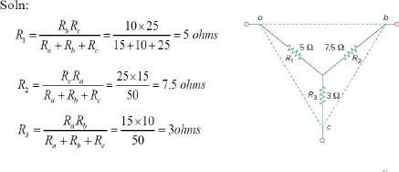

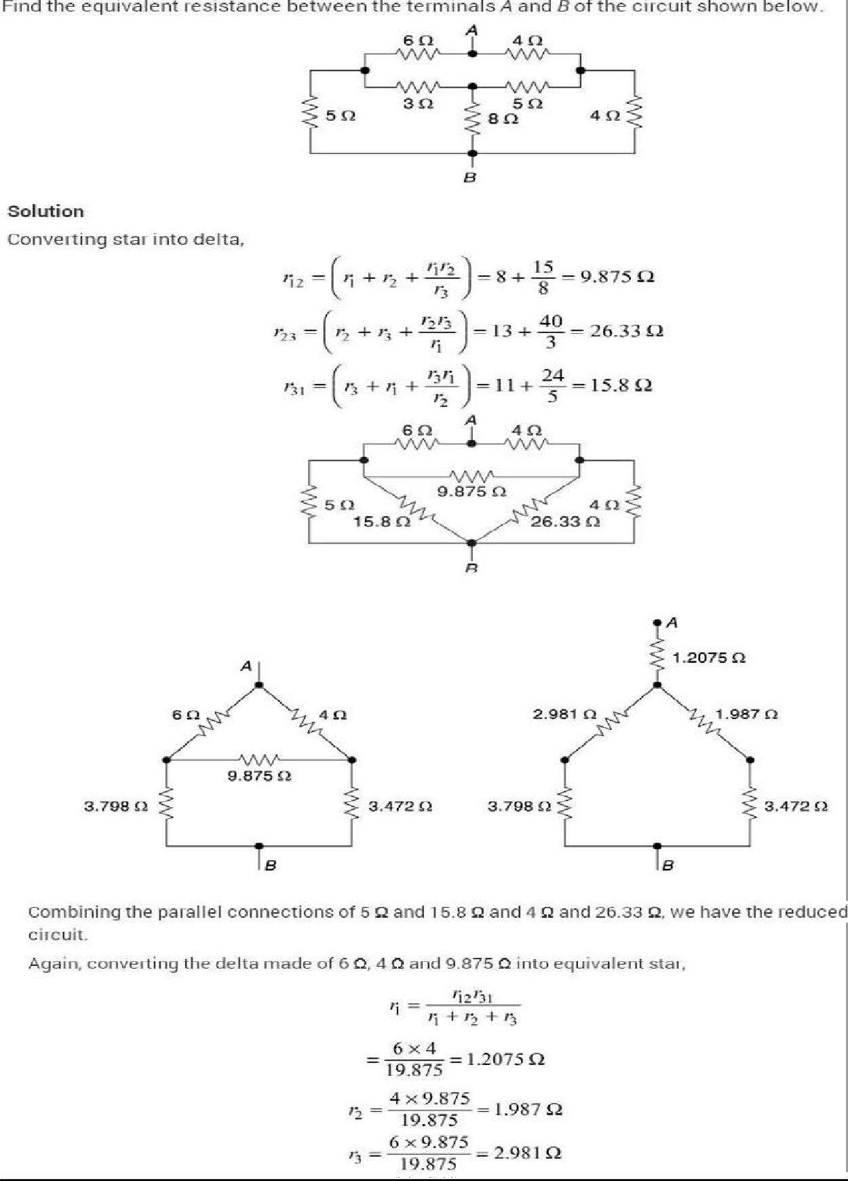

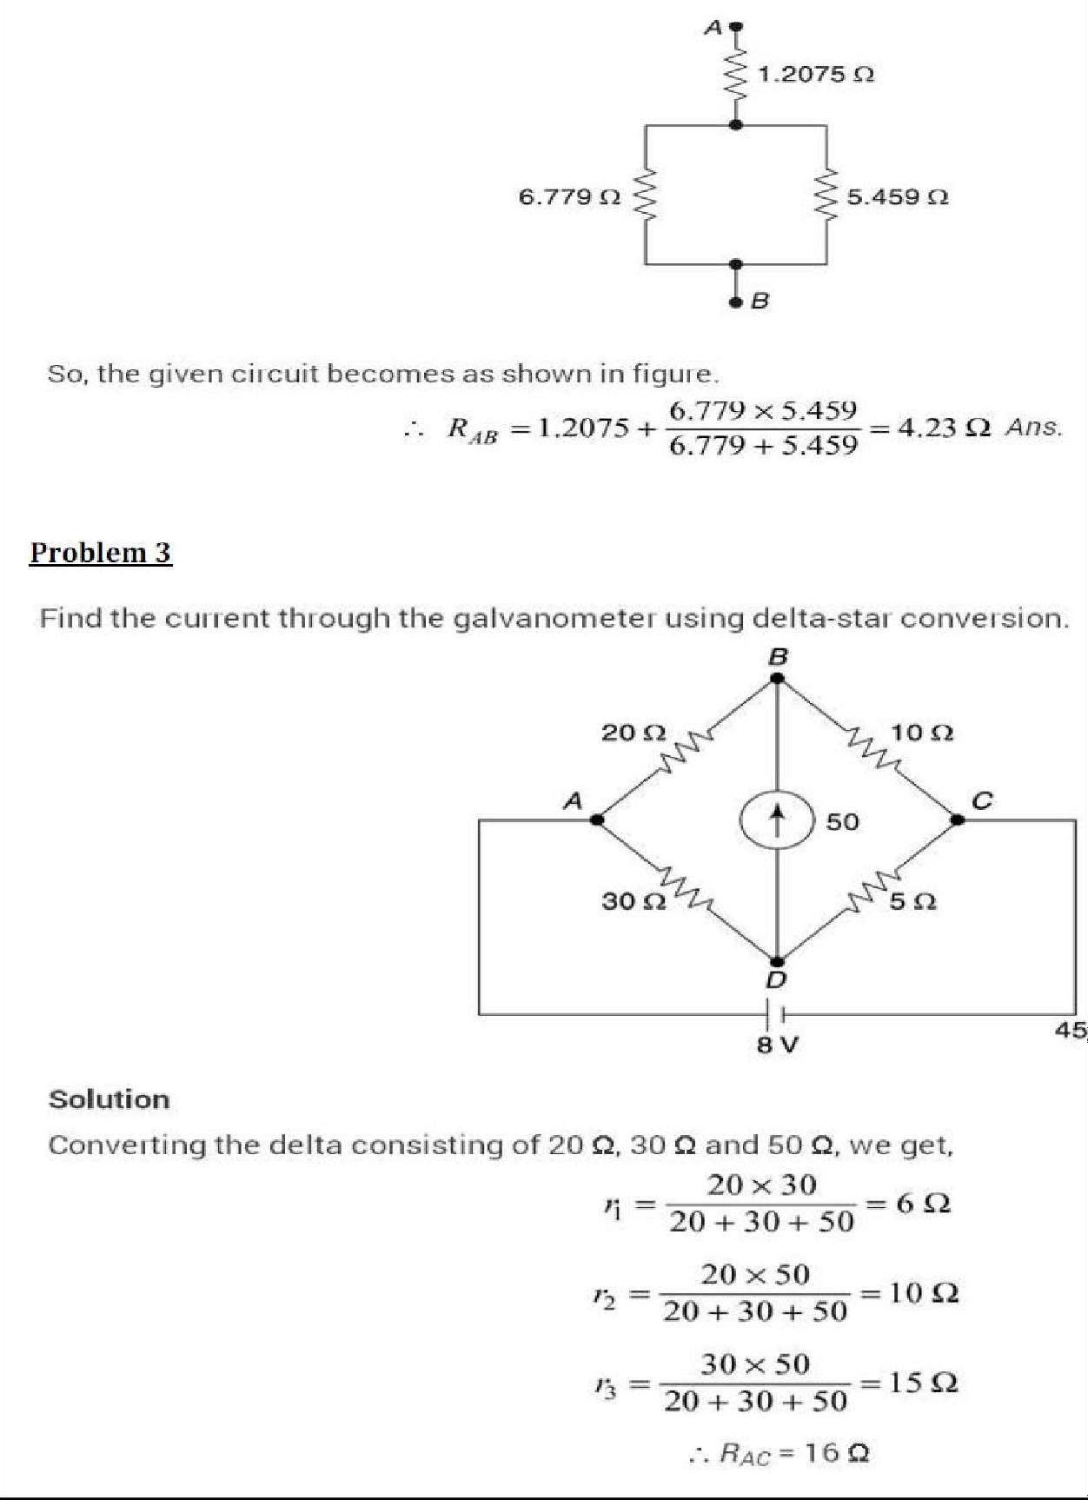

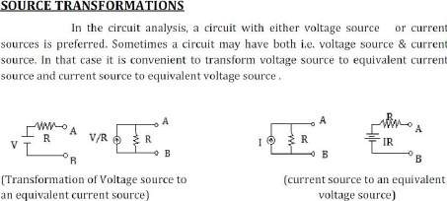Mutual inductance
Mutual induction is a phenomenon when a coil gets induced in EMF across it due to rate of change current in adjacent coil in such a way that the flux of one coil current gets linkage of another coil.

Definition of Mutual Inductance
Mutual Inductance is the ratio between induced emf across a coil to the rate of change of current of another adjacent coil in such a way that two coils are in possibility of flux linkage.
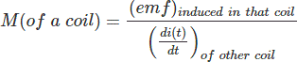

INTRODUCTION
CHAPTER -2

NETWORK THEOREMS

Electric circuits on network consist of a number of interconnected single circuit elements. This circuit will generally contain at least one voltage on current source. The arrangement of elements results in a new set of constraints between currents and voltages. These new constraints and their corresponding equations added to the current-voltage relationships of the individual elements provide the solution of the network. There are different approaches for this but the solution is always unique.

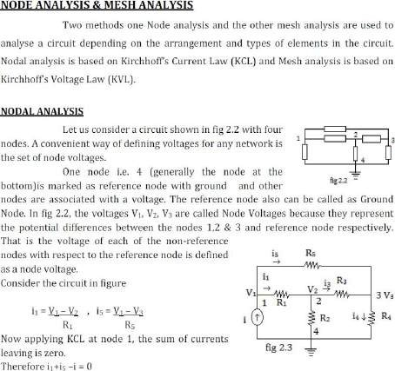

i = V1-V2 + V1-V3 eq. (1) R1 R5

Similarly at node 2 -i1= V2 – V1 , i2 = V2 , i3 = V2 – V3
R1 R2 R3
V2 – V1 + V2 –V3 + V2 = 0 eq.(2) R1 R3 R2
At Node 3 Sum of currents leaving are
-i3 = V3-V2 , i4 = V3 , -i5 = V3 – V1 R3 R4 R5

V3 – V2 + V3 + V3- V1 _ eq. (3) R3 R4 R5
All the above these equation can be solved to determine the individual node voltages V1, V2& V3.
Example 1
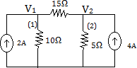
Find the node voltages V1 and V2 for the circuit at figure.
Solution At node 1 apply KCL sum of all the current leaving the node (1) is zero current leaving node 1 are V1, V1-V2 and -2A (2A is entering)
10 15
V1 + V1- V2_ -2 = 0
10 15
V1( 1 + 1 ) – 𝑉 2 = 2
10 15 15
5V1 – 2V2 = 60 eq. (1)
Similarly At node 2 current leaving are 𝑉2 , 𝑉2−𝑉1 and -4A
5 15
𝑉2 + 𝑉2−𝑉1 -4 = 0
5 15
4V2 – V1 = 60 eq. (2)
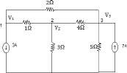
Solving the above two equations (1) & (2) We get V1 = 20V, V2 = 20V

Example 2
Find V1, V2 and V3 for the circuit in figure.
Solution
At node 1
V1 –V2 + 𝑉1−𝑉3 + 3 = 0
2
3V1-2V2-V3 = -6 eq. (1)
At node 2
V2-V1 + 𝑉2 + 𝑉2−𝑉3 = 0
3 4
-12V1 + 19V2 -3V3 = 0 _ eq.(2)

At node 3

𝑉3−𝑉1 + 𝑉3 + 𝑉3−𝑉2 = 7
2 5 4
-10V1- 5V2 +19V3 = 140 eq. (3)

Example 3

Solution
By solving we get V1 = 5.238V, V2 = 5.12V & V3 = 11.47V Find the node voltage V1& V2

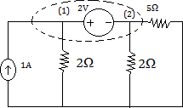
To write node equation treat node 1 and 2

and the voltage source together as a Sort of Super node and apply KCL to both nodes at the same time. The super node is individual by dotted line.
Applying KCL, we get
-1+ 𝑉1 + 𝑉2 + 𝑉2 = 0 eq. (1)
2 2 5
And from voltage source V1 – 2 = V2 eq. (2) Now we can solve for V1 and V2 using both equations.

MESH ANALYSIS
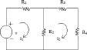
Mesh analysis is restricted to the category called Planar Circuit whereas nodal analysis can applied to any electrical circuits. A planer circuit is a circuit if the diagram of the circuit can be drawn on a plane surface without crossover. Example of planner and non-planar circuit are shown in fig (2.7).
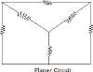
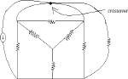
Figure depicts a circuit comprising two meshes.

They are

Mesh 1: V5 → R1 → R2 →V3
Mesh 2: R3 → R4 → R2 →R3

The two mesh currents are labeled as i1 and i2 flowing in clockwise direction. Now we will apply KVL around each mesh.

For mesh 1
i1R1 + (i1-i2) R2 = V5 eq. 1
For mesh 2
i2R3 + i2R4 + R2 (i2-i1) = 0 eq. 2

Eq.(1) & (2) can be rewritten as
(R1+R2)i1 – R2i2 = V5 eq.3
-R2i1 + (R2+R3+R4) i2 = 0
Finally the two equations can be put in matrix form
[𝑅1 + 𝑅2 −𝑅2 ] [i1]= [𝑉5]
−𝑅2 𝑅2 + 𝑅3 + 𝑅4 i2 0
Which can be solved for i1 and i2.
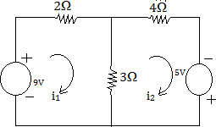
Examples 4 find the mesh current i1 and i2 for the circuit shown in figure. For first mesh 2i1+3(i1 – i2) = 9 eq.1
4i2-5+3(i2-i1) =0 eq.2
Equation can be rewritten as
5i1 -3i2 = 9 eq.3
-3i1+7i2 = 5 eq.4
By solving i1 = 3A, i2 = 2A

Example 5
Determine the voltage drop across 3Ω resister using mesh analysis in figure.
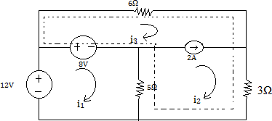

SUPERMESH
When a current source is common to two meshes we use the concept of super mesh to analysis the circuit using mesh current method. A super mesh is a larger mesh created from two meshes that have a current source as common element. A super mesh encloses more than one mesh for each common current source between two meshes, the number of meshes reduce by one, thus reading the number of mesh

Solution to Example 6
The 2A current source is common to mesh 2 & 3. So we create a super mesh as shown in dotted line.
For super mesh
6i3 + 3i2 + 5(i2-i1)-8= 0
⇒ -5i1 + 8i2 + 6i3 = 8 eq. 1

For mesh 1
-12+8+5(i1-i2) = 0
⇒ 5i1 – 5i2 = 4 eq.2

From current source i2-i3 = 2
By solving we get i2 = 2.664 Voltage across 3Ω resistor = 2.66×3 = 8v.

Example 7
Use node analysis to find V1, V2, V3 & i1
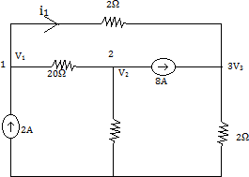
Solution
Applying KCL at node 1
We get
𝑉1−𝑉2 + 𝑉1−𝑉3 = 2 eq. 1
20 2
Applying KCL at node 2
𝑉2−𝑉1 + 𝑉2 + 8 = 0 eq.2
20 4
Applying KCL at node 3
𝑉3 + 𝑉3−𝑉1 = 8 eq.3
2 2
By solving all these equations we can get V1= 16v, V2= -24v, V3 = 16v, i1 = 0A

Examples 8
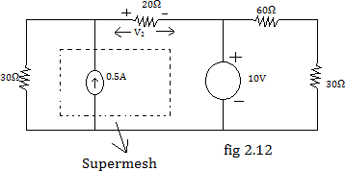
Find the voltage V2 using mesh analysis.

Solution
Applying KVL for super mesh 30i1+20(05+i1)+10=0
⇒ 50i1 = -20
⇒ i1 = -2 = - 0.4A, V2 = 20(i1+0.5)
5
= 20×0.1 = 2v

Superposition Theorem
In a linear bilateral network containing two or more independent sources, the voltage across or current in any branch is algebraic sum of individual voltages or currents produced by each independent sources acting separately with all the independent sources set equal to zero.
Procedure to solve the circuit using superposition theorem
- Select only one source and replace all other sources with their internal resistance. If the source is an ideal current source replace it by open circuit. If the source is an ideal voltage source, replace it by short circuit.
- Find the current and its direction through the desired branch.
- Add all the branch currents to obtain the actual branch current.

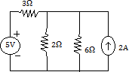
Examples 9
Find the current through 2Ω register using
superposition theorem.

Solution
First we find the contribution to I due to 5V
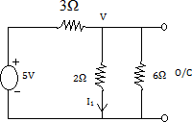
source by replacing 2A current source with open-circuit. Applying KCL for the circuit in figure.

𝑉−5 + 𝑉 + 𝑉 = 0

3 2 6
V = 5 v, I1 =
⁵ Amp

3 6
Next we find the contributions I2 due to 2A current source by replacing the voltage source by short-circuit.
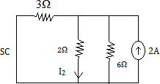
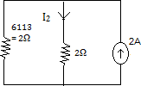

I2 = 2×2 = 1Amp
4
Total current flowing through the 2Ω resistor = I1+I2 = 1+5 = 11Amp
6 6

Limitation of Super-position Theorem
- Not applicable to the circuits consisting of only dependent sources.
- Not applicable to the circuits consisting of non-linear elements.
- Not applicable for calculation of power, since power is potential is propositional to the sequence of current or voltage.
- Not useful to the circuits consisting of less than two independent sources.

Example 10
Find current I using Superposition theorem for the circuit in the figure.
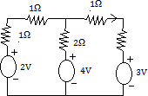

Solution:
The circuit has three voltage sources. First we find the contribution to I1
due to 2V. Therefore short-circuit the remaining two voltage sources as shown in figure.

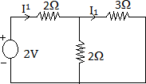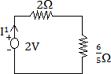I1 = ² = ¹⁰ = ⁵ A
2+6 16 8
5

I1 = 5 ×2 = 1 A
8 5 4

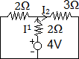
When 4V acting as shown in figure I1 = 4 = 5 A
2+6 4
5

I2 = 5 ×2 = 1 A
4 5 2

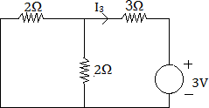
When 3V is acting alone as shown in figure I3 = - 3Amp
4
When all the sources are acting together total
current will be
I = I1 + I2 + I3 = 1 + 1 - 3= 1+2−3= 0Amp
4 2 4 4

Example 11
Find current Ia
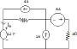
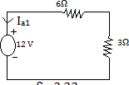
Solution: Let us assume that only 12V is acting done and current through it ia1, open circuit 4A and 1A current source and short-circuit the 6V voltage source as in the figure.

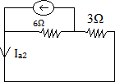
Ia1 = - 12 = - 4A
9 3
When 4A current source is acting alone as shown in figure.
Ia2 = 4×6 = 24 = 8 A
9 9 3

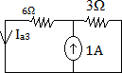
When 1A is acting alone as shown in figure.
Ia3 = 1×3 = 1 A
9 3

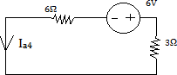
When 6V is acting alone as in figure
Ia4 = 6 = - 2 A
9 3

When all the sources are acting total current will be
Ia = Ia1 + Ia2 + Ia3 + Ia4
= - 4 + 8 + 1 - 2 = −4+8+1−2
3 3 3 3 3
= 3
3
= 1amp
Ia = 1A

APPLICATION OF SUPER-POSITION THEOREM
The super-position theorem is applicable for any linear circuit having time varying or time invariant elements. It is useful in circuit analysis for finding current & voltage when the circuit has a large number of independent sources.

LIMITATION OF SUPER-POSITION THEOREM
- Not applicable to the circuits consisting of dependent sources.
- Not applicable to the circuits consisting of non linear elements like diode, transistor etc.
- Not applicable for calculation of power.

THEVENIN’S THEOREM
Thevenin’s theorem states that any linear active two terminal network containing resistance and voltage sources or current sources can be replaced by a single voltage sources Vth in series with single resistance Rth. The Thevenin equivalent voltage Vth is the open circuit voltage at the network terminal and the Thevenin resistance Rth is the resistance between the network terminals when all the sources are replaced with their internal resistance.
Fig (a) shows a linear network containing resistance, voltage sources or current sources with output terminal AB using Thevenin’s theorem the linear network can be replaced by single voltage source Vth in series with a single resistor Rth as shown in fig(b). Now any resistor can be corrected between the terminal AB and current through it can be obtained easily.
Procedure to find the current through a branch using Thevenin’s Theorem.

- Remove the branch through which current is to be found and mark the terminal AB.
- Calculate the open circuit voltage Vth between the terminal AB.
- Replace the independent sources with their internal resistance. (if the internal resistances are zero, then voltage source should be short-circuited and current source should be open-circuited)
- Calculate Rth between the terminal AB.
- Correct thevenin’s voltage sources in series with Thevenin resistance with output
terminal AB.
- Correct the removed resistance between AB and find the current through it.

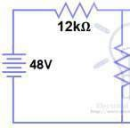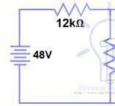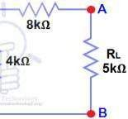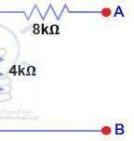Example
Find VTH, RTH nd the load current
a
flowing through and load voltage across the load resistor in figure by using T evenin’s Theorem.
h

Solution
Step 1
Open the 5kΩ load resistor figure. Step 2
Calculate / measur the Open Circuit Voltage. This is the Thevenin Voltage (VTH)
e
figure. We have already removed the load resistor from figure 1, so the circuit became an open circuit as shown in fi 2. Now we have to calculate the Theve in’s Voltage. Since
g n

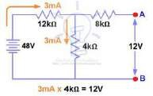
3mA Current flows in both 12kΩ and 4kΩ resistors as this is a series circuit because current will not flow in the 8kΩ resistor as it is open.
So 12V (3mA x 4kΩ will appear across the
)
o
4kΩ resistor. We also kn w that current is not
flowing through the 8kΩ resistor as it is open
circuit, but the 8kΩ resistor is in parallel with 4k resistor. So the same voltage (i.e. 12V) will appear
s

across the 8kΩ resistor a terminals. So,
4kΩ resistor. Therefore 12V will appear across the AB

VTH = 12V

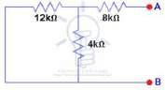
Step 3
Open Current Sources and Short
Voltage Sources figure.

Step 4
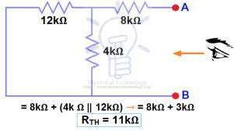
Calculate /measure the Open Circuit
Resistance. This is the Thev nin Resistance (RTH)
e
We have Reduced the 48V DC source
a

to zero is equivalent to repl (3), as shown in figure () resistor is in series with a p
a
ce it with a short in step We can see that 8kΩ rallel connection of 4kΩ

resistor and 12k Ω resistor. i.e.:
8kΩ + (4k Ω || 12kΩ) ….. (|| = in parallel with) RTH = 8kΩ + [(4kΩ x 12kΩ) / (4kΩ + 12kΩ)] RTH = 8kΩ + 3kΩ
RTH = 11kΩ

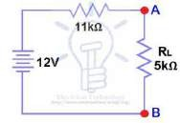
Step 5
Connect the RTHin series with Voltage
Source VTH and re-connect the load resistor. This is shown in figure i.e. Thevenin circuit with load resistor.

Step 6
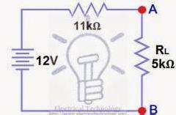
Now apply the last step i.e. calculate the

total load current & load voltage as shown in figure.
IL = VTH/ (RTH + RL)
= 12V (11kΩ + 5kΩ) →
/
= 12/16kΩ
IL = 0.75mA
And
VL = ILx R
L
VL = 0.75mA x 5kΩ
VL = 3.75V

NORTON’S THEOREM
Norton’s theorem states that any linear active two contains resistance and voltage source or current source can be

terminal network replaced by single

current source or current source can be replaced by single current source IN in parallel with a single resistance RN. The Norton’s equivalent current IN is the state circuit current through the terminals AB and resistance RN is the resistance between the network terminals when all the sources are replaced with internal resistances.
Procedure to find the current through a branch using Norton’s theorem.
- Remove the branch through which current is to be found and mark terminal AB.
- Short-circuit the terminal AB and find current through it and denote it as ISC.
- Replace the independent sources with their internal resis ances (if internal resistances are zero then voltage source should be short circuited and current sources should be open-circulated).
- Calculate RN between the terminals AB.
- Connect the short-circuit current (Norton’s) In in parallel with RN with output terminal AB.
Correct the removed branch between terminals AB and find current. Example
Find the current in RL using Norton’s Theorem
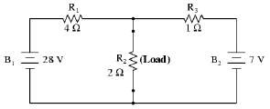

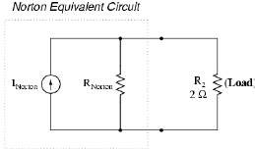
After Norton conversion . . .

Remember a current source is a co
that ponent

whose job is to provide a constant amount of current, outputting as much or as little voltage necessary to maintain that constant current.
m

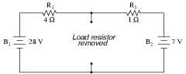
As with Thevenin's Theorem, everything in the original circuit except the load resistance has been reduced to an equival nt circuit that is simpler to analyze. Also similar to Thevenin's Theorem are the steps used in Norton's Theorem to
e
calculate the Norton source current (INorton) and Norton resistance (RNorton).
As before, the first step is to identify the load resistance and remove it from the original circuit.
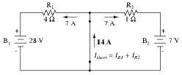
Then, to find the

Norton current (for the source in the Norton e circuit), place a direct wir
q
e
current uivalent (short)

connection between the load points and determine the resultant current.
Note that this step is exactly
opposite the respective step in Thevenin's Theorem, where we replaced the load resistor with a break (open circuit).
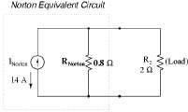
With zero voltage dropped between the load resis or connection points, the current through R1 is strictly a function of B1's voltage and R1's resistance:
t
7 amps (I=E/R). Likewise, the current through R3 is now strictly a function of B2's voltage and R3's resistance: 7 amps (I=E/R).

The total current through the short between the load connection points is the sum of these two currents: 7 amps + 7 amps = 14 amps. This figure of 14 amps becomes the Norton source current (INorton) in our equivalent circuit.
Current through load of 2 Ω resistor = 14 X .8 /2.8 = 4 Amp.
Maximum Power Transfer Theorem
In a linear bilateral network containing an independent voltage source in series with resistance RS delivers maximum power to the load resistance RL when RL=RS
Let us consider a circuit shown in fig(a)
Current I= 𝑉𝑠

𝑅𝑠+𝑅𝑙
2 2

Power delivered to the load PL = I RL = ( ) RL
𝑅𝑠+𝑅𝑙
To find the value of RL for optimum power transfer differentiate PL with respect to RL and equal to 2nd
[ ]

𝑑𝑃𝑙
𝑑𝑅𝑙
= V 2 (𝑅𝑠+𝑅𝑙)2−2𝑅𝑙(𝑅𝑠+𝑅𝑙) = S0
(𝑅𝑠+𝑅𝑙)2

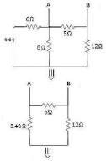⇒ (RS +RL)X = 2 RL (RS/+RL)
⇒RS + RL = 2RL

⇒
RS = RL

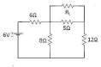
Maximum power will be = (VS/2RL)2 × RL = VS2/4RL Example
Find the value of RL for the given network below that the power is maximum? And also find the Max Power through load-resistance RL by using maximum power transfer theorem?

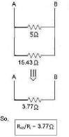
Solution
For the above network,
we are going to find-out the value of unknown resistance called “RL”. In previous post, I already show that when power is maximum through load- resistance is equals to the equivalent resistance between two ends of load- resistance after removing.
So, for finding load- resistance RL. We have to find-out the equivalent resistance like that for this circuit.

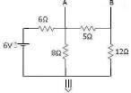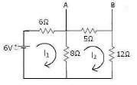Now, For finding Maximum Power through load-resistance we have to find-out the value of Vo.c. Here, Vo.c is known as voltage between open circuits. So, steps are
For this circuit using Mesh-analysis. We get
Applying Kvl in loop 1st:- 6-6I1-8I1+8I2=0
-14I1+8I2=-6 ∙∙∙∙∙∙∙∙∙∙∙∙∙∙∙∙∙∙∙∙∙∙∙∙∙∙∙∙∙∙∙∙ (1) Again, Applying Kvl in loop 2nd:-
-8I2-5I2-12I2+8I1=0
8I1-25I2=0 ∙∙∙∙∙∙∙∙∙∙∙∙∙∙∙∙∙∙∙∙∙∙∙∙∙∙∙∙∙∙∙∙ (2)
On solving,eqn (1) & eqn (2), We get I1 = 0.524 A
I2 = 0.167 A
Now, From the circuit Vo.c is VA-5I2- VB = 0
Vo.c/ VAB= 5I2 = 5X0.167 = 0.835v
So, the maximum power through the RL is given by:-
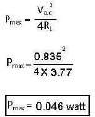

Milliman’s Theorem
This theorem states that Any number of current sources in parallel may be replaced by a single current source whose current is the algebraic sum of individual source currents and source resistance is the parallel combination of individual source resistance.
The alternative statement of Milliman’s theorem is Any number of voltage source V1, V2, V3, ----------Vn having source resistance R1, R2, R3 Rn
respectively connected in parallel may be replaced y a single voltage source Vn and resistance Rn where
V_{n} = ¹ where G₁ = ¹ , G₂ = ¹ etc.
𝐺1+𝐺2±−−−±𝐺𝑛 𝑅1 𝑅2
The above two statements are identical because a voltage source can be connected in to current source and vice-versa.
Reciprocity Theorem
The Reciprocity theorem states that if the source voltage and zero resistance ammeters are integrated, the magnitude of the current through the ammeter will be the same. In lead the principle states that in a linear positive network, supply voltage V and current I are mutually transferable. The ratio of V and I is called the transfer resistance.
Problem 1
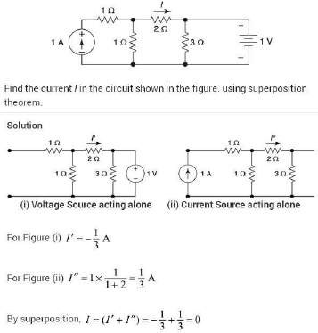

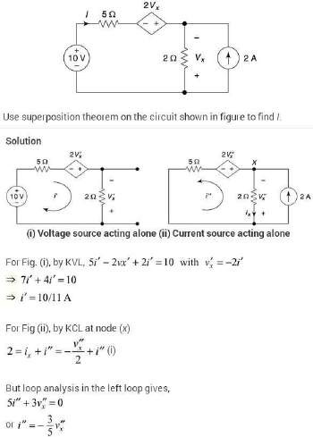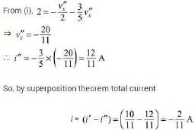Problem 2

Problem 3
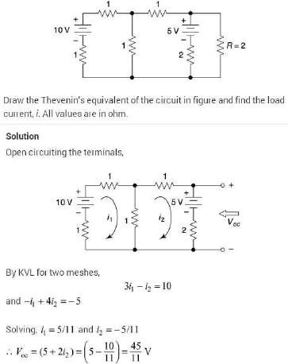
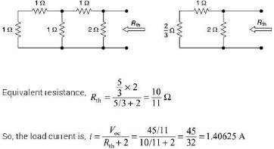

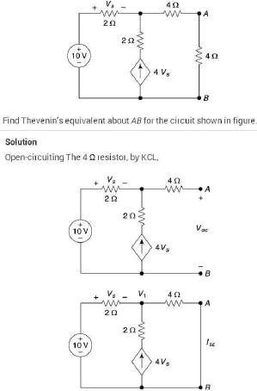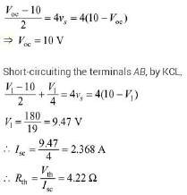Problem 4

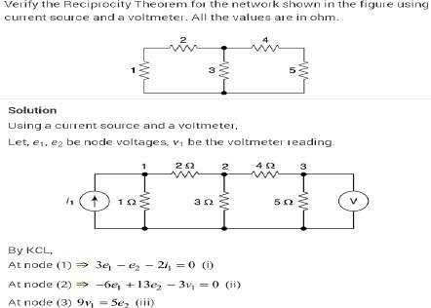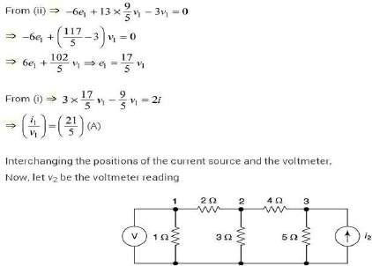Problem 5

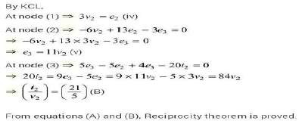
Problem 6
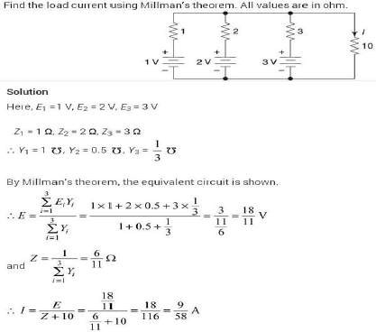

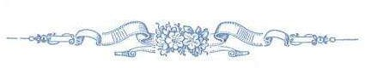

CHAPTER-3

POWER RELATION IN AC CIRCUITS
&

TRANSIENT RESPONSE OF PASSIVE CIRCUITS

TWHAT IS ALTERNATING CURRENT (A.C.)

Alternating current is the current which constantly changes in amplitude, and reverses direction at regular intervals. We know that direct current flows only in one direction, and that the amplitude of current is determined by the number of electrons flowing past a point in a circuit in one second. If, for example, a coulomb of electrons moves past a point in a wire in one second and all of the electrons are moving in the same direction, the amplitude of direct current in the wire is one ampere. Similarly, if half a coulomb of electrons moves in one direction past a point in the wire in half a second, then reverses direction and moves past the same point in the opposite direction during the next half-second, a total of one coulomb of electrons passes the point in one second. The amplitude of the alternating current is one ampere.
PROPERTIES OF ALTERNATING CURRENT
An A.C. source of electrical power changes constantly in amplitude and the ⁺ changes are so regular Alternating voltage and 0 current have a number of properties associated – with any such waveform. These basic properties include the following list:

Time
Frequency
One of the most important properties of any regular waveform identifies the number of complete cycles it goes through in a fixed period of time. For standard measurements, the period of time is one second, so the frequency of the wave is commonly measured in cycles per second (cycles/sec) and, in normal usage, is expressed in units of Hertz (Hz). It is represented in mathematical equations by the letter ‘f ’.
Period
Sometimes we need to know the amount of time required to complete one cycle of the waveform, rather than the number of cycles per second of time. This is logically the reciprocal of frequency
Wavelength
Because an A.C. wave moves physically as well as changing in time, sometimes we need to know how far it moves in one cycle of the wave, rather than how long that cycle takes to complete. This of course depends on how fast the wave is moving as well. The Greek letter (lambda) is used to represent wavelength in mathematical expressions. And, λ= c/f. As shown in the figure to the above, wavelength can be measured from any part of one cycle to the equivalent point in the next cycle. Wavelength is very similar to period as discussed above, except that wavelength is measured in distance per cycle while period is measured in time per cycle.

Amplitude
Mathematically, the amplitude of a sine wave is the value of that sine wave
at its peak. This is the maximum value, positive or negative, that it can attain. However, when we speak of an A.C. power system, it is more useful to refer to the effective voltage or current.

THE SINE WAVE
In discussing alternating current and voltage, you will often find it necessary to express the current and voltage in terms of maximum or peak values, peak- to-peak values, effective values, average values,
or instantaneous values. Each of these values
has a different meaning and is used to describe ^{V}m
a different amount of current or voltage. ^{I}m
Peak Value[Ip]
Refer to figure, it is the maximum value of voltage [Vp] or Current [Ip]. The peak

value applies to both positive and negative values of the cycle.
Peak-Peak value [Ip-p]
Fig. 1.6

During each complete cycle of ac there are always two maximum or peak values, one for the positive half-cycle and the other for the negative half-cycle. The difference between the peak positive value and the peak negative value is called the peak-to-peak value of the sine wave. This value is twice the
Voltage and
current in phase
Time
V
I
Peak to peak value
Peak value
maximum or peak value of the sine wave and is sometimes used for measurement of ac voltages.
Note the difference between peak and peak to-peak values in the figure. Usually alternating voltage and current are expressed in effective values rather than in peak-to-peak values.

INSTANTANEOUS VALUE
The instantaneous value of an alternating voltage or current is the value of voltage or current at one particular instant. The value may be zero if the particular instant is the time in the cycle at which the polarity of the voltage is changing. It may also be the same as the peak value, if the selected instant is the time in the cycle at which the voltage or current stops increasing and starts decreasing.
There are actually an infinite number of instantaneous values between zero and the peak value.

AVERAGE VALUE
The average value of an alternating current or voltage is the average of all the instantaneous values during one alternation. Since the voltage increases from zero to peak value and decreases back to zero during one alternation, the average value must be some value between those two limits.

The average value of A.C. is the average over one complete cycle and is clearly zero, because there are alternately equal positive and negative half cycles.

Average voltage = 2 × peakvalue
π

ROOT MEAN SQUARE VALUE
Circuit currents and voltage in A.C. circuits are generally stated as root- mean-square or rms values rather than by quoting the maximum values. The root- mean-square for a current is defined as the value of steady state current which when flowing through a resistor for a given time produces the same amount of hit as generated by the alternating current when passed through the same resistor for the same time.

Irms = Irms =
2
T ∫ i²dt
1 T
0
Im

Vrms = 1.11
Form Factor =
V
ave
It is the ratio of RMS value to average vale of voltage or current.

SINE WAVES IN PHASE
When a sine wave of voltage is applied to a pure resistance, the resulting current is also a sine wave. This follows Ohm’s law which states that current is directly proportional to the applied voltage. To be in phase, the two sine waves must go through their maximum and minimum points at the same time and in the same direction as shown in the figure.

Voltage wave Current wave
270_ 360_

0_ 90_ 180_ Time axis
E1 E2

90_

0_ 90_^{180_} 270_ Time

360_ Time

Sine Waves Out of Phase
Figure shows voltage wave E1 which is considered to start at 0° (time one). As voltage wave E1 reaches its positive peak, voltage wave E2 starts its rise (time two). Since these voltage waves do not go through their maximum and minimum points at the same instant of time, a phase difference exists between the two waves. The two waves are said to be out of phase. For the two waves in figure, the phase difference is 90°.
PHASORS
In an a.c. circuit, the e.m.f. or current vary sinusoidally wih time and may be mathematically represented as
E = E0 sin ωt
and I = I0 sin (ωt ± θ)
Where θ is the phase angle between alternating e.m.f. and current.
Displacement of S.H.M. also varies sinusoidally with time i.e.
Y = A sin ωt
And its instantaneous value is equal to the projection of the amplitude A on Y-axis. Therefore,instantaneous values of alternating e.m.f. (E) and current (I) may be considered as the projections of e.m.f. amplitude (E0) and current amplitude (I0) respectively. The quantities, such as alternating e.m.f. and alternating current are called phasor. Thus a phasor is a quantity which varies sinusoidally with time and represented as the projection of rotating vector.

PHASOR DIAGRAM
The generator at the power station which produces our A.C. mains rotates through 360 degrees to produce one cycle of the sine wave form which makes up the supply.
In the next diagram there are two sine waves.
They are out of phase because they do not start from zero at the same time. To be in phase they must start at the same time.
The waveform A starts before B and is LEADING by 90 degrees.

+ +
0_
90_ 180_ 270_ 360_
AB

– –

Waveform B is LAGGING A by 90 degrees.

The next left hand diagram, known as a PHASOR DIAGRAM, shows this in another way.

It is sometimes helpful to treat the phase as if it defines a vector in a plane. The usual reference for zero phase is taken to be the positive x-axis and is associated with the resistor since the voltage and current associated with the resistor are in phase. The length of the phasor is proportional to the magnitude of the quantity represented, and its angle represents its phase relative to that of the current through the resistor. The phasor diagram for the RLC series circuit shows the main features.

V_{C}
V_{C}

VR
VL
I
VL
VR
XC

V
VL
φ
XL
Z
φ
VR R

Note that the phase angle, the difference in phase between the voltage and the current in an A.C. circuit, is the phase angle associated with the impedance Z of the circuit.

AC SERIES CIRCUIT
RESISTANCE AC CIRCUIT

written as
A resistance R connected to an ac source is shown. Its voltage can be

e_{t} = E_{tm} sin wt i = I_{m} sin wt

i = Etm sin wt = I R m
sin wt

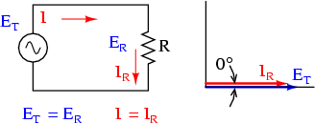

The above two equations depict that voltage and current in resistive network are in phase. Figure shows the voltage and current waveform and phasor diagram.

POWER IN RESISTIVE NETWORK
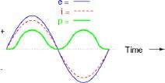
The instantaneous power curve is plotted in figure it is seen that the power curve is always positive in case of resistive network and equal to

p = e × i = E I sin2 wt = E I ⎛ 1− cos 2wt ⎞⎟ = Etm Im − Etm Im ×cos 2wt
t tm m tm m ⎜ 2 2 2
⎝ ⎠
The above power equation shows that the power has two components, one is constant i.e. Etm Im & an ac component Etm Im cos 2wt . The average value of ac component
2 2

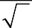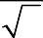in one cycle is zero. Therefore Average power p = Etm Im = Etm × Im
2
2
2
= E_{t} I

Inductance AC Circuit
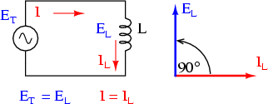
Figure shows an inductance L connected to an ac supply which voltage
is given by πv = E_{T} _{m} sin wt , i =
I sin ⎛ wt − ⎞
m ⎜ 2 ⎟
⎝ ⎠
The above equation shows
that current lags the applied voltage by 90∘ Where I = ET m , the quantity wL controls the

^{m} wL
current inductor and this quantity wL is known as inductive reactance denoted XL
.Hence XL = wL
POWER IN INDUCTIVE NETWORK
The instantaneous power in a purely inductive network is
p = e × i = E sin wt × I sin ⎛ wt − π ⎞
T T m m ⎜ 2 ⎟
⎝ ⎠
= −E_{T} _{m} I_{m} sin wt.cos wt
= −E_{T} _{m} I_{m} sin 2wt
2
The average power in a pure inductor during a cycle is zero.

CAPACITANCE IN AC CIRCUIT
Figure shows a capacitor C connected to an ac source equation of voltage & current are given below
v =V sin wt , I sin ⎛ wt + π ⎞
m m ⎜ 2 ⎟
⎝ ⎠

Equation shows that current leads voltage by 90∘ and capacitive reactance denoted as XC . Its unit is ohm.

I = Vm
m 1
wC
Where 1 is known as
wC

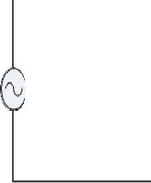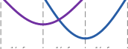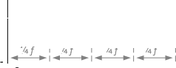

POWER IN CAPACITIVE NETWORK
The instantaneous power in a p⎛urelyπca⎞pacitive network is
p = v × i = V sin wt × I sin wt +
m m ⎜ 2 ⎟
⎝ ⎠
= V_{m} I_{m} sin 2wt
2
The average power in a pure capacitive network is zero.

SERIES RL NETWORK
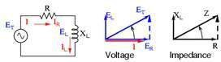
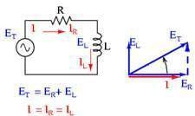
Figure shows a resistor (R) and inductor (L) series network with its phasor

diagram and impedance diagram. As discussed earlier ER is in phase with I and EL

I by 90∘ .
leads

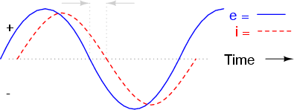

ET = EL + ER = I (R + jXL )
Hence ⇒ IZ = I ( R + jXL )
⇒ Z = ( R + jX L ) = R + jwL

Where magnitude of Z =
R² + X ²
L
The quantities R, XL , Z are shown in the impedence diagram.
POWER IN SERIES RL NETWORK
The average power in RL series circuit is

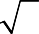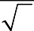p = ET m Im cosθ = ET m . Im
2
2
2
cosθ = ET
I cosθ

E I cosθ is known as active power. p = E I cosθ = E I R = ET .IR = I ² R∵ I = ET
T T T Z Z Z

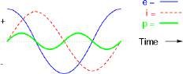

Thus the active power in ac circuit represents the power dissipated across resistance. It is measured in watt. The product of RMS voltage & current i.e. VI is known as apparent power and measured in volt ampere. The ration of active power to apparent power equals to cosθ where θ is the phase angle between V & I. The term cosθ is called

power factor of the circuit. The power factor is zero in case of pure inductive or capacitive network. The power factor of a circuit may be either leading or lagging. A leading power factor means that the current in the circuit leads the voltage and lagging power factor means the current lags the voltage. The power factor of a circuit is the ratio of resistance to impedence .
The instantaneous power across inductor of capacitor is known as reactive power. That is Q = I ² X = I ²wL = I ²Z sinθ = E I sinθ
L T
The reactive power does not contribute anything to the net energy transfer from source to load. Yet it constitutes a loading of the equipment.
The apparent power VI, active power VI cosθ and reactive power VI sinθ is also applicable in this case too. Current in RC circuit leads the apply voltage and therefore the power factor is leading.
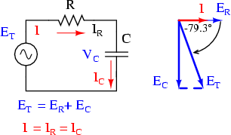SERIES RC NETWORK
C
Figure shows a
series RC network
E = RI − j I = ⎛ J ⎞
T wC I ⎜ R − wC ⎟
⎝ ⎠
⇒ ⎛⎜ J ⎞ j
IZ = I R − wC ⎟ ⇒ Z = R − wC = R − jX
⎝ ⎠
1
XC = Capacitive Re ac tan ce = wC
R² +
1
w2C 2
magnitudeofZ =

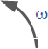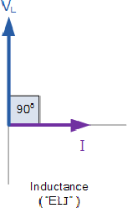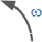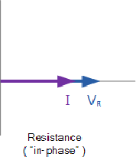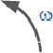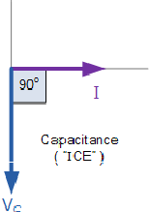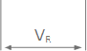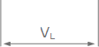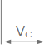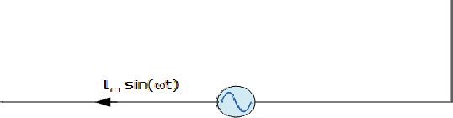SERIES R-L-C CIRCUIT

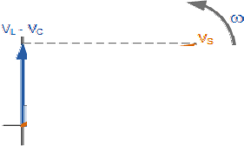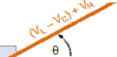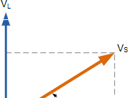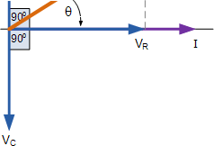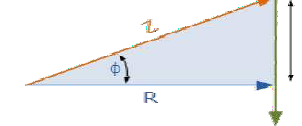Consider a series R-L-C circuit as shown in the figure. The voltage VR is in
phase with the current, the voltage V Lleads the current by 90∘ and the voltage V Clags the current by 90∘ . The total impedence

We can find
Z = Z_{R} + Z_{L} + Z_{C}
= R + j ( XL − XC )
that the reactance is positive if XL ≻ XC and negative if

XC ≻ XL . If XL ≻ XC the circuit behaves like an R-L series circuit and current lags voltage by an angle θ if XC ≻ XL the circuit behaves as an R-C series circuit and current leads the applied voltage by angleθ . The phasor diagram for both cases are shown.
The magnitude of the impedence is given by

Z =
wL − 1
i = vs
z
R² + ( X
L C
− X
)2

θ = tan⁻¹ wC
R

Transient Response of Simple Circuit (DC)
Circuits that contain capacitors and inductors can be represented by differential equation. If a circuit contains one resistor and one Inductor (or one capacitor), it can be represented by first order differential equation. On the other hand if a circuit contains a resistor, inductor and Capacitor it can be represented by a second order differential equation. The solution of the differential equation represents the response of the circuit. The response consists of two parts (1) Transient response (2) Steady State response. The transient response depends on the circuit elements and initial energy stored in it. To obtain the transient response of the network it is necessary to find the initial state of the network.

Initial Condition
Initial condition of a circuit is important to be calculated when a change of state occurs and the change of state of the network occurs when the switch change its position at time t=0. The value of voltage, current derivatives of both at t=0- and t=0+, that is immediately before and after change of switch position. Initial conditions in a circuit depends on the past history of the network prior to t= 0-. We will assume that the switch in the network has been in a position for a long time and at t=0, the switch changes its position. That is we say the circuit is in steady state at the time of switching.

Initial condition in circuit elements.
- Resistor:- By Ohm’s Law we have V= IR , if there is a change in voltage, the current through resistance will change simultaneously. Similarly if the current change, voltage across resistance changes simultaneously.
- Inductor:- Current through inductor cannot change instantaneously, if the current through an inductor before switching is zero, then the current through inductor after switching is also zero.
i.e. iL(0+) = iL(0-)=0
In the same way if the current through inductor before switching is I0, then the current through inductor after switching is also I0. i.e. iL(0+)=iL(0-)= I0.
- Capacitor:- Voltage across capacitor cannot change instantaneously. If the voltage across capacitor before switching is zero, then the voltage across capacitor after switching is also zero.
VC(0+) = VC(0-)= 0
If the voltage across capacitor prior to switching is V0 then the voltage across capacitor immediately after switching is
VC(0+) = VC(0-)=V0

The equivalent from of the elements in terms of the initial condition of the elements is shown below.

ELEMENT | EQUIVALENT FORM AT  t=0 | t=0+/EQUATION CIRCUIT AT  t= ∞
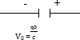 |  | 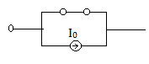  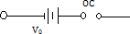
To solve the initial condition of an element it is necessary to study the steady state behavior of this element. The steady state behavior can be obtained from the basic relations.
VL = L 𝑑i ic= C 𝑑𝑣𝑐
𝑑𝑡 𝑑𝑡
At t=∞, VL = 0 hence the inductor acts as short-circuit Similarly at t= ∞, iL=0 hence the capacitor acts as open-circuit.

Example: In the network shown in fig.1, the switch K is called at t=0 with the capacitor
𝑑i

uncharged. Find the value of i,
, at t= 0+.
𝑑𝑡

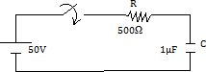

Solution:

⇒ 500i +

Apply KVL to the circuit
R_{i}∫+ 1 i 𝑑𝑡 = V eq. (i)
𝐶

∫ i 𝑑𝑡 = 50 eq. (ii)

VC (0+) = VC(0-)= 0
At t= 0+ 500i (0+)+ 0= 50
i(0+) = 50 = 0.1A
500

Differentiating eq. (ii)
𝑑i
500 + i = 0 eq. (iii)
𝑑𝑡
𝑑i
At t= 0+ 500 (0+) = -i (0+)- = - ×0.1

𝑑i
𝑑𝑡

⇒ (0+) = - = -2000Amp/sec.
𝑑𝑡

Differentiating eq. (iii)

500 𝑑i = 0
𝑑𝑡

⇒ 500 (0+) =
𝑑i
(0+) = (-2000)
𝑑𝑡

⇒ (0+) = 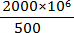 = 4×106 A/sec2
Transient Response of series R-L circuit having DC Excitation.
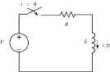
Consider a R-L series circuit as shown in figure. The switch is closed at time t=0 Applying KVL
Ldi(t) + Ri(t) = V
𝑑𝑡
⇒ di(t) + 𝑅i(t) = 𝑉
𝑑𝑡 𝐿 𝐿
General solution of the differential equation
𝑉 − Rt

i(t) =
𝑅
+ ke L

Since inductor behaves as an open circuit as switching i(0+)=0
0= 𝑉 +K or K= - 𝑉
𝑅 𝑅
Therefore i(t) = 𝑉 - 𝑉 e-R/L(t) = 𝑉 [1-e(-R/L)t]
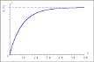
𝑅 𝑅 𝑅
Voltage across inductor VL(t)=L di(f) = Ve(-R/L)t
𝑑𝑡
Voltage across resistor VR(t)= V[1-e(-R/L)t] At t=0, i(t)=0, VL(t) = V VR(t)=0
At t=∞, i(t)=𝑉, VL(t)=0, VR(t)= V

At t= ^{𝐿}
𝑅𝑉 -1 𝑉

i(t)= (1-e ) = 0.632 , VL(t) = 0.368V

𝑅 𝑅 𝑅
i(t) & V(t) are plotted in figure.

τ = L
R
is known as the time content and is defined as the interval after

which current or voltage charges 63.2% of its total change.

Let us analyses the transient condition of the R-L circuit as the circuit reaches steady state charging switch to S1
di¹ (t )
L + Ri¹ (t ) = 0
dt

Solution of i1(t) = K1e(-R/L)t
Steady state current i(0+) = i(∞) = 𝑉
𝑅

𝑉 = K1e0
𝑅
⇒ K1 =
𝑅

di¹ (t )

Therefore i1(t) =
𝑉
e(-R/L)t , V1R(t) = Ve(-R/L)t, VL1(t) = L
𝑅
= -Ve(-R/L)t
dt

i1(t) and V1R(t), V1L(t) are plotted below.

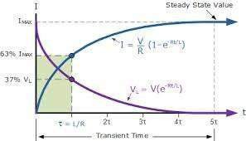

Transient response of series R-C circuit having DC excitation.

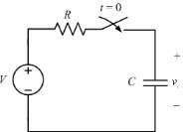
Consider a series R-C circuit as shown in figure. The switch S is closed at time t=0. Applying KVL
Ri(t) + 1 ∫ i (𝑡) dt = V
𝐶
Differentiating, we get
R di(f) + 1 i(t) = 0
𝑑𝑡 𝐶
General solution of this differential equation is
i(t) = K e – t/RC

at t= 0+ , i(0+) = 𝑉
𝑅
∵ capacitor acts as a short-circuit at switching.

𝑉 = Ke0 ⇒K= 𝑉
𝑅 𝑅
Therefore i(t) = 𝑉 e –t/RC
𝑅

Voltage across the resistor and capacitor are
i(t) = -
e-t/RC
VR(t)= i(t).R = Ve-t/RC
VC(t) = = -t/RC dt
= (-RC) e-t/RC = V(1-e-t/RC)
At t=0, i(t) = VC (t) = 0 , VR (t)=V
At t= ∞, i(t) = 0 , Vc(t)=V, VR(t) = 0 At t= RC i(t) = e-1 = 0.368 ,
Vi(t)= V(1-e-1) = 0.632V
Let us analyze another transient condition of R-C circuit as the circuit reaches
at steady state (at t=∞) by closing switch at point 2
Ril(t) + 1(t) =0 Differentiating we get
R + i¹ (t ) = 0
Its solution is i1(t) = Ke-t/RC
However at t=0+, capacitor keeps the steady state voltage VC(0+) = V and direction of i1(t) during discharge is negative
i(0+) = - -
- -= Ke0 ⇒K= - -

V1R(t) = i1(t). R= -V e-t/RC

VC1 (t) = 1(t) dt = V e-t/RC

Resonance circuit:-
CHAPTER-4
RESONANCE AND COUPLED CIRCUITS

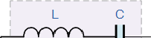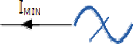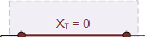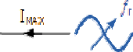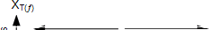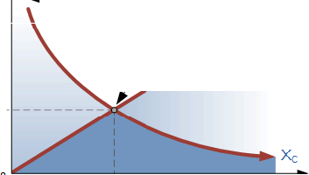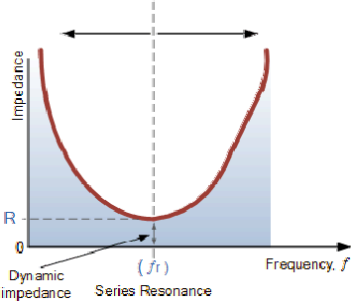An electric circuit which has very low impedance at a certain frequency. Resonant circuits are often built using an inductor, such as a coil, connected in parallel to a capacitor. The response of the circuit to signals of different frequencies is a function of the inductance and capacitance of the circuit and peaks at one frequency value, at which the current flow resonates most strongly with the input signal. Resonant circuits are used in radio and television tuners to pick out broadcast signals of specific frequencies

Tuned circuit:-Any electrically conducting pathway containing both inductive and capacitive elements. If these elements are connected in series, the circuit presents low impedance
to alternating current of the resonant frequency, which is determined by the values of
the inductance and capacitance, and high impedance to current of other frequencies.In a parallel- connected tuned circuit, the impedance is high at the resonant frequency, low at others.

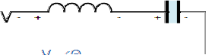RESONANCE
Consider a series R-L-C circuit as shown in the figure. The impedence of the circuit is given by
Z = R + j ( XL − XC )
where X is inductive reactance = wL and X = capacitive reactance = 1 .


L C wC

As frequency of the supply is increased XL increases and XC decreases. At one particular frequency XL = XC and the total reactance of the circuit become zero. At this particular frequency the impedence is resitive and voltage & current are in phase. This phenomenon is known as resonance.
XL = XC
⇒ 2π f0L = 1 2π f₀C

⇒ f₀ =
1
2π LC

f0 is called as frequency of resonance. Impedence Z of the R-L-C series circuit is equal to R at resonance and current is equal to V .
R

Q Factor
The ratio of capacitor voltage or inductor voltage at resonant frequency to
supply voltage is a measure of quality of a resonance circuit. This term is known as quality factor (Q factor).
At the frequency of the resonance ( f0 )
V = IX = V X ∵ I = V

L L R L R
Q = VL = X_{L} = 2π f₀ L
V R R
= VC = XC = 1

V R
Bandwidth
2π f₀ RC

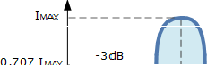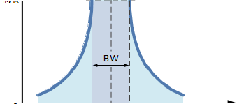At resonant frequency current in the R-L-C series circuit is maximum. Let us define two frequencies w₁ & w₂ at which current is 707I_{max} .

The frequency frequency.
w₁ & w₂ are called half power

Bandwidth = w2 − w1

Where w2 = upper half power frequency, w1 = lower half power frequency.

Bandwidth of a Series RLC Resonance Circuit

Then the relationship between resonance, bandwidth, selectivity and quality factor for a series resonance circuit being defined as:
- Resonant Frequency, (ƒr)

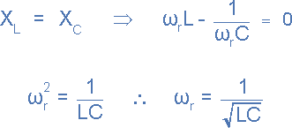
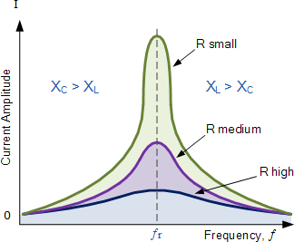
- Current, (I)
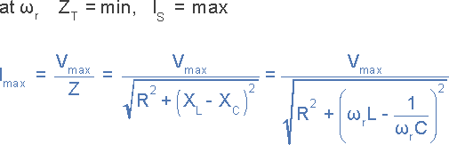

- Lower cut-off frequency, (ƒL)
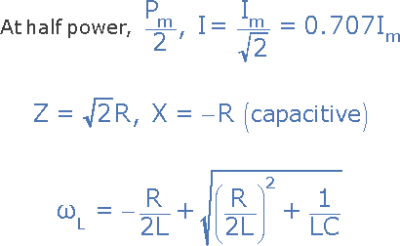
Upper cut-off frequency, (ƒH)

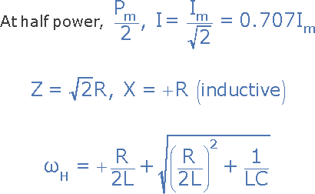

- Bandwidth, (BW)
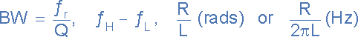
- Quality Factor, (Q)
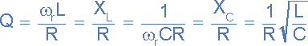

Relationship between Q and Bandwidth of R-L-C series circuit
Bandwidth = w2 − w1
At w = w₁ , the reactance is capacity as X_{C} ≻ X_{L}

Hence 1
w1C

− w1L = R eq.1

At w = w2 the reactance is inductive as X_{L} ≻ X_{C}

Hence w L − 1
2

= R eq. 2

w2C
From equation1 we get w ² LC + w RC −1 = 0
1 1

Dividing by LC we get w ² + w R − 1 = 0
¹ ¹ L LC
w = −R ±
4L2 LC
R2 +
1
1 2L
Similarly from equation 2
w ² − R w − 1 = 0
² L ² LC R
w₂ = 2L ±
4L² LC
R2 +
1
Hence bandwidth
w − w = R + R = R
² ¹ 2L 2L L
⇒ 2π ( f − f ) = R

2 1 L
⇒ f − f = R = f0
2 1 2π L Q
⇒ Q = f0 = w0
f₂ − f₁ BW

The Parallel Resonance Circuit
In many ways a parallel resonance circuit is exactly the same as the series resonance circuit we looked at in the previous tutorial. Both are 3-element networks that contain two reactive components making them a second-order circuit, both are influenced by variations in the supply frequency and both have a frequency point where their two reactive components cancel each other out influencing the characteristics of the circuit. Both circuits have a resonant frequency point.
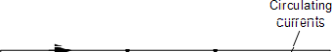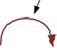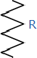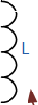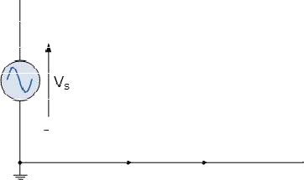The difference this time however, is that a parallel resonance circuit is influenced by the currents flowing through each parallel branch within the parallel LC tank circuit. A tank circuit is a parallel combination of L and C that is used in filter networks to either select or reject AC frequencies. Consider the parallel RLC circuit below.

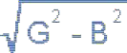
Let us define what we already know about parallel RLC circuits.
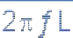

A parallel circuit containing a resistance, R, an inductance, L and a capacitance, C will produce parallel resonance (also called anti-resonance) circuit when the resultant current through the parallel combination is in phase with the supply voltage. At resonance there will be a large circulating current between the inductor and the capacitor due to the energy of the oscillations, then parallel circuits produce current resonance.
A parallel resonant circuit stores the circuit energy in the magnetic field of the inductor and the electric field of the capacitor. This energy is constantly being transferred back and forth between the inductor and the capacitor which results in zero current and energy being drawn from the supply. This is because the corresponding instantaneous values of IL and IC will always be equal and opposite and therefore the current drawn from the supply is the vector addition of these two currents and the current flowing in IR.
In the solution of AC parallel resonance circuits we know that the supply voltage is common for all branches, so this can be taken as our reference vector. Each parallel branch must be treated separately as with series circuits so that the total supply current taken by the parallel circuit is the vector addition of the individual branch currents. Then there are two methods available to us in the analysis of parallel resonance circuits. We can calculate the current in each branch and then add together or calculate the admittance of each branch to find the total current.

We know from the previous series resonance tutorial that resonance takes place when VL = -VC and this situation occurs when the two reactance are equal, XL = XC. The admittance of a parallel circuit is given as:

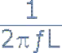

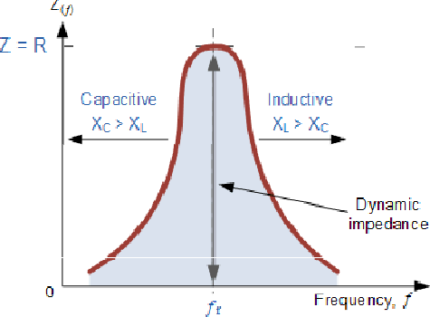Resonance occurs when XL = XC and the imaginary parts of Y become zero.
Then:
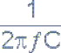
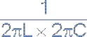
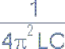
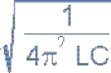
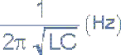
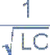

Notice that at resonance the parallel circuit produces the same equation as for the series resonance circuit. Therefore, it makes no difference if the inductor or capacitor is connected in parallel or series. Also at resonance the parallel LC tank circuit acts like an open circuit with the circuit current being determined by the resistor, R only. So the total impedance of a parallel resonance circuit at resonance becomes just the value of the resistance in the circuit and Z = R as shown.
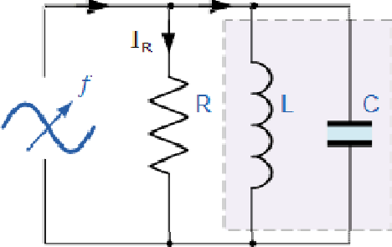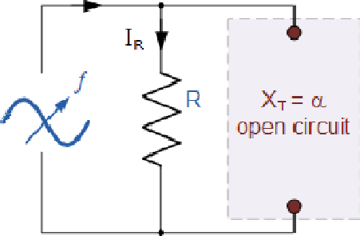

Impedance in a Parallel Resonance Circuit

Note that if the parallel circuit’s
impedance is at its maximum at resonance then
consequently, the circuit’s admittance must be at its
minimum and one of the characteristics of a parallel
resonance circuit is that admittance is very low limiting |  | the
circuits current. Unlike the series resonance circuit, the
resistor in a parallel resonance circuit has a damping
effect on the circuit’s bandwidth making the circuit
less selective.

Also, since the circuit current is constant for any valu of impedance, Z, the voltage across a parall l resonance circuit will have the same shape as the total impedance and for a parallel circuit the voltage waveform is generally taken from across the capacitor.
e
e
We now know that at the resonant frequency, ƒr the admittance of the circuit is at its minimum a d is equal to the conductance, G given by 1/R because in a parallel resonance circuit the imaginary part of admittance, i.e. the susceptance, B is zero because BL = BC as sho n.
n
w

t

Bandwidth & Selectivi y of a Parallel Resonance Circuit
The bandwidth of a parallel resonance circuit is defi ed in exactly the same way as for the series resonance circuit. The upper and lower cut-off frequencies given as: ƒupper and ƒlower respectively denote the half-power frequencies where the power dissipated in the circuit is half of the full power dissipate at the resonant frequency 0.5( I2 R ) which gives us the same -3dB points at a current value that is equal to 70.7% of its maximum re onant value, ( 0.707 x I )2 R.
n
s
d
As with the s ries circuit, if the resonant frequency re ains constant, an
o
e m
increase in the quality fact r,Q will cause a decrease in the bandwidth and likewise, a

decrease in the quality factor will cause an increase in the bandwidth
= ƒr /Q or BW = ƒ2 - ƒ2.
Also changing the ratio between the inductor, L and t
s defined by: BW

e capacitor, C, or
a
h

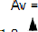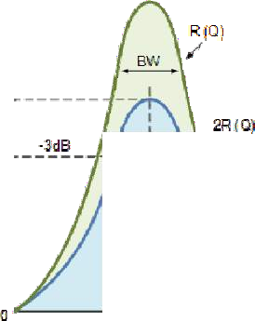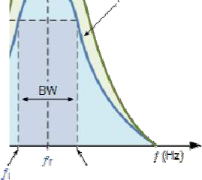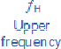the value of the resistance, the bandwidth and therefore the frequency response of the circuit will be changed for a fixed resonant frequency. This technique is used extensively in tuning circuits for radio and television transmitters and receivers.
R
The selectivity or Q-factor for a parallel resonance circuit is generally defined as the ratio of the circulating branch currents to the supply current and is given as:

Note that the Q-factor of a parallel resonance circuit is the inverse of the expression for the Q-factor of the series circuit. Also in series resonance circuits the Q-factor gives the voltage magnifica ion of the circuit, whereas in a parallel circuit it gives the c rrent magnification
u
t

Example No1
A parallel resonance network consisting of a resistor of 60Ω, a capacitor of 120uF and an inductor of 200mH is connected across a sinusoidal supply voltage which has a constant output of 100 volts at all frequencies.
Calculate, the resonant frequency, the quality factor and the bandwidth of the circuit, the circuit current at resonance and current magnification.
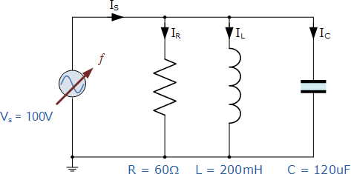
- Resonant Frequency, ƒr
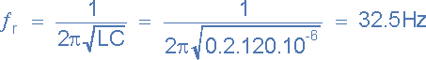
- Inductive Reactance at Resonance, XL
- Quality factor, Q
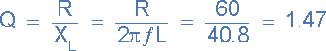
- Bandwidth, BW

- The upper and lower -3dB frequency points, ƒH and ƒL
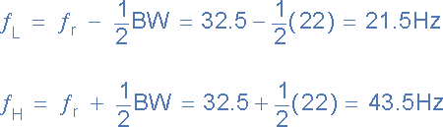
- Circuit Current at Resonance, IT
At resonance the dynamic impedance of the circuit is equal to R
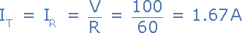
- Current Magnification, Imag
Note that the current drawn from the supply at resonance (the resistive current) is only 1.67 amps, while the current flowing around the LC tank circuit is larger at 2.45 amps. We can check this value by calculating the current flowing through the inductor (or capacitor) at resonance.

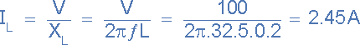

COMPARISON BETWEEN SERIES AND PARALLEL RESONANCE:

Similarities:
  - At Resonance Condition the Power Factor of the RLC Series Circuitis Unity. At Resonance Condition, the power factor of the RLC parallelCircuit Also Unity(1).
  - The equation of Resonant Frequency of RLC series Circuit is,
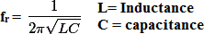

The equation of Resonant Frequency of RLC Parallel Circuit is,

  - The Bandwidth of RLC series circuit at Resonance Condition,
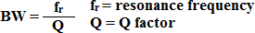

The Bandwidth of RLC parallel circuit at Resonance Condition,

  - The equation of Half Power frequencies for RLC series circuit,

The equation of Half Power frequencies for RLC Parallel Circuit

APPLICATIONS OF SERIES RESONANCE CIRCUIT:

- The main application of Series Resonance circuit is Tuning. They areused for Tuning purpose.
- Series Resonance circuit also used as Oscillator Circuit.
- Series resonance circuit is used as a Voltage Amplifier.
- Series Resonance circuits are used in the communication system forsignal processing.
- Series resonance Circuit also used as High-frequency filter circuit.

APPLICATION OF PARALLEL RESONANCE CIRCUIT:

  - The parallel resonance circuit is also used for Tuning purpose.
  - The parallel resonance circuit is used in Induction heating system.
  - The parallel resonance circuit is used as a Current Amplifier.
  - The parallel resonance circuit is also used as a filter circuit.
  - The parallel resonance circuits are used in RF amplifiers.

Difference Between Series and Parallel Resonance Circuits
Now we are going to learn about basic difference between series and parallel resonance circuits
 | Series Resonance Circuits | Parallel Resonance Circuits
 | 1. Series Resonance circuit is an acceptor circuit. | Parallel Resonance circuit is an rejecter circuit
 | 2. At resonant the impedance is a maximum equal to the resistance in circuit. | At resonance the impedance is maximum nearly equal to infinity.

3. In resonance Current at resonance is maximum = V/R | In Parallel circuit current at resonance is minimum = V/(L/CR)
4. In Series circuit power factor is unity | In parallel power circuit power factor is unity
5. Series circuit magnifies voltage | Parallel resonance circuit magnifies current
6. Series resonance magnification in WL/R | Parallel resonance circuit magnification is WL/R
7. In series resonance effective impedance is R which is R= V/ Resonant current | In parallel resistance effective resistance is L/CR  It is basic difference between series and parallel resonance circuits
8. Series Resonance used in the turning circuit to separate the wanted frequency from the incoming frequency by offering low impedance of that frequency | Parallel Resonance used to present a maximum impedance to wanted frequency usually in the plate circuit of values.

.

CHAPTER 6

LAPLACE TRANSFORM
The Laplace domain or the "Complex s Domain" is the domain into which
the Laplace transform transforms a time-domain equation. s is a complex variable, composed of real and imagi ary parts:
n
The Laplace domain graphs the real part (σ) as the horizontal axis, and the imaginary part (ω) as the vertical axis. The real and imaginary parts of s can be considered as independent quantities. The similarity of this notation with the notation used in Fourier transform t eory is no coincidence; for , the Laplace transform is the same as the Fourier transform if the signal is causal.

The mathematical definition of the Laplace transform is as follows:
h

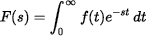

The transfor , by virtue of the definite integral, rem ves all t from the
m o
resulting equation, leaving instead the new variable s, a complex num er that is normally written as 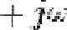. In essence, this transform takes the function f(t), and
b
"transforms it" into a function in terms of s, F(s). As a general rule the transform of a function f(t) is written as F(s). Time-domain functions are written in lower-case, and the resultant s-domain functions are written in upper-case.
We will use the following notation to show the transfor of a function:
m

We use this notation, because we can convert F(s) back into f(t) using the inverse Laplace transform.
The Inverse Transfor
m
Initial Value Theorem

This is useful for finding the initial conditions of a function needed when we perform the transform of a differentiation operation.

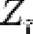Final Value Theorem
Similar to the Initial Value Theorem, the Final Value Theorem states that we can find the value of a function f, as t approaches infinity, in the laplace domain, as such:

This is useful for finding the steady state response of circuit. The final value theorem may only be pplied to stable systems.
a
o
a
Laplace Transformati n of Signal Waveform
Laplace transform of unit step function is 1
S
Laplace transform of ramp function is 1
S 2

Laplace transform of unit impulse function is unity.
The laplace transform can be used independently o different circuit elements, and then the circuit can be solved entirely in the S Domain (Which is much easier). Let's take a look at some of the circuit elements:
n
Resistor
Resistors are time and frequency invariant. Therefore, the transform of a resistor is the same as the resistance of the resistor:

Compare this result to the phasor impedance value for a resistance r:

You can see very quickly that resistance values are very similar between phasors and laplace transforms.
Ohm's Law
If we transform Ohm's law, we get the following equation:

Now, following ohms law, the resistance of the circuit element is a ratio of the voltage to the current. So, we will solve for the quantity 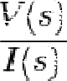, an the result will be the resistance of our circuit element.
d

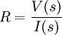
This ratio, the input/output ratio of our resistor is an i portant quantity, and we will find this qua tity for all of our circuit elements. We can say that the transform of a resistor with resistance r is given by:
n
m
Capacitors

Let us look at the relationship between voltage, current, and capacitance, in the time domain:

Solving for voltage, we get the following integral:
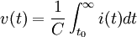
Then, transforming this equation into the laplace domain assuming the zero initial condition, we get the following:

Again, if we solve for the ratio 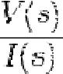, we get the following:

Therefore, the transform for a capacitor with capacitance C is given by:
Inductors
Let us look at our equation for inductance:

Putting this i we get the formula:
n o
to the laplace domain assuming the zer initial condition,


And solving for our ratio 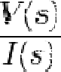, we get the following:

Therefore, the transform of an inductor with inductance L is given by:
Impedance

Impedance of all the load elements can be combined into a single format
e

dependent on s, we call the phasor representation. We
d
).
ffect of all load elements impedance, the same as we call it in enote impedance values with a capital Z (but not a phasor

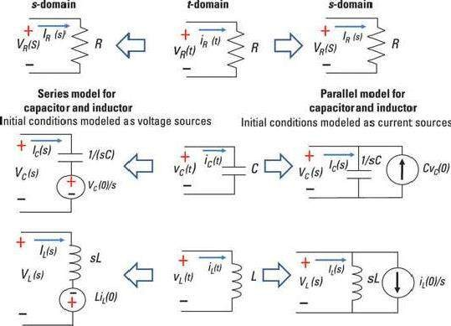

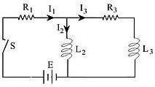
Determining electric current in circuits

In the net character of the currents
ork shown, determine the
, , and assuming
w

that each current is zero when the switch is closed.

Solution:
Current flow at a joint in circuit
Since the algebraic s m of the currents at any junction is zero, then
u
Voltage balance on a circuit
Applying the voltage law to the circuit on the left we get

Applying again the voltage law to the outside circuit, given that E is co stant, we get
o
n
ve equations, we get
Laplace transforms of current and voltage equations Transforming the ab

The above three Laplace transformed equations show the benefits of integral transformation in converting differential equations into linear algebraic equations that could be solved for the dependent variables (the three currents in this case), then inverse transformed to yield the required solution

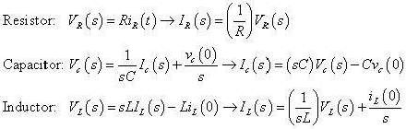

Example: Find the capacitor voltage.
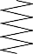+ v_{c} (t) −
3 Ω
+
v _{R} (t )
−
1 H
0.5 F

−
v L (t )
+

u (t )

−
V_{L} ( s )
+ V_{c} (s) −

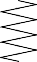1
3
+
V_{R} ( s )
−
I (s)
s
s
2

+ s

+V_{c}(s) − +V_{R} (s) −

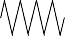− 3
2
s
3
s
I (s)
+
−
V_{L} (s) s
+

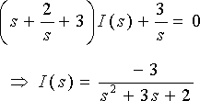

The capacitor’s voltage
V (s) = 2 ⋅ I (s) = −6
c s s(s2 + 3s + 2)

Expanding V (s) by partial fraction
c
V (s) = −6 = K1 + K2 − K3
^{c} s(s +1)(s + 2) s s +1 s + 2
v_{c}(t) = (−3 + 6e^{−t} − 3e^{−2t} ) u(t)

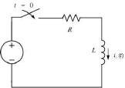
Step response of an R-L circuit
Consider the RL circuit as shown in the figure assuming the initial current to be zero. At t = 0 the switch is closed and the voltage E is impressed on the circuit. The differential equation on application of KVL is

Ri (t ) + L di (t ) = E
⇒ RI (s) + dt sI (s ) − i (0)⎤ = E
L ⎡
⎣ E L ⎦ s
⇒ I (s)[sL + R] = ∵i (0) = 0
s L
E E ⎡ ⎥⎤
⇒ I (s) = s = L = E ⎢1 − 1

sL + R
s ⎛ s +
⎝
⎜
R ⎞
⎟
L
⎠
E ⎡
R ⎢ s
⎣
⎢
− R
⎥
s + ⎥
R
L ⎦

takinginverseLT ⇒ i(t) = ⎢1− e L t ⎤
⎥
R ⎣ ⎦
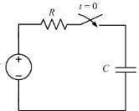
Step response of an R-C circuit
Consider the R-C circuit as shown in the figure assuming the initial current to be zero. At t = 0 the switch is closed and the voltage E is impressed on the circuit. The differential equation on application of KVL is

1 t
Ri (t ) + C ∫ i (t )dt = E
⇒ 0 1 ⎡ I (s )⎤ E

RI (s) +
⎢
C
s ⎥ = s

⇒ I (s)
⎡R +
⎣ ⎦
1 ⎤ = E

⎢⎣ Cs⎥⎦ s E

⇒ I (s) = R
s + 1
RC
takinginverseLTi(t) =

E −t 1
R e RC

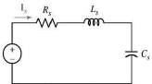
Step response of an R-L-C circuit
Consider the R-L-C series circuit as shown in the figure assuming the initial current to be zero. At t
= 0 the switch is closed and the voltage E is impressed on the circuit. The differential equation on application of KVL is

di (t ) 1 ^{t}
Ri (t ) + L
dt + C ∫ i (t )dt = E

0
⇒ RI (s ) + L ⎡⎣sI (s)⎤⎦+
1 ⎡ I (s) ⎤ = E C ⎢ s ⎥ s
⎣ ⎦

E E

⇒ I (s ) = s sL + R +

E

1 = L
s2 + R s + 1
Cs L LC

⇒ I (s ) = L = K₁ + K₂
(s − s1 )(s − s2 ) (s − s1 ) (s − s2 )
⇒ i(t) = K e^{s}1t + K e^{s}2t
1 2
Where s1 & s2 are the roots of the characteristic equation
s² + R + 1 and K & K are constant.
Ls LC 1 2
Value of s₁ & s₂ can be determined as
R
⎝ ⎠
⎛ R ⎞2 − 1
⎜ 2L ⎟
LC
s1 , s2 = − 2L ±

Problem 1
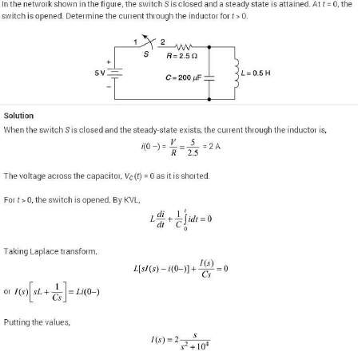
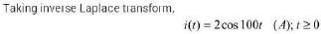

Problem 2
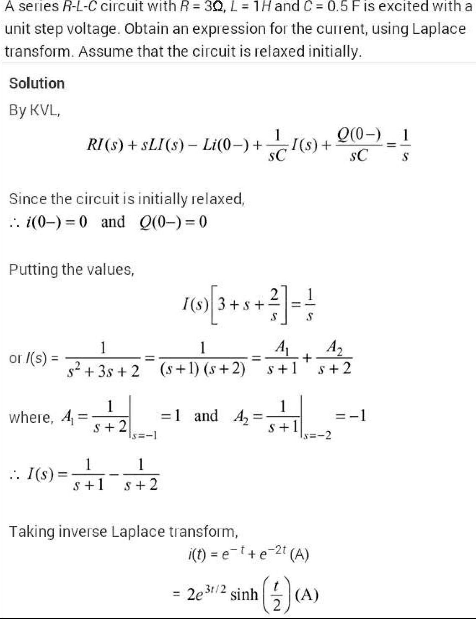

Problem 3
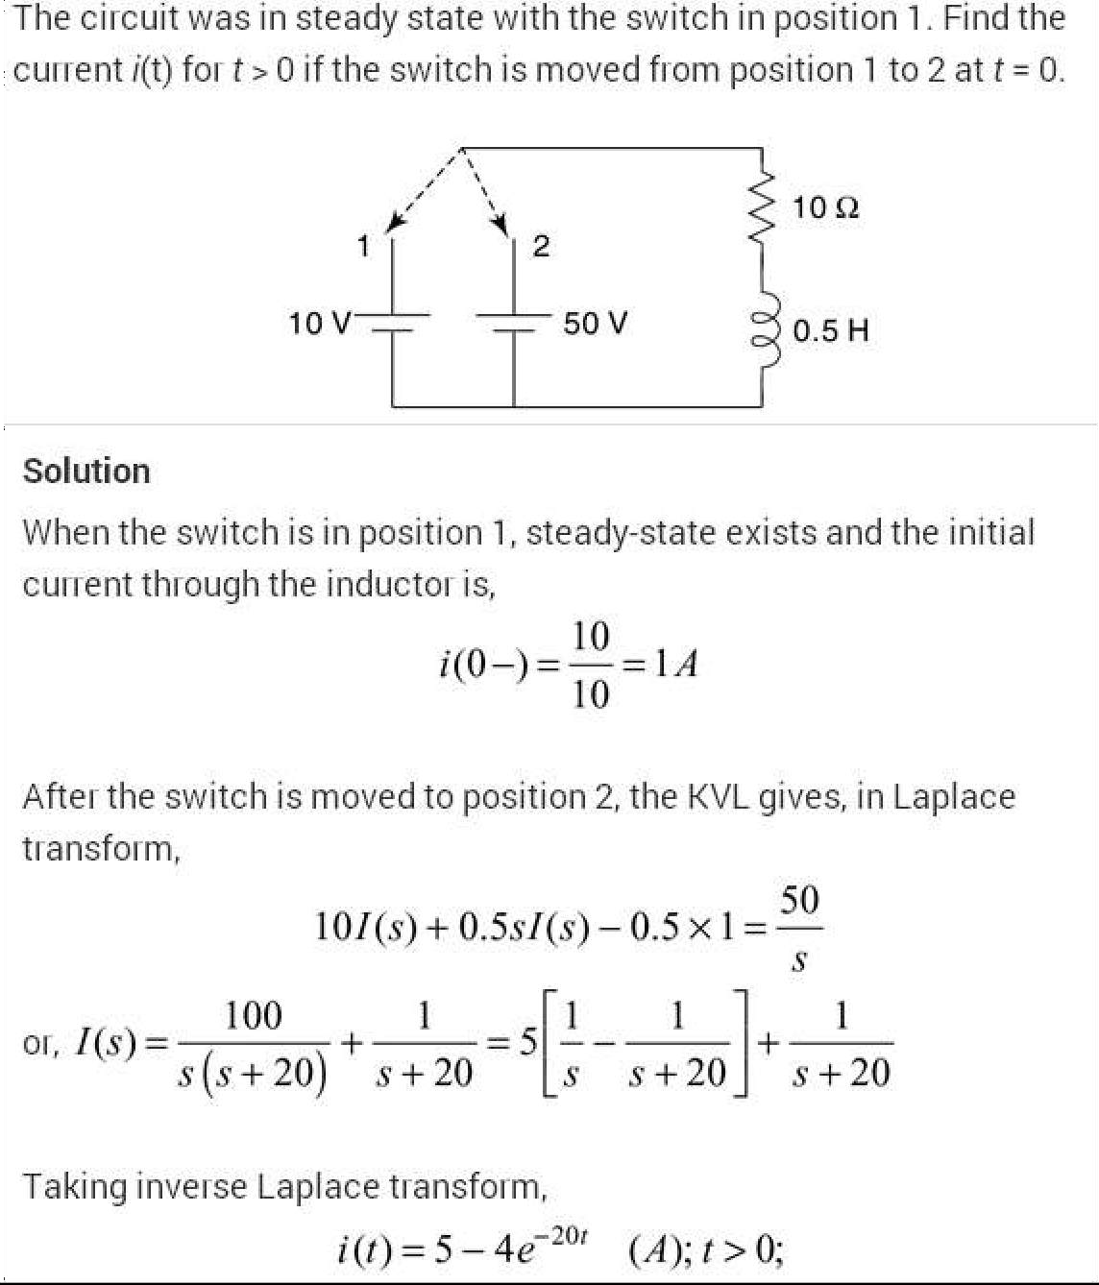

Problem 4
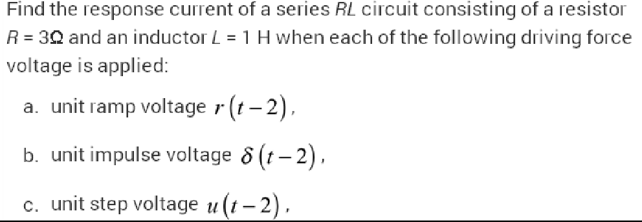

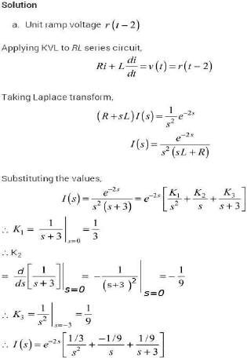

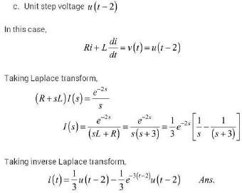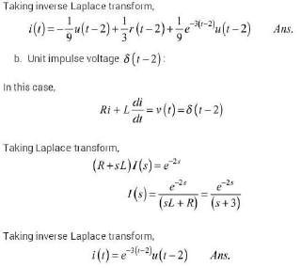

CHAPTER 7

TWO-PORT NETWORKS
 | One-Port Network
+i1  - | One-Port Network

v

- One port network is a two terminal electrical network in which, current enters through one terminal and leaves through another terminal. Resistors, inductors and capacitors are the examples of one port network because each one has two terminals. One port network representation is shown in the following figure.
- A pair of terminals at which a signal (voltage or current) may enter or leave is called a port.
- A network having only one such pair of terminals is called a one-port network.
- No connections may be made to any other nodes internal to the network.
- By KCL, we therefore havei1=i1
Two-Port Network
-
1  i'1 | Two-Port Network  - | i2  +  v  i'2

+

v
-

  - two port network is a pair of two terminal electrical network in which, current enters through one terminal and leaves through another terminal of each port. Two port network representation is shown in the following figure.Type equation here.
  - Two-port networks are used to describe the relationship between a pair of terminals
  - The analysis methods we will discuss require the following conditions be met
    - Linearity
    - No independent sources inside the network
    - No stored energy inside the network (zero initial conditions)
    - i1 = i1 and i2 = i

Two Port Network Parameters
There are various parameters needed to analyze a two port network. For examples, Z parameters, Y parameters, h parameters, g parameters, ABCD parameters etc.
Let us discuss these network parameters one by one to gain a better understanding of their application and uses.

Impedance Parameters
  - Suppose the currents and voltages can be measured.
  - Alternatively, if the circuit in the box is known,V1 and V2 can be calculated based on circuit analysis.
  - Relationship can be written in terms of the impedance parameters.
  - We can also calculate the impedance parameters after making two sets of measurements.
V1=z11I1+z12I2
V2=z21I1+z22I2
If the right port is an open circuit (I2=0), then we can easily solve for two of the impedance parameters: Similarly by open circuiting left hand port (I1=0 ) we can solve for the other two parameters.

2

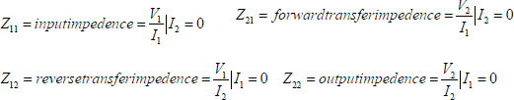

Impedance Parameter Equivalent

I1(s)
I2(s)
+
V1(s)
-
z11
z22
z12I2 z21I1
+
V2(s)
-

V1=z11I1+z12I2 V2=z21I1+z22I2

- Once we know what the impedance parameters are, we can model the behavior of the two-port with an equivalent circuit.
- Notice the similarity to Th´evenin and Norton equivalents

Admittance Parameters

+
Two-Port Network
-
1  - i'  1 | Two-Port Network  - | i2  +  v  i'2

v 2

I1=y11V1+y12V2 I2=y21V1+y22V2
Y11 = input admittance =

I1 V = 0

2
V
1
Y = forward transfer admittance = I2 V = 0
21 2
V
1

Y = output admittance = I1 V = 0
22 1
V
2
V

Y = reverse transfer admittance =
I1 V = 0

12

Hybrid Parameters
1
2

V1=h11I1+h12V2 I2=h21I1+h22V2

h11 = input impedance = V1 V = 0
2
I
1

h = forward current ratio = I2 V = 0
21 2
I
1

h12
= reverse voltage ratio = V1 I = 0
V2
1

h22
= output admittance = I2 I = 0
V2
1

Example:

Given the following circuit. Determine the Z parameters.

I1 8 Ω 10 Ω I2
+
+
V₁

_
20Ω
20 Ω
V₂
_

Z11 = 8 + 20||30 = 20 Ω
Z22 = 20||30 = 12 Ω

Z12
= V1 I = 0
I2
1

V = 20xI2 x20 = 8xI Therefore z = 8xI2 = 8 Ω = z
¹ 20 + 30 ² ¹² I 21
2
The Z parameter equations can be expressed in matrix form as follows.
⎡V1 ⎤ = ⎡ z11 z12 ⎤ ⎡ I1 ⎤
⎢ ⎥ ⎢ ⎥ ⎢ ⎥
V z z I
⎣ 2 ⎦ ⎣ 21 22 ⎦ ⎣ 2 ⎦

⎡V1 ⎤ = ⎢⎡20 8 ⎥⎤ ⎢⎡ I₁ ⎤⎥
⎢V ⎥ 8 12 I

Example:
⎣ 2 ⎦ ⎣ ⎦ ⎣ 2 ⎦

Given the following circuit. Determine the Y parameters.
I1 1 Ω I2
+ V1
_
1
s
s
+
V2
_

1 Ω

I1 = y11V1 + y12V2 I2 = y21V1 + y22V2

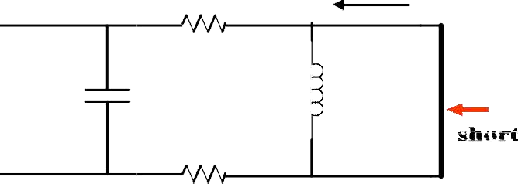I1 1 Ω I2
+ V₁
_
1
s
+
s
V
_
2

1 Ω
To find y11
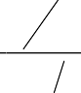
2 s ⎡ 2 ⎤
V1 = I1 ( 2 +1 s ) = I1 ⎢⎣ 2s +1⎥⎦
I I

So y11= 1 y = 1
V 11 V
1 1
= s + 0.5
V2 = 0

To find y and y we reverse things and short V
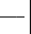12 21 1
I₂
V₁

y21
= V₂ = 0

V1 = − 2I2

y21
= I2 = 0.5 S
V1

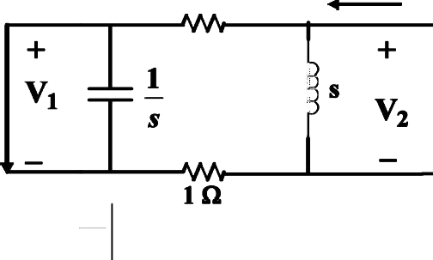V = − 2I y = I1 = 0.5s
y = I1 V = 0
12
V
1
2

2 1 12 V 2
y = 0.5 + 1
22 s
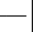y = V = 0 V = I 2s y = 0.5 + 1
I2
V2
22 1 2 2 (s + 2) 22 s

Problem 1
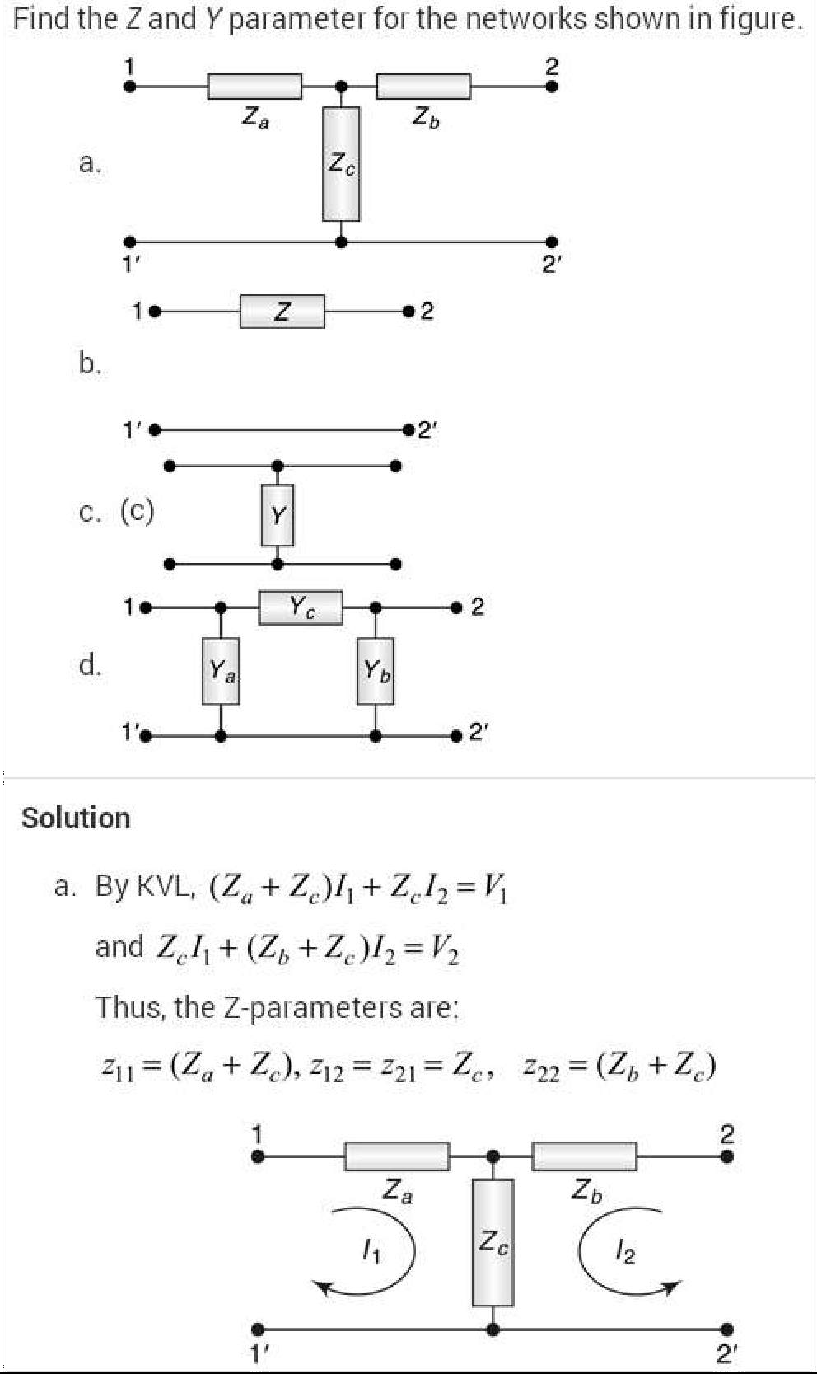

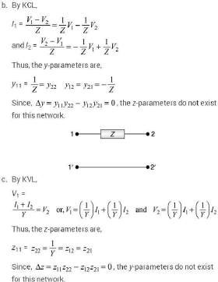
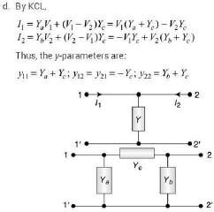

Problem 2
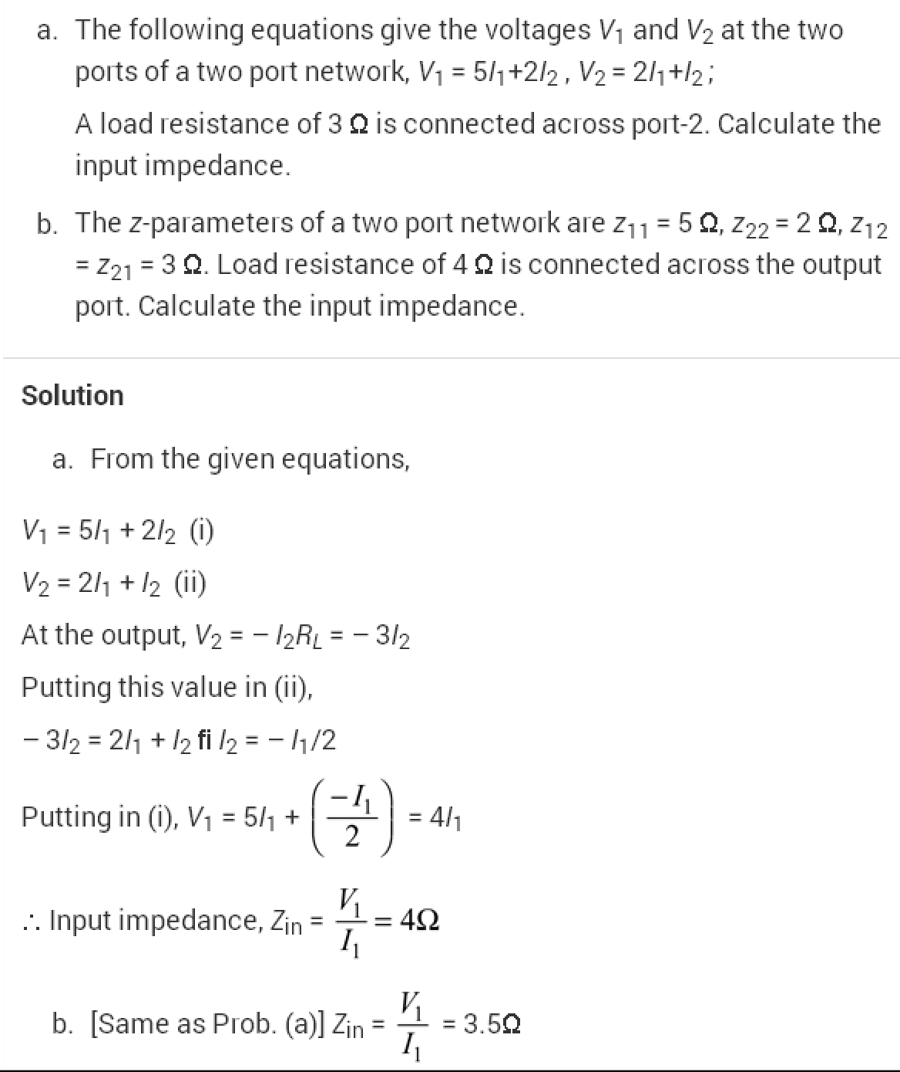

Problem 3
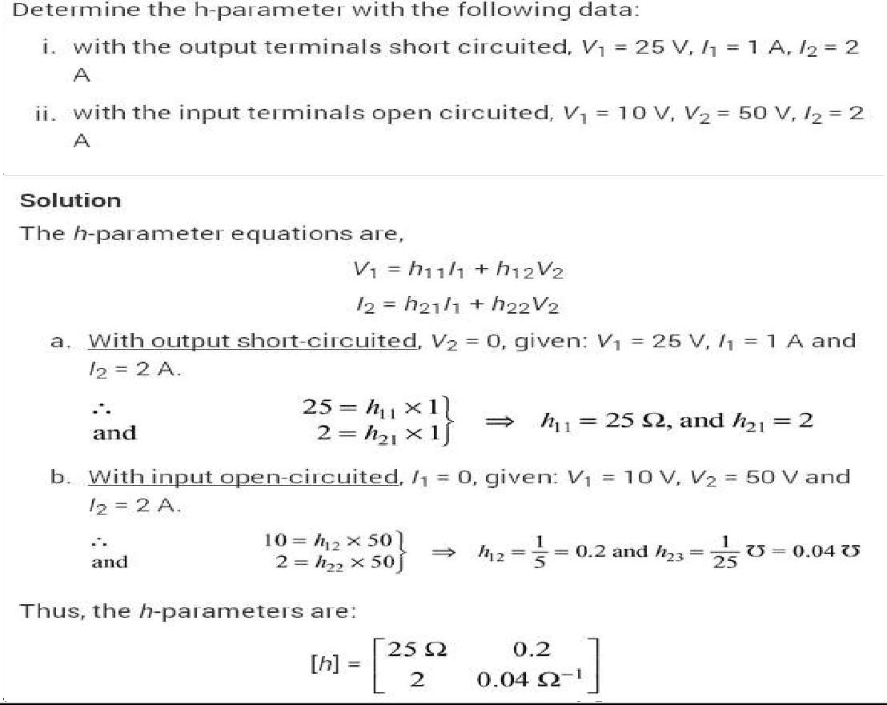
Problem 4
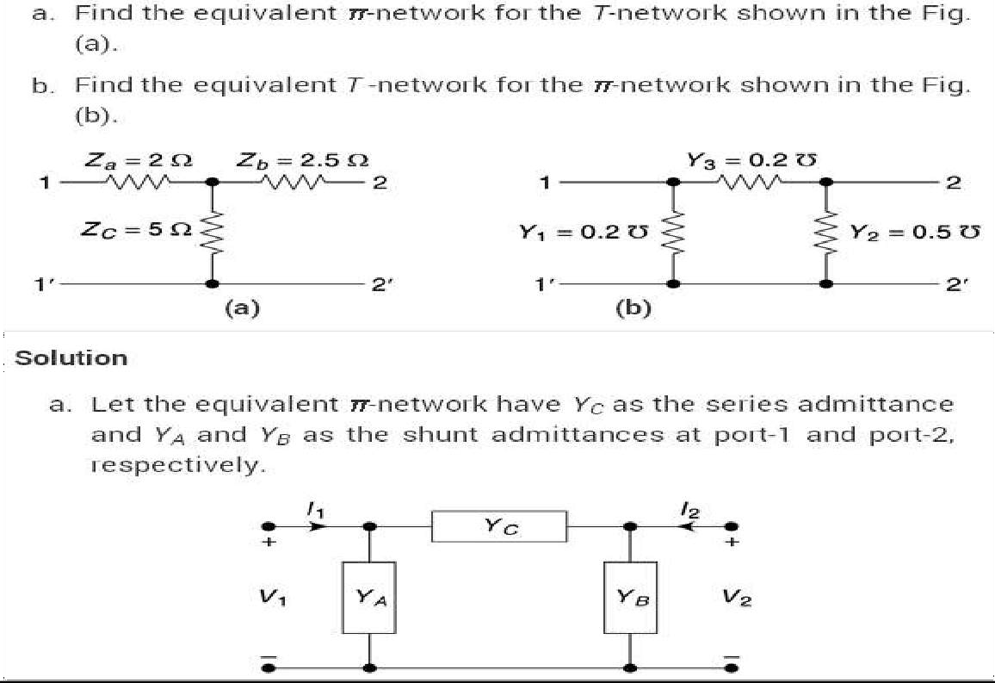

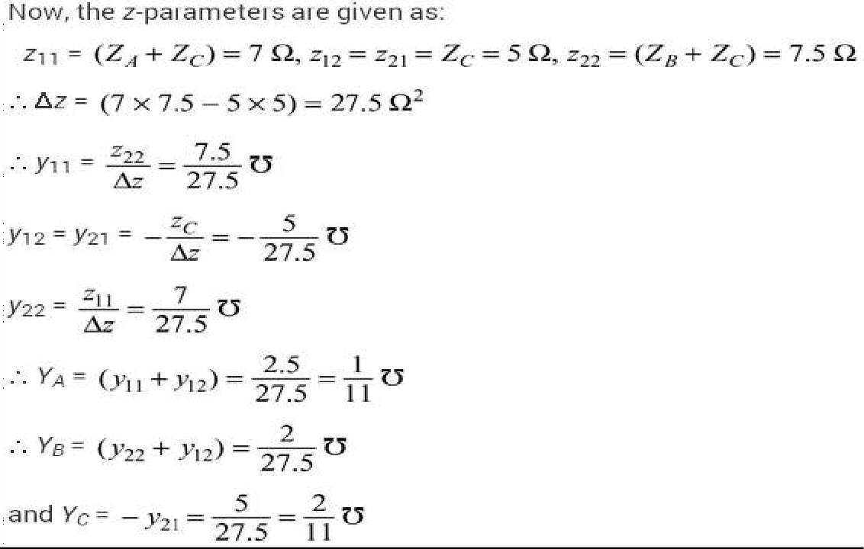
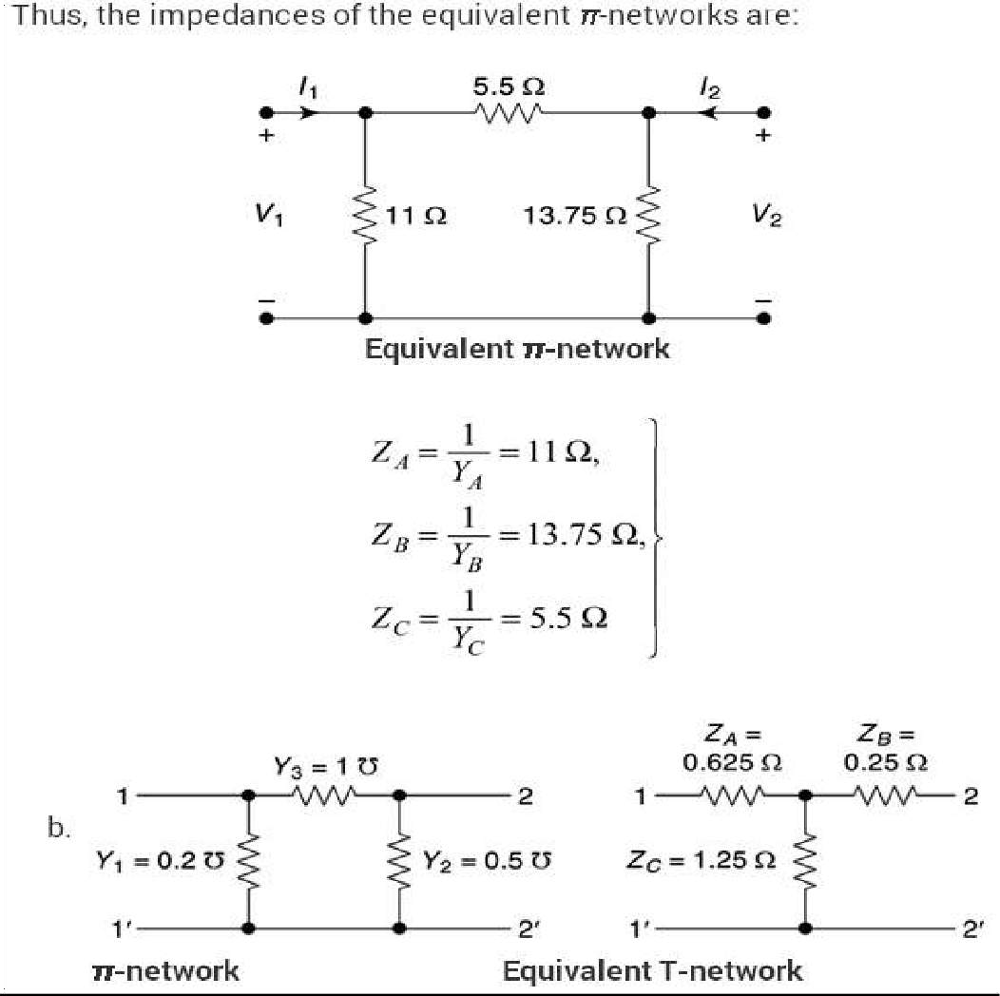

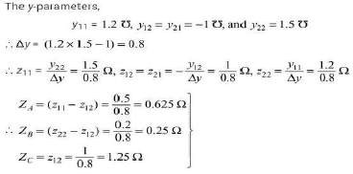

CHAPTER 8

LOW PASS FILTER INTRODUCTION
Basically, an electrical filter is a circuit that can be designed to modify, reshape or reject all unwanted frequencies of an electrical signal and accept or pass only those signals wanted by the circuit’s designer. In other words they “filter-out” unwanted signals and an ideal filter will separate and pass sinusoidal input signals based upon their frequency.
In low frequency applications (up to 100kHz), passive filters are generally constructed using simple RC(Resistor-Capacitor) networks, while higher frequency filters (above 100kHz) are usually made from RLC (Resistor-Inductor-Capacitor) components.
Passive Filters are made up of passive components such as resistors, capacitors and inductors and have no amplifying elements (transistors, op-amps, etc) so have no signal gain, therefore their output level is always less than the input.
Filters are so named according to the frequency range of signals that they allow to pass through them, while blocking or “attenuating” the rest. The most commonly used filter designs are the:
- 1. The Low Pass Filter – the low pass filter only allows low frequency signals from 0Hz to its cut-off frequency, ƒc point to pass while blocking those any higher.
- 2. The High Pass Filter – the high pass filter only allows high frequency signals from its cut-off frequency, ƒc point and higher to infinity to pass through while blocking those any lower.
- 3. The Band Pass Filter – the band pass filter allows signals falling within a certain frequency band setup between two points to pass through while blocking both the lower and higher frequencies either side of this frequency band.
- 4 Band Stop Filter - It is so called band-elimination, band-reject, or notch filters; this kind of filter passes all frequencies above and below a particular range set by the component values.
Simple First-order passive filters (1st order) can be made by connecting
together a single resistor and a single capacitor in series across an input signal, (Vin) with the output of the filter, (Vout ) taken from the junction of these two components. Depending on which way around we connect the resistor and the capacitor with regards to the output signal determines the type of filter construction resulting in either a Low Pass Filter or a High Pass Filter.
As the function of any filter is to allow signals of a given band of frequencies to pass unaltered while attenuating or weakening all others those are not

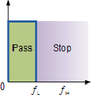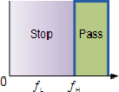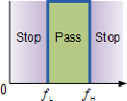wanted, we can define the amplitude response characteristics of an ideal filter by using an ideal frequency response curve of the four basic filter types as shown.

IDEAL FILTER RESPONSE CURVES
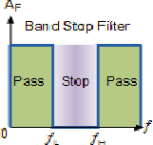
A Low Pass Filter can be a combination of capacitance, inductance or resistance intended to produce high attenuation above a specified frequency and little or no attenuation below that frequency. The frequency at which the transition occurs is called the “cutoff” frequency. The simplest low pass filters consist of a resistor and capacitor but more sophisticated low pass filters have a combination of series inductors and parallel capacitors. In this tutorial we will look at the simplest type, a passive two component RC low pass filter.

THE LOW PASS FILTER
A simple passive RC Low Pass Filter or LPF, can be easily made by connecting together in series a single Resistor with a single Capacitor as shown below. In this type of filter arrangement the input signal (Vin) is applied to the series combination (both the Resistor and Capacitor together) but the output signal (Vout ) is taken across the capacitor only. This type of filter is known generally as a “first-order filter” or “one-pole filter”, why first-order or single-pole?, because it has only “one” reactive component, the capacitor, in the circuit.

RC LOW PASS FILTER CIRCUIT
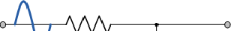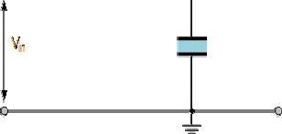As mentioned previously in the Capacitive Reactance tutorial, the reactance of a capacitor varies inversely with frequency, while the value of the resistor remains constant as the frequency changes. At low frequencies the capacitive reactance, (Xc) of the capacitor will be very
large compared to the resistive value of the resistor, R and as a result the voltage across the capacitor, Vc will also be large while the voltage drop across the resistor, Vr will be much lower. At high frequencies the reverse is true with Vc being small and Vr being large.
While the circuit above is that of an RC Low Pass Filter circuit, it can also be classed as a frequency variable potential divider circuit similar to the one we looked





at in the Resistors tutorial. In that tutorial we used the following equation to calculate the output voltage for two single resistors connected in series.




We also know that the capacitive reactance of a capacitor in an AC circuit

is given as:



Opposition to current flow in an AC circuit is called impedance, symbol Z and for a series circuit consisting of a single resistor in series with a single capacitor, the circuit impedance is calculated as:
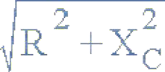

Then by substituting our equation for impedance above into the resistive potential divider equation gives us:

RC POTENTIAL DIVIDER EQUATION

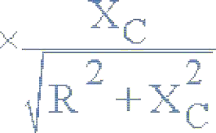

So, by using the potential divider equation of two resistors in series and substituting for impedance we can calculate the output voltage of an RC Filter for any given frequency.

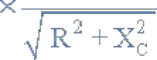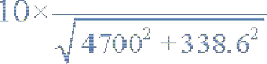LOW PASS FILTER EXAMPLE
A Low Pass Filter circuit consisting of a resistor of 4k7Ω in series with a capacitor of 47nF is connected across a 10v sinusoidal supply. Calculate the output voltage (Vout ) at a frequency of 100Hz and again at frequency of 10,000Hz or 10kHz.



Voltage Output at a Frequency of 100Hz.





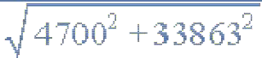




Voltage Output at a Frequency of 10,000Hz (10kHz).





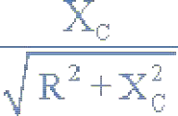
FREQUENCY RESPONSE
We can see from the results above that as the frequency applied to the RC network increases from 100Hz to 10 kHz, the voltage dropped across the capacitor and therefore the output voltage (Vout) from the circuit decreases from 9.9v to 0.718v.
By plotting the networks output voltage against different values of input frequency, the Frequency Response Curve or Bode Plot function of the low pass filter circuit can be found, as shown below.

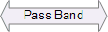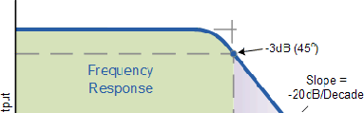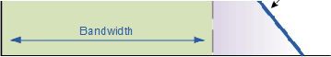Frequency Response of a 1st-order Low Pass Filter

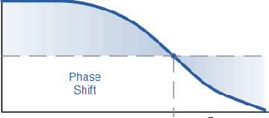

The Bode Plot shows the Frequency Response of the filter to be nearly flat for low frequencies and the entire input signal is passed directly to the output, resulting in a gain of nearly 1, called unity, until it reaches its Cut-off Frequency point (ƒc). This is because the reactance of the capacitor is high at low frequencies and blocks any current flow through the capacitor.
After this cut-off frequency point the response of the circuit decreases to zero at a slope of -20dB/ Decade or (-6dB/Octave) “roll-off”. Note that the angle of the slope, this -20dB/ Decade roll-off will always be the same for any RC combination.
Any high frequency signals applied to the low pass filter circuit above this cut-off frequency point will become greatly attenuated, that is they rapidly decrease. This happens because at very high frequencies the reactance of the capacitor becomes so low that it gives the effect of a short circuit condition on the output terminals resulting in zero output.
Then by carefully selecting the correct resistor-capacitor combination, we can create a RC circuit that allows a range of frequencies below a certain value to pass through the circuit unaffected while any frequencies applied to the circuit above this cut-off point to be attenuated, creating what is commonly called a Low Pass Filter.

For this type of “Low Pass Filter” circuit, all the frequencies below this cut-off, ƒc point that are unaltered with little or no attenuation and are said to be in the filters Pass band zone. This pass band zone also represents the Bandwidth of the filter. Any signal frequencies above this point cut-off point are generally said to be in the filters Stop band zone and they will be greatly attenuated.
This “Cut-off”, “Corner” or “Breakpoint” frequency is defined as being the frequency point where the capacitive reactance and resistance are equal, R = Xc = 4k7Ω. When this occurs the output signal is attenuated to 70.7% of the input signal value or - 3dB (20 log (Vout/Vin)) of the input. Although R = Xc, the output is not half of the input signal. This is because it is equal to the vector sum of the two and is therefore 0.707 of the input.
As the filter contains a capacitor, the Phase Angle (Φ) of the output signal LAGS behind that of the input and at the -3dB cut-off frequency (ƒc) and is - 45o out of phase. This is due to the time taken to charge the plates of the capacitor as the input voltage changes, resulting in the output voltage (the voltage across the capacitor) “lagging” behind that of the input signal. The higher the input frequency applied to the filter the more the capacitor lags and the circuit becomes more and more “out of phase”.
The cut-off frequency point and phase shift angle can be found by using the following equation:



CUT-OFF FREQUENCY AND PHASE SHIFT







Then for our simple example of a “Low Pass Filter” circuit above, the cut- off frequency (ƒc) is given as720Hz with an output voltage of 70.7% of the input voltage value and a phase shift angle of -45o.

HIGH PASS FILTERS
A High Pass Filter or HPF, is the exact opposite to that of the previously seen Low Pass filter circuit, as now the two components have been interchanged with the output signal ( Vout ) being taken from across the resistor as shown.
Where as the low pass filter only allowed signals to pass below its cut-off frequency point, ƒc, the passive high pass filter circuit as its name implies, only passes signals above the selected cut-off point, ƒc eliminating any low frequency signals from the waveform. Consider the circuit below.

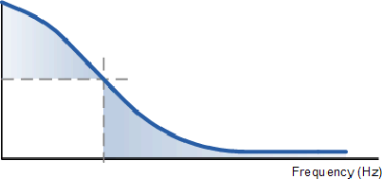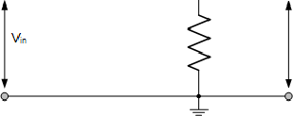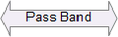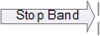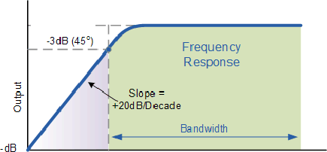THE HIGH PASS FILTER CIRCUIT

In this circuit arrangement, the reactance of the capacitor is very high at low frequencies so the capacitor acts like an open circuit and blocks any input signals at Vin until the cut-off frequency point (ƒc) is reached. Above this cut-off frequency point the reactance of the capacitor has reduced sufficiently as to now act more like a short circuit allowing the entire input signal to pass directly to the output as shown below in the High Pass Frequency Response Curve.

FREQUENCY RESPONSE OF A 1ST ORDER HIGH PASS FILTER.
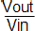

The Bode Plot or Frequency Response Curve above for a High Pass filter is the exact opposite to that of a low pass filter. Here the signal is attenuated or damped at low frequencies with the output increasing at +20dB/Decade (6dB/Octave) until the frequency reaches the cut-off point ( ƒc ) where again R = Xc. It has a response curve that extends down from infinity to the cut-off frequency, where the output voltage amplitude is 1/√2 = 70.7% of the input signal value or -3dB (20 log (Vout/Vin)) of the input value.
Also we can see that the phase angle (Φ) of the output signal LEADS that of the input and is equal to+45o at frequency ƒc. The frequency response curve for a high pass filter implies that the filter can pass all signals out to infinity. However in practice, the high pass filter response does not extend to infinity but is limited by the electrical characteristics of the components used.
The cut-off frequency point for a first order high pass filter can be found using the same equation as that of the low pass filter, but the equation for the phase shift is modified slightly to account for the positive phase angle as shown below.



CUT-OFF FREQUENCY AND PHASE SHIFT






The circuit gain, Av which is given as Vout/Vin (magnitude) and is calculated as:













HIGH PASS FILTER EXAMPLE.
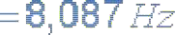

Calculate the cut-off or “breakpoint” frequency ( ƒc ) for a simple high pass filter consisting of an82pF capacitor connected in series with a 240kΩ resistor.



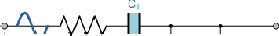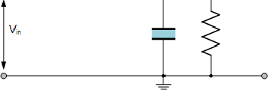BAND PASS FILTERS
The cut-off frequency or ƒc point in a simple RC passive filter can be accurately controlled using just a single resistor in series with a non-polarized capacitor, and depending upon which way around they are connected either a low pass or a high pass filter is obtained.

One simple use for these types of Passive Filters is in audio amplifier applications or circuits such as in loudspeaker crossover filters or pre-amplifier tone controls. Sometimes it is necessary to only pass a certain range of frequencies that do not begin at 0Hz, (DC) or end at some high frequency point but are within a certain frequency band, either narrow or wide.
By connecting or “cascading” together a single Low Pass Filter circuit with a High Pass Filter circuit, we can produce another type of passive RC filter that passes a selected range or “band” of frequencies that can be either narrow or wide while attenuating all those outside of this range. This new type of passive filter arrangement produces a frequency selective filter known commonly as a Band Pass Filter or BPF for short.

BAND PASS FILTER CIRCUIT

Unlike a low pass filter that only pass signals of a low frequency range or a high pass filter which pass signals of a higher frequency range, a Band Pass Filters passes signals within a certain “band” or “spread” of frequencies without distorting the input signal or introducing extra noise. This band of frequencies can be any width and is commonly known as the filters Bandwidth.
Bandwidth is commonly defined as the frequency range that exists between two specified frequency cut-off points ( ƒc ), that are 3dB below the maximum centre or resonant peak while attenuating or weakening the others outside of these two points.
Then for widely spread frequencies, we can simply define the term “bandwidth”, BW as being the difference between the lower cut-off frequency (ƒcLOWER ) and the higher cut-off frequency ( ƒcHIGHER ) points. In other words, BW = ƒH – ƒL. Clearly for a pass band filter to function correctly, the cut-off frequency of the low pass filter must be higher than the cut-off frequency for the high pass filter.
The “ideal” Band Pass Filter can also be used to isolate or filter out certain
frequencies that lie within a particular band of frequencies, for example, noise

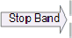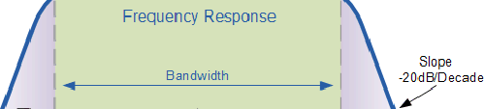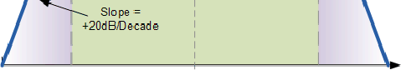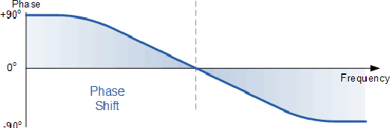cancellation. Band pass filters are known generally as second-order filters, (two-pole) because they have “two” reactive component, the capacitors, within their circuit design. One capacitor in the low pass circuit and another capacitor in the high pass circuit.



Frequency Response of a 2nd Order Band Pass Filter.

The Bode Plot or frequency response curve above shows the characteristics of the band pass filter. Here the signal is attenuated at low frequencies with the output increasing at a slope of +20dB/Decade (6dB/Octave) until the frequency reaches the “lower cut-off” point ƒL. At this frequency the output voltage is again 1/√2 = 70.7% of the input signal value or -3dB (20 log (Vout/Vin)) of the input.
The output continues at maximum gain until it reaches the “upper cut-off” point ƒH where the output decreases at a rate of -20dB/Decade (6dB/Octave) attenuating any high frequency signals. The point of maximum output gain is generally the geometric mean of the two -3dB value between the lower and upper cut-off points and is called the “Centre Frequency” or “Resonant Peak” value ƒr. This geometric mean value is calculated as being ƒr ² = ƒ(UPPER) x ƒ(LOWER).
A band pass filter is regarded as a second-order (two-pole) type filter because it has “two” reactive components within its circuit structure, then the phase angle will be twice that of the previously seen first-order filters, i.e., 180o. The phase

angle of the output signal LEADS that of the input by +90o up to the centre or resonant frequency, ƒr point were it ecomes “zero” degrees (0o) or “in-phase” and then changes to LAG the input by -90o as the output frequency increases.
b



The upper and lower cut-off frequency points for a band pass filter can be found using the same formula as that for both the low and high pass filters, For example.

Then clearly, the width of the pass band of the filter can be controlled by the positioning of the two cut-off frequency points of the two filters.

Band Pass Filter Example
A second-order band pass filter is to be constructed using RC components that will only allow a range of frequencies to pass above 1kHz (1,000Hz) and below 30kHz (30,000Hz). Assuming that both the resistors have values of 10kΩ´s,
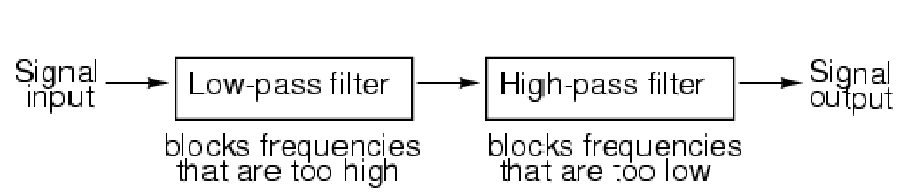
calculate the values of the two capacitors required.
The High Pass Filter Stage



The value of the capacitor C1 required to give a cut-off frequency ƒL of 1kHz with a resistor value of10kΩ is calculated as:


Then, the values of R1 and C1 required for the high pass stage to give a cut-off frequency of 1.0kHz are: R1 = 10kΩ´s and C1 = 15nF.

The Low Pass Filter Stage


The value of the capacitor C2 required to give a cut-off frequency ƒH of 30kHz with a resistor value of10kΩ is calculated as:


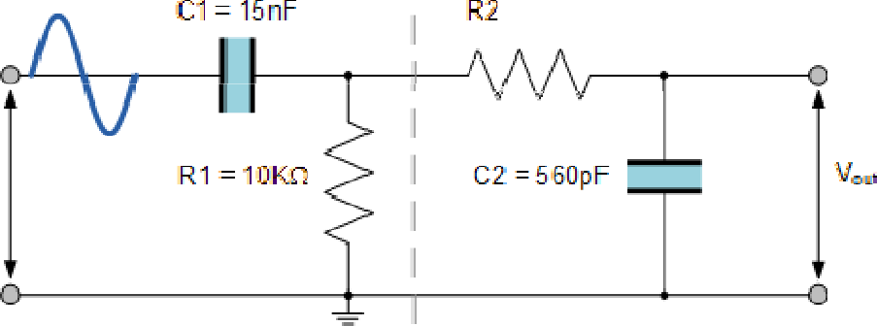Then, the values of R2 and C2 required for the low pass stage to give a cut- off frequency of 30kHz are, R = 10kΩ´s and C = 510pF. However, the nearest preferred value of the calculated capacitor value of 510pF is 560pF so this is used instead.
With the values of both the resistances R1 and R2 given as 10kΩ, and the two values of the capacitors C1 and C2 found for the high pass and low pass filters as 15nF and 560pF respectively, then the circuit for our simple passive Band Pass Filter is given as.

Completed Band Pass Filter Circuit

Band Pass Filter Resonant Frequency
We can also calculate the “Resonant” or “Centre Frequency” (ƒr) point of the band pass filter were the output gain is at its maximum or peak value. This peak value is not the arithmetic average of the upper and lower -3dB cut-off points as you might expect but is in fact the “geometric” or mean value. This geometric mean value is calculated as being ƒr ² = ƒc(UPPER) x ƒc(LOWER) for example:
Centre Frequency Equation

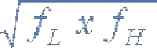
- Where, ƒr is the resonant or centre frequency
- ƒL is the lower -3dB cut-off frequency point
- ƒH is the upper -3db cut-off frequency point
And in our simple example above, the calculated cut-off frequencies were found to be ƒL = 1,060 Hz and ƒH = 28,420 Hz using the filter values.
Then by substituting these values into the above equation gives a central resonant frequency of:

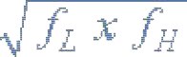



Band-stop filters
It is so called band-elimination, band-reject, or notch filters; this kind of filter passes all frequencies above and below a particular range set y the component values. Not surprisingly, it can be made out of a low-pass and a high-pass filter, just like the band-pass design, except that this time we connect the two filter sections in parallel with each other instead of in series. (Figure below)
b
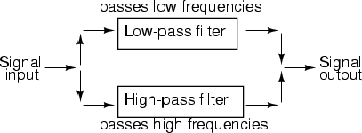
System level block diagram of a band-stop filter.
Constructed using two capacitive filter sections, it looks something like (Figure below).
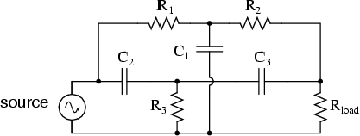

Butterworth Filter

A Butterworth filter is a type of signal processing filter designed to have a frequency response as flat as possible in the passband. Hence the Butterworth filter is also known as “maximally flat magnitude filter”. It was invented in 1930 by the British engineer and physicist Stephen Butterworth in his paper titled “On the Theory of Filter Amplifiers”.
The frequency response of the Butterworth filter is flat in the passband (i.e. a bandpass filter) and roll-offs towards zero in the stopband. The rate of roll-off response depends on the order of the filter. The number of reactive elements used in the filter circuit will decide the order of the filter.
The inductor and capacitor are reactive elements used in filters. But in the case of Butterworth filter only capacitors are used. So, the number of capacitors will decide the order of the filter.
Here, we will discuss the Butterworth filter with a low pass filter. Similarly, the high pass filter can be designed by just changing the position of resistance and capacitance.

Butterworth Low Pass Filter Design
While designing the filter, the designer tries to achieve a response near to the ideal filter. It is very difficult to match results with the exact ideal characteristic. We need to use complex higher-order If you increase the order of the filter, the number of cascade stages with the filter is also increased. But in practice, we cannot achieve Butterworth’s ideal frequency response. Because it produces excessive ripple in the passband.In Butterworth filter, mathematically it is possible to get flat frequency response from 0 Hz to the cut-off frequency at -3dB with no ripple. If the frequency is more than the cut-off frequency, it will roll-off towards zero with the rate of -20 dB/decade for the first-order filter.If you increase the order of the filter, the rate of a roll-off period is also increased. And for second-order, it is -40 dB/decade. The quality factor for the Butterworth filter is 0.707.
The below figure shows the frequency response of the Butterworth filter for various orders of the filter
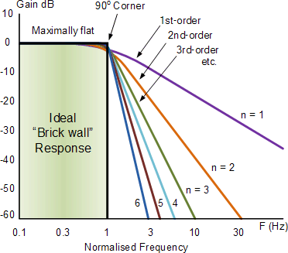

Frequency Response of Butterworth FilterThe generalized form of frequency response for nth-order Butterworth low-pass filter is;

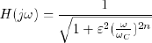
Where,
n = order of the filter,
ω = operating frequency (passband frequency) of circuit
ωC = Cut-off frequency
ε = maximum passband gain = Amax

The below equation is used to find the value of ε.

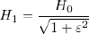

Where,
H1 = minimum passband gain H0 = maximum passband gain
First-order Lowpass Butterworth Filter
The lowpass filter is a filter that allows the signal with the frequency is lower than the cutoff frequency and attenuates the signals with the frequency is more than cutoff frequency. In the first-order filter, the number of reactive components is only one. The below figure shows the circuit diagram of the first-order lowpass Butterworth filter.

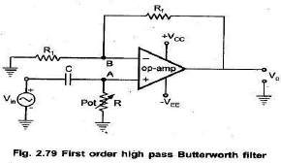

The low pass Butterworth filter is an active Low pass filter as it consists of the op-amp. This op-amp operates on non-inverting mode. Hence, the gain of the filter will decide by the resistor R1 and RF. And the cutoff frequency decides by R and C.
Now, if you apply the voltage divider rule at point Va and find the voltage across a capacitor. It is given as;
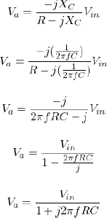

Because of the non-inverting configuration of an op-amp,

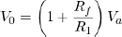

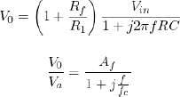

WHERE

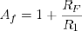

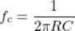
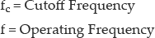

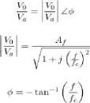

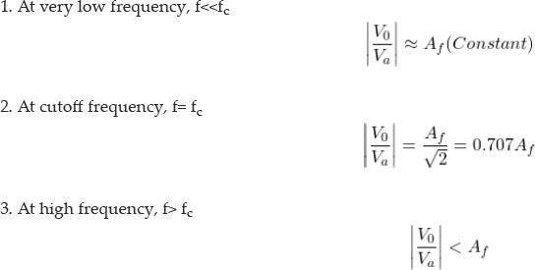

The below figure shows the frequency response of first-order lowpass Butterworth filter.
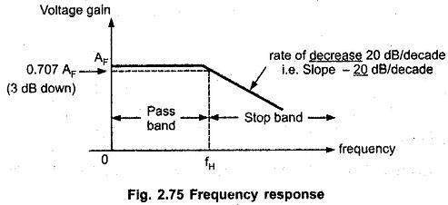

Second-order Butterworth Filter
The second-order Butterworth filter consists of two reactive components. The circuit diagram of a second-order low pass Butterworth filter is as shown in the below figure.
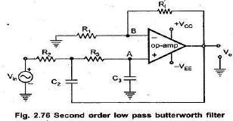
In this type of filter, resistor R and R_{F} are the negative feedback of op-amp. And the cutoff frequency of the filter decides by R₂, R₃, C₂, and C₃.The second-order lowpass Butterworth filter consists of two back-to-back connected RC networks. And R_{L} is the load resistance. First-order and second-order Butterworth filters are very important. Because we can get higher-order Butterworth filter by just cascading of the first-order and second-order Butterworth filters.

Let’s analyse the circuit of second-order Butterworth filter,

Apply Kirchhoff’s Current Law at point V₁.
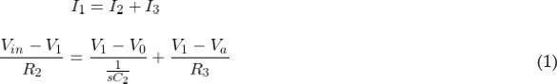

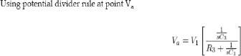
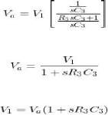

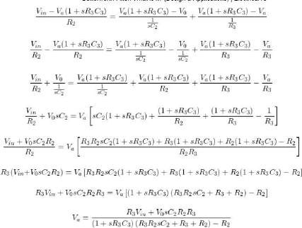

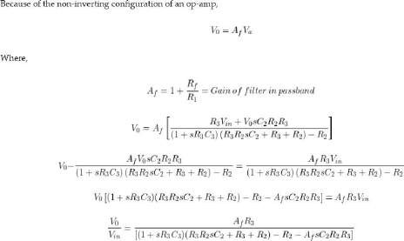

Rearrange this equation,
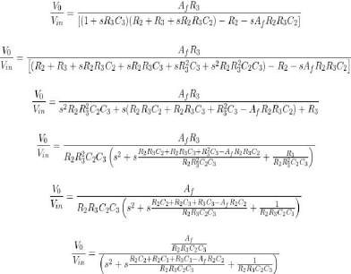

Compare this equation with the standard form transfer function for second-order Butterworth filter. And that is,

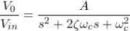
By comparing above equations, we can find the equation of cutoff frequency and overall gain for the second-order lowpass Butterworth filter.

The gain of filter is,

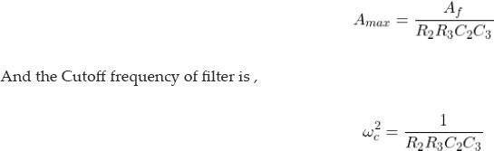
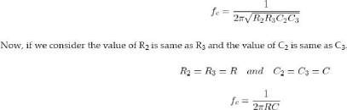

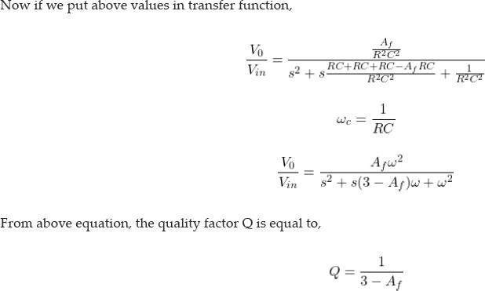

We can say that, the quality factor is only depends on the gain of filter. And the value of gain should not more than 3. If the value of gain is more than 3, the system will be unstable.

The value of quality factor is 0.707 for the Butterworth filter. And if we put this value in equation of quality factor, we can find the value of gain.

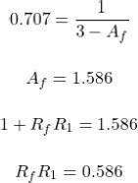

While designing the second-order Butterworth filter above relation must be satisfy. The frequency response of this filter is as shown in below figure.

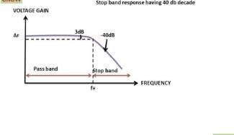
Third-order Lowpass Butterworth Filter

Third-order lowpass Butterworth filter can design by cascading the first-order and second-order Butterworth filter.

The below figure shows the circuit diagram of the third-order lowpass Butterworth filter.
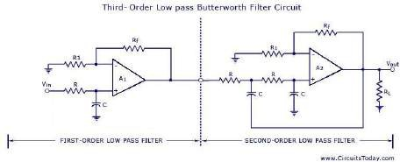
Third-order Low Pass Butterworth Filter
In this figure, the first part shows the first-order lowpass Butterworth filter, and the second part shows the second-order lowpass Butterworth filter.

But in this condition, the voltage gain of the first part is optional and it can be set at any value. Therefore, the first op-amp is not taking part in voltage gain. Hence, the figure for the third-order low pass filter can be expressed as below figure also;

; 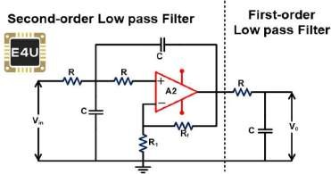

The voltage gain of a second-order filter affects the flatness of frequency response. If the gain of the second-order filter is kept at 1.586, the gain will down 3db for each part. So, the overall gain will down 6dB at the cutoff frequency.

By increasing the voltage gain of the second-order filter, we can offset the cumulative loss of voltage gain.

In the third-order Butterworth filter, the rate of a roll-off period is -60dB/decade. And the frequency response of this filter is nearer to the ideal Butterworth filter compared to the first and second-order filters. The frequ
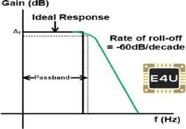

(frequency response of this filter is as shown in the below figure.)

Fourth-order Lowpass Butterworth Filter
Fourth-order Butterworth filter is established by the cascade connection of two second-order low pass Butterworth filters. The circuit diagram of the fourth-order lowpass Butterworth filter is as shown in the below figure.

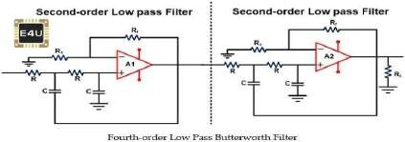
If the gain of both filters is set at 1.586, the voltage gain will be down 6 dB at the cutoff frequency. We can get a more flat response by choosing different values of voltage gain for both stages. According to the advanced research, we get maximum flat response, if we use the voltage gain 1.152 for the first stage and 2.235 for the second stage.

The below figure shows the frequency response of the fourth-order lowpass Butterworth filter.
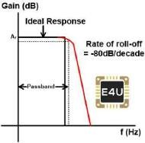

:

Butterworth Filter Applications
The applications of a Butterworth filter are listed below
- Because of the maximal flat frequency response in the passband, it is used as an anti-aliasing filter in data converter applications.
- The Butterworth filter is used in the audio processing application. An efficient audio noise reduction tool can be developed using a Butterworth filter.
- It is also used in various communication and control systems.
- It is used in radar to design the display of radar target tracking.
- It is used for motion analysis.

Attenuator
Every signal that includes electrical, telecommunication, entertainment signal (television), etc. should be transmitted from one place to another place through a medium. As the distance of signal travelled increases the strength of signal decreases and it will be difficult for a lot of tasks. But, attenuation, phenomenon of gradual loss of strength of signal over distance is still useful in many tasks.
Attenuators are simple passive two-port electronic devices that are used for attenuation, to reduce strength of signals without causing disturbance to its waveform.
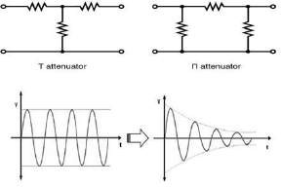

Definition of the decibel
- The bel is a logarithmic unit used to express the ratio between two values, and a reference , of a physical quantity. The decibel is a tenth of a bel. A level is calculated with the following method:
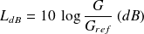
- The quantity under study is, in general, a power. For field quantities (speed, pressure, force, voltage...) which need to be squared to obtain the power, the level in decibels is given by the following relation:
- 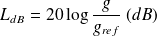 .

The decibel scale is used in numerous physical domains (electronics, acoustics, audio, etc...). As such, this units definition depends on the reference value and can be distinguished by the use of different symbols
- Electronics: , ...
- Audio: , ...
- Acoustics: , , ...
Hence, there are a lot of different decibels, which are not comparable. The use of this type of unit requires a sufficient knowledge of the definition of the considered decibel.

Gain and attenuation in decibels
The decibel can also be used to explain the gain, or attenuation, of a system. For example, the gain in decibels of an amplifier can be obtained by the ratio of output voltage by the input voltage . The calculation of is done with the following formula:
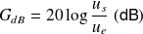 .

- Gain/Attenuation When we talk about transmitting signals, we’re very interested in the power of the signal that is transmitted (and the power that is received). As you know, power is measured in units of Watt (W). To get a sense of relative amounts of power, consider the following A typical household incandescent light bulb consumes 60WAn exercise bike average output is approx. 200W
- A microwave uses 1100W
- AM radio stations transmit 10,000-50,000W.Now, consider a typical situation where a radio receiver receives signal from a radio station as shown in the illustration to the right. Note that: The signal power decreases
- ◊significantly at the car receiver signal loss (attenuation). The signal power received is too
- signal must be amplified◊low first (gain). The term gain usually refers to amplification. For an amplifier, the gain (A) is the ratio of the output to the input. So, to calculate power gain (AP) where Pin is the power input and Pout is the power output:

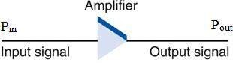
𝑨𝒑 = 𝑷𝒐𝒖𝒕/𝑷𝒊𝒏 (unitless)
Reduction or signal loss is termed attenuation. This occurs when we have a gain that is less than 1. Although
gain/attenuation is usually associated with the signal power, it is sometimes used to described the gain/attenuation of the
signal voltages as well.

Decibels
For many reasons of history and practicality, engineers usually use a logarithmic unit called the decibel (dB) to express gain
and attenuation figures. To express power gain or attenuation with decibels (dB):

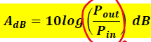
If we’re dealing with current or voltage gain such as 𝐴𝑉 = 𝑉𝑜𝑢𝑡/𝑉𝑖𝑛, then the gain in decibels is given by
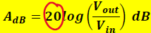

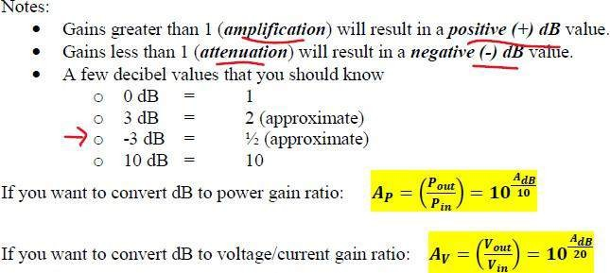

Types of Attenuator
Attenuators are available as both fixed attenuators and adjustable attenuators. Fixed attenuator networks are known as ‘attenuator Pads”. These are available for specific values from 0dB to 100dB. Attenuators are commonly found in Radio Frequency and Optical applications. Radio Frequency attenuators are used in the electronic circuits whereas optical attenuators find applications in fiber optics.
Few common layouts of attenuator are- T configuration, pI configuration, and L configuration. These configurations are of an unbalanced type. The balanced type of T configuration and pI configurations are denoted as ‘H’ configuration, O configuration respectively. The balanced type is a symmetrical circuit whereas unbalanced types are asymmetrical circuits

The RF-based design of the attenuator is of six types. They are Fixed type, Step type, Continuously Variable type, Programmable Type, DC Bias type and DC Blocking type.
Fixed Type
In Fixed type attenuators the resistor network is locked at a predetermined attenuation value. These are laid down in the signal path to attenuate the power of the transmitted signal. These can be unidirectional or bidirectional based on their application requirement. These can be available as either surface mount, waveguide or coaxial types. In a chip-based design, the different types of materials deposited on the thermally conductive substrate develop the resistance. This resistance value depends on the dimensions of the chip and the materials used for chip production.
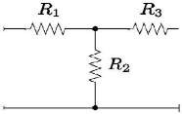
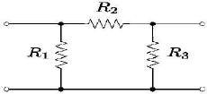

T configuration Pi configuration

Attenuator Applications:
There are so manyattenuator applications that we can observe in our daily life and a few of them are listed below:
- Microwave power can be controlled using PIN diode attenuators, PIN diode is used as control element in most of the electronically variable attenuators.
- To control volume of electronic equipment such as speakers, electric guitars, etc. attenuators are used.

- In general, while conducting tests in laboratories only a small voltage or current signal is used for which attenuators are widely used to reduce output signal strength.
- To test high power radio frequency signals, before applying it to the test equipment you should reduce the strength of the signal for which attenuators can be used.
- While driving match sensitive radio frequency mixers it is really important to ensure that proper impedance match is obtained as poor match can lead to degraded performance. So, impedance matched radio frequency attenuator can be used to improve this matching and improve performance.
- In some digital or analog circuits, a surge in voltage may cause damage to the circuits which can be avoided using attenuators to reduce high voltages.
- In fibre optic communication, it is important to obtain proper match for transmitter and receiver which can be obtained using optical attenuators.
- Basic signal generators will be able to generate an exact fixed level and to use this output signal we must use switch attenuators to reduce its signal which is less effective method compared to using a variable level control radio frequency attenuator that can be used to generate required levels.
- Attenuators are used as volume control equipment in broadcasting stations.
- For testing purposes in laboratories, to obtain smaller voltage signals, attenuators are used.
- Fixed attenuators are used to improve the impedance matching in circuits.
- These are used to protect the circuits from damages caused by high voltage values.
- RF attenuators are used for the protective dissipation of power in measuring RF signals.
- Optical attenuators are applied in fiber optic communication to properly match transmitter and receiver levels.

