RAJA KISHORE CHANDRA ACADEMY OF TECHNOLOGY,NILAGIRI

DEPARTMENT OF CIVL ENGINEERING

Building Materials & Construction Technology 3RD SEMESTER
PREPARED BY: ER. DEEPIKA BEHERA

PART-A (BUILDING MATERIALS)

CHAPTER:-01 [STONE]
Introduction: The engineering structures are composed of materials. These materials are known as the engineering materials or building materials or materials of construction.

CLASSIFICATION OF ROCKS:
The building stones are obtained from the rocks which are classified in the following three ways:
- Geological classification
- Physical classification
- Chemical classification

- Geological classification: According to this classification, the rocks are of the following three types:
  - Igneous rocks;
  - Sedimentary rocks; and
  - Metamorphic rocks.
- Igneous rocks: The inside portion of the earth's surface has high temperature so as to cause fusion by heat at even ordinary pressures. The molten or pasty rocky material is known as the magma and this magma occasionally tries to come out to the earth's surface through cracks or weak portions. The rocks which are formed by the cooling of magma are known as the igneous rocks.
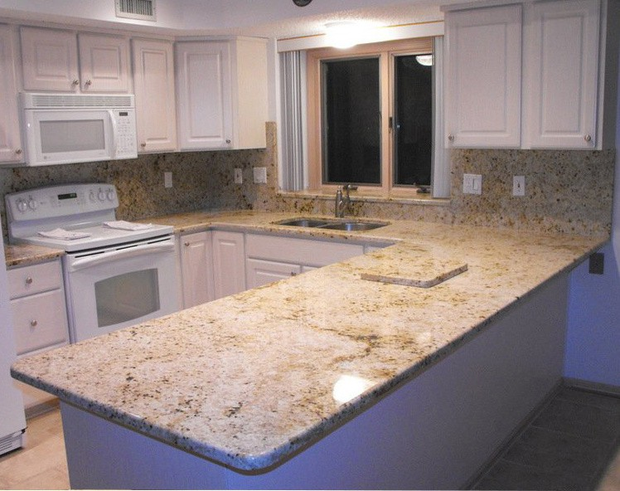
The igneous rocks are recognized in the following three classes:
  - Plutonic rocks: Such rocks are formed due to cooling of magma at a considerable depth from earth's surface. The cooling is slow and

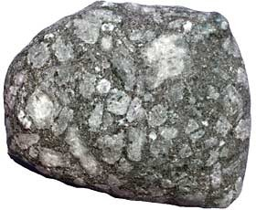
the rocks possess coarsely grained crystalline structure. The igneous rocks commonly used in building industry are of plutonic type. The granite is the leading example of this type of rock.
  - Hypabyssal rocks: Such rocks are formed due to cooling of magma at a relatively shallow depth from the earth's surface. The cooling is quick and hence these rocks possess finely grained crystalline structure. The dolerite is an example of this type of rock.
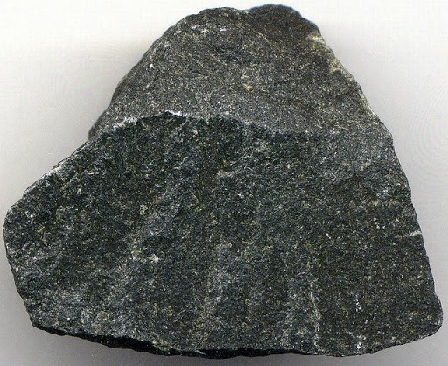
  - Volcanic rocks: Such rocks are formed due to pouring of magma at earth's surface. The cooling is very rapid as compared to the previous two cases. Hence these rocks are extremely fine grained in structure. They frequently contain some quantity of glass which is a non-crystalline material. The basalt is an example of this type of rock.

- Sedimentary rocks: These rocks are formed by the deposition of products of weathering on the pre-existing rocks. All the products of weathering are ultimately carried away from their place of origin by the agents of transport. Such agents are frost, rain, wind, flowing water etc.

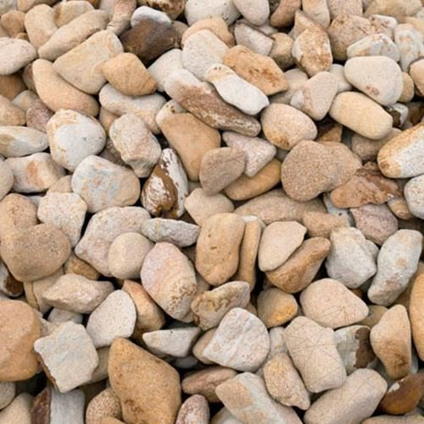
Following four types of deposits occur:
  - Residual deposits: Some portion of the products of weathering remain at the site of origin. Such a deposit is known as a residual deposit.
  - Sedimentary deposits: The insoluble products of weathering are carried away in suspension and when such products are deposited, they give rise to the sedimentary deposits.

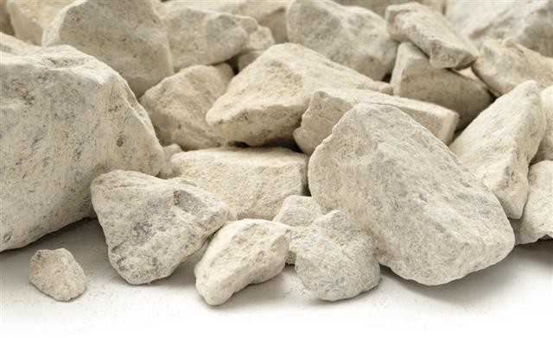
  - Chemical deposits: Some material that is carried away in solution be deposited by some physio- chemical processes such as evaporation precipitation, etc. It gives rise to the chemical
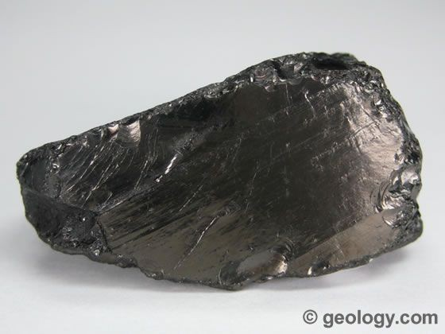
deposits.
  - Organic deposits: Some portion of the product of weathering gets deposited through the agency of organisms. Such deposits are known as the organic deposits.
The examples of sedimentary rocks are gravel, sandstone. Limestone, gypsum, lignite, etc.
- Metamorphic rocks: These rocks are formed by the change in character of the pre-existing rocks. The igneous as well as sedimentary rocks are changed in character when they are subject to great heat and pressure. The process of change is known as the metamorphism.

Following four types of metamorphism occur with various combinations of heat. uniform pressure and directed pressure:

  - Thermal metamorphism: The heat is the predominant factor in this type of metamorphism.
  - Cataclastic metamorphism: At the surface of earth, the temperatures are low and metamorphism is brought about by directed pressure only. Such metamorphism is known as the cataclastic metamorphism.
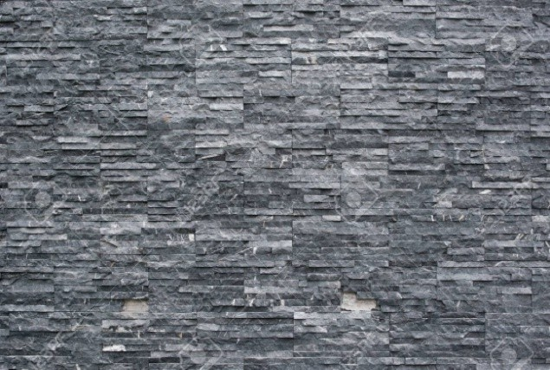
  - Dynamo-thermal metamorphism: There is rise in temperature with increase in depth. Hence, the heat in combination with stress brings about the changes in rock. Such metamorphism is known as the dynamo-thermal metamorphism.

  - Plutonic metamorphism: The stress is effective only upto a certain depth. This is due to the fact that rocks become plastic in nature at certain depths. At great depths, a stage is reached when stress cannot exist as it is converted into uniform pressure because of the plasticity of rocks. The metamorphic changes a great depths are therefore brought about by uniform pressure and heat. Such metamorphism is known as the Plutonic metamorphism.
- Physical classification: This classification is based on general structure of rocks. According this classification, the rocks are of the following three types:
  - Stratified rocks;
  - Unstratified rocks; and
  - Foliated rocks.

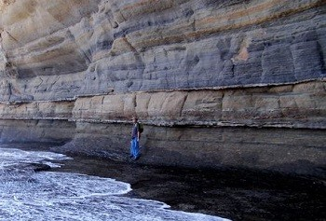
- Stratified rocks: These rocks possess planes of stratification or cleavage and such rocks can easily be split up along these planes. The sedimentary rocks are distinctly stratified
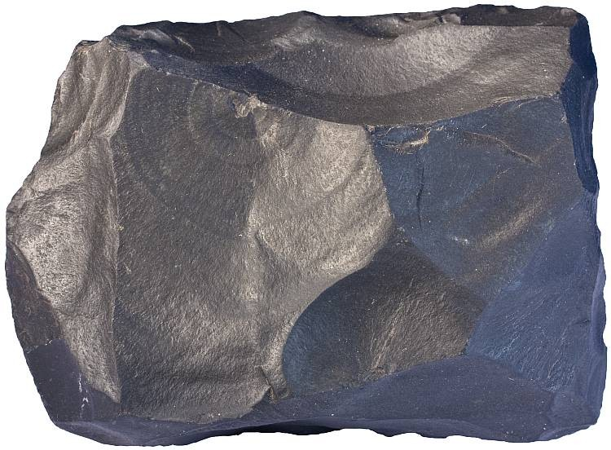
rocks.
- Unstratified rocks: These rocks are unstratified. The structure may be crystalline granular or compact granular. The igneous rocks of volcanic agency and sedimentary rocks affected by movements of the earth are this type of rocks.
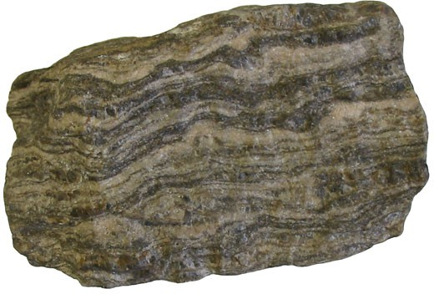
- Foliated rocks: These rocks have a tendency to be split up in a definite direction only. The foliated structure is very common in case of metamorphic rocks.

- Chemical classification: This classification is known as the scientific or engineering classification and according to this classification, the rocks are of the three following the type;
  - Silicious rocks;
  - Argillaceous rocks; and
  - Calcareous rocks.
- Silicious rocks: In these rocks, the silica predominates. The rocks are hard and durable. They are not easily affected by the weathering agencies. The silica however in combination with weaker minerals may disintegrate easily. It is therefore necessary that these rocks should contain maximum

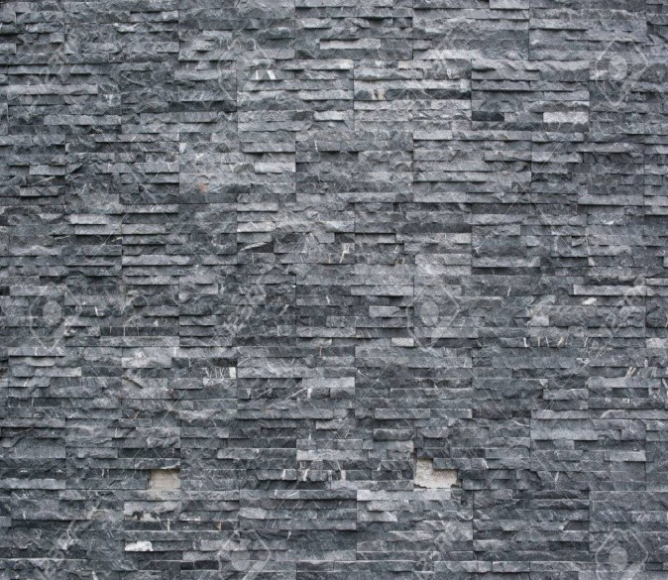
amount of free silica for making them hard and durable. The granites, quartzites, etc. are examples of siliceous rocks.
- Argillaceous rocks: In these rocks, the argil or clay predominates. Such rocks may be dense and compact or they may be soft. These stones are hard and durable but brittle. The slates, laterites, etc. are examples of the argillaceous rocks.
- Calcareous rocks: In these rocks, the calcium carbonate predominates. The durability of these rocks will depend upon the constituents present in the surrounding atmosphere. The limestones, marbles, etc. are examples of calcareous rocks.

USES OF STONES:
  - Structure: The stones are used for foundations walls, columns, lintels, arches, roofs, floors, damp-proof course, etc.
  - Face-work: The stones are adopted to give massive appearance to the structure. The walls are of bricks and facing is done in stones of desired shades. This is known as the composite masonry.
  - Paving: The stones are used to cover floor of buildings of various types such as residential, commercial, industrial, etc. They are also adopted to form paving of roads, footpaths, etc.
  - Basic material: The stones are disintegrated and converted to form a basic material for cement concrete, murum of roads, calcareous cements, artificial stones, hollow blocks, etc.
  - Miscellaneous: In addition to above uses the stones are also used as:
    - ballast for railways,

    - flux in blast furnace,
    - blocks in the construction of bridges, piers, abutments, retaining walls, light houses, dams, etc.

NATURAL BED OF STONES:
Definition: The building stones are obtained from rocks. These rocks have a distinct plane of division along which stone can easily be split. This plane is known as the natural bed of stone.
Importance:
      - In stone masonry, the general rule to be observed is that the direction of natural bed of all sedimentary stones should be perpendicular or nearly so to the direction of pressure. Such an arrangement gives maximum strength to the stonework.
      - The natural beds of stones can be detected by pouring water and examining the directions of layers. The magnifying glass may also be used for this purpose.

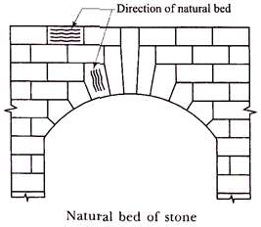
With respect to natural bed, the stones are placed in different situations as follows:
- Arches: The stones are placed with their natural beds radial.
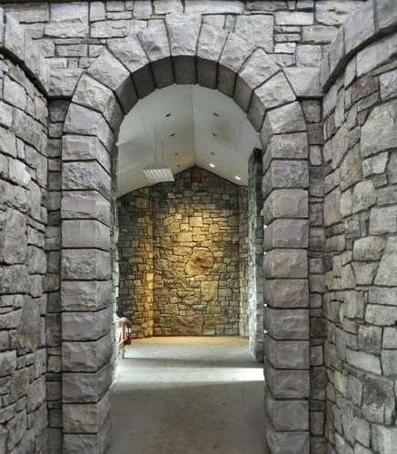
- Cornices, string courses, etc.: The stones are partially unsupported in case of cornices, string courses, etc. Hence they should be placed with direction of natural beds as vertical.
- Walls: The stones should be placed in walls with the direction of their natural beds horizontal.
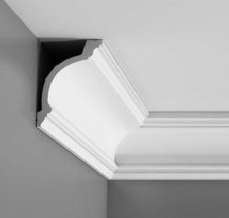
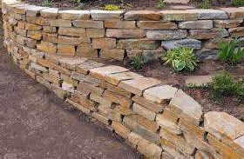


Continue…. [STONE]

QUALITIES OF A GOOD BUILDING STONE
Following are the qualities or characteristics or requirements of a good building stone:
  - Crushing strength: For a good structural stone, the crushing strength should be greater than 100 N/mm².
  - Appearance: The stones which are to be used for face work should be decent in appearance and they should be capable of preserving their colour uniformly for long time.
  - Durability: A good building stone should be durable. The various factors contributing to durability of a stone are its chemical composition, texture, resistance to atmospheric and other influences, location in secure, etc.
  - Facility of dressing: The stones should be such that they can be easily carved, moulded, cut and dressed. This property of stones is opposed to its strength, durability and hardness.

  - Fractures: For a good building stone, its fracture should be sharp, even, bright and clear with grains well cemented together. A dull, chalky and earthly fracture of a stone indicates signs of early future decay.
  - Hardness: The coefficient of hardness, as worked out in hardness test, should be greater than 17 for a stone to be used in road work. If it is between 14 and 17, the stone is said to be of medium hardness. If it is less than 14, the stone is said to be of poor hardness and such stone should not be used in road work.
  - Percentage wear: In Attrition test, if wear is more than 3 per cent. the stone is not satisfactory. If it is equal to 3 per cent, the stone is just tolerable. For a good building stone, the wear should be equal to or less than 3 per cent.
  - Resistance to fire: The minerals composing stone should be such that shape of stone is preserved when a fire occurs. The failure of stones in case of a fire is due to various reasons such as rapid rise in temperature, sudden cooling, different coefficients of linear expansions of minerals, etc. The free quartz suddenly expands at a temperature lower than 600°C.

  - Seasoning: The stones should be well seasoned before putting into use. The stones obtained fresh from a quarry contain some moisture which is known as the quarry sap. The stone should be dried or seasoned before they are used in structural work. A period of about 6 to 12 months is considered to be sufficient for proper seasoning.
  - Specific gravity: For a good building stone, its specific gravity should be greater than 2.7 or so. The heavy stones are more compact and less porous and they can be used for various engineering applications such as dams, weirs, retaining walls, docks, harbours, etc.
  - Texture: A good building stone should have compact fine crystalline structure free from cavities, cracks or patches of soft or loose material. The stones with such texture are strong and durable.
  - Toughness index: In impact test, if the value of toughness index comes below 13, the stone is not tough. If it comes between 13 and 19, the stone is said to be moderately tough. If it exceeds 19, t he toughness of stone is said to be high.

  - Water absorption: All the stones are more or less porous, but for a good stone, percentage absorption by weight after 24 hours should not exceed 0.60.
  - Weathering: A good building stone should possess better weathering qualities. It should be capable of withstanding adverse effects of various atmospheric and external agencies such as rain, frost, wind, etc. The stones having excellent weathering qualities should only be used in the construction of important buildings.

DRESSING OF STONES:
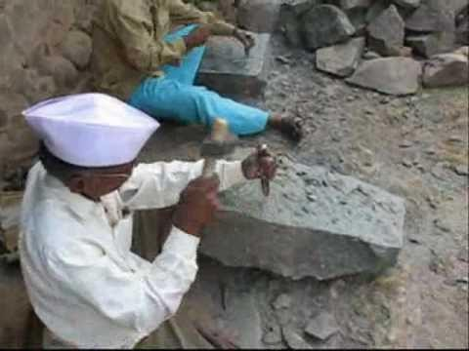
The stones, after being quarried, are to be cut into suitable sizes and with suitable surfaces. This process is known as the dressing of stones.
It is carried out for the following purposes:
    - to get the desired appearance from stone work,
    - to make the transport from quarry easy and economical,
    - to suit to the requirements of stone masonry,
    - to take advantage of local men near quarry who are trained for such type of work, etc.


Following are the varieties of finishes obtained by the dressing of stones:

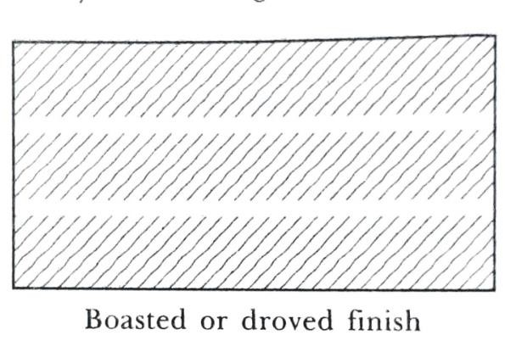
      - Axed finish: The surfaces of hard stones such as granite are dressed by means of an axe. Such a finish is termed as an axed finish.
      - Boasted or droved finish: In this type of finish, the boaster is used to make non-continuous parallel marks on the stone surface. These marks may be horizontal, inclined or vertical. A boaster is a chisel having an edge of width about 60 mm.
      - Chisel-draughted margins: In order to obtain uniform joints in stone work, the margins are placed which may be either squared or pitched or chamfered.
      - Circular finish: In this type of finish, the surface of stone is made round or circular as in case of a column.

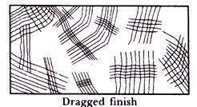
      - Dragged or combed finish: In this type of finish a drag or a comb, which is a piece of steel with a number of teeth, is rubbed on the surface in all directions and surface, is obtained.
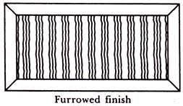
This finish is suitable for soft stones only.
      - Furrowed finish: In this type of finish, a margin of about 20 mm width, is sunk on all the edges of stone and the central portion is made to project about 15 mm.
A number of vertical or horizontal grooves about 10 mm wide are formed in this projected portion. This finish is generally adopted to make the quoins prominent.
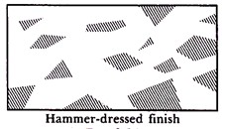
      - Moulded finish: The surface of stone can be moulded in any desired shape so as to improve the appearance of the work. The mouldings can be made either by hand or machine.
      - Hammer-dressed finish: In this type of finish, the stones are made roughly square or rectangular by means of a Waller's hammer. The hammer dressed stones have no sharp or irregular

corners and have comparatively even surface so as to fit well in masonry.
      - Plain finish: In this type of finish, the surface of the stone is made approximately smooth with a saw or with a chisel.
      - Polished finish: The surface of the stones such as marbles, granites, etc. can be polished either with hand or with machine.
      - Punched machine: On the stone surface, the depressions are made by using a punch. The surface of the stone takes the form of a series of hollows and ridges.
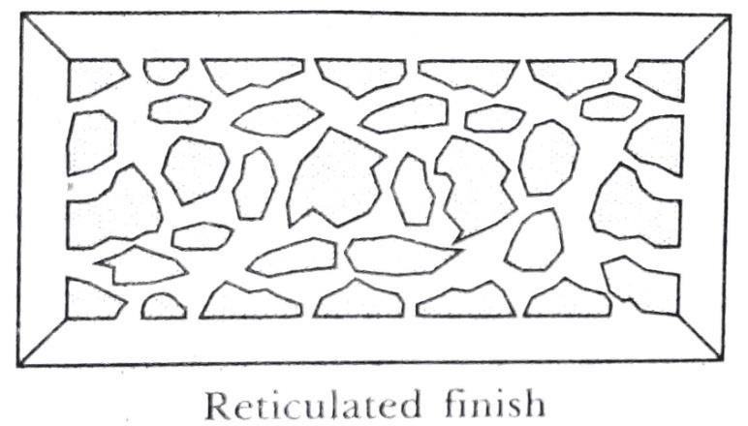
      - Reticulated finish: The type of finish presents a net- like appearance. A margin, about 20 mm wide, is marked on the edges of stone and irregular sinking are made on the enclosed space. A margin, about 10 mm wide, is provided around the irregularly shaped sinking, having a depth of about 5 mm. A pointed tool is used to put the marks on the sunk surface so as to present a pock-marked appearance.

      - Rubbed finish: This type of finish is obtained by rubbing a piece of stone with the surface or by rubbing the surface with the help of a suitable machine. The water and sand are freely used to accelerate the process of rubbing.
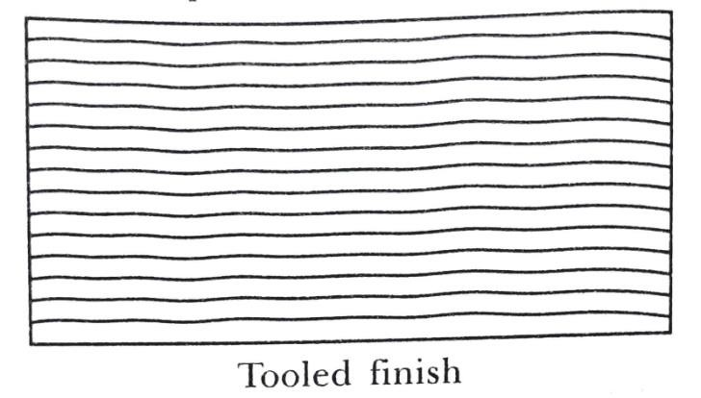
      - Scabbling finish: In this type of finish, the irregular projections are removed with a scabbling hammer and in this way, the stones are roughly dressed.
  - Tooled finish: The stone surface is finished by means of a chisel and parallel continuous marks, either horizontal or inclined or vertical, are left on the surface.
  - Self-faced or rock-faced or quarry-faced finish:
Some stones, as obtained from the quarry, possess smooth surface and they can be directly placed on the work. Such a stone surface is termed as self- faced or rock-faced or quarry-faced finish.
  - Sunk finish: This finish is obtained by sinking the surface below the original level in the form of wide grooves, chamfers, inclined surfaces, etc.

  - Vermiculated finish: This finish is just similar to reticulated type except that the sinking are more curved. This finish presents a worm-eaten appearance.

COMMON BUILDING STONES OF INDIA

No. | Stone | Classification | Qualities | Uses
1. | Basalt and trap | Igneous | Hard and tough: difficult to work. Its sp. gr. is 3 and compressive strength varies from 150 to 185 N/mm². Its weight varies from 18 to 29 kN  per m³. | Road metal, for rubble masonry, foundation work, etc.
2. | Chalk | Sedimentary | Pure white limestone; soft and easy to form powder. | In preparing glazier’s putty; as colouring material in manufacture of  Portland cement.
3. | Gneiss | Metamorphic | Splits into thin slab; easy to work. Its sp. gr. is 2.69 and compressive strength is 206  N/mm². | Street paving, rough stone masonry work, etc.
4. | Granite | Igneous | Hard, durable and available in  different colours, highly | Steps, sills, facing  work, walls, bridge

 |  |  | resistant to natural forces, can take nice polish. Its sp. gr. varies from 2.6 to 2.7 and compressive  Strength varies from 75 to 127  N/mm². Its weight is about 26 to 27 kN per m³. | piers, columns, road metal, ballast, etc. It is unsuitable for carving.
5. | Kankar | Sedimentary | Impure limestone. | Road metal, manufacture of  hydraulic lime, etc.
6. | Laterite | Metamorphic | Porous and spongy structure; easily quarried in blocks; contains high percentage of oxide of iron; available in different colours. Its compressive strength varies from 1.80 to 3.10 N/mm². | Building stone, road metal. rough stone masonry work, etc.

7. | Limestone | Sedimentary | Consists of carbonate of lime; easy work. Its sp. gr. varies from  2.00 to 2. 75 and compressive strength is 54 N/mm². | Floors, steps, walls, road metal, manufacture of lime in blast furnace, etc.
8. | Marble | Metamorphic | Can take good polish and available in different colours. Its sp. gr. is 2.65 and compressive strength is 71 N/mm². | Flooring, facing work, columns, steps, ornamental work, etc. It can take nice polish. It can easily be sawn and carved.
9. | Murum | Metamorphic | Decomposed laterite, deep brown or red in colour. | Blindage for metal roads, for fancy paths and garden walls.

10. | Quartzite | Metamorphic | Hard, brittle, crystalline and compact; difficult to work and dress. | Retaining walls, road metal, concrete aggregate, pitching, rubble masonry, facing of buildings, etc.
11. | Sandstone | Sedimentary | Consists of quartz and other minerals, easy to work and dress and available in different colours. Its sp. gr. varies from  2.65 to 2.95 and compressive strength is 64 N/mm². Its weight  is about 20 to 22 kN per m³. | Steps, facing work, columns, flooring, walls, road metal, ornamental carving, etc.
12. | Slate | Metamorphic | Black colour and splits along natural bedding planes; non- absorbent. Its sp. gr. is 2.89 and compressive strength varies  from 75 to 207 N/mm². | Roofing work, sills, damp-proof courses, etc.
***END***

CHAPTER:-02 [BRICKS]

Introduction: Bricks are the most commonly used construction material. Bricks are prepared by moulding clay in rectangular blocks of uniform size and then drying and burning these blocks.
Constituents of good brick earth:
Following are the constituents of good brick earth:
- Alumina
- Silica
- Lime
- Oxide of iron
- Magnesia
- ​Alumina:
  - It is the chief constituent of every kind of clay. A good brick earth should contain about 20% to 30% of alumina.
  - This constituent imparts plasticity to the earth so that it can be moulded.

  - If alumina is present in excess, with inadequate quantity of sand, the raw bricks shrink and warp during drying and burning.
- ​Silica:
  - A good brick earth should contain about 50 per cent to 60 per cent of silica.
  - The presence of this constituent prevents cracking, shrinking and warping of raw bricks. It thus imparts uniform shape to the bricks.
  - The durability of bricks depends on the proper proportion of silica in brick earth.
  - The excess of silica destroys the cohesion between particles and the bricks become brittle.
- ​Lime:
  - A small quantity of lime not exceeding 5 per cent is desirable in good brick earth.
  - The lime prevents shrinkage of raw bricks.
  - The sand alone is infusible. But it slightly fuses at kiln temperature in presence of lime. Such fused sand works as a hard cementing material for brick particles.
  - The excess of lime causes the brick to melt and hence its shape is lost.
- ​Oxide of iron:
  - A small quantity of oxide of iron to the extent of about 5 to 6 per cent is desirable in good brick earth.

  - It helps as lime to fuse sand. It also imparts red colour to the bricks.
  - The excess of oxide of iron makes the bricks dark blue or blackish.
- ​Magnesia:
  - A small quantity of magnesia in brick earth imparts yellow tint to the bricks and decreases shrinkage.
  - But excess of magnesia leads to the decay of bricks.

MANUFACTURE OF BRICKS:
In the process of manufacturing bricks, the following four distinct are involved:
- Preparation of clay
- Moulding
- Drying
- Burning
Each of the above operation of the manufacturing bricks will now be studied at length.
- Preparation of clay: The clay for bricks is prepared in the following order:
  - Unsoiling (iv) Weathering

  - Digging (v) Blending
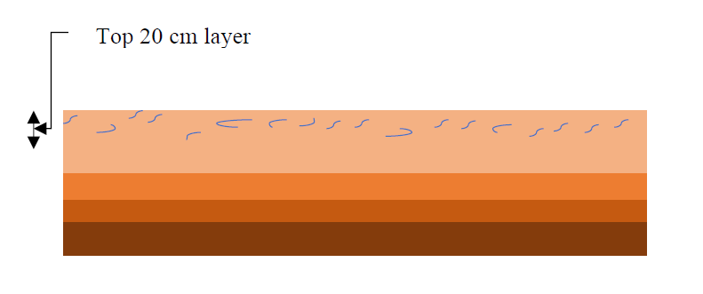
  - Cleaning (vi) Tempering
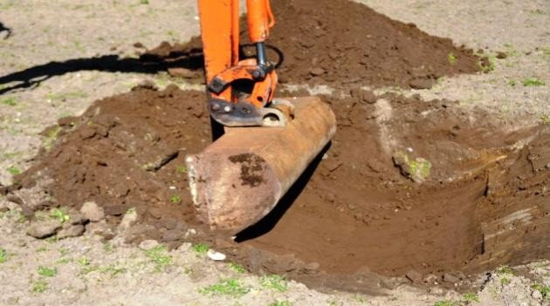
- ​Unsoiling: The top layer of the soil, about 200mm in depth, is taken out and thrown away. The clay in top soil is full of impurities and hence it is to be rejected for the purpose of preparing bricks.
- Digging: The clay is then dug out from the ground. It is spread on the levelled ground, just a little deeper than the general level of ground. The height of heaps of clay is about 600mm to 1200mm.
- ​Cleaning: The clay, as obtained in the process of digging, should be dean of stones, pebbles, vegetable matter, etc. If these particles are in excess, the clay is to be washed and screened. Such a process naturally will prove to be troublesome and expensive. The lumps of clay should be converted into powder form in the earth crushing roller.
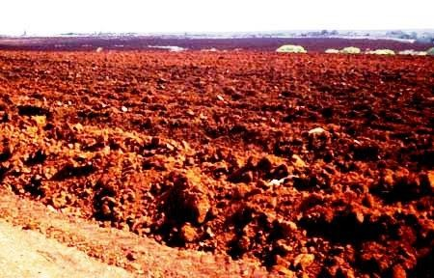
- ​Weathering: The clay is then exposed to atmosphere for softening or mellowing. The period of exposure varies from

few weeks to full season. For a large project, the clay is dug out just before the monsoon and it s allowed to weather throughout the monsoon.
- ​Blending: The clay is made loose and any ingredient to be added to it, is spread out at its top. The blending indicates intimate or harmonious mixing. It is carried out by taking small portion of clay every time and by turning it up and down in vertical direction. The blending makes clay fit for the next stage of tempering.
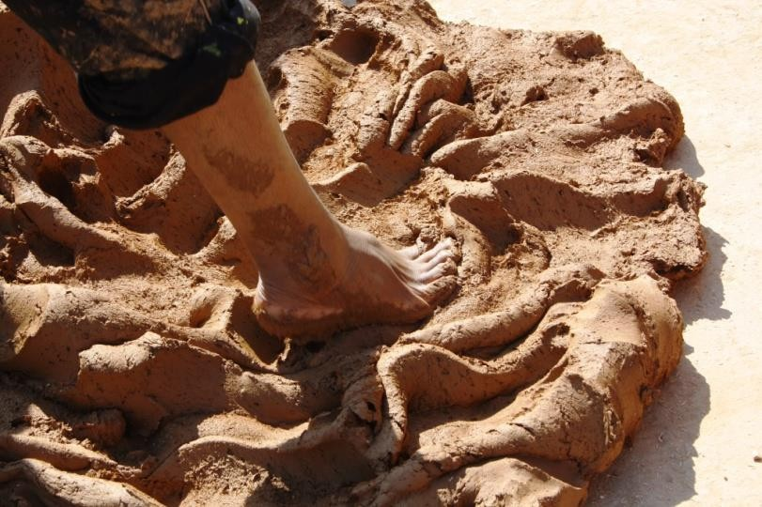
- ​Tempering: In the process of tempering the clay is brought to proper degree of hardness and it is made fit for the next operation of moulding. The water in required
quantity is added to clay and the whole mass is kneaded or pressed under the feet of men or cattle. The tempering should be done exhaustively to obtain homogeneous mass of clay of uniform character.
*Pug mill:
For manufacturing good bricks on a large scale, the tempering is usually done in a pug mill. A typical pug mill capable of tempering sufficient earth for a daily output of

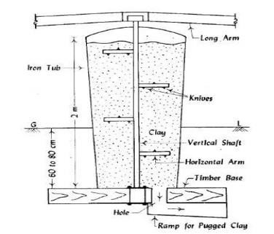
about 15000 to 20000 bricks. The process of grinding clay with water and making it plastic is known as the pugging.
  - A pug mill consists of a conical iron tub with cover at its top.
  - It is fixed on a timber base which is made by fixing two wooden planks at right angles to each other.
  - The bottom of tube is covered except for the hole to take out pugged earth.
  - The top and bottom diameter of pug mill is about 1000mm & 800mm respectively and height is about 2m.Its depth below ground is about 600mm to 800mm.
  - A vertical shaft with number of horizontal arms furnished with small wedge- shaped knives for breaking clay lumps is provided at the centre of iron tube.
  - The long arms are fixed at the top of vertical shaft to attach a pair of bullocks.
  - In the beginning, the hole for pugged clay is closed and clay with water is placed in pug mill from the top.
  - When clay has been sufficiently pugged, the hole at the bottom of tube, is opened out and the pugged earth is taken out.

  - If tempering is properly carried out, the good brick earth can then be rolled without breaking in small threads of 3 mm diameter.
- Moulding: The clay which is prepared as above is then sent for the next operation of moulding. Following are the two ways of moulding:
  - Hand moulding
  - Machine moulding
(i) Hand moulding:
- In hand moulding, the bricks are moulded by hand i.e., manually.
- It is adopted where manpower is cheap and is readily available for the manufacturing process of bricks on a small scale.
- The moulds are rectangular boxes which are open at top and bottom. They may be of wood or steel.
- The bricks shrink during drying and burning. Hence the moulds are to be made larger the size of fully burnt bricks.
- The moulds are therefore made longer by about 8 to 12 percent in all directions.

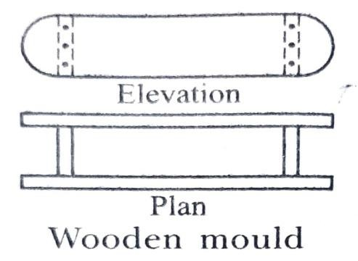
A typical wooden mould should be prepared from well seasoned wood. The longer sides are kept slightly projecting to serve as handles. The strips of brass or steel are sometimes fixed on the edges of wooden moulds to make them more durable.
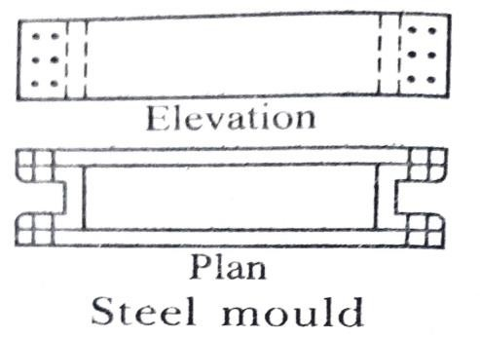
A typical steel mould is prepared from the combination of steel plates and channels. It may even be prepared from steel angles and plates. The thickness of steel mould is generally 6 mm. They are used for manufacturing bricks on a large scale.
The bricks prepared by hand moulding are of two types:
- Ground-moulded bricks
- Table-moulded bricks
- Ground-moulded bricks:
  - The ground is first made level and fine sand is sprinkled over it.
  - The mould is dipped in water and placed over the ground.
  - The lump of tempered clay is taken and it is dashed in the mould.

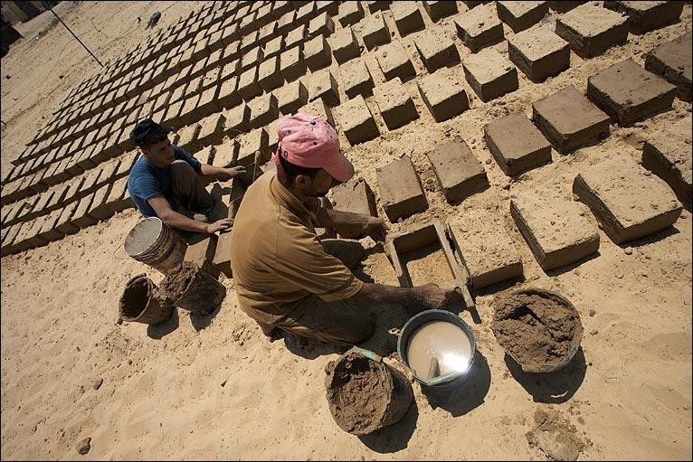
  - The clay is pressed or forced in the mould in such a way that it fills all the corners of mould.
  - The bricks prepared by dipping mould in water every time are known as the slope-moulded bricks.
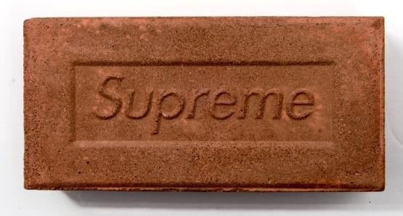
  - Fine sand or ash may be sprinkled on the inside surface of mould instead of dipping mould in water are known as the sand-moulded bricks.

- A frog is a mark of depth about 10 mm to 20mm which is placed on raw bricks during moulding.
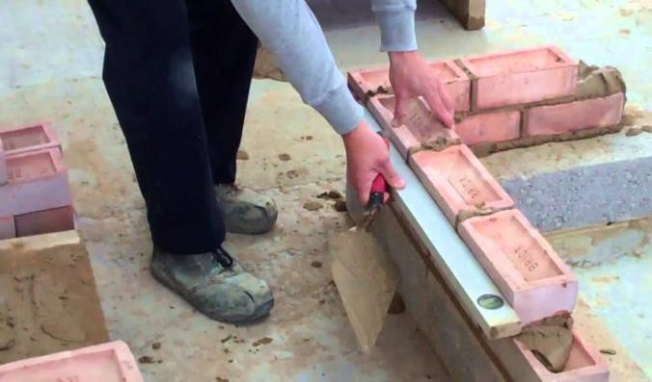
It serves two purposes:
- It indicates the trade name of the manufacture.
- In brickwork, the bricks are laid with frog uppermost. It thus affords a key for mortar when the next brick is placed over it.

- Table-moulded bricks:
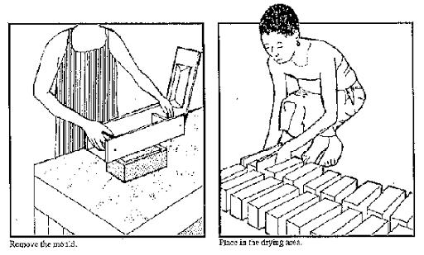
  - The process of moulding these bricks is just similar as hand moulded bricks.
  - In this case the moulder stands near a table of size about 2m × 1m.
  - The bricks are moulded on the table and sent for the further process of drying.
  - Efficiency of moulder decrease gradually because of standing at the same place for long duration.
  - The cost of moulding is more than the hand moulding bricks.
(ii) Machine moulding:
- The moulding may also be achieved by machines.
- It proves to be economical when bricks in huge quantity are to be manufactured at the same spot in a short time.
These machines are broadly classified in two categories:

- Plastic clay machines
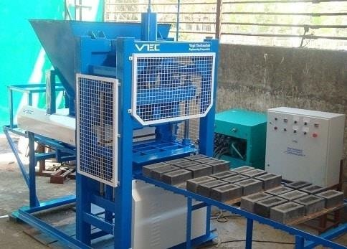
- Dry clay machines.
- Plastic clay machines:
  - Such machines contain a rectangular opening of size equal to length and width of a brick.
  - The pugged clay is placed in the machine and as it comes out through the opening, it is cut into strips by wires fixed in frames.
  - As the bricks are cut by wire, they are also known as the wire cut bricks.
- Dry clay machines:
  - In these machines, the strong clay is first converted into powder form.
  - A small quantity of water is then added to form a stiff plastic paste.
  - Then paste is placed in mould and pressed by machine to form hard and well shaped bricks.
  - These bricks are known as the pressed bricks and they do not practically require drying.
  - They can be sent directly for the process of burning.

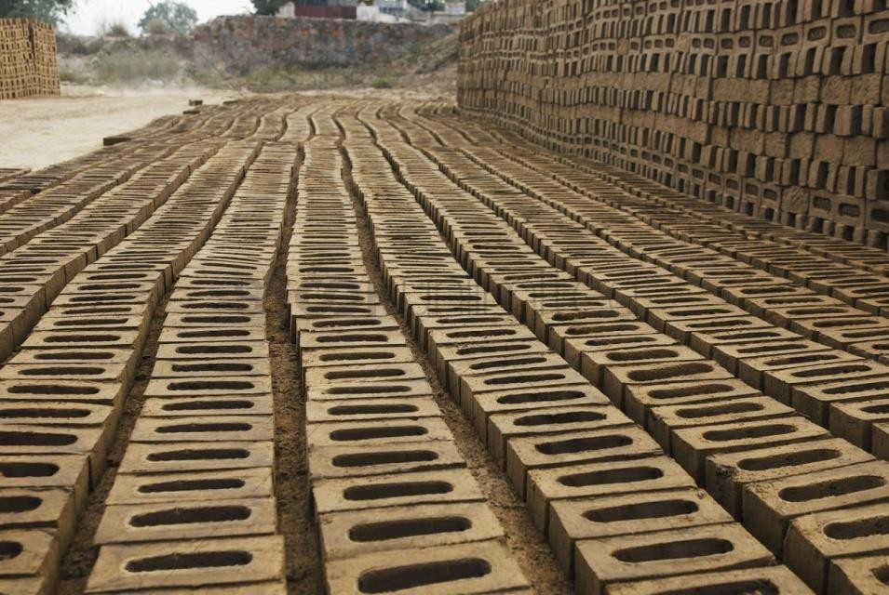
- Drying:
- The damp bricks, if burnt, are likely to be cracked and distorted.
- For drying, the bricks are laid longitudinally in stacks of width equal to two bricks.
- A stack consists of eight or ten tiers. The bricks are laid along and across the stock in alternate layers. All bricks are placed on edge.
- The bricks should be allowed to dry till they become leather hard or bone-dry with moisture content of about 2 per cent or so.
The important facts to be remembered in connection with the drying of bricks are as follows:
  - Artificial drying:
    - The bricks are generally dried by natural process.
    - When bricks are to be rapidly dried on a large scale, the artificial drying may be adopted.

    - In such a case, the moulded bricks are allowed to pass through special dryers which are in the form of tunnels or hot channels or floors.
    - The temperature is usually less than 120°C and the process of drying of bricks takes about 1 to 3 days depending upon the temperature maintained in the dryer.
  - Circulation of air:
    - The bricks in stacks should be arranged in such a way that sufficient air space is left between them for free circulation of air.
  - Drying yard:
    - For the drying purpose, special drying yards should be prepared.
    - It should be slightly on a higher level and it is desirable to cover it with sand.
    - Such an arrangement would prevent the accumulation of rain water.
  - Period for drying:
    - The time required by moulded bricks to dry depends on prevailing weather conditions. Usually it takes about 3 to 10 days for bricks to become dry.

  - Screens:
    - It is to be seen that bricks are not directly exposed to the wind or sun for drying. Suitable screens, if necessary, may be provided to avoid such situations.
- Burning:
- This is a very important operation in the manufacture of bricks.
- It imparts hardness and strength to the bricks and makes them dense and durable.
- The bricks should be burnt properly. If bricks are over burnt, they will be brittle and hence break easily. If they are under burnt, they will be soft and hence cannot carry loads.
- When the temperature of dull red heat, about 650°C, is attained, the organic matter contained in the brick is oxidized and also the water of crystallization is driven away.
- But heating of bricks is done beyond this limit for the following purposes:
  - If bricks are cooled after attaining the temperature of about 650°C, the bricks formed will absorb moisture from the air and get rehydrated.

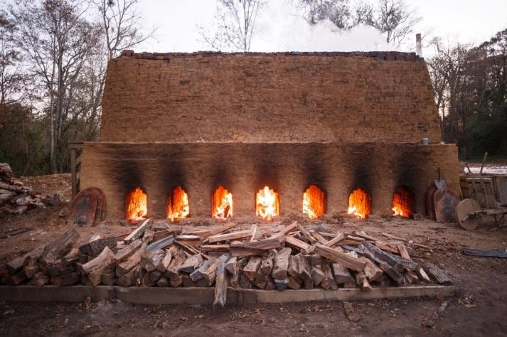
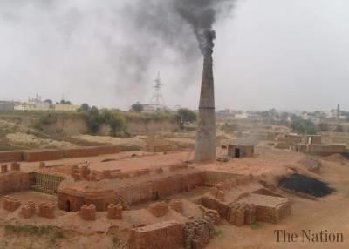
  - The reactions between the mineral constituents of clay are achieved at higher temperature and these reactions are necessary to give new properties such as strength, hardness, less moisture
absorption, etc. to the bricks.
- When the temperature of about 1100°C is reached, the particles of two important constituents of brick clay, namely, alumina and sand, bind themselves together resulting in the increase of strength and density of bricks.

- Further heating is not desirable and if the temperature is raised beyond 1100°C, a great amount of fusible glassy mass is formed and the bricks are said to be vitrified.
- The burning of bricks is done either in clamps or in kilns.
- The clamps are temporary structures and they are
adopted to manufacture bricks on a small scale to serve a local demand or a specific purpose.
- The kilns are permanent structures and they are adopted to manufacture bricks on a large scale.

Continue…. [BRICKS]
Bricks can be burnt using the following methods:
- Clamp Burning
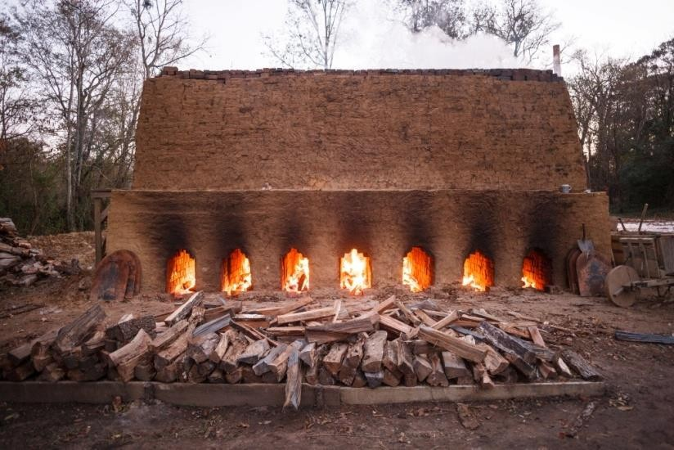
- Kiln Burning
- Clamp Burning:
  - A piece of ground is selected. Its shape in plan is generally trapezoidal. The floor of clamp is prepared in such a way that short end is slightly in the excavation and wider end is raised at an angle of about 15° from ground level.
  - The brick wall in mud is constructed on the short end and a layer of fuel is laid on the prepared floor. The fuel may consist of grass, cow dung, litter, husks of rice or ground nuts, etc. The thickness of this layer is about 700 mm to 800 mm. The wood or coal dust may also be used as fuel.
  - A layer, consisting of 4 or 5 courses of raw bricks, is then put up. The bricks are

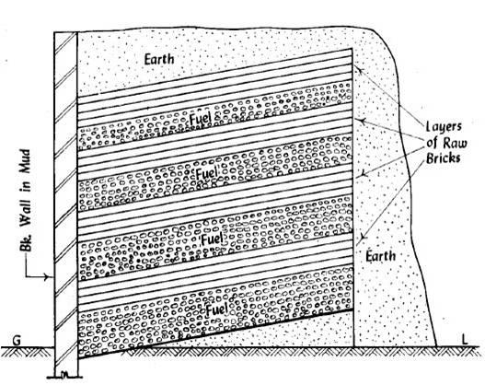
laid on edges with small spaces between them for the circulation of air.
  - A second layer of fuel is then placed and over it, another layer of raw bricks is put up. Thus alternate layers of fuel and raw bricks are formed. The thickness of fuel layer gradually decreases as the height of clamp increases.
  - The total height of a clamp is about 3 m to 4 m.
When nearly one-third height is reached, the lower portion of the clamp is ignited. The object for such an action is to burn the bricks in lower part when the construction of upper part of clamp is in progress.
  - When clamp is completely constructed, it is plastered with mud on sides and top and filled with earth to prevent the escape of heat. If there is any sudden and violent outburst of fire, it is put down by throwing earth or ashes.
  - The clamp is allowed to burn for a period of about one to two months.
  - It is then allowed to cool for more or less the same period as burning.
  - The burnt bricks are then taken out from the clamp.

- Kiln Burning:
A kiln is a large oven which is used to burn bricks. The kilns which are used in the manufacture of bricks are of the following two types:
- Intermittent kilns
- Continuous kilns.
- Intermittent kilns: These kilns are intermittent in operation which means that they are loaded, fired, cooled and unloaded. Such kilns may be either rectangular or circular in plan. They may be overground or underground. They are classified in two ways:
  - Intermittent up-draught kilns (ii)Intermittent down-draught kilns.
- Continuous kilns: These kilns are continuous in operation. This means that loading, firing, cooling and unloading are carried out simultaneously in these kilns. There are

various types of the continuous kilns. Following three varieties of continuous kilns will be discussed:
  - Bull's trench kiln (ii)Hoffman's kiln
(iii) Tunnel kiln.
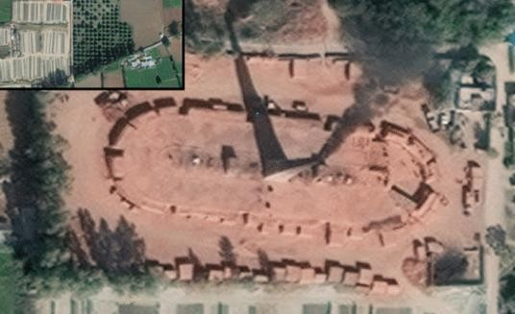
- Bull's trench kiln:
  - This is the most widely used kiln in India and it gives continuous supply of bricks.
  - This kiln may be of rectangular, circular or oval shape in plan. A typical Bull's kiln of oval shape in plan.
  - As the name suggests, the kiln is constructed in a trench excavated
in ground. It may be fully underground or partly projecting above ground.

  - The ramps of earth should be provided on outside walls. The outer and inner walls are to be constructed of bricks.
  - The openings are generally provided in the outer walls to act as flue holes.
  - The dampers are in the form of iron plates and they are used to divide the kilns in suitable sections.
  - The bricks are arranged in such a way that flues are formed.
  - The fuel is placed in flues and it is ignited through flue holes after covering top surface with earth and ashes to prevent the escape of heat.
  - The flue holes are provided in sufficient number on top to insert fuel when burning is in progress.
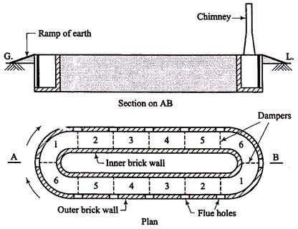
  - Usually the two movable iron chimneys are employed to form draught.
  - These chimneys are placed in advance of section being fired. Hence the hot gases leaving the chimneys warm up the bricks in next section.
  - Each section requires about one day to burn.

  - A tentative arrangement for different sections may be as follows: Section 1 – loading
Section 2 – empty Section 3 – unloading Section 4 – cooling Section 5 –burning Section 6 – heating

- Hoffman's kiln:
  - This kiln is constructed overground and hence it is sometimes known as the flame kiln.
  - Its shape is circular in plan and it is divided into a number of compartments or chambers.
  - As a permanent roof is provided, the kiln can even function during rainy season.
  - A plan and section of the Hoffman's kiln with 12 chambers.
  - Each chamber is provided with the following:
- a main door for loading and unloading of bricks,
- communicating doors which would act as flues in open condition,
- a radial flue connected with a central chimney, and

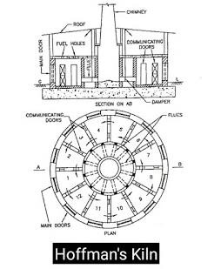
- fuel holes with covers to drop fuel, which may be in the form of powdered coal, into burning chambers.
  - Each chamber performs various functions such as loading, drying, burning, cooling and unloading;
Chamber 1 - Loading
Chambers 2 to 5 - Drying and pre-heating Chambers 6 and 7 - Burning
Chambers 8 to 11 - Cooling Chamber 12 - Unloading.
  - The cool air enters through chambers 1 and 12 as their main doors are open.
  - After crossing the cooling chambers 8 to 11, it enters the burning section in a heated condition.
  - It then moves to chambers 2 to 5 to dry and pre-heat the raw bricks.
  - The damper of chamber 2 is in open condition and hence it escapes into atmosphere through chimney.
  - Each chamber is of about 11m length, 4.50m average width and 2.50 m height, it is capable of manufacture about 25000 bricks per day.
  - The quantity of coal dust required for burning one lakh of bricks is about 120 to 150 kN.

COMPARISON BETWEEN BULL'S TRENCH KILN AND HOFFMAN'S KILN
No. | Item | BULL'S TRENCH KILN | HOFFMAN'S KILN
1. | Burning capacity | About 3 lakhs in 12 days. | About 40 lakhs in one season.
2. | Continuity of working | It stops functioning during monsoon as it is not provided  with a permanent roof. | It functions all the year round as it is provided with a permanent  roof.
3. | Cost of fuel | High as consumption of fuel  is more. | Low as consumption of fuel is  less.
4. | Drying space | It requires more space for drying of bricks. | It requires less space for drying of bricks.
5. | Initial cost | Low | High
6. | Nature | It is semi-continuous in loose  sense. | It is perfectly continuous.
7. | Popularity | More popular because of less initial cost. | Less popular because of high initial cost .
8. | Quality of bricks | Percentage of good quality  bricks is small. | Percentage of good quality  bricks is more.

9. | Suitability | Suitable when demand of bricks in monsoon is not  substantial. | Suitable when demand of bricks is throughout the year.

- Tunnel kiln:
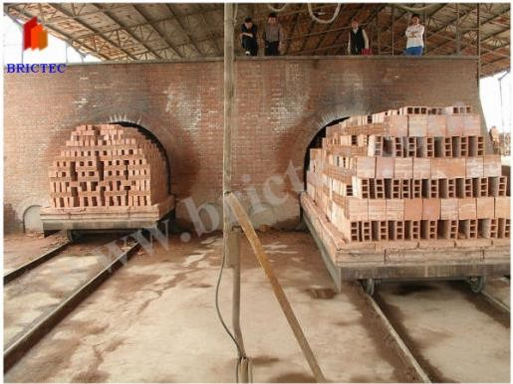
  - This type of kiln is in the form of tunnel which may be straight, circular or oval in plan.
  - It contains a stationary zone of fire. The raw bricks are placed on trolleys which are then moved from one end to the other end of tunnel.
  - The raw bricks get dried and pre-heated as they approach zone of fire.
  - In zone of fire, the bricks are burnt to the required degree and they are then pushed forward for cooling.
  - When bricks are sufficiently cooled, they are unloaded.

CLASSIFICATION OF BRICKS
The bricks can broadly be divided into two categories as follows:
- unburnt or sun-dried bricks, and
- burnt bricks.
- unburnt bricks: The unburnt or sun-dried bricks are dried with the help of heat received from sun after the process of moulding. These bricks can only be used in the construction of temporary and cheap structures. Such bricks should not be used at places exposed to heavy rains.
- burnt bricks: The bricks used in construction works are burnt bricks and they are classified into the following four categories:
  - First class bricks (3) Third class bricks
  - Second class bricks (4)Fourth class bricks.
- First class bricks: These bricks are table-moulded and of standard shape and they are burnt in kilns. The surfaces and edges of the bricks are sharp, square, smooth and

straight. They comply with all the qualities of good bricks. These bricks are used for superior work of permanent nature.
- Second class bricks: These bricks are ground-moulded and they are burnt in kilns. The surface of these bricks is somewhat rough and shape is also slightly irregular. These bricks may have hair cracks and their edges may not be sharp and uniform. These bricks are commonly used at places where brickwork is to be provided with a coat of plaster.
- Third class bricks: These bricks are ground-moulded and they are burnt in clamps. These bricks are not hard and they have rough surfaces with irregular and distorted edges. These bricks give dull sound when struck together. They are used for unimportant and temporary structures and at places where rainfall is not heavy.
- Fourth class bricks: These are overburnt bricks with irregular shape and dark colour. These bricks are used as aggregate for concrete in foundations, floors, roads, etc. because of the fact that the overburnt bricks have a compact structure and hence they are sometimes found to be stronger than even the first class bricks.

SIZE OF BRICKS
  - For India, standard size of brick is 190mm × 90mm × 90mm.
  - Nominal size (with mortar ) is 200mm × 100mm × 100mm.

QUALITIES OF GOOD BRICKS
The good bricks which are to be used for the construction of important structures should possess the following qualities:
- The bricks should be table-moulded, well-burnt in kilns, copper-coloured, free from cracks and with sharp and square edges. The colour should be uniform and bright.
- The bricks should be uniform in shape and should be of standard size.
- The bricks should give a clear metallic ringing sound when struck with each other.
- The bricks when broken or fractured should show a bright homogeneous and uniform compact structure free from voids.

- The brick should not absorb water more than 20 per cent by weight for first class bricks and 22 per cent by weight for second class bricks, when soaked in cold water for a period of 24 hours.
- The bricks should be sufficiently hard. No impression should be left on brick surface, when it is scratched with finger nail.
- The bricks should not break into pieces when dropped flat on hard ground from a height of about one metre.
- The bricks should have low thermal conductivity and they should be sound- proof.
- The bricks, when soaked in water for 24 hours, should not show deposits of white salts when allowed to dry in shade.
- No brick should have the crushing strength below 5.50 N/mm².

***END***

PART-A (BUILDING MATERIALS)

CHAPTER:-03 [CEMENT]
Introduction:
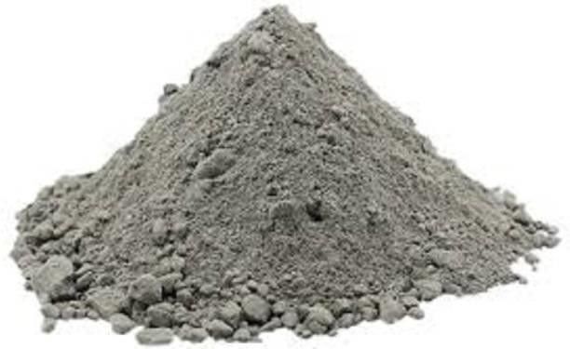
  - Cement is a building material for binding bricks, stones or aggregates.
  - It has cohesive and adhesive properties in the presence of water.
  - Cement was inverted by ‘ Joseph Aspdin ’ in England
in 1824.
  - Used for making mortar or concrete.
  - Natural cement:-burning and crushing of stones and lime.
  - Artificial cement:-burning at high temperature and gypsum is added.

COMPOSITION OF ORDINARY CEMENT
  - The ordinary cement contains two basic ingredients, namely, argillaceous and calcareous.
  - In argillaceous materials, the clay predominates and in calcareous materials, the calcium carbonate predominates.

Ingredient | Percentage | Range
Lime | (CaO) 62 | 62 to 67
Silica | (SiO₂) 22 | 17 to 25
Alumina | (Al₂O₃ ) 5 | 3 to 8
Calcium sulphate | (CaSO₄) 4 | 3 to 4
Iron oxide | (Fe₂O₃) 3 | 3 to 4
Magnesia | (Mgo) 2 | 1 to 3
Sulphur | (S) 1 | 1 to 3
Alkalies | … 1 | 0.2 to 1
 | Total. 100

FUNCTIONS OF CEMENT INGREDIENTS
The ingredients of ordinary cement, as mentioned above, perform the following functions:
- Lime (CaO): This is the important ingredient of cement and its proportion is to be carefully maintained. The lime in excess makes the cement unsound and causes the cement to expand and disintegrate. On the other hand, if lime is in deficiency, the strength of cement is decreased and it causes cement to set quickly.
- Silica (SiO₂): This is also an important ingredient of cement and it gives or imparts strength to the cement due to the formation of dicalcium and tricalcium silicates. If silica is present in excess quantity, the strength of cement increases but at the same time, its setting time is prolonged.
- Alumina (Al₂O₃): This ingredient imparts quick setting property to the cement. It acts as a flux and it lowers the clinkering temperature. However the high temperature is essential for the formation of a suitable type of cement and hence the alumina should not be present in excess amount as it weakens the cement.

- Calcium sulphate (CaSO₄): This ingredient is in the form of gypsum and its function is to increase the initial setting time of cement.
- Iron oxide (Fe₂0₃): This ingredient imparts colour, hardness and strength to the cement.
- Magnesia (MgO): This ingredient, if present in small amount, imparts hardness and colour to the cement. A high content of magnesia makes the cement unsound.
- Sulphur (S): A very small amount of sulphur is useful in making sound cement. If it is in excess, it causes cement to become unsound.
- Alkalies: The most of the alkalies present in raw materials are carried away by the flue gases during heating and the cement contains only a small amount of alkalies. If they are in excess in cement, they cause a number of troubles such as alkali-aggregate reaction, efflorescence and staining when used in concrete, brickwork or masonry mortar.
VARIETIES OF CEMENT
In addition to ordinary cement, the following are the other important varieties of cement:

  - Acid-resistant cement (8) Pozzolana cement
  - Blast furnace cement (9) Quick setting cement
  - Coloured cement (10) Rapid hardening cement
  - Expanding cement (11) Extra rapid hardening cement
  - High alumina cement (12) Sulphate resisting cement
  - Hydrophobic cement (13) White cement.
  - Low heat cement

- Acid-resistant cement: An acid-resistant cement is composed of the following:
  - acid-resistant aggregates such as quartz, quartzites, etc.;
  - additive such as sodium fluosilicate Na₂ SiF₆ ; and
  - aqueous solution of sodium silicate or soluble glass.
  - The acid-resistant cement is used for acid-resistant and heat-resistant coatings of installations of chemical industry.

  - By adding 0.50 per cent of linseed oil or 2 per cent of ceresit, its resistance to the water is increased and it is then known as the acid and water resistant cement.
- Blast furnace cement:
- For this cement, the slag as obtained from blast furnace is used.
- The slag is a waste product in the manufacturing process of pig-iron and it contains the basic elements of cement, namely, alumina, lime and silica.
- The clinkers of cement are ground with about 60 to 65 per cent of slag.
- The properties of this cement are more or less the same as those of ordinary cement.
- Its strength in early days is less and hence it requires longer curing.
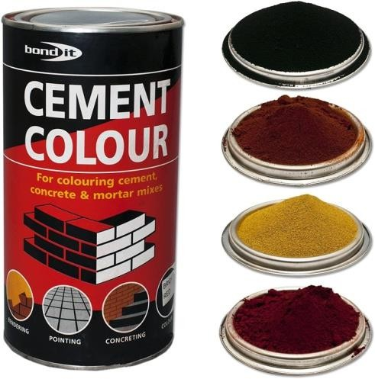
- Coloured cement:
- The cement of desired colour may be obtained by intimately mixing mineral pigments with ordinary cement.
- The amount of colouring material may vary from 5 to 10 per cent. If this percentage exceeds 10 per cent, the strength of cement is affected.

- The chromium oxide gives green colour. The cobalt imparts blue colour. The iron oxide in different proportions gives brown, red or yellow colour. The manganese dioxide is used to produce black or brown coloured cement.
- The coloured cements are widely used for finishing of floors, external surfaces, artificial marble, window sill slabs, textured panel faces, stair treads, etc.
- Expanding cement:
- This type of cement is produced by adding an expanding medium like sulpho- aluminate and a stabilising agent to the ordinary cement. Hence, this cement expands whereas other cements shrink.
- The expanding cement is used for the construction of water retaining structures and also for repairing the damaged concrete surfaces.


- High alumina cement:
- This cement is produced by grinding clinkers formed by calcining bauxite and lime. The bauxite is an aluminium ore.
- It is specified that total alumina content should not be less than 32 per cent and the ratio by weight of alumina to the lime should be between 0.85 and 1.30.

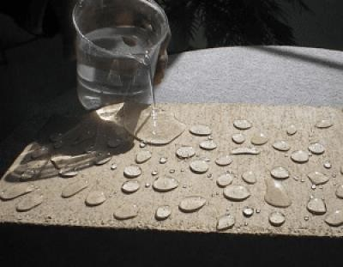
- Hydrophobic cement:
- This type of cement contains admixtures which decrease the wetting ability of cement grains.
- The usual hydrophobic admixtures are acidol, naphthenesoap, oxidized petrolatum, etc. These substances form a thin film around cement grains.
- When hydrophobic cement is used, the fine pores in concrete are uniformly distributed and thus the frost resistance and the water resistance of such concrete are considerably increased.

- Low heat cement:
- The considerable heat is produced during the setting action of cement. In order to reduce the amount of heat, this type of cement is used.
- It contains lower percentage of tricalcium aluminate C₃A of about 5% and higher percentage of dicalcium silicate C₂S of about 46%.
- The initial setting time is about one hour and final setting time is about 10 hours.
- It is mainly used for mass concrete work.

- Pozzolana cement:
- The Pozzolana is a volcanic powder. The percentage of Pozzolana material should be between 10 to 30.
- This cement is used to prepare mass concrete of lean mix and for marine structures. It is also used in sewage works and for laying concrete under water.
- Quick setting cement:
- This cement is produced by adding a small percentage of aluminium sulphate and by finely grinding the cement.
- The addition of aluminium sulphate and fineness of grinding are responsible for accelerating the setting action of cement.
- The setting action of cement starts within five minutes after addition of water and it becomes hard like stone in less than 30 minutes or so.
- The extreme care is to be taken when this cement is used as mixing and placing of concrete are to be completed in a very short period.
- This cement is used to lay concrete under static water or running water.

- Rapid hardening cement:
- The initial and final setting times of this cement are the same as those of ordinary cement. But it attains high strength in early days.
- It contains high percentage of tricalcium silicate C₃S to the extent of about 56%.
- This cement is used for the formwork of concrete that can be removed earlier.
- Extra rapid hardening cement:
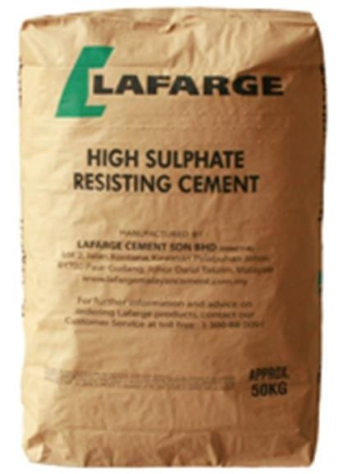
- It is obtained by inter-grinding calcium chloride with rapid hardening Portland cement.
- The normal addition of calcium chloride should not exceed 2% by the weight of rapid hardening cement.
- This type of cement should be transported, placed, compacted and finished within 20 minutes after mixing.
- Sulphate resisting cement:
- It is a cement with low C₃A content and comparatively lower C₄AF content. The percentage of C₃A (tricalcium aluminate) is kept below
5 per cent and it results in the increase in resisting power against sulphate attack.

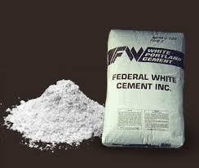
- Sulphate resisting cement is used for the structures which are likely to be damaged by severe alkaline conditions such as canal linings, culverts, siphons, etc.
- White cement:
- It is prepared from such raw materials which are practically free from colouring oxides of iron, manganese or chromium.
- It is white in colour and it is used for floor finish, plaster work, ornamental work, etc.

PROPERTIES OF CEMENT
Following are the physical, mechanical and chemical properties of cement:
- Physical properties of cement: Following are the important physical properties of a good cement which primarily depend upon its chemical composition, thoroughness of burning and fineness of grinding:
  - It gives strength to the masonry.
  - It is an excellent binding material.

  - It is easily workable.
  - It offers good resistance to the moisture.
  - It possesses a good plasticity.
  - It stiffens or hardens early.
  - A thin paste of cement with water should feel sticky between the fingers.
  - A cement thrown in water should sink and should not float on the surface.
  - The particles should have uniformity of fineness.
  - The consistency of cement should be checked with Vicat apparatus.
  - The initial setting time for ordinary cement is about 30 minutes.
  - The final setting time for ordinary cement is about 10 hours.
  - The cement should be tested for soundness using Le Chatelier apparatus.
- Mechanical properties of cement:
  - The compressive strength at the end of 3 days should not be less than
11.5N/mm² and that at the end of 7 days should not be less than 17.5 N/mm².

  - The tensile strength at the end of 3 days should not be less than 2 N/mm² and that at the end of 7 days should not be less than 2.50 N/mm².
- Chemical properties of cement:
  - The ratio of percentage of alumina to iron oxide should not be less than 0.66.
  - The ratio of percentage of lime to alumina, iron oxide and silica, known as Lime Saturation Factor (LSF) should not be less than 0.66 and should not be more than 1.02.
  - Total loss on ignition should not be more than 4 per cent.
  - Total sulphur content should not be more than 2.75 per cent.
  - Weight of insoluble residue should not be more than 1.50 per cent.
  - Weight of magnesia should not exceed 5 per cent.

Continue.....


PART-A (BUILDING MATERIALS)

Continue..... [CEMENT]

MANUFACTURE OF ORDINARY CEMENT:
The entire manufacturing process in a modern plant is now controlled through a microprocessor based programmable logic control system to maintain a consistently uniform quality of cement and a high rate of production. The entire operation of the plant is controlled centrally in a single control room and the plant employs minimum of manpower as compared to previous plants constructed prior to 1980.
Following three distinct operations are involved in the manufacture of normal setting or ordinary or Portland cement:
- Mixing of raw materials
- Burning
- Grinding

- MIXING OF RAW MATERIALS
The raw materials such as limestone or chalk and shale or clay may be mixed either in dry condition or in wet condition. The process is accordingly known as the dry process or the wet process of mixing.
- Dry process (modern technology):
  - In this process, the raw materials are first reduced in size of about 25 mm in crushers. A current of dry air is then passed over these dried materials.
  - These dried materials are then pulverised into fine powder in ball mills and tube mills.
  - All these operations are done separately for each raw material and they are stored in hoppers.
  - This finely ground powder of raw materials is known as the raw mix and it is stored in storage tank.
  - Then they are mixed in correct proportions and made ready for the feed of rotary kiln.

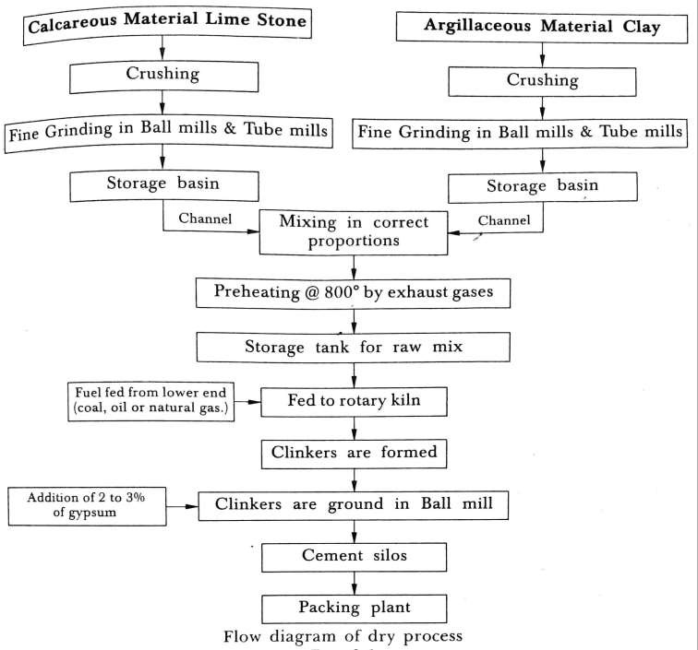

Following is the procedure of manufacture of cement by the dry process using modern technology:
- Most of the cement factories are located very close to the limestone quarries. The boulders upto 1.2 m size are transported in huge dumpers upto 300 kN capacity and dumped into the hopper of the crusher.
- The hammer mill crushers of single stage are now used for crushing as against the time consuming two stage crushers used in earlier plants. The crushed limestone now of 75 mm size is moved from the crusher by a series of conveyors for stacking. The modern stacker-reclaimer system is now in use in most of the modern plants. The stacker helps in spreading the crushed materials in horizontal layers and the reclaimer restricts the variation of calcium carbonate in crushed limestone to less than 1% thereby minimizing quality variation in the materials.
- The argillaceous or clay materials found in the quarry are also dumped into the crusher and stacked along with the limestone.
- The crushed materials are checked for calcium carbonate, lime, alumina, ferrous oxide and silica contents. Any component found short in the quarried materials is added separately. For instance, if silica content is less, the crushed sandstone is

separately transported to the raw material hopper. In a similar way, if limestone is found to contain less content of lime, the high grade limestone is crushed and stored separately in the raw material hopper.
- The additive material and crushed limestone are conveyed to the storage hoppers. The raw materials are fed to the raw mill by means of a conveyor and proportioned by use of weigh feeders which are adjusted as per the chemical analysis done on the raw materials taken from the hoppers from time to time.
- The materials are ground to the desired fineness in the raw mill. In some of the modern plants, the high efficiency vertical grinding mills are installed. The fine powder which emerges as a result of the grinding in the raw mill is blown upwards, collected in cyclones and fed to the giant sized continuous blending and storage silo by use of aeropole. The advantage of these silos is that one stage of pumping is eliminated which was inevitable in the traditional pattern of different silos for blending and storage.
- The material is dropped merely by gravity from the blending to the storage silo thereby conserving power.

- The material is then once again pumped using an aeropole into the preheater. The most modern preheaters have five stages. The temperature of the material fed from the top is increased in stages from 60°C to 850°C as hot gas at temperature of 1000°C is blown against the falling gradient.
- The material from the bottom of the preheater is fed to the rotary kiln. Due to the use of multi-stage preheaters in the modern plants, the length of rotary kilns is considerably reduced thereby resulting in saving of maintenance cost and power requirements.
- Wet process (old technology):
  - In this process, the calcareous materials such as limestone are crushed and stored in silos or storage tanks.
  - The argillaceous material such as clay is thoroughly mixed with water in a container known as the wash mill. This washed clay is stored in basins.
  - Now, the crushed limestone from silos and wet clay from basins are allowed to fall in a channel in correct proportions.
  - This channel leads the materials to grinding mills where they are brought into intimate contact to form which is known as the slurry.

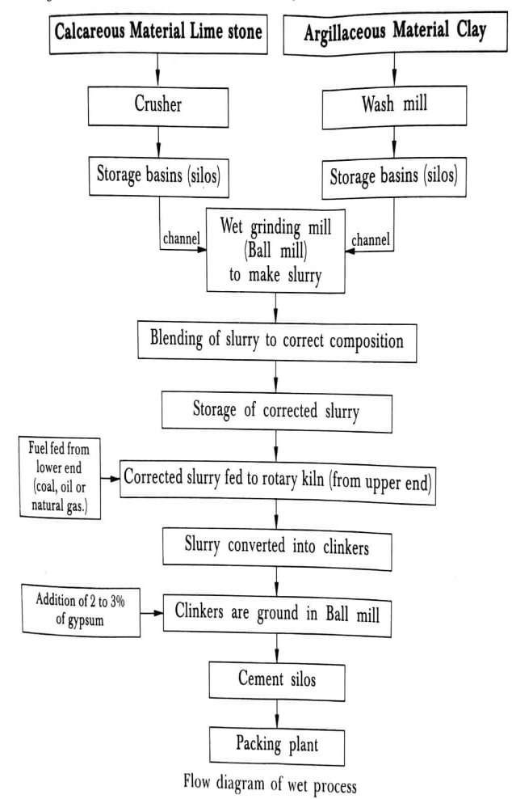
  - The grinding is carried out either in ball mill or tube mill or both.
  - The slurry is led to correcting basin where it is constantly stirred. At this stage, the chemical composition is adjusted as necessary.
  - The corrected slurry is stored in storage tanks and kept ready to serve as feed for rotary kiln.

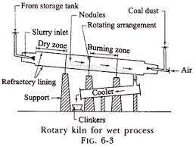
- BURNING
The burning is carried out in a rotary kiln. Construction of rotary kiln:-
  - A rotary kiln is formed of steel tubes. Its diameter varies from 2.50 m to 3 m. Its length varies from 90 m to 120 m. It is laid at a gradient of about 1 in 25 to 1 in 30.
  - The kiln is supported at intervals by columns of masonry or concrete. The refractory lining is provided on the inside surface of rotary kiln.
  - It is so arranged that the kiln rotates at about 1 to 3 revolutions per minute about its longitudinal axis.
Operation:-
  - The corrected slurry is injected at the upper end of kiln.
  - The hot gases or flames are forced through the lower end of kiln. The portion of the kiln near its upper end is known as the dry zone and in this zone, the water of slurry is evaporated.

  - As the slurry gradually descends, there is rise in temperature and in the next section of kiln, the carbon dioxide from slurry is evaporated.
  - The small lumps, known as the nodules, are formed at this stage. These nodules then gradually roll down passing through zones of rising temperature and ultimately reach to the burning zone, where temperature is about 1400°C to 1500°C.
  - In burning zone, the calcined product is formed and nodules are converted into small hard dark greenish blue balls which are known as the clinkers.
  - The size of clinkers varies from 3 mm to 20 mm and they are very hot when they come out of burning zone of kiln.
  - A rotary kiln of small size is provided to cool down the hot clinkers. It is laid in opposite direction and the cooled clinkers are collected in containers of suitable sizes.

- GRINDING
  - The clinkers as obtained from the rotary kiln are finely ground in ball mills and tube mills.

  - During grinding, a small quantity, about 3 to 4 per cent of gypsum is added.
  - The gypsum acts as a retarder and it delays the setting action of cement. It thus permits cement to be mixed with the aggregates and to be placed in position.
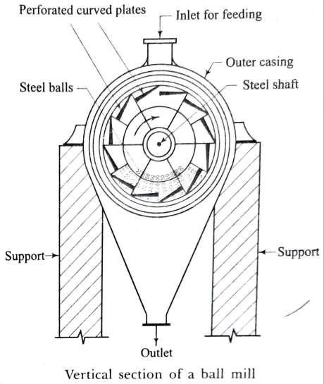
  - The grinding of clinkers in modern plants is carried out in the cement mill which contains chromium steel balls of various
sizes. These balls roll within the mill and grind the mixture which is collected in a hopper and taken in the bucket elevator for storage in silos.
  - The cement from silos is fed to the packer machines for packing.
  - Each bag of cement contains 50 kg or 500 N or about 0.035 m³ of cement.
BALL MILLS AND TUBE MILLS
The ball mills are used to have preliminary grinding and the tube mills are used to carry out final grinding.

BALL MILLS:-
  - In ball mill, the material to be ground is fed from the top. When the mill is rotated about its horizontal axis, the steel balls strike against the perforated curved plates and in doing so, they crush the material.
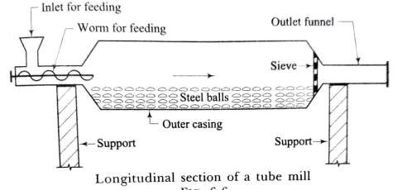
  - This crushed material passes through an inner sieve plate and then through an outer sieve plate. It is collected from an outlet at the bottom of outer casing of mill.
TUBE MILLS:-
  - The action of tube mill is similar to that of ball mill. But fine grinding is achieved due to steel balls of smaller size.
  - A worm is provided to feed the material
to the mill.
  - The pulverised material is collected at the outlet funnel.
Manufacturing of Portland cement: https://www.youtube.com/watch?v=YNUYMS9QKK8&t=36s
***END***

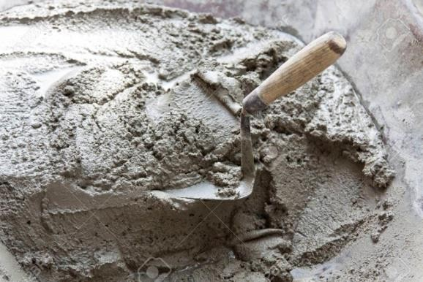
PART-A (BUILDING MATERIALS)

CHAPTER:-03 [MORTAR]
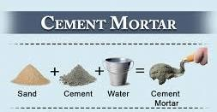
Definition: The term mortar is used to indicate a paste prepared by adding required quantity of water to a mixture of binding
material like cement or lime and fine aggregate like sand.
Properties of a good mortar:
- It should be capable of developing good adhesion with the building units such as bricks, stones, etc.
- It should be capable of developing the designed stresses.
- It should be capable of resisting penetration of rain water.
- It should be cheap.
- It should be durable.

- It should be easily workable.
- It should not affect the durability of materials with which it comes into contact.
- It should set quickly so that speed in construction may be achieved.
- The joints formed by mortar should not develop cracks and they should be able to maintain their appearance for a sufficiently long period.

USES OF MORTAR
Following are the uses of mortar:
- to bind the building units such as bricks, stones, etc, into a solid mass,
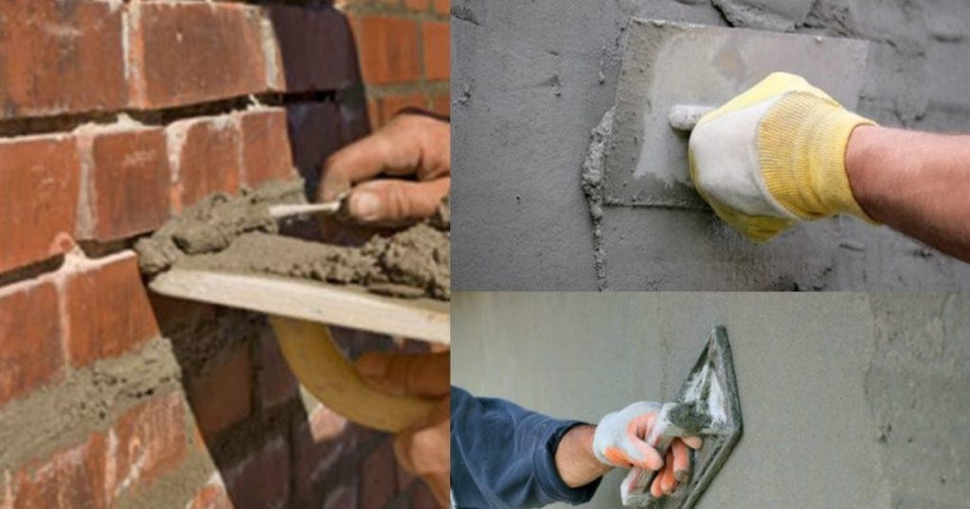

- to carry out pointing and plaster work on exposed surfaces of masonry,
- to form an even and soft bedding layer for building units,
- to form joints of pipes,
- to improve the general appearance of structure,
- to prepare moulds for coping, corbels, cornice, etc.,

- to serve as a matrix or cavity to hold coarse aggregates, etc.,
- to distribute uniformly the super incumbent weight from upper layer to lower layer of bricks or stones,
- to hide the open joints of brickwork and stonework,
- to fill up the cracks detected in the structure during maintenance process, etc.

CLASSIFICATION OF MORTARS
The mortars are classified on the basis of the following:
  - Bulk density
  - Kind of binding material
  - Nature of application
  - Special mortars
- Bulk density: According to the bulk density of mortar in dry state, there are two types of mortars:
  - Heavy mortars (ii) Lightweight mortars.

- Heavy mortars: The mortars having bulk density of 15 kN/m³ or more are known as the heavy mortars and they are prepared from heavy quartzs or other sands.
- Lightweight mortars: The mortars having bulk density less than 15 kN/m³ are known as the lightweight mortars and they are prepared from light porous sands from pumice and other fine aggregates.
- Kind of binding material: The kind of binding material for a mortar is selected by keeping in mind several factors such as expected working conditions, hardening temperature, moisture conditions, etc.
According to the kind of binding material, the mortars are classified into the following five categories:
  - Lime mortar (iv) Gauged mortar
  - Surkhi mortar (v)Gypsum mortar.
  - Cement mortar
- Lime mortar:
  - In this type of mortar, the lime is used as binding material. The lime may be fat lime or hydraulic lime.

  - The fat lime shrinks to a great extent and hence it requires about 2 to 3 times its volume of sand.
  - This mortar is unsuitable for water-logged areas or in damp situations.
  - For hydraulic lime, the proportion of lime to sand by volume is about 1:2 or so.
  - This mortar should be consumed within one hour after mixing.
  - It possesses more strength and can be used in damp situations.
- Surkhi mortar:
  - This type of mortar is prepared by using fully surkhi instead of sand.
  - The surkhi mortar is used for ordinary masonry work of all kinds in foundation and superstructure.
- Cement mortar:
  - In this type of mortar, the cement is used as binding material.
  - Depending upon the strength required and importance of work, the proportion of cement to sand by volume varies from 1:2 to 1:6 or more.

  - The cement mortar is used where a mortar of high strength and water-resisting properties is required such as underground constructions, water saturated soils, etc.
- Gauged mortar:
  - To improve the quality of lime mortar and to achieve early strength, the cement is sometimes added to it. This process is known as the gauging.
  - The usual proportion of cement to lime by volume is about 1:6 to 1:8.
  - It is also known as the composite mortar or lime-cement mortar.
  - This mortar may be used for bedding and for thick brick walls.
- Gypsum mortar:
  - These mortars are prepared from gypsum binding materials such as building gypsum and anhydrite binding materials.
- Nature of application: According are classified into two categories:
  - Bricklaying mortars.
  - Finishing mortars.

- Bricklaying mortars:
  - The mortars for bricklaying are intended to be used for brickwork and walls.
- Finishing mortars:
  - These mortars include common plastering work and mortars for developing architectural or ornamental effects.
  - For decorative finishing, the mortars are composed of suitable materials with due consideration of mobility, water retention, resistance to atmospheric actions, etc.
- Special mortars: Following are the various types of special mortars which are used for certain conditions:
  - Fire-resistant mortar
  - Lightweight mortar
  - Packing mortar (iv)Sound-absorbing mortar
(v) X-ray shielding mortar.

- Fire-resistant mortar:
  - This mortar is prepared by adding aluminous cement to the finely crushed powder of fire-bricks.
  - This mortar is fire-resistant and it is therefore used with fire-bricks for lining furnaces, fire places, ovens, etc.
- Lightweight mortar:
  - This mortar is prepared by adding materials such as saw dust, wood powder, etc. to the lime mortar or cement mortar.
  - This mortar is used in the sound-proof and heat-proof constructions.
- Packing mortar:
  - To pack oil wells, special mortars possessing properties of high homogeneity, water resistance, predetermined setting time, ability to form solid water-proof plugs in cracks and voids of rocks, resistance to subsoil water pressure, etc. have to be formed.
  - The varieties of packing mortars include cement-sand, cement-loam and cement- sand-loam.

- Sound-absorbing mortar:
  - To reduce the noise level, the sound-absorbing plaster is formed with the help of sound-absorbing mortar.
  - The bulk density of such a mortar varies from 6 to 12 kN/m³.
  - The binding materials employed in its composition may be Portland cement, lime, gypsum, slag, etc.
  - The aggregates are selected from lightweight porous materials such as pumice, cinders, etc.
- X-ray shielding mortar:
  - This type of mortar is used for providing the plastering coat to walls and ceiling of X-ray cabinets.
  - It is a heavy type of mortar with bulk density over 22 kN/m³.
  - The aggregates are obtained from heavy rock and suitable admixtures are added to enhance the protective property of such a mortar.

PART-A (BUILDING MATERIALS)


CHAPTER:-03 [MORTAR]
Continue... [ SAND ] Definition:
  - Sand is commonly used as fine aggregate in preparing cement as well as lime mortar.
  - The sand particles consist of small grains of silica (SiO₂).
  - It is formed by the decomposition of sandstones due to various effects of weather.
NATURAL SOURCES OF SAND
According to the natural sources from which the sand is obtained, it is of the following three types:
(1) Pit sand (2) River sand (3) Sea sand.

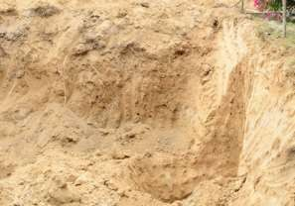
- Pit sand: This sand is found as deposits in soil and it is obtained by forming pits into soils. It is excavated from a depth of about 1 m to 2 m from ground level. The pit sand consists of sharp angular grains which are free from salts and it proves to be excellent material for mortar or concrete work. For making
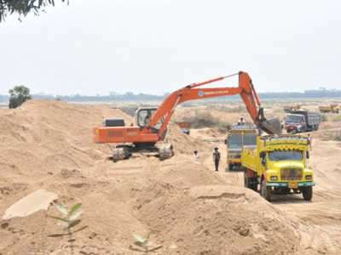
mortar, the clean pit sand free from organic matter and clay should only be used.
- River sand: This sand is obtained from banks or beds of rivers. The river sand consists of fine rounded grains probably due to mutual attrition under the action of water current. The colour of river sand is almost white. As river sand usually available in clean condition, it is widely used for all purposes.

- Sea sand: This sand is obtained from sea shores. The sea sand consists of fine rounded grains in light brown colour. The sea sand contains salts which attract moisture from the atmosphere and causes dampness, efflorescence and disintegration of work. Due to all such reasons, it is the general rule to avoid the use of sea sand

for engineering purposes except for filling of basement, etc. However be used as a local material after being thoroughly washed to remove the salt.
CLASSIFICATION OF SAND
According to the size of grains, the sand is classified as fine, coarse and gravelly
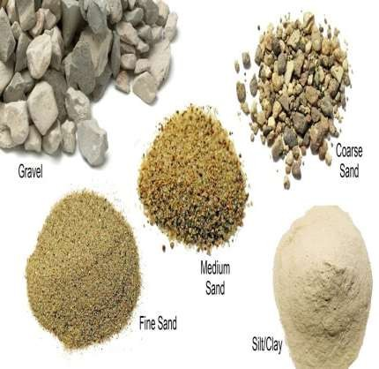
  - Fine sand: The sand passing through a screen with clear openings of 1.5875 mm is known as the fine sand. It is mainly used for plastering.
  - Coarse Sand: The sand passing through a screen with clear openings of 3.17 mm is known as the coarse sand. It is generally used for masonry work.
  - Gravelly Sand: The sand passing through a
screen with clear openings of 7.62 mm is known as the gravelly sand. It is generally used for concrete work.

PROPERTIES OF GOOD SAND
Following are the properties of good sand:
- It should be chemically inert.
- It should be clean and coarse. It should be free from any organic or vegetable matter. Usually 3 to 4% clay is permitted.
- It should contain sharp, angular, coarse and durable grains,
- It should not contain salts which attract moisture from the atmosphere.
- It should be well graded i.e., should contain particles of various sizes in suitable proportions.
BULKING OF SAND
  - The presence of moisture in sand increases the volume of sand. This is due to the fact that moisture causes film of water around sand particles which results in the increase of volume of sand.

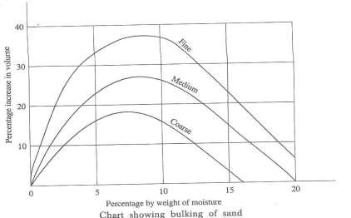
  - The finer the material, the more will be the increase in volume for a moisture content. This phenomena is known as the bulking of sand.
  - For a moisture content of about 5 to 8 per cent. This increase of volume may be as much as 20 to 40 per cent, depending upon the grading of sand.
  - Following procedure is adopted to decide the percentage of bulking of sand.
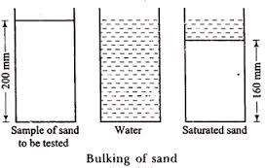
- A container is taken and it is filled two-third with the sample of sand to be tested.
- The height is measured, say it is 200 mm.
- The sand is taken out of container. Care should be taken to see that there is no loss of sand during this transaction.
- The container is filled with water.

- The sand is then slowly dropped in the container and it is thoroughly stirred by means of a rod.
- The height of sand is measured, say it is 160 mm.
Then, Bulking of sand = (200-160)/ 160 = 40/160 = 1/4 or 25%.

PART-A (BUILDING MATERIALS)

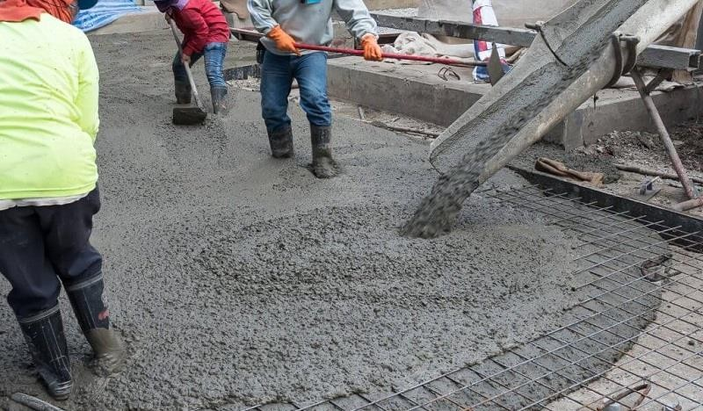
CHAPTER:-03 [CONCRETE]
Definition: The cement concrete is a mixture of cement, sand, pebbles or crushed rock and water. When placed in the skeleton of forms and allowed to cure, becomes hard like a stone.
Composition of cement concrete:
  - Cement: Before the introduction of ordinary Portland cement, the lime was used as a cementing material. Most of the cement concrete work in building construction is done with ordinary Portland cement at present. But other special varieties of cement such as rapid hardening cement and high alumina cement are used under certain circumstances. The cement should comply with all the standard requirements.
  - Fine Aggregates: The material which is passed through BIS test sieve no. 480 is termed as a fine aggregate. Usually, the natural river sand is used as a fine aggregate. But at places, where natural sand is not available economically, the finely crushed stone may be used as a fine aggregate.

  - Coarse Aggregates: The material which is retained on BIS test sieve no. 480 is termed as a coarse aggregate. The broken stone is generally used as a coarse aggregate. The nature of work decides the maximum size of the coarse aggregate. For thin slabs and walls, the maximum size of coarse aggregate should be limited to one- third the thickness of the concrete section.
  - Water: This is the least expensive but most important ingredient of concrete. The water, which is used for making concrete, should be clean and free from harmful impurities such as oil, alkali, acid, etc. In general, the water which is fit for drinking should be used for making concrete.
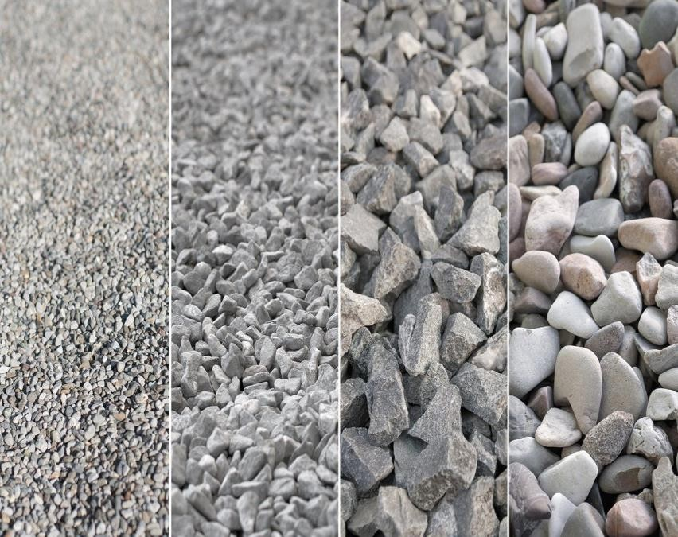
GRADING OF AGGREGATES
    - In order to obtain concrete of denser quality, the fine and coarse aggregates are properly graded. The grading of fine aggregates is expressed in terms of BIS test sieves nos. 480, 240, 120, 60, 30 and 15.
    - The grading of fine aggregates has a marked effect on the uniformity, workability and finishing qualities of concrete.

GRADING LIMITS FOR FINE AGGREGATES

 | Percentage by weight passing through sieve
BIS sieve | Natural or crushed gravel sand | Crushed stone sand
No. 480 | 95-100 | 90-100
No. 240 | 70-95 | 60-90
No. 120 | 45-85 | 40-80
No. 60 | 25-60 | 20-50
No. 30 | 5-30 | 5-30
No. 15 | 0-10 | 0-15

Water-cement ratio:
The water in concrete has to perform the following two functions:
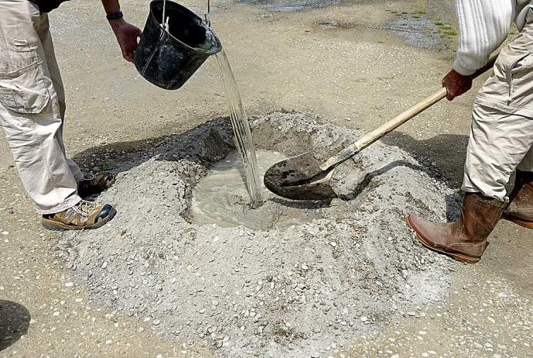
- The water enters into chemical action with cement and this action causes the setting and hardening of concrete.

- The water lubricates the aggregates and it facilitates the passage of cement through voids of aggregates. This means that water makes the concrete workable.
  - It is found theoretically that water required for these two functions is about 0.50 to 0.60 times the weight of cement. This ratio of the amount of water to the amount of cement by weight is termed as the water-cement ratio and the strength and quality of concrete primarily depend upon this ratio.
  - The quantity of water is usually expressed in litres per bag of cement.
  - For instance, if water required for 1 bag of cement is 30 litres, the water-cement ratio is equal to 30/50 = 0.60.
The important points to be observed in connection with the water-cement ratio are as follows:
- The strength of concrete is inversely proportional to the water-cement ratio.
- The water-cement ratio for structures which are exposed to weather should be carefully decided.
- Some rules-of-thumb are developed for deciding the quantity of water in concrete. The two such rules are mentioned below. The rules are for ordinary concrete and they assume that the materials are non-absorbent and dry.

- Weight of water =
28% of the weight of the cement + 4% of the weight of total aggregate.
- Weight of water =
30% of the weight of the cement + 5% of the weight of total aggregate. COMPRESSIVE STRENGTHS FOR VARIOUS WATER-CEMENT RATIOS
Net water-cement ratio by weight | Probable cube crushing strength in N/mm²
Net water-cement ratio by weight | 7 Days | 28 Days
0.35 | 40 | 52.5
0.40 | 35 | 47
0.45 | 30 | 42
0.50 | 25 | 37
0.55 | 22 | 33
0.60 | 18 | 28
0.65 | 15.5 | 24.5
0.70 | 13.5 | 22
0.75 | 11.2 | 20

0.80 | 10.5 | 17.5

WORKABILITY
  - The term workability is used to describe the ease or difficulty with which the concrete is handled, transported and placed between the forms with minimum loss of homogeneity.
  - The workability, as a physical property of concrete alone irrespective of a particular type of construction, can be defined as the amount of useful internal work necessary to produce full compaction.
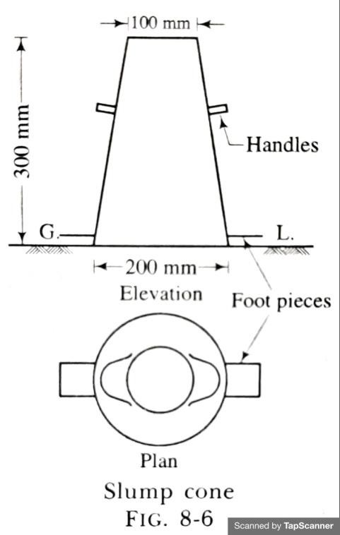
  - In order to measure the workability of concrete mixture, the various tests are developed. The tests such as flow test and compacting test are used in great extent in laboratory. The slump test, which is commonly used in the field, is briefly described below.
SLUMP TEST
  - Slump cone of bottom dia. 20 cm, top dia. 10 cm and height 30 cm. The diameter of the rod is 16 mm and its length is 60 mm.

  - The standard slump cone is placed on the ground. The operator holds the cone firmly by standing on the foot pieces.
  - The cone is filled with about one-fourth portion and then rammed with a rod which is provided with bullet nose at the lower end.
  - The strokes to be given for ramming vary from 20 to 30.
  - The remaining portion of the cone is filled in with similar layers and then the top of concrete surface is struck off so that the cone is completely full of concrete.
  - The cone is then gradually raised vertically and removed.
  - The concrete is allowed to subside and then the height of concrete is measured.
  - The slump of concrete is obtained by deducting height of concrete after subsidence from 30.
  - The difference in height in ‘mm’ is taken as slump of concrete.
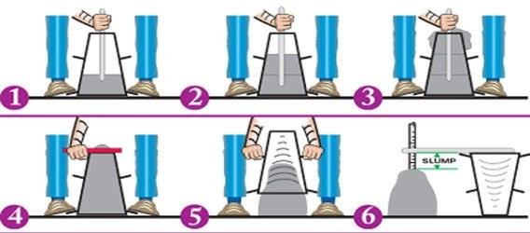

RECOMMENDED SLUMPS OF CONCRETE

No. | Type of concrete | Slump
1. | Concrete for road construction | 20 to 40 mm
2. | Concrete for tops of curbs, parapets, piers, | 40 to 50 mm
 | slabs and walls that are horizontal
3. | Concrete for canal linings | 70 to 80 mm
4. | Concrete for arch and side walls of tunnels | 90 to 100 mm
5 | Normal R.C.C. work | 80 to 150mm
6. | Mass concrete | 25 to 50 mm
7. | Concrete to be vibrated | 10 to 25 mm

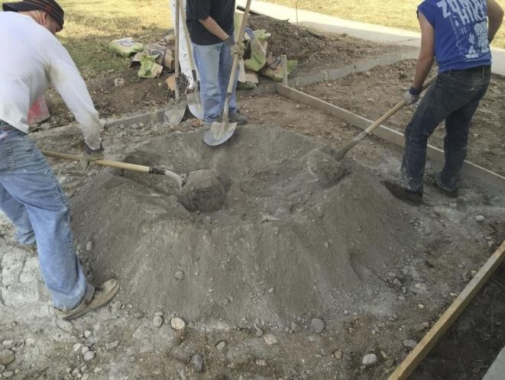
MIXING OF CONCRETE
  - The process of rolling, folding and spreading of particles is known as the mixing of concrete.

  - The materials of concrete should be mixed thoroughly so that there is uniform distribution of materials in the mass of concrete.
  - The thorough mixing also ensures that cement water paste completely covers the surfaces of aggregates.
  - The mixing of materials of concrete can be done either with hand or with the help of a machine.
- Hand mixing:
  - For hand mixing, the materials are stacked on a water-tight platform, which may be either of wood, brick or steel.
  - The materials should be thoroughly mixed, at least three times, in dry condition before water is added.
  - The prepared mix should be consumed in 30 minutes after adding water.
  - The mixing by hand is allowed in case of small works or unimportant works where small quantity of concrete is required.
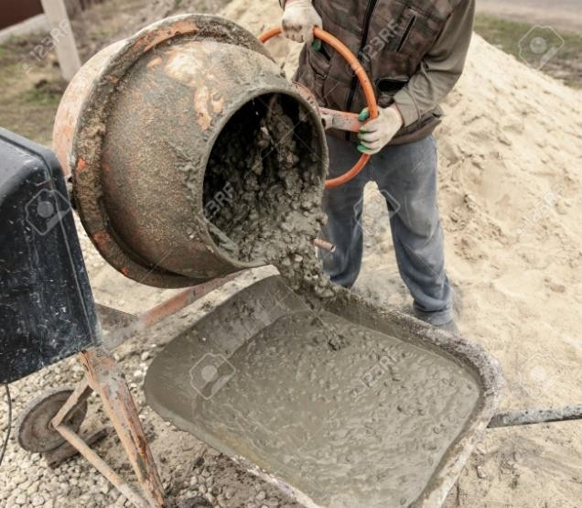
  - For important works, if hand mixing is to be adopted, it is advisable to use 10% more cement than specified.
- Machine mixing:

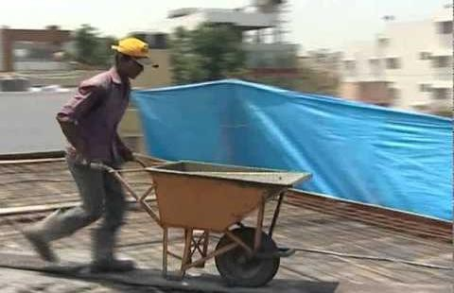
  - For machine mixing, all the materials of concrete including water, are collected in a revolving drum and then the drum is rotated for a certain
period.
  - The resulting mix is then taken out of the drum.
  - The concrete discharged by the mixer should be consumed within 30 minutes.
TRANSPORTING AND PLACING OF CONCRETE
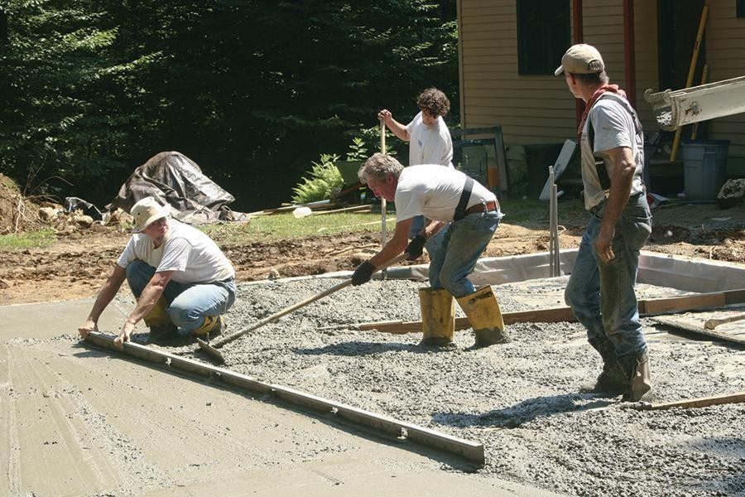
  - The concrete, as it comes out of the mixer or as it is ready for use on the platform, is to be transported and
placed on the formwork.
  - The type of equipment to be used for transport of concrete depends on the nature of work, height above ground level and distance between the points of preparation and placing of concrete.
  - For ordinary building works, the human ladder is formed and concrete is conveyed in pans from hand to hand.
  - For important works, the various mechanical devices such as dumpers, truck mixers, buckets, chutes, belt conveyors, pumps, hoist, etc. may be used.

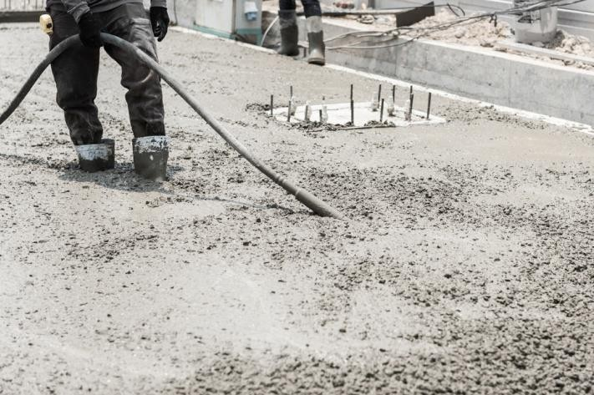
COMPACTION OF CONCRETE
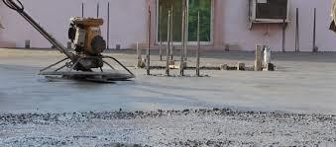
  - The term compaction of concrete is used to mean the compaction between aggregate and aggregate; between aggregate and reinforcement; and between aggregate and forms.
  - The main aim of compaction of concrete is to eliminate air bubbles and thus to give maximum density to the concrete.
  - The importance of compaction of concrete can be seen from the fact that a presence of 5% of voids reduces 30% strength of concrete.
  - The process of compaction of concrete can be carried out either with hand or with the help of vibrators.
CURING OF CONCRETE
  - Curing of concrete is one of the essential requirements of process of concreting.
  - Curing is process of keep the set concrete damp for some days in order to enable the concrete gain more strength.
Purposes: Following are the objects or purposes of the curing of concrete

- The curing protects the concrete surfaces from sun and wind.
- The presence of water is essential to cause the chemical action which accompanies the setting of concrete.
- The strength of concrete gradually increases with age, if curing is efficient.
- By proper curing, the durability and impermeability of concrete are increased and shrinkage is reduced.
- The resistance of concrete to abrasion is considerably increased by proper curing.
Period of curing:
  - This depends on the type of cement and nature of work.
  - For ordinary Portland cement, the curing period is about 7 to 14 days.
Methods of curing: Following two factors are considered while selecting any mode or method of curing:
- The temperature should be kept minimum for dissipation of heat of hydration.
- The water loss should be prevented.

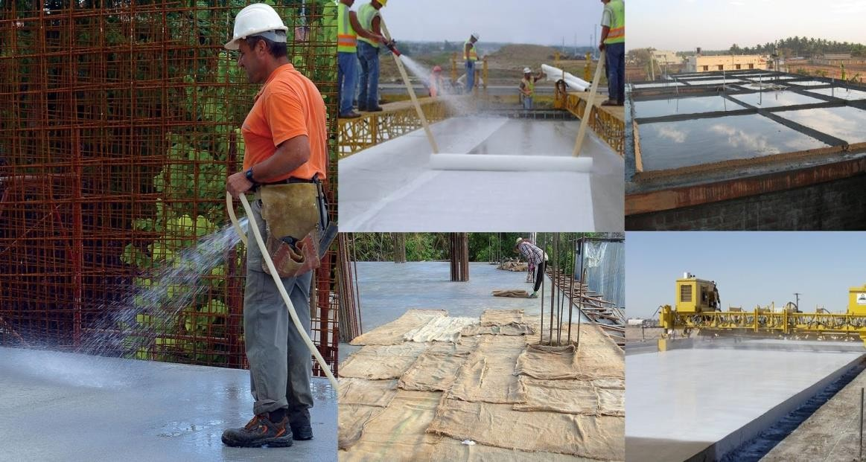
Most commonly employed methods of curing are as follows:

- Ponding with water.
- Covering concrete with wet jute bags.
- Covering concrete with wet sand , saw dust, etc.
- Covering concrete with water-proof paper or polyethylene sheets and holding it in position.
- Intermittent spraying with water and continuous sprinkling of water.
- Applying curing compounds.
***end***

PART-A (BUILDING MATERIALS)

CHAPTER:-04 [Other Construction Materials]
[Clay products ]
Definition:
  - Clay is the result of chemical reactions with felspar of Igneous rock.
  - Clay products are one of the most important classes of structural materials.
  - The clay products which are employed in building industry are tiles, terra-cotta, earthenwares, stonewares, porcelain and bricks.
TILES

  - The tiles may be defined as thin slabs of brick which are burnt in kiln. They are thinner than bricks and hence they should be carefully handled to avoid any damage to them.
  - The tiles can be classified in the following two groups:


- Common tiles: These tiles have different shapes and sizes. They are mainly used for paving, flooring and roofing.
- Encaustic tiles: These tiles are used for decorative purposes in floors, walls, ceilings and roofs.
- COMMON TILES:
  - Manufacture of common tiles: Following four distinct
operations are involved in the general process of manufacturing the common tiles:
    - Preparation of clay
    - Moulding
    - Drying
    - Burning
  - Characteristics of a good tile: Following are the characteristics of a good tile;
    - It should be free from any cracks, flaws or bends.
    - It should be regular in shape and size.

    - It should be sound, hard and durable.
    - It should be well burnt.
    - It should give a clear ringing sound when struck with hand or with one another or with light hammer.
    - It should fit in properly, when placed in position.
    - It should give an even and compact structure when seen on its broken surface.
    - It should possess uniform colour.
  - Types of common tiles: Depending upon the use to which the tiles are put, the following are their different types:
    - Drain tiles
    - Floor or paving tiles
    - Roof tiles. (i)Drain tiles:

      - These tiles are prepared in such a way that they retain porous texture after burning.
      - Hence, when such tiles are laid in the water-logged areas, they allow subsoil water to pass through their skeleton.
      - These drains may be circular, semi-circular or segmental.
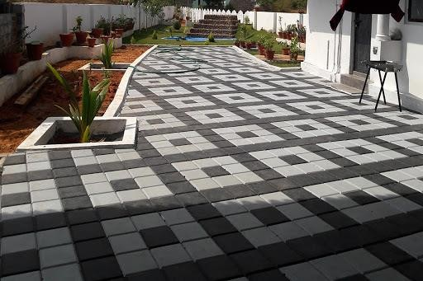
      - Such drain tiles are rarely adopted in modern times.
- Floor or paving tiles:
  - The floor or paving tiles may be square or hexagonal in shape.
  - These are flat tiles and their thickness varies from 12 mm to 50 mm. The size of square tiles varies from 150 mm to 300 mm.
  - The floor tiles should be hard and compact so that they can resist wear and tear in a better way.
  - The floor tiles of thin section can be adopted for ceiling also.
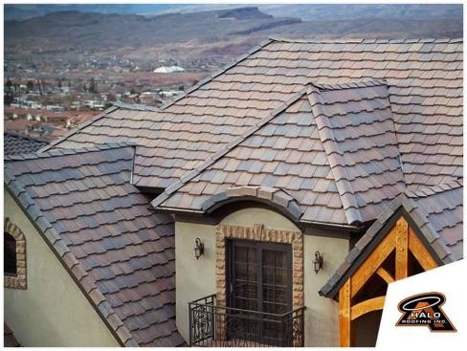
  - The floor tiles of comparatively less strength can be adopted for fixing on walls.

- Roof tiles:

  - These tiles are used to serve as covering for pitched roof. The various types of roof tiles are available in the market.
- ENCAUSTIC TILES:
- The encaustic tiles are manufactured from carefully prepared ordinary clays, colouring materials and sometimes with finer clays. Depending upon the colouring pigment added in the clay,
these tiles obtain the desired print or colour after manufacture.
- An encaustic tile usually consists of the following three layers:
  - Body: It is made of coarser clay.
  - Face: It comprises of a 6 mm coat of finer clay and the colouring matter for making the ground of the pattern.
  - Back: It is a thin coat of clay to prevent the tile from warping.

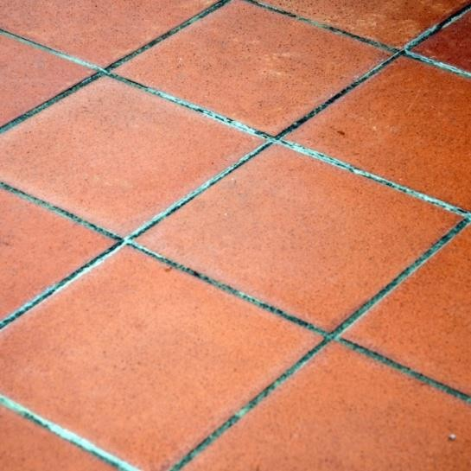
TERRA-COTTA
- General: The terra means earth and cotta means baked. Hence the terra-cotta means the baked earth. It is thus a type of earthenware or porous pottery made from local clays and glazed with glazes containing galena. It is soft enough to be scratched by a knife.
- Manufacture of terra-cotta: Following four distinct operations are involved in the manufacture of terra cotta:
  - Preparation of clay
  - Moulding
  - Drying
  - Burning.
- Varieties of terra-cotta: The terra-cotta articles are of the following two types:
  - Porous terra-cotta
  - Polished terra-cotta.

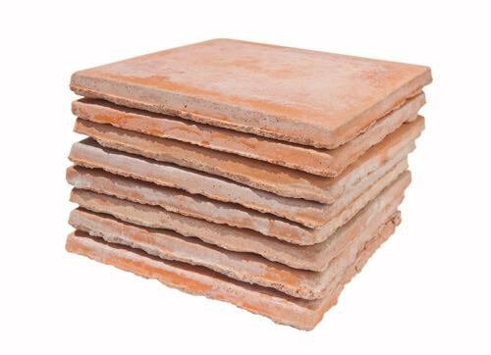
- Porous terra-cotta:
  - To prepare porous terra-cotta, the saw dust or ground cork is added in clay before the stage of moulding.
  - When articles from such clay are burnt in a kiln, the organic particles are burnt and they leave pores in the articles.
  - The porous terra-cotta is a fire-proof and a sound-proof material.
  - It can be chiselled, sawn and nailed easily with nails, screws, etc.
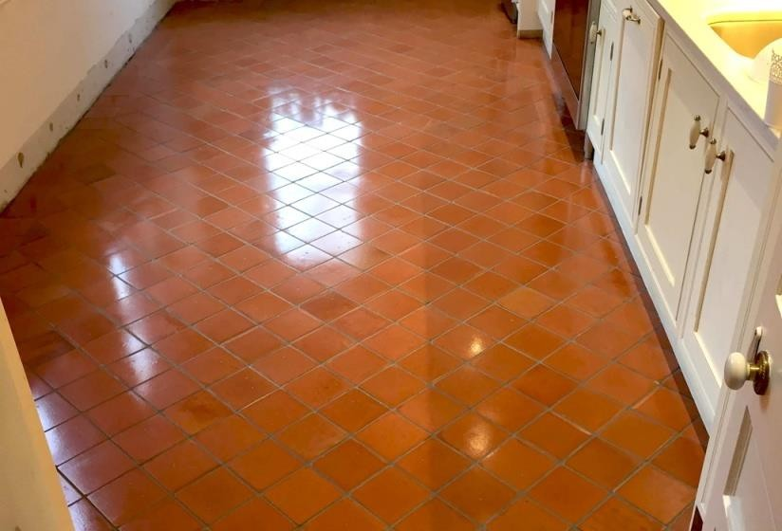
  - It is light in weight, but it is structurally weak. (ii)Polished terra-cotta:
  - This is also known as the fine terra-cotta or faience.
  - To obtain this variety of terra cotta, the articles are burnt at a lower temperature of about 650°C. The first burning is known as the biscuiting.
  - The articles brought to biscuit stage are removed from kiln and are allowed to cool down. They are

then coated with glazing compound and burnt again in the kiln at a temperature of about 1200°C.
  - The faience is available in a variety of colours and it indicates superior quality of terra-cotta.
  - It is used for ornamental purposes and in industrial areas since it is ordinarily unaffected by the adverse atmospheric conditions.
- Advantages of terra-cotta: Following are the advantages of terra-cotta:
  - It is strong and durable material.
  - It is available in different colours.
  - It is cheaper than ordinary finely dressed stones.
  - It is easily cleaned.
  - It is easily moulded in desired shapes.
  - It is fire-proof and can therefore be conveniently used with R.C.C. work.
  - It is light in weight.

  - It is not affected by atmospheric agencies and acids and is capable of withstanding weathering actions better than most kinds of stone.
- Disadvantages of terra-cotta: Following are the disadvantages of terra-cotta:
  - It cannot be fixed during the progress of work. But it is to be fixed when the work is in final stage of completion.
  - It is twisted due to unequal shrinkage in drying and burning.
- Uses of terra-cotta: Following are the uses of terra-cotta:
  - The hollow terra-cotta blocks are used for various ornamental purposes such as facing work, arches, cornices, casing for columns, etc.
  - It is adopted for all sorts of ornamental work.
  - It is used as a decorative material in place of stones for ornamental parts of buildings such as cornices, string courses, sills, copings, bases of pillars, fire places, etc.

PORCELAIN

    - The term porcelain is used to indicate fine earthenware which is white, thin and semi- transparent. Since the colour of porcelain is white, it is also referred to as the whiteware.
    - The clay of sufficient purity and possessing high degree of tenacity and plasticity is used in preparing porcelains.
    - It is hard, brittle and non-porous. It is prepared from clay, felspar, quartz and minerals.
    - The constituents are finely ground and then they are thoroughly mixed in liquid state.
    - The mixture is given the desired shape and it is burnt at high temperature.
    - The various types of porcelains are available and they are adopted for various uses such as sanitarywares, electric insulators, storage vessels, reactor chambers, crucibles, etc.

GLAZING

- General: The surfaces of clay products are sometimes glazed. A glaze is a glassy coat of thickness about 0.1 to 0.2 mm applied on the surface of an item and then fused into place by burning at high temperature:
- Purposes: Following are the purposes for which the glazing is done:
  - To improve the appearance.
  - To make the articles durable and impervious.
  - To produce the decorative effects.
  - To protect the articles from action of atmospheric agencies, chemicals, sewage, etc.
  - To provide smooth surface.
- Methods of glazing:
- The glazing may be transparent like glass or it may be opaque like enamels.

- For obtaining coloured glazes, the oxides and salts of various metals or special refractory colouring agents are added.
- For instance, the addition of copper oxides will impart green colour and addition of iron oxide will impart red and brown colours.

  - Transparent glazing: This type of glazing may be given by the following two methods:
    - Salt glazing
    - Lead glazing
- Salt glazing:
  - In this method, a small quantity of
wet sodium chloride or salt is added in the kiln at a high temperature of about 1300°C.
  - The salt is vaporized at a high temperature and a glass like glaze is formed on the surface of articles due to sticking of vapour of salt.
  - This method is useful for sanitary pipes and chemical stonewares.
  - The colour of articles glazed by this method is brownish.

- Lead glazing:
  - For getting articles of better quality, the lead glazing is preferred to the salt glazing.
  - In this method, the article is once burnt and it is then dipped in a bath containing oxide of lead and tin.
  - The article is taken out from the bath and it is reburnt at a high temperature.
  - The particles of oxide of lead and tin melt and they form a film of glass over the exposed surfaces of the article.
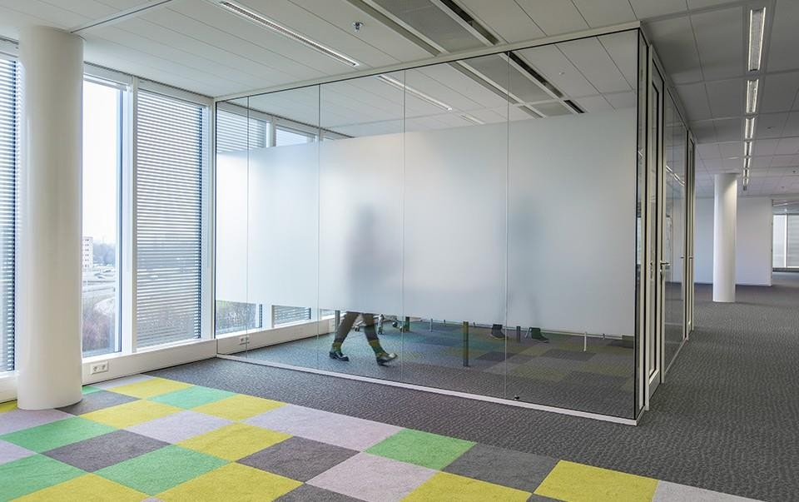
  - Opaque glazing:
- This type of glazing is adopted to give better appearance than that given by the burnt material.
- The superior clay is finely powdered and dried. The sufficient quantity of water is added to such clay to make a plastic cream like substance, known as the slip.

- The articles to be glazed are dipped in the slip before burning and they are subsequently heated.
- The burning of articles results into the flow of clay particle and an opaque glaze surface is formed.
- The sanitary articles are glazed by this process.

***end***

PART-A (BUILDING MATERIALS)

CHAPTER:-04 [Other Construction Materials]
[Iron and Steel]

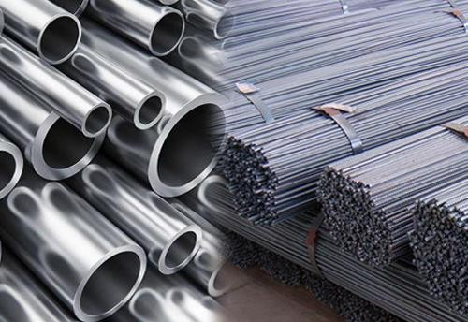
GENERAL:
- The metals are also employed for various engineering purposes such as structural members, roofing materials, damp-proof courses, pipes, tanks, doors, windows, etc.
- Out of all the metals, the iron is the most popular metal and it has been used in the construction activity since pre-historic times.
- There are three important ferrous metals, namely, cast-iron, wrought-iron and steel.
- The cast-iron contains carbon from 2 to 4 per cent.
- In wrought-iron, the carbon content does not exceed 0.15 per cent.

- As far as the carbon content is concerned, the steel forms an intermediate stage between cast-iron and wrought-iron.
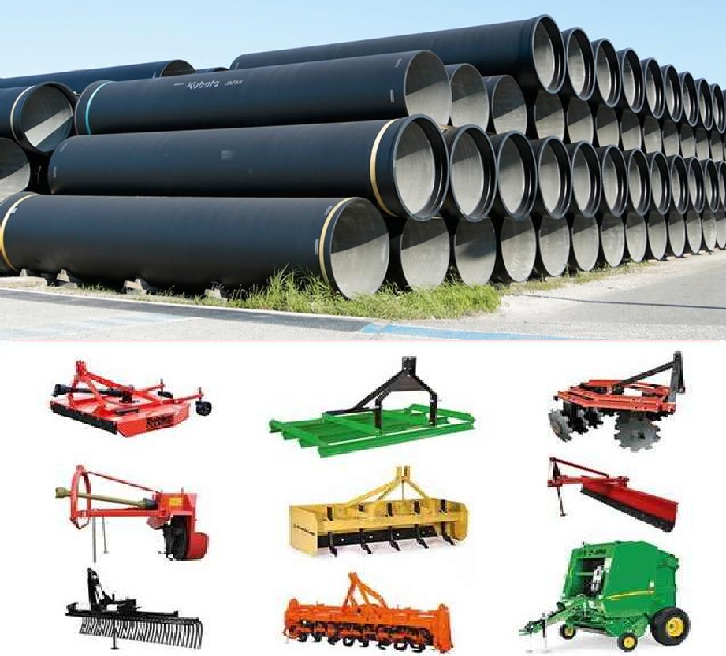
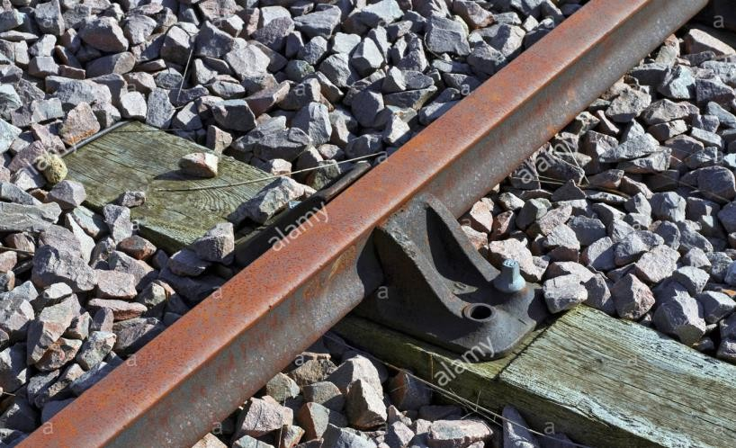
- In steel, the carbon content varies from anything below 0.25 per cent to 1.50 per cent maximum.
Uses of Cast-iron:
- For making cisterns, water pipes, gas pipes and sewers, manhole covers and sanitary fittings.
- For making ornamental castings such as brackets, gates, lamp posts, spiral staircases, etc.
- For making parts of machinery which are not subject to heavy shocks.
- For manufacturing compression members like columns in buildings, bases of columns, etc.
- For preparing agricultural implements.
- For preparing rail chairs, carriage wheels, etc.

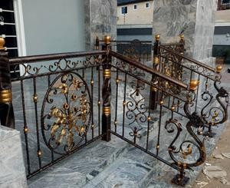
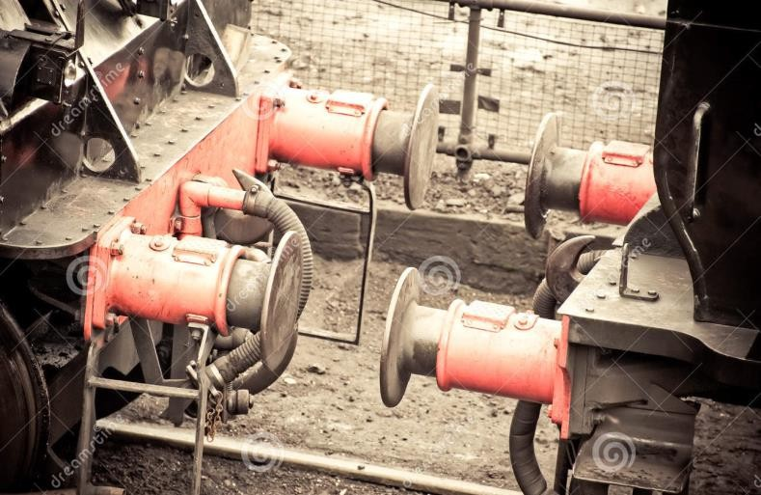

Uses of Wrought-iron:
  - The wrought-iron, at present, is used for rivets, chains, ornamental iron work, railway
couplings, water and steam pipes, raw material for manufacturing steel, bolts and nuts, horse shoe bars, handrails, straps for timber roof trusses, boiler tubes, roofing sheets, armatures, electro- magnets, etc.

Uses of Steel:
  - The carbon content of mild steel is about 0.10 to 0.25 per cent.
  - The carbon content of medium carbon steel is about 0.25 to 0.60 per cent.
  - The high carbon steel is also known as the hard steel and its carbon content varies from 0.60 to 1.10 per cent or so.

Name of steel | Carbon  content | Uses
Mild steel  Medium carbon steel  High carbon steel or hard steel | Upto 0.10%  Upto 0.25%  Upto 0.45%  Upto 0.60%  Upto 0.75% | Motor body, sheet metal, tin plate, etc. Boiler plates, structural steel, etc.  Rails, tyres, etc.  Hammers, large stamping and pressing dies, etc. Sledge hammers, springs, stamping dies, etc.
 | Upto 0.90%  Upto 1.00%  Upto 1.10% | Miner's drills, smith's tools, stone mason's tools, etc.  Chisels, hammers, saws, wood working tools, etc.  Axes, cutlery, drills, knives, picks, punches, etc.

***end***

PART-A (BUILDING MATERIALS)

CHAPTER:-04 [Other Construction Materials]
[Timber]
Definition:
  - The word timber is derived from an old English word timbrian which means to build.
  - The timber thus denotes wood which is suitable for building or carpentry or various other engineering purposes and it is applied to the trees measuring not less than 600 mm in girth or circumference of the trunk.
CLASSIFICATION OF TREES
For the engineering purposes, the trees are classified according to their mode of growth. Following is the classification:

Trees
Endogenous
Exogenous

Conifers

- Exogenous trees:
Deciduous
Soft woods
Hard woods
  - These trees increase in bulk by growing outwards and distinct consecutive rings are formed in the horizontal section of such a tree. These rings are known as the annual rings because one such ring is added every year and these rings are useful in predicting the age of tree.

  - The timber which is mostly used for engineering purposes belongs to this category.
The exogenous trees are further subdivided into two groups:
- conifers; and
- deciduous.
  - The conifers are also known as the ever-green trees and leaves of these trees do not fall till new ones are grown. As these trees bear cone-shaped fruits, they are given the name conifers. These trees yield soft woods which are generally light coloured, resinous, light in weight and weak. They show distinct annual rings.
  - The deciduous trees are also known as the broad-leaf trees and leaves of these trees fall in autumn and new ones appear in spring season. The timber for engineering purposes is mostly derived from deciduous trees. These trees yield hard woods which are usually close-grained, strong, heavy, dark coloured, durable and non resinous. They do not show distinct annual rings.

COMPARISON OF SOFT WOODS AND HARD WOODS

No. | Item | Soft woods | Hard woods
1. | Annual rings | Distinct | Indistinct
2. | Colour | Light | Dark
3. | Density | Low | High
4. | Fire resistance | Poor | More
5. | Medullary rays | Indistinct | Distinct
6. | Source | Coniferous trees with | Deciduous trees with flat-board
 |  | needle-shaped leaves. | leaves.
7. | Strength | Strong for direct pull and | Equally strong for resisting
 |  | weak for resisting thrust | tension, compression and shear
 |  | or shear. Also strong | Also strong along and across
 |  | along the grain. | the grain.
8. | Structure | Resinous and split easily | Non-resinous and close-grained
9. | Weight | Light | Heavy.

- The examples of soft woods are chir, deodar, fir, kail, pine, spruce, etc. and those of hard woods are babul, mahogany, oak, sal, teak, etc.
- Endogenous trees:
  - These trees grow inwards and fibrous mass is seen in their longitudinal sections. The timber from these trees has very limited engineering applications.
- The examples of endogenous trees are bamboo, cane, palm, etc. STRUCTURE OF A TREE
From the visibility aspect, the structure of a tree can be divided into two categories:
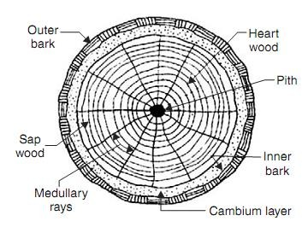
(1) Macrostructure (2)Microstructure.
- MACROSTRUCTURE: The structure of wood visible to the naked eye or at a small magnification is called the macrostructure.
Following are its different components:

- Pith:
  - The innermost central portion or core of the tree is called the pith or medulla.
  - It varies in size and shape for different types of trees. It consists entirely of cellular tissues and it nourishes the plant in its young age.
- Heart wood:
  - The inner annual rings surrounding the pith constitute the heart wood. It is usually dark in colour.
  - It does not take active part in the growth of tree. But it imparts rigidity to the tree and hence it provides strong and durable timber for various engineering purposes.
- Sap wood:
  - The outer annual rings between heart wood and cambium layer is known as the sap wood. It is usually light in colour and weight. It indicates recent growth and it contains sap.
  - It takes active part in the growth of tree and the sap moves in an upward direction through it. The sap wood is also known as the alburnum.

- Cambium layer:
  - The thin layer of sap between sap wood and inner bark is known as the cambium layer.
  - It indicates sap which has yet not been converted into sap wood.
- Inner bark:
  - The inner skin or layer covering the cambium layer is known as the inner bark.
  - It gives protection to the cambium layer from any injury.
- Outer bark:
  - The outer skin or cover of the tree is known as the outer bark.
  - It is the outermost protective layer and it sometimes contains cracks and fissures.
  - It consists of cells of wood fibre and is also known as the cortex.
- Medullary rays:
  - The thin radial fibres extending from pith to cambium layer are known as the medullary rays.

  - The function of these rays is to hold together the annual rings of heart wood and sap wood.
- MICROSTRUCTURE:
  - The structure of wood apparent only at great magnifications is called the
microstructure.
  - It consists of living and dead cells of various sizes and shapes.
  - A living cell consists of four parts, namely, membrane, protoplasm, sap and core.
  - The cell membrane consists mainly of cellular tissue and cellulose.
  - The protoplasm is a granular, transparent, viscous vegetable protein composed of carbon, hydrogen, oxygen, nitrogen and sulphur.
  - The core of cell differs from protoplasm merely by the presence of phosphorus and it is generally oval.
SEASONING OF TIMBER
By the process of seasoning, the excess water of timber is extracted in such a way that the moisture content of seasoned timber corresponds to the required moisture content in timber for the environments in which it is to be used.

Objects of Seasoning
- To allow timber to burn readily, if used as fuel.
- To decrease the weight of timber and thereby to lower the cost transport and handling.
- To make timber safe from the attack of fungi and insects.
- To reduce the tendency of timber to crack, shrink and warp.
- To make timber fit for receiving treatment of points, preservatives, varnishes.
- To import hardness, stiffness, strength and better electrical resistance to timber. Methods of Seasoning
- Natural seasoning
- Artificial seasoning
- Natural Seasoning:
In this method, the seasoning of timber is carried out by natural air and hence it is also sometimes referred to as air seasoning.

Advantage of Natural Seasoning
  - Depending upon the climatic conditions, the moisture content of ward can be brought down to about 10-20%.
  - It does not require skilled supervision.
  - This method of seasoning timber is cheap and simple.
  - It is uneconomical to provide artificial seasoning to timber sections thicker than 100 mm, as such sections dry very slowly. Hence such thicker timber sections are usually seasoned by the process of air seasoning.
Disadvantage
- As the process depends on the natural air, it sometimes becomes difficult to control it.
- The drying of different surface may not be even and uniform.
- If ends of thick sections of timber are not projected by suitable moisture proof coating, there are chances for end splitting because the end of such timber dry rapidly in comparison to the central portion.

- Artificial Seasoning:
Following are the reasons for adopting the artificial seasoning to the natural seasoning,
  - The defects such as shrinkage, cracking and warping are minimized.
  - The drying is controlled and there are practically no chances for the attack of fungi and insects,
  - The drying of different surface is even and uniform.
  - It considerably reduces the period of seasoning.
  - There is better control of circulation of air, humidity and temperature.
  - The wood becomes more suitable for painting, gluing, etc.
Various methods of artificial seasoning are as follows:
- Boiling
  - In this method of artificial seasoning, timber is immersed in water and water is then boiled. But it affects the elasticity and strength of wood.

- Chemical seasoning
  - This is also known as salt seasoning. In this method, timber is immersed in a solution of suitable salt. It is then taken out and seasoned in the ordinary way.
  - The interior surface of timber dries in advance of exterior one and chances of formation of external cracks are reduced.
- Electrical seasoning
  - In this method, use is made of high frequency alternating currents.
  - This is the most rapid method of seasoning.
  - Initial and maintenance costs are so high that it becomes uneconomical to season timber on commercial base by this method.
- Kiln Seasoning
  - In this method, drying of timber is carried out inside an airtight chamber or oven.
  - Air which is fully saturated with moisture and which is heated to a temperature of about 35°C to 38°C is then forced inside the chamber by suitable arrangement.
- Water Seasoning

  - Timber pieces are immersed wholly in water, preferably in running water of a stream. Care should be taken to see that timber is not partly immersed.
  - The thicker or larger end of timber is kept pointing on the upstream side.
  - Timber is taken out after a period of about 2 to 4 weeks. During this period, sap contained in timber is washed away by water.
QUALITIES OF GOOD TIMBER
Following are the characteristics or qualities of a good timber:
- Appearance: A freshly cut surface of timber should exhibit hard and shining appearance.
- Colour: The colour of timber should preferably be dark. The light colour usually indicates timber with low strength.
- Defects: A good timber should be free from serious defects such as dead knots, flaws, shakes, etc.
- Durability:
  - A good timber should be durable.

  - It should be capable of resisting the actions of fungi insects, chemicals, physical agencies and mechanical agencies.
  - If wood is exposed to the actions of acids and alkalies for a prolonged period, it is seriously damaged.
- Elasticity:
  - This is the property by which timber returns to its original shape when load causing its deformation is removed.
  - This property of timber would be essential when it is to be used for bows, carriage shafts, sport goods, etc.
- Fibres: The timber should have straight fibres.
- Fire resistance:
  - The timber is a bad conductor of heat.
  - A dense wood offers good resistance to the fire and it requires sufficient heat to cause a flame.
- Hardness:

  - A good timber should be hard i.e. it should offer resistance when it is being penetrated by another body.
  - The chemicals present in heart wood and density of wood impart hardness to the timber.
- Mechanical wear:
  - A good timber should not deteriorate easily due to mechanical wear or abrasion.
  - This property of timber would be essential for places where timber would be subject to traffic e.g. wooden floors, pavements, etc.
- Shape:
  - A good timber should be capable of retaining its shape during conversion or seasoning.
  - It should not bow or warp or split.
- Smell:
  - A good timber should have sweet smell.
  - An unpleasant smell indicates decayed timber.

- Sound:
  - A good timber should give out a clear ringing sound when struck.
  - A dull heavy sound, when struck, indicates decayed timber.
- Strength:
  - A good timber should be strong for working as structural member such as joist, beam, rafter, etc.
  - It should be capable of taking loads slowly or suddenly.
- Structure:
  - It should be uniform. The fibres should be firmly added.
  - The medullary rays should be hard and compact.
  - The annual rings should be regular and they should be closely located.
- Toughness:
  - A good timber should be tough i.e. it should be capable of offering resistance to the shocks due to vibrations.

  - This property of timber would be essential when it is to be used for tool handles, parts of motor cars and aeroplanes, etc.
- Water permeability: A good timber should have low water permeability which is measured by the quantity of water filtered through a unit surface area of specimen of wood.
- Weathering effects:
  - A good timber should be able to stand reasonably the weathering effects.
  - A good timber should show the least disintegration of the surface under adverse weather conditions such as drying and wetting, extreme heat and extreme cold, etc.
- Weight: The timber with heavy weight is considered to be sound and strong.
- Working condition:
  - The timber should be easily workable.
  - It should not clog the teeth of saw and should be capable of being easily planed or made smooth.
***end***

PART-A (BUILDING MATERIALS)

CHAPTER:-05 [Surface Protective Materials]

GENERAL:

According to the nature of the surface and the finishing required, the surface should be coated with paint or varnish or distemper, etc.
PAINTING
  - The paints are coatings of fluid materials and they are applied over the surfaces of timber and metals.
Following are the objects of painting a surface:
- It protects the surface from weathering effects of the atmosphere and actions by other liquids, fumes and gases.

- It prevents decay of wood and corrosion in metal.
- It is used to give good appearance to the surface. The decorative effects may be created by painting and the surface becomes hygienically good, clean, colourful and attractive.
- It provides a smooth surface for easy cleaning. CHARACTERISTICS OF AN IDEAL PAINT
Following are the characteristics of an ideal paint:
- It should possess a good spreading power.
- The paint should be fairly cheap and economical.
- The paint should be such that it can be easily and freely applied on the surface.
- The paint should be such that it dries in reasonable time and not too rapidly.
- The paint should be such that its colour is maintained for a long time. INGREDIENTS OF AN OIL BORNE PAINT
An oil paint essentially consists of the following ingredients:

  - a base,
  - a vehicle or carrier,
  - a drier,
  - a colouring pigment, and
  - a solvent.
- Bases: A base is a solid substance in a fine state of division and it forms the bulk of a paint. It determines the character of the paint and imparts durability to the surface which is painted.
- Vehicles: The vehicles are the liquid substances which hold the ingredients of in liquid suspension. They are required mainly for two reasons:
  - to make it possible to spread the paint evenly and uniformly on the surface in the form of a thin layer; and
  - to provide a binder for the ingredients of a paint so that they may stick or adhere to the surface.

- Driers: These substances accelerate the process of drying. A drier absorbs oxygen from the air and transfers it to the linseed oil, which in turn, gets hardened.
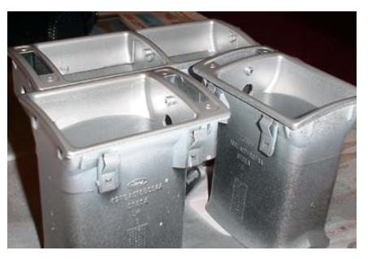
- Colouring pigments: When it is desired to have a different colour than the base of a paint, a colouring pigment is to be added. The pigments are available in the form of fine powders in various colours and qualities.
- Solvents: The function of a solvent is to make the paint thin so that it can be easily applied on the surface. It also helps the paint in penetrating through the porous surfaces. The most commonly used solvent is the spirit of turpentine.
TYPES OF PAINTS
- Aluminium paint:
  - The very finely ground aluminium is suspended in either quick-drying spirit varnish or slow-drying oil varnish as per requirement. The spirit or oil evaporates and a thin metallic film of aluminium is formed on the surface.
  - The aluminium paint is widely used for painting gas tanks, hot water pipes. marine piers, oil storage tanks, radiators, etc.


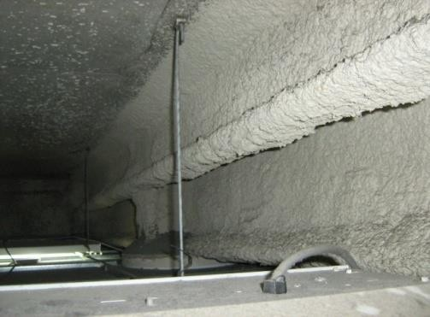
- Anticorrosive paint: This paint essentially consists of oil and a strong drier. A pigment such as chromium oxide or lead or red lead or zinc chrome is taken and after mixing it with some quantity of very fine sand, it is added to the paint.
- Asbestos paint: This is a peculiar type of paint and it is applied on the surfaces which are exposed to the acidic gases and steam.
- Bituminous paint:
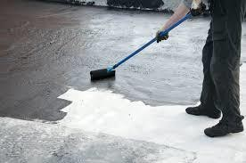
  - This paint is prepared by dissolving asphalt or mineral pitches or vegetable bitumen in any type of oil or petroleum. A variety of bituminous paints is available.
  - The paint presents a black appearance and it is used for painting ironwork under water.

- Cellulose paint:
  - This paint is prepared from nitro-cotton, celluloid sheets, photographic films, etc.

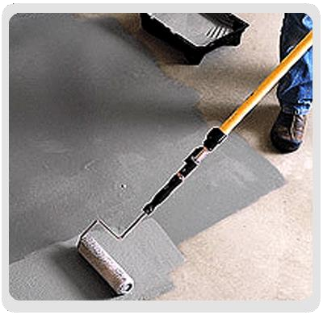
  - An ordinary paint hardens by oxidation. A cellulose paint hardens by evaporation of thinning agent. It thus hardens quickly.
  - The cellulose paint is not affected by contact with hot water and the surface can stand extreme degrees of cold and heat.
- Cement paint:
  - This paint consists of white cement, pigment, accelerator and other additives. It is available in dry powder form.
  - The cement paint is available in variety of shades and it exhibits excellent decorative appearance.
  - It is water proof and durable.

- Colloidal paint:
  - No inert material is mixed in this type of paint. It requires more time to settle and in the process of settlement, it penetrates through the surface.
  - It may be used for interior as well as exterior walls.


- Emulsion paint:
  - A variety of emulsion paints is available. It contains binding materials such as polyvinyl acetate, synthetic resins, etc.

  - This paint is easy to apply and it dries quickly in about 1.5 to 2 hours.
- Enamel paint:
  - This paint is available in different colours. It contains white lead or zinc white, oil, petroleum spirit and resinous matter.
  - It dries slowly and forms a hard and durable surface.
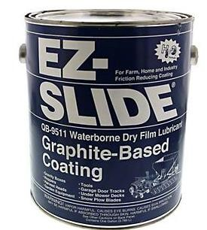
  - The surface provided with this paint is not affected by acids, alkalies, fumes of gas, hot and cold water, steam, etc.
  - It can be used for both internal and external walls.
- Graphite paint:
  - The paint presents a black colour and it is applied on iron surfaces which come in contact with ammonia, chlorine, sulphur gases, etc.

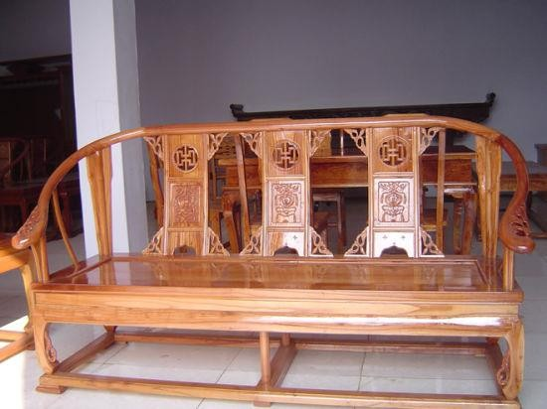
  - It is also used in mines and underground railways.
- Inodorous paint:
  - No turpentine is used in this paint, but white lead or zinc white is mixed with methylated spirit.
  - The shellac with some quantity of linseed oil and castor oil is dissolved in methylated spirit.
  - The paint is not durable, but it dries quickly.

  - The methylated spirit evaporates and a film of shellac remains on the surface.
- Luminous paint:
  - This paint contains calcium sulphide with varnish.
  - The surface on which luminous paint is applied shines like radium dials of watches after the source of light has been cut off.
  - The paint should be applied on surfaces which are free from corrosion or any other lead paint.


- Oil paint:
  - This is the ordinary paint and it is generally applied in three coats of varying composition.

  - They are respectively termed as primes, undercoats and finishing coats.
  - This paint is cheap and easy to apply and it possesses good opacity and low gloss.
- Plastic paint:
  - This paint contains the necessary variety of plastics and it is available in the market under different trade names.
  - The application of plastic paint can be done either by brush painting or spray painting.
  - This paint possesses pleasing appearance and it is attractive in colour.
  - This paint is widely used for show rooms, auditoriums, etc.

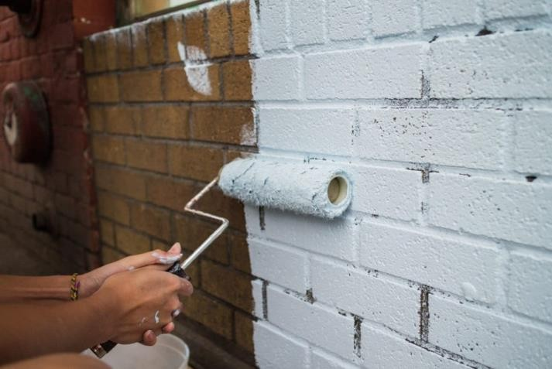
- Silicate paint:
  - This paint is prepared by mixing calcined and finely ground silica with resinous substances.
  - The paint when dried forms a hard surface and it is
durable. It is not affected by alkalies. No chemical action takes place on metals by this paint.
  - The silicate paint can directly be applied on brick, plaster or concrete surfaces. These surfaces should be made wet before the paint is applied.

- Synthetic rubber paint: This paint is prepared from resins.
It has the following advantages:
- It offers good resistance to the water and is not affected by heavy rains.
- It dries quickly.
- A uniform colour is maintained when this paint is applied on the surface.
- It is little affected by weather and sunlight.
- It can be applied on surfaces which may not be completely dry e.g. fresh concrete.

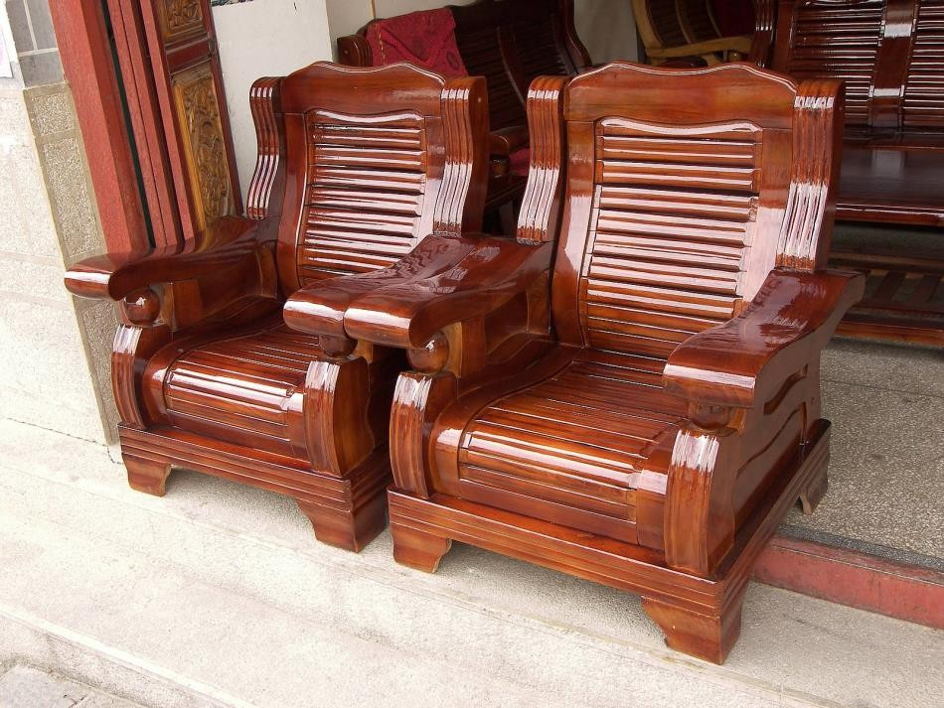
VARNISHING
  - The term varnish is used to indicate the solution of resins or resinous substances prepared either in alcohol, oil or turpentine.
  - The varnishes are transparent or nearly transparent solutions of resinous materials and they are applied over the painted surfaces.
Following are the main objects of applying varnish on a wooden
- It brightens the appearance of the grain in wood.
- It renders brilliancy to the painted surface.
- It protects the painted surface from atmospheric actions.
- It protects the unpainted wooden surfaces of doors, windows, roof trusses, floors, etc., from the actions of atmospheric agencies.

CHARACTERISTICS OF AN IDEAL VARNISH
Following are the characteristics of an ideal varnish:
- It should render the surface glossy.
- It should dry rapidly and present a finished surface which is uniform in nature and pleasing in appearance.
- The colour of varnish should not fade away when the surface is exposed to the atmospheric actions.
- The protecting film developed by varnish should be tough, hard and durable.
- It should not shrink or show cracks after drying. INGREDIENTS OF A VARNISH
Following are the ingredients of a varnish:
  - Resins or resinous substances
  - Driers
  - Solvents.

- Resins or resinous substances:
  - The commonly used resins are copal, lac or shellac and rosin.
  - The copal is a hard substance and is available from the earth a places where pine trees existed in past. It is available in variety of forms.
  - The lac or shellac is obtained by exudation of some types of insects in India.
  - The rosin is obtained from pine trees. Other resins are amber, mastic, gum dammar, etc.
- Driers: The function of a drier in varnish is to accelerate the process of drying. The common driers used in varnishes are litharge, white copper and lead acetate.
- Solvents: Depending upon the nature of resin, the type of solvent is decided. SOLVENTS FOR RESINS

No. | Solvent | Resins

1. | Boiled linseed oil | Amber, Copal
2. | Methylated spirits of wine | Lac or shellac
3. | Turpentine | Mastic, Gum dammar, Rosin
4. | Wood naphtha | Cheap varieties of resins

TYPES OF VARNISHES
Depending upon the solvent, the varnishes are dassified into the following four
categories:
- Oil varnishes
- Spirit varnishes
- Turpentine varnishes
- Water varnishes.

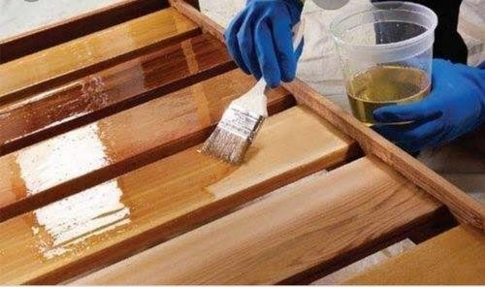
- Oil varnishes:
  - The linseed oil is used as solvent in this type of varnish.
  - The hard resins such as amber and copal are dissolved in linseed oil and if the varnish is
not workable, a small quantity of turpentine is added.
  - The oil varnishes dry slowly, but they form hard and durable surface.
  - They are specially adopted for exposed works which require frequent cleaning. They are used on coaches and fittings in houses.

- Spirit varnishes:
  - The methylated spirits of wine are used as solvent in this type of varnish.
  - The resins are of soft variety such as lac or shellac.
  - The spirit varnishes dry quickly. But they are not durable and are easily affected by weathering actions.

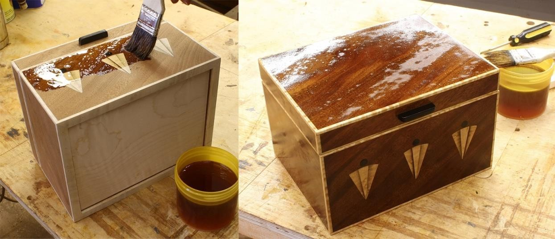
  - They are generally used for furniture.
- Turpentine varnishes:
  - The turpentine is used as solvent in this type of varnish.
  - The resins adopted are of soft variety such as gum dammar, mastic and rosin.
  - These varnishes dry quickly and possess light colours.
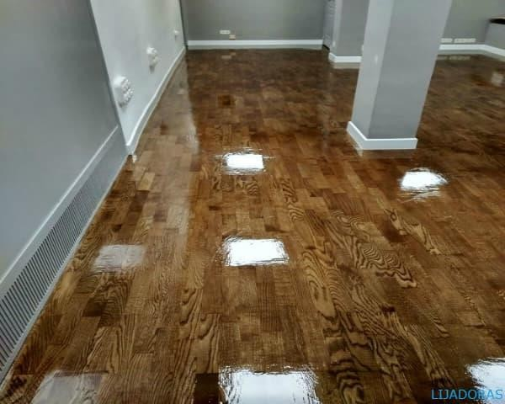
  - They are not durable and tough as oil varnishes.
- Water varnishes:
  - The shellac is dissolved in hot water and enough quantity of either ammonia or borax or potash or soda is added such that shellac is dissolved.
  - These varnishes are used for varnishing maps, pictures, etc.
  - They are also used for delicate internal work and as a covering for wall paper.

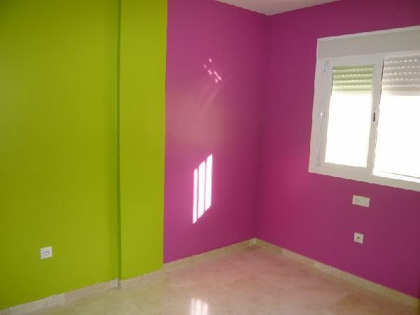
DISTEMPERING
  - The main object of applying distemper to the plastered surfaces is to create a smooth surface.
  - They are cheaper than paints and varnishes and they present a neat appearance.
  - They are available in a variety of colours. INGREDIENTS OF DISTEMPER
  - A distemper is composed of base, carrier, colouring pigments and size.
  - For base, the whiting or chalk is used and for carrier, the water is used.
  - The distempers are available in powder form or paste form.

  - They are to be mixed with hot water before use. PROCESS OF DISTEMPERING
The application of distemper is carried out in the following way:
- Preparation of surface: The surface to receive the distemper is thoroughly rubbed and cleaned.


- Priming coat: After preparing the surface to receive the coats of distemper, a priming coat is applied and it is allowed to become dry.

- Coats of distemper:
  - The first coat of distemper is then applied on the surface.
  - It should be of a light tint and applied with great care.
  - The second coat of distemper is applied after the first coat has dried and become hard.

***end***

PART: B (CONSTRUCTIONS TECHNOLOGY)

CHAPTER:-01 [Introduction]
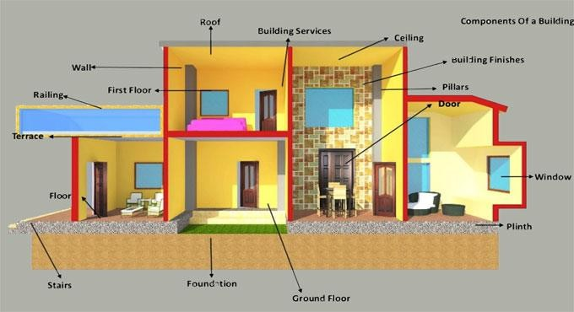
Buildings
Introduction: The term building in civil engineering parlance is used to mean a structure having various components like foundations, walls, columns, floors, roofs, doors, windows, ventilators, stairs, lifts, various types of surface finishes, etc.
TYPES OF BUILDINGS
As per National Building Code of India, buildings are classified into nine groups based on occupancy as follows:
Group A: Residential buildings

Group B: Educational buildings Group C: Institutional buildings Group D: Assembly buildings Group E: Business buildings Group F: Mercantile buildings Group G : Industrial buildings Group H: Storage buildings Group I: Hazardous building.
Group A: Residential buildings
The buildings which are provided with sleeping accommodation for normal residential purposes, with or without cooking or dining or both the facilities are termed as residential building.
The buildings of Group A are further sub-divided into five groups as follows:
- Sub-group A-1 : Lodging or rooming houses

- Sub-group A-2 : One or two family private dwellings
- Sub-group A-3: Dormitories
- Sub-group A-4: Apartment houses(Flats)
- Sub-group A-5: Hotels
Ex: Apartments, Flats, Bungalows, Dormitories, private houses, Hotels, Hostels, Cottages, Holiday camps, clubs, hotels, Inns etc.
Group B: Educational buildings
Any school, college building or day-care center used for educational purpose for more than 8 hours a week involving assembly for instruction, education or recreation and which is not covered by Group D comes under this group.
Group C: Institutional buildings
These include any building or part thereof, which is used for purposes like medical or other treatment or care of persons suffering from physical or mental illness, diseases or infirmity, care of infants, aged persons, etc.
This group further divided into three sub-groups as mentioned below:

  - Sub-group C-1 : Hospitals and Sanitaria
  - Sub-group C-2 Custodial Institutions
  - Sub-group C-3: Penal Institutions Group D: Assembly buildings
Any building or part of a building like theatres, assembly halls, drama theatres, auditorium, museums, exhibition halls, restaurants, places of worship, dance halls, club house, air terminals, surface and marine public transportation service, recreation piers, sports stadium, gymnasiums, skating rinks, etc., where group of people gather for amusement, recreation, social, religious, patriotic, civil, travel or other similar purposes are included in this group.
This group is further divided into five sub-groups as mentioned below:
- Sub-group D-1: Any building with a raised stage, proscenium curtain, fixed or portable scenery or scenery loft, lights, motion picture booth, mechanical appliances or other theatrical accessories and equipment, fixed seats over 1000 persons and primarily meant for theatrical or operatic performances and exhibitions is considered in this sub-group.

- Sub-group D-2: This sub-group includes any building primarily meant for use as described for sub-group D-1 but with a capacity of less than 1000 persons.
- Sub-group D-3: This sub-group includes any building, its lobbies, rooms and other spaces connected thereto, primarily meant for assembly of more than 300 people without permanent seating arrangement, raised theatrical stage or theatrical accessories but may be with raised platform. The buildings like dance halls, club halls, lecture halls, libraries, passenger terminals and buildings used for educational purposes for less than 8 hours per week are covered under this sub-group.
- Sub-group D-4: This sub-group includes any building primarily meant for use as described for sub-group D-3 but with a capacity of less than 300 persons
- Sub-group D-5: This sub-group includes any building meant for outdoor assembly of people not covered by sub-group D-1, D-2, D-3 or D-4, like grand stands, stadia, amusement park structures, reviewing stands and circus tents.
Group E: Business buildings
Any building or part of a building which is used for the transaction of business (other than that covered by building in Group F), for the keeping of accounts and

records and similar purposes, barber shops, beauty parlours, lunch counters serving
less than 100 people, is included in this group. Group F: Mercantile buildings
This sub-group includes any building or part of building, which is used as shops, offices, stores, markets, showrooms for display and sale of merchandise either wholesale or retail.
Group G : Industrial buildings
This sub-group includes any building or part of a building in which products or materials of all kinds and properties are fabricated, assembled or processed. These include assembly plants, smoke houses, gas plants, refineries, dairies, textile mills and saw mills.
Group H: Storage buildings
This sub group includes any building or part of a building which primarily used for the storage or sheltering (including servicing, processing or repairs incidental to storage) of goods, wares or merchandise except those that involve highly combustible or explosive products or materials, vehicles or animals. These include warehouses,

cold storages, freight depots, transit sheds, store houses, truck and marine terminals, garages, hangers (other than aircraft repair hangers), grain elevators, bars and stables.
Group I: Hazardous building
This sub-group includes any building or part of a building which is used as storage, handling, manufacture or processing of highly combustible or explosive materials or products which are liable to burn with extreme rapidity and/or which produce poisonous fumes or explosions or which are highly corrosive, toxic or noxious alkalis, acids or other chemicals producing flame, fumes and explosive, poisonous, irritant gases or which require any material producing explosive mixtures of dust or which result in division of matter into fine particles subject to spontaneous ignition.
IMPORTANT BUILDING COMPONENTS
Usually a building is divided into three parts
- Foundation
- Plinth and
- Superstructure,

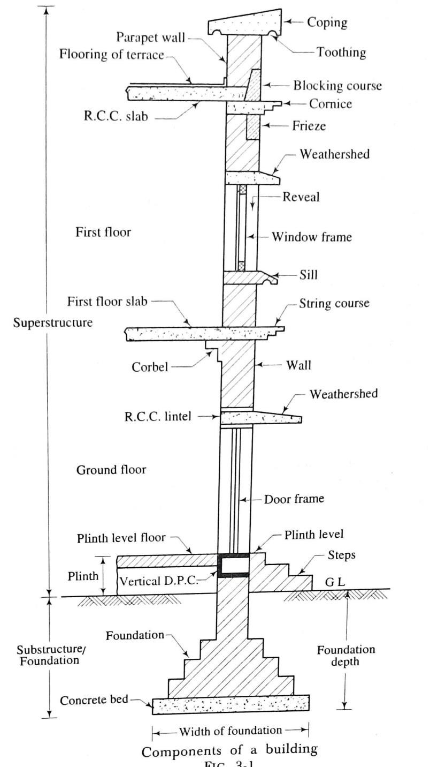
- Foundation: It is the part of a building constructed below ground level and which is in direct contact with sub- strata and transmits all the loads to the sub-soil.
- Plinth: It is the building above the ground level and upto the floor level immediately above the ground. The built-up area measure at the plinth level is known as plinth area.
- Superstructure: It is the part of the building constructed above the plinth level.
Following are the structural components of a building:
  - Foundation
  - Plinth
  - Masonry or R.C.C. walls and columns in superstructure
  - Basement, Ground floor and upper floors

  - Sills, lintels and weather sheds
  - Doors, windows and ventilators
  - Roofs
  - Stairs, lifts, ramps, etc.
  - Building finishes like plastering, painting, whitewashing, flooring, etc.
  - Utility fixtures.
- Foundation:
  - Foundation is also known as substructure of the building.
  - It is the most critical part of the building which transmits the entire load of the building to the subsoil in which it rests in such a way that settlement of the soil does not fail in shear.
- Plinth:
  - A part of superstructure located between the ground level and the floor level is known as the plinth.

  - The height of the plinth should not be less than 45 cm.
  - The height of the plinth depends upon architectural elevation, ground level, highest flood level, etc.
  - Usually coping, plinth beam and damp proof course are provided at the top of the plinth.
- Masonry or R.C.C. walls and columns in superstructure:
  - Walls are used enclose or divide the floor space.
  - Load bearing walls should be strong enough to take its own weight, superimposed weight and lateral pressure of wind.
  - They should provide stability, weather resistance, fire resistance, heat insulation, sound insulation, privacy and security.
- Basement, Ground floor and upper floors:
  - A floor provides support to the occupants, furniture, fixtures and equipments of a building.
  - Different floors divide the building into different levels to provide more accommodation on a given plot of land.

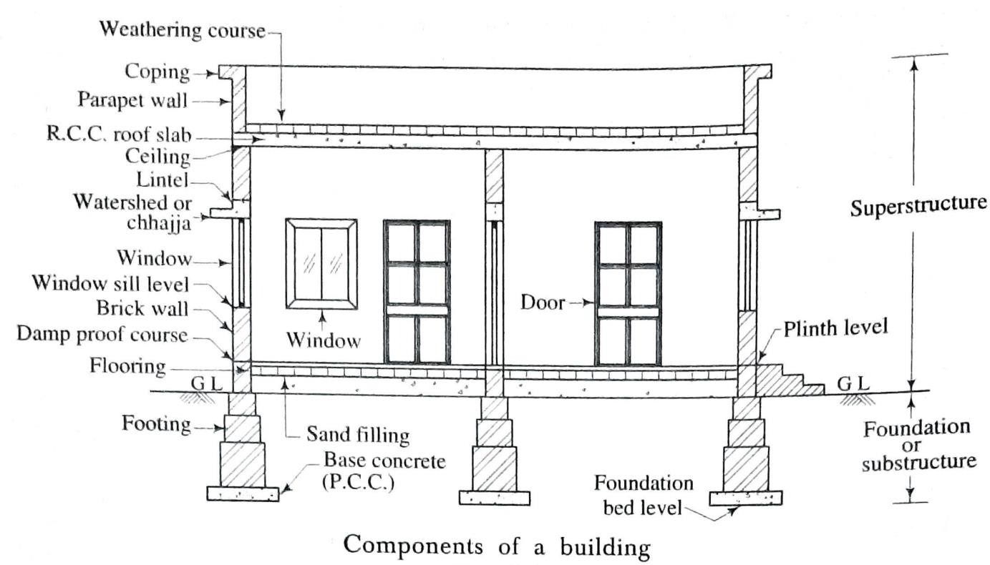
  - The floor of a building immediately above the ground is known as ground floor.
  - All other floors above the ground floor is known as upper floors.
  - The floor below the
ground level is known as basement floor or lower level floor.
- Sills, lintels and weather sheds:
  - Window sills are provided between the bottom of window frame and above the top of the wall below.
  - The lintel is provided above the openings of windows, doors and ventilators in the wall to support the weight of the wall above the openings.
  - Weathersheds or chhajjas are generally combined with lintels to protect doors, windows, or ventilators from sun, rain, wind frost, etc.

- Doors, windows and ventilators:
  - Doors are provided in a building to allow the free movement outside and to the internal part of the building. It is an openable barrier secured in an opening left in a wall. It consists of frame and shutter.
  - Windows are generally provided for proper light, ventilation and vision. Their sizes and numbers should be properly determined as per requirements.
  - When windows are provided for light and ventilation only, they may be fixed so that they cannot be opened. They are known as ventilators.
- Roofs:
A roof is the uppermost part of a building which is constructed in the form of a framework to give protection to the building against rain, heat, snow, wind, frost, etc.
- Stairs, lifts, ramps, etc:
  - Stairs, lifts, ramps, escalators, etc. are the means of vertical transportation between the floors.
  - Stair is defined as a sequence of steps suitably arranged for the purpose of ascent and descent between the floors or landings.

  - A ramp is a sloping surface and it is adopted as a substitute for stair for easy movement between the floors. A slope of 1 in 10 is desirable.
  - The flooring of ramp should be of non-slippery material. Its shape may be straight, zigzag, spiral, curve, etc.
  - Escalators are ever moving flights of electrically operated stairs. These escalators are kept in motion by a revolving drum.
- Building finishes like plastering, painting, whitewashing, flooring, etc:
  - To protect the exposed surface of walls and floors from the effects of atmospheric actions, building finishes are used.
  - They improve the appearance of the structure as a whole and give smooth surface.
- Utility fixtures:
  - Utility fixtures are built-in items in the building. They are immovable in nature.
  - Wooden cupboards made in walls, shelves, smokeless Chula, etc. are utility fixtures.
  - Generally they are provided by making recesses in walls, which makes the structure weak. So in modern construction, utility fixtures are avoided.

PART: B (CONSTRUCTIONS TECHNOLOGY)

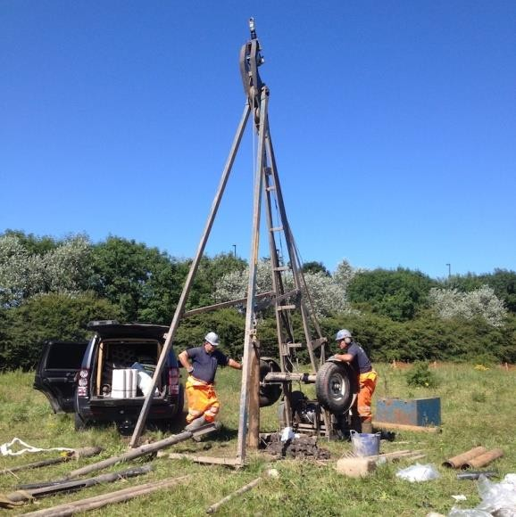
CHAPTER:-01 [Introduction]
Continue.......
[Site investigation]
GENERAL
  - It is desirable to visit the site of work and inspect the same carefully from the view point of foundation details.
  - The nature and thickness of strata of soil may be estimated by studying the excavation details of nearby constructions or by examining the open side of a nearby well, etc.
Objectives of Site Investigation
- Location of ground water and its variation;
- Nature and engineering characteristics of the soil and rock formation; and

- Order of occurrence and extent of different soil strata. DEPTH OF EXPLORATION
The depth of exploration will have to be decided very carefully. The term significant depth is used to indicate the depth upto which the increase in pressure due to structural loading is likely to cause perceptible settlement or shear failure of foundations.
The general rules to be adopted to decide the depth of exploration for various types of structures and site conditions are given in table.

No. | Description | Depth of exploration
1. | Adjacent footings with clear | 1.50 times the length.
 | spacing less than twice the
 | width
2. | Base of retaining wall | 1.50 times the base width or 1.50 times the
 |  | exposed height of face of wall whichever is greater.
3. | Floating basement | Depth of construction.
4. | Isolated spread footings or | 1.50 times the width.
 | raft foundations

5. | Pile foundations | 10 m to 30 m or more with minimum equal to 1.50
 |  | times the width of structure.
6. | Weathering conditions | 1.50 m in general and 3.50 m in black cotton soil.

METHODS OF SITE EXPLORATION
Following are the various methods of site exploration:
  - Test pits (5) Sub-surface soundings
  - Probing (6) Test piles
  - Auger boring (7) Deep boring
  - Wash boring (8) Geophysical method.
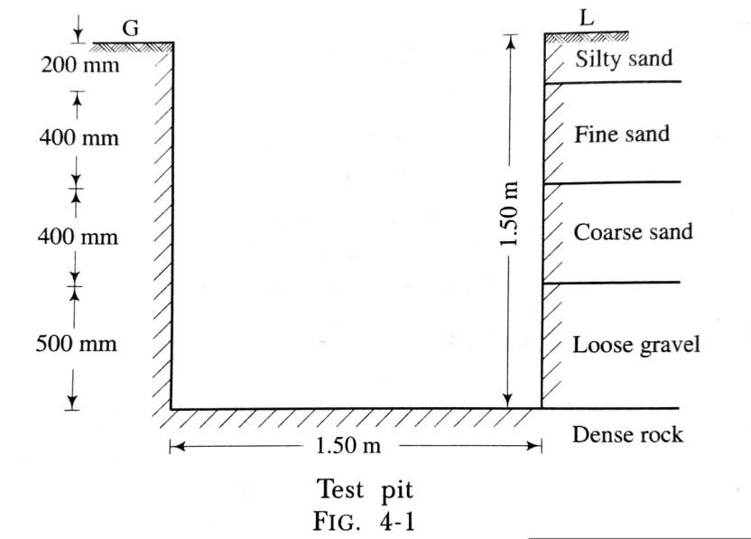
- Test pits:
  - A square pit, known as a trial pit or a test pit, with side as about 1.50 m, is excavated upto a depth at which sufficiently hard soil is available. The various strata of the soil can be inspected, studied and

classified accordingly as shown in fig.4-1. This method is useful when hard soil is available within a maximum depth of 1.50 m.
- Probing:
  - The probing consists of driving either a hollow tube or a steel rod or an iron rod into the ground.
  - A hollow tube of diameter 35 mm to 50 mm is taken. It has a slit of 3 mm thickness in the bottom portion of 600 mm as shown in fig. 4-2. The tube is driven into the ground 300 mm or so at a time. It is then withdrawn and the material caught in the slit is inspected.
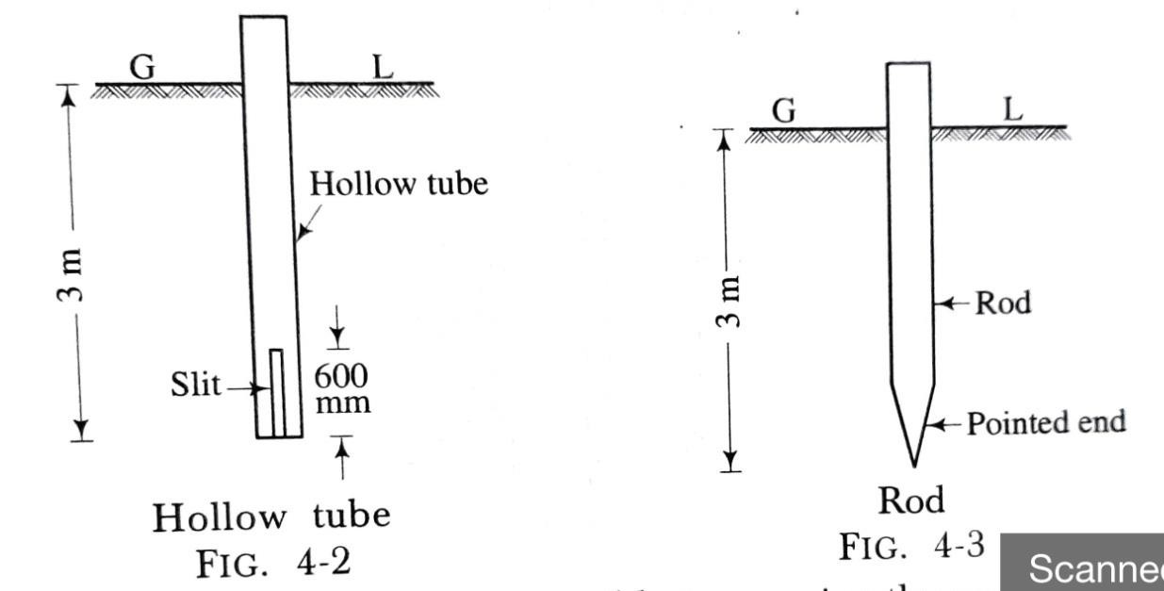
  - In other case, a solid rod of steel or iron having a diameter of about 30 mm to 35 mm is taken and driven into the ground. The rod has a pointed end as shown in fig. 4-3. The rod is frequently withdrawn and the material stuck up at the pointed end is examined.
  - With the help of this method, it is possible to examine the ground for a maximum depth of 3 m.

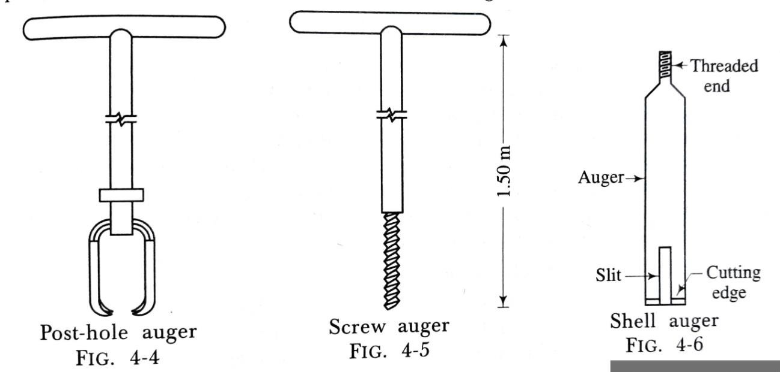
- Auger boring:
  - An auger may be of post-hole type or screw type or shell type. They all work in the same way.
  - Fig. 4-4, fig. 4-5 and fig. 4-6 show respectively a post-hole
auger, a screw auger and a shell auger.
  - Fig. 4-6 shows a typical shell auger. It consists of a hollow tube of diameter 75 mm to 100 mm. The tube is provided with a cutting edge at the bottom.
  - A slit extending over a length of 600 mm to 900 mm is provided at the bottom of the tube to catch the material.
  - The length of the tube is about 1.50 m and it is provided with a threaded end so that it can be suitably extended with the help of lengthening pieces.
  - The auger is worked by applying leverage at the top.
  - The auger is driven into the ground and turned like a screw. The auger is withdrawn and the material caught in the slit is inspected.

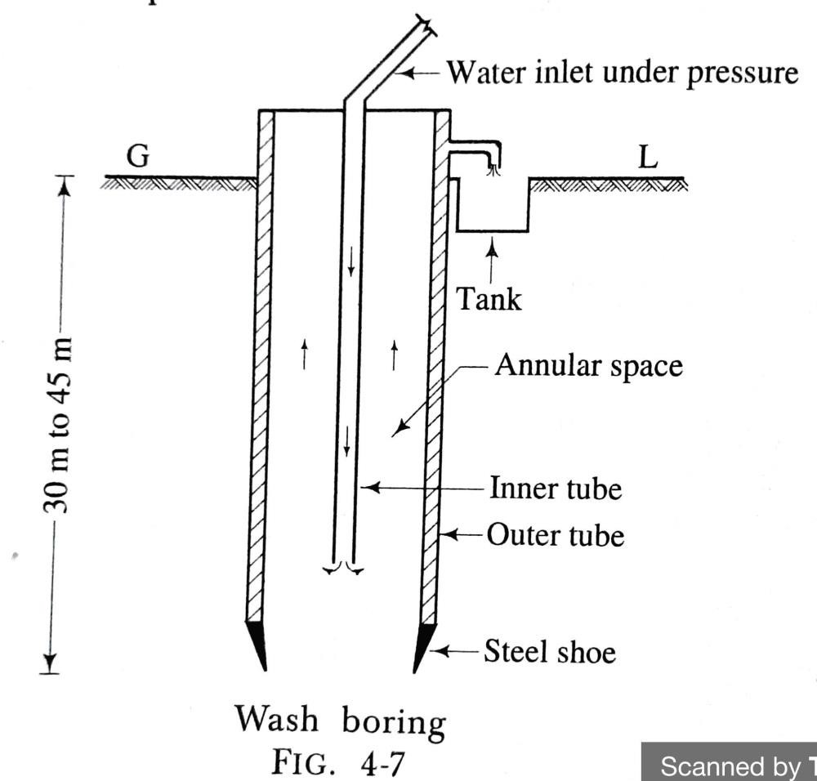
- Wash boring:
  - The wash boring is the term used to denote a method in which a casing is driven into the ground and the material inside the casing is washed out and brought to the surface for inspection.
  - The process of wash boring consists in driving an inner tube of diameter 25 mm to 50 mm, inside an outer tube of diameter 100 mm to 150 mm.
  - The water is simultaneously forced with driving of tube under pressure through the inner tube.
  - This facilitates easy driving of the tube and makes the soil loose enough to flow through the annular space as shown in fig. 4-7.
  - The quantity of water required is usually about 100 to 300 litres per minute under a pressure of 36.28 kN/m². The process is continued till hard surface is met with.
  - The washed material is collected in a tank and studied carefully.

- Sub-surface soundings:
  - In this method, the resistance of the soil with depth is measured by means of a tool known as the penetrometer under static or dynamic loading.
  - The penetrometer may consist of a sampling spoon, a cone or tool of other shape.
  - The procedure is as follows:
- The penetrometer is driven in the ground with the help of blows from a 650 N weight falling from a height of 750 mm.
- The number of blows required to drive the penetrometer into the ground through a distance of 300 mm is measured. It is known as the standard penetration resistance or SPT of the soil.
- The values of SPT of soil at different depths are determined.
- The bearing capacity and other engineering properties of certain types of soil are then known by referring to the curves corelating SPT and the corresponding characteristics of soil. These curves are available for ready reference.

The sub-surface sounding tests are useful for:
- Finding the depth of bed rock or stratum;
- Knowing the general exploration of erratic soil profiles; and
- Testing cohesionless soils from which it is difficult to obtain the undisturbed samples.
- Test piles:
  - Sometimes the test piles are driven into the ground to obtain the information of the solid strata.
  - With the help of this process, it is not possible to know definitely the kinds of strata through which the test piles pass, as the material is not available for inspection.
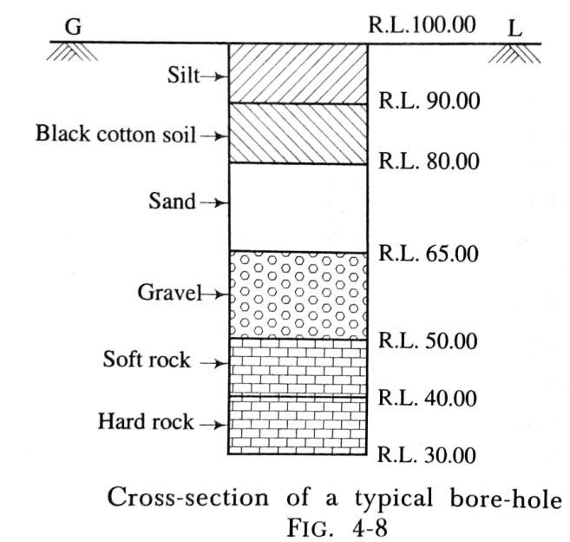
  - But the factors such as resistance of soil to driving of piles, load bearing data and any other available local information serve as useful guides.
- Deep boring:
  - It becomes essential to carry out deep boring for big important engineering structures such as dams.

  - In such structures, in addition to the stability of the superstructure, the importance is to be given to various other factors such as non-leakage of the stored water, seepage through porous strata, etc.
  - The machines used for deep boring are as follows:
- Percussion boring machine
- Core or rotary drilling machine.
- Geophysical method:
  - In favourable circumstances, the geophysical method is adopted to know the nature of soil strata.
  - These methods are used when the exploration depth is substantial and the speed of investigation is of primary importance.
  - These methods are mainly adopted to ascertain the depths at which useful minerals and oils are available.
  - The two most commonly adopted methods for civil engineering purposes are as follows:
- Electrical resistivity method; and
- Seismic refraction method.
***end***


PART: B (CONSTRUCTIONS TECHNOLOGY)

CHAPTER:-02 [Foundations]
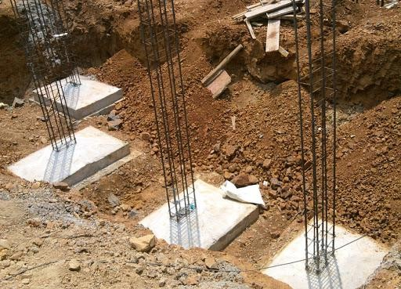
GENERAL
Every structure consists of the following two parts:
- Foundations; and
- Superstructures.
  - The lowest artificially prepared parts of the structures which are in direct contact with
the ground and which transmit the loads of the structures to the ground are known as the foundations or substructures.
  - The lowermost portion of the foundation which is in direct contact with the sub- soil is called the footing.

OBJECTS OF FOUNDATIONS
The foundations are provided for the following purposes:
- to distribute the total load coming on the structure on a larger area so as to bring down the intensity of load at its base below the safe bearing capacity of sub-soil;
- to support the structures;
(ii) to give enough lateral stability to the structures against various disturbing horizontal forces such as wind, rain, earthquake, etc.;
- to prepare a level and hard surface for concreting and masonry work;
- to transmit the super imposed loads through side friction and end bearing in case of deep foundations;
- to distribute the non-uniform load of the superstructure evenly to the sub-soil;
- to provide the structural safety against undermining or scouring due to animals, flood water, etc
- to prevent or minimize cracks due to movement of moisture in case of weak or poor soils; etc.

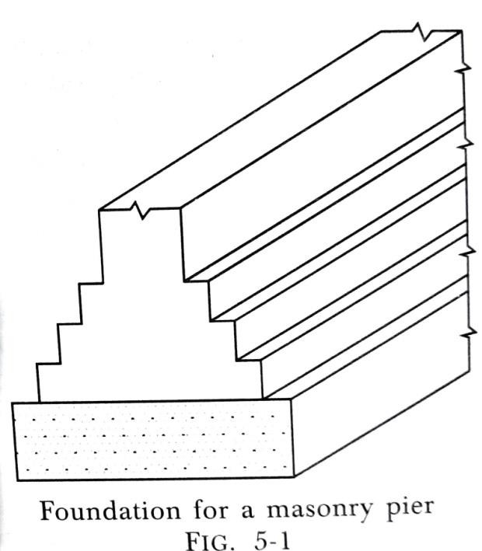
The foundations can broadly be classified into two categories:
  - shallow and
  - deep.
SHALLOW FOUNDATIONS:
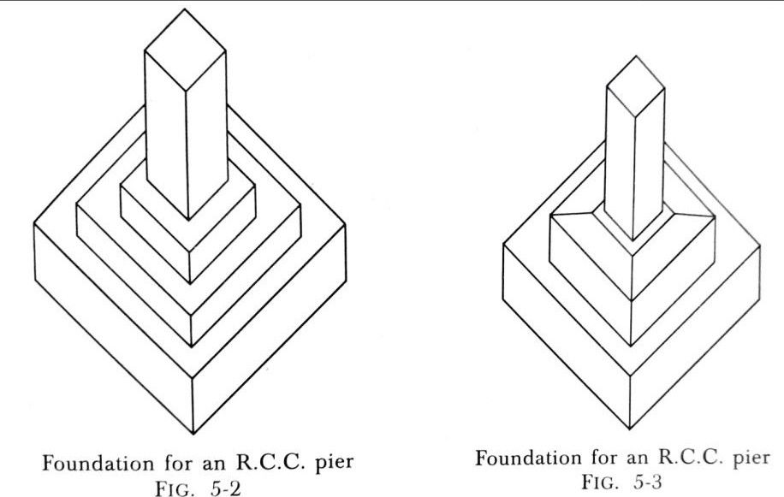
- If it is possible to construct foundations of a building at reasonable shallow depth, the foundations are termed as the shallow foundations.
- In such cases, a spread is given under the base of a wall or a column. This spread is known as the footing and the foundation is known as the spread footing.
- Typical sketches of spread foundations for a masonry wall, a masonry pier and a
R.C.C. pier are shown in fig. 5-1, fig. 5-2 and fig. 5-3 respectively.

DESIGN OF SHALLOW FOUNDATIONS
Following data are required before the design of shallow foundations is taken in hand:
- The total load to be transmitted by the wall or pier to the foundation bed.
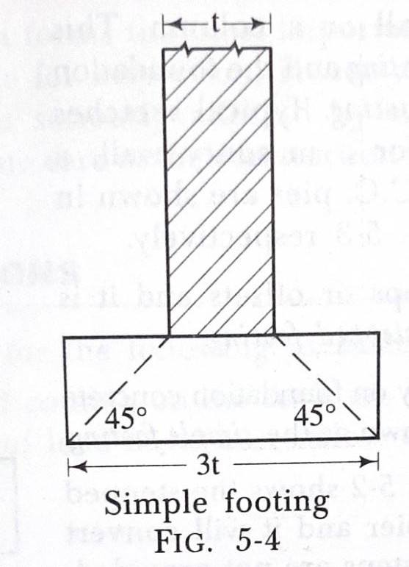
- The results of trial pits and the corresponding bearing capacity of each strata of soil.
The design of shallow foundations involves two aspects:
  - Width of foundations
  - Depth of foundations.
- Width of foundations: The width of foundations is decided by adopting the following rules:
  - If no footings are to be provided to the wall i.e. for simple footing, the width of foundations should be equal to three times the thickness of wall as shown in fig. 5-4.

  - The total load including dead load, live load and wind load coming on the wall per metre length or in case of a pier, at the centre of the pier, is worked out. Then the width of foundation is obtained from the following relations:
For walls, width of foundations = ( total load per metre length / allowable bearing
capacity of the soil )
For piers, width of foundations = (total load on the pier/ allowable bearing capacity of
the soil )
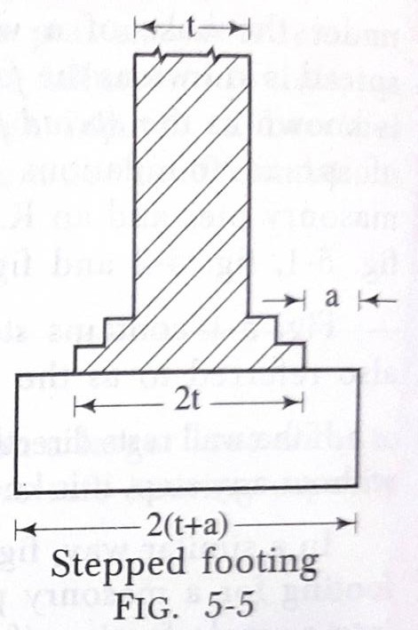
  - Usually the walls and piers are given footings such that the width at the base becomes equal to twice the width of wall at the plinth level as shown in fig. 5-5. By adding the width of offsets of concrete, the total width of foundations can be obtained for stepped footing,
If t = thickness of wall, and
a = offset of concrete. width of foundation = 2 (t + a).
Note: The greater result obtained from rules (ii) and (iii) should be

adopted.
- Depth of foundations: The depth of foundations is obtained by keeping in view the following rules:
- As a general rule, all the shallow foundations should be taken to a minimum depth of 800 mm below natural ground level unless hard soil is available within 800 mm.
- The total load to be transferred to the soil per square metre can be worked out and after the study of the results of the trial pits, the foundations should be taken to such a depth at which the soil has allowable bearing capacity greater than this
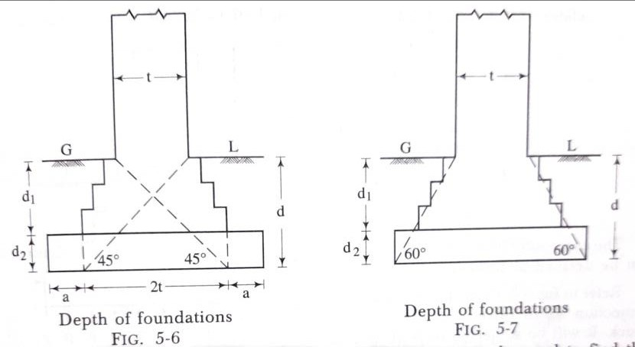
value.
- The depth of foundations can also be obtained by drawing the lines of angles 45° and 60° as shown in fig. 5-6 and fig. 5-7 respectively,
Let d₁ = Depth of footings
d₂= Depth of concrete block.

d = Total depth of foundations
Then, d = d₁ + d₂
- For loose soil, Rankine's formula, as given below, can be used to find the minimum depth of foundations:
𝝆 𝟏−𝒔𝒊𝒏𝝓
d = ( ) ²
𝝎 𝟏+𝒔𝒊𝒏𝝓
Where d = minimum depth of foundation in metres
𝜔 = weight of soil in kg/m³ or kN/m³
𝜙= angle of repose
𝜌 = load on soil in kg/m² or kN/m².
The above formula is not to be used when the building to be constructed rests on hard soil.
The values of angles of repose of some of the soils are given in table 5-1.
TABLE 5-1 ANGLES OF REPOSE OF VARIOUS SOILS

No. | Type of soil | Angle of repose in degrees

1. | Loose earth | 30 to 45
2. | Compact earth | 50
3. | Dry sand | 25 to 35
4. | Moist sand | 30 to 45
5. | Wet sand | 15 to 30
6. | Clay | 25 to 45
7. | Gravel | 30 to 40
8. | Ashes | 40
9. | Gravel and sand | 25 to 40

- For finding out the depth of concrete block, the following formula can be used:

𝟏
  - Depth of concrete block in cm =
𝟓𝟖
√𝝆𝒂²
𝒎

𝟓
  - Depth of concrete block in cm = t.
𝟔

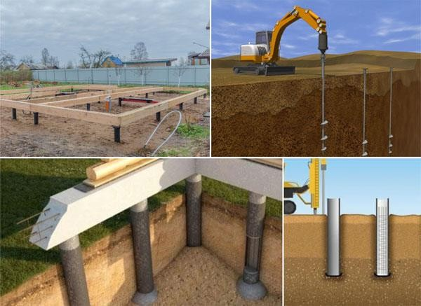
DEEP FOUNDATIONS:
- In case of deep foundations, the piles are used to transmit the load of structure to the soil.
- The term pile foundations is used to describe a construction for the foundation of a wall or a pier, which in turn is supported on the piles.
- This construction is adopted when the loose soil extends to a great depth.
- The load of the structure is transmitted by the piles to hard stratum below or it is resisted by the friction developed on the sides of piles.
USES OF PILES
The situations which demand piles as foundations are as follows:
- The load coming from the structure is very heavy and the distribution of load on soil is uneven.
- The subsoil water level is likely to rise or fall appreciably. This may be seasonal or occasional variation.

- The pumping of subsoil water is too costly for keeping the foundation trench in dry condition.
- The construction of raft or grillage foundations is likely to be very expensive or is practically impossible.
- The firm bearing stratum exists at a greater depth. The piles upto 20 metres depths are common and under exceptional circumstances, they may even be taken to 30 metres depth. The piles are considered to be long when their length exceeds 30 metres.
- The timbering to excavations is too difficult to maintain the sides of the foundation trench.
- The pile foundation is to be adopted for the structures in the area where canals, deep drainage lines, etc. are to be constructed in near future.
- The structure is situated on sea-shore or river bed and the foundation is likely to be affected by the scouring action of water. Thus, the piles are useful for the marine structures.

- The piles are also used as anchors. They may be designed to give lateral support or to resist an upward pressure or uplift pressure.
- The piles are used as fender piles in the construction of docks, piers and other marine structures. A fender pile protects the berthing ships from damage.
TYPES OF PILES
The piles are broadly classified into the following two categories:
  - Load bearing piles
  - Non-load bearing piles.
- Load bearing piles.
  - These piles bear the load coming from the structure. The piles are generally driven vertically or in near vertical position.
  - When a horizontal force is to be resisted, the piles may be driven in an inclined position and such inclined piles are termed as the batter piles.
  - The former piles are known as the bearing or sustaining piles and the latter piles are known as the friction or floating piles.

MATERIALS USED IN CONSTRUCTION OF LOAD BEARING PILES;
The materials which are used in the construction of load bearing piles are as follows:
- Cast-iron piles (4) Steel piles
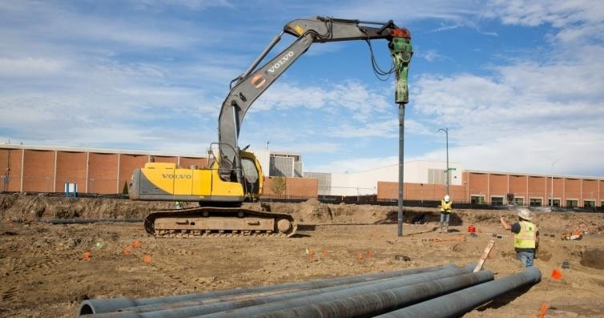
- Cement concrete piles (5) Timber piles
- Sand piles (6) Wrought-iron piles.
- Cast-iron piles:
  - The cast-iron piles are generally hollow.
  - The inside diameter of pile is about 300 mm and thickness is about 25 mm.
  - The length of pile is about 3 metres to 4 metres and with the help of suitable device, it can be extended to any desired length.
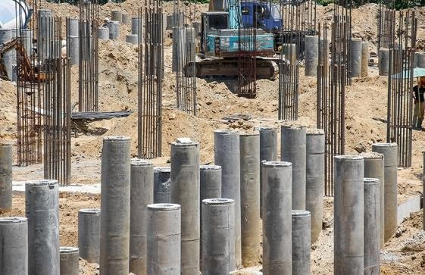
- Cement concrete piles:
  - The cement concrete possesses excellent compressive strength.
  - With the advent of reinforced cement concrete, the R.C.C. piles are becoming more popular and they are fast replacing piles of other materials.

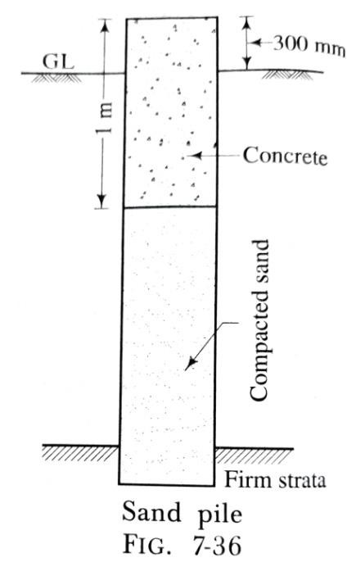
  - The R.C.C. piles are divided into two groups:
(1) Cast-in-situ concrete piles (2) Pre-cast concrete piles.
- Sand piles:
  - These piles are formed by making holes in the ground and then filling the holes by sand.
  - If sand is kept confined, it possesses great crushing strength and becomes incompressible.
  - A bore of required diameter, usually 300 mm, is formed either by
driving a wooden pile or by an auger or by forcing a pipe with closed end.
  - The hole is then filled with sand and it is well-rammed until the sand in the hole does not escape.
  - The sand to be used should be moist at the time of placing.
  - The top of sand pile is filled with concrete to prevent the sand to come upwards due to lateral pressure.

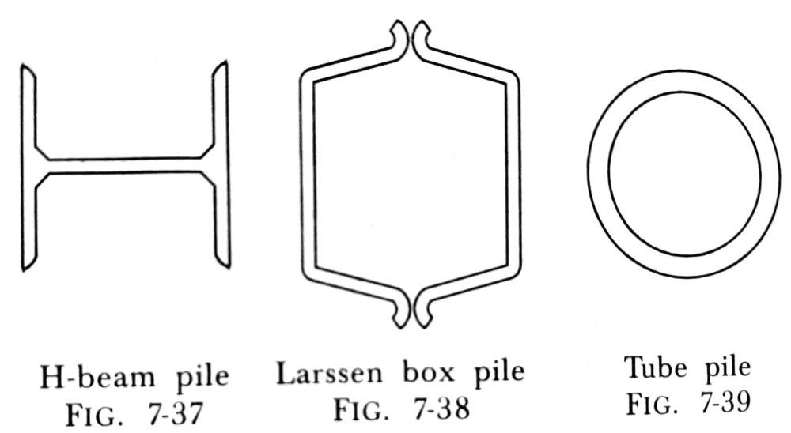
- Steel piles:
The steel piles are used as the load bearing piles in three different forms:
(1) H-beam piles (2) Box piles (3) Tube piles

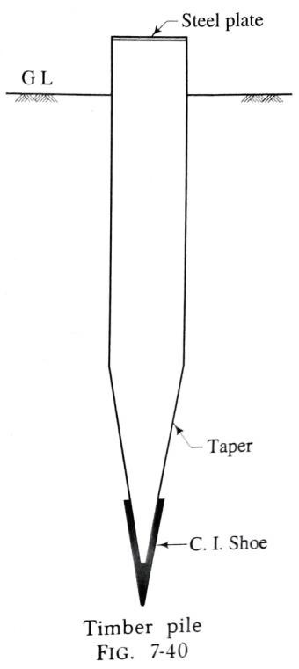
- Timber piles:
  - These piles are prepared from the trunks of trees and the use of timber as pile has been recorded since the beginning of the science of civil engineering.
  - The wood to be used for timber piles should be free from knots, flaws, shakes and other defects.
  - The common Indian timbers which are used as piles are: Babul, Chir, Deodar, Jarul, Poon, Sal, Semul, Teak and White Siris.
  - The timber piles may be circular or square.
  - The diameter of circular timber piles varies from 300 mm to 500 mm and the side of a square timber pile is about 300 mm to 500 mm.

  - The length of a timber pile should not exceed 20 times its top width. Otherwise it may fail by buckling.
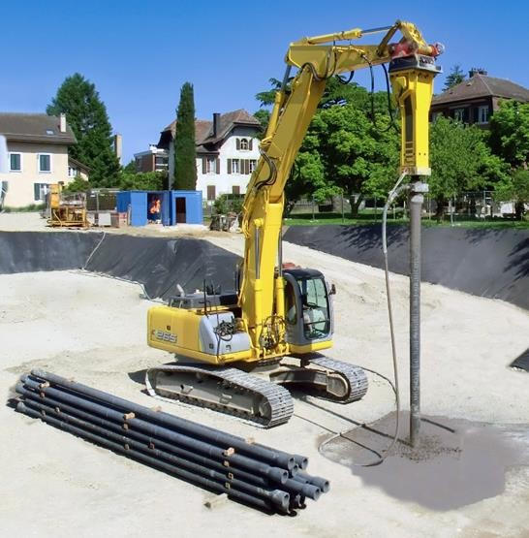
  - A timber pile. At the bottom, a cast-iron shoe is provided and at the top, a steel plate is fixed.
- Wrought-iron piles:
  - These piles are generally made solid. The diameter varies from 80 mm to 200 mm and the length is usually about 4 metres to 6 metres.
  - The wrought-iron piles have suitable devices for lengthening and sinking. These piles are mostly used for shafts of screw piles.
  - The wrought-iron piles are most suitable for use under sea water. But as these piles are expensive, they are now replaced by the steel piles.
- Non-load bearing piles.
  - These piles are used to function as the separating members below ground level and they are generally not designed to take any vertical load.

  - However such piles are indeed to be designed to carry the horizontal earth pressure.
  - Such piles are known as the sheet piles.
The materials which are employed in the construction of sheet piles are as follows:
- Concrete sheet piles
- Steel sheet piles
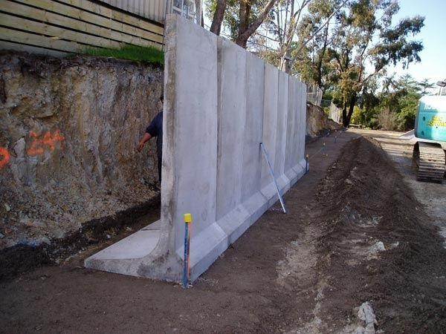
- Timber sheet piles.
- Concrete sheet piles:
  - These piles are always pre-cast and the reinforcement is provided as per design.
  - The piles are square or rectangular in cross-section and they are driven side by side so as to form a continuous wall.
  - The width of pre-cast R.C.C. piles varies from 500 mm to 600 mm and the thickness varies from 20 mm to 60 mm.
  - The reinforcement is in the form of vertical bars and hoops.
  - The length of piles is to be decided previously from the results of boring.

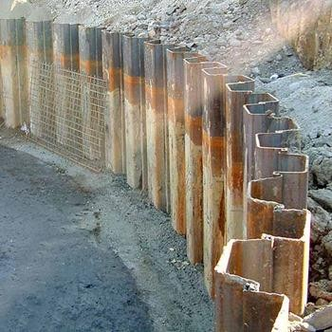
- Steel sheet piles:
  - The steel sheet piles are now commonly used.
  - The various patented forms have been developed for the steel sheet piles.
  - They are generally made from steel sheets 200 mm to 300 mm wide and 4 metres to 5 metres long with suitable
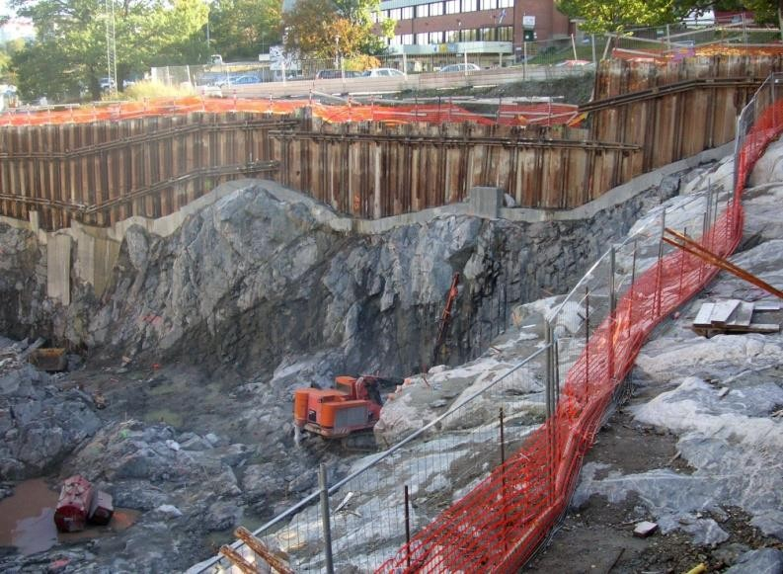
interlocking arrangements so as to form fairly watertight joints.
- Timber sheet piles:
  - The wooden sheet piles are commonly used for the temporary works such as cofferdams.
  - They usually consist of wooden boards 80 mm to 150 mm thick, 200 mm to 300 mm wide and 2 metres to 4 metres long.
  - The bottom is chamfered so as to form a cutting edge
and if necessary, both top and bottom are provided with suitable iron fittings.
***end***

PART: B (CONSTRUCTIONS TECHNOLOGY)
CHAPTER:-03 [Walls & Masonry Works]
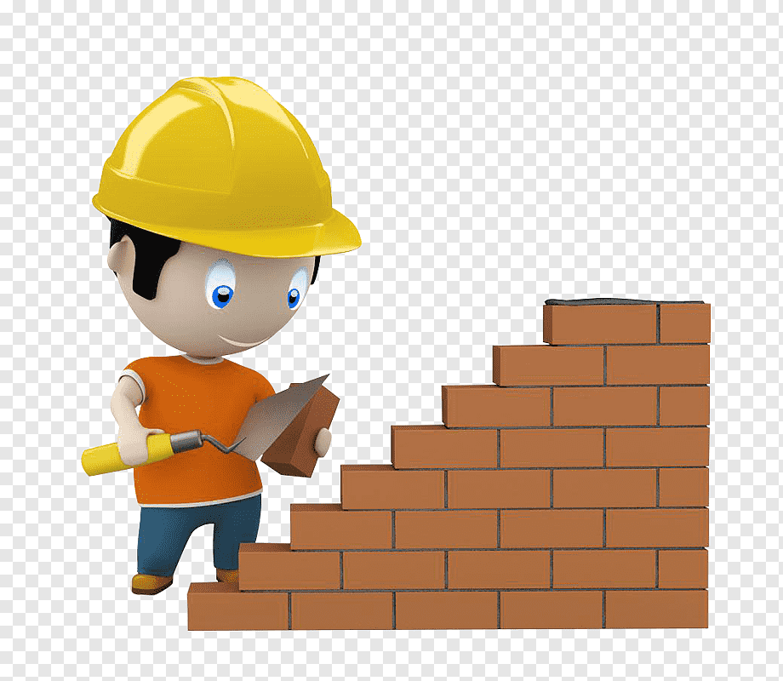
Wall
  - Walls are used to enclose or divide the floor space.
Functions of wall
  - Wall is one of the most essential components of a building.
  - The primary function of a wall is to enclose or divide space of the building to make it more functional and useful.
  - Walls provide privacy, afford security and give protection against heat, cold, sun and rain.
  - Walls provide support to floors and roofs.
  - Walls should therefore be so designed as to have provision of adequate;

Strength and stability Weather resistance Durability
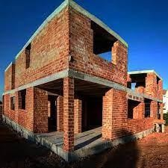
Fire resistance Thermal insulation Sound insulation
Classification of walls
Walls may be basically divided into two types:
  - Load bearing walls
  - Non load bearing walls
  - Retaining walls Load bearing walls:
  - Load bearing walls are those which are designed to carry super imposed loads in addition to their own weight.
  - It can be exterior wall or interior wall. It brace from the roof to the floor.
  - As the height of the building increased, required thickness of wall and resulting stress on foundation will also increase and cause it to be uneconomical.

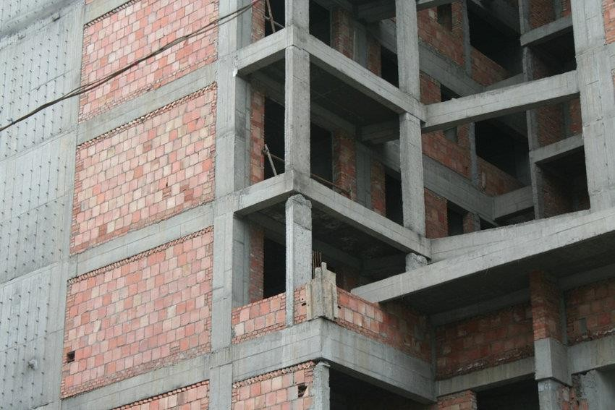
  - The thickness of load bearing walls is based on the quantity of load from roof it has to bear.
  - The load bearing walls can be reinforced or unreinforced masonry walls
Non load bearing walls:
  - Non load bearing walls carry their own load only.
  - They generally serve as divide walls or partition walls. The external non load bearing wall, commonly related to framed structures is termed as panel wall.
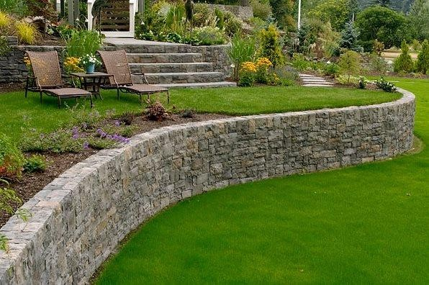
Retaining walls:
  - A retaining wall is a wall designed to retain soil or water on one side.
  - Design of a retaining wall Retaining walls have a primary function of retaining soils or water at an angle in excess of the soil's nature angle of repose.
  - Walls within the design height rand are designed to provide the necessary resistance by either their own mass or by the principles of leverage.

Classification of walls as per materials of construction
Load bearing wall
  - As the name suggests, the construction of the entire building rests on the walls instead of the pillars.
  - Generally, the load from the slab is transferred onto the beam, from the beam to the column, and then to the foundation.
  - In simple terms, whether its external or internal walls, the wall that carries the entire weight of the structure including the self-weight of the structural elements, is called a load-bearing wall.
  - Strip foundations are adopted for the load-bearing walls. Non-load bearing wall or Drop wall
  - This non-load-bearing wall does not support the ground or roof load above them which implies it does not bear any of the construction load.
  - The most effective examples are partition walls inside the building, where they are constructed to divide rooms and these walls should not be with their structural integrity.

  - These types of walls might be eliminated or shortened without affecting the structure of the building.
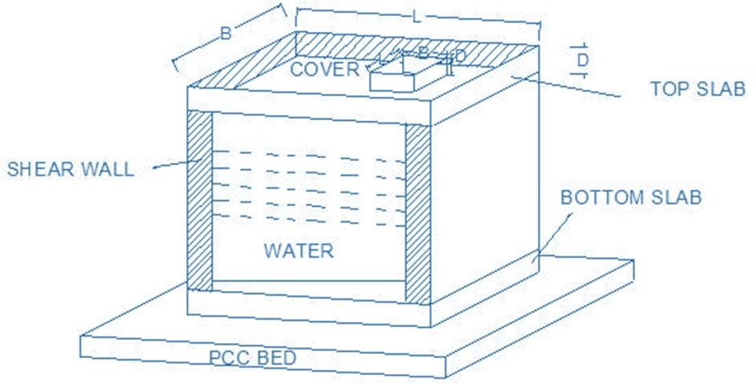
  - The thickness of a non-load bearing wall is usually between 100 mm to 125 mm. Shear wall
  - A shear wall is a wall that is built around a lift pit, water pump or ladder to retain soil.
  - There are two pressures on shear wall, either it can be air pressure, soil pressure or water pressure.
  - The shear wall is adapted to resist lateral forces exerted on the structure due to wind, earthquake or any other lateral load.
  - To explain, let us take an example of overhead water tank.
  - The overhead tank is exposed to air because it is built at heights that includes the wind pressure over it.
  - The water tank contains water which creates water pressure inside the tank, shear wall resists these forces without any deflection.

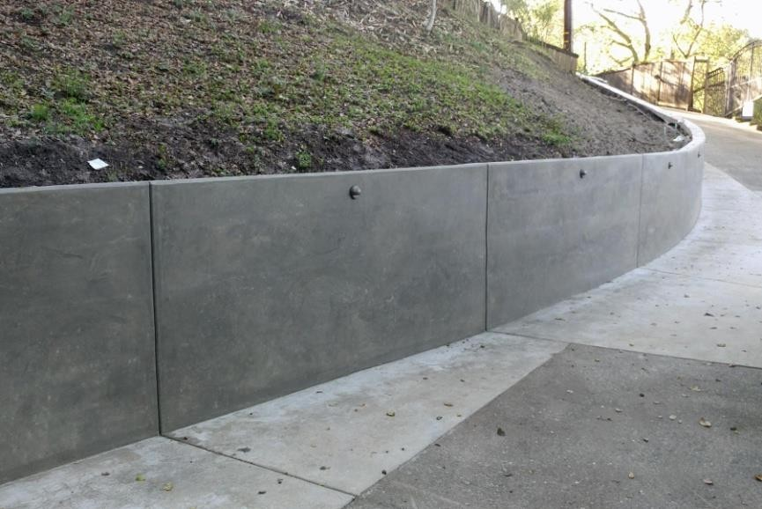
Retaining wall
  - The wall that is constructed to maintain an uneven level of the floor on its two faces known as a retaining wall.
  - The wall that is built around the plot below the
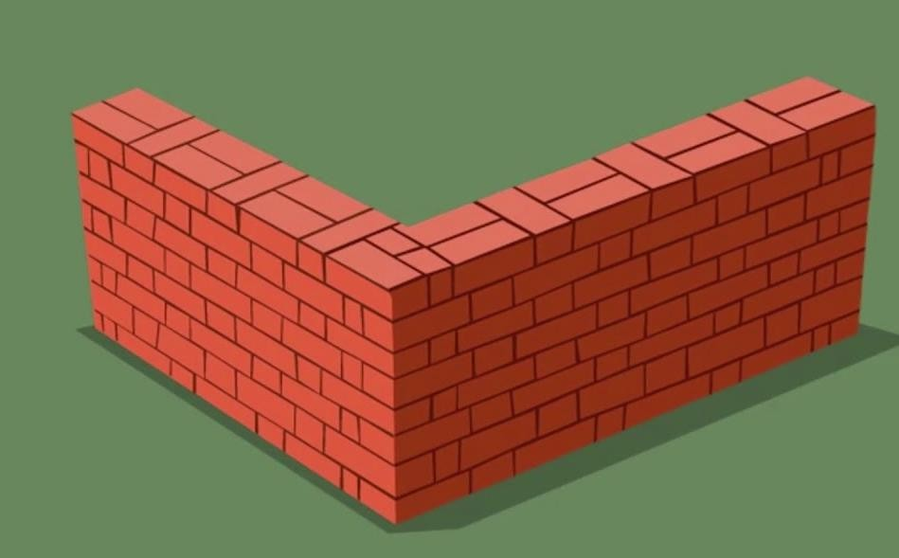
floor to retain soil at one end and land sliding after the earthwork on site are known as retaining wall.
Brick masonry wall
  - The wall that is built with the help of bricks is called a brick masonry wall, while masonry is used to join bricks to the wall, the thickness of the brick wall can be 20 cm or 10 cm.
  - The 20 cm wall is adopted for exterior walls.
  - The 10 cm wall is adopted for interior walls.
  - Remember, the length of a brick wall in a single section should not exceed 4 meters, if it exceeds, a column must be constructed with RCC.

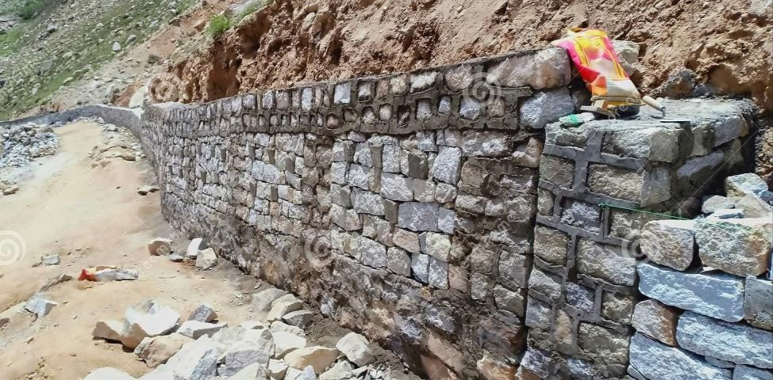
Course rubble stone masonry walls
  - The wall, which is regularly constructed with the shape of stones that are well finished & dressed is called the course rubble stone masonry wall.
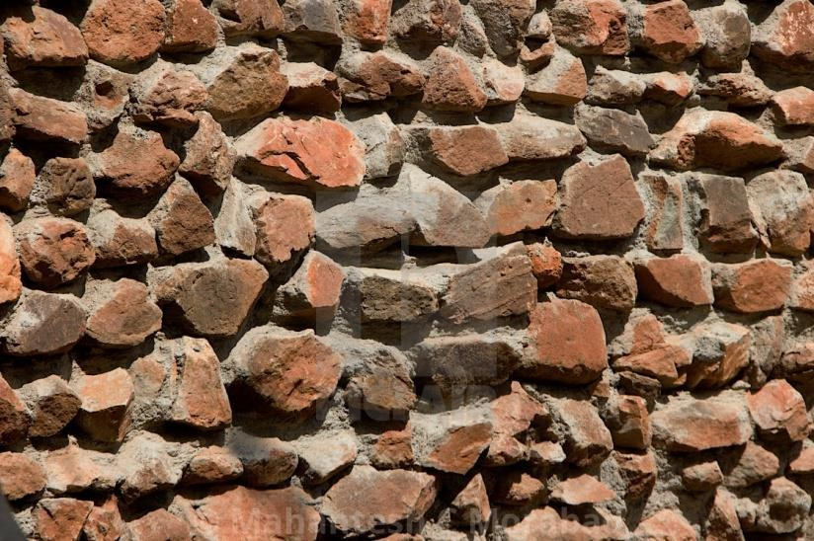
  - This types of walls are usually adopted for the abutments of bridges, composite walls or boundary walls.
Random rubble stone masonry wall
  - The wall that is constructed with irregular shapes of stones is called a random rubble wall, which has more masonry than the courted debris stone wall.
Core wall
  - The core wall has been constructed from the foundation which has grown to the height of the building.

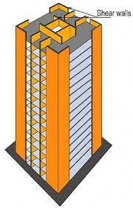
  - In these types of walls, the wall itself acts as a column, while the core wall is constructed to hold the lateral force exerted on the structure due to wind, earthquake or another lateral load.
  - These walls are a combination of shear walls, they organized and arranged like a core and installed on the geometric center of the building to minimize the torsional effect.
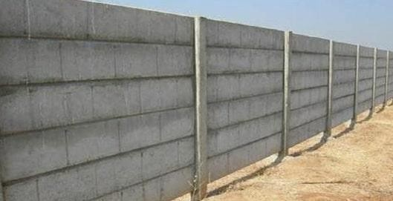
Precast walls
  - As the name itself proves it is a finished wall, where this wall is cast into the factory and bought on site to be installed.
  - These walls are preferred, where space for working is limited and labor is less likely.
  - The most effective part of precast walls is companies providing skilled labor to install walls in site.

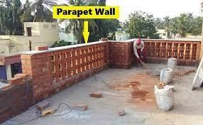
Parapet walls

  - The wall is built on the top floor of the building to prevent something from falling off the roof, while the height of the parapet wall is 3 feet.
Curtain walls
  - A wall made with glass, aluminum, or steel frame is called a curtain wall that is commonly adopted in offices, hospitals, and other public buildings.
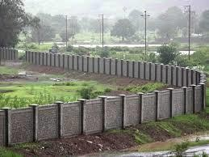
Boundary wall or Compound walls
  - The wall that is constructed across the building to indicate the boundary of the plot is known as boundary wall.

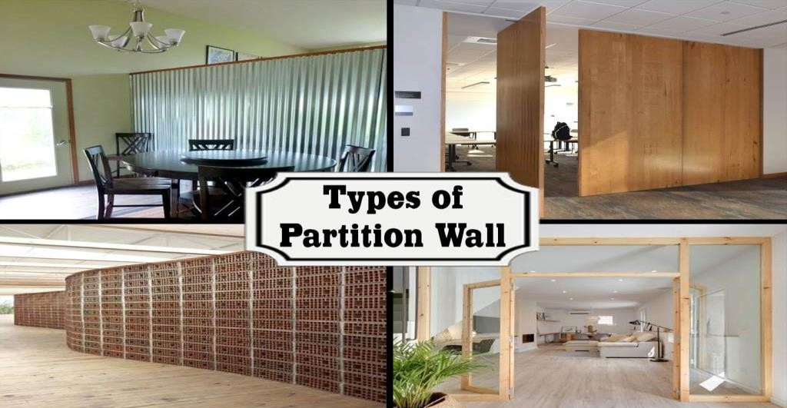
PARTITION WALLS
  - A dividing or a screen wall which is constructed inside the enclosed area is known as a partition and it can be constructed either on ground floor or upper floors.
  - On ground floor, the partitions rest either on flooring concrete or on beams spanning between the main walls.
  - In multi-storeyed buildings, the partitions are supported on concrete beams spanning between columns or on slab beams provided in the floor slab.
REQUIREMENTS OF PARTITION WALLS
Following are the requirements of a reasonably good partition wall:
- It should be strong enough to carry its own dead weight.
- It should be capable of resisting impact developed due to the use of the building.
- It should act as a sound barrier especially when it divides a room into two units.
- It should possess enough strength to support some wall fixtures, sinks, wash basins, etc.

- It should have the capacity to support suitable decorative surface.
- It should be light, thin, cheap, fire-resistant and easy to construct.
Brick partitions
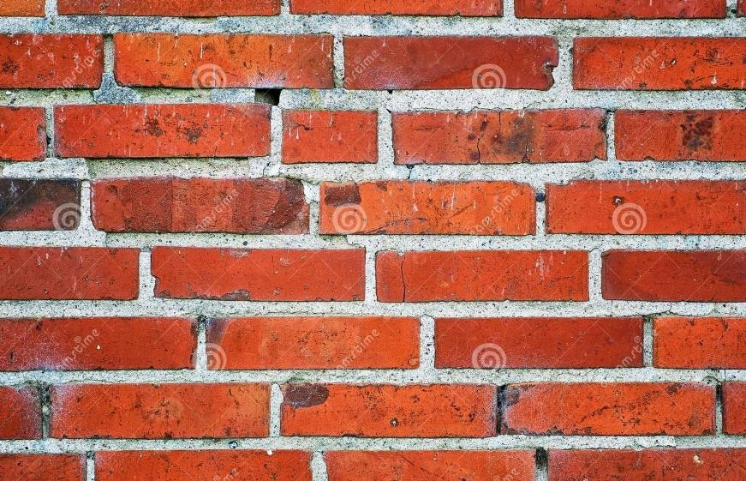
Brick partitions are quite common since they are the cheapest. Brick partitions are of three types:
  - Plain brick partitions
  - Reinforced brick partitions.
  - Bricknogged partitions. Plain brick partitions
  - The plain brick partitions of half-brick thickness
cannot take heavy load and their height is restricted to about 2 metres or so.
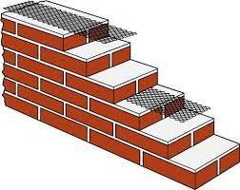
Reinforced brick partitions
  - The reinforced brick partitions of half-brick thickness are more durable and possess more strength.

  - The reinforcement is put up at every third course and the reinforcement may be in the form of wire mesh or hoop-iron or steel bars.
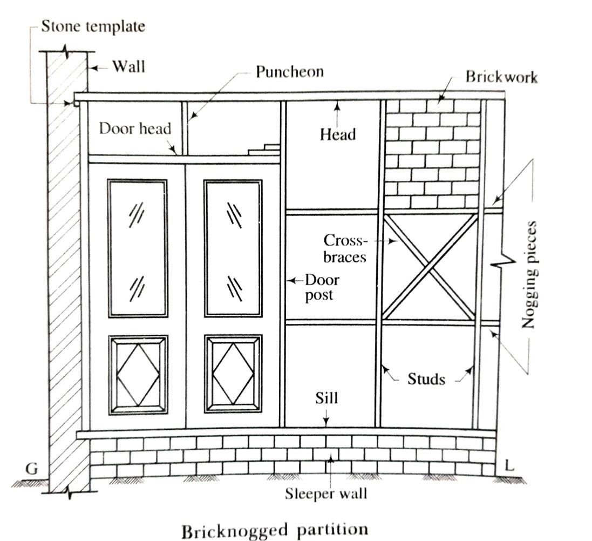
Bricknogged partitions
  - The bricknogged partitions consist of a framework of timber within which half- brick partitions are fitted.
  - The framework of timber consists of head, sill, vertical members known as the studs, horizontal members known as the nogging pieces and cross braces.
  - The studs are placed at a distance which is some multiple, usually 3 to 4, of the length of a brick.
  - The nogging pieces are placed at a vertical distance of about 600 mm.
  - The cross braces are provided at intersections.
  - The spaces between studs and nogging pieces are filled by half-brick partitions.

TIMBER PARTITIONS
  - In this type of partitions, the wooden framework is properly supported on floor and fixed to the side walls.
  - The framework which consists of horizontal and vertical members can either be plastered or covered with boards, etc. from both the sides.
Advantages: Following are the advantages of the timber partitions:
- They are light in weight and therefore can be easily constructed where a base for partition is not available.
- They are rigid and triangulation of framing is adopted to transfer some of the load of the wall.
- They are easy to construct.
- They are cheap at places where wood is available in plenty. Disadvantages: Following are the disadvantages of the timber partitions:
- They should not be constructed at places where damp is expected e.g. basement floors or ground floors.

- They do not possess fire-resisting property.
- They do not prevent the passage of sound to an appropriate extent.
- They are likely to decay or eaten away by the termites.
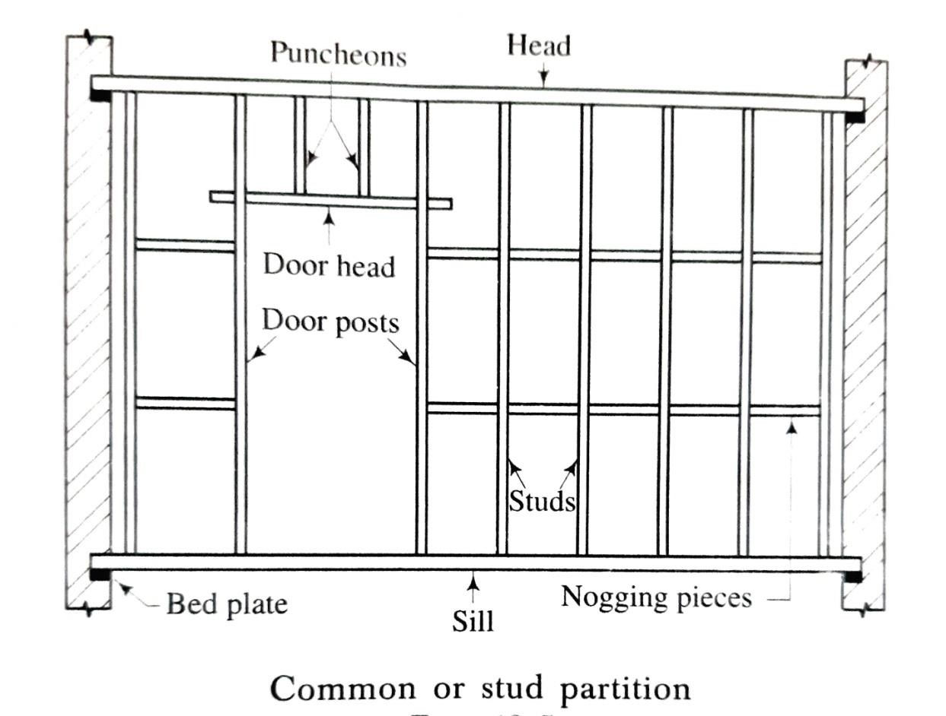
Types: The timber partitions can be divided into two categories:
  - Common or stud partitions
  - Trussed or braced partitions.
- Common or stud partitions
  - These partitions consist of vertical members, known as the studs, which are bridged between two horizontal members.
  - The upper and lower horizontal members are respectively known as the head and sill.

  - The nogging pieces are short horizontal pieces which are introduced to make the studs more stiff.
  - A stud of short length, as on an opening, is known as a puncheon.
  - The studs are generally of section 100 mm x 50 mm.
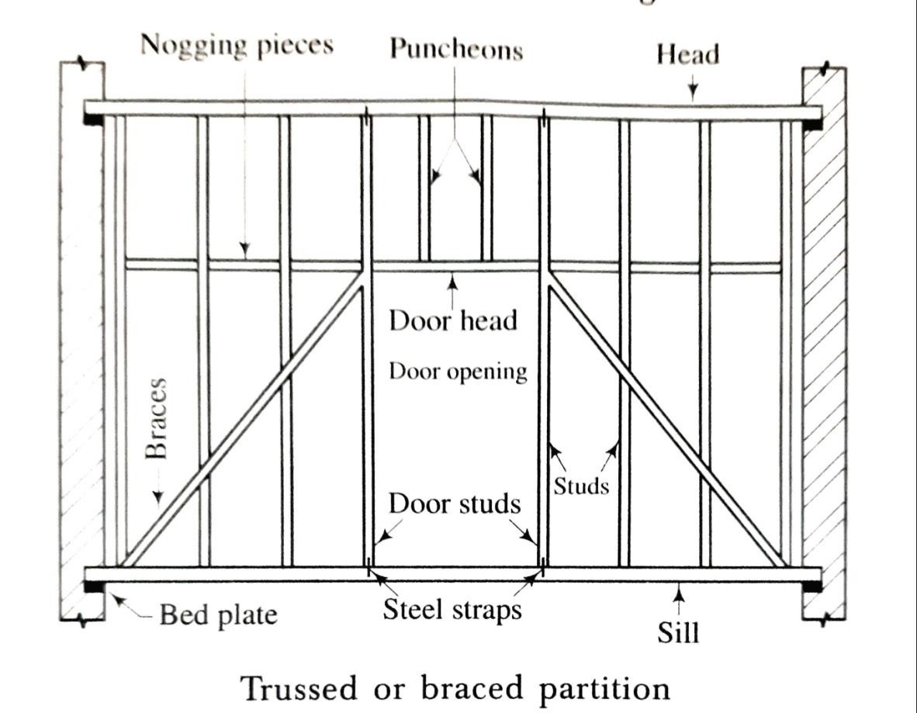
  - The head and sill are generally of section 100 mm x 75 mm.
- Trussed or braced partitions.
  - These partitions are similar to the common partitions. But braces, steel straps and bolts are used in addition to studs head, sill and nogging pieces.
  - The partitions behave on the theory of truss and hence they are useful when it is possible to provide supports only at the ends of partitions.
Continue.....

PART: B (CONSTRUCTIONS TECHNOLOGY)
CHAPTER:-03-ll [Walls & Masonry Works]

Continue ....... BRICK MASONRY
GENERAL
  - The bricks are obtained by moulding clay in rectangular blocks of uniform size and then by drying and burning these blocks.
  - As bricks are of uniform size, they can be properly arranged and as they are light in weight, no lifting appliance is required for them.
  - It is found that the weight of 1 m³ of brick earth is about 1800 kg.
  - The average weight of a brick will be about 3 to 3.50 kg. SOME DEFINITIONS
- Stretcher: This is a brick laid with its length parallel to the face or front or direction of a wall. The course containing stretchers is called a stretcher course.

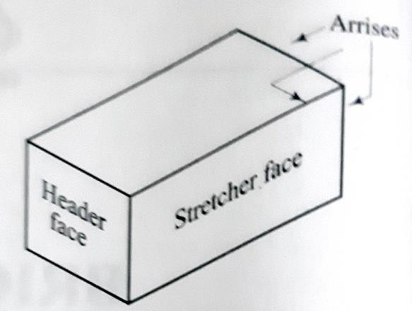
- Header: This is a brick laid with its breadth or width parallel to the face or front or direction of a wall. The course containing headers is called a header course.
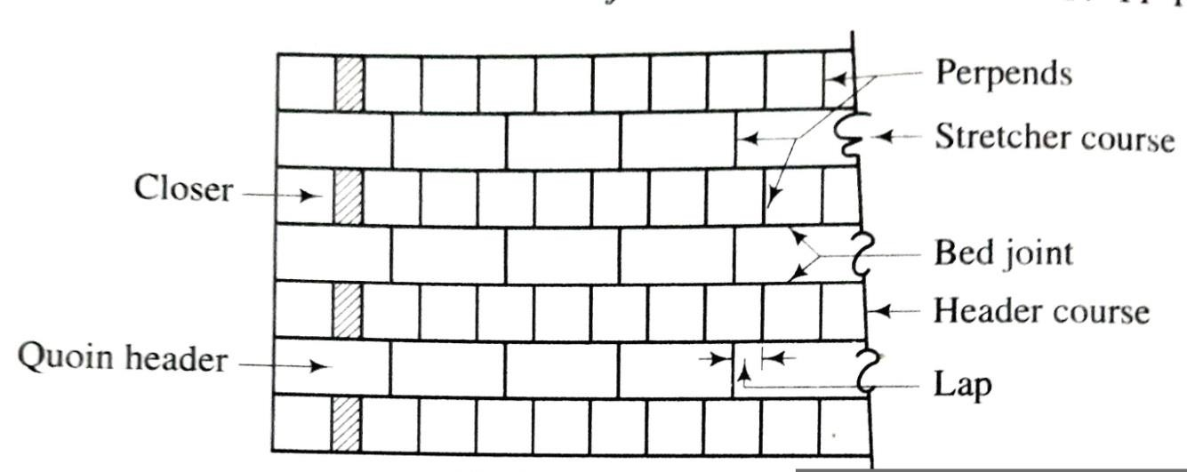
- Arrises: The edges formed by the intersection of plane surfaces of brick are called the arrises and they should be sharp, square and free from damage.
- Bed: The lower surface of the brick when laid flat is known as the bed.
- Bed joint: The horizontal layer of mortar upon which the bricks are laid is known as a bed joint.
- Perpends: The vertical joints separating the bricks in either length or cross directions are known as the perpends and for a good bond, the perpends in alternate courses should be vertically one above the other.
- Lap: The horizontal distance between the vertical joints in successive courses is termed as a lap and for a good bond, it should be one-fourth of the length of a brick.

- Closer:
  - A piece of brick which is used to close up the bond at the end of brick courses is known as a closer and it helps in preventing the joints of successive courses to come in a vertical line.
  - Generally the closer is not specially moulded. But it is prepared by the mason with the edge of the trowel.
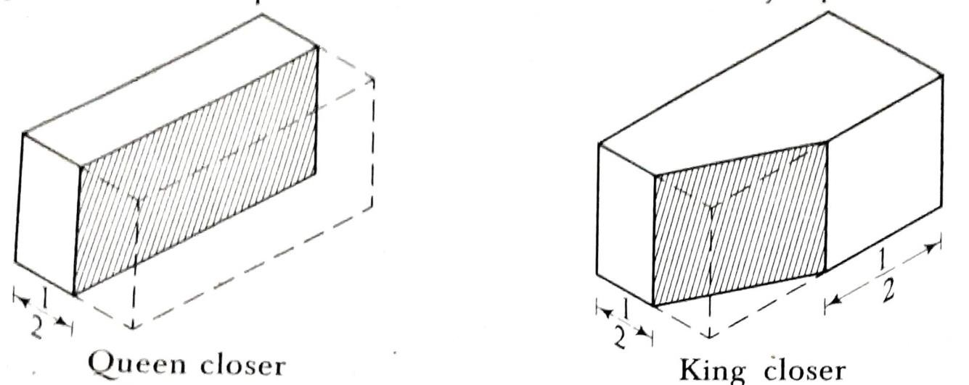
Following are the types of closers:
- Queen closer:
  - This is obtained by cutting the brick longitudinally in two equal parts.
  - It can also be made from two quarter bricks, known as the
quarter closers, to minimize the wastage of bricks.
  - A queen closer is generally placed near the quoin header to obtain the necessary lap.

- King closer:
  - This is obtained by cutting a triangular portion of the brick such that half a header and half a stretcher are obtained on the adjoining cut faces.
  - A king closer is used near door and window openings to get satisfactory arrangement of the mortar joints.
- Bevelled closer:
  - This is obtained by cutting a triangular portion of half the width but of full length.
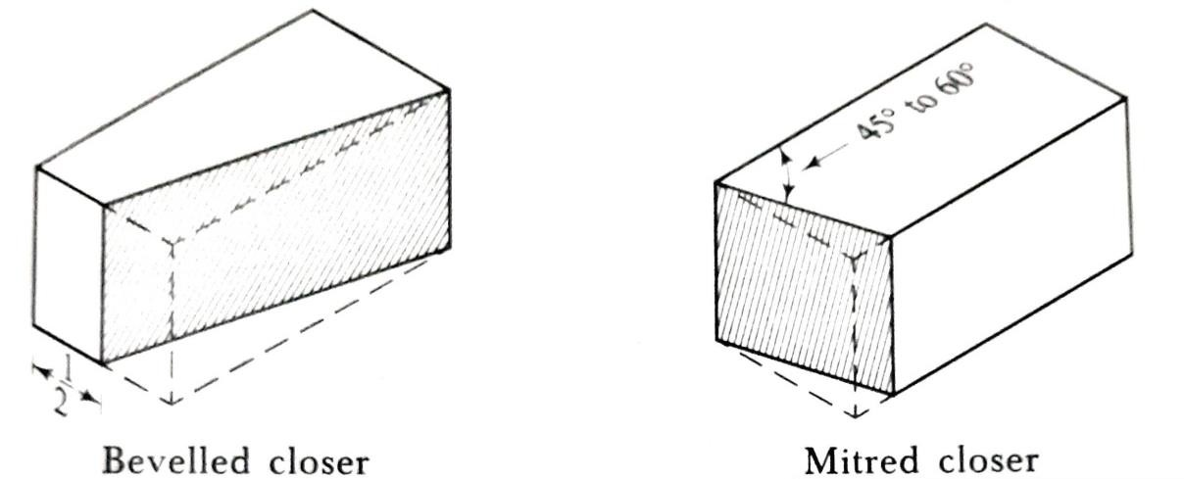
  - A bevelled closer appears as a closer on one face and as a header at the other face.
  - It is used for the splayed brickwork.
- Mitred closer:
  - This is obtained by cutting a
triangular portion of the brick through its width and making an angle of 45° to 60° with the length of the brick.
  - It is used at corners, junctions, etc.

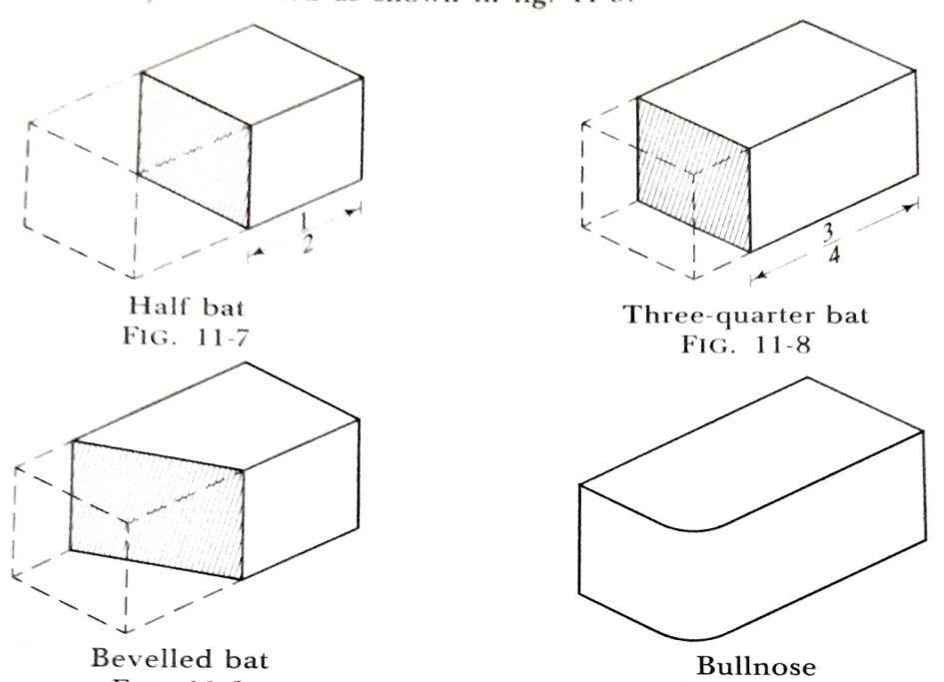
- Bat:
  - This is a piece of brick, usually considered in relation to the length of a brick and accordingly known as half bat or three-quarter bat.
- Bullnose:
  - A brick moulded with a rounded angle is termed as a bullnose and it is used for a rounded quoin.
  - A connection which is formed when a wall takes a turn is known as a quoin.
  - The centre of the curved portion is situated on the long centre-line of the brick.
- Cownose: A brick moulded with a double bullnose on end is termed as a cownose.
- Squint quoin: A brick which is cut or moulded such that an angle other than a right angle is formed in plan is known as a squint quoin.
- Frog:
  - A frog is a mark of depth about 10 mm to 20 mm which is placed on the face of a brick to form a key for holding the mortar.
  - The wire cut bricks are not provided with frogs.

  - A pressed brick as a rule has frogs on both the faces.
  - A hand made brick has only one frog.
- Racking back: The termination of a wall in a stepped fashion is known as the racking back.
- Toothing: The termination of a wall in such a fashion that each alternate course at the end projects is known as the toothing and it is adopted to provide adequate bond, when the wall is continued horizontally at a later stage.
BONDS IN BRICKWORK
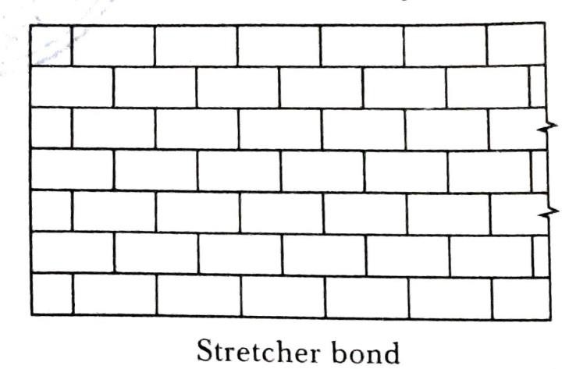
The various types of bonds with their patented names have been constructed
- Stretcher bond (6) Raking bond
- Header bond (7) Dutch bond
- English bond (8) Brick-on-edge bond
- Flemish bond (9) English cross bond
- Garden-wall bond (10) Facing bond.
- Stretcher bond:
  - In this type of bond, all the bricks are arranged in the stretcher courses.
  - The stretcher bond is useful for one-brick partition walls as there are no headers in such walls.

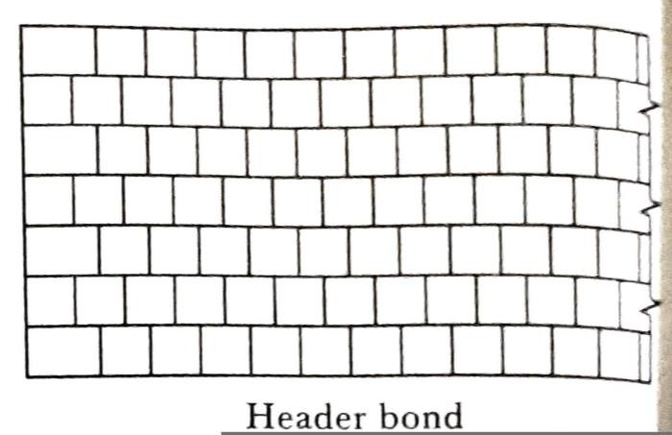
  - As this bond does not develop proper internal bond, it should not be used for walls having thicknesses greater than that of one-brick wall.
- Header bond :
  - In this type of bond, all the bricks are arranged in header courses. Fig. 11-12 shows the elevation of a wall with the header course
  - The overlap is usually kept equal to half the width of brick and it is achieved by using three-quarter brickbats in each alternate courses as quoins.
  - This bond does not have strength to transmit pressure in the direction of the length of the wall. Hence it is not suitable for load bearing walls.
  - However this bond is used for curved surfaces in brickwork because stretchers, if used for curved surfaces, would project beyond the face of the wall.
- English bond :
  - This type of bond is generally used in practice. It is considered as the strongest bond in brickwork.

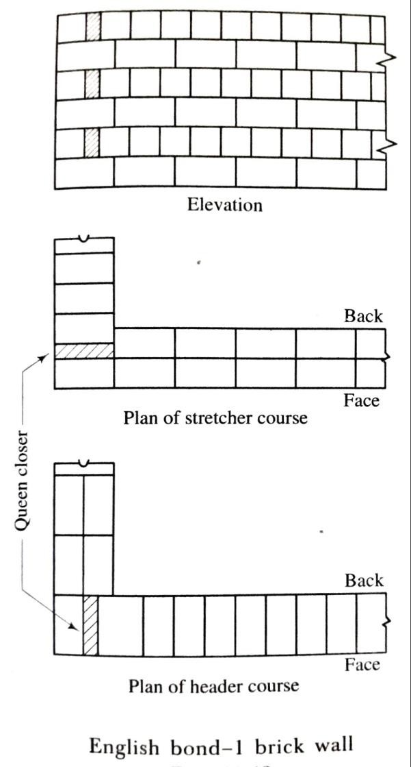
  - Following are the features of an English bond:
- The alternate courses consist of stretchers and headers.
- The queen closer is put next to the quoin header to develop the face lap.
- Each alternate header is centrally supported over a stretcher.
- If the wall thickness is an even multiple of half-brick, the same course shows headers or stretchers in both the front and the back elevations. But if the wall thickness is an uneven multiple of half- brick, a course showing stretcher on the face shows header on the back and vice versa.
- The bricks in the same course do not break joints with each other. The joints are straight.
- In this bond, the continuous vertical joints are not formed except at certain stopped ends.

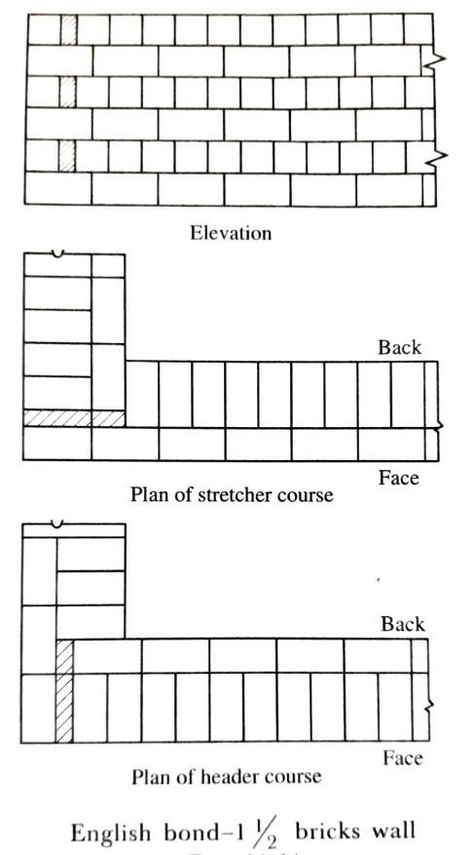
- The number of mortar joints in the header course is nearly double than that in the stretcher course. Hence care should be taken to make the header joints thinner; otherwise the face lap disappears quickly.
- A header course should never start with a queen closer as it is liable to get displaced in this position.
- The queen closers are not required in the stretcher courses.
- In the stretcher course, the stretchers have a minimum lap of one-

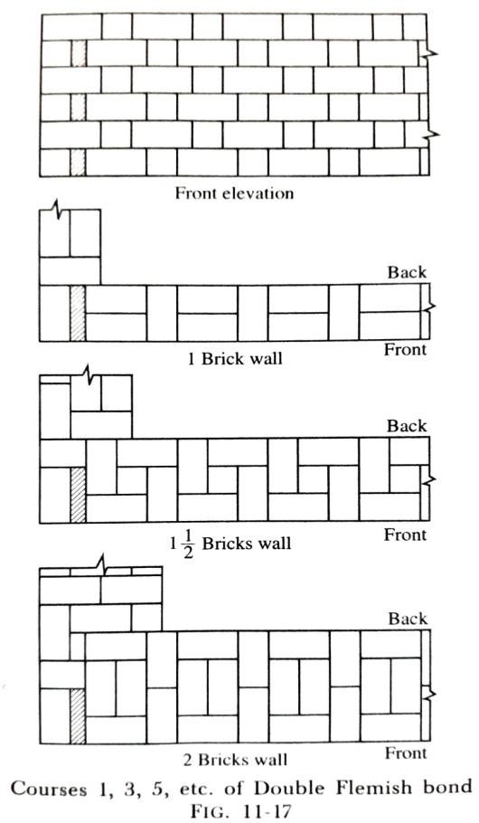
fourth of their length over the headers.
- For walls having thickness of two bricks or more, the bricks are laid as stretchers or headers only on the face courses of the wall. The interior filling is done entirely with the headers.
- Flemish bond :
  - In this type of bond, the headers are distributed evenly and hence, it creates a better appearance than the English bond.

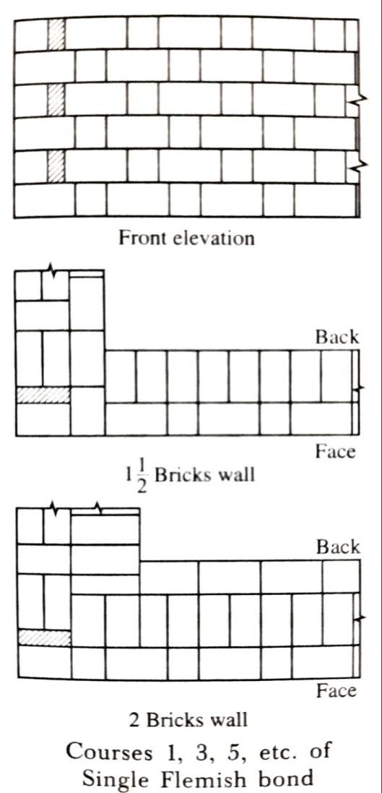
Following are the peculiarities of a Flemish bond:
- In every course, the headers and stretchers are placed alternatively.
- The queen closer is put next to the quoin header in alternate courses to develop the face lap.
- Every header is centrally supported over a stretcher below it.
- The Flemish bond may be divided into two groups:
  - Double Flemish bond
  - Single Flemish bond.
  - In Double Flemish bond , the headers and stretchers are placed alternatively in front as well as the back elevations.
  - In Single Flemish bond , the face elevation is of Flemish bond and the filling as well as backing are of the English bond.
BONDS AT CONNECTIONS
  - The walls in different directions are to be united at certain places. These places are known as the connections.
The three requirements to be satisfied by bond at a connection are:

- The vertical joints should not be continuous.
- The number of broken bricks to be used should be reduced to a minimum.
- The connection should be structurally strong enough to resist the differential settlement, if any.
There are two forms of such connections:
  - Junctions
  - Quoins.
(1) Junctions: A connection between a main wall and a partition wall is termed as a junction.
Following points should be kept in view while providing a junction:
(i) The header course of the cross wall enters the stretcher course of the main wall.
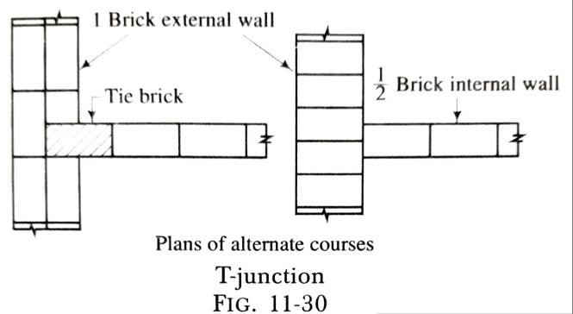
(ii) The alternate courses of the cross wall are simply abutting the main wall.
A junction is classified in two categories:
- Right-angled junction (ii) Squint junction.
- Right-angled junction: This type of junction has two forms:
  - Tee-junction

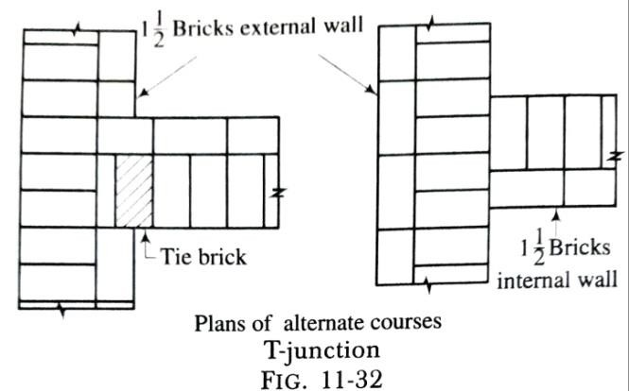
  - Cross-junction or intersection.
- Tee-junction:
  - This type of right-angled junction forms the shape of the English letter T in plan.
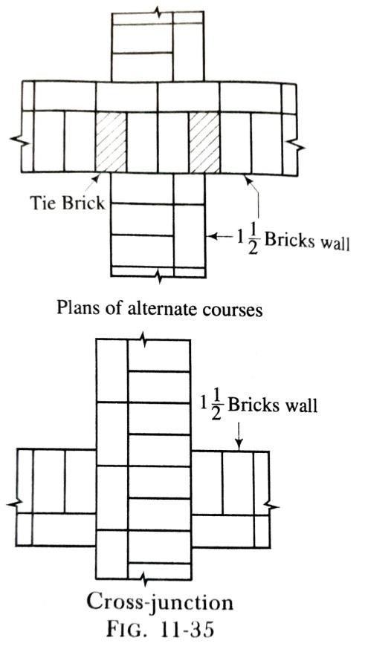
  - Fig. 11-30 shows the plans of alternate courses of a tee-junction between one- brick external wall and half-brick internal wall, both the walls being constructed in the English bond. One of the courses of the internal wall enters
the stretcher course of the main wall, creating a lap of half-brick.
  - Fig. 11-32 shows the plans of alternate courses of a tee-junction between 1½ bricks external and internal walls, both the walls being constructed in the English bond.
- Cross-junction or intersection:
  - When two continuous walls cross or intersect each other, a cross- junction or an intersection is formed.
  - Fig. 11-35 shows the plans of alternate courses of a cross-junction between 1½ bricks walls which are constructed in the English bond.
Following points should be noted:
- The alternate courses of the cross walls i.e. the courses of one of the walls simply butt against the courses of the other wall.
- The alternate courses which are not continuous are provided with
tie bricks in the form of key headers to create the necessary bond and lap.

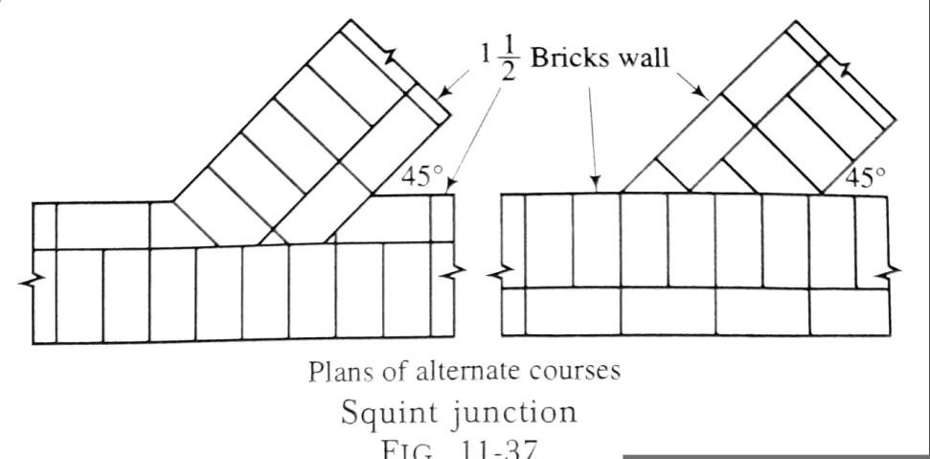
- Squint junction:
- A squint junction is formed when two walls meet each other at an angle other than a right angle without making a quoin.
- It may be in the English bond or Flemish bond.
- It is rarely adopted because great difficulty is experienced.
(2) Quoins:
- A connection which is formed when a wall takes a turn is known as a quoin.
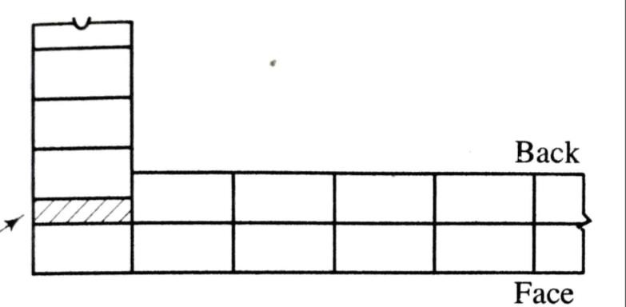
There are two forms of quoins:
- Right-angled or square quoins
- Squint quoins.
- Right-angled or square quoins:
  - As the term implies, this form of quoin is formed when two walls meet at an angle of 90°.
- Squint quoins:
  - When a wall takes a turn and makes an angle other than a right-angle, a squint quoin is formed.
  - The squint quoins can be classified in two categories:

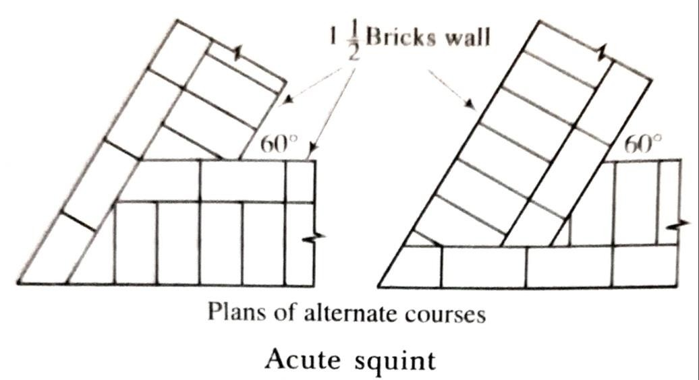
- Acute squint:
In this case, the enclosed angle on the inside of the wall is less than a right-angle.

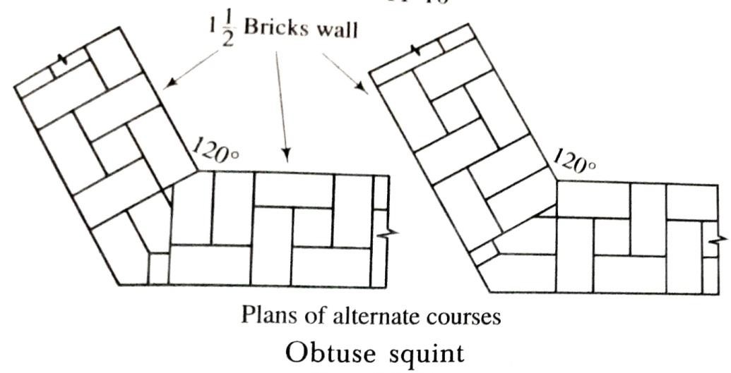
- Obtuse squint:
In this case, the enclosed angle on the inside of the wall is between 90° and 180°.

Continue .......

PART: B (CONSTRUCTIONS TECHNOLOGY)
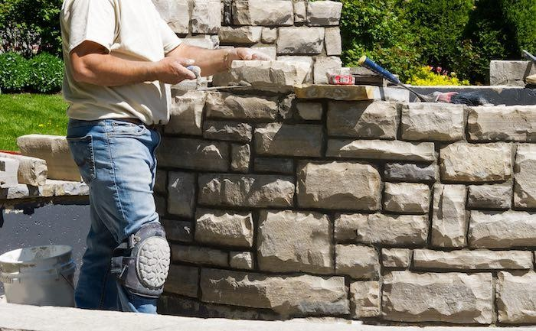
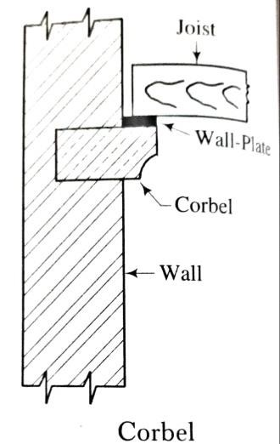
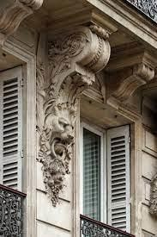
CHAPTER:-03-lll [Walls & Masonry Works]
Continue ....... STONE MASONRY
GENERAL
- Stone masonry is a type of building masonry construction that uses stones and mortar.
- This construction technique is used for building
foundations, floors, retaining walls, arches, walls and columns.
- The stones used for masonry construction are natural rocks. SOME DEFINITIONS
  - Corbel:
    - A corbel is a projecting stone which is usually provided to serve as support for roof truss, beam, weather shed, etc.
    - The corbels are generally moulded and given ornamental treatment.
    - The corbels should extend at least two-third of their length into the wall.

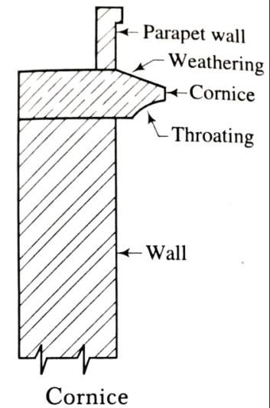
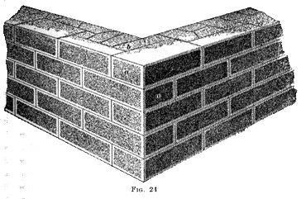
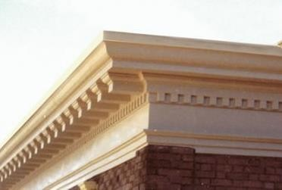
  - Cornice:
    - A cornice is a course of stone provided at the top of wall.
    - It is generally moulded and given ornamental treatment.
    - It is weathered and throated to dispose off rain water.
    - In order to prevent the overturning of the cornice, sufficient bearing and extra weight at the top in the form of a parapet wall should be provided.
  - Block-in-course:
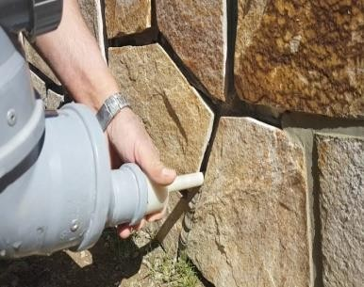
    - It is squared stone masonry with good close joints to give great strength and soundness.
  - Grouting:
    - It is a cementitious mixture used to fill cores or cavities in masonry construction.
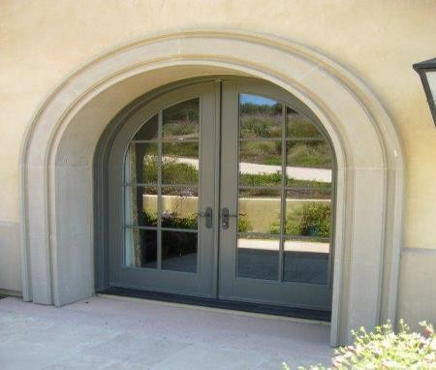
  - Mouldings:
    - A projecting or recessed part, used to give shadows to a wall, arch, or other surfaces.
  - Templates:
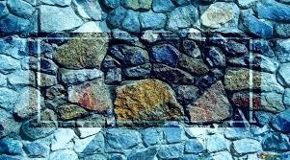
    - It is the science of making patterns, or templates, to which a stone is to be cut to fill a certain place in an arch or other complicated piece of stonework.

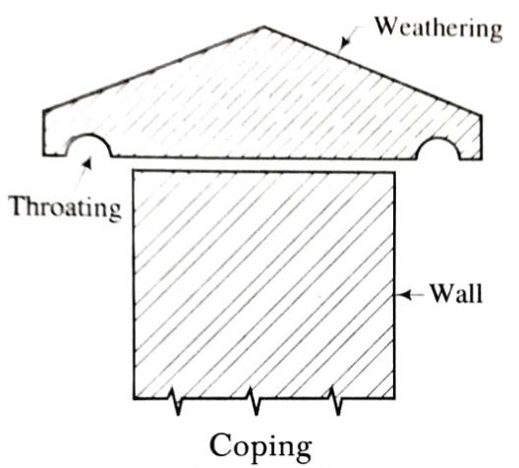
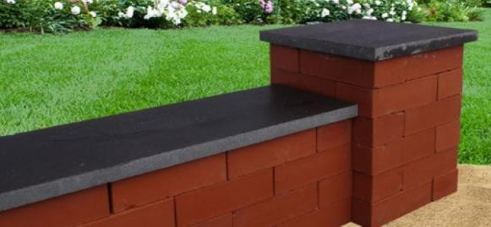
  - Coping:
    - A coping is a course of stone which is laid at the top wall so as to protect the wall from rain water.
    - This course is generally provided at the top of a compound wall or a parapet wall and it is suitably weathered and throated.
  - Throating:
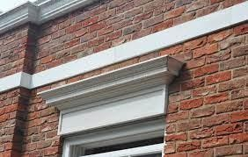
    - A groove is provided on the underside of sill, cornice and coping so that the rain water can be discharged clear of the wall surface. This is known as the throating.
  - String course:
    - The horizontal course provided at suitable levels between the plinth and the cornice is termed as a string course.
    - It breaks the monotony of a plane surface and it is sometimes moulded and given architectural treatment.
    - The string course is suitably weathered and throated so as to throw off the rain water clear of the wall surface.
  - Through stone:
    - In stonework, some stones at regular intervals are placed right across the wall.Such stones are known as the through stones or throughs or bond stones.

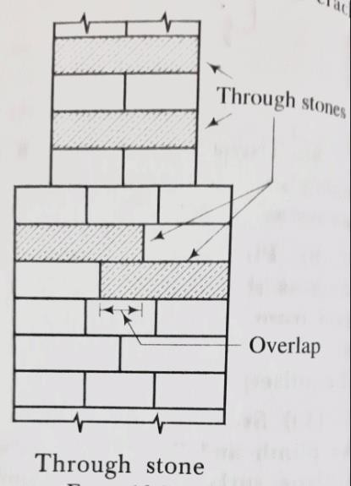
    - If the wall is considerably thick, two through stones with an overlap are provided.
    - The area covered by the through stones should be about one-fourth to one-half of the area of the wall surface.
    - The through stones should be non-porous so as to prevent the entry of moisture through the wall.

    - They should also be strong and of sufficient thickness so as to avoid the danger of fracture due to any slight settlement of the wall.
  - Parapet:
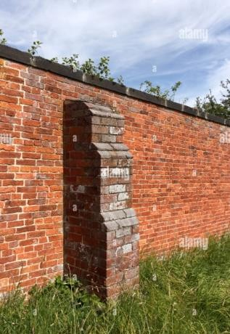
    - It is the portion of low height wall constructed along of the roof to protect the users.
  - Buttress:
    - A buttress is a sloping or a stepped pier and it is provided to work as lateral support of the wall.

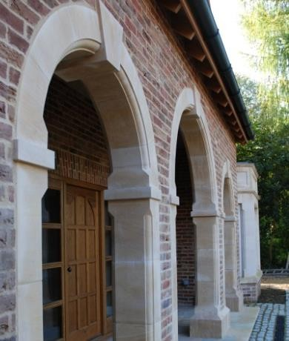
  - Pilaster:
    - A right-angled columnar projection from a wall or a pier is known as a pilaster.

CLASSIFICATION OF STONE MASONRY
The stone masonry is classified under two categories as shown below:
Stone masonry

Rubble masonry Ashlar masonry
- Coursed rubble (i) Ashlar fine
- Uncoursed rubble (ii) Ashlar rough-tooled
- Random rubble (iii) Ashlar rock or quarry faced
- Dry rubble (iv) Ashlar chamfered
- Polygonal rubble (v) Ashlar block-in-course
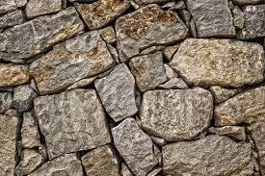
- Flint rubble
  - Rubble masonry:
    - In this type of construction, the stones of irregular sizes are used.
    - The stones, as obtained from quarry, are taken in use in the same form or they are broken and shaped in suitable sizes by means of hammer as the work proceeds.
    - The strength of rubble masonry mainly depends on three factors:
- the quality of mortar,
- the use of long through stones at frequent intervals, and
- the proper filling of the mortar between the spaces of stones.

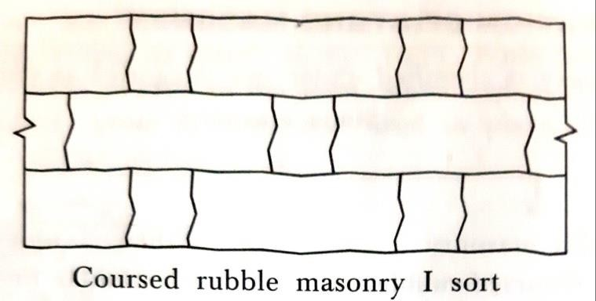
- Coursed rubble masonry:
  - In this type of rubble masonry, the heights of stones vary from 50 mm to 200 mm.
  - The stones are sorted out before the work commences.
  - The masonry work is then carried out in courses such that the stones in a particular course are of equal heights.
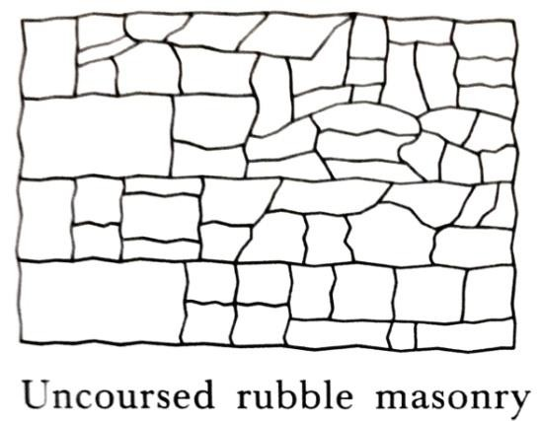
  - This type of masonry is used for the construction of public buildings, residential buildings, etc.
- Uncoursed rubble masonry:
  - In this type of rubble masonry, the stones are not dressed.
  - But they are used as they are available from the quarry, except knocking out some corners.
  - The courses are not maintained regularly.
  - The larger stones are laid first and the spaces between them are then filled up by means of spalls or snecks.
  - The wall is brought to a level every 300 mm to 500 mm.
  - This type of rubble masonry, being cheaper, is used for the construction of compound walls, godowns, garages, labour quarters, etc.
- Random rubble masonry:
  - In this type of rubble masonry, the stones of irregular sizes and shapes are used.
  - The stones are arranged so as to have a good appearance.

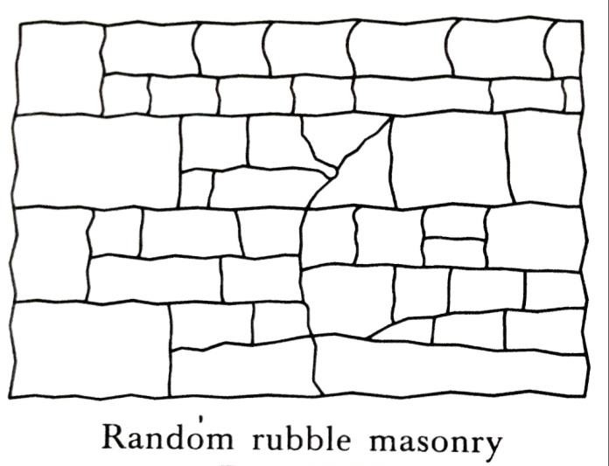
  - It is to be noted that more skill is required to make this masonry structurally stable.
  - If the face stones are chisel-dressed and the thickness of mortar joints does not exceed 6 mm, it is known as the random rubble masonry I sort.
  - If the face stones are hammer- dressed and the thickness of mortar joints does not exceed 12 mm, it is known as the random rubble masonry II sort.
  - This type of masonry is used for the construction of residential buildings, compound walls, godowns, etc.
- Dry rubble masonry:
  - This is just similar in construction to the coursed rubble masonry III sort except that no mortar is used in the joints.
  - This type of construction is the cheapest, but it requires more skill in construction.
  - It is extensively used for compound walls, pitching on bridge approaches, retaining walls, etc.
  - In order to prevent the displacement of stones and to make the work more stable, the two courses at top and about 500 mm length at the ends are sometimes built in mortar.

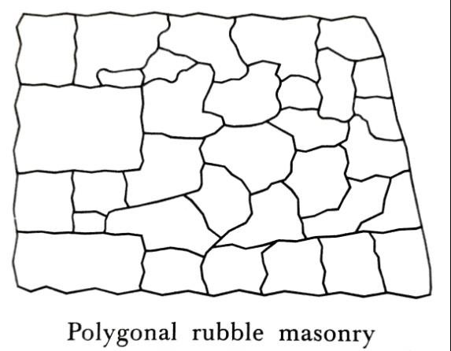
- Polygonal rubble masonry :
  - In this type of rubble masonry, the stones are hammer-dressed and the stones selected for face work are dressed in an irregular polygonal shape.
  - Thus the face joints are seen running in an irregular fashion in all directions.
  - It is to be noted that more skill is required in the construction of this type of masonry.
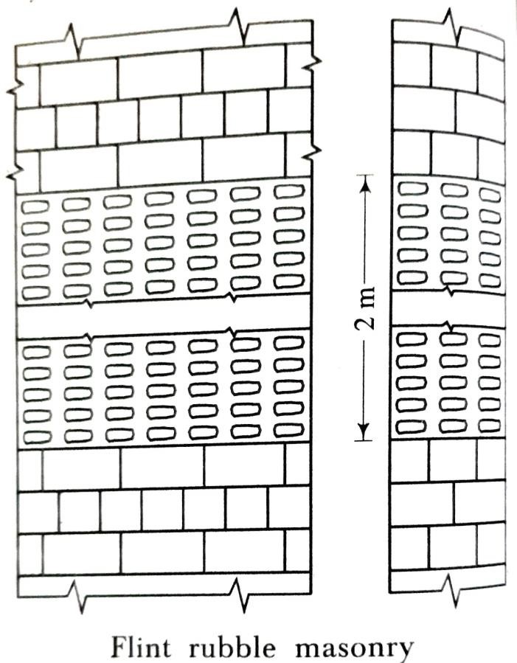
  - As the stones are of irregular shape, it is difficult to adjust them with regard to stability and appearance of the work as a whole.
- Flint rubble masonry :
  - In this type of rubble masonry, the stones used are flints which are irregularly shaped nodules of silica.
  - The width and thickness vary from 80 mm to 150 mm and the length varies from 150 mm to 300 mm.
  - The stones are extremely hard. But they are brittle and therefore they break easily.
  - The face arrangement may be either coursed or uncoursed.

  - The strength of a flint wall is increased by introducing lacing courses of either thin long stones or bricks or tiles at vertical distances of one to two metres.
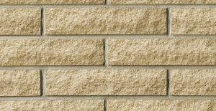
  - This type of masonry is used at places where the flints are available readily and economically.
  - Ashlar masonry:
    - In this type of construction, the square or rectangular blocks of stones are used.
    - The courses are not necessarily of the same height. The height of stones varies from 250 mm to 300 mm.
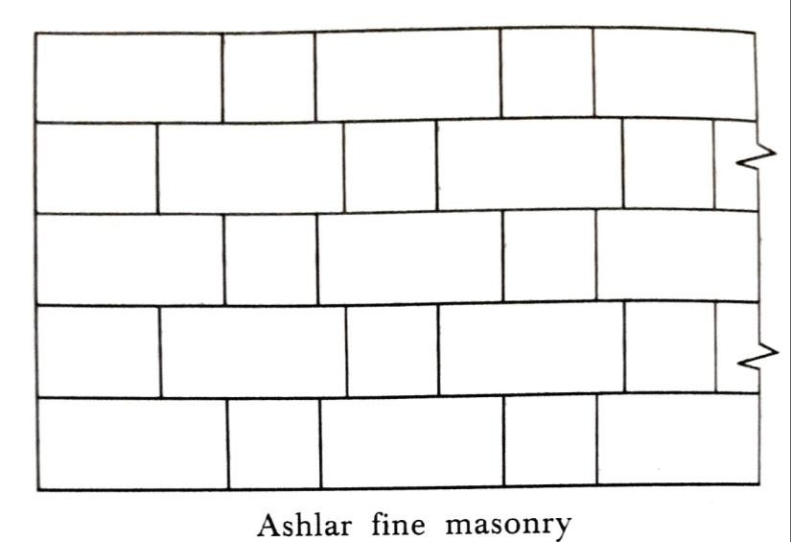
    - The length of stones should not exceed three times the height and the depth into the wall should be at least equal to half the height.
- Ashlar fine masonry:
  - In this type of ashlar masonry, the beds, sides and faces are finely chisel-dressed.
  - The stones are arranged in proper bond and the thickness of the mortar joints does not exceed 3 mm.
  - This type of construction gives perfectly smooth appearance, but it is costly in construction.
- Ashlar rough-tooled masonry:
  - In this type of ashlar masonry, the beds and sides are finely chisel-dressed. But the face is made rough by means of tools.

  - A strip, about 25 mm wide and made by means of a chisel, is provided around the perimeter of every stone exposed for view.
  - The thickness of mortar joints does not exceed 6 mm. This type of work is also known as the bastard ashlar.
- Ashlar rock or quarry faced masonry:
  - In this type of ashlar masonry, a strip about 25 mm wide and made by means of a chisel, is provided around the perimeter of every stone exposed for view as in case of rough- tooled ashlar.
  - But the remaining portion of the face is left in the same form as received from quarry.
  - Only projections on the face, known as the bushings, exceeding 80 mm are removed by a hammer.
  - This type of construction gives massive appearance.
- Ashlar chamfered masonry:
  - In this type of ashlar masonry, the strip is provided as above. But it is chamfered or bevelled at an angle of 45 degrees by means of chisel for a depth of about 25 mm.
  - Another strip 12 mm wide is then provided on the remaining exposed face of the stone and the surface inside this strip is left in the same form as received from quarry.
  - The large bushings projecting more than 80 mm are removed by a hammer.

  - A neat appearance of the grooved joints is obtained with the help of this type of construction.
- Ashlar block-in-course masonry:
  - This type of ashlar masonry occupies an intermediate position between the rubble masonry and the ashlar masonry.
  - The faces of the stones are generally hammer-dressed and the thickness of mortar joints does not exceed 6 mm.
  - The depth of courses varies from 200 mm to 300 mm.
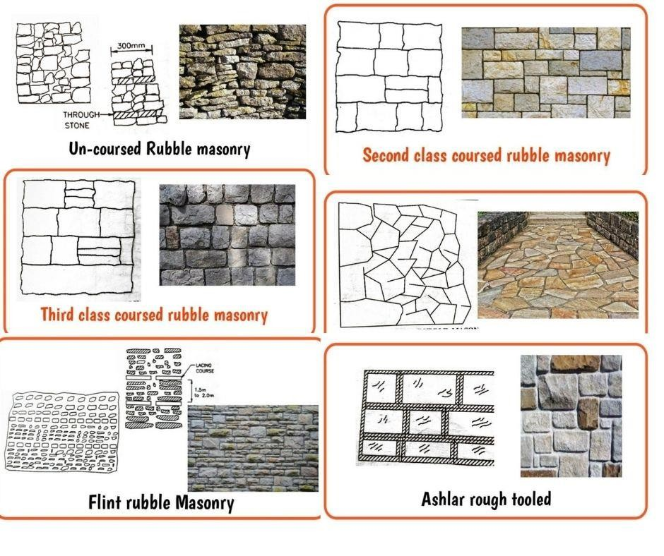
  - This type of construction is used for heavy engineering works such as retaining walls, sea-walls, etc. and in some cases, it may also be adopted for theatres, railway stations, temples, bridges, public buildings, etc.
***end***

PART: B (CONSTRUCTIONS TECHNOLOGY)
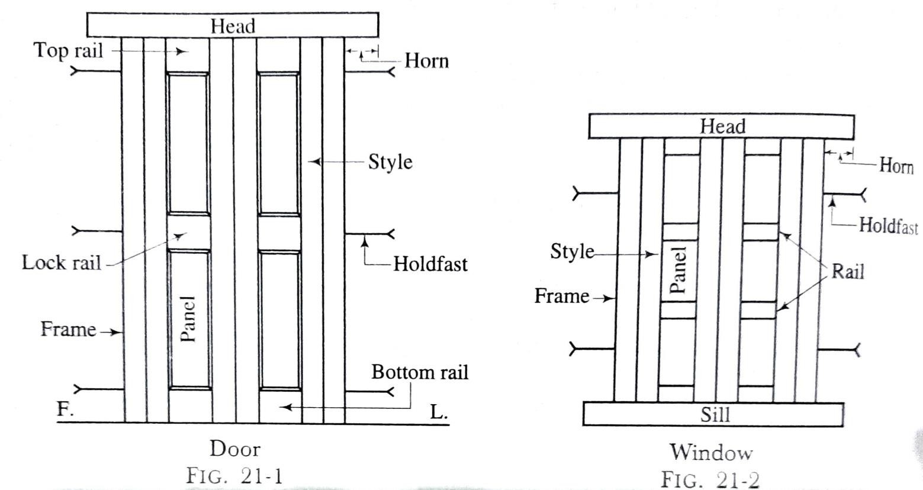
CHAPTER:-04 [Doors, Windows and Lintels]
TECHNICAL TERMS
- ​Frame: This consists of a group of members which form a support for a door or a window.
- ​Style: This is the outside vertical member of the shutter of a door or a window.
- ​Head: The top or uppermost horizontal part of a frame is known as the head.
- ​Sill: The lowermost or bottom horizontal part of a window frame is known as the sill. The door frames are usually not provided with the sills.

- ​Top rail: This is the topmost horizontal member of the shutter.
- ​Lock rail: This is the middle horizontal member of the shutter where the locking arrangement is provided.
- ​Bottom rail: This is the lowermost horizontal member of the shutter.
- ​Intermediate or cross-rails: The additional horizontal rails fixed between the top and bottom rails of a shutter are known as the intermediate or cross-rails.A rail which is fixed between the top rail and lock rail is called the frieze rail.
- ​Panel: This is the area of shutter enclosed between the adjacent rails.
- ​Holdfast: This is generally in the form of a mild steel flat bar of section 30 mm x 6 mm and of length 200 mm. The three numbers of such holdfasts are provided on each side of the door frame and two numbers of such holdfasts are provided on each side of the window frame. They keep the frame in position.
- ​Horn: This is a horizontal projection of head or sill beyond the face of the frame. It facilitates the fixing of the frame on the wall opening and its length is about 100 mm to 150 mm.

- ​Shutter: The entire assembly of styles, panels and rails is known as the shutter.
- ​Sash: This is a special type of frame, made of light sections and designed to carry glass. A sash consists of two vertical styles, a top rail and a bottom rail. A sash can be divided vertically or horizontally by providing bars. These bars are known as the sash bars or glazing bars.
- ​Mullion: This is a vertical member which is employed to sub-divide a window or a door opening vertically.
- ​Transom: This is a horizontal member which is employed to sub-divide a window opening horizontally.
- ​Louver: This is a piece of timber which is fixed in an inclined position within a frame.
- ​Jamb: The vertical wall face of an opening which supports the frame of door and window is known as the jamb.
- ​Reveal: The external jamb of a door or a window opening at right angles to the wall face is known as the reveal

- ​Rebate: The depression or recess made inside the door frame to receive the door shutter is known as the rebate.
- ​Putty: This is a mixture of linseed oil and whiting chalk. It is used for fixing glass panels.
- ​Architrave: This is a strip of wood, usually moulded or splayed, which is fixed around the sides and head of openings. It thus helps in giving a decent appearance to the joint of frame with the masonry. It is used only when doors and windows are placed flush with the face of masonry.
TYPES OF DOORS
Depending upon the type of materials, arrangement of different components, method
of construction, etc., the common types of doors used in the buildings can be grouped as follows:
  - Ledged doors
  - Ledged and braced doors
  - Ledged and framed doors

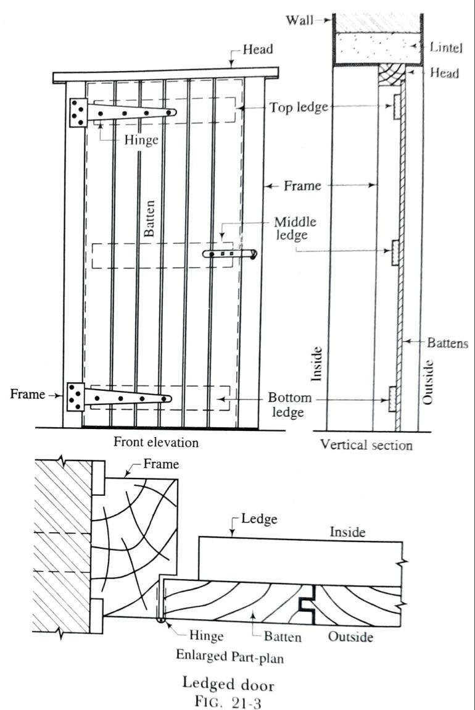
  - Ledged, framed and braced doors
  - Framed and panelled doors
  - Glazed or sash doors
  - Flush doors
  - Louvered doors
  - Collapsible steel doors
  - Revolving doors
  - Rolling steel doors Sliding doors
  - Sliding doors
  - Swing doors.
- Ledged doors (fig. 21-3):
  - A ledged door is formed of the vertical boards, known as the battens, which are secured by horizontal supports, known as the ledges as shown in fig.

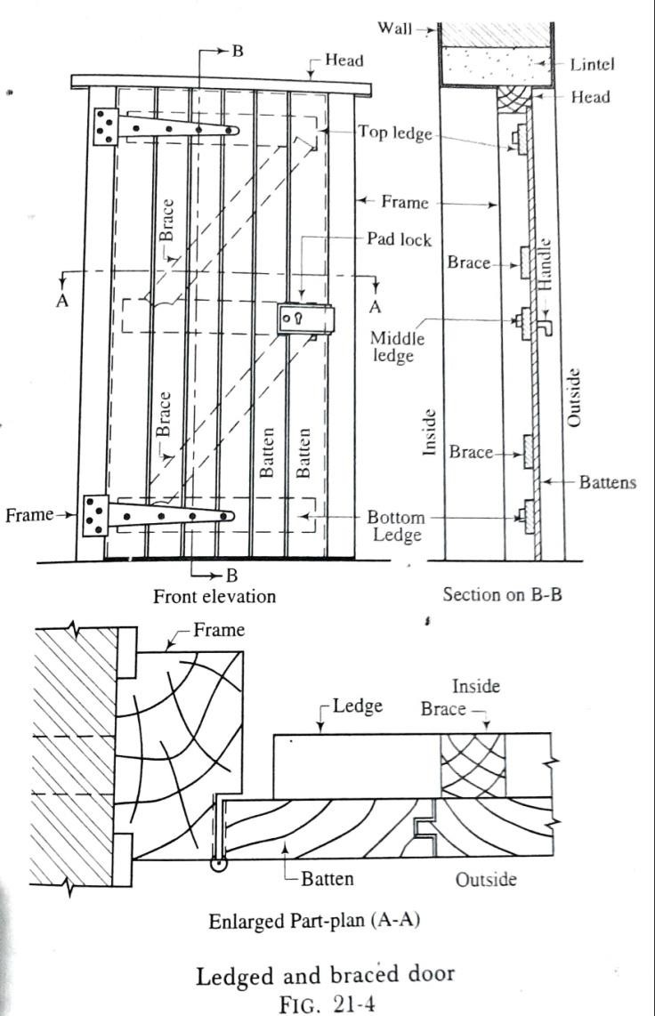
  - The battens are 100 mm to 150 mm wide and 20 mm to 30 mm thick. The ledges are generally 100 mm to 200 mm wide and 30 mm thick. The three ledges are generally employed-top, middle and bottom.
  - The battens are secured by means of suitable joints and the shutter is hung on T-hinges which are fixed on ledges.
  - This is the simplest form of door and it is used where strength and appearance are not important.
- Ledged and braced doors (fig. 21-4):
  - These are similar to the ledged doors except that the diagonal members, known as the braces, are provided as shown in fig.
  - The braces are generally 100 mm to 150 mm wide and 30 mm thick. The braces give rigidity to the door and hence the doors of this type are useful for wide openings.
  - The braces are usually housed in the ledges. It should be noted that the braces must slope upwards from the
hanging side as they have to work in compression and not in tension.

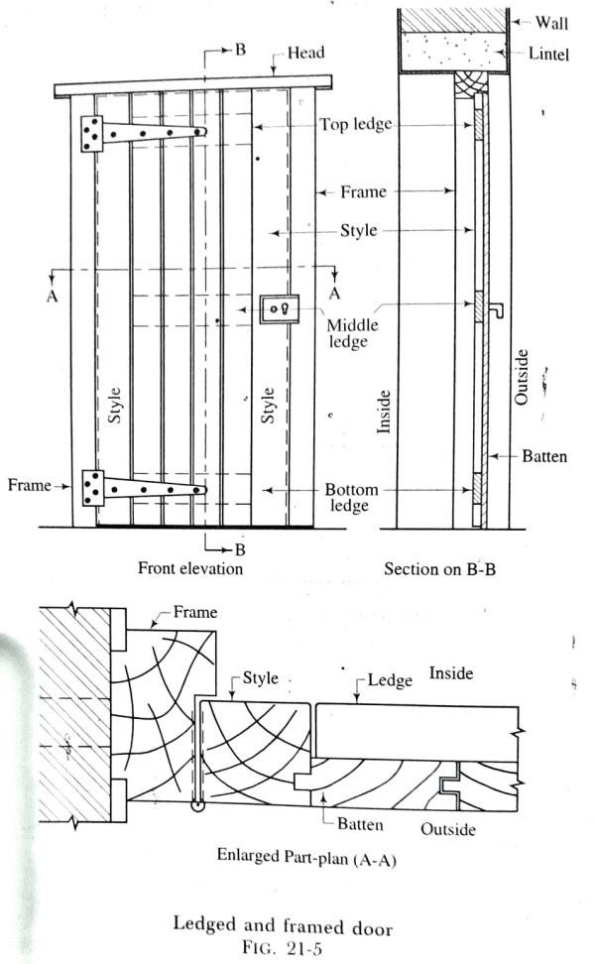
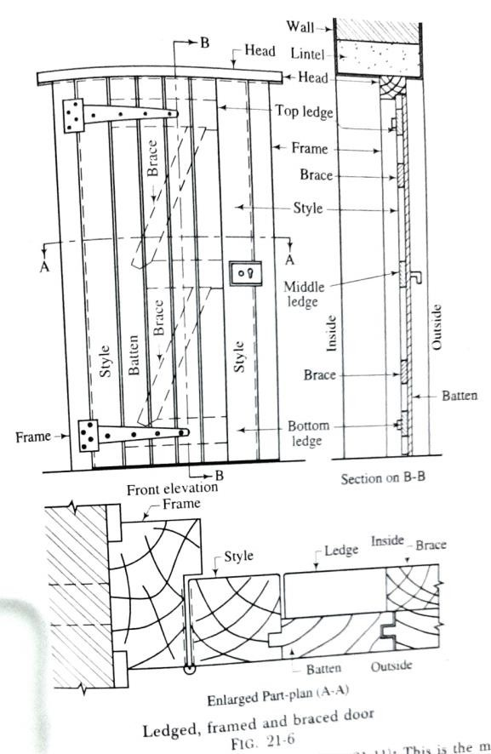

- Ledged and framed doors (fig. 21-5):
  - In this type of doors, a framework for shutters is provided to make the doors stronger and better in appearance as shown in fig.
  - The styles are generally 100 mm wide and 40 mm thick. The battens and ledges are provided as usual.

- Ledged, framed and braced doors (fig. 21-6):
  - This is just similar to the above type except that the braces are introduced as shown in fig.

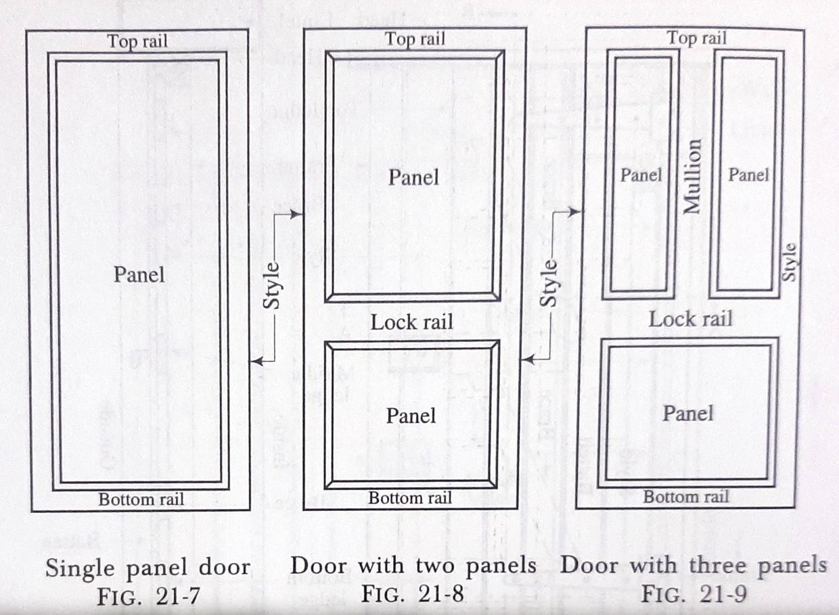
  - This type of door is more durable and stronger and hence it can be adopted for external use. The braces should incline upwards from the hanging side.
- Framed and panelled doors:
  - This is the most usual variety of door and it consists of a framework in which panels are fitted.
  - This type of door reduces the tendency of shrinkage and presents a decent appearance.

- Glazed or sash doors :
  - In order to admit more light, in addition to that coming from the windows, the fully glazed or partly panelled and partly glazed doors are used.
  - Usually the ratio of glazed portion to panelled portion is 2:1.

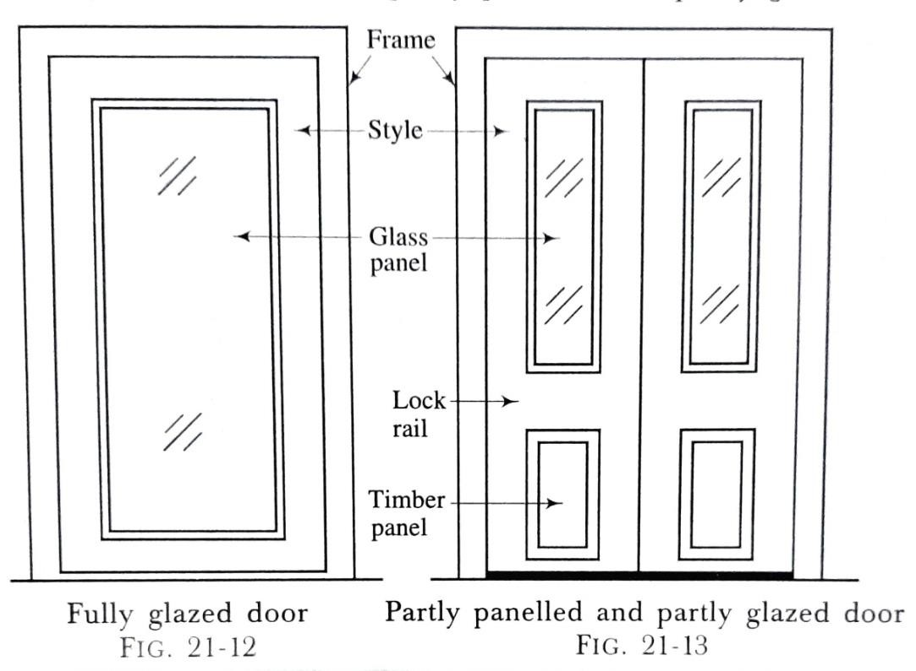
  - The glass is received into the rebates provided in the wooden sash bars and secured by nails and putty or by wooden beads fixed to the frame.
- Flush doors :
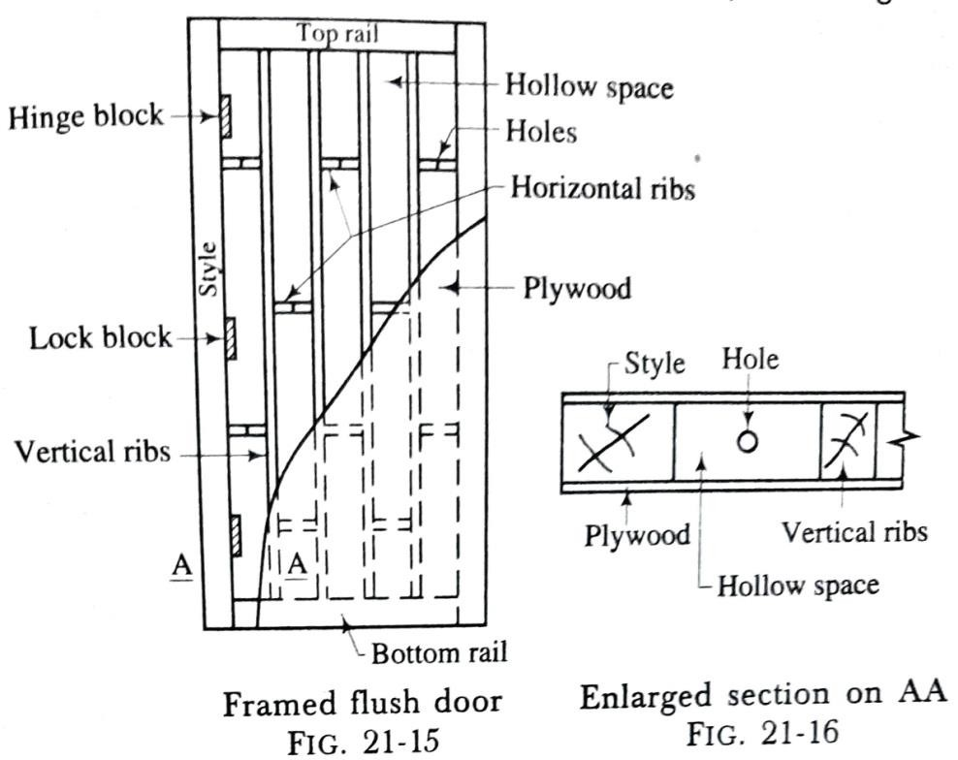
  - A flush door consists of a framework of rails and styles and it is covered with plywood or hard board.
  - There are two varieties of flush doors -a framed flush door and a laminated flush door.
  - A framed flush door consists of styles, rails, horizontal ribs, vertical ribs and plywood as shown in fig. 21-15 and fig. 21-16.
  - A laminated flush door consists of styles, rails, laminated core and plywood as shown in fig. 21-17 and fig. 21-18.

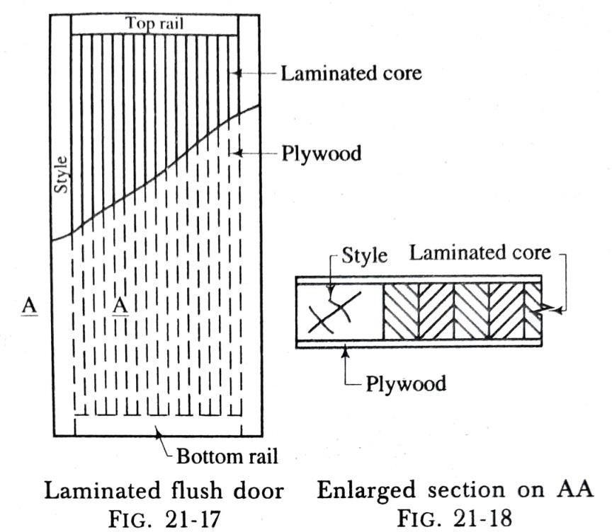
- Louvered doors:
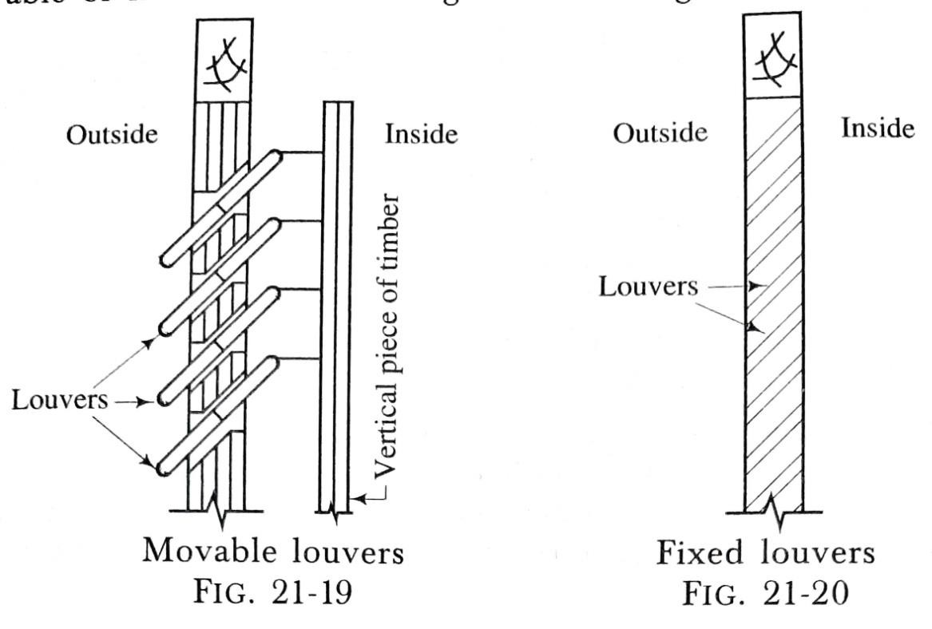
  - In this type of doors, the shutters are provided with louvers, either fully or partly.
  - The louvers are arranged at such an inclination that the horizontal vision is obstructed.
  - The louvers may be movable or fixed as shown in fig. 21-19 and fig. 21-20 respectively.

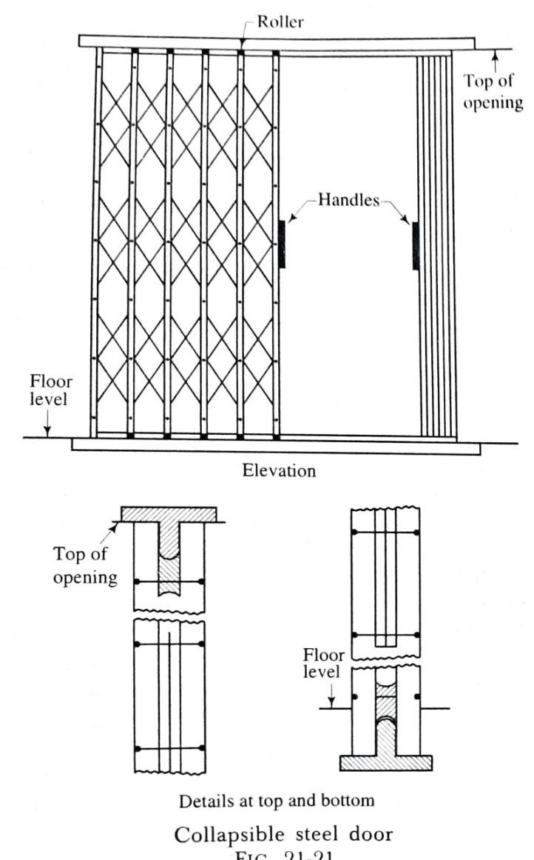
- Collapsible steel doors (fig. 21-21):
  - A collapsible steel door consists of a mild steel frame.
  - The two vertical pieces of mild steel channels, about 15 mm to 20 mm wide, are joined together with the hollow portion of the channel inside.
  - The rollers, mounted on horizontal piece, are provided at top and bottom ends of the vertical pieces.
  - A collapsible steel door thus works without hinges and it is used for compound gates, residential buildings, schools, sheds, go downs, workshops, public buildings, etc. for providing increased safety and protection to the property.
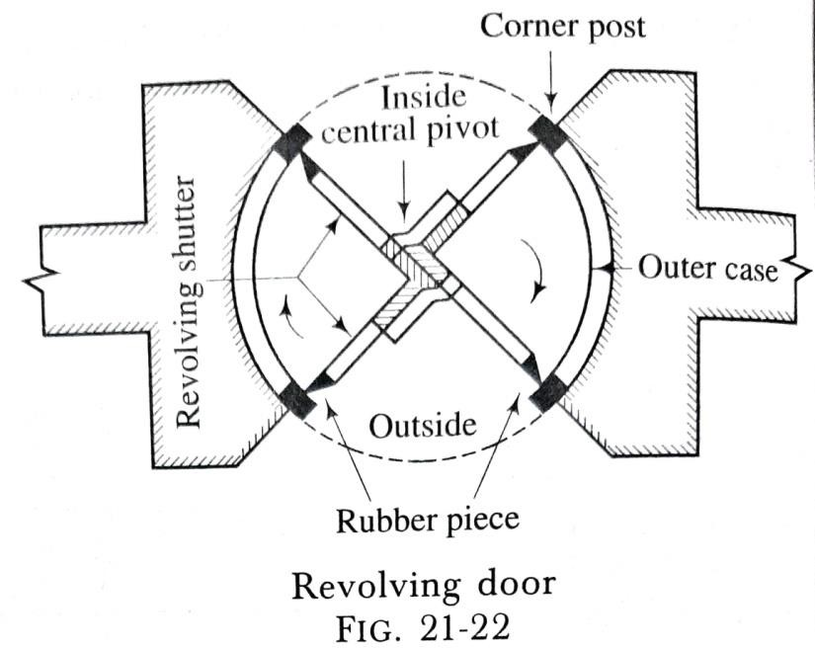
- Revolving doors (fig. 21-22):
  - A revolving door essentially consists of a centrally placed mullion or pivot in a circular opening.

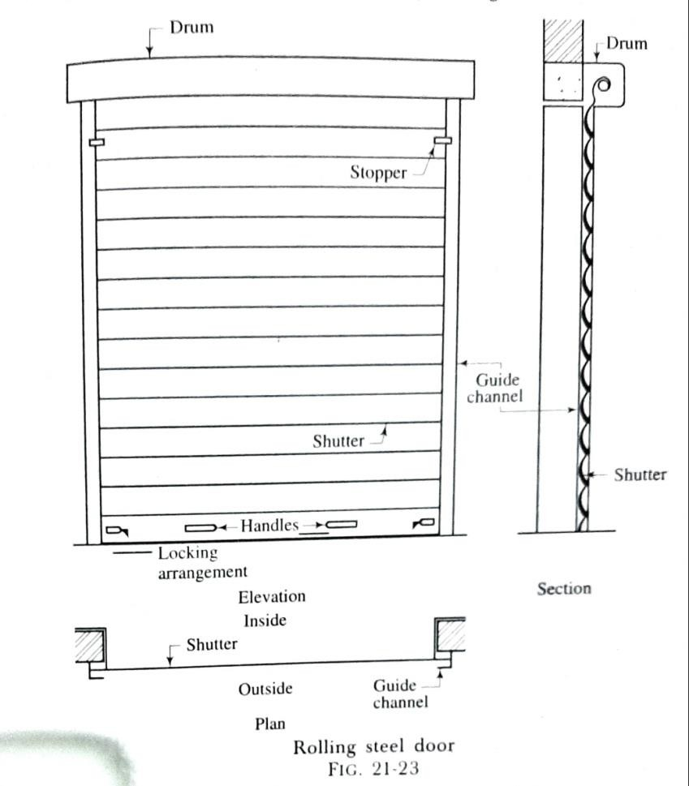
  - The revolving shutters or leaves which are 4 in number are radially attached to the pivot as shown in fig. 21-22.
  - The shutters may be fully glazed, fully panelled or partly panelled and partly glazed.
- Rolling steel doors (fig. 21-23):
  - A rolling steel door consists of a frame, a drum and a shutter of thin steel plates or iron sheets of thickness about 1 mm, as shown in fig. 21-23.
  - The grooves of about 25 mm thickness are left in the frame. A horizontal shaft and springs are provided in the drum at the top.
  - The diameter of the drum is about 200 mm to 300 mm.
  - The shutter usually rolls in turns. Thus a slight pull or push will close or open the shutter.

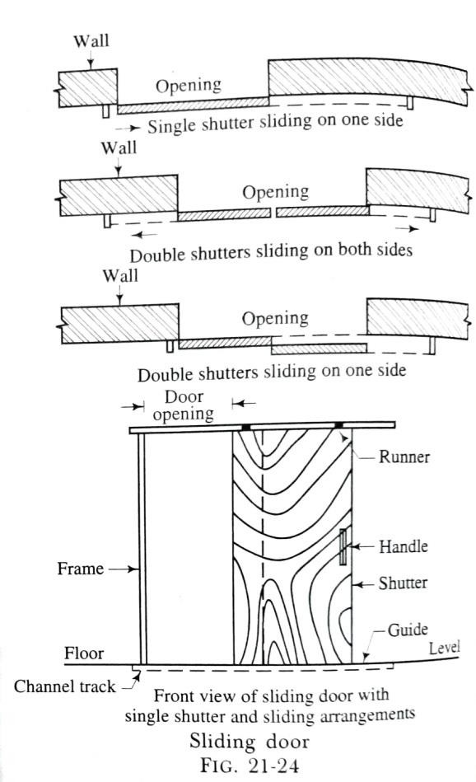
- Sliding doors (fig. 21-24):
  - In this type of doors, the shutter slides on the sides with the help of runners and guide as shown in fig. 21-24.
  - The shutter may be of one or several leaves and can slide either on one side or both the sides.
  - The cavities may be provided in the wall to receive the door in an open position or it may simply lie touching the wall, the latter arrangement being very common.
  - A sliding door does not cause any obstruction during movement
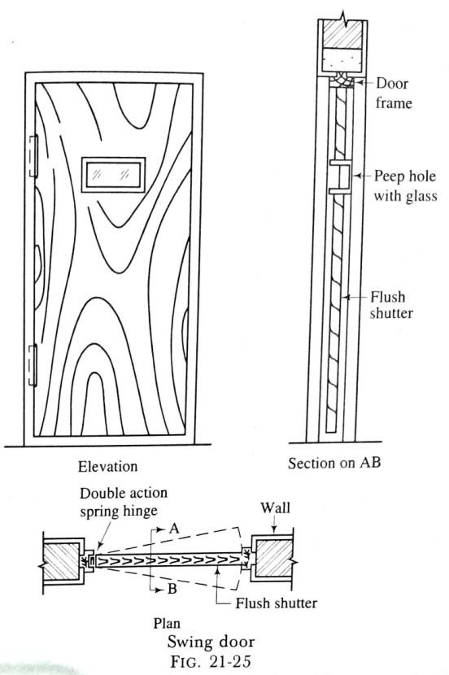
and is used for entrances of godowns, sheds, shops, show rooms, etc.
- Swing doors:
  - A swing door is provided with special hinges known as the double action spring hinges and thus the shutters of the door are held in closed position, when the door is not in use.
  - When the door is to be used, a slight push is made and then the action of spring brings the shutter in closed position.

TYPES OF WINDOWS
Depending upon the manner of fixing, materials used for construction, nature of operational movements of shutters, etc., the common varieties of windows used in the buildings can be grouped as follows:
- Casement windows
- Double-hung windows
- Pivoted windows
- Sliding windows
- Louvered windows
- Sash or glazed windows
(7) Metal windows (8)Circular windows
- Corner windows
- Gable windows

- Dormer windows
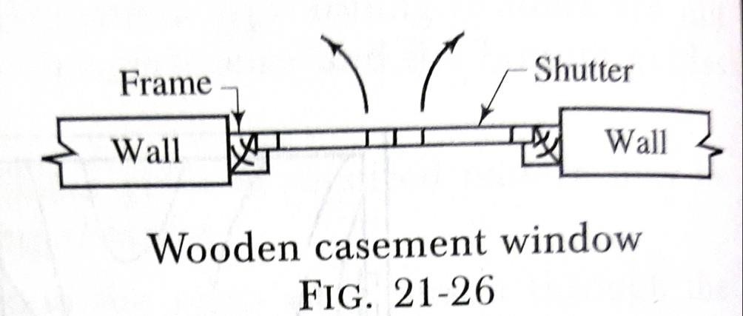
- Bay windows
- Clerestorey windows
- Lanterns or lantern lights
- Skylights.
- Casement windows (fig. 21-26):
  - These are the windows, the shutters of which open like doors.
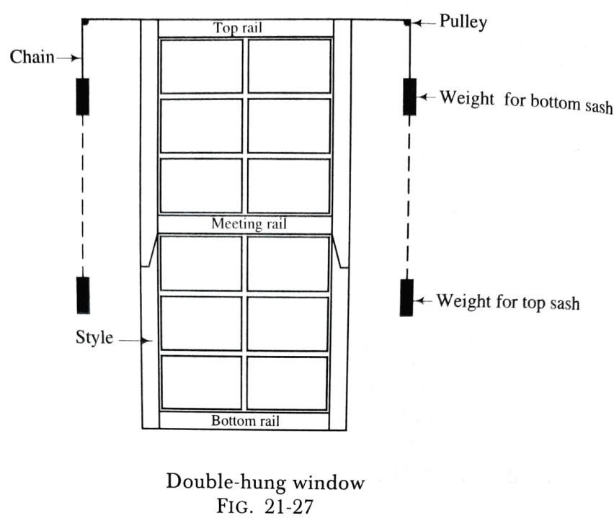
  - The construction of a casement window is similar to the door construction and it consists of a frame, styles, rails, vertical and horizontal sash bars and sometimes, it also includes mullions and transoms.
- Double-hung windows (fig. 21-27):
  - These windows consist of a pair of shutters which can slide within the grooves provided in the frame.
  - A pair of metal weights connected by cord or chain over pulleys is provided for each sash.

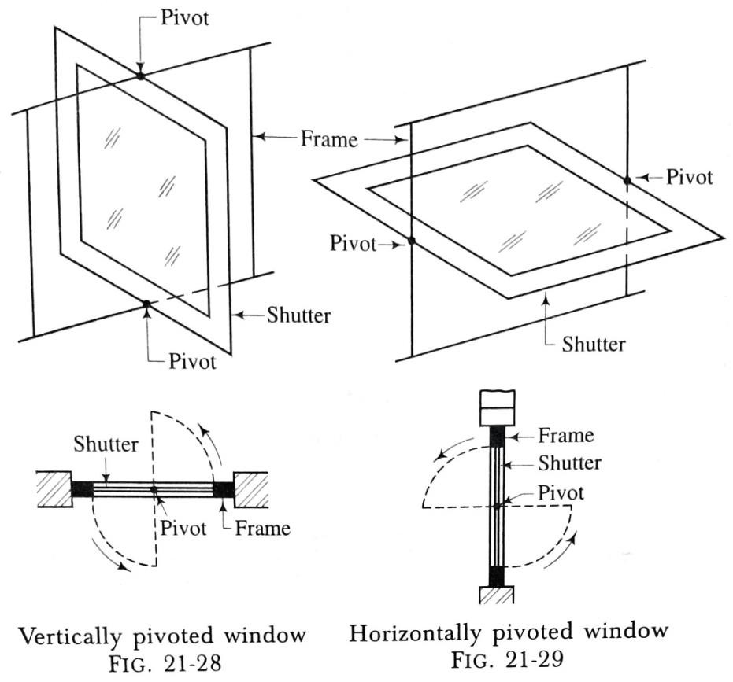
  - It is so arranged that the upper sash moves in the downward direction, thus opening at the top and the lower sash moves in the upward direction, thus opening at the bottom.
  - The weights, when pulled, open the shutter to the required level. Thus the ventilation can be controlled and cleaning of shutters can be carried out easily.
- Pivoted windows (fig. 21-28 and fig. 21-29):
  - In this type of windows, the shutters are allowed to swing round the pivots.
  - The frame of a pivoted window is just similar to casement window except that no rebates are provided.
  - The windows may be vertically pivoted or horizontally pivoted as shown in fig. 21-28 and fig. 21-29 respectively.
  - The pivoted windows are easy to clean and they admit more light than the side- hung windows.

- Sliding windows:
  - These windows are similar to the sliding doors and the shutters move on the roller bearings, either horizontally or vertically.
  - Suitable openings are provided in the walls to receive the shutters when windows are opened out.
  - Such windows are provided in trains, buses, bank counters, shops, etc.
- Louvered windows:
  - In this type of windows, the louvers are provided as in case of louvered doors.
  - They allow free passage of air when closed and at the same time, they maintain sufficient privacy.
  - The shutter consists of top rail, bottom rail and two styles which are grooved to receive the louvers.
  - The economical angle of inclination of the louvers is 45° and they are generally fixed in position.

- Sash or glazed windows:
  - These are fully glazed casement windows. The sashes are rebated to receive glass panels.
  - The width and depth of rebates are about 15 mm and 5 mm respectively.
  - The glass is secured in position either by putty or by mall fillets, known as the glazing beads.
- Metal windows (fig. 21-30 and fig. 21-31):
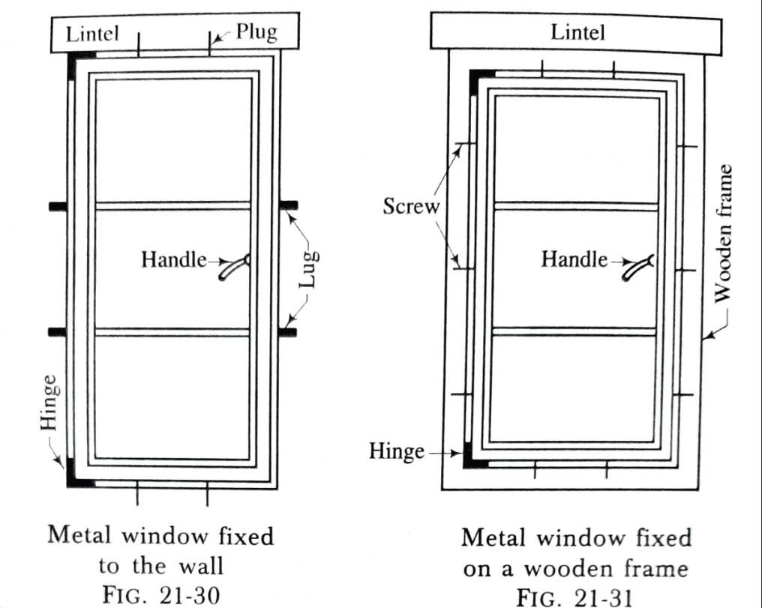
  - These are now-a-days widely used, especially for public buildings.
  - The metal used in the construction may be mild steel, bronze or other alloys.
  - The steel windows are manufactured in standard sizes and are widely used metal windows.
  - The metal frame may be fixed direct to the wall or it may be fixed on a wooden frame.

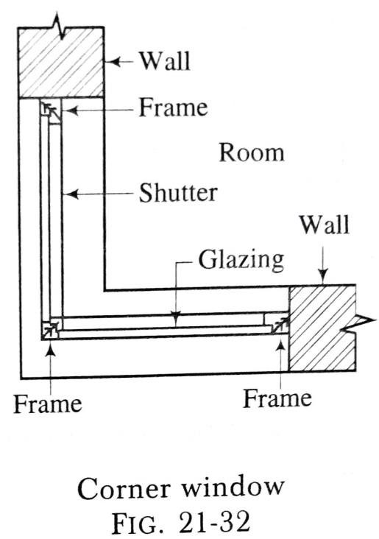
- Circular windows: These are pivoted windows of circular shape. They are useful for factories, workshops, etc.
- Corner windows (fig. 21-32):
  - These windows are provided at the corner of a room.
  - They are placed at the corner of a room and thus they have two faces in two perpendicular directions.
  - Due to such situation, there is entry of light and air from two
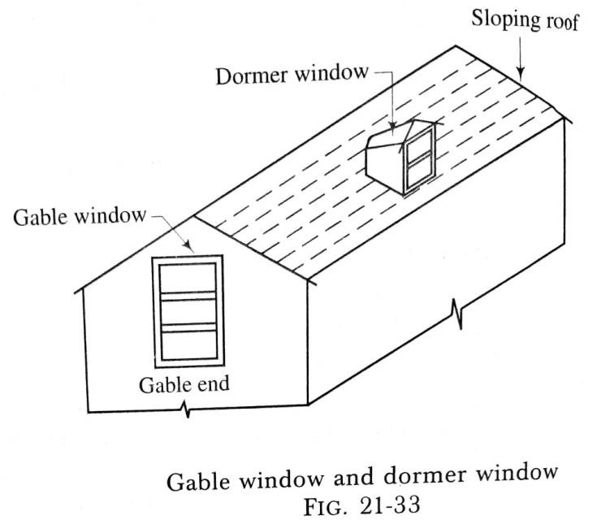
directions and in many cases, the elevation of the building is also improved.
- Gable windows (fig. 21-33): These are the windows which are provided in the gable ends of a roof.
- Dormer windows (fig. 21-33):
  - These are the windows provided on the sloping roofs.
  - The main purpose of providing dormer windows is to admit light and air to rooms which are constructed within or below the roof slopes.

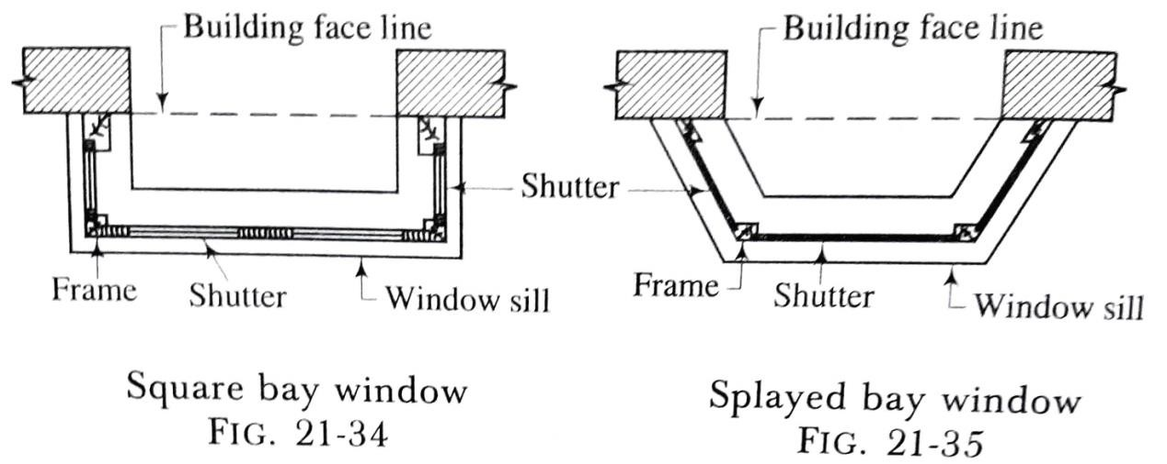
- Bay windows (fig. 21-34 and fig. 21-35):
  - These windows project outside the external walls of a room.
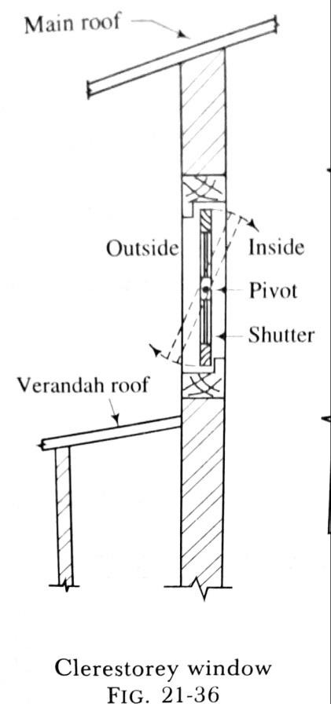
  - They may be square, splayed, circular, polygonal or of any shape.
  - The projection of bay windows may start from floor level or sill level.
  - These windows admit more light, increase opening area, provide ventilation and improve the appearance of the building.
- Clerestorey windows (fig. 21-36):
  - These windows are provided near the top of main roof as shown in fig. 21-36.
  - The pivoted windows are used for this purpose.
  - The clerestorey windows provide ventilation to the inside of the room as the front is blocked by the verandah. They also improve the appearance of building.
  - The care should be taken to see that the upper part opens inside and the lower part opens outside. Otherwise the rain water will accumulate in the room.

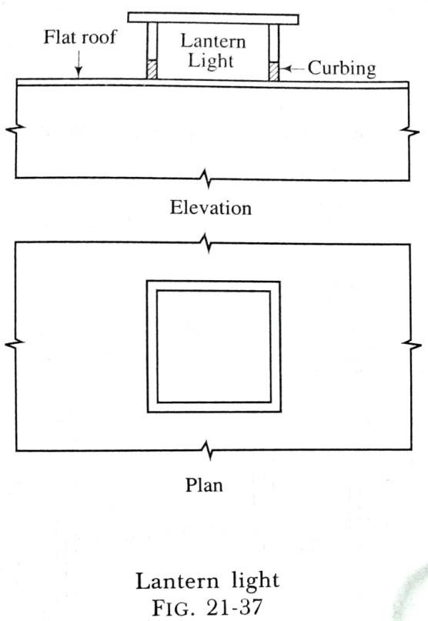
- Lanterns or lantern lights (fig. 21-37):
  - These are the windows which are fixed on flat roofs to provide light to the inner portion of the building where light coming from the windows in the external walls is insufficient.
  - They may be square or rectangular or curved.
  - The glass panels are generally fixed. But if ventilation is also required in addition to light, the pivoted windows may be provided.
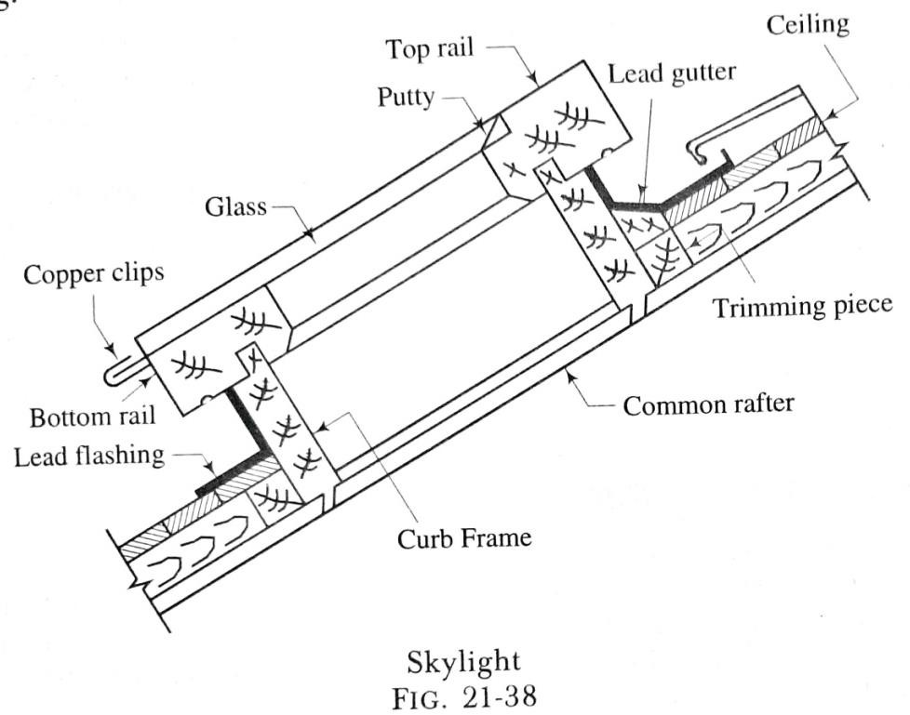
- Skylights (fig. 21-38):
  - These are the windows which are provided on the sloping surface of a pitched roof.
  - The common rafters are suitably trimmed and the skylight is erected on a curb frame.
  - As skylights are mainly meant for light, they are usually provided with the fixed glass panels.

  - The opening of skylight is properly treated by lead flashing to make water-proof the roof area surrounding the opening.
Purpose of Arches and Lintels
  - To support the loads of the portion of wall above the openings.
  - To transmit such loads to the ends of walls or piers or jambs or columns over which they are supported.

***end***

PART: B (CONSTRUCTIONS TECHNOLOGY)
CHAPTER:-05 [Floors, Roofs and Stairs] [Floors]
DEFINITIONS:
In order to sub-divide the portion between the plinth level or basement level and roof level, the solid constructions are carried out. These constructions are known as the floors and the exposed top surfaces of floors are termed as the floorings.
TYPES OF FLOORINGS
- Concrete:-
  - The thickness of concrete layer is about 40mm and it is carried out in proportion of 1 part of cement, 2 parts of sand and 4 parts of coarse aggregate by volume.
  - The size of coarse aggregate varies from 20 mm to 6 mm.
  - The square or diagonal lines are marked on the concrete surfaces when it is still wet.
  - This type of construction is known as the Indian Patent Stone and is widely used for cheap residential buildings.

  - The granolithic concrete should be laid before the base concrete has set and its thickness varies from 10 mm to 20 mm.
  - After laying the concrete, the surface is tamped and floated with wooden floats. The surface is then finally smoothened by means of steel trowel.

- Terrazo:-
  - This is simply a concrete in which marble chips are used as aggregates and which, when polished with carborundum stone, presents a smooth surface.
  - Any desired colour may be obtained by using marble chips of different shades and sizes and also by using different colours of cement.
  - The cement and marble chips are thoroughly mixed in dry condition and then enough quantity of water is added so as to obtain a plastic mixture. This mixture is laid on a sound and rough base.
  - This flooring material is used for residential buildings, bathrooms, cloakrooms, hotels, breweries, temples, theatres, etc.

- Tile:-
  - The pre-cast concrete tiles with marble chips at top surface, known as the mosaic tiles, are simply a form of pre-cast terrazo.
  - They are available in standard sizes. The polishing is done after fixing the tiles in position.
  - The white-glazed tiles are used for the flooring of water-closets, bathrooms, swimming pools, etc. These tiles do not require polishing and keep excellent sanitary conditions.
- Timber:-
  - This is the earliest but most common flooring material.
  - This material possesses natural beauty and is available in a variety of colours. It is elastic and has enough resistance to wear.
  - The timber to be used for flooring should be of the best quality, well-seasoned and free from cracks, knots, flaws and other defects. This flooring material is used for auditoriums, dance halls, gymnasium floors, etc.

  - The timber flooring can be carried out in one of the following three types:
- Strip flooring: This consists of wooden planks or boards which are suitably joined together. The strips are tongued and grooved at the edges and ends. The nails are fixed in such a way that their heads are not seen.

- Block flooring: This consists of blocks which can be laid in suitable designs over a concrete base. The size of blocks varies from 200 mm x 80 mm to 300 mm x 80 mm and the thickness varies from 20 mm to 40 mm. The blocks are suitably joined together.

- Parquet flooring: This is similar to the block flooring except that the blocks are supported on sub-floors and their thickness does not exceed 10mm. The blocks are laid in desired patterns and they are fixed by means of hot glue. The parquet flooring of plywood is of recent development.

[Roofs] GENERAL
A roof is defined as the uppermost part of a building which is constructed in the form of a framework to give protection to the building against rain, heat, snow, wind, etc. A roof basically consists of structural elements provided at the top of building for the support of roof coverings.
REQUIREMENTS OF A GOOD ROOF
- It should be durable against the adverse effects of various agencies such as wind, rain, sun, etc.
- It should grant the desirable insulation against sound and heat.
- It should be structurally stable and sound and it should be capable of taking the loads likely to come over it.
- It should be well-drained.
- It should have efficient water-proofing arrangement.
- It should be fire resistant.

CLASSIFICATION OF ROOFS
The roofs are classified into the following three categories:
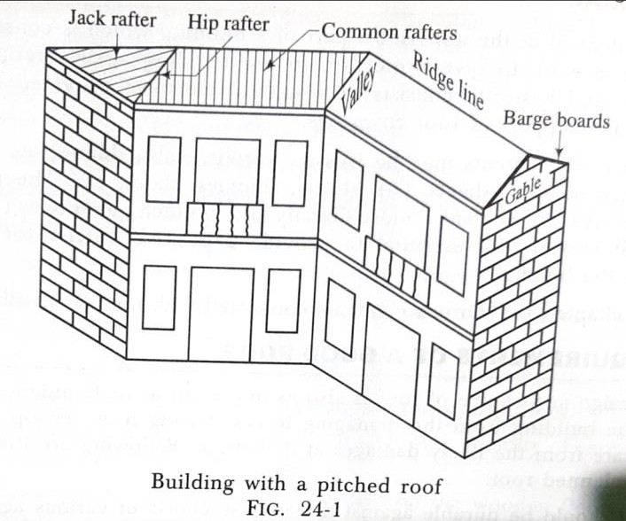
  - Pitched or sloping roofs
  - Flat or terraced roofs
  - Curved roofs.
- Pitched or sloping roofs:
A sloping roof is known as a pitched roof.
The definitions of technical terms used in connection with the pitched roofs are given below.
  - Barge boards: These are the wooden planks or boards which are fixed on the gable end of a roof as shown in fig. 24-1. They connect the ends of ridge, purlins and wall- plates.
  - Battens: These are the thin strips of wood which are fixed on the rafters or ceiling as shown in fig. 24-2. They support the roof ceiling.

  - Cleats: These are small blocks of wood which are fixedon the trusses to apex line prevent the sliding of purlins as shown in fig. 24-2.
  - Dragon beam: The lower end of a hip rafter is generally supported on a diagonal piece of wood which is laid across the corner of the wall. This diagonal piece is known as a dragon beam or a dragon tie or an angle tie.
  - Eaves: The lower edges of a roof which are resting upon or projecting beyond the supporting walls are known as the caves. Sometimes a thin board of wood in provided at the eaves to cover the ends of the common rafters. Such a board is known as an caves board or facia board as shown in fig. 24-2. It is usually 25 mm thick and 250 mm wide.
  - Gable: The triangular upper part of a wall formed at the end of a pitched roof is known as a gable as shown in fig. 24-1.
  - Hip: The angle formed at the intersection of two roof slopes is known as the hip.
  - Pitch: The inclination of sides of a roof to the horizontal plane is known as the pitch and it can be expressed either in terms of degrees or as a ratio of rise to span.

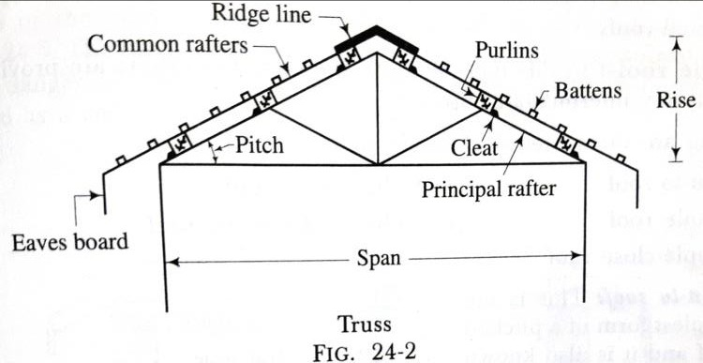
  - Purlins: The wooden pieces which are placed horizontally on principal rafters to carry the common rafters are known as the purlins as shown in fig. 24-2.
  - Rafters: These are the pieces of timber which extend from the eaves to the ridge. Following are the various types of rafters:
    - Common rafters: These are the intermediate rafters which give support to the roof covering as shown in fig. 24-1 and fig. 24-2.
    - Hip rafters: These are the rafters which are provided at the junction of two roof slopes as shown in fig. 24-1.
    - Jack rafters: Any rafter which is shorter than a common rafter is known as a jack rafter as shown in fig. 24-1.
    - Principal rafters: These are the inclined members of a truss as shown in fig. 24-2.
  - Ridge: A wooden piece provided at the ridge line of a sloping roof is known as the
ridge or ridge board or ridge piece.

  - Span: The horizontal distance between the internal faces of walls or supports is known as a span or a clear span as shown in fig. 24-2. The effective span indicates the horizontal distance between the centres of wall or supports.
  - Template: A bedding block is generally provided at the end of a truss. This block is known as a template and it helps in spreading the load over a large area. A template may be of wood or stone or R.C.C.
  - Truss: The framework, usually of triangles and designed to support the roof covering or ceiling over rooms, is known as a roof truss.
  - Verge: The edge of a gable, running between the eaves and ridge, is known as a
verge.
  - Valley: When two roof surfaces meet together and form an internal angle, a valley is formed as shown in fig. 24-1.
  - Wall-plates: These are the long wooden members which are embedded on top of walls to receive the common rafters. They actually connect the walls to the roof.

- Flat or terraced roofs:
- A roof which is nearly flat is known as the flat roof. It should be noted that no roof can be laid perfectly level.
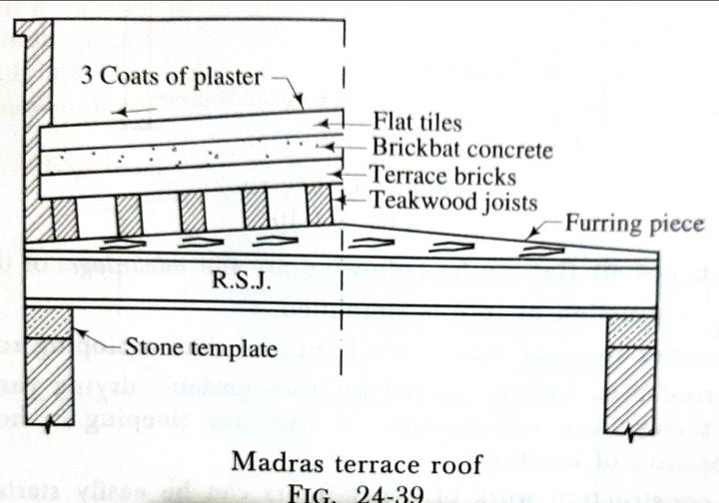
- The roof must slope in one direction or the other to cause rain water to flow off rapidly and easily.
- The two types of flat roofs which are commonly used in Madras and Bengal are discussed below.
  - Madras terrace roof: The procedure of construction is as follows:
    - The teakwood joists are placed on rolled steel joists with a furring piece between the joists and rolled steel joists. The
furring is placed sloping and it gives necessary slope to the flat roof.
    - A course of specially prepared terrace bricks is laid diagonally across the joists. The size of bricks is generally 150 mm x 75 mm x 25 mm and they are placed on edge in lime mortar.

    - After the brick course has set, a course of brickbat concrete is laid. The thickness of this course is about 75 mm and it consists of 3 parts of brickbats, one part of gravel and sand and 50 percent of lime mortar by volume.
    - The concrete is well-rammed for a period of three days and allowed to set.
    - The flat tiles are then laid over the layer of concrete. The tiles are laid in two courses, making the thickness of about 50 mm. Alternatively the China mosaic pieces may be used in place of flat tiles.
    - Finally, the surface of the roof is finished by three coats of plaster as shown in fig. 24-39. The surface is rubbed and polished and it is given a slope of 1 in 30.
    - As this type of flat roof construction is widely used in old Madras State (Tamil Nadu), it is known as the Madras terrace roof.
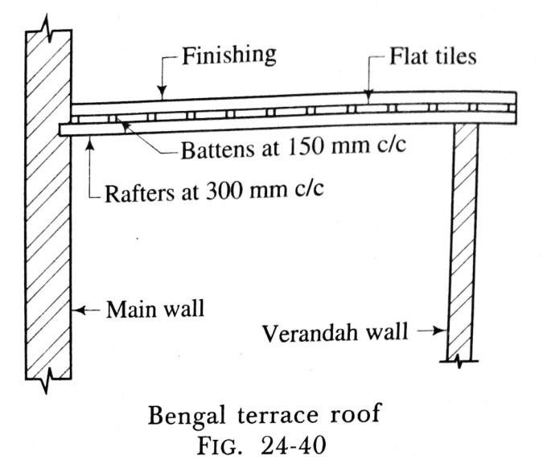
  - Bengal terrace roof: The procedure of construction is as follows:
    - The rafters are placed, with a slight inclination, at 300 mm to 500 mm c/c. One end of the rafter is inserted into the main wall

to a depth of 200 mm and its other end is supported on a verandah wall or a bressummer.
    - The battens are placed at right angles to the rafters at a centre to centre distance of about 150 mm.
    - A course of flat tiles is then laid in mortar over the battens.
    - Finally, the surface of the roof is finished in any one of the following methods:
      - The two or more courses of flat tiles may be laid and then the surface of roof is rubbed and polished with two or three coats of plaster.
      - A layer of fine jelly concrete may be laid over the first course of tiles. The thickness of layer of concrete may be 40 mm. On this layer of concrete, another course of flat tiles is laid and the surface of roof is rubbed and polished with two or three coats of plaster.
    - As this type of roof is mainly used in the Bengal State to cover verandahs, it is known as the Bengal terrace roof. Fig. 24-40 shows a sketch of Bengal terrace roof.

- Curved roofs:
- These are just the modifications of pitched roofs and are frequently employed in the modern age to cover large areas and to give architectural effects.
- The shell roofs and domes are the varieties of the curved roofs.
- They are useful for big structures such as factories, monumental works, libraries, theatres, recreation centres, etc.
- The curved roofs may be constructed of timber or R.C.C., the latter material being very common now-a-days.
- There are two common forms of a shell roof:
- A north-light shell roof as shown in fig. 24-41.
- A barrel vault shell roof as shown in fig. 24-42.
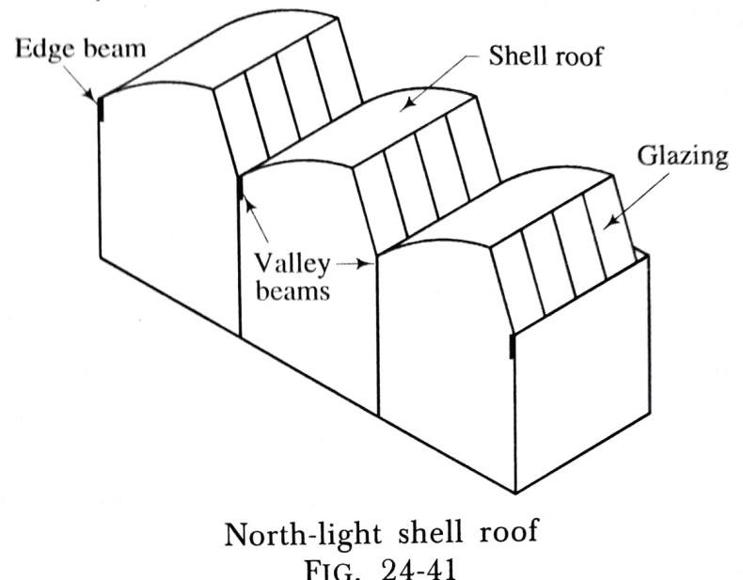
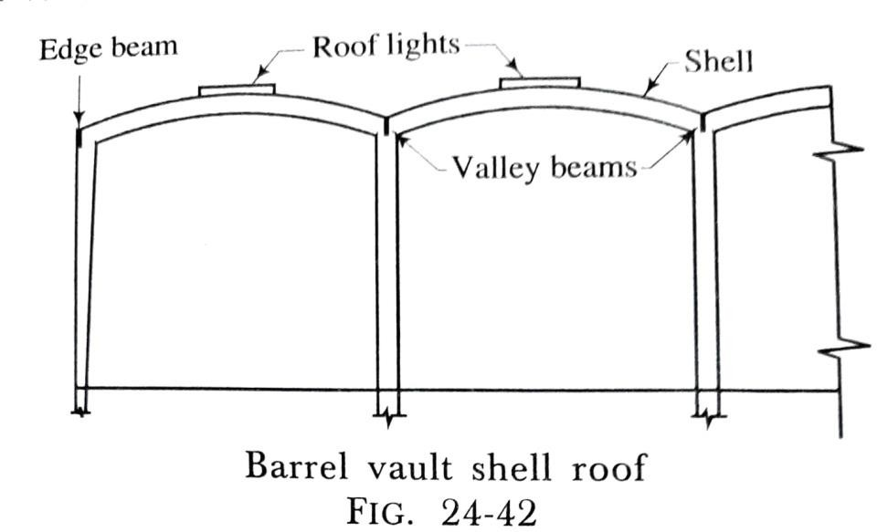

[Stairs]
GENERAL
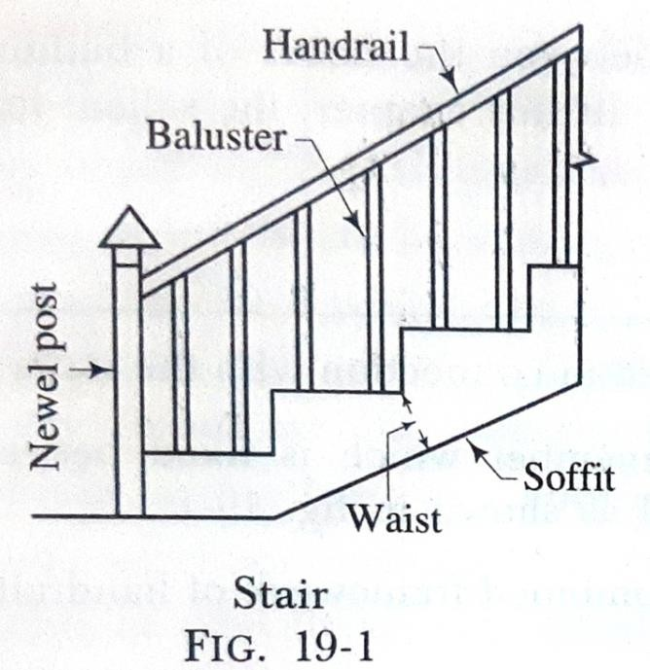
A stair is defined as a sequence of steps and it is provided to afford the means of ascent and descent between the floors or landings. The apartment or room of a building, in which the stair is located, is known as a staircase and the opening or space occupied by the stair is known as a stairway.
TECHNICAL TERMS
The definitions of technical terms used in connection with the stairs are as follows:
- Baluster: This is the vertical member which is fixed between string and handrail to give support to the handrail as shown in fig. 19-1.
- Balustrade or barrister: The combined framework of handrail and balusters is known as the balustrade or barrister.
- Flight: This is defined as an unbroken series of steps between the landings.

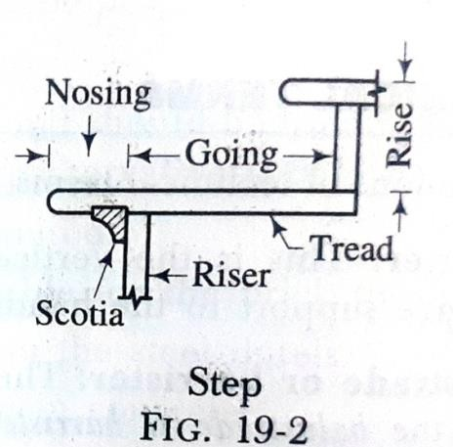
- Going: This is the horizontal distance between the faces of two consecutive risers as shown in fig. 19-2.
- Handrail: The inclined rail over the string is known as a handrail as shown in fig.19-1.
- Headroom: The vertical distance between the nosings of one flight and the bottom of flight immediately above is known as the headroom and it should be of sufficient value so as not to cause any difficulty to the persons using the stair.
- Landing: The horizontal platform between two flights of a stair is known as the landing. A landing facilitates change of direction and provides an opportunity for taking rest during the use of stair.
- Newel post: This is the vertical member which is placed at the ends of flights to connect the ends of strings and handrails as shown in fig. 19-1.
- Nosing: The projecting part of the tread beyond the face of riser is known as a nosing as shown in fig. 19-2.
- Pitch: The angle of inclination of the stair with the floor is known as a pitch. It also indicates the angle which the line of nosings makes with the horizontal.

- Rise: This is the vertical distance between two successive treads as shown in fig. 19-2.
- Riser: The vertical or front member of the step, which is connected to the treads, is known as a riser as shown in fig. 19-2.
- Run: The total length of a stair in a horizontal plane is known as the run and it includes the lengths of landings also.
- Scotia: This is an additional finish or moulding provided to the nosing or tread as shown in fig. 19-2 to improve the elevation of the step and to provide strength to the nosing.
- Soffit: The under surface of a stair is known as the soffit as shown in s. 19-1. It is generally covered with ceiling or finished with plaster.
- Step: A combination of tread and riser is known as a step as shown in fig. 19-2.
- String: The inclined member of a stair which supports the ends of steps is known as a string.
- Tread: The horizontal upper portion of a step is known as a tread.

- Waist: The thickness of structural slab in case of an R.C.C. stair is known as a waist as shown in fig. 19-1.
- Walking line: The approximate line of movement of people on a stair during ascending or descending is known as a walking line and it is situated at a distance of about 450 mm from the centre of handrail.
TYPES OF STAIRS
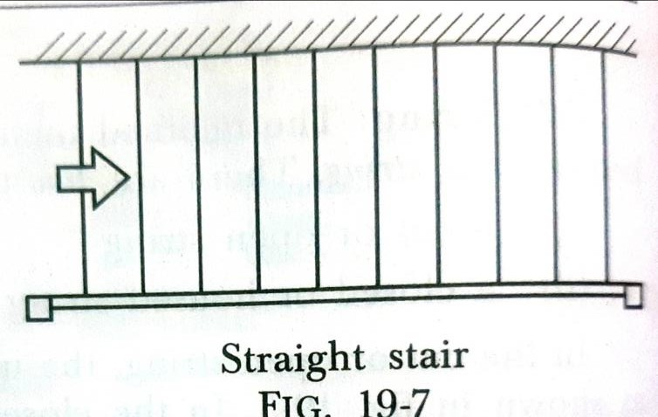
The stairs are classified as follows:
  - Straight stairs
  - Turning stairs
  - Circular or helical or spiral stairs
  - Geometrical stairs.
- Straight stairs:
  - In case of a straight stair, all steps lead in one direction only as shown in fig. 19-7.
  - This type of stair may consist of one or more flights and they are used when the space available for staircase is long but narrow in width.

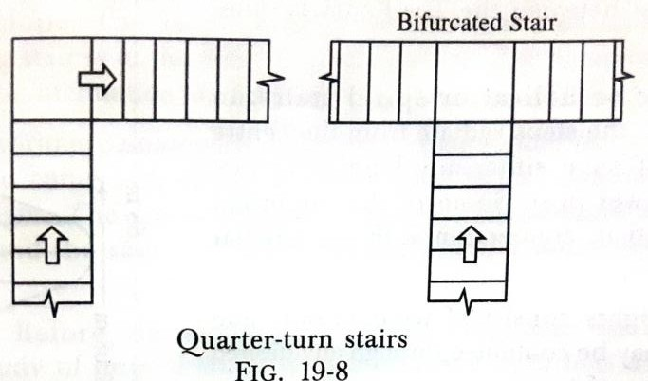
- Turning stairs: In case of turning stairs, the flights take turn. The usual types of turning stairs are described below.
- Quarter-turn stairs:
  - A stair turning through one right angle is known as a quarter-turn stair. If a quarter-turn stair is branched into two flights at a landing, as shown in fig. 19-8, it is known as a bifurcated stair.
  - This type of stair is commonly used in the public buildings near their entrance hall.
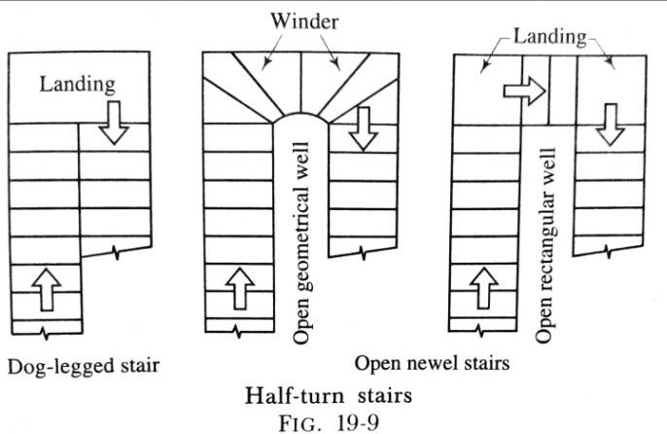
  - The stair has a wider flight at the bottom which bifurcates into two narrower flights at the landing - one turning to the left and the other
to the right.
- Half-turn stairs:
  - A stair turning through two right angles is known as a half- turn stair. A half-turn stair may be of dog-legged type or open newel type as shown in fig. 19-9.
  - In case of a dog-legged stair, the flights run in opposite directions and there is no

space between them in plan. These stairs are useful where total width of space available for the staircase is equal to twice the width of steps. Its name is derived from its appearance in the sectional elevation.
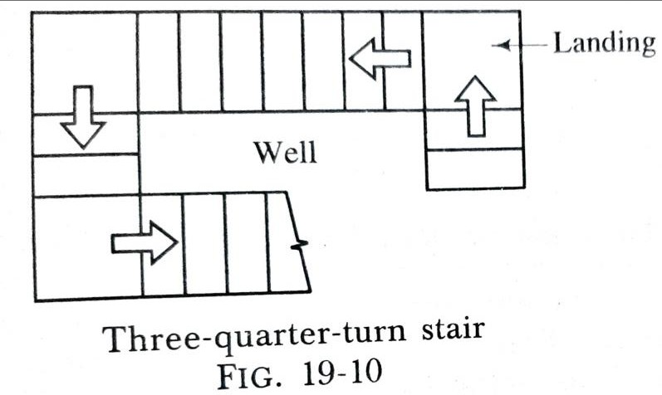
  - In case of an open newel stair, there is a well or hole or opening between the flights in plan. This well may be rectangular or of any
geometrical shape and it can be used for fixing lift. These stairs are useful where available space for staircase has a width greater than twice the width of steps.
- Three-quarter-turn stairs:
  - A stair turning through three right angles is known as a three-quarter-turn stair as shown in fig. 19-10.
  - In this case, an open well is formed. This type of stair is used when the length of the staircase is limited and when the vertical distance between the two floors is quite large.

- Circular or helical or spiral stairs:
  - In this type of stair, the steps radiate from the centre and they do not have either any landing or any intermediate newel post.
  - Some of the important facts to be noted in connection with the circular stairs are:
- The flights consist of winders only and they may be continued through any desired number of turns.
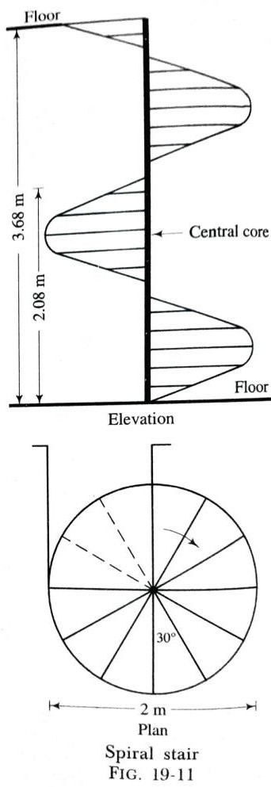
- A spiral stair may be constructed of cast iron, mild steel or concrete. Usually the structural design and construction of a spiral stair are
complicated in nature.
- For concrete spiral stairs, the steel reinforcement is heavy and formwork is complicated. These facts make the concrete spiral stairs expensive.
- The core of spiral stair may be solid or hollow and the stair may be provided with cut or closed strings.

- The spiral stairs are useful where the space available is limited and where the traffic is less.
- Geometrical stairs:
  - These stairs have any geometrical shape and they require no newel posts.
  - The handrail of a geometrical stair continues without interruption and without any angular turns.
  - The construction of a geometrical stair requires considerable skill and it is found that a geometrical stair is weaker than a corresponding open newel stair.

***end***

PART: B (CONSTRUCTIONS TECHNOLOGY)

CHAPTER:-06 [Protective, Decorative Finishes, Damp and Termite Proofing]

PLASTERING:
The term plastering is used to describe the thin plastic covering that is applied on the surfaces of walls and ceilings. The plastering removes the unevenness of the surfaces and sometimes the plastering is used to develop decorative effects.
Requirements of good plaster:
Following are the qualities of the plastering material so as to turn out good plaster:
- It should adhere to the background and should remain adhered during all variations of the climatic changes.
- It should be cheap and economical.
- It should be hard and durable.

- It should be possible to apply it during all weather conditions.
- It should effectively check the entry or penetration of moisture from the surface.
- It should possess good workability.
Mortar for plastering:
The selection of type of mortar for plaster depends on various factors such as availability of binding materials, atmospheric conditions, durability required, finishing desired, location of the surface, etc. There are mainly three types of mortar which can be used for the process of plastering:
  - Lime mortar
  - Cement mortar
  - Water-proof mortar.

- Lime mortar: The lime mortar consists of equal volumes of lime and sand, and these two materials are carefully ground in a mortar mill. The fat lime is recommended for plaster work because the fat lime contains 75% of CaO and it combines with CO₂ of atmosphere and gives CaCO₃ quickly. Thus, the lime sets quickly, but it imparts low strength and hence, it can be used only for plaster work.
- Cement mortar: The cement mortar consists of one part of cement to four parts of clean, coarse and angular river sand by volume. The materials are thoroughly mixed in dry condition before water is added to them. The mixing of materials is done on a watertight platform and mortar of one cement bag only is prepared at a time and this quantity of mortar is consumed within 30 minutes after adding water.
- Water-proof mortar: This mortar is water-proof and it is prepared by mixing one part of cement, two parts of sand and pulverised alum at the rate of 120 N per m³ of sand. In the water to be used, 0.75 N of soft soap is dissolved per one litre of water and this soap water is then added to the dry mix.
Tools for plastering:
Following tools are generally used for the plastering work:

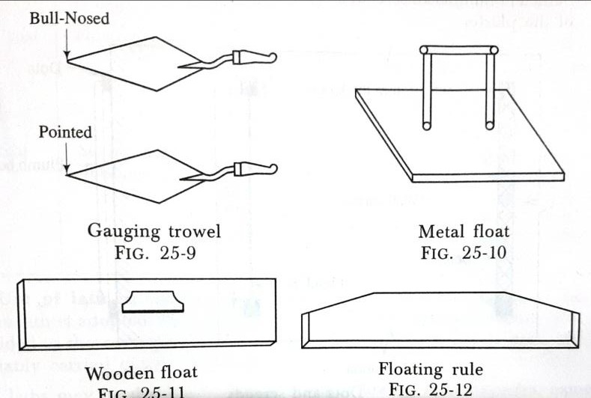
- Gauging trowel (fig. 25-9): This is the ordinary trowel and is useful for applying mortar to mouldings, corners, etc. It has a pointed or bull-nosed end.
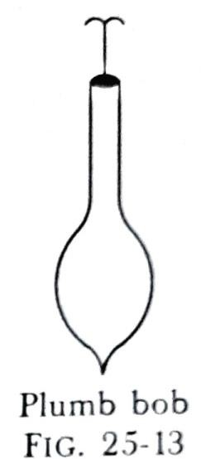
- Float (fig. 25-10 and fig. 25-11): This tool is used to spread the mortar on the surface. It is made of thin tempered steel. It is also known as the laying trowel.
- Floating rule (fig. 25-12): This tool is used to check the level of the plastered surface between the successive screeds.
- Plumb bob (fig. 25-13): This tool is very much useful in forming screeds in the same vertical plane.
- Miscellaneous tools: In addition to the above tools, other tools such as brushes, spirit level, set squares, straight edges, etc. are used for the plastering work.
Methods of plastering:
  - The plaster may be applied either in one, two or three coats.
  - It is in the cheapest form of construction that plaster is applied in one coat.
  - For works of ordinary nature, the plaster is applied in two coats and

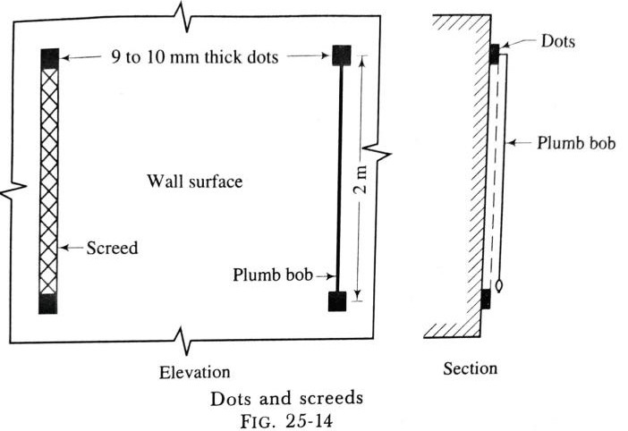
  - For works of superior quality, the plaster is applied in
three coats.
Plaster in two coats:
Following is the procedure for carrying out the plaster in cement mortar in two coats:
- The mortar joints are racked out to a depth of 20 mm and the surface is cleaned and well-watered.
- If it is found that the surface to be plastered is very rough and uneven, a preliminary coat is applied to fill up the hollows before the first coat of plaster is put up on the surface.
- The first coat of plaster is now applied on the surface. The usual thickness of first coat for brick masonry is 9 mm to 10 mm.
- The cement mortar is placed between the successive screeds and the surface is properly finished.

- The second coat of plaster is applied after about 6 hours and the thickness of second coat is usually about 3 mm to 2 mm. It is finished as per requirement. For smooth surface, the neeru or sagol is applied and for hard surface, the paste of cement is applied.
- The completed work is allowed to rest for 24 hours and then, the surface is kept well-watered for at least one week.
PLASTER IN THREE COATS WITH CEMENT MORTAR

 | Name of coat | Thickness | Remarks
First coat Second coat Third coat | Rendering coat  Floating coat  Setting coat or finishing coat | 9 to 10 mm  6 to 9 mm  3 mm | This is left for a period of 3 to 4 days to harden. Its surface is kept rough.  The purpose of this coat of plaster is to bring the work to an even surface.  This coat is similar to second coat of two coat plaster.

Types of plaster finishes:
  - Sand-faced finish:
    - The first coat of sand-faced cement plaster is carried out in cement mortar of proportion 1:4. The thickness of first coat is nowhere less than 12 mm. The first coat is to be well-watered for at least 7 days. The first coat is provided with zigzag lines such that the first coat adheres well with the second coat.
    - The second coat of sand-faced cement plaster is carried out in proportion 1:1 and the thickness of second coat is 8 mm. The second coat is to be applied on the first coat at least after 7 days of completion of first coat.
    - After completion of the second coat, the surface is kept well watered at least for 15 days.
  - Pebble-dash or dry-dash finish: In this type of finish, the finishing coat is made 12 mm thick and clean pebbles of size varying from 10 mm to 20 mm are dashed against the surface so that they are held in position by the mortar already applied. The pebbles may be lightly pressed into the mortar with the help of wooden float.

  - Rough-cast finish or spatter dash finish: The mortar contains coarse-grained sand and the usual proportion is 1:3 i.e. one part of cement to three parts of sand by volume. The mortar is dashed against the surface by means of large trowel and the surface is roughly finished by the light movements of a wooden float.
  - Smooth-cast finish: This finish is just similar to the rough-cast finish except that the fine-grained sand is used instead of coarse-grained sand.
  - Depeter finish: This is just another form of rough-cast finish. The rendering coat of 12 mm thickness is prepared as in case of pebble-dash finish and while this coat is wet, the pieces of gravel or flint are pressed with hand on the surface. It is thus possible to have beautiful patterns and ornamental designs on the surface by selecting materials of different colours.
  - Scrapped finish: In this type of finish, the final coat of 6 mm to 12 mm thickness is applied and it is allowed to become stiff for few hours. The surface is then scrapped in patterns for a depth of 3 mm by suitable tool such as steel straight edge or old saw blade. The scrapped finish is less liable to the cracks.

  - Textured finish: In this type of finish, the ornamental patterns or textured surfaces are made on the final coat of plaster with the help of suitable tools.

POINTING
The term pointing is used to denote the finishing of mortar joints of either stone masonry or brick masonry. The joints are raked out to a depth of about 20 mm and then, these spaces are filled up by suitable mortar in the desired shape.
OBJECTS OF POINTING AND PLASTERING
Following are the main objects for providing pointing and plastering to the exposed surfaces:
- To improve the appearance of the structure as a whole and to give smooth surface.
- To protect the exposed surfaces from the effects of atmospheric actions.
- To rectify the defective workmanship or to conceal inferior materials.

Mortar for pointing:
- The pointing is generally adopted for the finishing of exposed external walls of a structure. It is cheap in the first coat, but it requires frequent replacement.
- The pointing may be carried out either in lime mortar or in cement mortar.
Method of pointing: The pointing is carried out as follows:
- The mortar of the masonry joints to be covered by pointing is raked out at least to a depth of 20 mm.
- The dust from the masonry joints is removed by the brushes.
- The surface is then washed with clean water and it is kept wet for a few hours.
- The mortar is then carefully placed in desired shape in these prepared joints. The mortar is placed by a small trowel and it is slightly pressed to bring it into close contact with the old interior mortar of the joint.
- The finished surface is well-watered for a period of at least 3 days, if lime mortar is used and 10 days, if cement mortar is used.
Types of pointing:

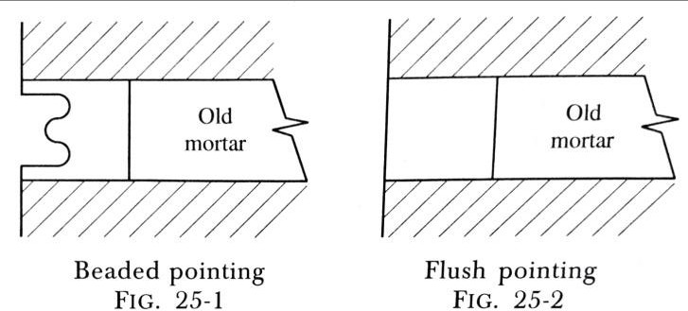
The pointing can be carried out in a number of shapes. The choice of a particular type will depend on the nature of masonry and the effect required. Following are the usual types of pointing:
- Beaded pointing: This type of pointing is shown in fig. 25-1 and it is formed by a steel or iron rod with a concave edge. The beaded pointing is good in appearance. But it is difficult to maintain as it can be easily damaged.
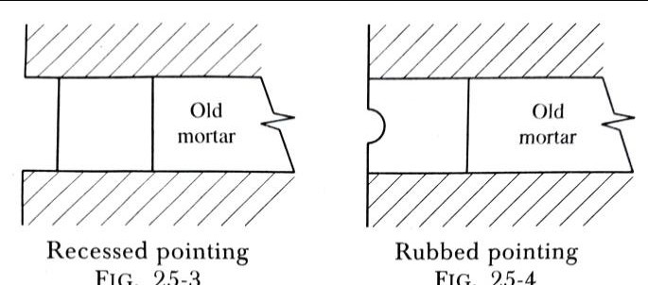
- Flush pointing: This type of pointing is shown in fig. 25-2 and it is formed by removing the excess mortar from the joint. The joint is made flush with the face. This type of joint does not give good appearance. But it is durable as it does not provide any space for accumulation of dust, water, etc, and
hence, it is extensively used.
- Recessed pointing: This type of pointing is shown in fig. 25-3.
The face of the pointing is kept vertical and it is pressed inside
the wall surface by a suitable tool to a depth of about 5 mm or more. This pointing gives very good appearance.

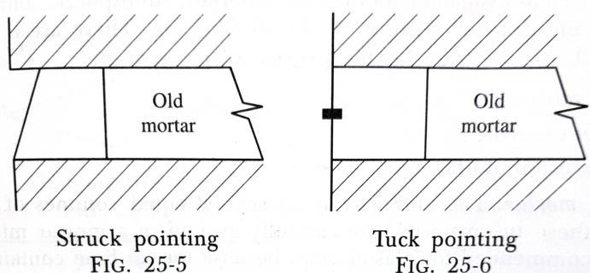
- Rubbed or keyed or grooved pointing: In this type of pointing, a groove is formed at the centre of height by a pointer as shown in fig. 25-4. This type of pointing gives better appearance and is generally adopted.
- Struck pointing: In this type of pointing, the face of pointing
is kept inclined as shown in fig. 25-5. The upper edge of joint is about 10 mm inside the face of masonry. This joint disposes water easily. If the lower edge of joint is kept inside the face of masonry, it is known as the overhand struck pointing. But it will not form a satisfactory joint as water will be collected in the joint.
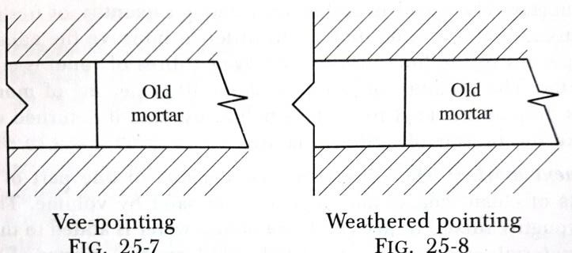
- Tuck pointing: In this type of pointing, a groove is formed at the centre of joint. The width and depth of groove are respectively 5 mm and 3 mm. The groove is then filled in or tucked in by white cement putty with a projection of 3 mm as shown in fig. 25-6. If projection is done in the mortar, it is called the Bastard pointing or half-tuck pointing.
- Vee-pointing: In this type of pointing, a Vee-shaped groove is formed in the mortar joint as shown in fig. 25-7.

- Weathered pointing: In this type of pointing, a projection in the form of a Vee- shape is formed as shown in fig. 25-8.
PAINTING
  - The paints are coatings of fluid materials and they are applied over the surfaces of timber and metals.

Objects of painting:
- It protects the surface from weathering effects of the atmosphere and actions by other liquids, fumes and gases.
- It prevents decay of wood and corrosion in metal.
- It is used to give good appearance to the surface. The decorative effects may be created by painting and the surface becomes hygienically good, clean, colourful and attractive.
- It provides a smooth surface for easy cleaning.

Methods of painting:
- Brushes:
  - It is necessary to have good brushes for painting.
  - The brushes should be composed of bristles and not of horse hairs. The bristle brushes are elastic and possess good paint-holding capacity. The bristles are split at ends and in this respect, they can be distinguished from horse hairs.
  - It is preferable to use a round brush in painting. The new brushes should be soaked in water upto level of bristles for a period of about two hours and then they should be allowed to dry for a period of about one hour.
  - During painting, the brush should be immersed in paint upto about one-third length of the bristle and the excess paint in the brush is removed by gently pressing the bristles against the inside surface of the pot.
  - After the work is over, the brushes should be cleaned at once with kerosene oil.
- Spray painting:
  - Instead of the ordinary brushes, a spraying pistol may be used for painting work. The pistol works under compressed air and the paint thrown through the pistol

on the surface forms a thin uniform film or layer of paint on the surface. The spray painting is superior to painting by brushes.
  - Following are the advantages of spray painting: (i)The speed of work increases considerably.
- An experienced painter can create artistic patterns or designs on the surface by spraying paints of different shades.
- It is found to be economical in material and labour. The two coats of spray would suffice whereas ordinary brush painting would require three or four coats.
- The mechanical equipment is such that the paint remains always in a state of motion. This ensures uniform mixing of ingredients of the paint.
PAINTING ON DIFFERENT SURFACES
- New woodwork: Normally four coats of paint are required for new woodwork. The process of painting is carried out as follows:

  - The surface of woodwork is prepared to receive the paint. For satisfactory working, it is necessary that the woodwork is sufficiently seasoned and it does not contain more than 15 per cent moisture at the time of painting. The surface of woodwork is thoroughly cleaned and the heads of nails are punched to a depth of 3 mm below the surface.
  - The surface of the woodwork is then knotted.
  - The priming coat is then applied on the surface of new woodwork. Generally, the priming coat is applied before the woodwork is placed in position.
  - The process of stopping is then carried out.
  - The subsequent coats of paint, namely, under coats and finishing coats, are then applied on the surface. The extreme care should be taken to see that the finishing coat presents smooth and even surface and that no brush marks are seen on the finished work.
- Repainting old woodwork: If the paint on the old woodwork has cracked or as developed blisters, it is to be removed. If the surface has become greasy, it should e

cleaned by rubbing down sand-paper or fine pumice stone. The old paint can also e removed by applying any one of the following three paint solvents:
  - A solution containing 2 N of caustic soda to a litre of water is prepared and used to wash the surface. The paint dissolves and the surface becomes clean.
  - A mixture consisting of one part of soft soap and two parts of potash is prepared and one part of quicklime is then added afterwards. This mixture is applied on the surface in a hot state and allowed to stay for about 24 hours. The surface is then washed with hot water.
  - A mixture consisting of equal parts of washing soda and quicklime is brought to a paste form by adding required quantity of water. It is applied on the surface and kept for about an hour. The surface is then washed with water.
After removing old paint from the surface, the woodwork is painted as in case of painting on new woodwork.
- New ironwork and steelwork:

- The surface of iron or steel to receive the paint should be free from rust, grease, dirt, etc. The suitable equipment such as wire brushes, scrapers, etc. are used to remove all loose scales, marks, etc. from the surface.
- The water with caustic soda or lime is used to remove grease. The cleaned surface is provided with a film of phosphoric acid. This film protects the surface from rust and it also facilitates the adhesion of paint.
- The coats of paint are then applied. The paint suitable to iron and steel surfaces should be selected for each coat.
- The finishing coat should present a smooth finish and precaution should be taken to avoid the presence of brush marks on the final painted surface.
- Repainting old ironwork and steelwork:
- The old surface should be thoroughly cleaned by the application of soap-water and if grease is present, it should be removed by washing the surface with lime and water.
- If it is necessary to remove old paint, the surface should be burnt, usually by a blow lamp and then old paint should be scraped off or dissolved and removed by using any paint solvent.

- After the surface is thus prepared, the painting is carried out as in case of new ironwork or steelwork.
WHITEWASHING
- The fresh lime is slaked at site of work and mixed thoroughly with sufficient quantity of water in a tub. It is then screened through a clean cloth.
- The clean gum dissolved in hot water is then added at the rate of 20 N per m³ of lime. The rice may be used in place of gum.
- The surface to be whitewashed should be cleaned before the work is started. For whitewashing walls which are whitewashed before, the old loose whitewash is to be first removed and repairing to the plaster is carried out, if necessary.
- The whitewash is applied with jute brush and the brush is so worked that a surface with uniform colour is obtained. The three coats are generally applied, each after the previous coat has completely dried.
- The lime is toxic for germs. It reflects light and thus it increases the brightness of the surface. The whitewashing therefore is extensively used for interior wall surfaces and ceilings of houses.

- The process of whitewashing is sometimes used for exterior wall surfaces also. A satisfactory work gives an opaque smooth surface with uniform white colour and does not readily come off on the hand, when rubbed.
COLOURWASHING
- This is prepared by adding the colouring pigment to the screened whitewash. It should be seen that the colouring pigment is not affected by the presence of lime.
- Ordinarily, the yellow earth is popular for colourwashing. Generally, the walls are colourwashed and ceilings are whitewashed. The mixture is to be kept constantly stirred during use.
- The colourwash is applied in the same fashion as the whitewash. A satisfactory work does not give out powder when the finished surface is rubbed with the fingers.
- The process of colourwashing imparts cleanliness and pleasant appearance of the surfaces which are treated.

DISTEMPERING
The main object of applying distemper to the plastered surfaces is to create a smooth surface. The distempers are available in the market under different trade names. They are cheaper than paints and varnishes and they present a neat appearance. They are available in a variety of colours.
PROCESS OF DISTEMPERING
The application of distemper is carried out in the following way:
- Preparation of surface: The surface to receive the distemper is thoroughly rubbed and cleaned. The important facts to be kept in mind are:
  - The new plastered surfaces should be kept exposed for a period of two months or so to dry out before distemper is applied on them. The presence of dampness on the surface results in failure of distemper coating.
  - The surface to receive distemper should be free from any efflorescence patches. These are to be wiped out by clean cloth.

  - The irregularities such as cracks, holes, etc. of the surface are to be filled by lime putty or gypsum and allowed to become hard before distemper is applied on the surface.
  - If distemper is to be applied on the existing distempered surfaces, the old distemper should be removed by profuse watering.
- Priming coat: After preparing the surface to receive the coats of distemper, a priming coat is applied and it is allowed to become dry. For readymade distempers, the priming coat should be composed of materials as recommended by the makers of distempers. For local made distempers, the milk is used for priming coat. One litre of milk will cover about 10 m² of the surface.
- Coats of distemper: The first coat of distemper is then applied on the surface. It should be of a light tint and applied with great care. The second coat of distemper is applied after the first coat has dried and become hard. Following facts are to be remembered:
  - The distempering should be done in dry weather to achieve better results.

  - The oil-bound distemper or washable distemper adheres well to oil-painted walls, wood, corrugated iron, etc. But a priming coat of pure milk should be applied before distempering is done on such surfaces.
  - The application of distemper by a spraying pistol is superior to that by brushes. The spraying affords smooth and durable film of distemper.

***end***

