

LECTURE NOTES
ON
AUTOMOBILE ENGINEERING AND HYBRID VEHICLES

Compiled by

ER. GAGAN KUMAR SINGH

DEPARTMENT OF MECHANICAL ENGINEERING

RKCAT POLYTECHNIC,NILGIRI,BALASORE

CONTENTS

S.No | Chapter Name | Page No
1 | INTRODUCTION & TRANSMISSION SYSTEM | 1-17
2 | BRAKING SYSTEM | 18-25
3 | IGNITION & SUSPENSION SYSTEM | 26-31
4 | COOLING AND LUBRICATION | 32-38
5 | FUEL SYSTEM | 39-46
6 | HYBRID AND ELECTRIC VEHICLES | 47-53

CH-1 INTRODUCTION AND TRANSMISSION SYSTEM

Automobile
Automobile is a self-propelled wheeled vehicle which is driven by internal combustion engine.
It is used for transporting goods and passengers upon the ground.

Needs of automobile
Automobiles are required for transporting goods and passengers from one place to another. There are also some special purpose automobiles which are used in different fields of work such as - bulldozer, concrete mixture, army vehicles, fire vehicles, ambulance, dumper, mobile crane etc.
Types of automobiles
Automobiles are classified on the following basis.

Purpose:
  - Passenger vehicles :: Car, jeep, station wagon, bus etc.
  - Goods vehicles :: Truck, pick-up etc.
  - Special purpose vehicles :: Ambulance, fire engine, concrete mixtures etc.

Load Capacity:
  - Light duty vehicles :: Car, jeep, scooter, motor cycle etc.
  - Heavy duty vehicles :: Bus, truck, tractor, coach, off road vehicles etc.

Number of Wheels:
  - Two wheeler :: Motor cycles, scooters, mopeds etc.
  - Three wheeler :: Auto rickshaws
  - Four wheelers :: Car, jeep, bus, truck etc.
  - Six wheelers :: Bus, trucks etc

Fuel Used:
  - Petrol vehicles :: Car, jeep, motor cycle, scooter etc
  - Diesel vehicle :: Car, truck, tractor, bus, bulldozer etc.
  - Electric vehicles :: Battery operated vehicles, solar powered vehicles

Suspension System Used:
  - Conventional type :: Leaf spring
  - Independent :: Coil spring, torsion bar, pneumatic

Drive of The Vehicle:
  - Right hand drive vehicle
  - Left hand drive vehicle
  - Front wheel drive vehicle
  - Rear wheel drive vehicle
  - Single wheel drive vehicle
  - Two wheel drive vehicle
  - Four wheel drive vehicle
  - Six wheel drive vehicle

Components of automobile and their functions
Functions of major components of automobile are:

1. | Engine | :: | It is a power generator which provides power to drive the vehicle.
2. | Chassis | :: | It consists of a frame which holds the engine and body. It carries all major components like transmission, steering and suspension, braking unit, wheels and suspension system.
3. | Power train | :: | It consists of the clutch, gearbox, drive shaft, differential and rear axle. It carries the engine power to the rear wheels.
4. | Clutch | :: | It is used to engage or disengage the power train and engine.
5. | Transmission | :: | It is the gear box which can produce variation in torque by changing the gear ratio between engine shaft and drive shaft.
6. | Propeller shaft | :: | It connects the gear box to differential unit for power transmission.
7. | Differential | :: | It can split the power of propeller shaft to the rear axle. It can produce variation in speed of rear wheels when the vehicle takes a turn.
8. | Axles | :: | Axles are the shafts on which wheels are mounted. These transmit power to the wheels.
9. | Wheels | :: | Wheels take load of the vehicle and produce tractive force to move the vehicle.
10. | Steering system | :: | It is used for changing the direction of vehicle i.e left or right.
11. | Braking system | :: | It is used for slowing down or stopping a moving vehicle.
12. | Suspension system | :: | It is used to absorb vibrations due to the up and down motion of wheels on the road.
13. | Electrical system | :: | It provides energy to operate the starting motor and to give power to all the accessories.
14. | Ignition system | :: | It is used for the combustion of fuel by high voltage spark.
15. | Fuel system | :: | It is used to supply fuel to the carburetor or injection system.
16. | Cooling system | :: | It is used to cool the engine and maintain engine optimum temperature.
17. | Lubrication system | :: | It is used to lubricate different moving components of engine to minimize friction loss and also used as a coolant.

Chassis layout of an automobile with major components
Automobile chassis is consists of a frame supporting the vehicle and all the major units responsible for propelling and controlling the vehicle.
Layout of automobile chassis:

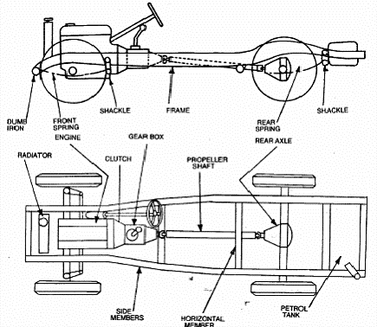

LAYOUT OF AUTOMOBILE CHASSIS
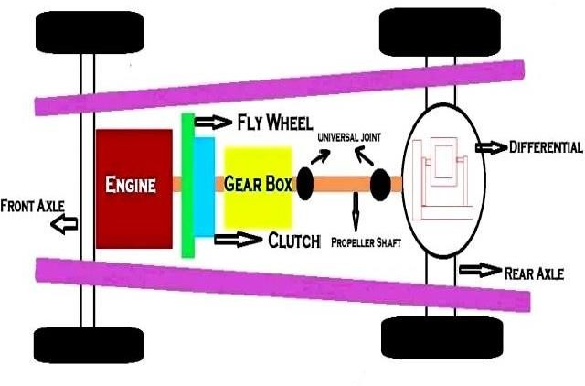

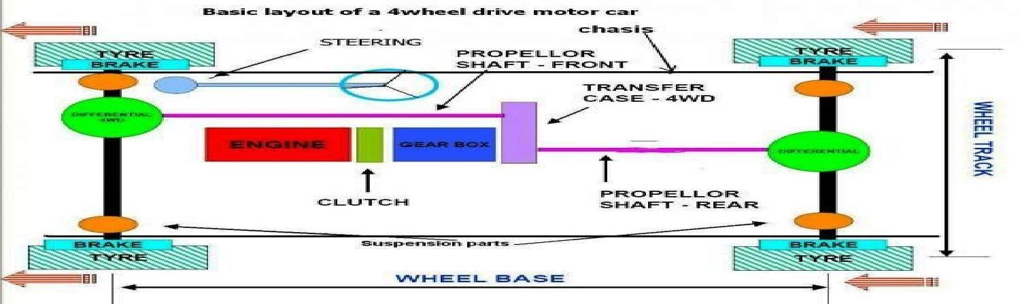
Layout of bus chassis with major components and the functions of main parts
Layout of bus chassis:

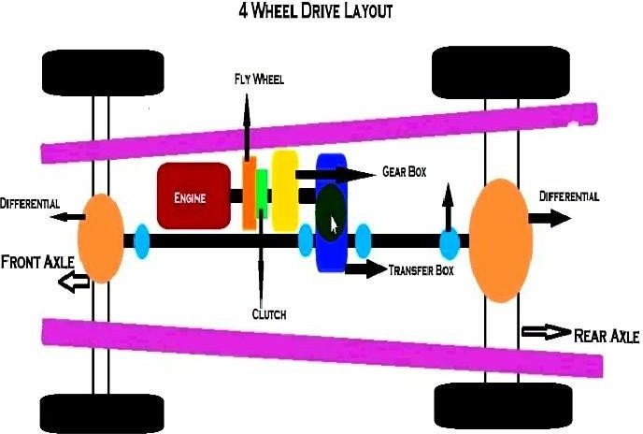

OR (Layout of chassis)

Manufacturer’s specification of automobiles (scooter, motor cycle, bus & car)
Manufacturer’s specification of automobiles:
- Type: Car, Truck, Scooter, Motor cycle, Bus etc.
- Capacity: 5 ton, 3 ton, 1 ton, ½ ton, 4 seater, 6 seater, 30 seater, 45 seater etc.
- Make: Tata Leyland, Standard etc.
- Drive: Left hand drive, Right hand drive, single wheel drive, two wheel drive, four wheel drive, six wheel drive.
- Model: Year of manufacture and code number

Classification of automobile engines
Automobile I.C engines are classified on the following basis:

On the basis of fuel used:
  - Petrol engine
  - Diesel engine
  - Gas engine

On the basis of number of strokes:
  - Four stroke engines
  - Two stroke engines

On the basis of thermodynamic cycle:
  - Otto cycle engines
  - Diesel cycle engines
  - Dual cycle engines

Method of igniting the fuel:
  - Spark ignition engine
  - Compression ignition engine

Method of cooling:
  - Water cooled engines
  - Air cooled engines

Engine cylinders arrangement:
  - Inline cylinder engines
  - Opposite cylinder engines
  - V-type engines
  - Radial engines

TRANSMISSION SYSTEM

Functions of transmission system of automobile and its components
The mechanism which transmits engine power to the wheels to drive the automobile is called as a transmission system.

Functions of transmission system:
- To disconnect the engine from driving wheels during starting and connect the engine withdriving wheels during running.
- To reduce the speed of the engine.
- To turn the drive through 90⁰.
- To provide relative movement between the engine and driving wheel

Components of transmission system:
- Clutch, ii) Gear box, iii) Propeller shaft, iv) Universal joint, v) Rear axle and differential, vi) driving wheels and tyres

Clutch and its classification
It is a device used in a transmission system of an automobile to engage and disengage the engine shaft to the transmission system. It is located between the engine and the gear box.
  - When the clutch is engaged, the power transmits from the engine to the driven shaft andthe vehicle moves.
  - When the clutch is disengaged, the power does not transmit to the driven wheels andvehicle stops or slows down.

Classification of Clutch:
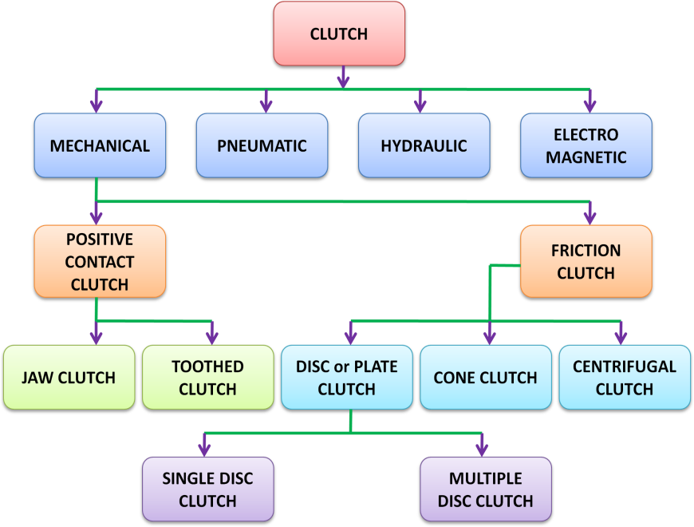
Working principle of clutch
Principle of operation of clutch:
The clutch principle is based on friction. When two friction surfaces are brought in contact with each other and pressed they are united due to friction between them. If one is revolved the other will also revolve.

Functions of clutch
Functions of clutch:
- To permit engagement or disengagement of the gear shaft to the engine shaft.
- To transmit the engine power to the road wheels smoothly without shock to thetransmission system.
- To allow gear change without damage.

Construction and working of single plate clutch
Construction of Single plate clutch:
A single plate clutch consists of the following parts.
  - A flywheel is rigidly fixed on the crankshaft of the engine.
  - One clutch plate is mounted on the splined hub of the clutch shaft.
  - Clutch plate is located between the flywheel and pressure plate.
  - Clutch plate has friction linings on both sides to provide friction surfaces for powertransmission.
  - Coil springs are provided circumferentially on the pressure plate to provide axial force.
  - A pressure plate is free to slide on the clutch shaft with the movement of clutch pedal.A Single plate clutch is shown in figure.

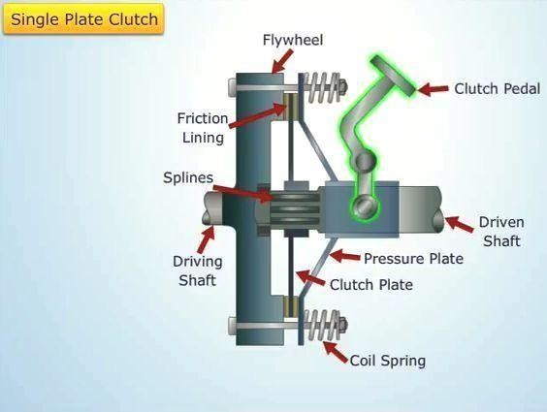

Working of Single plate clutch:
  - When clutch is in engaged position, the clutch plate remains gripped between flywheel and pressure plate by friction linings. Due to friction on both sides, the clutch plate revolves with engine flywheel. Therefore, clutch transmits engine power to clutch shaft. Clutch shaft is connected to transmission (or gear box) of automobile. Thus, clutch transmits power from engine to transmission system.
  - When the clutch pedal is pressed, clutch plate is disengaged. Because of this pressure plate moves back and clutch plate is disengaged from flywheel. Thus, clutch shaft stopsrotating even if engine flywheel is rotating. In this position, power does not reach the wheels and vehicle also stops running.

Construction and working of multiple plate clutch
Construction of Multiple plate clutch:
Multi-plate clutch consists of the following parts.
  - More than one clutch plates which are alternatively fitted with engine shaft and theshaft of gear box.
  - More number of friction plates is fitted with the flywheel to provide large torque.
  - Clutch plates are firmly held by the force of coil springs and they assembled in a drum.
  - One plate slides in the grooves on the flywheel and the next plate slides on spinesprovided on pressure plate.

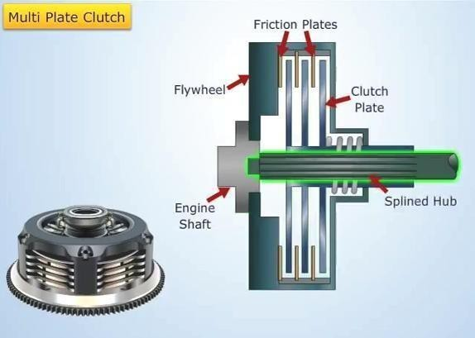

Working of Multiple plate clutch:
  - When the clutch pedal is pressed, the pressure plate moves back against the force of coil spring, hence the clutch plates are disengaged and engine flywheel and gear box are decoupled.
  - When clutch pedal is not pressed the clutch remain in engaged position and the power can be transmitted from engine flywheel to the gear box.

Need of gear box and its classification
Need of gear box (function):
- It helps the engine to disconnect from the driving wheels with the help of clutch during thestarting or running of the automobile.
- It can provide large torque during starting and low torque during running of vehicle.
- It can provide neutral position
- It can move a vehicle in reverse direction.
- It can provide smooth running of vehicle at different speeds.

Classification of gear box:

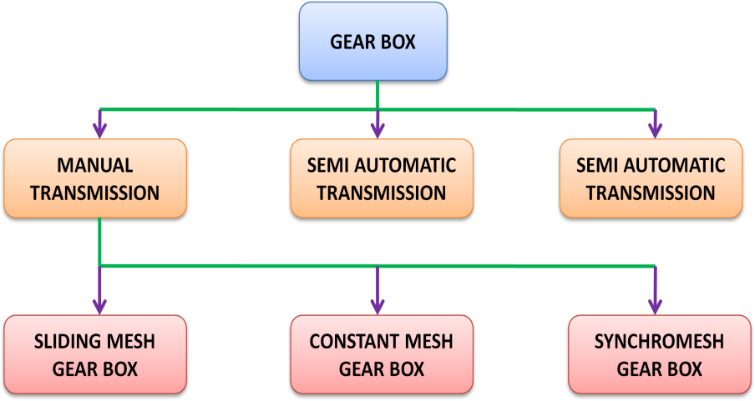

Construction and working of sliding mesh gear box Construction of Sliding mesh gear box:
A typical sliding mesh gear box is shown in figure. It consists of main shaft, clutch shaft and a counter shaft. Clutch shaft has one gear which is rigidly fixed to the clutch shaft. Main shaft has two gears which can slide horizontally. Counter shaft has four gears which can’t slide.
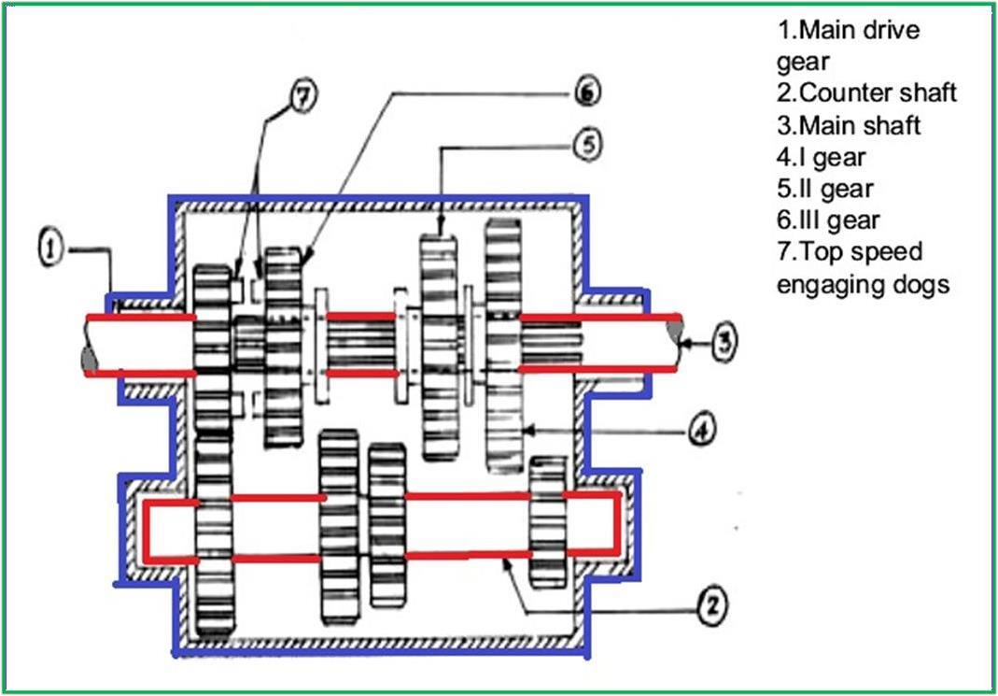
Working of Sliding mesh gear box:

Neutral position:
In this position, the engine is in running condition, clutch remains engaged and clutch gear drives the counter shaft drive gear. The direction of rotation of countershaft is opposite to that of clutch shaft. In this position 1st, 2nd, 3rd and reverse gears are free. Thus, main (transmission) shaft does not rotate and automobile wheels do not rotate. So vehicle remains stationary.

First gear:
In this position the first gear (large gear) on the main shaft slides and is connected to first gear on the countershaft. The direction of rotation of main shaft is same as that of clutch shaft. Small gear of countershaft meshes with larger gear on main shaft and produces speed reduction in the ratio 3:1.

Second gear:
In this position the second gear on countershaft meshes with second gear (small gear on main shaft) on the main shaft. The direction of main shaft is same as that of clutch shaft. Speed reduction of the order of 2:1 is obtained in second gear.

Third gear:
In this position the main shaft slides axially towards the clutch shaft so that main shaft is directly connected to the clutch shaft. The main shaft rotates at the same speed of clutch shaft. Thus, a speed ratio of 1:1 is obtained.

Reverse gear:
When the shift lever is operated to engage the reverse gear, the larger (reverse) gear of the main shaft meshes with the reverse idler gear. Reverse idler gear is always connected to reverse gear on countershaft and changes the direction of rotation of main shaft. Thus, the direction of main shaft becomes opposite to that of clutch shaft. Therefore, wheels of the automobile start moving in backward direction.

Comparison between sliding mesh and synchromesh gear box
Sliding mesh : This is where the gears are not in constant mesh with each other and the gears on the main shaft slide over to mesh with the gears on the lay shaft/counter shaft.
Synchromesh : Synchromesh which uses Baulk rings to lock onto the gear first before the sliding sleeve comes over to lock on.

Gear changing mechanism
Automatic transmission system is the most advanced system in which drives mechanical efforts are reduced and different speeds are obtained automatically. It contains epicyclic gear arrangement, fluid coupling and torque converter. In this planetary gear sets are placed in series to provide transmission. Epicyclic gear system consisting of one or more outer gears, or planet gears, revolving about a central gear .By using epicyclic gear, different torque speed ratio can be obtained. It also compact the size of gear box.

Stages of automatic transmission :

  - Park(P) : selecting the park mode will lock the transmission, thus restricting thevehicle from moving.
  - Reverse( R) : selecting the reverse mode puts the car into reverse gear, allowing thevehicle to move backward.
  - Neutral (N) : selecting neutral mode disconnects the transmission from the wheel.
  - Low (L) : selecting the low mode will allow you to lower the speed to move onhilly and middy areas.
  - Drive (D) : selecting drive mode allows the vehicle to move and acceleratethrough a range of gears.

Universal joint

Universal Joint:
Universal joint is used to connect two non parallel shafts inclined at some angle for transmitting torque between them.
In the transmission shaft of an automobile, two universal joints are used – one between main transmission shaft and propeller shaft and another between other end of propeller shaft and the differential.
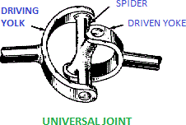

Slip joint.
A slip joint is provided between universal joint and propeller shaft to adjust for any change in length. When its spring is compressed propeller shaft shortens and when its spring is expanded, propeller shaft returns to original length.

Function of propeller shaft in the transmission system
The propeller shaft is used to transmit power from transmission (gear box) to the differential. Propeller shaft transmits the rotary motion of main transmission shaft (coming from gear box) to the differential so that rear wheels can be rotated.
Propeller shaft is connected to main transmission shaft by universal joint and it is connected to differential pinion shaft by another universal joint.

Construction of propeller shaft
Propeller shaft is made of a steel tube which can withstand torsional stresses and vibrations at high speeds. Its constructional details are shown in figure.
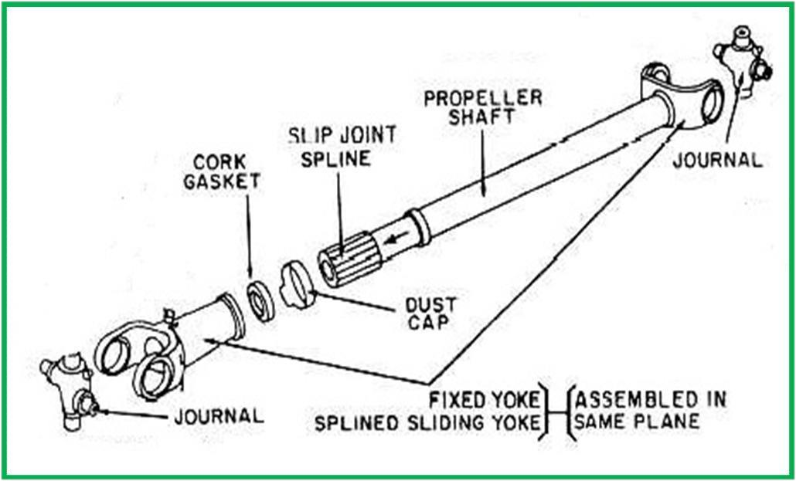

Function of final drive
The final drive is composed of a bevel gear (or pinion) and crown wheel. The bevel pinion is connected to propeller shaft. The pinion is in mesh with the crown wheel of differential.
Final drive is the last stage of power transmission from propeller shaft to rear axles and then to wheels. It turns the propeller shaft motion at right angle to drive the rear axle.

Differential
Necessity of differential:
The differential is used to permit the relative movement between inner and outer wheels when vehicle takes a turn. The torque transmitted to each rear wheel is equal in this case, although their speed is different.

Construction of differential:
The construction of a simple differential is shown in Figure.
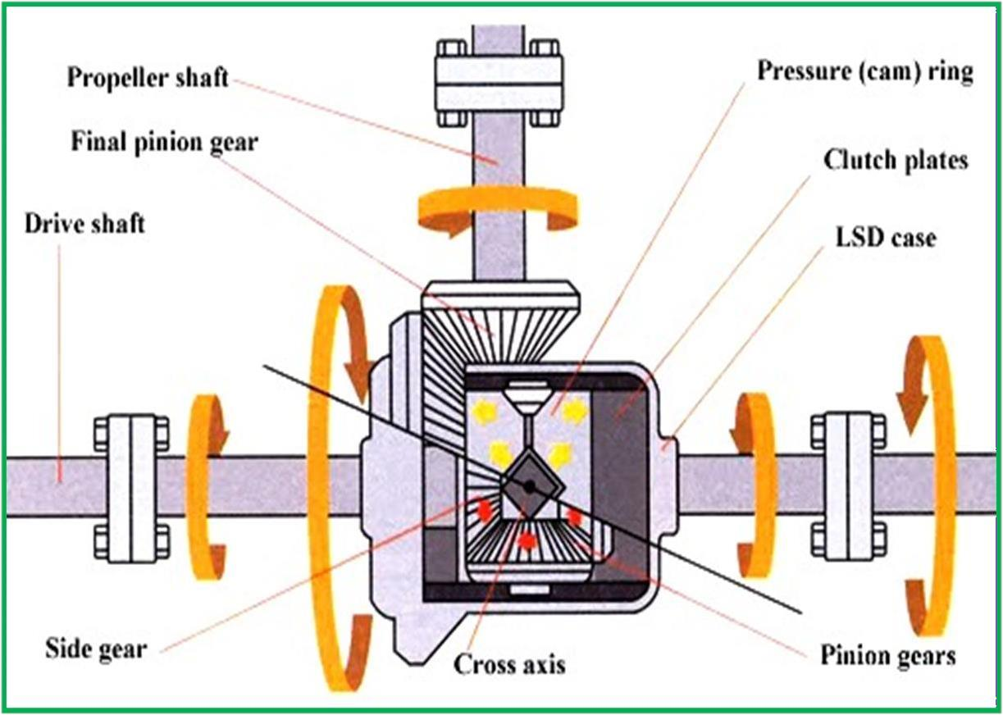

- It consists of sun gears, planet pinion, a cage, a crown wheel and a bevel pinion.
- A sun gear is attached to inner end of each rear axle (half shaft).
- A cage is attached on left axle.
- A crown gear is attached to the cage and the cage rotates with the crown gear.
- The crown gear is rotated by the bevel pinion.
- Crown gear and cage remain free on the left rear axle.
- Two planet pinions are on a shaft which is supported by the cage.

- The planet pinions mesh with the sun gears.
- The rear wheels are attached to outer ends of two rear axles.

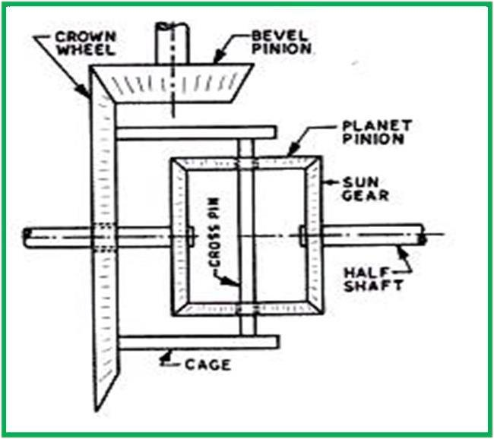

Working of differential:

When the cage rotates, sun gears rotate. Thus, the wheels also rotate. In case one inner wheel runs slower than other when the vehicle takes a turn, the planet gears spin on their shaft, transmit more rotary motion to outer wheel. When vehicle runs in straight line, the crown gear, cage, planet pinions and sun gears turn together as a unit. Thus there is no relative motion.

CH-2 BRAKING SYSTEM

Introduction
Brake is a mechanical device which inhibits motion. Brakes are applied on the wheels to stop or to slow down the vehicle.

Need of braking system:

- To slow down or stop the vehicle in the shortest possible time at the time of need.
- To control the speed of vehicle at turns and also at the time of driving on a slope.

Principle of braking
Brakes work on the following principle to stop the vehicle:
“The kinetic energy due to motion of the vehicle is dissipated in the form of heat energy due to friction between moving parts (wheel or wheel drum) and stationary parts of vehicle (brake shoes)”.

Classification of brakes
Brakes are classified on the following basis:

Classification of Brakes:
- On the basis of Mode of operation:
  - Mechanical brakes (drum and disk brakes)
  - Hydraulic brakes
  - Air brakes
  - Air hydraulic brakes
  - Vacuum brakes
  - Electric brakes

On the basis of method of actuation:
  - Foot brake
  - Hand brake

On the basis of action on front or rear wheels:
  - Front wheel brakes
  - Rear wheel brakes

On the basis of method of application of braking contact:
  - Internally expanding brakes
  - Externally contracting brakes

Various types of braking system
The various types of braking systems are as follows:

Air Brakes:
Air brakes are applied by the pressure of compressed air. Air pressure applies force on brakes shoes through suitable linkages to operate brakes. An air compressor is used to compress air. This compressoris run by engine power.

Vacuum Brakes:
Vacuum brakes are a piston or a diaphragm operating in a cylinder. For application of brakes one side of piston is subjected to atmospheric pressure while the other is applied vacuum by exhausting air from this side. A force acts on the piston due to difference of pressure. This force is used to operate brake through suitable linkages.

Electric Brakes:
In electrical brakes an electromagnet is used to actuate a cam to expand the brake shoes. The electromagnet is energized by the current flowing from the battery. When flow of current is stopped the cam and brake shoes return to their original position and brakes are disengaged. Electric brakes are not used in automobiles as service brakes.

Hydraulic brakes:
The brakes which are actuated by the hydraulic pressure (pressure of a fluid) are called hydraulic brakes. Hydraulic brakes are commonly used in the automobiles. Hydraulic brakes work on the principle of Pascal’s law.

Mechanical brake

DRUM OR SHOE BRAKE:
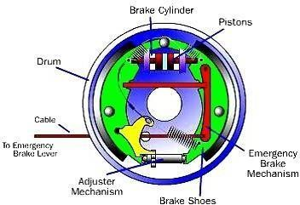
The drum brake has a metal brake drum that encloses the brake assembly at each wheel. Two curved brake shoes expand outward to slow or stop the drum which rotates with the wheel.

DISC BRAKES:
In a disc brake, the fluid from the master cylinder is forced into a caliper where it presses against a piston. The piston in turn squeezes two brake pads against the disc (rotor), which is attached to wheel, forcing it to slow down or stop.

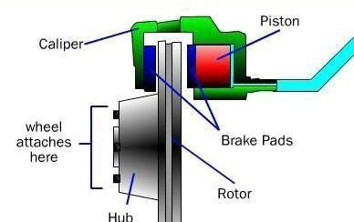

Advantages and disadvantages of disc brakes

Advantage of Disc Brakes:
- Resistance to wear as the discs remains cool even after repeated brake applications.
- Brake pads are easily replaceable.
- The condition of brake pads can be checked without much opening of brake system.

Disadvantage of Disc Brakes:
- More force is needed be applied as the brakes are not self emerging.
- Pad wear is more.
- Hand brakes are not effective if disc brakes are used in rear wheels also.

Hydraulic brakes
The brakes which are actuated by the hydraulic pressure (pressure of a fluid) are called hydraulic brakes. Hydraulic brakes are commonly used in the automobiles.

Principle:
Hydraulic brakes work on the principle of Pascal’s law which states that, “pressure at a point in a fluid is equal in all directions in space”. According to this law when pressure is applied on a fluid it travels equally in all directions so that uniform braking action is applied on all four wheels.

Construction of Hydraulic Brakes:
Figure shows the system of hydraulic brake of a four wheeler automobile. It consists of a master cylinder, four wheel cylinders and pipes carrying a brake fluid from master cylinder to wheel cylinder.
The master cylinder is connected to all the four-wheel cylinders by tubing or piping. All cylinders and tubes are fitted with a fluid which acts as a link to transmit pedal force from master cylinder to wheel cylinders.

Master cylinder consists of a piston which is connected to peal through connecting rod. The wheel cylinder consists of two pistons between which fluid is filled.

Each wheel brake consists of a cylinder brake drum. This drum is mounted on the inner side of wheel. The drum revolves with the wheel. Two brake shoes which are mounted inside the drum remain stationary. Heat and wear resistant brake linings are fitted on the surface of the brake shoes.
The fluid filled in the hydraulic brake system is known as brake fluid. It is a mixture of glycerin and alcohol or caster oil and some additives.
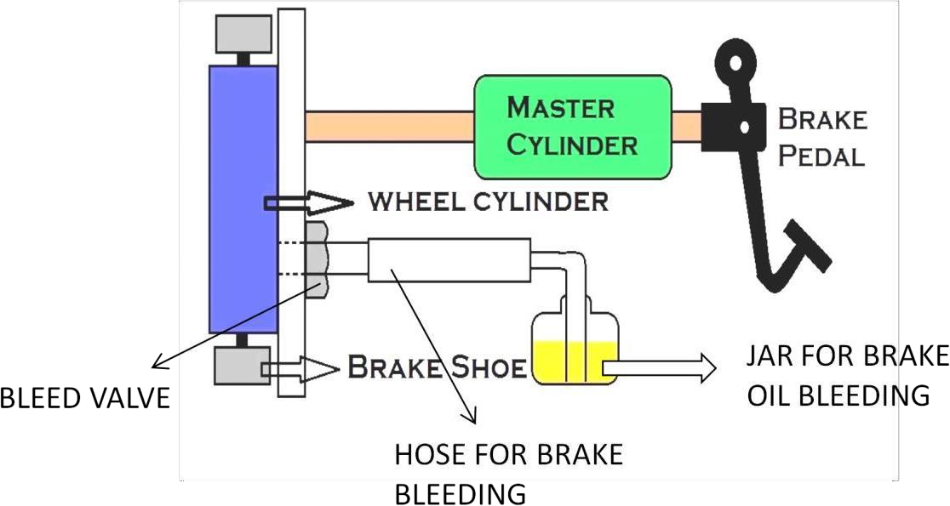

Application of Brakes
When brake pedal is pressed to apply the brakes, the piston in the master cylinder forces the brake fluid. This increases the pressure of fluid. This pressure is transmitted in all the pipes and up to all wheel cylinders according to Pascal’s law. This increased pressure forces out the two pistons in the wheel cylinders. These pistons are connected to brake shoes. So, the brake shoes expand out against brake drums. Due to friction between brake linings and drum, wheels slow down and brakes are applied.

Release of Brakes
When pedal is released, the piston of master cylinder returns to its original position due to retractor spring provided in master cylinder. Thus, fluid pressure drops to original value. The retractor spring provided in the wheel cylinders pulls the brake shoes and contact between drum and brake linings is broken. Therefore, brakes are released.
Advantages and disadvantages of hydraulic brakes

Advantages:
- Equal braking action on all wheels.
- Increased braking force.
- Simple in construction.
- Low wear rate of brake linings.
- Flexibility of brake linings.
- Increased mechanical advantage.

Disadvantages:

- Whole braking system fails due to leakage of fluid from brake linings.
- Presence of air inside the tubing ruins the whole system.

Master cylinder and function of master cylinder
Master cylinder consists of a piston which is connected to pedal through connecting rod. It produces hydraulic force by pressing the brake fluid which exerts force on the brake.

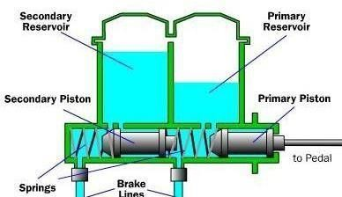

When we press the brake pedal, it pushes on primary piston of master cylinder through a linkage. Pressure is built in the cylinder and the lines as the brake pedal is depressed further. The pressure between the primary and secondary piston forces the secondary piston to compress the fluid in its circuit. If the brakes are operating properly, the pressure will be same in both the circuits. If there is a leak in one of the circuits, that circuit will not be able to maintain pressure.

Parking brake or emergency brake
Parking brakes or emergency brakes are essentially mechanical brakes operated by hand. These are used to prevent the motion of vehicle when parked at a place or when parked on slopes. In cars, these brakes are generally attached to rear wheels. In this type, a cable connects the hand lever to the brake. Brakes are applied by pulling the lever and released by pushing a button (provided on lever) and pressing the lever down.

Bleeding of brakes
When air enters, into the brake system and any brake line is disconnected, bleeding of brakes has to be done. Since air is compressible so any presence of air inside brake lining does not allow to transmit brake force to apply brakes. Therefore, the system must be free from presence of air. Bleeding is the process of removal of air from the braking system.

CH-3 IGNITION SYSTEM

Ignition coil
The construction of ignition coil is shown in figure. This coil contains a rod shaped, laminated soft iron core at its centre, and the soft iron cover surrounds both primary and secondary windings.
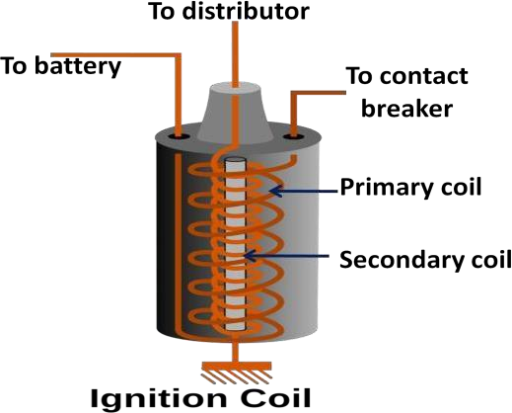

Ignition coil is the source of the high voltage pulses of current in the ignition system. The coil stores the energy in the magnetic field around the primary winding and at the required instant of ignition, transforms it into a pulse of high voltage current in the secondary winding. From here it is delivered to the correct spark plug via the high tension (HT) cables and distributor.

Spark plug
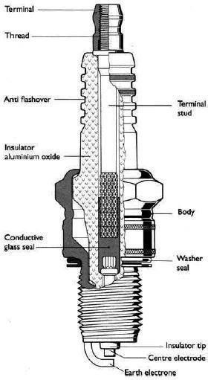
Construction and Working of Spark plug:

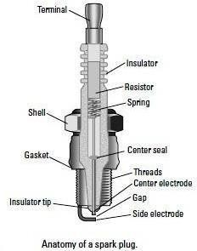
A typical spark plug used in case of petrol engines. It is shown in the figure. It mainly consists of a central electrode and ground electrode. Central electrode is covered by means of porcelain insulating material. Through the metal screw the spark plug is fitted in the cylinder head plug.

Working:
When the high tension voltage of the order of 30000 volts is applied across the spark electrodes, current jumps from one electrode to another and produces a spark. This spark ignites the air fuel mixture inside the engine cylinder.

Battery ignition system
Battery Ignition System:

The line diagram of battery ignition system for a 4-cylinder petrol engine is shown in figure.
It mainly consists of a 6 or 12 volt battery, ammeter, ignition switch, auto-transformer (step up transformer), contact breaker, capacitor, distributor rotor, distributor contact points, spark plugs, etc.

In this system there are 4-spark plugs and contact breaker cam has 4-corners. The ignition system is divided into 2-circuits:
- Primary Circuit: It consists of 6 or 12 V battery, ammeter, ignition switch, primary winding it has 200-300 turns of 20 SWG (Sharps Wire Gauge) gauge wire, contact breaker, capacitor.
- Secondary Circuit: It consists of secondary winding. Secondary Ignition Systems winding consists of about 21000 turns of 40 (S WG) gauge wire. Bottom end of which is connected to bottom end of primary and top end of secondary winding is connected to centre of distributor rotor. Distributor rotors rotate and make contacts with contact points and are connected to spark plugs which are fitted in cylinder heads (engine earth).
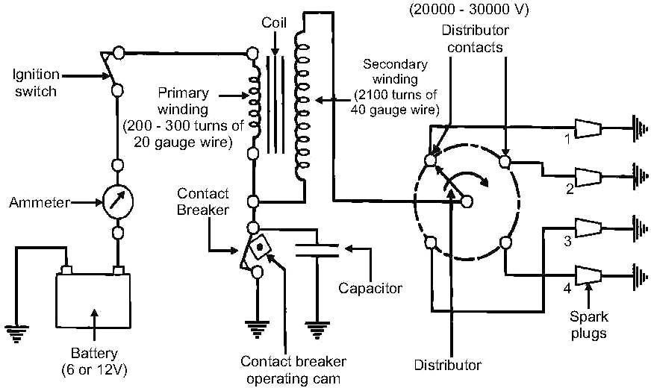

BATTERY IGNITION SYSTEM

Working :

When the ignition switch is closed and engine in cranked, as soon as the contact breaker closes, a low voltage current will flow through the primary winding. It is also to be noted that the contact beaker cam opens and closes the circuit 4-times (for 4 cylinders) in one revolution.
When the contact breaker opens the contact, the magnetic field begins to collapse. Because of this collapsing magnetic field, current will be induced in the secondary winding. And because of more turns of secondary, voltage goes unto 28000-30000 volts.
This high voltage current is brought to centre of the distributor rotor. Distributor rotor rotates and supplies this high voltage current to proper stark plug depending upon the engine firing order. When the high voltage current jumps the spark plug gap, it produces the spark and the charge is ignited-combustion starts-products of combustion expand and produce power.

Magneto ignition system
Magneto Ignition System:

In magneto ignition system a magneto is used to generate electric current for producing spark. Main components of magneto ignition system are: frame, permanent magnet, armature, soft iron field, rotor, primary and secondary winding, contact breaker and condenser.
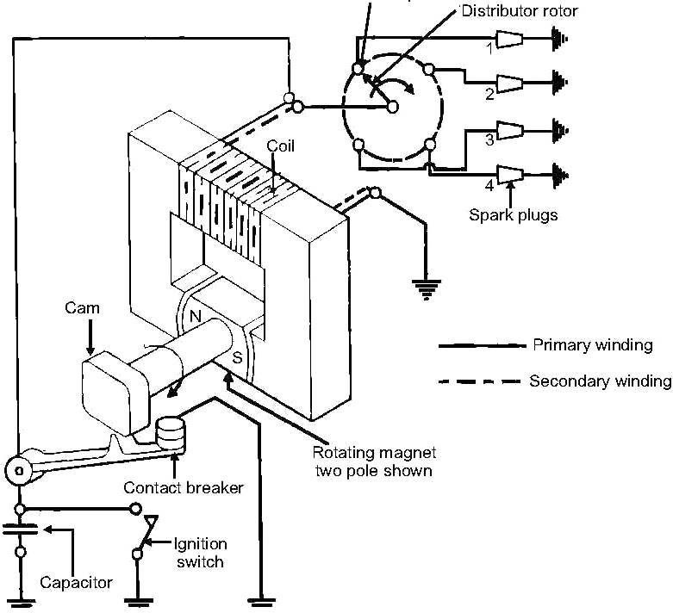

MAGNETO IGNITION SYSTEM

The armature is driven by the engine. When the armature rotates, current flows in the primary winding. This current flows into the condenser by a contact breaker. Condenser sends back high voltage high current into the secondary winding. Current is then flows into the distributor. Distributor distributes the current into the spark plugs.

Difference between the Battery and Magneto ignition system
Difference between Battery and Magneto ignition system:

 | Battery Ignition System |  | Magneto Ignition System
1. | Battery is necessary. | 1. | No battery is necessary.
2. | Battery supplies current in primary  circuit. | 2. | Magneto produces the required current  for primary circuit.

3. | A good spark is available at low  speed also. | 3. | During starting the quality of spark is  poor due to low speed.
4. | Occupies more space. | 4. | It is more compact.
5. | Battery recharge is necessary. | 5. | Not required because there is no such  arrangements.
6. | Mostly used in case of cars and  buses. | 6. | Mostly used in motor cycles and  scooters.
7. | Battery maintenance is required. | 7. | No such arrangement is there.
8. | It is commonly used because of its combined cheapness, convenience of maintenance, attention and general  suitability. | 8. | It is an efficient, reliable, self contained unit, which is often preferred for air craft engines because storage batteries are  heavy and troublesome.

CH-4 COOLING & LUBRICATION

Function of engine cooling system
The cooling system has four primary functions. These functions are as follows:
- Removes excess heat from the engine
- Maintains a constant engine operating temperature
- Increases the temperature of a cold engine quickly
- Provides heater operation to warm the passenger compartment

Types of cooling system
The different Types of cooling system are:
- Air cooling system
- Liquid cooling system
- Forced circulation system
- Pressure cooling system

Water cooling system/Liquid cooling system:
A simple liquid-cooled system consists of a radiator, coolant pump, piping, fan, thermostat, and a system of water jackets and passages in the cylinder head and block through which the coolant circulates.
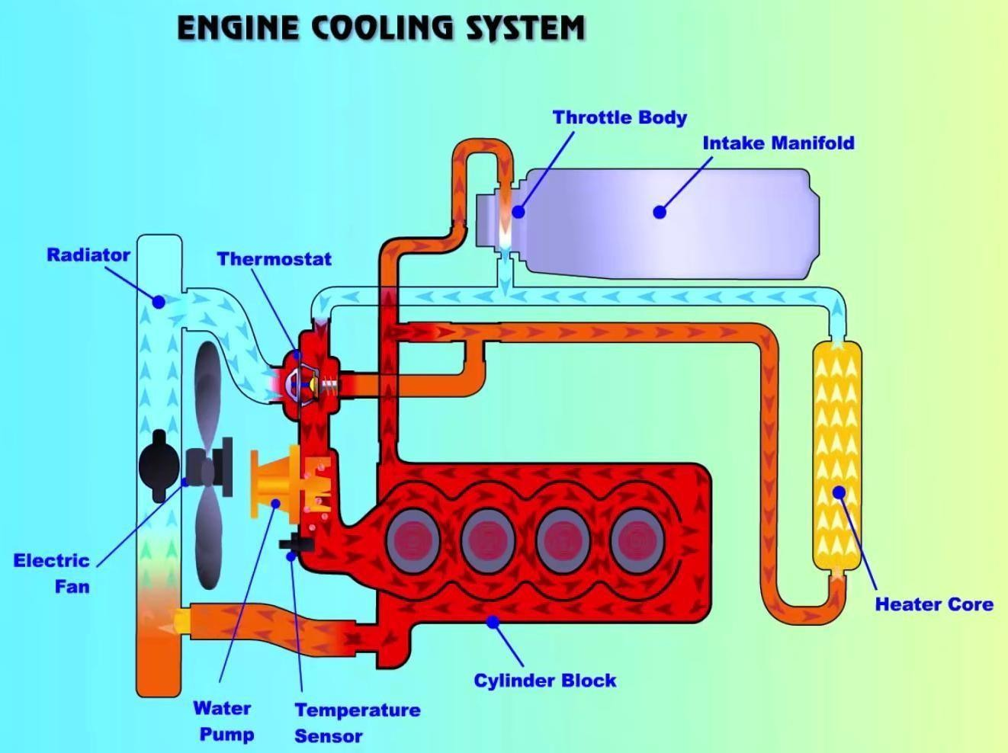
The pump draws the coolant/water from the bottom of the radiator, forcing it through the water jackets and passages, and ejects it into the upper radiator tank. The coolant then passes through a set of tubes to the bottom of the radiator from which the cooling cycle begins.
The radiator is situated in front of a fan that is driven either by the water pump or an electric motor. The fan ensures airflow through the radiator at times when there is no vehicle motion.

The heating in the engine and the cooling in the radiator therefore create a natural circulation that aids the water pump.

Components used in engine cooling system
The main components of cooling system are:
- Water pump
- Radiator
- Thermostat
- Coolant temperature sensor
- Coolant
- Fan
- Water jacket
Water pump pumps the coolant in cooling system. Radiator is a heat exchanger used to transfer the excess heat developed by the engine to the atmosphere. Thermostat is a valve which regulates the flow of coolant and helps to maintain the proper operating temperature for the engine. Coolant temperature sensor is used to monitor the engine temperature. The engine is having a passage for the flow of coolant known as water jacket.

Air cooling system in IC engines
Air cooled system is generally used in small engines ranging up to 15-20 kW and in aero plane engines. In this system fins or extended surfaces are provided on the cylinder walls, cylinder head, etc. Heat generated due to combustion in the engine cylinder will be conducted to the fins and when the air flows over the fins, heat will be dissipated to air.
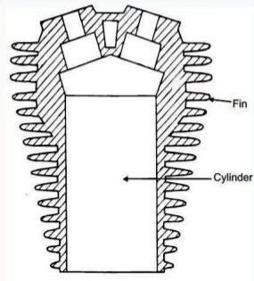
The amount of heat dissipated to air depends upon:
  - Amount of air flowing through the fins.
  - Fin surface area.
  - Thermal conductivity of metal used forfins.

Advantages and disadvantages of air cooling system

Advantages of Air Cooled System
Following are the advantages of air cooled system:
    - Radiator/pump is absent hence the system is light.
    - In case of water cooling system there are leakages, but in this case there are no leakages.
    - Coolant and antifreeze solutions are not required.
    - This system can be used in cold climates, where if water is used it may freeze.

Disadvantages of Air Cooled System

    - Comparatively it is less efficient.
    - It is used in aero planes and motorcycle engines where the engines are exposed to airdirectly.

Advantages and disadvantages of water cooling system
[38]

Advantages Water Cooling System:
    - Uniform cooling of cylinder, cylinder head and valves.
    - Specific fuel consumption of engine improves by using water cooling system.
    - If we employ water cooling system, then engine need not be provided at the front endof moving vehicle.
    - Engine is less noisy as compared with air cooled engines, as it has water for dampingnoise.

Disadvantages of Water cooling system:
    - It depends upon the supply of water.
    - The water pump which circulates water absorbs considerable power.
    - If the water cooling system fails then it will result in severe damage of engine.
    - The water cooling system is costlier as it has more number of parts. Also it requiresmore maintenance and care for its parts.

Functions of lubrication system
The functions of an engine lubrication system are as follows:
    - Reduces the friction and wear between moving parts
    - Helps transfer heat and cool engine parts
    - Cleans the inside of the engine by removing contaminants
    - Absorbs shocks between moving parts to quiet engine operation and increase enginelife

Components of lubrication system of I.C engine
The main components of lubricating system are:
    - Sump for lubricant and oil strainer
    - Oil pump
    - Pressure regulator
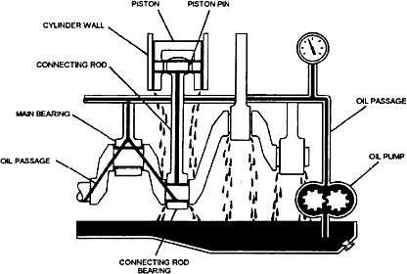
    - Oil filter

Working:

The Oil pump is operated by the engine, which sucks oil from the sump through oil strainer. Oil pump discharges the oil to Oil filter at high pressure. The oil pressure regulator checks the required oil pressure and supplies clean oil by removing dust from it. The pressurized oil flows through the oil lines and galleries to lubricate the moving engine parts. The galleries lubricate all engine parts and then the oil return back to the sump for recycling.

Oil filter
Oil filter is a type of strainer using cloth, paper, felt, wire screen or similar elements.Oil filler removes the dirty elements of the oil in an effective way.
Troubles in lubrication system

Troubles in Lubrication System:
There are a few common troubles in lubrication system such as: (1) Excessive oil consumption
(2) Low oil pressure and (3) Excessive oil pressure.
Pressure cooling system

Pressure Cooling System:
It is the modification of ordinary water cooling system. In this system a pressure type radiator cap is used with forces circulation cooling system. It
The cap is fitted on the radiator neck with an air tight seal. The pressure-release valve is set to open at a pressure between 4 and 13 psi. With this increase in pressure, the boiling temperature of water increases to 243°F (at 4 psi boiling tap 225°F and 13 psi boiling temperature 243°F). Any increase in pressure is released by the pressure release valve to the atmosphere. On cooling, the vapours will condense and a partial vacuum will be created which will result in the collapse of the hoses and tubes. To overcome this problem the pressure release valve is associated with a vacuum valve which opens the radiator to the atmosphere.

CH-5 FUEL SYSTEM

Air fuel ratio and its importance
The air fuel ratio (AFR) defines the ratio of the amount of air consumed by the engine compared to the amount of fuel.

Functions of ignition system
The functions of the coil ignition systems may be divided into three areas. These are:
    - Production of the high voltage necessary to produce a spark at the plug gap.
    - Distribute the spark to all the cylinders at proper time based on the firing order.
    - Varying the timing of the spark depending on the various operating conditions of theengine

Carburetion
The process of formation of a combustible fuel-air mixture by mixing the proper amount of fuel with air before admission to engine cylinder is called carburetion

Carburetor
The device which does the process of formation of a combustible fuel-air mixture by mixing the proper amount of fuel with air is called a carburetor.

Function of spark plug
A spark plug is used in SI engines to ignite the charge of air and fuel before the end of compression inside the engine cylinder.

Specification of Spark plugs
Spark plugs are specified by size, either thread or nut, sealing type (taper or crush washer), and spark gap.

Types of ignition system used in I.C engines
The two types of ignition systems used in I.C engines are Battery ignition system and Magneto-ignition system.

Hot and cold plug
A spark plug is said to be "hot" if it is a better heat insulator, keeping more heat in the tip of the spark plug.
A spark plug is said to be "cold" if it can conduct more heat out of the spark plug tip and lower the tip's temperature.

Fuel feed pump

The function of feed pump is to deliver the fuel from the fuel tank to fuel injection pump through thefuel filter. The feed pump is attached to the injection pump.

Fuel injector
A fuel injector atomizes the fuel through a small nozzle under high pressure and delivers into the engine cylinder for combustion.

Detonation
Detonation or Knocking in spark-ignition internal combustion engines occurs when combustion of the air/fuel mixture in the cylinder does not start off correctly in response to ignition by the spark plug.
Under normal conditions the air fuel mixture ignites properly inside the cylinder during combustion. Detonation occurs when fuel pre-ignites before the reach of piston during ignition. It leads to a powerful explosion inside the cylinder and may divert the direction of piston. It has a sign to damage the piston components.

Ignition timing
It is the correct instant for the introduction of spark near the end of compression stroke in the cycle.

Firing order, Firing order for 4-cylinder inline engine
The order or sequence in which the firing takes place, in different cylinders of a multi cylinder engine is called Firing order.
The firing order for a four cylinder inline engine is 1-3-4-2 or 1-2-4-3.

Octane number and cetane number
Octane number is the measure of the resistance of gasoline against detonation or preignition of the fuel in the engine. It is the measure of ignition quality of gasoline/petrol.
Cetane number is the measure of combustion quality of diesel oil or it is the measure of the ignition delay. It is the measure of ignition quality of diesel.

Working of simple carburetor
The simple carburetor mainly consists of a float chamber, fuel discharge nozzle, a metering orifice, a venturi, a throttle valve and a choke. The float and a needle valve system maintain a constant level of gasoline in the float chamber.
If the amount of fuel in the float chamber falls below the designed level, the float goes down, thereby opening the fuel supply valve and admitting fuel.
When the designed level has been reached, the float closes the fuel supply valve thus stopping additional fuel flow from the supply system.

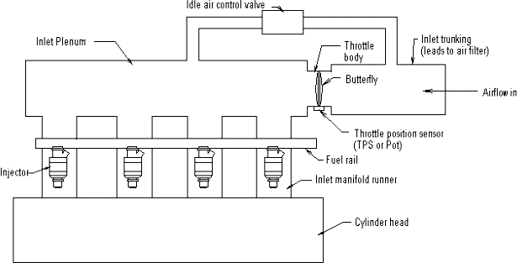
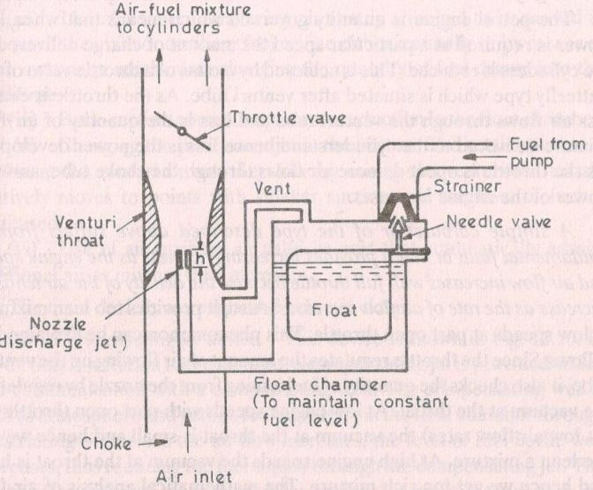

Solex carburettor:
-provide ease of starting, good performance, and reliability
-used in Fiat and standard cars and Willey jeep
-Bi-starter is used for cold starting
-well of emulsion system is used for idling and slow running condition
-diaphragm type acceleration pump is used for increasing speed case

Multipoint fuel injection system
Fuel injection is a system for mixing fuel with air in an internal combustion engine. Fuel injection atomizes the fuel by forcibly pumping it through a small nozzle under high pressure.
The construction of multipoint fuel injection system is shown in figure.

Solex carburettor:
-provide ease of starting, good performance, and reliability
-used in Fiat and standard cars and Willey jeep
-Bi-starter is used for cold starting
-well of emulsion system is used for idling and slow running condition
-diaphragm type acceleration pump is used for increasing speed case

Multipoint fuel injection system
Fuel injection is a system for mixing fuel with air in an internal combustion engine. Fuel injection atomizes the fuel by forcibly pumping it through a small nozzle under high pressure.
The construction of multipoint fuel injection system is shown in figure.

Multi-point fuel injection (MPFI) injects fuel into the intake port just upstream of the
cylinder’s intake valve, rather than at a central point within an intake manifold. In MPF

systems fuel is injected to the cylinders in groups in which fuel is injected at the same time toall the cylinders

Working principle of an fuel injector
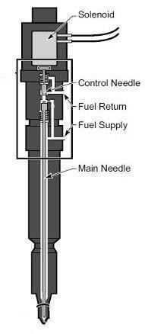
The fuel injector is used to spray fuel into the engine cylinder. It is fixed to the cylinder head. Fuel injector atomizes the fuel by forcibly pumping it through a small nozzle under high pressure.

A mechanical type fuel injector is spring-loaded into the closed position and is opened by fuel pressure. Its
The fuel is fired into either the inlet construction is shown in
Fuel from the tank is pumped at high pressure to a fuel accumulator. Fromnject there it passes into the fuel distributor which sends fuel to injector, from where
or.
figure.
manifold or the inlet port via an i

it is fired into the inlet port.

CH-6 HYBRID AND ELECTRIC VEHICLES

ELECTRIC VEHICLE
Specific energy and power in addition to cycle life are primary concerns of batteries utilized in electric vehicles (EV). The lithium-ion battery is believed to be able to potentially meet these requirements in the future. Hence, several well-known types of lithium batteries, such as lithium iron phosphate, lithium polymer, and nano-phosphate lithium-ion cells, have been developed. In addition, their reliability and durability are very susceptible to operational and environmental conditions, particularly in EV applications. To achieve the required EV traction power and range, low-voltage lithium-ion cells are generally connected in series and in parallel to construct a dedicated battery pack. A battery management system (BMS), along with protective circuitry and a communication bus, is provided for management, monitoring, and diagnosis. Measurement of state-of-charge (SoC) is one of basic functions of the BMS, which indicates the remaining charge

of the battery so that the driver can be reminded to charge the battery prior to its depletion. It is known that inaccurate SoC determination is likely to cause catastrophic situations such as over discharge or overcharge. In addition, state-of-health (SoH), which defines the battery performance relative to its fresh condition, is used to predict its end-of-life and aging.
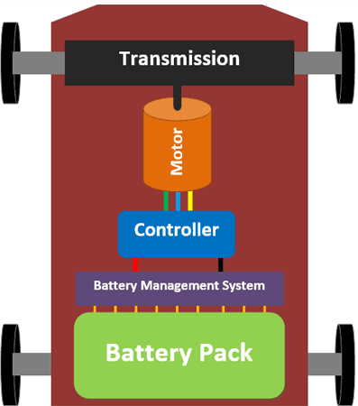

The usage history might involve normal charge–discharge cycles and abusive experiences, e.g., instances in which the operational limits of voltage, current, and temperature were exceeded. A data fusion technique is utilized to integrate the aforementioned data for the estimation of the remainder of battery lifetime. On the other hand, the battery aging also induces the loss of useful capacity and increase of internal resistance. The rated capacity measurement must apply a full charge–discharge process that is time-intensive and only suitable for testing in a laboratory.
Instead, the battery impedance can be either directly analyzed by a spectroscopic instrument or be estimated through the transient response. For instance, some prevailing methods have analyzed the battery voltage profile by detecting the drop depth in a discharge operation.

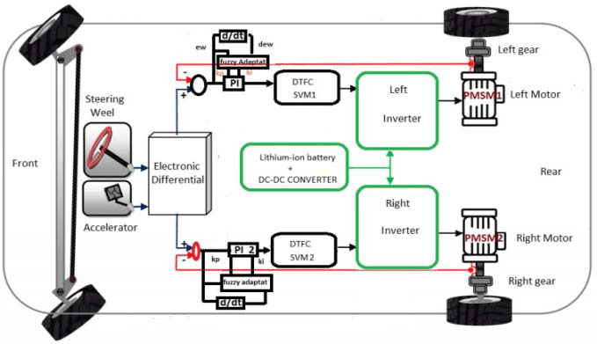

The Function of a Converter

More properly called a voltage converter, this electrical device actually changes the voltage (either AC or DC) of an electrical power source.² There are two types of voltage converters: step up converters (which increases voltage) and step down converters (which decreases voltage).
The most common use of a converter is to take a relatively low voltage source and step-it-up to high voltage for heavy-duty work in a high power consumption load, but they can also be used in reverse to reduce voltage for a light load source.

DC-to-DC Converter

The DC-to-DC converters convert one level of DC voltage to another level. The operating voltage of different electronic devices such as ICs, MOSFET can vary over a wide range, making it necessary to provide a voltage for each device. A Buck Converter outputs a lower voltage than the original voltage, while a Boost Converter supplies a higher voltage.
With the application of DC-to-DC Converters, the circuit’s efficiency, ripple, and load- transient response can be changed. Optimal external parts and components are generally dependent on operating conditions such as input and output specifications. So, while designing the products, the standard circuits must be varied or changed according to and as per the need to their individual specification requirements. Designing the circuit that satisfies the specification and all the requirements needs a great deal of expertise and experience in that field.

The step-up or step-down DC-to-DC Converters are useful in applications where the battery voltage can be above or below the regulator output voltage. The DC to DC converter must be able to operate as a step up or down voltage supplier to provide constant load voltage over the entire battery voltage range through the operation.

Working Principle of DC-DC converter

The working principle of the DC-to-DC converter is very simple. The inductor in the input resistance has an unexpected variation in the input current. If the switch is kept as high (on), then the inductor feeds the energy from the input and stores the energy in the form of magnetic energy.
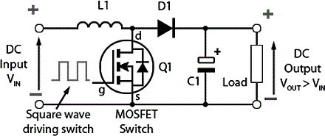

If the switch is kept as low (off), it discharges the energy. Here, the output of the capacitor is assumed as high that is sufficient for the time constant of an RC circuit on the output side. The huge time constant is compared with the switching period and made sure that the steady-state is a constant output voltage. It should be Vo(t) = Vo(constant) and present at the load terminal.

The Function of an Inverter

Broadly speaking, an inverter is an electrical device that converts electricity derived from a DC (Direct Current) source to AC (Alternating Current) of the type that can be used to drive a device or appliance. In a solar power system, for example, the power stored by batteries charged by solar panels is converted to standard AC power by the inverter,¹ which provides the power to plug-in outlets and other standard 120-volt devices.

An inverter serves the same kind of function in a hybrid or EV car, and the theory of operation is relatively simple.² DC power, from a hybrid battery, for example, is fed to the primary winding in a transformer within the inverter housing. Through an electronic switch (generally a set of semiconductor transistors), the direction of the flow of current is continuously and regularly flip- flopped (the electrical charge travels into the primary winding, then abruptly reverses and flows back out). The in/outflow of electricity produces AC current in the transformer's secondary

winding circuit. Ultimately, this induced alternating current electricity provides power for an AC load—for example, an electric vehicle's (EV) electric traction motor.
A rectifier is a similar device to an inverter except that it does the opposite, converting AC power to DC power.

EV Power Systems (Motors and controllers)

The power system of an electric vehicle consists of just two components: the motor that provides the power and the controller that controls the application of this power. In comparison, the power system of gasoline-powered vehicles consists of a number of components, such as the engine, carburetor, oil pump, water pump, cooling system, starter, exhaust system, etc.

Motors
Electric motors convert electrical energy into mechanical energy. Two types of electric motors are used in electric vehicles to provide power to the wheels: the direct current (DC) motor and the alternating current (AC) motor.

DC electric motors have three main components:

A set of coils (field) that creates the magnetic forces which provide torque A rotor or armature mounted on bearings that turns inside the field
Commutating device that reverses the magnetic forces and makes the armature turn, thereby providing horsepower.
As in the DC motor, an AC motor also has a set of coils (field) and a rotor or armature, however, since there is a continuous current reversal, a commutating device is not needed.
Both types of electric motors are used in electric vehicles and have advantages and disadvantages, as shown here.
While the AC motor is less expensive and lighter weight, the DC motor has a simpler controller, making the DC motor/controller combination less expensive. The main disadvantage of the AC motor is the cost of the electronics package needed to convert (invert) the battery‘s direct current to alternating current for the motor.

Past generations of electric vehicles used the DC motor/controller system because they operate off the battery current without complex electronics. The DC motor/controller system is still used today on some electric vehicles to keep the cost down. However, with the advent of better and less expensive electronics, a large number of today’s electric vehicles are using AC

motor/controller systems because of their improved motor efficiency and lighter weight. For more information, visit avt.inl.gov These AC motors resemble motors commonly used in home appliances and machine tools, and are relatively inexpensive and robust. These motors are very reliable, and since they have only one moving part, the shaft, they should last the life of the vehicle with little or no maintenance.

Controllers
The electric vehicle controller is the electronics package that operates between the batteries and the motor to control the electric vehicle‘s speed and acceleration much like a carburetor does in a gasoline-powered vehicle. The controller transforms the battery’s direct current into alternating current (for AC motors only) and regulates the energy flow from the battery. Unlike the carburetor, the controller will also reverse the motor rotation (so the vehicle can go in reverse), and convert the motor to a generator (so that the kinetic energy of motion can be used to recharge the battery when the brake is applied).

Electronic Differential
When cornering, the inner and outer wheels rotate at different speeds, because the inner wheels describe a smaller turning radius. The electronic differential uses the steering wheel command signal and the motor speed signals to control the power to each wheel so that all wheels are supplied with the torque they need.

