

LECTURE NOTES ON

ADVANCED MANUFACTURING PROCESSES

PREPARED BY:-

ER. BADRI NARAYAN PATRA

DEPARTMENT OF MECHANICAL ENGINEERING

1.1 Introduction :-
Modern Manufacturing processes is defined as a group of processes that remove excess material by various techniques involving mechanical, thermal, electrical or chemical energy or combinations of these energies but do not use a sharp cutting tools as it needs to be used for traditional manufacturing processes.

Extremely hard and brittle materials are difficult to machine by traditional machining processes such as turning, drilling, shaping and milling. Modern Manufacturing processes, also called Non Traditional OR Advanced Manufacturing processes, are employed where traditional machining processes are not feasible, satisfactory or economical due to special reasons as outlined below.

*Very hard fragile materials difficult to clamp for traditional machining
*When the work piece is too flexible or slender
*When the shape of the part is too complex
Several types of non-traditional machining processes have been developed to meet extra required machining conditions. When these processes are employed properly, they offer many advantages over non- traditional machining processes.

Definition:

A machining process is called non-traditional(Advance manufacturing) if its material removal mechanism is basically different than those in the traditional processes,
i.e. a different form of energy (other than the excessive forces exercised by a tool, which is in physical contact with the work piece) is applied to remove the excess material from the work surface, or to separate the workpiece into smaller parts.
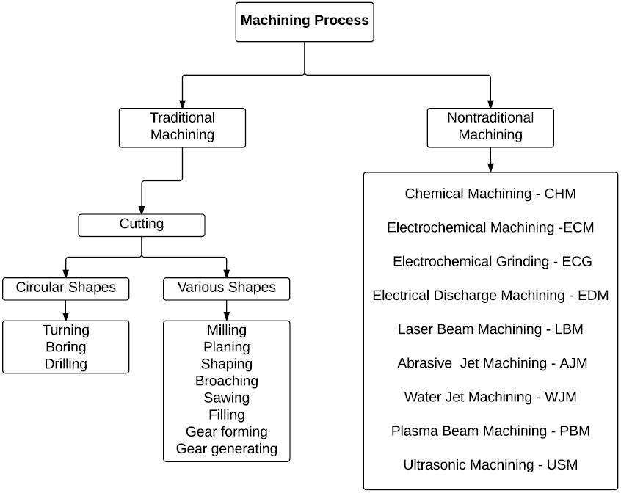

Comparison with TRADITIONAL MACHINING PROCESSES

- Tool used
- Tool and workpiece contact
- Accuracy
- Waste material
- Machining process
- Energy source
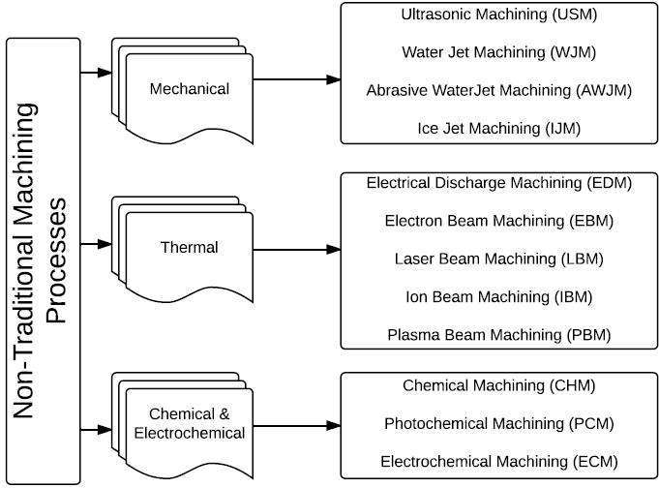

Classification of Advanced Manufacturing Processes:-

Mechanical type AMP:-
Abrasive jet Ultrasonic machining
Thermoelectric type AMP

Electric discharge machining Wire EDM
Laser beam Electron beam Plasma arc
Electro chemical machining

ULTRASONIC MACHINING PROCESS:-

Ultrasonic machining is a non-traditional machining process. USM is grouped under the mechanical group NTM processes. Fig. briefly depicts the USM process.
Principle Of Ultrasonic Machining :

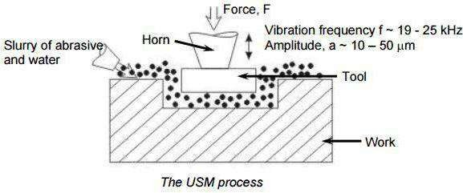

Ultrasonic Machining
In ultrasonic machining, a tool of desired shape vibrates at an ultrasonic frequency (19 ~ 25 kHz) with an amplitude of around 15 – 50 μm over the workpiece. Generally the tool is pressed downward with a feed force,
F. Between the tool and workpiece, the machining zone is flooded with hard abrasive particles generally in the form of a water based slurry. As the tool vibrates over the workpiece, the abrasive particles act as the indenters and indent both the work material and the tool. The

abrasive particles, as they indent, the work material, would remove the same, particularly if the work material is brittle, due to crack initiation, propagation and brittle fracture of the material. Hence, USM is mainly used for machining brittle materials which are poor conductors of electricity and thus cannot be processed by Electrochemical and Electro-discharge machining (ECM and ED).

Process Parameters and their Effects.
During discussion and analysis as presented in the previous section, the process parameters which govern the ultrasonic machining process have been identified and the same are listed below along with material parameters
- Amplitude of vibration (ao) – 15 – 50 μm
- Frequency of vibration (f) – 19 – 25 kHz
- Feed force (F) – related to tool dimensions
- Feed pressure (p)
- Abrasive size – 15 μm – 150 μm
- Abrasive material – Al2O3
- SiC
- B4C
- Boronsilicarbide
- Diamond
- Flow strength of work material
- Flow strength of the tool material
- Contact area of the tool – A
- Volume concentration of abrasive in water slurry – C

Machine
The basic mechanical structure of an USM is very similar to a drill press. However, it has additional features to carry out USM of brittle work material. The workpiece is mounted on a vice, which can be located at the desired position under the tool using a 2 axis table. The table can further be lowered or raised to accommodate work of different thickness.

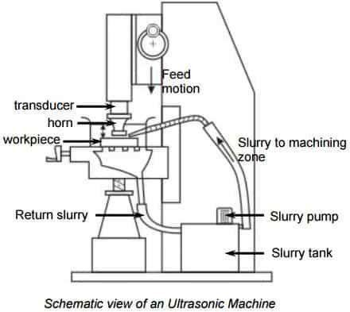

The typical elements of an USM are
- Slurry delivery and return system
- Feed mechanism to provide a downward feed force on the tool during machining
- The transducer, which generates the ultrasonic vibration

- The horn or concentrator, which mechanically amplifies the vibration to the required amplitude of 15 – 50 μm and accommodates the tool at its tip.
The ultrasonic vibrations are produced by the transducer. The transducer is driven by suitable signal generator followed by power amplifier. The transducer for USM works on the following principle
- Piezoelectric effect
- Magneto strictive effect
- Electro strictive effect

Applications
- Used for machining hard and brittle metallic alloys, semiconductors,
glass, ceramics, carbides etc.
  - Used for machining round, square, irregular shaped holes and
surface impressions.
  - Machining, wire drawing, punching or small blanking dies.
Limitations

- Low MRR
- Rather high tool wear
- Low depth of hole

ELECTRIC DISCHARGE MACHINING

Electrical Discharge machining is the process of metal removal from the work surface due to an erosion of metal caused by electric spark discharge between the two electrodes tool (cathode) and the work (Anode).
Working Principle of Electrical Discharge Machining:
It consists of an electric power supply, the dielectric medium, the tool, workpiece, and servo control.
The workpiece is connected to the positive terminal and the tool is connected to a negative terminal of the DC power supply.
An air gap of 0.005 to 0.05 mm is maintained between the tool and the work.
The die electric fluid which is non-conductor of electricity is forced under pressure through the gap.
When a DC power is supplied, the fluid in the gap gets ionized and produces a spark between the tool and workpiece, causing a local rise in temperature at about 1000 degrees Celsius, when melts the metal in a small area of the workpiece and tool vaporizes.
The DC supply generates a pulse between 40 to 3000 V and the frequency of spark at the rate of 10000 sparks per second can be achieved.
The electric and magnetic fields on heated metal cause a compressive force which removes the metal from the work surface.
The die electric fluid acts as a coolant carry the cooled metal from the work surface.

The die electric fluid acts as a coolant carries the eroded metal particles which are filtered regularly and supplied back to the tank.
A servomechanism is used to feed the tool continues to maintain a constant gap between two electrodes.
The accuracy of about 0.005 mm can be achieved in this process.
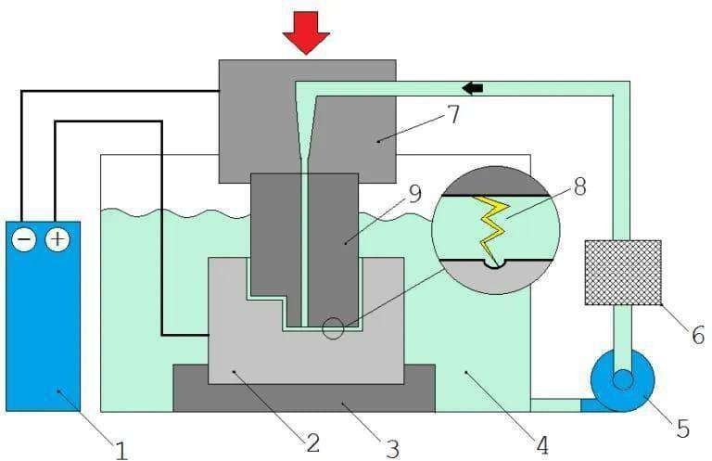
- A pulse generator (DC).
- Workpiece.
- Fixture.
- dielectric fluid.
- Pump
- Filter
- Tool holder
- Spark
- Tool

Description of Equipment :
An Electric Discharge Machine consists of:
  - DC pulse Generator
  - Voltmeter
  - Ammeter
  - Tool
  - Die electric fluid
  - Pump
  - Filter
  - Servo Controlled Feed
  - Fixtures
  - Table
- DC Pulse Generator:
This is a power source for the machining operation. DC power is supplied.
- Voltmeter:
We know that the voltmeter measures the voltage. Here in this device the same for use.
- Ammeter:
It measures or checks the flow of the current. If Ammeter is not connected we might not see or check current is flowing or not.
- Tool:
A tool is connected to negative sources of power whereas the workpiece is connected to positive sources. from the filter, the fluid comes to the tool for the operation.
When Power supply will increase, between tools workpiece the spark generates and then machining starts.

- Die electric fluid:
It has a property like insulation and we know what insulation means?
Insulation means no current flows from one to another.
The Die electric fluid will be ionized in the form of ion which will help between the tool and workpiece again when power supply stops the fluid comes to its initial position.

Pump:
The pump is connected there for sending the fluid to the filter. This works like flowing the fluid from one source to another one.

Filter:
As the name indicates the filter, is used to filtrate the different particles like:
In this device, if there is dust particles presence the filter will remove that particle and then it will send to the tool for the operation.

Servo controlled feed:
The constant feed will be supplied by the servo for the operation.

Fixture:
To hold the table.

Table:
To hold the workpiece.

Process Parameter

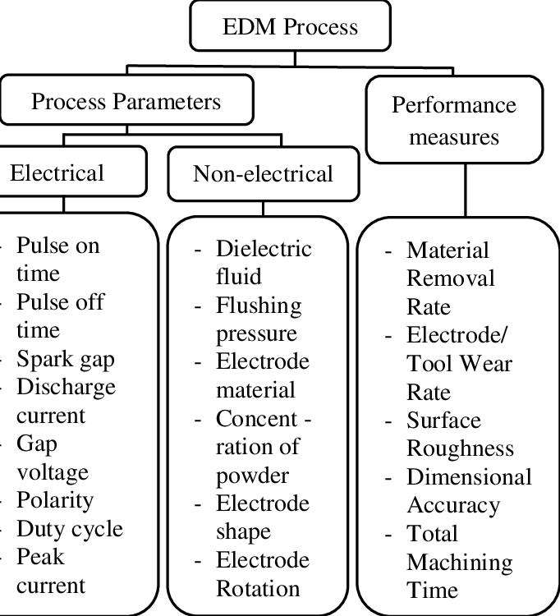
The EDM process parameters which drive this process are divided into two types, namely, electrical and non-electrical parameters.
The major electrical parameters are discharge voltage, peak current, pulse duration and interval (pulse-on and pulse-off times), electrode gap, polarity, and pulse wave form. Important non-electrical parameters include flushing of the dielectric fluid, workpiece rotation, electrode rotation, etc. These parameters are discussed below.

The discharge or machining voltage is the average voltage across the spark gap during machining. The discharge voltage directly influences the regulation of the size spark gap and overcut . Normally, electrode and workpiece materials of high electrical conductivity use low voltage.
In contrast, higher voltage is considered with materials of low conductivity. This parameter has a direct effect on the material removal rate (MRR), tool wear rate (TWR), and machining accuracy . An increase in current increases MRR and TWR and adversely affects the accuracy. These characteristics of the parameter current and its responses opened the door for electrodes of high wear resistance that can be used in high- current conditions [47]. The pulse-on time is the time during which the discharge is applied. The amount of energy generated during pulse-on time has a direct influence on the MRR .
Accordingly, increasing the discharge energy by applying longer pulse-on time also increases the MRR . The pulse-off time is the time during which there is no discharge. During this time, the debris as a result of sparking and erosion is flushed out of the gap between the workpiece and the electrode.
Flushing improves the ionization conditions and avoids the formation of an insulating layer; thus, proper selection of pulse-off time provides stable machining. A shorter period of this time increases MRR as long as enough flushing of debris takes place. Otherwise, it may result in unsuitable conditions during the next pulse-on time period.
Furthermore, a pulse wave has many forms such as rectangular and trapezoidal waves or even a composite geometric form. It is demonstrated in the literature that, among standard forms, the trapezoidal wave form generator minimizes the electrode wear. Recently, other generators were developed such as a typical one which initially facilitates the main pulse by producing a high-voltage pulse with a low current of narrower duration before the main pulse .
The polarity in EDM depends on many factors, including electrode and workpiece materials, current density, and pulse length. Either the electrode or the workpiece has a positive charge polarity and the other has a negative charge polarity.

Negative electrode polarity is recommended for high-precision machining when the MRR is high. In the wire EDM process, the electrode “wire” usually has a negative polarity to keep machining rate high, and, since the wire wear keeps on moving continuously during arcing, its wear rate is less.
The electrode and workpiece are located at a small predetermined
distance called the “discharge gap” which is controlled by the discharge gap servo . A discharge gap on the order of 0.005 mm and 0.1 mm is usually maintained.
Finishing or high-precision machining requires a relatively low voltage in the gap on the order of 50 V and 300 V, as too high a voltage reduces machining precision. Non-electrical parameters include flushing of the dielectric fluid, workpiece rotation, and electrode rotation.
The function of the dielectric fluid is to provide insulation against premature discharging, reduce the temperature during machining, and clean away the debris from the machining area . Good dielectric fluids should have characteristics such as high dielectric strength, flushing ability, fast recovery after breakdown, etc.
In the case of a sinker type EDM, hydrocarbon- and silicon-based dielectric oil and kerosene are used after raising the flash point.
Meanwhile, de-ionized water and oil are used in wire EDM.
Moreover, some sinker EDMs also use de-ionized water in high-precision machining, such as in fine hole drilling. Many studies were conducted recently to explore oil-based synthetics to avoid harmful effects on workers and the environment. Importantly, the dielectric type and flushing method influence MRR, TWR, and surface roughness (SR) .
The dielectric flushing conditions can be improved with workpiece and electrode rotation. This improvement in flushing caused by electrode rotation achieves better SR and higher MRR and minimizes the density of cracks on the surface and recast layer .
The effect of the EDM process parameters on the response parameters are difficult to explain because of the stochastic nature of the discharge mechanism. Several researchers performed studies related to EDM processes and explored the influence of process parameters on the performance measures .

Output Parameters
The two output parameters considered were: MRR and Ra. Material Removal Rate (MRR)
Equation (1) could be used for the determination of the MRR (cubic centimetre/min) in the EDM process:
MRR = Wi − Wf /t
(1)
where, Wi is the initial weight of the work piece before machining, Wf is the final weight of the work piece after machining, and t is the time period of trials.
MRR is directly proportional on the amount of current passed and the machining time (Pulse on Time, Pulse off Time). Besides these critical factors the MRR is also dependent on the type of voltage etc.
Average Roughness (Ra)
The deviation of a surface from its ideal level is defined in terms of surface roughness. The surface roughness is defined according to ISO 4287:1997 international standard. The term average roughness is often referred to as roughness and determines the surface texture. The average roughness is calculated by the deviations, i.e., deviation of surface from a theoretical centre line. If the deviations are large, the surface roughness is high, whereas the surface is considered to be smooth for small deviations. This is known as arithmetic mean surface roughness Ra.

The applications of EDM:
- Drilling for micro holes in the nozzle.
- This is used in thread cutting.
- Used in wire cutting.
- Rotary form cutting.
- Helical profile milling.
- Curved hole drilling.
- Engraving operation on harder materials.
- Cutting off operation.
- The shaping of alloy steel and tungsten carbide dies. Advantages of Electrical Discharge Machining:
- It can be used for any hard material and even in the heat- treated condition.
- Any complicated shapes made on the tool can be reproduced.
- High accuracy of about 0.005 mm can be achieved.
- Good surface finish can be achieved economically up to
0.2 microns.
- Machining time is less than the conventional machining process.
- No mechanical stresses are developed in this process (There is no contact between tool and work)
- Higher tool life due to proper lubrication and cooling.
- Hard and erosion resistant surface on the dies can be developed easily.
- It can be applied to any electrically conductive materials.

Disadvantages of Electrical Discharge Machining:
- Excessive tool wear.
- High power consumption.

- The sharp corner cannot be reproduced.
- High heat developing causing the change in metallurgical properties of materials.
- The workpiece must be an electrical conductor.
- Surface cracking may take place in some materials.
- Redressing of a tool is required for deep holes.
- Over-cut is formed.
- Difficult finding expert machinists

Wire Cut EDM

Principle

CNC wire cut EDM machine puts impulse voltage between electrode wire and workpiece through impulse source, controlled by servo system, to get a certain gap, and realize impulse discharging in the working liquid between electrode wire and workpiece. Numerous tiny holes appears due to erosion of impulse discharging, and therefore get the needed shape of workpiece( as show in figure 1-1).

Electrode wire is connecting to cathode of impulse power source, and workpiece is connecting to anode of impulse power source. When workpiece is approaching electrode wire in the insulating liquid and gap between them getting small to a certain value, insulating liquid was broken through; very shortly, discharging channel forms, and electrical discharging happens. And release huge high temperature instantaneously, up to more than 10000 degree centigrade, the eroded workpiece is cooling down swiftly in working liquid and flushed away. As show in figure 1-2


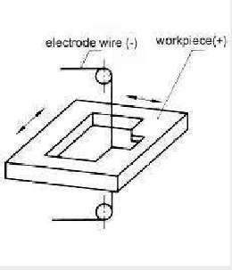

Description of equipment

In wire EDM, three elements are of particular importance: wire electrode, dielectric bath and workpiece. Both the workpiece and the wire electrode are in the dielectric bath during the cutting process. This is produced with the aid of a non-conductive liquid, for which either deionized water or special erosion oil is used. In some cases, a coaxial jet is used as an alternative to the dielectric bath. The wire is usually made of brass, but can just as easily be made of copper or steel. Wire electrodes with a diameter between 0.02 mm and 0.33 mm are normally used for wire EDM.
Finally, the exact process takes place in three phases: First, the wire electrode and the material to be machined are placed at a clearly defined distance from each other in advance. It is important that both are charged differently (workpiece = anode and wire = cathode). Now, with the help of electrical voltage pulses, an electric field is generated (ignition phase) - exactly where the distance between wire and workpiece is smallest.
In this field, an acceleration of the electrically charged particles takes place, which leads to the generation of a visible spark. This generates great heat, which causes the dielectric to evaporate and the material of the electrode and workpiece to melt. As a result, a gas bubble forms, which in turn fills with plasma (discharge phase). The current supply is interrupted by the onset of a pulse pause (pause phase), causing the bubble to implode. At this point, the molten material is detached from the workpiece and transported away with the dielectric. Depending on the machine, the processes from ignition phase to pause phase are repeated up to 100,000 times per second. Temperatures of up to 40,000°C are generated in the
Controlling parameters of wire cut EDM
Four process control parameters, namely Wire speed,
Gap voltage,
Flushing pressure and
Current
are analyzed for two response parameters viz surface roughness and material removal rate (MRR). It is found that MRR during WEDM have a predominant impact of current on it, while flushing pressure has the least impact on MRR. Whereas, surface roughness is most effected by wire speed during WEDM and gap voltage has the least impact on surface roughness of steel workpiece during WEDM process.
Applications of wire cut EDM
Applications of wire EDM include:

- Prototype production
- Automotive parts
- Aerospace parts
- Medical devices for implantations
- Prototypes
- Small hole drilling
- Blanking punches
- Extrusion dies
- Miniature parts

- Titanium needles
- Turbine blades
- Internal gear

Materials Used in Wire EDM
Wire EDM should be used with any conductive metal such as titanium, aluminum, brass, alloys, and superalloys. Thanks to wire EDM’s accuracy, wire EDM has become a popular manufacturing method for various industries. Whether for part or prototype, Fathom has many materials suitable for wire EDM, including:

- Copper
- Carbide . Carbon graphite
- High alloy steel
- Tungsten
- Bronze
- Carbon steel

Abrasive Jet Machining
The fundamental principle of Abrasive jet machining involves the use of a high-speed stream of abrasive particles carried by a high-pressure gas or air on the work surface through a nozzle.

The metal is removed due to erosion caused by the abrasive particles impacting the work surface at high speed. With repeated impacts, small bits of material get loosened and a fresh surface is exposed to the jet.

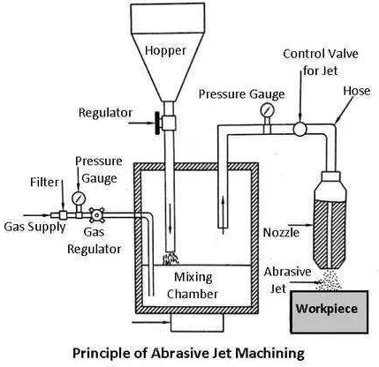

This process is mainly employed for such machining works which are otherwise difficult, such as thin sections of hard metals and alloys, cutting of material which is sensitive of heat damage, producing intricate holes, deburring, etching, polishing etc.

Equipment for abrasive jet machining
Air compressor: It compresses the carrier gas to a pressure of 15 – 20bar. Compressor unit also consists of drier and filter. So it removes water vapor and dust particles to avoid condensation or jamming during compression.

Pressure gauges: A number of such gauges are employed for measuring pressure of carrier gas as well as gas-abrasive mixture.

Flow regulating valves: These valves controls volume flow rate of carrier gas in order to maintain constant mixing ratio.

Hopper: In AJM, usually circular hopper with gradual compression is employed for continuously supplying fresh abrasive to the mixing chamber. Hopper is sometime vibrated to avoid bridging (jamming at outlet).

Mixing chamber: Its purpose is to mix abrasives with pressurized carrier gas. Here momentum transfer takes place and abrasives start flowing with carrier gas.
Chamber is vibrated to obtain homogeneous mixing.

Nozzle: As an isentropic steady flow device, nozzle converts hydraulic energy (pressure) of the gas-abrasive mixture to the kinetic energy and thus high velocity jet is obtained.

Working chamber: A close working chamber, inbuilt with proper exhaust system, is usually maintained in order to avoid environmental pollution. It also helps protecting workers from lung dieses caused by exposing into atmosphere containing excessive tiny abrasive dust.


Servo controller: Sometime movement of work table is controlled by servo mechanism. This gives easy, accurate and precise control and is suitable for cutting intricate profiles and contours.

Material removal rate and its estimation
Knowledge of material removal rate (MRR) is beneficial for selecting process parameters and choosing feed rate of the nozzle. It also facilitates accurate estimation of productivity, delivery time as well as production cost. Since only kinetic energy of abrasive grits is utilized for erosion, the analytical formula for MRR can be established by equating available kinetic energy with the work done required for creating an indentation of certain cord length on a specific work material.

However, ductile and brittle materials behave differently in indent formation, and thus size of indentation created by the impact of single abrasive grit is different for ductile and brittle materials. Under few assumptions, MRR for abrasive jet machining for different materials can be modeled analytically and can be expressed as provided below.

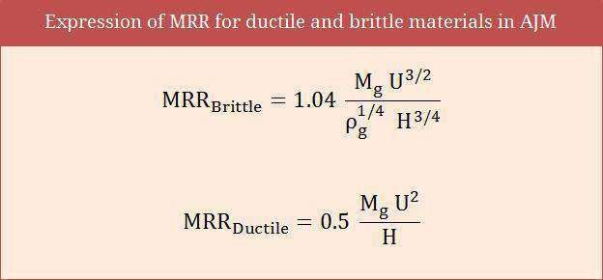

Applications of AJM
Abrasive jet machining can be advantageously utilized for multifarious purposes including surface cleaning, deburring, abrading and even making holes. Common applications of abrasive jet machining process are provided below. It is to be noted that, irrespective of the purpose, abrasive jet machining (AJM) is beneficial only for hard and brittle materials. AJM should be avoided if work material is soft and ductile; otherwise quality of machined surface will be poor. Read also: Applications of AJM process.

- Work surface cleaning—AJM can be advantageously used for cleaning metallic or ceramic surfaces (substrate must be hard). Such cleaning processes include removal of oxide, paint, coating, stain, glue, loose sand particles, etc.
- Deflashing and trimming—Controlled abrasive jet machining can be utilized for removing flash to get desired clean product with higher dimensional accuracy and tolerance as well as sumptuous appearance.
- Engraving—As an alternative to laser beam machining, abrasive jet machining can also be applied for incising purposes irrespective of chemical and electrical properties of work material.
- Ceramic abrading and glass frosting—Very hard materials including glass, refractory, stone, etc. can be easily abraded by AJM in order to get finished surface having tight tolerance.
- Deburring—Abrasive jet machining is one of the efficient methods for deburring (process for removal of burr) of milled features and drilled holes, especially when work material is hard.
- Cutting and drilling hole—AJM can also be utilized for cutting various shapes as well as for drilling holes. However, holes, slots or pockets may lack accuracy as sharp corners cannot be obtained by this process.

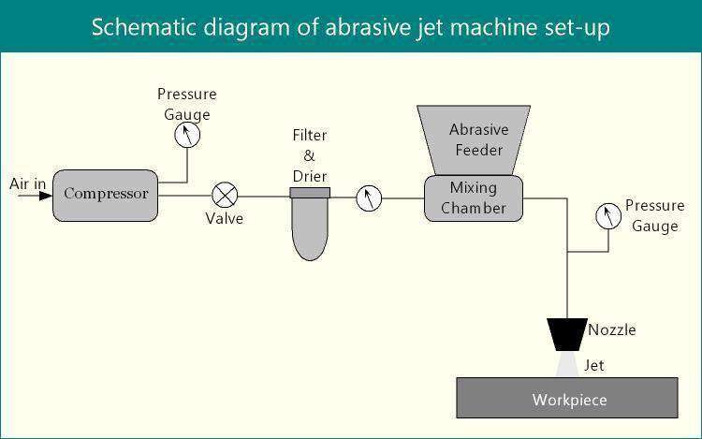

Characteristics of AJM
Abrasive - Al₂O, or Sic to be used once Size of abrasive - around 25 um
Flow rate - 2-20 g/min Medium - Air or CO₂ Velocity - 150-300 m/sec Pressure - 2 to 8 kg/cm sq
Nozzle - WC or sapphire with orifice area-0.05 to 0.2 mm sq Life of nozzle - WC (12-30 hrs), sapphire (around 300 hrs) Nozzle tip distance - 0.25 to 15 mm
Tolerance - ± 0.05 mm

Surface Roughness - 0.15-0.2 μm with particles of 10 μ m size,
0.4-0.8 μm and 1.0 to 1.5 μm, with particle
size of 25 and 50 μm

Work material - Hard and brittle materials like glass, ceramic, mica,
etc.
Machining operations - Drilling, cutting, deburring, cleaning Advantages - Can cut intricate hole shapes in hard and brittle
materials, fragile and heatsensitive materials can be cut without damage because there is no heating of working surface

Limitations -. Low material removal rate, low accuracy (0.1 mm) due to stray cutting (taper effect), abrasives get embedded in surface if material is soft

Laser Beam Machining:

A laser beam machining is a non-conventional machining method in which the operation is performed by laser light. The laser light has maximum temperature strikes on the workpiece, due to high temp the workpiece gets melts. The process used thermal energy to remove material from a metallic surface.

Laser Beam Machining Working Principle:
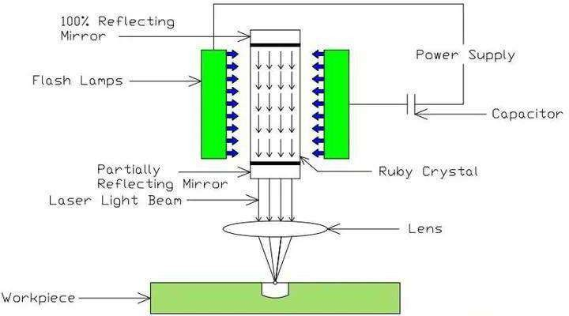

The working principle of laser machining is,

In this process, the Laser Beam is called monochromatic light, which is made to focus on the workpiece to be machined by a lens to give extremely high energy density to melt and vaporize any material.

The Laser Crystal (Ruby) is in the form of a cylinder as shown in the above figure or Diagram with flat reflecting ends which are placed in a flash lamp coil of about 1000W.

The Flash is simulated with the high-intensity white light from Xenon. The Crystal gets excited and emits the laser beam which is focused on the workpiece by using the lens.

The beam produced is extremely narrow and can be focused to a pinpoint area with a power density of 1000 kW/cm2. Which produces high heat and the portion of the metal is melted and vapourises.

Power Supply:
It provides the energy for excitation of electron from lower energy level to higher energy level. This gives power to xenon flash lamps, which produce light energy. The laser material are exposed in light energy to keep storing energy.

Laser Discharge Tube:
The laser material filled in lased discharge tube. The excitation of electron and come back to its original state process takes place in it. It’s one side is partially transparent for laser opening and other side is 100% reflected. It is situated between flash lamp.

Laser Material:
There are many different type of laser material available but in later machining mostly CO2(Pulsed or continuous waves) and Nd: YAG is Used. Carbon die oxide is a laser material that emits light in infrared region. It can provide up to 25 KW power in continuous wave mode. The other one is called Neodymium doped Yttrium Aluminum Garnet is a solid state laser which can delivery light through optical fiber. It can generate about 50 KW power in pulsed mode and 1 KW power in continuous mode.

Focusing Lens:
A focusing lens is used in laser machining operation. It is a convex lens which focus is at work piece.

DESCRIPTION OF EQUIPMENT
- A pumping Medium: A medium is needed that contains a large number of atoms. The atoms of the media are used to produce lasers.
- Flash Tube/Flash Lamp: The flash tube or flash lamp is used to provide the necessary energy to the atoms to excite their electrons.
- Power Supply: A high voltage power source is used to produce light in flashlight tubes.
- Capacitor: Capacitor is used to operate the laser beam machine at pulse mode.
- Reflecting Mirror: Two types of mirror are used, first one is 100 % reflecting and other is partially reflecting. 100 % reflecting mirror is kept at one end and partially reflecting mirror is at the other end. The laser beams comes out from that side where partially reflecting mirror is kept.
MATERIAL REMOVAL RATE

If a lower amount of power supply is given to the Ruby rod, the intensity of the electromagnetic waves is reduced. Therefore the heat generated in the workpiece is sufficient to melt and join the blades called a laser beam welding operation.

In practical conditions, the wavelength of the laser beam is about 0.4 to 0.6 micrometers only.

If a lower amount of power supply is given to the Ruby rod, the intensity of the electromagnetic waves is reduced. Therefore the heat generated in the workpiece is sufficient to melt and join the blades called a laser beam welding operation.

In practical conditions, the wavelength of the laser beam is about 0.4 to 0.6 micrometers only.

APPLICATIONS

- No vacuum is required.
- Mainly used for producing holes in the diesel injection nozzle.
- Also used for producing blind holes, Narrow slots in the workpieces.

CHARACTERISCTICS of LBM

Material removal technique - Heating, melting and vaporisation. Tool - Laser beams in wavelength range of 0.4-0.6 µm.
Power density - As high as 107 W/mm²

Output energy of laser and its pulse duration -20 J , 1 milli second.
Peak power - 20Kw
Medium - normal atmosphere Material removal rate - 5 mm³ /min.
Specific power consumption -1000 W/mm³/min

Material of workpiece - All materials except those with high thermal conductivity and high reflectivity.

Applications .- Drilling micro holes (upto 250 µm) and cutting very narrow slots. Dimensional accuracy - ±0.025 mm.
Efficiency - 0.3-0.5%

Limitations - Taper of 0.05 mm when work thickness is more than 0.25 mm.
Very large power consumption

Electro Chemical Machining

Electrochemical machining is a process of removing metal with the help of the electrolysis process. The electrochemical process is also known as the reverse of the electroplating process because, in electroplating, the metal is deposited on the surface of the workpiece, while in electro-chemical machining the metal is removed from the workpiece. This process is used for the large-scale production of machined parts.

PRINCIPLE OF ECM

The Electrochemical machining process is based on Faraday's law of electrolysis.

Faraday's law of electrolysis states that when two electrodes, anode ( +ve) and cathode (-ve) are placed in an electrolyte the mass of the metal deposited on the cathode coming from the anode is directly proportional to the potential difference applied across the electrodes.

In the setup shown below, NaCl is used as an electrolyte, the workpiece is placed as the anode, tool (desired shape) is used as cathode and a potential difference is applied. There is a very small gap between the workpiece and the tool for the removal of material.

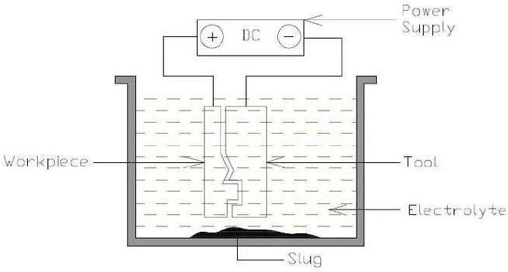

Diagram of Conceptual Electrochemical Model,

As soon as a potential difference is applied between the anode and the cathode, the ions start moving from anode to cathode.

The negative ions are attracted towards the workpiece which is placed at the +ve potential and positive ions are attracted towards the tool which is placed at the - ve potential.

The chemical reactions taking place in the basic process of electrochemical machining are as follows:

2H+ + 2e- = H2

Hydrogen ions gain electrons and get converted into hydrogen gas. (at the cathode) Fe = Fe++ + 2e-
The iron atom releases its 2 electrons and gets converted into Iron ions. (at the anode)

Na++OH- = NaOH Fe2++2Cl- = FeCl2
Sodium ions react with hydroxyl ions to form Sodium hydroxide. Iron ions react reacts with chlorine ions to form iron chloride (slug) DESCRIPTION OF EQUIPMENT
An electrochemical plant has various parts, those are as follows,

#1 Power supply

The power supply is the source of energy that is provided to the setup. The power supply is generally a DC battery consisting of a potential difference from 3 to 30V depending upon the requirement.

#2 Electrolyte
An electrolyte is a salt solution in which the workpiece and tool are kept during the process of machining. It acts as a current-carrying medium between the workpiece and the tool.

It also helps in the removal of waste products from internal gaps and also acts as a coolant by preventing overheating of the tool and the workpiece. Different electrolytes used in ECM are Sodium chloride (NaCl), Sodium nitrate (NaNO3), hydrochloric acid (HCl), etc.

#3 Tool

Tool or cathode used in ECM is one of the electrodes. It is also the desired shape in which the workpiece is to be cut. The tool used in ECM should always have accurate dimensions.

#4 Mechanical System

One of the most important elements in ECM is the mechanical system. It is used for the advancement of a tool that is perpendicular to the workpiece and is at a constant velocity.

#5 Tank

The tank contains the electrolyte, tool, and workpiece. All the reactions take place here.

#6 Pressure Gauge

A pressure gauge is used to measure the pressure of electrolytes which is supplied to the tool.

#7 Flow Control Valve

A flow control valve is used to control the flow of electrolyte which is supplied to the tool.

#8 Pressure Relief Valve

In case the pressure of electrolyte flow exceeds a certain limit, the pressure relief valve opens and it sends the electrolyte back to the tank.

#9 Reservoir Tank

The tank that stores pure Electrolytes is called the reservoir tank.

#10 Pump


There are two pumps used namely A and B. Pump A is used to draw electrolytes from the reservoir tank and pump B is used to supply the electrolyte to the reservoir tank.
#11 Filter and Centrifuge
A filter is used to filter the electrolyte reaching the reservoir tank. And prevents the accumulation of excess electrolytes. The function of a centrifuge is to separate the slug from the electrolyte.

#12 Slug Container

A slug container is used to store the slug which is separated from the electrolyte. This slug can be used for various experimental purposes.

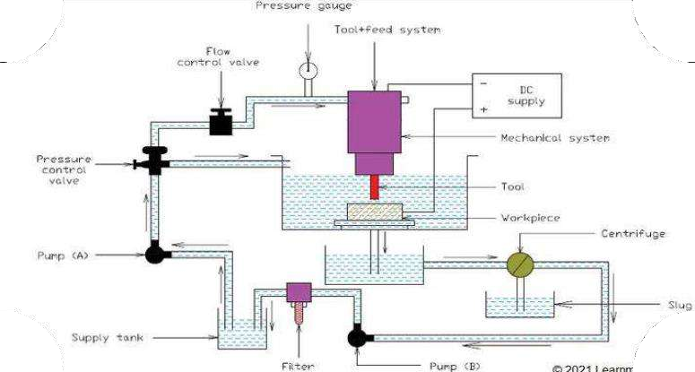
Diagram of Electro-Chemical Machining Setup

Working of Electrochemical Machining

The working of electrochemical machining starts with the advancement of the tool towards the workpiece. The tool and the workpiece are kept in a suitable electrolyte with a very small gap between them.


As soon as the potential difference is applied (DC), the workpiece starts behaving as an anode and the tool starts behaving as a cathode.

When the condition of electrolysis is fulfilled, the removal of metal from the workpiece starts. The removal takes place according to the shape of the tool. Material is removed from the workpiece and gets settled down in the form of a slug, which is due to the flow of electrolytes.

The electrolyte then goes through a filtration process. In the filtration process, the electrolyte is passed through a centrifuge where the slug is removed. Then it passes through a filter where other remaining impurities are removed. If there is an increase in the pressure of the electrolyte, the pressure valve deviates the flow of the electrolyte directly to the tank.

Material removal rate
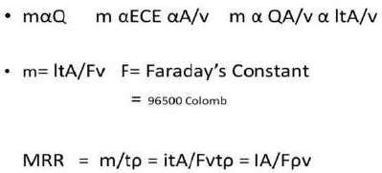

Applications
- As mentioned earlier in the article ECM is used for heavy machining of hard materials which cannot be machined using conventional methods.
- Due to its high accuracy and surface finish, ECM is used for micromachining. As there is no contact between the tool and workpiece the final product obtained is accurate at the atomic level.
- ECM is also used for the production of very small gear systems which cannot be machined using typical machining processes.
- ECM is used for machining turbine blades as it is difficult to machine due to its complex concave structure.
- ECM can also be used for drilling and milling operations.

CHARACTERISTICS of ECM
Material removal mechanism - Controlled removal of metal by
anodie dissolution in an electrolytic medium.
Tool - Cu, brass or steel.
Power supply - Constant voltage DC supply Voltage and Current - 5-30 V d.c, 50-40,000 Amp. Material removal rate - 1600 mm/min.
Specific power consumption - 7 W/mm/min (around 150 times more in comparison to conventional methods)
Electrolytic solution - Neutral salts, acids and alkalies. Accuracy and Surface finish - ±0.02mm, 0.4μm.
Applications -Used for machining difficult-to-machine materials and complex-shaped parts.
Mechanical and surface properties of metals - Stress free machining, burr-free surface, reduced tool wear,no thermal damage.
Limitations - High specific energy consumption, not suited for non- conducting pieces; high initial and working cost.

Plasma Arc Machining

Plasma-arc machining (PAM) employs a high-velocity jet of high-temperature gas to melt and displace material in its path. Called PAM, this is a method of cutting metal with a plasma-arc, or tungsten inert-gas-arc, torch. The torch produces a high-velocity jet of high-temperature ionized gas called plasma that cuts by melting and removing material from the workpiece. Temperatures in the plasma zone range from 20,000° to 50,000° F (11,000° to 28,000° C).

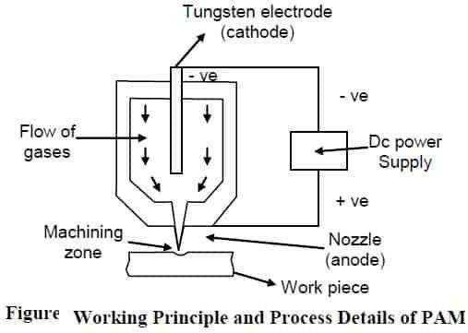

DESCRIPTION OF EQUIPMENTS

Plasma Gun
Gases are used to create plasma-like, nitrogen, argon, hydrogen, or a mixture of these gases. The plasma gun consists of a tungsten electrode fitted in the chamber. The electrode is given negative polarity and the nozzle of the gun is given positive polarity. The supply of gases is maintained into the gun. A strong arc is established between the two terminals anode and cathode. There is a collision between molecules of gas and electrons of the established arc. As a result of this collision, gas molecules get ionized and heat is evolved. This hot and ionized gas called plasma is directed to the workpiece with high velocity. The established arc is controlled by the supply rate of gases.

Power Supply and Terminals
Power supply (DC) is used to develop two terminals in the plasma gun. A tungsten electrode is inserted to the gun and made cathode and nozzle of the gun is made anode. Heavy potential difference is applied across the electrodes to develop a plasma state of gases.

Cooling Mechanism
As we know that hot gases continuously come out of nozzle so there are chances of its overheating. A water jacket is used to surround the nozzle to avoid its overheating.

Tooling
There is no direct visible tool used in PAM. Focused spray of ho0t, plasma state gases works as a cutting tool.

Workpiece
The workpiece of different materials can be processed by the PAM process. These materials are aluminum, magnesium, stainless steel, and carbon and alloy steels. All those material which can be processed by LBM can also be processed by the PAM process.

Material removal rate
The values of the material removal rates in Plasma beam machining will be nearly 150 cm3/min.

PROCESS PARAMETER
Parameters that govern the performance of PAM can be divided into three categories:
- Those associated with the design and operation of the torch – eletrical power delievered , the gases used to form the plasma, the flow rate of the gases through the torch, the orifice diameter through the nozzle duct

- Those associated with the physical configuration of the set up – torch standoff, angle to the work, depth of cut, feed into the work and speed of the work toward the torch
- Environment in which the work is performed – cooling that is done on the bar, any protective type of atmosphere used to reduce oxidation fo the exposed high temperature machined surface and any means that might be utilized to spread out or deflect the arc and plasma impingment area

CHARACTERISTICS OF PAM

Technique of machining Heating of workpiece by high temperature ionised
gas (plasma) and causing quick melting

Tool Plasma jet

Velocity of plasma jet 500 m/sec.

Material removal rate 150 cm³/min

Specific energy 1000 W/cm³-min

Power range 2 to 200 kW

Material of workpiece All materials which conduct electricity Voltage 30-250 V

Current Upto 600 amp.

Cutting speed 0.1-7.5 m/min

Applications Profile cutting of stainless steel, monel, and superalloy plates

Plate thickness 200 mm (max)

Limitation Low accuracy.

Construction of PAM

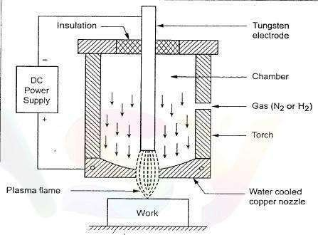

APPLICATIONS

- It is used for cutting alloy steels, stainless steel, cast iron, copper, nickel, titanium, aluminum, and alloy of copper and nickel, etc.
- It is used for profile cutting.
- It is successfully used for turning and milling of hard to machine materials.
- It can be used for stack cutting, shape cutting, piercing, and underwater cutting.
- Uniform thin film spraying of refractory materials on different metals, plastics, ceramics are also done by plasma arcs.

Electron Beam Machining

Electron beam machining (EBM) is a thermal machining process in which high-velocity electrons concentrated into a narrow beam are used for instantly heating, melting, or vaporizing the material. This process is used in many applications, including drilling, cutting, annealing, and welding

PRINCIPLE
In an electron beam machining, the electrons strike the workpiece with a high velocity. As the electron strikes the workpiece, the kinetic energy of the electron changes into heat energy. The heat energy so produced is used to melt and vaporize the materials from the w/p. The whole process takes place in vacuum. Vacuum environment is used to prevent the contamination and avoid collision of electrons with air molecules. If the electrons collide with the air molecules, it will lost its Kinetic energy.
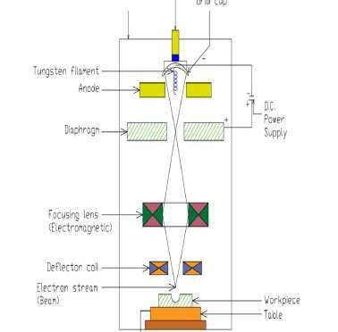

DESCRIPTION OF EQUIPMENTS
The various equipment used in EBM machine are

Cathode
The cathode is negatively charged and it is used to produce Electrons.

Annular Bias Grid
It is present next to the cathode. Annular bias grid is a circular shaped bias grid and prevents the diversion of electrons produced by the cathode. It works as a switch and makes the electron gun to operate in pulse mode.

Anode
It is placed after the annular bias grid. It is positively charged. Annular anode attracts the beam of electron towards it and gradually the velocity of the electron increases. As the electron beam leave the anode section, its velocity becomes half of the velocity of light

.4. Magnetic Lenses
The magnetic lenses reduce the divergence of electron beam and shape them. It allows only convergent electrons to pass and captures the low energy divergent electrons from fringes. It improves the quality of the beam.

Electromagnetic Lens
It helps the Electron beam to focus on the desired spot.

Deflector Coils
The deflector coil carefully guides the high velocity electron beam to a desired location on the workpiece and improves the shape of the holes.

Material removal rate,
The values of the material removal rates in the process of electron beam machining are about 10 mm3/min.

Process parameters

The process parameters of EBM are as follows.

  - Beam current: It is related to the emission of electrons by the cathode in the beam whose value is as low as 1µA.
  - Duration of Pulse: It can be varied from 50 µs to 15 ms.
  - Accelerating voltage (Va) is 100 Kv.
  - Energy per pulse is 100 J/Pulse.

Characteristics 0f EBM
Material Removal Technique High speed electrons impinge on surface and
kinetic energy of electrons produces intense heat. or vaporise the metal
Voltage 150 KV

Electron velocity 228 x 1000 km/sec. Power density 6500 billion W/mm2
Operations performed Annealing, welding, or metal removal by cutting narrow
slots, drilling holes of 25-125 um in 1.25mm thick shells. Complex contours possible by deflection by coils
Medium Vacuum (10 mm Hg) Materials of workpiece All materials

Material removal rate 10 mm/min (max) Specific power consumption 500 W/mm min
Limitations Not suitable for large workpieces. Small crates produced on beam incident side of work. A little taper produced on holes.Very high specific energy consumption, necessity of vaccum,high cost of machine
Advantages There is no effect of local heat on workpiece as the temperature of surrounding material(25-50 μm away from the machining spot)is not raised.
Applications

The applications of Electron Beam Machining Process are as follows.

  - Mainly used for producing holes in the diesel injection nozzles.
  - Also used for producing blind holes, narrow slots, etc. in the workpieces.
  - In electron beam machining, if the voltage given to the electron gun is about 60 to 70000 volts, the velocity of electrons produced is reducing, heat generation at the workpiece is reducing.
  - Therefore, the heat generated is sufficient to melt and join the workpiece called an electron beam welding

Plastics Processing

Plastics Processing
    - Plastics can be machined, cast, formed, and joined with relative ease requiring little post-processing or surface- finish operations
    - Plastics melt or cure at relative low temperatures
    - Plastics require less energy to process than metals
    - Raw materials most commonly are pellets, powders
    - Also available as sheet, plate, rod, and tubing (produced by extrusion, etc.)
    - Liquid plastics used to make reinforced plastic parts (composite materials)

Plastics Processes

TABLE 18.1

Process Characteristics

Extrusion Long, uniform, solid or hollow complex cross-sections; high production rates; low tooling costs; wide tolerances.
Injection molding Complex shapes of various sizes, eliminating assembly; high production rates;
costly tooling; good dimensional accuracy.
Structural foam molding Large parts with high stiffness-to-weight ratio; less expensive tooling than in injection molding; low production rates.
Blow molding Hollow thin-walled parts of various sizes; high production rates and low cost for
making containers.
Rotational molding Large hollow shapes of relatively simple shape; low tooling cost; low production
rates.
Thermoforming Shallow or relatively deep cavities; low tooling costs; medium production rates.
Compression molding Parts similar to impression-die forging; relatively inexpensive tooling; medium
production rates.
Transfer molding More complex parts than compression molding and higher production rates; some
scrap loss; medium tooling cost.
Casting Simple or intricate shapes made with flexible molds; low production rates. Processing of composite materials Long cycle times; tolerances and tooling cost depend on process.

Plastics Processes
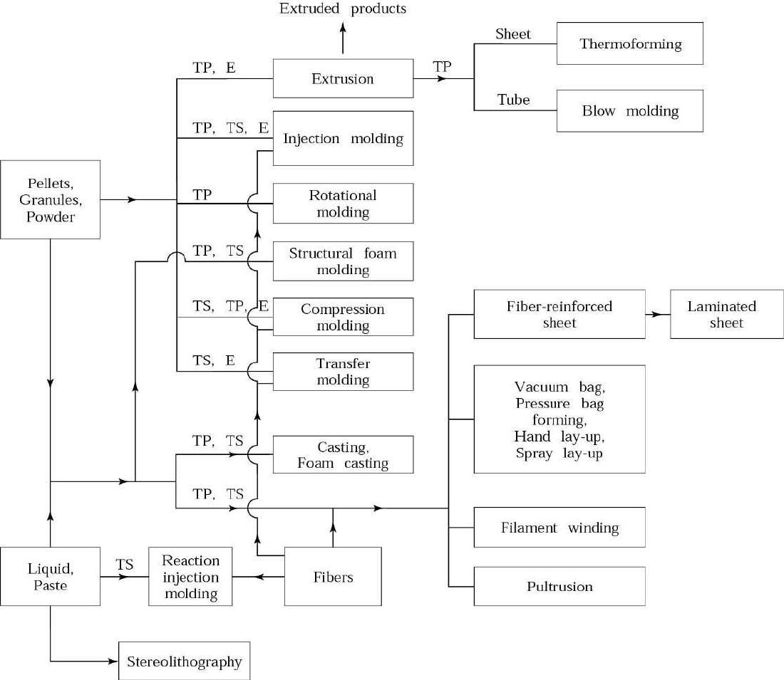

Extrusion

- Raw materials are thermoplastic pellets, granules, or powder
- Placed in hopper and fed into extruder barrel
- Screw blends pellets and pushes them down the barrel –
through the feed, transition/melt, and pumping sections
- Barrel is heated from outside, and by friction
- Plastic (or elastomer) is liquefied and forced through a die under pressure
- Pellets for other plastics processes are made by extruding small-diameter rod and chopping into short segments
- Equipment costs on the order of $300,000
  - Rated by barrel diameter (D, 1-8 inch) and L/D ratio (5 to 30)

Extruded Products
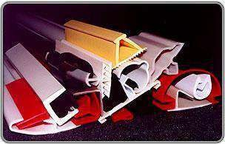
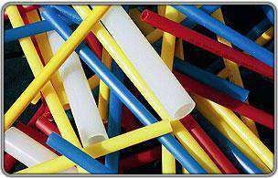

Extrusion
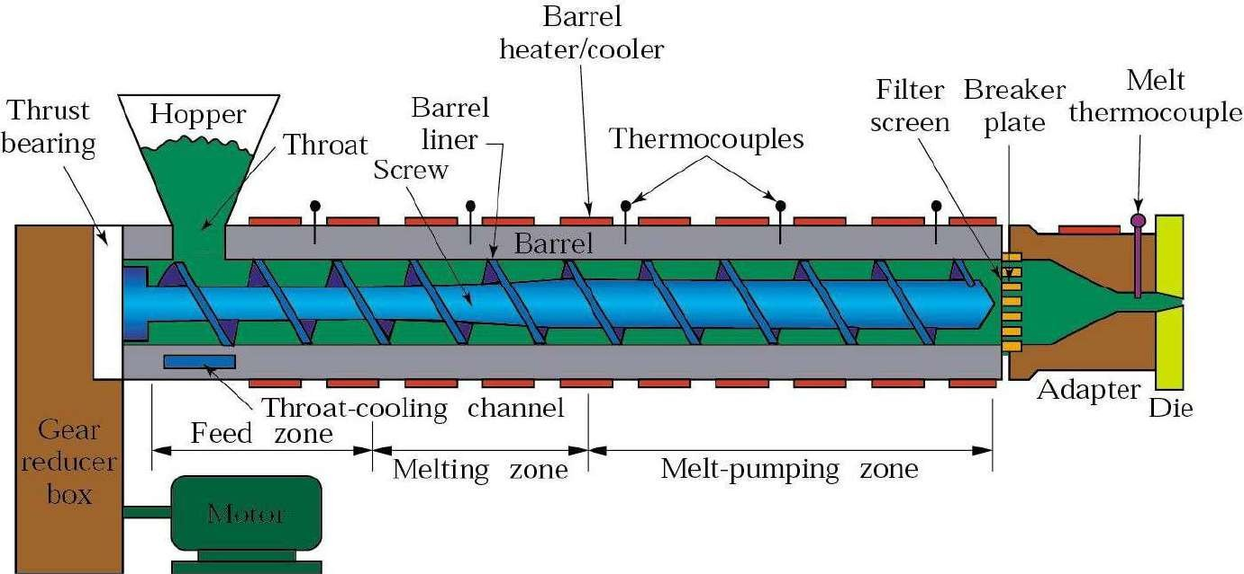

Polymer Melts

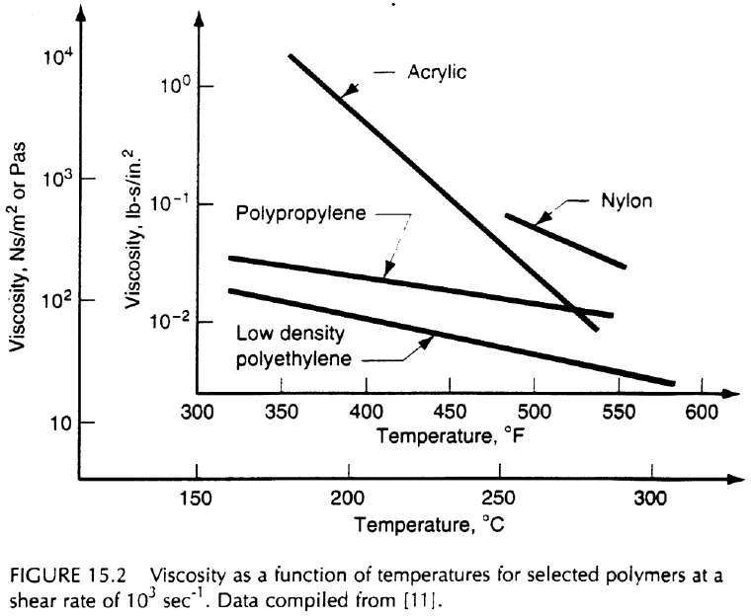
- Viscosity reduces with temperature
- Polymer melts have viscoelastic properties
- This causes die swell during extrusion

Extrusion Die Swell

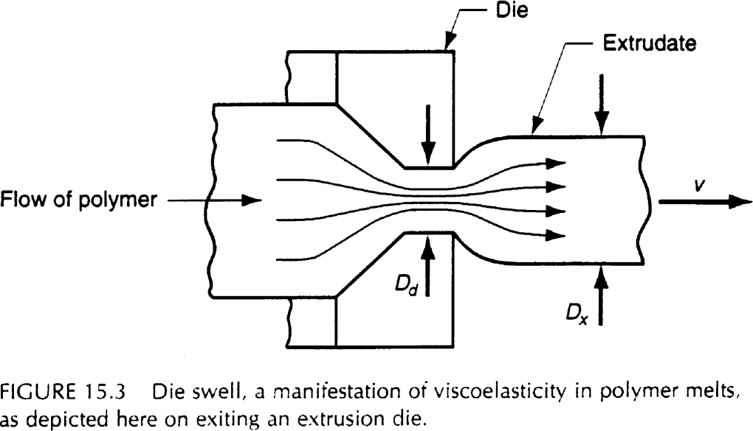
Swell ratio: r = Dx
Dd
s

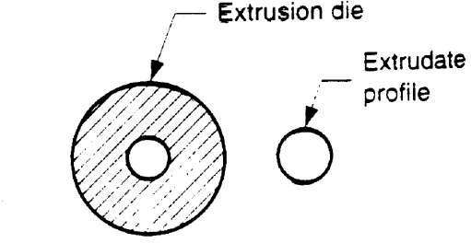
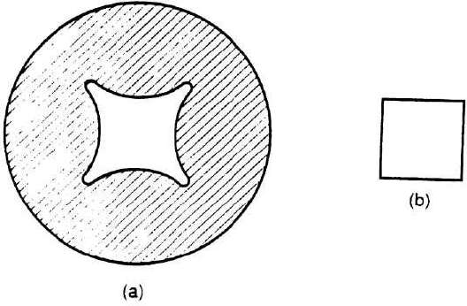
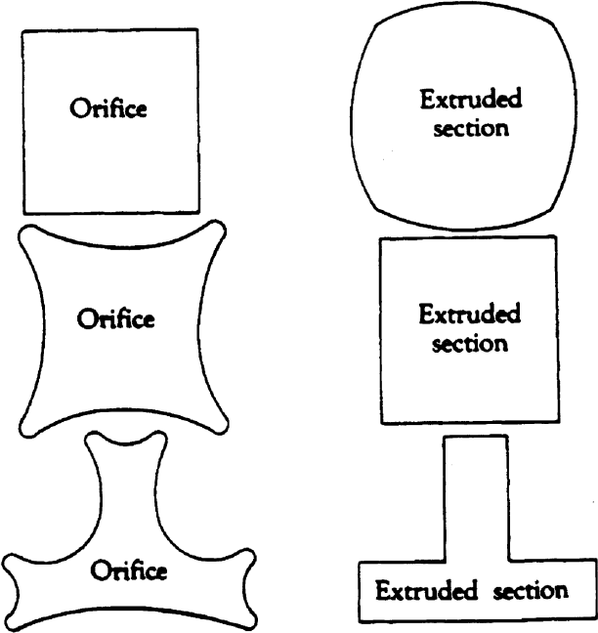
Extrusion – Effects of Die Swell

Extrusion of Hollow Shapes

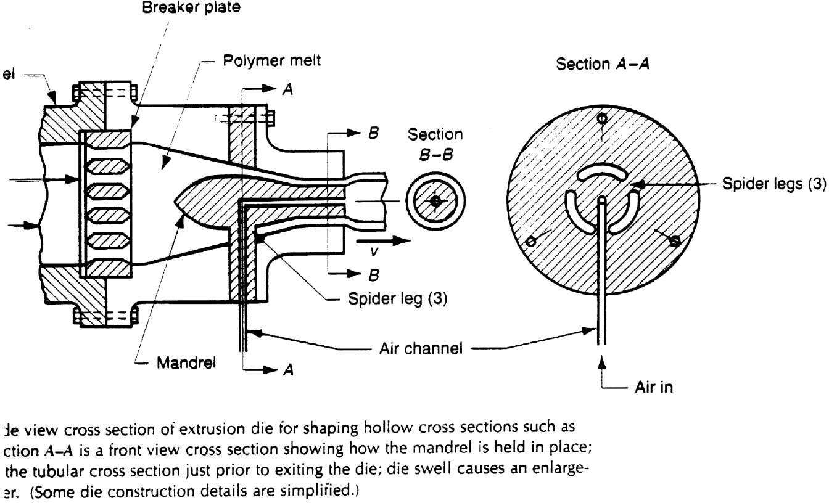

Extrusion Coating of Wires

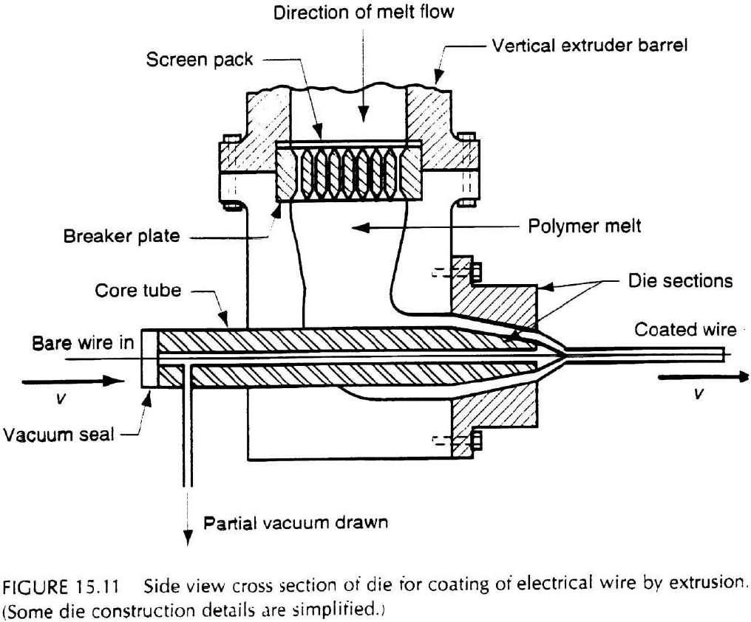

Extrusion of Sheet

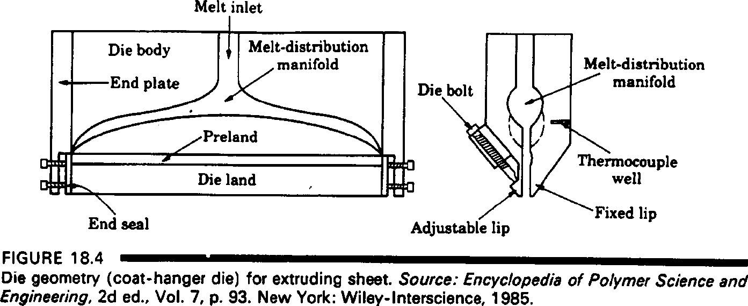

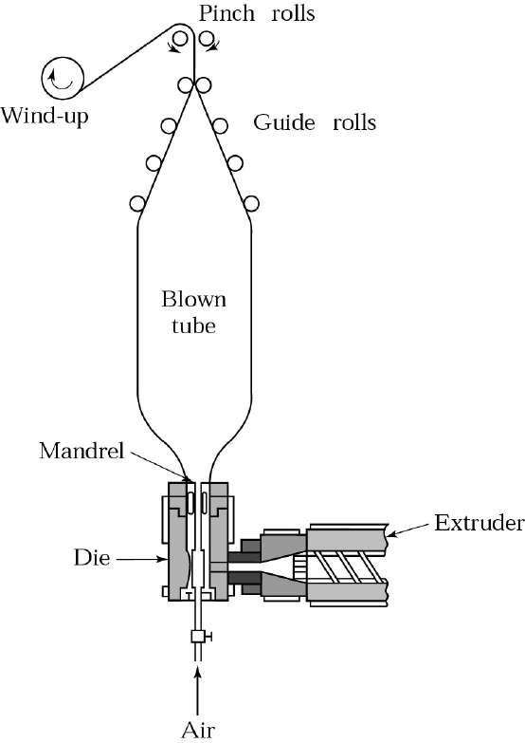
Blown Film Extrusion

- Carried vertically
- Used to manufacture plastic film and plastic bags
- Mainly for materials such as LDPE and PVC

Injection Molding

- Similar to hot-chamber die casting of metals
- Pellets, granules, or powder are fed into heated cylinder, then forced into die chamber by hydraulic plunger or rotating screw system
- Pressures from 70-200 MPa (10-30 Kpsi)
- Cool molds for thermoplastics. Heated molds for thermosets
- Complex shapes and good dimensional accuracy
- Using metallic inserts, multiple materials/colors, and printed films can eliminate post processing or assembly operations

Injection Moldings
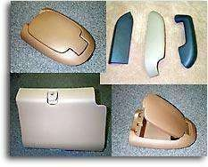
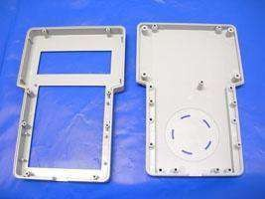
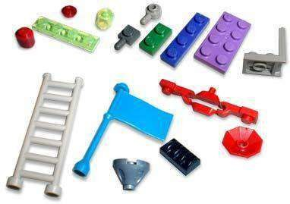

Injection Molding

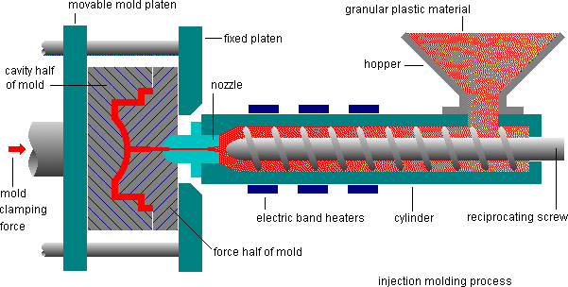

Injection Molding

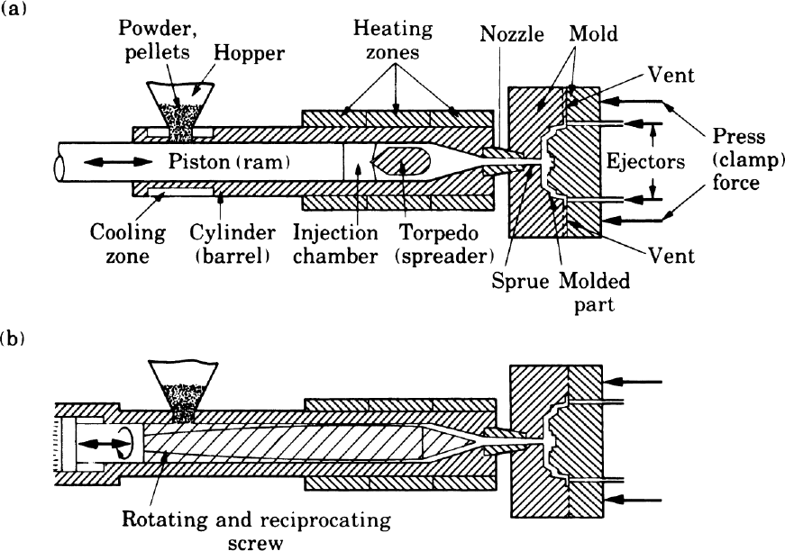
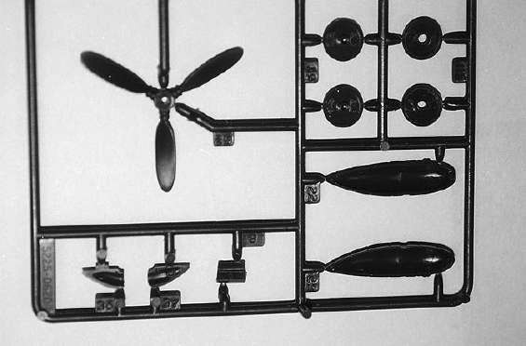
(c)

  - Cold-runner molds are similar to metal casting
  - More expensive hot-runner molds have no gates, runners, or sprues attached to final part

Plastic Injection Molding
Cycle Time Breakdown

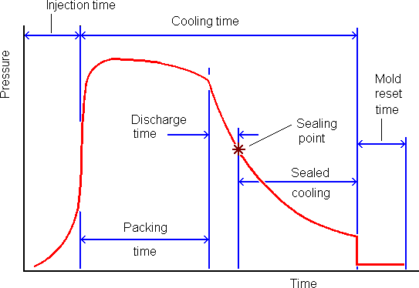

Injection Molding Two Plate Mold

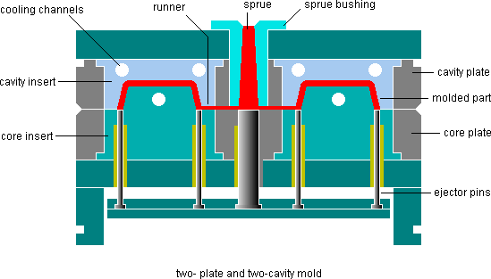

Injection Molding Die Mechanisms Unscrewing Core

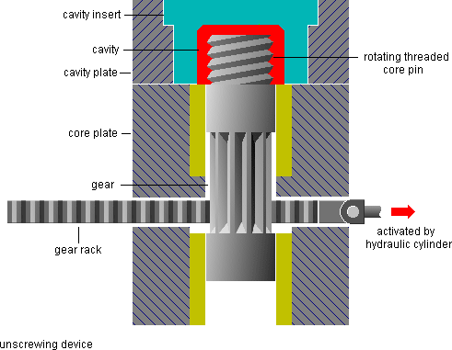

Injection Molding Capabilities

- High production rates
- Good dimensional control
- 5-60 second cycle times (or several minutes for thermoset materials)
- Molds with multiple cavities, made of tool steels (2 million cycles), aluminum (10,000 cycles), etc.
- Mold costs up to $20-200K
- Machines are usually horizontal with clamping forces 0.9-
2.2 MN (100-250 tons)
- 100 ton machines cost $60-90K
- 300 ton machines cost $85-140K

Structural Foam Molding

- A variation of the injection molding process, developed for applications where stiffness is a primary concern, and particularly for large structural parts.
- Parts consist of a rigid, closed-cellular core surrounded by a continuous, solid skin.
- The polymer melt contains a dissolved inert gas; most commonly nitrogen, introduced in the extrusion screw.
- A predetermined shot size is injected into the mold cavity, the extruder valve is closed, and the foam material generates internal pressure and expands to fill mold cavity.
- A much lower pressure operation than the conventional injection molding system, which allows much larger parts to be molded.

Structural Foam Molding

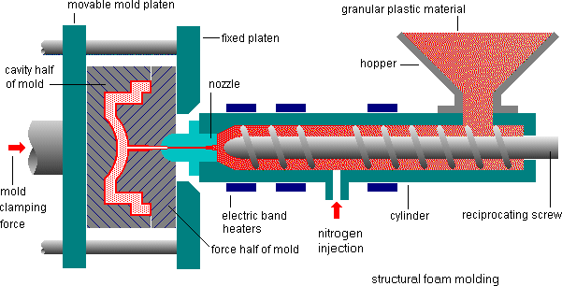

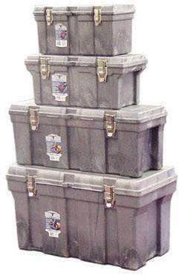
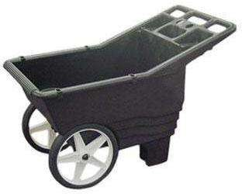
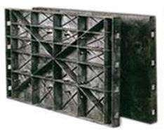
Structural Foam Moldings

Reaction Injection Molding
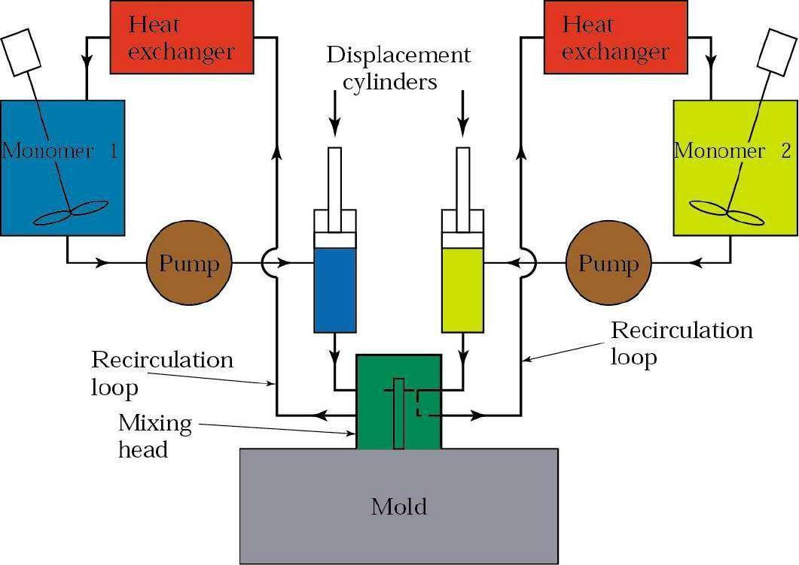
Chemical reaction between two polymer materials - thermoset

- Large parts
- Low tooling costs
- Car bumpers are good examples for this process

Reaction Injection Moldings

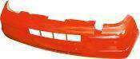
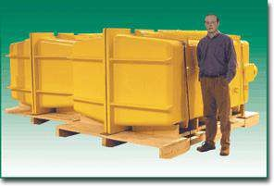

Blow Molding

  - Modified extrusion and injection molding processes
  - Extrusion Blow Molding
    - Small tube is first extruded, usually vertically, then clamped and air blown inside to expand it to fit a much larger diameter mold
    - Air pressures 350-700 kPa (50-100 psi)
    - Can be a continuous process (corrugated pipe and tubing)
  - Injection blow molding
    - Short tubular piece (parison) injection molded, transferred to a blow-molding die
    - Plastic beverage bottles and hollow containers
  - Multilayer blow molding
    - Uses coextruded tubes or parisons
    - Plastic packaging for food and beverages, cosmetics and pharmaceutical industries

Blow Moldings


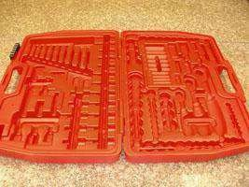

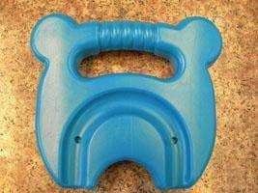

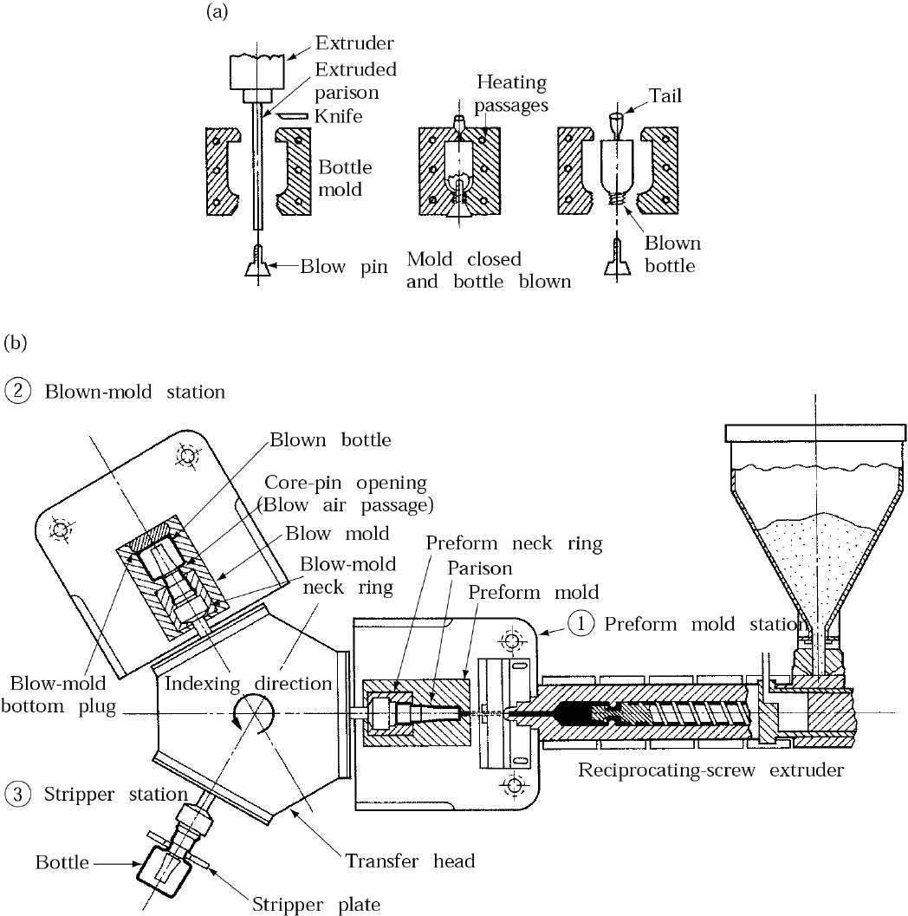
Blow Molding

Figure 18.9 Schematic illustrations of (a) the blow-molding process for making plastic beverage bottles, and (b) a three- station injection blow-molding machine. Source: Encyclopedia of Polymer Science and Engineering (2d ed.).
Copyright ©1985.
Reprinted by permission of John Wiley & Sons, Inc.

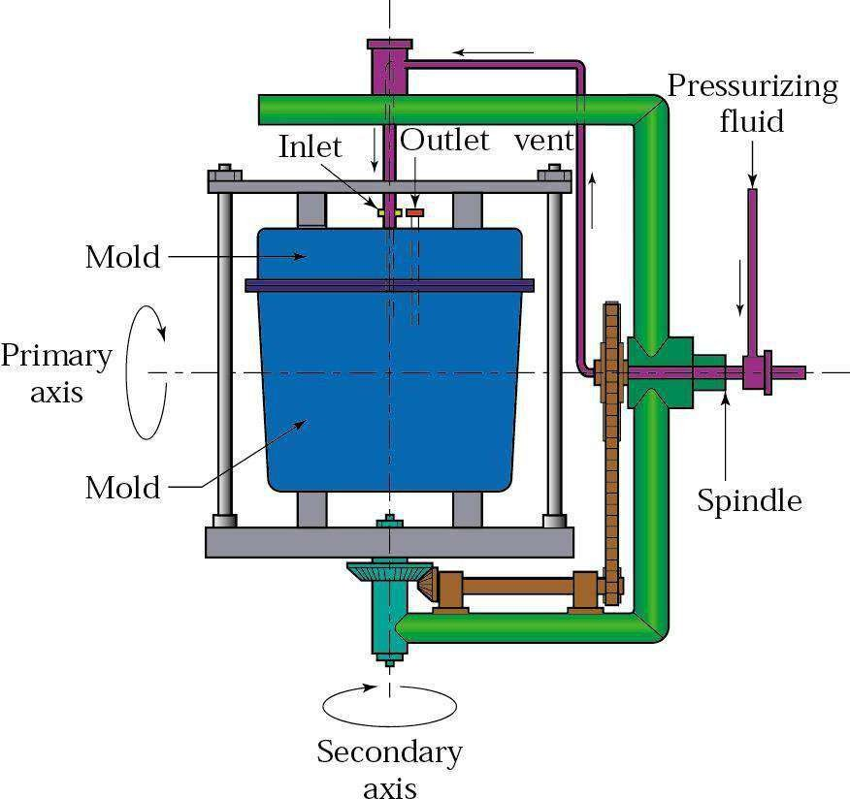
Rotational Molding

- Premeasured quantity of powder placed inside warm mold
- Rotated on two axes inside a heated furnace
- Low equipment costs
- Longer process times
- Trash cans, boat hulls, buckets, toys, footballs
- 0.4 mm wall thickness possible
- Also, slush molding

Rotational Moldings

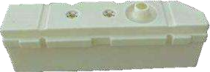




Thermoforming
- Plastic sheet is heated to a sag point (softened, but not melted)
- Heated sheet placed over a room-temperature mold and forced against it by vacuum pressure
- Stretch forming process – material thickness variations
- Advertising signs, refrigerator liners, appliance housings, shower stalls, packaging
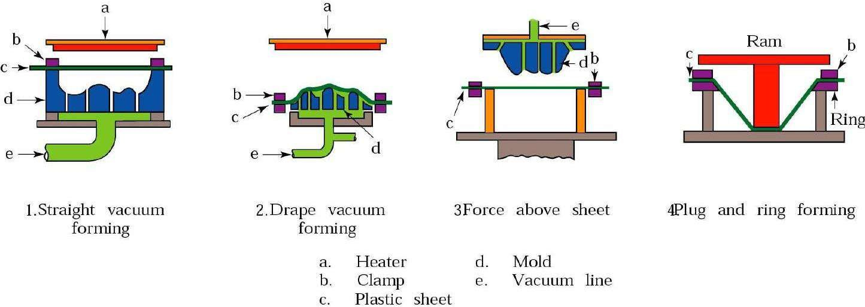

Thermo Formed Parts

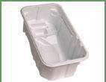
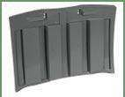

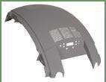

Compression Molding
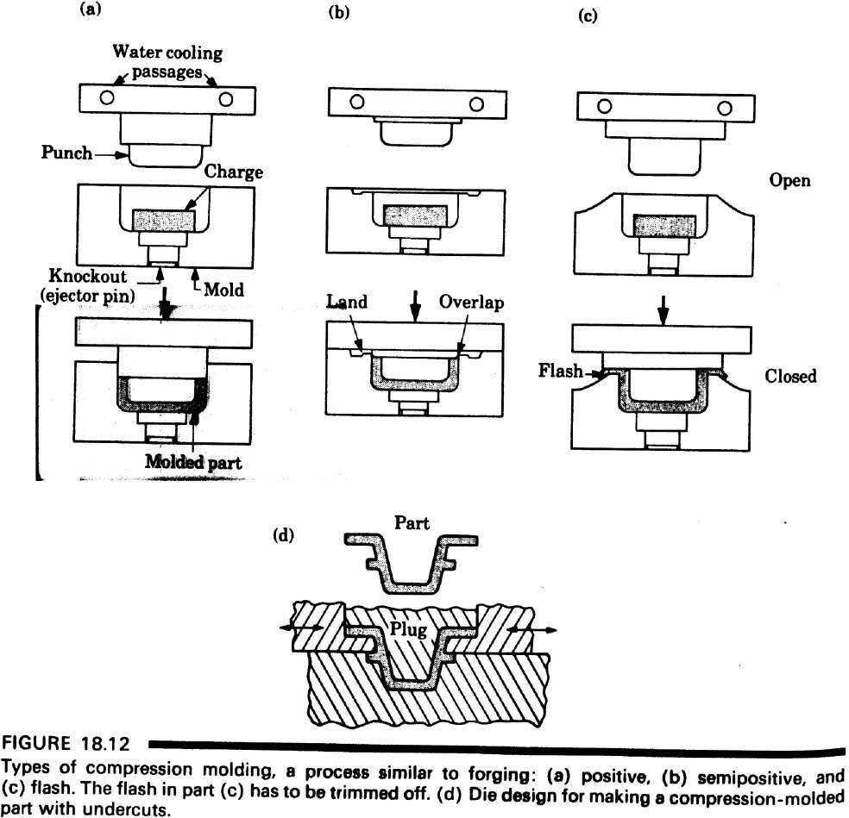

Compression Moldings

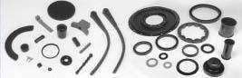

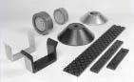

Rapid prototyping:
It is the fast fabrication of a physical part, model or assembly using 3D computer aided design (CAD). The creation of the part, model or assembly is usually completed using additive manufacturing, or more commonly known as 3D printing.
Different Types of Rapid Prototyping Processes:
- Stereolithography Apparatus (SLA) or Vat Photopolymerization:-
This fast and affordable technique was the first successful method of commercial 3D printing. It uses a bath of photosensitive liquid which is solidified layer-by-layer using a computer-controlled ultra violet (UV) light.

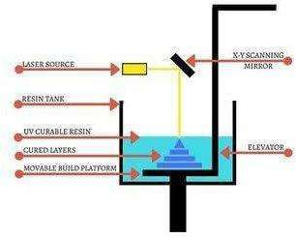

- Selective Laser Sintering (SLS):
Used for both metal and plastic prototyping, SLS uses a powder bed to build a prototype one layer at a time using a laser to heat and sinter the powdered material. However, the strength of the parts is not as good as with SLA, while the surface of the finished product is usually rough and may require secondary work to finish it.
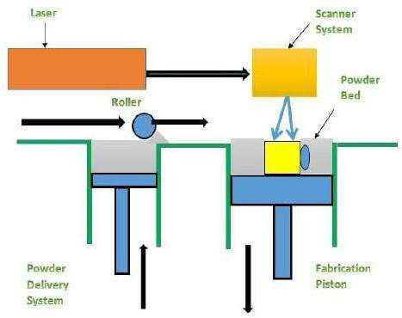

- Fused Deposition Modelling (FDM) or Material Jetting:
This inexpensive, easy-to-use process can be found in most non-industrial desktop 3D printers. It uses a spool of thermoplastic filament which is melted inside a printing nozzle barrel before the resulting liquid plastic is laid down layer-by-layer according to a computer deposition program. While the early

results generally had poor resolution and were weak, this process is improving rapidly and is fast and cheap, making it ideal for product development.

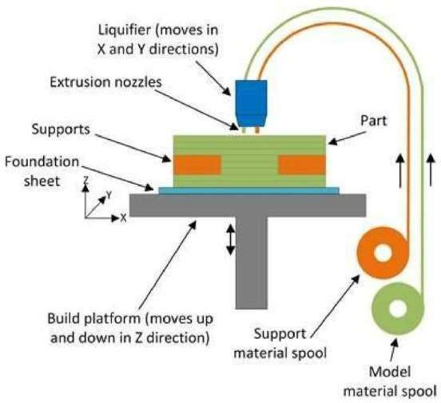

- Selective Laser Melting (SLM) or Powder Bed Fusion:
Often known as powder bed fusion, this process is favoured for making high-strength, complex parts. Selective Laser Melting is frequently used by the aerospace, automotive, defence and medical industries. This powder bed based fusion process uses a fine metal powder which is melted in a layer by layer manner to build either prototype or production parts using a high-powered laser or electron beam. Common SLM materials used in RP include titanium, aluminium, stainless steel and cobalt chrome alloys.

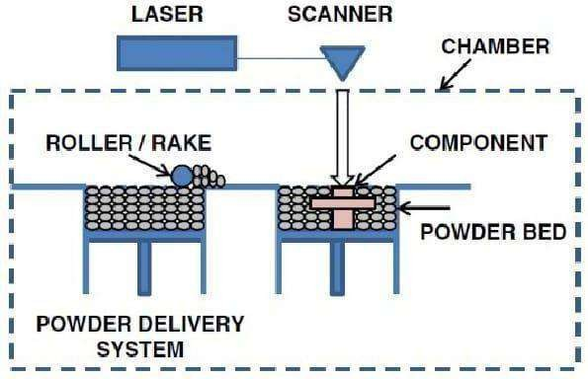

- Laminated Object Manufacturing (LOM) or Sheet Lamination:

This inexpensive process is less sophisticated than SLM or SLS, but it does not require specially controlled conditions. LOM builds up a series of thin laminates that have been accurately cut with laser beams or another cutting device to create the CAD pattern design. Each layer is delivered and bonded on top of the previous one until the part is complete.

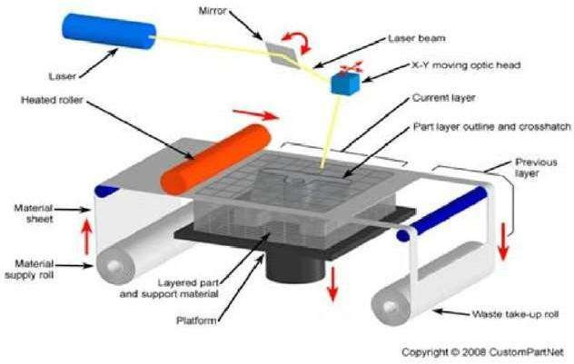
- Digital Light Processing (DLP):
Similar to SLA, this technique also uses the polymerisation of resins which are cured using a more conventional light source than with SLA. While faster and cheaper than SLA, DLP often requires the use of support structures and post-build curing.
An alternative version of this is Continuous Liquid Interface Production (CLIP), whereby the part is continuously pulled from a vat, without the use of layers. As the part is pulled from the vat it crosses a light barrier that alters its configuration to create the desired cross-sectional pattern on the plastic.

Working Process:
The digital light projector is the light source of a DLP 3D printer. The DMD (Digital Micromirror Device) is a component which is made of thousands of micromirrors used for navigating the light beam projected by the digital light projector. Next up the line is the vat, which is basically a tank for the resin.
However, the vat needs to have a transparent bottom so that the light projected by the digital light projector reaches the resin and cures it. The build platform is simply the surface the printed objects stick to during printing. The z-axis is also a self-explanatory component, used for slowly lifting the build platform during the printing process.
Again next layer is formed until complete model gets ready.

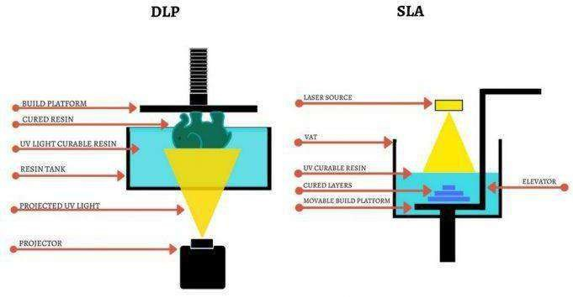
- Binder Jetting:
This technique allows for one or many parts to be printed at one time, although the parts produced are not as strong as those created using SLS. Binder Jetting uses a powder bed onto which nozzles spray micro-fine droplets of a liquid to bond the powder particles together to form a layer of the part. Each layer may then compacted by a roller before the next layer of powder is laid down and the process begins again. When complete the part may be cured in an oven to burn off the binding agent and fuse the powder into a coherent part.

Applications:

Product designers use this process for rapid manufacturing of representative prototype parts. This can aid visualisation, design and development of the manufacturing process ahead of mass production.

Originally, rapid prototyping was used to create parts and scale models for the automotive industry although it has since been taken up by a wide range of applications, as medical and aerospace. across multiple industries such
Rapid tooling is another application of RP, whereby a part, such as an injection mould plug or ultrasound sensor wedge, is made and used as a tool in another process.

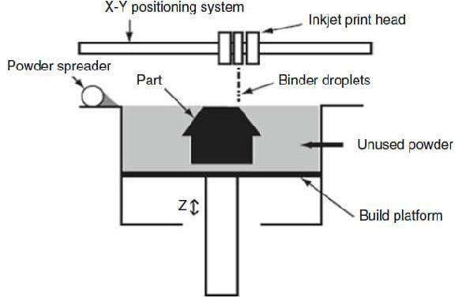

Web-based RP systems:
Rapid prototyping (RP) technique has shown a high potential to reduce the cycle and cost of product development, and has been considered as one of crucial enabling tools in digital manufacturing to effectively aid rapid product development.
Manufacturing industry is evolving toward digitalization, network and globalization. The Internet, incorporating computers and multimedia, has provided tremendous potential for remete integration and collaboration in business and manufacturing applications. RP&M technique using the Internet can further enhance the design and manufacturing productivity, speed, and economy, as well as share the RP machines.

Web-based RP systems have been developed and employed to implement remote service and manufacturing for rapid prototyping, enhance the availability of RP facilities and improve the capability of rapid product development for a large number of small and medium sized enterprises.

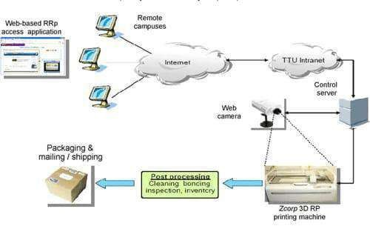

Flexible Manufacturing System:

A flexible manufacturing system is a automated machine cell, consisting of a group of processing workstations, interconnected with automated material handling and storage system.

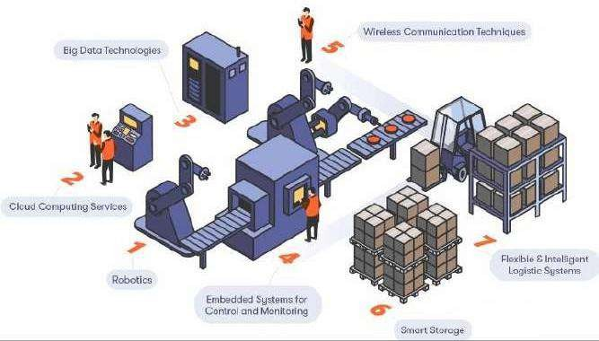
The FMS is most suited for the mid-variety, mid-volume production range
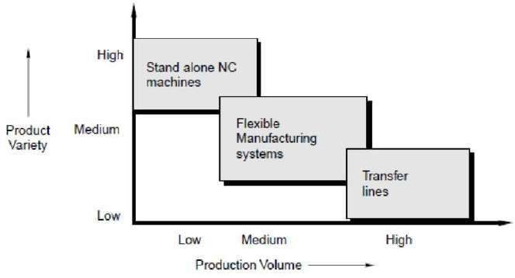

Benefits of FMS:

- It allows external changes such as change in product design and production system.
- Optimizing the manufacturing cycle time
>Reduced production costs
- Overcoming internal changes like breakdowns etc.

Three capabilities that a manufacturing system must possess to be a flexible.
- The ability to identify and distinguish among the different part styles processed by the system.
- Quick changeover of operating instructions, and
- Quick changeover of physical setup.

Basic components of FMS :
Workstations
Automated Material Handling and Storage systems Computer Control System

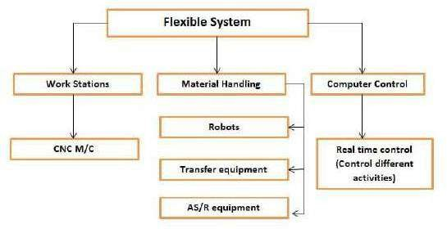

Concurrent Engineering
It is also known as simultaneous engineering. It is a method of designing and developing products, in which the different stages run simultaneously, rather than consecutively. It decreases product development time and also the time to market, leading to improved productivity and reduced costs.
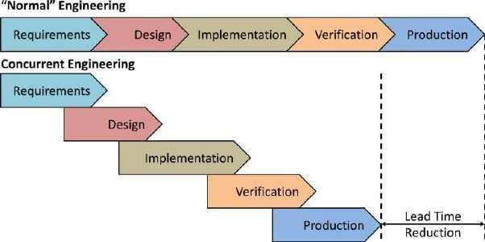

Capstan Lathe

It is the modified form of Engine Lathe and Center Lathe in which the tailstock is replaced by a hexagonal turret tool head.
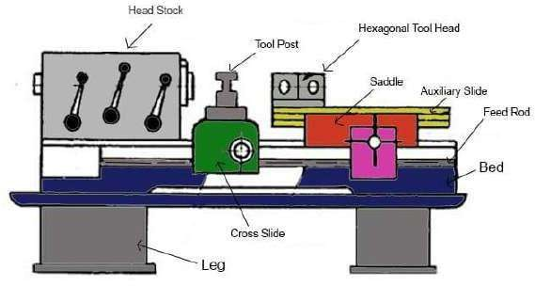

Turret Lathe:
A turret lathe is a semi-automatic lathe machine that is used for repetitive production of lathe parts. It is advance from the lathe machine produced earlier as it has a hexagonal turret.

Hexagonal turret is an indexable tool holder which can hold six tools at a time. With the help of hexagonal turret, multiple cutting operations can be performed each with different cutting tool in rapid succession without the need to replace or install and uninstall the tool in the lathe machine. In turret lathe, the tool can be switched automatically resulting in faster and more efficient production processes. The turret lathe can change to a different cutting tool in a few seconds but in a traditional lathe, it can take minutes for a human worker to manually change the cutting tool. When many operations are to be performed and the production has to be increased the turret lathe is used.

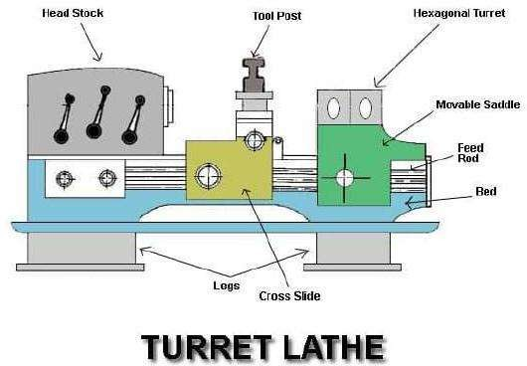

CAPSTAN LATHE | TURRET LATHE
Turret head is mounted on a ram which slides over the saddle | Turret head is directly mounted on saddle. But it slides on the bed.
Turret movement is limited | Turret movement on the entire length of bed without any restriction
Shorter work piece can be machined | Longer work piece can be machined
Light duty application | Heavy duty application
Turret head can be moved manually | Turret head cannot be moved manually

SPECIAL PURPOSE MACHINE
Any machine which is used for mass production of particular component is called Special Purpose machine. SPM tools are developed for performing specific operation in mass production environment. SPM intended for manufacture of a special type of product. The machine will not have much variation but will have a small with in that vacinity. Ex.
Hexagonal nuts, springs are some of the examples of product which am manufacture with the help of special purpose machines.

Advantage of Special Purpose Machines
- High accuracy
- Comprehensive tooling solutions
- Uniform quality
- Large production quantites.
- Repeatability
- Minimum possible time. Uncomplicated service or repair
- Short batch production

Elements of Special Purpose Machine
The elements that are used only in the specific type of machine are called as special purpose elements. For instance piston and connecting rods are used in the engines and compressors, while blades are used in the turbines and blowers. Some other examples are cam shafts push roads,crankshaft, cylinder etc.
The Elements of Special Purpose Machine are classified into two types fasteners and elements of rotary motion drive. These an described below:

- Fasteners
The fasteners are the machine elements that connect or join various parts of the machine. The joints can be of permanent type or temporary type The permanent joints are the ones that cannot be separated or disassembled into individual elements without destroying or damaging them. The examples of permanent joints an welded joints, riveted joints etc. The temporary joints are the ones in which the individual elements of the assembly can be separated easily without destroying or damaging them. The joints obtained by nut and bolt, and the cotter joints are common and widely used examples of the temporary joints.

- Elements of rotary motion drive
These are the elements that help transmit the motion or power to or from the machines. For example belt connected to the motor and pump helps running the them. The gear box helps transmit the motion and power from the engine to the wheels of the vehicles. Other examples of elements of the rotary motion drive are rope, chain, gear, worm drives, shafts, axles, couplings, bearings etc.

Principle of SPM design
Machine design and drawing are very important subjects of mechanical engineering No product can be manufactured without designing it. He some basic concepts of machine design or mechanical design have been covered.

The knowledge of machine design helps the designers as follows:
- To select proper materials and best suited shapes,
- To calculate the dimensions based on the loads on machines and strength of the material,
- Specify the manufacturing process for the manufacture of the designed component of the machine or the whole machine.

Machine Design is the application of mathematics, kinematics, statics dynamics, mechanics of materials, engineering materials, mechanical technology of metals and engineering drawing. It also involves application of other subjects like thermodynamics, electrical theory, hydraulics, engines, turbines, pumps etc. Machine drawing is the integral part of the machine design, since all the components or the machines that have been designed should be drawn to manufacture them as per the specifications Without machine drawing the subject of machine design is Incomplete.

Here are some guidelines as to how the machine design engineer cas proceed with the design

- Making the written statement
Make the written statement of what exactly is the problem for which the machine design has to be done. This statement should be very clear and

as detailed as possible If you want to develop the new produce write down the details about the project. This statement is sort of the list of the alms that are to be achieved from machine design.

- Consider the possible mechanism
When we designing the machine consider all the possible mechanisms which help desired motion of the group of motions in your proposed machine. From the various options the best can be selected whenever required

- Transmitted forces
Machine is made up of various machine elements on which various fores are applied. Calculate the forces acting on each of the element and energy transmitted by them.

- Material selection
Select the appropriate materials for each element of the machine so that they can sustain all the forces and at the same time they have least possible cost.

- Find allowable stress
All the machine elements are subjected to stress whether small or large Considering the various forces acting on the machine elements, their material and other facts that affect the strength of the machine calculate the allowable or design stress for the machine elements.
- Dimension of the machine elements
Find out the appropriate diameters for the machine elements considering the forces acting on it, its material, and design stress. The size of the machine elements should be such that they should not distort or break when loads are applied.

- Consider the past experience
If you have the past experience of designing the machine element or the previous records of the company, consider them and make the necessary changes in the design. Further, designer can also consider the personal judgment so as to facilitate the production of the machine and machine elements.

- Make drawings:
After designing the machine and machine elements make the assembly drawings of the whole machines and detailed drawings of all the elements of the machine. In the drawings clearly specify the dimensions of the assembly and the machine elements,their total number required,their material and method of their production. The designer should also specify the accuracy, surface finish and other related parameters for the machine.

Productivity Improvement by SPM:
The special purpose machine are designed and manufactured to improve productivity. Productivity is generally defined as the ratio of aggregate output and aggregate input. In any firm or industry, productivity is a concept that measures the efficiency with which inputs are transformed into valuable output in a production process. Similarly, it can be defined as the combination of efficiency and effectiveness of a production process that aims to maximize output while minimizing the use of inputs. Productivity measures the relationship between outputs such as goods and services produced, and inputs that include labor, capital, material and other resources.
Some major considerations in developing a special purpose machine
Specific operations on the job and produce components at shortest possible time

- Work automatically, to the extent possible Involve
- Involve only the barest minimum of operator's involvement
- Should set up and run machine in the shortest time.
Special purpose machine are aimed at reducing the cycle times and control unnecessary costs thus increasing the profits. Special purpose machine should work automatically, to the extend possible. This sentence reveals the study of Burnham that productivity improvement can be accomplished via People and technology. Special purpose machine are designed and manufactured keeping in focus that it must have barest minimum of operator's involvement.
In addition to technology, there are also other means for improving productivity like, re-organization of resources, effective management of

human resources Improving the quality work, reducing the amount of maintenance needed, making sure that delays do not occur ete are only some examples.

Some of the Improvement by SPM are given below:
- New developed machine saves a considerable amount of time which ultimately results in production of more components
- Reduced cycle time has resulted the company in manufacturing of components of a higher rate
3 Previously the component was machined on conventional setape which were associated with more cycle time, harulling skilled labor, inspection of components. In newly SPM manufactured machine the component is machinel and finished to required dimensional accuracies with an unskilled labor.
- The direct labor cost for component has been reduced with saving in time
- Loading and unloading of the component on the machine does not require skill. An unskilled labor can do the loading and unloading of component.

MAINTENANCE OF MACHINE TOOLS
Machine maintenance can include regularly scheduled service, routine checks, and both scheduled and emergency repairs. It also includes replacement or realignment of parts that are worn, damaged, or misaligned. Machine maintenance can be done either in advance of failure or after failure occurs. Machine maintenance is critical at any plant or facility that uses mechanical assets. It helps organizations meet production schedules, minimize costly downtime, and lower the risk of workplace accidents and injuries.

Types of machine maintenance:
There are different types of machine maintenance. Each one has its pros and cons (except reactive maintenance, which is all cons), and can be mixed and matched with assets to create a balanced maintenance program.

Reactive maintenance:
Reactive maintenance refers to repairs done when a machine has already reached failure. Since it's unexpected, unplanned, and usually leads to rushed, emergency repairs, It's often called "fighting fires."
Run to fail maintenance:
Run to fail maintenance is very similar to reactive maintenance. It involves letting a piece of equipment run until it breaks down. However,run to fail is a deliberate choice, whereas reactive maintenance is not. A plan is in place to ensure parts and labour are available to get the asset up and running, or replaced, as soon as possible.

Routine maintenance:
Routine maintenance consists of basic maintenance tasks, such as checking, testing, lubricating, and replacing wom or damaged parts on a planned and ongoing basis.
Corrective maintenance:
Corrective maintenance is any work that gets assets back into proper working order, although it's most commonly associated with smaller, non-invasive tasks that fix a problem before a complete failure occurs. For example- realigning a part during a routine inspection.
Preventive maintenance:
Preventive maintenance refers to any regularly scheduled machine maintenance intended to identify problems and repair them before failure occurs. Preventive maintenance can be split up into two predominant types:
- Time-based preventive maintenance and
- usage-based preventive maintenance. Time-based preventive maintenance are tasks scheduled at a certain time interval, such as the last day of every month. Usage-based preventive maintenance is when work is scheduled based on the operation of equipment, such as after 30 production cycles.

Condition-based maintenance:
Condition-based maintenance depends on monitoring the actual condition of assets in order to perform maintenance when there is evidence of decreased performance or upcoming failure. This evidence can be obtained through inspection, performance data, or scheduled tests, and it can be gathered either on a regular basis or continuously, through the use of internal sensors.

Predictive maintenance:

Predictive maintenance builds on condition-based maintenance, using tools and sensors to track machinery performance in real-time. This enables the identification of potential problems so they can be corrected before failure occurs.

Prescriptive maintenance:
Prescriptive maintenance automates the maintenance process even further through the use of machine learning and artificial intelligence (AI). With a prescriptive maintenance strategy in place, sensors track machinery performance in real-time and uses AI to let you know what maintenance work needs to be done and when.
REPAIR CYCLE ANALYSIS
The stages through which a reparable item passes from the time of its removal or replacement until it is reinstalled or placed in stock in a serviceable condition. Level of repair analysis (LORA) is a process used to determine when and where an asset should be repaired. Level of repair analysis is intended to optimize repair decisions in order to minimize the overall life cycle costs of assets. The Level of repair analysis process takes into account numerous factors, including:

- The costs of different types of repairs, including diagnostics, parts, and labor The impact asset failure could have on operations
- The skills and equipment needed to complete specific repairs
After assessing what it would take to repair specific issues and how necessary those repairs would be, Level of repair analysis determines the type of repair work that should be done and who should do it..

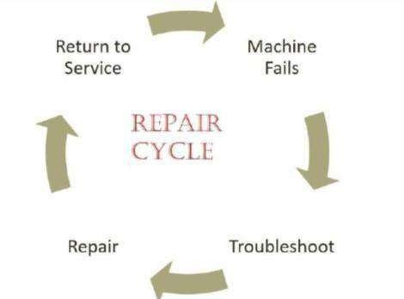

It is a comprehensive document that provides all the details necessary about a physical plant as well as individual pieces of equipment to help the maintenance staff keep everything running smoothly.

Components of maintenance manual:
A comprehensive operations and maintenance manual have several common parts:
Overview: This section provides a general overview of the physical plant being discussed as well as the components covered in the manual. It includes personnel information, organizational charts, company history, or other background information.
Physical building: This section details important information about one specific facility. Ideally, this information is collected during the construction of the facility itself and contains floor plans, building materials, finish data, building code and specification information, and site survey.

Operating procedures: A comprehensive, detailed explanation of all major operating procedures should be documented so that a new employee can learn quickly and a seasoned technician can double-check work.

Maintenance procedures: The preventive and corrective maintenance programs should be explained thoroughly including schedules, procedures, responsibilities, trouble-shooting and test requirements.
Emergency procedures: It's important to think through emergency situations before they happen because it can be difficult to remember details in the middle of a chaotic situation. This section outlines all the people, steps, agencies, and other organizations that need to be notified as well as a primer on how to handle crisis communications internally and externally.

Maintenance records:
It is a document that includes information regarding each repair and maintenance work that is done on asset or equipment. In simple words, it keeps tracks of assets failures and repairs. It is one of best way to maintain health and safety management.


HOUSEKEEPING
Lubrication: Regular lubrication, as part of your regular machine tool maintenance routine, will ensure moving parts are protected reducing wear and tear. This includes greasing internal and external moving parts and visual inspection.

Cleanliness: Cleanliness is a simple, but often overlooked maintenance step. However, it can go a long way in reducing grime accumulation and rust.
Proper maintenance of machine tool accessories and parts: Routine inspection can sharpen operators' ability to detect developing issues beforehand. Keeping a checklist and a detailed log of all machine tool maintenance procedures can also help catch possible problems.
TOTAL PRODUCTIVE MAINTENANCE
It is the process of using machines, equipment, employees and supporting processes to maintain and improve the integrity of production and the quality of systems.

In other word it is the process of maximizing equipment effectiveness through the active involvement of all supporting departments. The goal of Total Productive Maintenance (TPM) is to improve overall productivity by optimizing equipment availability.
The 8 Pillars of Total Productive Maintenance (TPM): Traditional total productive maintenance was developed by Seiichi Nakajima of Japan. The results of his work on the subject led to the TPM process in the late 1960s and early 1970s.
Nippon Denso a company that created parts for Toyota, was one of the first organizations to implement a TPM program.

TPM is built on eight pillars based on the 5-S system. The 5-S system is an organizational method based around five Japanese words and their meaning.
- Seiri (organize): eliminating clutter from the workspace
- Seiton (orderliness): ensure order by following "a place for everything and everything in its place"
- Seiso (cleanliness): clean the workspace and keep it that way
- Seiketsu (standardize): standardize all work processes, making them consistent
- Shitsuke (sustain): constantly reinforcing the first four steps
  - Sort tools, equipment, and materials to identify which of these can be discarded.
  - Straighten and set things in the proper order to reduce unnecessary motion and efficiently travel between working groups and locations.
  - Shine refers to performing necessary housekeeping to clean up the work area.
  - Standardize and schedule activities to systematically form the habits to keep the workplace organized.
  - Sustain the process and principles for long-term applications
