RAJAKISHORE CHANDRA ACADEMY OF TECHNOLOGY
(POLYTECHNIC)



LECTURE NOTES ON
ANALOG ELECTRONICS &OP-AMP

DEPARTMENT OF ELECTRONICS & TELECOMMUNICATION
4TH SEMESTER
PREPARED BY
ER. PRIYA RANJAN SEN
LECTURER (ETC)

UNIT-1: PN JUNCTION DIODE

SEMICONDUCTOR:
Semiconductors (e.g. germanium, silicon etc.) are those substances whose electrical conductivity lies in between conductors and insulators. In terms of energy band, the valence band is almost filled and conduction band is almost empty. Further, the energy gap between valence and conduction bands is very small. The semiconductor has:
- Filled valence band
- Empty conduction band
- Small energy gap or forbidden gap ( 1 ev) between valence and conduction bands.
- Semiconductor virtually behaves as an insulator at low temperatures. However, even at room temperature, some electrons cross over to the conduction band, imparting little conductivity (i.e. conductor).

Types of semiconductors:-
Semiconductors are classified into two types:-
- Intrinsic semiconductors
- Extrinsic semiconductors
- Extrinsic semiconductors are also of two types:-
- P-type semiconductors
- N-type semiconductors

Intrinsic semiconductors
- A semiconductor in an extremely pure form is known as anintrinsic semiconductor. When electric field is applied across an intrinsic semiconductor, the current conduction takes place by two processes i.e. by free electrons and holes.
- The free electrons are produced due to the breaking up of some covalent bonds by thermal energy. At the same time, holes are created in the covalent bonds.
- Under the influence of electric field, conduction through the semiconductor is by both free electrons and holes. Therefore, the total current inside the semiconductor is the sum of currents due to free electrons and holes.

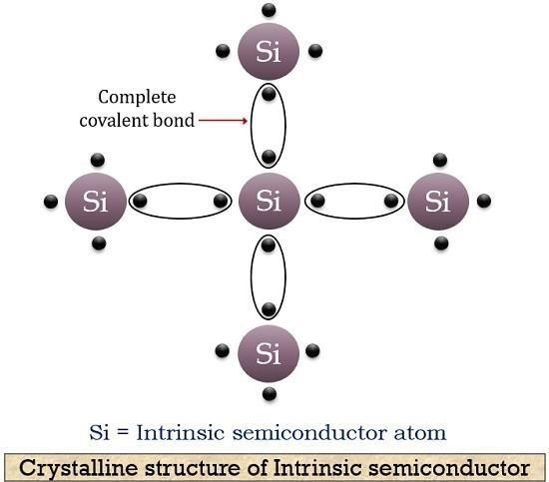

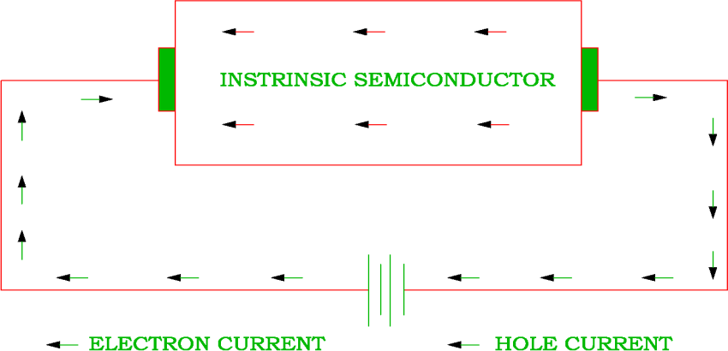

Extrinsic semiconductors
An extrinsic semiconductor is a semiconductor doped by addition of small amount impurity. The process of adding impurities to a semiconductor is known as doping. The purpose of adding impurity is to increase either the number of free electrons or holes in the semiconductor crystal. Depending upon the type of impurity added, extrinsic semiconductors are classified into:
- n-type semiconductor
- p-type semiconductor

N-type semiconductors
When a small amount of pentavalent impurity is added to a pure semiconductor, it is known as n-type semiconductor. Examples of pentavalent impurities are arsenic, antimony, Bismuth and Phosphorous etc. Such impurities are known as donor impurities

because they donate or provide free electrons to the semiconductor crystal.Electrons are said to be the majority carriers whereas holes are the minority carriers.

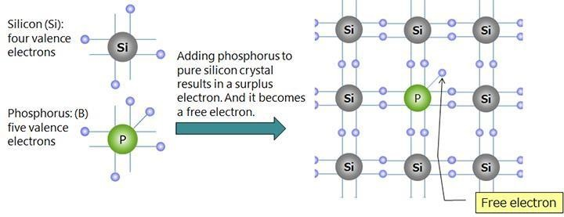

P-type semiconductors
When a small amount of trivalent impurity is added to a pure semiconductor, it is called p- type Semiconductor. Examples of trivalent impurities are gallium, indium, boron etc. The addition of trivalent impurity provides a large number of holes in the semiconductor. Such impurities are known as acceptor impurities because the holes created can accept the electrons. In a p type semiconductor holes are the majority carriers and electrons are the minority carriers.

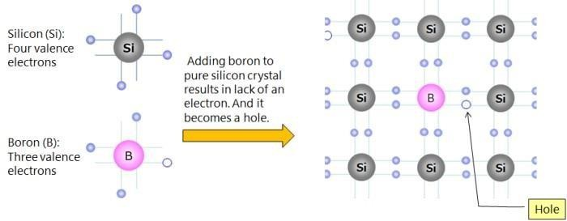

PN JUNCTION:-

Zero Biased Junction Diode
When a diode is connected in a Zero Bias condition, no external potential energy is applied to the PN junction. However if the diodes terminals are shorted together, a few holes (majority carriers) in the P-type material with enough energy to overcome the potential barrier will move across the junction against this barrier potential. This is known as the “Forward Current” and is referenced as IF. Likewise, holes generated in the N-type material (minority carriers), find this situation favorable and move across the junction in the opposite direction. This is known as the “Reverse Current” and is referenced as IR. This transfer of electrons and holes back and forth across the PN junction is known as diffusion.
The potential barrier that now exists discourages the diffusion of any more majority carriers across the junction. However, the potential barrier helps minority carriers (few free electrons in the P-region and few holes in the N-region) to drift across the junction.
Then an “Equilibrium” or balance will be established when the majority carriers are equal and both moving in opposite directions, so that the net result is zero current flowing in the circuit. When this occurs the junction is said to be in a state of “Dynamic Equilibrium“.
The minority carriers are constantly generated due to thermal energy so this state of equilibrium can be broken by raising the temperature of the PN junction causing an increase in the generation of minority carriers, thereby resulting in an increase in leakage current but an electric current cannot flow since no circuit has been connected to the PN junction.
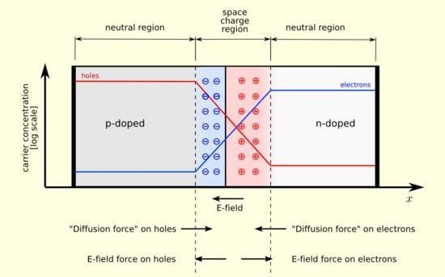

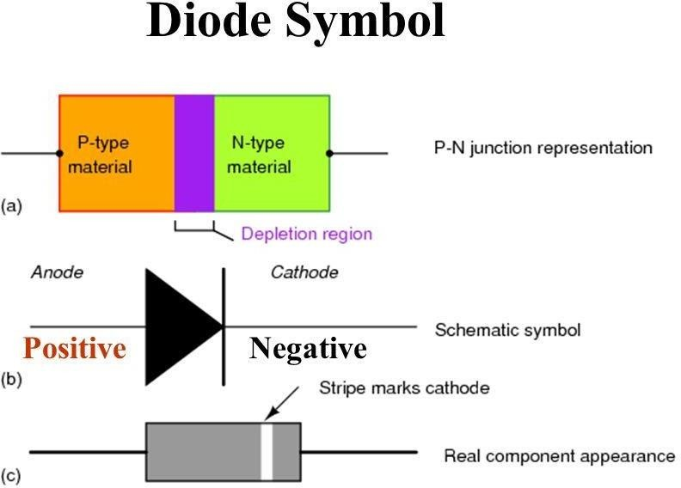

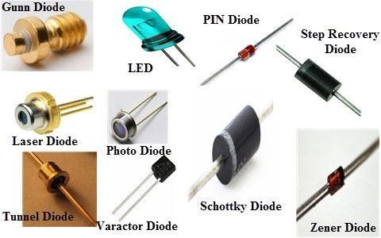

FORWARD BIASING:-

- A P-N junction diode is said to be forward biased when the positive terminal of a cell or battery is connected to the p-side of the junction and the negative terminal to the n side.
- When diode is forward-biased the depletion region narrows and consequently, the potential barrier is lowered.
- This causes the majority charge carriers of each region to cross into the other region.
- The electrons travel from the n-side to the p-side and go to the positive terminal of the battery.
- The holes that travel from the p-side to the n-side combine with the electrons injected into the n-region from the negative terminal of the battery.
With the increase in forward bias voltage, the depletion region eventually becomes thin, thus reducing electrical resistance.
- This causes electrons to pass through the junction resulting in an exponential rise in current.
- This way the diode conducts when forward-biased.

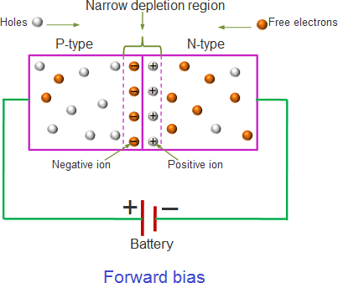

REVERSE BIASING:-
- A pn-junction diode is said to be reverse biased when the positive terminal of a cell or battery is connected to then-side of the junction and the negative terminal to the p-side.
- When reverse biased, the depletion region widens and the potential barrier is increased.
- The polarity of thebattery extracts the majority charge carriers of each region.
- The holes in the p-region from the electrons injected into the p-region from the negative terminal of the battery.
- The electrons in the n-region go to the positive terminal of the battery.

- This way, the majority charge carrier concentration in each region decreases against the equilibrium values and the reverse biased junction diode has a high resistance.
- Thus, the diffusion current across the junction becomes zero.
- Thus, the diode does not conduct when reverse biased and is said to be in a quiescent or non- conducting state i.e., it acts as an open switch.

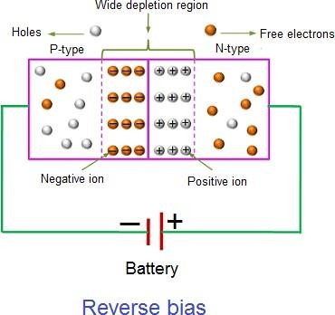

VI CHARACTERISTICS OF PN JUNCTION:-
Volt-ampere (V-I) characteristics of a pn junction or semiconductor diode is the curve between voltage across the junction and the current through the circuit.

Normally the voltage is taken along the x-axis and current along y-axis.

The circuit connection for determining the V-I characteristics of a pn junction is shown in the figure below.
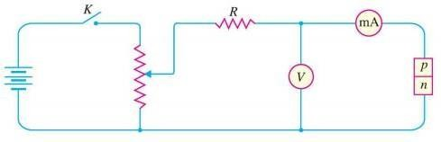

The characteristics can be explained under three cases, such as :

- Zero bias
- Forward bias
- Reverse bias

Case-1: Zero Bias
In zero bias condition, no external voltage is applied to the pn junction i.e. the circuit is open at K.

Hence, the potential barrier at the junction does not permit current flow.
Therefore, the circuit current is zero at V=0 V, as indicated by point O in figure below.
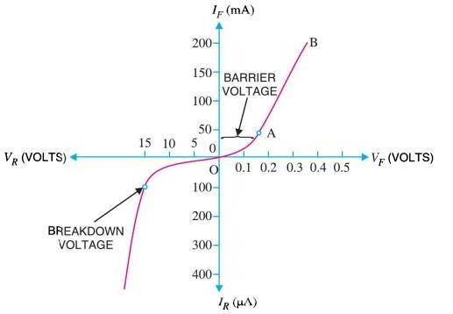

Case-2: Forward Bias
In forward biased condition, p-type of the pn junction is connected to the positive terminal and n-type is connected to the negative terminal of the external voltage.

This results in reduced potential barrier.

At some forward voltage i.e. 0.7 V for Si and 0.3 V for Ge, the potential barrier is almost eliminated and the current starts flowing in the circuit.

Form this point, the current increases with the increase in forward voltage. Hence a curve OB is obtained with forward bias as shown in figure above.

From the forward characteristics, it can be noted that at first i.e. region OA, the current increases very slowly and the curve is non-linear. It is because in this region the external voltage applied to the pn junction is used in overcoming the potential barrier.

However, once the external voltage exceeds the potential barrier voltage, the potential barrier is eliminated and the pn junction behaves as an ordinary conductor. Hence, the curve AB rises very sharply with the increase in external voltage and the curve is almost linear.

Case-3: Reverse Bias
In reverse bias condition, the p-type of the pn junction is connected to the negative terminal and n-type is connected to the positive terminal of the external voltage.

This results in increased potential barrier at the junction.

Hence, the junction resistance becomes very high and as a result practically no current flows through the circuit.

However, a very small current of the order of μA, flows through the circuit in practice. This is knows as reverse saturation current (IS) and it is due to the minority carriers in the junction.
As we already know, there are few free electrons in p-type material and few holes in n- type material. These free electrons in p-type and holes in n-type are called minority carriers.

The reverse bias applied to the pn junction acts as forward bias to their minority carriers and hence, small current flows in the reverse direction.

If the applied reverse voltage is increased continuously, the kinetic energy of the minority carriers may become high enough to knock out electrons from the semiconductor atom.

At this stage breakdown of the junction may occur. This is characterized by a sudden increase of reverse current and a sudden fall of the resistance of barrier region. This may destroy the junction permanently.

DC LOAD LINE-

A circuit supplied with dc power as the external source of the circuit. There exist both alternating and direct currents in the circuit. The reactive components of the circuits are

made zero and the straight line is drawn above the voltage-current characteristics curves. Hence these results in the formation of intersecting point referred to an operating point. The straight that is drawn for this purpose is defined as the DC load line.

DC Load Line of a Diode and Its Equation
DC load line for a non-linear device is drawn by making the reactive components as zero. Hence a diode is considered as a non-linear device and its voltage and current characteristics are exponentially related to each other. The formation of the intersection point for the characteristic curve and the straight line or dc-load line can be analyzed better by considering the example for the diode as in forward bias condition.
Let us consider a diode connected to the resistor(R), source of voltage (VDD) in series. The diode is connected in forward bias so that the forward current and the forward voltages flowing through the circuit. As per the Kirchhoff’s current law, the current flowing through the diode (ID) and the resistor (IR) is equal.
ID = IR
Analysis of the circuit is done by applying Kirchhoff’s voltage law (KVL). This law results in the formation of the final equation for the dc load line. Here the dc voltage is the biasing voltage of the circuit by keeping any further reactive components as zero.
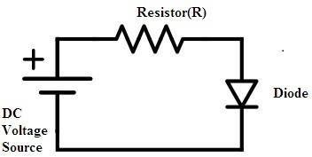

Diode-operating-in-forward-bias-for-the-analysis-of-dc-load
Once the Kirchhoff’s voltage law is applied to the circuit an equation is obtained for voltages and currents in the circuit.
VDD = VD + IDR VD = IDR-VDD

Where VDD, is the applied dc source voltage and VD is the voltage across the diode. Hence the above can be considered as the equation for the diode. The voltage and current characteristics of the diode in forward bias condition can be drawn. By our previous analysis on the condition of the diode in forward bias applied a voltage and the generated current in the circuit are exponentially related to each other.
After a certain cut-off voltage, the diode starts operating in forward bias condition. To this slope, the technique is considered and a straight line on the v-i characteristics is drawn. The slope here for the above general circuit for the diode is VDD/R.
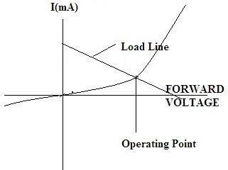

Dc-load-line-and-the-formation-of-operating-point
In this way, the analysis for the dc-load line is done for the non-linear device like a diode. Depending on the type of non-linear device some part of the analysis differs but the technique remains the same. This type of method comes under the graphical analysis because here the characteristics curve is considered for the formation of the dc-load line.

IMPORTANT TERMS SUCH AS IDEAL DIODE, KNEE VOLTAGE

Ideal Diode:
An ideal diode is one kind of an electrical component that performs like an ideal conductor when voltage is applied in forward bias and like an ideal insulator when the voltage is applied in reverse bias. So when +ve voltage is applied across the anode toward the cathode, the diode performs forward current immediately. When a voltage is applied in reverse bias, then ir performs no current at all. This diode operates like a switch. When the diode is in forward bias, it works like a closed switch. Whereas, if an ideal diode is in reverse bias, then it works like an open switch.

Knee Voltage:

The forward voltage at which the current through the junction starts increasing rapidly, is called knee voltage or cut-in voltage. It is generally 0.6v for a diode.

JUNCTIONS BREAKDOWN:
- The Avalanche Breakdown and Zener Breakdown are two different mechanisms by which a PN junction breaks.
- The Zener and Avalanche breakdown both occur in diode under reverse bias.
- The avalanche breakdown occurs because of the ionization of electrons and hole pairs whereas the Zener diode occurs because of heavy doping.

AVALANCHE BREAKDOWN:
The mechanism of avalanche breakdown occurs because of the reverse saturation current. The P-type and N-type material together forms the PN-junction. The depletion region develops at the junction where the P and N-type material contact. The P and N-type materials of the PN junction are not perfect, and they have some impurities in it, i.e., the p-type material has some electrons, and the N-type material has some hole in it. The width of the depletion region varies. Their width depends on the bias applied to the terminal of P and N region. The reverse bias increases the electrical field across the depletion region. When the high electric field exists across the depletion, the velocity of minority charge carrier crossing the depletion region increases. These carriers collide with the atoms of the crystal. Because of the violent collision, the charge carrier takes out the electrons from the atom. The collision increases the electron-hole pair. As the electron- hole induces in the high electric field, they are quickly separated and collide with the other atoms of the crystals. The process is continuous, and the electric field becomes so much higher than the reverse current starts flowing in the PN junction. The process is known as the Avalanche breakdown. After the breakdown, the junction cannot regain its original position because the diode is completely burnt off.

ZENER BREAKDOWN:
The PN junction is formed by the combination of the p-type and the n-type semiconductor material. The combination of the P-type and N-type regions creates the depletion region. The width of the depletion region depends on the doping of the P and N- type semiconductor material. If the material is heavily doped, the width of the depletion region becomes very thin. The phenomenon of the Zener breakdown occurs in the very thin depletion region. The thin depletion region has more numbers of free electrons. The reverse bias applied across the PN junction develops the electric field intensity across the depletion region. The strength of the electric field intensity becomes very high. The electric field intensity increases the kinetic energy of the free charge carriers. Thus the carrier starts jumping from one region to another. These energetic charge carriers collide with the atoms of the p-type and n-type material and produce the electron-hole pairs. The reverse current starts flowing in the junction because of which depletion region becomes entirely vanishes. This process is known as the Zener breakdown. In Zener breakdown, the

junction is not completely damaged. The depletion region regains it original position after the removal of the reverse voltage.The voltage of Zener breakdown is less than the Avalanche breakdown.

BreakdownCharacteristicGraph
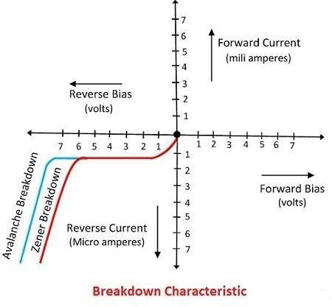
The graphical representation of the Avalanche and Zener breakdown is shown in the figure below.

RECTIFIER CIRCUITS

RECTIFIERS AND CLASSIFICATION OF RECTIFIER:-
Rectifier is an electronic device which converts the alternating current to unidirectional current, in other words rectifier converts the AC voltage to DC voltage. We use rectifier in almost all the electronic devices mostly in the power

supply section to convert the main voltage into DC voltage. Every electronic device will work on the DC voltage supply only.
Rectifiers are classified according to the period of conduction. They are
- Half Wave Rectifier
- Full Wave Rectifier

ANALYSIS OF HALF WAVE, FULL WAVE CENTRE TAPPED AND BRIDGE RECTIFIERS:

Half Wave Rectifier:
The half wave rectifier is a type of rectifier that rectifies only half cycle of the waveform. This article describes the half wave rectifier circuit working. The half rectifier consist a step down transformer, a diode connected to the transformer and a load resistance connected to the cathode end of the diode. The circuit diagram of half wave transformer is shown below:
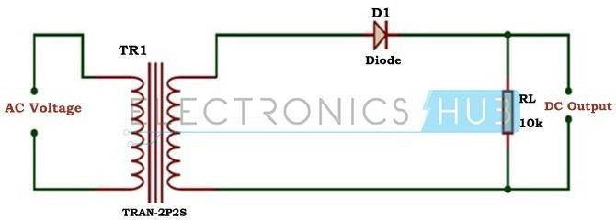

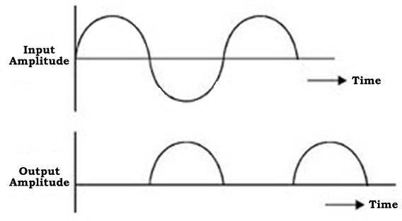

The main supply voltage is given to the transformer which will increase or decrease the voltage and give to the diode. In most of the cases we will decrease the supply voltage by using the step down transformer here also the output of the step down transformer will be in AC. This decreased AC voltage is given to the diode which is connected serial to the secondary winding of the transformer, diode is electronic component which will allow only the forward bias current and will not allow the reverse bias current. From the diode we will get the pulsating DC and give to the load resistance RL.

Working of Half Wave Rectifier:
The input given to the rectifier will have both positive and negative cycles. The half rectifier will allow only the positive half cycles and omit the negative half cycles. So first we will see how half wave rectifier works in the positive half cycles.

Positive Half Cycle:

- In the positive half cycles when the input AC power is given to the primary winding of the step down transformer, we will get the decreased voltage at the secondary winding which is given to the diode.
- The diode will allow current flowing in clock wise direction from anode to cathode in the forward bias (diode conduction will take place in forward bias) which will generate only the positive half cycle of the AC.
- The diode will eliminate the variations in the supply and give the pulsating DC voltage to the load resistance RL. We can get the pulsating DC at the Load resistance.

Negative Half Cycle:

- In the negative half cycle the current will flow in the anti-clockwise direction and the diode will go in to the reverse bias. In the reverse bias the diode will not conduct so, no current in flown from anode to cathode, and we cannot get any power at the load resistance.
- Only small amount of reverse current is flown from the diode but this current is almost negligible. And voltage across the load resistance is also zero.

Characteristics of Half Wave Rectifier:
There are some characteristics to the half wave rectifier they are

Efficiency: The efficiency is defined as the ratio of input AC to the output DC. Efficiency, Ƞ = P dc / Pac
DC power delivered to the load, Pdc = I2dc RL = ( Imax/pi ) 2 RL

AC power input to the transformer, Pac = Power dissipated in junction of diode + Power dissipated in load resistance RL

= I2rms RF + I2rms RL = {I2MAX/4}[RF + RL]

Rectification Efficiency, Ƞ = Pdc / Pac = {4/ 2}[RL/ (RF + RL)] = 0.406/{1+ RF/RL } If RF is neglected, the efficiency of half wave rectifier is 40.6%.
- Ripple factor: It is defined as the amount of AC content in the output DC. It is nothing but amount of AC noise in the output DC. Less the ripple factor, performance of the rectifier is more. The ripple factor of half wave rectifier is about
1.21. It can be calculated as follows:

The effective value of the load current I is given as sum of the rms values of harmonic currents I1, I2, I3, I4 and DC current Idc.

I2 =I2dc+I21+I22+I24 = I2dc +I2ac

Ripple factor, is given as γ = I ac / Idc = (I2 – I2dc) / Idc = {( I rms / Idc2)-1} = Kf2 – 1) Where Kf is the form factor of the input voltage. Form factor is given as
Kf = Irms /Iavg = (Imax/2)/ (Imax/pi) = pi/2 = 1.57 So, ripple factor, γ = (1.572 – 1) = 1.21
- Peak Inverse Voltage: It is defined as the maximum voltage that a diode can with stand in reverse bias. During the reverse bias as the diode do not conduct total voltage drops across the diode. Thus peak inverse voltage is equal to the input voltage Vs.

- Transformer Utilization Factor (TUF): The TUF is defined as the ratio of DC power is delivered to the load and the AC rating of the transformer secondary. Half wave rectifier has around 0.287 and full wave rectifier has around 0.693.

Im 2
- TUF = Pdc
Pac

( ) R
π L VmIm 2√2
=

= 0.287

Voltage regulation

The variation of d.c output voltage as function of d.c load current is called regulation.
V.R in % age = VNL−VFL *100
VFL

Where, V_{NL}=DC voltage across load resistance when minimum current flows through it.
V_{FL}=DC voltage across load resistance when maximum current flows through it.

Form factor

It is the ratio of the rms value to the average value.
Form factor = Rms value = Im/2 = 1.57
Average value Im/π

Output DC Voltage
The output voltage (VDC) across the load resistor is denoted by:

RMS value of Half Wave Rectifier
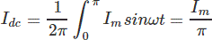
To derive the RMS value of half wave rectifier, we need to calculate the current across the load. If the instantaneous load current is equal to iL = ImSinωt, then the average of load current (IDC) is equal to:
Where Im is equal to the peak instantaneous current across the load (Imax). Hence the output DC current (IDC) obtained across the load is:
For a half-wave rectifier, the RMS load current (Irms) is equal to the average current (IDC) multiple by π/2. Hence the RMS value of the load current (Irms) for a half wave rectifier is:
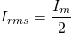
Where Im= Imax which is equal to the peak instantaneous current across the load.

Half wave rectifier is mainly used in the low power circuits. It has very low performance when it is compared with the other rectifiers.

FULL WAVE RECTIFIER:-
Full wave rectifier rectifies the full cycle in the waveform i.e. it rectifies both the positive and negative cycles in the waveform. This Full wave rectifier has an advantage over the half wave i.e. it has average output higher than that of half wave rectifier. The number of AC components in the output is less than that of the input.
The full wave rectifier can be further divided mainly into following types.

- Center Tapped Full Wave Rectifier
- Full Wave Bridge Rectifier

Center Tapped Full Wave Rectifier
Center tap is the contact made at the middle of the winding of the transformer.

In the center tapped full wave rectifier two diodes were used. These are connected to the center tapped secondary winding of the transformer. Above circuit diagram shows the center tapped full wave rectifier. It has two diodes. The positive terminal of two diodes is connected to the two ends of the transformer. Center tap divides the total secondary voltage into equal parts.
Center Tapped Full Wave Rectifier Working:
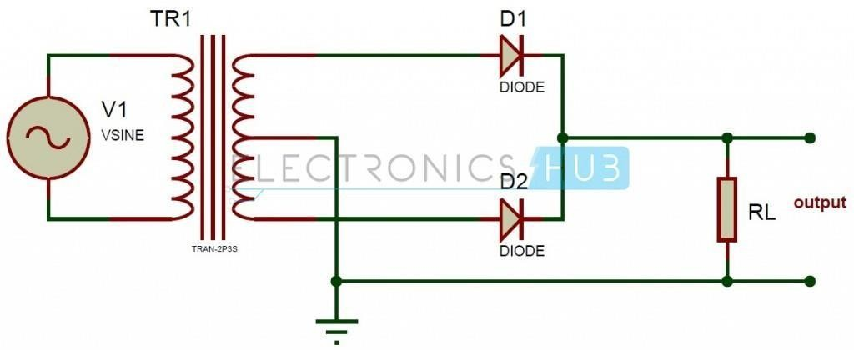
The primary winding of the center tap transformer is applied with the Ac voltage. Thus the two diodes connected to the secondary of the transformer conducts alternatively. For the positive half cycle of the input diode D1 is connected to the positive terminal and D2 is connected to the negative terminal. Thus diode D1 is in forward bias and the diode D2 is reverse biased. Only diode D1 starts conducting and thus current flows from diode and it appears across the load RL. So positive cycle of the input appears at the load.

During the negative half cycle the diode D2 is applied with the positive cycle. D2 starts conducting as it is in forward bias. The diode D1 is in reverse bias and this does not conduct. Thus current flows from diode D2 and hence negative cycle is also rectified, it appears at the load resistor RL.

By comparing the current flow through load resistance in the positive and negative half cycles, it can be concluded that the direction of the current flow is same. Thus the frequency of rectified output voltage is two times the input frequency. The output that is rectified is not pure, it consists of a dc component and a lot of ac components of very low amplitudes.

Peak Inverse Voltage (PIV) of Centre Tap Full Wave Rectifier:
PIV is defined as the maximum possible voltage across a diode during its reverse bias. During the first half that is positive half of the input, the diode D1 is forward bias and thus conducts providing no resistance at all. Thus, the total voltage Vs appears in the upper-half of the ac supply, provided to the load resistance R. Similarly, in the case of diode D2 for the lower half of the transformer total secondary voltage developed appears at the load. The amount of voltage that drops across the two diodes in reverse bias is given as

PIV of D2 = Vm + Vm = 2Vm PIV of D1 = 2Vm
Vm is the voltage developed across upper and lower halves.

Peak Current
The peak current is the instantaneous value of the voltage applied to the rectifier. It can be written as

Vs = Vsm Sinwt

Let us assume that the diode has a forward resistance of RF ohms and a reverse resistance is equal to infinity, thus current flowing through the load resistance RL is given as

Im = Vsm / (RF + RL)

Transformer Utilization Factor:
This can be calculated by considering primary and secondary windings separately. Its value is 0.693.This can be used to determine transformer secondary rating.

Output Current:
Since the current is same through the load resistance 𝑅_{𝐿} in the two halves of the ac cycle, magnitude of dc current 𝐼_{𝑑𝑐}, which is equal to the average value of ac current,

can be obtained by integrating the current 𝐼1 between 0 and π or current 𝐼2 between π and 2π.
𝐼 = 1⁄ ∬𝜋 𝐼1(𝑤𝑡) = 1 𝜋 2𝐼
= 𝑚⁄
^{𝑑𝑐} 𝜋 0 ⁄𝜋 ∬ 𝐼𝑚𝑎𝑥 sin (𝑤𝑡) 𝜋
0
DC output voltage:
Average value or dc value of voltage across the load is given by
𝜋 𝜋
𝐼_{𝑑𝑐} = 1⁄𝜋 ∬ 𝐼1(𝑤𝑡) = 1⁄𝜋 ∬ 𝐼𝑚𝑎𝑥 sin 𝑤𝑡𝑑(𝑤𝑡) = 2𝐼𝑚⁄𝜋
0 0
Root Mean Square (RMS) value of current:
RMS value of current flowing through the load resistance is given as

2
𝐼
𝑅𝑀𝑆

Or
= 1⁄𝜋
𝜋
∬ 𝐼12(𝑤𝑡) =
0
𝐼2

𝑚⁄
2

𝐼𝑟𝑚𝑠 = 𝐼𝑚⁄
√2
Root Mean Square (RMS) Value of output voltage: RMS value of voltage across the load is given by:
𝑉𝑙𝑜𝑎𝑑𝑟𝑚𝑠 = 𝐼𝑟𝑚𝑠 ∗ 𝑅𝑙𝑜𝑎𝑑
Rectification efficiency:
𝑃_{𝑑𝑐} = 𝐼2𝑑𝑐𝑅_{𝐿} = 2𝐼𝑚⁄𝜋= 𝑅_{𝐿} = (4⁄ ₂) ²𝑅
𝜋 𝑚 𝐿
As power input to the transformer = power dissipated at the diode + power dissipated at the in load resistance 𝑅_{𝐿}.
𝐼 2

𝐼𝑟𝑚𝑠2𝑅𝐹 + 𝐼𝑟𝑚𝑠 2𝑅𝑙𝑜𝑎𝑑 = {
𝑚 ⁄2} [𝑅_{𝐹} + 𝑅

𝑃 4 2 𝐼 ²

Rectification efficiency ƞ=

Ripple factor:
𝑑𝑐 𝑚
⁄𝑃𝑎𝑐= (( ⁄𝜋2)𝐼_{𝑚} 𝑅_{𝐿})/({ ⁄2 } [𝑅_{𝐹} + 𝑅_{𝑙𝑜𝑎𝑑}])

Form factor 𝐾_{𝑓} of the rectified output voltage of a full wave rectifier is given as

𝐾𝑓 = 𝐼𝑟𝑚𝑠⁄𝐼
𝐼𝑚⁄√2
=

= 1.11

Regulation:
The dc output voltage is given by
𝑎𝑣𝑔
(2𝐼_{𝑚}⁄𝜋)

𝑉_{𝑑𝑐} = 𝐼_{𝑑𝑐}𝑅_{𝐿} = 2/(𝜋𝐼_{𝑚}𝑅_{𝐿})
=2𝑉_{𝑠𝑚}𝑅_{𝐿}/(𝑅_{𝐹} + 𝑅_{𝐿})
= (2𝑉𝑠𝑚⁄𝜋) − (𝐼_{𝑑𝑐}𝑅_{𝐹})

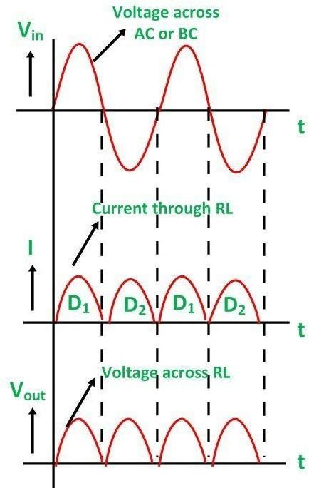

Advantages:-
- Output is obtained for both cycles of input ac voltages.
- Efficiency is higher than that of half wave rectifier.

Disadvantages:-
- Locating center tap on the secondary winding is difficult.
- The diodes used have high PIV.
- The d.c output is small as each diode utilizes only one half of the transformer secondary voltage.

FULL WAVE BRIDGE RECTIFIER
Bridge is a type of electrical circuit. Bridge rectifier is a type of rectifier in which diodes were arranged in the form of a bridge. This provides full wave rectification and is of low cost. So it is used in many applications.

Bridge Rectifier:
In bridge rectifier four diodes are used. These are connected as shown in the circuit diagram. The four diodes are connected in the form of a bridge to the transformer and the load as shown.
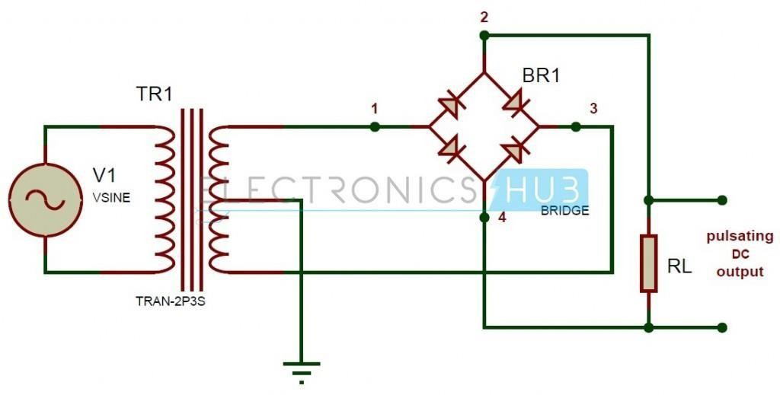

Working of Bridge Rectifier:
The working of a bridge rectifier is simple. The circuit diagram of bridge rectifier is given above. The secondary winding of the transformer is connected to the two diametrically opposite points of the bridge at points 1 and 3. Assume that a load is connected at the output. The load RLoad is connected to bridge through points 2 and 4.

During first half cycle of the AC input, the upper portion of the transformer secondary winding is positive with respect to the lower portion. Thus during the first half cycle diodes D1 and D4 are forward biased. Current flows through path 1-2, enter into the load RL. It returns back flowing through path 4-3. During this half input cycle, the diodes D2 and D3 are reverse biased. Hence there is no current flow through the path 2-3 and 1-4.

During the next cycle lower portion of the transformer is positive with respect to the upper portion. Hence during this cycle diodes D2 and D3 are forward biased.
Current flows through the path 3-2 and flows back through the path 4-1.The diodes

D1 and D4 are reverse biased. So there is no current flow through the path 1-2 and 3-4.Thus negative cycle is rectified and it appears across the load.

Peak Inverse Voltage (PIV) of a bridge rectifier = Maximum of Secondary Voltage
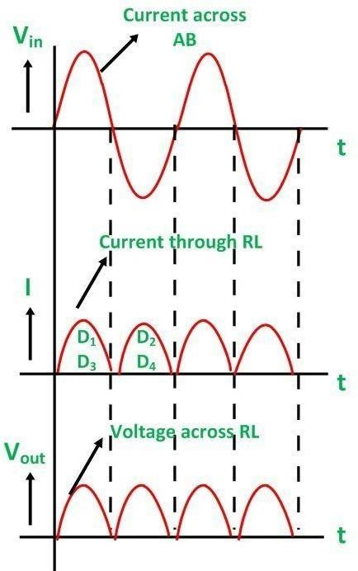

Advantages:-
- PIV is one half that of centre tap circuit.
- Output is twice that of centre tap circuit.
- Need for centre tapped transformer is eliminated.

Disadvantages:-
- Requires 4 diodes which increase the cost.

Bridge Rectifier Applications:

- Because of their low cost compared to center tapped they are widely used in power supply circuit.

- This can be used to detect the amplitude of modulated radio signal.
- Bridge rectifiers can be used to supply polarized voltage in welding.

TRANSISTORS

PRINCIPLE OF BIPOLAR JUNCTIONTRANSISTOR:

The transistor is a semiconductor device which transfers a weak signal from low resistance circuit to high resistance circuit. The words trans mean transfer property and istor mean resistance property offered to the junctions. In other words, it is a switching device which regulates and amplifies the electrical signal likes voltage or current.
The transistor consists of two PN diode connected back to back. It has three terminals namely emitter, base and collector. The base is the middle section which is made up of thin layers. The right part of the diode is called emitter diode and the left part is called collector-base diode. These names are given as per the common terminal of the transistor. The emitter based junction of the transistor is connected to forward bias and the collector-base junction is connected in reverse bias which offers a high resistance.

TransistorSymbols
There are two types of transistor, namely NPN transistor and PNP transistor. The transistor which has two blocks of n-type semiconductor material and one block of P- type semiconductor material is known as NPN transistor. Similarly, if the material has one layer of N-type material and two layers of P-type material then it is called PNP transistor. The symbol of NPN and PNP is shown in the figure below.
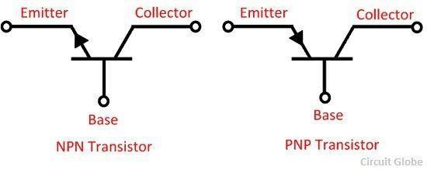

The arrow in the symbol indicates the direction of flow of conventional current in the emitter with forward biasing applied to the emitter-base junction. The only difference between the NPN and PNP transistor is in the direction of the current.

TransistorTerminals
The transistor has three terminals namely, emitter, collector and base. The terminals of the diode are explained below in details.

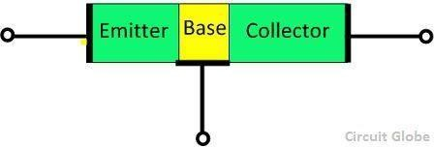

Emitter – The section that supplies the large section of majority charge carrier is called emitter. The emitter is always connected in forward biased with respect to the base so that it supplies the majority charge carrier to the base. The emitter-base junction injects a large amount of majority charge carrier into the base because it is heavily doped and moderate in size.

Collector – The section which collects the major portion of the majority charge carrier supplied by the emitter is called a collector. The collector-base junction is always in reverse bias. Its main function is to remove the majority charges from its junction with the base. The collector section of the transistor is moderately doped, but larger in size so that it can collect most of the charge carrier supplied by the emitter.

Base – The middle section of the transistor is known as the base. The base forms two circuits, the input circuit with the emitter and the output circuit with the collector. The emitter-base circuit is in forward biased and offered the low resistance to the circuit. The collector-base junction is in reverse bias and offers the higher resistance to the circuit. The base of the transistor is lightly doped and very thin due to which it offers the majority charge carrier to the base.

WorkingofTransistor
Usually, silicon is used for making the transistor because of their high voltage rating, greater current and less temperature sensitivity. The emitter-base section kept in forward biased constitutes the base current which flows through the base region. The magnitude of the base current is very small. The base current causes the electrons to move into the collector region or create a hole in the base region.
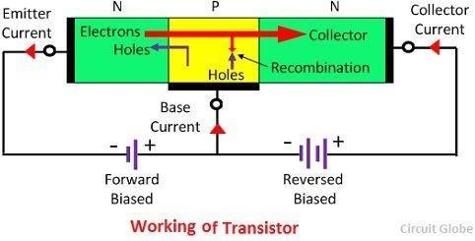

The base of the transistor is very thin and lightly doped because of which it has less number of electrons as compared to the emitter. The few electrons of the emitter are combined with the hole of the base region and the remaining electrons are moved towards the collector region and constitute the collector current. Thus we can say that the large collector current is obtained by varying the base region.

DIFFERENT MODES OF OPERATION OFTRANSISTOR:
When the emitter junction is in forward biased and the collector junction is in reverse bias, then it is said to be in the active region. The transistor has two junctions which can be biased in different ways. The different working conduction of the transistor is shown in the table below.

CONDITION | EMITTER JUNCTION (EB) | COLLECTOR JUNCTION (CB) | REGION OF OPERATION
FR | Forward-biased | Reversed-biased | Active
FF | Forward-biased | Forward-biased | Saturation
RR | Reversed-biased | Reversed-biased | Cut-off
RF | Reversed-biased | Forward-biased | Inverted
FR – In this case, the emitter-base junction is connected in forward biased and the collector-base junction is connected in reverse biased. The transistor is in the active region and the collector current depends on the emitter current. The transistor, which operates in this region, is used for amplification.

FF – In this condition, both the junction is in forward biased. The transistor is in saturation and the collector current becomes independent of the base current. The transistors act like a closed switch.

RR – Both the current are in reverse biased. The emitter does not supply the majority charge carrier to the base and carriers current are not collected by the collector. Thus the transistors act like a closed switch.

RF – The emitter-base junction is in reverse bias and the collector-base junction is kept in forward biased. As the collector is lightly doped as compared to the emitter junction it does not supply the majority charge carrier to the base. Hence poor transistor action is achieved.

CURRENT COMPONENTS OF IN A TRANSISTOR:
The conduction of current in NPN transistor is owing to electrons and in PNP transistor, it is owing to holes. The direction of current flow will be in opposite direction. Here, we can discuss the current components in a PNP transistor with common base configuration. The emitter-base junction (JE) is forward biased and the collector-base junction (JC) is reversed biased as shown in figure. All the current components related to this transistor are shown here.
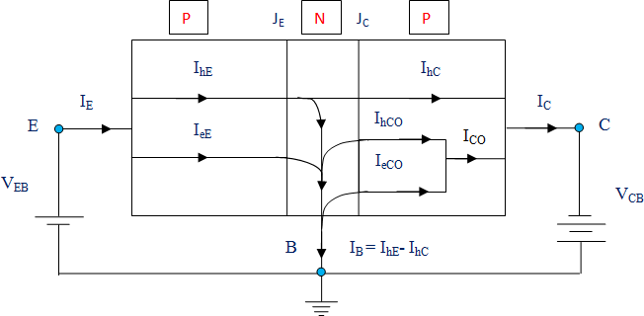
The current arrives the transistor through the emitter and this current is called emitter current (IE). This current consists of two constituents – Hole current (IhE) and Electron current (IeE). IeE is due to passage of electrons from base to emitter and IhE is due to passage of holes from emitter to base.
Normally, the emitter is heavily doped compared to base in industrial transistor. So, the Electron current is negligible compared to Hole current. Thus we can conclude that, the whole emitter current in this transistor is due to the passage of holes from the emitter to the base.

Some of the holes which are crossing the junction JE (emitter junction) combines with the electrons present in the base (N-type). Thus, every holes crossing JE will not arrive at JC. The remaining holes will reach the collector junction which produces the hole current component, IhC. There will be bulk recombination in the base and the current leaving the base will be
The electrons in the base which are lost by the recombination with holes (injected into the base across JE) are refilled by the electrons that enter into the base region. The holes which are arriving at the collector junction (JC) will cross the junction and it will go into the collector region.
When the emitter circuit is open circuited, then IE = 0 and IhC = 0. In this condition, the base and collector will perform as reverse biased diode. Here, the collector current, IC will be same as reverse saturation current (ICO or ICBO).
ICO is in fact a small reverse current which passes through the PN junction diode. This is due to thermally generated minority carriers which are pushed by barrier potential. This reverse current increase; if the junction is reverse biased and it will have the same direction as the collector current. This current attains a saturation value (I0) at moderate reverse biased voltage.
When the emitter junction is at forward biased (in active operation region), then the collector current will become
The α is the large signal current gain which is a fraction of the emitter current which comprises of IhC.
When the emitter is at closed condition, then IE ≠ 0 and collector current will be

In a PNP transistor, the reverse saturation current (ICBO) will comprises of the current due to the holes passing through the collector junction from the base to collector region (IhCO) and the current due to the electrons which are passing through the collector junction in the opposite direction (IeCO).

The total current entering into the transistor will be equal to the total current leaving the transistor (according to Kirchhoff’s current law).

TRANSISTOR AS AN AMPLIFIER:-
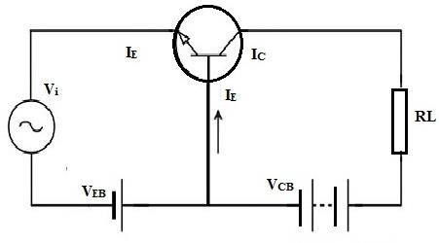

A transistor can be used as an amplifier by enhancing the weak signal’s strength. With the help of the following transistor amplifier circuit, one can get an idea about how the transistor circuit works as an amplifier circuit.
In the below circuit, the input signal can be applied among the emitter-base junction and the output across the Rc load connected in the collector circuit.

For accurate amplification, always remember that the input is connected in forward- biased whereas the output is connected in reverse-biased. For this reason, in addition to the signal, we apply DC voltage (VEE) in the input circuit as shown in the above circuit.

Generally, the input circuit includes low resistance as a result; a little change will occur in signal voltage at the input which leads to a significant change within the emitter current. Because of the transistor act, emitter current change will cause the same change within the collector circuit.

At present, the flow of collector current through an Rc generates a huge voltage across it. Therefore, the applied weak signal at the input circuit will come out in the amplified form at the collector circuit in the output. In this method, the transistor performs as an amplifier.

TRANSISTOR CIRCUIT CONFIGURATION & ITSCHARACTERISTICS:
A transistor can be connected in a circuit in the following three ways:
- common base connection
- common emitter connection
- common collector connection

COMMON BASE CONNECTION
Here the base terminal is common to both input and output circuit. The common base configurations or modes are as shown in the figure below. Here, the common base mode of NPN transistor and PNP transistor are shown separately.
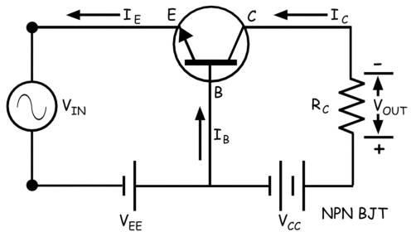

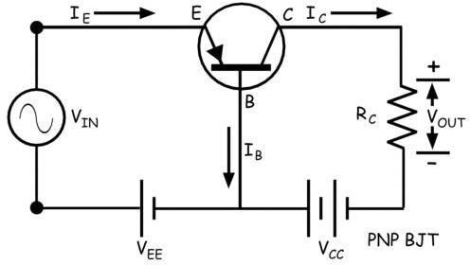

Here emitter-base circuit is taken as input circuit and collector base circuit as output circuit.

Current Gain

Here the input current is emitter current IE and output current is collector current IC. The current gain is considered as when we only consider the dc biasing voltages
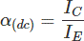
of the circuit and no alternating signal is applied in the input.
Now if we consider the alternating signal applied to the input then the current amplification factor (α) at a constant collector-base voltage, would be
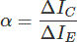
Here it is seen that neither of current gain and current amplification factor has value more than unity since collector current in no way can be more than emitter current. But as we know that the emitter current and collector current are nearly equal in a bipolar junction transistor, these ratios would be very near to unity. The value generally ranges from 0.9 to even 0.99.

Expression of Collector Current
- If the emitter circuit is open, there will be no emitter current (IC = 0). But in this condition, there will be a tiny current flowing through the collector region. This is because of flow of minority charge carriers and this is the reverse leakage current.
- As this current flow through collector and base keeping the emitter terminal open, the current is denoted as ICBO. In small power rated transistor the reverse leakage current ICBO is quite small and generally, we neglect it during calculations but in high power rated transistor this leakage current cannot be neglected.
- This current is highly dependent on the temperature so at high temperatures the reverse leakage current ICBO cannot be neglected during calculations.
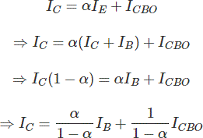
This expression proves that collector current also depends on base current.

Characteristic of Common Base Connection

Input Characteristic

This is drawn between input current and input voltage of the transistor itself. The input current is emitter current (IE) and the input voltage is emitter-base voltage (VEB). After crossing emitter-base junction forward barrier potential emitter current (IE) starts increasing rapidly with increasing emitter-base voltage (VEB).
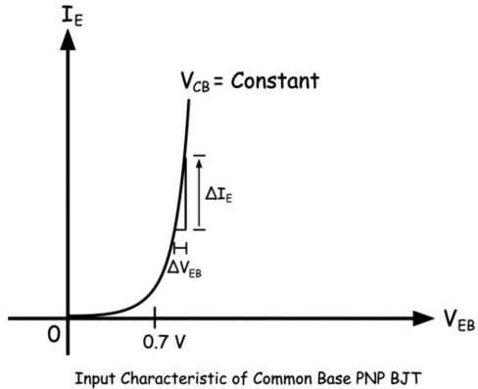

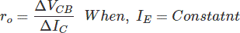
The input resistance of the circuit is the ratio of change in emitter-base voltage (ΔVEB) to emitter current (ΔIE) at a constant collector-base voltage (VCB = Constant). As the change in emitter current is quite large compared to the change in emitter- base voltage (ΔIE>> ΔVEB), the input resistance of the common base transistor is quite small.

Output Characteristic

- Collector current gets only constant value when there is sufficient reverse biased established between base and collector region. This is why there is a rise of collector current with an increase of collector-base voltage when this voltage has very low value.
- But after a certain collector-base voltage the collector-base junction gets sufficient reverse biased and hence the collector current becomes constant for a certain emitter current and it entirely depends on the emitter current.

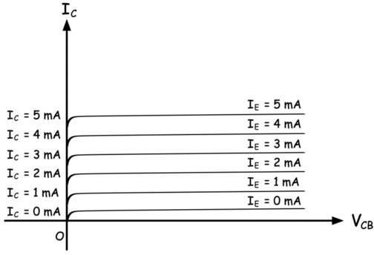

The ratio of change in collector-base voltage to the change in collector current is defined as the output resistance of common base mode of a transistor. Naturally, the value of output resistance is very high in the common base mode of a transistor.

COMMON EMITTER CONNECTION
Common Emitter Transistor is the most commonly used transistor connection. Here the emitter terminal is common for both input and output circuit. The circuit connected between base and emitter is the input circuit and the circuit connected between collector and emitter is the output circuit. The common emitter mode of NPN transistor and PNP transistor are shown separately in the figure below.
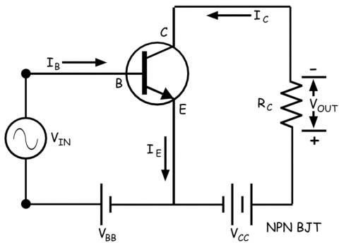

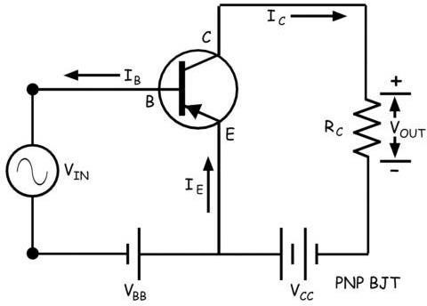

Current Gain
In common emitter configuration, the input current is base current (IB) and the output current is collector current (IC). In bipolar junction transistor, the base current controls the collector current. The ratio of change in collector current (ΔIC) to change in base current (ΔIB) is defined as the current gain of common emitter transistor. In a bipolar junction transistor, the emitter current (IE) is the sum of the base current (IB) and collector current (IC).
If base current changes, the collector current also changes and as a result the emitter current gets also changed accordingly.
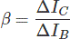
Again the ratio of change of collector current to the corresponding change in emitter current is denoted by α
As the value of base current is quite low compared to the collector current (IB << IC), the current gain in a common emitter transistor is quite high and it ranges from 20 to 500.

Characteristic of Common Emitter Transistor
  - In common emitter mode of the transistor, there are two circuits – input circuit and the output circuit. In the input circuit, the parameters are base current and base- emitter voltage.
  - The characteristic curve drawn against variations of base current and base-emitter voltage is input characteristic of a common emitter transistor.
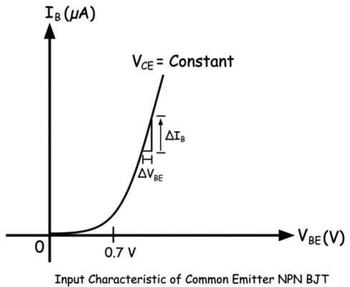
Input resistance of the circuit is:
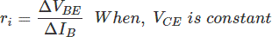

Output Characteristic of Common Emitter Transistor
  - The output characteristic is drawn against variations of output current and the output voltage of the transistor. The collector current is output current and collector-emitter voltage is the output voltage of the transistor.
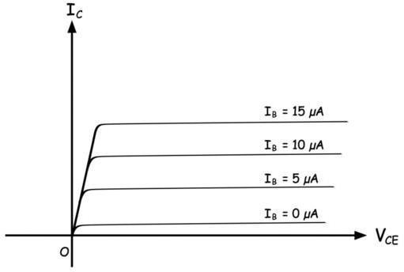

The output resistance would be
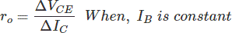

COMMON COLLECTOR:
In common collector configuration the input circuit is between base and collector terminal and the output circuit is between emitter and collector terminal.
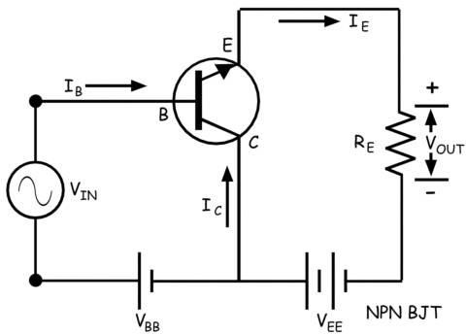

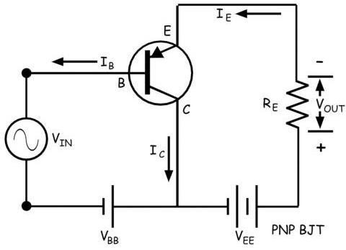
The ratio of change of emitter current to change of base current is defined as the current gain of common collector configuration. This is denoted as,

The current amplification factor of the circuit is the ratio of change of emitter current to change of base current when a time-varying signal is applied to the input.
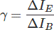

Input Characteristic of Common Collector Transistor
The input current is base current and input voltage of the transistor is base- collector voltage. The base-collector junction is reverse biased and hence with increasing base-collector voltage the reverse biasing of the junction increases. This causes base current to decrease slightly with the increase in base-collector voltage.
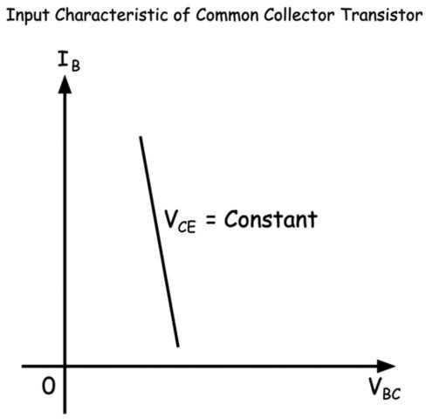

Output Characteristic of Common Collector Transistor
The output characteristic of a common collector transistor is nearly the same as the output characteristic of a common emitter transistor. The only difference that here

in the case of common collector configuration the output current is emitter current instead of collector current as in the case of common emitter configuration. Here also for a fixed base current, the emitter current increases linearly with increasing collector-emitter voltage up to a certain level of this voltage and then the emitter current gets almost constant irrespective of collector-emitter voltage. Although there would be a very slow increase of emitter current with the collector-emitter voltage as shown in the characteristic curve below.
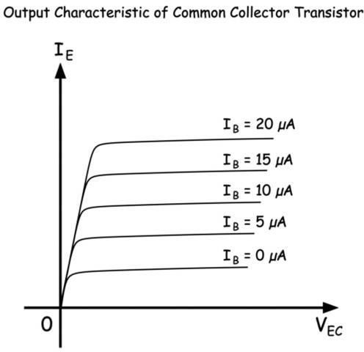

TRANSISTOR BIASING:-
    - Biasing is the process of providing DC voltage which helps in functioning of the circuit.
    - A transistor is biased in order to make the emitter base junction forward biased and collector base junction reverse biased, so that it maintains in active region, to work as an amplifier.
    - The proper flow of zero signal collector current and the maintenance of proper collector emitter voltage during the passage of a signal is known as transistor biasing.
    - The circuit which provides transistor biasing is known as biasing circuit.
    - Transistor biasing is basically classified into 4 types:
      - Fixed biasing
      - Emitter stabilized biasing
      - Voltage divider biasing
      - DC biasing with voltage feedback

DIFFERENT METHOD OF TRANSISTORSBIASING: FIXED BIASING:
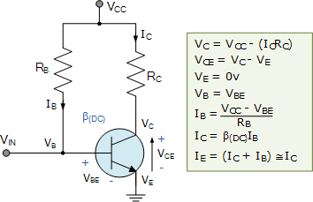
- Fixed biasing is also known as base biasing.

- The above circuit shown is called as a “fixed base bias circuit”, because the transistors base current, IB remains constant for given values of Vcc, and therefore the transistors operating point must also remain fixed.
- This two resistor biasing network is used to establish the initial operating region of the transistor using a fixed current bias.
- This type of transistor biasing arrangement is also beta dependent biasing as the steady-state condition of operation is a function of the transistors beta β value, so the biasing point will vary over a wide range for transistors of the same type as the characteristics of the transistors will not be exactly the same.
- The emitter diode of the transistor is forward biased by applying the required positive base bias voltage via the current limiting resistor RB.
- Assuming a standard bipolar transistor, the forward base-emitter voltage drop would be 0.7V. Then the value of RB is simply: (VCC – VBE)/IB where IB is defined as IC/β.
- With this single resistor type of biasing arrangement the biasing voltages and currents do not remain stable during transistor operation and can vary enormously.
- Also the operating temperature of the transistor can adversely affect the operating point.

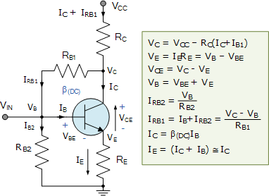
EMITTER STABILIZED BIASING/COLLECTOR FEEDBACK BIASING
- This type of transistor biasing configuration, often called self-emitter biasing, uses both emitter and base-collector feedback to stabilize the collector current even further.
- This is because resistors RB1 and RE as well as the base-emitter junction of the transistor are all effectively connected in series with the supply voltage, VCC.

- The downside of this emitter feedback configuration is that it reduces the output gain due to the base resistor connection.
- The collector voltage determines the current flowing through the feedback resistor, RB1 producing what is called “degenerative feedback”.
- The current flowing from the emitter, IE (which is a combination of IC + IB) causes a voltage drop to appear across RE in such a direction, that it reverse biases the base- emitter junction.
- So if the emitter current increases, due to an increase in collector current, voltage drop I*RE also increases. Since the polarity of this voltage reverse biases the base- emitter junction, IB automatically decrease. Therefore the emitter current increase less than it would have done had there been no self-biasing resistor.
- Generally, resistor values are set so that the voltage dropped across the emitter resistor RE is approximately 10% of VCC and the current flowing through resistor RB1 is 10% of the collector current IC.
- Thus this type of transistor biasing configuration works best at relatively low power supply voltages.

VOLTAGE DIVIDER BIASING:
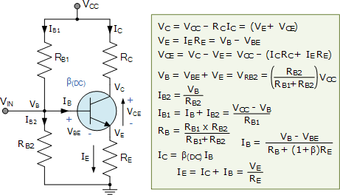
- Voltage divider biasing is also known as universal biasing.

- Here the common emitter transistor configuration is biased using a voltage divider network to increase stability.
- The name of this biasing configuration comes from the fact that the two resistors RB1 and RB2 form a voltage or potential divider network across the supply with their center point junction connected the transistors base terminal as shown.

- This voltage divider biasing configuration is the most widely used transistor biasing method.
- The emitter diode of the transistor is forward biased by the voltage value developed across resistor RB2.
- The voltage divider network biasing makes the transistor circuit independent of changes in beta as the biasing voltages set at the transistors base, emitter, and collector terminals are not dependant on external circuit values.
- To calculate the voltage developed across resistor RB2 and the voltage applied to the base terminal we simply use the voltage divider formula for resistors in series.
- Generally the voltage drop across resistor RB2 is much less than for resistor RB1. Clearly the transistors base voltage VB with respect to ground will be equal to the voltage across RB2.
- The amount of biasing current flowing through resistor RB2 is generally set to 10 times the value of the required base current IB so that it is sufficiently high enough to have no effect on the voltage divider current or changes in Beta.

DC BIAS WITH COLLECTOR FEEDBACK:
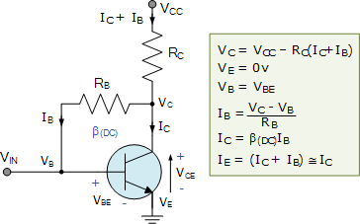
This self-biasing collector feedback configuration is another beta dependent biasing method which requires two resistors to provide the necessary DC bias for the transistor. The collector to base feedback configuration ensures that the transistor is always biased in the active region regardless of the value of Beta (β). The DC base bias voltage is derived from the collector voltage VC, thus providing good stability.

In this circuit, the base bias resistor, RB is connected to the transistors collector C, instead of to the supply voltage rail, Vcc. Now if the collector current increases, the collector voltage drops, reducing the base drive and thereby automatically reducing the collector current to keep the transistors Q-point fixed. Therefore this method of collector feedback biasing produces negative feedback round the transistor as there is a direct feedback from the output terminal to the input terminal via resistor, RB.
Since the biasing voltage is derived from the voltage drop across the load resistor, RL, if the load current increases there will be a larger voltage drop across RL, and a corresponding reduced collector voltage, VC. This effect will cause a corresponding drop in the base current, IB which in turn, brings IC back to normal.
The opposite reaction will also occur when the transistors collector current reduces. Then this method of biasing is called self-biasing with the transistors stability using this type of feedback bias network being generally good for most amplifier designs.

PRACTICAL CIRCUIT OF TRANSISTORAMPLIFIER
The transistor raises the strength of a weak signal and hence acts an amplifier. The transistor amplifier circuit is shown in the figure below. The transistor has three terminals namely emitter, base and collector. The emitter and base of the transistor are connected in forward biased and the collector base region is in reverse bias. The forward bias means the P-region of the transistor is connected to the positive terminal of the supply and the negative region is connected to the N-terminal and in reverse bias just opposite of it has occurred.
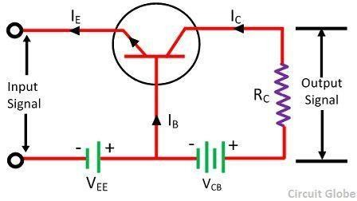

The input signal or weak signal is applied across the emitter base and the output is obtained to the load resistor RC which is connected in the collector circuit. The DC voltage VEE is applied to the input circuit along with the input signal to achieve the amplification. The DC voltage VEE keeps the emitter-base junction under the forward biased condition regardless of the polarity of the input signal and is known as a bias voltage.

When a weak signal is applied to the input, a small change in signal voltage causes a change in emitter current (or we can say a change of 0.1V in signal voltage causes a change of 1mA in the emitter current) because the input circuit has very low resistance. This change is almost the same in collector current because of the transmitter action.

In the collector circuit, a load resistor RC of high value is connected. When collector current flows through such a high resistance, it produces a large voltage drop across it. Thus, a weak signal (0.1V) applied to the input circuit appears in the amplified form (10V) in the collector circuit.

TRANSISTOR LOAD LINE ANALYSIS:
The load line analysis of transistor means for the given value of collector-emitter voltage we find the value of collector current. This can be done by plotting the output characteristic and then determine the collector current IC with respect to

collector-emitter voltage VCE. The load line analysis can easily be obtained by determining the output characteristics of the load line analysis methods.

DC LOAD LINE & DC EQUIVALENT CIRCUIT: -

The DC load represents the desirable combinations of the collector current and the collector-emitter voltage. It is drawn when no signal is given to the input, and the transistor becomes bias.

Consider a CE NPN transistor circuit shown in the figure below where no signal is applied to the input side. For this circuit, DC condition will obtain, and the output characteristic of such a circuit is shown in the figure below.
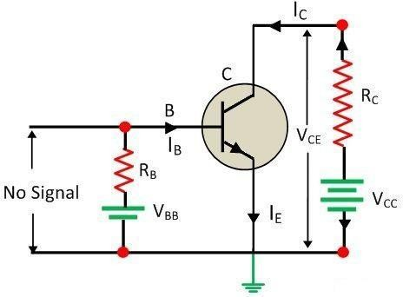

The DC load line curve of the above circuit is shown in the figure below.
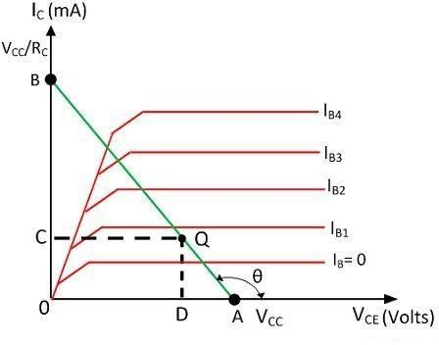

By applying Kirchhoff’s voltage law to the collector circuit, we get,
𝑉𝐶𝐶 = 𝑉𝐶𝐸+ 𝐼𝐶𝑅𝐶

𝑉𝐶𝐸 = 𝑉𝐶𝐶 - 𝐼𝐶𝑅𝐶 equation 1

The above equation shows that the VCC and RC are the constant value, and it is the first-degree equation which is represented by the straight line on the output characteristic. This load line is known as a DC load line. The input characteristic is used to determine the locus of VCE and IC point for the given value of RC. The end point of the line are located as
- The collector-emitter voltage VCE is maximum when the collector current IC = 0 then from the equation (1) we get,
𝑉_{𝐶𝐸} = 𝑉_{𝐶𝐶} − 0 𝑋 𝑅_{𝐶}
𝑉𝐶𝐸 = 𝑉𝐶𝐶

The first point A (OA = VCC) on the collector-emitter voltage axis shown in the figure above.
- The collector current IC becomes maximum when the collector-emitter voltage VCE = 0 then from the equation (1) we get,
0 = 𝑉_{𝐶𝐶} − 𝐼_{𝐶}𝑅_{𝐶}

𝐼_{𝐶} =
𝑉𝐶𝐶

𝑅𝐶

This gives the second point on the collector current axis as shown in the figure above.
By adding the points A and B, the DC load line is drawn. With the help of load line, any value of collector current can be determined.

AC LOAD LINE & AC EQUIVALENT CIRCUIT: -

The DC load line discussed previously, analyzes the variation of collector currents and voltages, when no AC voltage is applied. Whereas the AC load line gives the peak-to-peak voltage, or the maximum possible output swing for a given amplifier.
We shall consider an AC equivalent circuit of a CE amplifier for our understanding.
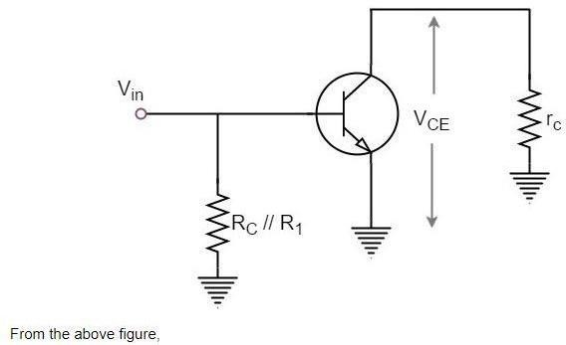

𝑉_{𝐶𝐸} = ( // 𝑅₁) 𝑋 𝐼_{𝐶}
𝑟_{𝐶} = ( // 𝑅₁)

For a transistor to operate as an amplifier, it should stay in active region. The quiescent point is so chosen in such a way that the maximum input signal excursion is symmetrical on both negative and positive half cycles.
Hence,
𝑉𝑚𝑎𝑥 = 𝑉𝐶𝐸𝑄 𝑎𝑛𝑑 𝑉𝑚𝑖𝑛 = −𝑉𝐶𝐸𝑄
Where VCEQ is the emitter-collector voltage at quiescent point
The following graph represents the AC load line which is drawn between saturation and cut off points.
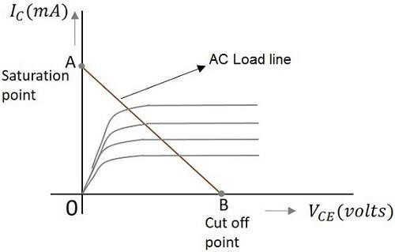
From the graph above, the current 𝐼_{𝐶} at the saturation point is
𝐼 = 𝐼 𝑉𝐶𝐸𝑄⁄ )
𝐶(𝑠𝑎𝑡) 𝐶𝑄 + ( 𝑟𝐶
The voltage 𝑉_{𝐶𝐸} at the cutoff point is
𝑉𝐶𝐸(𝑜𝑓𝑓) = 𝑉𝐶𝐸𝑄 + 𝐼𝐶𝑄𝑟𝐶
Hence the maximum current for that corresponding 𝑉_{𝐶𝐸𝑄} = 𝑉_{𝐶𝐸𝑄}/(𝑅_{𝐶}//𝑅₁) is
𝐼_{𝐶𝑄} = 𝐼_{𝐶𝑄} ∗ (𝑅_{𝐶}//𝑅₁)
Hence by adding quiescent currents the end points of AC load line are
(𝑠𝑎𝑡) = 𝐼𝐶𝑄 + 𝑉𝐶𝐸𝑄/(𝑅𝐶//𝑅1)
(𝑜𝑓𝑓) = 𝑉𝐶𝐸𝑄 + 𝐼𝐶𝑄 ∗ (𝑅𝐶//𝑅1)

AC and DC Load Line
When AC and DC Load lines are represented in a graph, it can be understood that they are not identical. Both of these lines intersect at the Q-point or quiescent point. The endpoints of AC load line are saturation and cut off points. This is understood from the figure below.

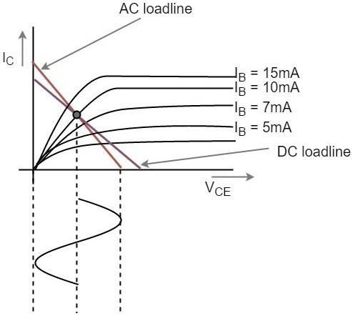
From the above figure, it is understood that the quiescent point (the dark dot) is obtained when the value of base current IB is 10mA. This is the point where both the AC and DC load lines intersect.

HYBRID PARAMETERS OR H PARAMETERS
Hybrid parameters (also known as h parameters) are known as ‘hybrid’ parameters as they use Z parameters, Y parameters, voltage ratio, and current ratios to represent the relationship between voltage and current in a two port network.
H parameters are useful in describing the input-output characteristics of circuits where it is hard to measure Z or Y parameters (such as a transistor). H parameters encapsulate all the important linear characteristics of the circuit, so they are very useful for simulation purposes. The relationship between voltages and current in h parameters can be represented as:
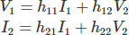

This can be represented in matrix form as:
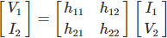

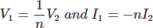
To illustrate where h parameters are useful, take the case of an ideal transformer, where Z parameters cannot be used. Since here, the relations between voltages and current in that ideal transformer would be,

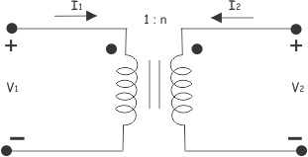

Since, in an ideal transformer voltages cannot be expressed in terms of current, it is impossible to analyze a transformer with Z parameters because a transformer does not have Z parameters. The problem can be solved by using hybrid parameters (i.e. h parameters).

Determining h Parameters
Let us short circuit the output port of a two port network as shown below,
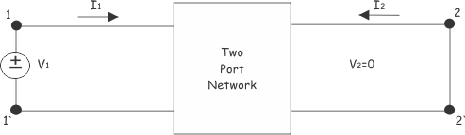
Now, ratio of input voltage to input current, at short circuited output port is:
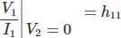

This is referred to as the short circuit input impedance. Now, the ratio of the output current to input current at the short-circuited output port is:
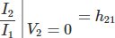

This is called short-circuit current gain of the network. Now, let us open circuit the port 1. At that condition, there will be no input current (I1=0) but open circuit voltage V1 appears across the port 1, as shown below:

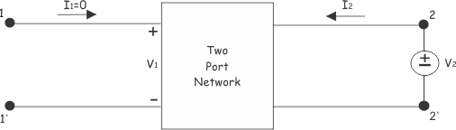

Now:

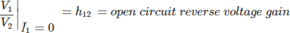

This is referred as reverse voltage gain because, this is the ratio of input voltage to the output voltage of the network, but voltage gain is defined as the ratio of output voltage to the input voltage of a network.

Now:
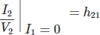

It is referred as open circuit output admittance.
To draw h parameter equivalent network of a two port network, first we have to write the equation of voltages and currents using h parameters. These are:
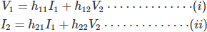

Equation (i) can be represented as a circuit based on Kirchhoff Voltage Law:
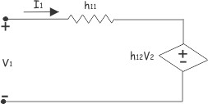
Equation (ii) can be represented as a circuit based on Kirchhoff Current Law:

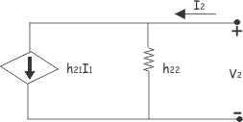

Combining these two parts of the network we get:
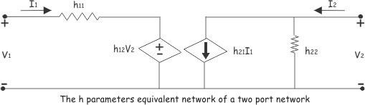

GENERALISED APPROXIMATE MODEL:
In the analysis of transistor amplifier, we have as far used the exact h-model for the transistor. In practice, we may conveniently use an approximately h-model for the transistor which introduces error < 10% in most cases.
This much error may be conveniently tolerated since the h-parameters themselves are not steady but vary considerably for the same type of transistor. We first derive this approximate CE h-model.
Figure 1 gives the equivalent circuit of CE amplifier using exact h-model for CE transistor.
The following steps are used to driving the approximate h-model:

- If𝑅_{𝐿}
RL.
< 0.1 1
ℎ𝑜𝑒
and hoe. RL < 0.1, then we may neglected, 1 being in parallel with
ℎ𝑜𝑒

- Having neglected hoe, the collected current IC equals hfe. Ib and the magnitude of the dependent voltage generator in the emitter circuit is then given by,
ℎ_{𝑟𝑒} ∗ |𝑉_{𝐶}| = ℎ_{𝑟𝑒} ∗ 𝐼_{𝐶} ∗ 𝑅_{𝐿} ≈ ℎ_{𝑟𝑒} ∗ ℎ_{𝑓𝑒} ∗ 𝐼_{𝑏} ∗ 𝑅_{𝐿} …….(1)

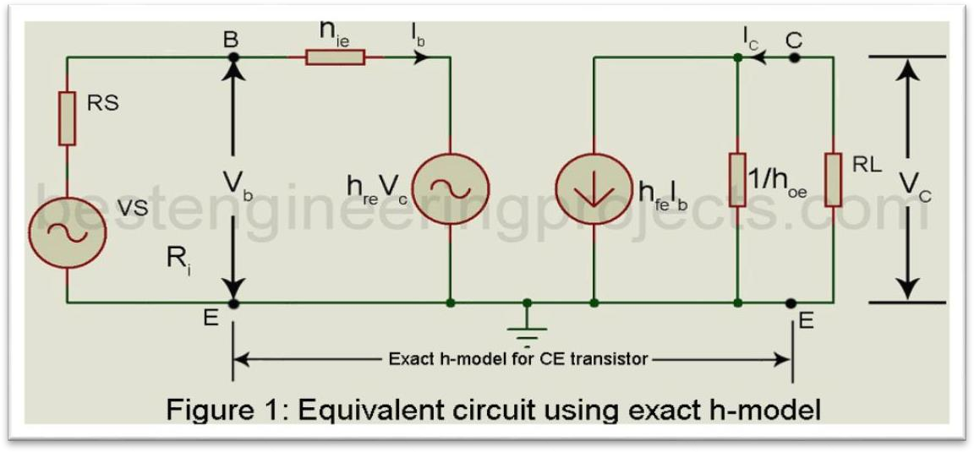

But ℎ𝑟𝑒 ∗ ℎ𝑓𝑒 ≈ 0. Hence the voltage hre |VC | in the emitter circuit may be neglected in comparison with the voltage drop hie.Ib provided that RL is not very large. Then the approximate CE h-model reduces to the form shown in Figure 2.
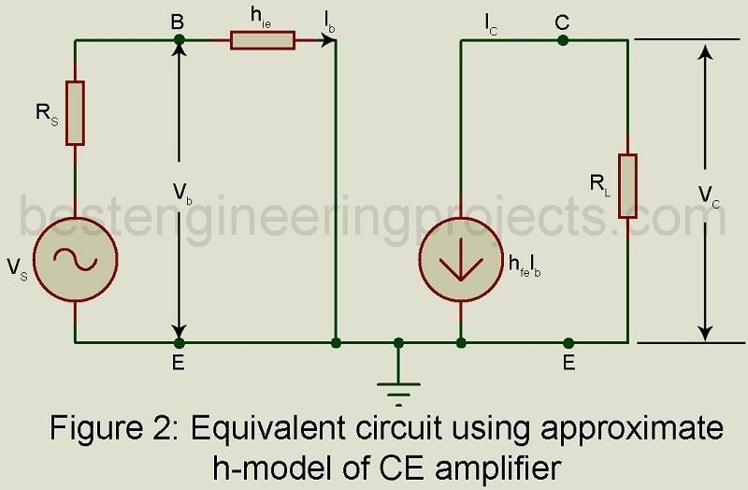

ANALYSIS OF CB, CE, CC AMPLIFIER USING GENERALISED APPROXIMATE MODEL:

Approximate h-model Valid for all the three Configuration
The approximate CE h-model of Figure 2 is redrawn in figure 3. This model may be used for any of the three configurations by grounding the appropriate node and analysis done accordingly. It may be proved that the error in values of AI, Ri, AV or output terminal resistance Rot (= R0 || RL) caused by use of approximate model does not exceed 10% if .ℎ_{𝑜𝑒} ∗ 𝑅_{𝐿} < 0.1.
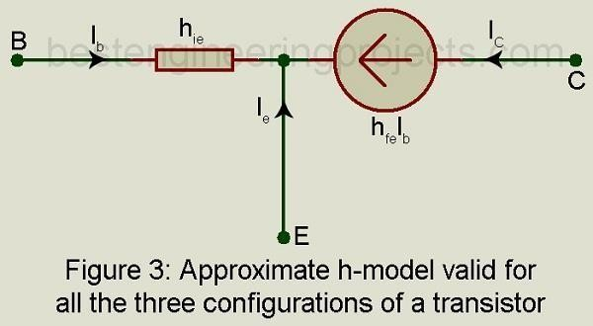

Analysis of CE Amplifier using approximate h-model
Figure 2 gives the equivalent circuit of CE amplifier using approximate h-model for the transistor. For this equivalent circuit we get,
Current gain = −ℎ𝑓𝑒 𝑋 𝐼𝑏= −ℎ …..(2)
𝐼 𝐼𝑏 𝑓𝑒
Input resistance 𝑅_{𝑖} = ℎ_{𝑖𝑒}
Voltage gain 𝐴 = 𝐴 𝑥 𝑅𝐿 = −ℎ𝑓𝑒 𝑋 𝑅𝐿……(3)
𝑉 𝐼 𝑅𝑖 ℎ𝑖𝑒
Output resistance R0: From this approximate equivalent circuit of figure 1(b) with Vs = 0 and with external voltage source connected across the output, we get Ib = 0 and therefore IC = 0. Hence output resistance𝑅0 = ∞. However, in actual practice, R0 lies between 40kῺ 𝑎𝑛𝑑 80𝑘Ὼ depending on the value of RS.
With load resistance 𝑅_{𝐿} = 4𝑘Ὼ(the maximum practical value), the output terminal resistance𝑅_{𝑡} = 𝑅_{𝐿} ‖ ∞ = 𝑅_{𝐿} = 4𝑘Ὼ.
Condition ℎ_{𝑜𝑒} ∗ 𝑅_{𝐿} < 0.1. For a typical transistor ℎ_{𝑜𝑒} = 25 ∗ 10−6S. Hence to meet the condition that, ℎ|𝑜𝑒| * 𝑅𝐿 < 0.1.we must use RL less than.
Analysis of CB Amplifier using the Approximate Model
From figure 4 gives the equivalent circuit of a CB amplifier using the approximate model for the transistor as given in figure 2 with base grounded, the input applied between emitter and base and output obtained across load resistor RL between the collector and the base.
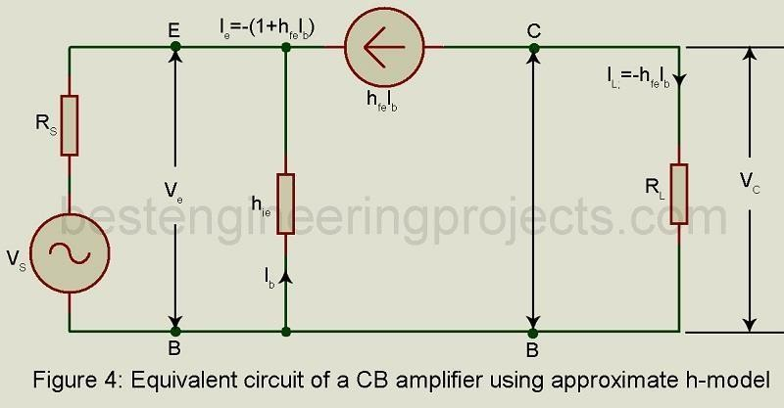
Current gain 𝐴 = 𝐼𝐿 = −ℎ𝑓𝑒 𝑋 𝐼𝑏 = ℎ𝑓𝑒 …..(4)
𝐼 𝐼𝑒 −(1+ ℎ𝑓𝑒)𝑋 𝐼𝑏 1+ ℎ𝑓𝑒

Input resistance RI: from figure 4,
𝑉_{𝑒} = −𝐼_{𝑏} ∗ ℎ_{𝑖𝑒}…… (5)
𝐼_{𝑒} = −(1 + ℎ_{𝑓𝑒}) ∗ 𝐼_{𝑏} …….(6)

Hence, = 𝑉𝑒 = −𝐼𝑏 𝑋 ℎ𝑖𝑒 = ℎ …..(7)
𝑖 𝐼𝑒 −𝐼𝑏 (1+ ℎ𝑓𝑒) 1+ ℎ𝑓𝑒

Voltage Gain AV: From figure 4,
𝑉_{𝐶} = −ℎ_{𝑓𝑒} ∗ 𝐼_{𝑏} ∗ 𝑅_{𝐿}
Hence, 𝐴 = 𝐶 = −ℎ𝑓𝑒 𝑋 𝐼𝑏 𝑋 𝑅𝐿 = ℎ𝑓𝑒 𝑋 𝑅𝐿…..(8)
𝑉 𝑉𝑒 − 𝐼𝑏 𝑋 ℎ𝑖𝑒 ℎ𝑖𝑒
Output resistance in the equivalent circuit of figure 3, with Vs = 0, we get Ie = 0. Hence, Ib = 0. Hence the output resistance .
Output Terminal Resistance 𝑅_{𝑜𝑡} = 𝑅_{𝑜}‖𝑅_{𝐿} = ∞‖𝑅_{𝐿} = 𝑅_{𝐿} …..(9) Analysis of CC Amplifier (Emitter Follower) using approximate h-model
Figure 5 gives the equivalent circuit of an emitter follower using the approximate model as given in figure 3, with collector grounded, input signal applied between the base and the ground and the load impedance RL connected between emitter and ground.
Current gain AI : from the circuit of figure 5, Load current 𝐼_{𝐿} = (1 + ℎ_{𝑓𝑒})𝐼_{𝑏}…..(10)
Hence Current gain 𝐴 = 𝐼𝐿 = (1 + ℎ )…..(11)
𝐼 𝐼𝑏 𝑓𝑒
Input resistance Ri: from figure 5,
𝑉_{𝑏} = 𝐼_{𝑏} 𝑥 ℎ_{𝑖𝑒} + (1 + ℎ_{𝑓𝑒}) 𝑥 𝑅_{𝐿}….. (12)

Hence, 𝑅_{𝑖}
= 𝑉𝑏 = ℎ
𝐼𝑏 𝑖𝑒
+ (1 + ℎ_{𝑓𝑒}
)𝑅_{𝐿}
…… (13)

Voltage Gain AV: From figure 5,
𝑉_{𝑒} = (1 + ℎ_{𝑓𝑒}) ∗ 𝑅_{𝐿} …… (14)Hence,
𝐴 = 𝑒 = (1+ℎ𝑓𝑒) 𝑋 𝑅𝐿
𝑉 𝑉𝑏 𝐼𝑏 𝑋 ℎ𝑖𝑒+(1+ ℎ𝑓𝑒)𝐼𝑏 𝑋 𝑅𝐿
= (1+ ℎ𝑓𝑒) = 1 − ℎ𝑖𝑒 = 1 − ℎ𝑖𝑒 ℎ𝑖𝑒+(1+ℎ+ 𝑓𝑒)𝑅𝐿 ℎ𝑖𝑒+(1+ ℎ𝑓𝑒)𝑅𝐿 𝑅𝑖
Output Resistance from figure 5, Open circuit output voltage = VS
Short circuit output current

Hence output impedance
I = (1 + ℎ_{𝑓𝑒}
) 𝐼_{𝑏}
= (1+ ℎ𝑓𝑒)
ℎ𝑖𝑒+ 𝑅𝑠

𝑅₀
𝑂𝑝𝑒𝑛 𝑐𝑖𝑟𝑐𝑢𝑖𝑡 𝑜𝑢𝑡𝑝𝑢𝑡 𝑣𝑜𝑙𝑡𝑎𝑔𝑒
= =
𝑆ℎ𝑜𝑟𝑡 𝑐𝑖𝑟𝑐𝑢𝑖𝑡 𝑜𝑢𝑡𝑝𝑢𝑡 𝑐𝑢𝑟𝑟𝑒𝑛𝑡
ℎ_{𝑖𝑒} + 𝑅_{𝑠} 1 + ℎ_{𝑓𝑒}

Output terminal Impedance 𝑅_{𝑜𝑡} = 𝑅₀ ‖ 𝑅_{𝐿}
Expressions for current gain etc. for the three configurations using approximate h- model.

Expressions for AI, Ri, AV, R0 and Rot using Approximate h-model

Quantity | CE | CB | CC
AI | -hfe | 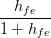 | 1 + hfe
Ri | hie | 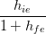 | hie + (1 + hfe)RL
AV | 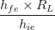 | 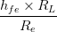 | 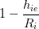
R0 |  |  | 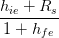
Rot | RL | RL | R0 || RL

MULTISTAGE TRANSISTOR AMPLIFIERS:
In Multi-stage amplifiers, the output of first stage is coupled to the input of next stage using a coupling device. The following figure shows a two-stage amplifier connected in cascade.
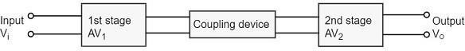

If there are n numbers of stages, the product of voltage gains of those n stages will be the overall gain of that multistage amplifier circuit.

COUPLING:-
Coupling is a process in which the output of one stage is fed as input to the next stage. The main purpose of coupling is to:-
  - Transfer output of one stage to the input of next stage.
  - Isolate the dc condition of one stage from the next stage.

TYPES OF COUPLING:
Coupling is classified into three types. They are:- RC coupling
Transformer coupling Direct coupling

RC COUPLED TRANSISTOR AMPLIFIER:-
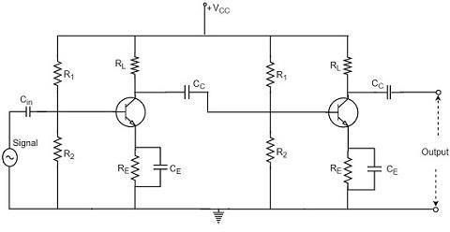

Operation of RC Coupled Amplifier
When an AC input signal is applied to the base of first transistor, it gets amplified and appears at the collector load RL which is then passed through the coupling capacitor CC to the next stage. This becomes the input of the next stage, whose amplified output again appears across its collector load. Thus the signal is amplified in stage by stage action.
Frequency Response of RC Coupled Amplifier
Frequency response curve is a graph that indicates the relationship between voltage gain and function of frequency. The frequency response of a RC coupled amplifier is as shown in the following graph.

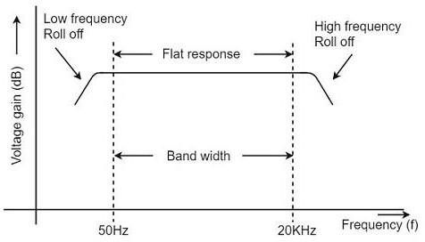

From the above graph, it is understood that the frequency rolls off or decreases for the frequencies below 50Hz and for the frequencies above 20 KHz. whereas the voltage gain for the range of frequencies between 50Hz and 20 KHz is constant.
We know that,
XC=1/2πfc
It means that the capacitive reactance is inversely proportional to the frequency.

At Low frequencies (i.e. below 50 Hz)
The capacitive reactance is inversely proportional to the frequency. At low frequencies, the reactance is quite high. The reactance of input capacitor Cin and the coupling capacitor CC are so high that only small part of the input signal is allowed. The reactance of the emitter by pass capacitor CE is also very high during low frequencies. Hence it cannot shunt the emitter resistance effectively. With all these factors, the voltage gain rolls off at low frequencies.

At High frequencies (i.e. above 20 KHz)
Again considering the same point, we know that the capacitive reactance is low at high frequencies. So, a capacitor behaves as a short circuit, at high frequencies. As a result of this, the loading effect of the next stage increases, which reduces the voltage gain. Along with this, as the capacitance of emitter diode decreases, it increases the base current of the transistor due to which the current gain (β) reduces. Hence the voltage gain rolls off at high frequencies.

At Mid-frequencies (i.e. 50 Hz to 20 KHz)
The voltage gain of the capacitors is maintained constant in this range of frequencies, as shown in figure. If the frequency increases, the reactance of the

capacitor CC decreases which tends to increase the gain. But this lower capacitance reactive increases the loading effect of the next stage by which there is a reduction in gain.
Due to these two factors, the gain is maintained constant.

Advantages of RC Coupled Amplifier
The following are the advantages of RC coupled amplifier.
- The frequency response of RC amplifier provides constant gain over a wide frequency range, hence most suitable for audio applications.
- The circuit is simple and has lower cost because it employs resistors and capacitors which are cheap.
- It becomes more compact with the upgrading technology.

Disadvantages of RC Coupled Amplifier
The following are the disadvantages of RC coupled amplifier.
- The voltage and power gain are low because of the effective load resistance.
- They become noisy with age.
- Due to poor impedance matching, power transfer will be low.

TRANSFORMER COUPLED AMPLIFIER:-
In a transformer-coupled amplifier, the stages of amplifier are coupled using a transformer. Let us go into the constructional and operational details of a transformer coupled amplifier.
The figure below shows the circuit diagram of transformer coupled amplifier.
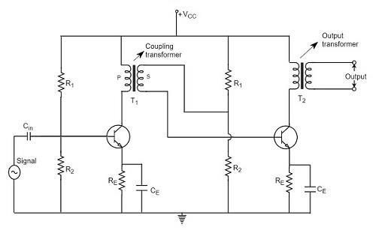

Operation of Transformer Coupled Amplifier
When an AC signal is applied to the input of the base of the first transistor then it gets amplified by the transistor and appears at the collector to which the primary of the transformer is connected.
The transformer which is used as a coupling device in this circuit has the property of impedance changing, which means the low resistance of a stage (or load) can be reflected as a high load resistance to the previous stage. Hence the voltage at the primary is transferred according to the turns ratio of the secondary winding of the transformer.
This transformer coupling provides good impedance matching between the stages of amplifier. The transformer coupled amplifier is generally used for power amplification.

Frequency Response of Transformer Coupled Amplifier
The figure below shows the frequency response of a transformer coupled amplifier. The gain of the amplifier is constant only for a small range of frequencies. The output voltage is equal to the collector current multiplied by the reactance of primary.
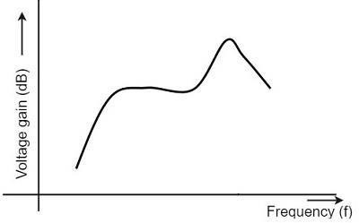
At low frequencies, the reactance of primary begins to fall, resulting in decreased gain. At high frequencies, the capacitance between turns of windings acts as a bypass condenser to reduce the output voltage and hence gain.
So, the amplification of audio signals will not be proportionate and some distortion will also get introduced, which is called as Frequency distortion.

Advantages of Transformer Coupled Amplifier
The following are the advantages of a transformer coupled amplifier −
- An excellent impedance matching is provided.
- Gain achieved is higher.
- There will be no power loss in collector and base resistors.
- Efficient in operation.

Disadvantages of Transformer Coupled Amplifier
The following are the disadvantages of a transformer coupled amplifier −
- Though the gain is high, it varies considerably with frequency. Hence a poor frequency response.
- Frequency distortion is higher.
- Transformers tend to produce hum noise.
- Transformers are bulky and costly.

UNIT-2

SKDAV GOVT.POLYTECHNIC

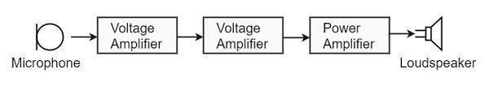

AUDIO POWER AMPLIFIERS
In practice, any amplifier consists of few stages of amplification. If we consider audio amplification, it has several stages of amplification, depending upon our requirement.

Power Amplifier
After the audio signal is converted into electrical signal, it has several voltage amplifications done, after which the power amplification of the amplified signal is done just before the loud speaker stage. This is clearly shown in the below figure.

While the voltage amplifier raises the voltage level of the signal, the power amplifier raises the power level of the signal. Besides raising the power level, it can also be said that a power amplifier is a device which converts DC power to AC power and whose action is controlled by the input signal.

The DC power is distributed according to therelation, DC power input = AC power output + losses
Power Transistor
For such Power amplification, a normal transistor would not do. A transistor that is manufactured to suit the purpose of power amplification is called as a Power transistor.

A Power transistor differs from the other transistors, in the following factors.
- It is larger in size, in order to handle large powers.
- The collector region of the transistor is made large and a heat sink is placed at the collector-base junction in order to minimize heat generated.
- The emitter and base regions of a power transistor are heavily doped.
- Due to the low input resistance, it requires low input power.

Hence there is a lot of difference in voltage amplification and power amplification. So, let us now try to get into the details to understand the differences between a voltage amplifier and a power amplifier.

Difference between Voltage and Power Amplifiers:
Let us try to differentiate between voltage and power amplifier.
Voltage Amplifier

The function of a voltage amplifier is to raise the voltage level of the signal. A voltage

SKDAV GOVT.POLYTECHNIC

amplifier is designed to achieve maximum voltage amplification. The voltage gain of an amplifier is given by
Av=β(Rc/Rin)
The characteristics of a voltage amplifier are as follows −
- The base of the transistor should be thin and hence the value of β should be greater than 100.
- The resistance of the input resistor Rin should be low when compared to collector load RC.
- The collector load RC should be relatively high. To permit high collector load, the voltage amplifiers are always operated at low collector current.
- The voltage amplifiers are used for small signal voltages.

Power Amplifier

The function of a power amplifier is to raise the power level of input signal. It is required to deliver a large amount of power and has to handle large current.
The characteristics of a power amplifier are as follows –
- The base of transistor is made thicken to handle large currents. The value of β being (β > 100) high.
- The size of the transistor is made larger, in order to dissipate more heat, which is produced during transistor operation.
- Transformer coupling is used for impedance matching.
- Collector resistance is made low.

The comparison between voltage and power amplifiers is given below in a tabular form.

S.No | Particular | Voltage Amplifier | Power Amplifier
1 | β | High (>100) | Low (5 to 20)
2 | RC | High (4-10 KΩ) | Low (5 to 20 Ω)
3 | Coupling | Usually R-C coupling | Invariably transformer coupling
4 | Input voltage | Low (a few m V) | High (2-4 V)
5 | Collector current | Low (≈ 1 mA) | High (> 100 mA)
6 | Power output | Low | High
7 | Output impendence | High (≈ 12 K Ω) | Low (200 Ω

The Power amplifiers amplify the power level of the signal. This amplification is done in the last stage in audio applications. The applications related to radio frequencies employ radio power amplifiers. But the operating point of a transistor plays a very important role in determining the efficiency of the amplifier. The main classification is done based on this mode of operation.

SKDAV GOVT.POLYTECHNIC

The classification is done based on their frequencies and also based on their mode of operation.

Classification Based on Frequencies

Power amplifiers are divided into two categories, based on the frequencies they handle.
They are as follows.

- Audio Power Amplifiers − The audio power amplifiers raise the power level of signals that have audio frequency range (20 Hz to 20 KHz). They are also known as Small signal power amplifiers.
- Radio Power Amplifiers − Radio Power Amplifiers or tuned power amplifiers raise the power level of signals that have radio frequency range (3 KHz to 300 GHz). They are also known as large signal power amplifiers.

Classification Based on Mode of Operation

On the basis of the mode of operation, i.e., the portion of the input cycle during which collector current flows, the power amplifiers may be classified as follows.
- Class A Power amplifier − When the collector current flows at all times during the full cycle of signal, the power amplifier is known as class A poweramplifier.
- Class B Power amplifier − When the collector current flows only during the positive half cycle of the input signal, the power amplifier is known as class B power amplifier.
- Class C Power amplifier − When the collector current flows for less than half cycle of the input signal, the power amplifier is known as class C power amplifier.
There forms another amplifier called Class AB amplifier, if we combine the class A and class B amplifiers so as to utilize the advantages of both. Before going into the details of these amplifiers, let us have a look at the important terms that have to be considered to determine the efficiency of an amplifier.
Terms Considering Performance
The primary objective of a power amplifier is to obtain maximum output power. In order to

SKDAV GOVT.POLYTECHNIC

achieve this, the important factors to be considered are collector efficiency, power dissipation capability and distortion. Let us go through them in detail.
Collector Efficiency
This explains how well an amplifier converts DC power to AC power. When the DC supply is given by the battery but no AC signal input is given, the collector output at such a condition is observed as collector efficiency.
The collector efficiency is defined as
η=average a.c poweroutput / average d.c powerinputtotransisto
The main aim of a power amplifier is to obtain maximum collector efficiency. Hence the higher the value of collector efficiency, the efficient the amplifier will be.
Power Dissipation Capacity
Every transistor gets heated up during its operation. As a power transistor handles large currents, it gets more heated up. This heat increases the temperature of the transistor, which alters the operating point of the transistor. So, in order to maintain the operating point stability, the temperature of the transistor has to be kept in permissible limits. For this, the heat produced has to be dissipated. Such a capacity is called as Power dissipation capability.
Power dissipation capability can be defined as the ability of a power transistor to dissipate the heat developed in it. Metal cases called heat sinks are used in order to dissipate the heat produced in power transistors.
Distortion
A transistor is a non-linear device. When compared with the input, there occur few variations in the output. In voltage amplifiers, this problem is not pre-dominant as small currents are used. But in power amplifiers, as large currents are in use, the problem of distortion certainly arises.

SKDAV GOVT.POLYTECHNIC

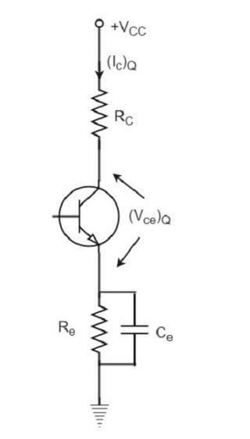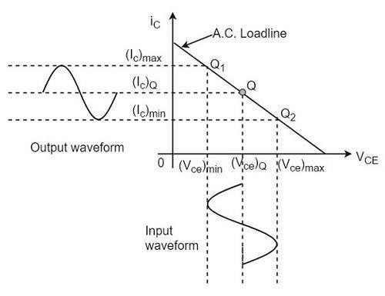

Distortion is defined as the change of output wave shape from the input wave shape of the amplifier. An amplifier that has lesser distortion produces a better output and hence considered efficient.
We have already come across the details of transistor biasing, which is very important for the operation of a transistor as an amplifier. Hence to achieve faithful amplification, the biasing of the transistor has to be done such that the amplifier operates over the linear region.
A Class A power amplifier is one in which the output current flows for the entire cycle of the AC input supply. Hence the complete signal present at the input is amplified at the output. The following figure shows the circuit diagram for Class A Power amplifier.

From the above figure, it can be observed that the transformer is present at the collector as a load. The use of transformer permits the impedance matching, resulting in the transference of maximum power to the load e.g. loud speaker.

SKDAV GOVT.POLYTECHNIC

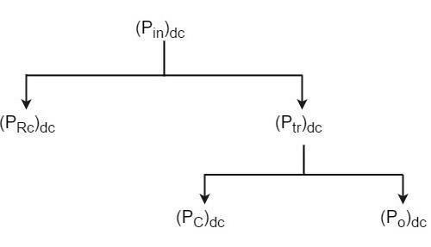
The operating point of this amplifier is present in the linear region. It is so selected that the current flows for the entire ac input cycle. The below figure explains the selection of operating point.
The output characteristics with operating point Q is shown in the figure above. Here (Ic)Q and (Vce)Q represent no signal collector current and voltage between collector and emitter respectively. When signal is applied, the Q-point shifts to Q1 and Q2. The output current increases to (Ic)max and decreases to (Ic)min. Similarly, the collector-emitter voltage increases to (Vce)max and decreases to (Vce)min.
D.C. Power drawn from collector battery Vcc is given by
Pin=voltage×current=VCC(IC)Q
This power is used in the following two parts −
- Power dissipated in the collector load as heat is given by
PRC=(current)²×resistance=(IC)²QRC
- Power given to transistor is given by
Ptr=Pin−PRC=VCC−(IC)2QRC

When signal is applied, the power given to transistor is used in the following two parts −
- A.C. Power developed across load resistors RC which constitutes the a.c. power output.
(PO)ac=I²RC=V² / RC=(Vm/√2 ) /RC=V2m/2RC
- Where I is the R.M.S. value of a.c. output current through load, V is the R.M.S. value of a.c. voltage, and Vm is the maximum value of V.
- The D.C. power dissipated by the transistor (collector region) in the form of heat, i.e., (PC)dc
We have represented the whole power flow in the following diagram.

SKDAV GOVT.POLYTECHNIC

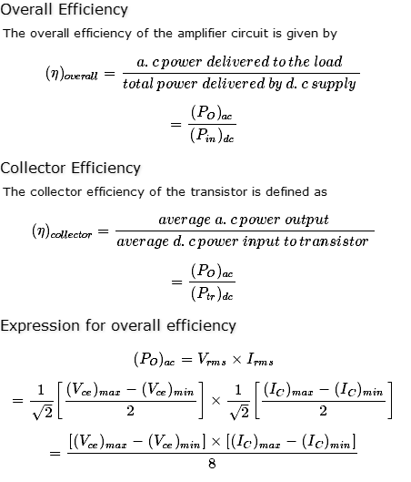
This class A power amplifier can amplify small signals with least distortion and the output will be an exact replica of the input with increased strength.
Let us now try to draw some expressions to represent efficiencies.

Advantages of Class A Amplifiers
The advantages of Class A power amplifier are as follows −
- The current flows for complete input cycle
- It can amplify small signals
- The output is same as input
- No distortion is present

Disadvantages of Class A Amplifiers

The advantages of Class A power amplifier are as follows −
- Low power output
- Low collector efficiency

The class A power amplifier as discussed in the previous chapter, is the circuit in which the output current flows for the entire cycle of the AC input supply. We also have learnt about the

SKDAV GOVT.POLYTECHNIC

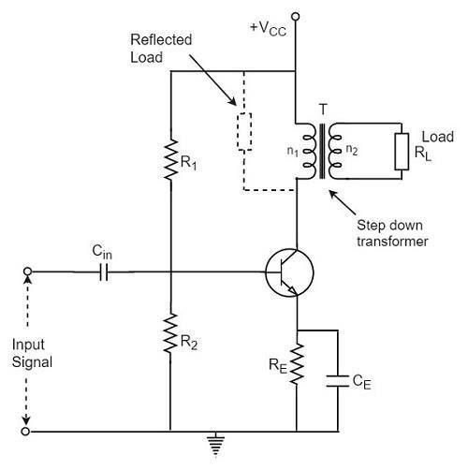
disadvantages it has such as low output power and efficiency. In order to minimize those effects, the transformer coupled class A power amplifier has been introduced.

Class B- WORKING PRINCIPLE
The biasing of the transistor in class B operation is in such a way that at zero signal condition, there will be no collector current. The operating point is selected to be at collector cut off voltage. So, when the signal is applied, only the positive half cycle is amplified at the output.
The figure below shows the input and output waveforms during class B operation.

When the signal is applied, the circuit is forward biased for the positive half cycle of the input and hence the collector current flows. But during the negative half cycle of the input, the circuit is reverse biased and the collector current will be absent. Hence only the positive half cycle is amplified at the output.
As the negative half cycle is completely absent, the signal distortion will be high. Also, when the applied signal increases, the power dissipation will be more. But when compared to class A power amplifier, the output efficiency is increased. Well, in order to minimize the disadvantages and achieve low distortion, high efficiency and high output power, the push-pull configuration is used in this class B amplifier.

SKDAV GOVT.POLYTECHNIC

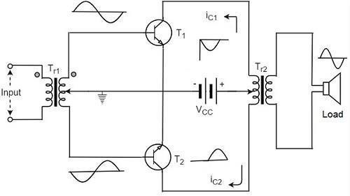

Class B Push-Pull Amplifier
Though the efficiency of class B power amplifier is higher than class A, as only one half cycle of the input is used, the distortion is high. Also, the input power is not completely utilized. In order to compensate these problems, the push-pull configuration is introduced in class B amplifier.

Construction:
The circuit of a push-pull class B power amplifier consists of two identical transistors T1 and T2 whose bases are connected to the secondary of the center-tapped input transformer Tr1. The emitters are shorted and the collectors are given the VCC supply through the primary of the output transformer Tr2.
The circuit arrangement of class B push-pull amplifier, is same as that of class A push-pull amplifier except that the transistors are biased at cut off, instead of using the biasing resistors. The figure below gives the detailing of the construction of a push-pull class B power amplifier.

The circuit operation of class B push pull amplifier is detailed below.

Operation
The circuit of class B push-pull amplifier shown in the above figure clears that both the transformers are center-tapped. When no signal is applied at the input, the transistors T1 and T2 are in cut off condition and hence no collector currents flow. As no current is drawn from VCC, no power is wasted.

When input signal is given, it is applied to the input transformer Tr1 which splits the signal into two signals that are 180º out of phase with each other. These two signals are given to the two identical transistors T1 and T2. For the positive half cycle, the base of the transistor T1 becomes positive and collector current flows. At the same time, the transistor T2 has negative half cycle, which throws the transistor T2 into cutoff condition and hence no collector current flows. The waveform is produced as shown in the following figure.

SKDAV GOVT.POLYTECHNIC

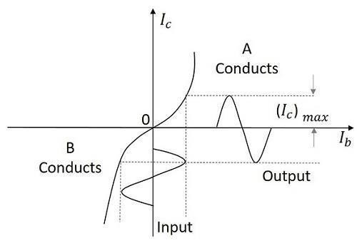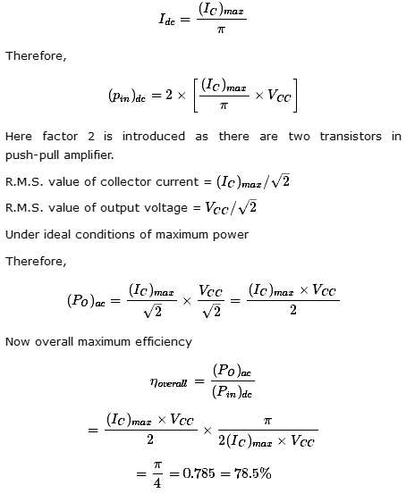

For the next half cycle, the transistor T1 gets into cut off condition and the transistor T2 gets into conduction, to contribute the output. Hence for both the cycles, each transistor conducts alternately. The output transformer Tr3 serves to join the two currents producing an almost undistorted output waveform.
Power Efficiency of Class B Push-Pull Amplifier

The current in each transistor is the average value of half sine loop. For half sine loop, Idc is given by

SKDAV GOVT.POLYTECHNIC

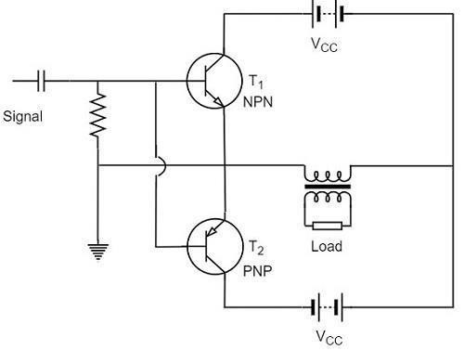
The collector efficiency would be the same.
Hence the class B push-pull amplifier improves the efficiency than the class A push-pull amplifier.

Complementary Symmetry Push-Pull Class B Amplifier
The push pull amplifier which was just discussed improves efficiency but the usage of center-tapped transformers makes the circuit bulky, heavy and costly. To make the circuit simple and to improve the efficiency, the transistors used can be complemented, as shown in the following circuit diagram.

The above circuit employs a NPN transistor and a PNP transistor connected in push pull configuration. When the input signal is applied, during the positive half cycle of the input signal, the NPN transistor conducts and the PNP transistor cuts off. During the negative half cycle, the NPN transistor cuts off and the PNP transistor conducts.

In this way, the NPN transistor amplifies during positive half cycle of the input, while PNP transistor amplifies during negative half cycle of the input. As the transistors are both complement to each other, yet act symmetrically while being connected in push pull configuration of class B, this circuit is termed as Complementary symmetry push pull class B amplifier.

Advantages
The advantages of Complementary symmetry push pull class B amplifier are as follows.

- As there is no need of center tapped transformers, the weight and cost are reduced.
- Equal and opposite input signal voltages are not required.

Disadvantages
The disadvantages of Complementary symmetry push pull class B amplifier are as follows.

SKDAV GOVT.POLYTECHNIC

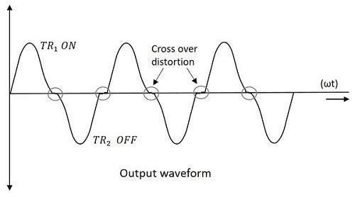
- It is difficult to get a pair of transistors (NPN and PNP) that have similar characteristics.
- We require both positive and negative supply voltages.

The class A and class B amplifier so far discussed has got few limitations. Let us now try to combine these two to get a new circuit which would have all the advantages of both class A and class B amplifier without their inefficiencies. Before that, let us also go through another important problem, called as Cross over distortion, the output of class B encounters with.

Cross-over Distortion:
In the push-pull configuration, the two identical transistors get into conduction, one after the other and the output produced will be the combination of both.
When the signal changes or crosses over from one transistor to the other at the zero voltage point, it produces an amount of distortion to the output wave shape. For a transistor in order to conduct, the base emitter junction should cross 0.7v, the cut off voltage. The time taken for a transistor to get ON from OFF or to get OFF from ON state is called the transition period.
At the zero voltage point, the transition period of switching over the transistors from one to the other, has its effect which leads to the instances where both the transistors are OFF at a time. Such instances can be called as Flat spot or Dead band on the output wave shape.

The above figure clearly shows the cross over distortion which is prominent in the output waveform. This is the main disadvantage. This cross over distortion effect also reduces the overall peak to peak value of the output waveform which in turn reduces the maximum power output. This can be more clearly understood through the non-linear characteristic of the waveform as shown below.

SKDAV GOVT.POLYTECHNIC

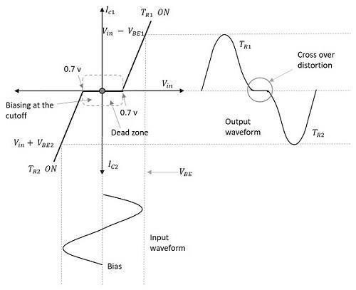

It is understood that this cross-over distortion is less pronounced for large input signals, where as it causes severe disturbance for small input signals. This cross over distortion can be eliminated if the conduction of the amplifier is more than one half cycle, so that both the transistors won’t be OFF at the same time.
This idea leads to the invention of class AB amplifier, which is the combination of both class A and class B amplifiers, as discussed below.

Class AB Power Amplifier
As the name implies, class AB is a combination of class A and class B type of amplifiers. As class A has the problem of low efficiency and class B has distortion problem, this class AB is emerged to eliminate these two problems, by utilizing the advantages of both the classes.
The cross over distortion is the problem that occurs when both the transistors are OFF at the same instant, during the transition period. In order to eliminate this, the condition has to be chosen for more than one half cycle. Hence, the other transistor gets into conduction, before the operating transistor switches to cut off state. This is achieved only by using class AB configuration, as shown in the following circuit diagram.

SKDAV GOVT.POLYTECHNIC

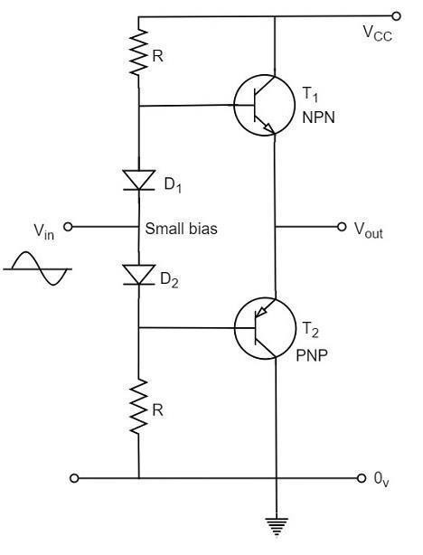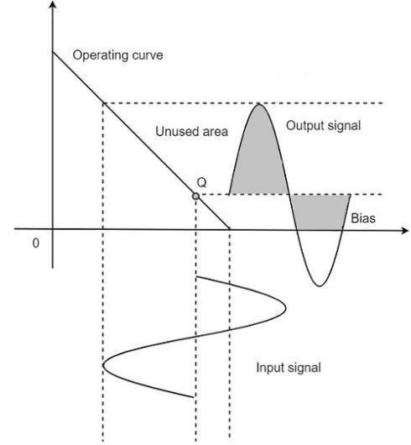

Therefore, in class AB amplifier design, each of the push-pull transistors is conducting for slightly more than the half cycle of conduction in class B, but much less than the full cycle of conduction of class A.
The conduction angle of class AB amplifier is somewhere between 180º to 360º depending upon the operating point selected. This is understood with the help of below figure.

The small bias voltage given using diodes D1 and D2, as shown in the above figure, helps the operating point to be above the cutoff point. Hence the output waveform of class AB results as seen in the above figure. The crossover distortion created by class B is overcome by this class AB, as well the inefficiencies of class A and B don’t affect the circuit.
So, the class AB is a good compromise between class A and class B in terms of efficiency and linearity having the efficiency reaching about 50% to 60%. The class A, B and AB amplifiers are called as linear amplifiers because the output signal amplitude and phase are linearly related to the input signal amplitude and phase.

SKDAV GOVT.POLYTECHNIC

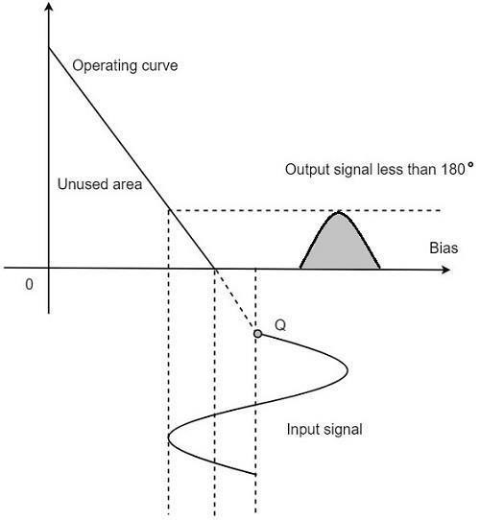

Class C Power Amplifier

When the collector current flows for less than half cycle of the input signal, the power amplifier is known as class C power amplifier. The efficiency of class C amplifier is high while linearity is poor. The conduction angle for class C is less than 180º. It is generally around 90º, which means the transistor remains idle for more than half of the input signal. So, the output current will be delivered for less time compared to the application of input signal.

The following figure shows the operating point and output of a class C amplifier.

This kind of biasing gives a much improved efficiency of around 80% to the amplifier, but introduces heavy distortion in the output signal. Using the class C amplifier, the pulses produced at its output can be converted to complete sine wave of a particular frequency by using LC circuits in its collector circuit.

The types of amplifiers that we have discussed so far cannot work effectively at radio frequencies, even though they are good at audio frequencies. Also, the gain of these amplifiers is such that it will not vary according to the frequency of the signal, over a wide range. This allows the amplification of the signal equally well over a range of frequencies and does not permit the selection of particular desired frequency while rejecting the other frequencies.

SKDAV GOVT.POLYTECHNIC

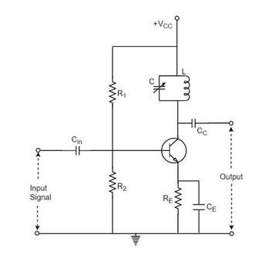

SKDAV GOVT.POLYTECHNIC

