R.K.C. A. T (POLYTECHNIC)

BALASORE

DEPARTMENT OF ELECTRONICS AND TELECOMMUNICATION ENGINEERING

LECTURE NOTES

Year & Semester: 3RD Year, V Semester Subject Code/Name: TH-3, A & D COMMUNICATION

Prepared by ER. CHIMYA MOHANTY , Lect. (E&TC)

VISION -

To be a center of excellence in the field of E&TC Engg by providing quality technical education as well as inculcating entrepreneurial skill, self-learning attitude and human values.

MISSION -

- To create an excellent infrastructure and teaching-learning environment for making the student acquire the knowledge needed.
- To inculcate self-learning attitude, entrepreneurial skill and human values.
- To impart knowledge required for recent & advanced Engg.

PROGRAM EDUCATIONAL OBJECTIVE-

- To apply knowledge of E&TC Engg. and principles of basic science & mathematics for analyzing the circuit of different electronics devices.
- To compete for employment both in public and private sector.
- To pursue higher study in E&TC as well as any other related branch for carrier enhancement.
- To establish own assembly or service section with innovative, entrepreneurial ideas.
- To work with team spirit and social ethics.

PROGRAM SPECIFIC OUTCOME-

- Use techniques and skills to design, analyze, synthesize and simulate electronics components and systems.
- Architect, partition and select appropriate technology for implementation of a specified communication system.

CONTENTS

Unit-1: Elements of Communication Systems
  - Elements of Communication System & its Block diagram
  - Source of information & Communication Channels.
  - Classification of Communication systems ( Line & Wireless or Radio)
  - Modulation Process, Need of modulation and classify modulation process
  - Analog and Digital Signals & its conversion.
  - Basic concept of Signals & Signals classification
  - Bandwidth limitation

Unit-2: Amplitude (linear) Modulation System
  - Amplitude modulation & derive the expression for amplitude modulation signal, power relation in AMwave & find Modulation Index.
  - Generation of Amplitude Modulation(AM)- Linear level AM modulation only
  - Demodulation of AM waves (liner diode detector, square law detector & PLL)
  - Explain SSB signal and DSBSC signal
  - Methods of generating & detection SSB-SC signal (Indirect method only)
  - Methods of generation DSB-SC signal
  - Detection of DSB-SC signal
  - Vestigial Side Band Modulation

Unit-3: Angle Modulation Systems.
  - Concept of Angle modulation & its types (PM & FM)
  - Basic principle of Frequency Modulation & Frequency Spectrum of FM Signal.
  - Expression for Frequency Modulated Signal & Modulation Index of FM signal
  - Explain Phase modulation & difference of FM & PM)- working principle with Block Diagram
  - Compare between AM and FM modulation (Advantages & Disadvantages)
  - Methods of FM Generation (Indirect (Armstrong) method only) working principle with Block Diagram
  - Methods of FM Demodulator or detector (Forster-Seely & Ratio detector)- working principle with BlockDiagram

Unit-4: AM & FM TRANSMITTER & RECEIVER
  - Classification of Radio Receivers
  - Define the terms Selectivity, Sensitivity, Fidelity and Noise Figure
  - AM transmitter - working principle with Block Diagram
  - Concept of Frequency conversion, RF amplifier & IF amplifier ,Tuning, S/N ratio
  - Working of super heterodyne radio receiver with Block diagram
  - Working of FM Transmitter & Receiver with Block Diagram.

Unit-5: ANALOG TO DIGITAL CONVERSION & PULSE MODULATION SYSTEM.
  - Concept of Sampling Theorem , Nyquist rate & Aliasing
  - Sampling Techniques ( Instantaneous, Natural, Flat Top)
  - Analog Pulse Modulation - Generation and detection of PAM, PWM & PPM system with the help ofBlock diagram & comparison of all above.
  - Concept of Quantization of signal & Quantization error.
  - Generation & Demodulation of PCM system with Block diagram & its applications.
  - Companding in PCM & Vocoder
  - Time Division Multiplexing & explain the operation with circuit diagram.
  - Generation & demodulation of Delta modulation with Block diagram.
  - Generation & demodulation of DPCM with Block diagram.
  - Comparison between PCM, DM , ADM & DPCM

Unit-6: DIGITALMODULATION TECHNIQUES.
  - Concept of Multiplexing (FDM & TDM)- ( Basic concept , Transmitter & Receiver) & Digital modulationformats.
  - Digital modulation techniques & types.
  - Generation and Detection of binary ASK, FSK, PSK, QPSK, QAM, MSK, GMSK.
  - Working of T1-Carrier system.
  - Spread Spectrum & its applications
  - Working operation of Spread Spectrum Modulation Techniques (DS-SS & FH-SS).
  - Define bit, Baud, symbol & channel capacity formula.(Shannon Theorems)
  - Application of Different Modulation Schemes.
  - Types of Modem & its Application

PROGRAM OUTCOME (PO)-

PO1: Basic and Discipline specific knowledge- Apply knowledge of basic mathematics, science and engineering fundamentals and engineering specialization to solve the engineering problems.

PO2: Problem Analysis- Identify and analyze well defined engineering problems using codified standard methods.

PO3: Design/ development of solutions- Design solutions for well-defined technical problems and assist with the design of systems components or processes to meet specified needs.

PO4: Engineering Tools, Experimentation and Testing- Apply modern engineering tools and appropriate technique to conduct standard tests and measurements.

PO5: Engineering Practices for society, sustainability and environment- Apply appropriate technology in context of society, sustainability, environment and ethical practices.

PO6: Project Management- Use engineering management principles individually, as a team member or a leader to manage projects and effectively communicate about well-defined engineering activities.

PO7: Life-long learning- Ability to analyze individual needs and engage in updating in the context of technological changes.

COURSE OUTCOME
After the completion of the course the students will be able to
CO1-Identify the elements of communication system and explain them.
CO2-Compare the performance of AM, FM and PM schemes and describe the working of modulator and demodulator circuits.
CO3-Analyze and explain the working of transmitter and receiver circuits.
CO4-Differentiate the types of pulse modulation techniques and explain the working of PAM, PWM, PPM & PCM modulator and demodulator circuits.
CO5-Analyze the performance of various digital modulation techniques.

UNIT-1: ELEMENTS OF COMMUNICATION SYSTEMS

ELEMENTS OF COMMUNICATION SYSTEM-
Communication involves the transmission of information from one point to another.

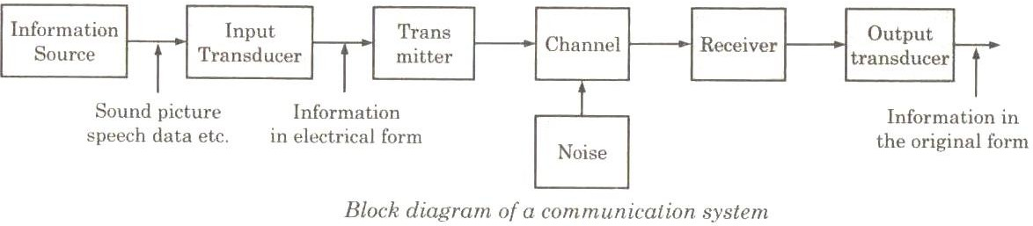

INFORMATION SOURCE-
Communication system serves to communicate a message or information. This message originates in the information source. There can be various messages in the form of words, groups of words, code, symbols, sound signals etc.

INPUT TRANSDUCER-
A transducer is a device which converts one form of energy into another form. The message from the information source may or may not be electrical in nature. When the message produced by the information source is not electrical in nature, an input transducer is used to convert it into a time varying electrical signal.

TRANSMITTER-
The function of the transmitter is to process the electrical signal from different aspects. Inside the transmitter, signal processing such as restriction of range of audio freqiuencies, amplification and modulation are achieved.

THE CHANNEL AND THE NOISE-
There are two types of channels, namely point to point channels and broadcast channels. Examples of point to point channels are wire lines, microwave links and optical fibers. Wire lines operate by guided electromagnetic waves and they are used for local telephone transmission. Microwave links are used in long distance telephone transmission. Optical fibers are used in optical communication. On the other hand the broadcast channels provide a capability where several receiving stations can be reached simultaneously from a single transmitter. During the

process of transmission and reception the signal gets distorted due to noise introduced in the system. Noise is an unwanted signal which tends to interfere with the required signal. Noise may interfere with signal at any point in a communication system.

RECEIVER-
The main function of the receiver is to reproduce the message signal in electrical form from the distorted received signal. This reproduction of the original signal is accomplished by a process known as the demodulation. Demodulation is the reverse process of modulation carried out in transmitter.

DESTINATION-
Destination is the final stage which is used to convert an electrical message signal into its original form.

SOURCE OF INFORMATION & COMMUNICATION CHANNELS SOURCE OF INFORMATION-
Some of the important source of information in the communication environment given below-
- Speech (iii) Picture
- Music (iv) Computer data
A source of information is basically a signal which carries the information.

Signal-
A signal may be defined as the single valued function of time. Time plays the role of an independent variable. This means that at every instant of time, the signal has a unique value.
The signals may be classified as:

Speech
Speech involves transfer of information from the speaker to the listener. Such a transfer of information takes place in following three stages:
  - Production
  - Propagation and
  - Perception

Music signal-

It is originated from the instruments such as the piano, violin, flute etc. Music signal has following two possible structure:
  - Melodic structure
  - Harmonic structure

Picture
The picture can be either static or dynamic. Examples of static picture is the picture sent by fax machine and that of a dynamic picture is the one produced on T.V.

Computer Data
Personal computers are used for electronic mail, exchange of software, and sharing of resources.

COMMUNICATION CHANNEL-
The medium over which the information is passed from the transmitter to the receiver is called as a communication channel. Depending on the mode of transmission, the communication channels classified in to two categories.
- Guided medium
- Unguided medium
The classification of channels has been shown below:
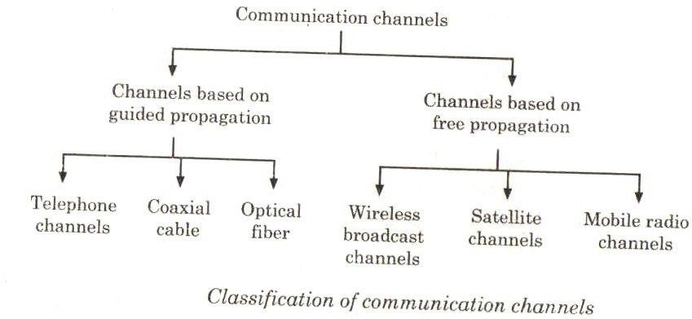

Guided Medium-

Telephone Channels-

It is designed for providing service to voice signals such as telephones. The telephone channels are also used for the worldwide internet connection. Therefore, telephone channel is the best possible option for the data transmission over long distances.
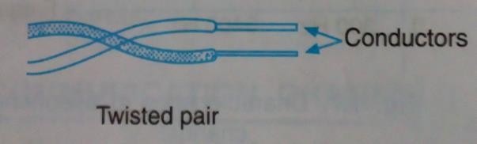

The telephone channels are built using the twisted pair of wires. A twisted pair consists of two insulated conductor twisted together in the spiral form. It can be shielded or un- shielded.

The un-shielded twisted pair cables are very cheap and easy to install. However, they are badly affected by the noise interference.

The noise immunity can be improved by using shielded twisted pair cable. Co-axial cable-
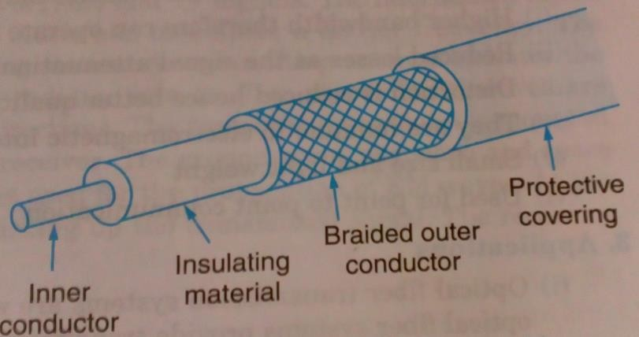

It consists of two concentric conductors separated by a dielectric material. The external conductor is metallic braid and used for the purpose of shielding. The co-axial cable may contain one or more co-axial pairs.

One more application is Ethernet LAN using the co-axial cable.

The co-axial cable is used for its large bandwidth and high noise immunity. Optical fiber cables-

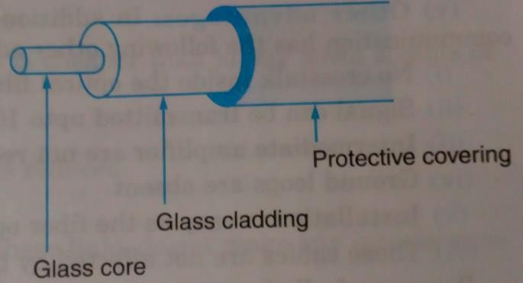

It consists of an inner glass core surrounded by a glass cladding which has a lower refractive index.

Digital signals are transmitted in the form of intensity-modulated light signal which is trapped in the glass core.

Light is launched into the fiber using a light source such as a LED or laser.

It is detected on the other side using a photo detector such as a phototransistor.

Unguided Medium-

Wireless Broadcast channel-

These channels are used for the transmission of radio and TV signals.

The information signal which represents the speech, music etc. modulates a carrier frequency.

The carrier frequency is different for every transmitting station.

A transmitting antenna radiates the modulated signal in the form of electromagnetic radiation into the free space.

These waves are radiated in all directions or in some specified directions.

The transmitting antenna is mounted on a tower or a hall in order to reach the farther receiver.

The ground wave, sky wave and space wave are three types of propagation techniques used for the propagation of EM waves.

At the receiving end, the receiving antenna is used for picking up the transmitted signal. Satellite Channels-

Satellite microwave systems transmits signals between directional parabolic antennas. They use low gigahertz frequencies and line of sight communication.
These systems use satellites which are in the geostationary orbit (36000 km above the earth).

The satellites act as repeaters with receiving antennas, transponder and transmitting antenna.

Satellite microwave systems can reach the most remote places on earth and communicate with mobile devices.

In this method signal is sent through cable media to an antenna which beams the signal to the satellite, the satellite then transmits the signal back to another location on earth.

Mobile Radio Channels-

In mobile communication, the sender and the receiver both are allowed to move with respect to each other.

The radio propagation takes place due to scattering of EM waves from the surface of the surrounding buildings and diffraction over and around them. Hence, the transmitted energy reaches the receiver via multiple paths. This is called as multi path communication.

The signals taking different paths will have to travel different path lengths. So, they have different phase shifts when they reach the receiver.

The total signal strength at the receiver is equal to the vector sum of all the signals.

Therefore it keeps changing continuously. Hence, mobile channels are called as the linear time varying channels and it is statistical in nature.

CLASSIFICATION OF COMMUNICATION SYSTEM-

    - Depending upon the message signal, communication system may be classified as-

- Analog communication system

- Digital communication system Analog communication system-

It is a type of communication in which the message or information signal to be transmitted is analog in nature. This means that in analog communication the modulating signal is an analog signal.

Digital communication system-

It is a type of communication in which the message signal to be transmitted is digital in nature. This means that digital communication involves the transmission of information in digital form.

- Based on communication channel used, communication system may be classified as-

  - Line communication system

  - Radio communication system Line communication system-
There is a physical link present between the transmitter and receiver in line communication system.

Ex- Landline telephony is purely a line communication system Radio communication system-
In this system there is no link present between transmitter and receiver.

Ex.- Radio broadcast

- Based on transmission mode, communication system may be classified as-

  - Simplex communication system

  - Duplex communication system Simplex communication system-
In this communication system, one way transmission is used. Ex.- TV transmission Duplex communication system-
In this communication system, two way transmission is used. Ex.- Telephony system.

MODULATION PROCESS, NEED OF MODULATION AND CLASSIFY MODULATION PROCESS

MODULATION:
Modulation is the process in which parameters (i.e, Amplitude, Phase and Frequency) of the carrier signal changes according to the message signal or modulating signal.

NEED OF MODULATION:
- Practicality of Antenna-
The voice frequencies in the band of 20HZ to 20KHZ, For the efficient transmission and reception of radio frequency signals. The antenna length ‘L’ required in terms of wavelength
L = ^{𝜆} 4

= 𝐶 4𝑓
(C = 3*108 m/sec)

Where λ = wavelength C = Speed of light f = Frequency
- To remove Interference
- Reduction of noise
- Multiplexing-
- Simultaneously transmission of multiple message over a single channel is known as multiplexing.
- If it transmits without modulation, the different message signal over a single channel will interfere with one another.
- Multiplexing helps in transmitting numbers of message signal simultaneously over a single channel & therefore a number of channel needed will be less.

CLASSIFY MODULATION PROCESS-

Continuous wave modulation-

When the carrier wave is continuous in nature, the modulation process is known as continuous wave modulation or analog modulation.

Pulse modulation-

When the carrier wave is a pulse type waveform, the modulation process is known as pulse modulation. In pulse modulation, the carrier consists of a periodic sequence of rectangular pulses.

ANALOG AND DIGITAL SIGNALS-

  - The analog signal is that type of signal which varies smoothly and continuously with time.

  - This means that analog signals are defined for every value of time and they take on continuous values in a given time interval.

  - An alternative form of signal representation is that of a sequence of numbers, each number representing the signal magnitude at an instant of time. The resulting signal is called a digital signal.

CONVERSION OF ANALOG SIGNALS TO DIGITAL SIGNALS-

There are three steps for conversion process.

- The signal is sampled.
- The sampled signal is quantized.
- The quantized signal is digitally coded.

Sampling
Sampling generally is done with a Sample-And-Hold circuit. To be able to reconstruct the signal we must consider the Sampling Theorem which says that a sampling frequency twice of the highest frequency. In a simple way sampling can be defined as the process of taking samples from the continuous time function x(t) and for the signal to reconstruct we must consider the sampling theorem which states that the sampling frequency must be always greater than or equal to twice the highest frequency.

Quantization
Quantization is the process of taking a continuous voltage signal and mapping it to a discrete number of voltage levels. The number of voltage levels affects the quantization noise that occurs. Since digital computers are binary in nature, the number of quantization levels is usually a power of 2, i.e.,
N=2^{𝑛}
where n is the number of quantization bits.

Encoding
Encoding is the process of converting the quantized signals into a digital representation. This encoding is performed by giving each quantization level a unique label. For instance, if four bits are used, the lowest level may be (in binary) 0000, and the next highest level 0001, etc.

BASIC CONCEPT OF SIGNALS & SIGNALS CLASSIFICATION BASIC CONCEPT OF SIGNALS-
A signal is a physical quantity which varies with respect to time, space and contains some information from source to destination. The term signal includes audio, video, speech, image etc.

The signals are functions of one or more variables and the systems respond to an input signal by producing an output signal.

CLASSIFICATION OF SIGNAL-
Signals are classified into the following categories:
- Continuous Time and Discrete Time Signals
- Deterministic and Non-deterministic Signals
- Even and Odd Signals
- Periodic and Aperiodic Signals
- Energy and Power Signals
- Real and Imaginary Signals

Continuous Time and Discrete Time Signals-
Continuous signal-
A signal is said to be continuous when it is defined for all instants of time. Discrete signal-
A signal is said to be discrete when it is defined at only discrete instants of time.

Deterministic and Non-deterministic Signals-
Deterministic signal-
A signal is said to be deterministic if there is no uncertainty with respect to its value at any instant of time. Or, signals which can be defined exactly by a mathematical formula are known as deterministic signals.
Non-Deterministic signal-
A signal is said to be non-deterministic if there is uncertainty with respect to its value at some instant of time. Non-deterministic signals are random in nature hence they are called random signals. Random signals cannot be described by a mathematical equation.

Even and Odd Signals-
Even signals-
A signal is said to be even when it satisfies the condition x(t) = x(-t). Odd signals-
A signal is said to be odd when it satisfies the condition x(t) = -x(-t).

Periodic and Aperiodic Signals-
Periodic signals-
A signal is said to be periodic if it satisfies the condition x(t) = x(t + T) or x(n) = x(n + N). Where
T = fundamental time period, 1/T = f = fundamental frequency. Aperiodic signals-
The above signal will repeat for every time interval T0 hence it is periodic with period T0.

Energy and Power Signals-
Energy signals-

A signal is said to be energy signal when it has finite energy. Power signals-
A signal is said to be power signal when it has finite power.

Real and complex signals-
Real signals-
A signal x(t) is a real signal if its value is a real number. Complex signals-
A signal x(t) is a complex signal if its value is a complex number.

BANDWIDTH LIMITATION-
While designing a communication system, an engineer generally faces several limitations. These are:
- Noise limitation
- Bandwidth limitation
- Equipment limitation Noise Limitation-
The noise may be defined as an unwanted form of energy which tend to interfere with the transmission and reception of the desired signals in a communication system. The noise cannot be eliminated completely. However the effect of noise on desired signals can be minimized.
The noise limits our ability to identify the intended or desired message correctly.
Bandwidth Limitation-
The bandwidth limitation is another major limitation in a communication system.
The frequency range needed for a particular transmission is known as bandwidth.
This band of frequencies or bandwidth for a particular transmission is also called channel and it is always allocated by some international regulatory agencies. This type of regulation is essential to avoid interference among the signals having same frequency.
The information theory states that the greater is the transmission bandwidth of a communication system, the more is the information can be transmitted.
Equipment Limitation-
The noise and bandwidth limitation dictate theoretical limit may not be realized in a practical system due to equipment limitations.

UNIT-2: AMPLITUDE (LINEAR) MODULATION SYSTEM

​ AMPLITUDE MODULATION & DERIVE THE EXPRESSION FOR AMPLITUDE MODULATION SIGNAL, POWER RELATION IN AM WAVE & FIND MODULATION INDEX
AMPLITUDE MODULATION AND DERIVE THE EXPRESSION FOR AMPLITUDE MODULATED SIGNAL:-
Amplitude modulation may be defined as a system in which the maximum amplitude of the carrier wave is proportional to the instantaneous value of the modulating signal.
A continuous-wave goes on continuously without any intervals and it is the baseband message signal, which contains the information. This wave has to be modulated.
According to the standard definition, “The amplitude of the carrier signal varies in accordance with the instantaneous amplitude of the modulating signal.” Which means, the amplitude of the carrier signal containing no information varies as per the amplitude of the signal containing information, at each instant. This can be well explained by the following figures.

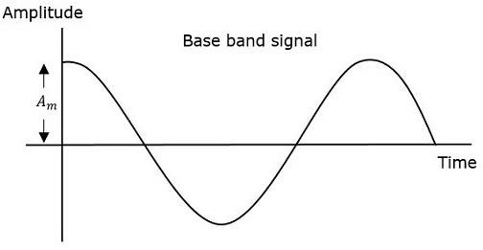
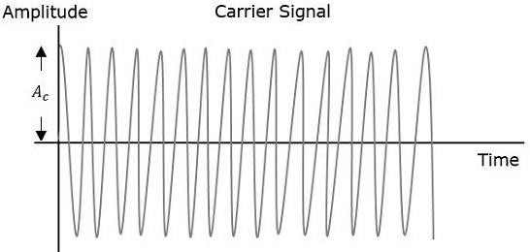

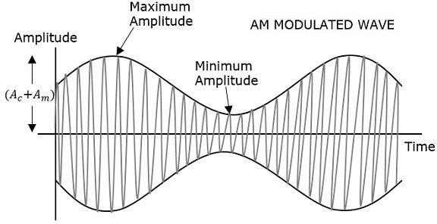

The first figure shows the modulating wave, which is the message signal. The next one is the carrier wave, which is a high frequency signal and contains no information. While, the last one is the resultant modulated wave.
It can be observed that the positive and negative peaks of the carrier wave, are interconnected with an imaginary line. This line helps recreating the exact shape of the modulating signal. This imaginary line on the carrier wave is called as Envelope. It is the same as that of the message signal.

Mathematical Expressions
Modulating signal- x(t)= 𝐴𝑚𝐶𝑜𝑠𝑤𝑚𝑡
Carrier Signal, C(t)= 𝐴𝑐𝐶𝑜𝑠𝑤𝑐𝑡

Where, 𝐴𝑚 𝑎𝑛𝑑 𝐴𝑐 are the amplitude of the modulating signal and the carrier signal respectively.
𝑤𝑚 𝑎𝑛𝑑 𝑤𝑐 are the frequency of the modulating signal and the carrier signal.
Modulated Signal-
m(t)= [𝐴𝑐 + 𝑥(𝑡)]𝐶𝑜𝑠𝑤𝑐𝑡
= (𝐴𝑐 + 𝐴𝑚𝐶𝑜𝑠𝑤𝑚𝑡)𝐶𝑜𝑠𝑤𝑐𝑡
= 𝐴 (1 + 𝐴𝑚 𝐶𝑜𝑠 ) 𝐶𝑜𝑠𝑤 𝑡
𝑐 𝐴𝑐 𝑚 𝑐
= 𝐴 (1 + 𝑚 𝐶𝑜𝑠𝑤 𝑡)𝑠𝑤 𝑡 (^{𝐴𝑚} = 𝑚 )

𝑐 𝑎 𝑚 𝑐
𝐴𝑐 𝑎

= 𝐴𝑐𝐶𝑜𝑠𝑤𝑐𝑡 + 𝐴𝑐𝑚𝑎𝐶𝑜𝑠𝑤𝑚𝑡 𝐶𝑜𝑠𝑤𝑐𝑡
= 𝐴 𝐶𝑜𝑠𝑤 𝑡 + 𝐴𝑐𝑚𝑎 [𝐶𝑜𝑠 (𝑤 − 𝑤 )𝑡 + 𝐶𝑜𝑠 (𝑤 + 𝑤 )𝑡]

𝑐 𝑐 2
𝑐 𝑚
𝑐 𝑚

=𝐴 𝐶𝑜𝑠𝑤 𝑡 + 𝐴𝑐𝑚𝑎 𝐶𝑜𝑠 (𝑤 − 𝑤 )𝑡 + 𝐴𝑐𝑚𝑎 𝐶𝑜𝑠 (𝑤 + 𝑤 )𝑡

𝑐 𝑐 2
Bandwidth-
𝑐 𝑚 2
𝑐 𝑚

𝑓𝑚𝑎𝑥 = 𝑤𝑐 + 𝑤𝑚
𝑓𝑚𝑖𝑛 = 𝑤𝑐 − 𝑤𝑚

Bandwidth= 𝑓𝑚𝑎𝑥 − 𝑓𝑚𝑖𝑛

= (𝑤𝑐 + 𝑤𝑚) − (𝑤𝑐 − 𝑤𝑚)

=𝑤𝑐 + 𝑤𝑚 − 𝑤𝑐 + 𝑤𝑚

= 2𝑤𝑚

MODULATION INDEX
Modulation Index-
It is the ratio of amplitude of modulating signal to the amplitude of the carrier signal. It is denoted as
𝑚𝑎.
𝑚 = 𝐴𝑚= 𝑀𝑎𝑥𝑖𝑚𝑢𝑚 𝐴𝑚𝑝𝑙𝑖𝑡𝑢𝑑𝑒 𝑜𝑓 𝑚𝑜𝑑𝑢𝑙𝑎𝑡𝑖𝑛𝑔 𝑠𝑖𝑔𝑛𝑎𝑙

𝑎 𝐴𝑐

𝐴𝑚𝑝𝑙𝑖𝑡𝑢𝑑𝑒 𝑜𝑓 𝑡ℎ𝑒 𝑐𝑎𝑟𝑟𝑖𝑒𝑟 𝑠𝑖𝑔𝑛𝑎𝑙

Modulation index means how much energy of the carrier wave used during modulation. Maximum amplitude= 𝐴_{𝑚𝑎𝑥} = 𝐴_{𝑐} + 𝐴_{𝑚}
Minimum amplitude= 𝐴_{𝑚𝑖𝑛} = 𝐴_{𝑐} − 𝐴_{𝑚}
When, 𝐴_{𝑚𝑎𝑥} + 𝐴_{𝑚𝑖𝑛}
=𝐴_{𝑐} + 𝐴_{𝑚} + 𝐴_{𝑐} − 𝐴_{𝑚}

= 2𝐴_{𝑐}
=> 𝐴_{𝑚𝑎𝑥} + 𝐴_{𝑚𝑖𝑛} = 2𝐴_{𝑐}
𝐴𝑚𝑎𝑥 + 𝐴𝑚𝑖𝑛
=> 𝐴_{𝑐} = 2
When, 𝐴_{𝑚𝑎𝑥} − 𝐴_{𝑚𝑖𝑛}
=𝐴_{𝑐} + 𝐴_{𝑚} − 𝐴_{𝑐} + 𝐴_{𝑚}
= 2𝐴_{𝑚}
=> 𝐴_{𝑚𝑎𝑥} − 𝐴_{𝑚𝑖𝑛} = 2𝐴_{𝑚}
𝐴𝑚𝑎𝑥 − 𝐴𝑚𝑖𝑛

=> 𝐴_{𝑚} =

2

𝐴𝑚
𝑚 = =

𝐴𝑚𝑎𝑥 − 𝐴𝑚𝑖𝑛
2 = 𝐴𝑚𝑎𝑥 − 𝐴𝑚𝑖𝑛

𝑎

There are three cases of 𝑚𝑎.
Case-I
𝐴𝑐
𝐴𝑚𝑎𝑥 + 𝐴𝑚𝑖𝑛 2

𝐴𝑚𝑎𝑥 + 𝐴𝑚𝑖𝑛

When 𝐴_{𝑚} < 𝐴_{𝑐}, 𝑚_{𝑎} < 1. This condition is known as under modulation.
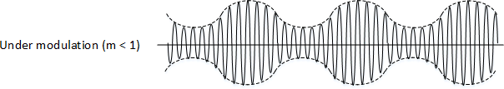
Case-II
When 𝐴_{𝑚} = 𝐴_{𝑐}, 𝑚_{𝑎} = 1. This condition is known as 100% modulation.
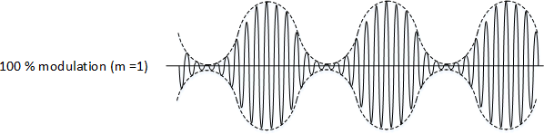
Case-III

When 𝐴_{𝑚} > 𝐴_{𝑐}, 𝑚_{𝑎} > 1. This condition is known as over modulation.
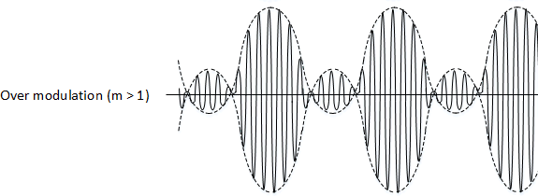
𝑄𝑢𝑒𝑠𝑡𝑖𝑜𝑛𝑠 −
    - Carrier wave of frequency 1 MHz with peak voltage of 20V used to modulate a signal of frequency 1 KHz with peak voltage of 10V.
Find out the following-
      - µ
      - Frequencies of modulated signal
      - Bandwidth
    - A modulating signal is x(t)= 10 cos (2π x 10³𝑡) and carrier signal is c(t)= 50 cos (2π x
10⁵𝑡). Find out the percentage of modulation.
    - What is the modulation index value if 𝑉_{𝑚𝑎𝑥} = 5.9 𝑉 𝑎𝑛𝑑 𝑉_{𝑚𝑖𝑛} = 1.2𝑉.

POWER RELATION IN AM WAVE:-

𝑃_{𝑡}(𝑡𝑜𝑡𝑎𝑙 𝑝𝑜𝑤𝑒𝑟) = 𝑃_{𝑐} + 𝑃_{𝑈𝑆𝐵} + 𝑃_{𝐿𝑆𝐵}

=𝑃_{𝑐} + 𝑃_{𝑠}

P=^{𝑉}2
𝑅
= (𝑉𝑟𝑚𝑠)2
𝑅
𝑉𝑚 2
( ⁄ )
= √2
𝑅
(𝐴𝑐⁄ )²
𝑃𝑐 = √2
𝑅
= 𝐴𝑐2
2𝑅
(𝑉𝑚⁄ )²
𝑃𝑈𝑆𝐵 = √2
𝑅

𝑚𝑎𝐴𝑐 2
( )
= 2√2
𝑅
𝑚2 𝐴2

𝑃𝑈𝑆𝐵 =
𝑎 𝑐

8𝑅
= 𝑃𝐿𝑆𝐵

𝑃𝑆 = 𝑃𝑈𝑆𝐵 + 𝑃𝐿𝑆𝐵
𝑚2 𝐴2 𝑚2 𝐴2
= 𝑎 𝑐 + 𝑎 𝑐

8𝑅
𝑚2 𝐴2
8𝑅
𝑚2 𝐴2

=2 𝑐 = 𝑐
8𝑅 4𝑅
𝑃𝑡 = 𝑃𝑐 + 𝑃𝑠
= 𝐴𝑐2 + 2 𝐴2
𝑎 𝑐
2𝑅 4𝑅
= ^{𝐴𝑐}2 [1 + 2 ]
𝑎

2𝑅
2
𝑚2

𝑃𝑡= [1 + ^{𝑎}] Current Relation- P= 𝐼²𝑡
2

𝑚2
𝑡= 𝑐 𝑎

𝑃 𝑃 [1 + ]
2

=> 𝐼²𝑅 = 𝐼²[1 +

𝑚2
𝑎]

𝑡 𝑐

2
𝑚2

=> 𝐼² = 𝐼²[1 + 𝑎]

𝑡 𝑐

2
𝑚2
𝑐

=> 𝐼𝑡

= √𝐼²[1 +
𝑎] 2

Questions-
- A 800watt carrier is modulated to a depth of 50%. Find the total power in the AM wave.
- An AM broadcast radio transmitter radiates 10Kwatt of power of modulation percentage is 60%. Calculate how much of this is carrier power.

GENERATION OF AM WAVES-
The device which is used to generate an amplitude modulation (AM) wave is known as amplitude modulator. The methods as amplitude modulator Generation may be broadly classified as following:-

- Low level AM Modulation.
- High level AM Modulation.

Low Level Amplitude Modulation:-
In a low level amplitude modulation system, the modulation is done at low power level. At low power levels, a very small power is associated with the carrier signal and the modulation signal. Because of this the output power of modulation is low. Therefore the power amplifiers are required to boost the amplitude modulated signals up to the desired output level.
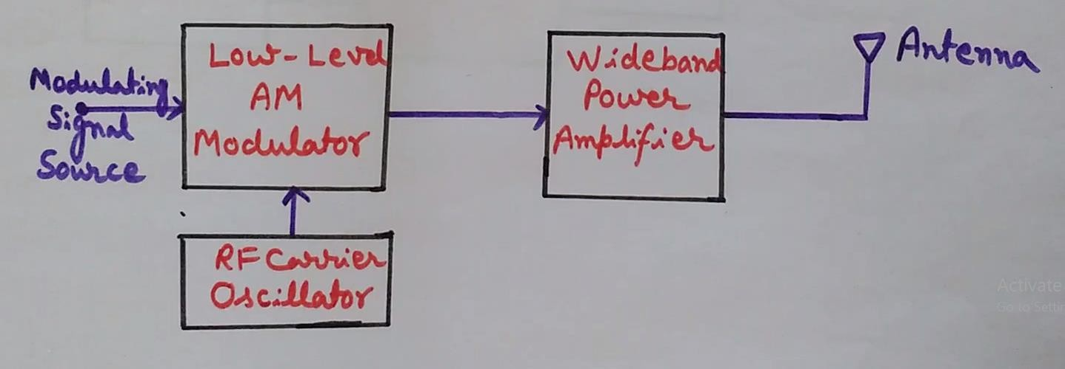
A wide band power amplifier is used just to preserve the sidebands of the modulated signal. Amplitude modulated systems, employing modulation at low power levels are also called low level amplitude modulation transmitters.
Square-law diode modulation and switching modulation are examples of low-level modulation.

High level Amplitude Modulation:-

In a high-level amplitude -modulation system, the modulation is done at high power level. Therefore, to produce amplitude modulation at these high power levels, the base band signal and the carrier signal must be at high power levels. In block diagram of figure the modulating signal and carrier signal are first power amplified and then applied to AM high level modulator. For modulating signal the wide band power amplifier is required just to preserve all the frequency components present in modulating signal.
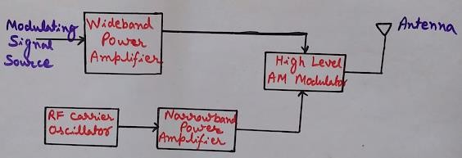

On the other hand for carrier signal, the narrow band power amplifier is required because it is a fixed frequency signal. The collector modulation method is the example of high level modulation.

COLLECTOR MODULATION (LINEAR LEVEL AM MODULATION)-
Collector modulator is a linear modulator.
The circuit consists of two transistors T1 and T2. The transistor T1 makes a radio frequency class-C amplifier. At the base of the T1 carrier signal is applied.
The transistor T2 makes a class B amplifier, which is used to amplify the modulating signal appears across the modulation transformer. For biasing purpose voltage divider circuit is used.
A capacitor is used to isolate the modulation transformer from the high frequency carrier signal. Here double tuned circuit is used for better performance. The resonance frequency of tank circuit is equal to the carrier frequency.
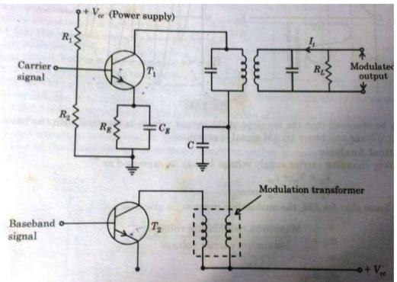
Operation-
As we know class C amplifier gives 80% efficiency but more distortion. But here a high frequency carrier signal is used. So, distortion is less.
A linear relationship exists between the output tank current (𝐼_{𝑡}) and the variable supply voltage 𝑉_{𝑐}.
During absence of modulating signal, the output voltage will be an exact replica of the input voltage waveform.
So, if 𝑅_{𝐿} is the resistance of the output tank circuit at resonance, then the magnitude of the magnitude of the output voltage is

𝑅_{𝐿}𝐼_{𝑡} ≅ 𝑉_{𝑐𝑐}
But, if a modulating signal voltage appears across the modulating transformer, this signal will be added to the carrier supply voltage𝑉_{𝑐𝑐}.
So, 𝑉_{𝑐} = 𝑉_{𝑐𝑐} + 𝑉_{𝑚}
Where 𝑉_{𝑚} = 𝑉_{𝑚}𝑐𝑜𝑠ѡ_{𝑚}𝑡
𝑉_{𝑐𝑐}= amplitude of the carrier signal Carrier signal represented as
𝑉_{𝑐} = 𝑉_{𝑐𝑐}𝑐𝑜𝑠ѡ_{𝑐}𝑡
𝑇ℎ𝑒 𝑚𝑜𝑑𝑢𝑙𝑎𝑡𝑒𝑑 𝑠𝑖𝑔𝑛𝑎𝑙 𝑖𝑠
𝑉_{𝑜} = (𝑉_{𝑐𝑐} + 𝑉_{𝑚}𝑐𝑜𝑠ѡ_{𝑚}𝑡)𝑠ѡ_{𝑐}𝑡
𝑉_{𝑚}
=> 𝑉_{𝑜} = 𝑉_{𝑐𝑐} (1 + 𝑐𝑜𝑠ѡ_{𝑚}𝑡) 𝑐𝑜𝑠ѡ_{𝑐}𝑡
𝑉
𝐶𝐶
=> 𝑉_{𝑜} = 𝑉(1 + 𝑚_{𝑎}𝑐𝑜𝑠ѡ_{𝑚}𝑡)𝑐𝑜𝑠ѡ_{𝑐}𝑡

DEMODULATION OF AM WAVE:-
The process of extracting a modulating signal from the modulated signal is called demodulation. The devices used for demodulation are called demodulators.
Types of detector (1) square-law detectors
  - Envelope detectors
  - PLL AM detector
AM signal with large carrier are detected by using the envelope detector uses the circuit which extracts the envelope of the am wave but detected by using square-low detectors.

DEMODULATION OF AM WAVES
SQUARE-LAW DETECTORS/LINEAR DIODE DETECTOR:-
The Square-Law Detector ckt is used for detecting modulated signal of small magnitude, so that operating region may be restricted to the non –linear portion of the v-characteristics of the device it may be observed that the circuit is very similar to the square law modulator. The only difference is that in square low modulator the filter used is a band pass filter where in a square law detector, a low pass filter is used.

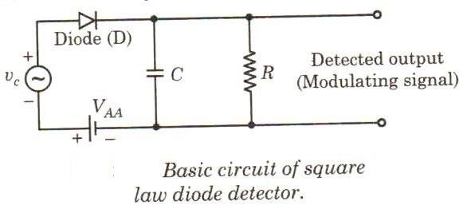
In the circuit, the dc supply voltage VAA is used to get the fixed operating point in the non-linear portion of the diode V-I characteristics. Since, the operation is limited to the non-linear region of the diode characteristics, the lower half portion of the modulated wave form is compressed. This produces envelope applied distortion. Due to this the average value of the diode –current is no longer constant, rather it varies with time.
This distorted output diode current is expressed by I =av+bv2
v=is the i/p modulated voltage AM wave is expressed as
v=A (1+ma Cos 𝜔mt) Cos 𝜔ct Substituting, the value of v, we get
I =a [A (1+maCos 𝜔mt) Cos 𝜔ct] +b [A (1+maCos 𝜔mt) Cos 𝜔ct] 2
If above expression is expanded, then we get terms of frequencies like 2𝜔c, 2(𝜔c±𝜔m), 𝜔m& 2𝜔mbesides the input frequency terms.
Hence this diode current I containing all these frequencies terms is passed through a low pass filter, which allows to pass the frequency below or up to modulating frequency
𝜔m and rejects the other higher frequency components. Therefore, the modulating signal with frequency 𝜔m is recovered from the input modulated signal.

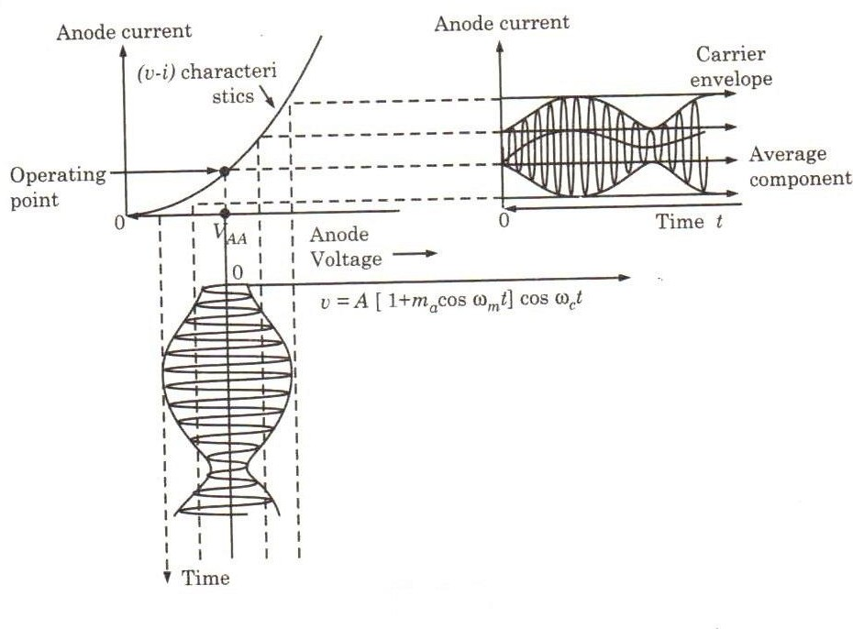

ENVELOPE DETECTOR:-
A diode operating in a linear region of its V-I characteristics can extract the envelope of an AM wave. This type of detector is known as envelope detector. Envelope detector is most popular in commercial receiver circuits. Since it is very simple and is not expensive.
In the input portion of the ckt, the tuned transformer provides perfect tuning at the desired carrier frequency. RC network is the time-constant network. If the magnitude of the modulated signal at the input of the detector is 1 volt or more, the operation takes place in the linear portion of the V-I characteristics of diode.

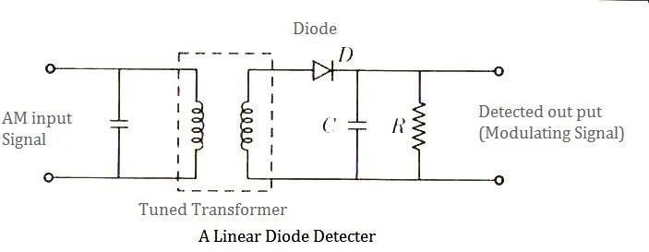

Operation:-
First, let us assume that the capacitor is absent in the ckt. In this case, the detector ckt will work as a half-wave rectifier. Therefore, the output waveform would be a half rectified modulated signal. Now let us consider that the capacitor is introduced in the circuit. For the +ve half cycle b, the diode conducts and the capacitor is charged to the peak value of the carrier voltage. However, for a –ve half cycle, the diode is reverse biased and does not conduct. This means that the input carrier voltage is disconnected from the RC circuit. Therefore the capacitor starts discharging through the resistance are with a time constant
𝜏 = RC is suitably chosen, the voltage across the capacitor C will not fall appreciably during the small period of –ve half cycle, and by that time the next +ve cycle appear. The +ve cycle again charges the capacitor C to the peak value of the voltage and thus this process repeats again and again.
Hence the output voltage across the capacitor C is spiky modulating signal. However spikes are introduced because of charging and discharging of the capacitor C.

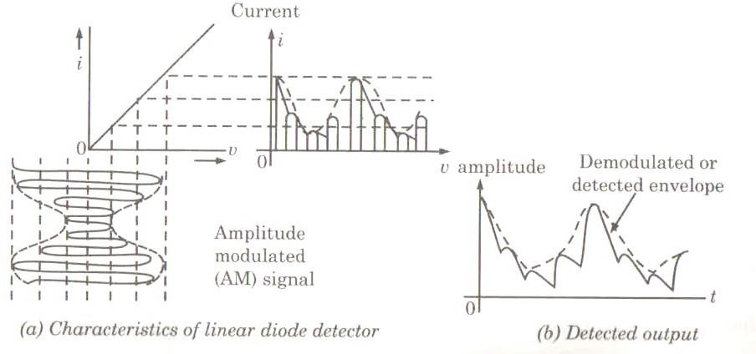

AM Demodulator using Phase locked loop

A PLL can be used to demodulate AM signals.

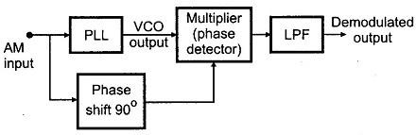
- The PLL is locked to the carrier frequency of the incoming AM signal. Once locked the output frequency of VCO is same as the carrier frequency, but it is in unmodulated form.
- The modulated signal with 90° phase shift and the unmodulated carrier from output of PLL are fed to the multiplier. Since VCO output is always 90° out of phase with the incoming AM signal under the locked condition, both the signals applied to the multiplier are in same phase.
- Therefore, the output of the multiplier contains both the sum and the difference signals. The low pass filter connected at the output of the multiplier rejects high frequency components gives demodulated output.
- As PLL follows the input frequencies with high accuracy, a PLL AM detector exhibits a high degree of selectivity and noise immunity which is not possible with conventional peak detector type AM modulators.

DSB-SC SIGNAL AND SSB SIGNAL DSB-SC
For 100% modulation about 67% of the total power is required for transmitting the carrier which does not contain any information. Hence, if the carrier is suppressed, only the sidebands remain and in this way a saving of two-third power may be achieved at 100% modulation. This type of suppression of carriers does not affect baseband signal. The resulting signal is DSB-SC signal.
As we know,
𝑚𝑎2
𝑃_{𝑡} = (1 + 2 )
𝑃𝑢𝑡 𝑚_{𝑎} = 1
𝑃_{𝑡} = (1 + 1⁄2)
=> 𝑃_{𝑡} = 3⁄2 𝑃_{𝑐}
=> 𝑃_{𝑐} = 2⁄3 𝑃_{𝑡}
=> 𝑃_{𝑐} = 0.67𝑃_{𝑡}

𝑆𝑜, 𝑃_{𝑐} 𝑖𝑠 67% 𝑜𝑓 𝑡ℎ𝑒 𝑡𝑟𝑎𝑛𝑠𝑚𝑖𝑡𝑡𝑒𝑑 𝑝𝑜𝑤𝑒𝑟.

METHODS OF GENERATING & DETECTION OF SSB-SC SIGNAL SSB-SC
- Amplitude modulation and double-sideband suppressed carrier modulation are wasteful of bandwidth. Since then both need a transmission bandwidth equal to twice the message signal bandwidth.
- In either case one half of the transmission bandwidth is occupied by the upper sideband of the modulated signal whereas the other half is occupied by the lower sideband. As far as the transmission of information is concerned, only one sideband is necessary.
- Thus if the carrier and one of the two side bands are suppressed at the transmitter, no information is lost. Modulation of this type which provides a single sideband with supressed carrier is known as single sideband supressed carrier system. Thus, SSB-SC system reduces the transmission bandwidth by half.

Generation-
SSB-SC signals may be generated by two methods
  - Frequency discrimination
  - Phase discrimination

FREQUENCY DISCRIMINATION METHOD-
In a frequency discrimination method, a DSB-SC signal is generated by using an ordinary product modulator or balance modulator. After this, from the DSB-SC signal one of the two sidebands is filtered out by a suitable band pass filter.
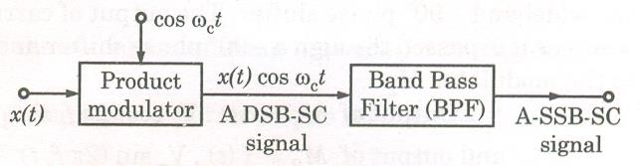

Frequency Discrimination Method for SSB SC Generation

Limitations-
- The frequency discrimination method is useful only if the base band signal is restricted at its lower edge due to which the upper and lower sidebands are non-overlapping.

- The design of the band pass filter becomes difficult if the carrier frequency is quite higher than the bandwidth of the baseband signal.

PHASE-SHIFT METHOD-
The phase shift method avoids filter. This method makes use of the two balanced modulators and two phase shifting networks.
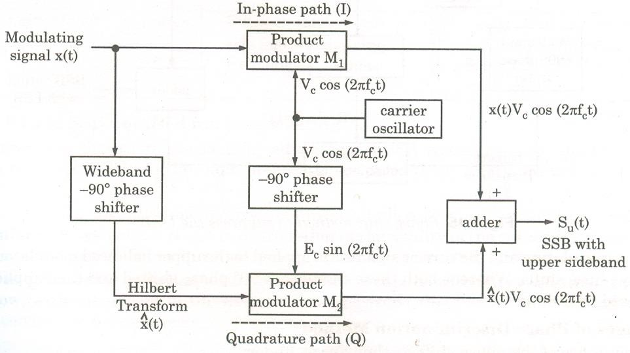

Phase Discrimination Method for SSB- SC signal

One of the modulators M₁ receives the carrier voltage shifted by 90° and the modulating voltage, whereas another balanced modulator M₂ receives the modulating voltage shifted by 90° and the carrier voltage. Both balanced modulators produce an output consisting only of sidebands. The two lower sidebands are out of phase and when combined together in the adder, they cancel each other. The upper sidebands are in phase and they added in the adder producing SSB in which the lower sideband has been cancelled.

DEMODULATION-
The baseband signal x(t) can be recovered from the SSB-SC signal by using the synchronous detection technique. With the help of synchronous detection method the spectrum of an SSB-SC signal centred about ω=±𝜔c, is retranslated to the baseband spectrum which is centered about ω=0. The process of synchronous detection involves multiplication of the received SSB-SC signal with locally generated carrier. The generated carrier should have exactly the same frequency as that of the suppressed carrier. The product modulator multiplies the two signals at its input and the product signal is passed through a low pass filter with a bandwidth equal to fm. At the output of the filter, we get the modulating signal back.
ed(t) = S(t)SSB ⨉ cos𝜔ct
= [x(t) Cos𝜔ct ± xn(t) Sin𝜔ct] cos𝜔ct

= 1/2 x(t) + ½ [x(t) Cos2𝜔ct ± xn(t) Sin2𝜔ct]
When ed(t) is passed through a low pass filter, then the terms cantered about
±2𝜔care filtered out and we get, at the output of detector, signal eo which is given as eo(t) = 1/2 x(t)

SSB-SC Modulating
Filter
Product
Modulator
fc
Locally generated carrier
Signal signal

gram of coherent SSB demodulator
Block dia

METHODS OF GENERATION OF DSB-SC SIGNAL GENERATION OF DSB-SC SIGNAL-
A circuit used to achieve the generation of a DSB-SC signal is called a product modulator. There are two types of product modulator.
- Balanced Modulator
- Ring Modulator

Balance Modulator :-
A non-linear resistance or a non –linear device may be used to produce amplitude modulation i.e, one carrier and two sidebands. However a DSB-SC signal contains only two sidebands. Thus if two nom- linear devices such as diodes , transistors etc. are connected in a balanced mode so as to suppress the carriers of each other , then only sidebands are left i.e. a DSB- SC signal is generated.

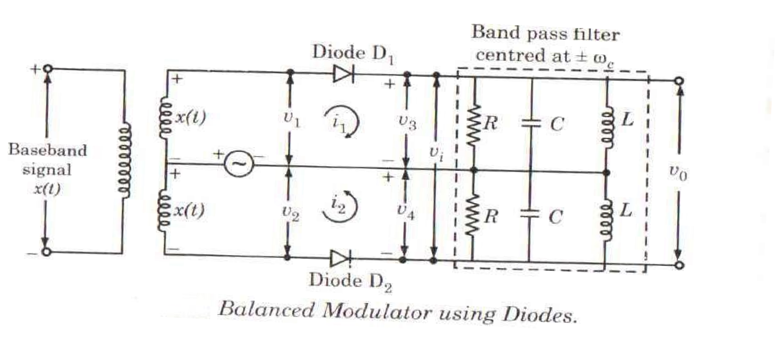
Therefore a Balanced Modulator may be defined as a circuit in which two nonlinear devices are connected in a balanced mode to produce a DSB-SC signal. A modulating signal x(t) is applied to the diodes through a center-tapped transformer with the carrier signal Cos ωct.
A non- linear VI relationship is given as,
i= av + bv2 where v is the input voltage applied across a non- linear device and i is the current through the non-linear device.
For diode D1 , i1 = av1 + b𝑣²
1
Similarly, For diode D2 , i2 = av2 + b𝑣²
2
𝑣₁ = cos 𝜔_{𝑐}𝑡 + x(t)
𝑣₂ = cos 𝜔_{𝑐} 𝑡 - x(t)
Done to currents i1 and i2 the net voltage 𝑣_{𝑖} at the input of band pass filter expressed as vi = i1R - i2R.
After substituting the values of i1 & i2 we get
𝑣_{𝑖} = 2R[ax(t) + 2bx(t) cos 𝜔_{𝑐}𝑡]
A band pass filter is that type of filter which allows to pass a band of frequencies. Here the band pass filter is centred around ± , it will pass a narrow band of frequencies cantered at ±𝜔_{𝑐}.
The output of the BPF is
𝑣_{𝑜} = 4bR x(t) cos 𝜔_{𝑐} 𝑡

Ring Modulator-

Ring Modulator is another product Modulator, which is used to generate DSB-SC Signal. In a ring modulator circuit, four diodes are connected in the form of ring in which all four diodes point in same manner. All the four diodes in ring are controlled by a square wave carrier signal c(t) of frequency fϲ applied through a centre tapped transformer.
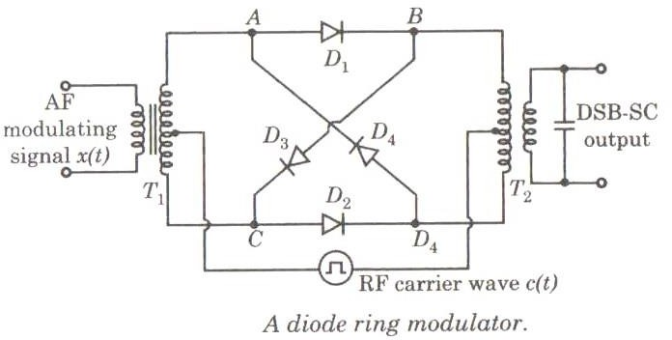

In case, when diodes are ideal and transformer are perfectly balanced, the two outer diodes are switched on if the carrier signal is positive whereas the two inner diodes are switched off and thus presenting very high impedence. Under this condition, the modulator multiplies the modulating signal x(t) by +1.
When carrier signal is –ve , he situation becomes reversed . In this case the modulator multiplies the modulating signal by -1.
𝑛 =1
C(t) = 4/𝜋 ∑∞ (−1) {cos[2𝜋𝑓 𝑡(2𝑛 − 1)]}
𝑛=1 2𝑛−1 𝑐
We have S(t) = x(t) C(t)

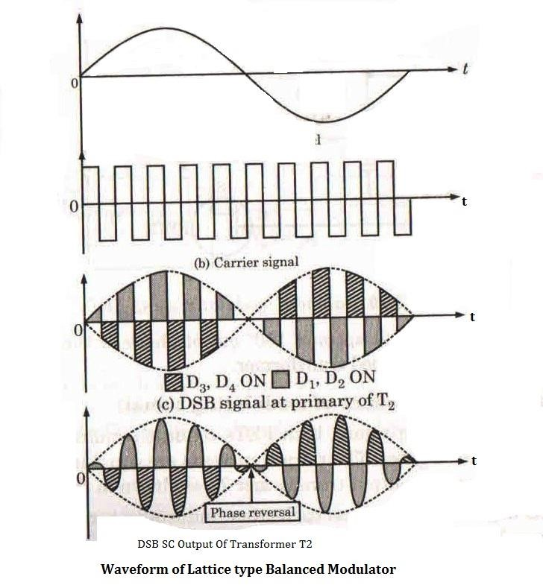

A Ring modulator is also known as a double balanced modulator. The modulating signal is band limited to −𝑓_{𝑚} ≤ 𝑓 ≤ . The desired sideband around the carrier frequency fc may be selected using band pass filter having centre frequency 𝜔_{𝑐} and bandwidth 2fm . To avoid overlapping of side bands fc is greater than fm .

DETECTION OF DSB-SC SIGNAL-
The DSB-SC signal may be demodulated by following two methods.
- Synchronous detection method
- Using envelope detector after carrier reinsertion.

Synchronous detection Method-
DSB-SC signal is transmitted from the transmitter and it reaches the receiver through a transmission medium. At the receiver end, the original modulating signal x(t) is recovered from the modulated signal. This can be achieved by simply retranslating the baseband or modulating signal from a higher spectrum, cantered at ±ωc, to the original

spectrum. This process is called demodulation or detection. Hence, the original or baseband signal is recovered from the modulated signal by the detection process.
A method of DSB-SC detection is known as synchronous detection.
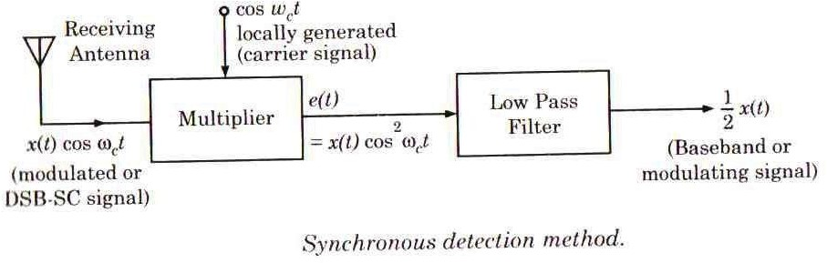

Working principle-
In synchronous detection method, the received modulated or DSB-SC signal is first multiplied with a locally generated carrier signal Cos ωct and then passed through a low pass filter. At the output of a low pass filter, the original modulating signal is recovered.

VESTIGIAL SIDE BAND MODULATION:
In case of SSB modulation, when a sideband is passed through the filters, the band pass filter may not work perfectly in practice. As a result of which, some of the information may get lost.
Hence to avoid this loss, a technique is chosen, which is a compromise between DSB- SC and SSB, called as Vestigial Sideband (VSB) technique. The word vestige which means “a part” from which the name is derived.

Vestigial Sideband
Both of the sidebands are not required for the transmission, as it is a waste. But a single band if transmitted, leads to loss of information. Hence, this technique has evolved.
Vestigial Sideband Modulation or VSB Modulation is the process where a part of the signal called as vestige is modulated, along with one sideband. A VSB signal can be plotted as shown in the following figure.

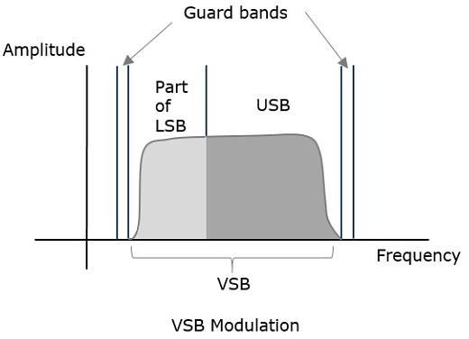

Along with the upper sideband, a part of the lower sideband is also being transmitted in this technique. A guard band of very small width is laid on either side of VSB in order to avoid the interferences. VSB modulation is mostly used in television transmissions.
VSB Modulation − Advantages Following are the advantages of VSB −
- Highly efficient.
- Reduction in bandwidth.
- Filter design is easy as high accuracy is not needed.
- The transmission of low frequency components is possible, without difficulty.
- Possesses good phase characteristics.
VSB Modulation − Disadvantages Following are the disadvantages of VSB −
- Bandwidth when compared to SSB is greater.
- Demodulation is complex.

UNIT-3: ANGLE MODULATION SYSTEMS

CONCEPT OF ANGLE MODULATION & ITS TYPES
Angle modulation is the process in which the frequency or the phase of the carrier signal varies according to the message signal.
The standard equation of the angle modulated wave is
S (t) = 𝐴𝑐𝐶𝑜𝑠(𝑡)
Where 𝐴𝑐 is the amplitude of the modulated wave, which is the same as the amplitude of the carrier signal.
(𝑡) is the angle of the modulated wave

TYPES

Angle modulation is further divided into frequency modulation and phase modulation.
Frequency Modulation- it is the process of varying the frequency of the carrier signal linearly with the message signal.
Phase Modulation- It is the process of varying the phase of the carrier signal linearly with the message signal.

BASIC PRINCIPLE OF FREQUENCY MODULATION & FREQUENCY SPECTRUM OF FM SIGNAL
FREQUENCY MODULATION
In frequency modulation, the frequency of the carrier signal varies in accordance with the instantaneous amplitude of the modulating signal. Here amplitude and phase of the carrier signal remains constant.
The frequency of the modulated wave increases, when the amplitude of the modulating signal increases and the frequency of the modulated wave decreases, when the amplitude of the modulating signal decreases.
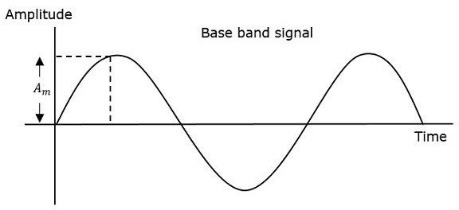
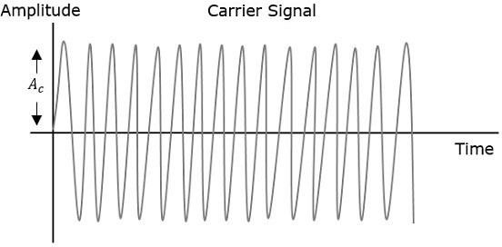

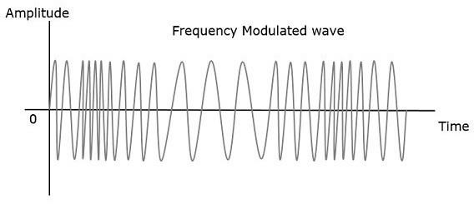

FREQUENCY SPECTRUM OF FM SIGNAL-
The frequency spectrum of the signal
v(t) = cos(𝜔𝑐 𝑡 + 𝛽 sin 𝜔𝑚) …….(1) which is the signal with the amplitude arbitrarily set at unity.
We have
cos(𝜔𝑐 𝑡 + 𝛽 sin 𝜔𝑚) = cos 𝜔𝑐 𝑡 𝑐𝑜𝑠 (𝛽 sin 𝜔𝑚 𝑡) - sin 𝜔𝑐 𝑡 𝑠𝑖𝑛 (𝛽 sin 𝜔𝑚 𝑡) …………
(2)
Consider now the expression 𝑐𝑜𝑠 (𝛽 sin 𝜔𝑚 𝑡) which appears as a factor on the
right hand side. It is an even, periodic function having an angular frequency 𝜔𝑚. Therefore, it is possible to expand this expression in a Fourier series in which 𝜔𝑚/2π is the fundamental frequency. The coefficients are functions of β, and, since function is even, the coefficients of the odd harmonics are zero. The result is
cos 𝜔𝑐 𝑡 𝑐𝑜𝑠 (𝛽 sin 𝜔𝑚 𝑡) = 𝐽0(𝛽) + 2𝐽2(𝛽) cos 2𝜔𝑚 t + 2𝐽4(𝛽) cos 4𝜔𝑚 t + ⋯ … … + 2 𝐽₂𝑛(𝛽) cos 2𝑛𝜔𝑚𝑡 + ⋯ ..
While for sin 𝜔 , which is an odd function, we find the expansion contains only odd harmonics and is given by
𝑠𝑖𝑛 (𝛽 sin 𝜔𝑚 𝑡) = 2𝐽1(𝛽) sin 𝜔𝑚 𝑡 + 2𝐽3(𝛽) sin 3𝜔𝑚 t + ⋯ +
2 𝐽2𝑛−1(𝛽) sin (2𝑛 − 1)𝜔𝑚𝑡 + ⋯ ..
The functions (𝛽) occur often in the solution of engineering problem. They are known as Bessel functions of the first kind and of order n.
Putting the results given and using the identities
𝑐𝑜𝑠 𝐴. 𝑐𝑜𝑠 𝐵 = ½ 𝑐𝑜𝑠 (𝐴 − 𝐵) + ½ 𝑐𝑜𝑠 (𝐴 − 𝐵)
𝑠𝑖𝑛 𝐴. 𝑠𝑖𝑛 𝐵 = ½ 𝑐𝑜𝑠 (𝐴 − 𝐵) − ½ 𝑐𝑜𝑠 (𝐴 − 𝐵)
We find v (t) becomes

(𝑡) = 𝐽0(𝛽) cos 𝜔𝑐 − 𝐽1(𝛽)[𝑐𝑜𝑠(𝜔𝑐 − 𝜔𝑚)𝑡 – cos(𝜔𝑐 + 𝜔𝑚) 𝑡]
+ 𝐽2(𝛽)[𝑐𝑜𝑠(𝜔𝑐 − 2𝜔𝑚)𝑡 + cos(𝜔𝑐 + 2𝜔𝑚) 𝑡]
− 𝐽3(𝛽)[𝑐𝑜𝑠(𝜔𝑐 − 3𝜔𝑚)𝑡 − cos(𝜔𝑐 + 3𝜔𝑚) 𝑡] + ⋯ …
Observe that the spectrum is composed of a carrier with an amplitude and a set of sidebands spaced symmetrically on either side of the carrier at frequency separations of
𝜔𝑚, 2𝜔𝑚, 3𝜔𝑚, etc.

EXPRESSION FOR FREQUENCY MODULATED SIGNAL & MODULATION INDEX EXPRESSION FOR FREQUENCY MODULATED SIGNAL-
The equation for instantaneous frequency 𝑓𝑖 in FM modulation is:
𝑓𝑖 = 𝑓𝑐 + 𝐾𝑓𝑚(𝑡)
Where 𝑓𝑐 is the carrier frequency
𝐾𝑓 is the frequency sensitivity m(t) is the message signal
The relationship between angular frequency 𝑤𝑖 and angle (𝑡) is

𝑤𝑖
= 𝑑𝜃𝑖(𝑡)
𝑑𝑡

⇒ 2π𝑓𝑖
= 𝑑𝜃𝑖(𝑡)
𝑑𝑡

⇒ (𝑡) = 2π∫ 𝑓_{𝑖} dt
Substitute 𝑓𝑖 value in the equation
(𝑡) = 2π∫(𝑓_{𝑐} + 𝐾_{𝑓}𝑚(𝑡)) dt
⇒ (𝑡) = 2π𝑓_{𝑐}𝑡 + 2π𝐾_{𝑓} ∫ 𝑚(𝑡) 𝑑𝑡
Substitute the (𝑡) value in the standard equation of angle modulated wave.
S(t)= 𝐴_{𝑐}𝐶𝑜𝑠(2𝜋𝑓_{𝑐}𝑡 + 2𝜋𝐾_{𝑓} ∫ 𝑚(𝑡) 𝑑𝑡
If the modulating signal is m(t)= 𝐴𝑚 cos (2π𝑓𝑚𝑡), then the equation of FM wave will be S(t)= 𝐴_{𝑐}𝐶𝑜𝑠(2𝜋𝑓_{𝑐}𝑡 + 2𝜋𝐾_{𝑓} ∫ 𝐴_{𝑚} 𝑐𝑜𝑠 (2π𝑓_{𝑚}𝑡 ) 𝑑𝑡
⇒ S(t)= 𝐴 𝐶𝑜𝑠(2𝜋𝑓 𝑡 + 2𝜋𝐾 1 𝐴 𝑆𝑖𝑛 (2π𝑓 𝑡 ))

𝑐 𝑐
𝑓 2𝜋𝑓𝑚 𝑚 𝑚

⇒ S(t)= 𝐴𝑐𝐶𝑜𝑠(2𝜋𝑓𝑐 𝑡 + 𝛽 𝑆𝑖𝑛 (2π𝑓𝑚𝑡 )) Where 𝛽= modulation index
= 𝑘𝑓𝐴𝑚= ∆𝑓
𝑓𝑚 𝑓𝑚

The difference between FM modulated frequency and normal carrier frequency is termed as frequency deviation. It is denoted by ∆𝑓.
∆𝑓 = 𝑘𝑓𝐴𝑚

MODULATION INDEX-
The modulation index is defined as the ratio of frequency deviation to the modulating frequency.
Modulation index, 𝛽 = frequency deviation/modulation frequency
Or β= ^{𝛥𝑓}
𝑓𝑚
This modulation index may be greater than unity.

PHASE MODULATION & DIFFERENCE OF FM & PM-

PHASE MODULATION-

In phase modulation, the phase of the carrier signal varies in accordance with the instantaneous amplitude of the modulating signal. Here with the change in phase, the frequency of the signal also shows variation. Thus it can be said that while phase modulating any signal, the phase as well as the frequency of the carrier signal shows variation.
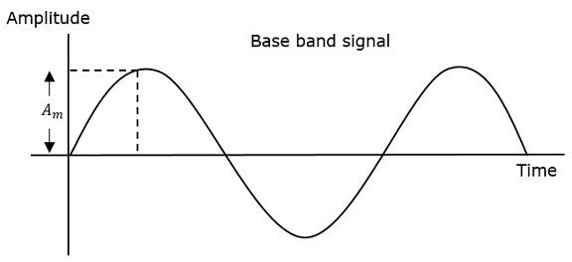

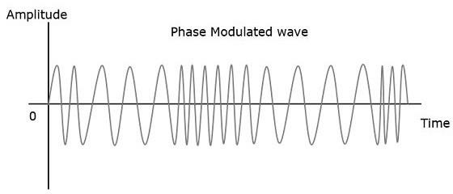
The figure shows a sinusoidal message signal that is to be transmitted from one end to another, a carrier signal which is to be phase modulated and the last figure represents the phase modulated signal. Here it is clear from the above figure that when the amplitude of the sinusoidal signal starts to increase and reaches the maximum value then the phase lead of the carrier signal gets increased. Due to this a compression in the carrier signal is noticed.
However, when the amplitude of the modulating signal starts falling and attains a minimum value, then the phase lag of the carrier wave occurs. Due to this, the frequency of the signal gets increased.
The equation for instantaneous phase 𝛷 𝑖 in phase modulation is
𝛷𝑖 = 𝐾𝑃𝑚(𝑡)
Where, 𝐾𝑃 is the phase sensitivity m(t) is the modulating signal
The standard equation of angle modulated wave is S(t)= 𝐴𝑐𝐶𝑜𝑠 (2𝜋𝑓𝑐𝑡 + 𝛷𝑖)
Substitute, 𝛷𝑖 value in the above equation
S(t)= 𝐴𝑐𝐶𝑜𝑠 (2𝜋𝑓𝑐𝑡 + 𝐾𝑃𝑚(𝑡))
If the modulating signal, m(t)= 𝐴𝑚 𝑐𝑜𝑠 (2π𝑓𝑚𝑡) then the equation of PM wave will be S(t)= 𝐴𝑐𝐶𝑜𝑠 (2𝜋𝑓𝑐𝑡 + 𝐾𝑃𝐴𝑚 𝑐𝑜𝑠 (2π𝑓𝑚𝑡 ))
=> S(t)= 𝐴𝑐𝐶𝑜𝑠 (2𝜋𝑓𝑐𝑡 + 𝛽 𝑐𝑜𝑠 (2π𝑓𝑚𝑡 )) Where, β= modulation index

DIFFERENCE OF FM & PM-

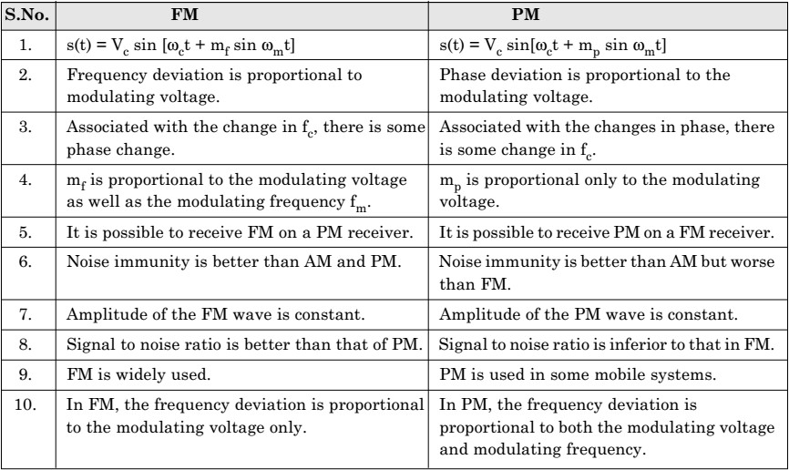
  - COMPARE BETWEEN AM AND FM MODULATION- AM-
    - Amplitude of AM wave will change with the modulating voltage.
    - Transmitted power is dependent on the modulation index.
    - Carrier power and one sideband power are useless.
    - AM receivers are not immune to noise.
    - Frequency deviation feature is absent in AM.
    - Bandwidth = 2 . It is not dependent on the modulation index.
    - Bandwidth is much less than FM.
    - Ground wave and sky wave propagation is used. Therefore larger area is covered than FM.
    - Not possible to operate more channels on the same frequency.
    - AM equipment are less complex.
    - Number of sidebands in AM will be constant and equal to 2.
    - The information is contained in the amplitude variation of the carrier.
FM-

- Amplitude of FM wave is constant. It is independent of the modulation index.
- Transmitted power remains constant. It is independent of mf.
- All the transmitted power is useful.
- FM receivers are immune to noise.
- It is possible to decrease noise further by increasing deviation.
- Bandwidth = 2[∆𝑓 + ]. The bandwidth depends on modulation index.
- Bandwidth is large. Hence, wide channel is required.
- Space wave is used for propagation. So, radius of transmission is limited to line of sight.
- It is possible to operate several transmitters on same frequency.
- FM transmission and reception equipment are more complex.
- The number of sidebands having significant amplitudes depends on modulation index mf.
- The information is contained in the frequency variation of the carrier.

FM GENERATION-
The FM modulator circuits used for generating FM signals may be put into two categories as under.
    - The direct method or parameter variation method
    - The indirect method or the Armstrong method

INDIRECT METHOD OR THE ARMSTRONG METHOD:
In direct methods of generation of FM, LC oscillators are used. The crystal oscillator cannot be used. The LC oscillators are not stable enough for the broadcast purpose. Thus, the direct methods cannot be used for the broadcast application. In order to overcome the limitation of direct method, we use indirect method of FM generation called as the Armstrong method.
In this method, the FM is obtained through phase modulation. A crystal oscillator can be used hence the frequency stability is very high and this method is widely used in practice. The Armstrong method uses the phase modulator to generate a frequency modulated wave. Crystal oscillator produce stable frequency upto 1MHz.

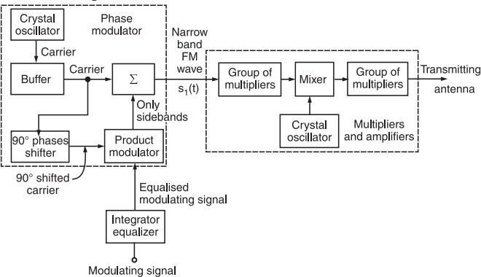
- The modulating signal x(t) is passed through an integrator before applying it to the phase modulator.
- The crystal oscillator produces a stable unmodulated carrier which is applied to the 90° phase shifter as well as the combining network through a buffer.
- The 90° phase shifter produces a 90° phase shifted carrier. It is applied to the balanced modulator along with the modulating signal. Thus, the carrier used for modulation is 90° shifted with respect to the original carrier.
- At the output of the product modulator, we get DSB SC signal i.e., AM signal without carrier. This signal consists of only two sidebands with their resultant in phase with the 90° shifted carrier.
- The two sidebands and the original carrier without any phase shift are applied to a combining network (∑). At the output of the combining network, we get the resultant of vector addition of the carrier and two sidebands
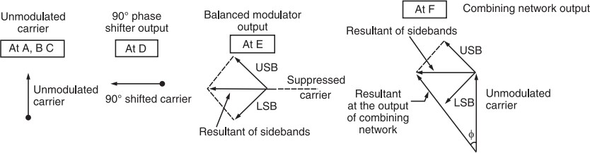

- As the amplitude of modulating signal increases the modulation index will increase and the amplitude of sidebands will also increase. Hence the amplitude of their resultant increases.
- This will increase the angle ∅ made by the resultant with unmodulated carrier. The angle ∅ deceases with reduction in modulation index. Thus the resultant at the output of the combining network is phase modulated.
- The FM signal produced at the output of phase modulator has a low carrier frequency and low modulation index. They are increased to an high value with the help of frequency multiplies, mixer and amplifier.
- For low modulation index, ∅ is small and for high modulation index, ∅ increases.

FM DEMODULATOR-
The demodulation process of FM waves is exactly opposite to that of the frequency modulation. After demodulation, we get the original modulating signal at the demodulation output.

METHODS OF FM DEMODULATION- FORSTER SEELY DETECTOR-
The circuit diagram of phase discriminator or Foster Seeley Discriminator is given below
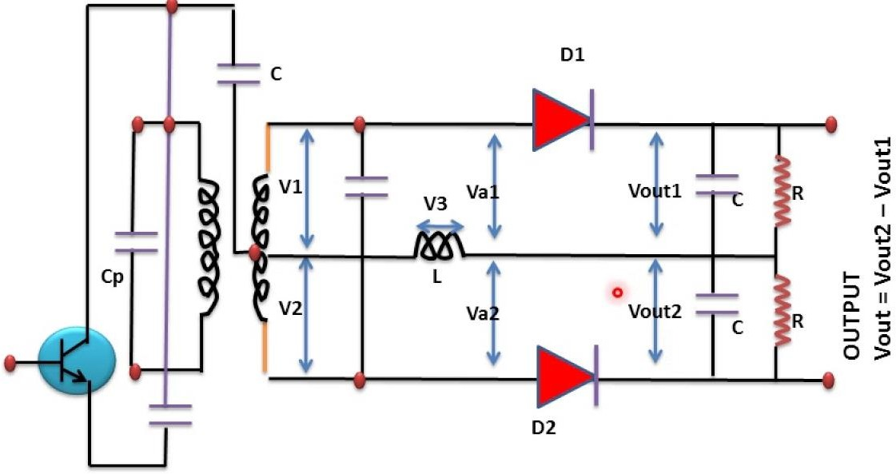
This circuit consists of an inductively coupled double tuned circuit in which both primary and secondary coils are tuned to the same frequency. The center of the secondary coil is connected to the top of the primary through a capacitor C. this capacitor performs the functions are:
    - It blocks the D.C. from primary to secondary.

    - It couples the signal frequency from primary to center tapping of the secondary.

The primary voltage 𝑉₃ appears across the inductor in primary side. Nearly entire voltage 𝑉₃ appears across inductor L except a small drop across the capacitor C.
The center tapping of the secondary coil has an equal and opposite voltage across each half winding. Hence 𝑉₁ and 𝑉₂ are equal in magnitude but opposite in phase. The radio frequency voltages 𝑉𝑎1 and 𝑉𝑎2 applied to the diodes 𝐷1 𝑎𝑛𝑑 𝐷2 are expressed as
𝑉𝑎1 = 𝑉3 + 𝑉1
𝑉𝑎2 = 𝑉3 + 𝑉2
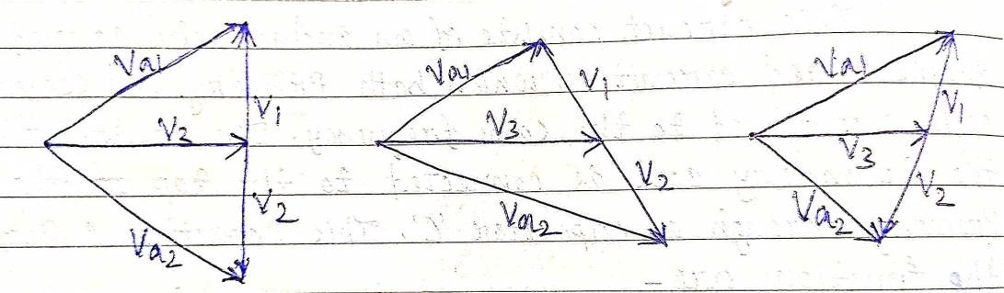
Voltages 𝑉𝑎1 and 𝑉𝑎2 depend upon the phasor relations between𝑉1, 𝑉2 𝑎𝑛𝑑 𝑉3. The phase position of 𝑉₁ 𝑎𝑛𝑑 𝑉₂ relative to 𝑉₃ would depend upon the tuned secondary coil at the resonance or off the resonance.
  - At resonance- when an input voltage has a frequency equal to the resonant frequency of the tuned secondary, 𝑉₃ is in phase quadrature with 𝑉₁ and 𝑉₂. The resultant voltage 𝑉𝑎1 𝑎𝑛𝑑 𝑉𝑎2 are equal in magnitude.
  - Off resonance- when an input signal frequency is above the resonant frequency
the phase difference between 𝑉₃ and 𝑉₁ is 45°. Because 𝑉₂ is in phase opposition of
𝑉₁ the phase difference between 𝑉₃ and 𝑉₂ is 135°. The phasor diagram reveals that
𝑉𝑎1 is reduced where as 𝑉𝑎2 is increased. The situation is reversed when the input voltage has a frequency below the resonant frequency. Hence the amplitude of the voltage 𝑉𝑎1 𝑎𝑛𝑑 𝑉𝑎2 will vary.
The voltage 𝑉𝑎1 𝑎𝑛𝑑 𝑉𝑎2 are separately rectified by diodes 𝐷1 and 𝐷2 respectively to produce 𝑉𝑜𝑢𝑡1 𝑎𝑛𝑑 𝑉𝑜𝑢𝑡2. The output voltage 𝑉𝑜 is

𝑉𝑜 = ⃒𝑉𝑜𝑢𝑡2⃒ − ⃒𝑉𝑜𝑢𝑡1⃒

Advantages:

- It is more easy to align than the balanced slope detector as there are only two tuned circuits and both are to be tuned at the same frequency fc.
- Linearity is better. This is because the operation of the circuit is dependent more on the primary to secondary relationship which is very much linear.

Drawbacks
It does not provide amplitude limiting. So in the presence of noise or any other spurious amplitude variations, the demodulator output responds to them and produce errors.

RATIO DETECTOR-

The RATIO DETECTOR uses a double-tuned transformer to convert the instantaneous frequency variations of the fm input signal to instantaneous amplitude variations. These amplitude variations are then rectified to provide a dc output voltage which varies in amplitude and polarity with the input signal frequency. This detector demodulates fm signals and suppresses amplitude noise without the need of limiter stages.
In the Foster-Seeley discriminator, changes in the magnitude of the input signal will give rise to amplitude changes in the resulting output voltage. This makes prior limiting necessary. It is possible to modify the discriminator circuit to provide limiting, so that the amplitude limiter may be dispensed with. A circuit so modified is called a Ratio Detector Circuit.
As we now, the sum Vao + Vbo remains constant, although the difference varies because of changes in input frequency. This assumption is not completely true. Deviation from this ideal does not result in undue distortion in the Ratio Detector Circuit, although some distortion is undoubtedly introduced. It follows that any variations in the magnitude of this sum voltage can be considered spurious here. Their suppression will lead to a discriminator which is unaffected by the amplitude of the incoming signal. It will therefore not react to noise amplitude or spurious amplitude modulation.
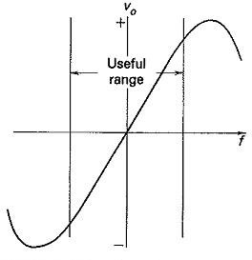

It now remains to ensure that the sum voltage is kept constant. Unfortunately, this cannot be accomplished in the phase discriminator, and the circuit must be modified.. This is used to show how the circuit is derived from the discriminator and to explain its operation. It is seen that three important changes have been made: one of the diodes has been reversed, a large capacitor (C5) has been placed across what used to be the output, and the output now is taken from elsewhere.
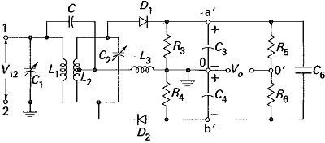

Operation:
With diode D2 reversed, o is now positive with respect to b’, so that Va′b′ is now a sum voltage, rather than the difference it was in the discriminator. It is now possible to connect a large capacitor between a’ and b’ to keep this sum voltage constant. Once C5 has been connected, it is obvious that Va′b′ is no longer the output voltage; thus the output voltage is now taken between o and o′. It is now necessary to ground one of these two points, and o happens to be the more convenient, as will be seen when dealing with practical Ratio Detector Circuit. Bearing in mind that in practice R5 = R6, Vo is calculated as follows:
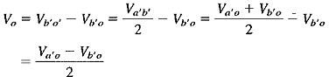
The above equation shows the ratio detector output voltage is equal to half the difference between the output voltages from the individual diodes. Thus (as in the phase discriminator) the output voltage is proportional to the difference between the individual output voltages. The Ratio Detector Circuit therefore behaves identically to the discriminator for input frequency changes.

